State of Florida  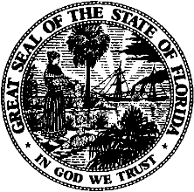 |  | Public Service Commission  Capital Circle Office Center ● 2540 Shumard Oak Boulevard  Tallahassee, Florida 32399-0850  -M-E-M-O-R-A-N-D-U-M-
DATE: | September 24, 2020
TO: | Office of Commission Clerk (Teitzman)
FROM: | Office of Industry Development and Market Analysis (Eichler, Breman, Clark, Crawford, Hinton)  Division of Accounting and Finance (Fletcher, Maurey, Mouring)  Division of Economics (Coston, Galloway)  Office of the General Counsel (Stiller, Crawford)
RE: | Docket No. 20200092-EI – Storm protection plan cost recovery clause.
AGENDA: | 09/24/20 – Regular Agenda – Post-Hearing Decision – Participation is Limited to Commissioners and Staff
COMMISSIONERS ASSIGNED: |  |  | All Commissioners
PREHEARING OFFICER: |  |  | Fay
CRITICAL DATES: |  |  | None
SPECIAL INSTRUCTIONS: |  |  | None

Case Background
On September 1, 2020, the Florida Public Service Commission (Commission) conducted an administrative hearing to consider two Motions for Approval of Settlement Agreement. Both Motions were filed by Duke Energy Florida, LLC (Duke or Company) in Docket No. 20200069-EI (Storm Protection Plan or SPP) and Docket No. 20200092-EI (Storm Protection Plan Cost Recovery Clause or SPPCRC). The first Motion was filed July 17, 2020, and requested approval of the “2020 SPP/SPPCRC Agreement” (July Agreement). The second Motion was filed August 10, 2020, and requested approval of the “SPPCRC Stipulation and Settlement Agreement” (August Agreement), attached hereto.

The signatories to both Agreements are Duke, the Office of Public Counsel (OPC), and White Springs Agricultural Chemicals, Inc. d/b/a PCS Phosphate (PCS). The Florida Industrial Power Users Group (FIPUG) is a party to both dockets but did not sign and takes no position regarding either Agreement. Walmart, Inc. (Walmart) is a party to both dockets, takes no position regarding the July Agreement, and objects to the August Agreement.

The July Agreement contains a series of stipulations regarding the reasonable costs Duke should be permitted to recover through the SPPCRC in 2021. The Commission approved the July Agreement at the conclusion of the September 1, 2020 hearing, without objection from any party.

The August Agreement also contains a series of stipulations. Specifically, the signatories agree that the prefiled testimony provides the Commission with a record basis to approve the reasonableness of Duke’s 2021 SPPCRC costs and revenue requirements. The signatories further agree that the SPPCRC rate factors should be approved, but that such rates should not have precedential value in future SPPCRC proceedings. Finally, the signatories agree that Duke should be permitted to seek recovery of its initial 2020-2029 SPP development costs through the SPPCRC, where Duke will bear the burden of proving reasonableness and prudence.

At the September 1, 2020 public hearing, counsel for Duke, OPC, and PCS made presentations in favor of the August Agreement. Duke also introduced into evidence the testimony of witnesses Jay W. Oliver and Thomas G. Foster. Counsel for Walmart presented argument in opposition to the August Agreement. Walmart also introduced into evidence the testimony of its witness Steve W. Chriss and conducted cross examination of Duke witness Geoff Foster. Exhibits 1 through 8 on the Comprehensive Exhibit List were admitted without objection. At the conclusion of the hearing, the Commission established September 11, 2020, as the deadline for any party wishing to file a brief to do so. Duke, PCS, and Walmart timely filed post-hearing briefs.
Walmart made one argument at the September 1st hearing and in its post-hearing brief: to wit, Duke’s proposal to recover SPP costs from demand-metered customers through a $/kWh energy charge is not appropriate. Walmart notes that this portion of Duke’s proposal is inconsistent with the approach taken by the other utilities in Docket No. 20200092-EI, and contends that it will result in costs being recovered differently from how they are incurred and allocated, which is further alleged to violate cost causation principles.
In its brief, Duke counters that focusing on this one provision is not consistent with the law governing consideration of settlement agreements, which directs the Commission to examine such agreements as a whole to determine whether they are in the public interest. Looking to the other numerous negotiated provisions that can serve to avoid a full evidentiary hearing, Duke asserts that Commission approval of the August Agreement is in the public interest.
On the issue specifically contested by Walmart, Duke points out that the billing methodology will be in place for 2021 only, with it being revisited when the 2022 SPPCRC factors are set. Duke continues that $10 million in revenue requirements it is seeking to recover through the SPPCRC in 2021 is a relatively modest amount. Finally, Duke notes that the Commission has previously approved storm cost recovery on both an energy and demand basis, and that Duke’s choice of one for 2021 only should not override the public interest served by the August Agreement in its entirety.
In its brief, PCS supports Duke and approval of the August Agreement. PCS also argues that because a hearing in this matter would involve litigating complex legal and factual issues relating to a comprehensive 2017 settlement agreement, and that the opportunity for those issues to be fully vetted is anticipated in a base rate proceeding involving Duke in 2022, the one year bridge on the billing issue crafted into the August Agreement as part of an overall negotiated settlement serves the public interest.
The Commission should vote on whether or not to grant the Motion filed August 10, 2020, requesting approval of the SPPCRC Stipulation and Settlement Agreement (August Agreement).
The Commission has jurisdiction over this matter pursuant to Sections 366.03, 366.05, and 366.06, Florida Statutes.

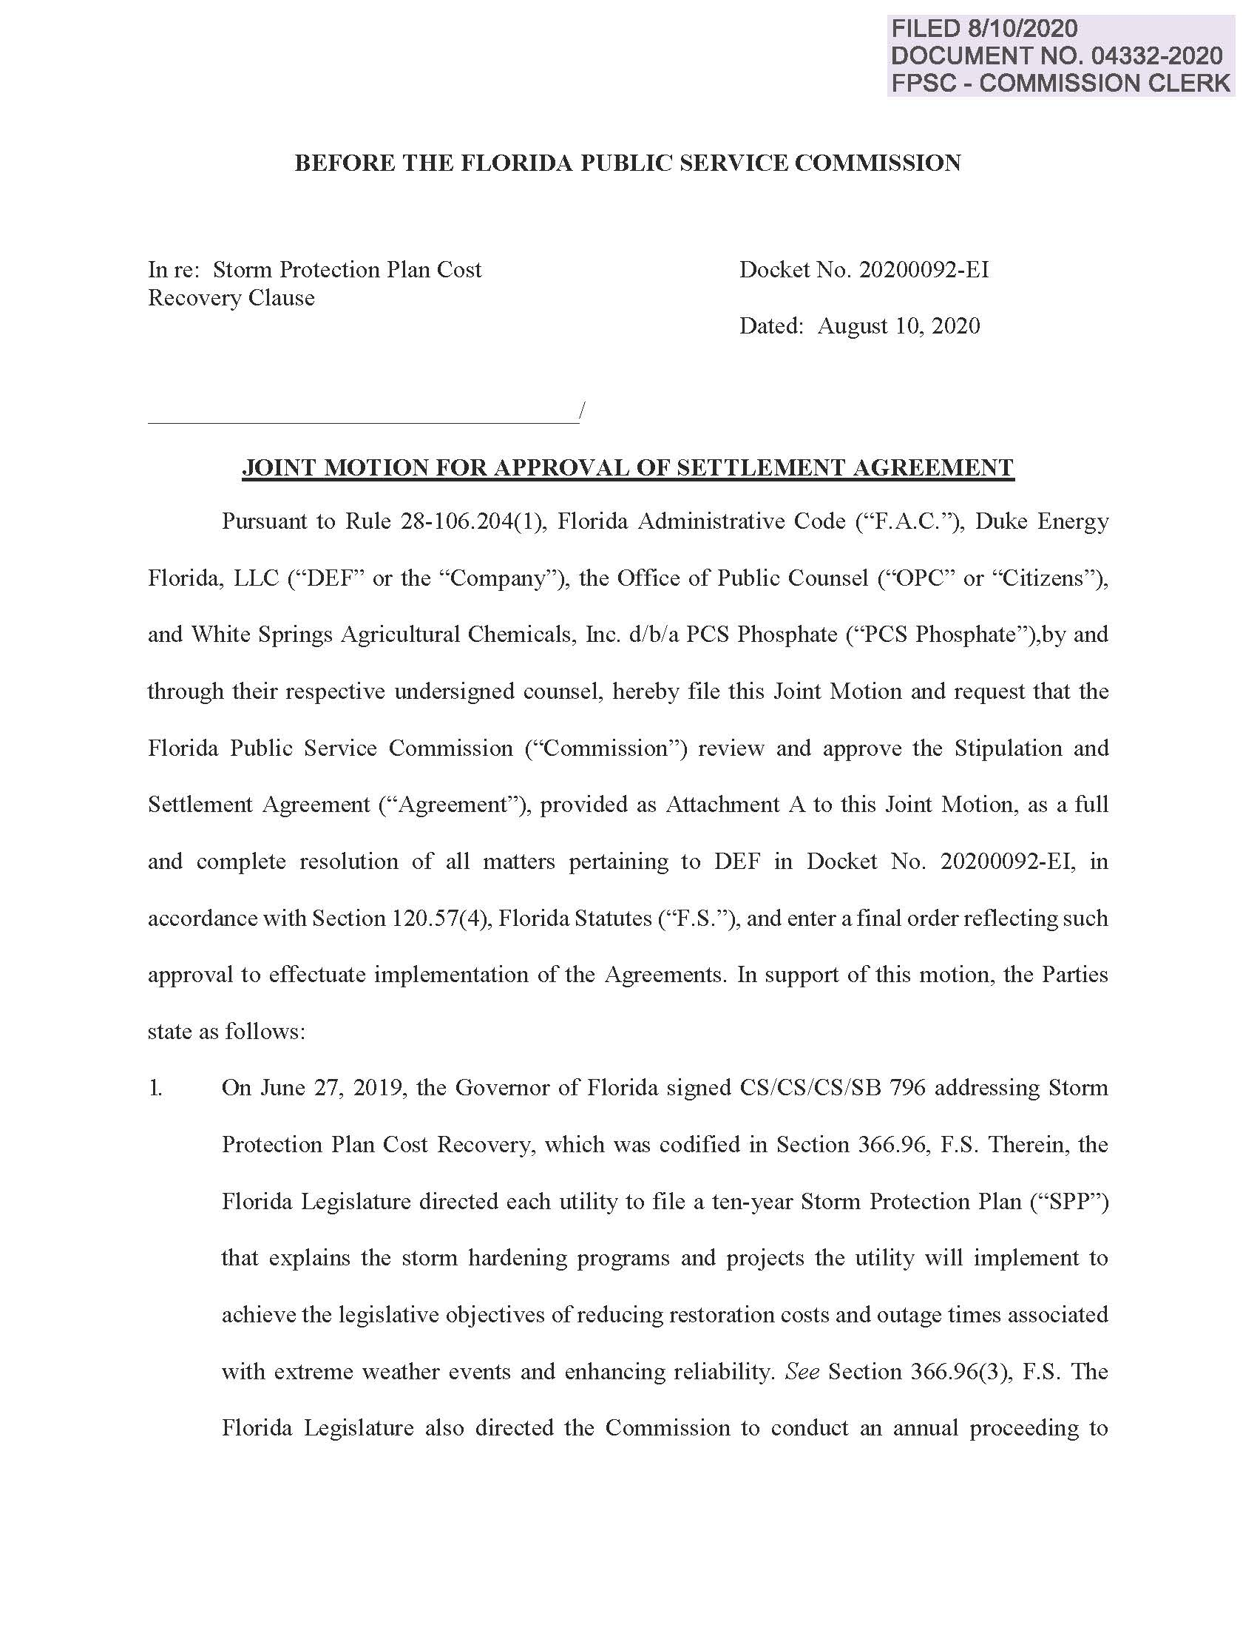

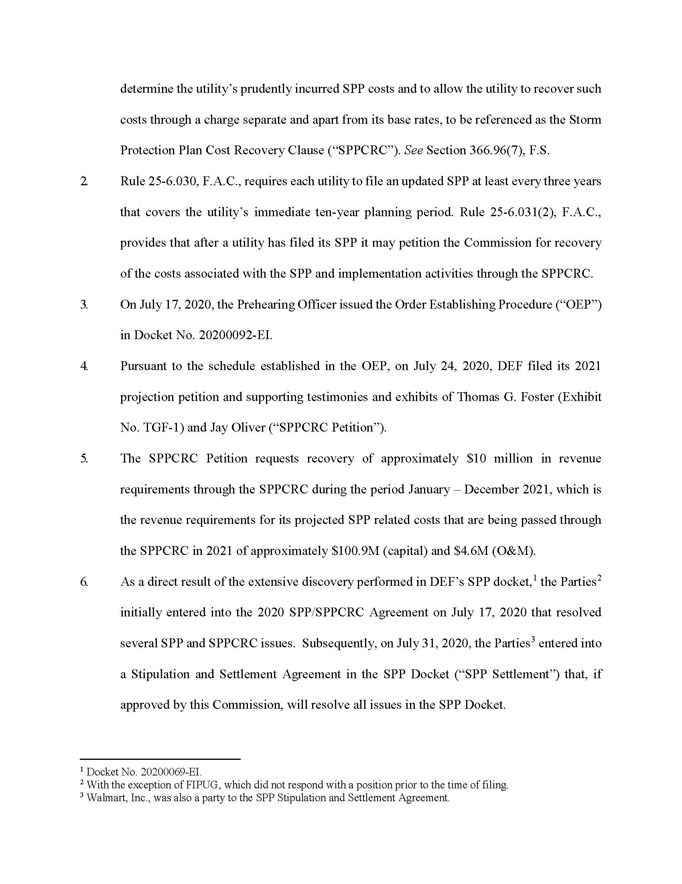

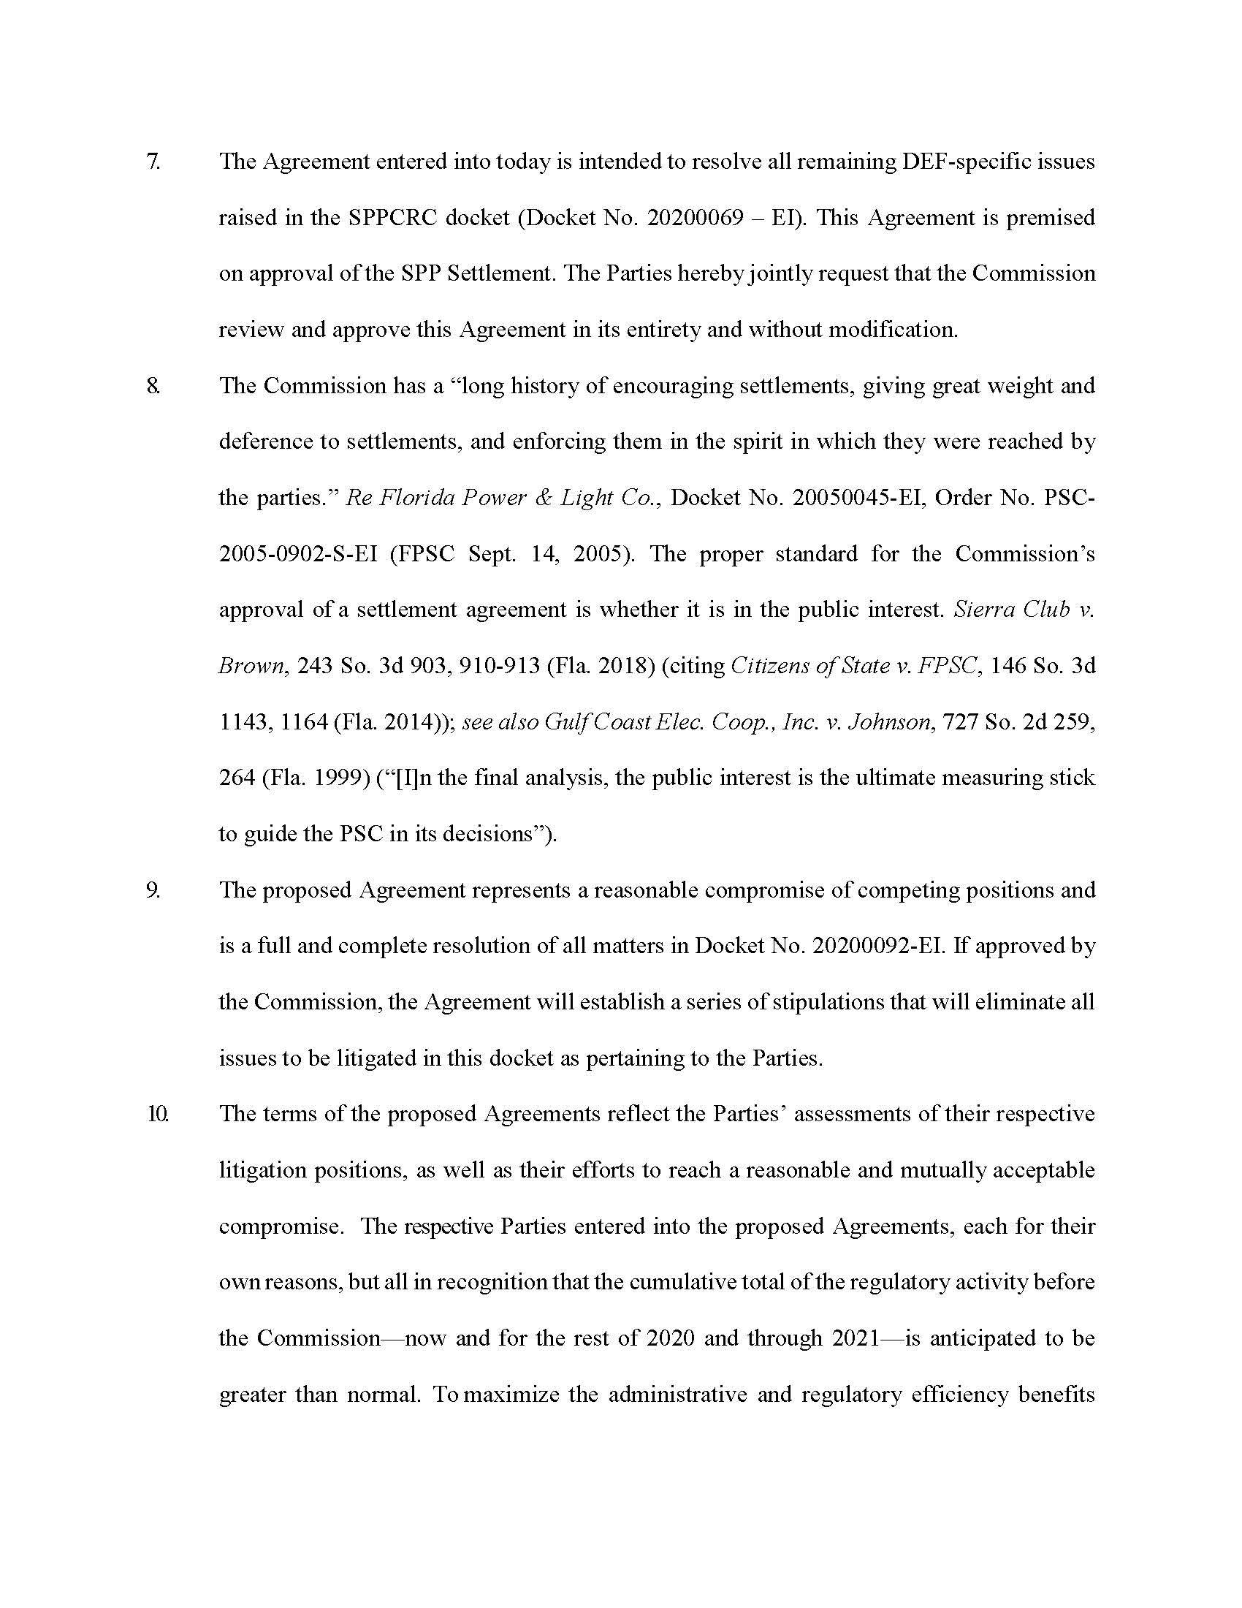

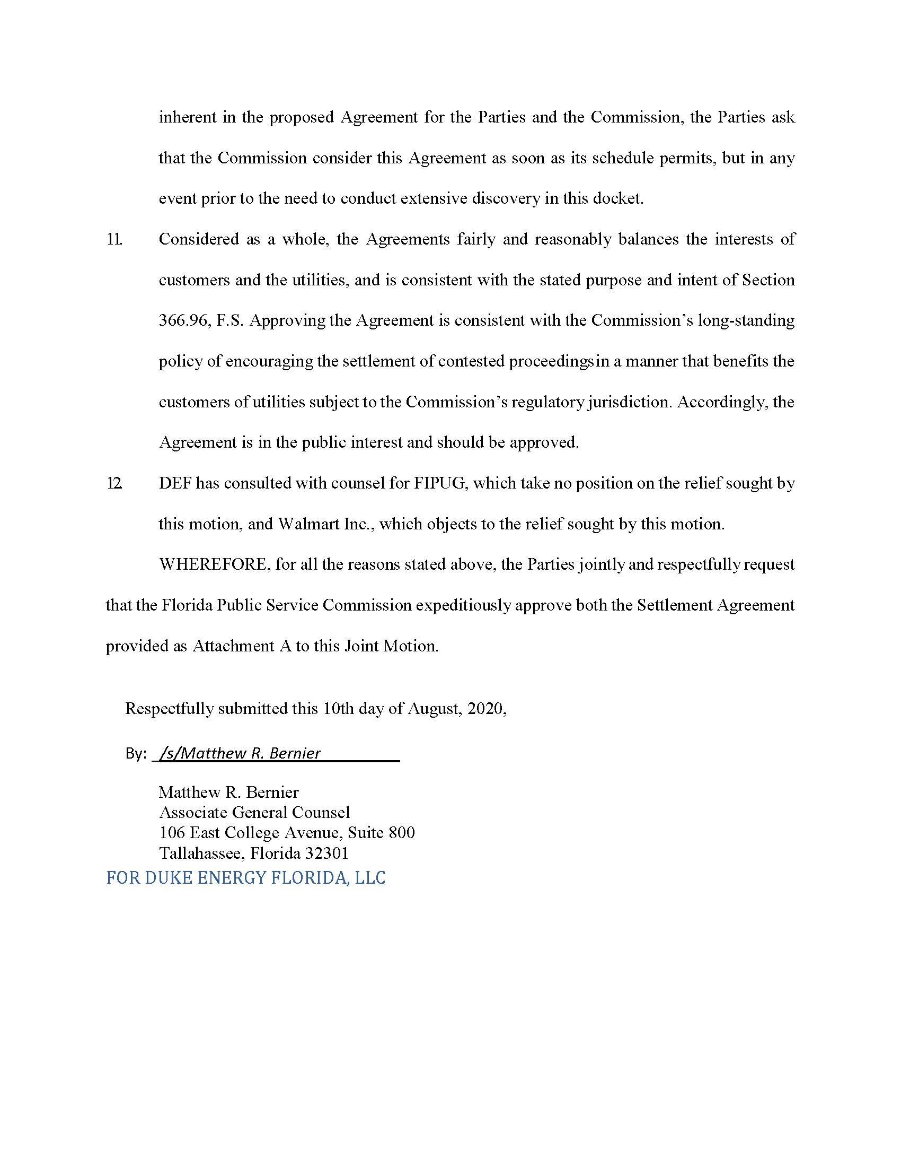

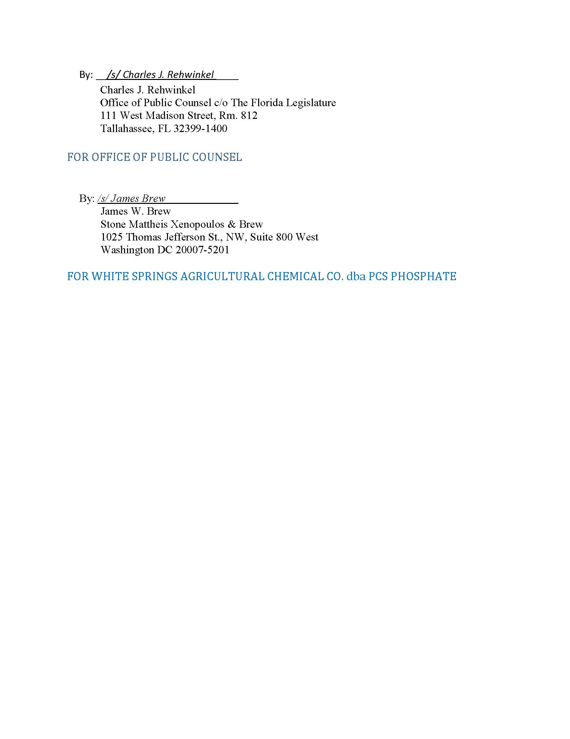

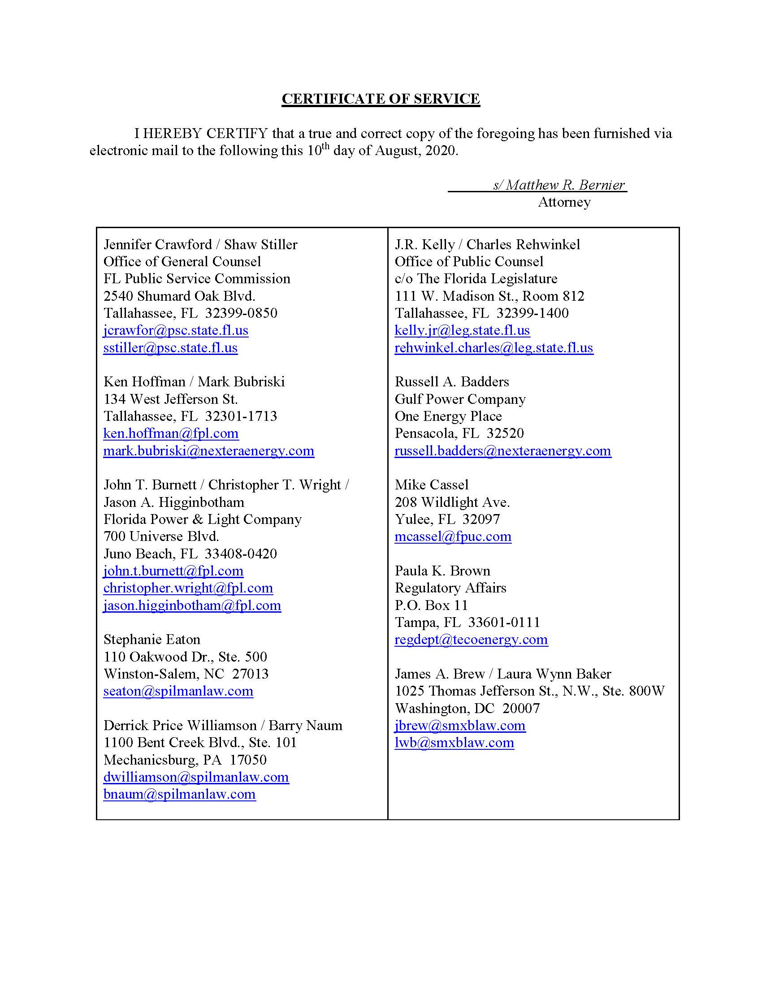

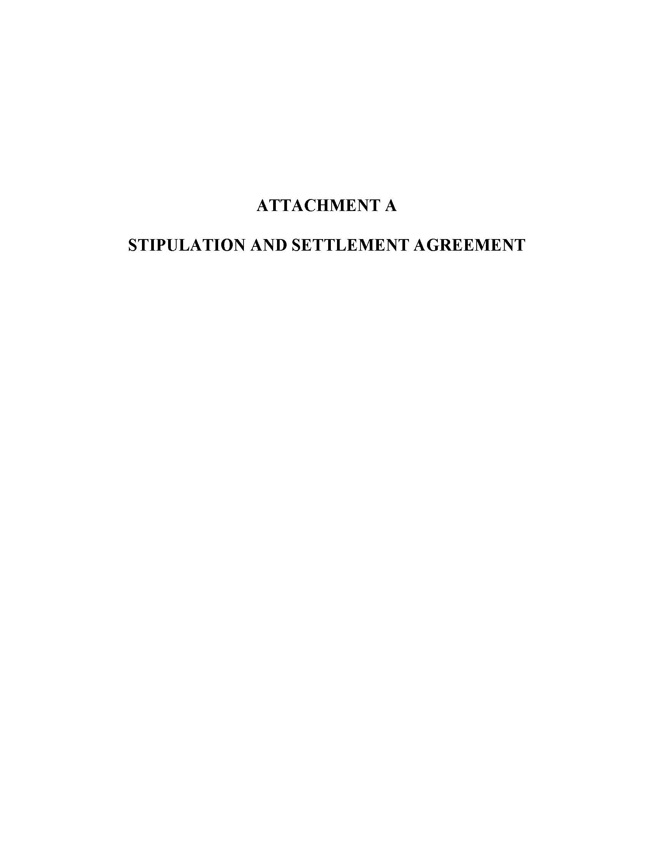

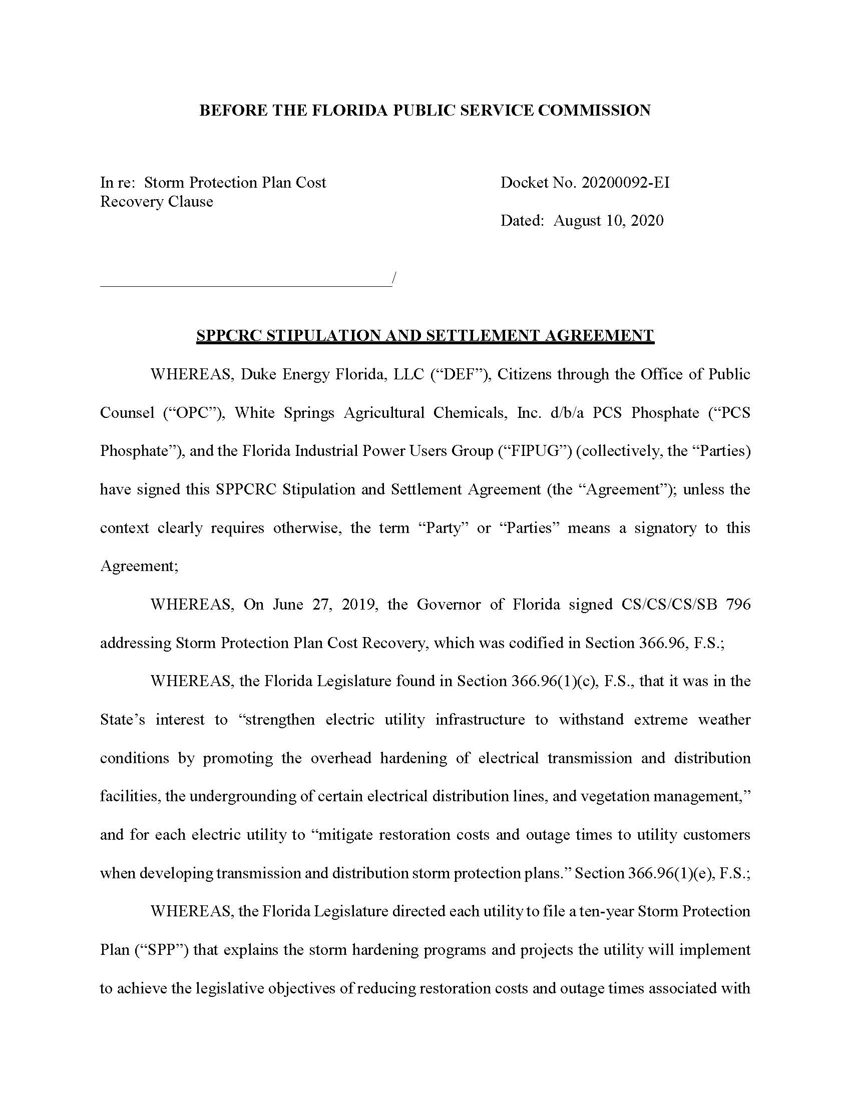

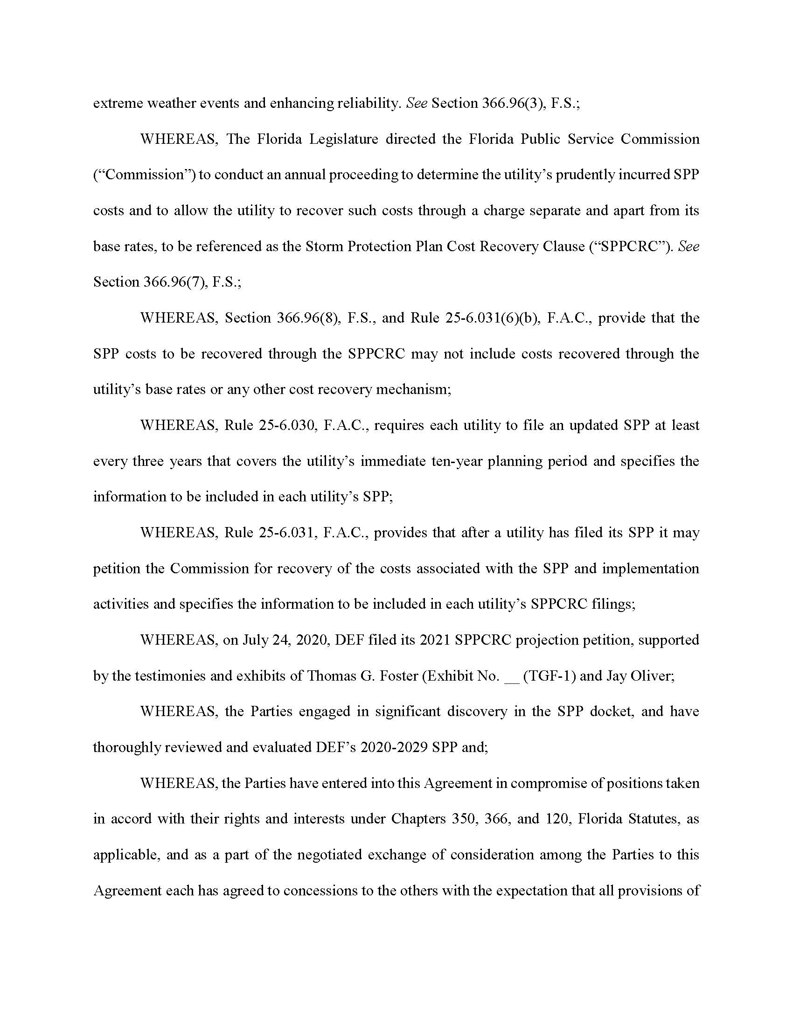

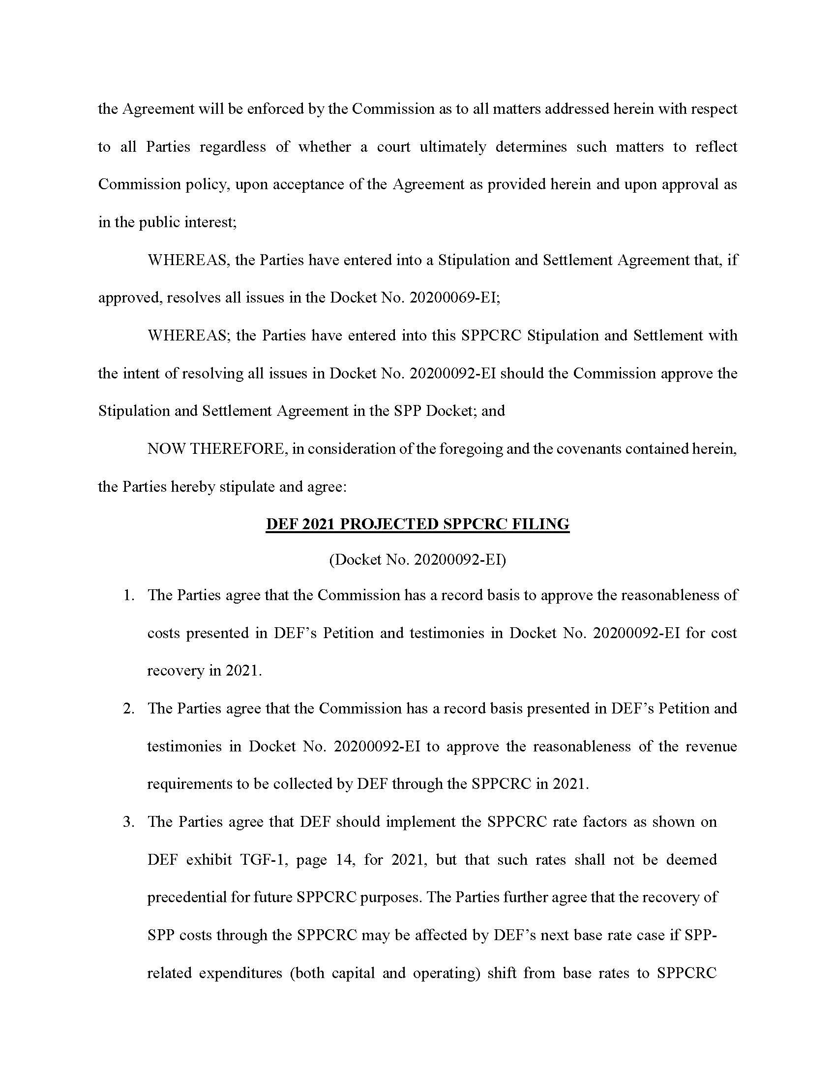

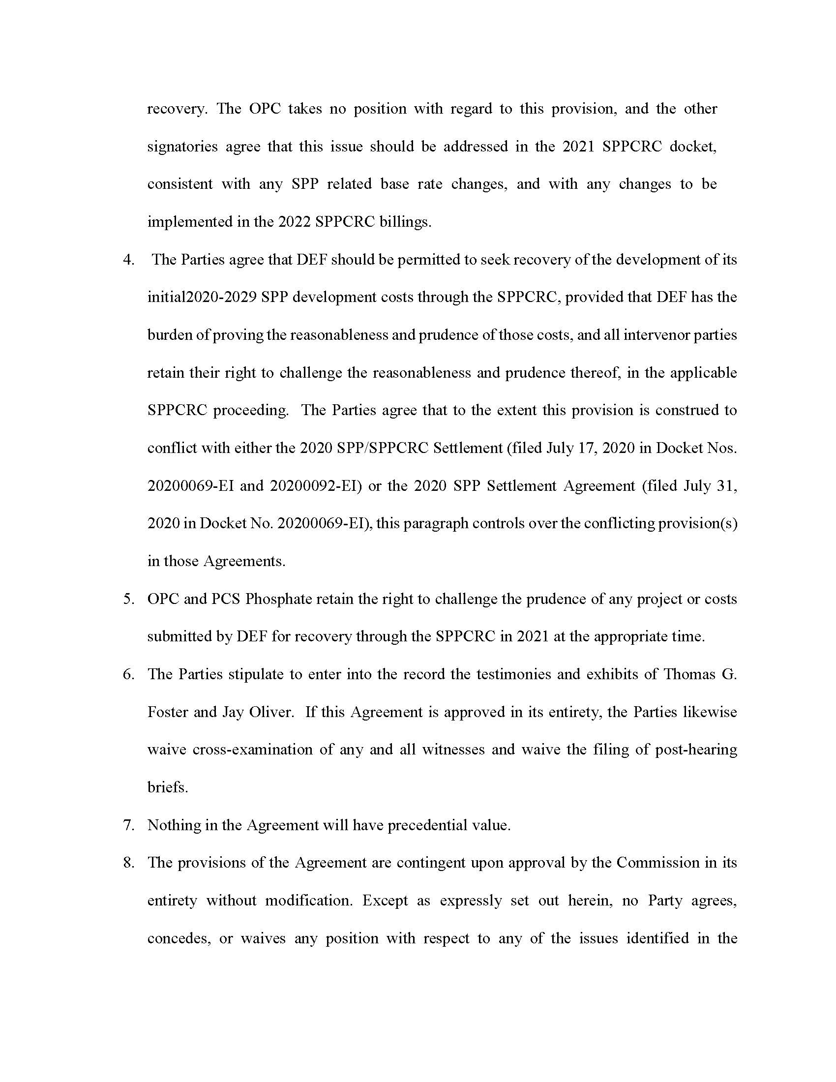

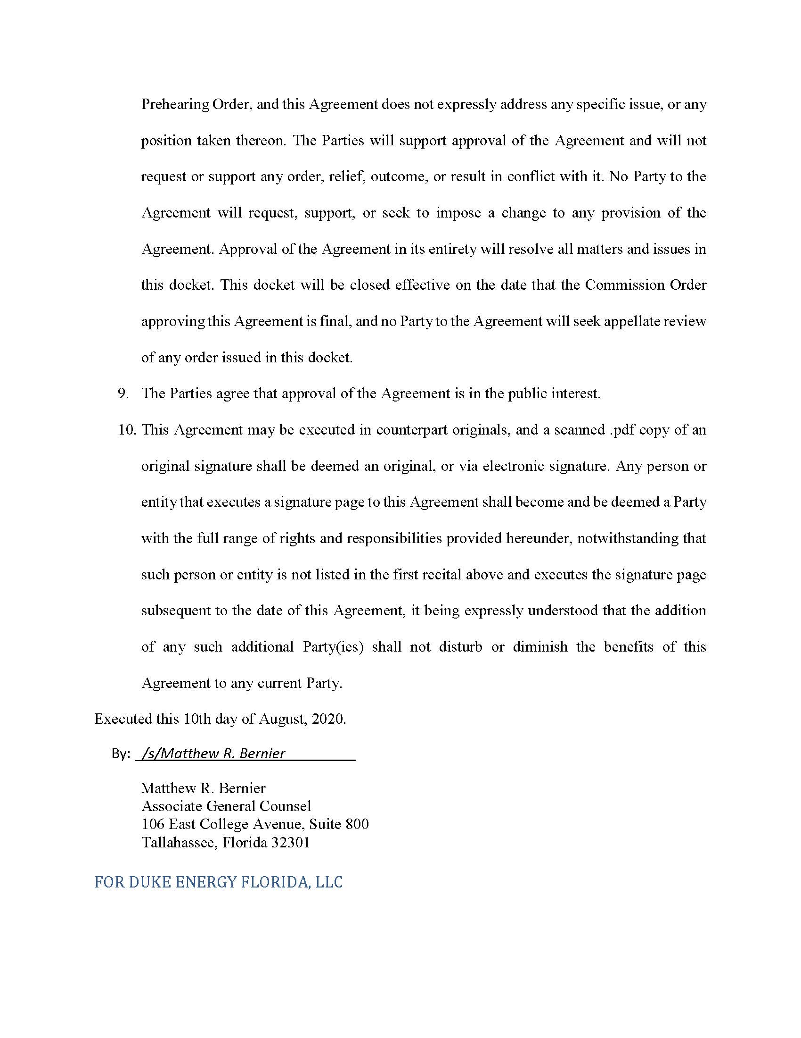

On August 10, 2020, after these Settlement Agreements were executed and filed, the Commission approved a Settlement in Docket No. 20200069-EI. Based on that approval, that docket was closed August 28, 2020. The closing of that docket was a ministerial act and does not affect the substance of the two Agreements, which were both properly considered by the Commission at the public hearing as part of Docket No. 20200092-EI.

