State of Florida |  | Public Service Commission  Capital Circle Office Center ● 2540 Shumard Oak Boulevard  Tallahassee, Florida 32399-0850  -M-E-M-O-R-A-N-D-U-M-
DATE: | November 17, 2020
TO: | Office of Commission Clerk (Teitzman)
FROM: | Office of the General Counsel (Cowdery)  Division of Accounting and Finance (Bulecza-Banks, Cicchetti, Fletcher)  Office of Consumer Assistance and Outreach (DeMello, Thompson)  Division of Economics (Coston, Guffey, Hudson)  Division of Engineering (Ramos)
RE: | Docket No. 20200193-PU – Proposed amendment of Rules 25-6.043, 25-7.039, 25-22.0406, 25-22.0407, 25-30.436, and 25-30.437, and repeal of Rules 25-30.438, 25-30.4385, 25-30.440, and 25-30.443, F.A.C., concerning notice, public information, and minimum filing requirements for electric, gas, water, and wastewater applications for rate increase.
AGENDA: | 12/01/20 – Regular Agenda – Rule Proposal - Interested Persons May Participate
COMMISSIONERS ASSIGNED: |  |  | All Commissioners
PREHEARING OFFICER: |  |  | Fay
RULE STATUS: |  |  | Proposal May Be Deferred
SPECIAL INSTRUCTIONS: |  |  | None

Case Background
This rulemaking was initiated to update electric, gas, water, and wastewater utility rate case filing rules and the notice and public information rules. Notices of Rule Development for these rules appeared in the September 1, 2020 edition of the Florida Administrative Register, Vol. 46, No. 171.
A staff rule development workshop was held on September 21, 2020. All regulated industries were represented at the workshop. Participating were the Office of Public Counsel, Tampa Electric Company, Florida City Gas, Florida Power & Light Company, Peoples Gas System, Gulf Power Company, Utilities, Inc. of Florida (UIF), Pluris Wedgefield, Florida Utility Services 1, LLC, and Investor Owned Utilities, representing twenty-two water and wastewater utilities.
This recommendation addresses whether the Commission should propose the amendment of:
- Rule 25-6.043, F.A.C., Investor-Owned Electric Utility Minimum Filing Requirements; Commission Designee;
- Rule 25-7.039, F.A.C., Natural Gas Utility Minimum Filing Requirements, Commission Designee;
- Rule 25-22.0406, F.A.C., Notice and Public Information on General Rate Increase Requests and Petitions for Limited Proceedings by Electric and Gas Utilities;
- Rule 25-22.0407, F.A.C., Notice of and Public Information for General Rate Increase Requests by Water and Wastewater Utilities;
- Rule 25-30.436, F.A.C., General Information and Instructions Required of Class A and B Water and Wastewater Utilities in an Application for Rate Increase; and
- Rule 25-30.437, F.A.C., Financial, Rate and Engineering Information Required of Class A and B Water and Wastewater Utilities in an Application for Rate Increase.
This recommendation also addresses whether the Commission should propose the repeal of:
- Rule 25-30.438, F.A.C., Information Required in Application for Rate Increase From Utilities with Related Parties;
- Rule 25-30.4385, F.A.C., Additional Rate Information Required in Application for Rate Increase;
- Rule 25-30.440, F.A.C., Additional Engineering Information Required of Class A and B Water and Wastewater Utilities in an Application for Rate Increase; and
- Rule 25-30.443, F.A.C., Minimum Filing Requirements for Class C Water and Wastewater Utilities.
The Commission has jurisdiction pursuant to Sections 120.54, 350.127(2), 366.04, 366.041, 366.05, 366.06, 366.071, 366.076, 367.081, 367.0812, 367.0814, 367.0817, 367.082, 367.083, 367.091, and 367.121, Florida Statutes (F.S.).

Discussion of Issues

Issue 1:
Should the Commission propose the amendment of Rules 25-6.043, 25-7.039, 25-22.0406, 25-22.0407, 25-30.436, and 25-30.437, F.A.C., and the repeal of Rules 25-30.438, 25-30.4385, 25-30.440, and 25-30.443, F.A.C.?

Recommendation:
Yes, the Commission should propose the amendment of Rules 25-6.043, 25-7.039, 25-22.0406, 25-22.0407, 25-30.436, and 25-30.437, F.A.C., and the repeal of Rules 25-30.438, 25-30.4385, 25-30.440, and 25-30.443, F.A.C., as set forth in Attachment A of this recommendation. The Commission should also certify Rules 25-6.043, 25-7.039, 25-22.0406, 25-22.0407, 25-30.436, and 25-30.437, F.A.C., as minor violation rules. (Cowdery, Bulecza-Banks, Fletcher, Cicchetti, Coston, Guffey, Hudson, Ramos, DeMello, Thompson)

Staff Analysis:
All the draft amended rules have been revised with non-substantive changes to improve clarity. Staff’s recommendations on substantive revisions to these rules are discussed below.

Rule 25-6.043, F.A.C., Investor-Owned Electric Utility Minimum Filing Requirements; Commission Designee
Rule 25-6.043(1), F.A.C., requires electric utilities to file 21 copies of rate case filings. E-filing is optional under the Commission Clerk’s e-filing guidelines, but the number of paper copies required by rule must still be filed. Prudent and reasonable copying costs resulting from these rule requirements have historically been included in rate case expense and recovered in rates.
Staff has determined that because rate case documents are accessible on-line, the number of paper copies required by rule may be reduced. The draft amendments to Subsection (1) of Rule 25-6.043, F.A.C., reduce the number of paper copies required to be filed to ten. This change lowers costs to electric utilities by reducing filing and copying costs, while at the same time providing the number of hard copies staff has determined is needed for analyzing rate cases.
Draft Subsection (1) requires the Minimum Filing Requirements (MFRs) to also be provided in Microsoft Excel format with formulas intact and unlocked, and may be provided in media such as a USB flash drive, CL, or DVD, but may not be submitted by e-mail. This format allows staff to review formulas and conduct sensitivity analyses on the filed data. In addition, draft Subsection (1) provides that the paper copies must be provided to the Office of Commission Clerk within seven calendar days of the electronic filing. This amendment was made in response to electric investor-owned utility (IOU) comments that ten paper copies of MFRs would require printing of approximately 100,000 pages of paper, which after printing, need to be assembled into sets, reviewed for quality control, boxed up and transported by truck to the Commission. Staff believes that allowing IOUs this additional time to provide paper copies will provide sufficient time to accomplish these tasks and will not interfere with Commission staff’s review of the MFRs.
The Commission designee under Subsection (2) of Rule 25-6.043, F.A.C., is the person who determines if MFRs have been met. This person is currently the Deputy Executive Director, Technical. Staff recommends changing the Commission designee to the Director of the division that has been assigned as the office of primary responsibility (OPR) for the rate filing. This change is administratively efficient since the OPR will be analyzing the application for completeness.

Rule 25-7.039, F.A.C., Natural Gas Utility Minimum Filing Requirements; Commission Designee
Rule 25-7.039, F.A.C., is very similar to Rule 25-6.043, F.A.C., discussed above, and staff’s recommended amendments are likewise very similar. Rule 25-7.039(1), F.A.C., requires gas utilities to file 20 copies of rate case filings with the Commission. For the same reasons as explained for Rule 25-6.043, F.A.C., above, staff is recommending that the number of paper copies required be reduced to ten; the paper copies be provided to the Office of Commission Clerk within seven calendar days of the electronic filing; and an Excel version of the MFRs be provided.
Section (1)(c) of Rule 25-7.039, F.A.C., requires that each schedule must be cross-referenced to identify related schedules as either supporting schedules and/or recap schedules. Staff is recommending that this section be amended to add language stating that if a schedule requires certain information, a utility may on that schedule reference a different schedule that provides that same information. This amendment results in utilities not being required to file duplicate information and is consistent with current language in the electric utility MFR rule, Rule 25-6.043(2), F.A.C.
As in current Rule 25-6.043, the Commission designee under Subsection (2) of Rule 25-7.039, F.A.C., is currently the Deputy Executive Director, Technical. For the same administrative efficiency reason explained above, staff recommends changing the Commission designee to the Director of the division that has been assigned as the OPR for the rate filing.
Subsection (3) of Rule 25-7.039, F.A.C., states that the Commission may grant a waiver to rule requirements upon a showing that production of the data would be impractical or impose an excessive economic burden upon the company. Staff recommends that Subsection (3) of Rule 25-7.039, F.A.C., be deleted because Section 120.542, F.S., and the Uniform Rules of Procedure, Chapter 28-104, F.A.C., contain the requirements for a waiver from or variance of an agency rule. Subsection (3) is therefore unnecessary and could lead to confusion as to the appropriate test for requesting and obtaining a rule waiver.

Rule 25-22.0406, F.A.C., Notice and Public Information on General Rate Increase Requests and Petitions for Limited Proceedings by Electric and Gas Utilities
Existing Rule 25-22.0406(2)(c), F.A.C., requires MFRs to be placed at the utility’s official headquarters; at a location approved by Commission staff in each municipality in which service hearings were held in the utility’s last general rate case; and at a location in each additional city in which service hearings are to be held in the current rate case. A copy of the synopsis must be placed at those same locations as well as the main county library within or most convenient to the service area. In addition, Rule 25-22.0406, F.A.C., requires utilities to mail a copy of the rate petition to the chief executive officer of the governing body of each municipality and county within the service areas included in the rate request.
Utilities incur significant copying costs to produce sufficient copies for placement at these specified physical locations, the costs of which have historically been passed on to customers in their rates. Further, staff has found that public buildings, such as libraries and community centers, have indicated that they have limited space and prefer not to have the rate case filings in their facilities.
Draft Rule 25-22.0406(2)(a) and (c)2., F.A.C., replaces the requirements for paper copies with the requirement that a gas or electric utility requesting a general rate increase or limited proceeding must establish clearly identifiable links on its website to provide electronic access to the petition, MFRs, and synopsis. The draft rule deletes the requirement that a copy of the petition and MFRs must be mailed to county and municipal executive officers and, instead, requires the utility to provide the link for electronic access to the documents. The effect of these recommended amendments is to save costs incurred in rate cases by eliminating the cost of copying documents and providing them to various physical locations, and, instead, requiring utilities to provide the link for electronic access to the documents.

Rule 25-22.0407, F.A.C., Notice of and Public Information for General Rate Increase Requests by Water and Wastewater Utilities.
Similar to Rule 25-22.0406, F.A.C., for electric and gas utilities, Rule 25-22.0407, F.A.C., requires water and wastewater utilities to place paper copies of the rate petition, MFRs, and synopsis at the utility’s official headquarters, business offices in the service area, and main county library or other appropriate location convenient to the service area. In addition, Rule 25-22.0407, F.A.C., requires water and wastewater utilities to mail a copy of the rate petition to the chief executive officer of the governing body of each municipality and county within the service areas included in the rate request.
As with draft Rule 25-22.0406, F.A.C., the rule amendments delete the requirement that a copy of the petition, MFRs, and synopsis must be mailed to county and municipal executive officers. Instead, draft Rule 25-22.0407(2) requires the utility to notify the appropriate government officer that the utility has petitioned for a general rate increase, to clearly identify the Commission-assigned docket number, and to state that a copy of the petition and MFRs can be accessed on the Commission’s website. In addition, draft Rule 25-22.0407(3)(a) requires the utility to notify the appropriate governmental officer that the rate case synopsis can be accessed on the Commission’s website.
Draft Rule 25-22.0407(3)(b)5., F.A.C., replaces the requirements to place paper copies at physical locations with the requirement that the water or wastewater utility rate case synopsis include a statement that the MFRs can be accessed on the Commission’s website. Draft Rule 25-22.0407(4)(b)3., F.A.C., requires the initial customer notice to include a statement that the MFRs, petition, and rate case synopsis are available on the Commission’s website. Draft rule paragraph (8)(c)5. requires the customer meeting notice to include the website address where the staff report of its initial analysis of the case is available.
The effect of these recommended amendments is to save costs incurred in rate cases by eliminating the cost of copying documents and providing them to various physical locations. Instead, utilities would be required to provide clear information that these documents are available for review on-line.

Water and Wastewater Utility Applications for Rate Increase
Staff examined six rules containing requirements for filing water and wastewater utility rate increase applications for Class A, B, and C utilities. Staff is recommending that two obsolete rules be repealed and that the requirements of the remaining four rules be updated, clarified, and consolidated into two rules, resulting in the repeal of two additional rules. In addition, staff is recommending changes to two schedules in the Class A, B, and C water and wastewater utility MFR forms as well as changing the word “sewer” to “wastewater” in all three forms. These changes are discussed below.

Rule 25-30.436, F.A.C., General Information and Instructions Required of Class A and B Water and Wastewater Utilities in an Application for Rate Increase
For the same reasons discussed above for gas and electric utility rate case filings, staff is recommending that Rule 25-30.436(4), F.A.C., be amended to require e-filing and to reduce the number of copies of a water or wastewater rate case application, testimony and exhibits, and corrections, updates or other changes. The number of copies required would be reduced from 16 or 20 copies, depending on the document identified, to ten paper copies. The draft amendments also require that an electronic copy be served on each party on the date the application is e-filed.
Staff received comments from UIF and Pluris Wedgfield that although reducing the number of MFR paper copies to ten is an improvement, the draft rule still results in a substantial unnecessary expense for copies, binders and tabs, the expense of which is ultimately borne by the customers. Staff believes that ten paper copies of water and wastewater MFRs is necessary for the same reasons as discussed above for electric and gas MFRs. This change lowers costs to water and wastewater utilities by reducing filing and copying costs, while at the same time providing the number of paper copies staff has determined is needed for analyzing rate cases.
In addition, staff is recommending that this rule’s title be changed to reflect that it applies to all water and wastewater utilities, instead of being limited to Class A and B utilities. This is because Rule 25-30.443(1), F.A.C., Minimum Filing Requirements for Class C Water and Wastewater Utilities, specifically states that Class C utilities must file the information required in Rule 25-30.436, F.A.C. Consistent with this change, since Rule 25-30.436, F.A.C., applies to Class C utilities, staff recommends that draft subsections (4), (5)(g) and (7) of Rule 25-30.436, F.A.C., be amended to reference the Commission MFR Form for Class C utilities. These changes allow a Class C utility to refer to one rule instead of two concerning general information required in an application for a rate increase.
The language in draft paragraph (1)(f) is changed from requiring an affidavit of an officer of the utility that the utility will comply with Rule 25-22.0407, F.A.C., to requiring a statement to that effect signed by an officer of the utility. This change is being made because in order to require the signing of an affidavit, which is made under oath, an agency must have specific legislative authority. Staff is making the recommended change because there is no statute giving the Commission authority to require an affidavit as set out in paragraph (1)(f).
Draft paragraph (5)(h) of Rule 25-30.436, F.A.C., contains the filing requirement concerning land recorded on the utility’s books since rate base was last established. Staff recommends that this language be amended for clarity and consistency with identical language found in the water and wastewater certification and transfer rules, Rules 25-30.033(1)(m), 25-30.034(1)(m), 25-30.035(11), 25-30.036(2)(e), and 25-30.037(2)(s), F.A.C.
Draft section (6) of Rule 25-30.436, F.A.C., states that the Commission designee who determines if minimum filing requirements have been met is the Deputy Executive Director, Technical. Just as staff recommended for Rules 25-6.043 and 25-7.039, F.A.C., above, staff recommends that for administrative efficiency, the Commission designee should be changed to the Director of the division that has been assigned as the OPR for the rate filing.
Draft subsection (7) of the rule states that if the utility cannot file a breakdown of rate case expense within 60 days following the final order, it may request an extension for good cause shown. The rule does not state what would constitute good cause. Staff recommends adding clarity to this subsection by requiring the utility to show good cause such as financial hardship, severe illness, or significant weather events such as hurricanes, but that good cause does not include reasons such as management oversight or vacation time. This language is consistent with the good cause requirements for a utility to obtain an extension of time for filing its regulatory assessment fees under Rule 25-30.120, F.A.C., Form PSC/AIT 124 (12/11).

Rule 25-30.437, F.A.C., Financial, Rate and Engineering Information Required of Class A and B Water and Wastewater Utilities in an Application for Rate Increase
Draft Rule 25-30.437, F.A.C., currently applies only to Class A and B water and wastewater utilities. Rule 25-30.443 for Class C utilities contains essentially the same requirements as Rule 25-30.437, F.A.C. Instead of having two rules with the same requirements, staff is recommending that the requirements in Rule 25-30.443 for Class C utilities be merged into Rule 25-30.437, F.A.C., in renumbered Subsections (1), (2), (4), (5), and (6) The result would be that Rule 25-30.437, F.A.C., would apply to Class A, B, and C utilities, instead of having two separate rules containing substantially the same requirements. The effect is administrative efficiency and clarity that the same requirements apply to Class A, B, and C utilities.
Staff recommends that Subsection (1) of Rule 25-30.437, F.A.C., be amended to state that the forms referenced in the rule are available on the Commission’s website, instead of by contacting the Director, Division of Accounting and Finance. In addition, rules accessed on-line will contain a direct link to the forms as filed with the Department of State. This amendment results in administrative efficiency.
New draft Subsection (3) of Rule 25-30.437, F.A.C., identifies the engineering information required for Class A, B, and C water and wastewater utilities in applications for rate cases. Currently, Rule 25-30.440, F.A.C., contains additional engineering information required by Class A and B Water and Wastewater utilities in an application for rate increase. Rule 25-30.443, F.A.C., in turn, requires Class C utilities to provide the engineering information required by Rule 25-30.440, F.A.C. To simplify these rule requirements, staff recommends that the information required by Rule 25-30.440 be moved to Rule 25-30.437 and incorporated in new Subsection (3) so that there will be one rule containing the requirements for engineering information required by Class A, B, and C water and wastewater utilities. The result will be that Rule 25-30.440, F.A.C., would be repealed as unnecessary.
New draft Subsection (3) to Rule 25-30.437, F.A.C., retains the current requirement that a utility must provide the Office of Commission Clerk two paper copies of the additional engineering MFRs, with the exception of the detailed map, of which only one copy is required. Staff received comments that two paper copies is excessive and results in unnecessary cost ultimately borne by customers, and that, instead electronic files should be required along with the proposed required Excel file. It was pointed out that in a recent Utilities Inc., Florida rate case, this requirement amounted to over 16,000 pages. However, staff believes the current requirement of two paper copies is reasonable and should be retained due to the detailed nature of the information provided in the additional engineering MFRs. Given the voluminous nature of these filings, multiple staff are usually assigned to analyze the data, and having only one or no paper copies of the documents may hinder staff.

The MFR Forms for Class A, B, and C Water and Wastewater Utilities
The MFR forms for Class A, B, and C water and wastewater utilities are incorporated by reference in Rule 25-30.437, F.A.C. These forms are renumbered in draft Subsection (1) of that rule to follow current Commission form numbering format. The new form numbers would be as follows: Form PSC 1028 for Class A utilities, Form PSC 1029 for Class B utilities, and Form PSC 1030 for Class C utilities. In addition, the term “sewer” in all forms is changed to “wastewater.” Staff is also recommending a substantive change to the form requirements for certain schedules as explained below and shown in Attachment B.

MFR Form Schedule E-14 for Class A and B water and wastewater utilities and MFR Form Schedule E-6 for Class C utilities are the billing analysis schedules. These schedules are amended in draft PSC Forms 1028, 1029, and 1030. The Schedule E-14 and E-6 billing analysis schedules currently require utilities to provide a billing analysis for each class of service. The schedules also require that if a rate change occurred during the test year, a separate billing analysis must be provided which coincides with each period.

Staff is recommending that Schedules E-14 and E-6 be amended to require a utility to provide the billing analysis for only the residential class, including residential irrigation. This is because, in terms of evaluating rate structures, staff uses the residential billing analysis for purposes of designing tiers for conservation efforts. For all other classes of service staff does not need the level of detail provided in the billing analysis. Staff is also recommending that these schedules be amended to remove the requirement of providing a billing analysis for every rate change occurring during the test year because it is not necessary for staff’s examination of revenues for the test year period. These changes result in administrative efficiency and reduce the volume of the Schedule E-14 or E-6 filing for the utility.

Schedule E-2 of the MFR Forms for Class A, B, and C water and wastewater utilities is the revenue schedule at present and proposed rates. Schedule E-2 requires utilities to provide a calculation of revenues at present and proposed rates using the billing analysis for all classes of service. Staff recommends that this language be amended to require use of the billing analysis for only the residential service class and bills and consumption for all other classes of service. This change is consistent with the changes being recommended for Schedules E-14 and E-6, as discussed above.

In addition, the Explanation section on Schedule E-2 provides that if a rate change occurred during the test year, a revenue calculation must be made for each period. For the same reasons that staff is recommending amendments to Schedules E-14 and E-6, revenue calculations for every rate change occurring during the test year are not necessary for staff’s examination of revenues for the test year period. These amendments result in administrative efficiency.

Rule 25-30.438, F.A.C., Information Required in Application for Rate Increase From Utilities with Related Parties
Rule 25-30.438, F.A.C., requires water and wastewater utilities to submit copies of the developer’s offering statements as filed with the Division of Land Sales, Department of Business Regulation. This rule is obsolete and should be repealed. In 1986, when this rule was adopted, Section 498.037(14)(b), F.S., required developers to file public offering statements with the Division of Land Sales. However, this statute was repealed in 2008, and since that time, developers have not been required by statute to file offering statements with the Division of Land Sales, a division which no longer exists.
Further, staff does not believe that a developer’s offering statement is needed in processing a rate application. If the premise of the requirement was to scrutinize related party activity, staff conducts a thorough review of related party transactions by reviewing the rate filing and following-up as necessary with data requests. The Class A and B utilities annual report filed pursuant to Rule 25-30.110(4)(a), F.A.C., includes schedules requiring information on business contract and transactions with affiliates and related parties. For these reasons, staff recommends that the Commission repeal Rule 25-30.438, F.A.C., as obsolete and unnecessary.

Rule 25-30.4385, F.A.C., Additional Rate Information Required in Application for Rate Increases
Rule 25-30.4385, F.A.C., states that the utility shall file an original and three copies of all revised tariff sheets for each service classification in which any change is proposed, except those tariff sheets in which the only change is to the service rates. Staff prepares water and wastewater tariff sheets in all water and wastewater rate cases and does not require utilities to file revised tariff sheets. The reason staff does not require these tariff sheets to be filed is because all water and wastewater tariffs are maintained electronically. In order to maintain formatting standards and consistency of tariffs across all utility classes, once the utility notices the customers of the Commission-approved rates and charges, staff sends stamped, approved tariffs to the utility. For this reason, staff recommends that this rule be repealed as obsolete and unnecessary.

Rule 25-30.440, F.A.C., Additional Engineering Information Required of Class A and B Water and Wastewater Utilities in an Application for Rate Increase
For the reasons discussed above, staff recommends that the requirements of this rule be merged into Rule 25-30.437, F.A.C., Financial, Rate and Engineering Information Required of Class A and B Water and Wastewater Utilities in an Application for Rate Increase. For this reason, staff recommends that Rule 25-30.440, F.A.C., be repealed as unnecessary.

Rule 25-30.443, F.A.C., Minimum Filing Requirements for Class C Water and Wastewater Utilities
If staff’s recommendations discussed above are approved by the Commission, Rule 25-30.443, F.A.C., should be repealed as unnecessary. Subsection (1) states that Class C utilities must submit a rate application containing the information required by Rules 25-30.436, 25-30.4385, 25-30.440, 25-30.4415, and 25-30.442, F.A.C. Staff has recommended above that Rule 25-30.436, F.A.C., be amended to specifically apply by its terms to Class C utilities; that Rule 25-30.4385, F.A.C., be repealed as obsolete; and that Rule 25-30.440, F.A.C., be merged into 25-30.437, F.A.C., and therefore repealed. As a result of these amendments, there would be no reason for these rules to be referenced in Rule 25-30.443, F.A.C. In addition, Rule 25-30.4415, Additional Information Required in Application for Rate Increase by Utilities Seeking to Recover the Cost of Investment in the Public Interest, and Rule 25-30.442, Duplicate Information, F.A.C., by their terms apply to Class C utilities, and for that reason, do not need to be referenced in Rule 25-30.443, F.A.C. Subsection (1) would therefore be unnecessary.
Also as discussed above, staff recommends that the requirements in Subsections (2) – (5) of Rule 25-30.443, F.A.C., be merged into Rules 25-30.436 and 25-30.437, F.A.C. As a result of staff’s suggested amendments, Rule 25-30.443, F.A.C., should be repealed as unnecessary.

Minor Violation Rules Certification
Pursuant to Section 120.695, F.S., the agency head must certify for each rule filed for adoption whether any part of the rule is designated as a rule the violation of which would be a minor violation. Rules 25-6.043, 25-7.039, 25-22.0406, 25-22.0407, 25-30.436, 25-30.437, 25-30.438, 25-30.4385, 25-30.440, and 25-30.443, F.A.C., are currently listed on the Commission’s website as rules for which a violation would be minor because violation of the rules would not result in economic or physical harm to a person or have an adverse effect on the public health, safety, or welfare or create a significant threat of such harm.
If Rules 25-30.438, 25-30.4385, 25-30.440, and 25-30.443, F.A.C., are repealed as recommended by staff, these rules will be deleted from the Commission’s website listing of minor violation rules after the repeals are certified by the Department of State. The amendments to Rules 25-6.043, 25-7.039, 25-22.0406, 25-22.0407, 25-30.436, and 25-30.437, F.A.C., would not change their status as minor violation rules. Thus, staff recommends that the Commission certify Rules 25-6.043, 25-7.039, 25-22.0406, 25-22.0407, 25-30.436, and 25-30.437, F.A.C., as minor violation rules.

Statement of Estimated Regulatory Costs
Pursuant to Section 120.54(3)(b), F.S., agencies are encouraged to prepare a statement of estimated regulatory costs (SERC) before the adoption, amendment, or repeal of any rule. The SERC is appended as Attachment C to this recommendation.
The SERC concludes that the rule amendments and repeals will not likely directly or indirectly increase regulatory costs in excess of $200,000 in the aggregate in Florida within one year after implementation. Further, the SERC economic analysis concludes that the rule amendments and repeals will not likely have an adverse impact on economic growth, private sector job creation or employment, private sector investment, business competitiveness, productivity, or innovation in excess of $1 million in the aggregate within five years of implementation. Thus, the rules do not require legislative ratification pursuant to Section 120.541(3), F.S.
In addition, the SERC states that the rule amendments and repeals will not have an adverse impact on small business and will have no impact on small cities or counties. The SERC also concludes that the recommended amendments and repeals will not result in transactional costs to utilities required to comply with the rule, and, instead, will result in cost reductions and administrative efficiencies. No regulatory alternatives were submitted pursuant to paragraph 120.541(1)(a), F.S. None of the impact/cost criteria established in paragraph 120.541(2)(a), F.S., will be exceeded as a result of the recommended amendments to Rules 25-6.043, 25-7.039, 25-22.0406, 25-22.0407, 25-30.436, and 25-30.437, F.A.C., and recommended repeal of Rules 25-30.438, 25-30.4385, 25-30.440, and 25-30.443, F.A.C.

Conclusion
Staff recommends that the Commission propose the amendment of Rules 25-6.043, 25-7.039, 25-22.0406, 25-22.0407, 25-30.436, and 25-30.437, F.A.C., and the repeal of Rules 25-30.438, 25-30.4385, 25-30.440, and 25-30.443, F.A.C., as set forth in Attachment A. The Commission should also certify Rules 25-6.043, 25-7.039, 25-22.0406, 25-22.0407, 25-30.436, and 25-30.437, F.A.C., as minor violation rules.

Issue 2:
Should this docket be closed?

Recommendation:
Yes. If no requests for hearing, information regarding the SERC, proposals for a lower cost regulatory alternative, or JAPC comments are filed, the rules should be filed with the Department of State, and the docket should be closed. (Cowdery)

Staff Analysis:
If no requests for hearing, information regarding the SERC, proposals for a lower cost regulatory alternative, or JAPC comments are filed, the rules should be filed with the Department of State, and the docket should be closed.

25-6.043 Investor-Owned Electric Utility Petition for Rate Increase Minimum Filing Requirements; Commission Designee.
(1) General Filing Instructions.
(a) The petition under Sections 366.06 and 366.071, F.S., for adjustment of rates and must include or be accompanied by:
1. The information required by Commission Form PSC 1026 (12/20) PSC/AFD/011-E (2/04), entitled “Minimum Filing Requirements for Investor-Owned Electric Utilities,” which is incorporated into this rule by reference, and is available at [hyperlink]. The form may be obtained from the Commission’s Division of Accounting and Finance. This form is also available on the Commission’s website, www.floridapsc.com.
2. The exact name of the applicant and the address of the applicant’s principal place of business.
3. Prepared Copies of prepared direct testimony and exhibits for each witness testifying on behalf of the utility Company. Each witness’s prefiled testimony and exhibits shall be on numbered pages and all exhibits shall be attached to the witness’s testimony.
(b) In compiling the required schedules, a utility must company shall follow the policies, procedures and guidelines prescribed by the Commission in relevant rules and in the utility’s company’s last rate case or in a more recent rate case involving a comparable utility. These schedules shall be identified appropriately (e.g., Schedule B-1 would be designated Company Schedule B-1 – Company basis).
(c) Each schedule must shall be cross-referenced to identify related schedules as either supporting schedules or recap schedules. If a schedule requires certain information, a utility may on that schedule reference a different schedule that provides that same information.
(d) The dimensions of each page, regardless of format, must be 8 ½ by 11 inches, and each page must be numbered. Each page of the filing shall be numbered on 8 1/2 × 11-inch paper. Each witness’ prefiled testimony and exhibits shall be on numbered pages and all exhibits shall be attached to the proponent’s testimony.
(e) Except for handwritten official company records, all data in the petition, testimony, exhibits and minimum filing requirements must shall be typed.
(f) Each schedule must shall indicate the name of the witness responsible for its presentation.
(g) All schedules involving investment data must shall be completed on an average investment basis. Unless a specific schedule requests otherwise, average is defined as the average of 13 monthly balances.
(h) The petition and information required by Subsection (1) of this rule must be e-filed by the utility Twenty-one copies of the filing, consisting of the petition and its supporting attachments, testimony, and exhibits, shall be filed with the Office of Commission Clerk. Ten paper copies of the filing, clearly labeled “COPY,” and Commission Form PSC 1026 (12/20) in Microsoft Excel format with formulas intact and unlocked, must be provided to the Office of Commission Clerk within seven calendar days of the electronic filing. Excel files may be provided in media such as a USB flash drive, CD, or DVD, but may not be submitted by e-mail.
(i) Any proposed Whenever the company proposes any corrections, updates or other changes to the original filing must be e-filed by the utility originally filed data, 21 copies shall be filed with the Office of Commission Clerk., Ten paper copies of the proposed corrections, updates or other changes, clearly labeled “COPY,” and any schedules in Commission Form PSC 1026 (12/20) that have been changed must be provided to the Office of Commission Clerk within seven calendar days of the electronic filing. Any schedules in Commission Form PSC 1026 (12/20) that have been changed must be provided in Microsoft Excel format with formulas intact and unlocked. Excel files may be provided in media such as a USB flash drive, CD, or DVD, but may not be submitted by e-mail. On the same day as the e-filing, the utility must serve an electronic copy of the filing on each party. with copies also served on all parties at the same time.
(2) The Director of the division that has been assigned primary responsibility for the filing is Commission Designee: Division of Accounting and Finance-shall be the designee of the Commission designee for purposes of determining whether the utility has met the minimum filing requirements imposed by this rule. In making this determination, the Director shall consider whether information that would have been provided in a particular schedule required by this rule has been provided to the same degree of detail in another required schedule that the utility incorporates by reference.
Rulemaking Authority 350.127(2),366.05(1), (2), 366.06(1), (3) FS. Law Implemented 366.04(2)(f), 366.06(1), (2), (3), (4), 366.071 FS. History–New 5-27-81, Formerly 25-6.43, Amended 7-5-90, 1-31-00, 2-12-04, _____________.

25-7.039 Natural Gas Utility Petition for Rate Increase Minimum Filing Requirements; Commission Designee.
(1) General Filing Instructions.
(a) The petition under Sections 366.06 and 366.071, F.S., for an adjustment of rates must include or be accompanied by:
1. The information required by Commission Form PSC 1027 (12/20) PSC/AFD 10-G (11/89), entitled “Investor Owned Natural Gas Utilities Minimum Filing Requirements,” which is incorporated into this rule by reference, and is available at [hyperlink]_. The form may be obtained from the Commission’s Division of Accounting and Finance. This form is also available on the Commission’s website, www.floridapsc.com.
2. The exact name of the applicant and the address of the applicant’s principal place of business.
3.Prepared Copies of prepared direct testimony and exhibits for each witness testifying on behalf of the utility company. Each witness’s prefiled testimony and exhibits shall be on numbered pages and all exhibits shall be attached to the witness’s testimony.
(b) In compiling the required schedules, a utility must company shall follow the policies, procedures and guidelines prescribed by the Commission in relevant rules and in the utility’s company’s last rate case or in a more recent rate case involving a comparable utility. These schedules shall be identified appropriately (e.g. Schedule B-1 would be designated Company Schedule B-1 – Company basis).
(c) Each schedule must shall be cross-referenced to identify related schedules as either supporting schedules and/or recap schedules. If a schedule requires certain information, a utility may on that schedule reference a different schedule that provides that same information.
(d) The dimensions of each page, regardless of format, must be 8 ½ by 11 inches, and each page must be numbered. Each page of the filing shall be numbered on 8 1/2'' × 11'' inch paper. Each witness’ prefiled testimony and exhibits shall be on numbered pages and all exhibits shall be attached to the proponent’s testimony.
(e) Except for handwritten official utility company records, all data in the petition, testimony, exhibits and minimum filing requirements must shall be typed.
(f) Each schedule must shall indicate the name of the witness responsible for its presentation.
(g) All schedules involving investment data must shall be completed on an average investment basis. Unless a specific schedule requests otherwise, average is defined as the average of thirteen (13) monthly balances.
(h) The Twenty (20) copies of the filing, consisting of the petition and its supporting attachments, testimony, and exhibits, must be e-filed by the utility shall be filed with the Office of Commission Clerk. Ten paper copies of the filing, clearly labeled “COPY,” and Commission Form PSC 1027 (12/20) in Microsoft Excel format with formulas intact and unlocked, must be provided to the Office of Commission Clerk within seven calendar days of the electronic filing. Excel files may be provided in media such as a USB flash drive, CD, or DVD, but may not be submitted by e-mail.
(i) Any proposed Whenever the company proposes any corrections, updates or other changes to the original filing must by e-filed by the utility originally filed data, twenty (20) copies shall be filed with the Office of Commission Clerk., Ten paper copies of the proposed corrections, updates or other changes, clearly labeled “COPY,” and any schedules in Commission Form PSC 1027 (12/20) that have been changed must be provided to the Office of Commission Clerk within seven calendar days of the electronic filing. Any schedules in Commission Form PSC 1027 (12/20) that have been changed must be provided in Microsoft Excel format with formulas intact and unlocked. Excel files may be provided in media such as a USB flash drive, CD, or DVD, but may not be submitted by e-mail. On the same day as the e-filing, the utility must serve an electronic copy of the filing on each party. with copies also served on all parties at the same time.
(2) The Director of the division that has been assigned the primary responsibility for the filing is Commission Designee. The Deputy Executive Director, Technical shall be the designee of the Commission designee for purposes of determining whether the utility has met the minimum filing requirements imposed by this rule.
(3) Waiver of MFR Requirements. The Commission may grant a waiver with respect to specific data required by this rule upon a showing that production of the data would be impractical or impose an excessive economic burden upon the company.
Rulemaking Authority 350.127(2), 366.05(1), 366.06 (3) FS. Law Implemented 366.06(3), 366.071 FS. History–New 5-27-81, Formerly 25-7.39, Amended 11-21-89, ____________.

25-22.0406 Notice and Public Information on General Rate Increase Requests and Petitions for Limited Proceedings by Electric and Gas Utilities.
(1) The provisions of this rule apply shall be applicable to all requests for general rate increases and to all limited proceedings filed by electric and gas utilities pursuant to Rules 25-6.0431 and 25-7.0391, F.A.C.
(2) The following noticing procedures shall apply to requests for a general rate increase:
(a) The utility must establish a clearly identifiable link on the utility’s website to provide electronic access to the utility’s petition and Minimum Filing Requirements (MFRs). The utility must provide this link shall mail a copy of the petition to the chief executive officer of the governing body of each municipality and county within the service area affected.
(b) The utility must shall establish a clearly identifiable link on the utility’s website to provide the address on the Commission’s website that provides electronic access to all documents filed in the rate case.
(c) Location of Minimum Filing Requirements.
1. Within 15 days after it has been notified by the Commission that the Minimum Filing Requirements (MFRs) have been met, the utility shall place a copy of the MFRs at its official headquarters and at a location approved by the Commission staff in each municipality in which service hearings were held in the last general rate case of the utility.
2. Within 15 days after the time schedule has been posted on the Commission’s website, copies of the MFRs shall be placed in a location approved by Commission staff in each additional city in which service hearings are to be held in the current rate case.
3. In addition to the locations listed above, if the Commission staff determines that the locations listed above will not provide adequate access, the Commission staff will require that copies of the MFRs be placed at other specified locations.
4. Copies of the MFRs shall be available for public inspection during the regular business hours of the location hosting the MFRs and through a link on the utility’s website.
(c)(d) Rate Case Synopsis.
1. Within 15 days after the time schedule for the case has been posted to the Commission’s website, the utility must shall prepare and submit to the Commission staff for approval a synopsis of the rate request. The synopsis must shall include:
a. A summary of the section of the MFRs showing a comparison of the present and proposed rates for major services;
b. A statement of the anticipated major issues involved in the rate case;
c. A copy of the executive summary filed with the MFRs;
d. A description of the ratemaking process and the time schedule established for the rate case; and
e. The website addresses locations at which complete MFRs are available.
2. Within 7 days following approval of the synopsis, the utility must establish a clearly identifiable link on its website to provide electronic access to the synopsis and must provide this link copies of the synopsis shall be distributed to the same locations as required for the MFRs, to the main county library within or most convenient to the service area, and to the chief executive officer of each county and municipality within the service area affected.
(d)(e) Within 15 days after the rate case time schedule has been posted on the Commission’s website, the utility must shall prepare and submit a customer notice to Commission staff for approval. The customer notice must shall include:
1. A statement that the utility has applied for a rate increase and the general reasons for the request;
2. The locations at which copies of the MFRs and synopsis are available, including the link on the utility’s website;
3. The time schedule established for the case, and the dates, times and locations of any hearings that have been scheduled;
4. A comparison of current rates and service charges and the proposed new rates and service charges;
5. The docket number assigned to the petition by the Commission’s Office of Commission Clerk;
6. A statement that written comments regarding the proposed changes in rates and charges should be addressed to the Office of Commission Clerk, 2540 Shumard Oak Boulevard, Tallahassee, Florida 32399-0850, and that such correspondence should include the docket number; and
7. A statement that comments regarding service may be made to the Commission’s Office of Consumer Assistance and Outreach at this toll free number: 1(800) 342-3552.
(e)(f) The utility must shall begin sending the notice to customers within 30 days after it has been approved by Commission Staff.
(3) The following noticing procedures shall apply to a petition for a limited proceeding filed pursuant to Rules 25-6.0431 and 25-7.0391, F.A.C.:
(a) The utility must shall establish a clearly identifiable link on the utility’s website to the address on the Commission’s website that provides electronic access to all documents filed in the limited proceeding.
(b) Within 15 days after the time schedule for the limited proceeding has been posted to the Commission’s website, the utility must shall prepare and submit a customer notice to the Commission staff for approval. The customer notice must shall contain:
1. A statement that the utility has requested a change in rates, a statement of the amount requested, and the general reason for the request;
2. A statement of where and when the petition and supporting documentation are available for public inspection, including the link on the utility’s website;
3. A comparison of the current and proposed rates;
4. The utility’s address, telephone number, and website address;
5. The docket number assigned to the petition by the Commission’s Office of Commission Clerk;
6. A statement that written comments regarding the proposed changes in rates and charges should be addressed to the Office of Commission Clerk, 2540 Shumard Oak Boulevard, Tallahassee, Florida 32399-0850, and that such correspondence should include the docket number; and
7. A statement that comments regarding service may be made to the Commission’s Office of Consumer Assistance and Outreach at this toll free number: 1(800) 342-3552.
(c) The utility must shall begin sending the notice to customers within 30 days after it has been approved by staff.
(4) All customer notices prepared pursuant to this rule must shall be sent to the customer’s address of record at the time the notice is issued, in the manner in which the customer typically receives the monthly bill, whether electronically or via U.S. mail.
(5) All customer notices regarding the locations and time of any service hearings or customer meetings must shall be sent to the customer no less than 10 days, or more than 45 days, prior to the first service hearing or customer meeting.
(6) At least 7 days and not more than 20 days prior to any service hearing or customer meeting, the utility must shall have published in a newspaper of general circulation in the area in which the hearing or customer meeting is to be held a display advertisement stating the date, time, location and purpose of the hearing or customer meeting. The advertisement must shall be approved by the Commission staff prior to publication.
(7) When the Commission issues proposed agency action and a hearing is subsequently held, the utility must shall give written notice of the hearing to its customers at least 14 days in advance of the hearing. This notice must shall be approved by the Commission staff prior to distribution.
(8) After the Commission’s issuance of an order granting or denying a rate change, the utility must shall give notice to its customers of the order and the revised rates. The notice must shall be approved in advance by the Commission or its staff and transmitted to the customers with the first bill containing the new rates.
Rulemaking Authority 350.127(2), 366.05, 366.06(1) FS. Law Implemented 366.03, 366.041(1), 366.05(1), 366.06(1), 366.076(1) FS. History–New 9-27-83, Formerly 25-22.406, Amended 5-27-93, 5-3-99, 10-8-13, ________.

25-22.0407 Notice of and Public Information for General Rate Increase Requests by Water and Wastewater Utilities.
(1) This rule applies to all requests for general rate increases made by water and wastewater utilities.
(2) Upon filing a petition for a general rate increase, the utility must notify shall mail a copy of the petition to the chief executive officer of the governing body of each municipality and county within the service areas included in the rate request that the utility has petitioned for a general rate increase and must clearly identify the Commission-assigned docket number. The notification must Each copy of the petition shall be accompanied by a statement that a copy of the petition and Mminimum Ffiling Rrequirements (MFRs) when accepted by the Commission can be accessed on the Commission’s website obtained from the petitioner upon request.
(3) Within 30 days after the official date of filing established by the Commission, the utility shall place a copy of the petition and the MFRs at its official headquarters and at any business offices it has in the service areas included in the rate request. Such copies shall be have a business office in a service area included in its rate request, the utility shall place a copy of the petition and the MFRs at the main county library, the local community center or other appropriate location which is within or most convenient to the service area and which is willing to accept and provide public access to the copies. If the Commission determines that these locations will not provide adequate access, the Commission will require that copies of the petition and MFRs be placed at other specified locations.
(4)(a) Within 30 days after the official date of filing established by the Commission, the utility shall place a copy of its rate case synopsis at all locations where copies of the petition and MFRs were placed.
(3)(a)(b) Within 30 days after the official date of filing established by the Commission, the utility must notify shall mail a copy of its rate case synopsis to the chief executive officer of the governing body of each municipality and county within the service areas included in the rate request that the utility’s rate case synopsis can be accessed on the Commission’s website.
(b)(c) The utility’s rate case synopsis must shall be approved by the Commission staff prior to distribution and must shall include the following:
1. A summary of the section of the MFRs showing a comparison of the present and proposed rates and charges:
2. A statement of the general reasons for the rate request,
3. A statement of any anticipated major issues involved in the rate case,
4. A description of the ratemaking process and the time schedule established for the rate case; and,
5. A statement that the MFRs can be accessed on the Commission’s website. The locations where complete MFRs are available.
(4)(5)(a) Within 50 days after the official date of filing established by the Commission, the utility must shall provide, in writing, an initial customer notice to all customers within the service areas included in the rate request and to all persons in the same service areas who have filed a written request for service or who have been provided a written estimate for service within the 12 calendar months prior to the month the petition is filed.
(b) The initial customer notice must shall be approved by Commission staff prior to distribution and must shall include the following:
1. The date the notice was issued,
2. A statement that the utility has filed a rate request with the Commission and a statement of the general reasons for the request,
3. A statement that of the locations where copies of the MFRs, petition, and rate case synopsis are available on the Commission’s website for public inspection and the hours and days when inspection may be made,
4. The time schedule established for the case, including the dates, times, and locations of any hearings scheduled,
5. A comparison of current rates and charges and the proposed new rates and charges,
6. The utility’s address, telephone number, and business hours,
7. A statement that written comments regarding utility service or the proposed rates and charges should be addressed to the Office of Commission Clerk, 2540 Shumard Oak Boulevard, Tallahassee, Florida 32399-0850, and that such comments should identify the docket number assigned to the proceeding,
8. A statement that complaints regarding service may be made to the Commission’s Office of Consumer Assistance and Outreach at the following toll-free number: 1(800)342-3552; and,
9. If the utility has not requested a change in its service availability charges as part of its rate request, a statement that the Commission will be reviewing the utility’s service availability charges in the pending rate case and that the Commission may adjust those charges.
10. The docket number assigned by the Commission’s Office of Commission Clerk.
(c) The initial customer notice must shall be mailed to the out-of-town address of all customers who have provided the utility with an out-of-town address.
(5)(6)(a) No less than 14 days and no more than 30 days prior to the date of each service hearing, in those cases where the Commission has scheduled a service hearing, the utility must shall provide written notice of the date, time, location, and purpose of the service hearing to all customers within service areas designated by the prehearing officer or the Commission staff. The notice must shall be approved by the Commission staff prior to distribution. The notice must shall be mailed to the out-of-town address of all customers who have provided the utility with an out-of-town address.
(b) No less than 14 days and no more than 30 days prior to the date of the hearing, in all cases, including those in which the Commission has scheduled a service hearing, the utility must shall provide written notice of the date, time, location, and purpose of the hearing to all customers within the service areas included in the rate request. The notice must shall be approved by Commission staff prior to distribution. The notice must shall be mailed to the out-of-town address of all customers who have provided the utility with an out-of-town address.
(6)(7) No less than 14 days and no more than 30 days prior to the date of each hearing held in or near a utility service area included in the rate request, the utility must shall have published in a newspaper of general circulation in the area in which such hearing is to be held a display advertisement stating the date, time, location, and purpose of the hearing. The notice must shall be approved by Commission staff prior to publication.
(7)(a)(8) When a utility files for a petition for a general rate increase and requests that its case be processed as proposed agency action in accordance with Section 367.081(10), F.S., the utility must shall comply with the requirements of subsections (2), (3), and (4) and (5), of this rule.
(b)(a) No less than 14 days and no more than 30 days prior to the date of a customer meeting conducted by the Commission staff, the utility must shall provide written notice of the date, time, location, and purpose of the customer meeting to all customers within service areas designated by the Commission staff. The notice must shall be approved by Commission staff prior to distribution. The notice must shall be mailed to the out-of-town address of all customers who have provided the utility with an out-of-town address.
(c)(b) If the proposed agency action order issued in the case is protested and any hearings are subsequently held, the utility must shall give notice in accordance with subsections (5) and (6) and (7), above.
(8)(a)(9) When a utility applies for a staff-assisted rate case in accordance with Section 367.0814, F.S., and Rule 25-30.455, F.A.C., and staff-assistance is granted, the requirements of subsections (2), (3), and (4) and (5), of this rule, do shall not apply.
(a) Upon receipt of the staff reports, the utility shall place two copies of its application for staff-assistance and the staff reports at any business offices it has in its service area. Such copies shall be available for public inspection during the utility’s regular business hours. If the utility does not have a business office in its service area, the utility shall place two copies of its application and the staff reports at the main county library, the local community center or other appropriate location that is within or most convenient to the service area and that is willing to accept and provide public access to the copies.
(b) No less than 14 days and no more than 30 days prior to the date of a customer meeting conducted by the Commission staff, the utility must shall provide, in writing, a customer meeting notice to all customers within its service area and to all persons in the same service areas who have filed a written request for service or who have been provided a written estimate for service within the 12 calendar months prior to the month the petition is filed.
(c) The customer meeting notice must shall be approved by the Commission staff prior to distribution and must shall include the following:
1. The date the notice was issued.
2. The time, date, location, and purpose of the customer meeting.
3. A statement that the utility has applied for a staff-assisted rate case and the general reasons for doing so.
4. A statement that the Commission staff has prepared a staff report of its initial analysis of the case.
5.4. The website address where the staff report is available. A statement of the location where copies of the application and the staff reports are available for public inspection and the times during which inspection may be made.
6,5. A comparison of current rates and charges and the proposed new rates and charges.
7.6. The utility’s address, telephone number, and business hours.
8.7. A statement that written comments regarding utility service or the proposed rates and charges should be addressed to the Office of Commission Clerk, 2540 Shumard Oak Boulevard, Tallahassee, Florida 32399-0850, and that such comments should identify the docket number assigned to the proceeding.
9.8. A statement that complaints regarding service may be made to the Commission’s Office of Consumer Assistance and Outreach at the following toll-free number: 1(800)342-3552.
10.9. A statement that the Commission will be reviewing the utility’s service availability charges in the pending case and that the Commission may adjust those charges.
11.10. The docket number assigned by the Commission’s Office of Commission Clerk.
(d) The customer meeting notice must shall be mailed to the out-of-town address of all customers who have provided the utility with an out-of-town address.
(e) If the proposed agency action order issued in the case is protested and any hearings are subsequently held, the utility must shall give notice in accordance with subsections (5) and (6) and (7), above.
(9)(10) After the Commission issues an order granting or denying a rate change, the utility must shall notify its customers of the order and any revised rates. The customer notification must shall be approved by Commission staff and be distributed no later than with the first bill containing any revised rates.
Rulemaking Authority 350.127(2), 367.121(1)(f) FS. Law Implemented 120.569, 120.57, 367.081(2)(a), 367.0814(1), 367.0817, 367.091, 367.121(1)(a) FS. History–New 5-27-93, Amended 5-3-99, ___________.

25-30.436 General Information and Instructions Required of Class A and B Water and Wastewater Utilities in an Application for Rate Increase.
(1) Each applicant for a rate increase must shall provide the following general information to the Commission:
(a) The name of the applicant as it appears on the applicant’s certificate and the address of the applicant’s principal place of business.
(b) The type of business organization under which the applicant’s operations are conducted; if the applicant is a corporation, the date of incorporation; the names and addresses of all persons who own 5 percent or more of the applicant’s stock or the names and addresses of the owners of the business.
(c) The number of the Commission order, if any, which previously considered the applicant’s rates for the system(s) involved.
(d) The address within the service area where the application is available for customer inspection during the time the rate application is pending.
(e) Where the utility requests rates which generate less than a fair rate of return, it must provide a statement of assurance that its quality of service will not suffer.
(f) A statement An affidavit signed by an officer of the utility that states that the utility will comply with Rule 25-22.0407, F.A.C.
(g) A statement whether the applicant requests to have the case processed using the proposed agency action procedure outlined in Section 367.081(10) 367.081(8), F.S.
(2) The applicant’s petition for rate relief will not be deemed filed until the appropriate filing fee has been paid and all minimum filing requirements set forth in this rule and in Rule 25-30.437, F.A.C., have been met, including filing of the applicant’s prepared direct testimony unless the applicant has filed its petition pursuant to Section 367.081(10) 367.081(8), F.S. At a minimum, the direct testimony shall explain why the rate increase is necessary and address those areas anticipated at the time of filing to be at issue.
(3) The applicant must shall state any known deviation from the policies, procedures and guidelines prescribed by the Commission in relevant rules or in the company’s last rate case.
(4) The rate case application and information required by this rule must be e-filed by the utility with the Office of Commission Clerk. Within seven calendar days after the electronic filing, the utility must provide to the Office of Commission Clerk ten paper copies of the filing, clearly labeled “COPY,” and, as applicable, Commission Form PSC 1028 (12/20) for a Class A utility, Form PSC 1029 (12/20) for a Class B utility, or Commission Form PSC 1030 (12/20) for a Class C utility, which are incorporated by reference in Rule 25-30.437, F.A.C. For Class A and B utilities, only two copies of Schedule E-14, entitled Billing Analysis Schedules, are required. For Class C utilities, only two copies of Schedule E-6, entitled Billing Analysis Schedules, are required. The applicable Commission Form must be provided in Microsoft Excel format with formulas intact and unlocked. Excel files may be provided in media such as a USB flash drive, CD, or DVD, but may not be submitted by e-mail.
(5)(4) In the rate case application:
(a) Each schedule must shall be cross-referenced to identify related schedules as either supporting schedules or recap schedules.
(b) Each page of the filing must shall be consecutively numbered on 8 1/2 x 11-inch paper.
(c) Except for handwritten official company records, all data in the petition, exhibits and minimum filing requirements must shall be typed.
(d) Sixteen copies shall be filed with the Commission’s Office of Commission Clerk, except as specifically identified in paragraph (4)(h) below or in Rule 25-30.437, 25-30.4385 or 25-30.440, F.A.C.
(d)(e) Any proposed Whenever the applicant proposes any corrections, updates or other changes to the originally filed data must be e-filed by the utility, 20 copies shall be filed with the Office of Commission Clerk., Within seven calendar days after the electronic filing, the utility must provide to the Office of Commission Clerk ten paper copies of the filing, clearly labeled “COPY.” Any schedules that have been changed must be provided in Microsoft Excel format with formulas intact and unlocked. Excel files may be provided in media such as a USB flash drive, CD, or DVD, but may not be submitted by e-mail. On the same day as the e-filing, the utility must serve an electronic copy of the filing on each party. with copies also served on all parties of record at the same time.
(e)(f) If the capital structure contains zero or negative equity, a return on equity must shall be requested, which shall be up to the maximum of the return of the current equity leverage formula established by order of this Commission pursuant to Section 367.081(4), F.S.
(f)(g) The provisions of Rule 25-30.433, F.A.C., must shall be followed in preparing the utility’s application.
(g)(h) Any system that has costs allocated or charged to it from a parent, affiliate or related party, in addition to those costs reported on Schedule B-12 of Commission Form PSC 1028 (12/20) PSC/AFD 19-W for a Class A utility, or PSC 1029 (12/20) PSC/AFD 20-W for a Class B utility, or PSC 1030 (12/20) for a Class C utility, which are (incorporated by reference in Rule 25-30.437, F.A.C., ) must e-file shall file three copies of additional schedules that show the following information:
1. The total costs being allocated or charged prior to any allocation or charging as well as the name of the entity from which the costs are being allocated or charged and its relationship to the utility.
2. For costs allocated or charged to the utility in excess of one percent of test year revenues:
a. A detailed description and itemization; and
b. The amount of each itemized cost.
3. The allocation or direct charging method used and the bases for using that method.
4. The workpapers used to develop the allocation method, including but not limited to the numerator and denominator of each allocation factor.
5. The workpapers used to develop, where applicable, the basis for the direct charging method.
6. An organizational chart of the relationship between the utility and its parent and affiliated companies and the relationship of any related parties.
7. A copy of any contracts or agreements between the utility and its parent or affiliated companies for services rendered between or among them.
(h)(i) For any land recorded on the utility’s books since rate base was last established, the utility shall file documentation of the utility’s right to access and continue use of the land upon which the utility treatment facilities are or will be located. Documentation of continued use must be in the form of a recorded warranty deed, recorded quit claim deed accompanied by title insurance, recorded lease such as a 99-year lease, or recorded easement. The applicant may submit an unrecorded copy of the instrument granting the utility’s right to access and continued use of the land upon which the utility treatment facilities are or will be located, provided the applicant files a recorded copy within the time required in the order granting a rate increase. copies of the documents that demonstrate that the utility owns the land upon which the utility treatment facilities are located, or that provides for the continued use of the land, such as a 99-year lease. The Commission may consider a written easement or other cost-effective alternative.
(6)(5) The Director of the division that has been assigned the primary responsibility for the filing is Commission Designee. The Deputy Executive Director, Technical shall be the designee of the Commission for purposes of determining whether the utility applicant has met the minimum filing requirements imposed by this rule.
(7)(6) Within 60 days after the issuance of a final order entered in response to an application for increased rates, or, if applicable, within 60 days after the issuance of an order entered in response to a motion for reconsideration of the final order, each utility must shall submit a breakdown of actual rate case expense incurred, in total, in a manner consistent with Schedule No. B-10 of Commission Form PSC 1028 (12/20) for Class A utilities, Form PSC 1029 (12/20) for Class B utilities, and Schedule B-7 of Commission Form PSC 1030 (12/20) for Class C utilities, which are incorporated by reference (PSC/AFD Form 19-W or 20-W, whichever is applicable, as described in Rule 25-30.437, F.A.C.). If the deadline prescribed above cannot be met, a utility may request an extension from shall be granted by the Director of the Division of Accounting and Finance for good cause shown, such as financial hardship, severe illness, or significant weather events such as hurricanes, but good cause does not include reasons such as management oversight or vacation time.
Rulemaking Authority 350.127(2), 367.121 FS. Law Implemented 367.081, 367.083, 367.121 FS. History–New 11-10-86, Amended 6-25-90, 11-30-93, 1-31-00, _________.

25-30.437 Financial, Rate, and Engineering Minimum Filing Requirements Information Required for of Class A and B Water and Wastewater Utilities in an Application for Rate Increase.
(1) Each Class A or B utility applying for a rate increase must shall provide the information required by Commission Form PSC 1028 (12/20) PSC/AFD 19-W (11/93), entitled “Class A Water and/or Wastewater Utilities Financial, Rate and Engineering Minimum Filing Requirements,”, or PSC 1029 (12/20) PSC/AFD 20-W (11/93), entitled “Class B Water and/or Wastewater Utilities Financial, Rate and Engineering Minimum Filing Requirements,”, or PSC 1030 (12/20), entitled “Class C Water and/or Wastewater Utilities Financial, Rate and Engineering Minimum Filing Requirements,” whichever is applicable. Commission Form PSC 1028 (12/20) is available at [hyperlink]; Commission Form PSC 1029 (12/20) is available at [hyperlink]; and Commission Form PSC 1030 (12/20) is available at [hyperlink]. These forms are incorporated into this rule by reference and are available on may be obtained from the Commission’s website at www.floridapsc.com. Director, Division of Accounting and Finance, Florida Public Service Commission, 2540 Shumard Oak Boulevard, Tallahassee, Florida 32399-0850.
(2) In compiling the required schedules, additional instructions are set forth below:
(a)(1) Each section of this form must shall be indexed and tabbed, including a table of contents listing the page numbers of each schedule.
(b)(2) If information requested in the form described above is not applicable to the applicant, so state and provide an explanation on the specific schedule.
(c)(3) If a projected test year is used, provide a complete set of Commission Form PSC 1028 (12/20) PSC/AFD 19-W (for Class A utilities), or PSC 1029 (12/20) PSC/AFD 20-W (for Class B utilities), or PSC 1030 (12/20) for Class C utilities (as described above), which require a designation of historical or projected information. Such schedules must shall be submitted for the historical base year, and any year subsequent to the base year and prior to the projected test year, in addition to the projected test year. If no designation is shown on a schedule, submit that schedule for the test year only. In lieu of providing separate pages for the above required schedules, the information required can be combined on the same page by adding additional columns. In the rate base schedules, Section A, the beginning and end of year balances must shall be shown. For any intermediate period or year, only the year-end balance must shall be shown. A schedule must shall also be included which describes in detail all methods and bases of projection, explaining the justification for each method or basis employed. If an historical test year is used, Schedule E-13 is not required.
(4) Only two copies of Schedule E-14, entitled Billing Analysis Schedules, be filed with the application. Each copy shall be submitted in a separate binder from the other required information.
(d)(5) If a petition for interim rates is filed, a utility must shall demonstrate that it is earning outside the range of reasonableness on rate of return calculated in accordance with Section 367.082(5), F.S. To demonstrate this In doing such, the utility must shall submit schedules of rate base, cost of capital and net operating income on an historical basis, with schedules of all adjustments thereto, consistent with Commission Form PSC 1028 (12/20) PSC/AFD 19-W (for a Class A utility), or PSC 1029 (12/20) PSC/AFD 20-W (for a Class B utility), or PSC 1030 (12/20) for a Class C utility (described above).
(3) Each applicant for a rate increase must e-file with the Office of Commission Clerk the additional engineering minimum filing requirements (MFRs), identified in paragraphs (a) – (k) below. Within seven calendar days after e-filing the additional engineering MFRs, the utility must provide to the Office of Commission Clerk two paper copies of the additional engineering MFRs clearly labeled “COPY,” with the exception of the detailed map required by paragraph (a), of which only one copy is required.
(a) A detailed map showing:
1. The location and size of the applicant’s distribution and collection lines as well as its plant sites, and
2. The location and respective classification of the applicant’s customers.
(b) A list of chemicals used for water and wastewater treatment, by type, showing the dollar amount and quantity purchased, the unit prices paid and the dosage rates utilized.
(c) The most recent chemical analyses for each water system conducted by a certified laboratory covering the inorganic, organic turbidity, microbiological, radionuclide, secondary and unregulated contaminants specified in Chapter 62-550, F.A.C.
(d) All water and wastewater plant operating reports for the test year and the year preceding the test year.
(e) The most recent sanitary survey for each water plant and inspection report for each wastewater plant conducted by the health department or the Department of Environmental Protection (DEP).
(f) All health department and DEP construction and operating permits.
(g) Any Notices of Violation, Consent Orders, Letters of Notice, or Warning Notices from the health department or DEP in the previous five years.
(h) A list of all field employees, their duties, responsibilities, and certificates held, and an explanation of each employee’s salary allocation method to the utility’s capital or expense accounts.
(i) A list, by serial number and description, of all vehicles owned or leased by the utility showing the original cost or annual lease expense, who the vehicle is assigned to, and the method of allocation to the utility.
(j) A list, by customer, of all complaints received during the test year, with an explanation of how each complaint was resolved.
(k) A copy of all customer complaints that the utility has received regarding DEP secondary water quality standards during the past five years.
(4) If a utility is requesting uniform rates for systems that are not already combined in a uniform rate, the information required by this rule must be submitted on a separate basis for each system that has not already been combined in a uniform rate. For those systems already combined in a uniform rate, the utility must should submit the required information as a single system. At a minimum, the following schedules of Form PSC 1030 (12/20), described above, must be filed on a combined basis for all systems included in the filing: A-1, A-2, A-3, A-16, B-1, B-2, B-3, B-4, B-5, B-10, B-11, B-12, plus all “C,” “D” and “E” schedules (no “F” schedules are required).
(5)(6) In proposing rates, each the utility must shall use the base facility and usage charge rate structure, unless an alternative rate structure is adequately supported by the applicant. The base facility charge incorporates fixed expenses of the utility and is a flat monthly charge. This charge is applicable as long as a person is a customer of the utility, regardless of whether there is any usage. The usage charge incorporates variable utility expenses and is billed on a per 1,000 gallon or 100 cubic feet basis in addition to the base facility charge. The rates are first established with the 5/8'' x 3/4'' meter as the foundation. For meter sizes larger than 5/8'', the base facility charge shall be based on the usage characteristics.
Rulemaking Authority 350.127(2), 367.0812(5), 367.121 FS. Law Implemented 367.081, 367.0812, 367.082 FS. History–New 6-10-75, Amended 10-16-77, 3-26-81, Formerly 25-10.176, Amended 11-10-86, 6-25-90, 11-30-93, __________.

25-30.438 Information Required in Application for Rate Increase From Utilities with Related Parties.
If the system for which a rate increase is sought has a “related party” which is a land developing company, the applicant shall, for the system(s) concerned, submit copies of the developer’s offering statements as filed with the Division of Land Sales, Department of Business Regulation. “Related party” is defined by Financial Accounting Standards Board, FASB 57, App. B paragraph 24(f), March 1982. Developer’s offering statements submitted to the Commission in a prior docket may be eliminated from this filing by indicating the docket number the offering statement(s) were filed in. In addition, the applicant shall submit a statement relative to the amount of the land sales purchase price which is allocated for the cost of constructing the applicant’s facilities, the amount for connection collected from the purchasers or lots, or any water or wastewater service availability charges.
Rulemaking Authority 367.121 FS. Law Implemented 367.081 FS. History–New 11-10-86, Repealed ______.

25-30.440 Additional Engineering Information Required of Class A and B Water and Wastewater Utilities in an Application for Rate Increase.
Each applicant for a rate increase shall provide two copies of the following engineering information to the Commission, with the exception of subsection (1), of which only one copy is required.
(1) A detailed map showing:
(a) The location and size of the applicant’s distribution and collection lines as well as its plant sites, and
(b) The location and respective classification of the applicant’s customers.
(2) A list of chemicals used for water and wastewater treatment, by type, showing the dollar amount and quantity purchased, the unit prices paid and the dosage rates utilized.
(3) The most recent chemical analyses for each water system conducted by a certified laboratory covering the inorganic, organic turbidity, microbiological, radionuclide, secondary and unregulated contaminants specified in Chapter 62-550, F.A.C.
(4) All water and wastewater plant operating reports for the test year and the year preceding the test year.
(5) The most recent sanitary survey for each water plant and inspection report for each wastewater plant conducted by the health department or the Department of Environmental Protection (DEP).
(6) All health department and DEP construction and operating permits.
(7) Any Notices of Violation, Consent Orders, Letters of Notice, or Warning Notices from the health department or the DEP in the previous five years.
(8) A list of all field employees, their duties, responsibilities, and certificates held, and an explanation of each employees’ salary allocation method to the utility’s capital or expense accounts.
(9) A list, by serial number and description, of all vehicles owned or leased by the utility showing the original cost or annual lease expense, who the vehicle is assigned to, and the method of allocation to the utility.
(10) Provide a list, by customer, of all complaints received during the test year, with an explanation of how each complaint was resolved.
(11) Provide a copy of all customer complaints that the utility has received regarding DEP secondary water quality standards during the past five years.
Rulemaking Authority 350.127(2), 367.0812(5), 367.121 FS. Law Implemented 367.081, 367.0812 FS. History–New 11-10-86, Amended 6-25-90, 2-10-15, Repealed___________.

25-30.443 Minimum Filing Requirements for Class C Water and Wastewater Utilities.
(1) A Class C Utility seeking a rate increase shall submit an application which contains the information required by Rules 25-30.436, 25-30.4385, 25-30.440, 25-30.4415 and 25-30.442, F.A.C.
(2) Each Class C Utility seeking a rate increase shall also provide the information required by Commission Form PSC/AFD 18 (6/90), entitled “Financial, Rate and Engineering Minimum Filing Requirements – Class C Utilities” which is incorporated into this rule by reference. The form may be obtained from the Director, Division of Accounting and Finance, Florida Public Service Commission, 2540 Shumard Oak Boulevard, Tallahassee, Florida 32399-0850. In compiling the required schedules, additional instructions are set forth below:
(a) Each section of this form shall be indexed and tabbed, including a table of contents listing the page numbers of each schedule.
(b) If information requested in the form described above is not applicable to the applicant, so state and provide an explanation on the specific schedule.
(c) If a projected test year is used, provide a complete set of the Commission Form PSC/AFD 18 (6/90), entitled “Financial, Rate and Engineering Minimum Filing Requirements – Class C Utilities” (as described above) which require a designation of historical or projected information. Such schedules shall be submitted for the historical base year, and any projected year subsequent to the base year and prior to the projected test year, in addition to the projected year. If no designation is shown on a schedule, submit that schedule for the test year only. In lieu of providing separate pages for the above required schedules, the information required can be combined on the same page by adding columns. In the rate base schedules, Section A, the beginning and end-of-year balances shall be shown. For any intermediate period or year, only the year-end balance shall be shown. If a historical test year is used, Schedule E-5 will not be required. A schedule shall also be included which describes in detail all methods and bases of projection, explaining the justification for each method or basis employed.
(d) Only two copies of Schedule E-6, entitled Billing Analysis Schedules shall be filed with the application. Each copy shall be submitted in a separate binder from the other required information.
(e) In designing rates, the base facility and usage charge rate structure shall be utilized for metered service.
(3) Within 60 days after the issuance of a final order entered in response to an application for increased rates, or, if applicable, within 60 days after the issuance of an order entered in response to a motion for reconsideration of such final order, each utility shall submit a breakdown of actual rate case expense incurred, in total, in a manner consistent with Schedule No. B-10 (PSC/AFD Form 19-W, as described in Rule 25-30.437, F.A.C.). If this deadline cannot be met, an extension shall be granted by the Director of the Division of Accounting and Finance for good cause shown.
(4) If a petition for interim rates is filed, a utility shall demonstrate that it is earning outside the range of reasonableness on rate of return calculated in accordance with Section 367.082(5), F.S. To demonstrate this, the utility shall submit schedules of rate base, cost of capital and net operating income on an historical basis, with schedules of all adjustments thereto, consistent with Commission Form PSC/AFD 18 (6/90), described above.
(5) If a utility is requesting uniform rates for systems that are not already combined in a uniform rate, the information required by this rule must be submitted on a separate basis for each system that has not already been combined in a uniform rate. For those systems already combined in a uniform rate, the utility should submit the required information as a single system. At a minimum, the following schedules of Form PSC/AFD 18 (6/90), described above, shall be filed on a combined basis for all systems included in the filing: A-1, A-2, A-3, A-16, B-1, B-2, B-3, B-4, B-5, B-10, B-11, B-12, plus all “C”, “D” and “E” schedules (no “F” schedules are required).
Rulemaking Authority 350.127(2), 367.121 FS. Law Implemented 367.081, 367.082 FS. History–New 6-25-90, Amended 11-30-93, Repealed_________.

25-30.4385 Additional Rate Information Required in Application for Rate Increase.
The utility shall file an original and three copies of all revised tariff sheets for each service classification in which any change is proposed, except those tariff sheets in which the only change is to the service rates.
Rulemaking Authority 350.127(2), 367.121 FS. Law Implemented 367.081, 367.121 FS. History–New 11-30-93, Repealed _______________.

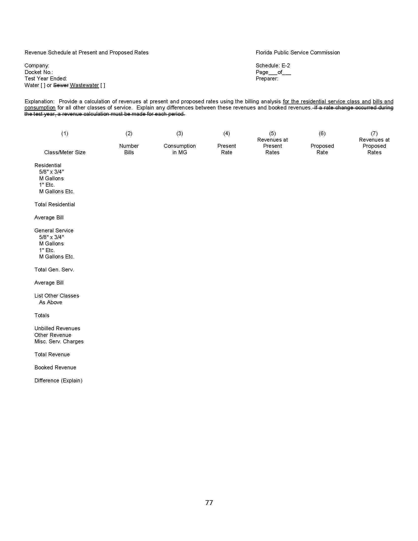

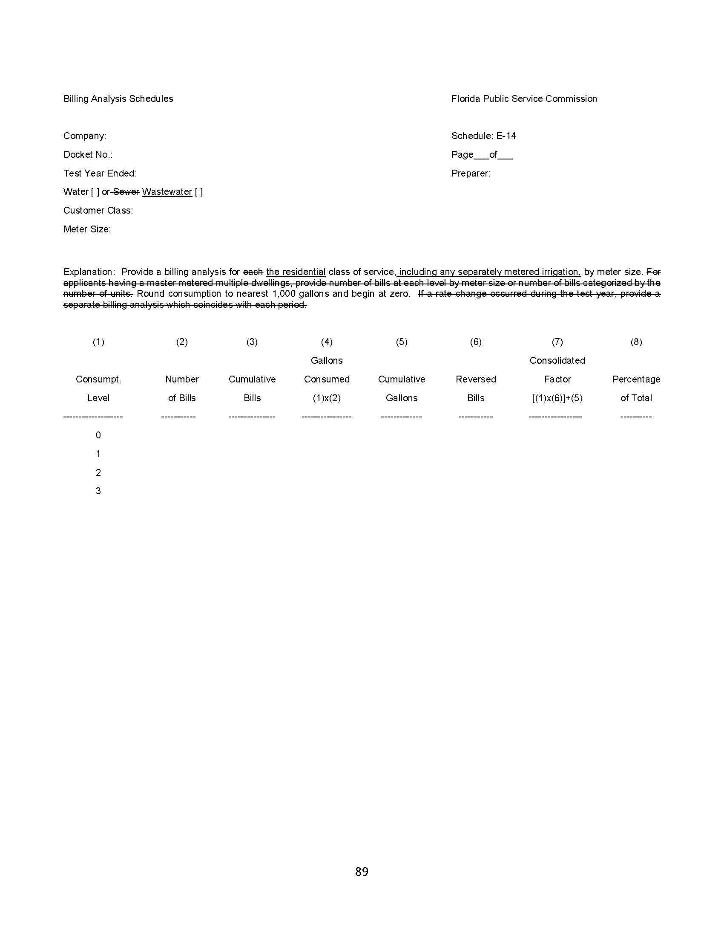

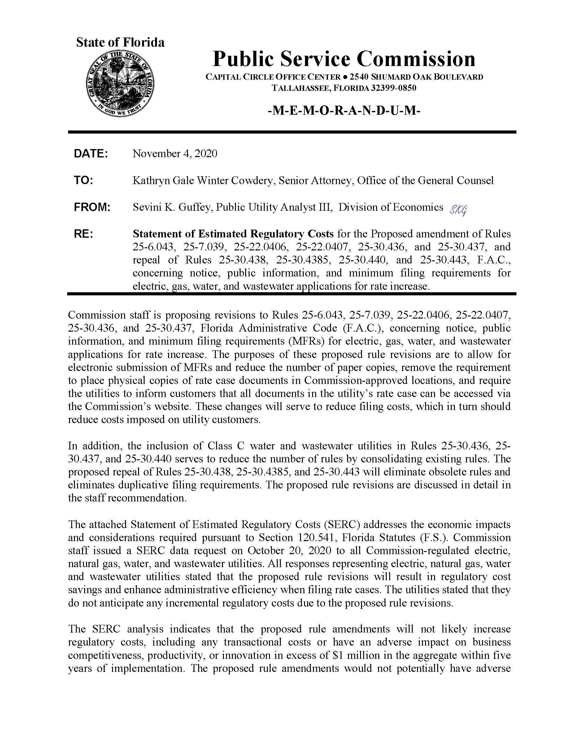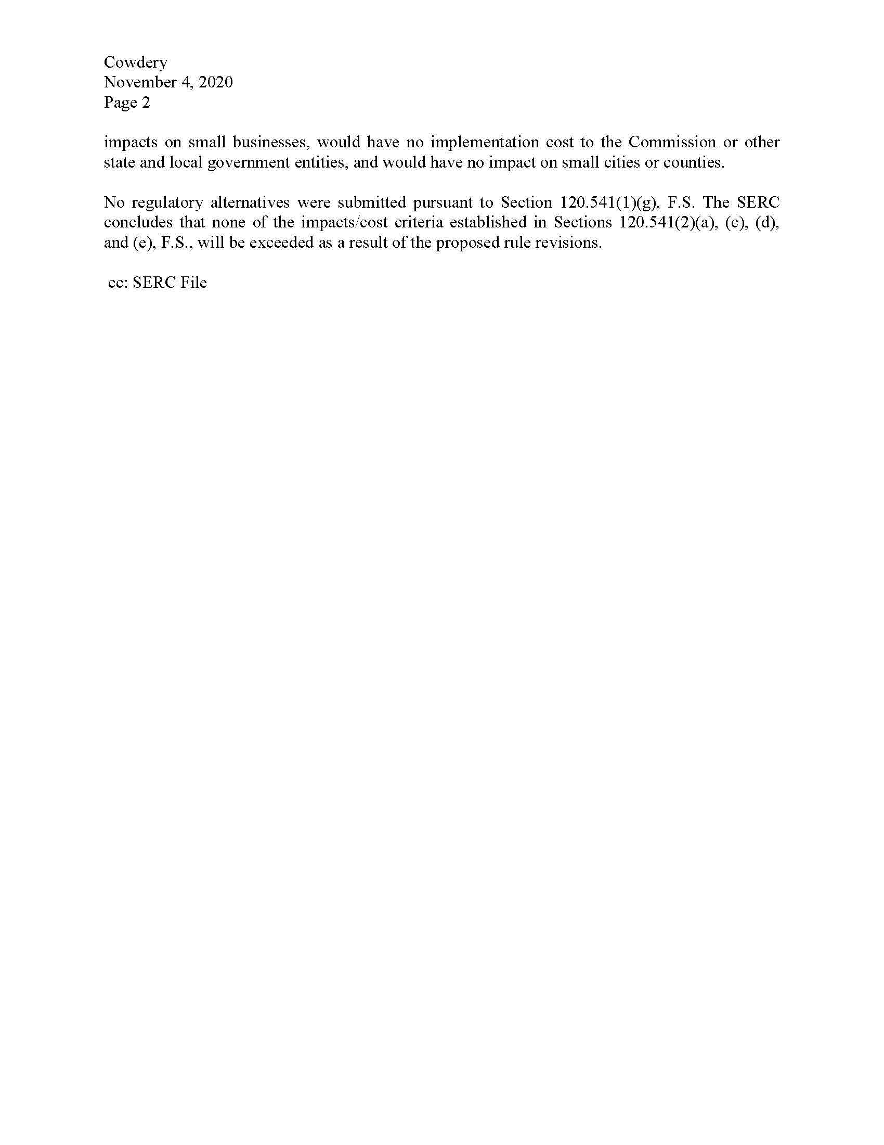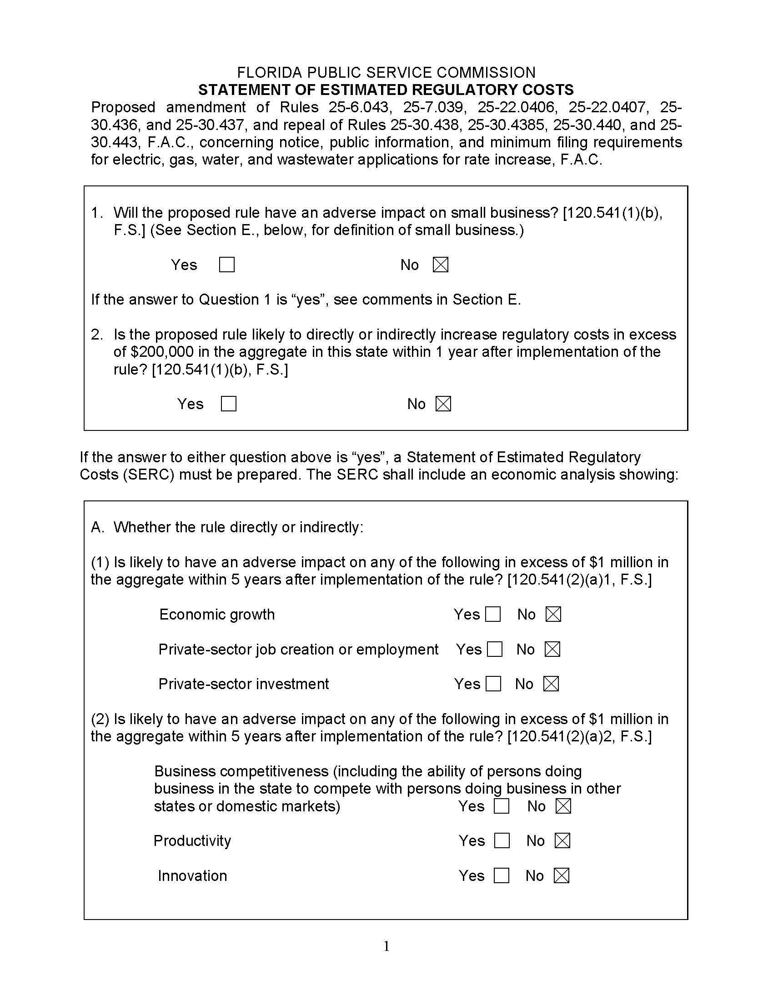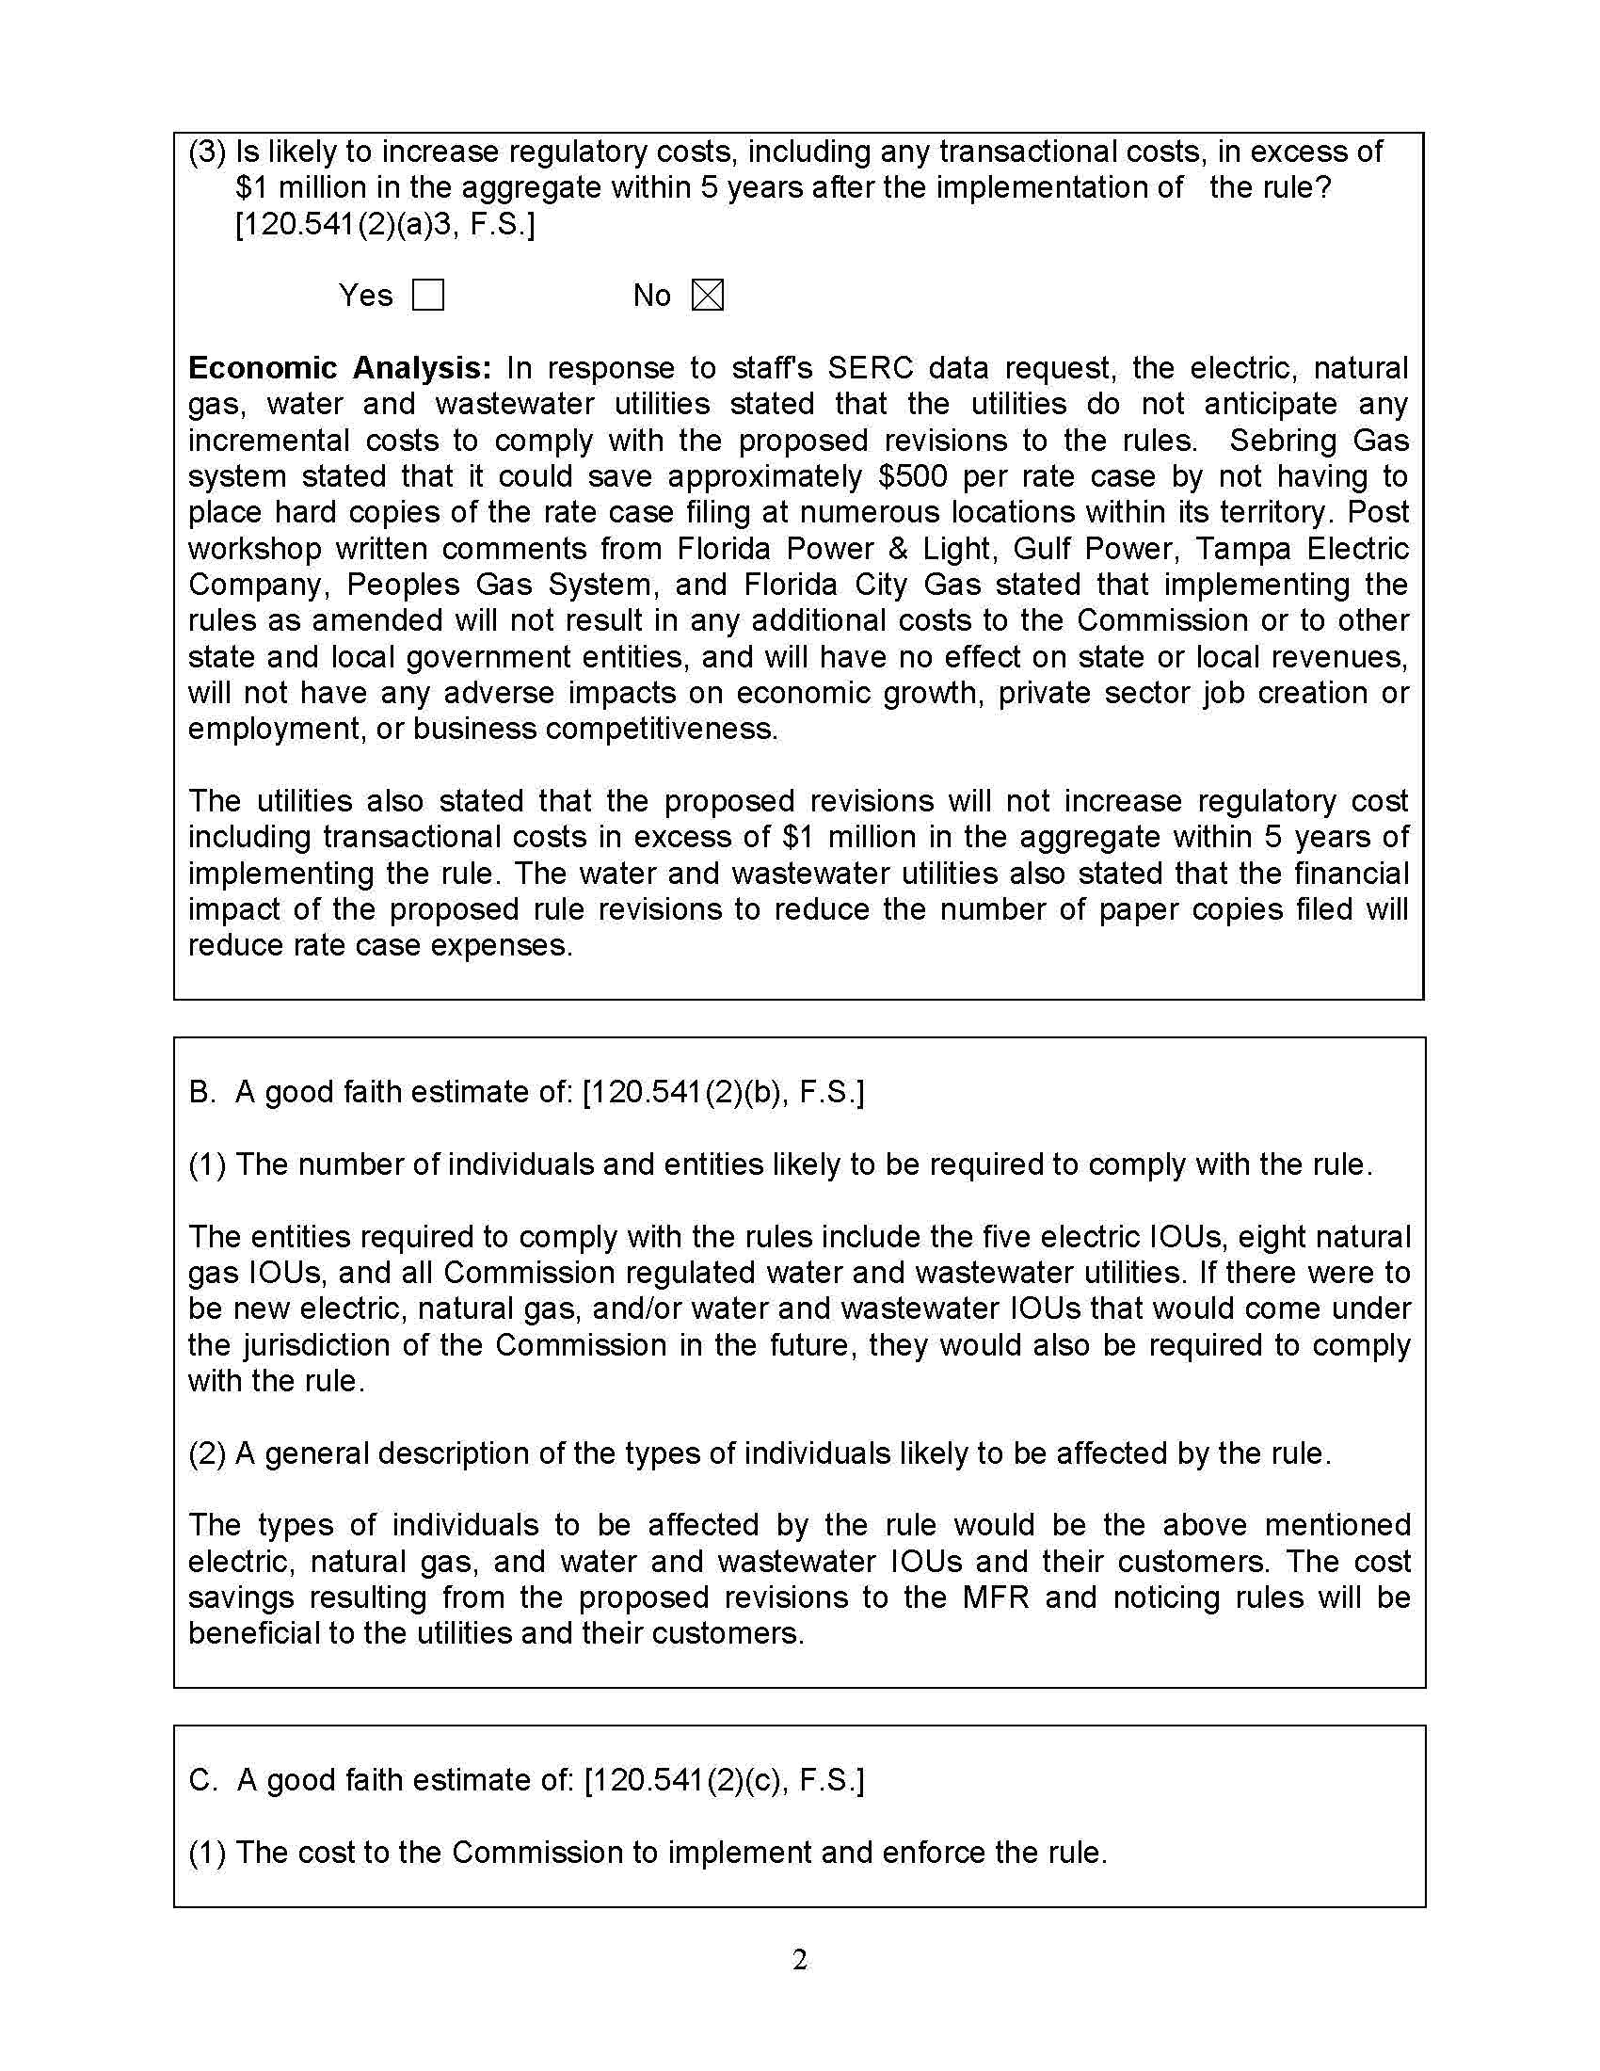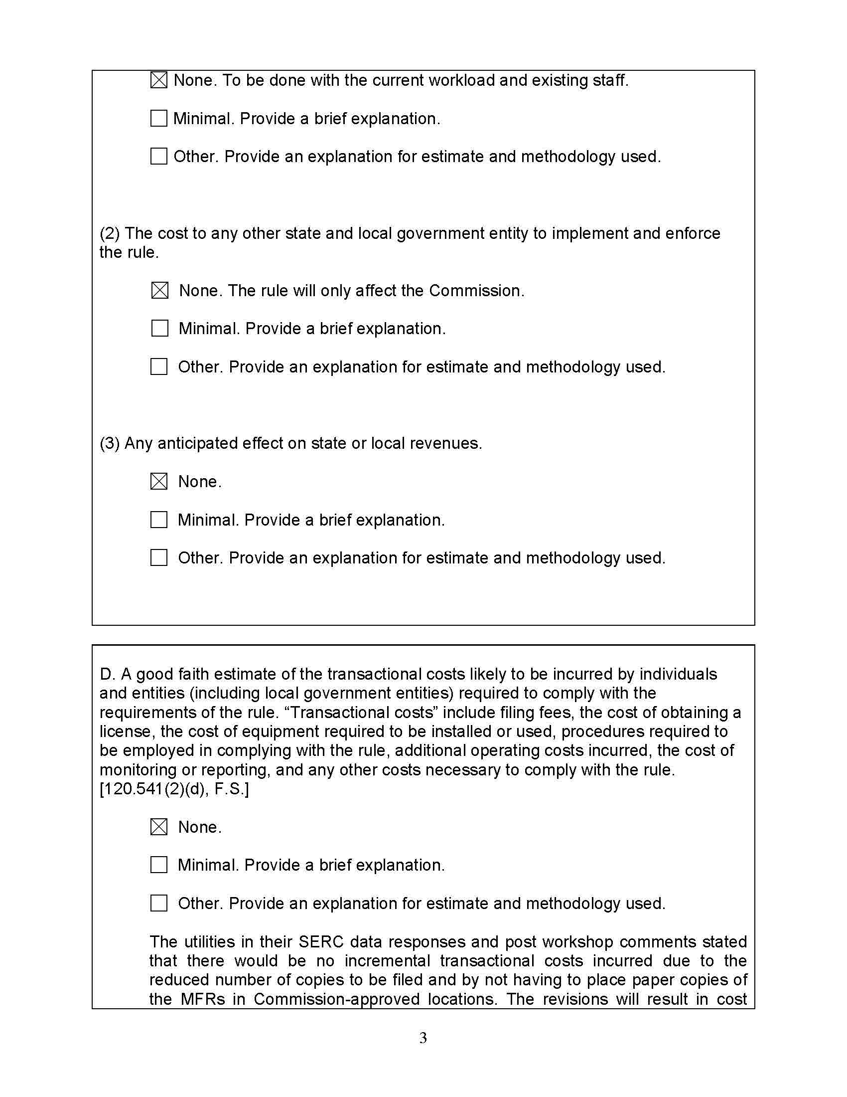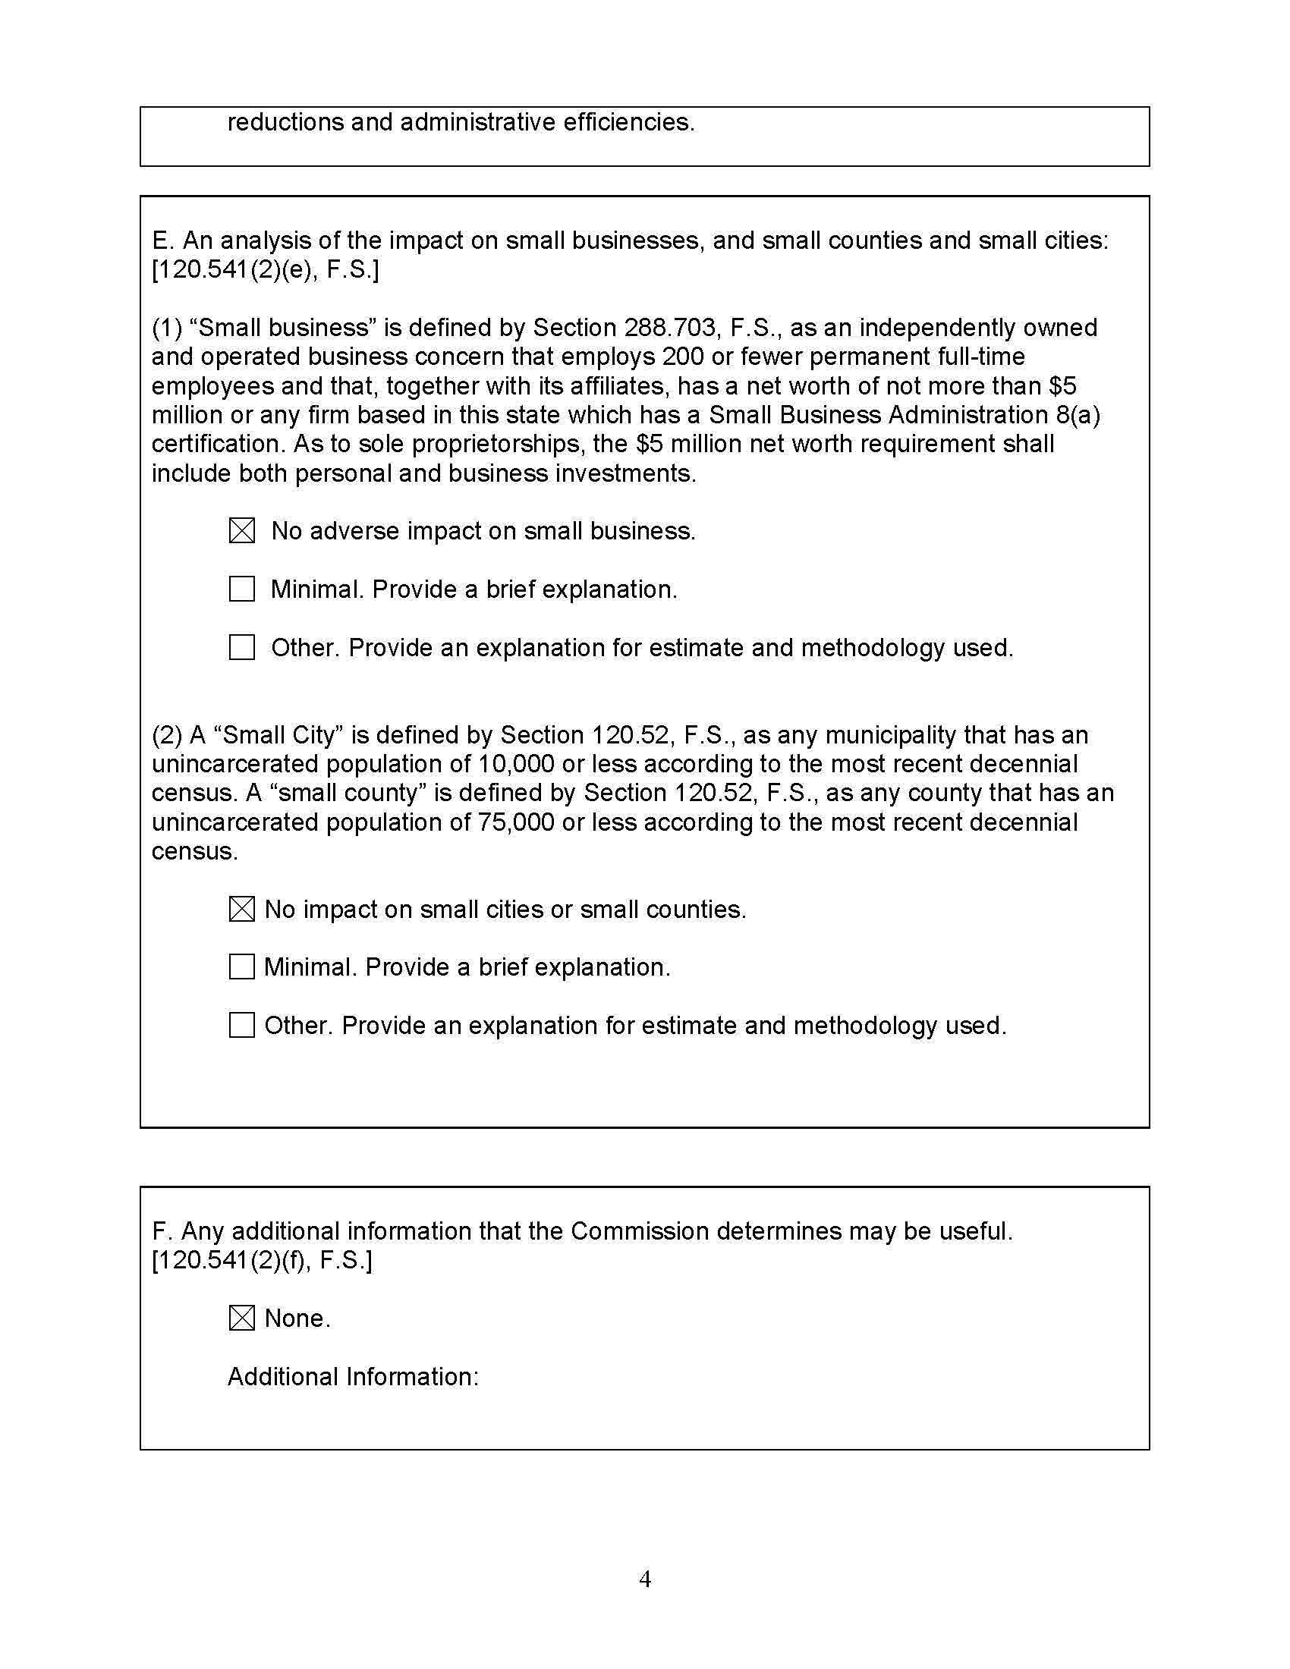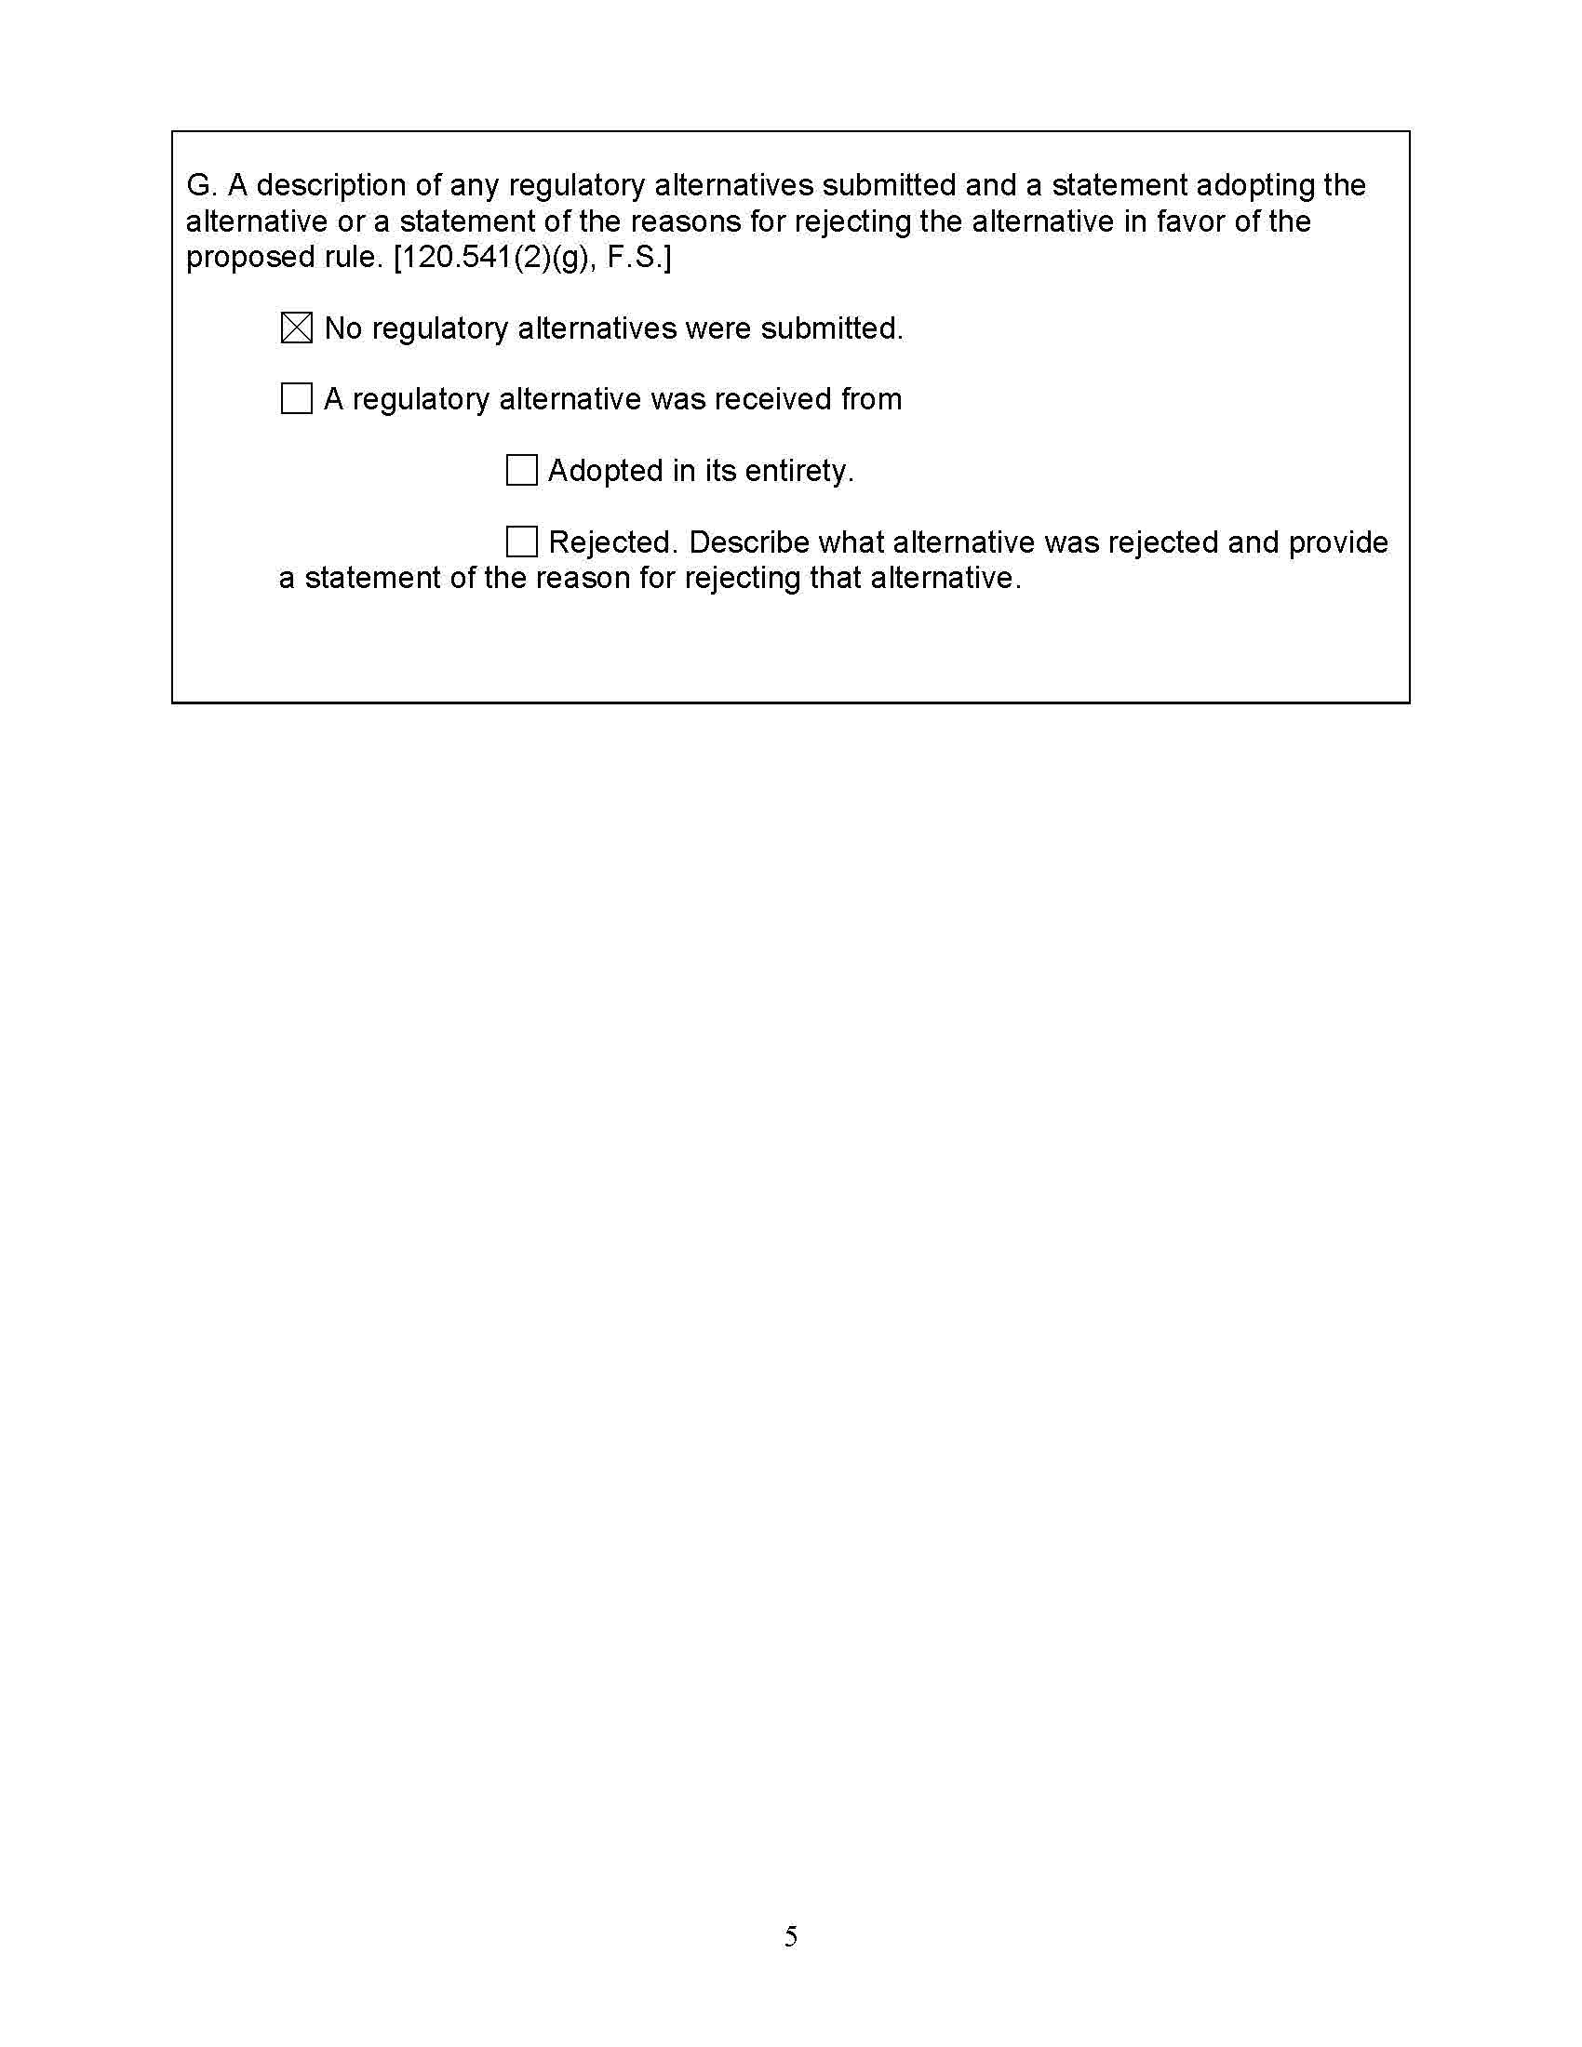

The rules addressed in this docket do not pertain to water or wastewater staff assisted rate cases, which are governed by other rules. It should also be noted that the last time a Class C utility filed a rate case that was not staff-assisted was in 2006, in Docket 060540-WU, In re: Application for increase in water rates in Pasco County by Colonial Manor Utility Company.
Schedule E-14 in Forms PSC 1028 and 1029 and Schedule E-6 in Form PSC 1030 are identical. Draft Schedule E-14 shown in Attachment B is from Form PSC 1028.
Staff notes that the Commission has granted variances to the Schedule E-14 requirement of providing a separate billing analysis that coincides with each period of rate change during the test year. The Commission found that the purpose of the MFR requirement was achieved through the billing analysis schedules provided with the MFRs, which would allow staff and parties to examine revenues for the test year period and the additional billing analysis was not necessary for that determination. Order No. PSC-2016-0530-PAA-WS, issued on November 22, 2016, in Docket No. 160101-WS, In re: Application for increase in water and wastewater rates by Utilities Inc. of Florida, and Order No. PSC-2020-0211-PAA-WS, issued on June 25, 2020, in Docket No. 20200139-WS, In re: Application for increase in water and wastewater rates by Utilities, Inc. of Florida.
Schedule E-2 is identical in Forms PSC 1028, 1029, and 1030. Draft Schedule E-2 shown in Attachment B is from Form PSC 1028.
Schedules E-5, E-7, E-8, and E-10.

