State of Florida |  | Public Service Commission  Capital Circle Office Center ● 2540 Shumard Oak Boulevard  Tallahassee, Florida 32399-0850  -M-E-M-O-R-A-N-D-U-M-
DATE: | November 17, 2020
TO: | Office of Commission Clerk (Teitzman)
FROM: | Division of Economics (Ward, Coston)  Office of the General Counsel (Osborn, Crawford)
RE: | Docket No. 20200207-GU – Joint petition for approval of GRIP cost recovery factors for January 2021 through December 2021, by Florida Public Utilities Company, Florida Public Utilities Company-Fort Meade, and Florida Division of Chesapeake Utilities Corporation.
AGENDA: | 12/01/20 – Regular Agenda – Tariff Filing – Interested Persons May Participate
COMMISSIONERS ASSIGNED: |  |  | All Commissioners
PREHEARING OFFICER: |  |  | Administrative
CRITICAL DATES: |  |  | 8-Month Effective Date: 04/03/21 (60 day suspension date waived by the utility)
SPECIAL INSTRUCTIONS: |  |  | None

Case Background
On September 3, 2020, Florida Public Utilities Company (FPUC), Florida Public Utilities Company-Fort Meade (Fort Meade), and Florida Division of Chesapeake Utilities Corporation (Chesapeake), collectively the companies, filed a joint petition for approval of their gas reliability infrastructure program (GRIP or program) cost recovery factors for the period January through December 2021. The GRIP for FPUC and Chesapeake was first approved in Order No. PSC-12-0490-TRF-GU (2012 order) to recover the cost of accelerating the replacement of cast iron and bare steel distribution mains and services, including a return on investment, through a surcharge on customers’ bills. Fort Meade’s GRIP was originally approved in Order No. PSC-15-0578-TRF-GU, and allowed Fort Meade to file its annual petition for GRIP factors concurrently with FPUC and Chesapeake. The current GRIP charges for January through December 2020 were approved in Order No. PSC-2019-0502-TRF-GU.
In a September 17, 2020 email, the companies waived the 60-day file and suspend provision of Section 366.06(3), Florida Statutes (F.S.). On October 21, 2020, staff issued a data request to the companies, for which the companies filed responses on October 30, 2020. The proposed tariff sheets are contained in Attachment B (FPUC), Attachment C (Chesapeake), and Attachment D (Fort Meade). The Commission has jurisdiction over this matter pursuant to Sections 366.03, 366.04, 366.05, and 366.06, F.S.

Discussion of Issues

Issue 1:
Should the Commission approve FPUC's, Fort Meade's, and Chesapeake's proposed GRIP surcharges for the period January through December 2021?

Recommendation:
Yes, the Commission should approve FPUC's, Fort Meade's, and Chesapeake's proposed GRIP surcharges for the period January through December 2021. (Ward)

Staff Analysis:
The GRIP surcharges have been in place since January 2013 for FPUC and Chesapeake, while Fort Meade’s surcharges were first implemented in January 2017. In response to staff’s data request, the companies stated that replacement projects in Lake Worth, West Palm Beach, Palm Beach, Winter Haven, and Lake Wales were completed in 2020. Additional replacement projects in Lake Worth, Palm Beach, West Palm Beach, Lantana, Lake Alfred, Haines City, and Plant City were projected to continue into 2021. Attachment A provides an update of mains and services replaced and replacement forecasts. The companies stated that they prioritize the potential replacement projects focusing on areas of high consequence and areas more susceptible to corrosion.

FPUC’s True-ups by Year
FPUC’s calculation for the 2021 GRIP revenue requirement and surcharges includes a final true-up for 2019, an actual/estimated true-up for 2020, and projected costs for 2021. FPUC was authorized to recover $747,727 of annual GRIP expenses in base rates; therefore, the $747,727 is excluded from the GRIP surcharge calculation.

Final True-up for 2019
FPUC stated that the revenues collected through the GRIP surcharges for 2019 were $9,210,533, compared to a revenue requirement of $9,820,941, resulting in an under-recovery of $610,408. The 2018 over-recovery of $2,616,870, the 2019 under-recovery of $610,408, and interest of $59,250 associated with any over- and under-recoveries results in a final 2019 over-recovery of $2,065,712.

Actual/Estimated 2020 True-ups
FPUC provided actual revenues for January through July 2020 and estimated revenues for August through December 2020, totaling $9,184,211, compared to an actual/estimated revenue requirement for 2020 of $10,931,270, resulting in an under-recovery of $1,747,059. The 2019 over-recovery of $2,065,712, the 2020 under-recovery of $1,747,059, and interest of $12,577 results in a total 2020 over-recovery of $331,231.

Projected 2021 Costs
FPUC expects capital expenditures of $17,750,000 for the replacement of cast iron/bare steel infrastructure in 2021. The return on investment (which includes federal income taxes, regulatory assessment fees, and bad debt), depreciation expense, and property tax and customer notification expense associated with that investment is $11,695,318. Subtracting the revenue requirement for bare steel replacement included in base rates results in a 2021 revenue requirement of $10,947,591. After subtracting the total 2020 over-recovery of $331,231, the 2021 revenue requirement is $10,616,361. Table 1-1 shows FPUC’s 2021 revenue requirement calculation.
Table 1-1
FPUC 2021 Revenue Requirement Calculation
2021 Projected Expenditures | $17,750,000
Return on Investment | $7,317,570
Depreciation Expense | 2,398,413
Property Tax and Customer Notice Expense | 1,979,335
2021 Revenue Requirement | $11,695,318
Less Revenue Requirement in Base Rates | 747,727
2021 GRIP Revenue Requirement | $10,947,591
Less 2020 Over-recovery | 331,231
2021 Total Revenue Requirement | $10,616,361
Source: Schedule C-2, page 4 of 18 in petition (Docket No. 20200207-GU).

Chesapeake’s True-ups by Year
Chesapeake’s calculation for the 2021 GRIP revenue requirement and surcharges includes a final true-up for 2019, an actual/estimated true-up for 2020, and projected costs for 2021. Chesapeake does not have a replacement recovery amount embedded in base rates.

Final True-up for 2019
Chesapeake stated that the revenues collected for 2019 were $4,099,554, compared to a revenue requirement of $3,703,085, resulting in an over-recovery of $396,469. The 2018 over-recovery of $192,146, 2019 over-recovery of $396,469, and interest of $11,270 associated with any over- and under-recoveries results in a final 2019 over-recovery of $599,885.

Actual/Estimated 2020 True-up
Chesapeake provided actual GRIP revenues for January through July 2020 and estimated revenues for August through December 2020, totaling $3,053,757, compared to an actual/estimated revenue requirement of $3,951,203, resulting in an under-recovery of $897,446. The 2019 over-recovery of $599,885, 2020 under-recovery of $897,446, and interest of $2,807 associated with any over- and under-recoveries results in a total 2020 under-recovery of $294,754.

Projected 2021 Costs
Chesapeake projects capital expenditures of $250,000 for the replacement of cast iron/bare steel infrastructure in 2021. Chesapeake has almost completed its infrastructure replacement project, two years ahead of the originally scheduled completion date of 2022, with only one replacement project in Plant City scheduled for 2021. The return on investment (calculated on the total GRIP investment installed to date), depreciation expense, and property tax and customer notification expense to be recovered in 2021 totals $3,843,929. After adding the total 2020 under-recovery of $294,754, the total 2021 revenue requirement is $4,138,683. Table 1-2 shows Chesapeake’s 2021 revenue requirement calculation.

Table 1-2
Chesapeake 2021 Revenue Requirement Calculation
2021 Projected Expenditures | $250,000
Return on Investment | $2,380,672
Depreciation Expense | 779,113
Property Tax and Customer Notice Expense | 684,144
2021 Revenue Requirement | $3,843,929
Plus 2020 Under-recovery | 294,754
2021 Total Revenue Requirement | $4,138,683
Source: Schedule C-2, page 10 of 18 in petition (Docket No. 20200207-GU).

Fort Meade’s True-ups by Year
Fort Meade started its replacement program in 2016 and first implemented GRIP surcharges in January 2017. Unlike FPUC and Chesapeake, only bare steel services (and no mains) require replacement in Fort Meade. Fort Meade’s replacement program was completed in 2019.

Final True-up for 2019
Fort Meade stated that the revenues collected for 2019 were $29,923, compared to a revenue requirement of $24,087, resulting in an over-recovery of $5,836. Adding the 2018 under-recovery of $3,693, the 2019 over-recovery of $5,836, and $29 for interest associated with any over- and under-recoveries, the final 2019 over-recovery is $2,113.

Actual/Estimated 2020 True-up
Fort Meade provided actual GRIP revenues for January through July 2020 and estimated revenues for August through December 2020 totaling $29,315, compared to an actual/estimated revenue requirement of $25,474, resulting in an over-recovery of $3,841. Adding the 2019 over-recovery of $2,113, the 2020 over-recovery of $3,841, and interest of $33 associated with any over- and under-recoveries, the resulting total 2020 true-up is an over-recovery of $5,987.

Projected 2021 Costs
Fort Meade projects capital expenditures of $0 for the replacement of cast iron/bare steel infrastructure in 2021, as the replacement program was completed in 2019. Therefore, the 2021 GRIP factors are designed to only recover the remaining 2020 over-recovery of $5,987 and the revenue requirement of $25,474 associated with the 2020 year-end total investment ($25,474 - $5,987 = $19,487).

Proposed Surcharges for FPUC, Chesapeake, and Fort Meade
As established in the 2012 order approving the GRIP program, the total 2021 revenue requirement is allocated to the rate classes using the same methodology used for the allocation of mains and services in the cost of service study used in the utilities’ most recent rate case. The respective percentages were multiplied by the 2021 revenue requirements and divided by each rate class’ projected therm sales to provide the GRIP surcharge for each rate class.
The proposed 2021 GRIP surcharge for FPUC’s residential customers on the Residential Service (RS) schedule is $0.22417 per therm (compared to the current surcharge of $0.22312 per therm). The monthly bill impact is $4.48 for a residential customer using 20 therms per month. The proposed FPUC tariff page is shown in Attachment B.
The proposed 2021 GRIP surcharge for Chesapeake’s residential customers on the FTS-1 schedule is $0.11567 per therm (compared to the current surcharge of $0.10585). The monthly bill impact is $2.31 for a residential customer using 20 therms per month. The proposed Chesapeake tariff pages are contained in Attachment C.
The proposed 2021 GRIP surcharge for Fort Meade’s residential customers on the RS schedule is $0.16325 per therm (compared to the current surcharge of $0.24865). The monthly bill impact is $3.27 for a residential customer using 20 therms per month. The proposed Fort Meade tariff page is shown in Attachment D.

Conclusion
Staff believes the calculation of the 2021 GRIP surcharge revenue requirement and the proposed GRIP surcharges for FPUC, Chesapeake, and Fort Meade are reasonable and accurate. Staff recommends approval of FPUC’s, Chesapeake’s, and Fort Meade’s proposed GRIP surcharges for the period January through December 2021.

Issue 2:
Should this docket be closed?

Recommendation:
Yes. If Issue 1 is approved and a protest is filed within 21 days of the issuance of the order, the tariffs should remain in effect, with any revenues held subject to refund, pending resolution of the protest. If no timely protest is filed, this docket should be closed upon the issuance of a consummating order. (Osborn, Crawford)

Staff Analysis:
If Issue 1 is approved and a protest is filed within 21 days of the issuance of the order, the tariffs should remain in effect, with any revenues held subject to refund, pending resolution of the protest. If no timely protest is filed, this docket should be closed upon the issuance of a consummating order.

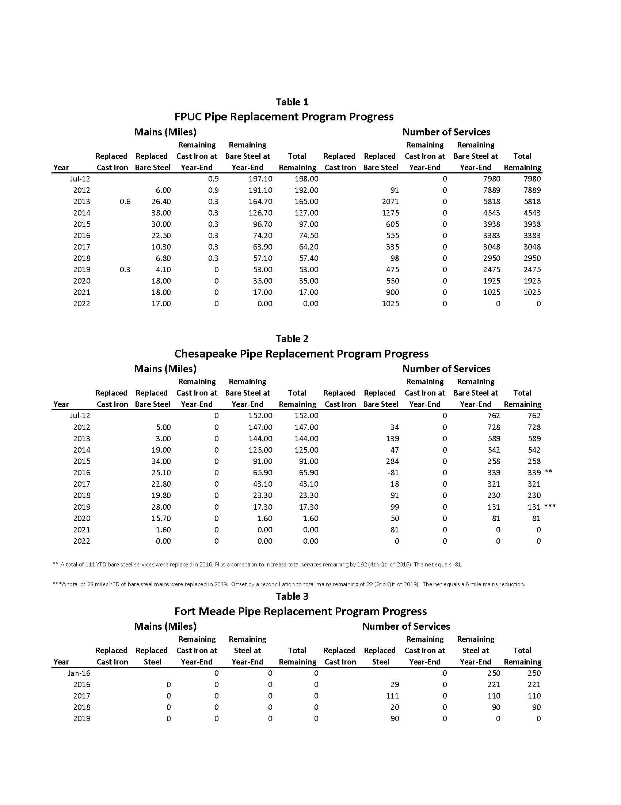

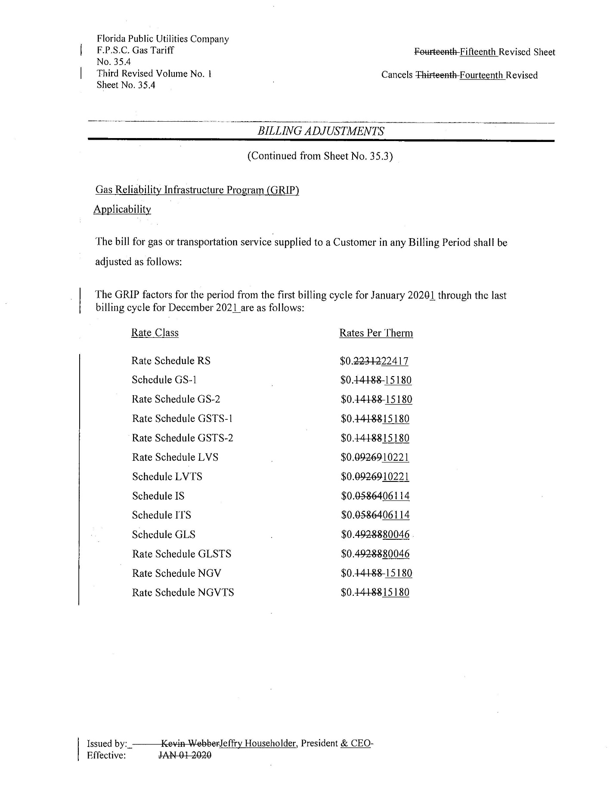
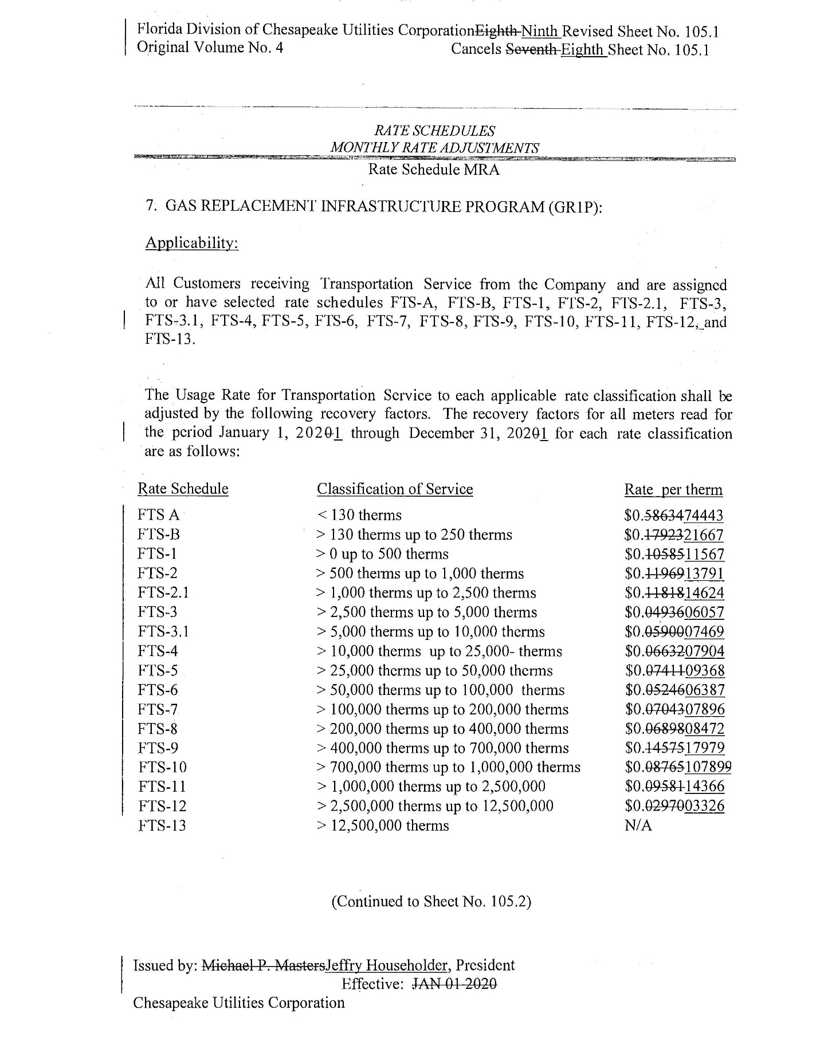
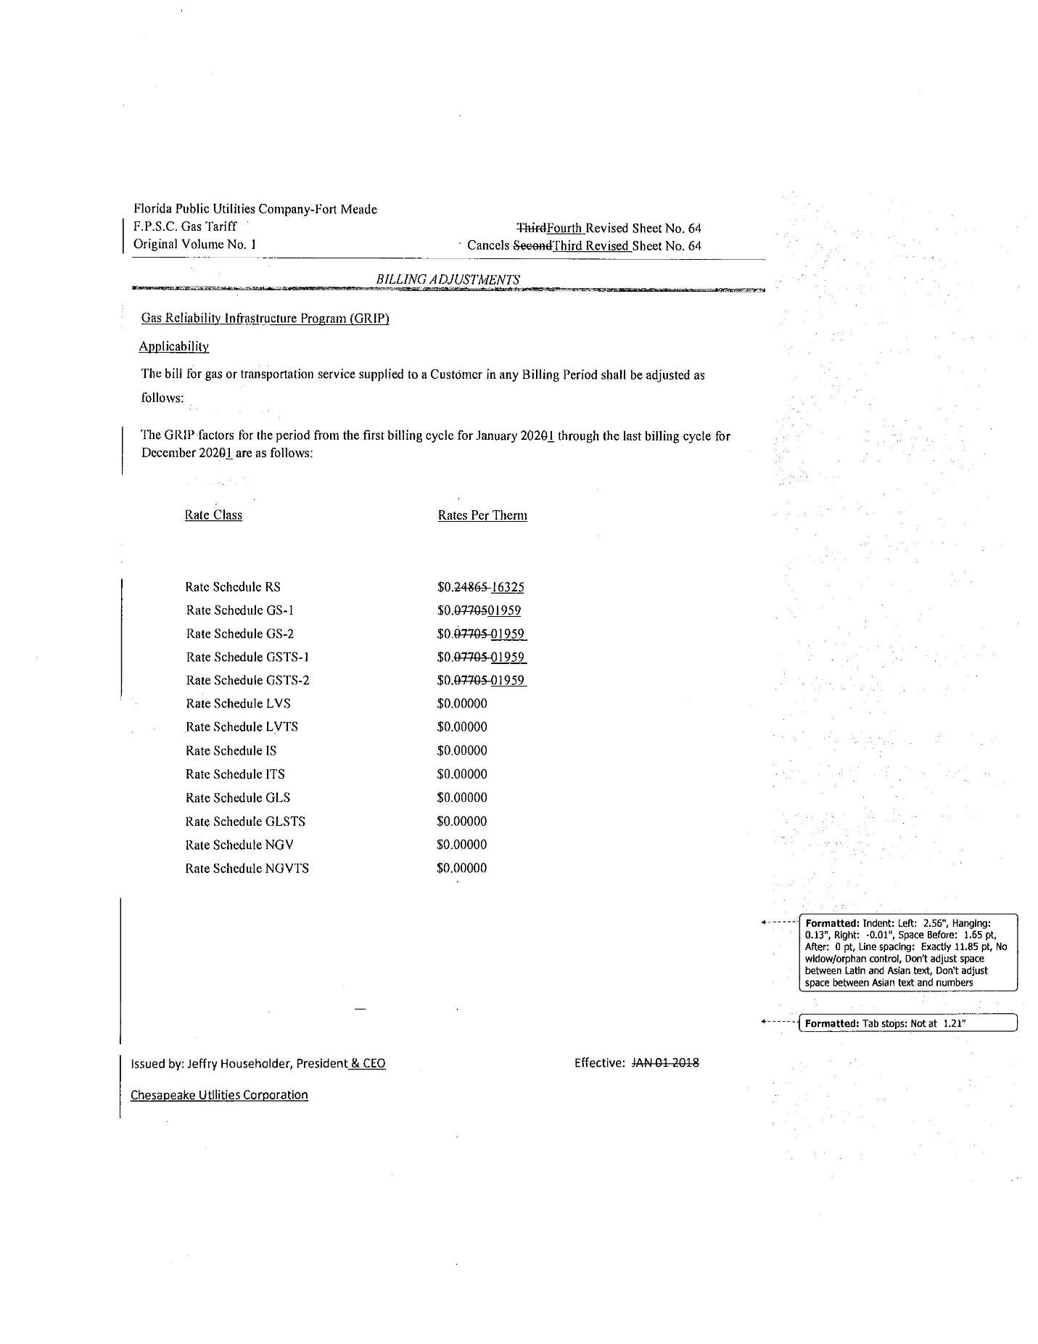

Order No. PSC-12-0490-TRF-GU, issued September 24, 2012, in Docket No. 20120036-GU, In re: Joint petition for approval of Gas Reliability Infrastructure Program (GRIP) by Florida Public Utilities Company and the Florida Division of Chesapeake Utilities Corporation.
Order No. PSC-15-0578-TRF-GU, issued December 21, 2015, in Docket No. 20150191-GU, In re: Joint petition for approval to implement gas reliability infrastructure program (GRIP) for Florida Public Utilities Company-Fort Meade and for approval of GRIP cost recovery factors by Florida Public Utilities Company, Florida Public Utilities Company-Fort Meade, and the Florida Division of Chesapeake Utilities Corporation.
Order No. PSC-2019-0502-TRF-GU, issued November 25, 2019, in Docket No. 20190173-GU, In re: Joint petition for approval of GRIP cost recovery factors, by Florida Public Utilities Company, Florida Public Utilities Company-Fort Meade, and Florida Division of Chesapeake Utilities Corporation.

