State of Florida |  | Public Service Commission  Capital Circle Office Center ● 2540 Shumard Oak Boulevard  Tallahassee, Florida 32399-0850  -M-E-M-O-R-A-N-D-U-M-
DATE: | November 17, 2020
TO: | Office of Commission Clerk (Teitzman)
FROM: | Division of Economics (Guffey)  Office of the General Counsel (Trierweiler)
RE: | Docket No. 20200201-EU – Joint petition for approval of modification to territorial agreement in Lake and Sumter Counties, by City of Leesburg and Duke Energy Florida, LLC.
AGENDA: | 12/01/20 – Regular Agenda – Proposed Agency Action – Interested Persons May Participate
COMMISSIONERS ASSIGNED: |  |  | All Commissioners
PREHEARING OFFICER: |  |  | Fay
CRITICAL DATES: |  |  | None
SPECIAL INSTRUCTIONS: |  |  | None

Case Background
On August 27, 2020, Duke Energy Florida, LLC. (Duke), and the City of Leesburg (Leesburg) filed a joint petition for approval of the first amendment to their existing territorial agreement (First Amendment) in Lake and Sumter Counties. Duke and Leesburg are parties to a currently effective territorial agreement that was approved by the Commission in 2015. The proposed First Amendment to the current territorial agreement and maps depicting the modified territorial boundaries are included in Attachment A to this recommendation.
During the review process, staff issued a data request to the joint petitioners to which responses were received on October 14, 2020. The Commission has jurisdiction over this matter pursuant to Section 366.04, Florida Statutes (F.S.).

Discussion of Issues

Issue 1:
Should the Commission approve Leesburg’s and Duke’s proposed First Amendment to their existing territorial agreement in Lake and Sumter Counties?

Recommendation:
Yes. The Commission should approve Leesburg’s and Duke’s proposed First Amendment to their existing territorial agreement in Lake and Sumter Counties. The approval of the First Amendment will allow the parties to reallocate land and form more compact, contiguous service areas for future development. The reallocation of land will enable Leesburg and Duke to avoid duplication of facilities and serve their customers efficiently. The proposed amendment is in the public interest and will not cause a decrease in reliable electric service to existing and future customers of either utility. (Guffey)

Staff Analysis:
Pursuant to Section 366.04(2)(d), F.S., and Rule 25-6.0440(2), Florida Administrative Code (F.A.C.), the Commission has the jurisdiction to approve territorial agreements between and among rural electric cooperatives, municipal electric utilities, and other electric utilities. Unless the Commission determines that the agreement will cause a detriment to the public interest, the agreement should be approved.

Proposed First Amendment to the Territorial Agreement
Leesburg and Duke executed their First Amendment to the Territorial Agreement (see Attachment A) on August 28, 2020. The intent of the First Amendment is to reallocate vacant land pursuant to Article III and modify the territorial boundaries pursuant to Section 3.1 of the agreement. The exchange of land will form more compact and contiguous service territories for future development and avoid duplication of facilities in Lake and Sumter Counties. There are no customer or infrastructure transfers contemplated in this proposed First Amendment. Through the First Amendment, the joint petitioners seek to more accurately define the portions of their respective service areas and gain operational efficiencies.
In response to staff’s data request, the joint petitioners stated that the land areas proposed to be reallocated are currently vacant. Therefore, no notice to customers was required pursuant to Rule 25-6.0440(1), F.A.C. However, staff notes that there are conceptual plans for a residential development of approximately 900 dwelling units in the area allocated to Leesburg. Although the area reallocated to Duke has no conceptual development plans at the moment, future development for this area is projected to be equal to that of Leesburg’s conceptual development plans.
As stated in paragraph 6 of the petition, with the exception of the modifications contained in the First Amendment, the terms and conditions of the existing agreement remain unchanged and in effect. The First Amendment to the existing Agreement will become effective and enforceable upon the issuance of the Commission’s Order and will remain in effect until July 29, 2045.

Conclusion
After review of the joint petition, the proposed First Amendment to the Territorial Agreement, and the petitioners’ joint responses to staff’s data request, staff recommends that the Commission should approve Leesburg’s and Duke’s proposed First Amendment to their existing territorial agreement in Lake and Sumter Counties. The approval of the First Amendment will allow the parties to reallocate land and form more compact, contiguous service areas for future development. The reallocation of land will enable Leesburg and Duke to avoid duplication of facilities and serve their customers efficiently. The proposed amendment is in the public interest and will not cause a decrease in reliable electric service to existing and future customers of either utility.
Issue 2:
Should this docket be closed?

Recommendation:
Yes. If no protest is filed by a person whose substantial interests are affected within 21 days of the issuance of the Order, this docket should be closed upon the issuance of a Consummating Order. (Trierweiler)

Staff Analysis:
If no protest is filed by a person whose substantial interests are affected within 21 days of the issuance of the Order, this docket should be closed upon the issuance of a Consummating Order.

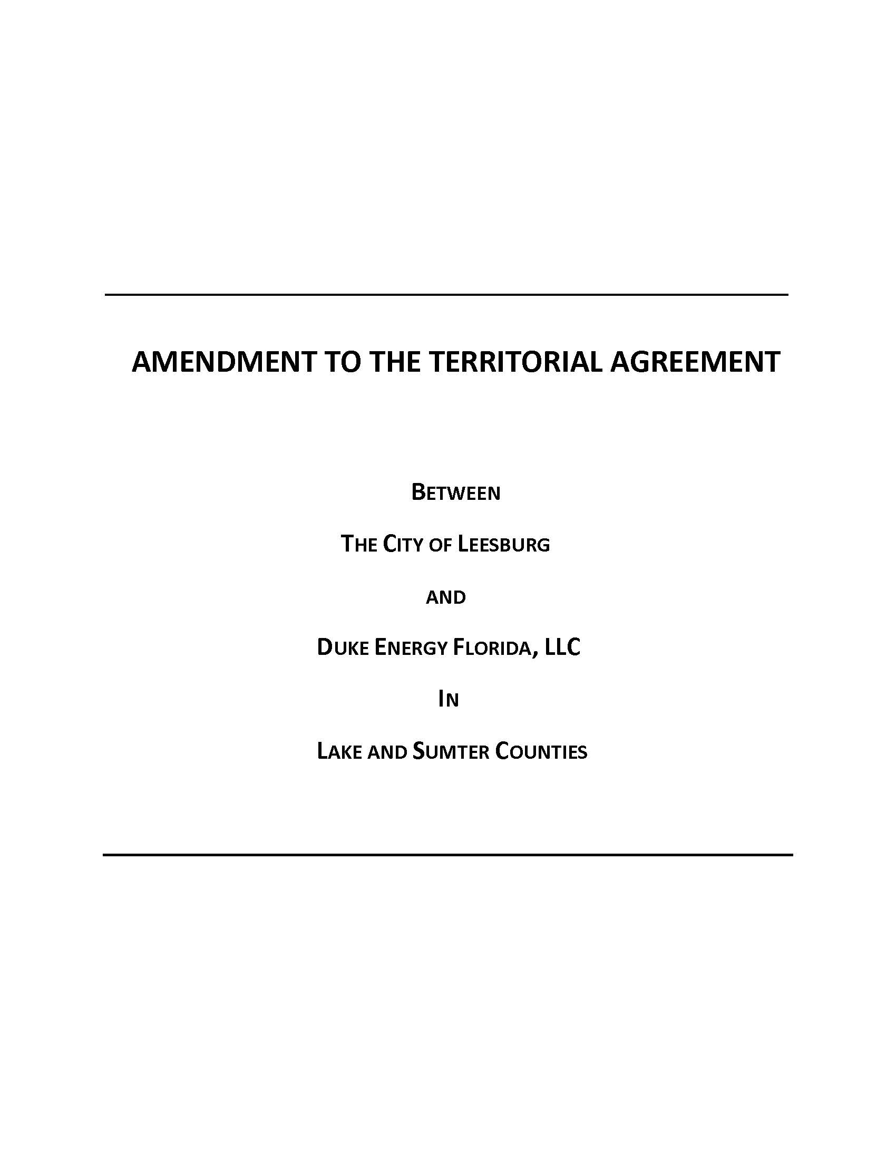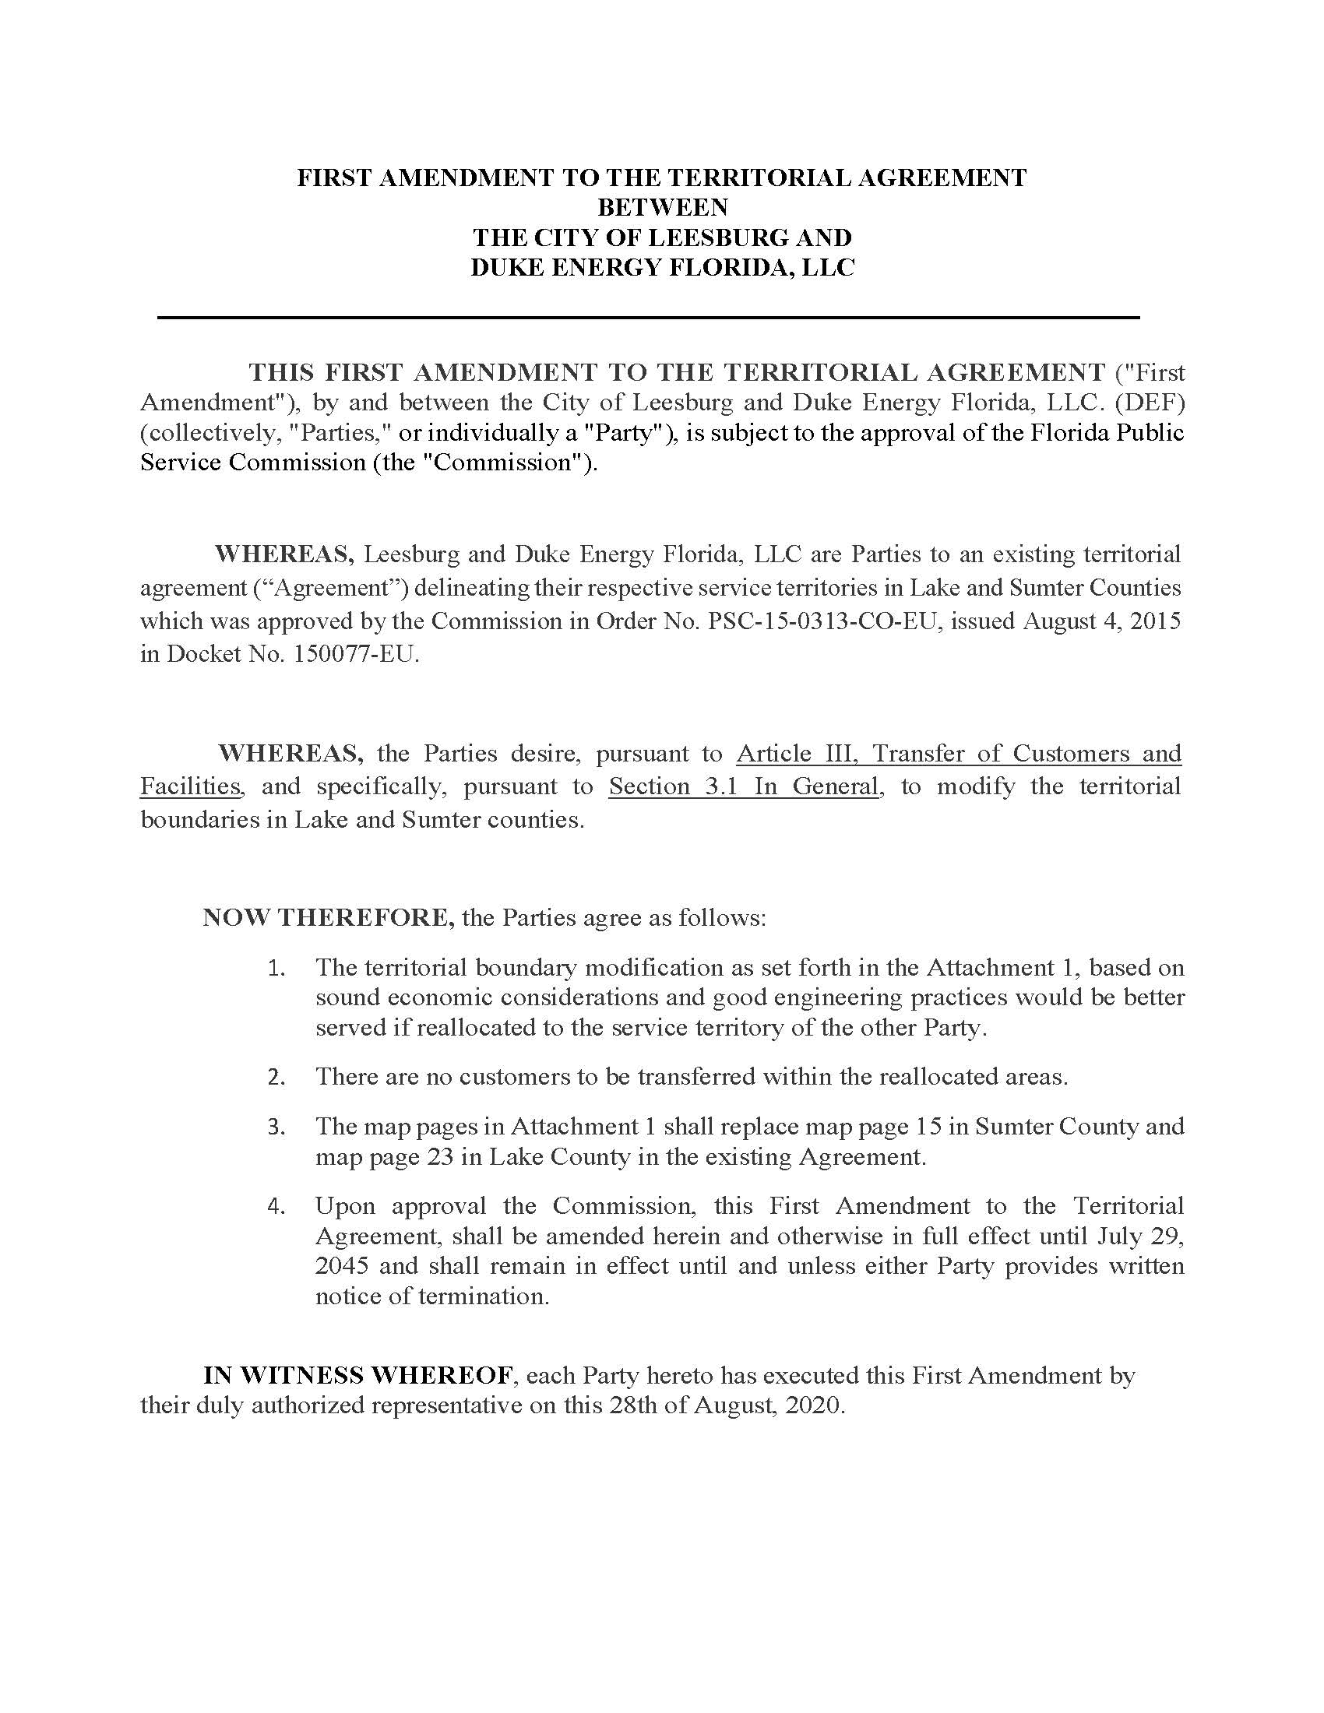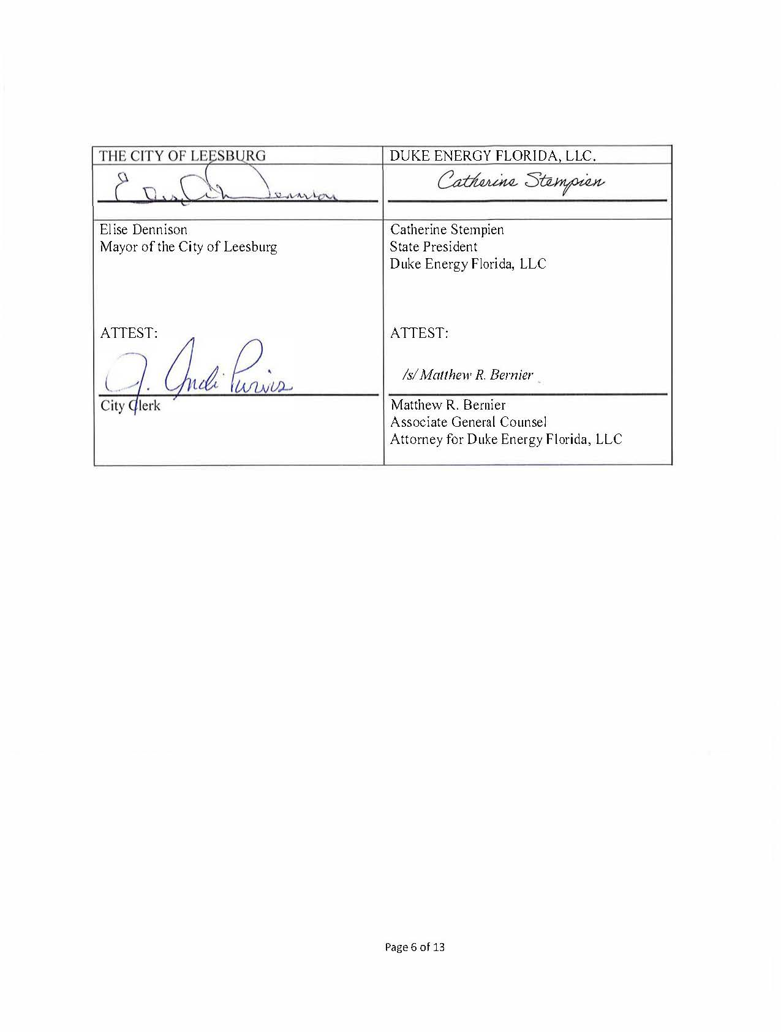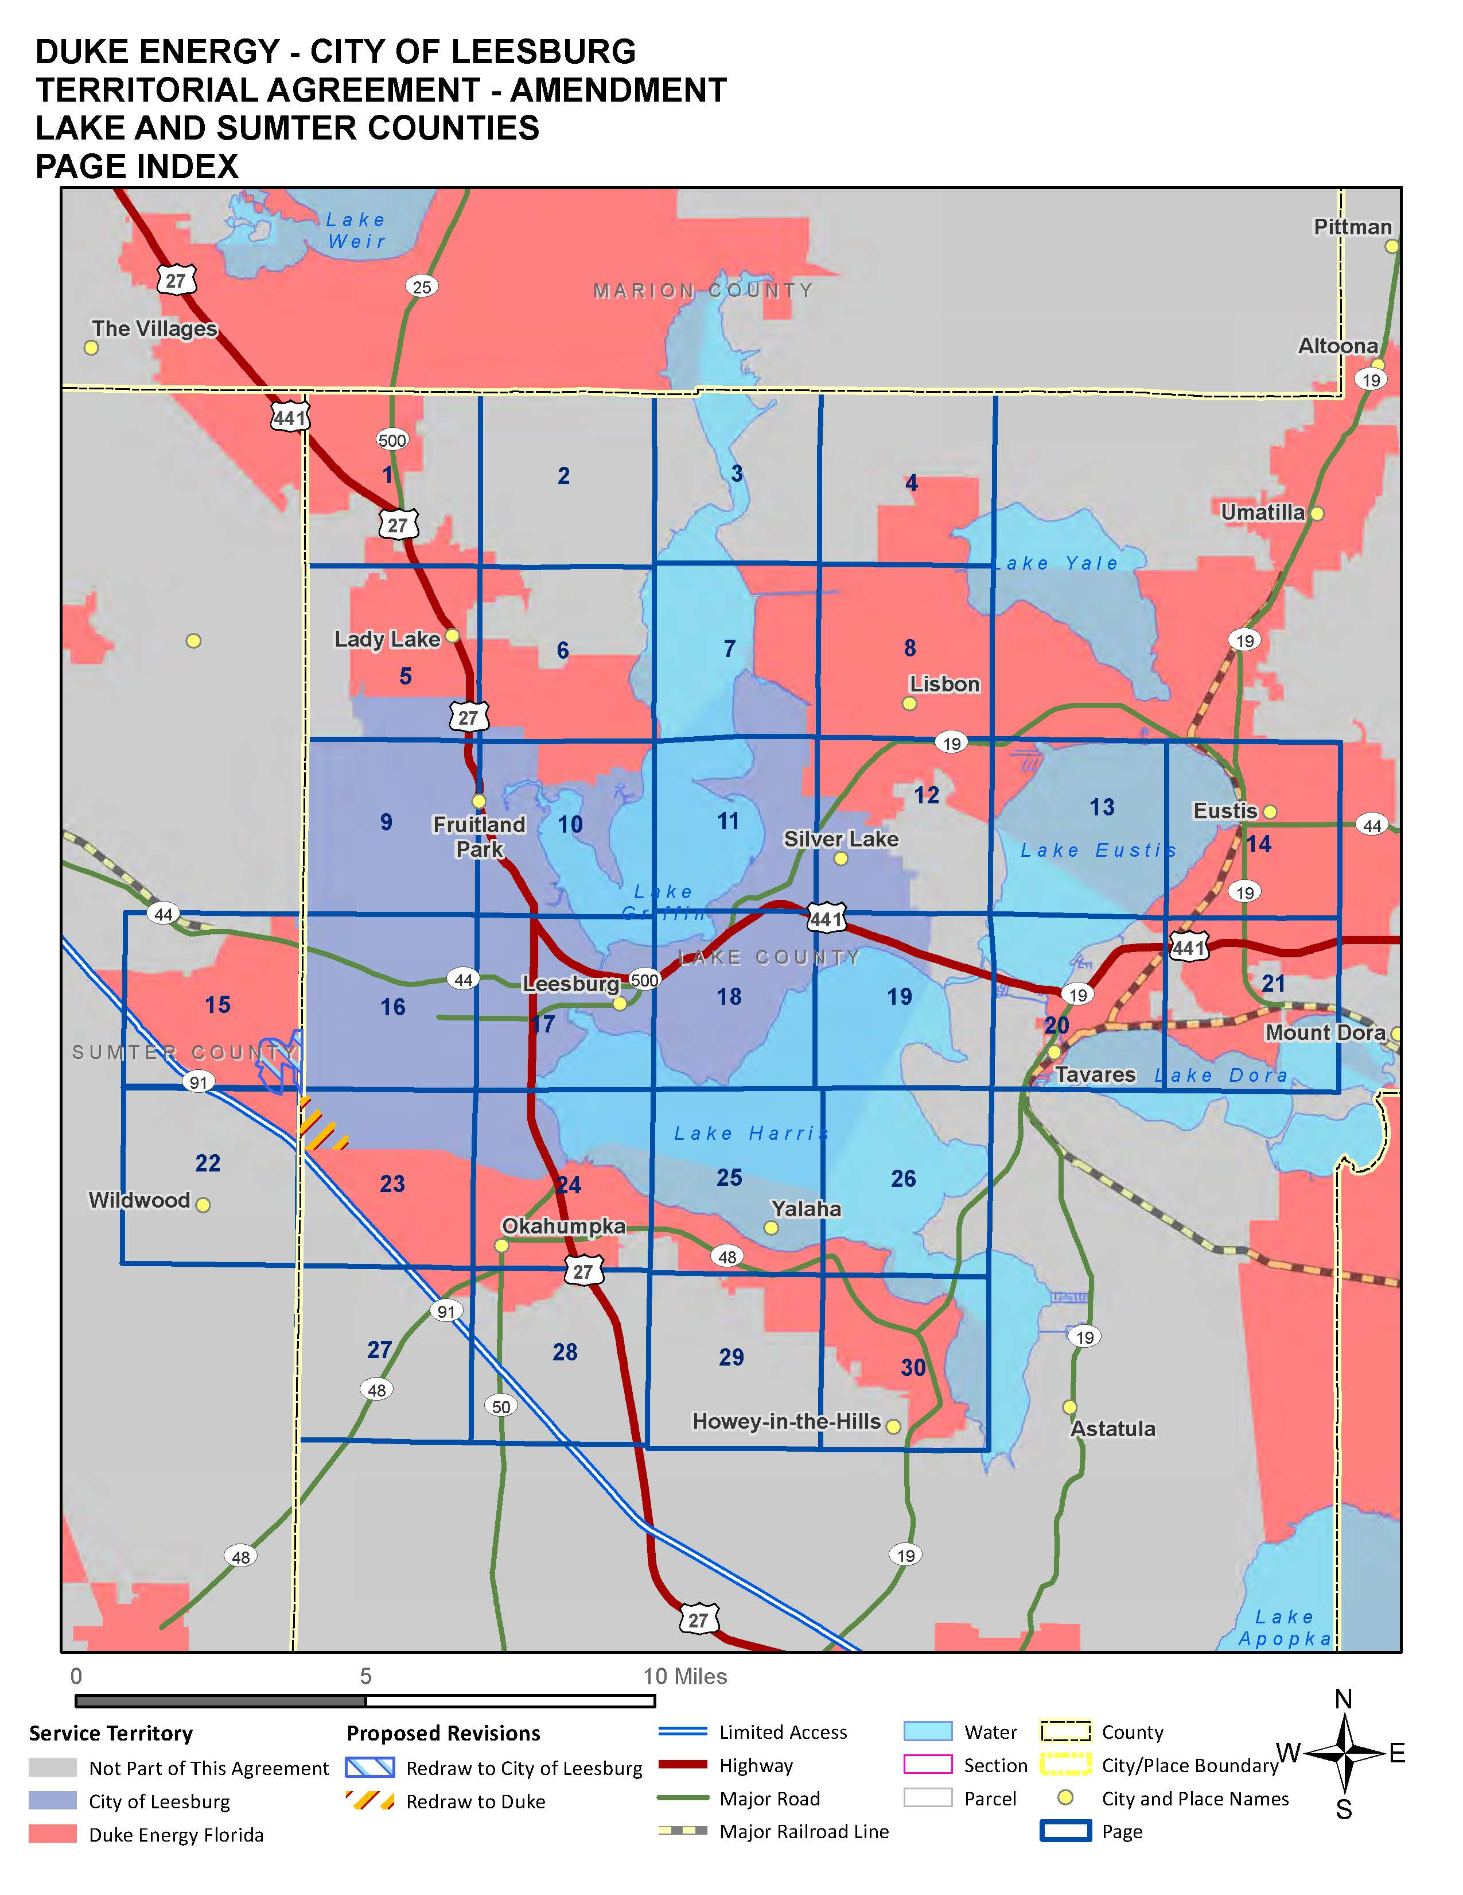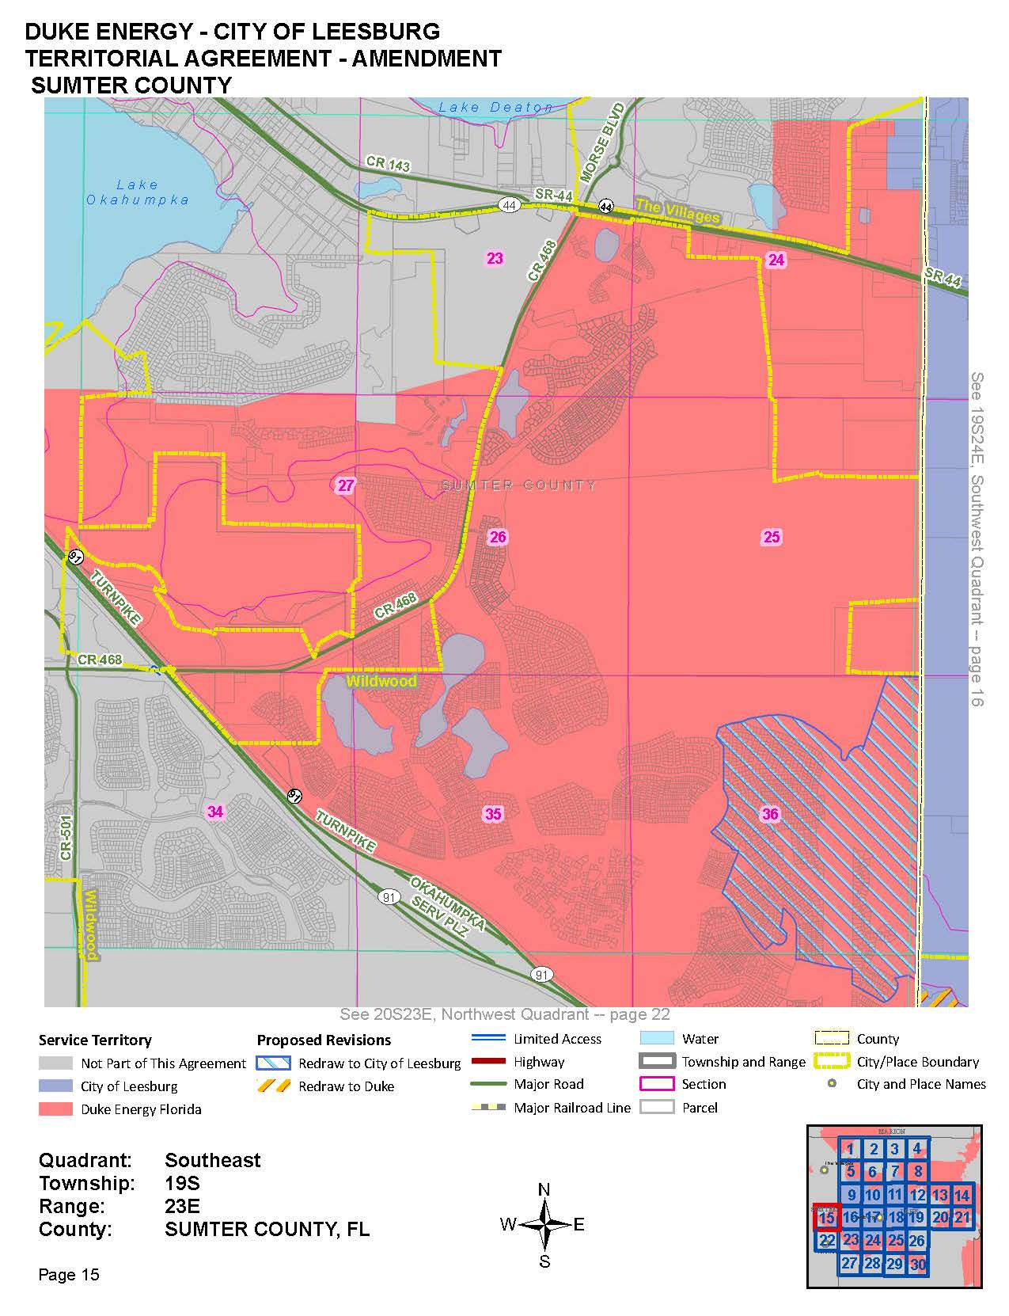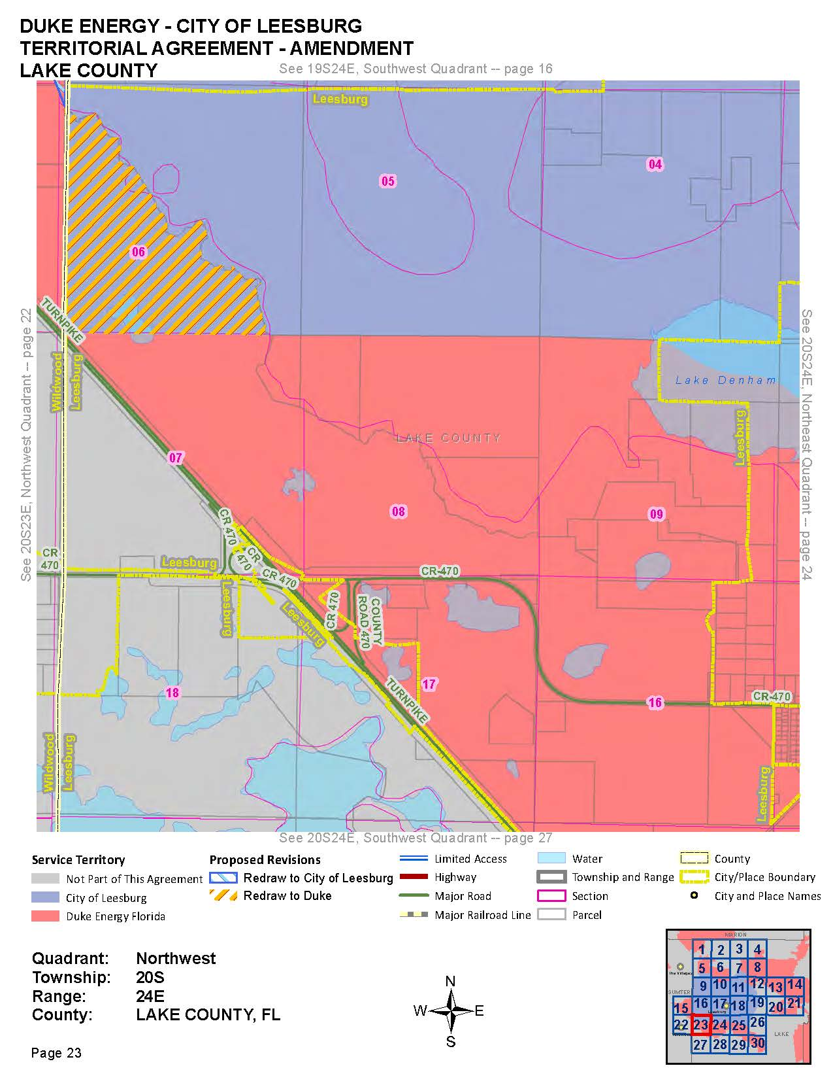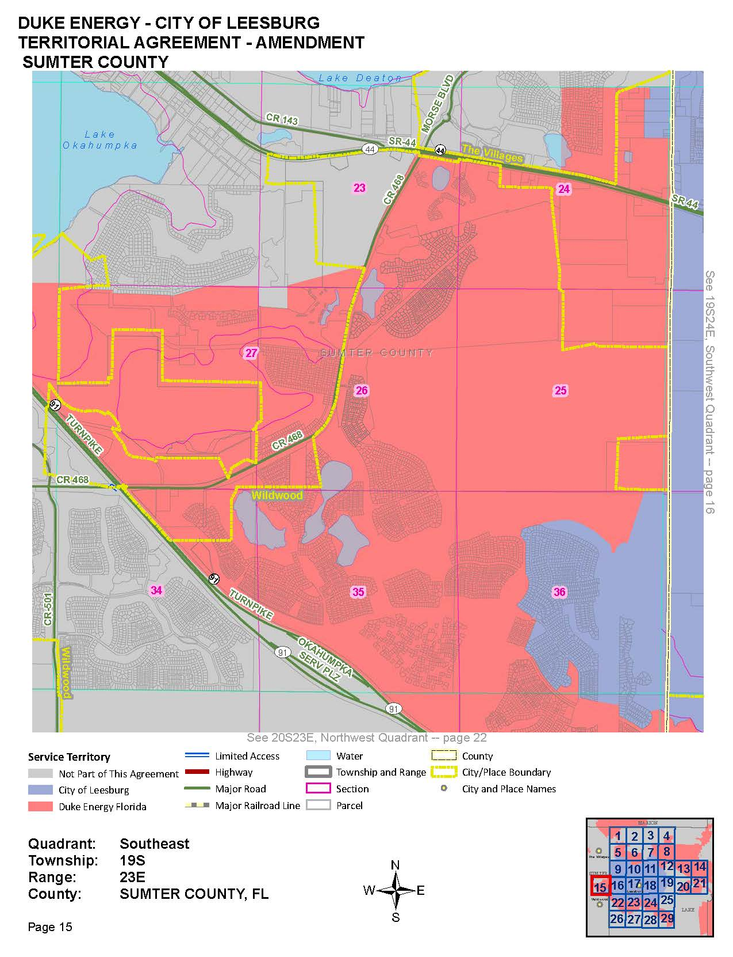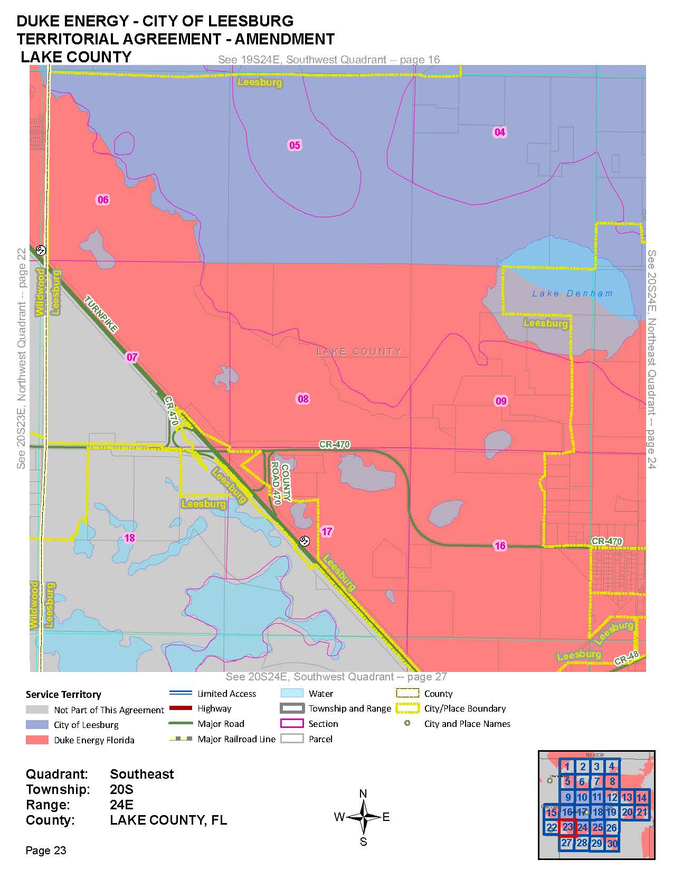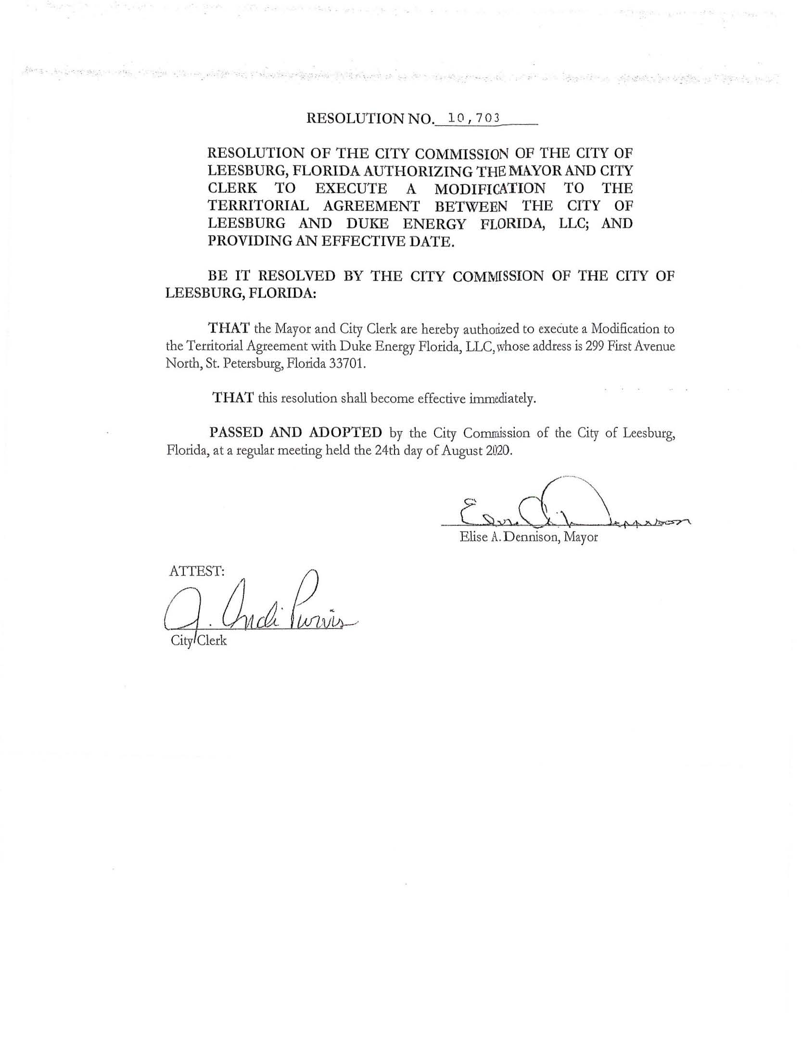

Order No. PSC-15-0278-PAA-EU, issued July 7, 2015, in Docket No. 150077-EU, In re: Joint petition for approval of territorial agreement in Lake and Sumter counties by the City of Leesburg and Duke Energy Florida, Inc.
Utilities Commission of the City of New Smyrna Beach v. Florida Public Service Commission, 469 So. 2d 731 (Fla. 1985).

