BEFORE THE FLORIDA PUBLIC SERVICE COMMISSION

In re: Joint petition for approval of swing service rider rates for January through December 2021, by Florida Public Utilities Company, Florida Public Utilities Company-Indiantown Division, Florida Public Utilities Company-Fort Meade, and Florida Division of Chesapeake Utilities Corporation. | DOCKET NO. 20200203-GU  ORDER NO. PSC-2020-0452-TRF-GU  ISSUED: November 23, 2020

The following Commissioners participated in the disposition of this matter:

GARY F. CLARK, Chairman
ART GRAHAM
JULIE I. BROWN
DONALD J. POLMANN
ANDREW GILES FAY

ORDER APPROVING SWING SERVICE RIDER RATES

BY THE COMMISSION:

On August 31, 2020, Florida Public Utilities Company, Florida Public Utilities Company – Indiantown Division, and Florida Public Utilities Company – Fort Meade (jointly, FPUC), as well as the Florida Division of Chesapeake Utilities Corporation (Chesapeake) (jointly, companies), filed a petition for approval of a revised swing service rider tariff for the period January through December 2021. FPUC is a local distribution company (LDC) subject to our regulatory jurisdiction pursuant to Chapter 366, Florida Statutes (F.S.). FPUC is a wholly-owned subsidiary of Chesapeake Utilities Corporation, which is headquartered in Dover, Delaware. Chesapeake is also an LDC subject to our jurisdiction under Chapter 366, F.S., and is an operating division of Chesapeake Utilities Corporation.
We first approved the companies’ swing service rider tariff in Order No. PSC-16-0422-TRF-GU (swing service order) and the initial swing service rider rates were in effect for the period March through December 2017. As required in the swing service order, the companies submitted the instant petition with revised 2021 swing service rider rates for our approval by September 1, 2020. The January through December 2020 swing service rider rates were approved in Order No. PSC-2019-0491-TRF-GU. The swing service rider is a cents per therm charge that is included in the monthly gas bill of transportation customers. This order addresses the 2021 swing service rider rates.
On September 8, 2020, the companies waived the 60-day file and suspend provision of Section 366.06(3), F.S., via an e-mail, which has been placed in the docket file. During its evaluation of the petition, a data request to the companies was issued for which responses were received on September 14, 2020, and on September 28, 2020. The updated swing service rider rates and revised tariff sheets are shown in Attachment A. We have jurisdiction over this matter pursuant to Sections 366.04, 366.05, and 366.06, F.S.
DECISION
The companies incur intrastate capacity costs when they transport natural gas on intrastate pipelines (i.e., pipelines operating within Florida only). The companies have two types of natural gas customers: sales and transportation. The swing service rider allows the companies to recover the intrastate capacity costs directly from all transportation customers as intrastate pipeline projects benefit all customers.
Types of Natural Gas Customers
Sales customers are primarily residential and small commercial customers that purchase natural gas from an LDC and receive allocations of intrastate capacity costs through the Purchased Gas Adjustment (PGA) charge. Of the joint petitioners in the instant docket, only Florida Public Utilities Company and Florida Public Utilities Company – Fort Meade have sales customers.
Transportation customers receive natural gas from third party marketers, also known as shippers and, therefore, do not pay the PGA charge to the LDC. The companies’ transportation customers can be categorized as Transitional Transportation Service (TTS) or non-TTS. TTS program shippers purchase gas in aggregated customer pools for residential and small commercial customers, who do not contract directly with a shipper for their gas supply. Of the joint petitioners in the instant docket, only Florida Public Utilities Company – Indiantown Division (Indiantown) and Chesapeake have TTS customers.
TTS customers receive allocations of intrastate capacity costs through the swing service rider. Prior to the approval of the swing service rider, TTS customers received allocations of intrastate capacity costs through the Operational Balancing Account (OBA) mechanism. The OBA mechanism allowed Indiantown and Chesapeake to assign intrastate capacity costs to TTS shippers, who then passed the costs on to the TTS customers for whom they purchase gas. With the approval of the swing service rider, TTS customers are now charged directly for their allocated portion of the intrastate capacity costs (rather than Indiantown and Chesapeake charging the shippers who then passed the costs on to the TTS customers).
Non-TTS customers are primarily large commercial or industrial customers who contract directly with a shipper for their natural gas supply. Prior to the approval of the swing service rider, non-TTS customers were not paying a share of the intrastate capacity costs. We approved a stepped implementation process for the swing service rider for non-TTS customers because the implementation of the swing service rider can have a significant financial impact on those customers who previously had not been allocated any portion of the intrastate capacity costs.
Specifically, the swing service order approved a five-year implementation period for non-TTS customers with a 20 percent per year stepped allocation. Accordingly, the 2020 swing service charges included an 80 percent allocation of intrastate capacity costs to the non-TTS customers; the instant petition includes a 100 percent allocation of intrastate capacity costs to the non-TTS customers. The allocation to the non-TTS customers will remain at 100 percent in future petitions.
Updated 2021 Swing Service Rider Rates
The updated 2021 swing service rider rates were calculated based on the same methodology approved in the swing service order. As shown in the companies’ petition, the total intrastate capacity costs for the period July 2019 through June 2020 are $18,173,823. The total intrastate capacity costs reflect payments by the companies to intrastate pipelines for the transportation of natural gas, pursuant to approved transportation agreements. In addition, the intrastate capacity costs include payments to outside contractors the companies hired to provide expertise on the purchase of commodity and capacity.
Of these costs, $6,082,989 will be billed directly to certain large special contract customers. The remaining costs of $12,090,834 are allocated between sales and transportation customers and will be recovered during the period January 1, 2021 through December 31, 2021.
The companies used actual therm usage data for the period July 2019 through June 2020 to allocate the intrastate capacity costs. Based on the usage data, the appropriate split for allocating the cost is $8,571,149 (70.9 percent) to transportation customers and $3,519,684 (29.1 percent) to sales customers. The sales customers’ share of the cost is embedded in the PGA.
The transportation customers’ share ($8,571,149) is allocated to the various transportation rate schedules in proportion with each rate schedule’s share of the companies’ total throughput. To calculate the swing service rider rates, the cost allocated to each rate schedule is divided by the rate schedule’s number of therms.
As stated earlier, TTS customers are charged an allocated portion of the intrastate capacity costs, while non-TTS customers were subject to a phased implementation in the 2017 through 2020 swing service rider rates. Since non-TTS customers are allocated 100 percent of the total intrastate capacity costs in 2021, the swing service revenues the companies are projected to receive is a total of $8,571,149.
Credit to the PGA
The total intrastate capacity costs are embedded in the PGA with the projected 2021 swing service rider revenues incorporated as a credit in the calculation of the 2021 PGA. The amount credited to the 2021 PGA is $8,571,149 plus $6,082,989 received from special contract customers, for a total of $14,654,138.
We have reviewed the total projected intrastate capacity costs and verified that the costs included are appropriate. We further find that the methodology for calculating the swing service rider rates is consistent with the swing service order. For these reasons, we hereby approve the proposed swing service rider rates for the period January through December 2021.

Based on the foregoing, it is

ORDERED by the Florida Public Service Commission that Florida Public Utilities Company’s, Florida Public Utilities Company – Indiantown Division’s, Florida Public Utilities Company – Fort Meade’s, and Florida Division of Chesapeake Utilities Corporation’s Joint Petition for approval of swing service rider rates for the period January through December 2021 is hereby granted. It is further

ORDERED that the swing service rider rates as stated on Attachment A hereto are approved for the period January through December 2021. It is further

ORDERED that if a protest is filed within 21 days of the issuance of this order, the tariffs shall remain in effect, with any revenues held subject to refund, pending resolution of the protest. If no timely protest is filed, this docket shall be closed upon the issuance of a consummating order.

By ORDER of the Florida Public Service Commission this 23rd day of November, 2020.

/s/ Adam J. Teitzman
ADAM J. TEITZMAN
Commission Clerk
Florida Public Service Commission
2540 Shumard Oak Boulevard
Tallahassee, Florida 32399
(850) 413-6770
www.floridapsc.com

Copies furnished: A copy of this document is provided to the parties of record at the time of issuance and, if applicable, interested persons.

SBr

NOTICE OF FURTHER PROCEEDINGS

The Florida Public Service Commission is required by Section 120.569(1), Florida Statutes, to notify parties of any administrative hearing or judicial review of Commission orders that is available under Sections 120.57 or 120.68, Florida Statutes, as well as the procedures and time limits that apply. This notice should not be construed to mean all requests for an administrative hearing or judicial review will be granted or result in the relief sought.

Mediation may be available on a case-by-case basis. If mediation is conducted, it does not affect a substantially interested person's right to a hearing.

The Commission's decision on this tariff is interim in nature and will become final, unless a person whose substantial interests are affected by the proposed action files a petition for a formal proceeding, in the form provided by Rule 28-106.201, Florida Administrative Code. This petition must be received by the Office of Commission Clerk, 2540 Shumard Oak Boulevard, Tallahassee, Florida 32399-0850, by the close of business on December 14, 2020.

In the absence of such a petition, this Order shall become final and effective upon the issuance of a Consummating Order.

Any objection or protest filed in this docket before the issuance date of this order is considered abandoned unless it satisfies the foregoing conditions and is renewed within the specified protest period.

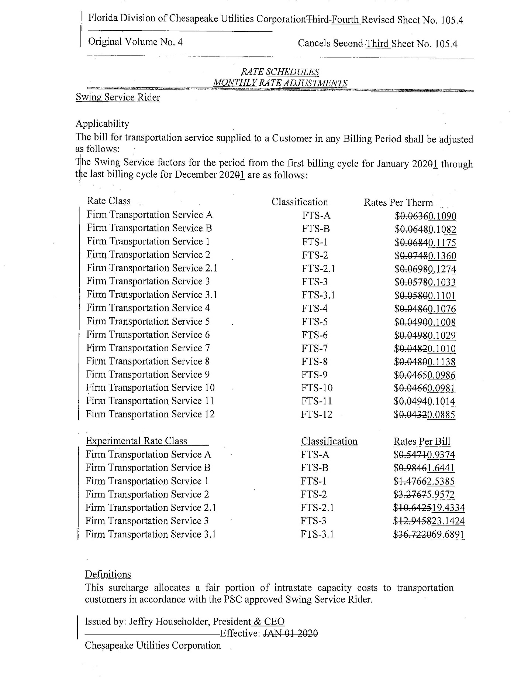

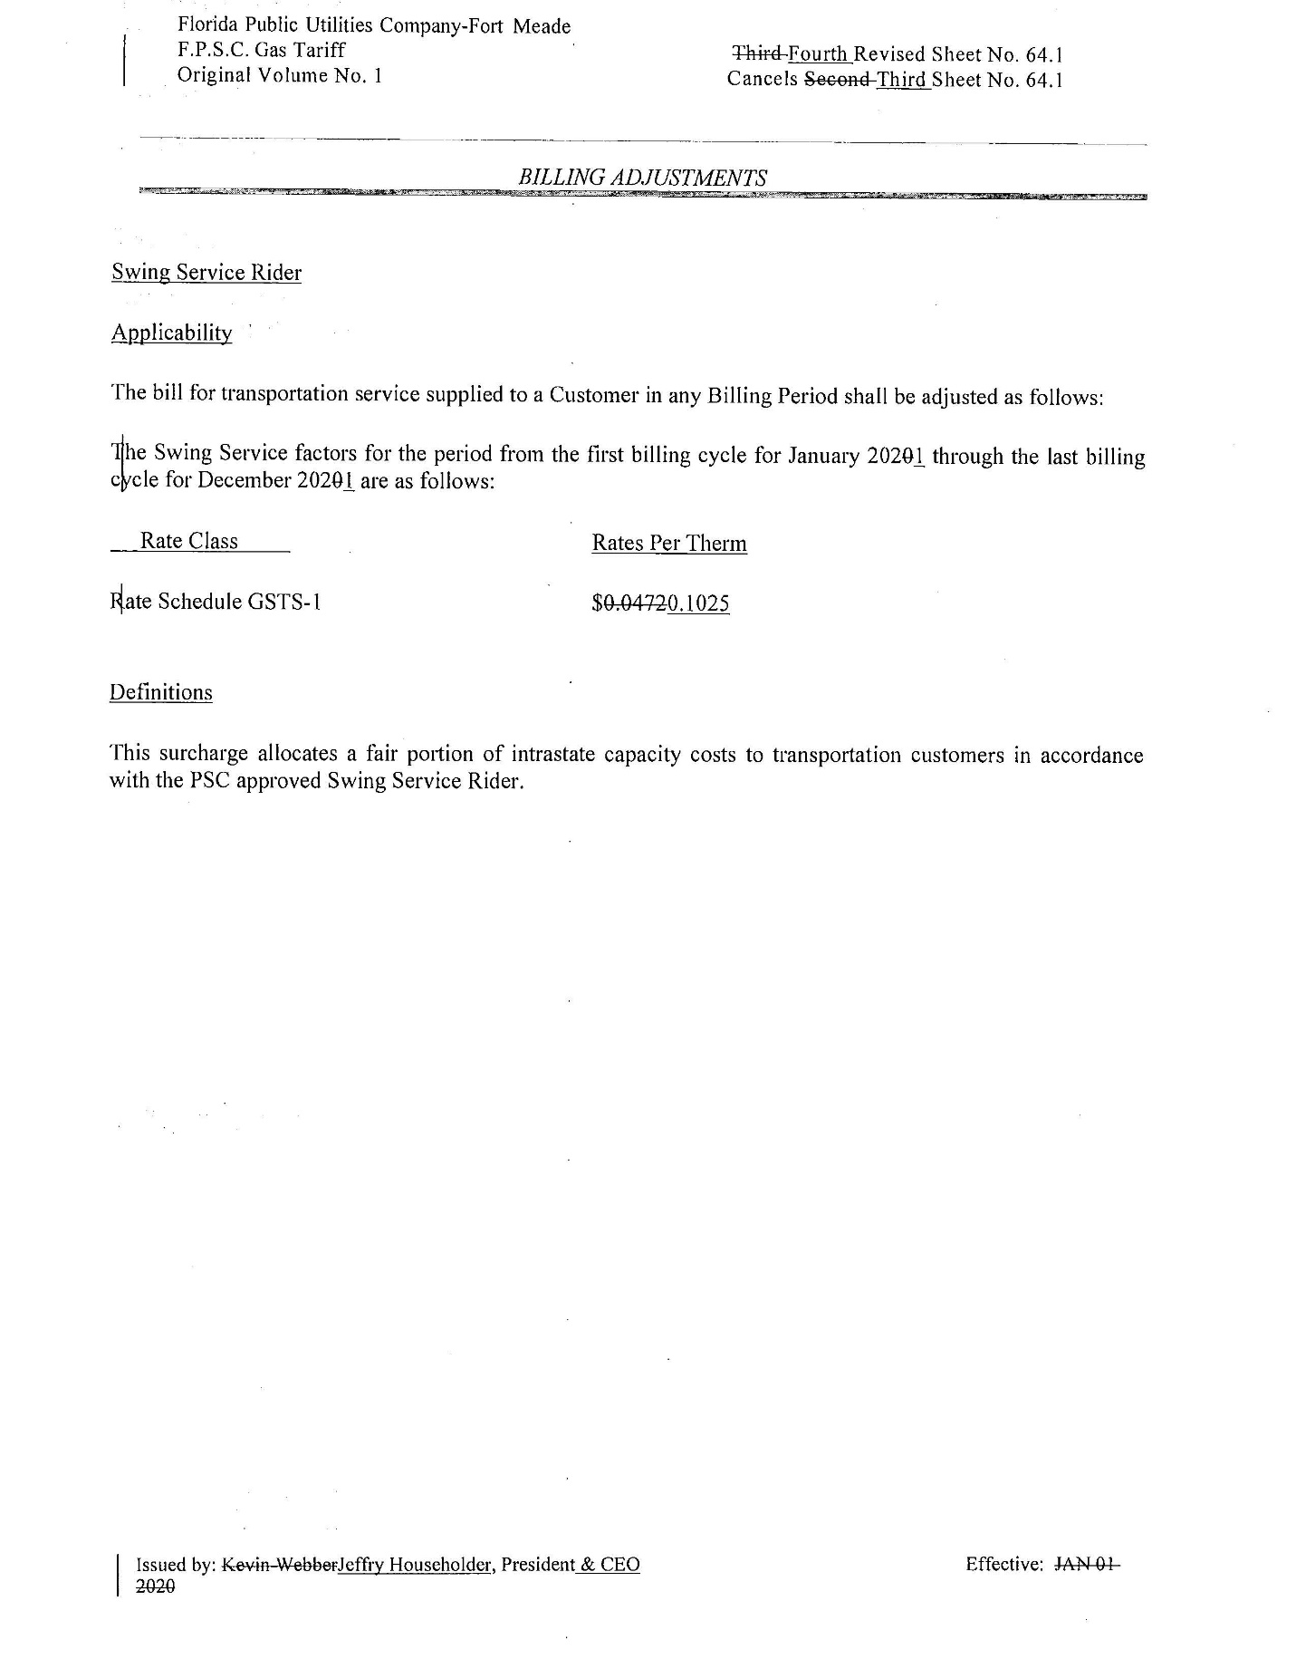

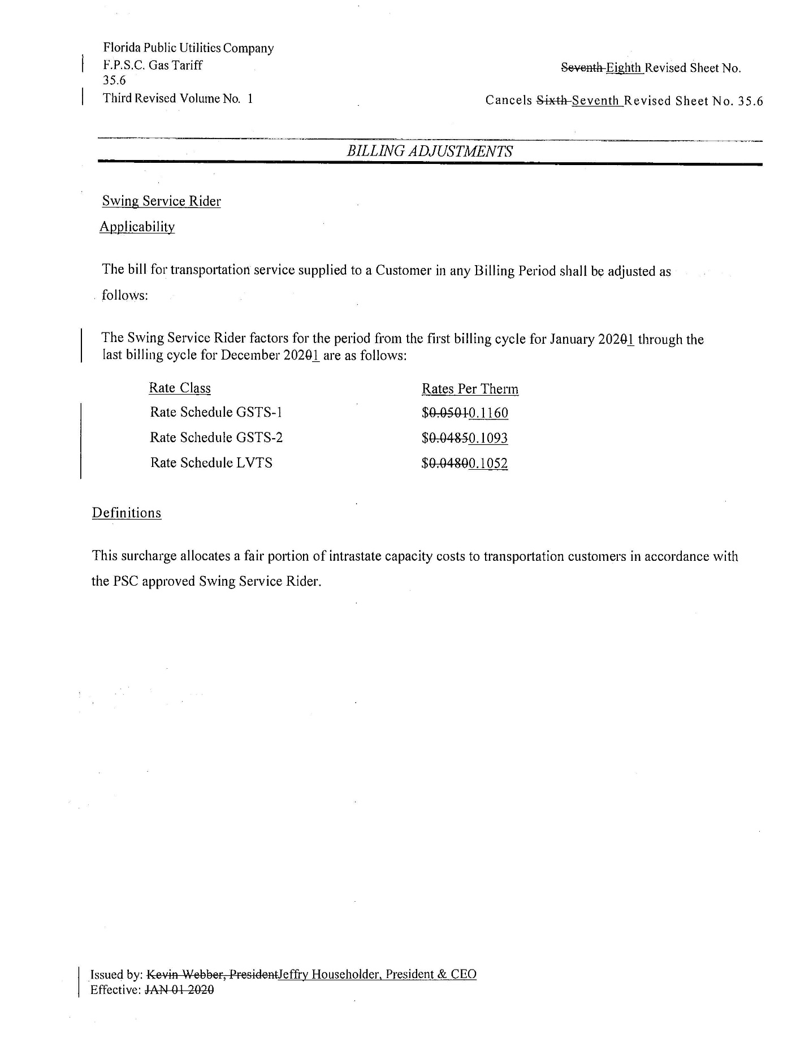

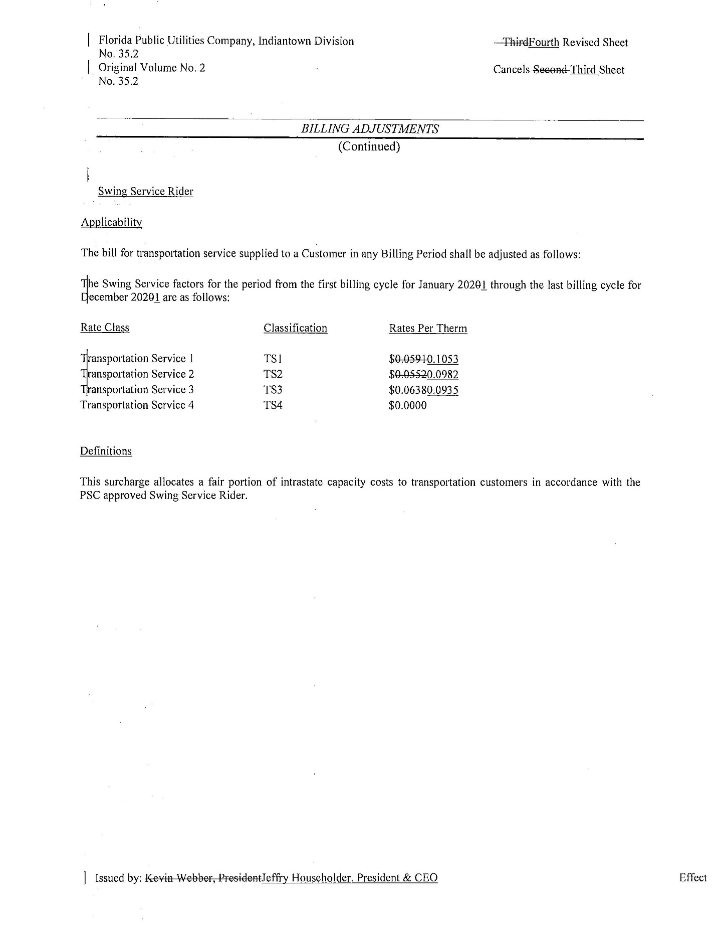

Order No. PSC-16-0422-TRF-GU, issued October 3, 2016, Docket No. 160085-GU, In re: Joint petition for approval of swing service rider, by Florida Public Utilities Company, Florida Public Utilities Company-Indiantown Division, Florida Public Utilities Company-Fort Meade, and Florida Division of Chesapeake Utilities Corporation.
Order No. PSC-2019-0491-TRF-GU, issued November 19, 2019, Docket No. 20190160-GU, In re: Joint petition for approval of swing service rider rate for January through December 2020, by Florida Public Utilities Company, Florida Public Utilities Company-Indiantown Division, Florida Public Utilities Company-Fort Meade, and Florida Division of Chesapeake Utilities Corporation.
We set the PGA charge in our annual PGA cost recovery clause proceeding.
We do not regulate the shippers or their charges for the gas commodity.
See direct testimony of Derrick M. Craig on behalf of FPUC, filed on August 7, 2020, Document No. 04291-2020, in Docket No. 20200003-GU, Exhibit No. DMC-2, Schedule E-1, line 8 on Page 1 of 6.

