State of Florida |  | Public Service Commission  Capital Circle Office Center ● 2540 Shumard Oak Boulevard  Tallahassee, Florida 32399-0850  -M-E-M-O-R-A-N-D-U-M-
DATE: | December 22, 2020
TO: | Office of Commission Clerk (Teitzman)
FROM: | Division of Economics (Forrest, Coston)  Office of the General Counsel (Osborn, Crawford)
RE: | Docket No. 20200216-GU – Request for approval of tariff modifications to accommodate receipt and transportation of renewable natural gas from customers, by Florida City Gas.
AGENDA: | 01/05/21 – Regular Agenda – Tariff Filing - Interested Persons May Participate
COMMISSIONERS ASSIGNED: |  |  | All Commissioners
PREHEARING OFFICER: |  |  | Administrative
CRITICAL DATES: |  |  | 05/14/21 (8-Month Effective Date)
SPECIAL INSTRUCTIONS: |  |  | None

Case Background
Florida City Gas (FCG or utility) is a local distribution company subject to the Commission’s jurisdiction pursuant to Chapter 366, Florida Statutes (F.S.). FCG serves approximately 114,000 residential, commercial, and industrial natural gas customers in southern Florida. On September 15, 2020, the utility filed a petition requesting approval of a new Renewable Natural Gas Service (RNGS) tariff to allow FCG to provide biogas conditioning services for the purpose of converting biogas into usable renewable natural gas (RNG) for the biogas producer. In addition, the petition requests modifications to FCG’s Volume No. 10 natural gas tariffs to accommodate and allow for the receipt and transportation of RNG through the utility’s distribution system on behalf of the biogas producer.
RNG is produced by cleaning and conditioning biogas in order to meet pipeline quality gas standards. In 2017, the Commission approved a similar petition by Peoples Gas System by Order No. PSC-2017-0497-TRF-GU. The proposed new RNGS tariff, as shown on tariff sheet Nos. 74.1 through 74.3, and the additional Volume No. 10 proposed tariff modifications, are included as Attachment A of the recommendation.
During the review of this petition, staff issued two data requests, for which responses were received on October 21, 2020 and November 25, 2020. By Order No. PSC-2020-0459-PCO-EI, issued on November 23, 2020, the Commission suspended the tariff pursuant to the 60-day file and suspend provision in Section 366.06(3), F.S. The Commission has jurisdiction over this matter pursuant to Sections 366.03, 366.04, 366.05, and 366.06, F.S.

Discussion of Issues

Issue 1:
Should the Commission approve FCG’s proposed new RNGS tariff and modifications to its current Volume No. 10 natural gas tariffs?

Recommendation:
Yes, the Commission should approve FCG’s proposed new RNGS tariff and modifications to its current Volume No. 10 tariffs, effective January 5, 2021. The RNGS tariff would provide FCG with an opportunity to provide biogas conditioning services to interested customers and the utility demonstrated a reasonable approach to implementing the tariff. A participating customer would enter into an agreement with FCG and all capital and operating costs associated with the RNG cleaning and conditioning facility will be borne by the customer over the life of the contract. (Forrest, Coston)

Staff Analysis: FCG explained that it has been approached by municipalities or private businesses seeking the opportunity to contract with the utility to construct and operate conditioning facilities to convert biogas into pipeline quality RNG. Specifically, the utility stated that FCG has been in contact with five entities who are evaluating the production of RNG from landfill gas or waste treatment facilities. The primary intention from the biogas-producing customers is to use the RNG to help offset their natural gas demand. The utility stated that sources of biogas include landfills, wastewater treatment plants, or agricultural digesters associated with facilities such as dairies. FCG also stated that the utility has received inquiries from residential and commercial/industrial customers regarding the availability of RNG.
In its petition, the utility explained that once biogas has been cleaned and conditioned to pipeline quality safety standards, RNG is a “carbon-neutral” energy source. Once conditioned, RNG can be interchangeable with natural gas from other sources. FCG stated in its petition that the use of RNG “reduces total emission of greenhouse gases.” Without the collection of the biogas to be conditioned into RNG, the biogas produced would escape into the atmosphere or be burned off at the source with the emissions from the burning process released into the atmosphere. Biogas producers currently may elect to install and maintain their own conditioning equipment or contract with a third-party for the service. FCG estimates that the costs for biogas conditioning equipment could range from $5 to $25 million for a single facility.
FCG also noted that by assisting customers to convert biogas into RNG, the resulting natural gas would offset the demand for natural gas the customer is currently purchasing from the utility, thus freeing capacity on FCG’s distribution system. The utility states that the potential offset of natural gas by the customer could allow for new growth within FCG’s service territory.

Proposed New RNGS Tariff
Under the proposal, FCG would enter into a contract with a biogas-producing customer to construct and operate the RNG facilities on behalf of the customer. The resulting RNG would be used onsite by the producing customer or injected into FCG’s distribution system for transportation and delivery to another location on behalf of the customer. The tariff requires that all RNG be conditioned to meet the utility’s gas quality and heat standards. This requirement would ensure that all RNG produced under the proposed tariff can be safely used without any adverse impact to the integrity of the customer’s and FCG’s natural gas equipment. The biogas equipment would be installed on the customer’s property or on utility-owned property if there isn’t enough room on the customer’s property.
The proposed tariff requires that the utility and customer enter into a mutually satisfactory RNG Service Agreement (agreement). The terms of this agreement would include the design, location, quantity, quality specifications, operational requirements, and the required Monthly Service Charge. This charge would be designed to cover the costs of the construction, operational costs, and carrying costs of the facilities. In addition, in the event that RNG is injected into FCG’s distribution system for transportation on behalf of the producing customer, the RNGS tariff requires that the customer pay the Commission-approved per-therm distribution charge under the applicable tariff. This safeguard ensures that there is not any cross-subsidization for transporting and delivering RNG on FCG’s distribution system on behalf of the biogas customer.
In the event that a customer produces more RNG than it needs for its facility, the customer can do one of the following: (a) make arrangements with FCG to inject the excess produced RNG into FCG’s system to deliver it to the producing customer at a different location, (b) inject the excess RNG into FCG’s system to deliver it to a third party that is also a customer of FCG, or (c) inject the excess into FCG’s system for delivery to the interstate pipeline for sale in the interstate gas market. In the case of excess supply of RNG, the customer served under the tariff would contract directly with the purchasing entity of the excess supply. There is an additional option of storing the excess RNG if there are storage facilities available to that customer.
Finally, depending on the price and other variables such as the location of the biogas source, FCG stated that the RNG could be purchased by FCG as part of its system supply, which would allow the utility to include in its portfolio a renewable natural gas source. Should FCG elect to purchase RNG from a biogas producer to serve its customers, FCG would seek Commission approval of the RNG costs through the annual Purchased Gas Adjustment proceeding. FCG explained that it is anticipated that the cost of the RNG would be higher compared to the current cost of fossil natural gas; however, the location of the biogas producer could mitigate pipeline capacity costs FCG incurs to transport natural gas into its service territory.

Impact on the General Body of Ratepayers
FCG stated that the RNGS tariff has essential safeguards that ensure that the utility’s general body of ratepayers will not subsidize the biogas customers taking service under the RNGS tariff. Specifically, the utility stated that it would ensure that service taken under the proposed RNGS tariff will not affect any ratepayers by confirming the credit worthiness of the customers taking service under the tariff. In response to staff’s first data request, the utility stated it will do its due diligence to ensure that the non-participants are not at risk by requiring RNGS customers to provide one of the following options: (a) a deposit in the amount of two months estimated billing, (b) providing an immutable and binding letter of credit, or (c) a surety bond. In addition, the utility stated that customers served under the RNGS tariff will also be required to provide banking references. FCG will perform credit analyses for potential customers by using a reputable and unbiased reporting agency such as Dun & Bradstreet or a similar reporting agency. If a biogas customer were to default, FCG stated that the utility would discontinue biogas conditioning services and secure its equipment, and seek resolution of default according to the method used to guarantee credit.

Staff recommends approval of the petition based, in part, on FCG’s assertion that it will implement a thorough and reasonable process to evaluate the credit worthiness of a potential customer to be served under the RNGS tariff, and the utility’s own internal risk assessment policies. Based on this process, the utility does not anticipate any cost impact to the general body of ratepayers.

Proposed Modifications to Volume No. 10 Tariffs
The proposed tariff modifications to FCG’s natural gas tariffs, Volume 10, are necessary tariff changes to allow FCG to receive and transport on its distribution system the RNG on behalf of the biogas-producing customer. These changes recognize that an RNG customer could be delivering gas into the utility’s system, not taking it out. Traditionally, natural gas utilities receive natural gas from intrastate or interstate pipelines.

Conclusion
Staff recommends that the Commission should approve FCG’s proposed new RNGS tariff and proposed modifications to its current Volume No. 10 tariffs, effective January 5, 2021, as shown in Attachment A of this recommendation. The RNGS tariff would provide FCG with an opportunity to provide biogas conditioning services to interested customers and the utility demonstrated a reasonable approach to implementing the tariff. A participating customer would enter into an agreement with FCG and all capital and operating costs associated with the RNG cleaning and conditioning facility will be borne by the customer over the life of the contract.

Issue 2:
Should this docket be closed?

Recommendation:
Yes. If Issue 1 is approved and a protest is filed within 21 days of the issuance of the order, the tariffs should remain in effect, with any revenues held subject to refund, pending resolution of the protest. If no timely protest is filed, this docket should be closed upon the issuance of a consummating order. (Osborn, Crawford)

Staff Analysis:
If Issue 1 is approved and a protest is filed within 21 days of the issuance of the order, the tariffs should remain in effect, with any revenues held subject to refund, pending resolution of the protest. If no timely protest is filed, this docket should be closed upon the issuance of a consummating order.

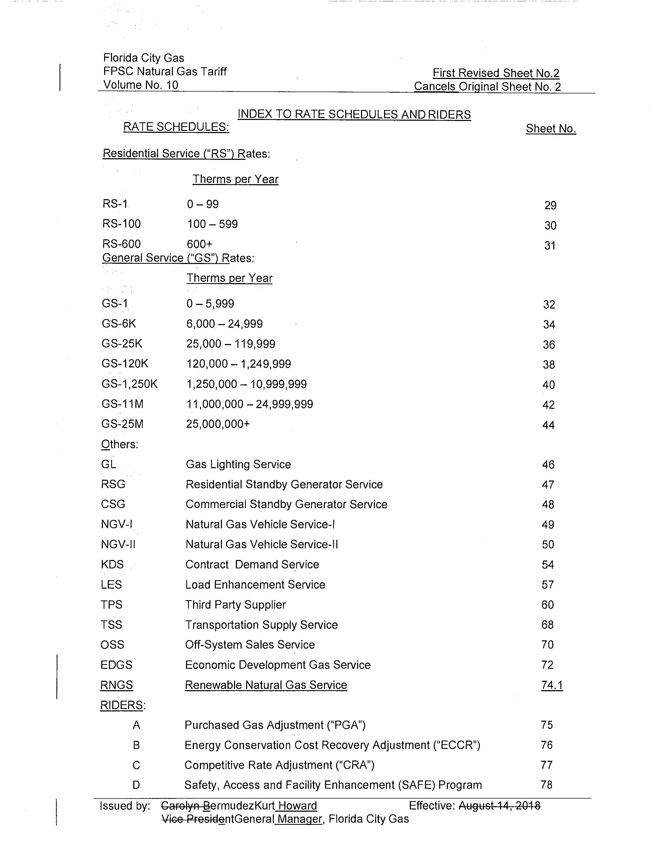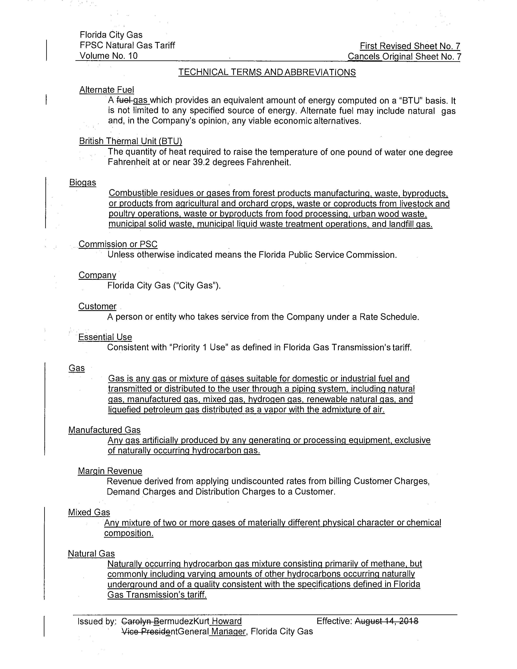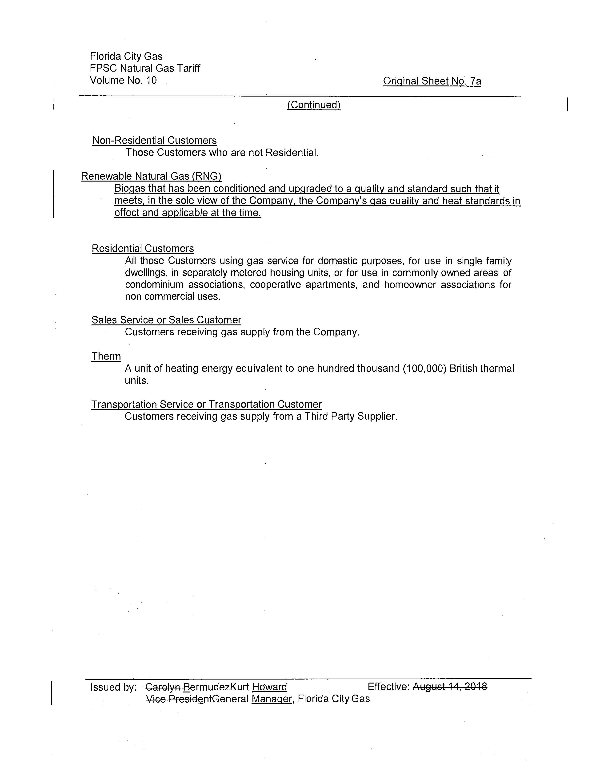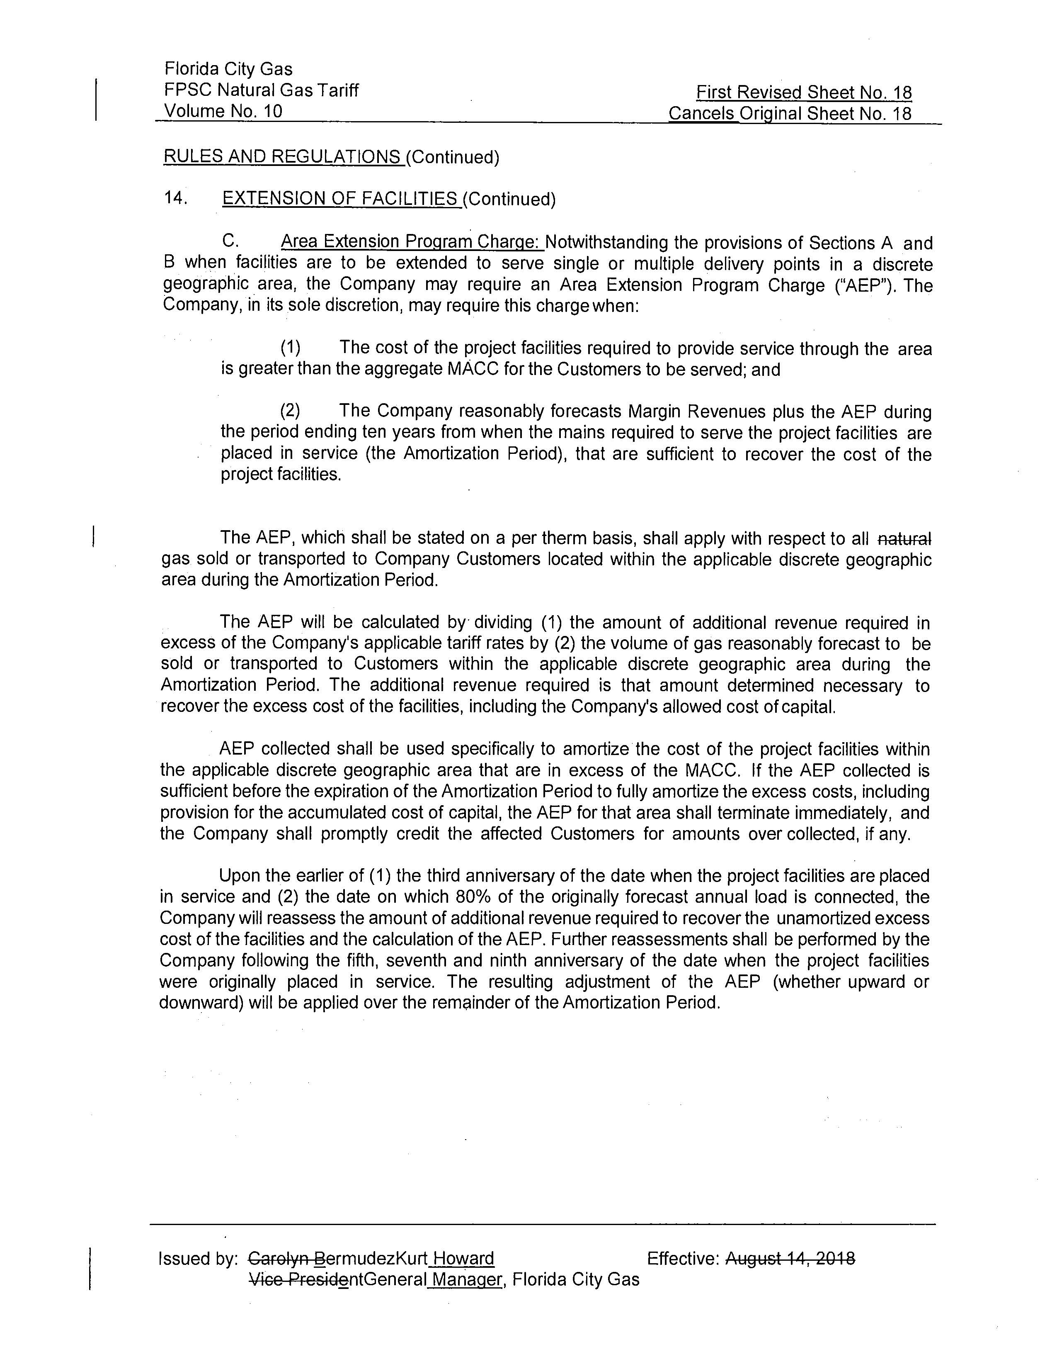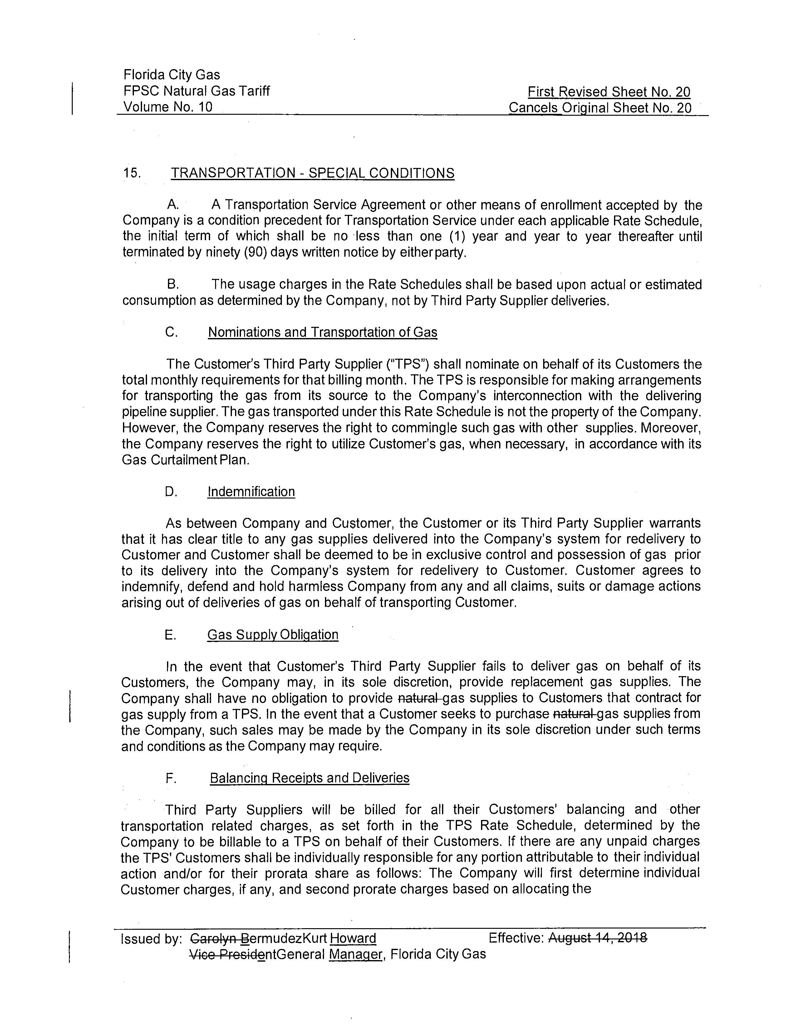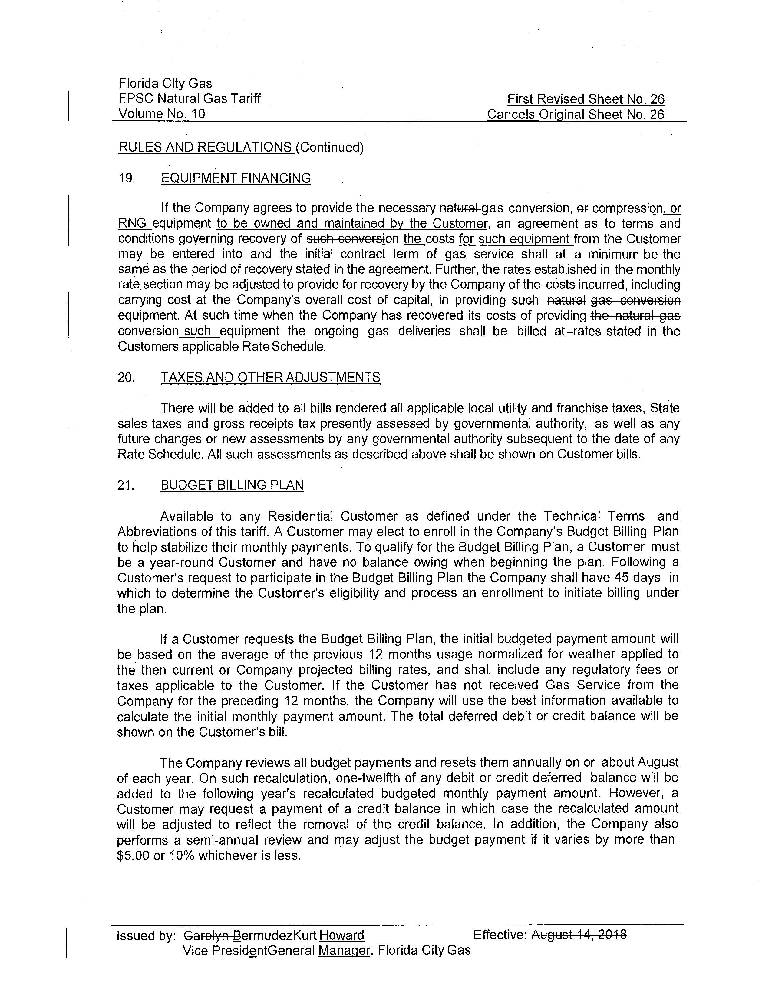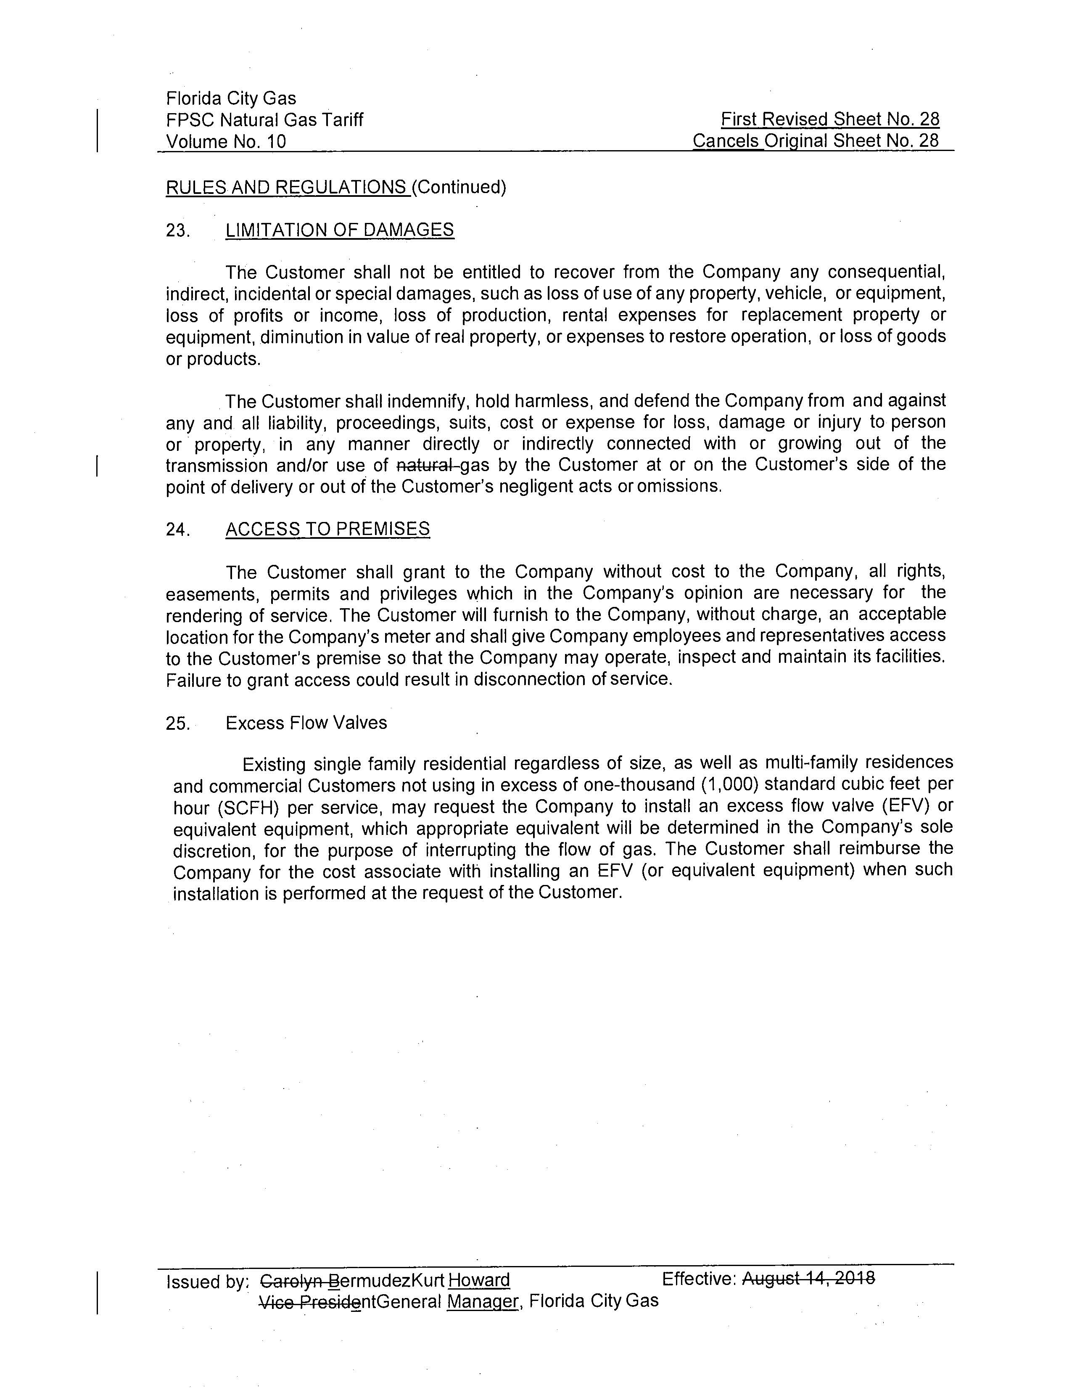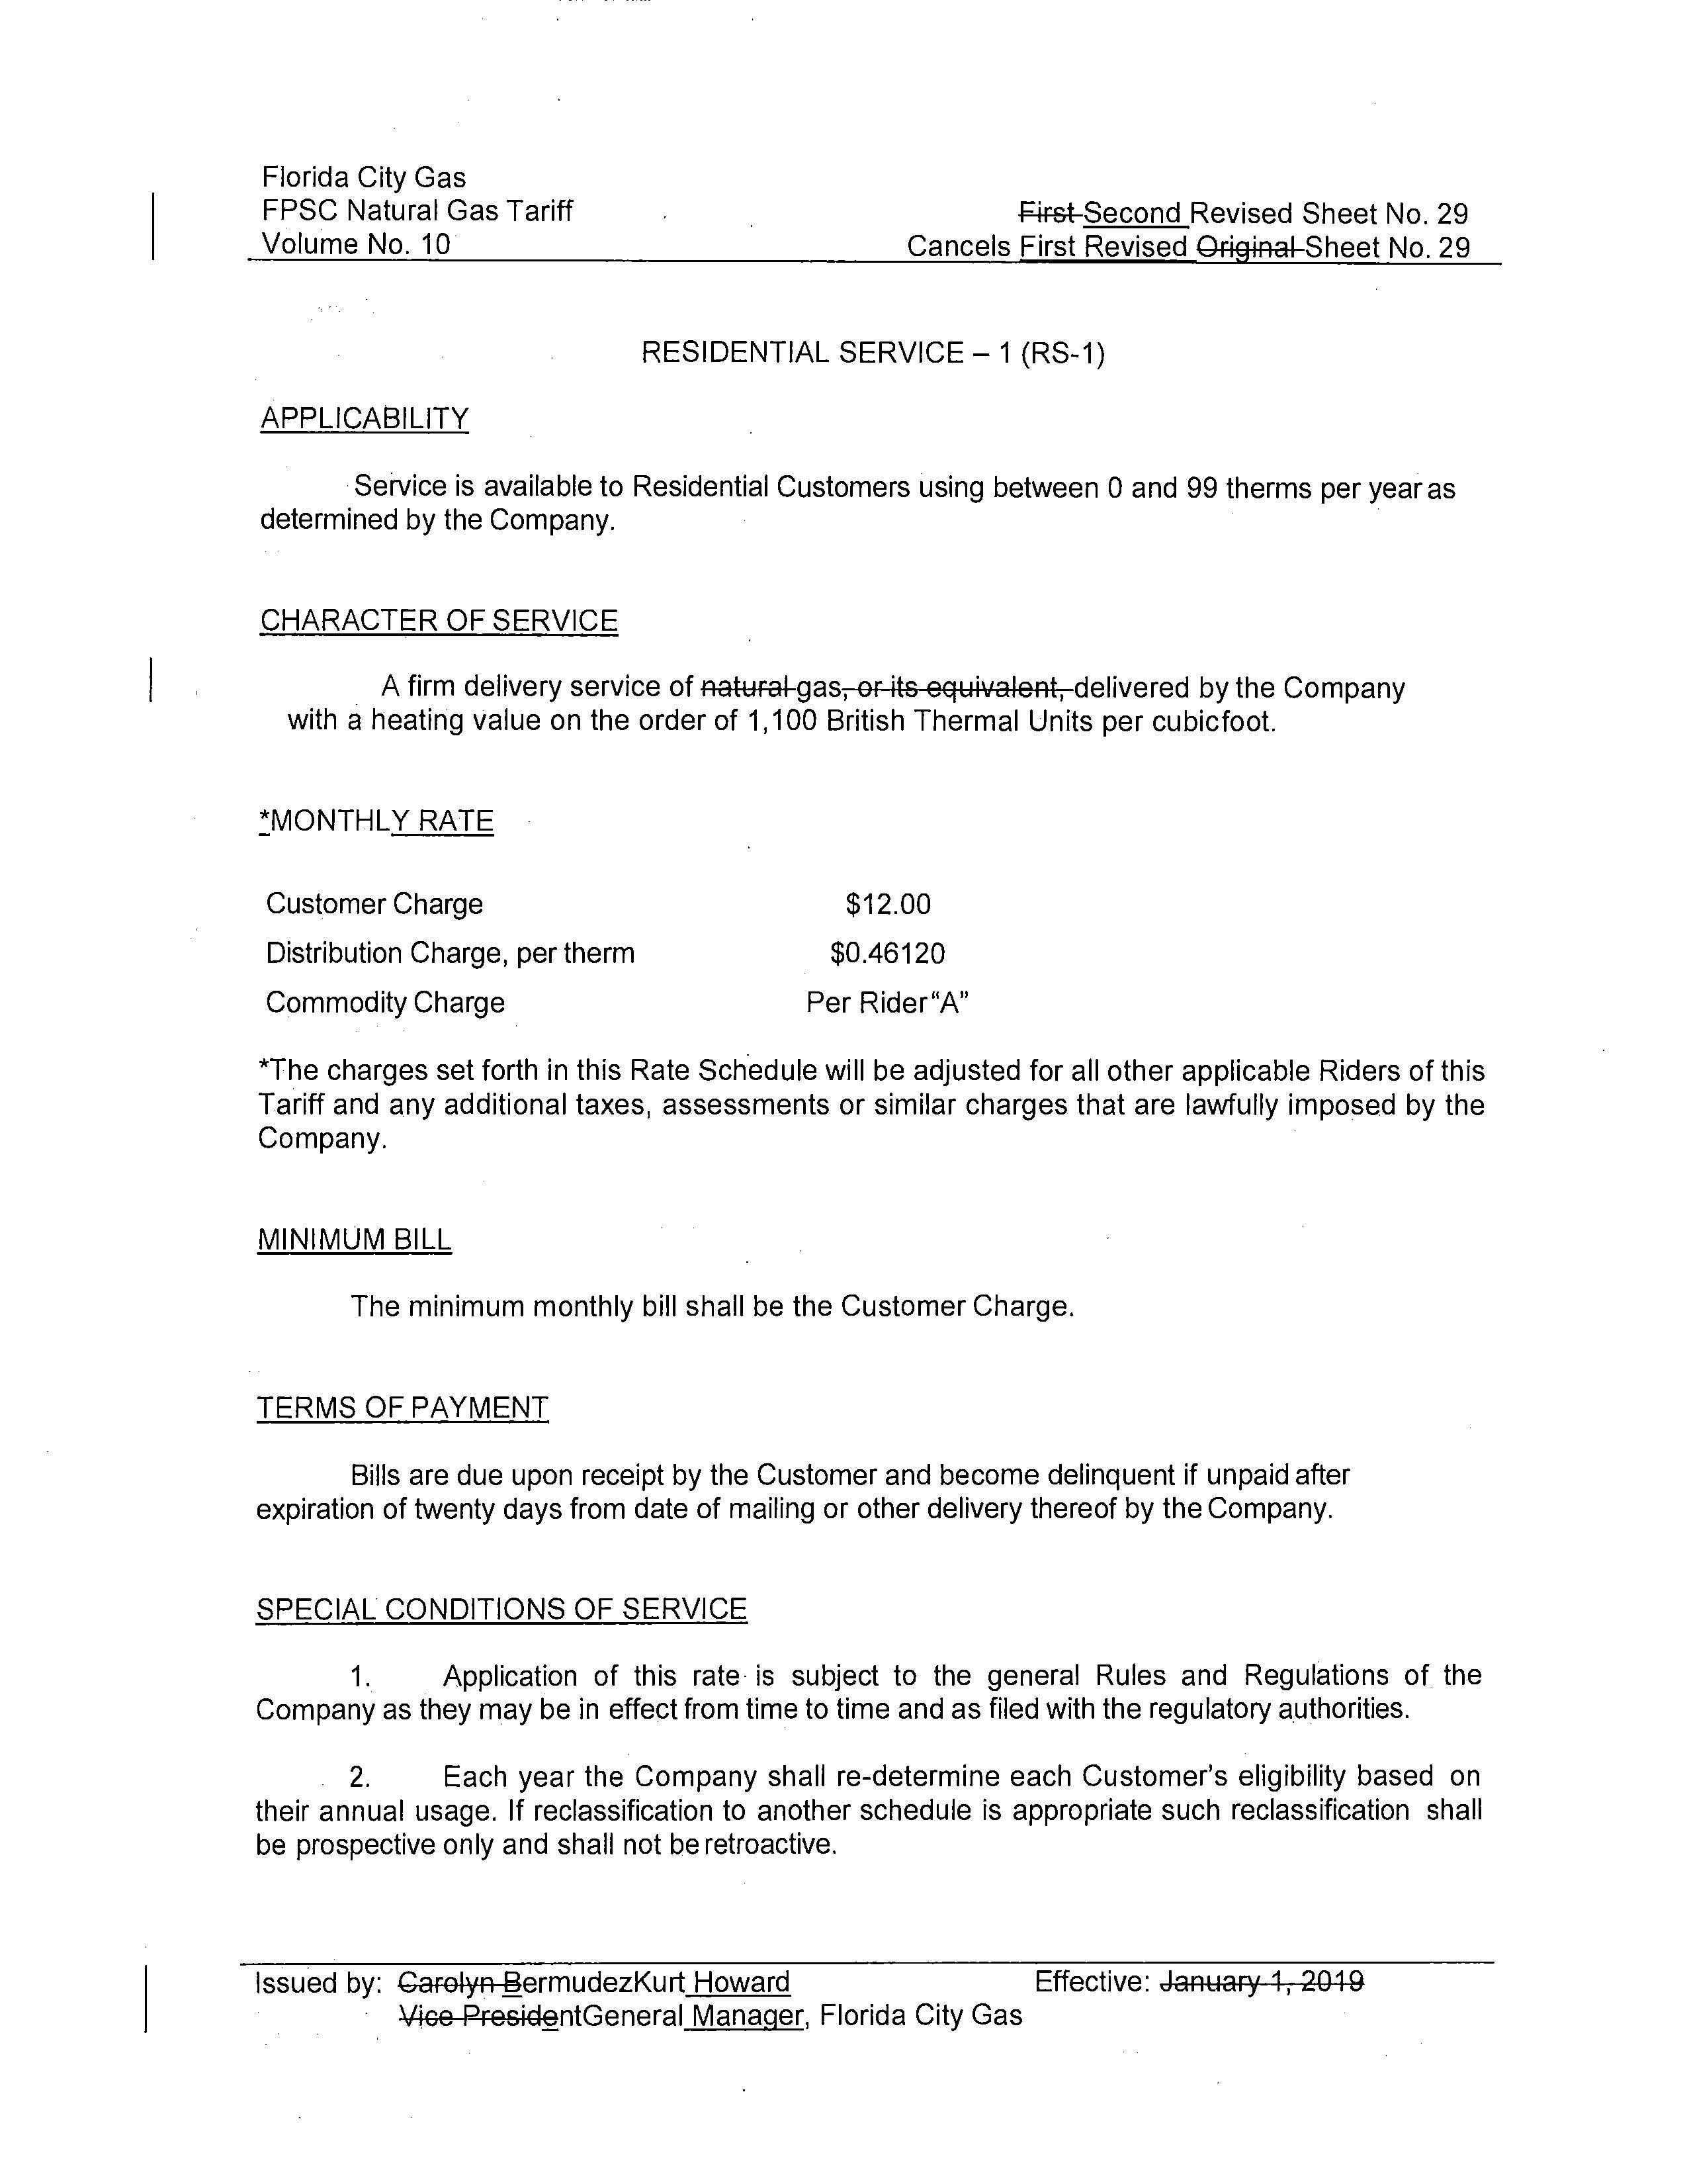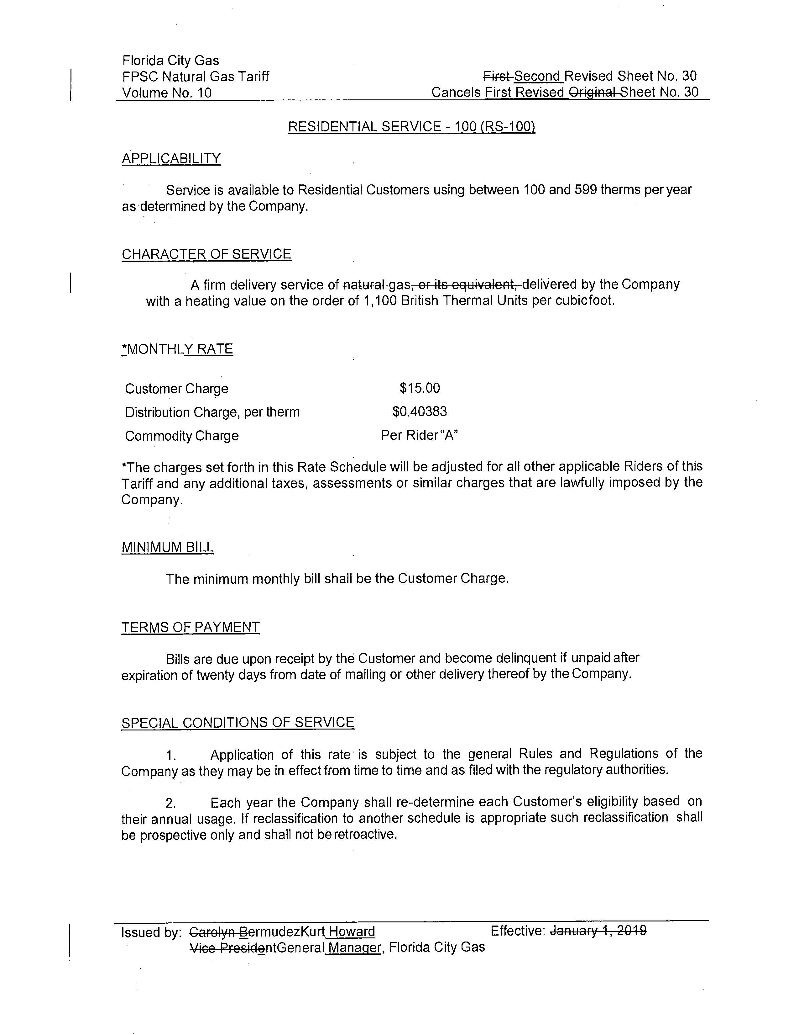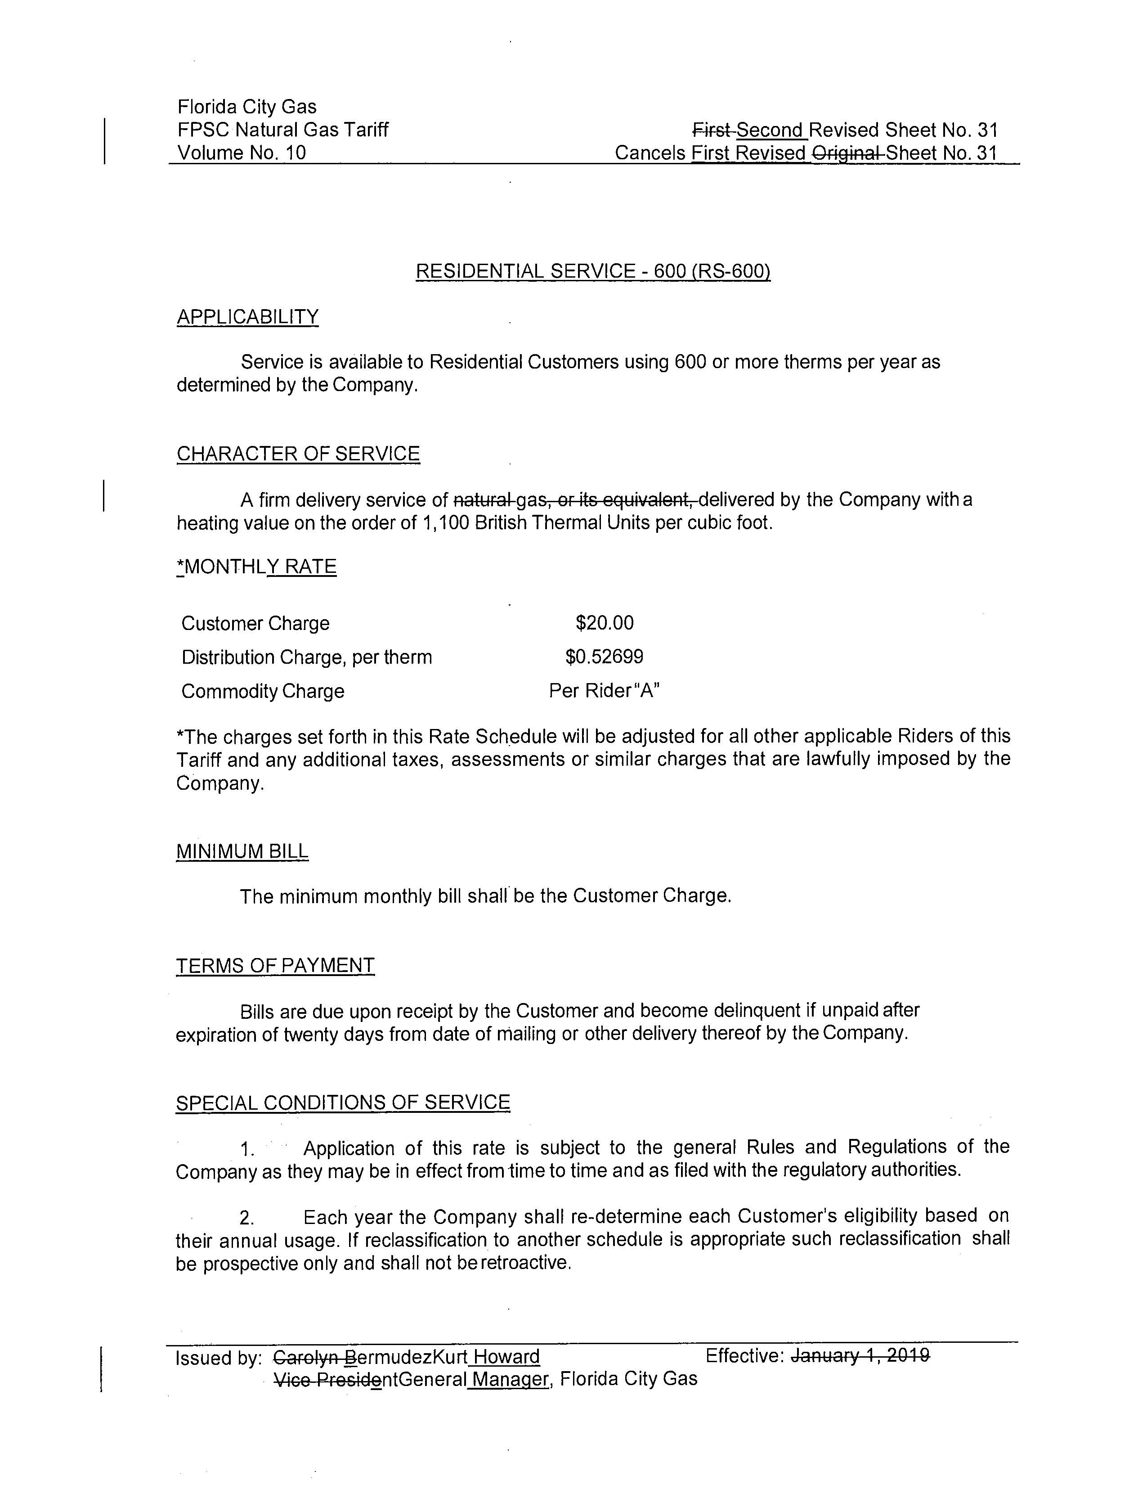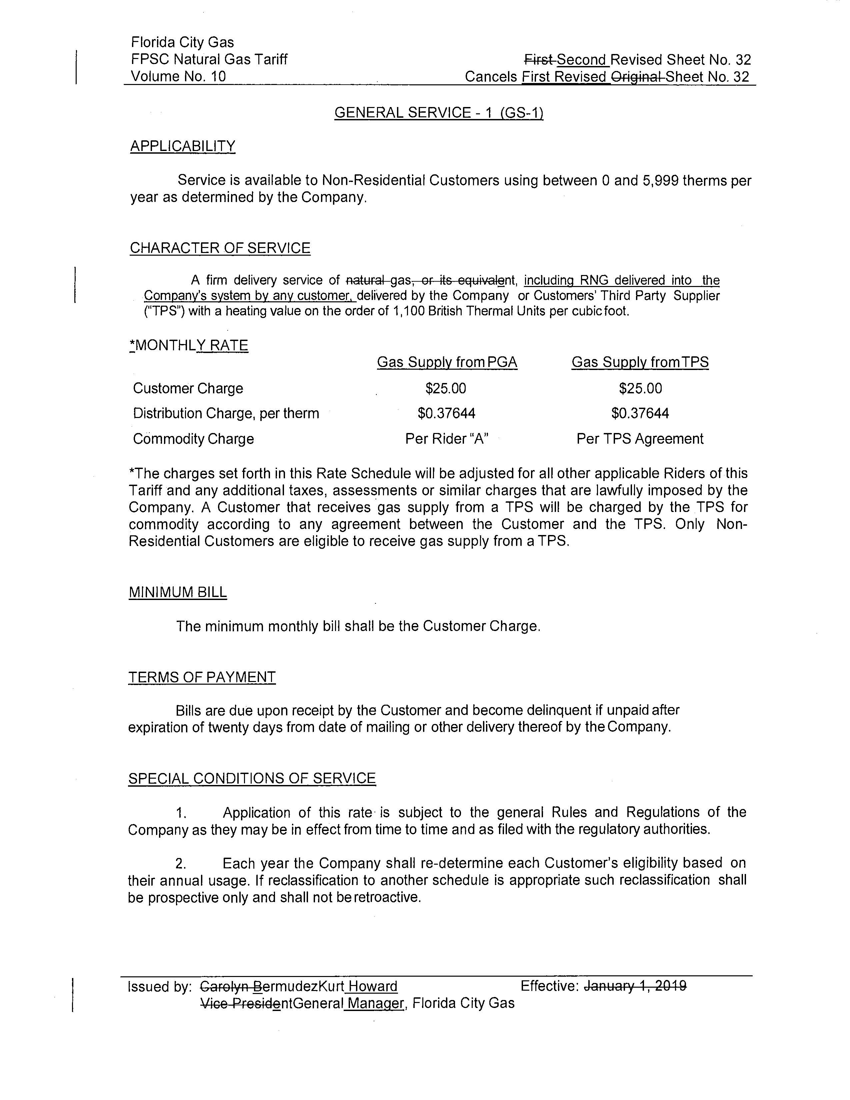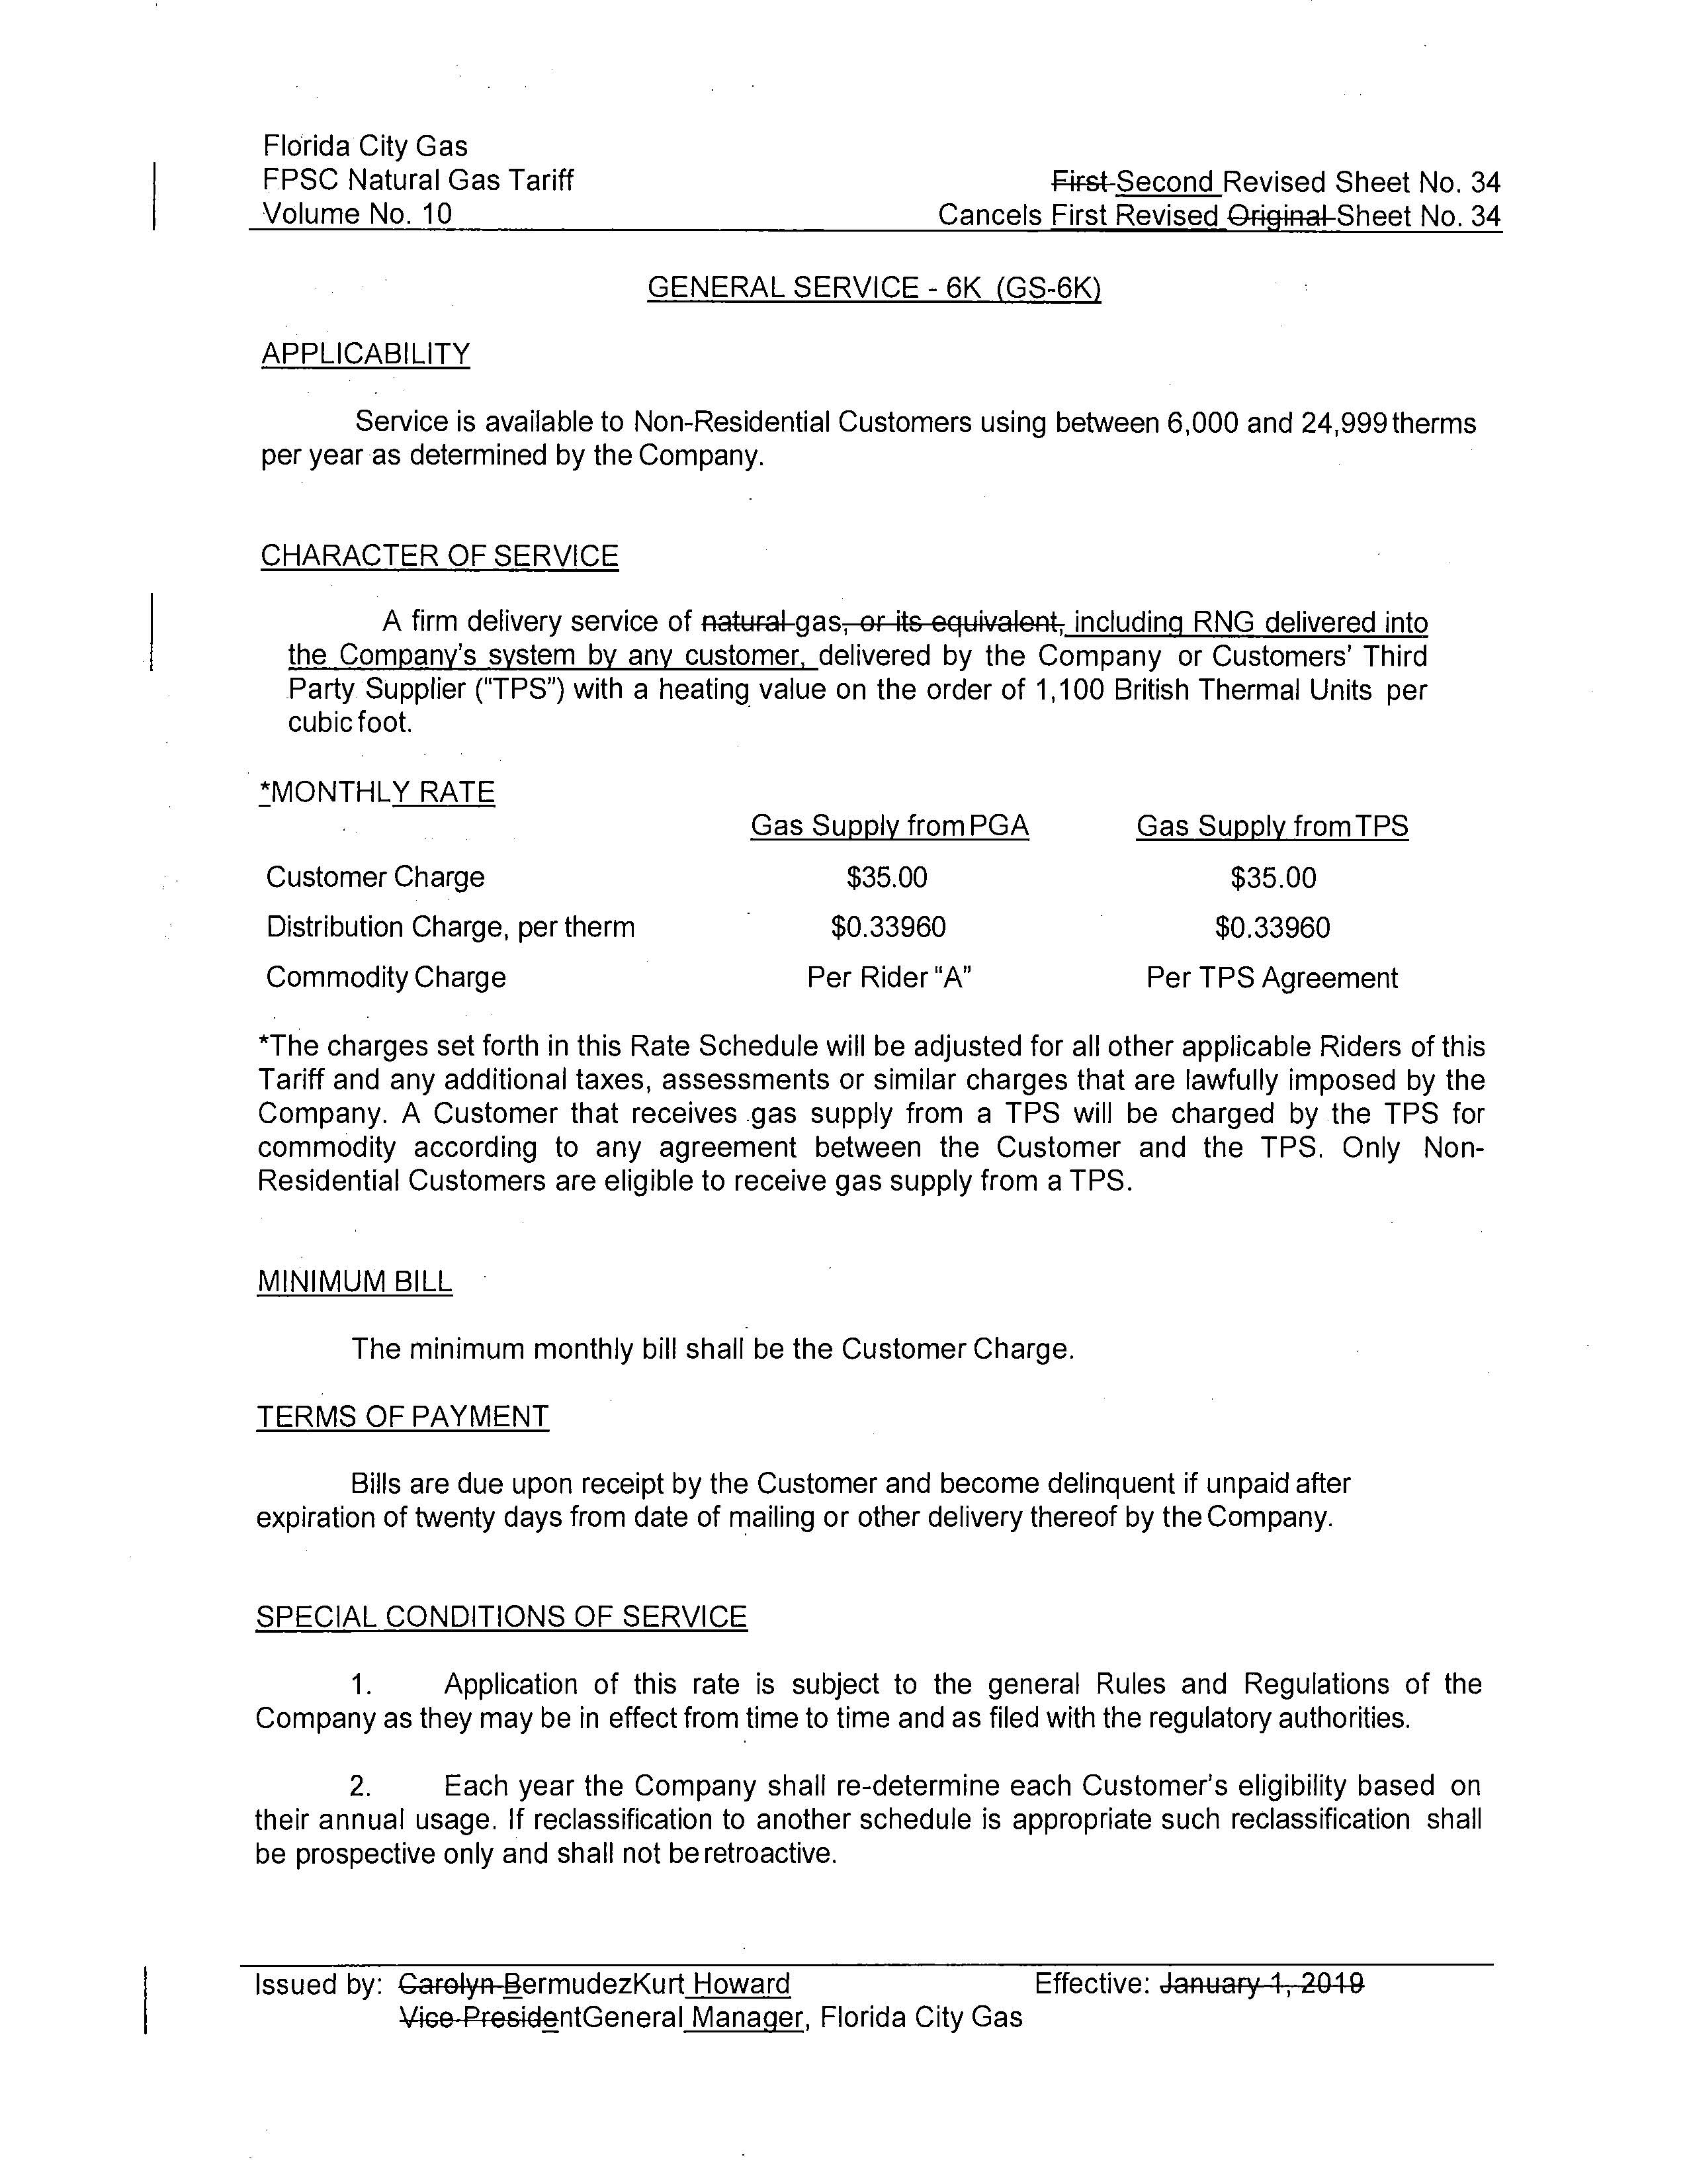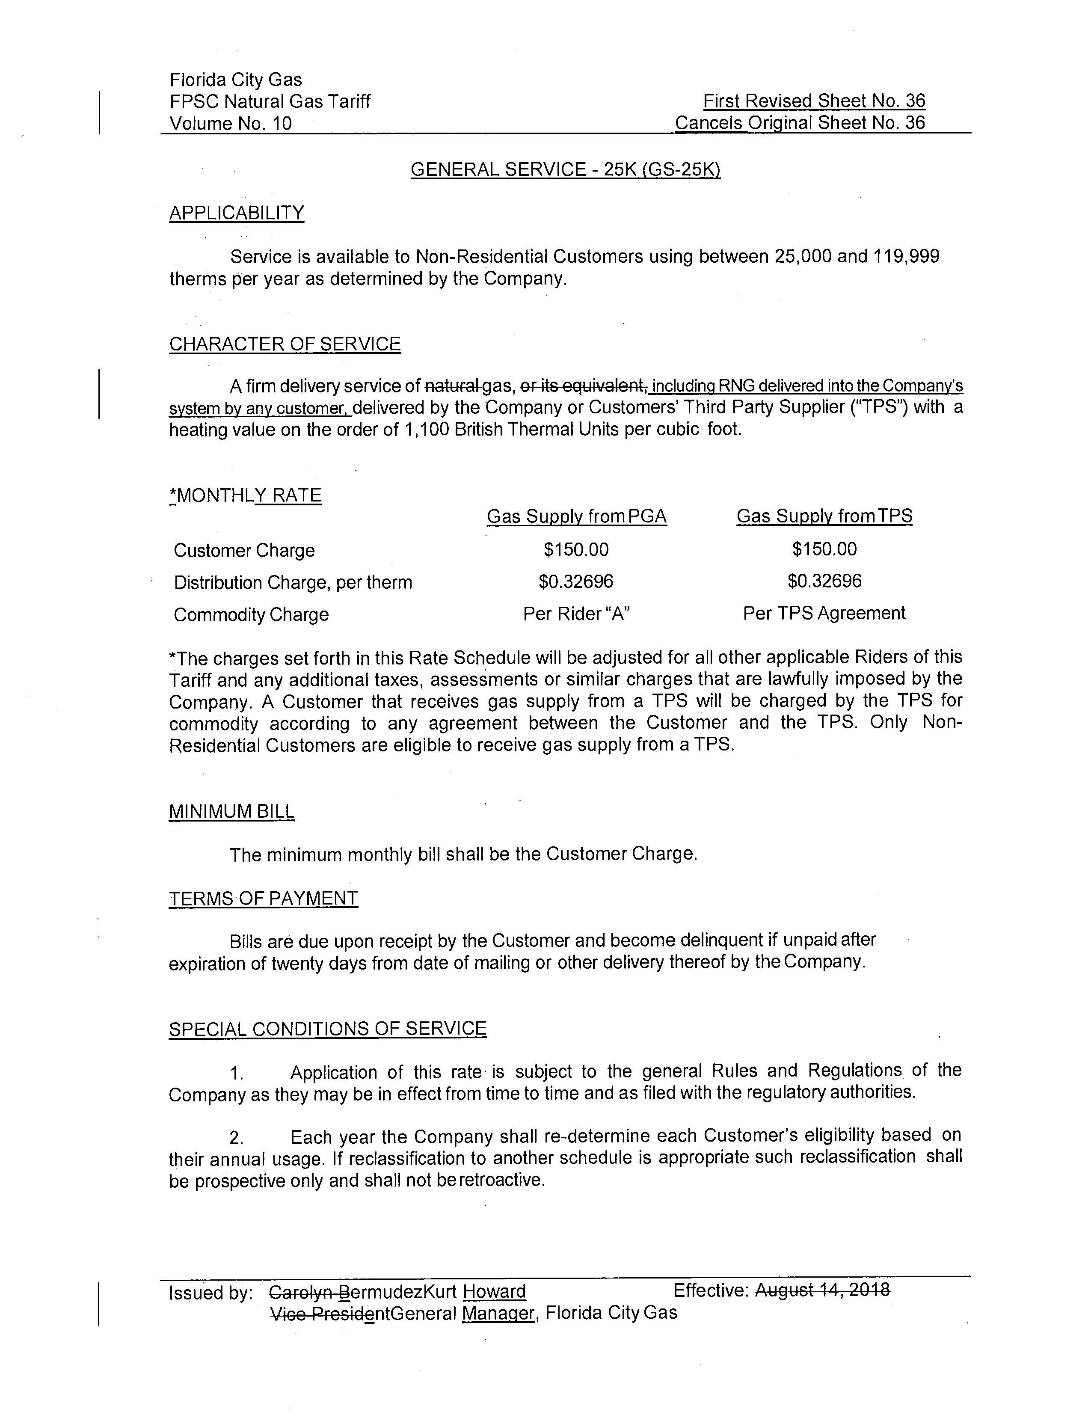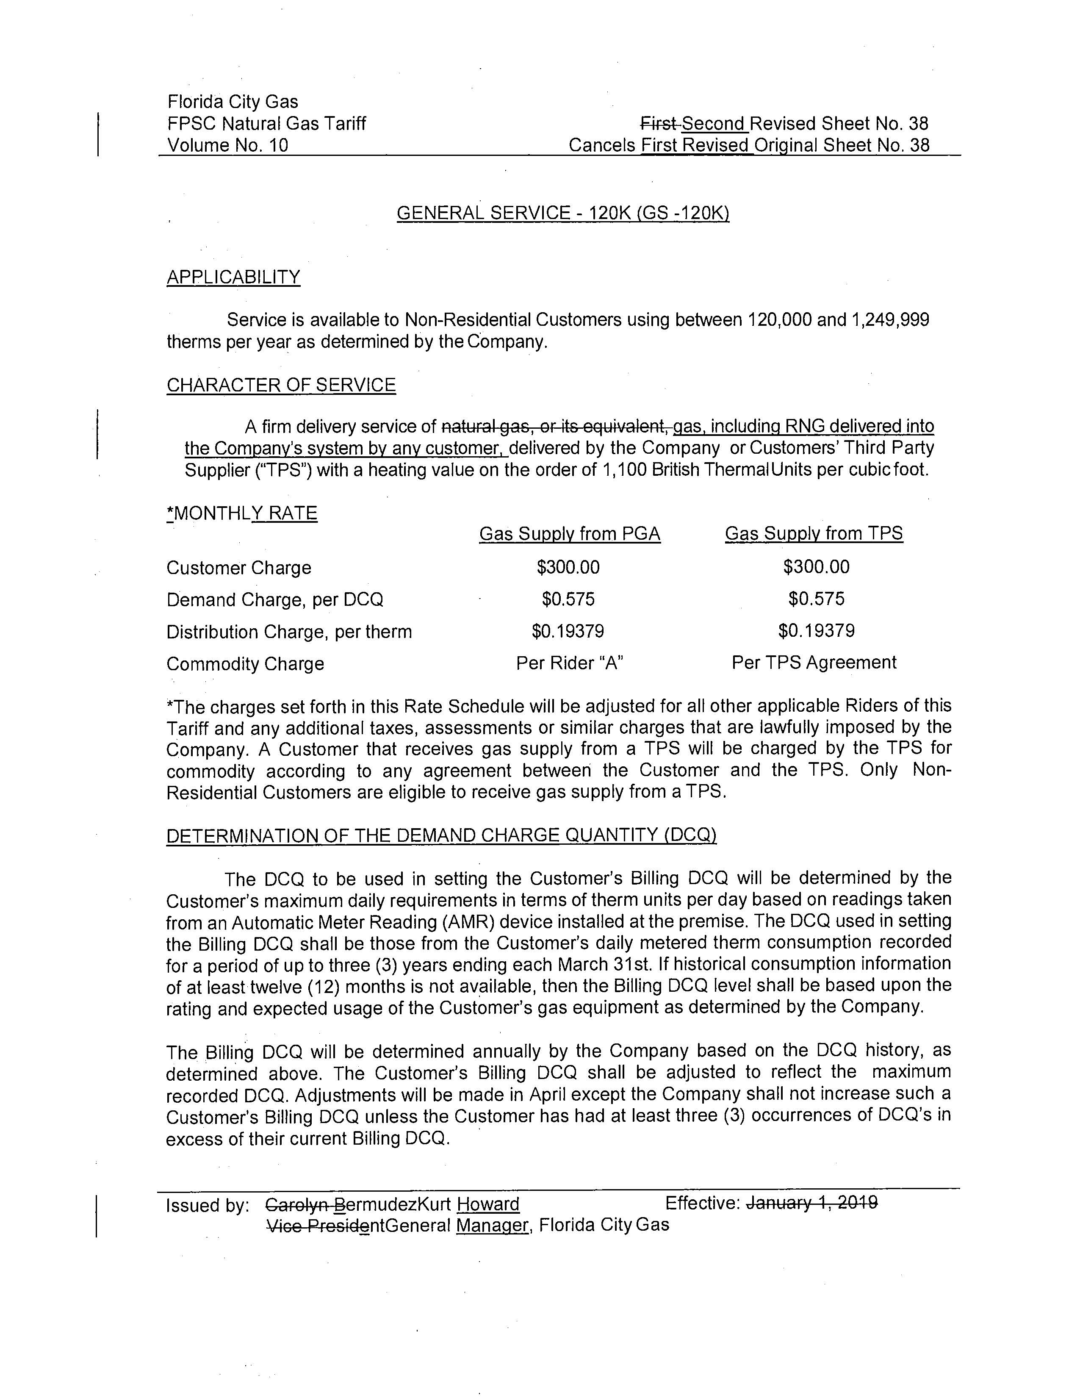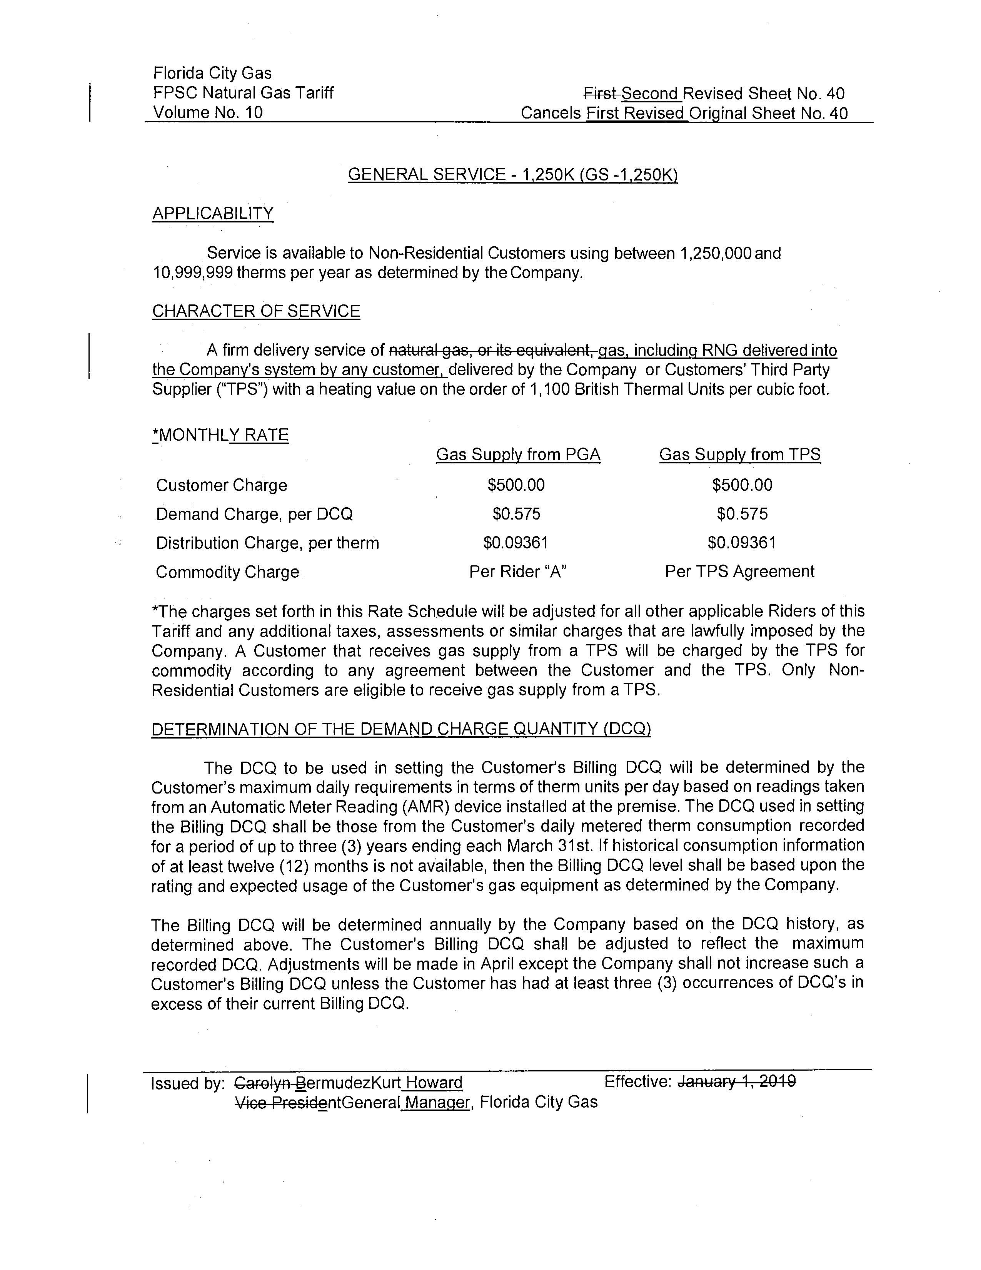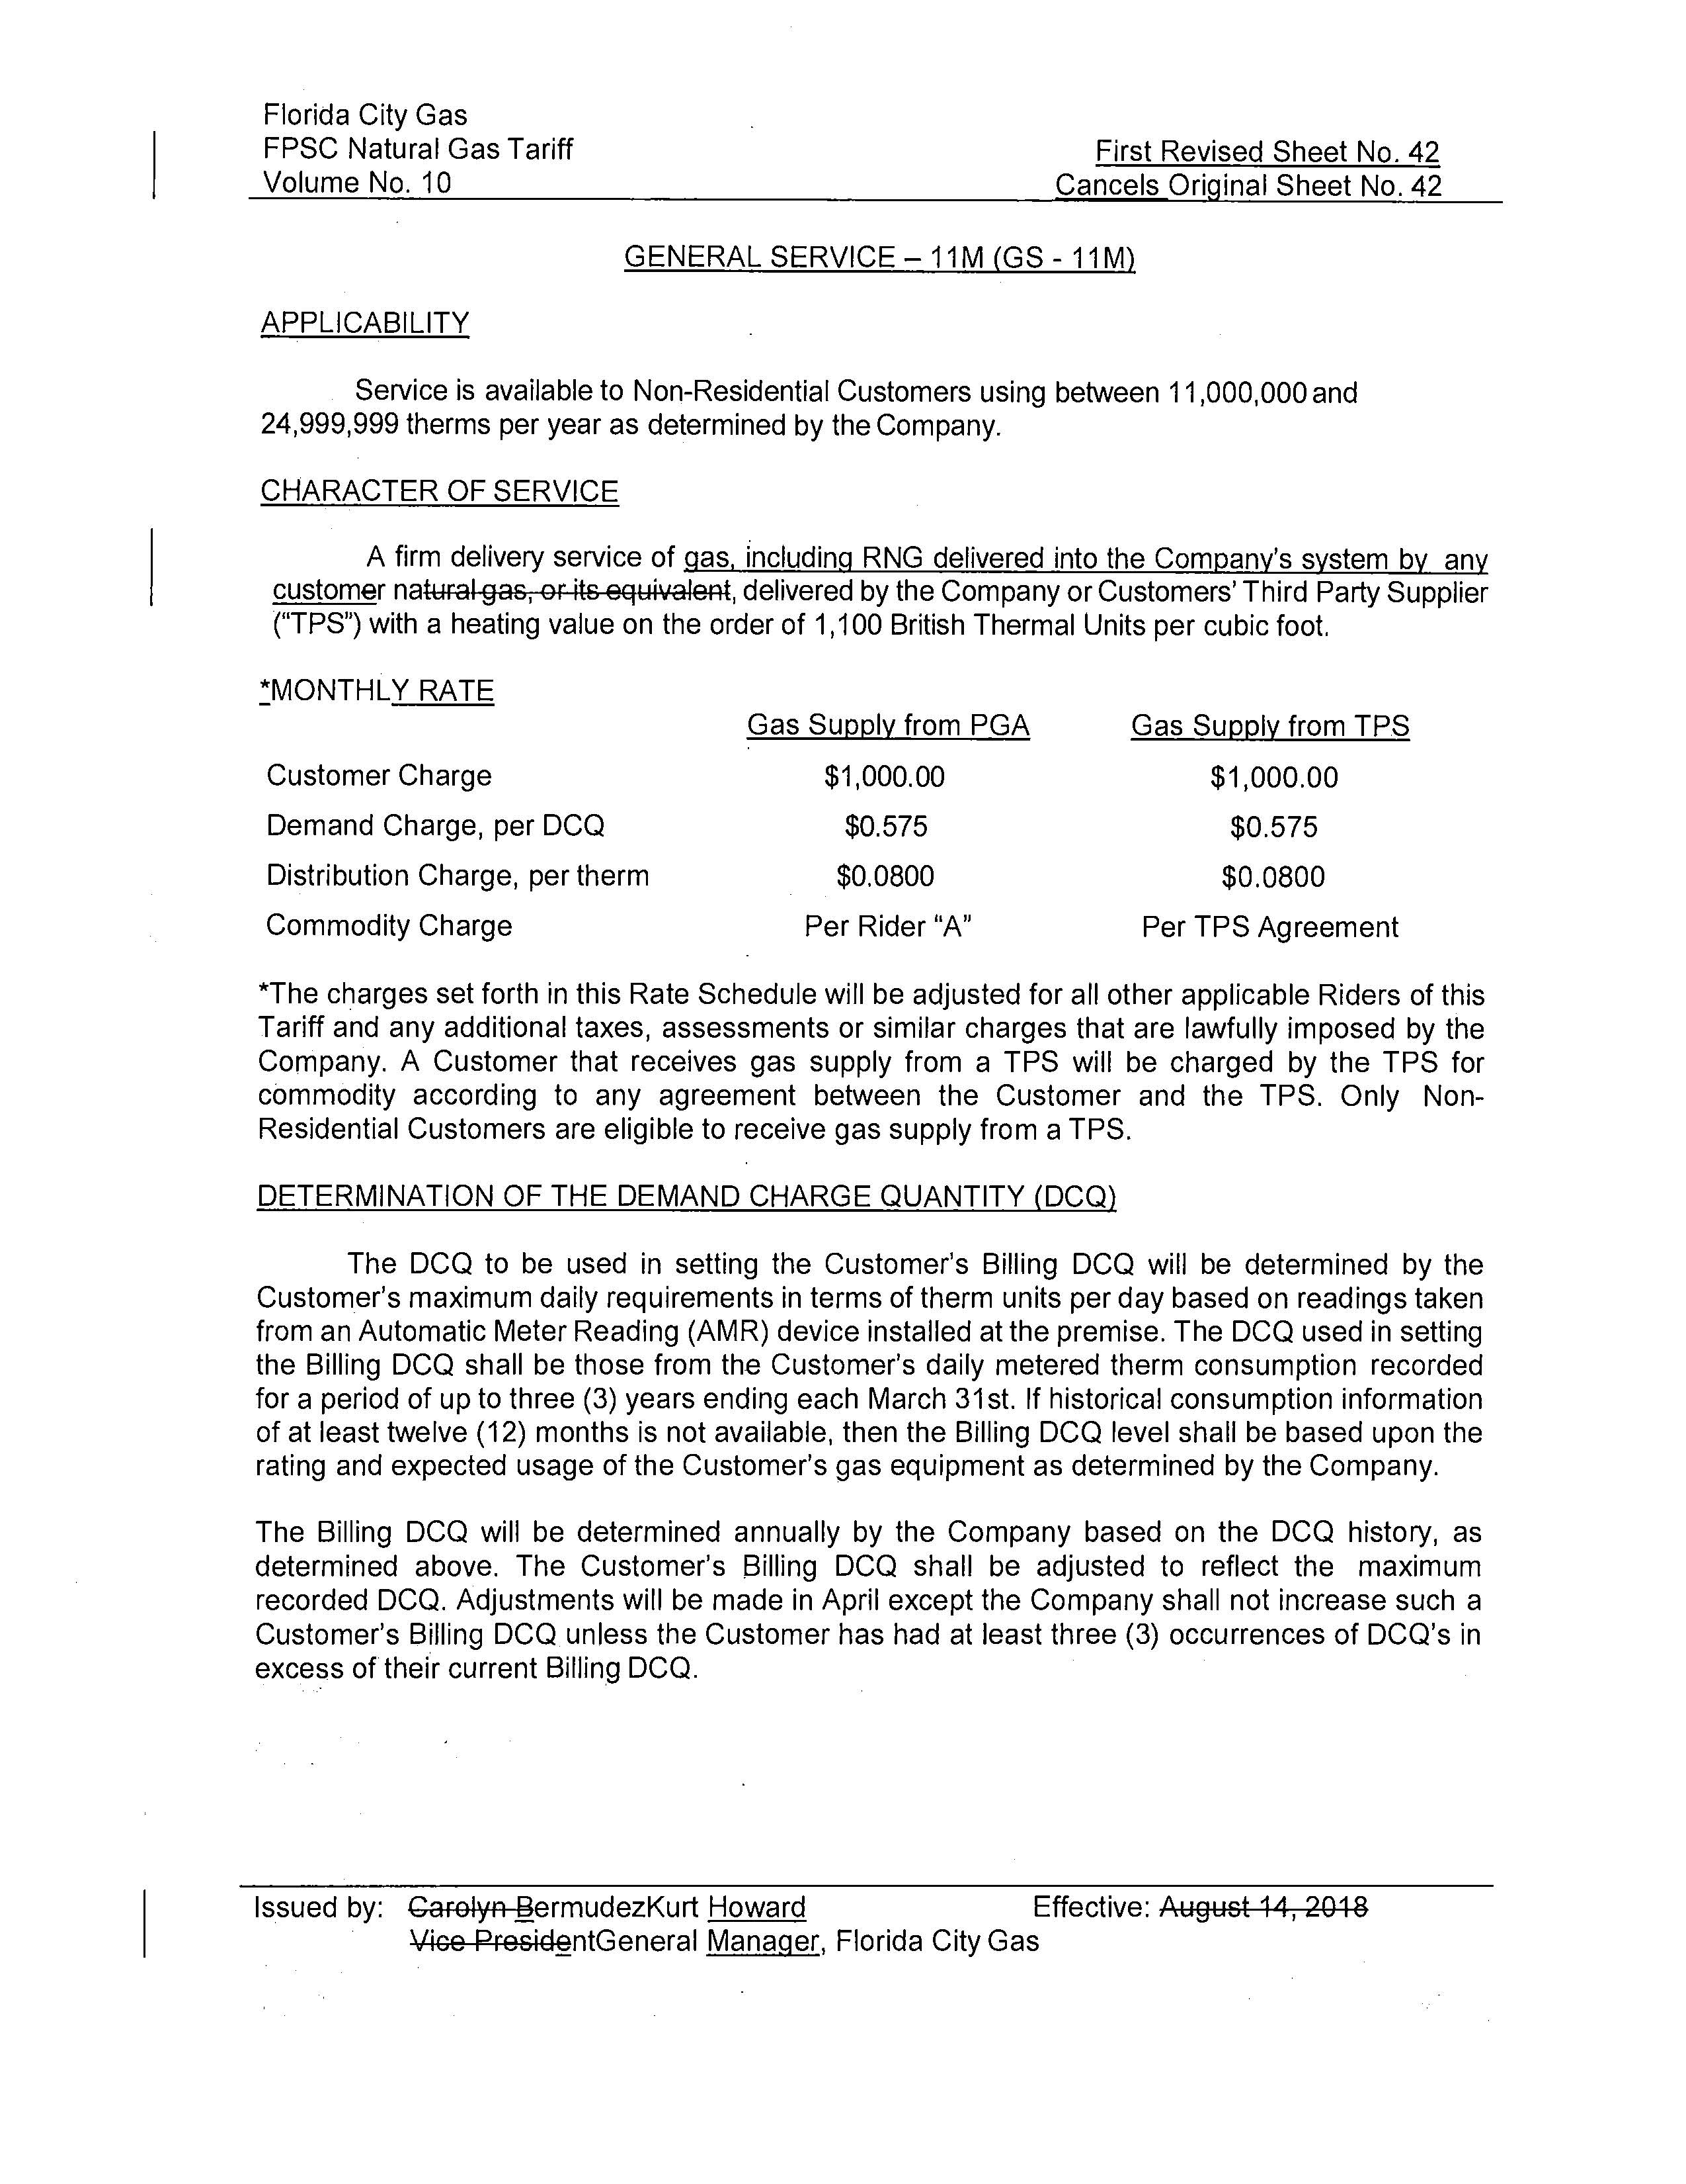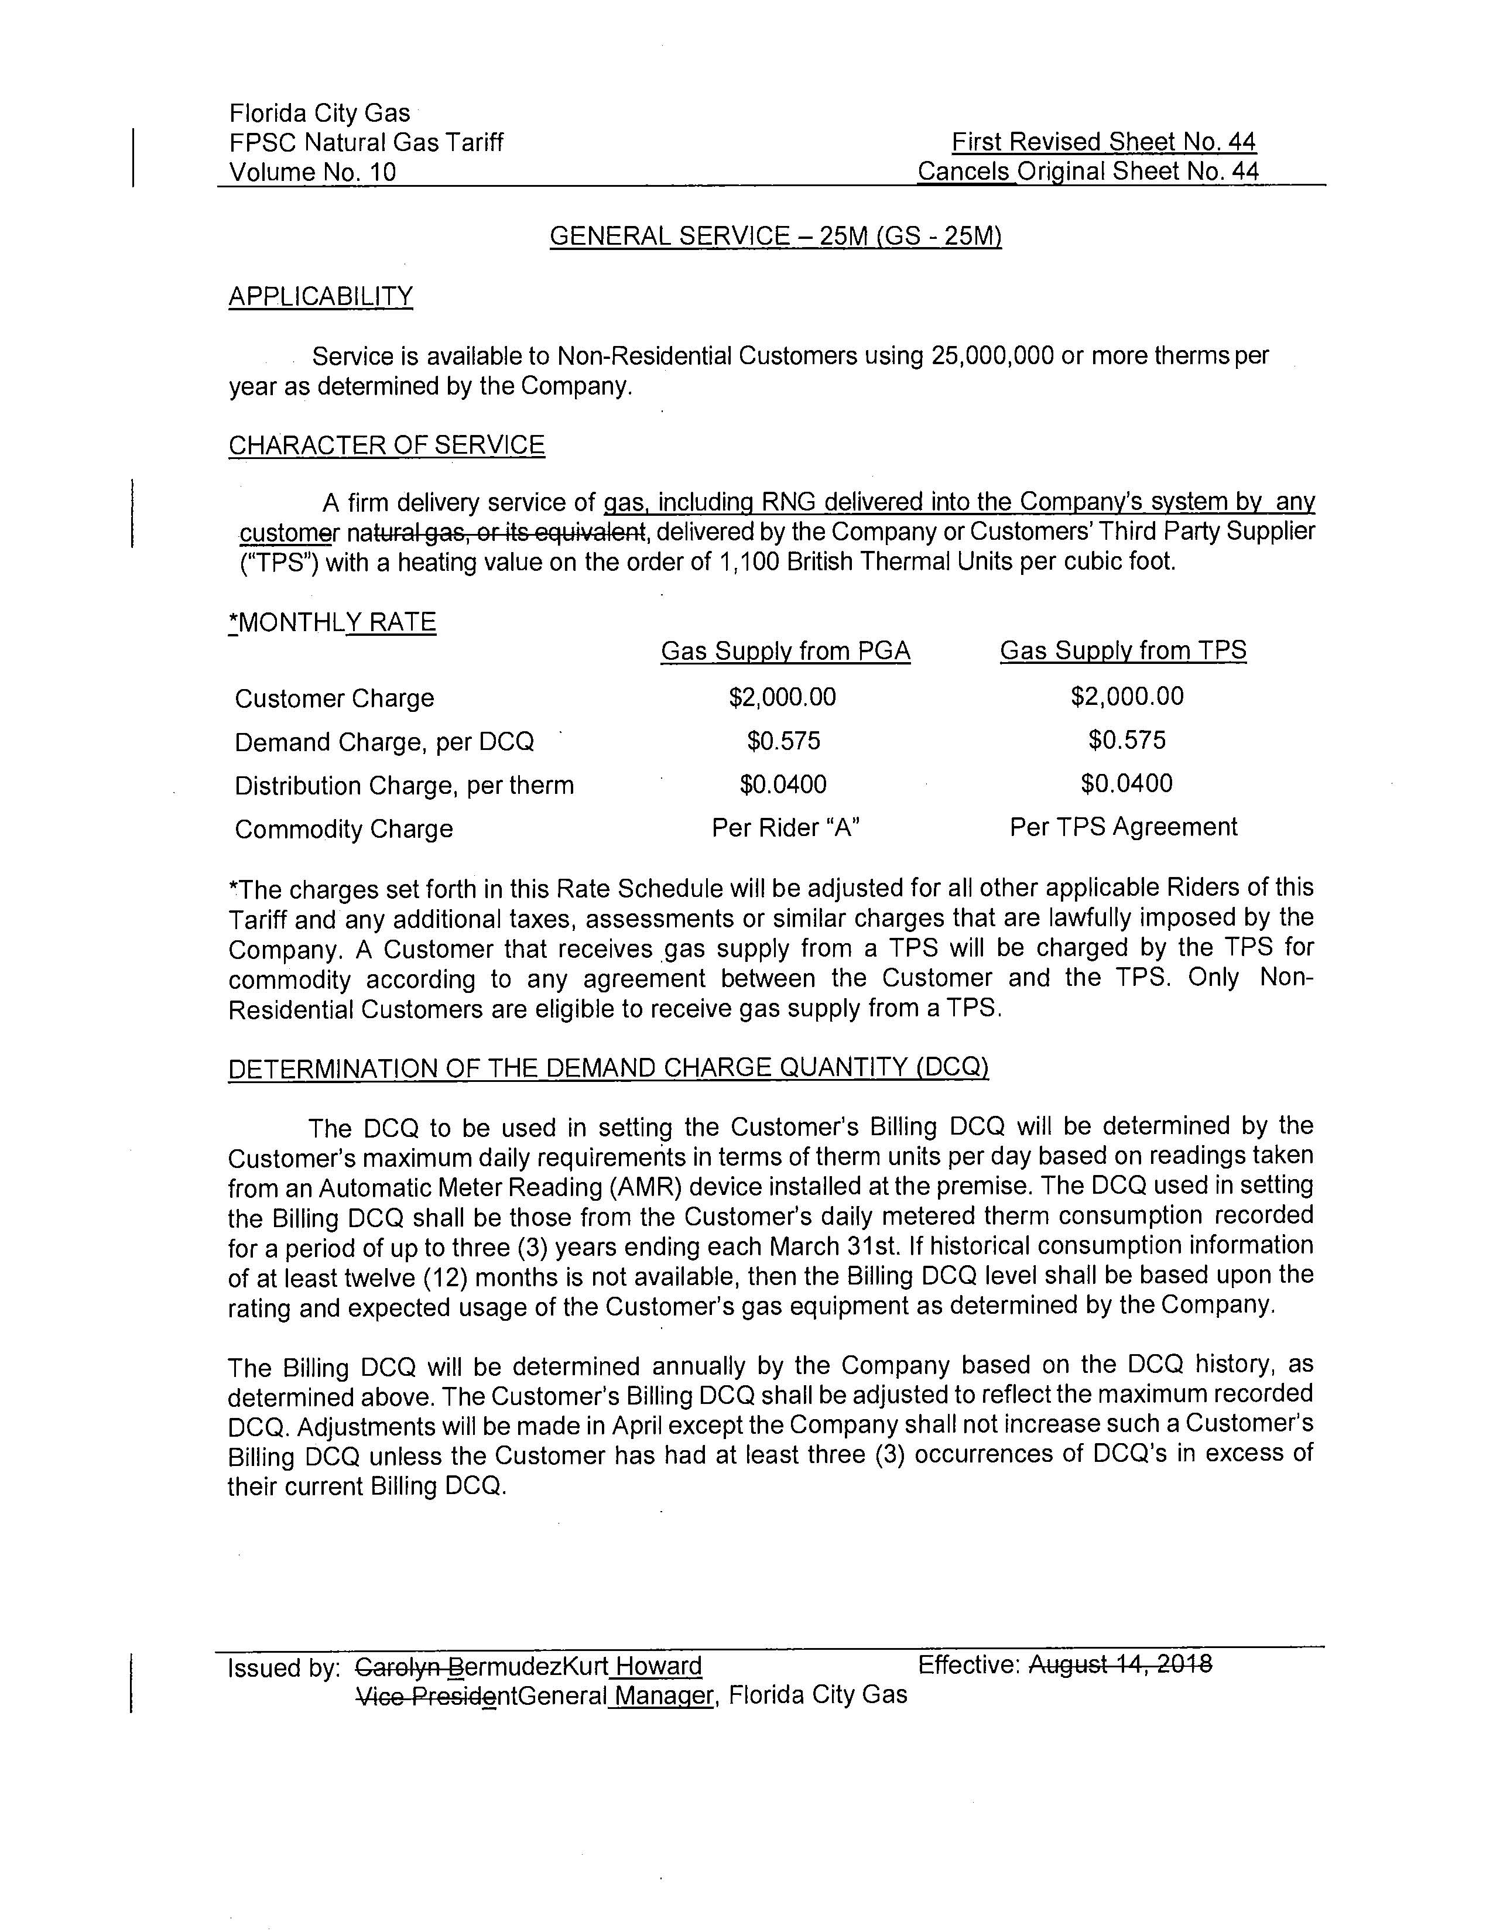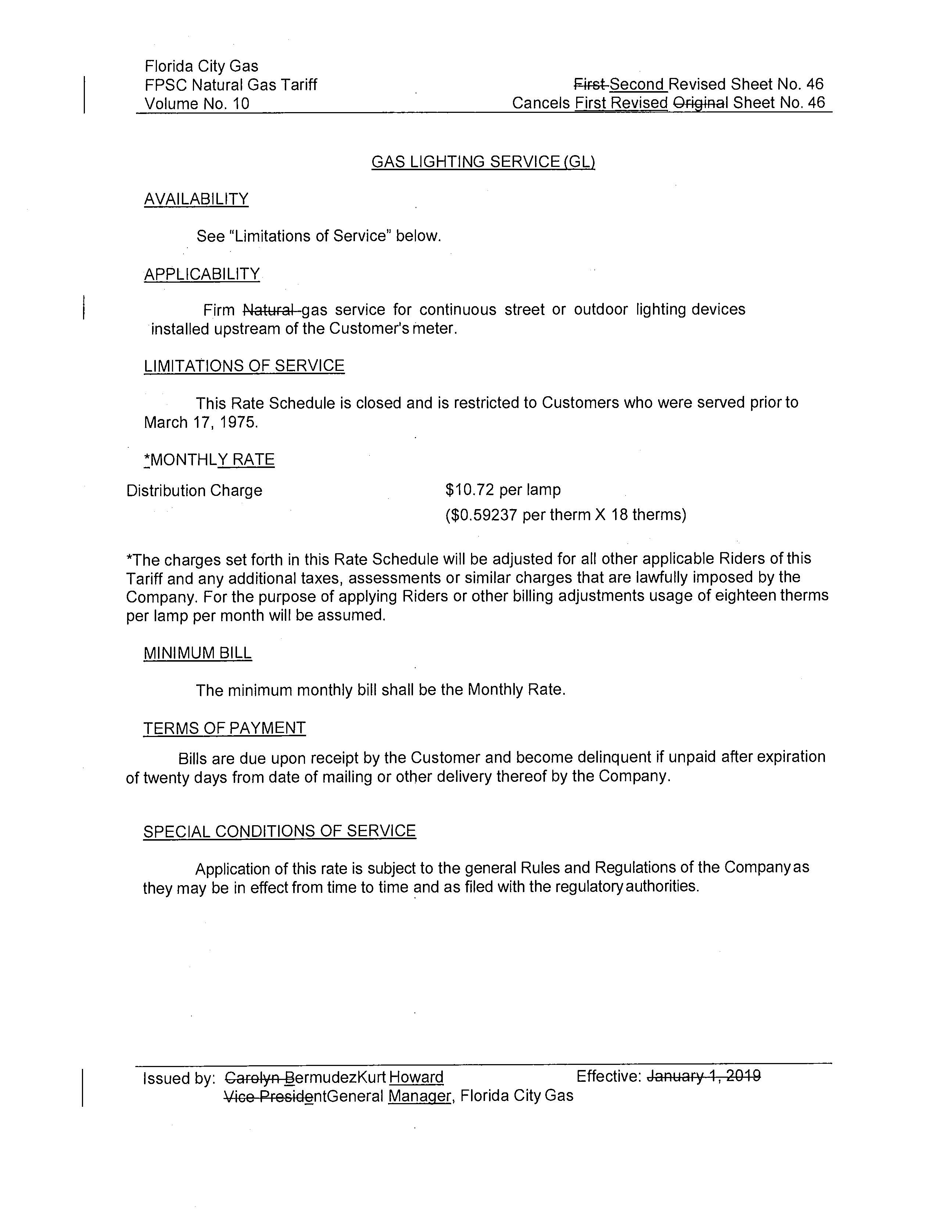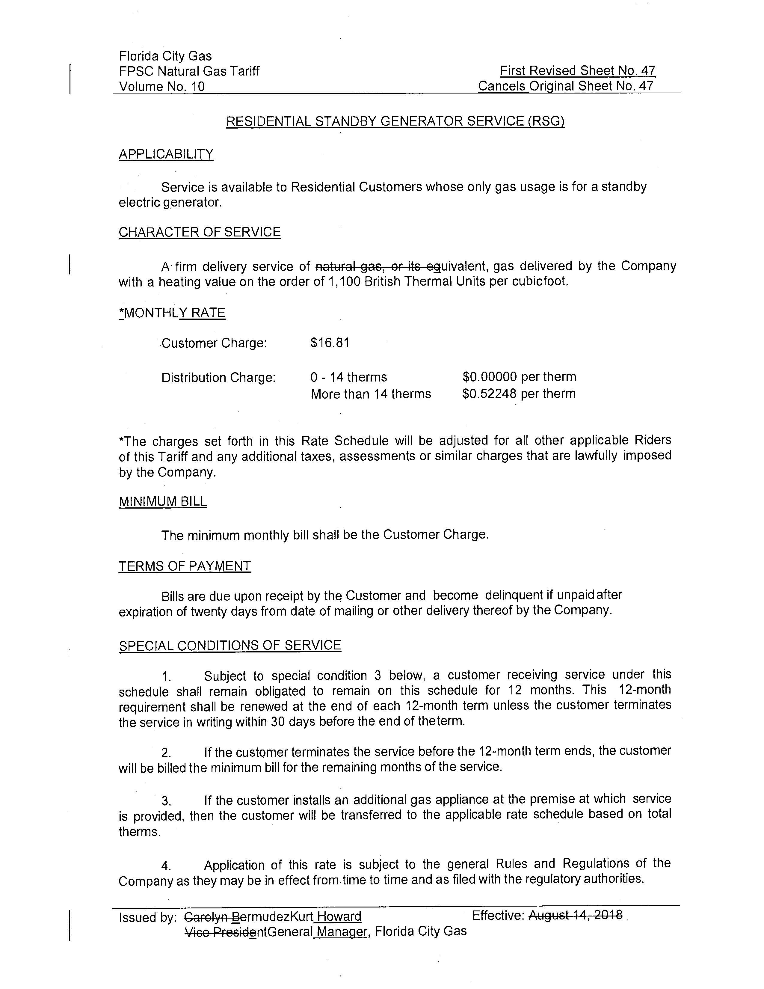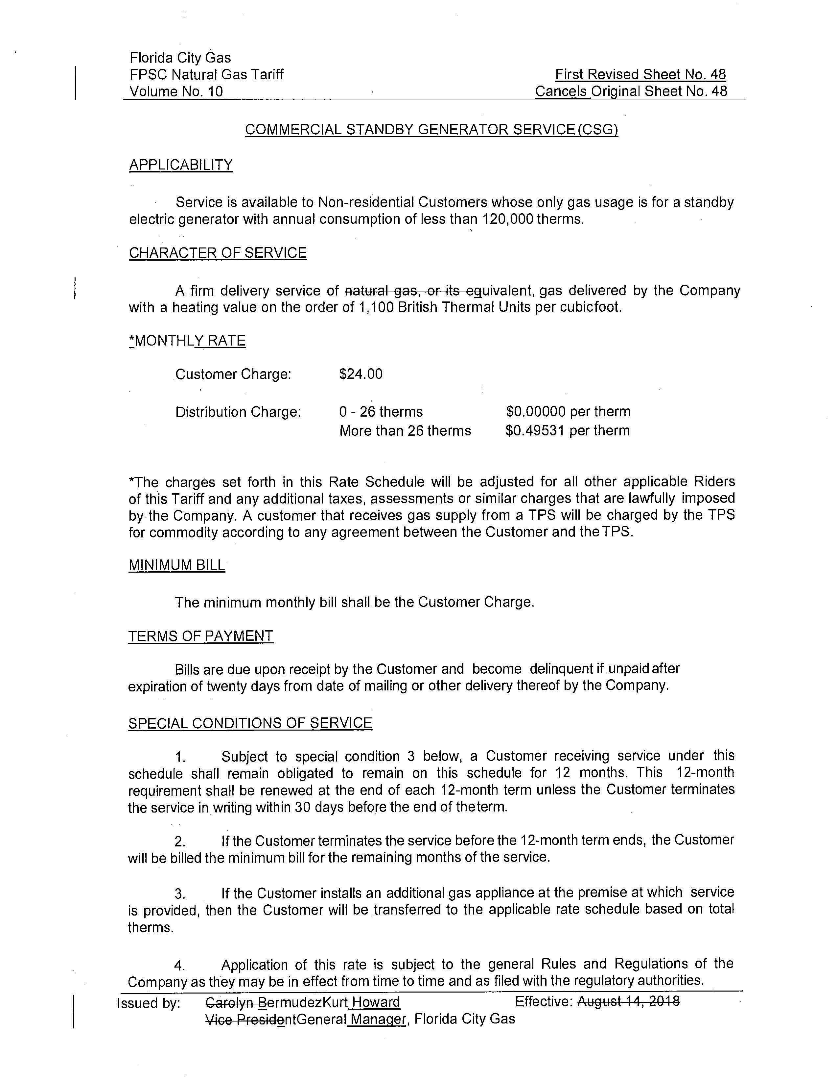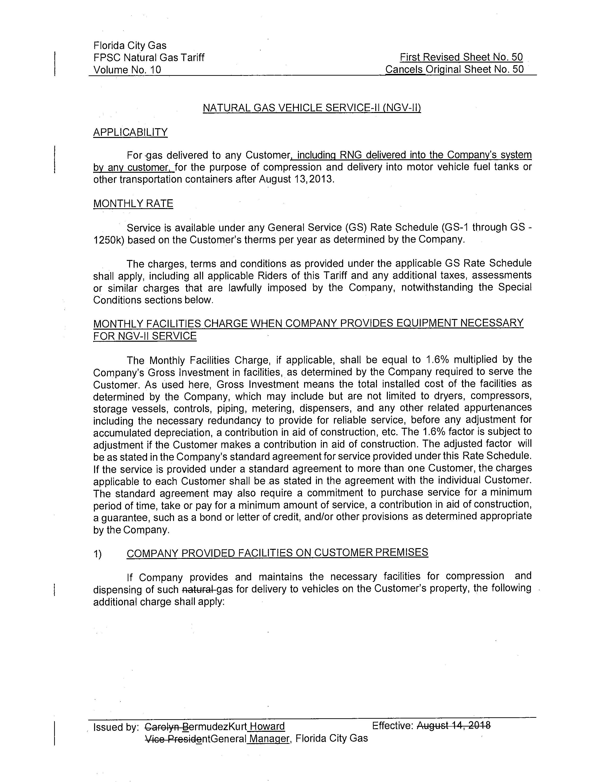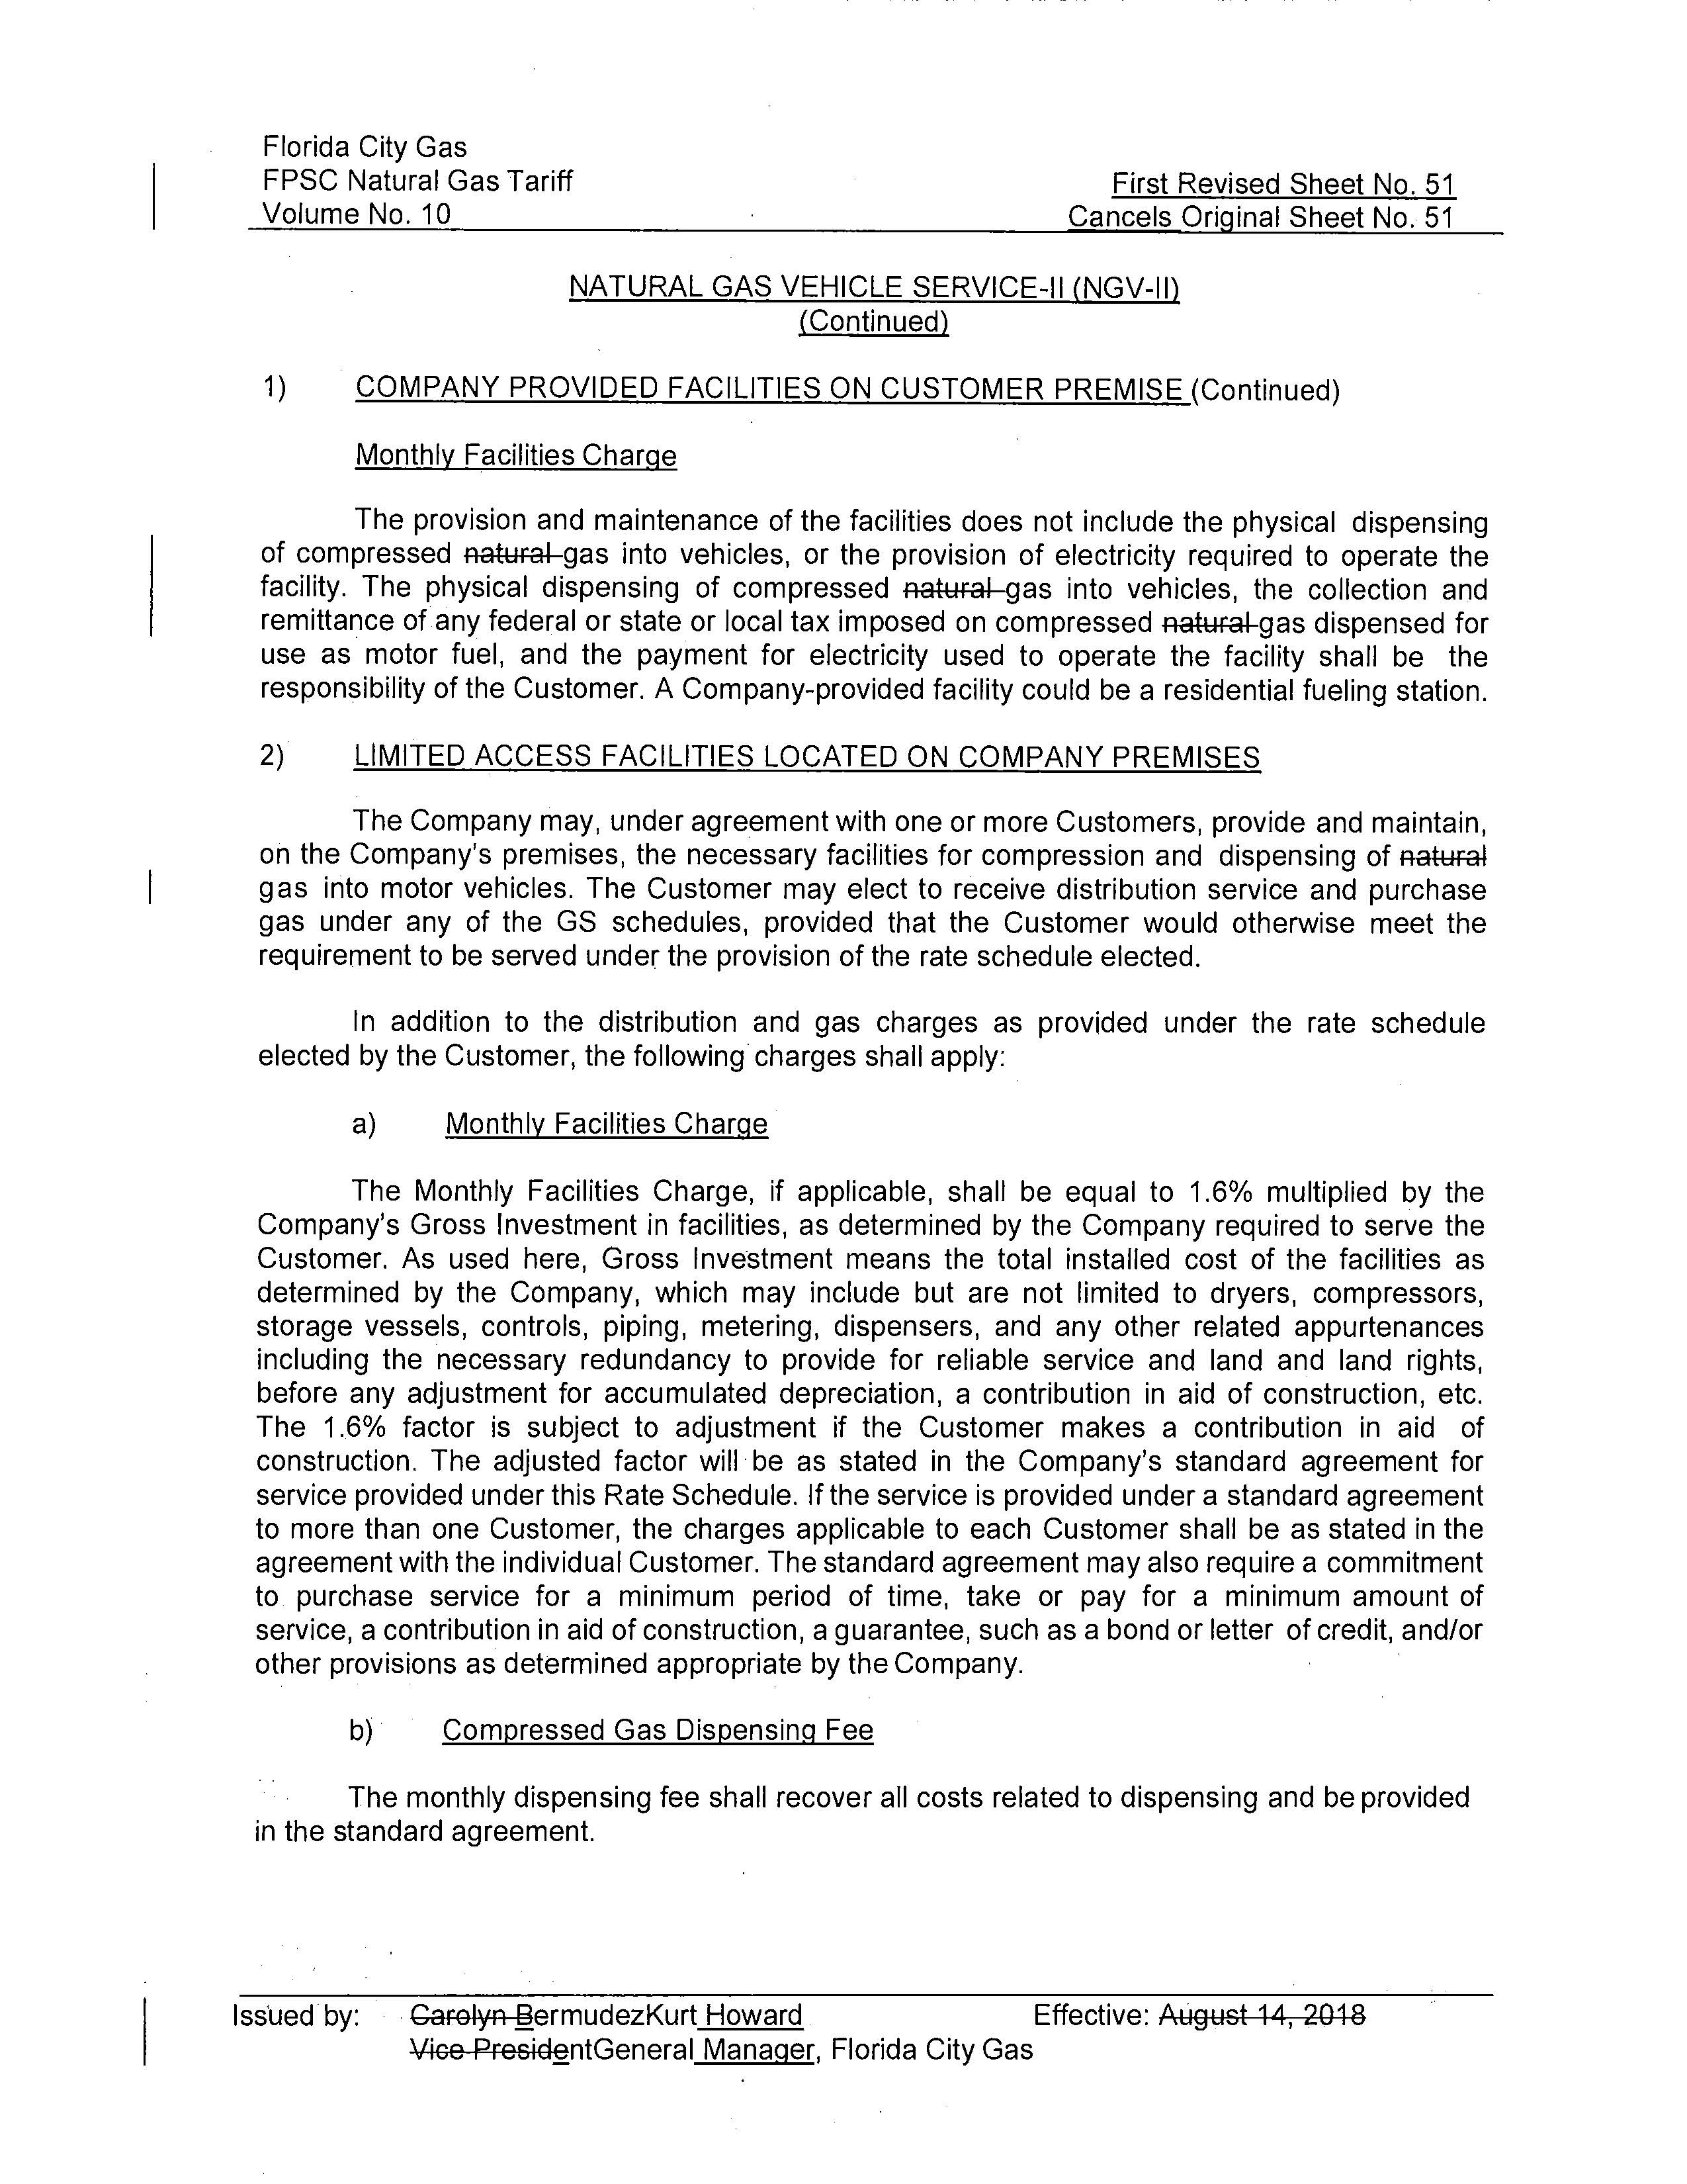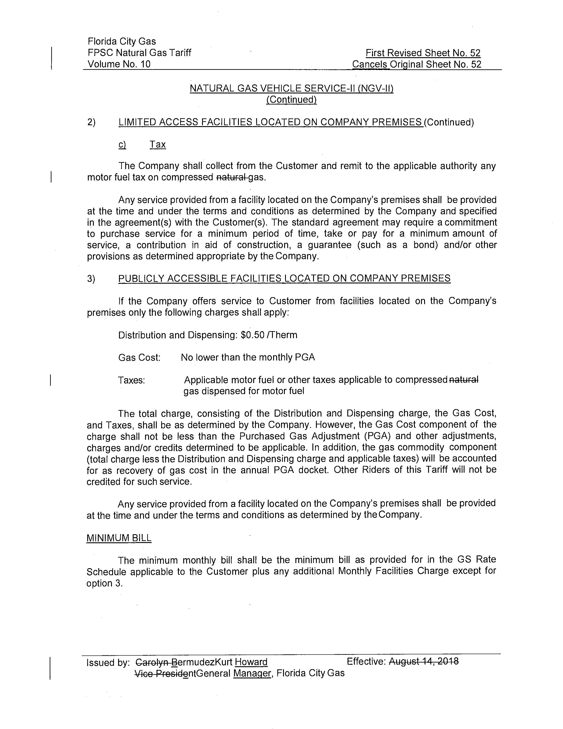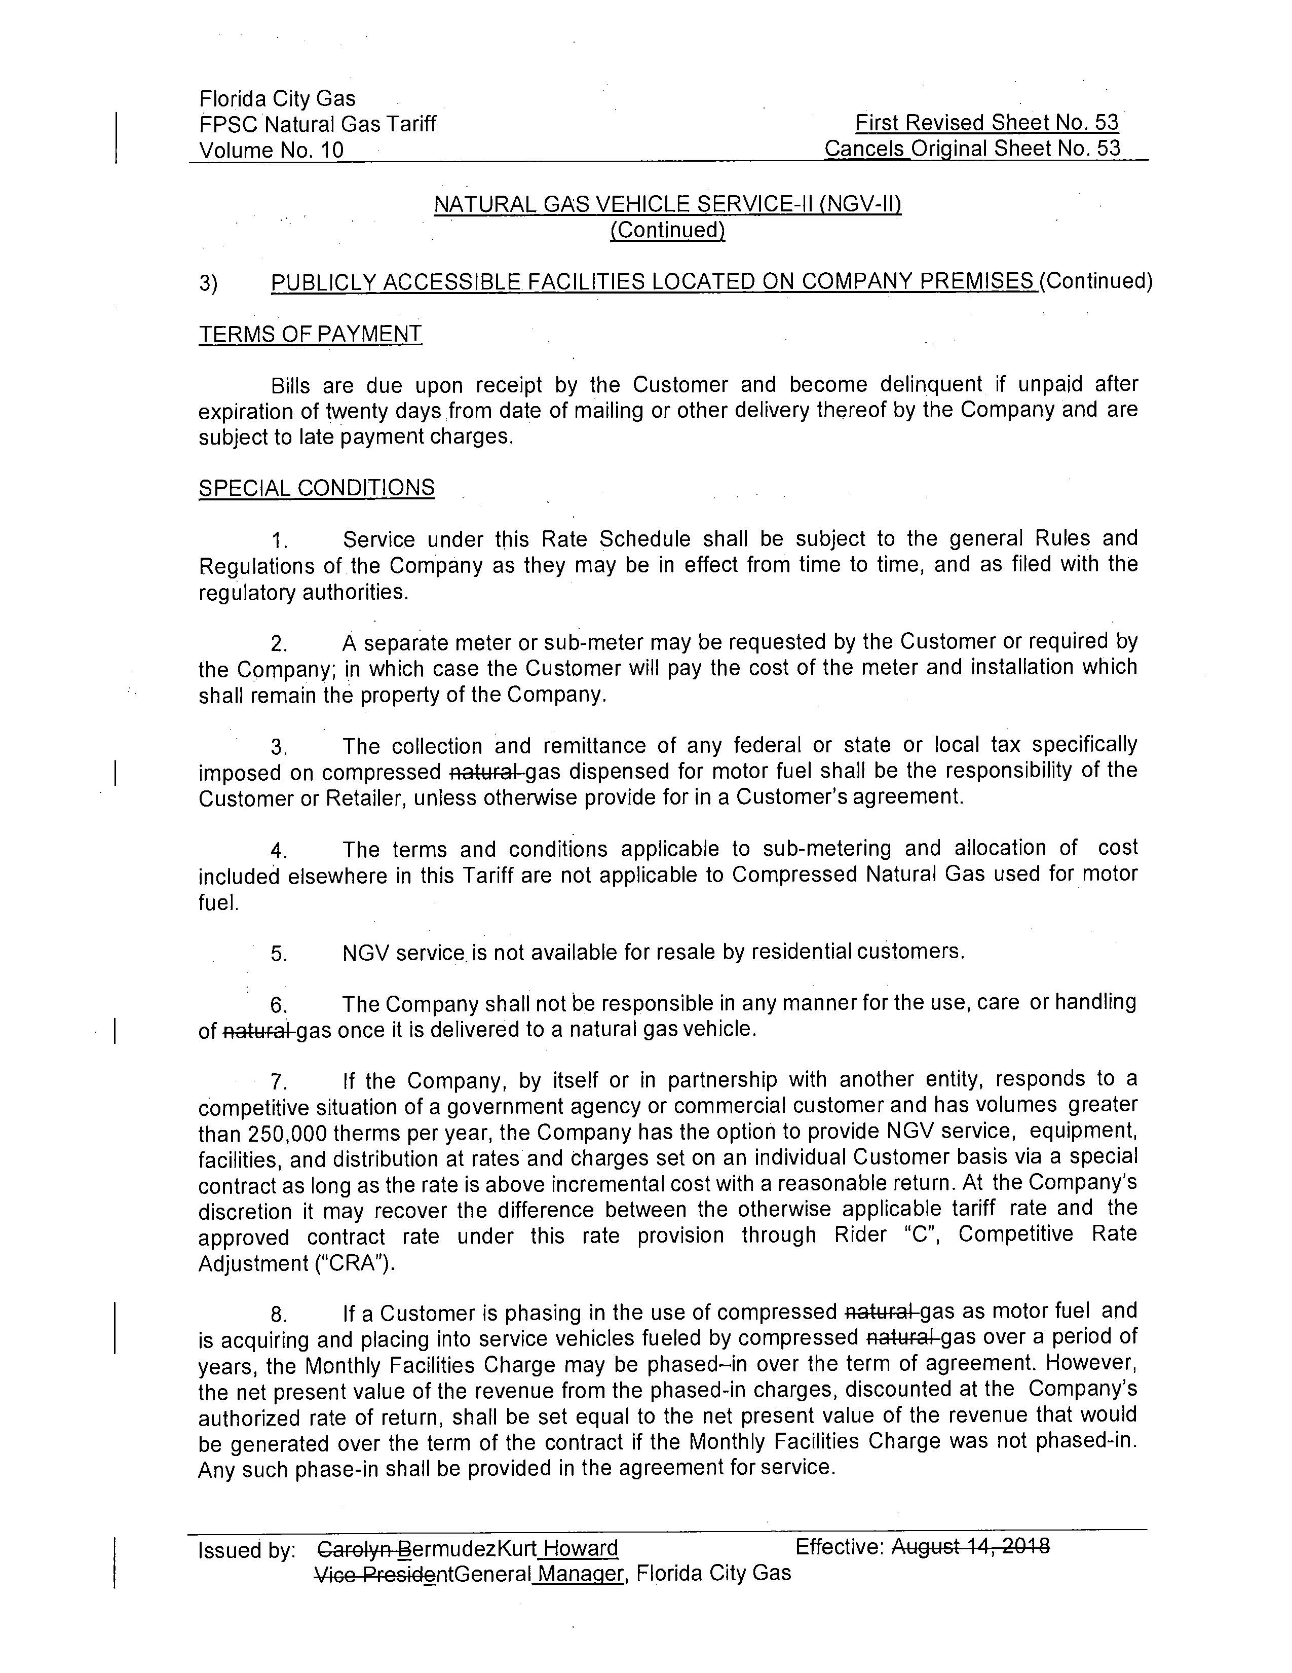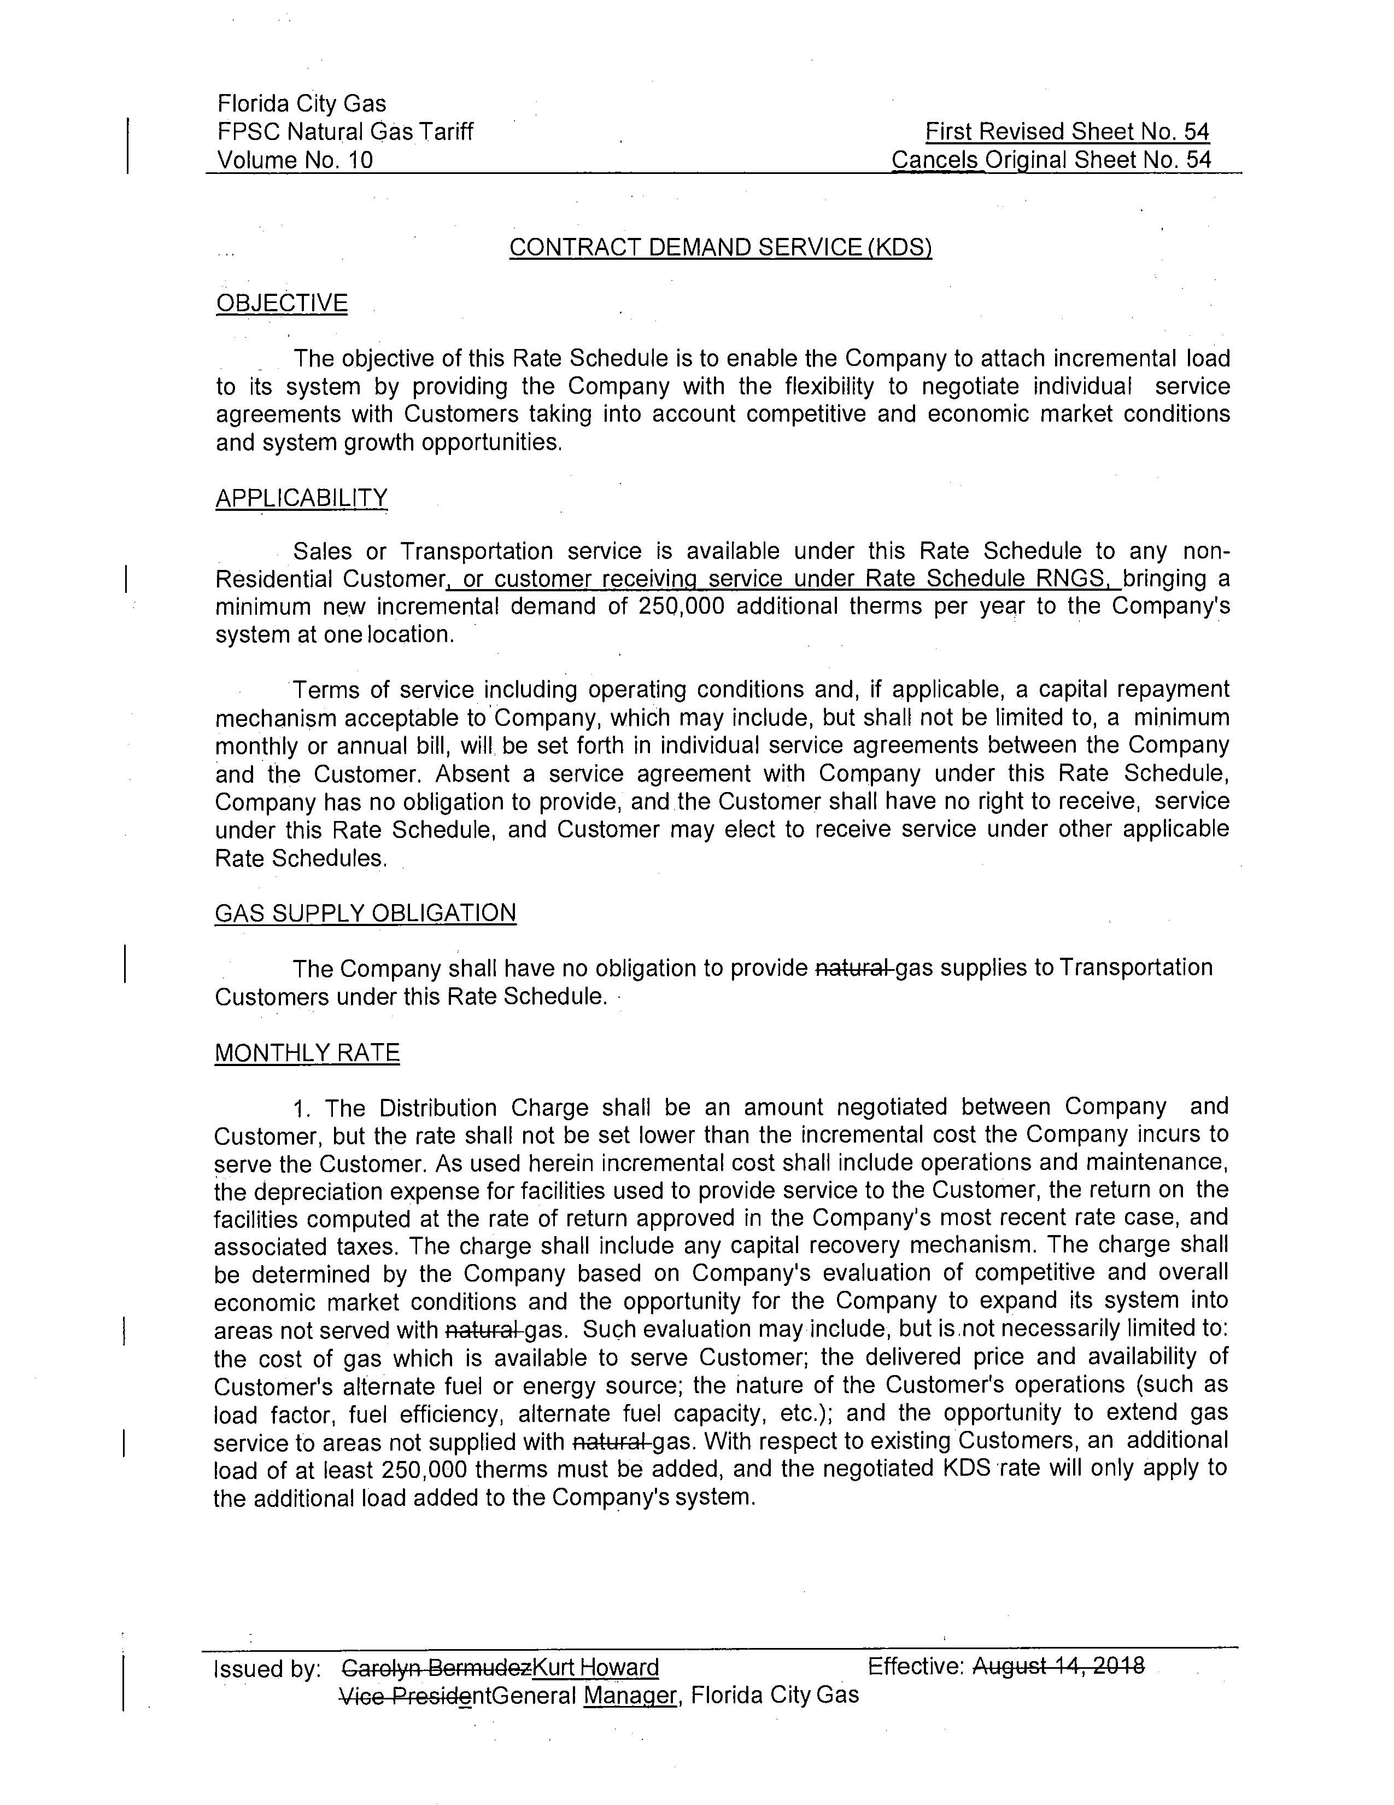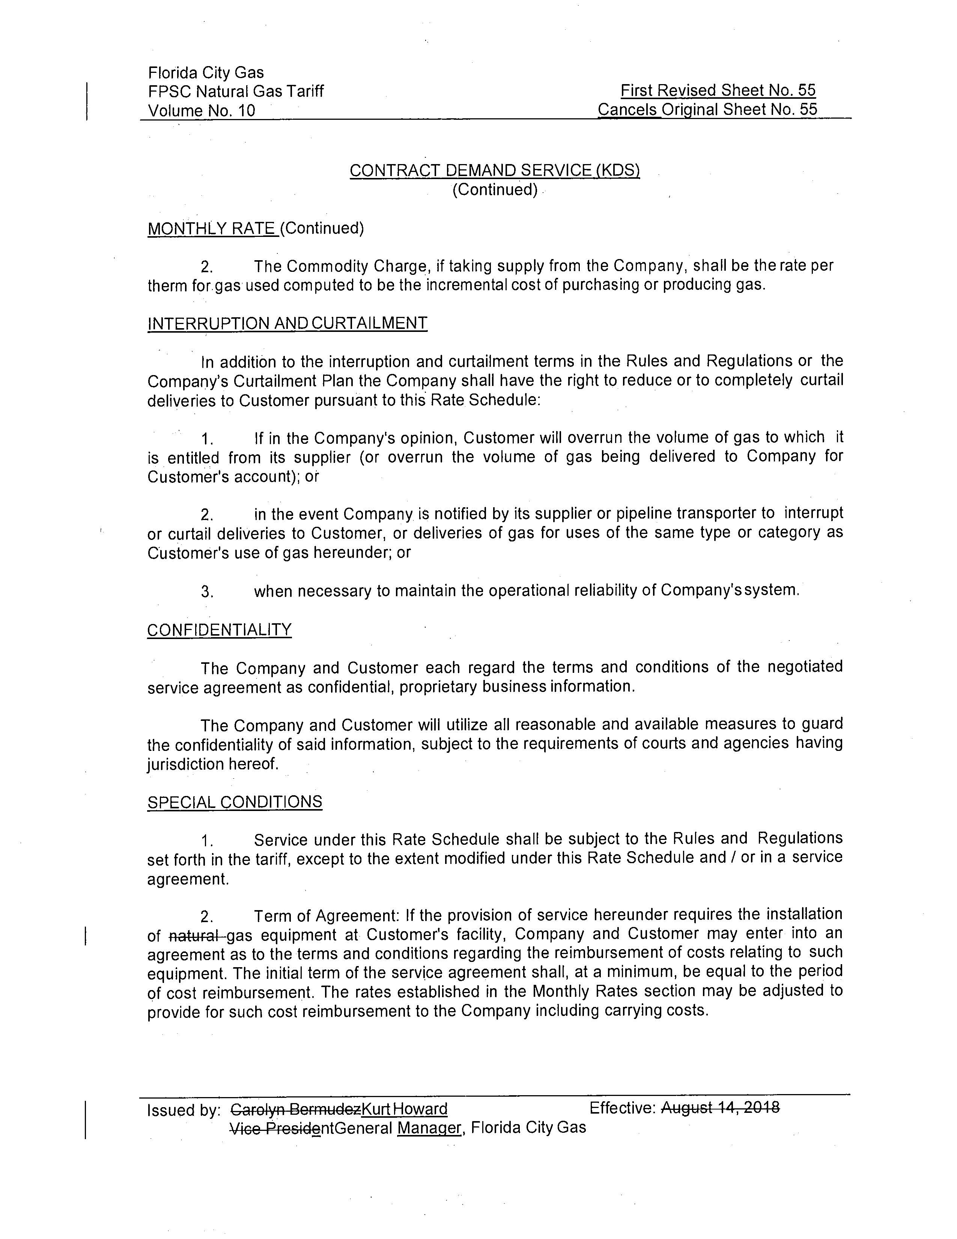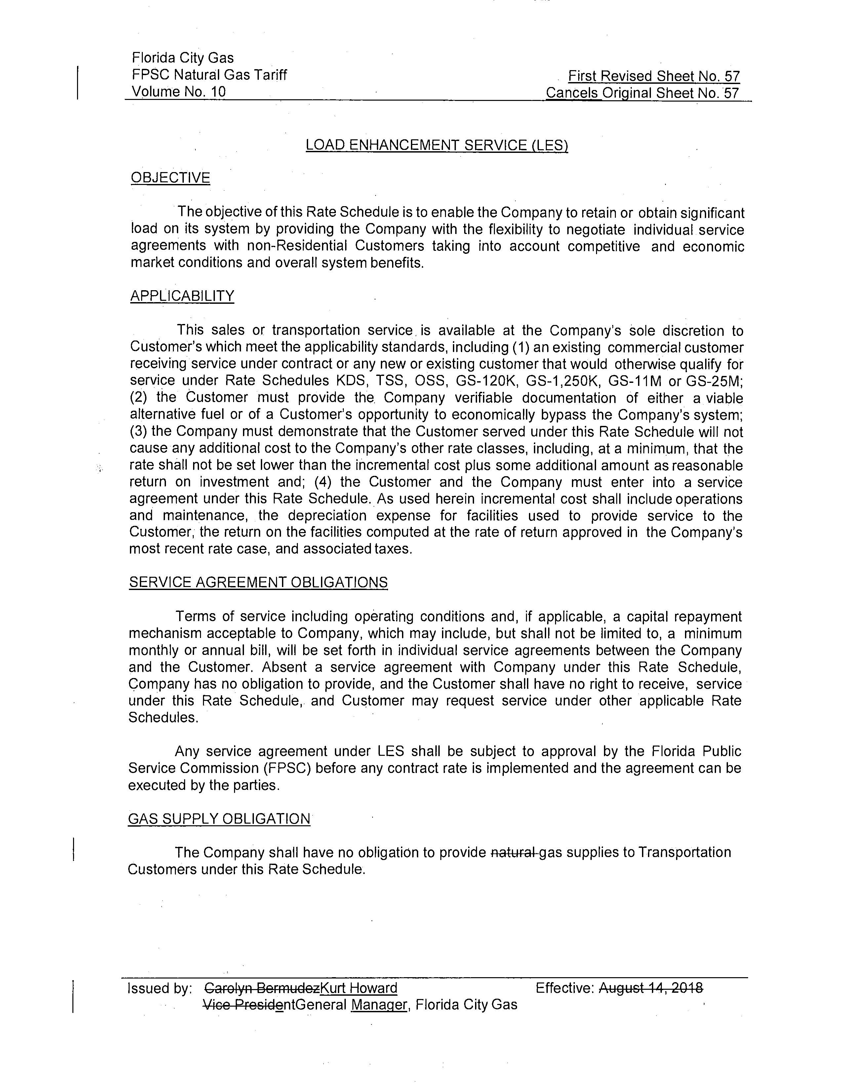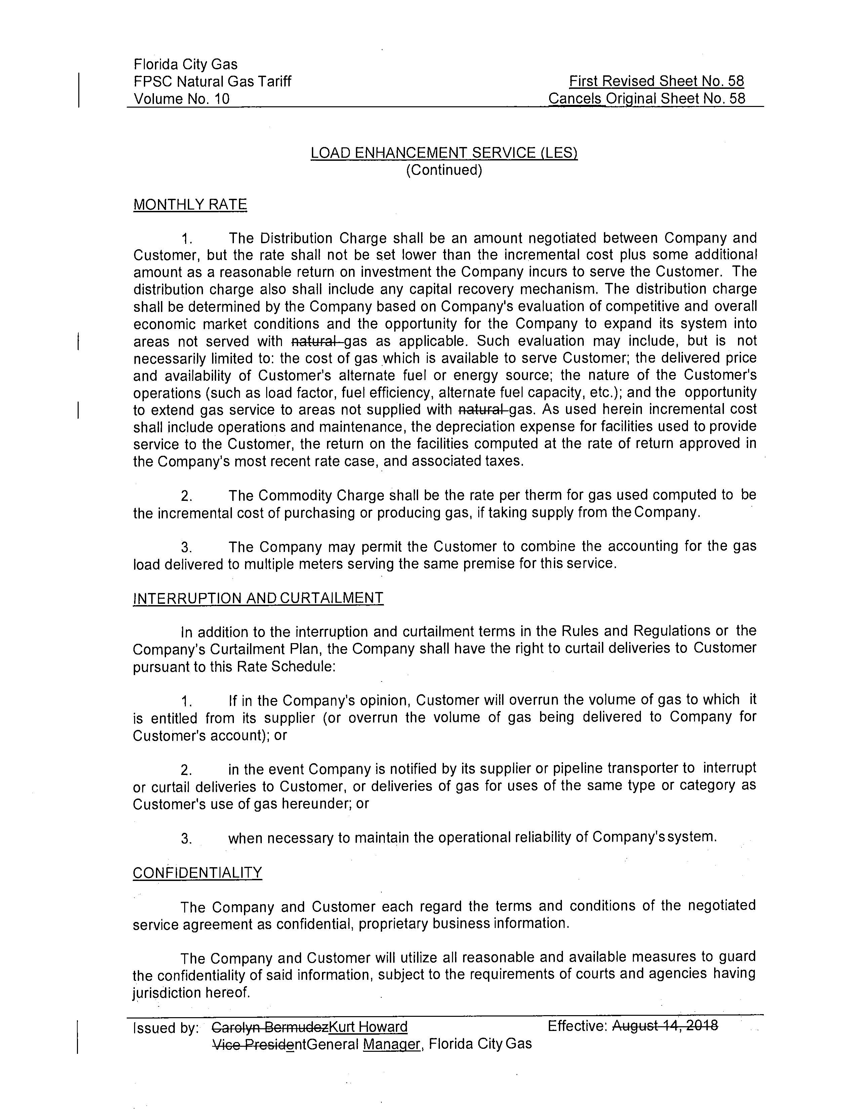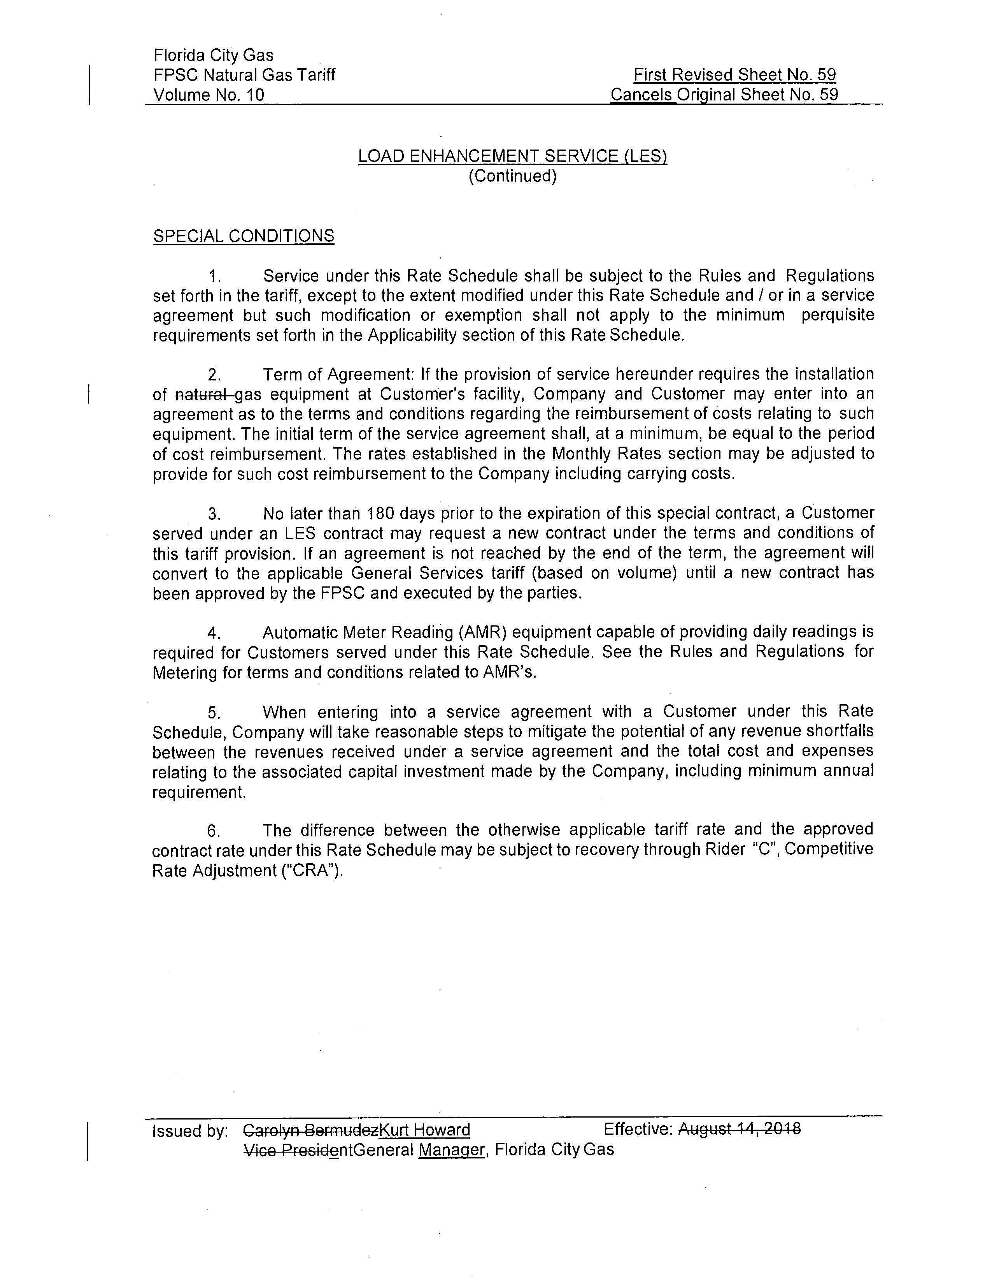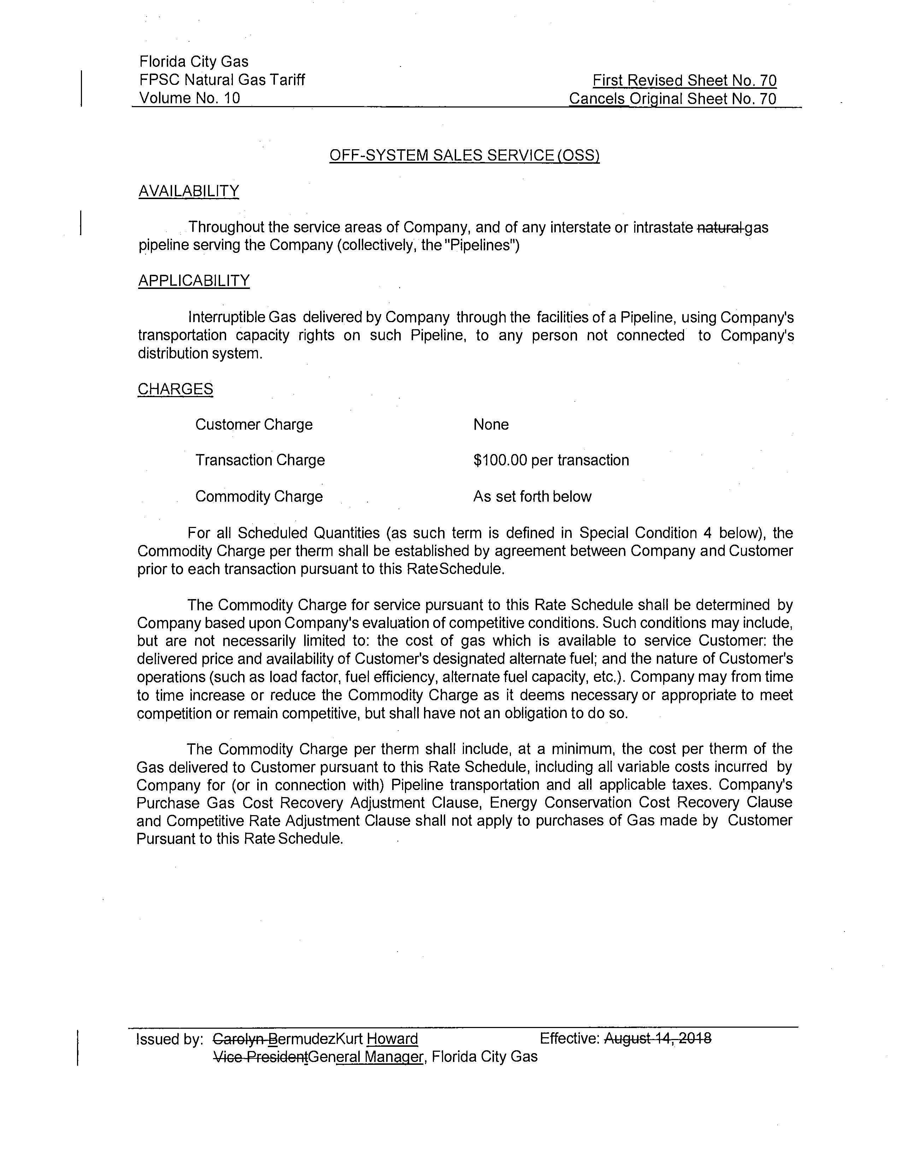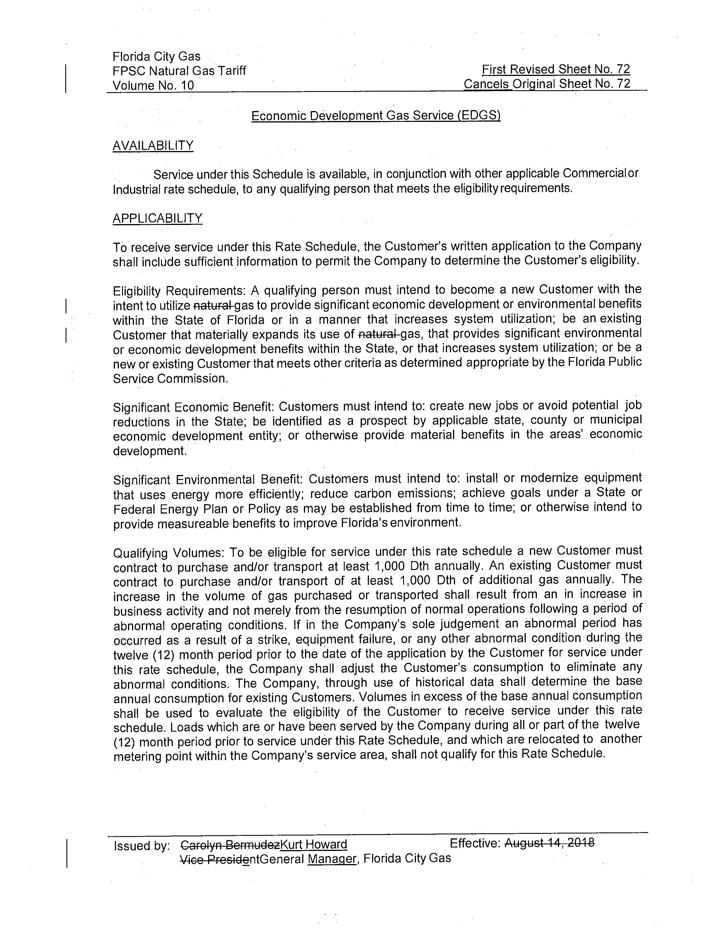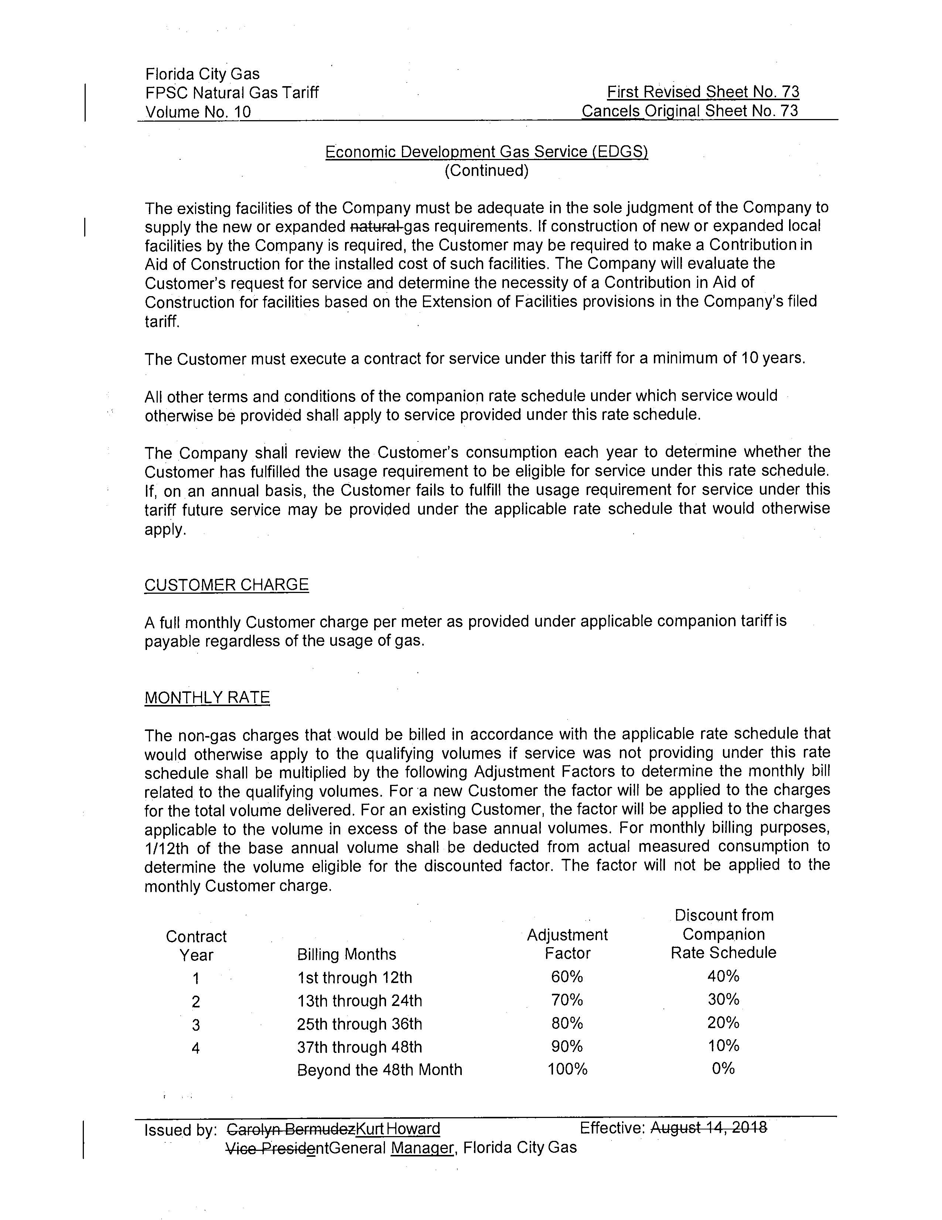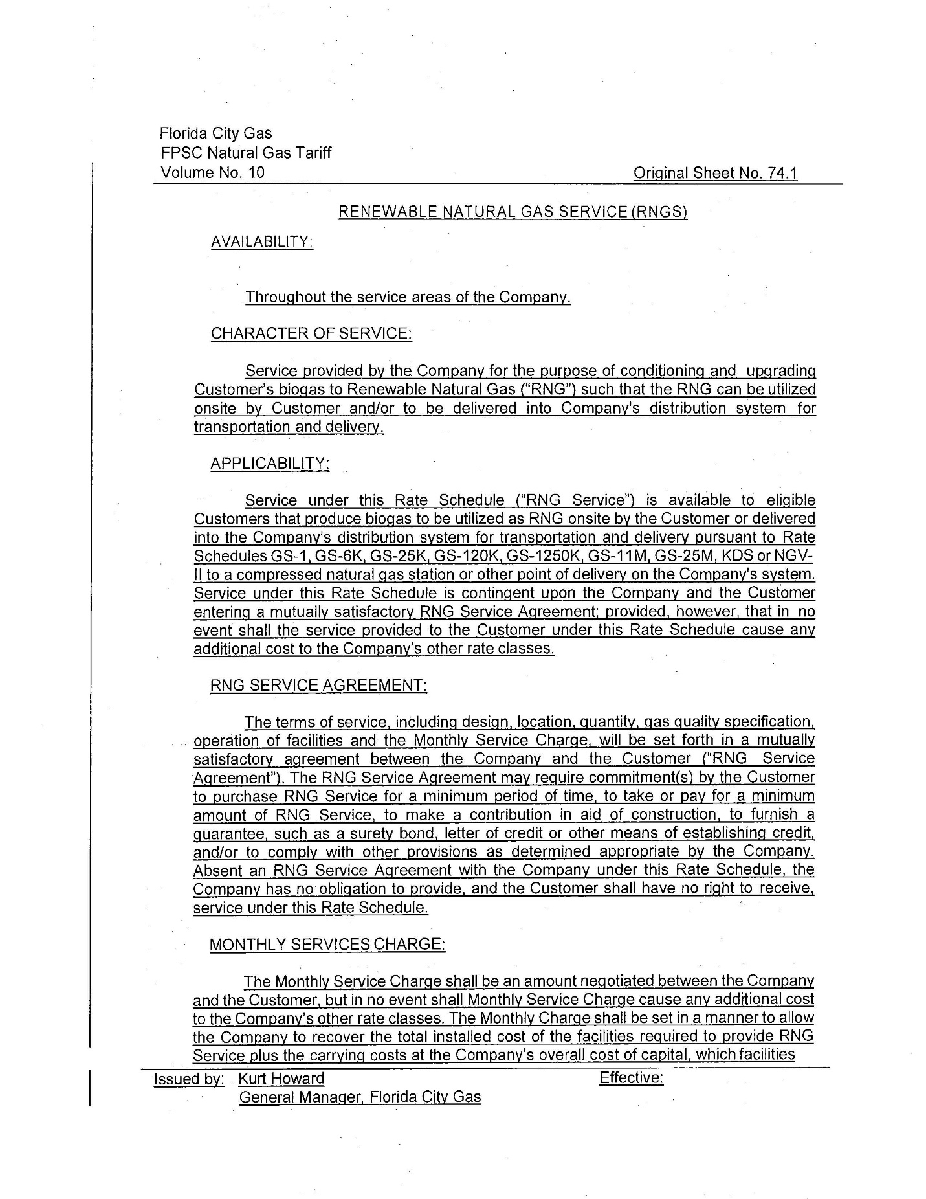
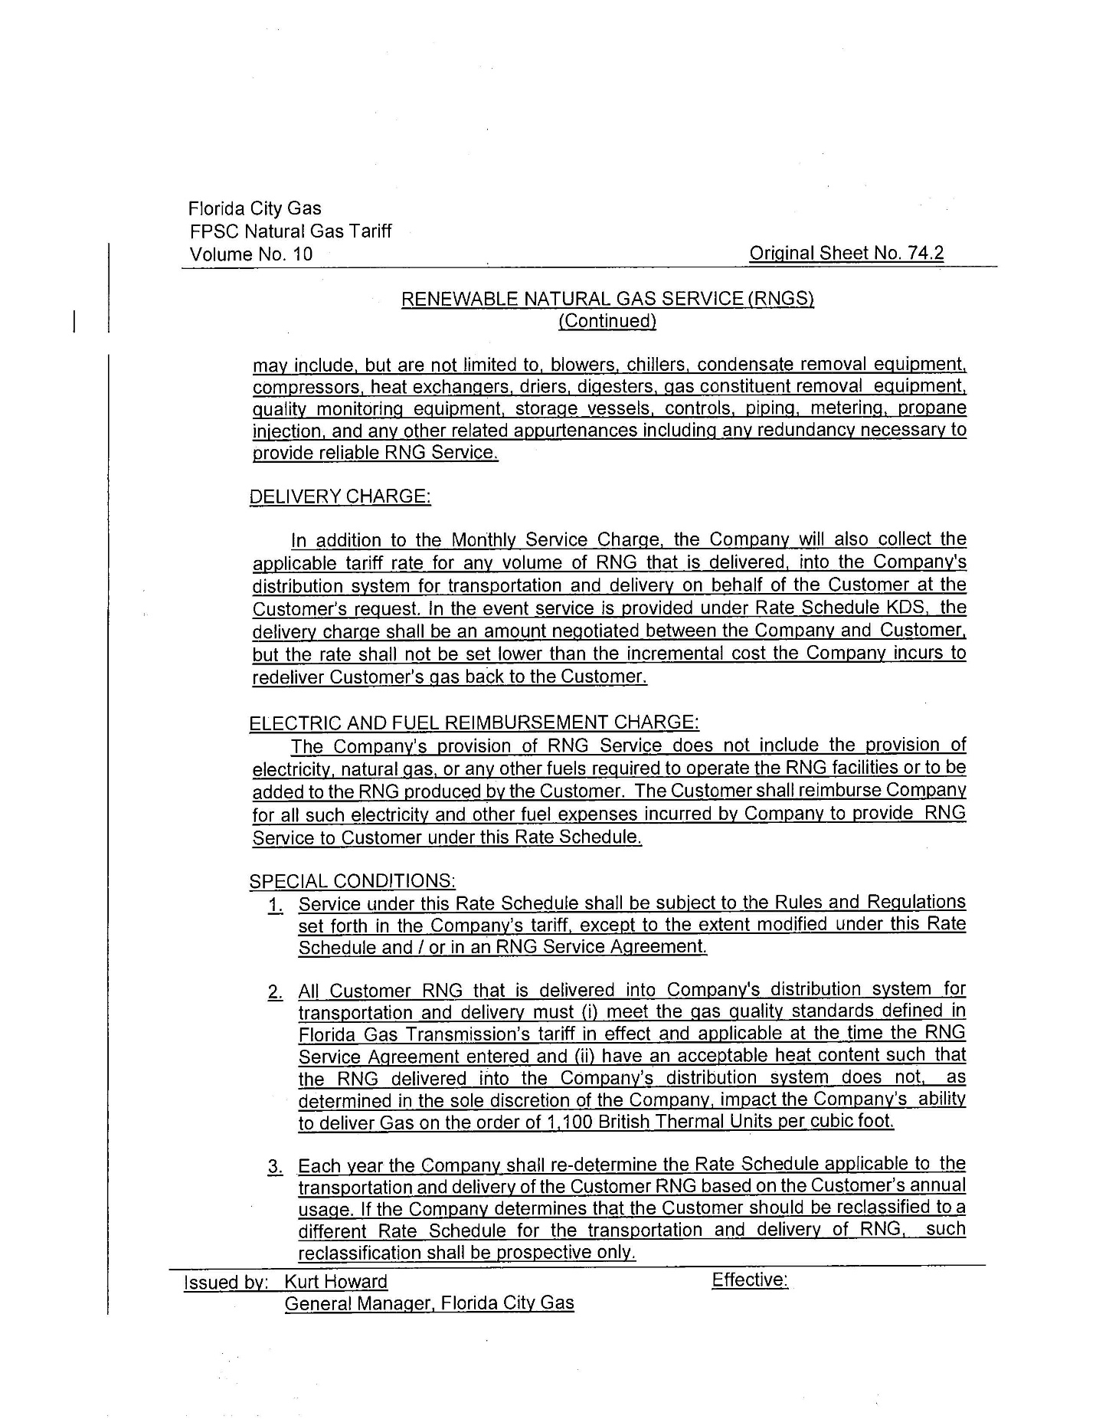
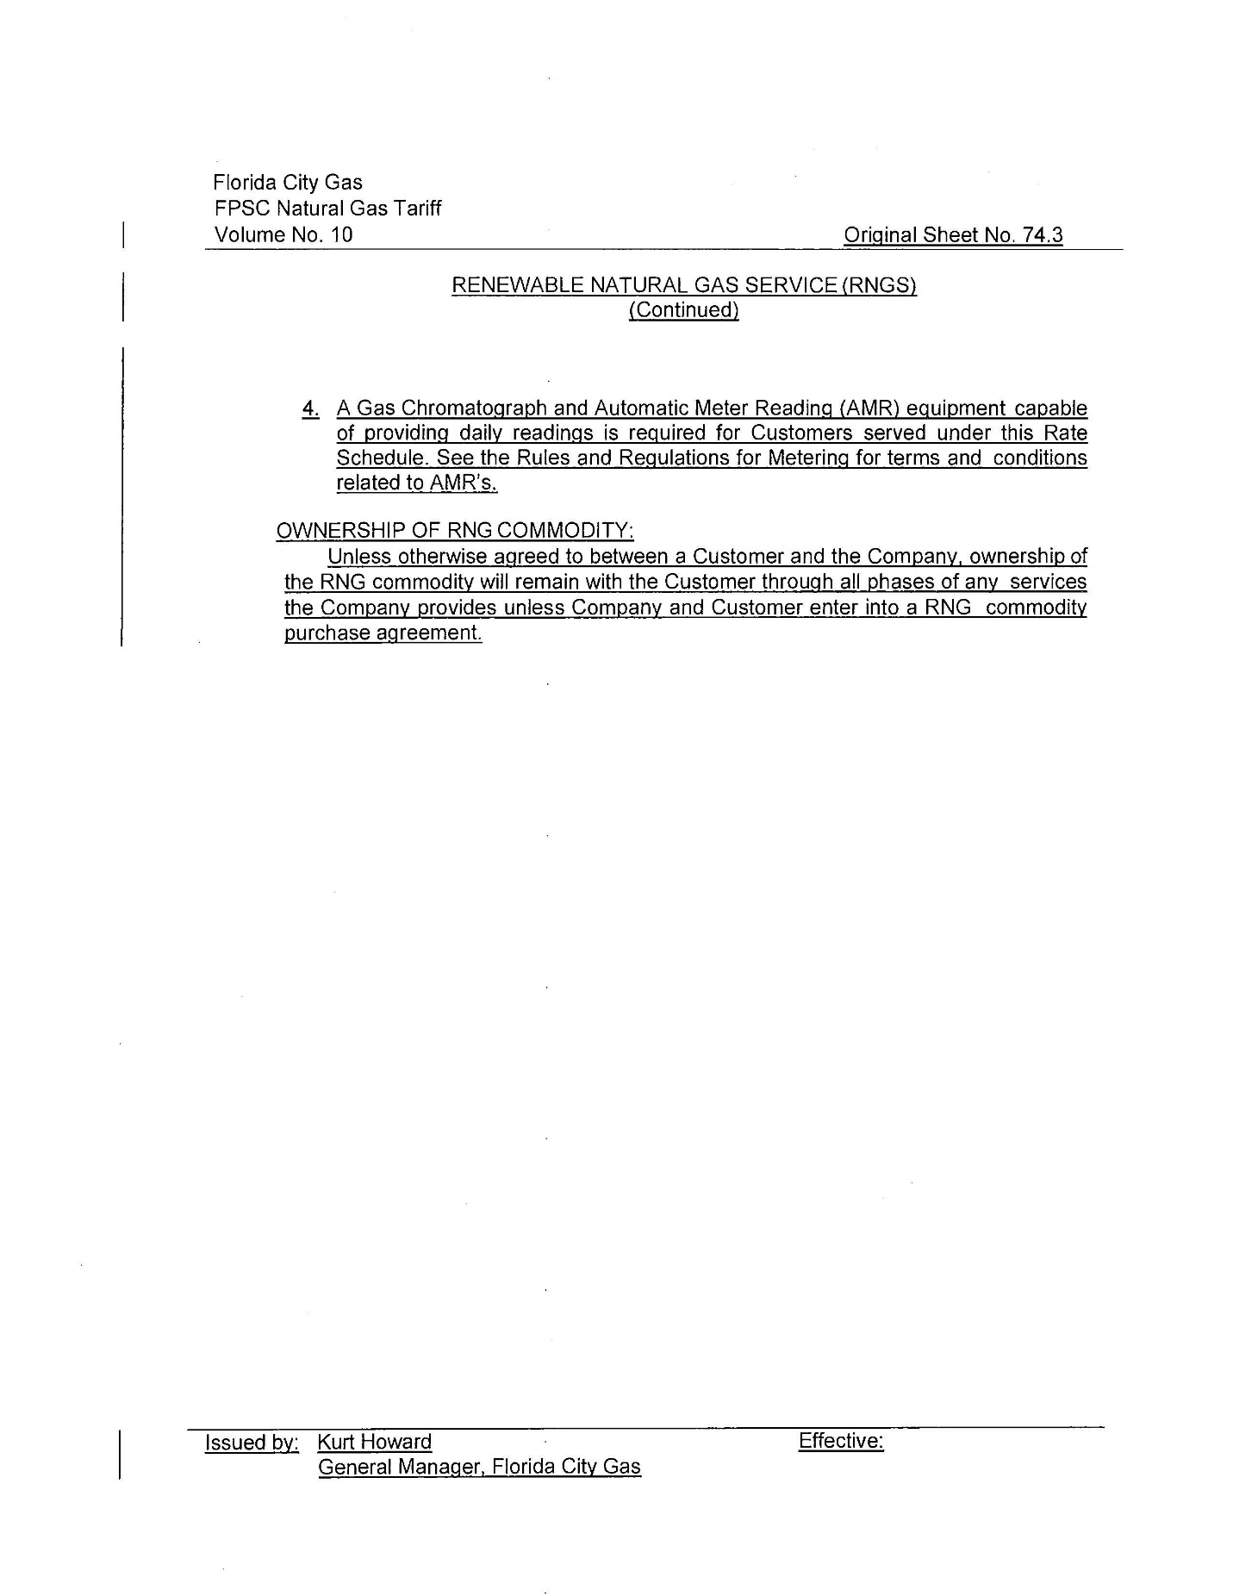

Biogas is described as raw, freshly emitted, and untreated gas, especially methane, produced by the breakdown of organic matter.
Order No. PSC-2017-0497-TRF-EI, issued December 29, 2017, in Docket No. 20170206-GU, In Re: Petition for approval of tariff modifications to accommodate receipt and transportation of renewable natural gas from customers, by Peoples Gas System.
FCG’s petition, Document No. 07393-2020.
FCG’s Response to Staff’s Second Data Request No. 1, Document No. 12882-2020.
FCG’s Response to Staff’s First Data Request No. 1, Document No. 11428-2020.
FCG’s Response to Staff’s First Data Request No. 11, Document No. 11428-2020.

