State of Florida |  | Public Service Commission  Capital Circle Office Center ● 2540 Shumard Oak Boulevard  Tallahassee, Florida 32399-0850  -M-E-M-O-R-A-N-D-U-M-
DATE: | December 22, 2020
TO: | Office of Commission Clerk (Teitzman)
FROM: | Division of Economics (Guffey)  Office of the General Counsel (Osborn, Crawford)
RE: | Docket No. 20200217-EU – Joint petition for approval of territorial agreement in Jefferson, Madison and Taylor Counties, by Tri-County Electric Cooperative and Duke Energy Florida, LLC.
AGENDA: | 01/05/21 – Regular Agenda – Proposed Agency Action - Interested Persons May Participate
COMMISSIONERS ASSIGNED: |  |  | All Commissioners
PREHEARING OFFICER: |  |  | Graham
CRITICAL DATES: |  |  | None
SPECIAL INSTRUCTIONS: |  |  | None

Case Background
On September 16, 2020, Tri-County Electric Cooperative (TCEC) and Duke Energy Florida, LLC (DEF) filed a joint petition seeking approval of their modified territorial agreement (Territorial Agreement) in Jefferson, Madison, and Taylor counties. The Commission approved the joint petitioners’ original territorial agreement in Order No. PSC-92-1214-FOR-EU. The proposed modified Territorial Agreement seeks to transfer 193 TCEC customers to DEF and 225 DEF customers to TCEC. The joint petitioners have also negotiated respective service boundaries in Jefferson, Madison, and Taylor counties. The proposed Territorial Agreement is Attachment A, responses to staff’s second data request correcting errors in the Territorial Agreement is Attachment B, and the maps are Attachment C to this recommendation. Pursuant to Rule 25-6.0440(1)(a), Florida Administrative Code (F.A.C.), the joint petitioners provided a written description of the territorial boundaries in Exhibit D of the petition. Pursuant to Rule 25-6.0440(1)(d), F.A.C., the customers subject to the transfer were notified by letter (Exhibit E of the petition).
The proposed modified Territorial Agreement establishes the new territorial boundaries reflecting the assets and customers transferred between TCEC and DEF. During the review process, staff issued two data requests to the joint petitioners to which responses were received on November 4, 2020 and on November 19, 2020. The Commission has jurisdiction over this matter pursuant to Section 366.04, Florida Statutes (F.S.).

Discussion of Issues

Issue 1:
Should the Commission approve the proposed modified Territorial Agreement in Jefferson, Madison, and Taylor counties between Tri-County Electric Cooperative (TCEC) and Duke Energy Florida, LLC (DEF)?

Recommendation:
Yes, the Commission should approve the modified Territorial Agreement in Jefferson, Madison, and Taylor counties between TCEC and DEF. The approval of this Territorial Agreement will not be a detriment to the public interest and it will enable TCEC and DEF to avoid duplication of facilities. The modified Territorial Agreement between TCEC and DEF should become effective on the date the Commission order approving the 2020 Territorial Agreement becomes final. (Guffey)

Staff Analysis:
Pursuant to Section 366.04(2)(d), F.S., and Rule 25-6.0440(2), F.A.C., the Commission has the jurisdiction to approve territorial agreements between and among rural electric cooperatives, municipal electric utilities, and other electric utilities. Unless the Commission determines that the agreement will cause a detriment to the public interest, the agreement should be approved.

The Proposed Modified Territorial Agreement
TCEC and DEF entered into the proposed Territorial Agreement on September 15, 2020, to replace the 1992 Territorial Agreement, which expired in October 2012. The joint petitioners have negotiated the agreement delineating their respective modified service boundaries in each county that is part of this proposed Territorial Agreement. In response to staff’s first data request, the joint petitioners stated since 2012, they continued to collaborate to provide service and perform due diligence activities to update and revise the agreement. Upon its approval by the Commission, and pursuant to Section 5.3, the proposed Territorial Agreement will supersede any and all prior agreements between the parties in Jefferson, Madison, and Taylor counties. Through the proposed Territorial Agreement, the joint petitioners seek to gain operational efficiencies and customer service improvements in their respective retail service territories in Jefferson, Madison, and Taylor counties and eliminate circumstances leading to uneconomic duplication of service facilities and hazardous situations. The Territorial Agreement represents the continued effort by the parties to minimize unnecessary duplication of generation, transmission, and distribution facilities and accurately delineate their respective service boundaries which are contiguous.
The proposed Territorial Agreement has been negotiated for a term of 30 years from the date the Commission order approving the Territorial Agreement in its entirety is no longer subject to judicial review. Pursuant to Section 6.1 of the proposed Territorial Agreement, upon the expiration of the initial 30-year term, the Territorial Agreement shall remain in effect until either party provides written notification to terminate no less than 12 months prior to the termination date in accordance with Section 8.2 of the Territorial Agreement. Pursuant to Article V of the Territorial Agreement, any modifications to this agreement will be submitted to the Commission for approval.

Customer and Facilities Transfer
This proposed Territorial Agreement contemplates the transfer of 193 TCEC customers (12 commercial, 181 residential) to DEF and 225 DEF customers (37 commercial, 188 residential) to TCEC. Section 3.5 of the proposed Territorial Agreement contemplates the transfer of these customers and the associated facilities in segments. A segment is based on geographic location and engineering requirements needed to complete the transfer. In response to staff’s first data request, the petitioners stated that the transfer of these customers will be conducted in between 10 to 15 transfer segments based on geographic location and engineering requirements. Paragraph 5 of the petition and Section 3.1 of the Territorial Agreement state that the joint petitioners intend to complete all transfers within 36 months of the effective date of this Agreement. Pursuant to Sections 3.3 and 3.4 of the proposed Agreement, the receiving party of transferred customers may elect to purchase electric distribution facilities from the transferring party for the purpose of providing electricity to those customers. Purchase price and compensation will be determined by applying an industry cost calculator such as the Handy Whitman Index or a common engineering cost estimation methodology to the original cost.

Customer Notification
Pursuant to Rule 25-6.0440(1)(d), F.A.C., in early 2020, TCEC and DEF informed customers subject to transfer by letters of the impending transfers and rate comparisons for February 2020. The written notifications indicate a February residential rate of $123.99 for 1,000 kilowatt-hours (kWh) for DEF and $131.28 for 1,000 kWh for TCEC. The sample customer notification letters are included as Exhibit E in the petition. In response to staff’s first data request, the joint petitioners provided September 2020 residential rates indicating $130.26 for DEF and $125.00 for TCEC for 1,000 kWh. In response to a supplemental request by staff, the joint petitioners confirmed that the transferred customers will be billed pursuant to their new utility’s rates. Paragraph 6 of the petition states that, at the time of the filing, the petitioners have not received any negative responses to the customer notifications. Additionally, no customer comments or concerns have been filed in the docket file.

Conclusion
After review of the petition, the proposed modified Territorial Agreement, and evaluation of responses to staff’s data requests, staff believes that the proposed Territorial Agreement will not be a detriment to the public interest and will enable TCEC and DEF to serve their current and future customers in an efficient manner.
The approval of this Territorial Agreement will not be a detriment to the public interest and it will enable TCEC and DEF to avoid duplication of facilities. Staff recommends that the modified Territorial Agreement between TCEC and DEF be approved and should become effective on the date the Commission order approving the 2020 Territorial Agreement becomes final.
Issue 2:
Should this docket be closed?

Recommendation:
If no protest is filed by a person whose substantial interests are affected within 21 days of the issuance of the Order, this docket should be closed upon the issuance of a Consummating Order. (Osborn, Crawford)

Staff Analysis:
If no protest is filed by a person whose substantial interests are affected within 21 days of the issuance of the Order, this docket should be closed upon the issuance of a Consummating Order.

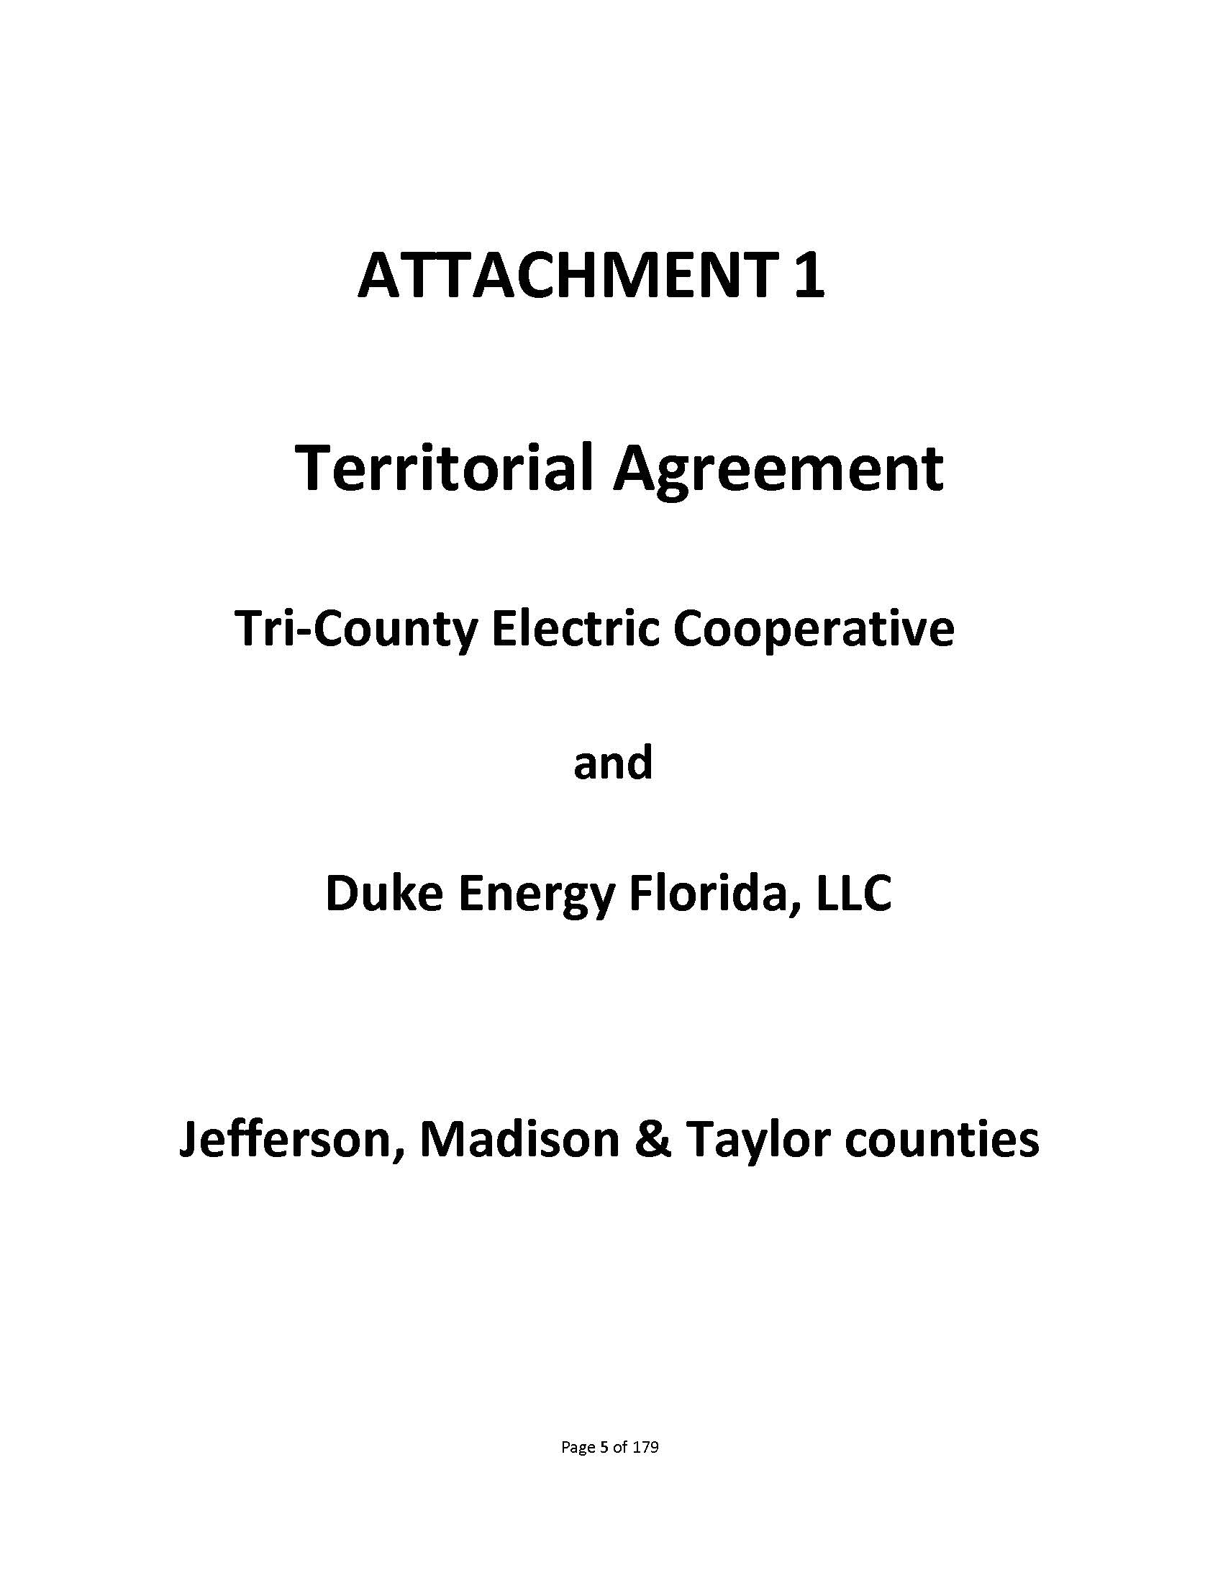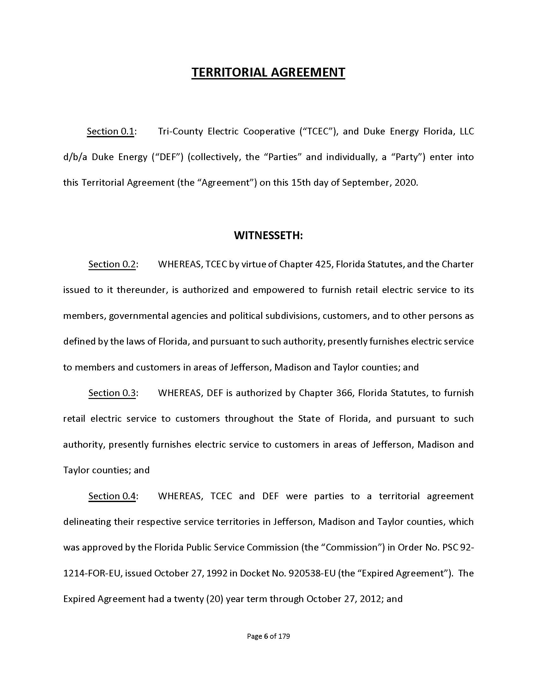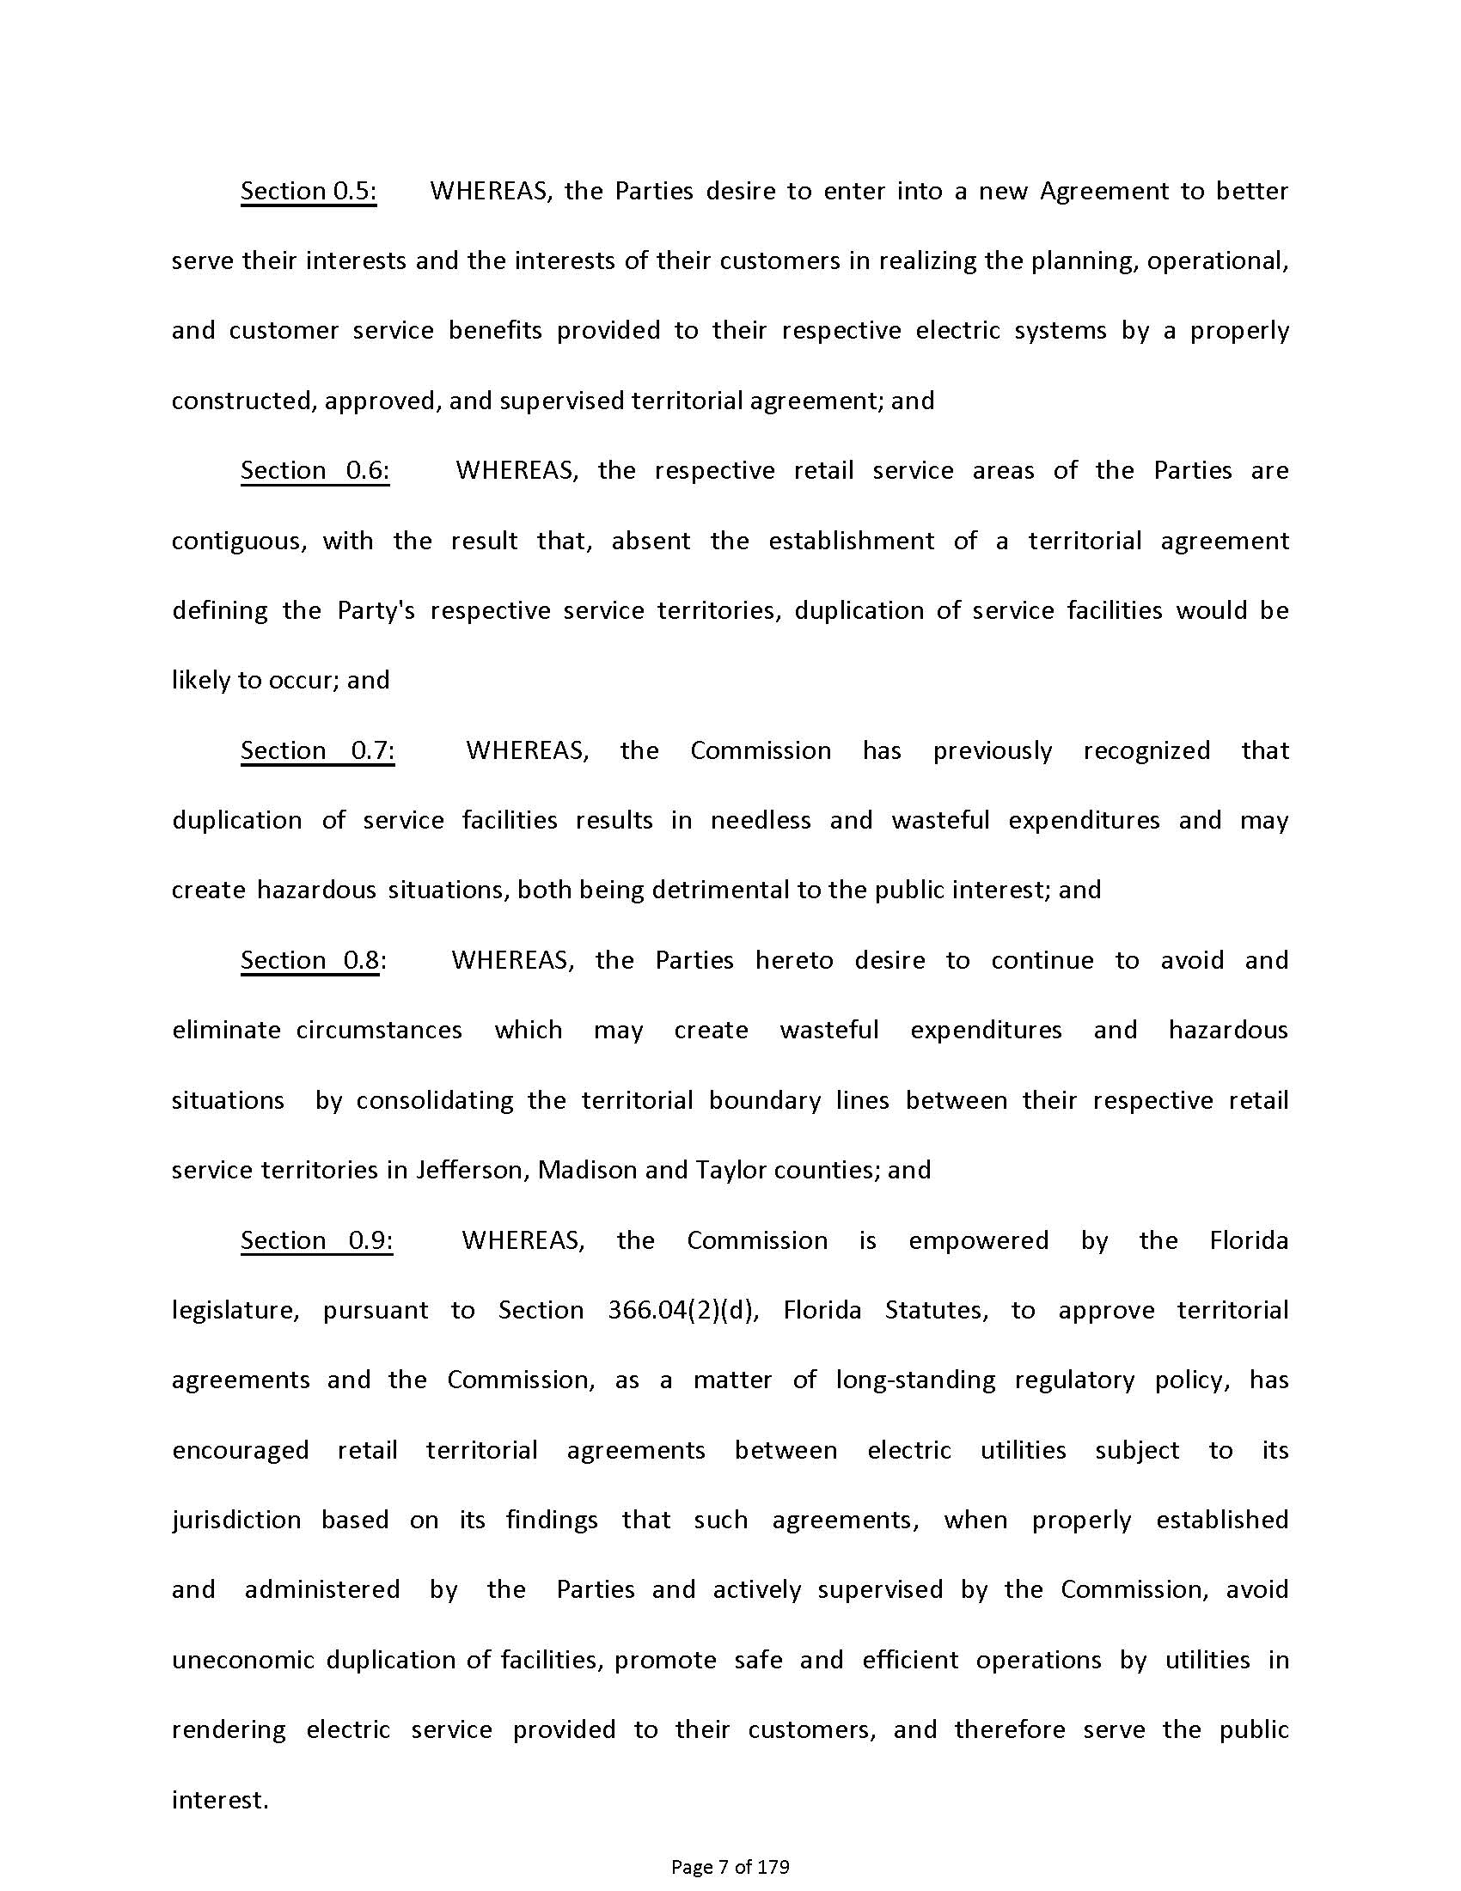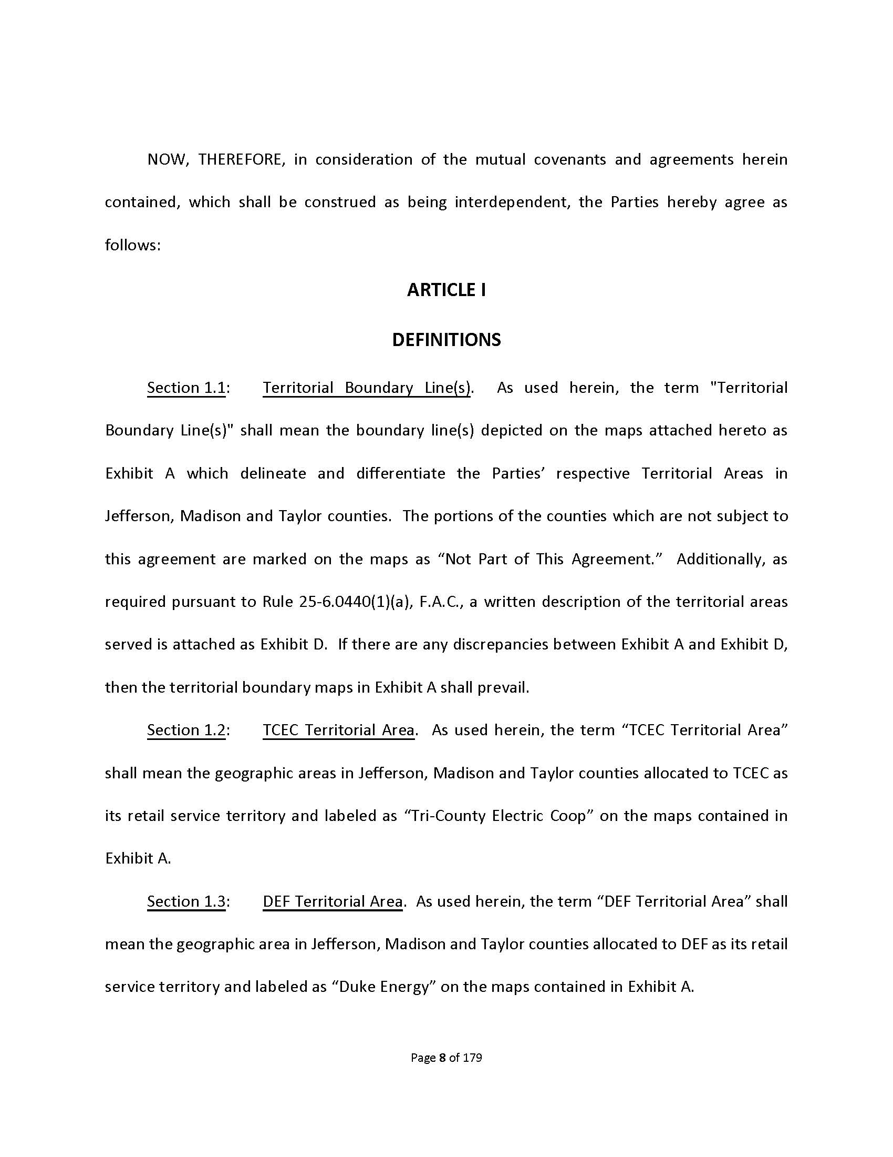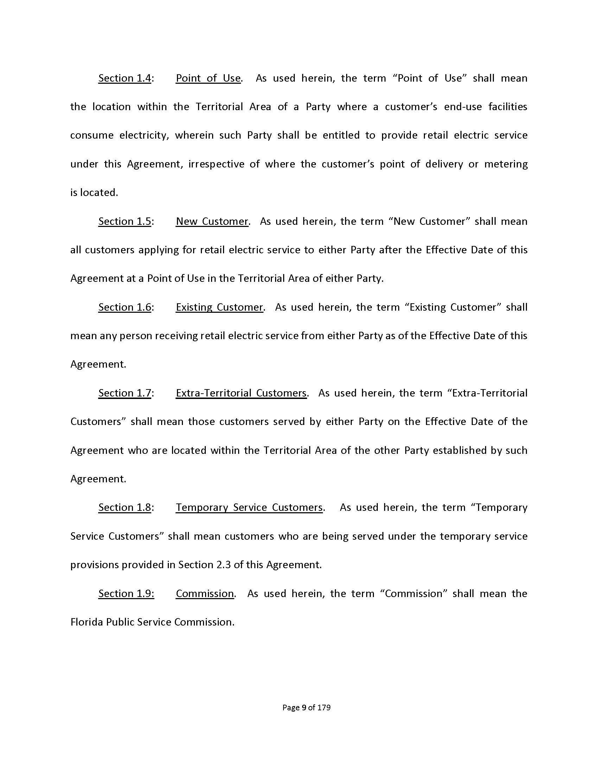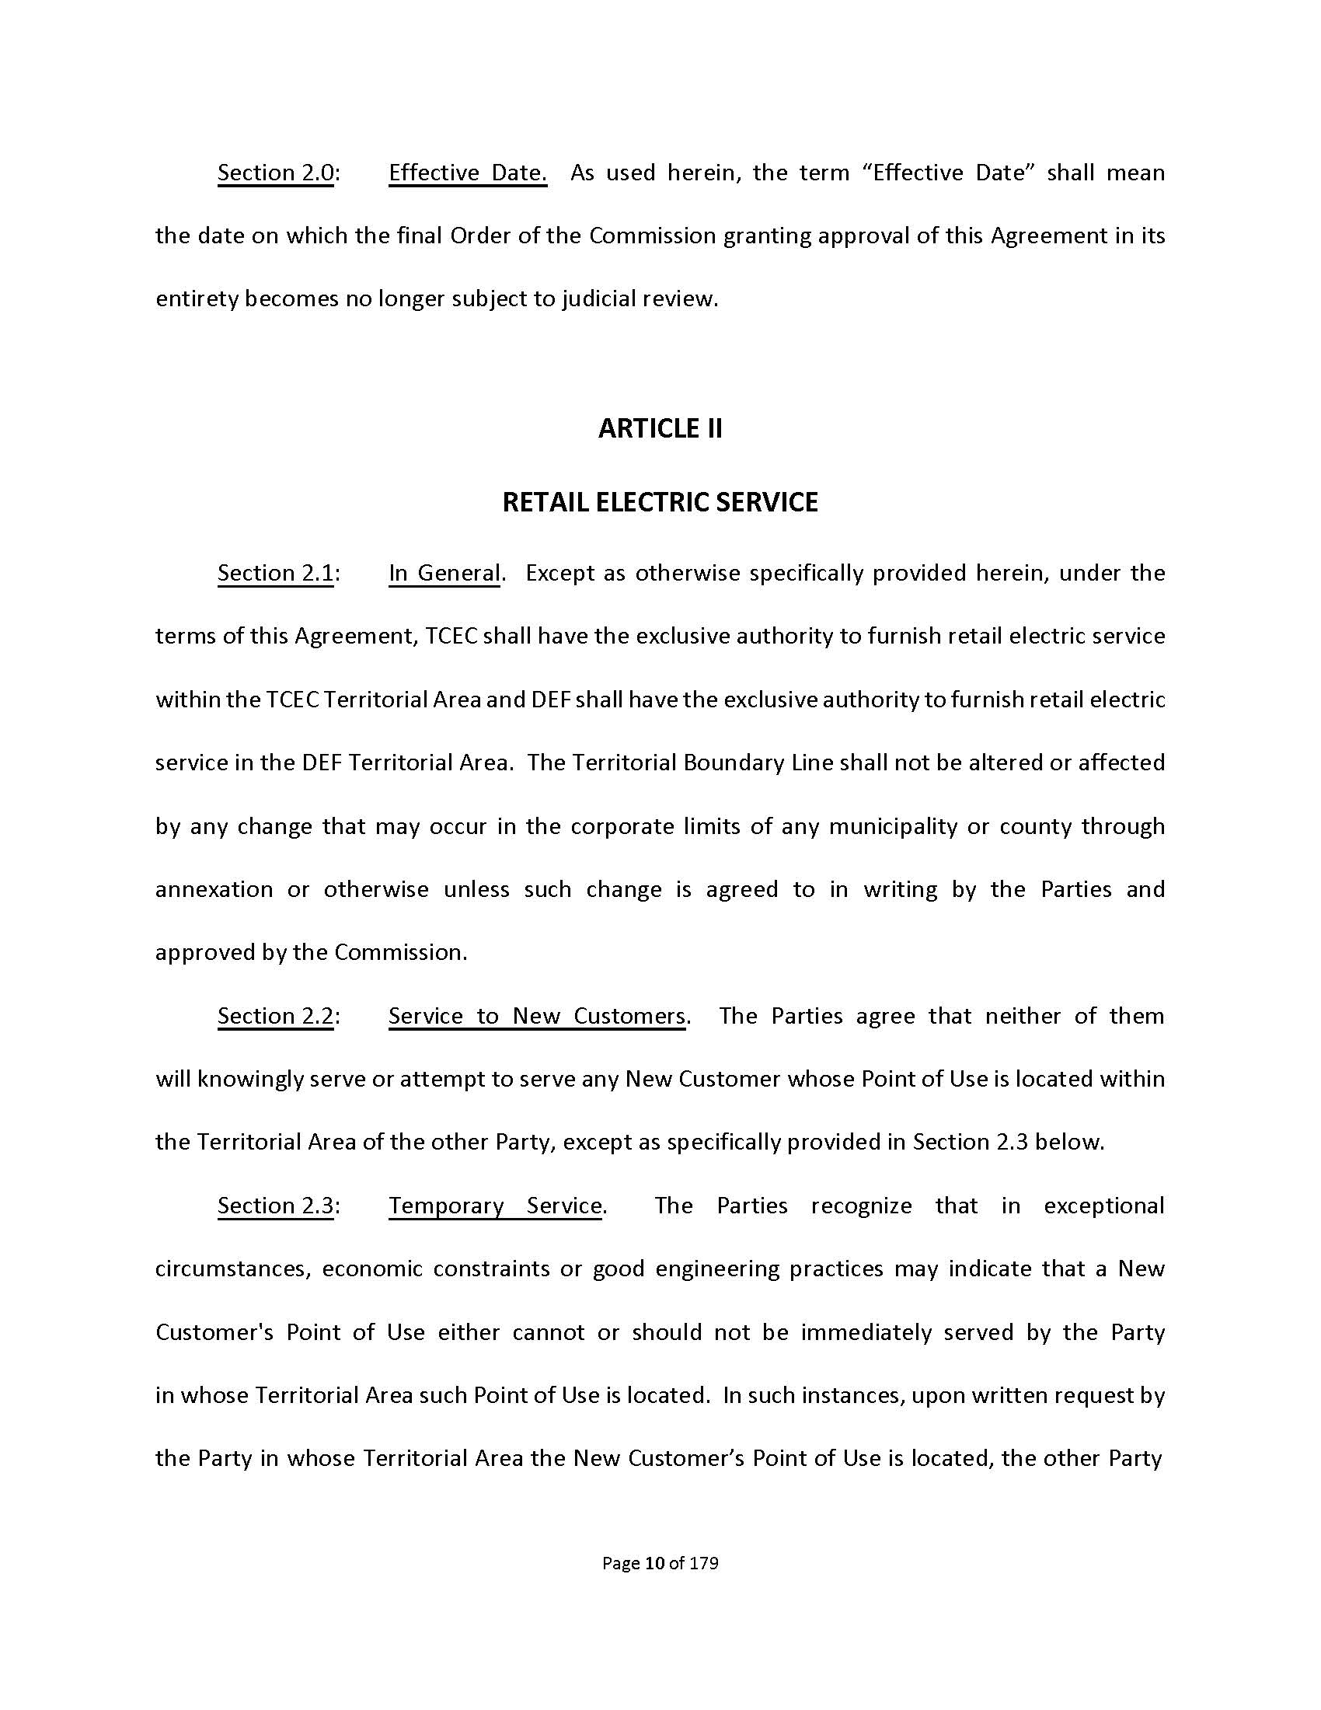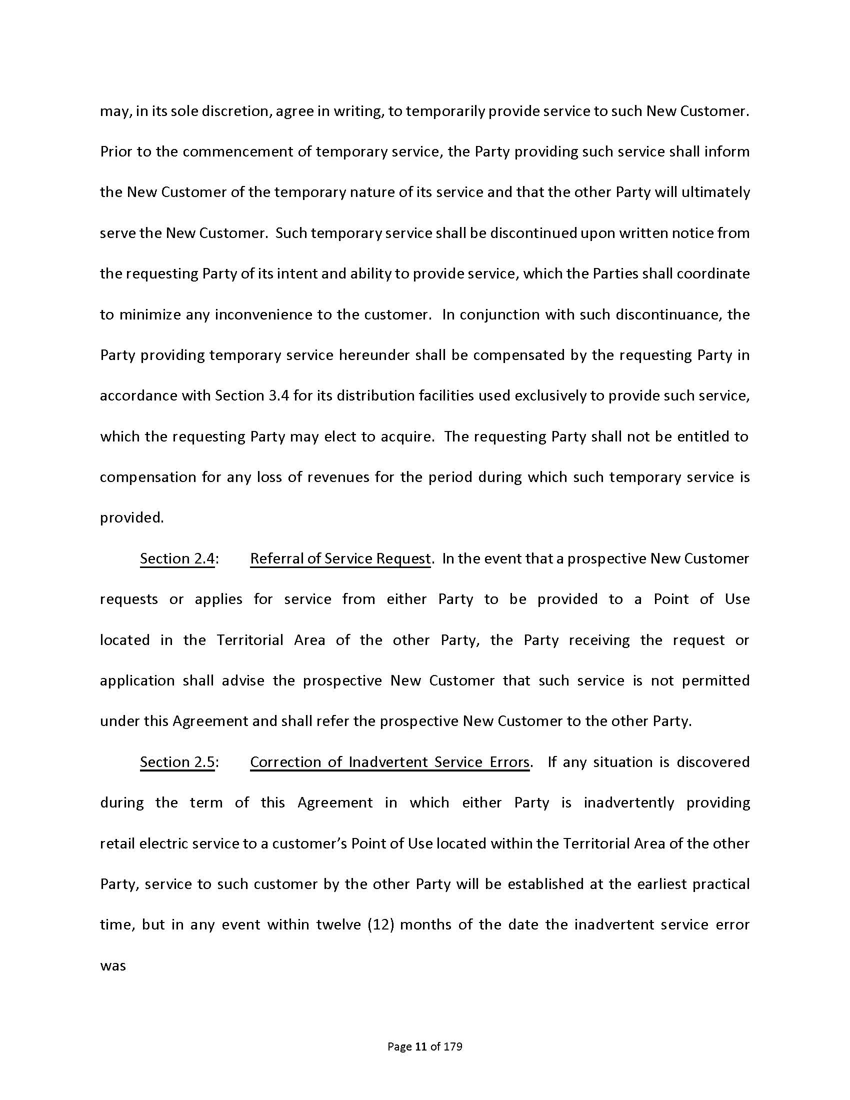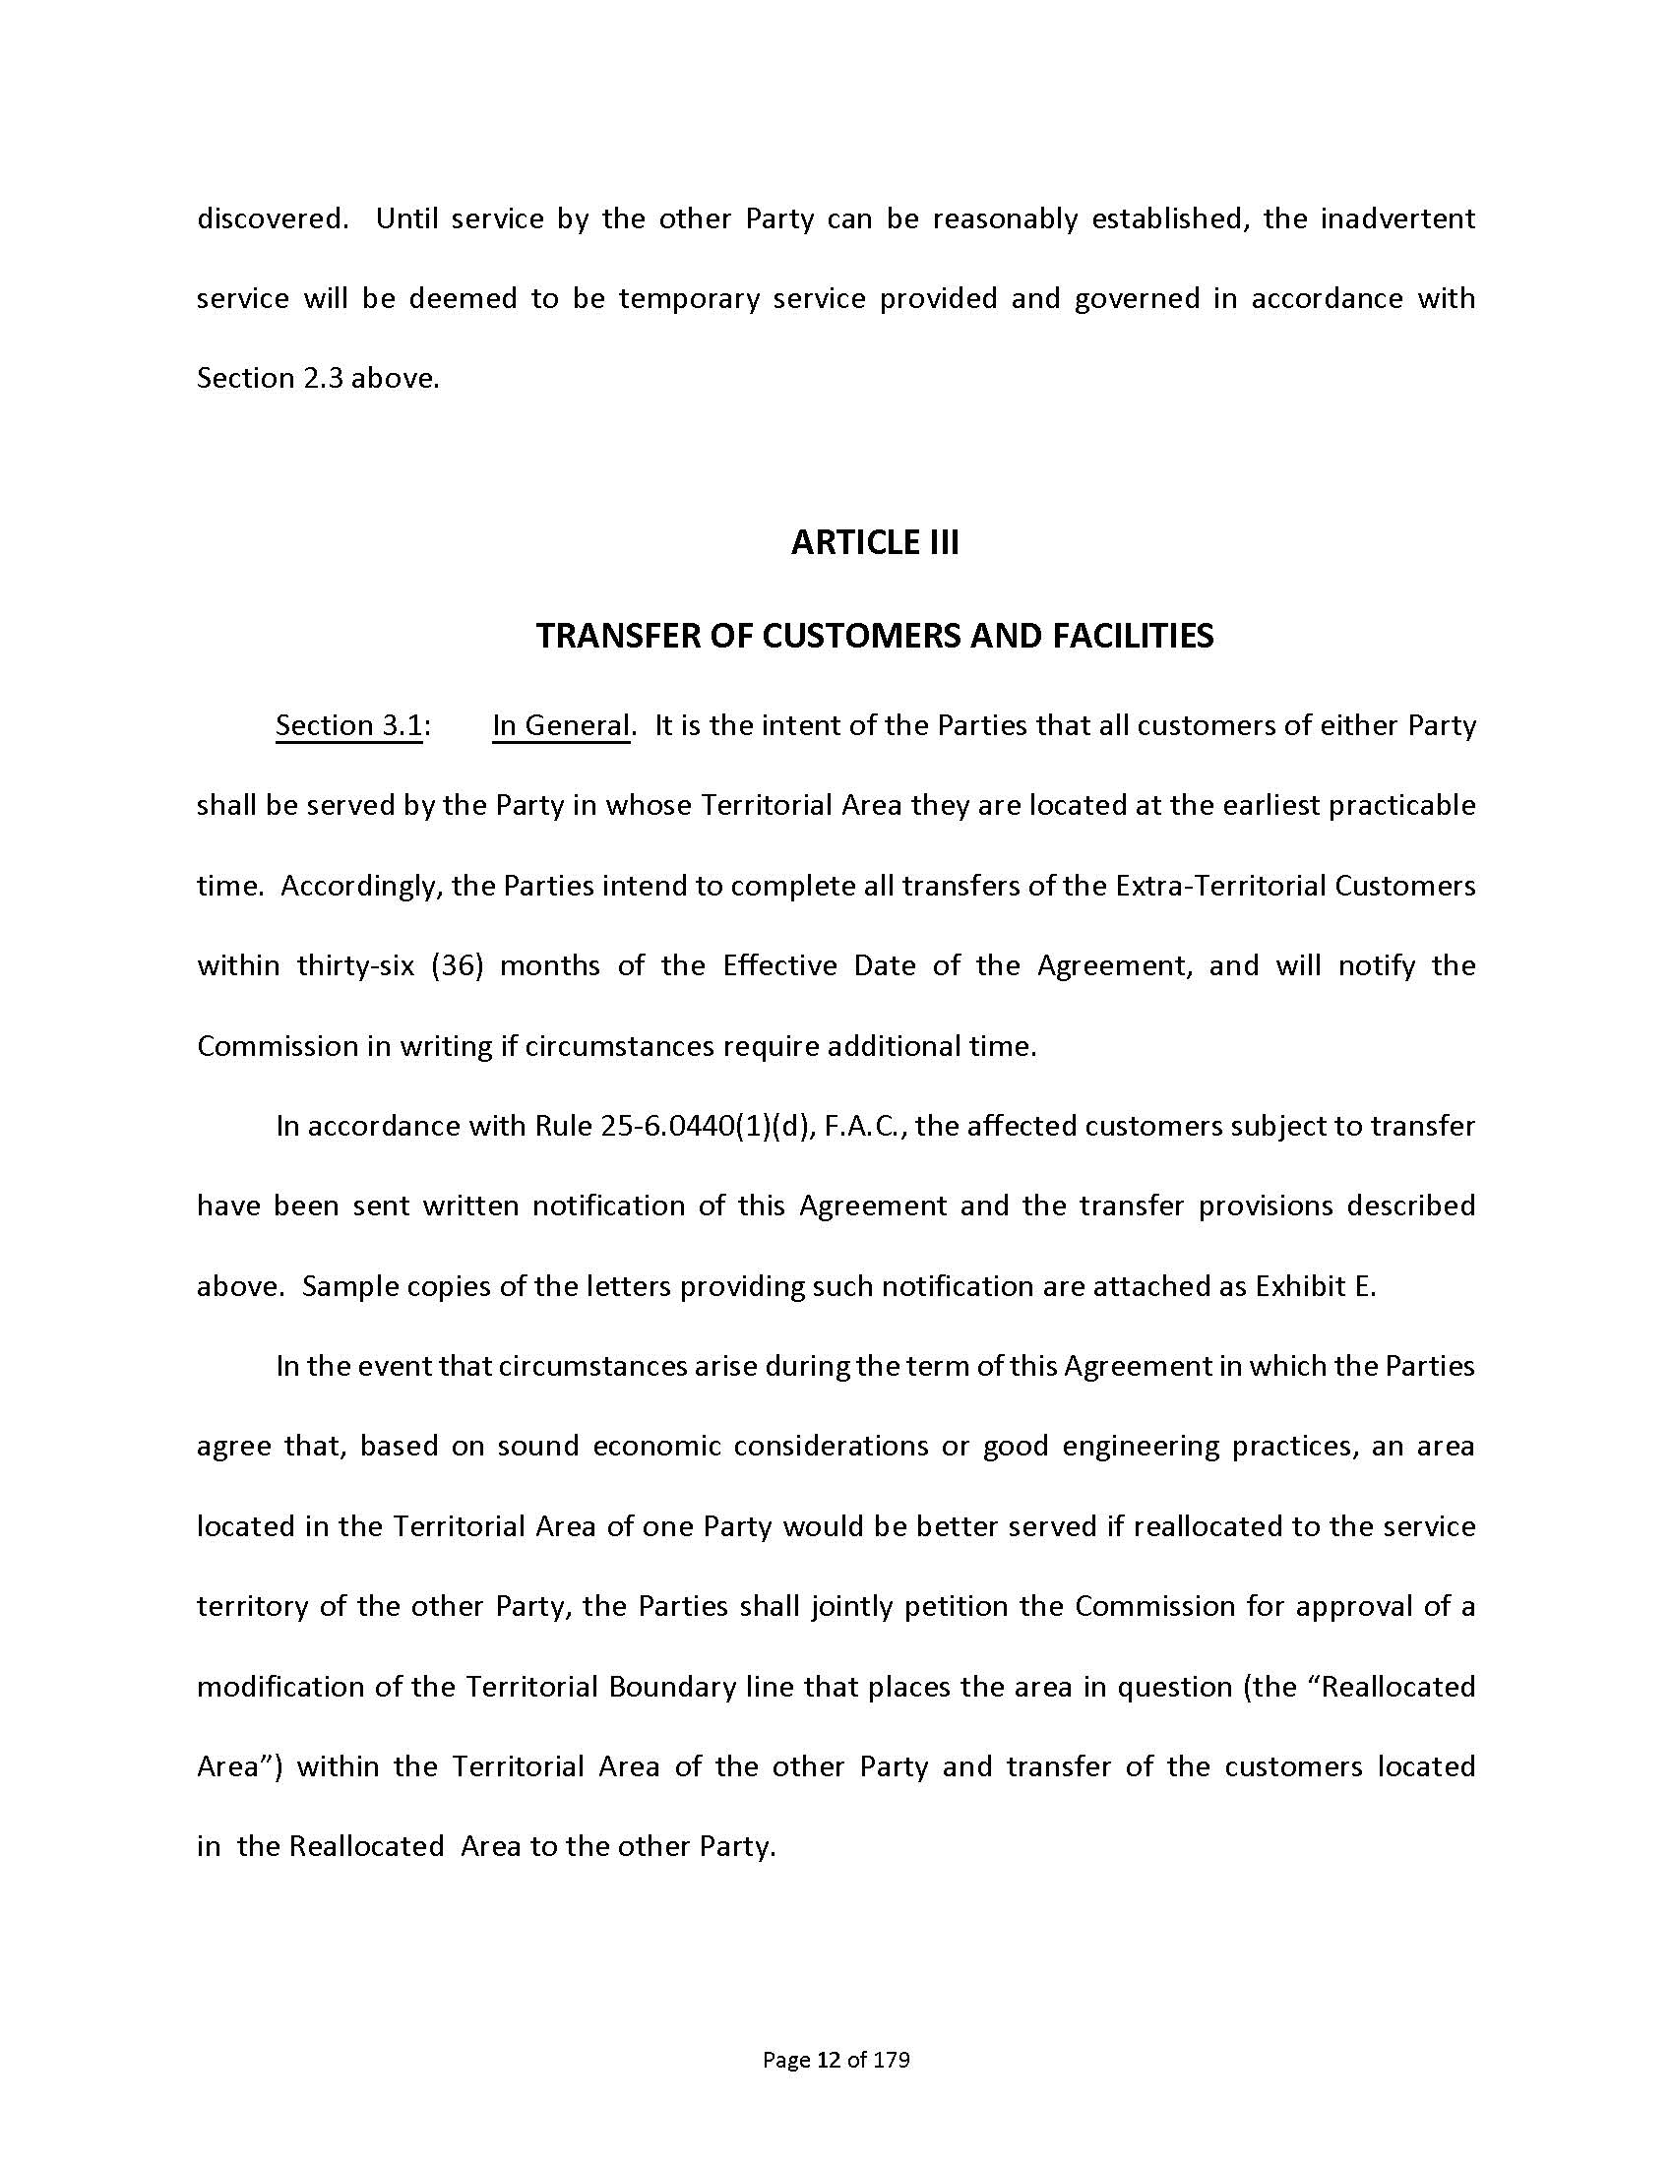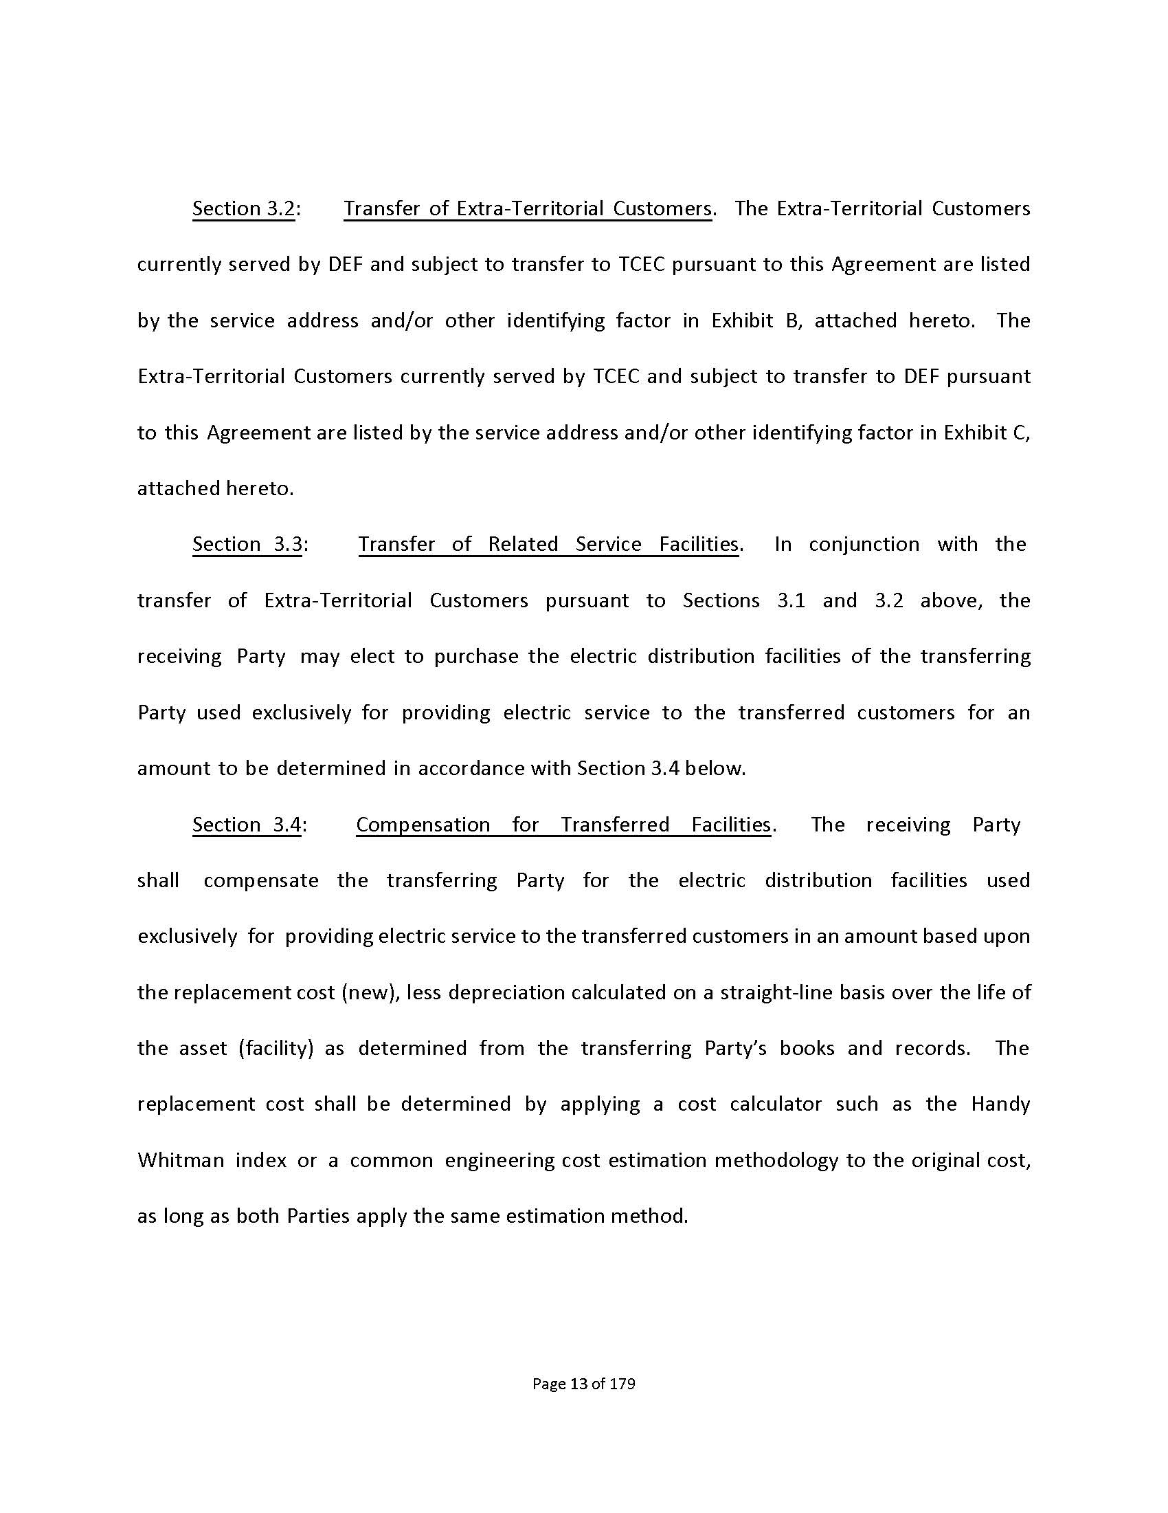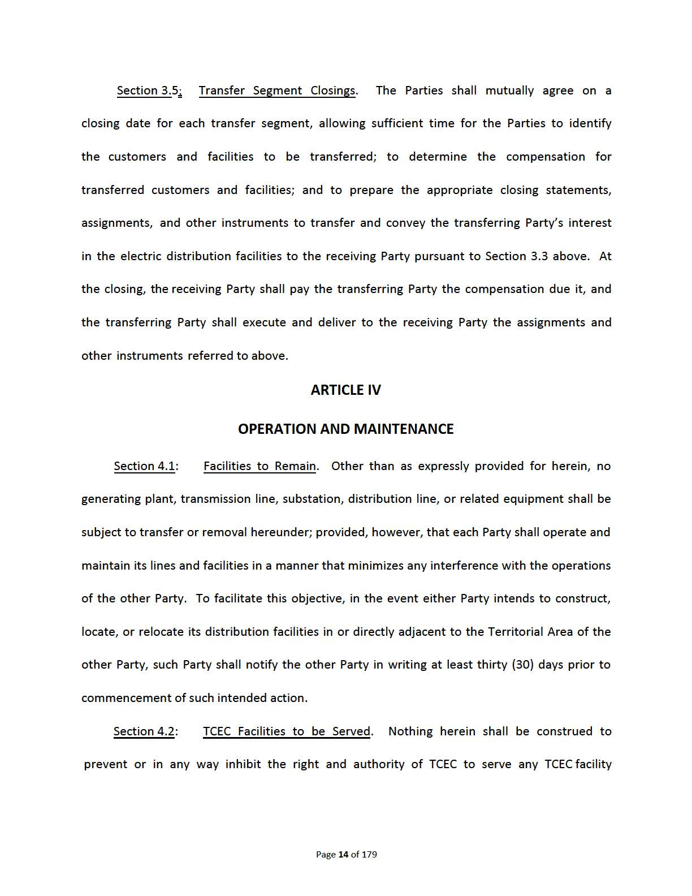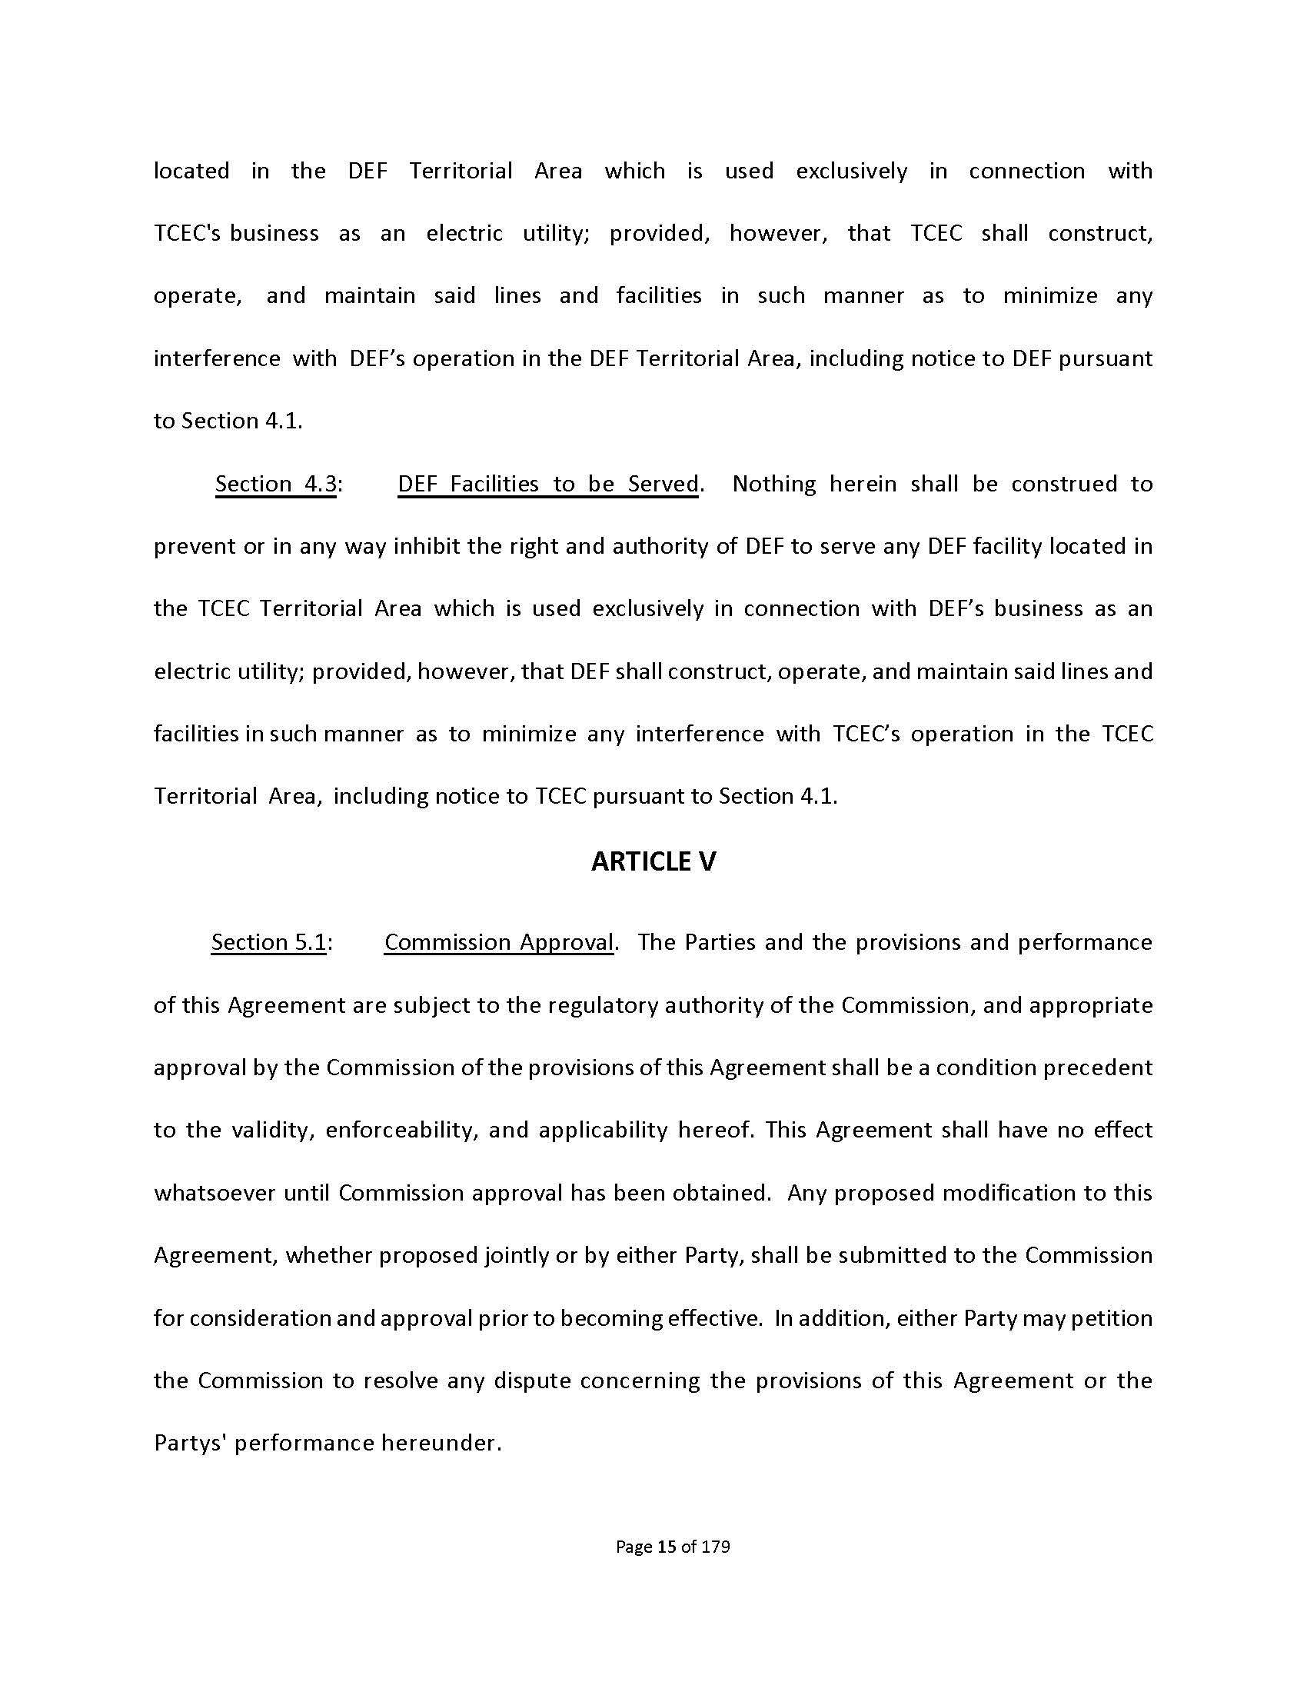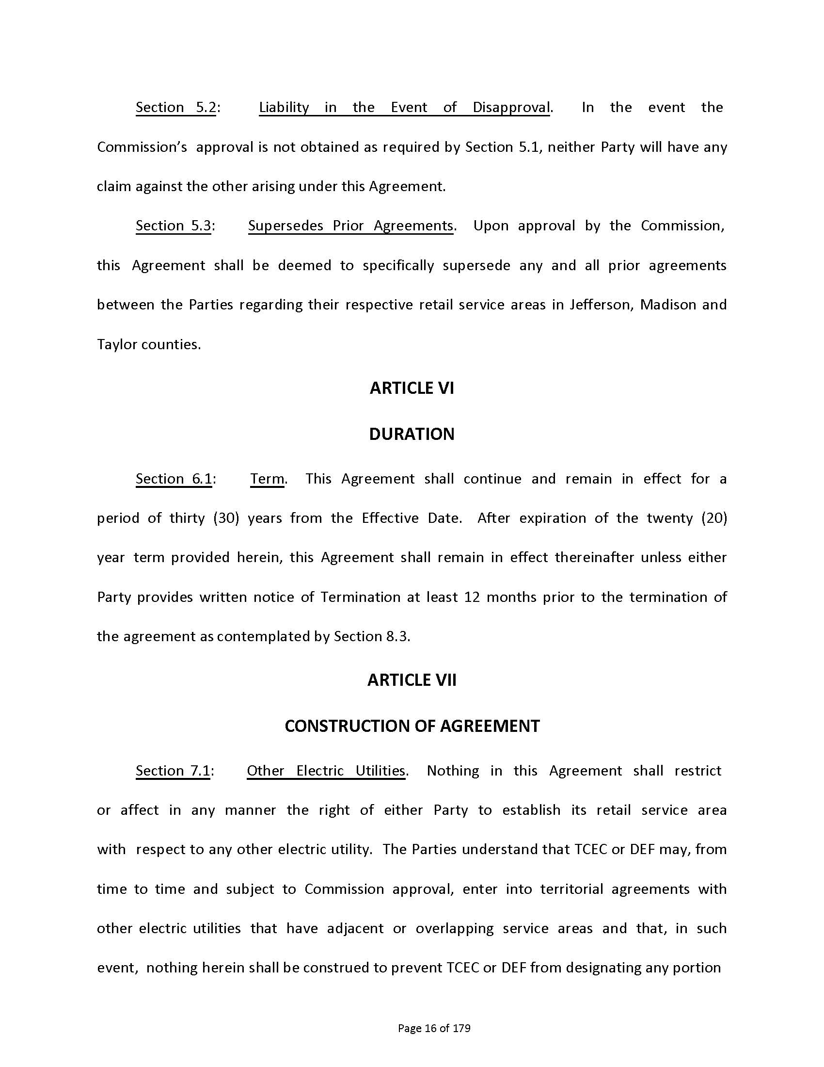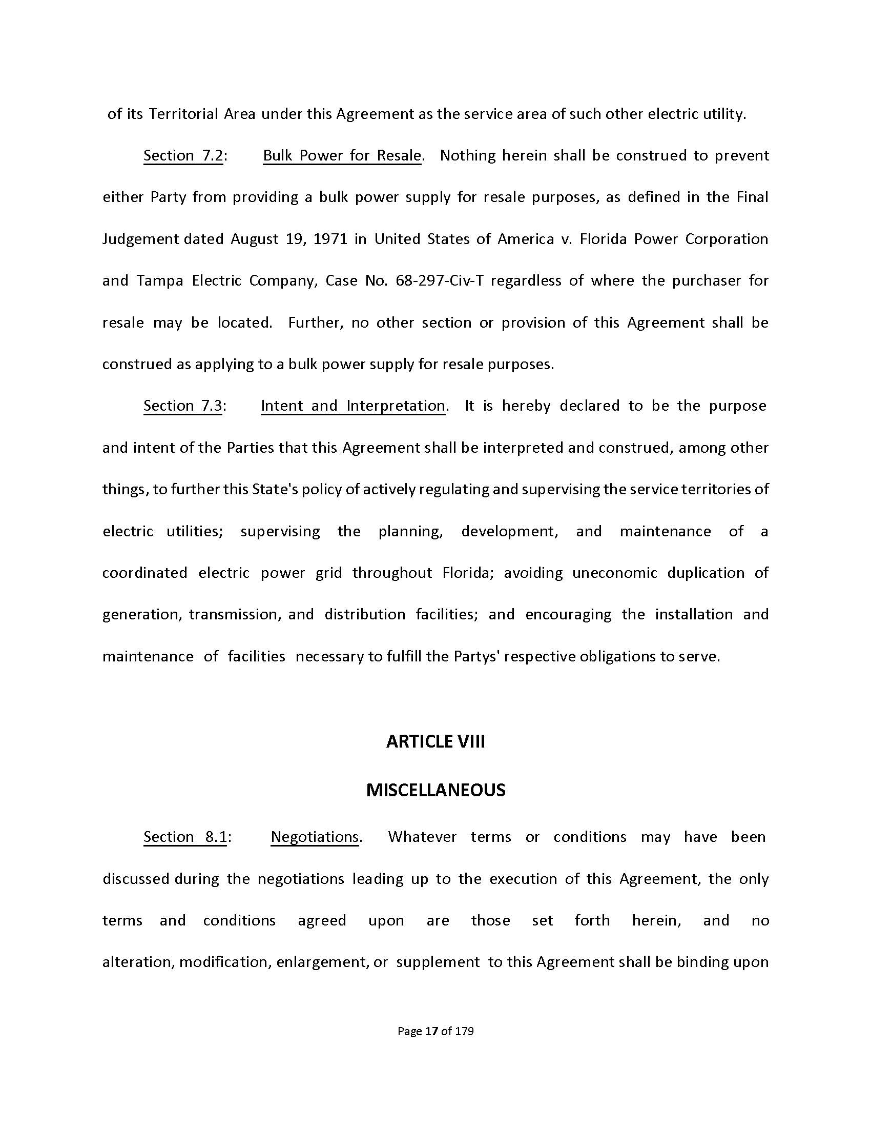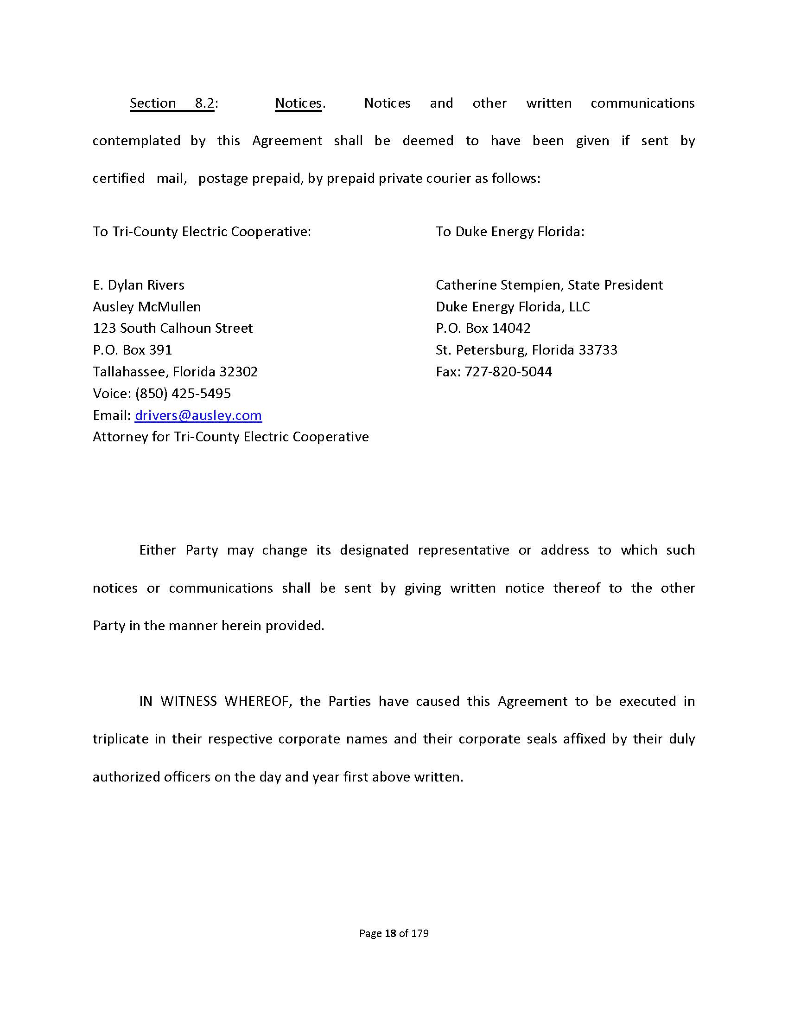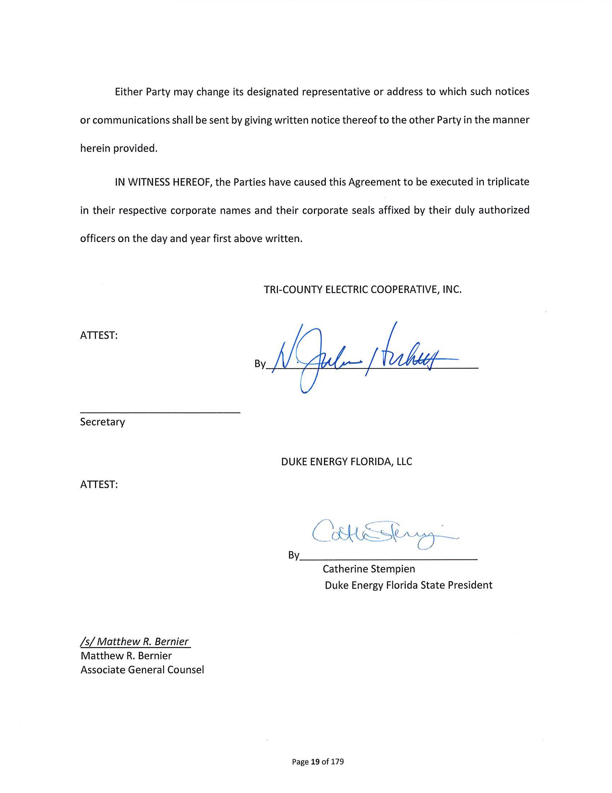

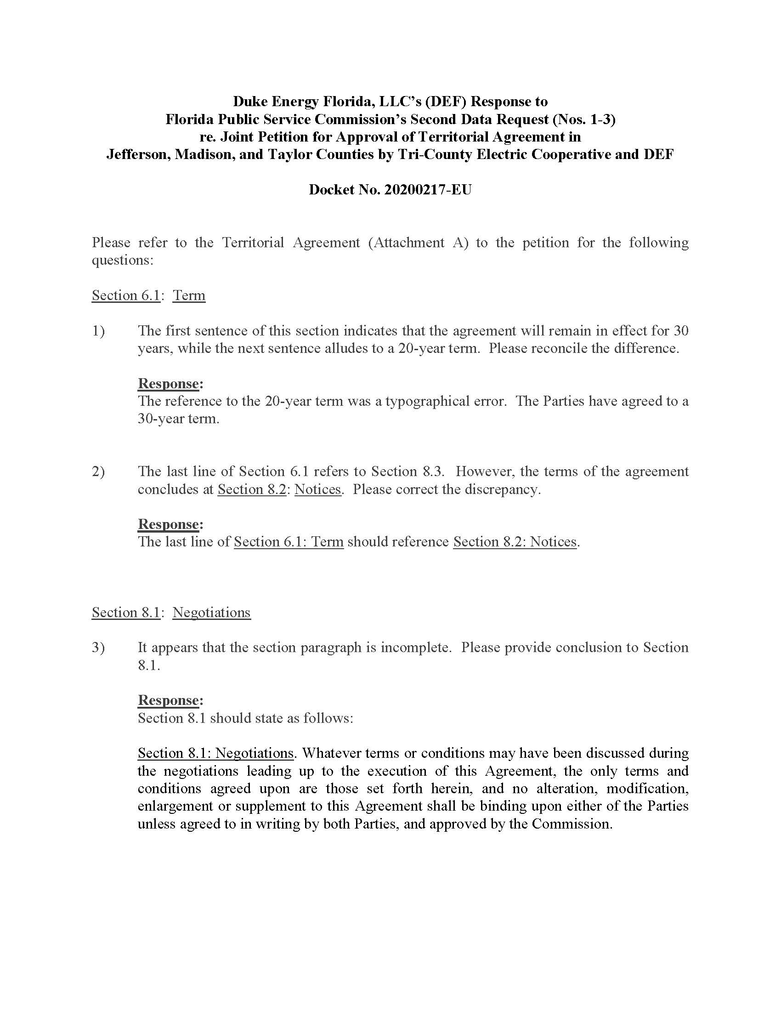
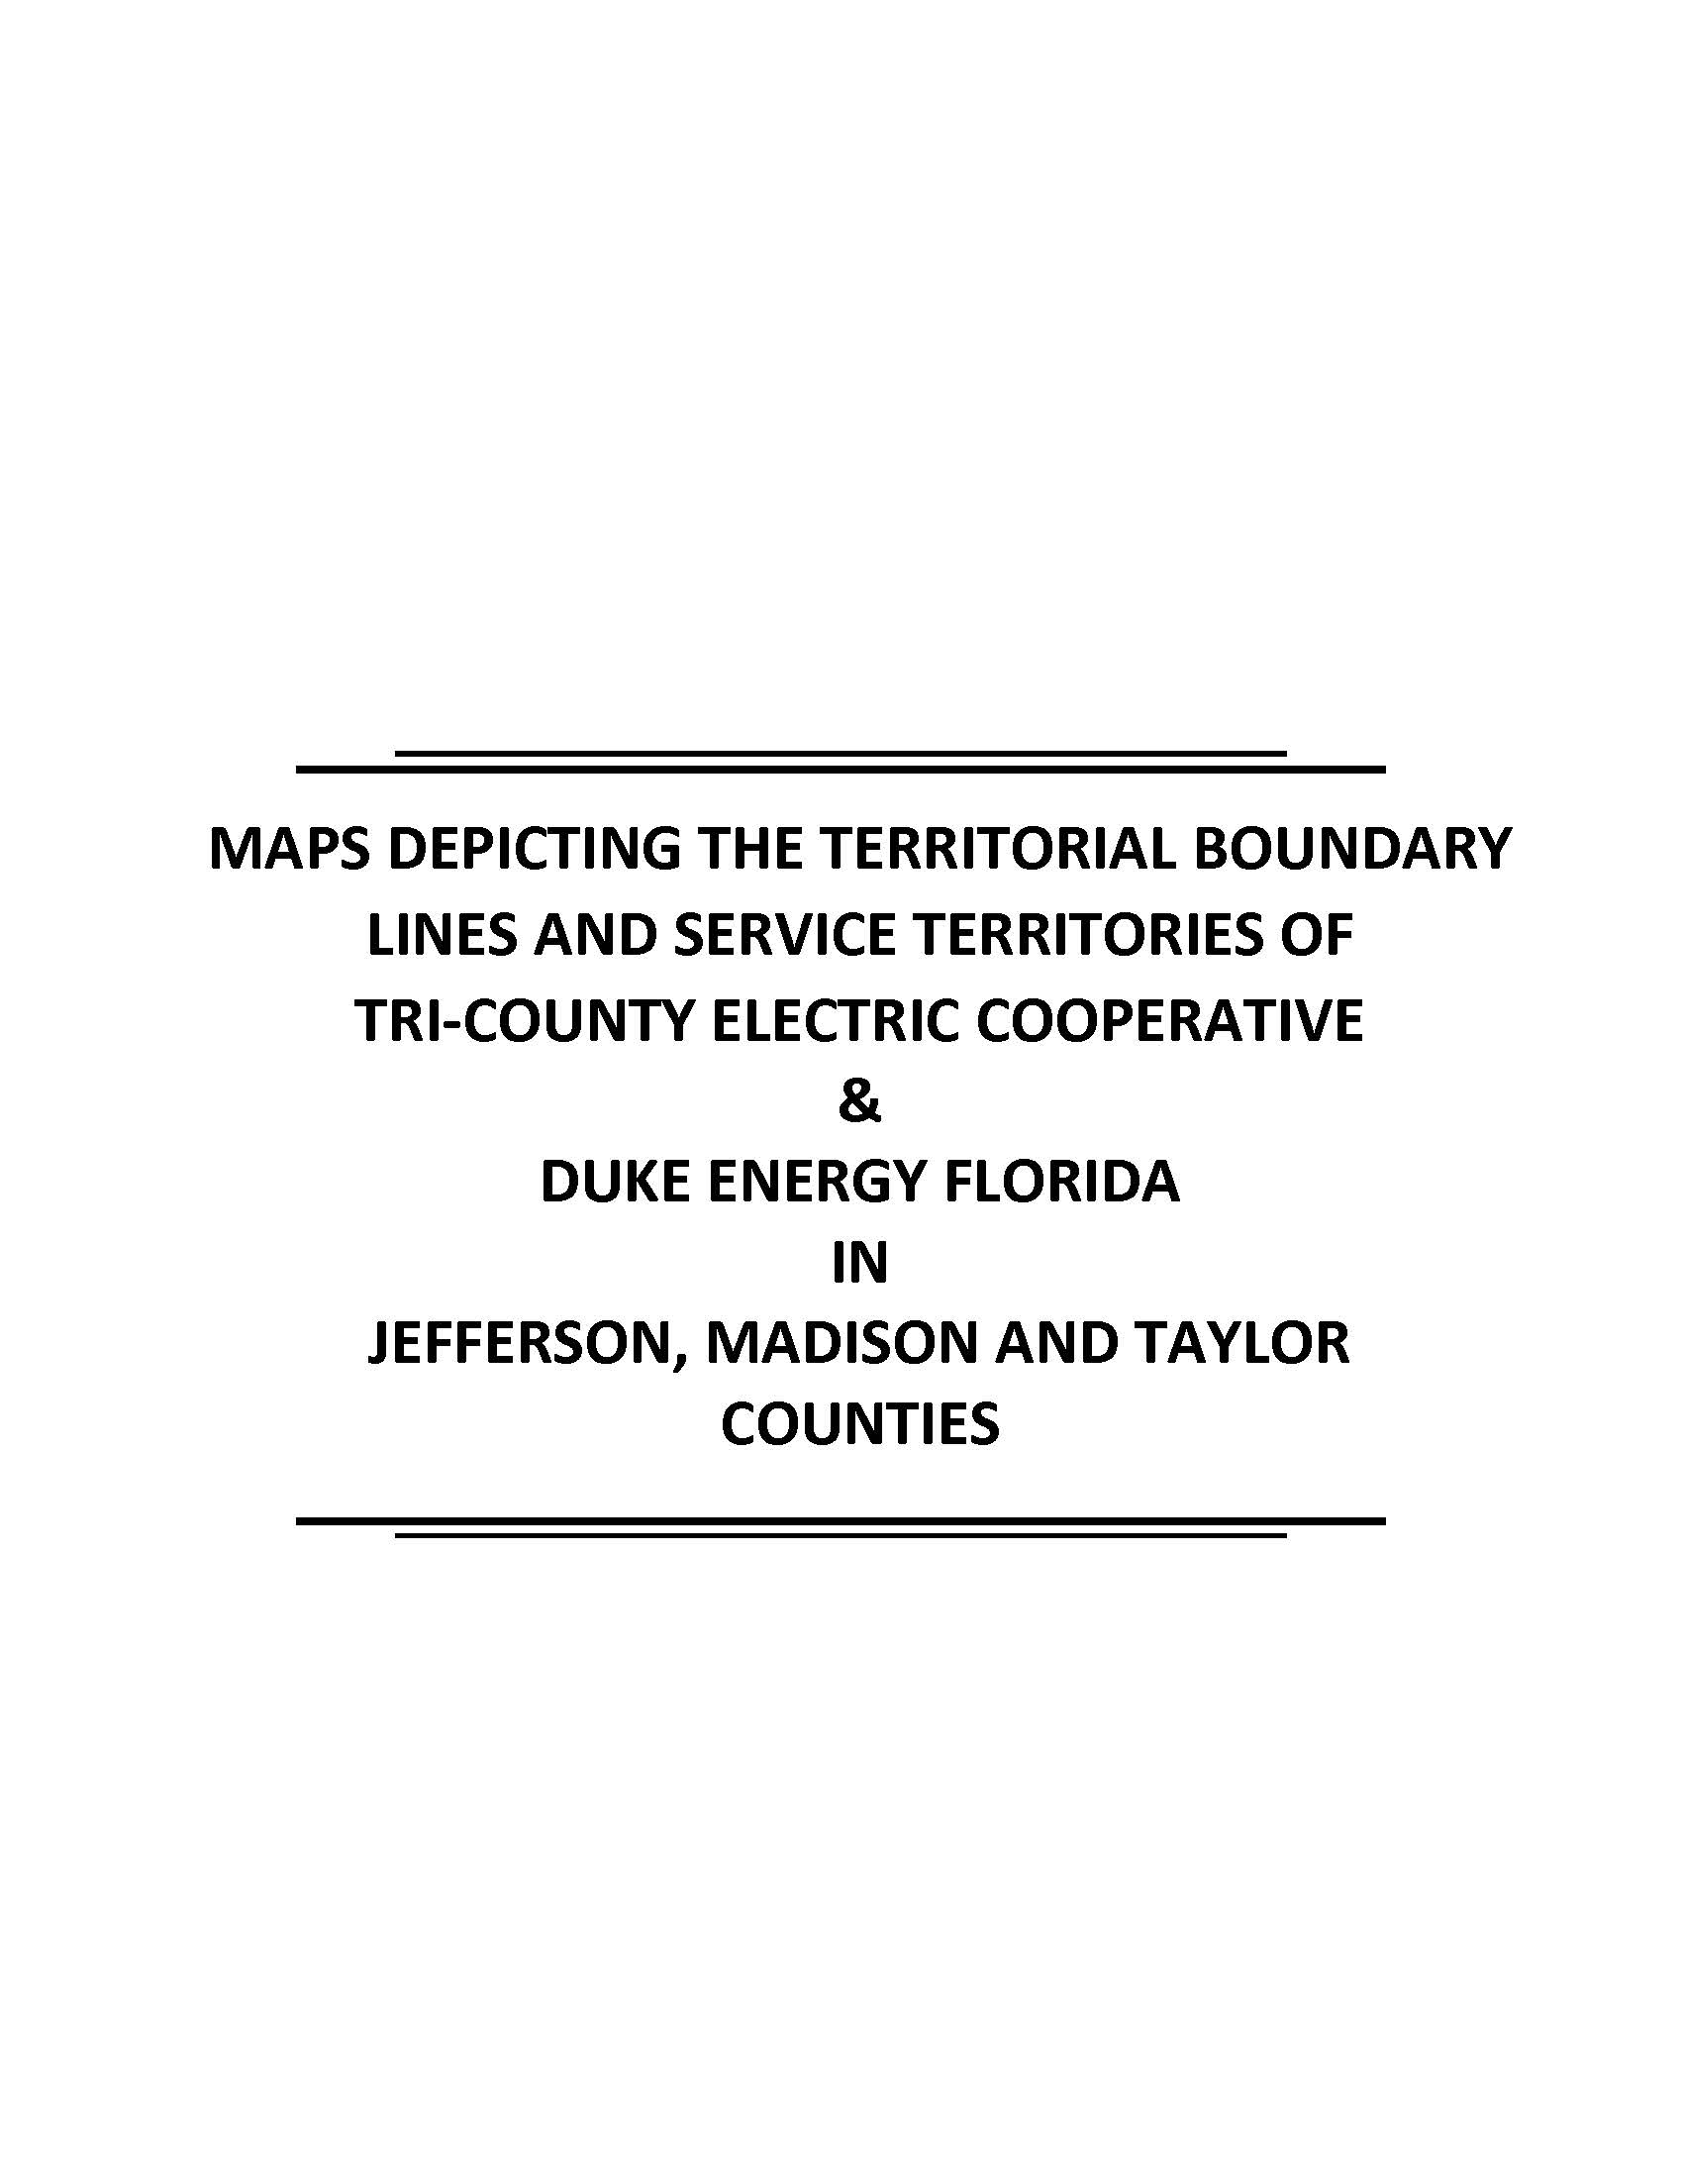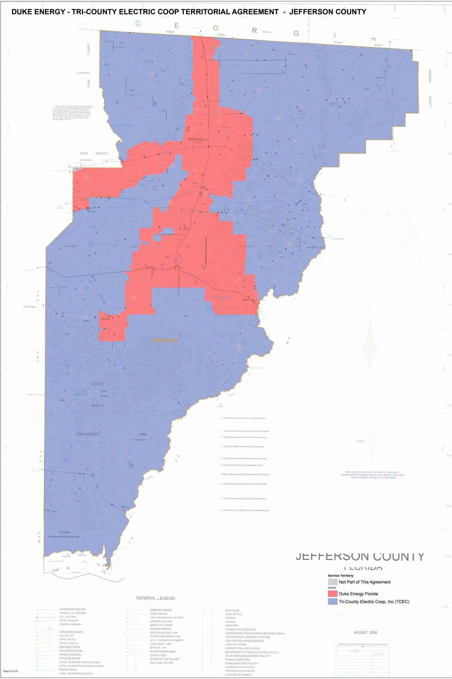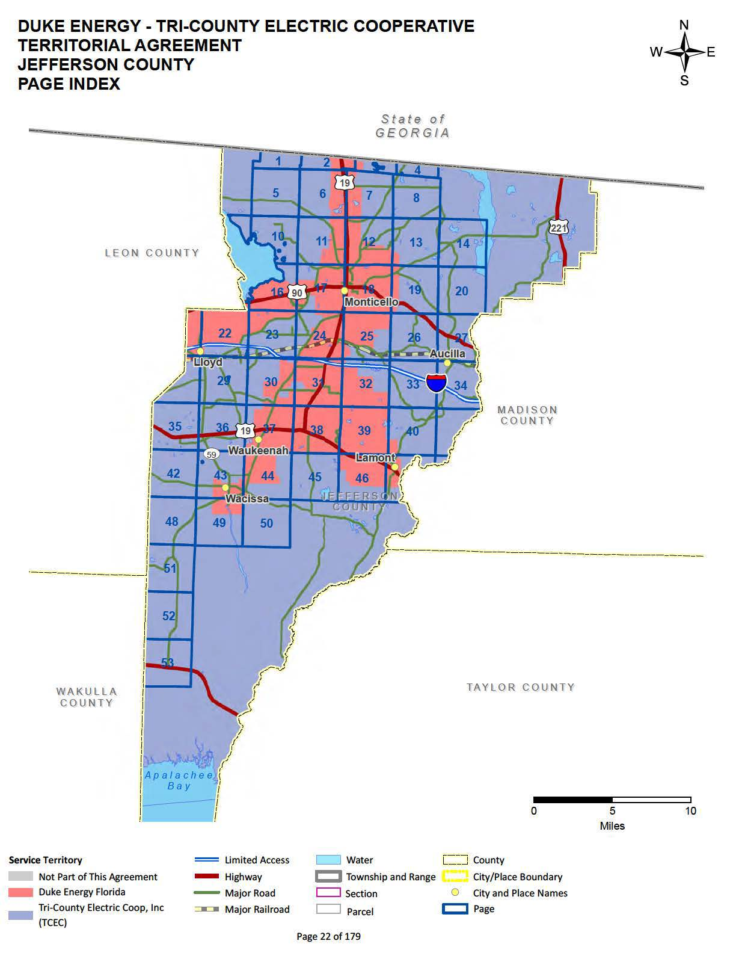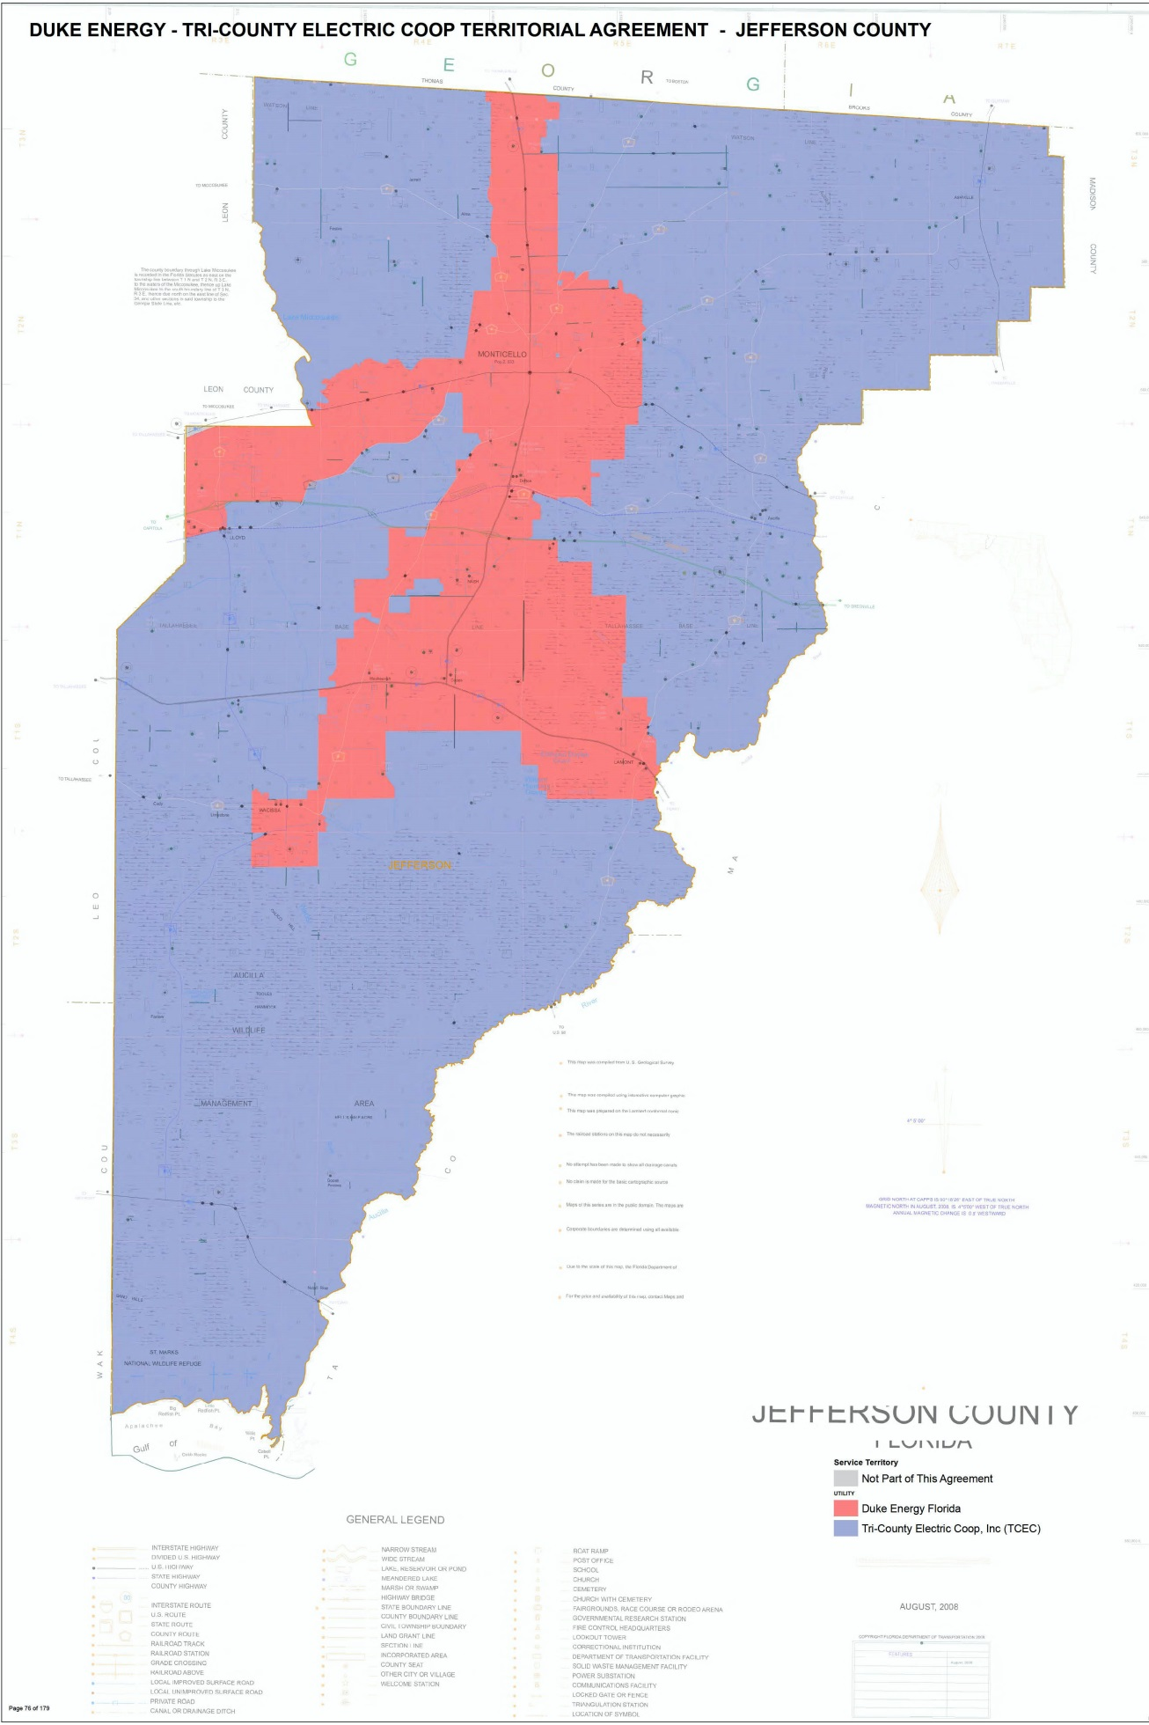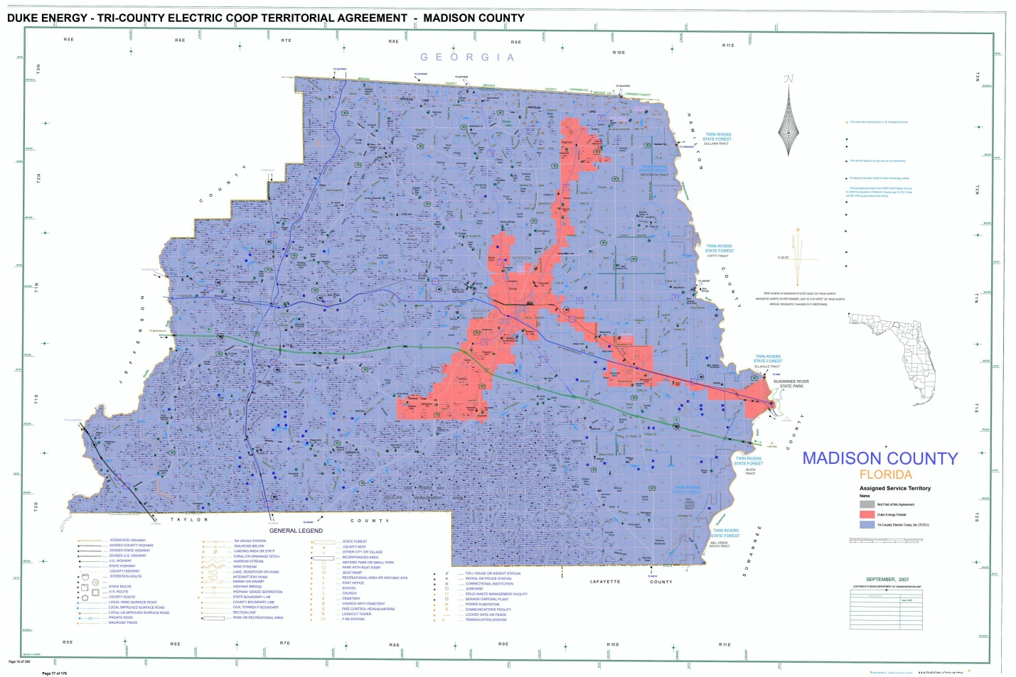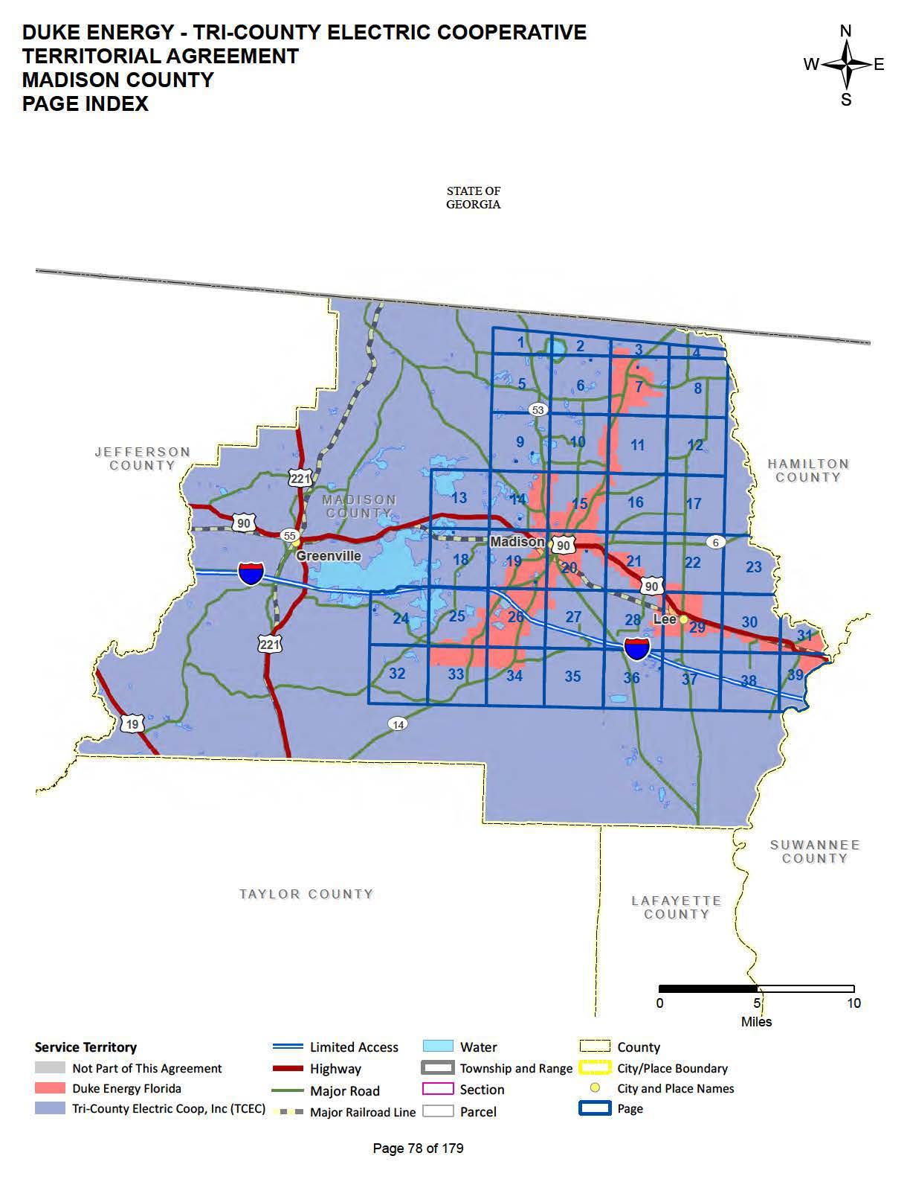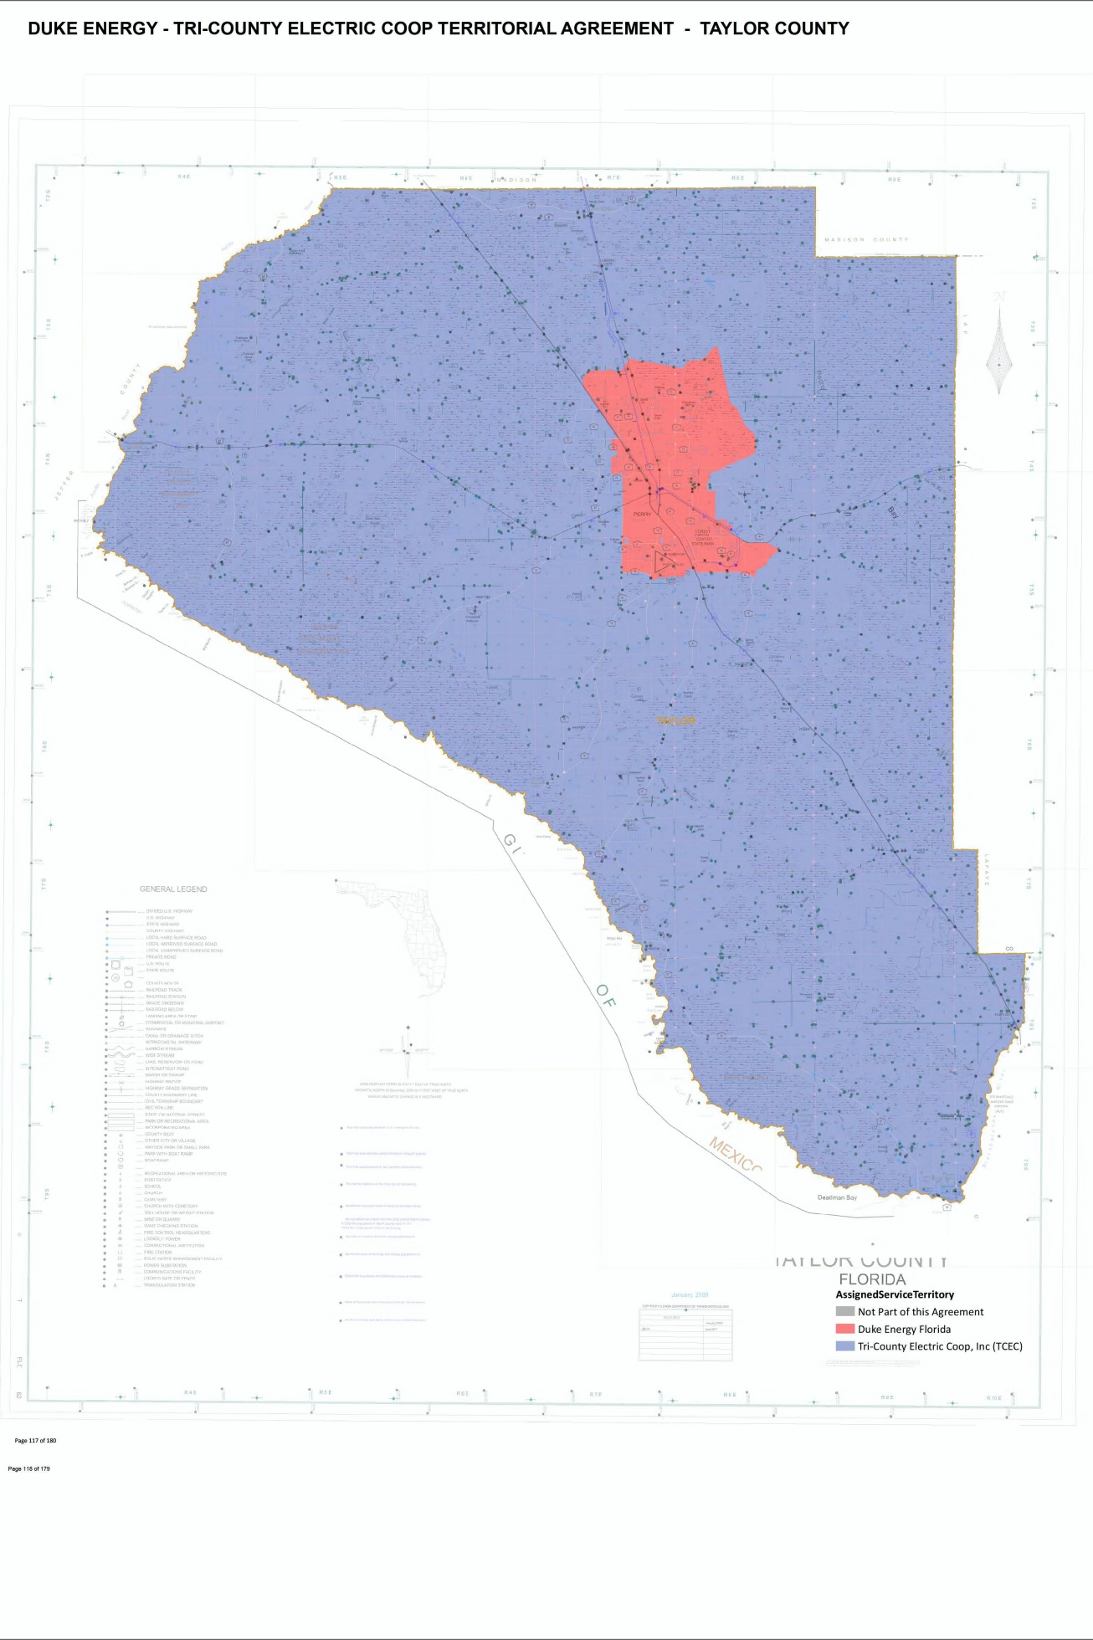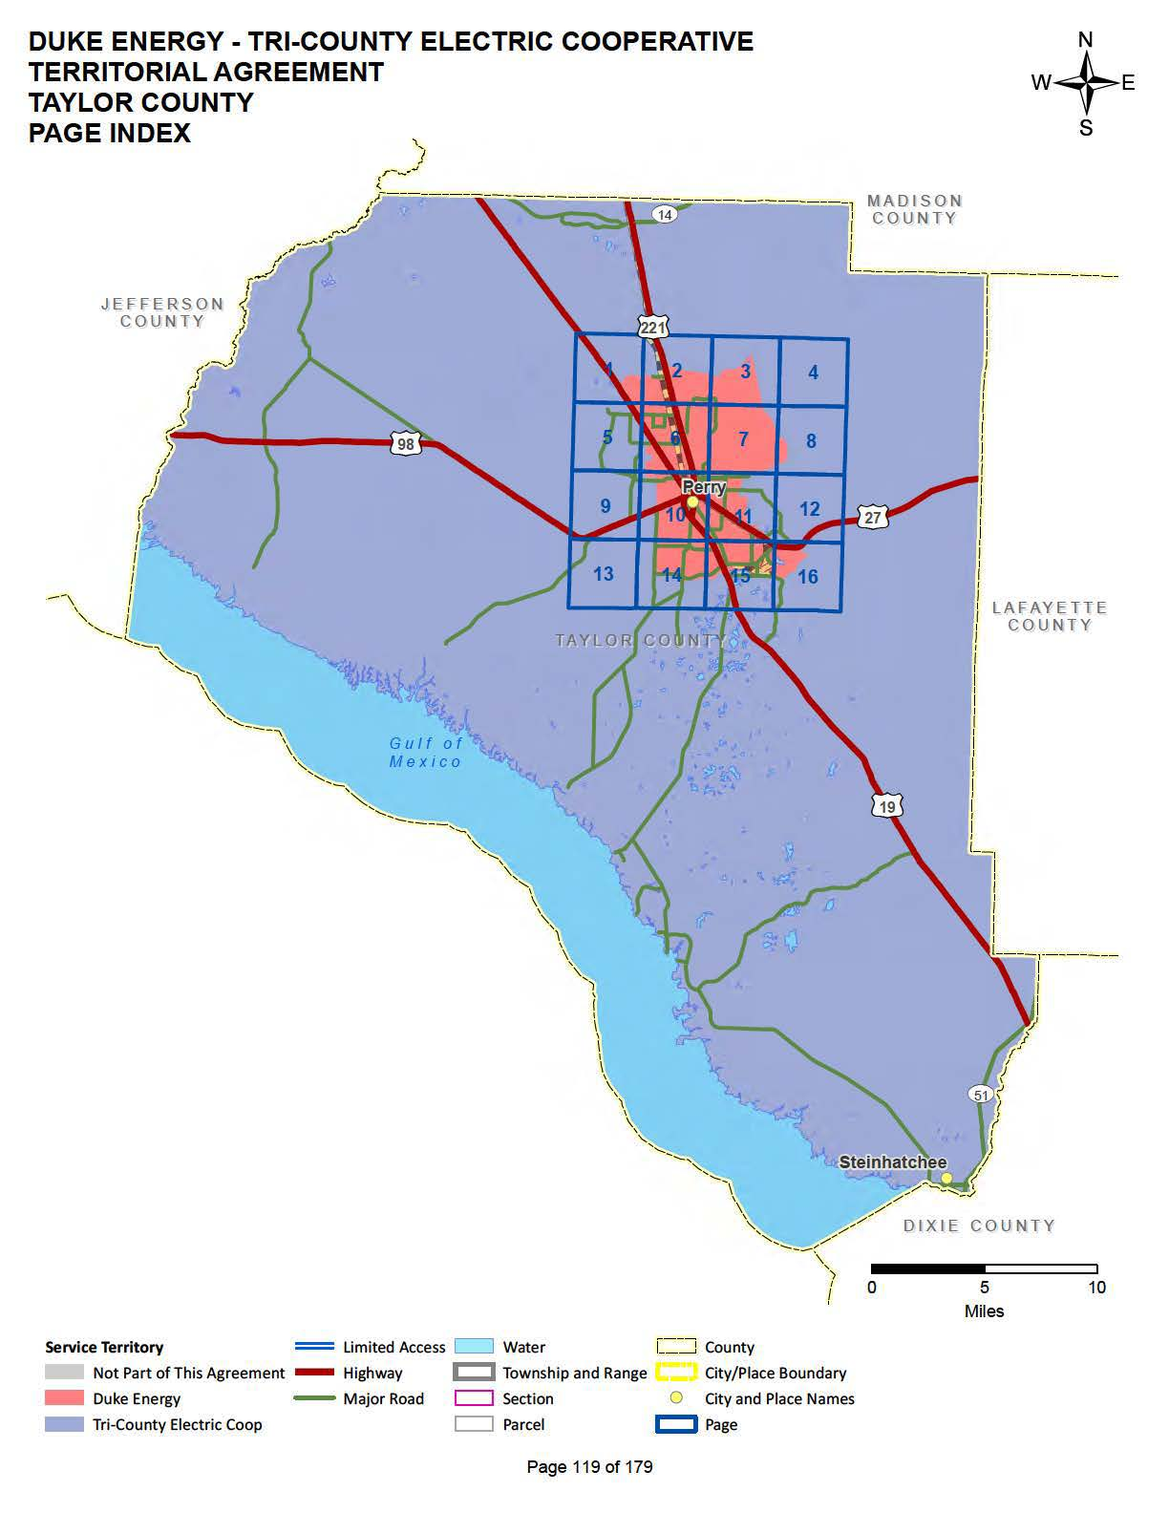

Order No. PSC-92-1214-FOR-EU, issued October 27, 1992, in Docket No. 19920538-EU, In re: Joint Petition for approval of Territorial Agreement between Florida Power Corporation and Tri-County Electric Cooperative, Inc.
Utilities Commission of the City of New Smyrna Beach v. Florida Public Service Commission, 469 So. 2d 731 (Fla. 1985).
Response No.3 in Staff’s First Data Request, Document No. 11747-2020.
Supplemental Response, Document No. 13178-2020.

