State of Florida |  | Public Service Commission  Capital Circle Office Center ● 2540 Shumard Oak Boulevard  Tallahassee, Florida 32399-0850  -M-E-M-O-R-A-N-D-U-M-
DATE: | January 21, 2021
TO: | Office of Commission Clerk (Teitzman)
FROM: | Division of Economics (Guffey)  Office of the General Counsel (Brownless)
RE: | Docket No. 20200222-EI – Petition for approval of modifications to rate schedule FB-1, FixedBill program by Duke Energy Florida, LLC.
AGENDA: | 02/02/21 – Regular Agenda – Tariff Filing – Interested Persons May Participate
COMMISSIONERS ASSIGNED: |  |  | All Commissioners
PREHEARING OFFICER: |  |  | Administrative
CRITICAL DATES: |  |  | 05/28/21 (8-Month Effective Date)
SPECIAL INSTRUCTIONS: |  |  | None

Case Background
On September 28, 2020, Duke Energy Florida, LLC (DEF or utility) filed a petition for approval of modifications to its optional FixedBill (FB-1) rate schedule and associated Tariff Sheet No. 6.391. The FB-1 rate schedule, or tariff, is available to residential customers and offers participating customers a predetermined electric bill for 12 months.
DEF is proposing revisions to its FB-1 rate schedule to implement a pilot program which would allow the utility to control the heating, ventilation, and air conditioning (HVAC) thermostats of participating customers taking service on the FB-1 rate schedule, through December 31, 2021. DEF stated that its goal is to test eligible customers’ willingness to allow DEF to control their thermostats in exchange for a $50 prepaid credit card. The proposed pilot program would be limited to 2,000 participants. The revised Tariff Sheet No. 6.391 is attached to this recommendation as Attachment A.
At the November 3, 2020 Agenda Conference, the Commission suspended DEF’s revised tariff to allow staff sufficient time to review the petition and gather all pertinent data. Staff issued a data request to DEF for which responses were received on December 16, 2020. On January 6, 2020, staff held an informal meeting with DEF to obtain additional information and clarifications to DEF’s responses to staff’s data request. On January 15, 2021, DEF provided staff additional information related to its FixedBill program. The Commission has jurisdiction over this matter pursuant to Sections 366.03, 366.04, 366.05, and 366.06, Florida Statutes (F.S.).

Discussion of Issues

Issue 1:
Should the Commission approve DEF's modifications to its FB-1 rate schedule?

Recommendation:
Yes. The Commission should approve DEF’s modifications to its FB-1 rate schedule effective on the date of the Commission vote. The proposed revisions will allow DEF to control customers’ thermostats within set parameters to achieve peak demand reductions. Participating customers benefit by receiving a $50 prepaid credit card and the general body of ratepayers benefits by any demand reductions. Staff also recommends that DEF, at the end of the pilot program, file a report in the docket file on the results of the pilot program. (Guffey)

Staff Analysis:

Description of Current Optional FB-1 Tariff
The FB-1 rate schedule was first approved in 2017 by Commission Order No. PSC-2017-0451-AS-EU and became effective on March 1, 2018. This tariff allows participating customers to receive a fixed monthly bill for 12 months, which is calculated using the prior 12-month average usage plus an additional risk and usage adder. The order approving the FB-1 tariff states that the difference between the calculated amount customers would have otherwise paid under traditional residential rates and what customers are actually billed under the FixedBill tariff will be treated as a below the line revenue or expense, along with any costs to implement and maintain the program. In 2018, the Commission approved a revision to the original FB-1 tariff which specified that customers taking service under the optional Non-Standard Meter Rider (NSMR) tariff may not participate in the FixedBill Program.
Pursuant to the currently effective FB-1 rate schedule, customers who voluntarily enroll in the FixedBill program need to enter into a Service Agreement with DEF for a term of 12 months. The Service Agreement will automatically renew for an additional 12 months unless the customer notifies the utility of their intention to be removed from the program. DEF calculates a new monthly FixedBill amount for the following year and notifies the customer of the new amount before the current 12-month FixedBill period expires. Currently, approximately 53,000 customers are enrolled in the FixedBill Program.
To be eligible to enroll in the FixedBill Program, a customer must take service under the standard residential rate schedule, must have lived in their current residence for the past 12 months, must have a load profile that can be modeled with reasonable predictability, and must be current on their bill payments.

Proposed Revisions to the FB-1 Tariff
DEF is proposing revisions to its FB-1 Tariff Sheet No. 6.391 to establish a pilot program that would allow DEF to have limited control of participating customers’ thermostats. DEF stated customers opting to participate in the pilot program would need to have qualifying smart, WI-FI enabled thermostats such as Nest, Ecobee or Emerson thermostats. Under the pilot, the utility would be allowed to control the thermostat by adjusting the temperature within a specified range. The maximum number and duration of control events would be outlined in the customer’s service agreement. DEF stated that there will be up to three events each month in the shoulder seasons (March-May and October-November) and up to five events each month in the summer and winter (June-September and December-February). These limits should be considered maximums, and the utility anticipates fewer events in any given month. DEF stated its goal is to leverage the existing FB-1 program and introduce technology to further enhance energy savings along with peak energy demand reduction. DEF explained that smart thermostats use predictive algorithms to understand the household’s heating and cooling needs, automatically adjusting the system’s performance to match the user’s needs. The customer has the ability to override the automatic settings of their thermostat. The smart thermostat will communicate each participating customer’s usage data to a third-party aggregator that will receive data from all participating customers. This data will be used to provide daily energy optimizations to determine when and if specific customers’ load should be reduced while maintaining customers’ personal comfort levels.
DEF proposes to limit the proposed program to 2,000 participants and the proposed FB-1 tariff modification would be effective until December 31, 2021. Participants will be enrolled on a first-come-first-serve basis. In response to staff’s data request, DEF stated that even in the event that the utility fails to enroll 2,000 customers, the utility would still implement this voluntary pilot program. There is no initial set-up fee for customers who wish to participate in the proposed voluntary pilot. At the conclusion of the pilot on December 31, 2021, DEF will evaluate customer interest and receptiveness to additional options under the FixedBill tariff and the associated value.
DEF stated that once the program is approved, the utility would market the pilot program on its webpage, social media, etc. Prior to DEF taking control of a participating customer’s thermostat, for a particular event, DEF will inform the customer via email or text message, mobile app or via the thermostat. The customer would have the option to opt out of participation in the energy reduction program for that day.
DEF explained that its goal is to test customer willingness to allow DEF to control customers’ thermostats in exchange for a $50 prepaid credit card. DEF stated that shareholder money will fund the $50 prepaid credit card; therefore, the general body of ratepayers bears no risk associated with the proposed pilot program. DEF also confirmed that all administrative costs associated with this pilot program will be recorded below the line.
A customer would be able to participate in the pilot program and the current Commission-approved Demand-Side Management (DSM) programs. While the proposed FB-1 tariff pilot program is similar to its residential EnergyWise DSM program, DEF stated that this pilot program is separate and it will not seek to apply any associated demand or energy savings towards its DSM goals. DEF’s current similar DSM programs for residential customers are the load management tariffs RSL-1 and RSL-2 which provide for monthly load management bill credits in return for allowing DEF to interrupt service to a water heater, central heating system, central cooling system, or a pool pump. Under these load management programs, customers receive bill credits based on the number of appliances selected by the customer to be interrupted. DEF does not see an overlap between the existing load management programs and the proposed pilot program. DEF stated that if a customer is enrolled in both a load management program and the proposed pilot program, the traditional load management program would take precedence in the event the utility determines it needs to reduce the customer’s heating or cooling load.

Reporting Requirements for the FB-1 Tariff Pilot Program
Staff recommends that DEF provide a report to the Commission at the conclusion of the pilot program on the program’s results. This report should include information related to total number of residential customers enrolled in the pilot, the average number of events per customer per month, the average event duration per customer per month, and total demand (kilowatt) and estimated energy (kilowatt-hour) savings. DEF should also include a discussion on any lessons learned from the pilot. The utility should file this report in the docket file within 30-days of termination of the pilot.

Conclusion
Having reviewed the petition, staff data request responses, and responses given at an informal meeting, staff recommends that the Commission should approve DEF’s revised Optional FixedBill (FB-1) pilot rate schedule and associated Tariff Sheet No. 6.391 effective on the date of the Commission vote. The proposed pilot program will allow DEF to achieve peak demand reductions, while gauging customer receptiveness to HVAC control by way of a WI-FI enabled thermostat combined with the FixedBill program. Participating customers will benefit by receiving a $50 prepaid credit card and the general body of ratepayers will benefit by any demand reductions realized. Staff also recommends that DEF, at the end of the pilot program, file a report in the docket file on the results of the program.

Issue 2:
Should this docket be closed?

Recommendation:
Yes. If Issue 1 is approved and a protest is filed within 21 days of the issuance of the order, the tariff should remain in effect pending resolution of the protest. If no timely protest is filed, this docket should be closed upon the issuance of a consummating order. (Brownless)

Staff Analysis:
If Issue 1 is approved and a protest is filed within 21 days of the issuance of the order, the tariff should remain in effect pending resolution of the protest. If no timely protest is filed, this docket should be closed upon the issuance of a consummating order.

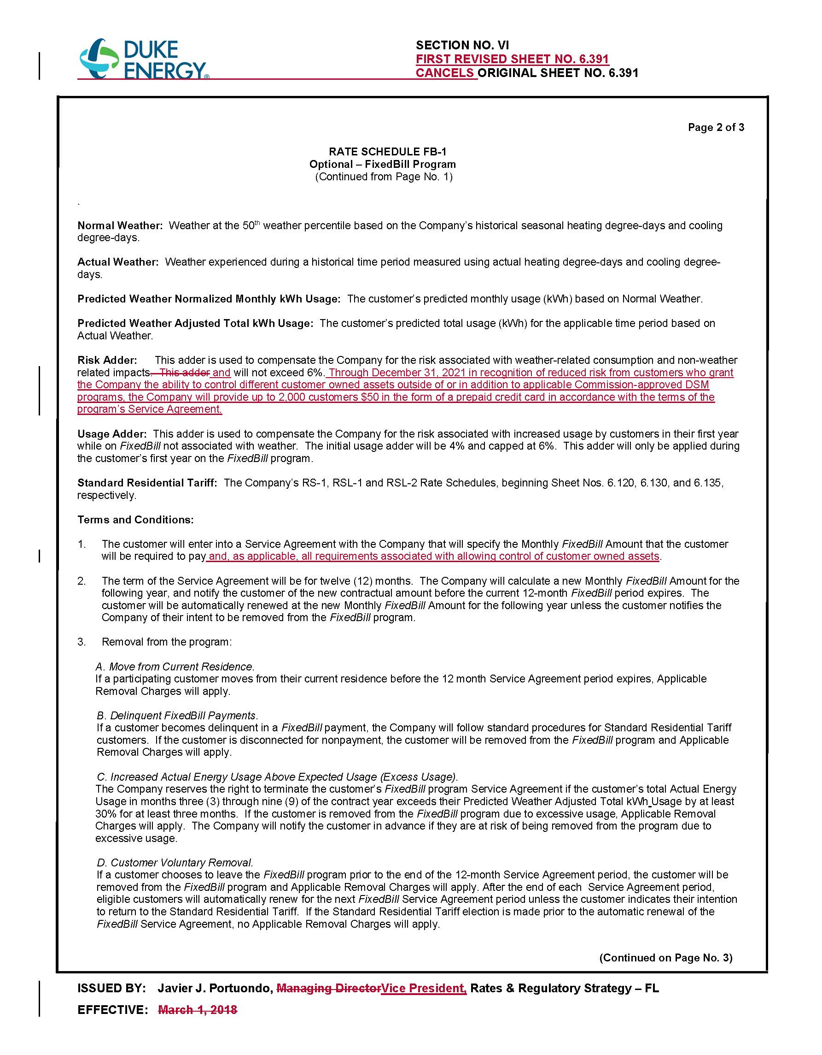

Document No. 01347-2021.
Order No. PSC-2017-0451-AS-EU, issued November 20, 2017, in Docket No. 20170183-EI, In re: Application for limited proceeding to approve 2017 second revised and restated settlement agreement, including certain rate adjustments, by Duke Energy Florida, LLC.
Order No. PSC-2018-0435-TRF-EI, issued August 28, 2018, in Docket No. 20180088-EI, In re: Petition for limited proceeding for approval of a smart meter opt-out tariff, by Duke Energy Florida, LLC.
Response No. 7 in Staff’s First Data Request. Document No. 13566-2020.
Response No. 1 in Staff’s First Data Request. Document No. 13566-2020.

