State of Florida |  | Public Service Commission  Capital Circle Office Center ● 2540 Shumard Oak Boulevard  Tallahassee, Florida 32399-0850  -M-E-M-O-R-A-N-D-U-M-
DATE: | February 18, 2021
TO: | Office of Commission Clerk (Teitzman)
FROM: | Office of the General Counsel (Cowdery)  Division of Economics (Bruce, Guffey, Hudson, Sibley)
RE: | Docket No. 20200119-WS – Proposed amendment of Rule 25-30.335, F.A.C., Customer Billing.
AGENDA: | 03/02/21 – Regular Agenda – Rule Proposal - Interested Persons May Participate
COMMISSIONERS ASSIGNED: |  |  | All Commissioners
PREHEARING OFFICER: |  |  | Fay
RULE STATUS: |  |  | Proposal May Be Deferred
SPECIAL INSTRUCTIONS: |  |  | None

Case Background
Rule 25-30.335, Florida Administrative Code (F.A.C.), Customer Billing, addresses water and wastewater utility customer billing requirements. Staff initiated rule development in order to update and clarify the requirements in the Customer Billing rule. The Notice of Rule Development was published in the Florida Administrative Register on January 8, 2020. No workshop was requested, and none was held. Also, no utility submitted comments on the draft rule in response to the January 8, 2020 notice of rule development.

Staff brought a recommendation on the draft rule to the July 7, 2020 Commission Conference. The Commission deferred consideration of staff’s recommendation so that staff could look into questions raised by Commissioners concerning new subsection (5) of the rule, relating to billing base facility charges to customers who request permanent termination of their service but subsequently request service to be turned back on at the same location. Following the Commission Conference, in order to get additional input on the draft rule, staff sent a data request to all regulated water and wastewater utilities and the Office of Public Counsel (OPC). Staff received comments from OPC, Indiantown Co., Florida Utility Services 1, LLC, Utilities Inc. of Florida (UIF), Pluris Wedgefield, and Investor Owned Utilities that represents twenty-two water and wastewater utilities. Staff sent out a follow-up request for comments on the revised draft rule and received additional comments.

This recommendation addresses whether the Commission should propose the amendment of Rule 25-30.335, F.A.C. The Commission has jurisdiction under Sections 350.127(2) and 367.121, Florida Statutes (F.S.).

Discussion of Issues

Issue 1:
Should the Commission propose the amendment of Rule 25-30.335, F.A.C., Customer Billing?

Recommendation:
Yes, the Commission should propose the amendment of Rule 25-30.335, F.A.C., as set forth in Attachment A. The Commission should also certify Rule 25-30.335, F.A.C., as a minor violation rule. (Hudson, Bruce, Sibley, Guffey, Cowdery)

Staff Analysis:
The purpose of this rulemaking is to update and clarify rule requirements for billing customers when they are not in residence and to bill customers with different rate structures consistently. Overall, staff is recommending several non-substantive amendments to the rule to clarify rule language. Staff is also recommending a number of substantive amendments to Rule 25-30.335, F.A.C., which are discussed in more detail below.

Subsection (3): Consistency in Prorating over a 30-day Billing Cycle
Draft subsection (3) concerns prorating bills over a 30-day billing cycle. Under subsection (3) of the current rule, when service is rendered for less than 50 percent of the normal billing cycle, the utility must prorate the base facility charge as if the billing cycle were 30 days. That same subsection states that for service taken under flat rates, 50 percent of the normal charges may be applied. Subsection (3) does not address customers paying rates that include minimum usage. Customers paying rates that include minimum usage have a base facility charge and some amount (“minimum usage”) of gallons included in their bill. If the customer uses more than the minimum usage, they pay the applicable gallonage tariff rate.

The draft amendments to subsection (3) clarify that customers who pay for service under flat rates or rates that include minimum usage will be treated the same as those who pay base facility charges when service is rendered for less than 50 percent of the billing cycle. In all cases, the utility must prorate the identified charges over a 30-day billing cycle. This recommended amendment gives consistency in treatment to all customers.

Subsection (4): Temporary Discontinuance of Service
Draft subsection (4) replaces existing subsection (8) that requires a utility to bill customers the base facility charge regardless of whether there is any usage, unless the utility has an authorized vacation rate. The reference to vacation rates is obsolete because no Commission-regulated water or wastewater utility has “vacation rates.” In addition, current subsection (8) does not address customers who pay flat or minimum tariff rates that do not include a specific base facility charge. For these reasons, subsection (8) is deleted and replaced by the language in draft subsection (4).
Draft subsection (4) requires customers who request temporary discontinuance of service or are out of residence to pay either the base facility charge or 40 percent of the flat rate or rates that include minimum usage, whatever is the utility’s approved tariff rate. Customers with a flat or minimum tariff rate structure are required to pay 40 percent of that rate because 40 percent represents the utility’s fixed costs and is the equivalent of a base facility charge.

Subsection (5): Permanent Termination of Service
As stated in the Case Background, this item was deferred from the July 7, 2020 Commission Conference to allow staff time to explore questions raised by the Commission concerning draft subsection (5). As part of this effort, staff requested comments from water and wastewater utilities on the draft rule amendments. As a result of its review, staff made one revision to subsection (5) concerning requests for permanent termination of service, changing a six month time period to twelve months.
Draft subsection (5) presented at the July 7, 2020 Commission Conference provided that if a customer requests a permanent termination of service and subsequently requests service at the same location within six months of termination, the utility must bill and the customer is responsible for paying all outstanding rates and charges for that termination period. In response to staff’s request for comments that was submitted to utilities subsequent to the July 7, 2020 Commission Conference, Investor Owned Utilities stated that the standard industry-wide practice for water and wastewater utilities throughout Florida has been to require customers to pay base facility charges for customers who are out of residence with discontinued service for 12 months or less. As an example, they provided an Aqua Utilities tariff sheet (no longer in effect) that had included that requirement.
Investor Owned Utilities stated that to shorten the 12-month period to six months would be burdensome and could result in lost revenues which would be borne by the remaining general body of ratepayers and would be discriminatory toward full-time customers who do not leave the state for part of the year.
Florida Utility Services 1, LLC, stated that it has not had an issue with seasonal customers not paying base facility charges once it is explained to them that there are no “vacation rates” in Florida. It did request that the rule provide that if a customer requests a permanent termination of service and subsequently requests service at the same location, the base facility charges apply if the subsequent service is requested within 12 months of termination, instead of six months, noting that some customers come to Florida for only two or three months a year.
Pluris Wedgefield and UIF stated that for the rule to codify existing policy, it should provide that if someone moved back to the same residence within 12 months, they would have to pay the intervening months’ base facility charge. They noted that a six-month time frame allows Canadian customers who can only reside in Florida for six months to stay away an extra day and avoid the base facility charges. It is their opinion that whether or not the intent of the rule is to codify existing policy, the time should be changed to 12 months.

Based on industry responses, staff believes that draft subsection (5) should provide that if a customer requests a permanent termination of service and subsequently requests service at the same location within 12 months of termination, the utility must bill and the customer is responsible for paying all outstanding rates and charges for that termination period.

Customer Responsibility for Paying Rates and Charges Prior to Reconnection
As stated above, draft subsection (5) states that if a customer requests permanent termination of service but requests reconnection within 12 months, the customer is responsible for paying all outstanding rates and charges for the service termination period in order for service to be restored. The term “customer” as used in this rule is defined in Rule 25-30.210(1), F.A.C., to mean any person, firm, association, corporation, governmental agency, or similar organization who has an agreement to receive service from the utility.
There was a question raised at the July 7, 2020 Commission Conference about whether there is a problem that the rule should address with people representing they are permanently terminating service while they are actually intending to be out-of-residence temporarily, and then subsequently asking for service under a different family member’s name in order to avoid paying the monthly base facility charges. Staff looked into this question, and it appears that at this time utilities are not experiencing problems of this nature. Thus, rulemaking to address this issue is not necessary at this time. However, if at any time in the future it does appear that utilities are experiencing issues in this regard, staff can explore this issue in a future rulemaking.

Military Service Members
At the July 7, 2020 Commission Conference, staff was asked to explore whether other states have provisions for waiver or abatement of water and wastewater charges and fees for deployed military Service Members. Staff was unable to find any utility regulations in other states that specifically address exemptions from paying water rates or charges for deployed service members. However, the state of New Mexico enacted a statute in 2013 that provides that upon return from deployment or temporary duty assignment, a resident who is a member of a branch of the U.S. armed forces, the reserves, or the New Mexico National Guard shall be allowed to reconnect suspended public utilities services without having to pay a reconnection fee. Florida does not have a similar statute that would give the Commission authority to exempt deployed military Service Members from paying base facility or reconnection charges as required by Rule 25-30.335, F.A.C.
Staff notes that there are federally sponsored programs that give military Service Members assistance with paying utility bills. The U.S. Department of Labor sponsors a veteran and military transition center that offers federal assistance from the Low Income Home Energy Assistance Program, a federally funded program that helps low-income households with their home energy bills. In addition, Army Emergency Relief is a nonprofit organization that helps soldiers and their family members who experience financial emergencies, including paying utilities.

Notice to Customers of Rule Amendment
At the July 7, 2020 Commission Conference, staff was asked to consider the issue of customers having notice of the draft changes to subsection (5). Draft subsection (5), as explained above, requires customers to be responsible for paying the monthly base facility charge if they request a permanent termination of service but subsequently request service at the same location within 12 months.
Staff considered various ways in which water and wastewater utilities could provide notice of this rule requirement to customers. The main concern was how small Class C utilities could provide such notice. Staff considered utilities providing notice to individual customers who were requesting temporary or permanent disconnection of service; requiring utilities to send out an annual notice to all customers; or requiring utilities to give notice on the utilities’ website. Staff received comments from Class C utilities raising concerns with all these approaches.
Although Investor Owned Utilities was not opposed to providing customer notice, it stated that several of its member utilities are very seasonal and may have up to 60 percent of their customers return to their northern residences, which would make notifying individual customers who request temporary discontinuance or permanent termination of service onerous. Investor Owned Utilities suggested annual notification through bill inserts, notification on the utility’s website, or messages periodically placed on customers’ bills as possible alternatives.
Pluris Wedgefield and UIF had concerns with requiring small utilities to give an annual notice, noting that most do not have websites and the customer base of many of these small utilities do not have a seasonal winter population to which the rule amendments are directed. They suggested that perhaps a one-time notification when the amended rule becomes effective would be sufficient. However, they requested that no noticing be required, noting that there are many tariff rules that are applicable and of interest to customers that rightfully have no annual noticing requirement. Florida Utility Services 1, LLC also requested that no noticing requirement be added to this rule.
After considering utility comments concerning adding a noticing requirement to this rule, staff concludes that the burden and cost to utilities outweighs any benefits to customers. Staff agrees that not all utilities have a seasonal customer base and not all utilities have the means to provide the notification in a less costly manner, such as displaying on a website. Sending a utility-wide notice that does not impact the entire customer base is not cost effective. In addition, staff agrees with utility comments that there are rules that are applicable and of interest to customers that do not have noticing requirements. Pursuant to Rule 25-30.325, F.A.C, a utility may require a customer to give reasonable notice of his or her intention to discontinue service. Staff believes if and when a customer requests temporary discontinuance or permanent termination of service, the onus is on the utility to communicate, at that time, the requirements of the rule. This would alleviate any undue cost burden of noticing to the general body of ratepayers.

Landlord/Tenant Delinquent and Inactive Accounts
During the course of finalizing the draft rule, staff requested additional comments from the participating water and wastewater utilities and OPC. In its October 9, 2020 comments, Investor Owned Utilities for the first time suggested additional amendments to the Customer Billing Rule to address certain issues pertaining to landlord/tenants and vacant inactive accounts. They suggested rule amendments that would:
- Prohibit a new account to be opened in a new property owner’s name until the delinquent amount is paid;
- Hold the property owner (landlord) accountable for its tenants’ unpaid balance;
- Revert the account back to the property owner after any tenant leaves the premise; and
- Charge the base facility charge to all inactive accounts where water/wastewater service is available.
Staff has considered these comments. The landlord/tenant and inactive account issues raised by Investor Owned Utilities appear to be beyond the scope of this rule. Section 120.54(1)(g), F.S., requires each rule to contain only one subject. It is possible that some or all of these issues could impact Rule 25-30.320, F.A.C., Refusal or Discontinuance of Service. These issues appear to include some complex policy considerations that could be of great interest to a number of persons not participating in this docket. Staff believes it is the better course to finalize the draft customer billing rule so that issues concerning temporary and permanent discontinuance of service billing may be updated and clarified for utilities and customers. For these reasons, staff does not recommend addressing the landlord/tenant and vacant inactive accounts issues raised by Investor Owned Utilities in this rulemaking. However, staff will continue to assess these issues and determine whether rulemaking may be appropriate in the future.

Minor Violation Rules Certification
Pursuant to Section 120.695, F.S., the agency head must certify for each rule filed for adoption whether any part of the rule is designated as a rule the violation of which would be a minor violation. Rule 25-30.335, F.A.C., is currently listed on the Commission’s website as a rule for which a violation would be minor because violation of the rule would not result in economic or physical harm to a person or have an adverse effect on the public health, safety, or welfare or create a significant threat of such harm. The amendments to the rule would not change its status as minor violation rules. Thus, staff recommends that the Commission certify Rule 25-30.335, F.A.C., as a minor violation rule.

Statement of Estimated Regulatory Costs
Pursuant to Section 120.54(3)(b), F.S., agencies are encouraged to prepare a statement of estimated regulatory costs (SERC) before the adoption, amendment, or repeal of any rule. Following the July 7, 2020 Commission Conference, receipt of responses to staff’s information request, and revision of the draft rule, staff prepared a new SERC. The SERC is appended as Attachment B to this recommendation.
The SERC concludes that the rule will not likely directly or indirectly increase regulatory costs in excess of $200,000 in the aggregate in Florida within one year after implementation. Further, the SERC economic analysis concludes that the rule will not likely have an adverse impact on economic growth, private sector job creation or employment, private sector investment, business competitiveness, productivity, or innovation in excess of $1 million in the aggregate within five years of implementation. Thus, the rule does not require legislative ratification pursuant to Section 120.541(3), F.S. In addition, the SERC states that the rule will not have an adverse impact on small business and will have no impact on small cities or counties. No regulatory alternatives were submitted pursuant to paragraph 120.541(1)(a), F.S. None of the impact/cost criteria established in paragraph 120.541(2)(a), F.S., will be exceeded as a result of the recommended amendments to Rule 25-30.335, F.A.C.

Conclusion
Based on the foregoing, staff recommends that the Commission should propose the amendment of Rule 25-30.335, F.A.C., as set forth in Attachment A. The Commission should also certify Rule 25-30.335, F.A.C., as a minor violation rule.

Issue 2:
Should this docket be closed?

Recommendation:
Yes. If no requests for hearing, information regarding the SERC, proposals for a lower cost regulatory alternative, or Joint Administrative Procedure Committee comments are filed, the rule should be filed with the Department of State, and the docket should be closed. (Cowdery)

Staff Analysis:
If no requests for hearing, information regarding the SERC, proposals for a lower cost regulatory alternative, or JAPC comments are filed, the rule may be filed with the Department of State and the docket should be closed
25-30.335 Customer Billing.
(1) Except as provided in this rule, a utility must shall render bills to customers at regular intervals, and each bill must shall indicate: the billing period covered; the applicable rate schedule; beginning and ending meter reading; the amount of the bill; the delinquent date or the date after which the bill becomes past due; and any authorized late payment charge.
(2) When a utility is unable to obtain an actual meter read, estimated bills may be provided.
(a) If the utility estimates a bill, the bill statement shall prominently show the word “Estimated” must be prominently displayed on the face of the bill.
(b) The utility is obligated to timely correct any problems within the utility’s control causing the need to estimate bills. In no event may shall a utility provide an estimated bill to any one customer account more than four times in any 12-month period due to circumstances that are within the utility’s control and service obligations.
(c) Upon issuance of a second estimated bill in a 6-month period, the utility must shall provide the customer with an explicit written explanation for the estimation, along with the utility contact information and the Commission toll-free complaint number, 1(800) 342-3552.
(d) The utility must shall maintain records, for a minimum of two years, detailing the number, frequency, and causes of estimated bills, and those records must which shall be made available upon request to the Commission or to any party to a rate proceeding for the utility.
(3) When service is rendered for less than 50 percent of the normal billing cycle, the utility must shall prorate the base facility charges, flat rates, or rates that include minimum usage as though the normal billing cycle were 30 days., except that Tthe utility may elect not to not issue an initial bill for service if the service is rendered for during a time period which is less than 50 percent of the normal billing cycle. Instead, the utility may elect to issue a single bill combining combine the amount owed for the service rendered during the initial time period with the amount owed for the next billing cycle, and issue a single bill for the combined time period. For service taken under flat rate schedules, 50 percent of the normal charges may be applied.
(4) If a customer requests a temporary discontinuance of service or is out of residence:
(a) Utilities that have the base facility charge rate structure must continue to bill the base facility charge.
(b) Utilities that have a flat rate or a rate that includes minimum usage must bill the customer 40 percent of the flat or minimum rate contained on the applicable tariff.
(5) If a customer requests a permanent termination of service and the same customer subsequently requests service at the same location within 12 months of that termination, the utility must bill the customer the base facility charges or 40 percent of the flat rate or rates that include minimum usage for the service termination period. The customer is responsible for payment of all outstanding rates and charges for the termination period in order for service to be restored.
(6)(4) A utility may not consider a customer delinquent in paying his or her bill until the 21st day after the utility has mailed or presented the bill for payment.
(7)(5) A Each utility must shall establish each point of delivery as an independent customer account and must shall calculate the amount of the bill accordingly, except where physical conditions make it necessary to use additional meters or points of delivery for one class of service to a single customer on the same premises, or where such multiple meters or delivery points are used for the convenience of the utility.
(8)(6) A utility may not incorporate municipal or county franchise fees into the amount indicated as the cost for service on the customer’s bill. Rather, the utility must shall show any such franchise fee as a separate item.
(9)(7) The utility must shall maintain a record of each customer’s account for the most current 2 years so as to permit reproduction of the customer’s bills during the time that the utility provided service to that customer.
(8) If a utility utilizes the base facility and usage charge rate structure and does not have a Commission authorized vacation rate, the utility shall bill the customer the base facility charge regardless of whether there is any usage.
Rulemaking Authority 350.127(2), 367.121 FS. Law Implemented 367.091, 367.121 FS. History–New 9-14-74, Amended 6-21-79, Formerly 25-10.97, 25-10.097, Amended 11-10-86, 11-30-93, 6-17-13, ____________.

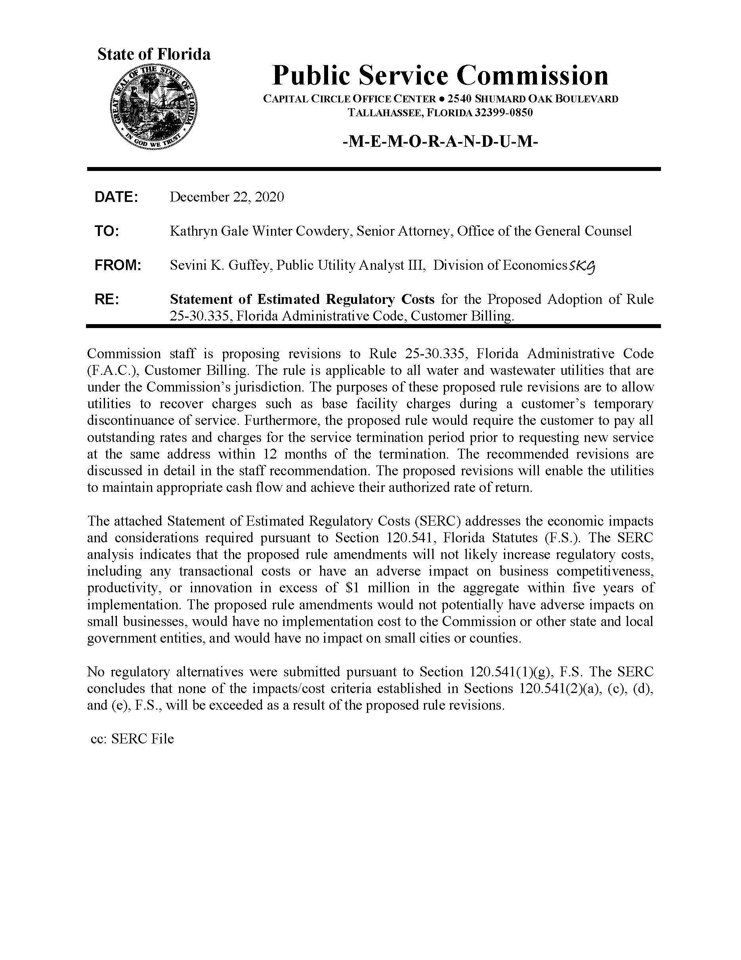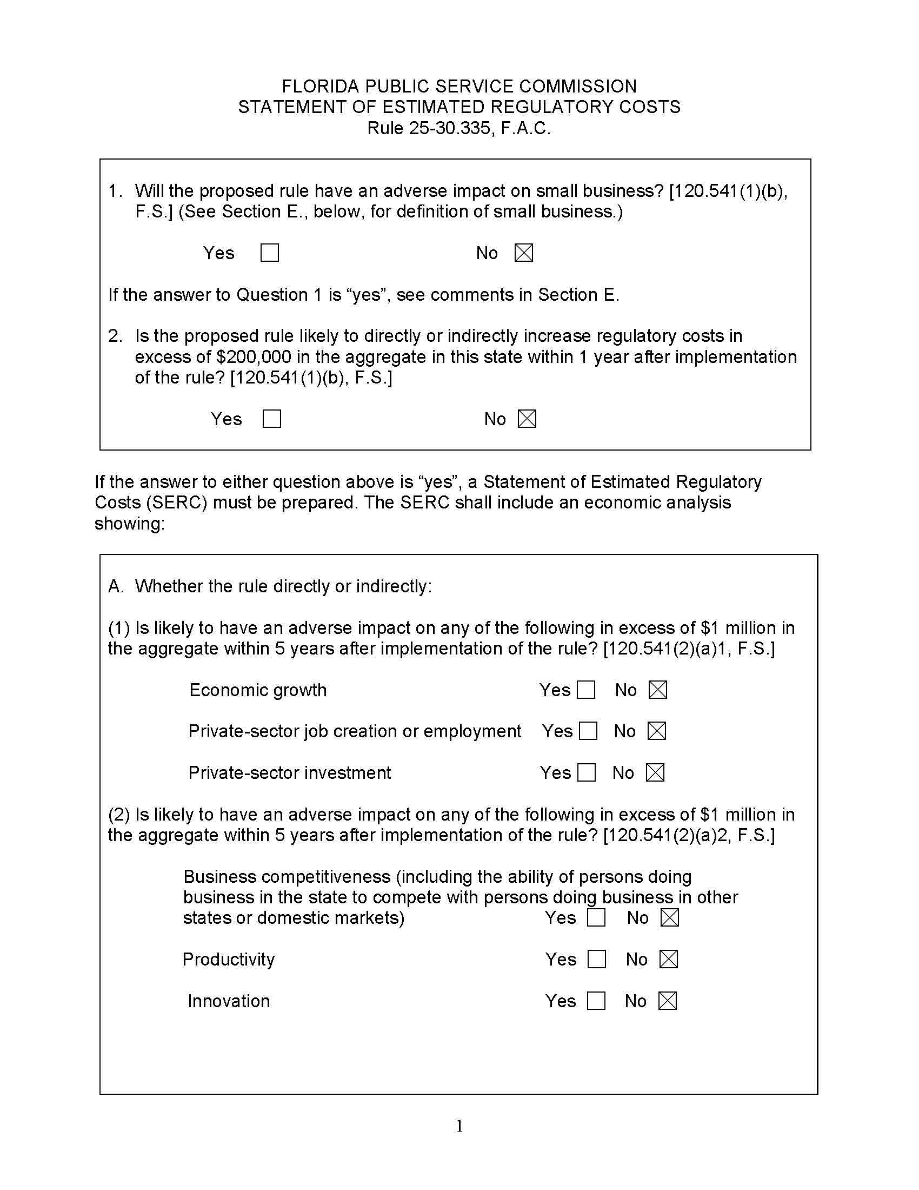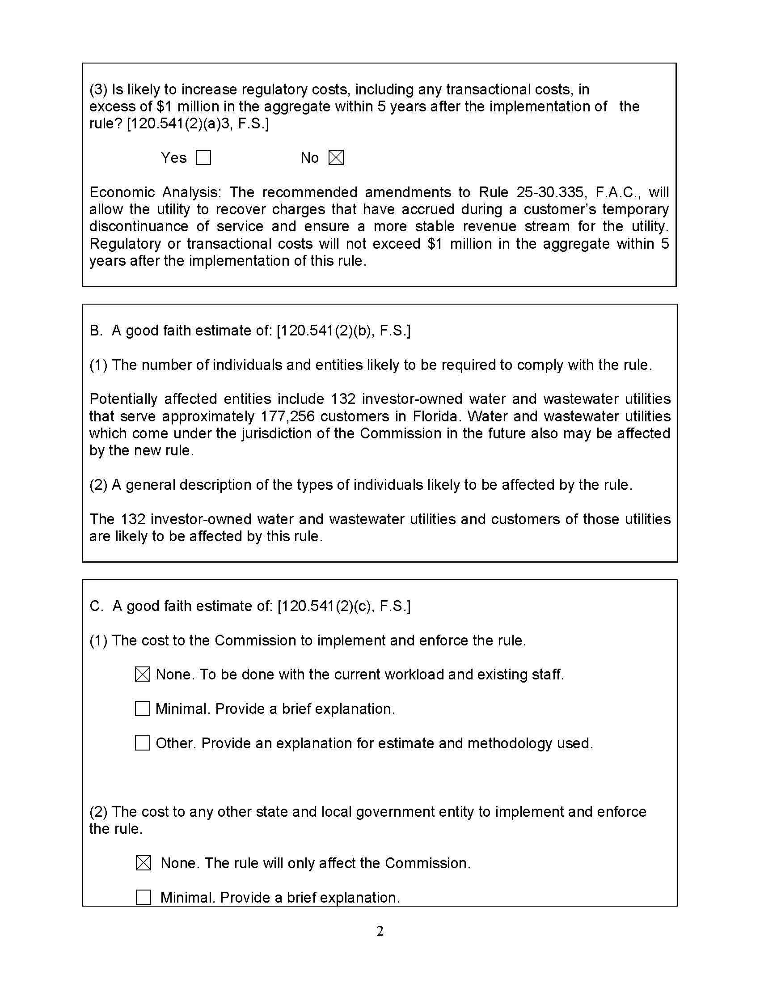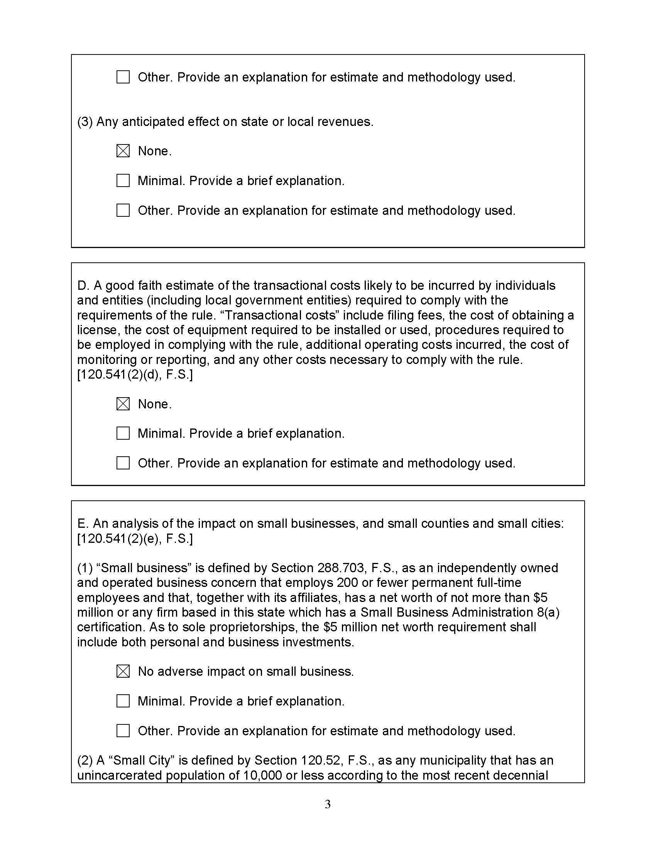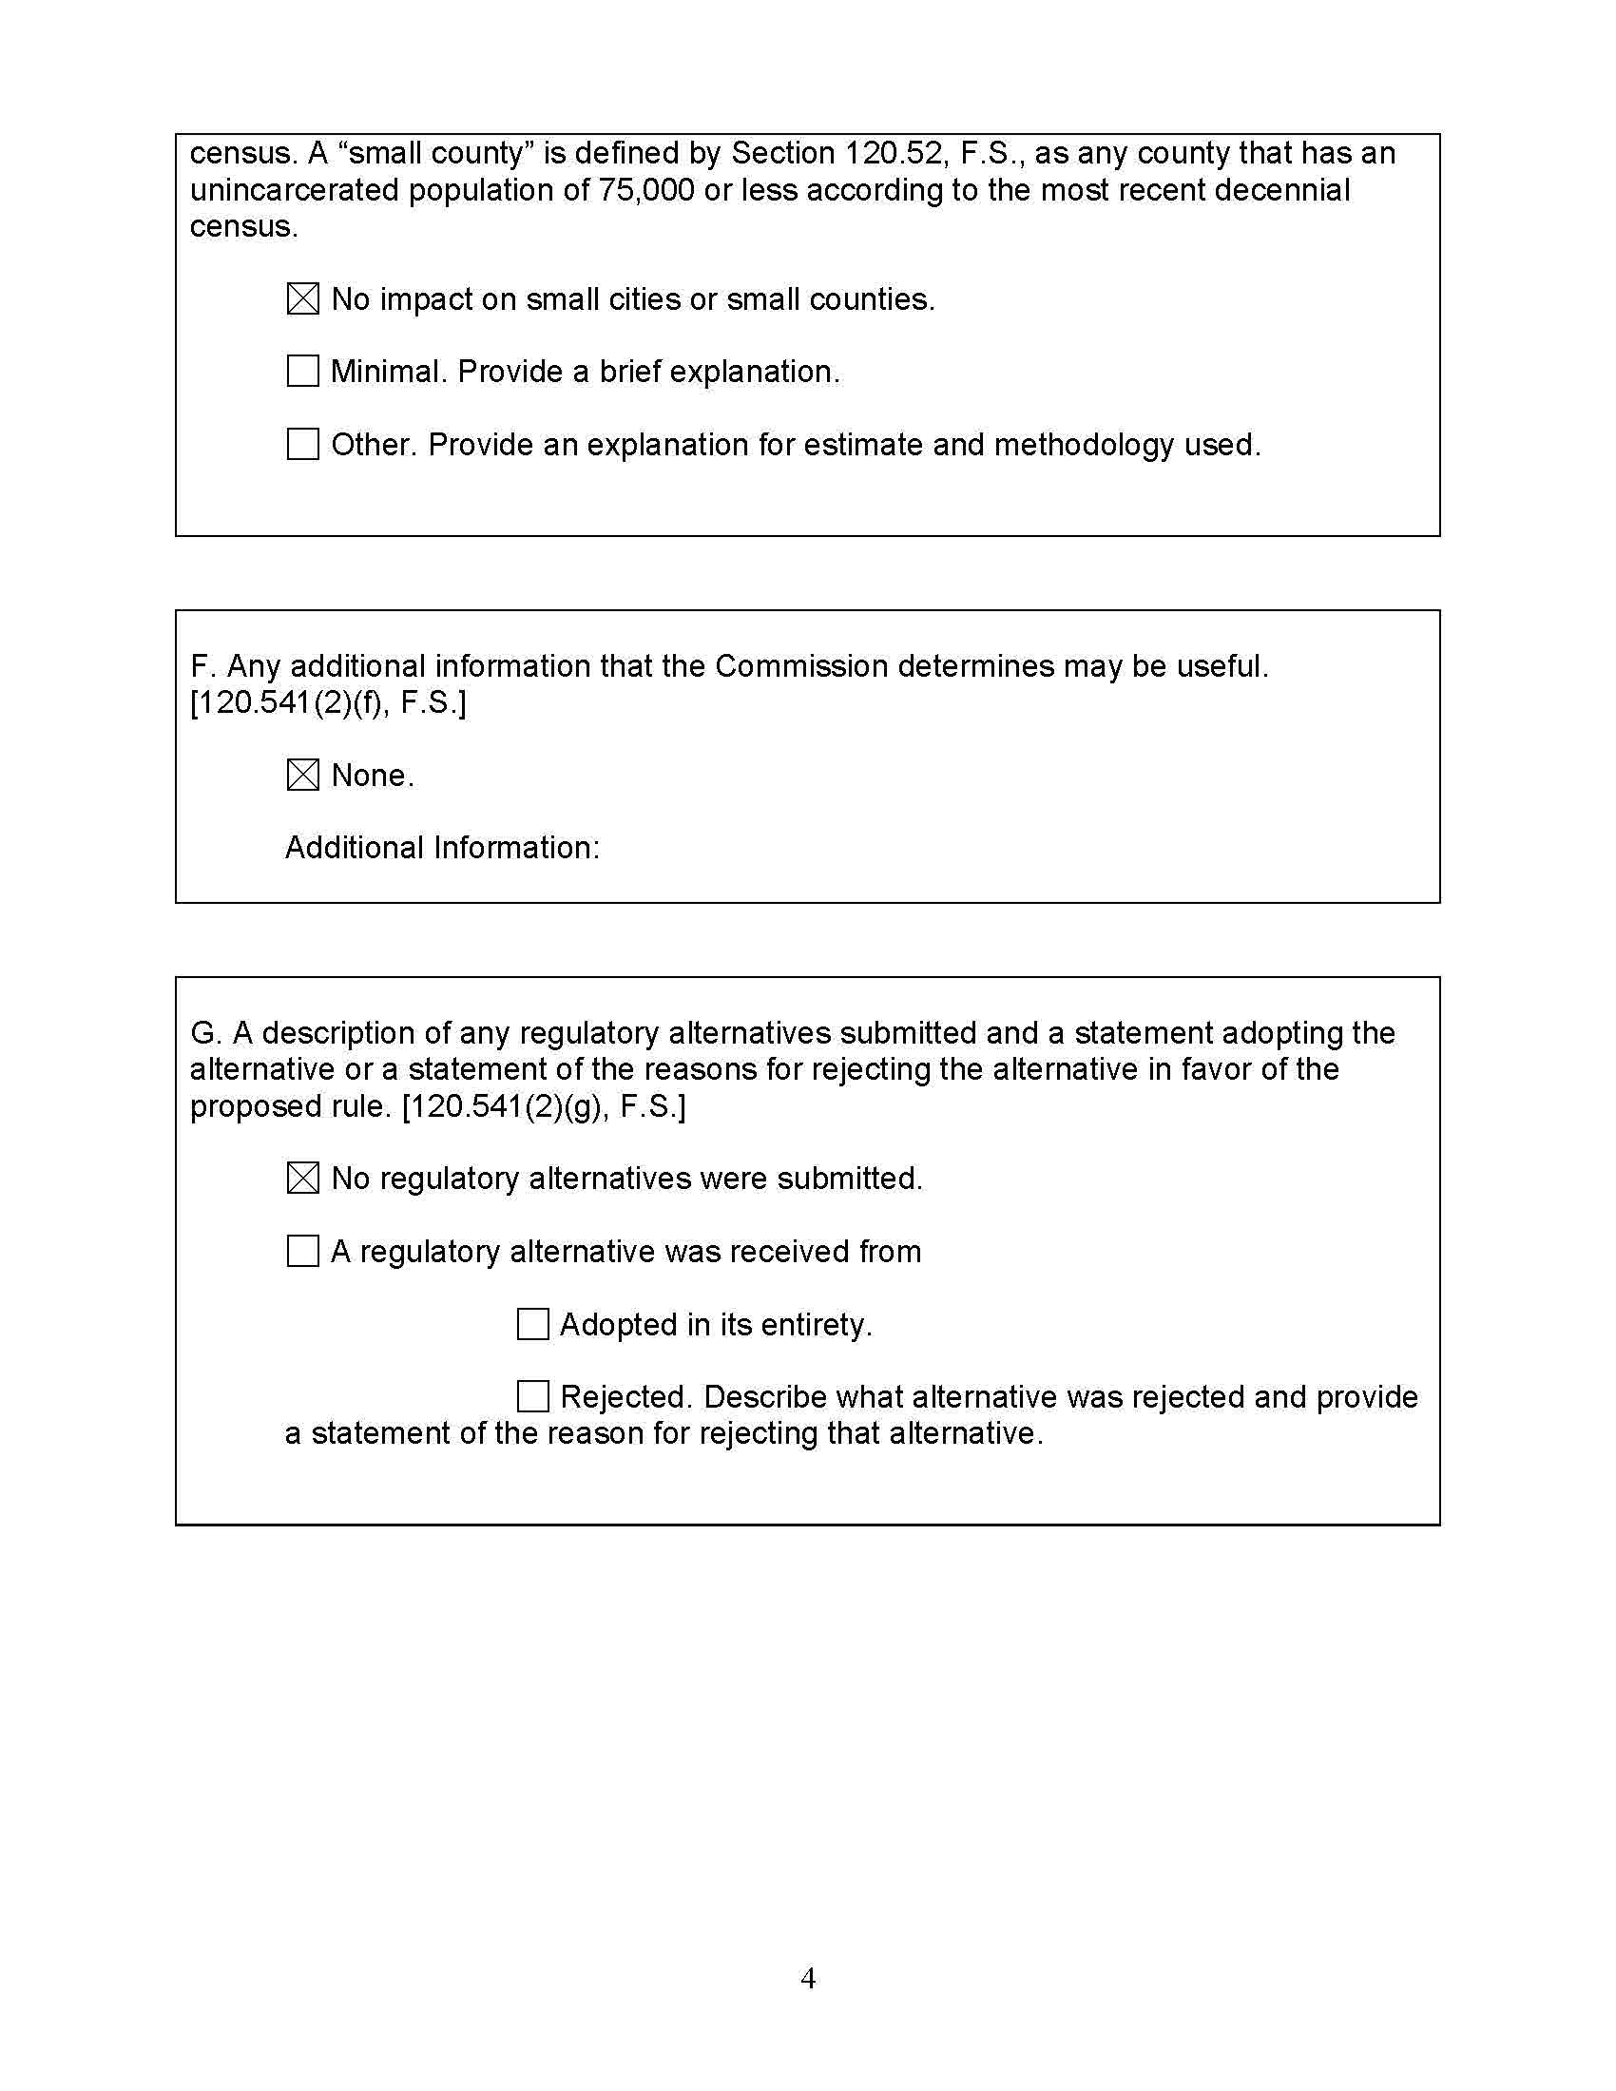

It is Commission practice to recover no more than 40 percent of revenues through the base facility charge for water utilities. If a water utility experiences high seasonal fluctuations in its customer base, the rate structure might allow recovery of more than 40 percent of revenues through the base facility charge.
This tariff stated: TEMPORARY DISCONTINUANCE OF SERVICE – If service is terminated and resumed at the same address to the same Customer within twelve (12) months or less from the date of termination, a monthly standby charge equivalent to the Base Facility Charge will be collected by the Company as a condition precedent to restoration of service to that Customer. If the Base Facility rate structure is not in effect, one half of the approved minimum bill will be charged for each billing period. The standby charge will be collected for each month, not to exceed twelve (12) months. Staff notes that several years ago, staff revised water and wastewater utility tariffs to a standard format and in doing so unintentionally eliminated this temporary discontinuance language from the very few utilities’ tariffs that included this provision. The draft rule amendment would codify the industry practice into the rules that govern tariffs.
NMSA Sec 20-1-8.1.

