BEFORE THE FLORIDA PUBLIC SERVICE COMMISSION

In re: Application for increase in water rates in Highlands County by HC Waterworks, Inc. | DOCKET NO. 20190166-WS  ORDER NO. PSC-2021-0089-S-WS  ISSUED: February 22, 2021

The following Commissioners participated in the disposition of this matter:

GARY F. CLARK, Chairman
ART GRAHAM
JULIE I. BROWN
ANDREW GILES FAY
MIKE LA ROSA

ORDER GRANTING JOINT MOTION AND APPROVING
STIPULATION AND SETTLEMENT AGREEMENT

BY THE COMMISSION:

Background
HC Waterworks, Inc. (HC or Utility) is a Class B utility providing water service to approximately 949 residential customers, 9 general service customers, and 1 private fire protection customer in the Leisure Lakes, Lake Josephine, and Sebring Lakes subdivisions in Highlands County. HC also provides wastewater service to 323 residential wastewater customers in the Leisure Lakes subdivision. On October 15, 2019, HC filed its application for an increase in water rates. The Utility requested that the application be processed using the Proposed Agency Action (PAA) procedure and a test year ended June 30, 2019. The Utility was notified of deficiencies in the MFRs on November 12, 2019, and December 6, 2019. The deficiencies were cured and December 13, 2019, was established as the official filing date.
On May 22, 2020, we issued PAA Order No. PSC-2020-0168-PAA-WS (Order). By that Order, we found the Utility’s quality of service to be unsatisfactory due to the high volume of customer complaints, and therefore reduced the Utility’s return on equity by 50 basis points. We also ordered the Utility to work with its customers and the Office of Public Counsel (OPC) to resolve customer service issues. On June 12, 2020, OPC timely filed a petition protesting those portions of the Order related to the Commission’s decision on HC’s quality of service. On June 16, 2020, HC filed its response to OPC’s petition and also a cross petition requesting the Commission dismiss OPC’s protest.

On August 11, 2020, HC and OPC filed a joint motion for approval of a stipulation and settlement agreement (Agreement), a copy of which is appended hereto as Attachment A. The Agreement addresses issues associated with the Utility’s quality of service. On September 15, 2020, Commission staff held a noticed informal meeting with the parties to discuss the Agreement. Subsequently on December 18, 2020, Commission staff sent a data request to the parties requesting clarification of certain terms within the Agreement. HC and OPC filed their responses on December 21, 2020, and January 8, 2021, respectively. In response to staff’s data request, the joint movants indicate that the instant docket shall be closed upon the Utility’s filing of its final status report. Additionally, the responses confirm that OPC has scheduled a virtual meeting with customers, Highlands County Commission personnel, and HC to occur on January 21, 2021, which staff plans to attend.
The Commission has jurisdiction pursuant to Sections 367.081 and 367.121, F.S.

Decision

The standard for approval of a settlement agreement is whether it is in the public interest. A determination of whether a settlement is in the public interest requires a case-specific analysis based on consideration of the proposed settlement taken as a whole.

The Agreement serves the public interest directly with provisions to improve customer and utility engagement and the Utility will file quarterly status reports, in the docket file, detailing these engagements beginning 3 months after the issuance of this order for a period of one year. The Agreement also sets forth processes to enhance communications flowing from HC to its customers regarding matters such as planned outages and precautionary boil water notices. The Agreement does not impact the rates we approved by Order PSC-2020-0168-PAA-WS.

Having carefully reviewed the Agreement, we find that, taken as a whole, the Agreement is in the public interest, and we hereby approve it.

Based on the foregoing, it is

ORDERED by the Florida Public Service Commission that the joint motion for approval of a stipulation and settlement agreement filed August 11, 2020, is granted, and the stipulation and settlement agreement is approved. It is further

ORDERED that this docket shall be administratively closed once the Utility files its last status report in the docket file.

By ORDER of the Florida Public Service Commission this 22nd day of February, 2021.

/s/ Adam J. Teitzman
ADAM J. TEITZMAN
Commission Clerk
Florida Public Service Commission
2540 Shumard Oak Boulevard
Tallahassee, Florida 32399
(850) 413-6770
www.floridapsc.com

Copies furnished: A copy of this document is provided to the parties of record at the time of issuance and, if applicable, interested persons.

SPS

NOTICE OF FURTHER PROCEEDINGS OR JUDICIAL REVIEW

The Florida Public Service Commission is required by Section 120.569(1), Florida Statutes, to notify parties of any administrative hearing or judicial review of Commission orders that is available under Sections 120.57 or 120.68, Florida Statutes, as well as the procedures and time limits that apply. This notice should not be construed to mean all requests for an administrative hearing or judicial review will be granted or result in the relief sought.

Any party adversely affected by the Commission's final action in this matter may request: 1) reconsideration of the decision by filing a motion for reconsideration with the Office of Commission Clerk, 2540 Shumard Oak Boulevard, Tallahassee, Florida 32399-0850, within fifteen (15) days of the issuance of this order in the form prescribed by Rule 25-22.060, Florida Administrative Code; or 2) judicial review by the Florida Supreme Court in the case of an electric, gas or telephone utility or the First District Court of Appeal in the case of a water and/or wastewater utility by filing a notice of appeal with the Office of Commission Clerk, and filing a copy of the notice of appeal and the filing fee with the appropriate court. This filing must be completed within thirty (30) days after the issuance of this order, pursuant to Rule 9.110, Florida Rules of Appellate Procedure. The notice of appeal must be in the form specified in Rule 9.900(a), Florida Rules of Appellate Procedure.

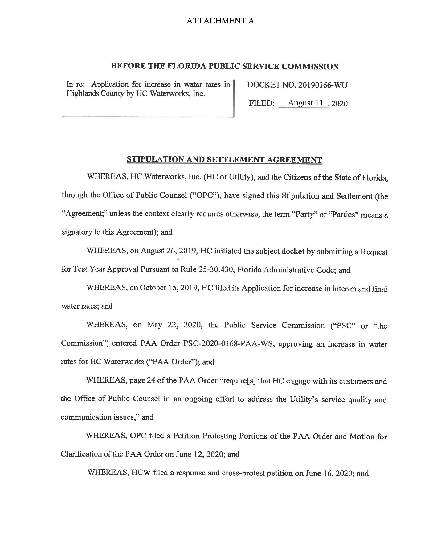

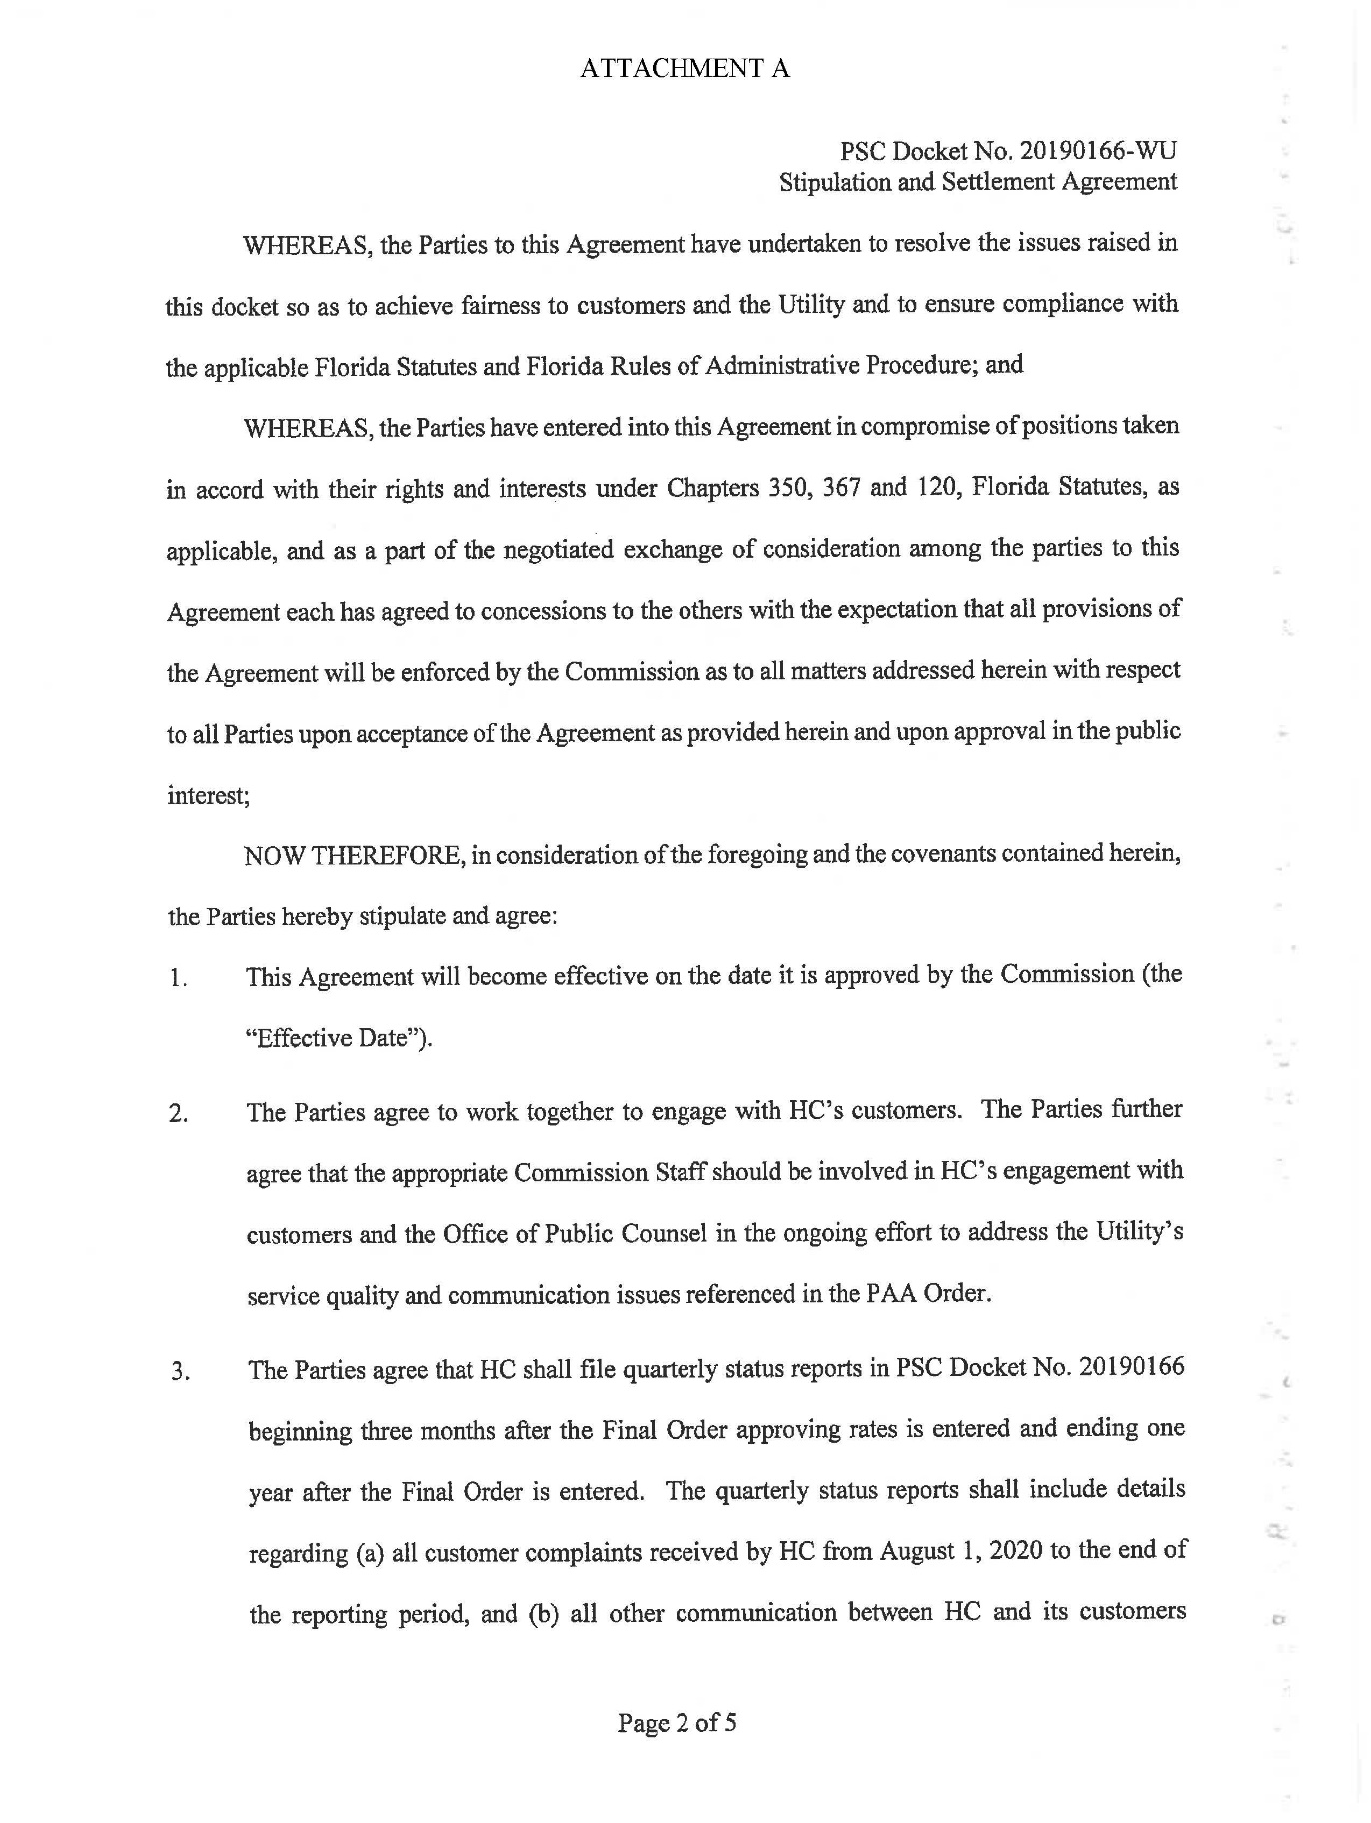

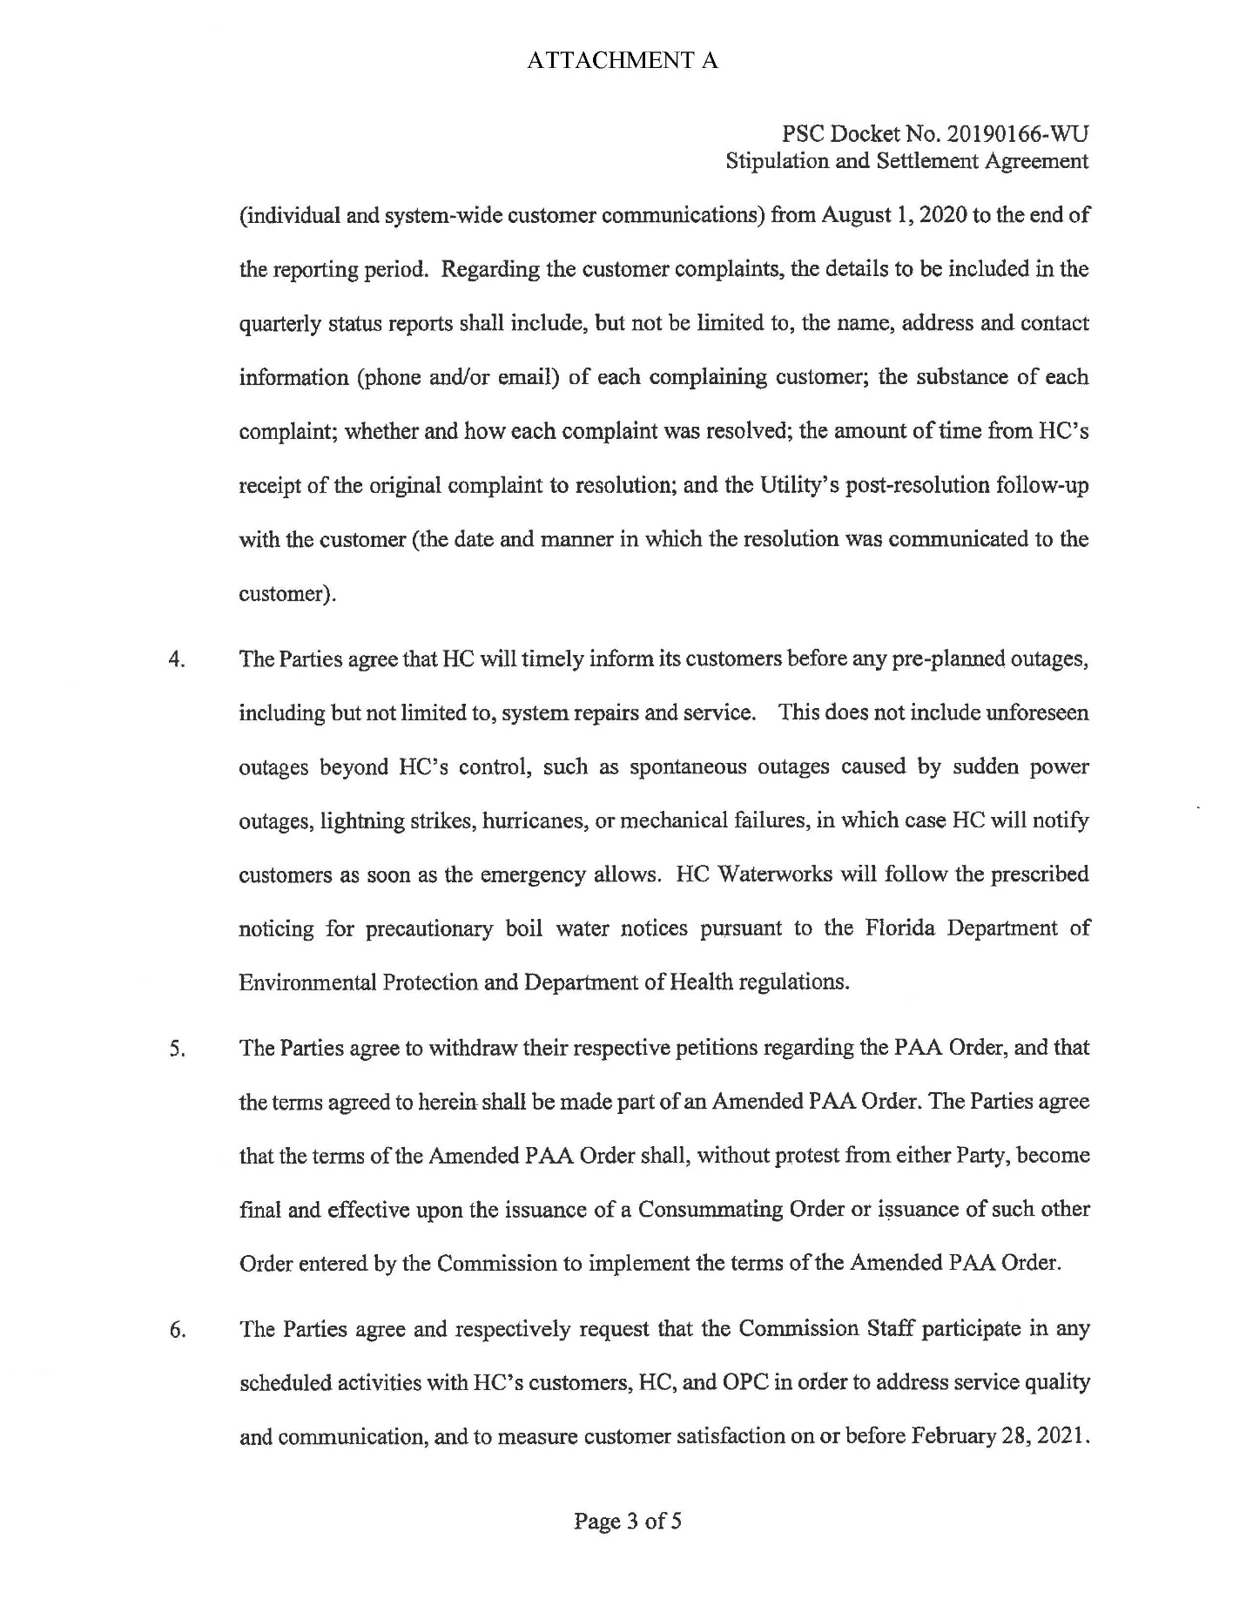

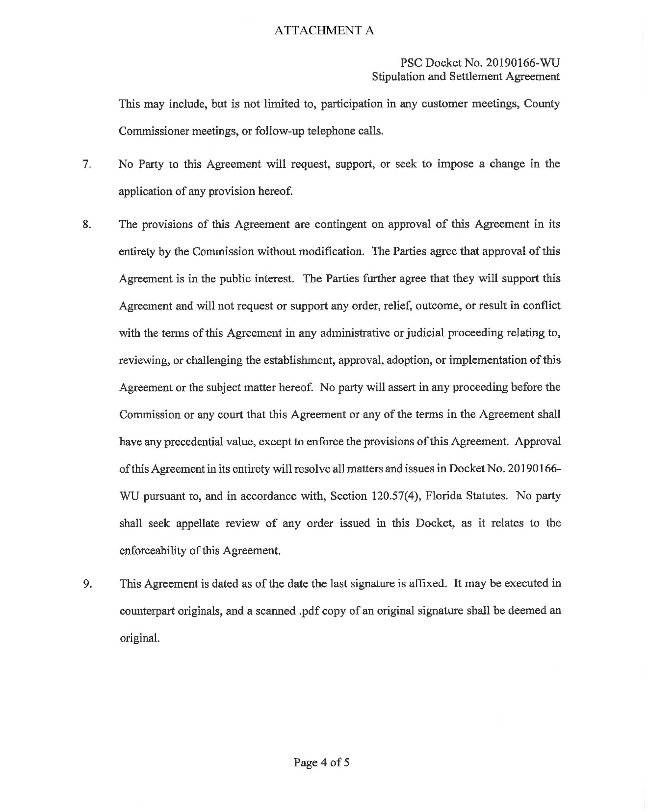

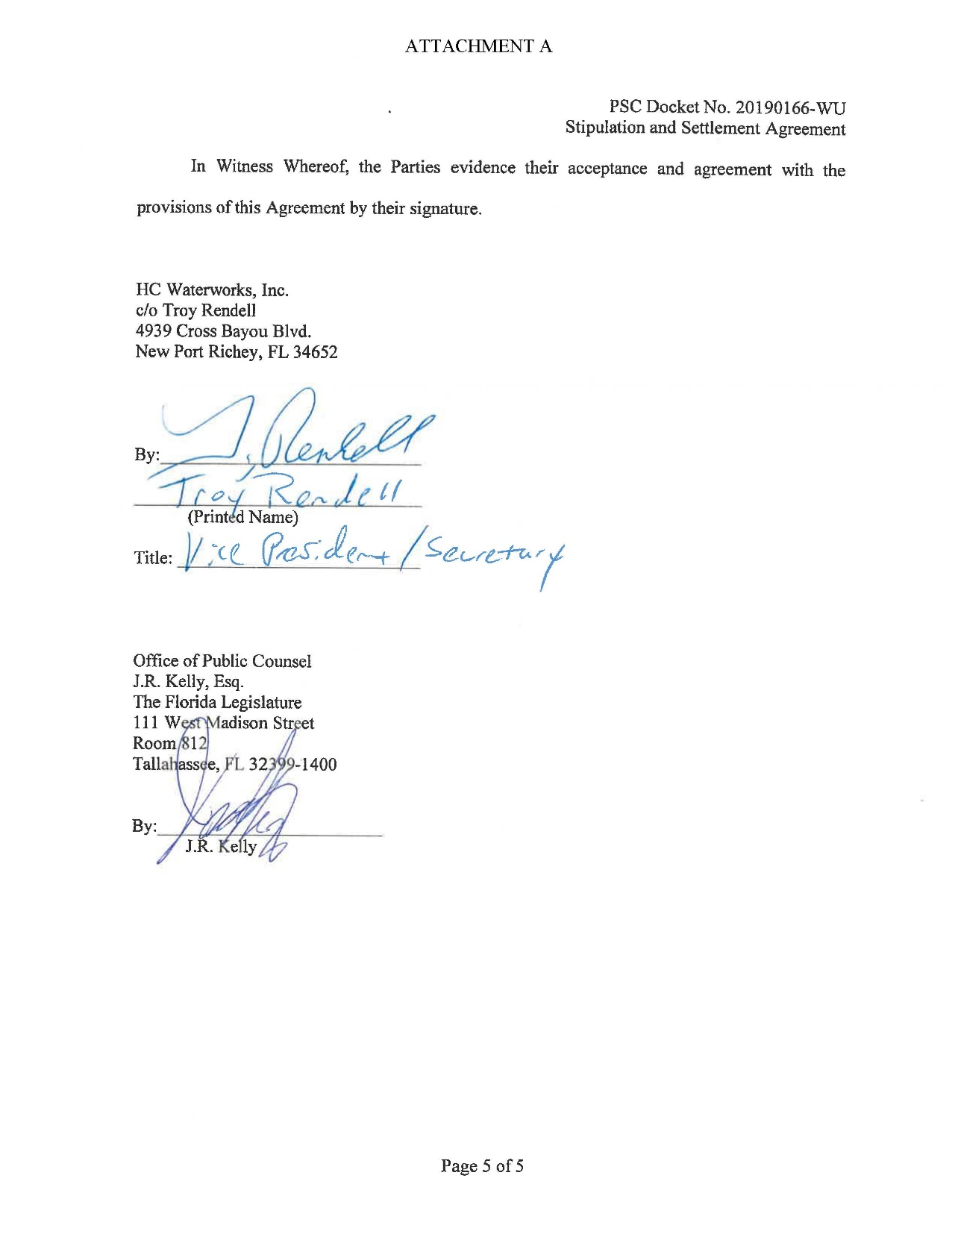

Sierra Club v. Brown, 243 So. 3d 903, 910-913 (Fla. 2018); Order No. PSC-13-0023-S-EI, issued on January 14, 2013, in Docket No. 120015-EI, In re: Petition for increase in rates by Florida Power & Light Company; Order No. PSC-11-0089-S-EI, issued February 1, 2011, in Docket Nos. 080677-EI and 090130-EI, In re: Petition for increase in rates by Florida Power & Light Company and In re: 2009 depreciation and dismantlement study by Florida Power & Light Company; Order No. PSC-10-0398-S-EI, issued June 18, 2010, in Docket Nos. 090079-EI, 090144-EI, 090145-EI, and 100136-EI, In re: Petition for increase in rates by Progress Energy Florida, Inc., In re: Petition for limited proceeding to include Bartow repowering project in base rates, by Progress Energy Florida, Inc., In re: Petition for expedited approval of the deferral of pension expenses, authorization to charge storm hardening expenses to the storm damage reserve, and variance from or waiver of Rule 25-6.0143(1)(c), (d), and (f), F.A.C., by Progress Energy Florida, Inc., and In re: Petition for approval of an accounting order to record a depreciation expense credit, by Progress Energy Florida, Inc.; Order No. PSC-05-0945-S-EI, issued September 28, 2005, in Docket No. 050078-EI, In re: Petition for rate increase by Progress Energy Florida, Inc.
Order No. PSC-13-0023-S-EI, at p. 7.

