BEFORE THE FLORIDA PUBLIC SERVICE COMMISSION

In re: Petition for approval of firm service agreement with Peoples Gas System, by SeaCoast Gas Transmission, L.L.C. | DOCKET NO. 20210042-GU  ORDER NO. PSC-2021-0187-PAA-GU  ISSUED: May 24, 2021

The following Commissioners participated in the disposition of this matter:

GARY F. CLARK, Chairman
ART GRAHAM
ANDREW GILES FAY
MIKE LA ROSA

NOTICE OF PROPOSED AGENCY ACTION
ORDER APPROVING FIRM TRANSPORTATION SERVICE AGREEMENT

BY THE COMMISSION:

NOTICE is hereby given by the Florida Public Service Commission that the action discussed herein is preliminary in nature and will become final unless a person whose interests are substantially affected files a petition for a formal proceeding, pursuant to Rule 25-22.029, Florida Administrative Code (F.A.C.).

BACKGROUND
On February 19, 2021, SeaCoast Gas Transmission, L.L.C. (SeaCoast), filed a petition seeking our approval of a Firm Service Agreement (Agreement) with Peoples Gas System (Peoples), collectively the parties. Peoples is a local distribution company which owns and operates natural gas distribution facilities to serve retail customers and is subject to our regulatory jurisdiction under Chapter 366, Florida Statutes (F.S.). SeaCoast operates as an intrastate natural gas transmission company as defined in Section 368.103, F.S., and only transports natural gas.
By Order No. PSC-08-0747-TRF-GP, SeaCoast received approval of an intrastate gas pipeline tariff that allows it to construct and operate intrastate pipeline facilities and to actively pursue agreements with natural gas customers. SeaCoast provides transportation service only; it does not engage in the sale of natural gas. Pursuant to Order No. PSC-08-0747-TRF-GP, SeaCoast is allowed to enter into certain gas transmission agreements without our prior approval. However, SeaCoast is requesting our approval of this proposed agreement as it does not fit any of the criteria enumerated in the tariff for which our approval would not be required. The parties are subsidiaries of TECO Energy, Inc., and agreements between affiliated companies must be approved by us pursuant to Section 368.105, F.S., and Order No. PSC-08-0747-TRF-GP.
The proposed Agreement is contained in Attachment A to this order. During the evaluation of the instant petition, our staff issued a data request to the parties for which responses were received on April 1, 2021. In addition, an informal conference call was held on April 15, 2021, with the parties to discuss specifics of the request. We have jurisdiction over this matter pursuant to Sections 366.04, 366.05(1), 366.06, and 368.105, F.S.

DECISION
In order to serve growth and safeguard system reliability for existing and new customers in the Lakeland and Polk County area, Peoples has entered into the proposed Agreement with SeaCoast to expand gas flow into this region of its service territory. To provide intrastate transportation of gas to Peoples, SeaCoast will tap into an existing four-inch pipeline lateral of Florida Gas Transmission Company, LLC’s (FGT) system serving Hillsborough County and extend a new 2.5 mile six-inch pipeline into Peoples’ new high pressure main pipeline at the Polk-Hillsborough County line. As part of this project, an existing out-of-service gate station that previously provided gas to an end-use industrial customer will serve as the access point of the expansion. During the April 15, 2021 call with Peoples, the utility explained that the recommission process would involve testing and repairing the gate station to bring it in line with current safety and operational standards. The cost to recommission the gate station is included in the proposed Agreement. The map showing the proposed extension and its connections to existing facilities is contained in Attachment B of this order.
The parties stated that they have completed the preliminary design for the infrastructure extensions. Pending our approval of the Agreement, the permitting process will be initiated and is expected to take four to five months. Construction is anticipated to begin in the third quarter of 2021. SeaCoast estimated that the proposed transmission pipeline will be completed by the first quarter of 2022. Peoples stated that it projects approximately 5,480 existing customers, including 4,750 residential and 730 commercial/industrial customers, would benefit from the expansion project through increased resiliency and reliability. In addition, Peoples stated that the proposed project would support additional customer growth in the Lakeland region.
The proposed Agreement specifies an initial term of 20 years and thereafter shall be extended for additional 10-year increments, unless either party gives no less than 30 days of written notification of termination. The negotiated reservation charge (confidential) included in the proposed Agreement is designed to allow SeaCoast to recover its operational and maintenance costs, depreciation, taxes, and return on investment associated with the new transmission pipeline. SeaCoast stated that the rate set forth in the Agreement is a cost-based rate similar to rates set forth in firm service agreements with its other customers. SeaCoast asserts that the agreement is just, reasonable and not unreasonably preferential or unduly discriminatory, and therefore, consistent with Section 368.105(3)(b), F.S. While specific circumstances vary by projects due to pipe sizing, construction conditions, permitting, etc., we find that the information provided by SeaCoast for the proposed pipeline appears reasonable and comparable to similar agreements.

Consideration of Potential Alternatives to the SeaCoast Extension

Peoples stated that it evaluated other options to meet demand and improve delivery of gas to customers in the Lakeland and Polk County area, but those alternatives were more expensive and had shortcomings. One option considered by Peoples was a transmission line that traversed the Lakeland area with approximately 9 miles of eight-inch steel pipeline serving as the project’s main line, along with approximately 2.5 miles of six-inch steel pipeline for the distribution system. The origin point of this alternative was Peoples’ North Lakeland Gate Station, which serves Peoples’ Lakeland and Tampa divisions. Peoples explained that this alternative line could create competing capacity demands on its North Lakeland Gate Station, which could limit the efficiency and effectiveness of that option. Contracting with SeaCoast, as proposed in the Agreement, would provide Peoples with an alternative access to FGT’s system. This option would result in improved system resiliency through an additional gas delivery access point.
In response to data request, SeaCoast and Peoples provided a cost estimate for the proposed six-inch SeaCoast transmission pipeline and stated that this alternative is the most cost- effective. Peoples also stated that FGT provided a proposal to expand its pipeline in order to meet the requirements of this project, but the FGT proposal was not cost-effective in comparison to the proposal from SeaCoast and could not be completed within the utility’s time requirements.

Peoples’ Cost Recovery of Payments to SeaCoast

Peoples’ payments to SeaCoast would be included in the calculation of the monthly Purchased Gas Adjustment (PGA) factor. Consistent with the methodology we approved in Docket No. 20000810-GU, a portion of the costs would be paid by transportation customers taking service under Peoples’ Natural Choice Transportation Service program via the swing charge mechanism. Swing service charge revenues collected from transportation customers would then be credited back to the PGA. Sales customers purchase their gas from Peoples and are subject to Peoples’ PGA charges. Peoples stated that if this project is approved it would include the charges in the 2022 PGA cap that would be filed for our review and approval in September 2021. Peoples estimates the impact on the PGA cap to be $0.0073 per therm.

Conclusion

In 2015 and 2019, we approved similar transportation agreements between Peoples and SeaCoast. Based on the petition and the parties’ responses to data request, the parties have supported the importance of the need for pipeline extensions to service customers in the Lakeland and Polk County area. We hereby find that the proposed Agreement is cost-effective, reasonable, meets the requirements of Section 368.105, F.S., and benefits Peoples’ customers. We therefore approve of the proposed Agreement between the parties dated February 19, 2021.
Based on the foregoing, it is

ORDERED by the Florida Public Service Commission that the Agreement dated February 19, 2021, between SeaCoast Gas Transmission, L.L.C. and Peoples Gas System, is hereby approved. It is further

ORDERED that the provisions of this Order, issued as proposed agency action, shall become final and effective upon the issuance of a Consummating Order unless an appropriate petition, in the form provided by Rule 28-106.201, Florida Administrative Code, is received by the Commission Clerk, 2540 Shumard Oak Boulevard, Tallahassee, Florida 32399-0850, by the close of business on the date set forth in the “Notice of Further Proceedings” attached hereto. It is further

ORDERED that if no protest is filed by a person whose substantial interests are affected within 21 days of the issuance of the Order, this docket shall be closed upon the issuance of a Consummating Order.

By ORDER of the Florida Public Service Commission this 24th day of May, 2021.

/s/ Adam J. Teitzman
ADAM J. TEITZMAN
Commission Clerk
Florida Public Service Commission
2540 Shumard Oak Boulevard
Tallahassee, Florida 32399
(850) 413-6770
www.floridapsc.com

Copies furnished: A copy of this document is provided to the parties of record at the time of issuance and, if applicable, interested persons.

BYL

NOTICE OF FURTHER PROCEEDINGS OR JUDICIAL REVIEW

The Florida Public Service Commission is required by Section 120.569(1), Florida Statutes, to notify parties of any administrative hearing that is available under Section 120.57, Florida Statutes, as well as the procedures and time limits that apply. This notice should not be construed to mean all requests for an administrative hearing will be granted or result in the relief sought.

Mediation may be available on a case-by-case basis. If mediation is conducted, it does not affect a substantially interested person's right to a hearing.

The action proposed herein is preliminary in nature. Any person whose substantial interests are affected by the action proposed by this order may file a petition for a formal proceeding, in the form provided by Rule 28-106.201, Florida Administrative Code. This petition must be received by the Office of Commission Clerk, 2540 Shumard Oak Boulevard, Tallahassee, Florida 32399-0850, by the close of business on June 14, 2021.

In the absence of such a petition, this order shall become final and effective upon the issuance of a Consummating Order.

Any objection or protest filed in this/these docket(s) before the issuance date of this order is considered abandoned unless it satisfies the foregoing conditions and is renewed within the specified protest period.

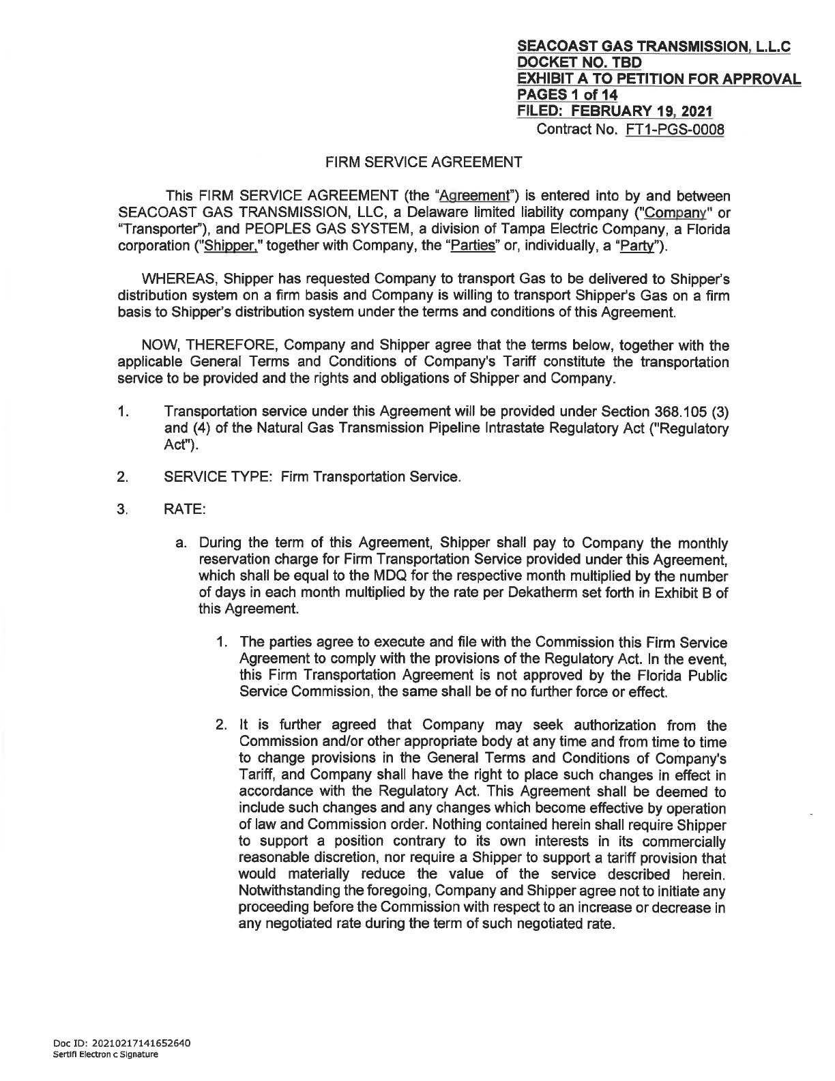

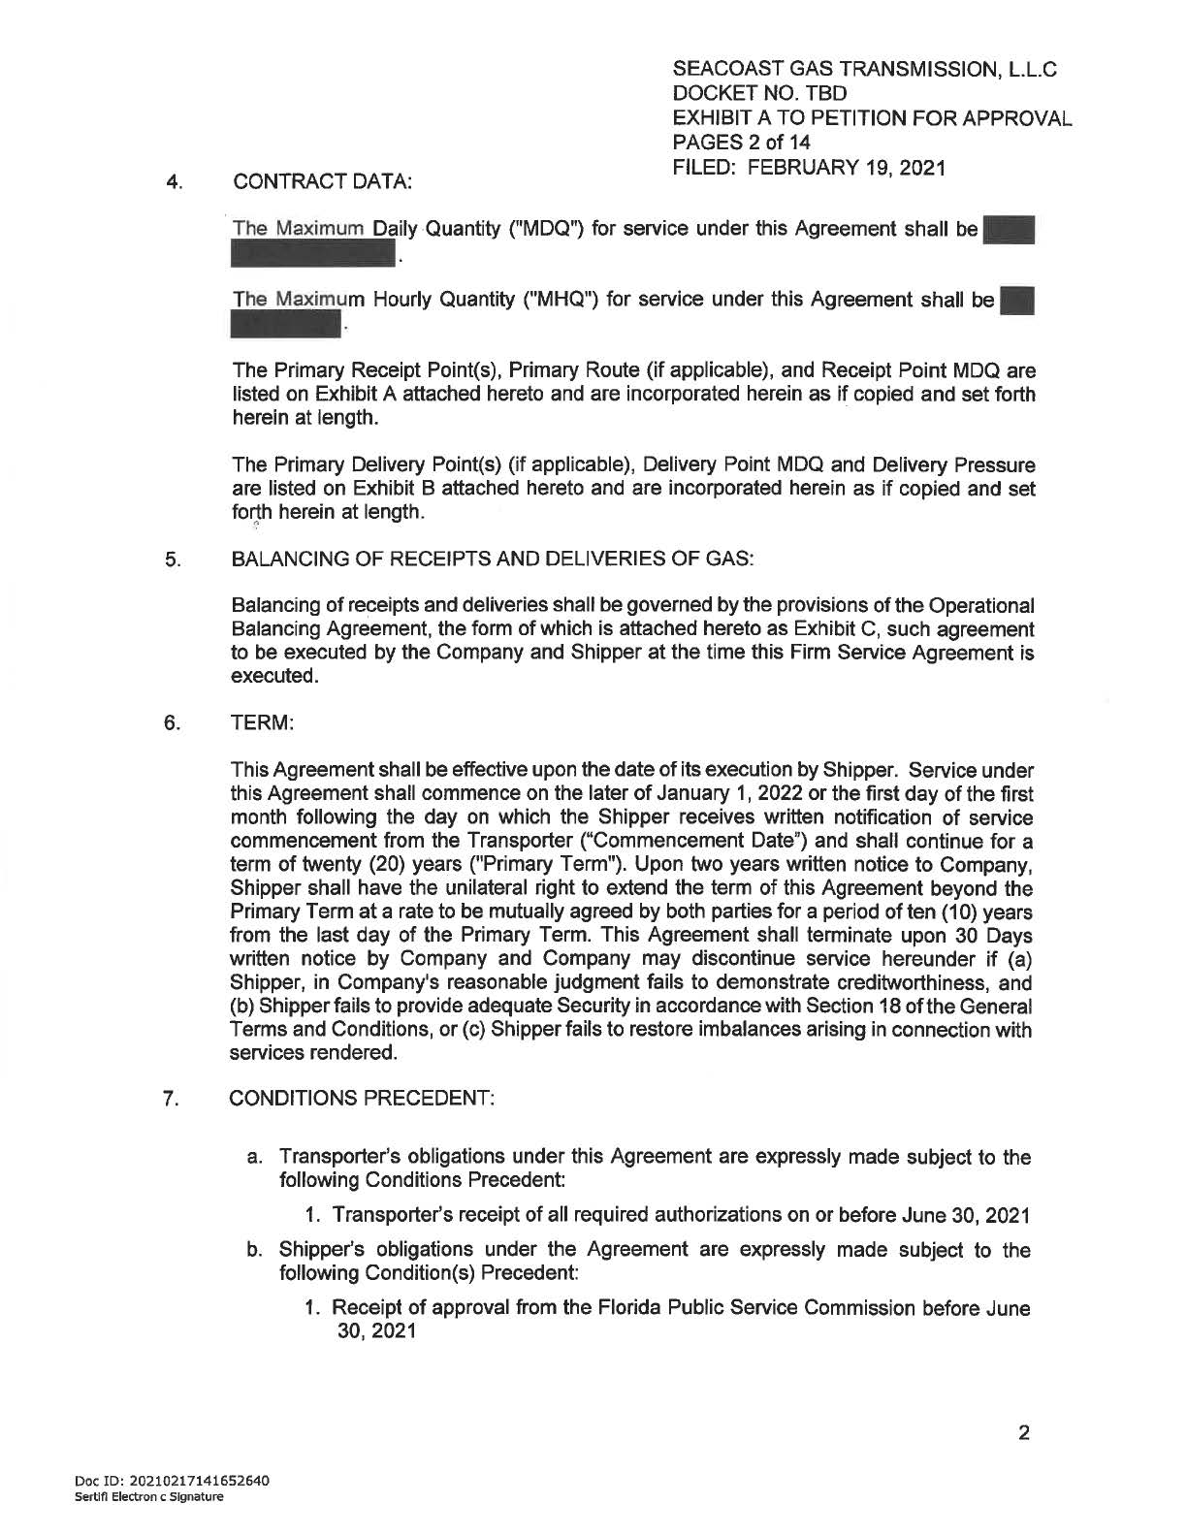

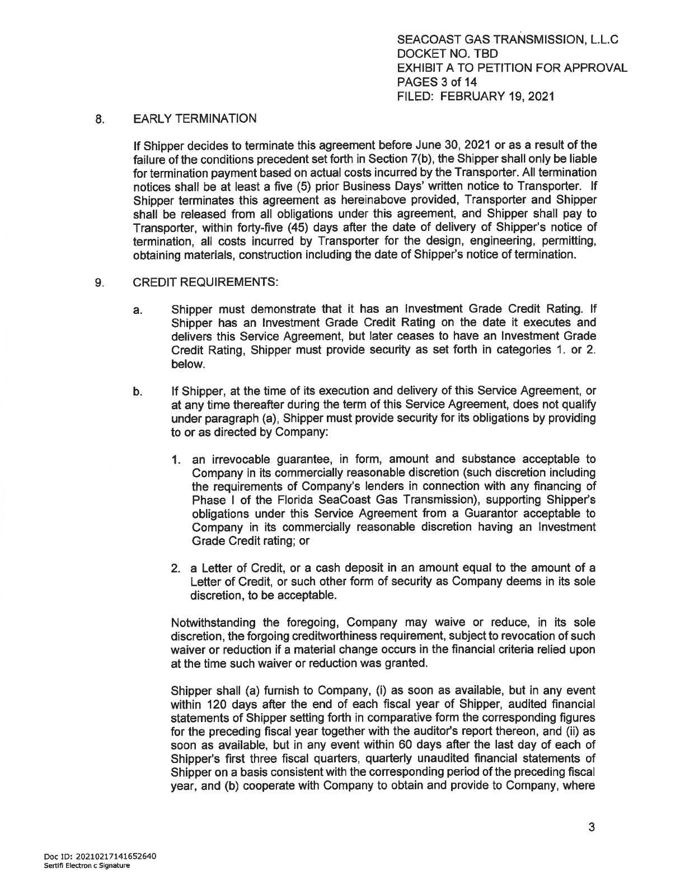

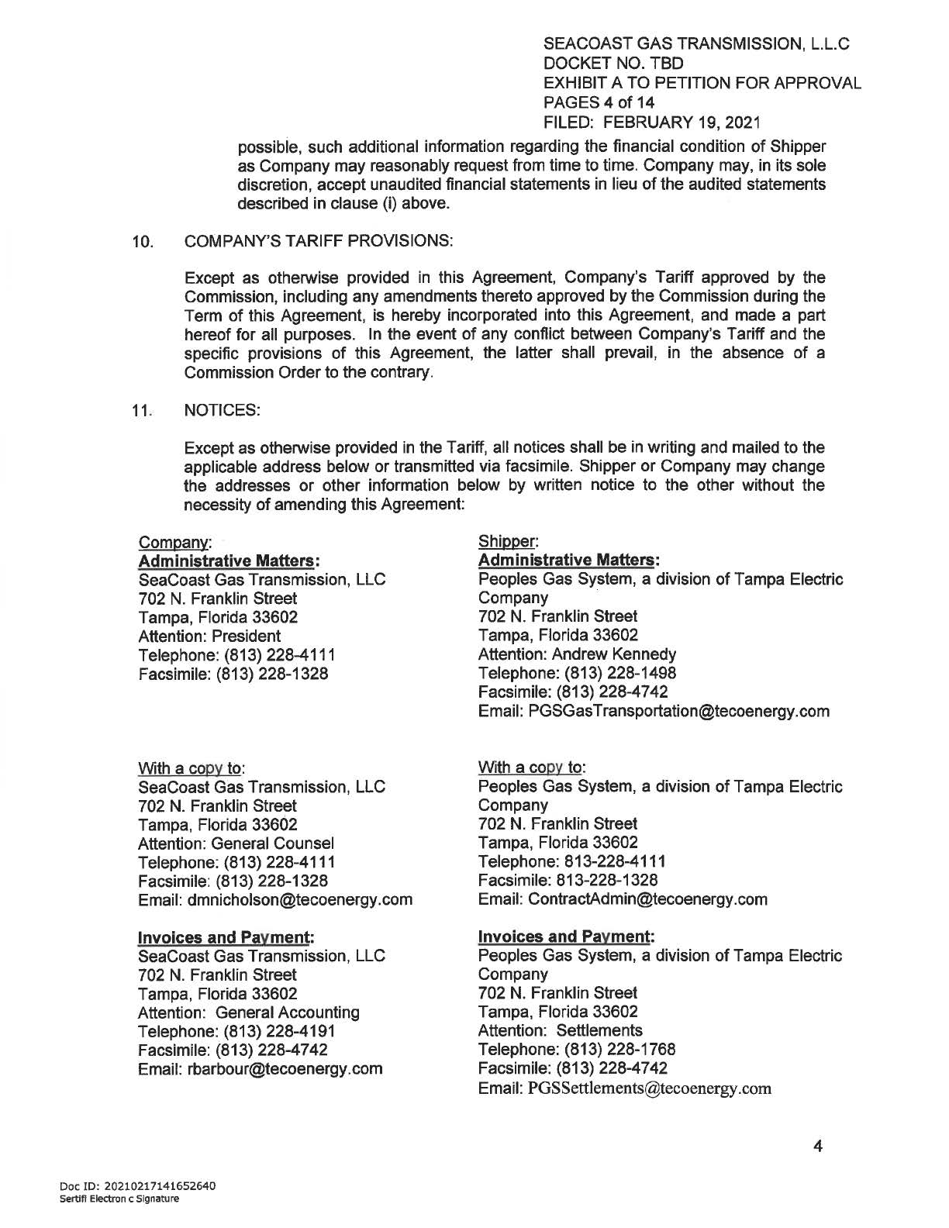

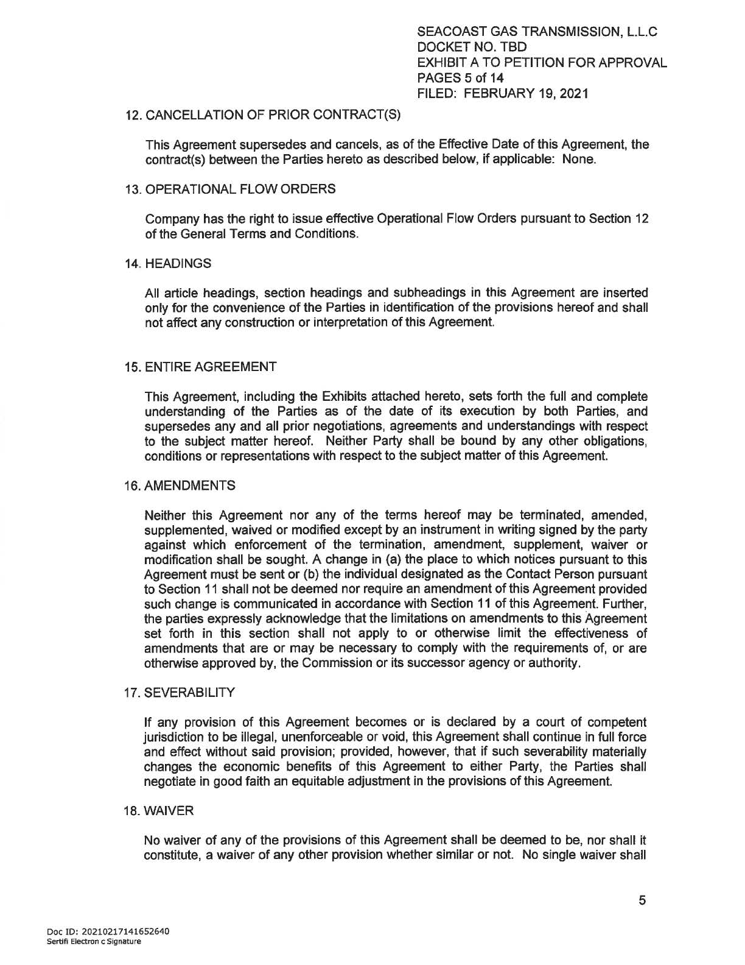

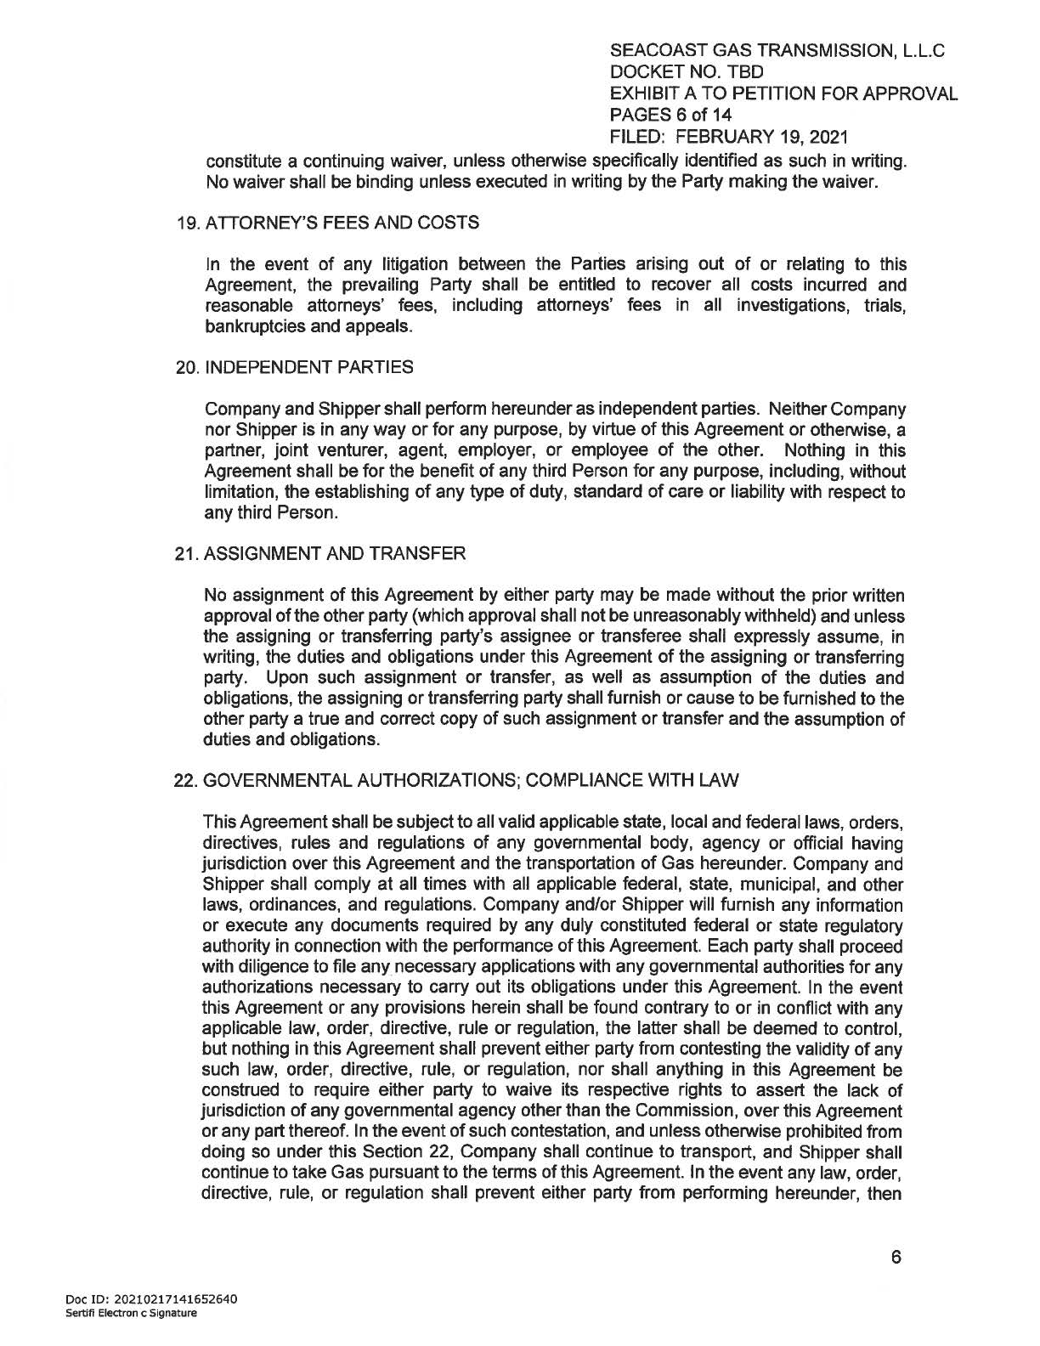

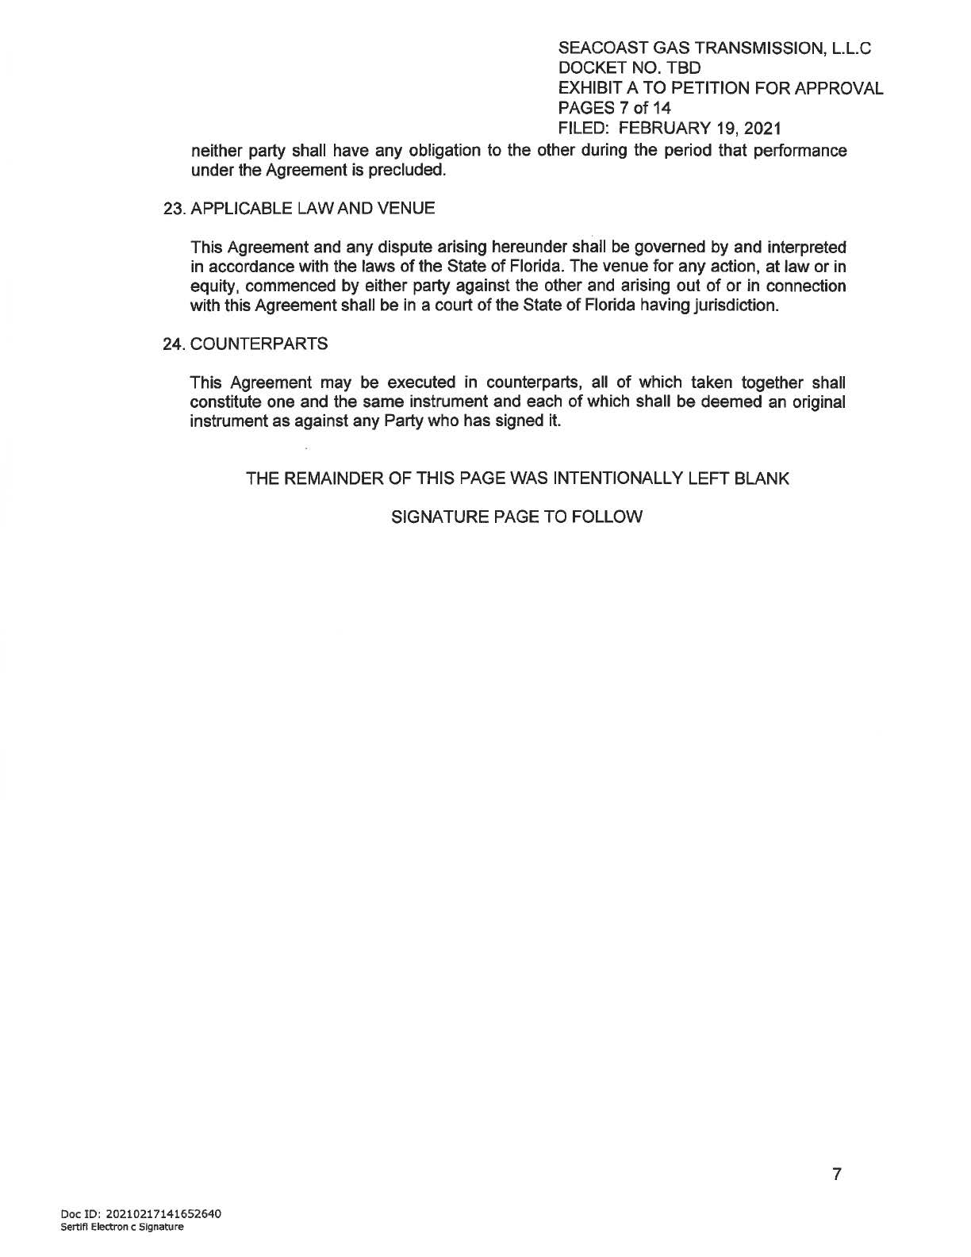

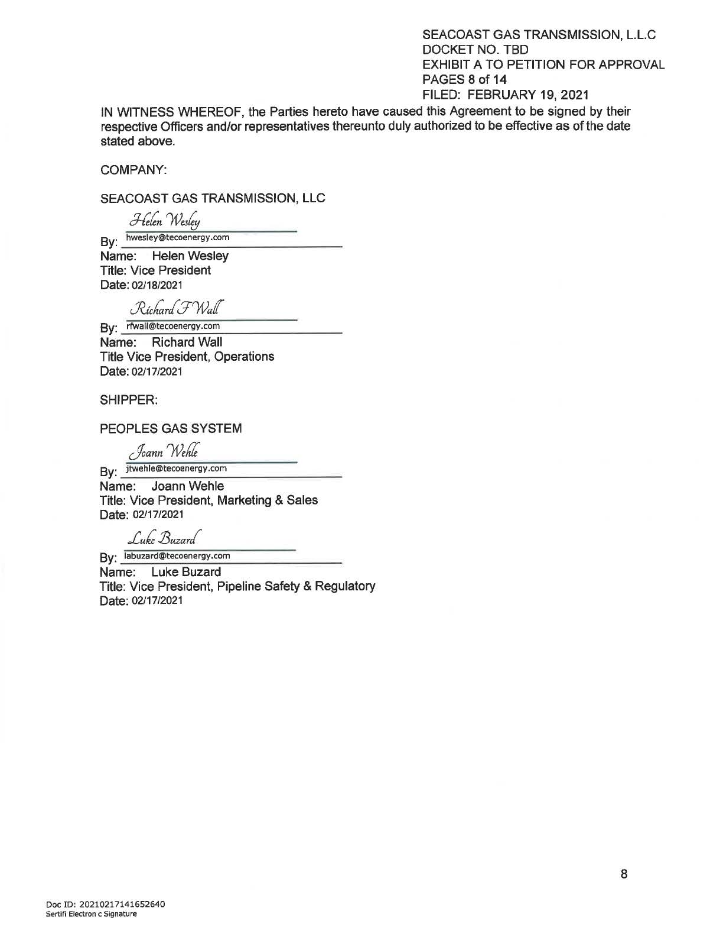

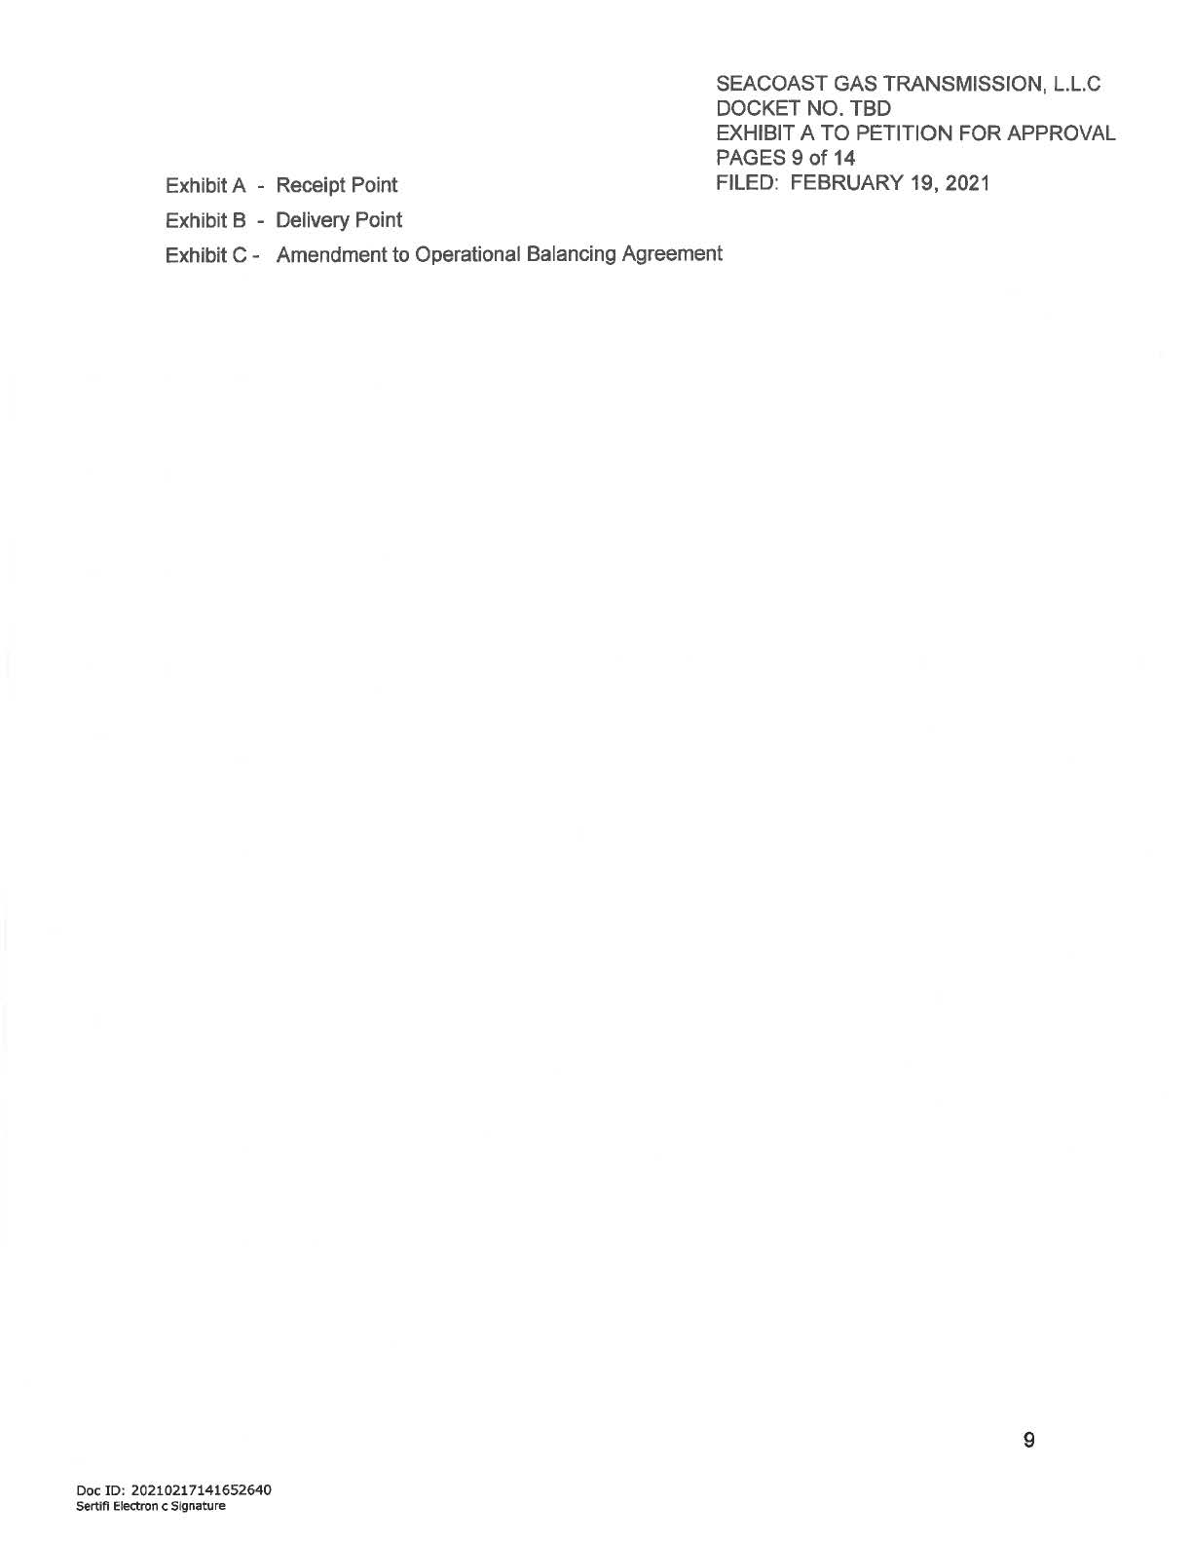

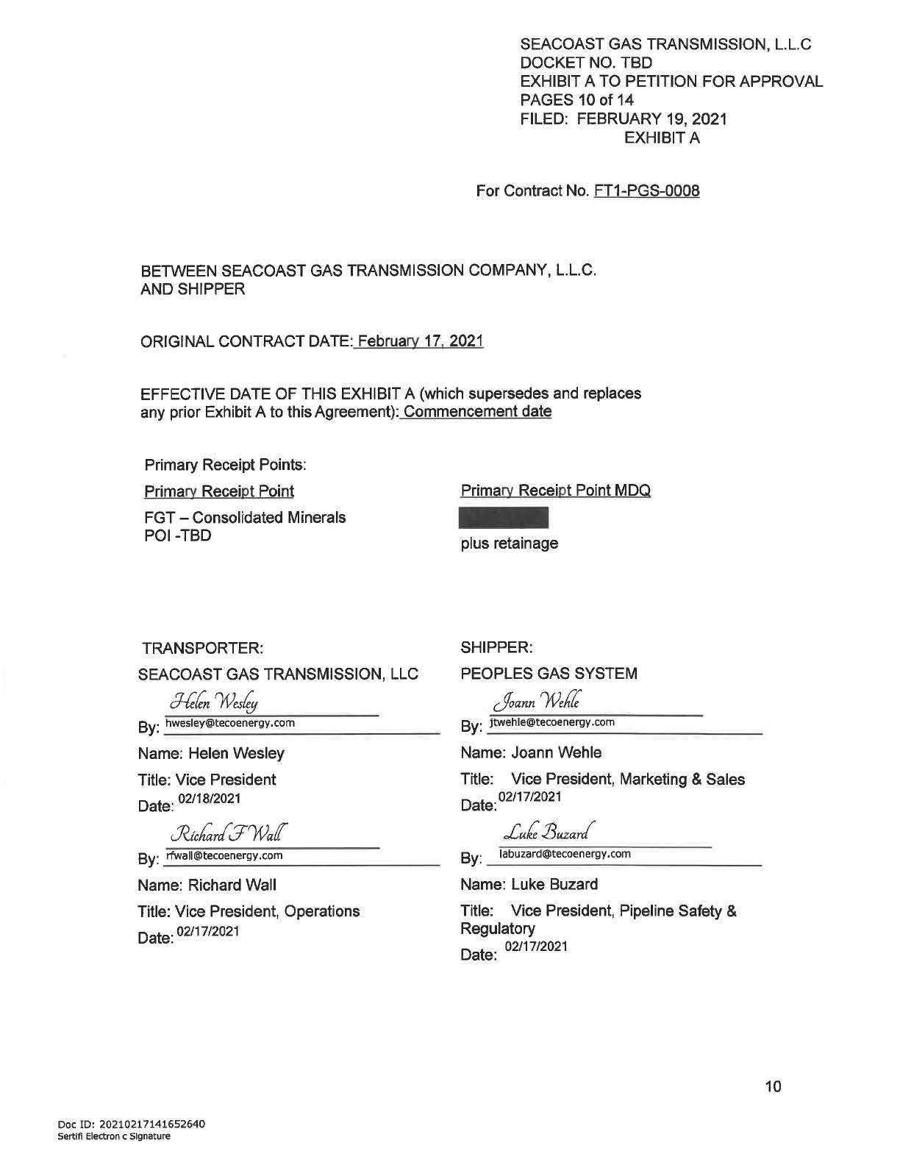

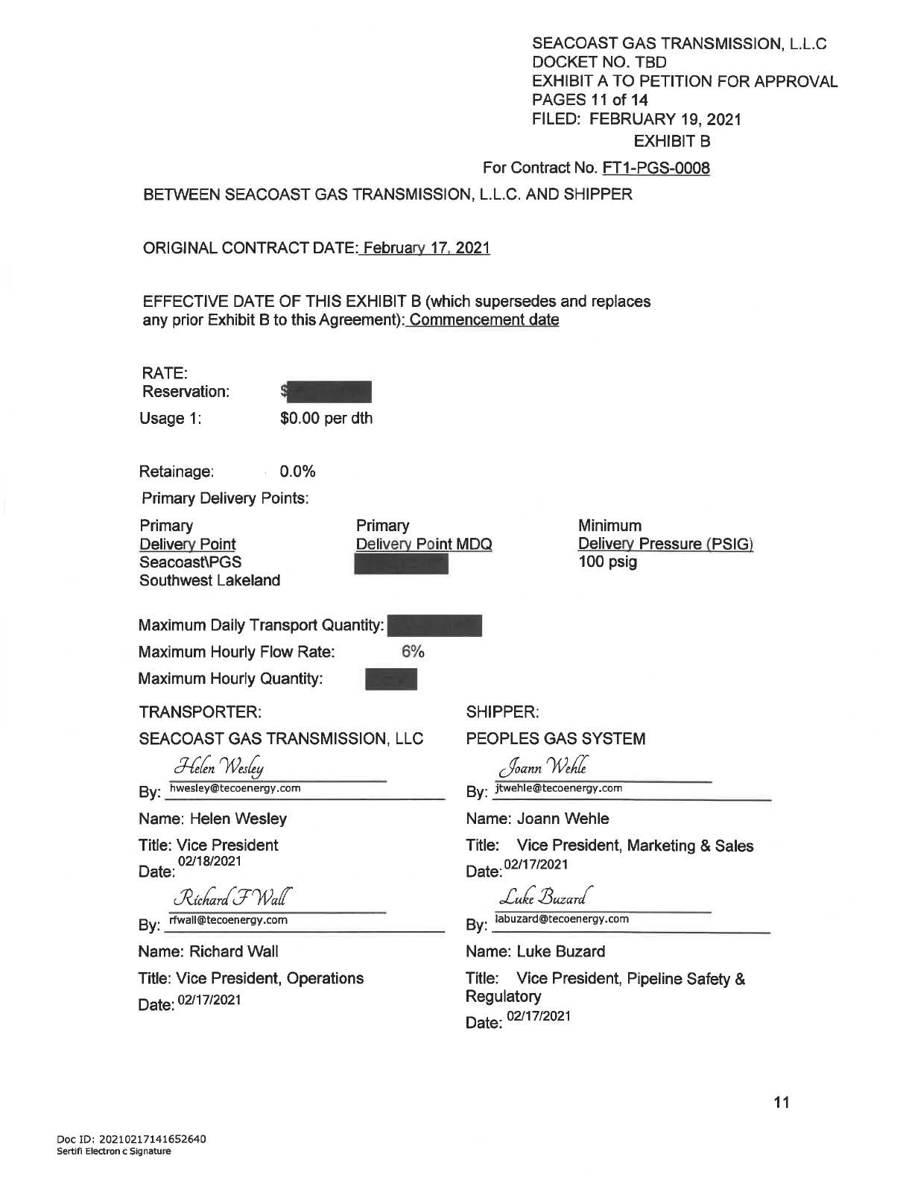

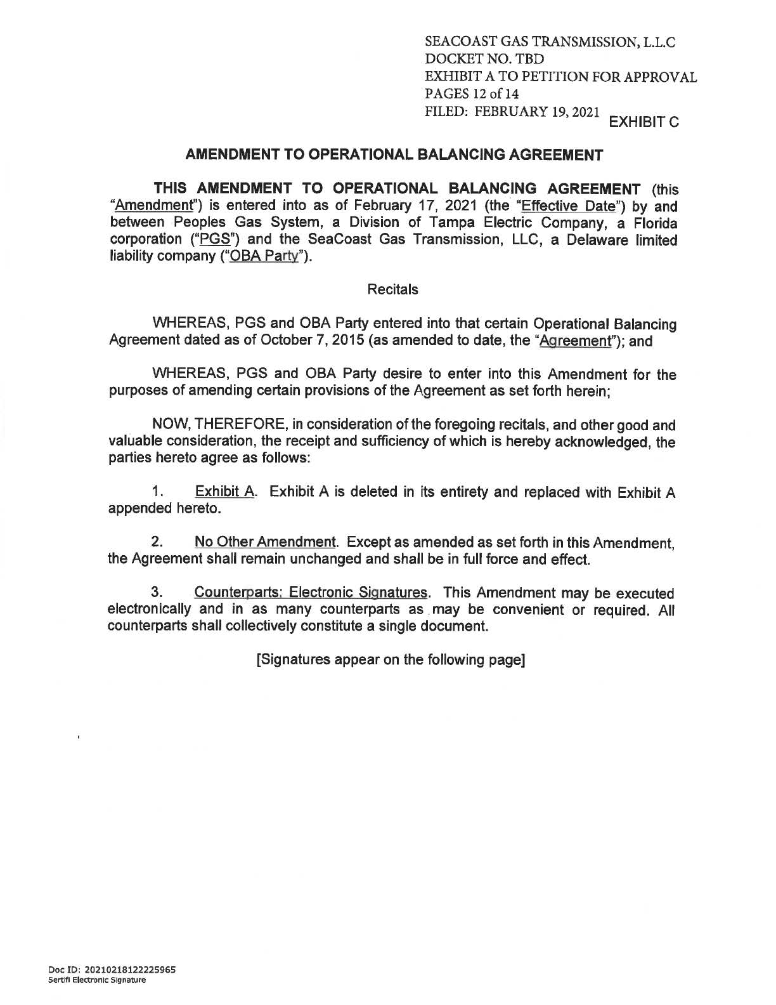

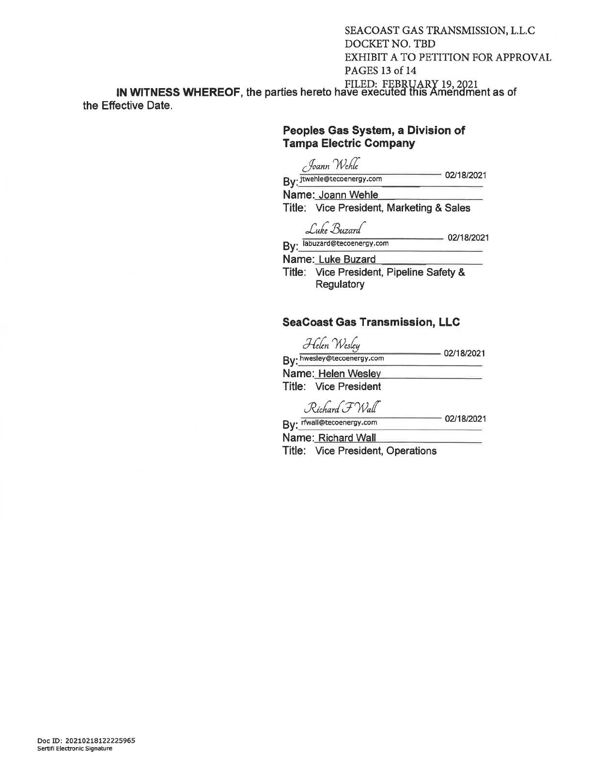

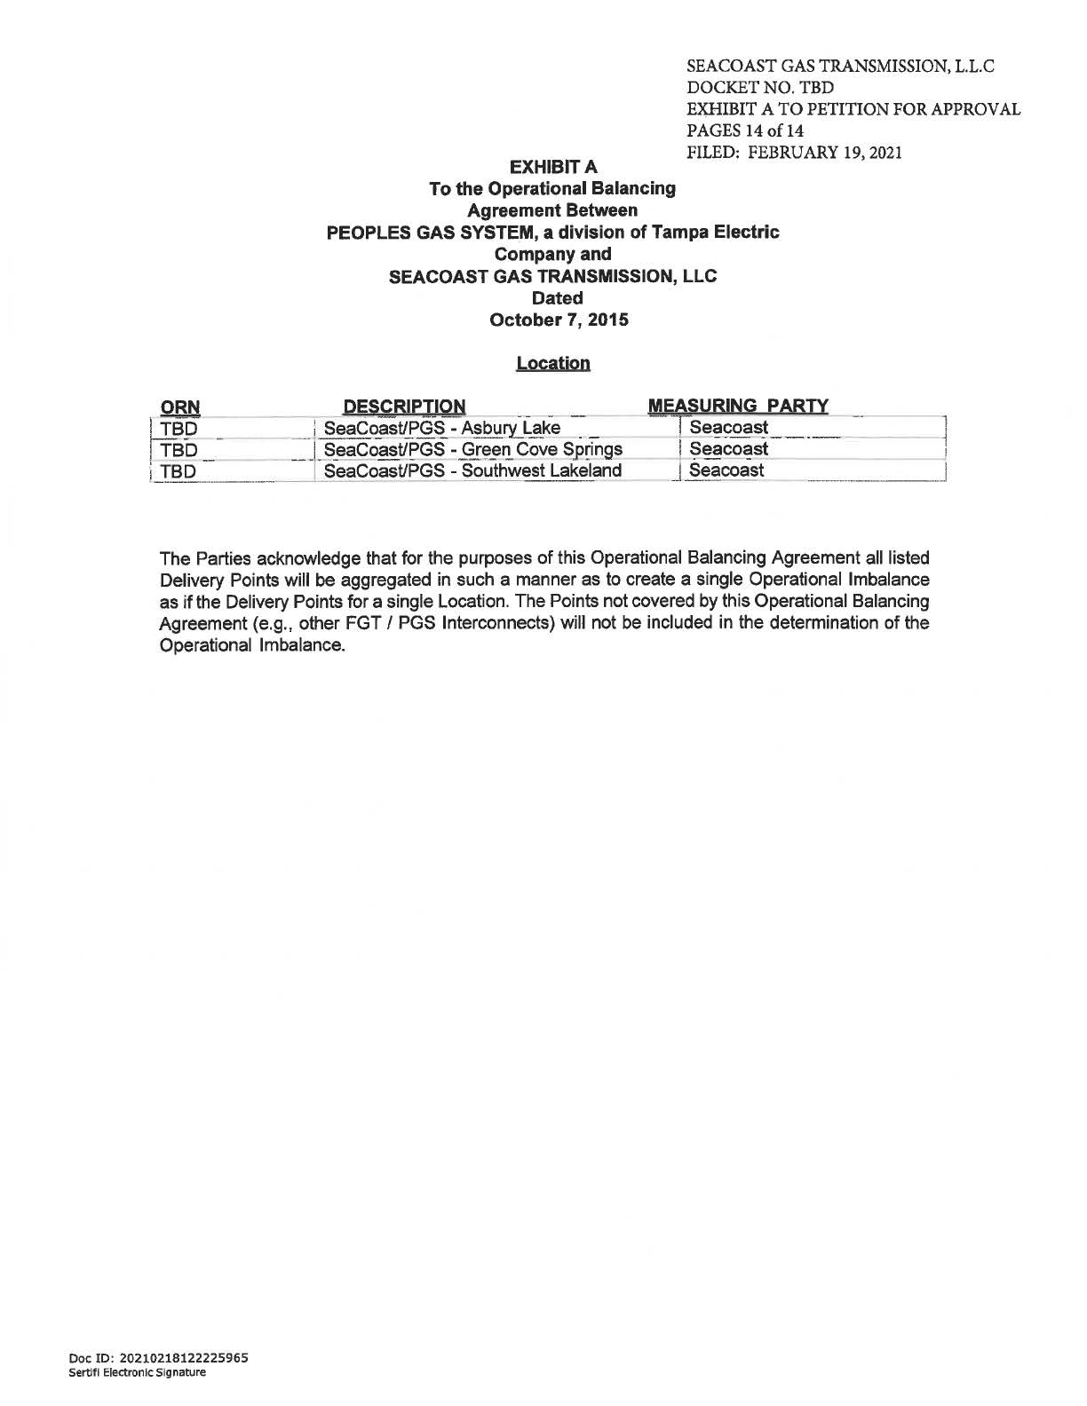

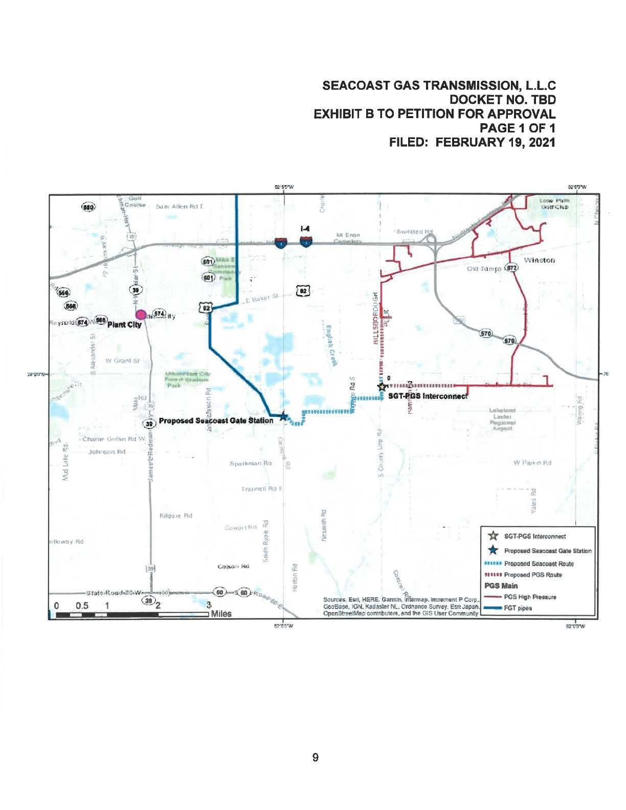

Order No. PSC-08-0747-TRF-GP, issued November 12, 2008, in Docket No. 20080561-GP, In re: Petition for approval of natural gas transmission pipeline tariff by SeaCoast Gas Transmission, LLC.
Peoples Gas System’s response to Commission staff’s first data request, question 5. Document No. 03189-2021.
Peoples Gas System’s response to Staff’s first data request, question 1. Document No. 03189-2021.
Peoples Gas System’s response to Staff’s first data request, question 4. Document No. 03189-2021.
The swing charge mechanism is designed to recover the estimated costs incurred by the Company to provide swing service (i.e., manage the level of gas and interstate pipeline capacity nominated for delivery to Peoples' system) to transportation customers. The revenue derived from the charge is credited to the Purchased Gas Adjustment clause.
Order No. PSC-15-0574-PAA-GU, issued December 18, 2015, in Docket No. 20150221-GU, In re: Petition for approval of firm service agreement with Peoples Gas System for an extension in Clay County, by SeaCoast Gas Transmission, LLC.
Order No. PSC-2019-0545-PAA-GU, issued December 20, 2019, in Docket No. 20190145-GU, In re: Joint petition for approval of restructures Nassau County agreements to reflect Callahan expansion, by Peoples Gas System, Florida Public Utilities Company, SeaCoast Gas Transmission, and Peninsula Pipeline Company, Inc.

