State of Florida |  | Public Service Commission  Capital Circle Office Center ● 2540 Shumard Oak Boulevard  Tallahassee, Florida 32399-0850  -M-E-M-O-R-A-N-D-U-M-
DATE: | June 3, 2021
TO: | Office of Commission Clerk (Teitzman)
FROM: | Division of Engineering (Phillips, Ellis)  Office of the General Counsel (Weisenfeld)
RE: | Docket No. 20210068-EQ – Petition for approval of standard offer contract and request for temporary waiver of rule on annual filing, by Florida Public Utilities Company.
AGENDA: | 06/15/21 – Regular Agenda – Proposed Agency Action – Interested Persons May Participate
COMMISSIONERS ASSIGNED: |  |  | All Commissioners
PREHEARING OFFICER: |  |  | Administrative
CRITICAL DATES: |  |  | 06/30/2021 (The Commission must vote to grant or deny the rule waiver by this date)
SPECIAL INSTRUCTIONS: |  |  | None

Case Background
Section 366.91(3), Florida Statutes (F.S.), requires each investor-owned utility (IOU) to continuously offer to purchase capacity and energy from renewable generating facilities and small qualifying facilities. Florida Public Service Commission (Commission) Rules 25-17.200 through 25-17.310, Florida Administrative Code (F.A.C.), implement the statute and require each IOU to file with the Commission, by April 1 of each year, a revised standard offer contract based on the next avoidable fossil fueled generating unit of each technology type identified in the utility’s current Ten-Year Site Plan (TYSP). On April l, 2021, Florida Public Utilities Company (FPUC) filed a petition for approval of its standard offer contract and request for temporary waiver of Rule 25-17.250(1), F.A.C. If granted, the rule waiver would allow FPUC to forgo filing a standard offer contract until such a time as the Company enters into a new contract or contracts for power supply to its electric divisions.
FPUC’s standard offer contract filing does not reflect any changes or revisions from the filing approved by Order No. PSC-2020-0166-PAA-EQ. The Commission has jurisdiction over this standard offer contract pursuant to Sections 120.542, 366.04 through 366.055, and 366.91, F.S.

Discussion of Issues

Issue 1:
Should the Commission grant FPUC’s petition for a temporary waiver of Rule 25-17.250(1), F.A.C.?

Recommendation:
Yes. Staff recommends that FPUC’s petition for a temporary waiver of Rule 25-17.250(1) should be granted. (Weisenfeld, Phillips).

Staff Analysis:

Rule 25-17.250(1), F.A.C., requires each electric investor-owned utility (IOU) to file with the Commission by April 1 of each year a standard offer contract for the purchase of firm capacity and energy from renewable generating facilities and small qualifying facilities with a design capacity of 100 kW or less. The standard offer contracts reflect each IOU’s next avoided unit shown in its most recent TYSP. The rule further requires that “[e]ach investor-owned utility with no planned generating unit identified in its TYSP shall submit a standard offer based on avoiding or deferring a planned purchase.” As FPUC is a non-generating electric IOU, it does not file a TYSP and has no avoidable generating units.

Rule 25-17.250(2)(a), F.A.C., provides that in order to ensure that each IOU continuously offers a contract to producers of renewable energy, each standard offer contract shall remain open until: 1) a request for proposal is issued for the utility’s planned generating unit, or 2) the IOU files a petition for a need determination or commences construction for generating units, or 3) the generating unit upon which the standard offer contract was based is no longer part of the IOU’s generation plan, as evidenced by a petition to that effect filed with the Commission or by the utility’s most recent TYSP.
In its petition, FPUC asks that it be granted a temporary waiver from the requirement to file its standard offer contract annually on April 1 of each year until such time as the Company has entered into a new contract or contracts for power supply to its electric divisions. FPUC is a party to a long-term purchase power contract with Florida Power & Light and Gulf Power Company that extends to 2026. FPUC states that granting a waiver from the filing requirement would enable the Company to avoid for up to five years the cost and use of resources necessary to accomplish the yearly filing, since the Company’s standard offer contract will not change until its purchased power agreements change. FPUC provides that in the event that the Company’s purchased power agreements change sooner and in a manner that it becomes necessary to amend the Company’s standard offer contract, that the Company would make a revised standard offer filing as soon as necessary to reflect such changes to its purchased power agreement.

Pursuant to 120.542(6), F.S., FPUC’s request for a rule waiver was submitted to Florida Administrative Weekly for publication. Interested parties had until May 13, 2021, to submit written comments. No public comment was received.

Section 120.542, F.S., authorizes the Commission to grant variances or waivers to the requirements of its rules where the person subject to the rules demonstrates that the purpose of the underlying statute has been or will be achieved by other means, and when application of a rule would create substantial hardship or would violate principles of fairness. "Substantial hardship" as defined in this Section means “a demonstrated economic, technological, legal, or other type of hardship to the person requesting the variance or waiver.”
The underlying statutory provision pertaining to Rule 25-17.250(1), F.A.C., is Section 366.91, F.S. Section 366.91(1), F.S., states:

The Legislature finds that it is in the public interest to promote the development of renewable energy resources in this State. Renewable energy resources have the potential to help diversify fuel types to meet Florida’s growing dependency on natural gas for electric production, minimize the volatility of fuel costs, encourage investment within the State, improve environmental conditions, and make Florida a leader in new and innovative technologies.

Section 366.91(3), F.S., enumerates requirements to promote the development of renewable energy resources. In summary:

a) By January 1, 2006, each investor-owned electric utility (IOU) and municipal utility subject to the Florida Energy Efficiency and Conservation Act (FEECA) of 1980 must continuously offer to purchase capacity and energy from specific types of renewable resources;
b) The contract shall be based on the utility’s full avoided costs, as defined in Section 366.051, Florida Statutes; and,
c) Each contract must provide a term of at least ten years.

Staff recommends that FPUC has demonstrated it will suffer a substantial hardship if the provisions of Rule 25-17.250(1), F.A.C., are strictly applied, and therefore, FPUC has provided a basis for a waiver of the rule. Granting FPUC a waiver of Rule 25-17.250(1), F.A.C., would help the Company avoid unnecessary costs and allocation of resources to produce a filing that is otherwise redundant of the prior year’s filing and is already in compliance with the pertinent rules and statutes. A waiver of Rule 25-17.250(1), F.A.C., allows the Commission to continue promoting the development of renewable energy resources in Florida because it allows FPUC to offer an economically feasible standard offer contract for renewable energy.

Issue 2:
Should the Commission approve the proposed standard offer contract filed by FPUC?

Recommendation:
Yes. The provisions of FPUC’s standard offer contract conform to all requirements of Rules 25-17.200 through 25-17.310, F.A.C. The proposed standard offer contract provides flexibility in the arrangements for payments so that a developer of renewable generation may select the payment stream best suited to its financial needs. (Phillips)

Staff Analysis:
Section 366.91(3), F.S., and Rule 25-17.250, F.A.C., require that FPUC, as an IOU, continuously make available a standard offer contract for the purchase of firm capacity and energy from renewable generating facilities (RF) and small qualifying facilities (QF) with design capacities of 100 kilowatts (kW) or less. Pursuant to Rules 25-17.250(1) and (3), F.A.C., the standard offer contract must provide a term of at least 10 years, and the payment terms must be based on the utility’s next avoidable fossil-fueled generating unit identified in its most recent TYSP, or if no avoided unit is identified, its next avoidable planned purchase.
FPUC has determined that no changes are necessary from last year’s filing that was approved by Order No. PSC-2020-0166-PAA-EQ, issued in Docket No 20200109-EQ. Attachment A of this recommendation reflect identical provisions approved last year.

Conclusion
Staff recommends that FPUC’s proposed standard offer contract be approved as filed. The provisions of FPUC’s standard offer contract conform to all requirements of Rules 25-17.200 through 25-17.310, F.A.C., and should therefore be approved and made effective as of the date of the Commission’s vote.

Issue 3:
Should this docket be closed?

Recommendation:
Yes. If no person whose substantial interests are affected by the proposed agency action files a protest within 21 days of the issuance of the Proposed Agency Action Order, this docket should be closed upon the issuance of a consummating order. (Weisenfeld)

Staff Analysis:
At the conclusion of the protest period, if no protest is filed, this docket should be closed upon the issuance of a consummating order.

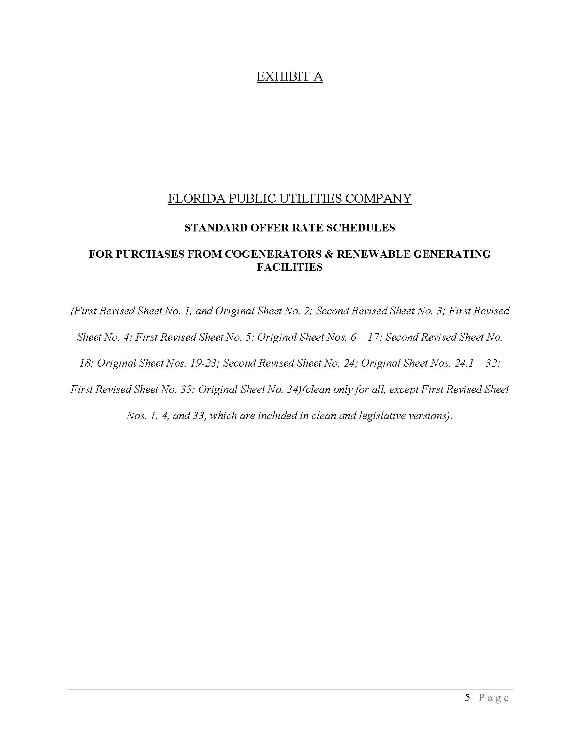

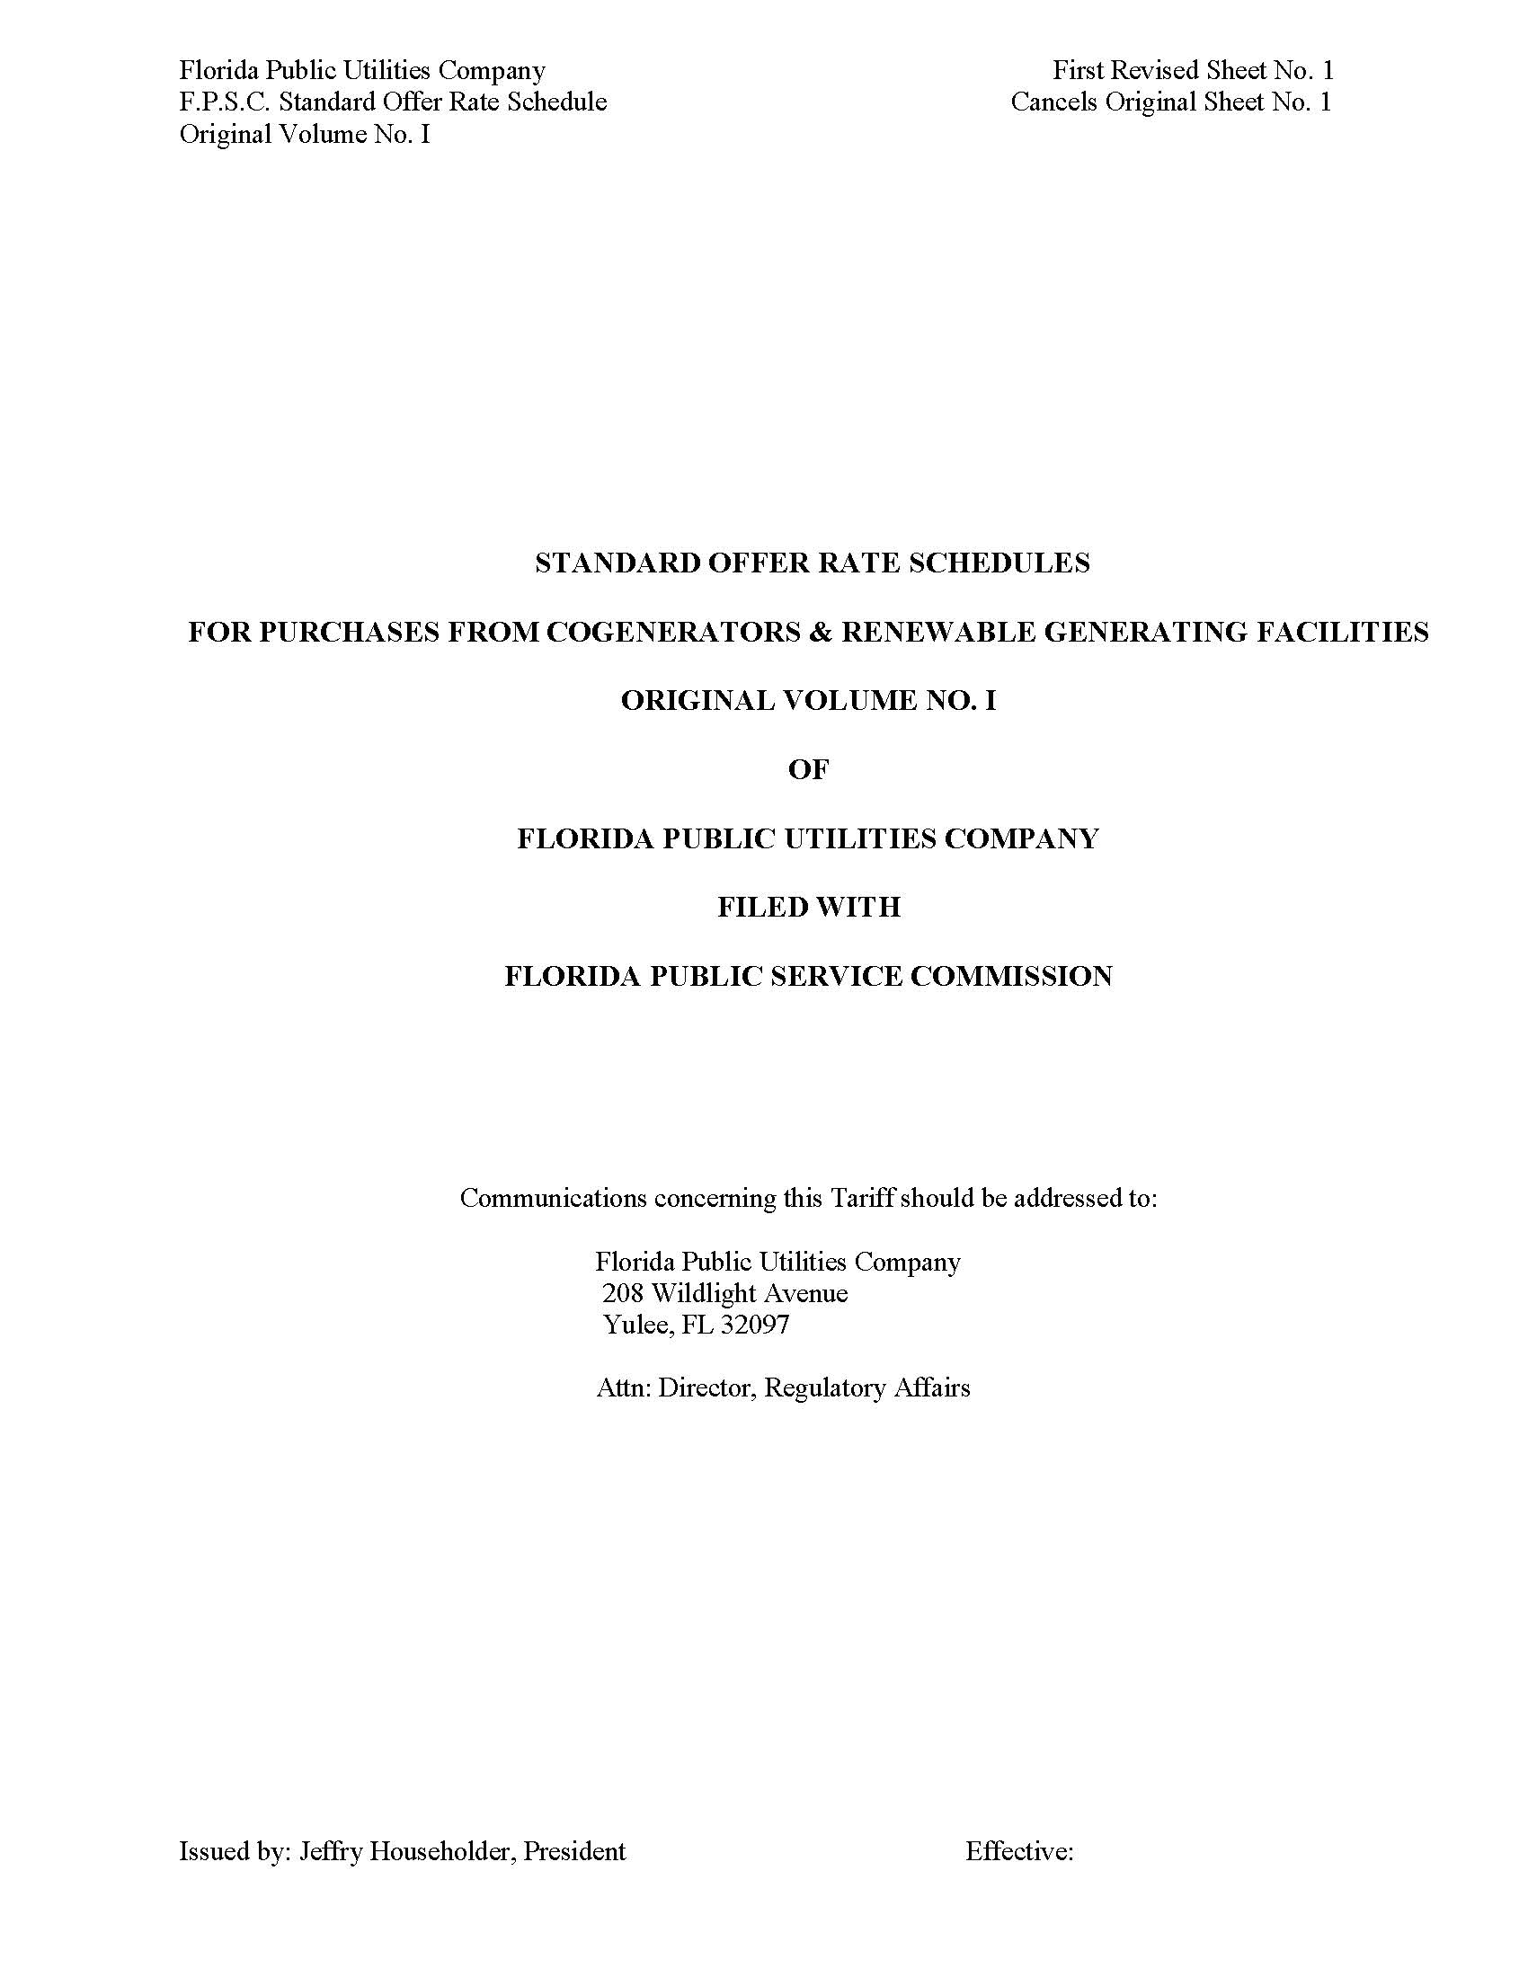

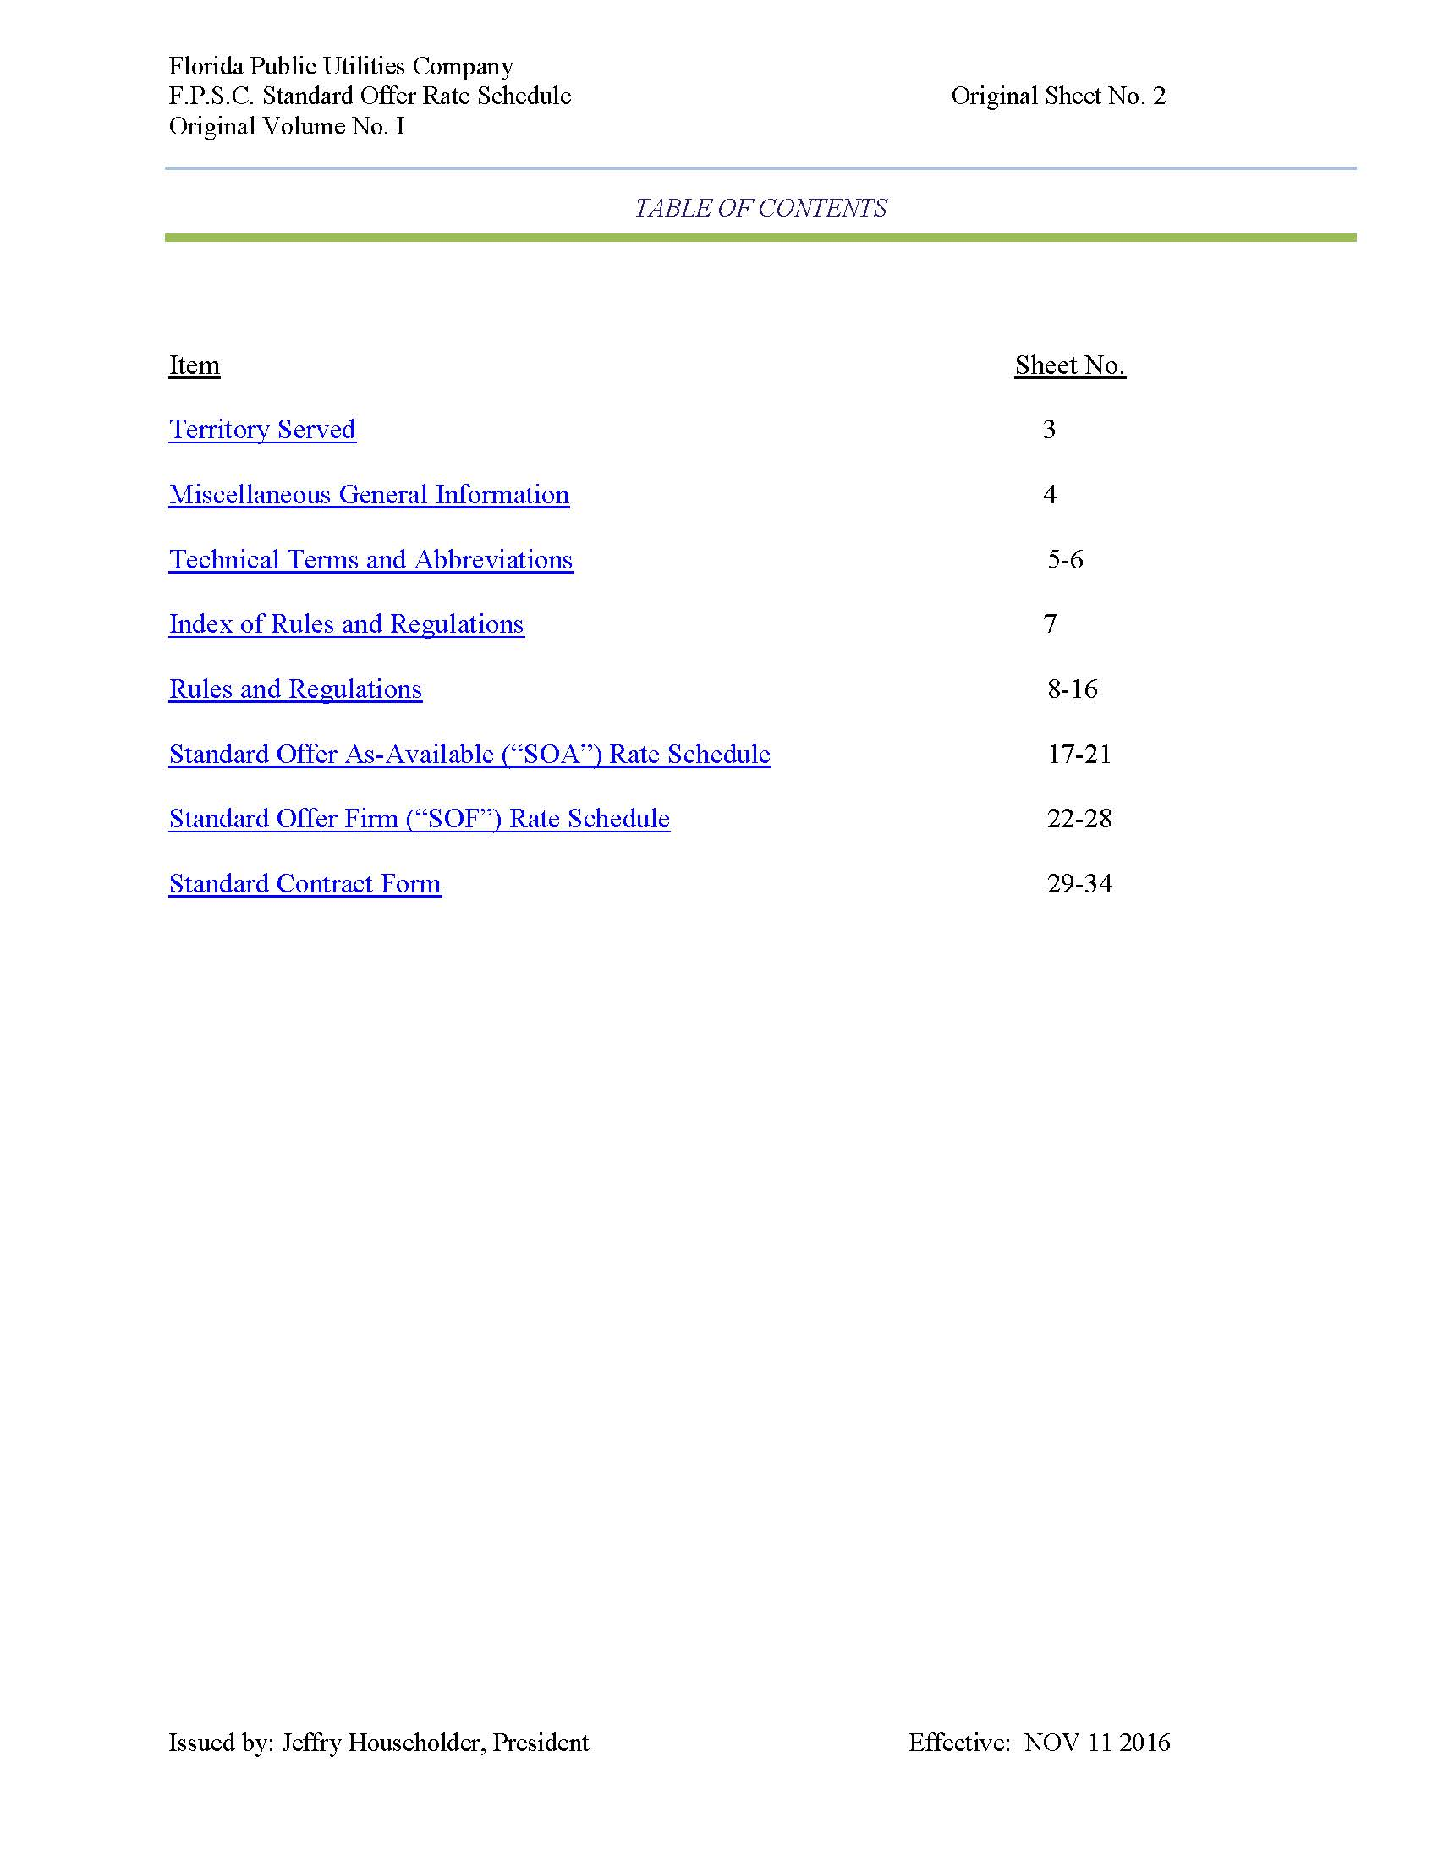

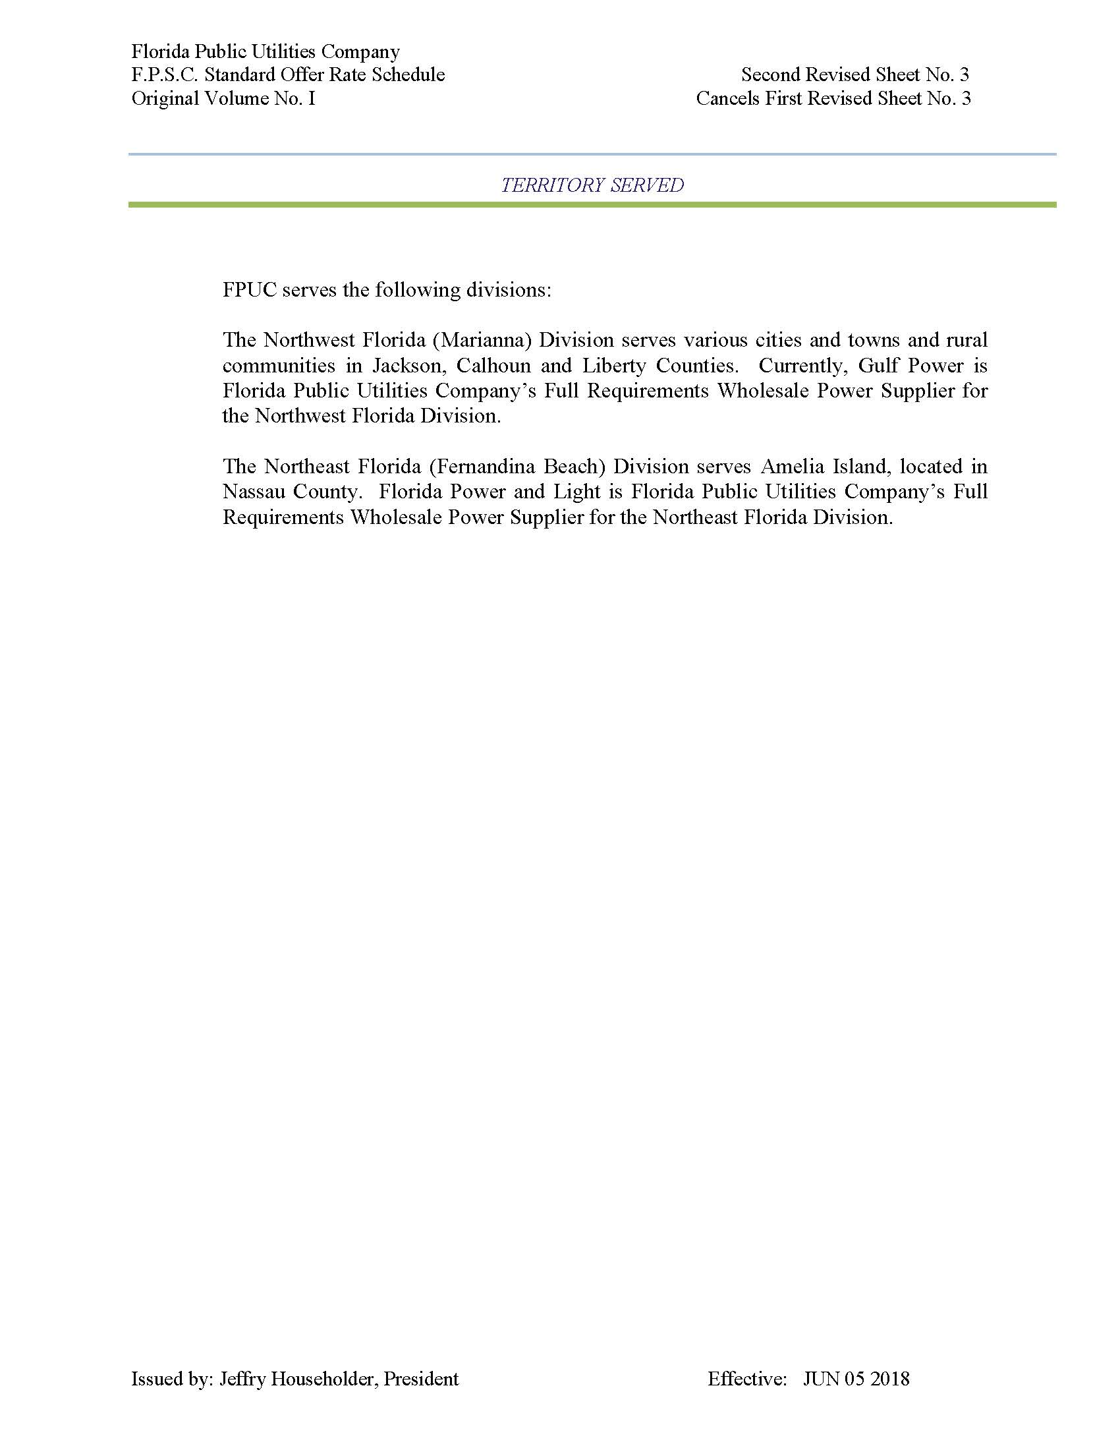

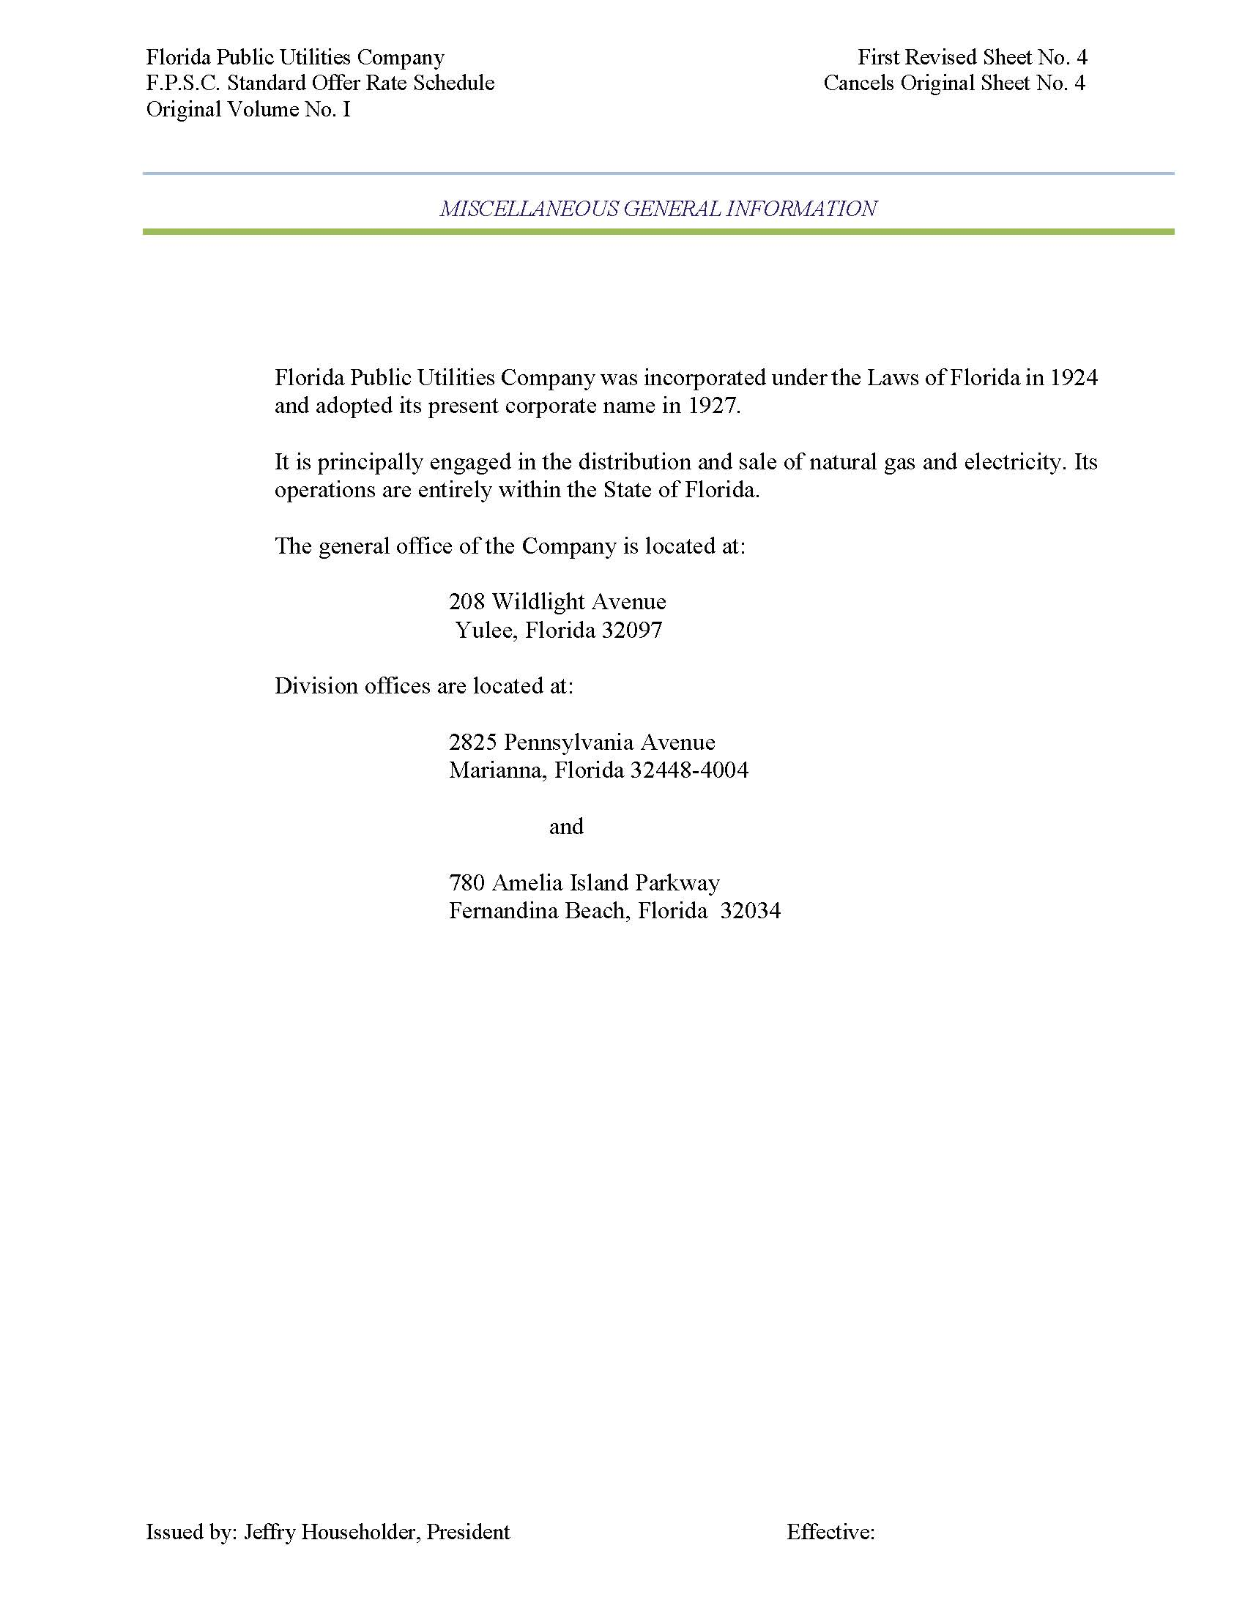

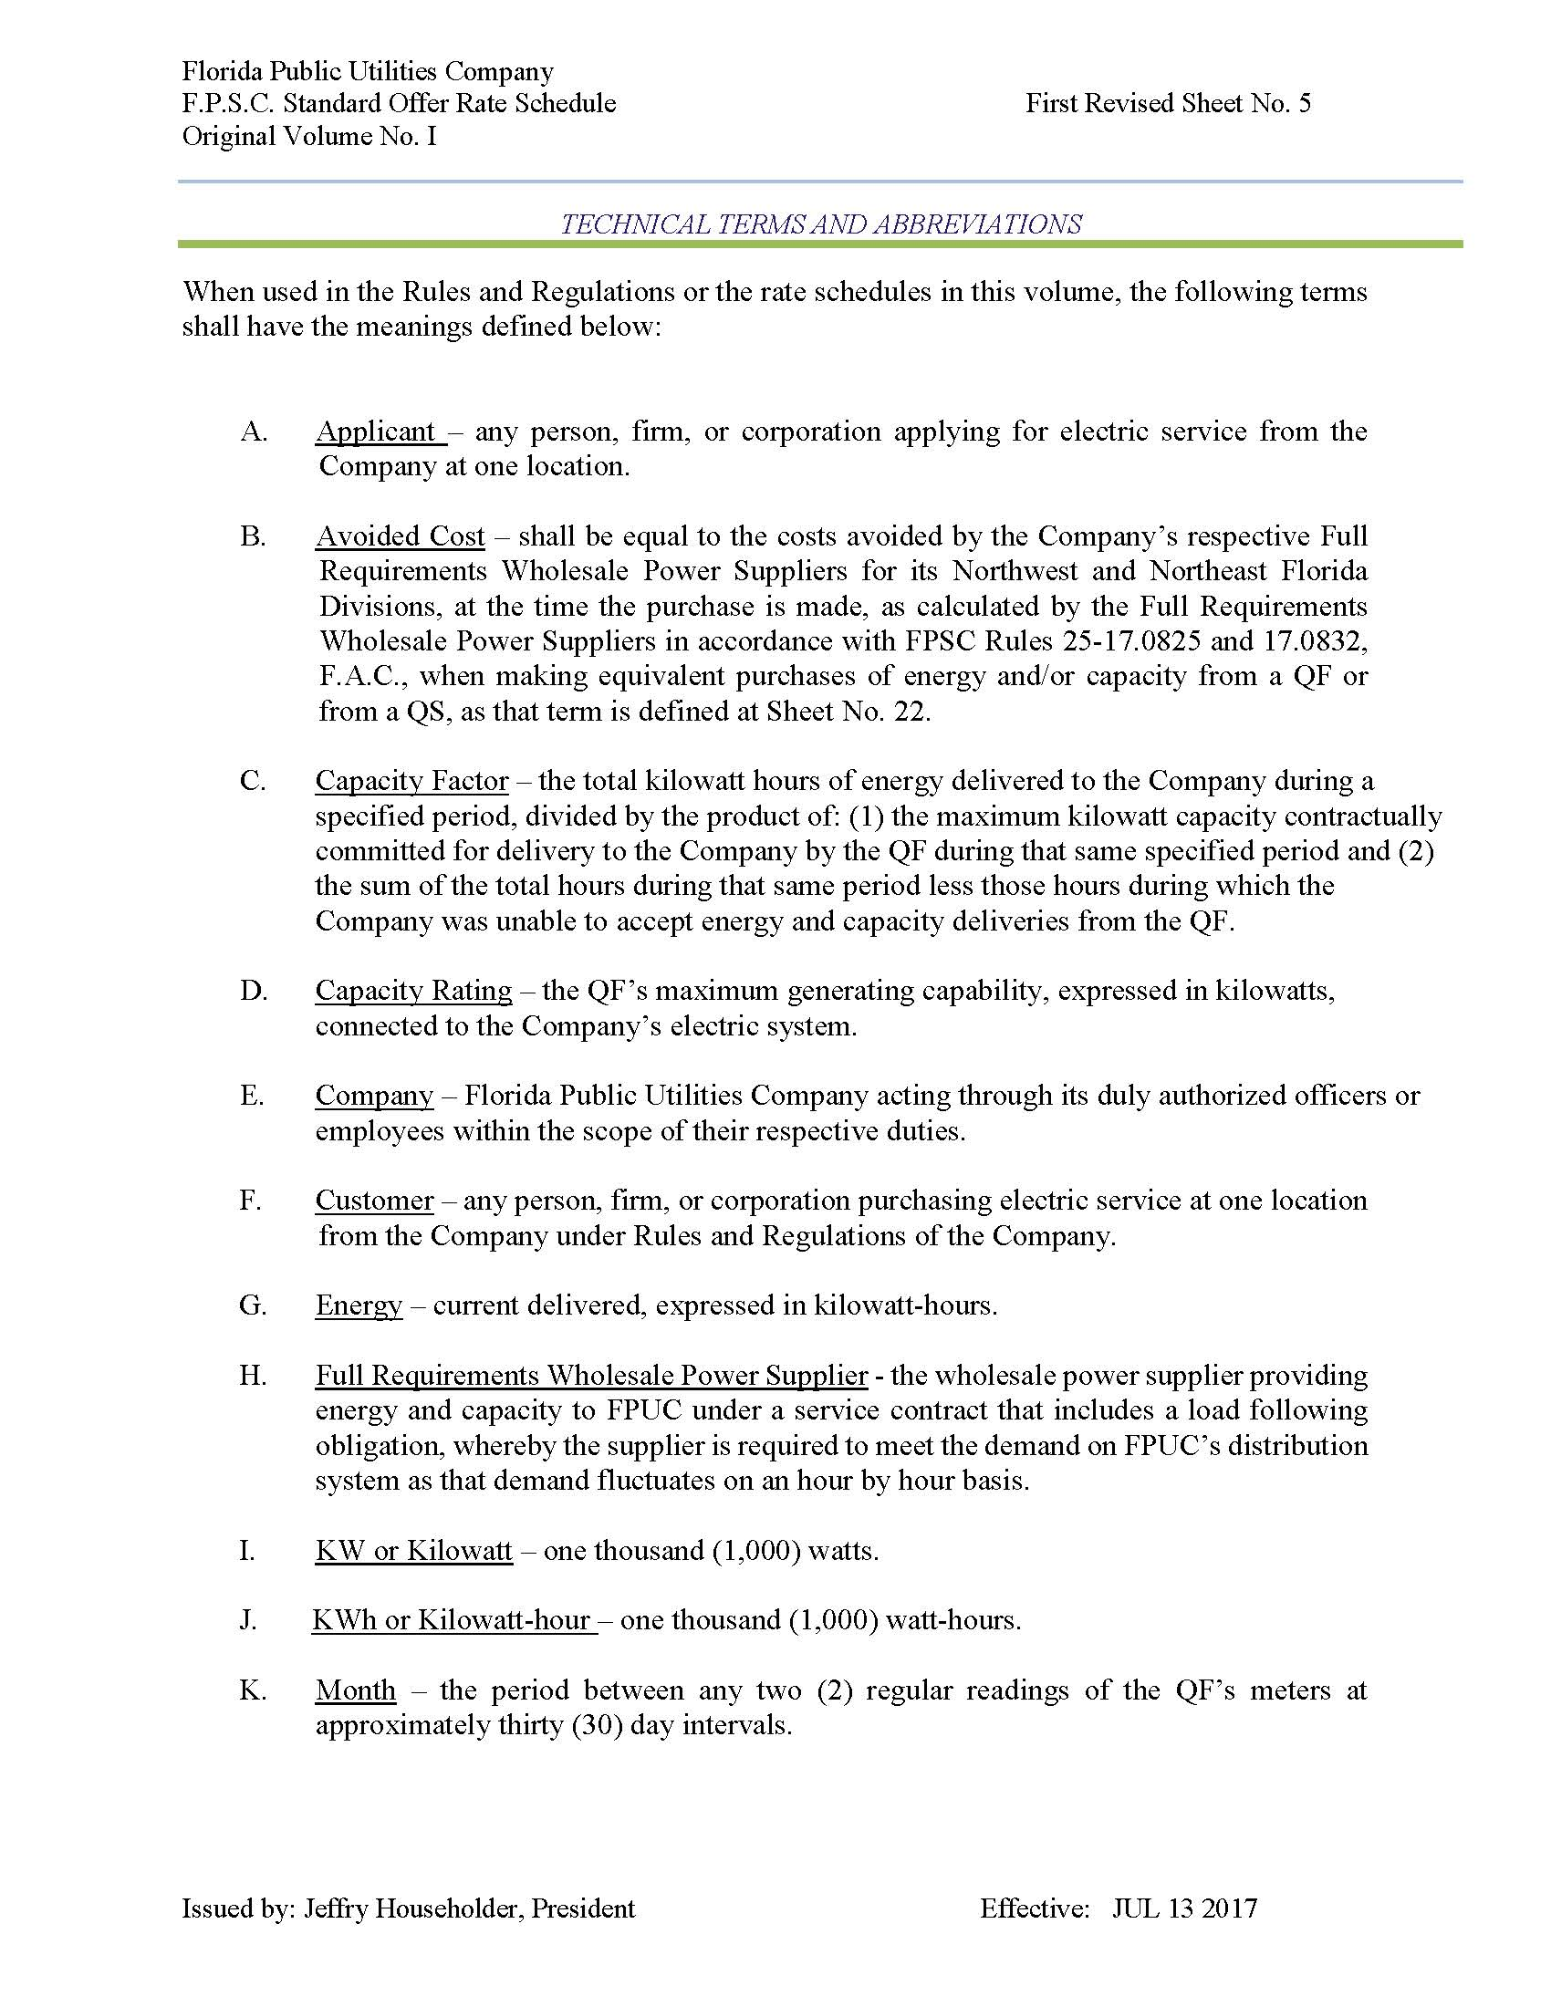

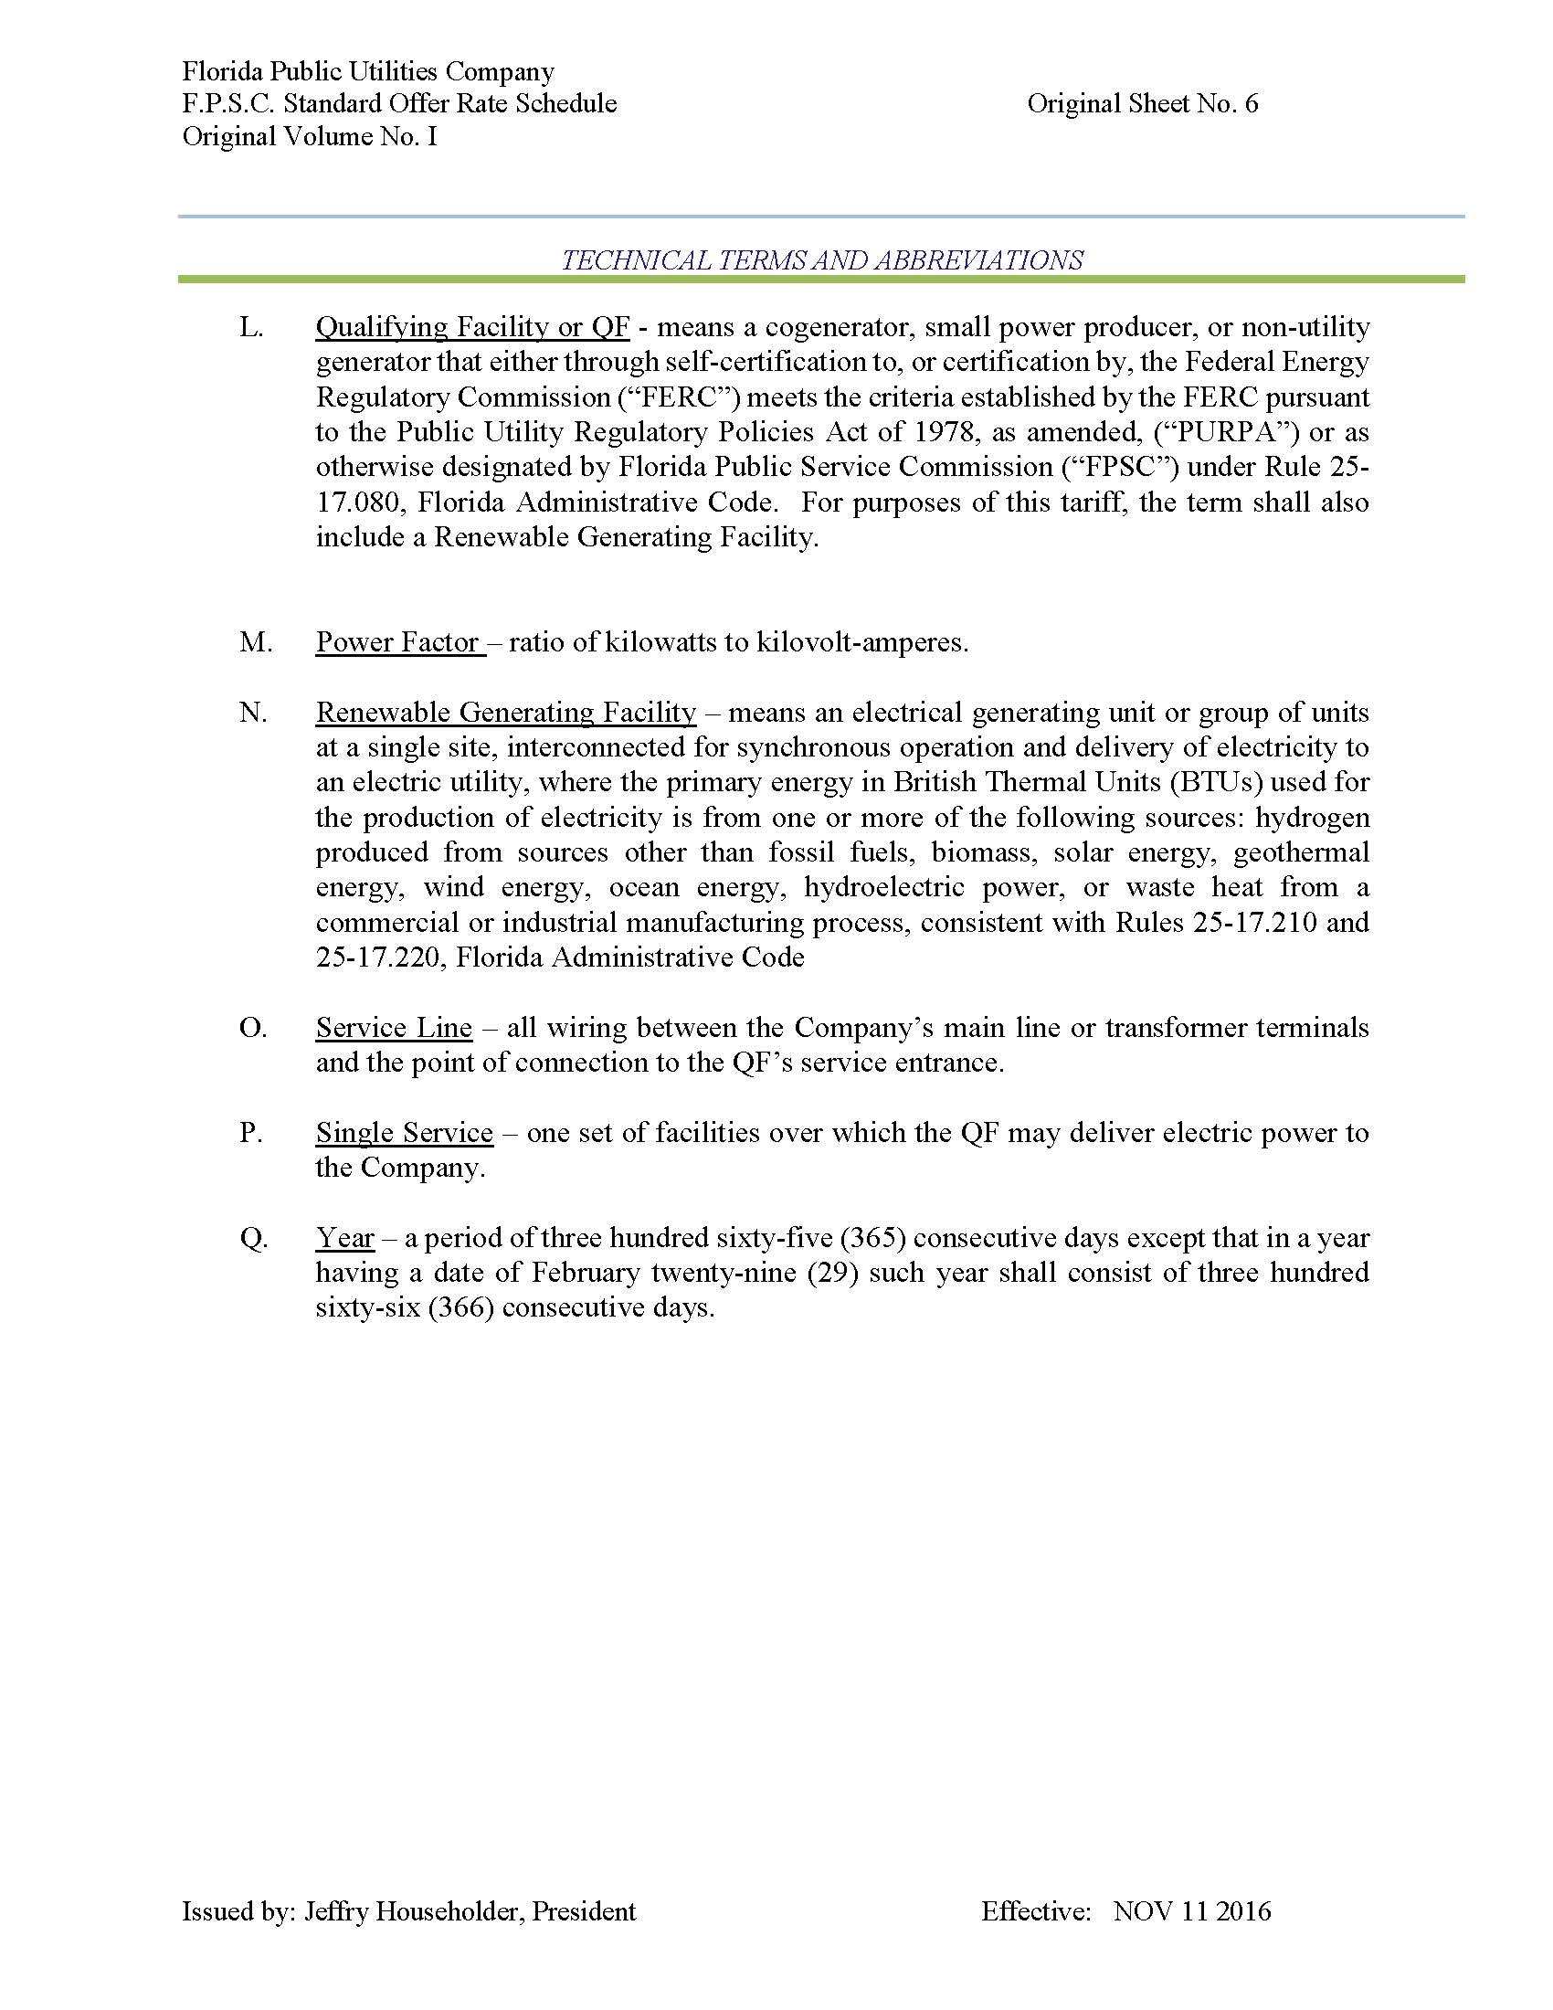

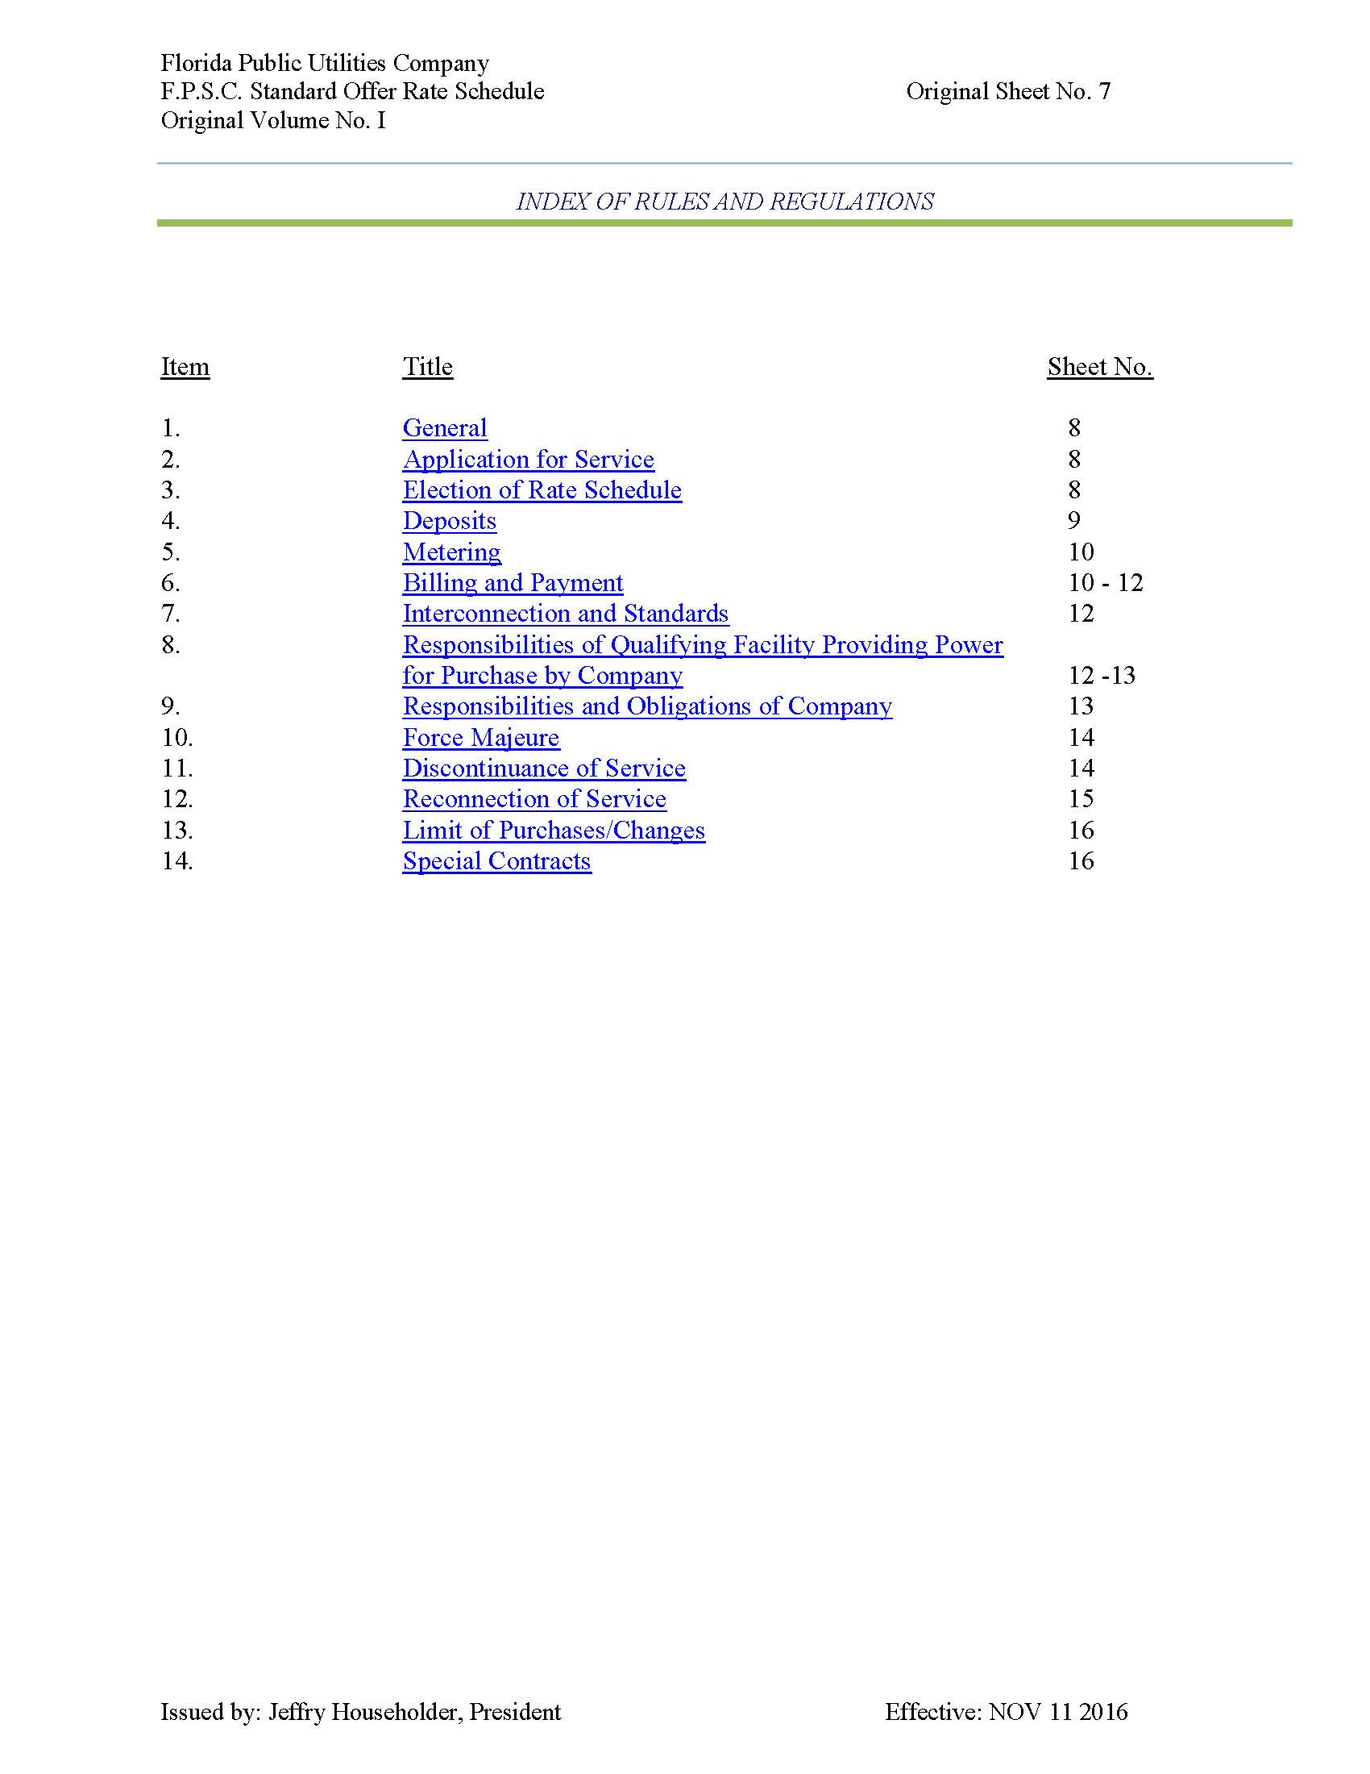

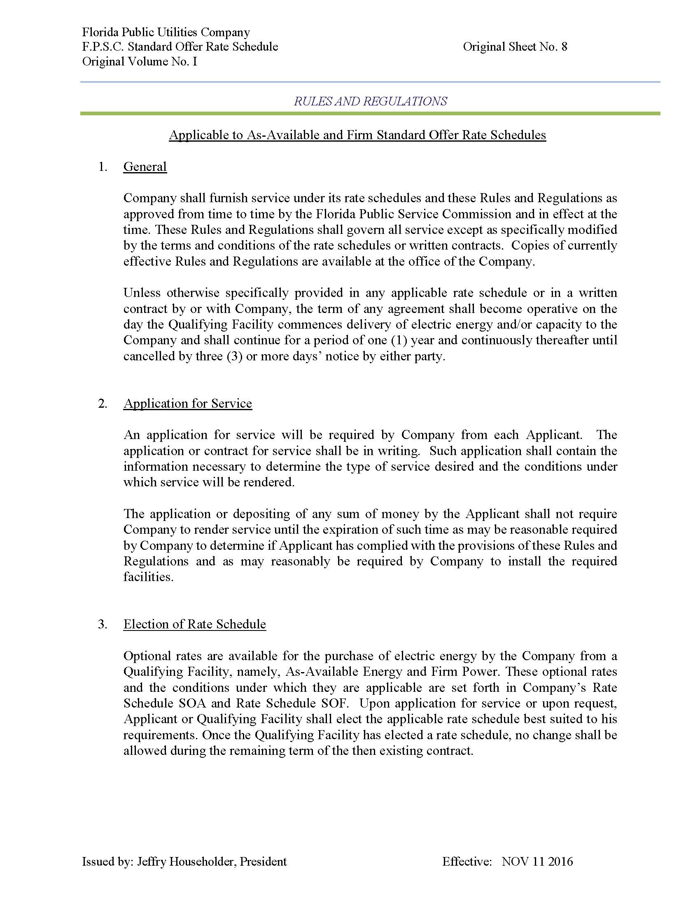

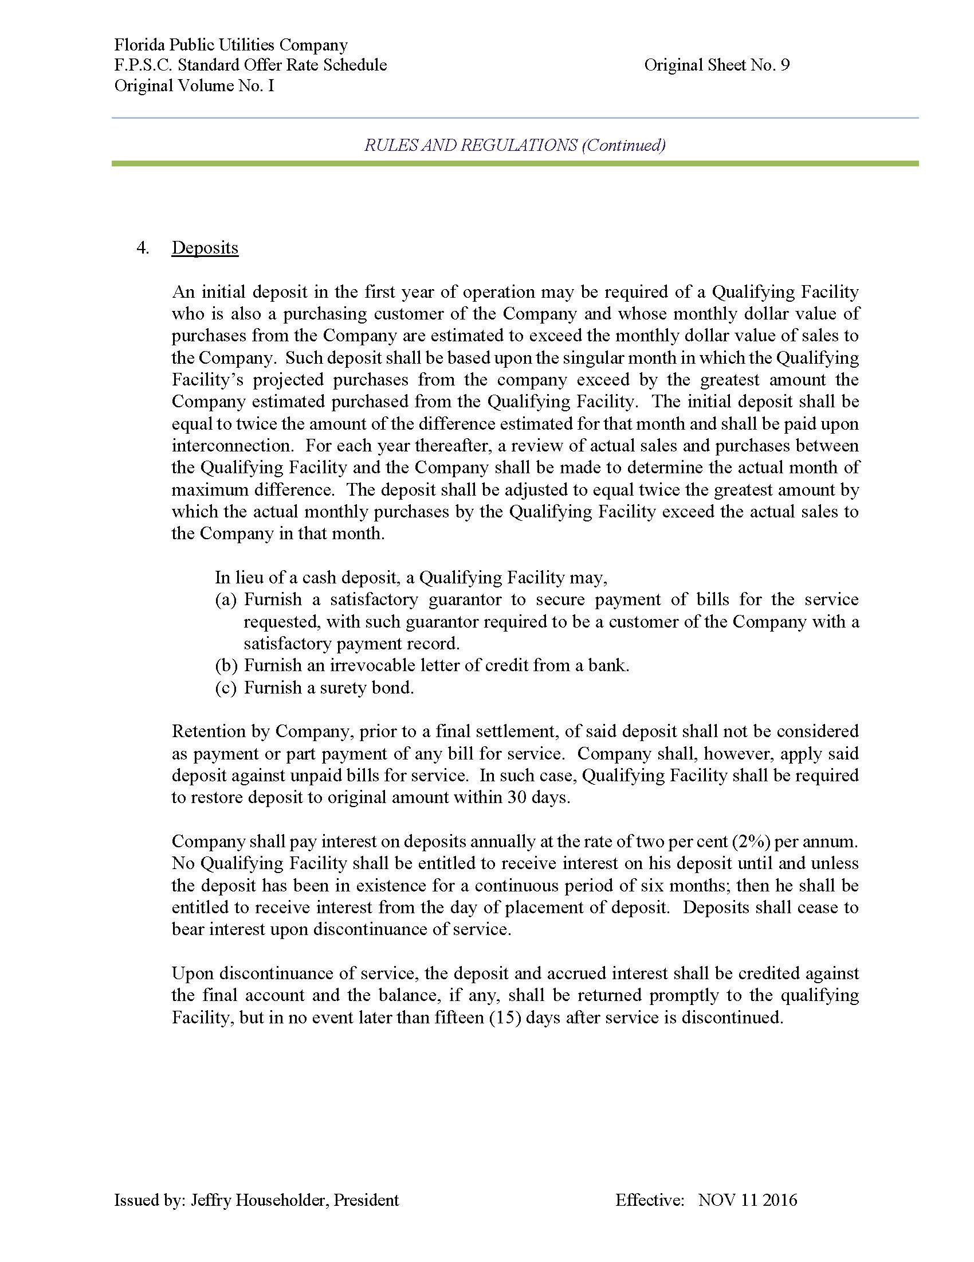

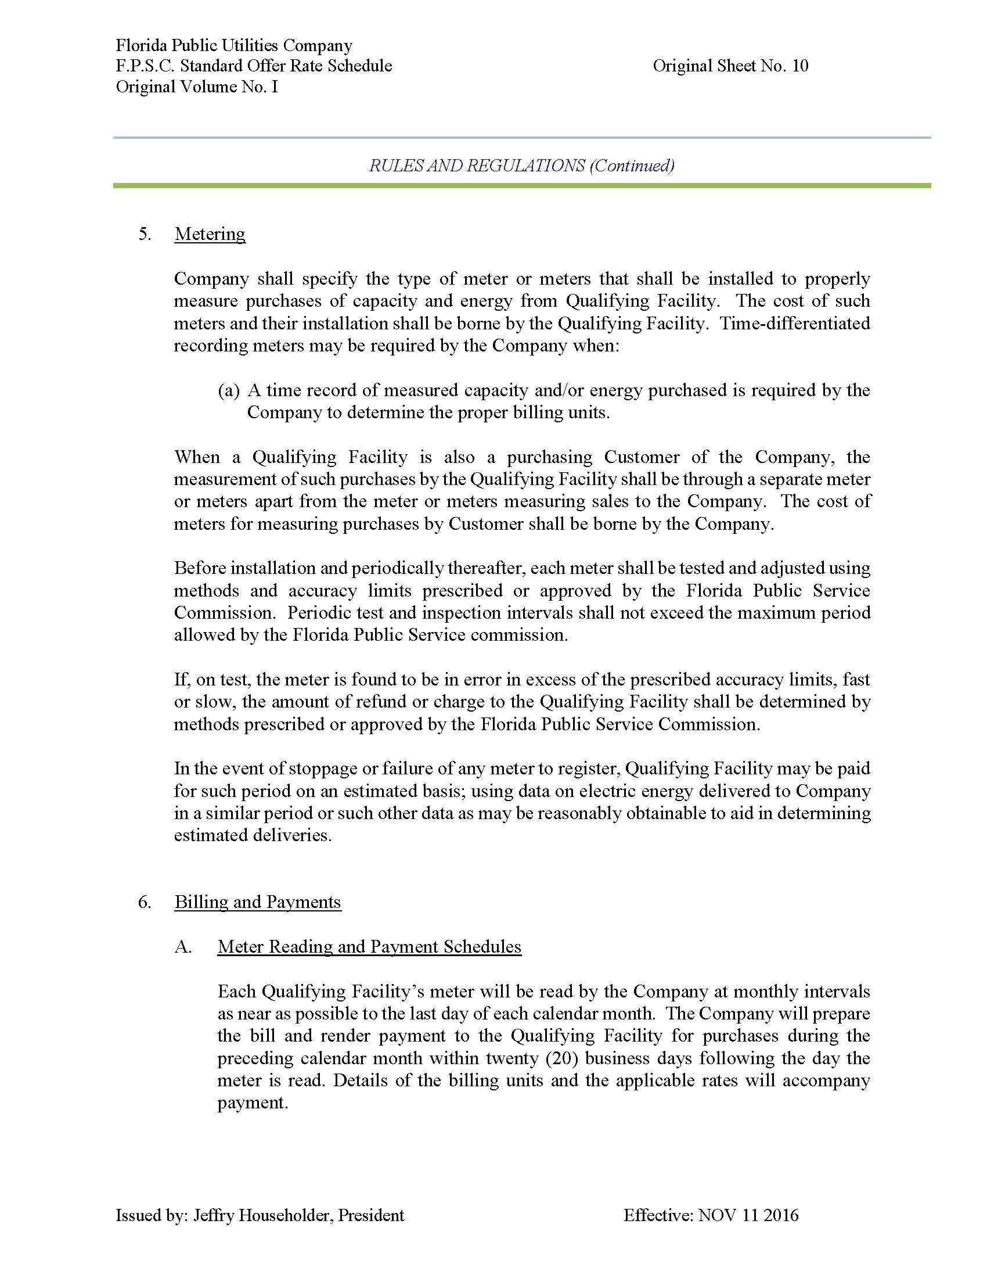

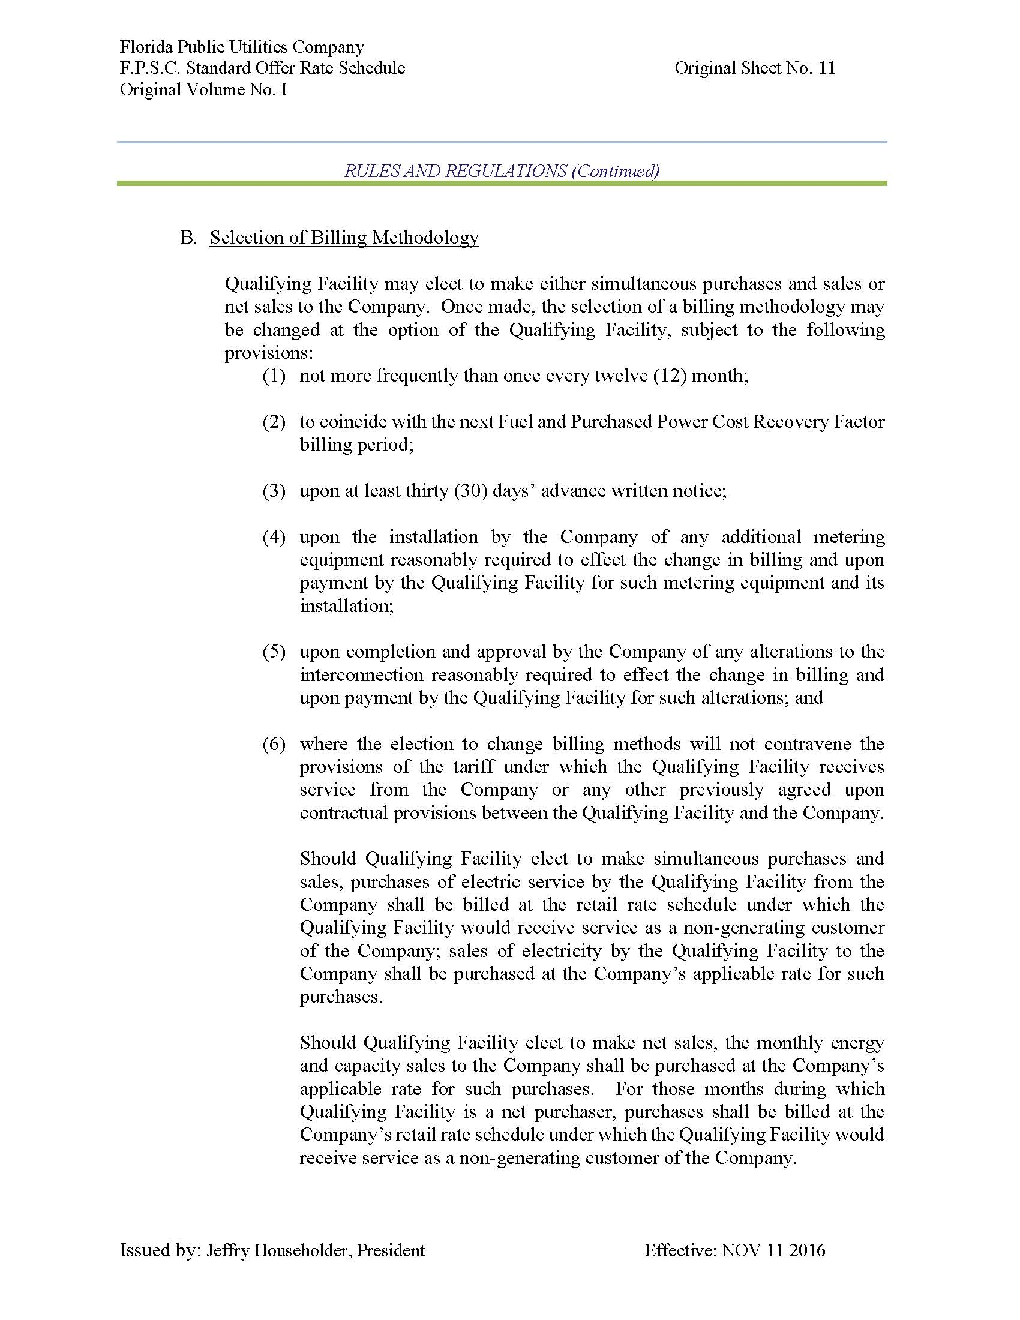

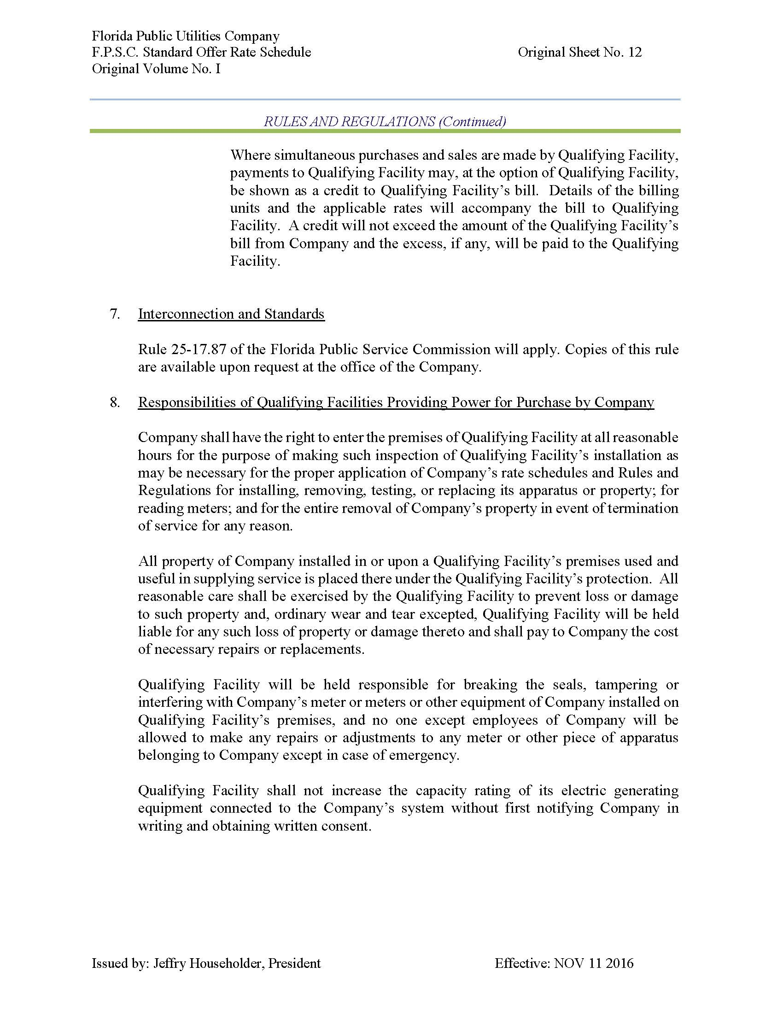

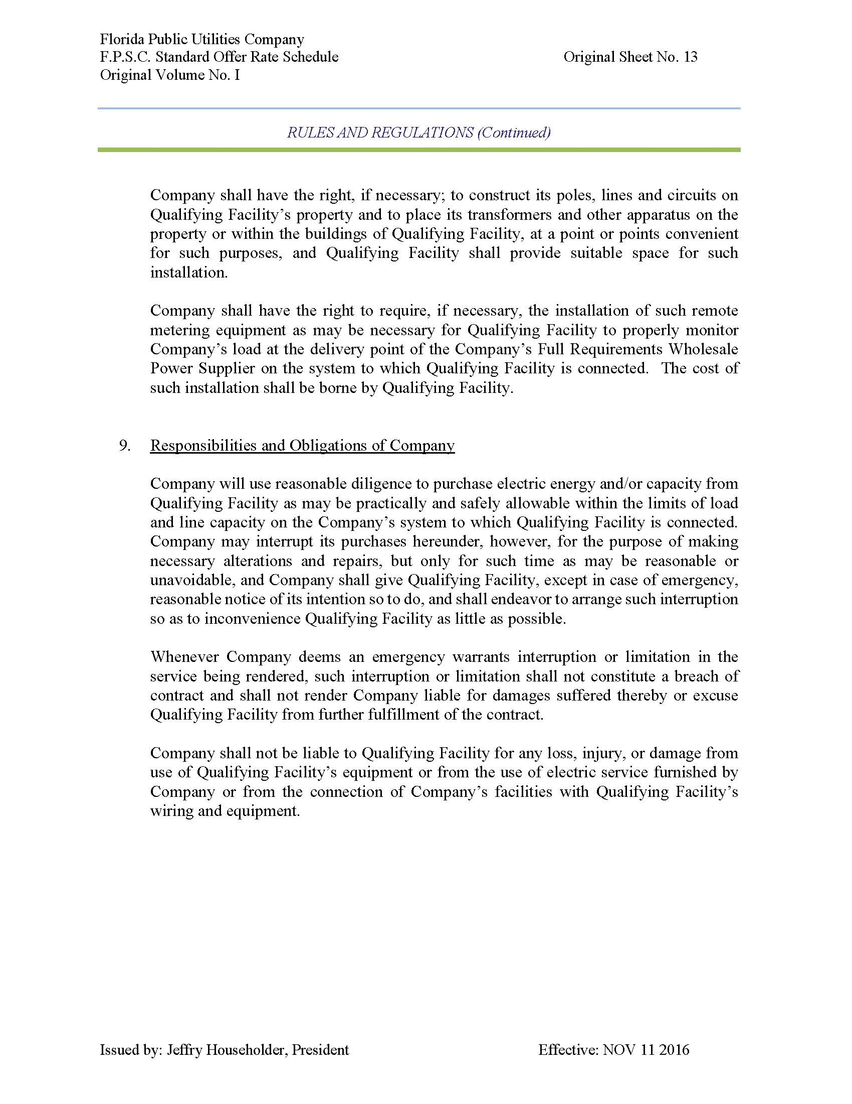

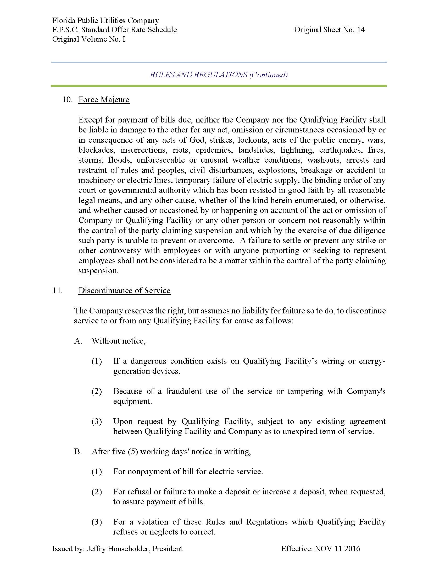

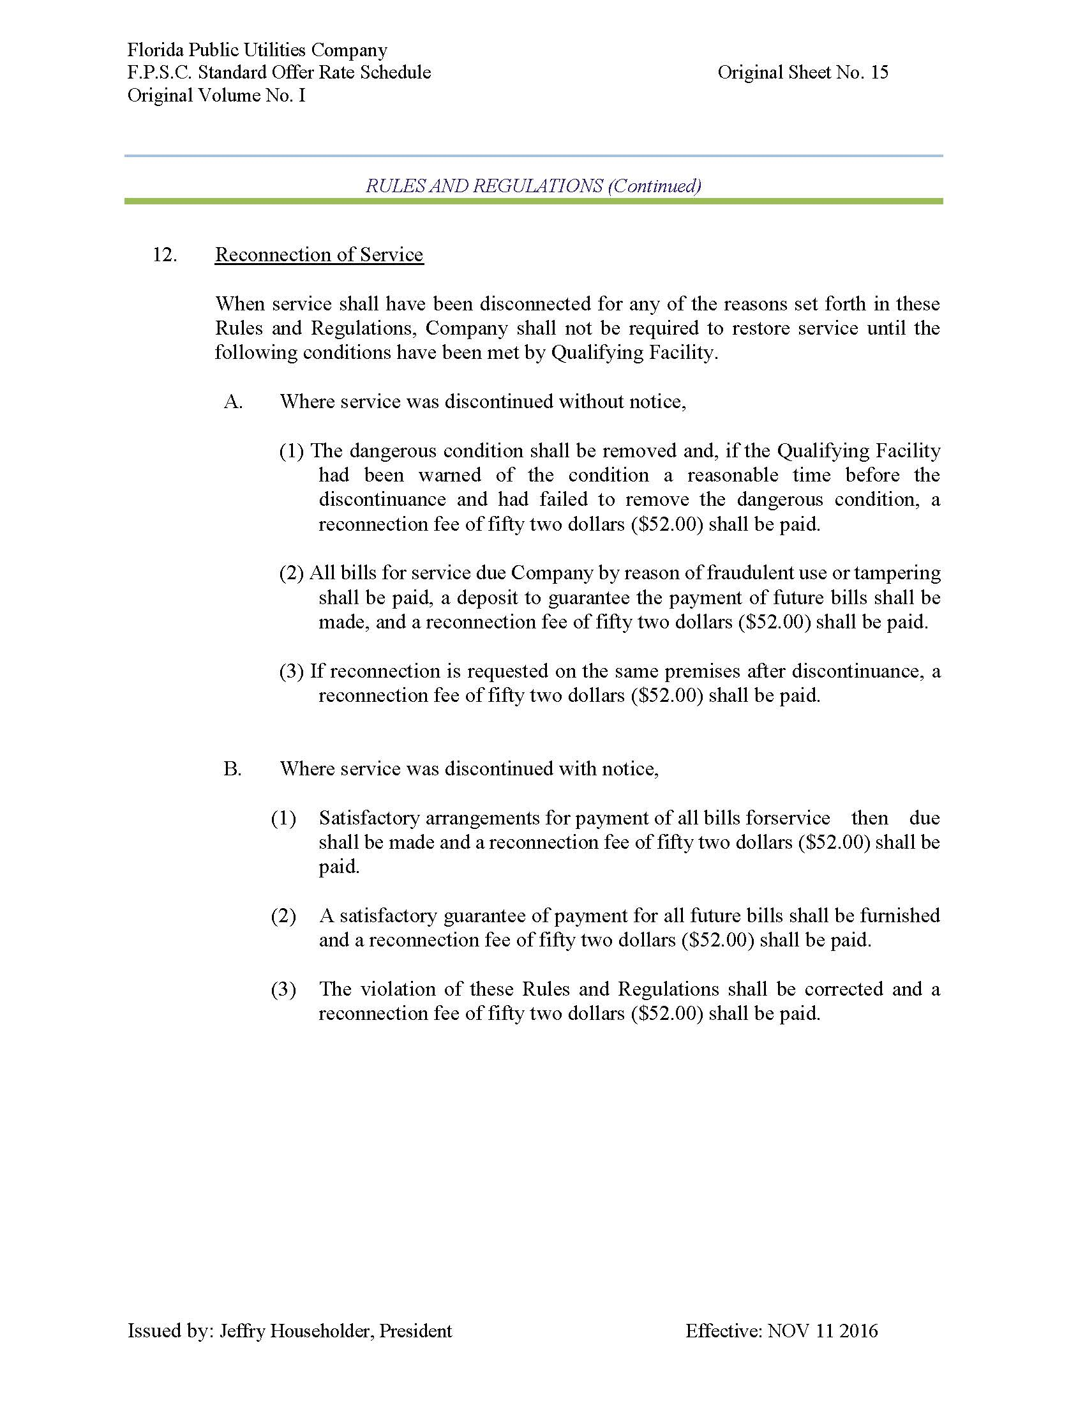

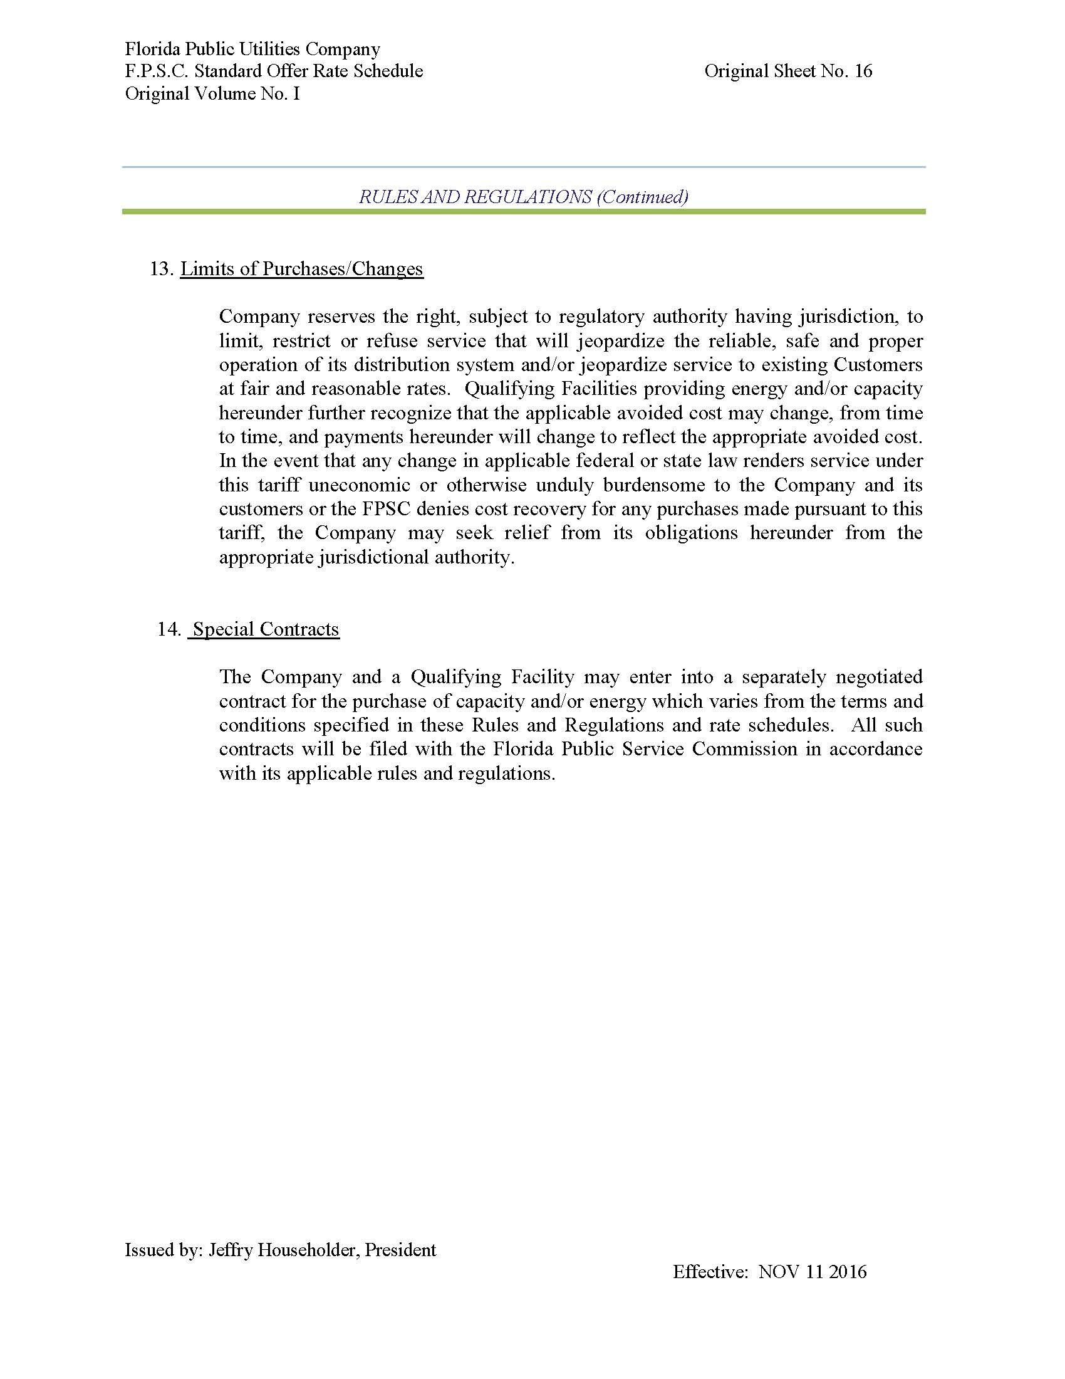

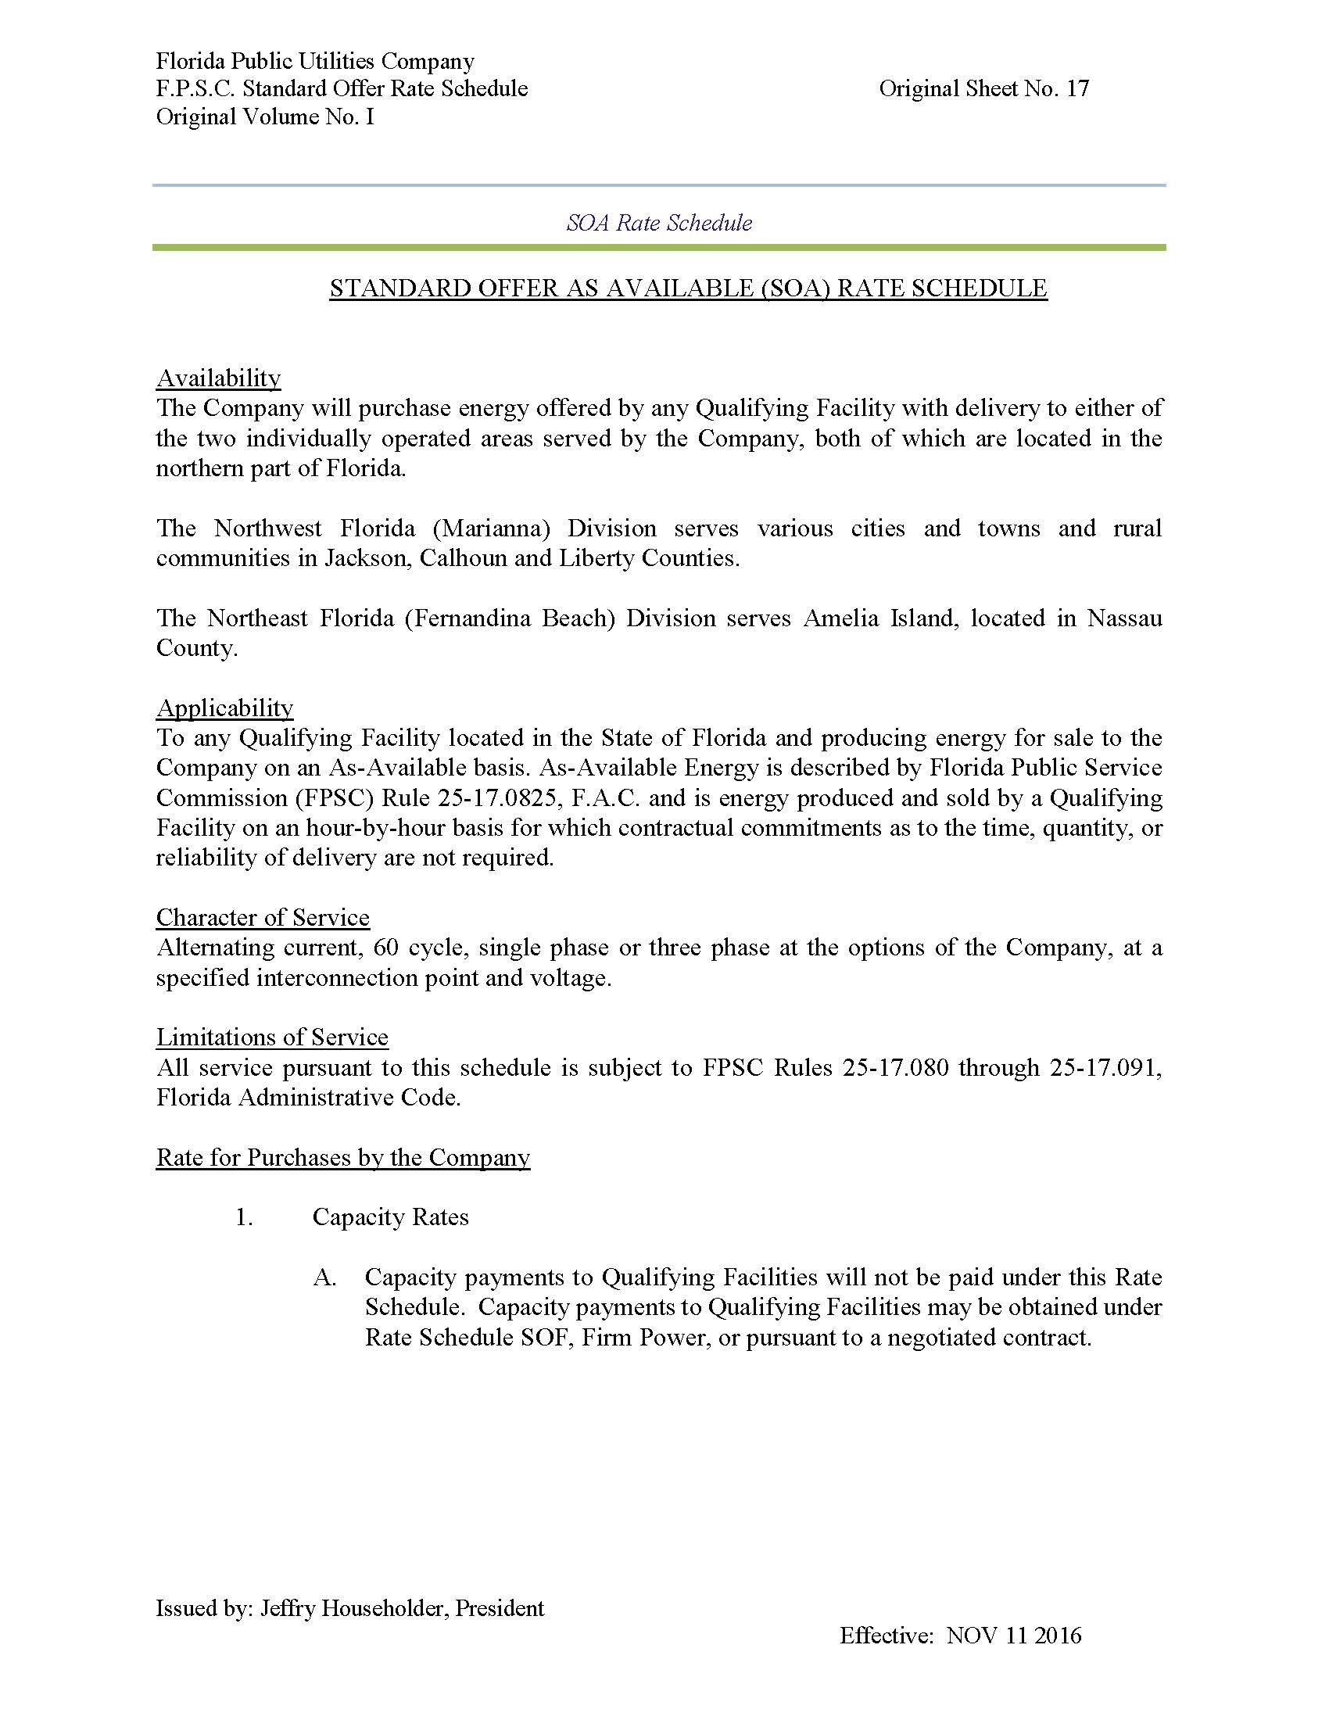

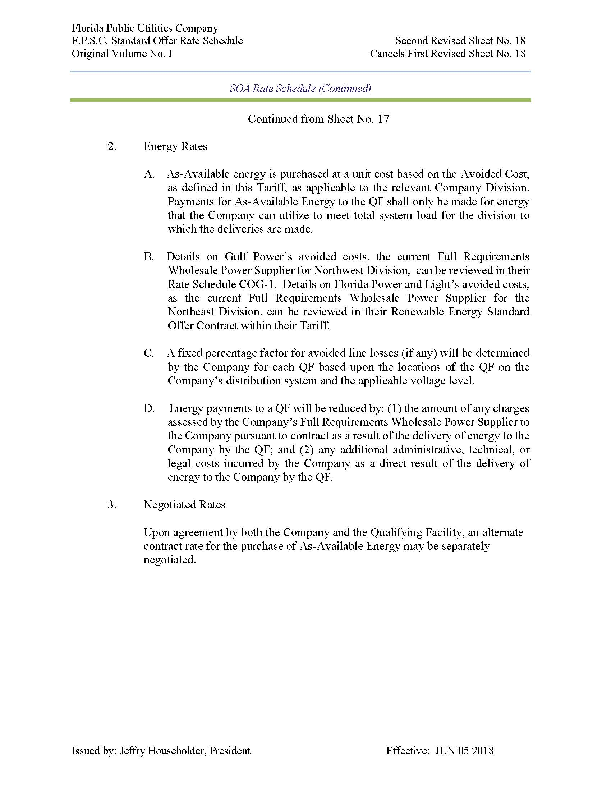

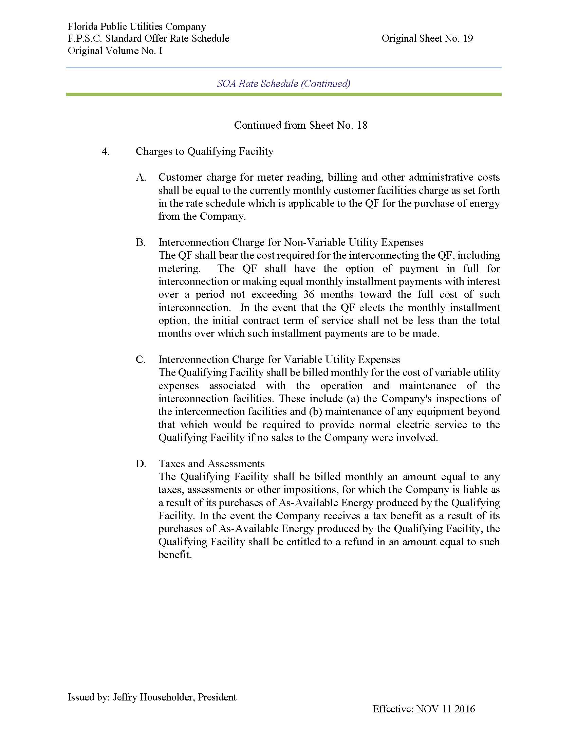

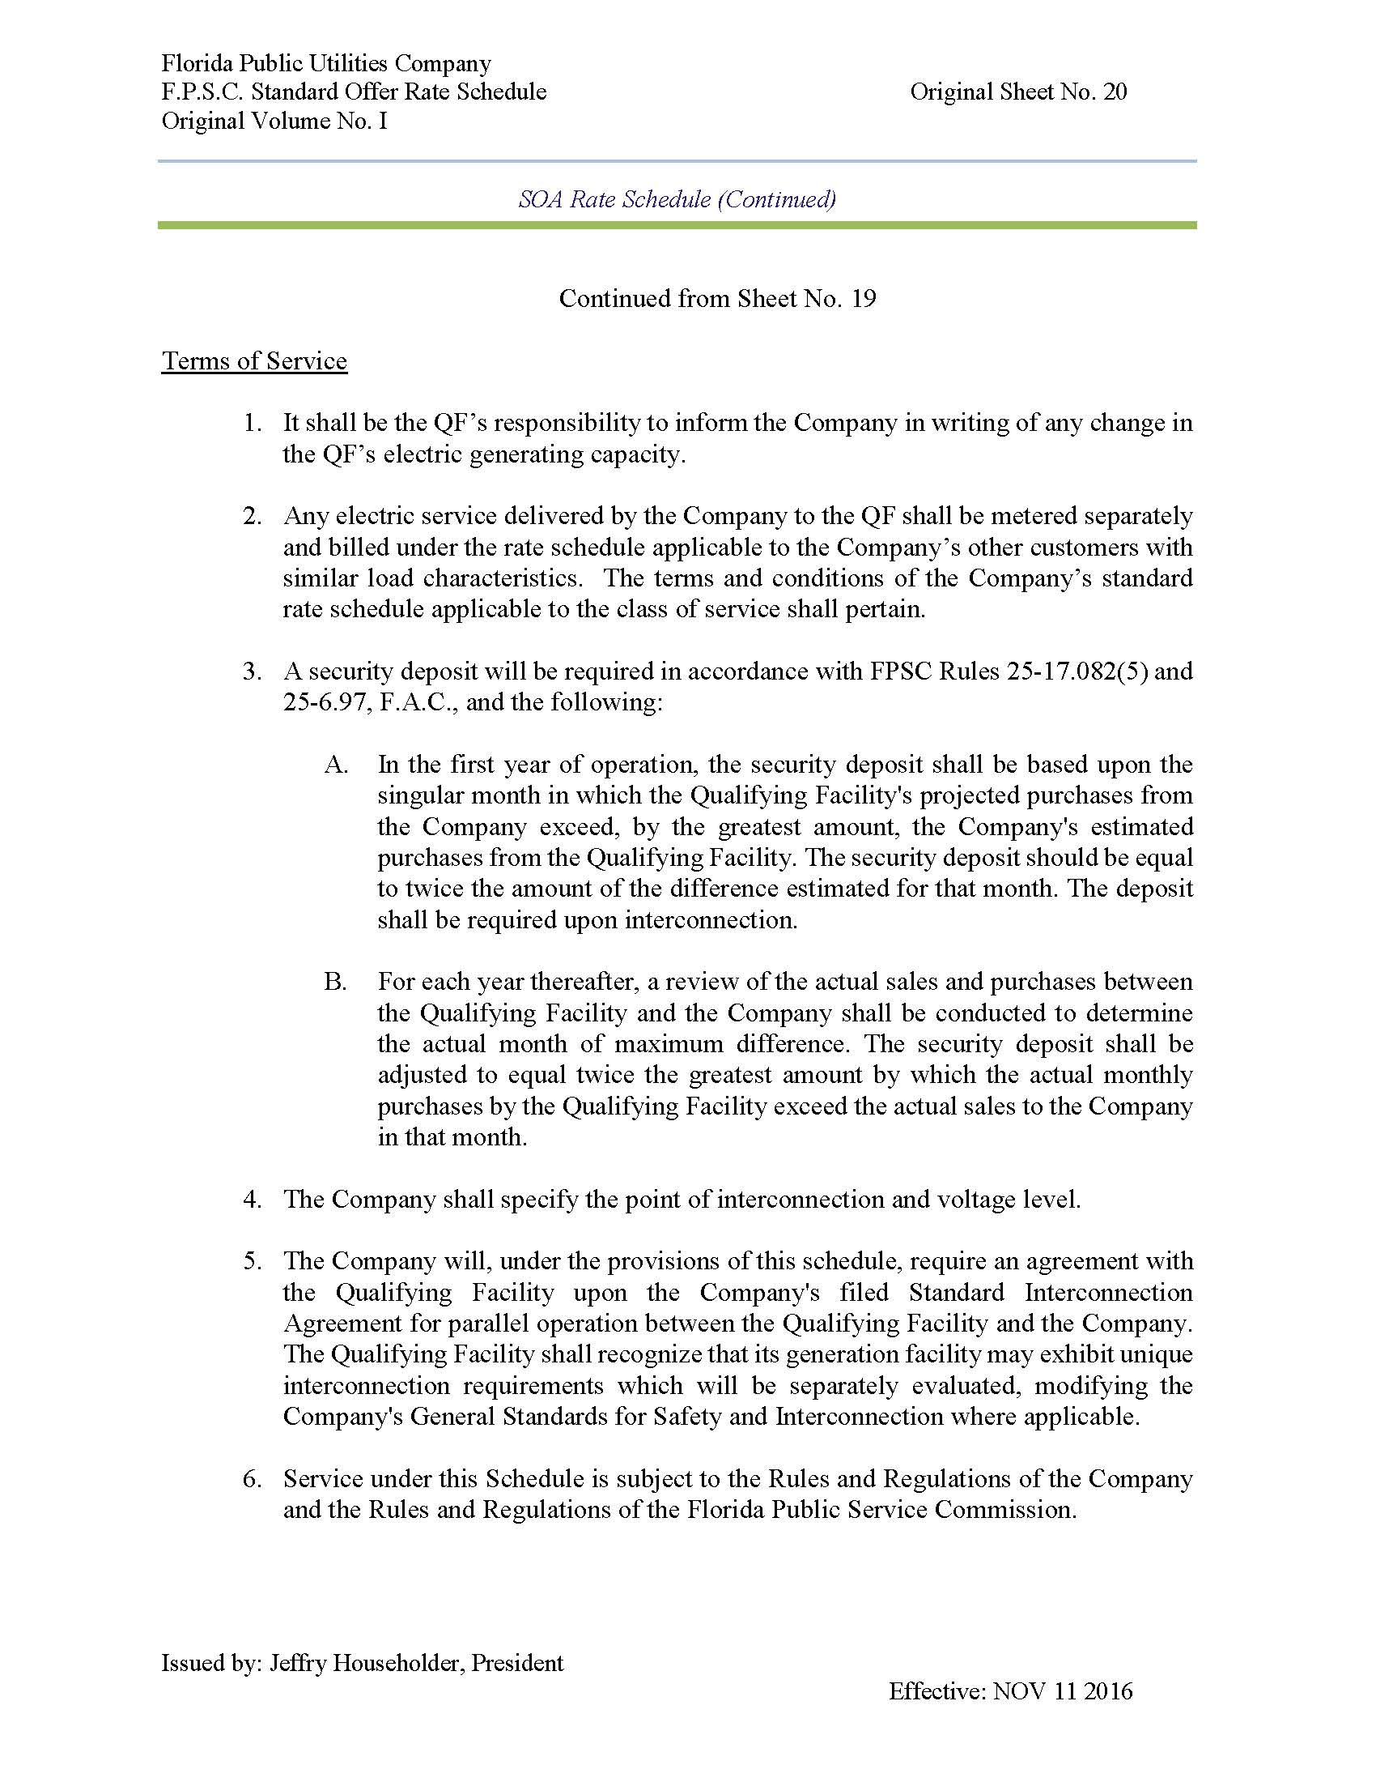

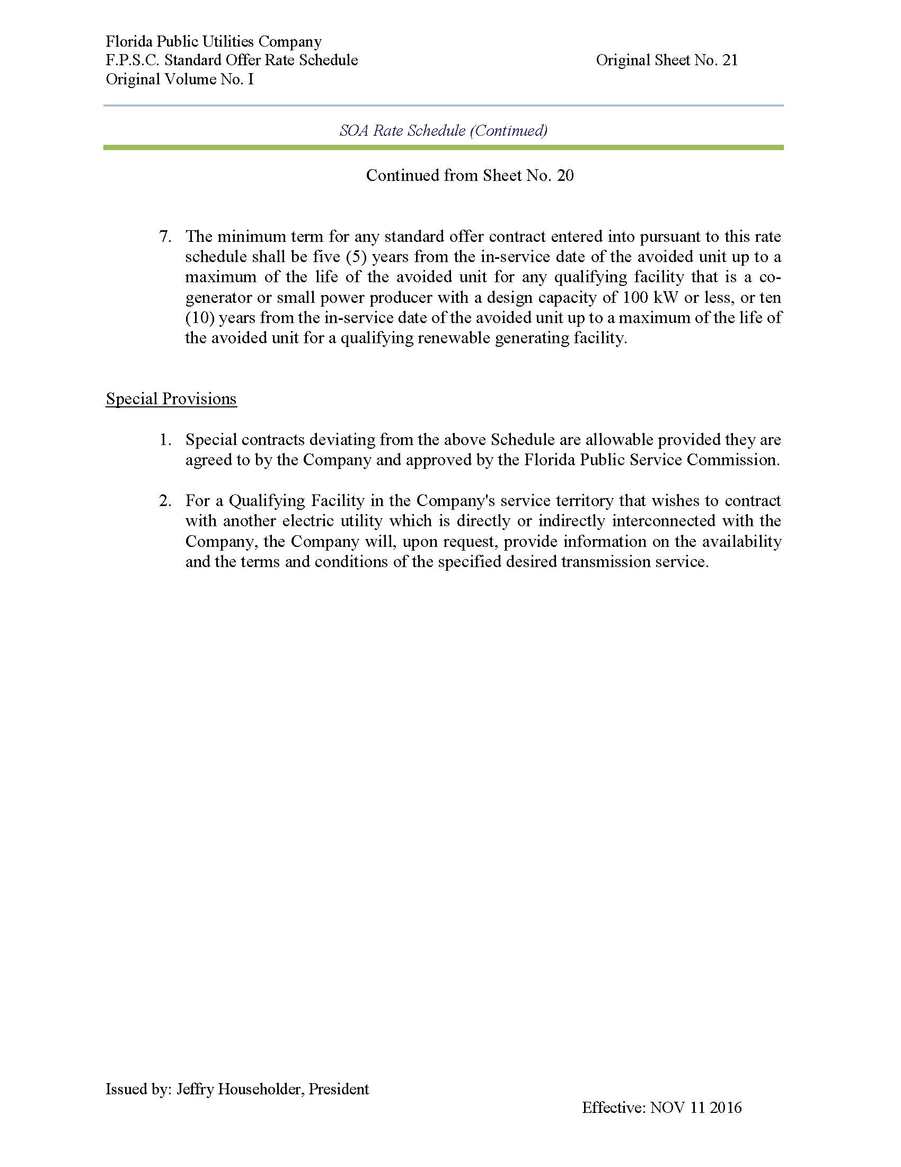

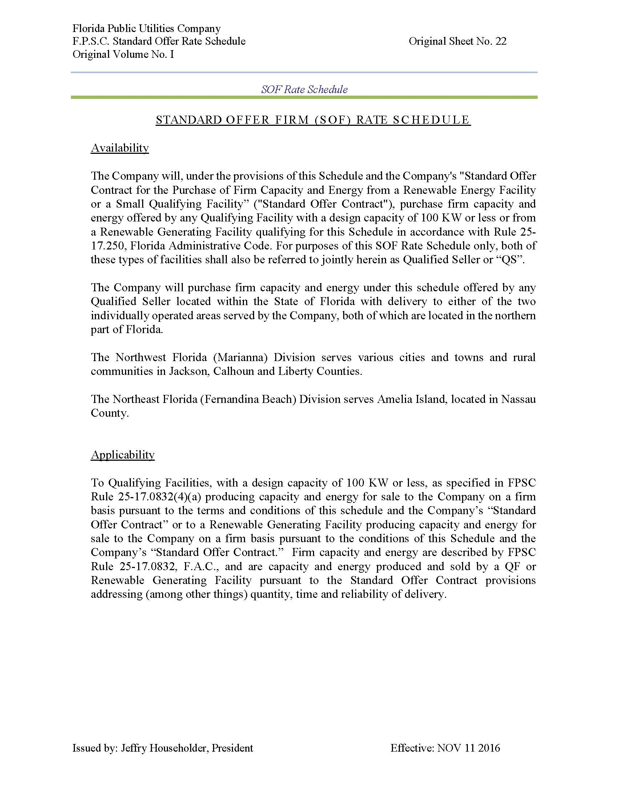

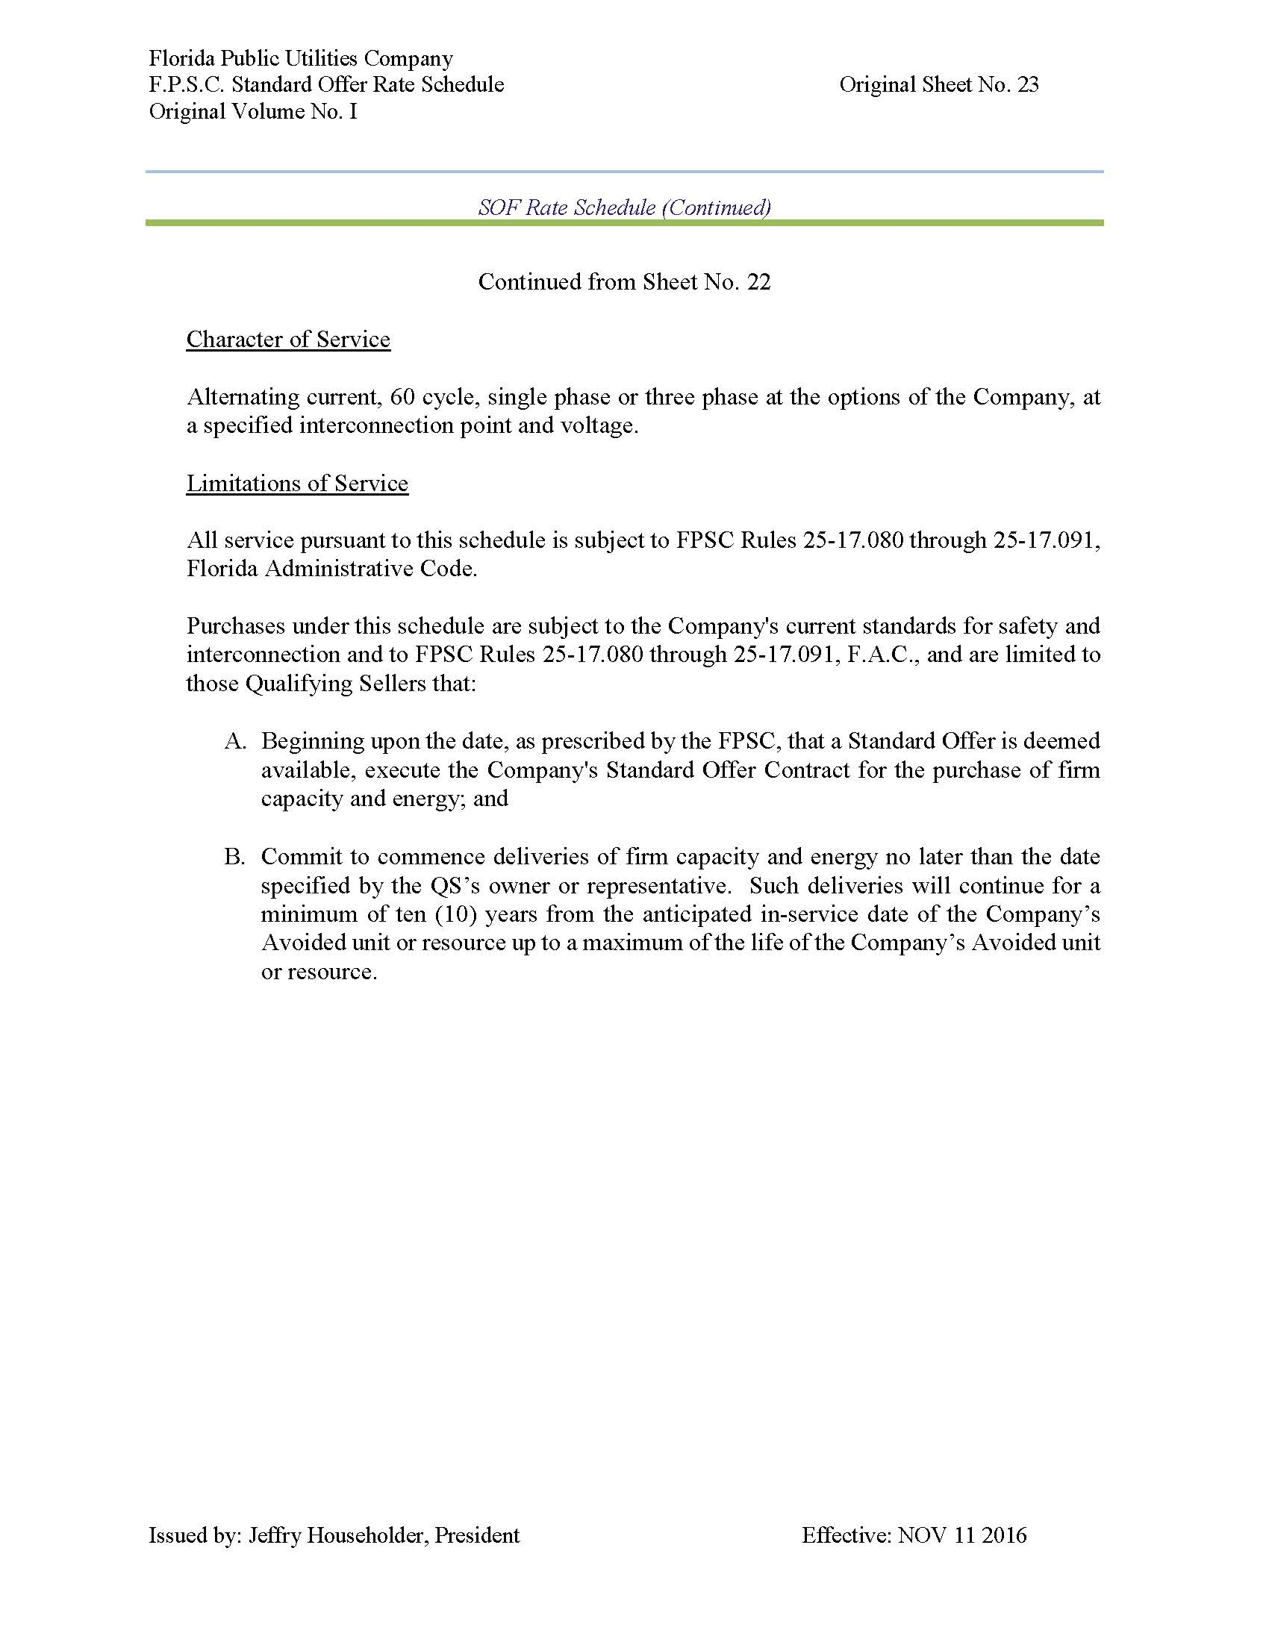

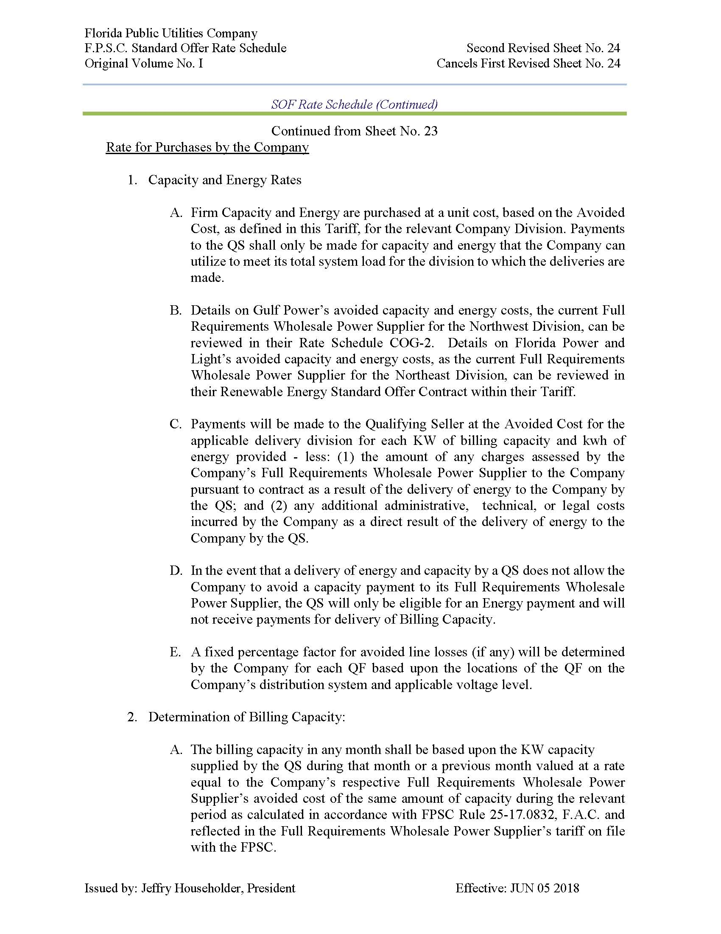

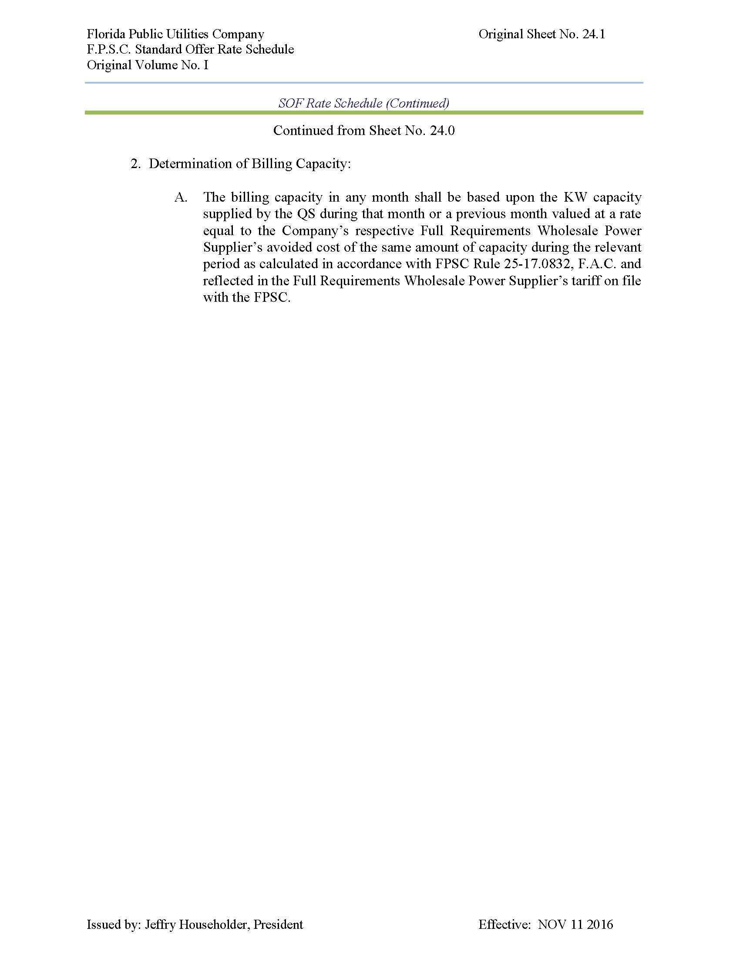

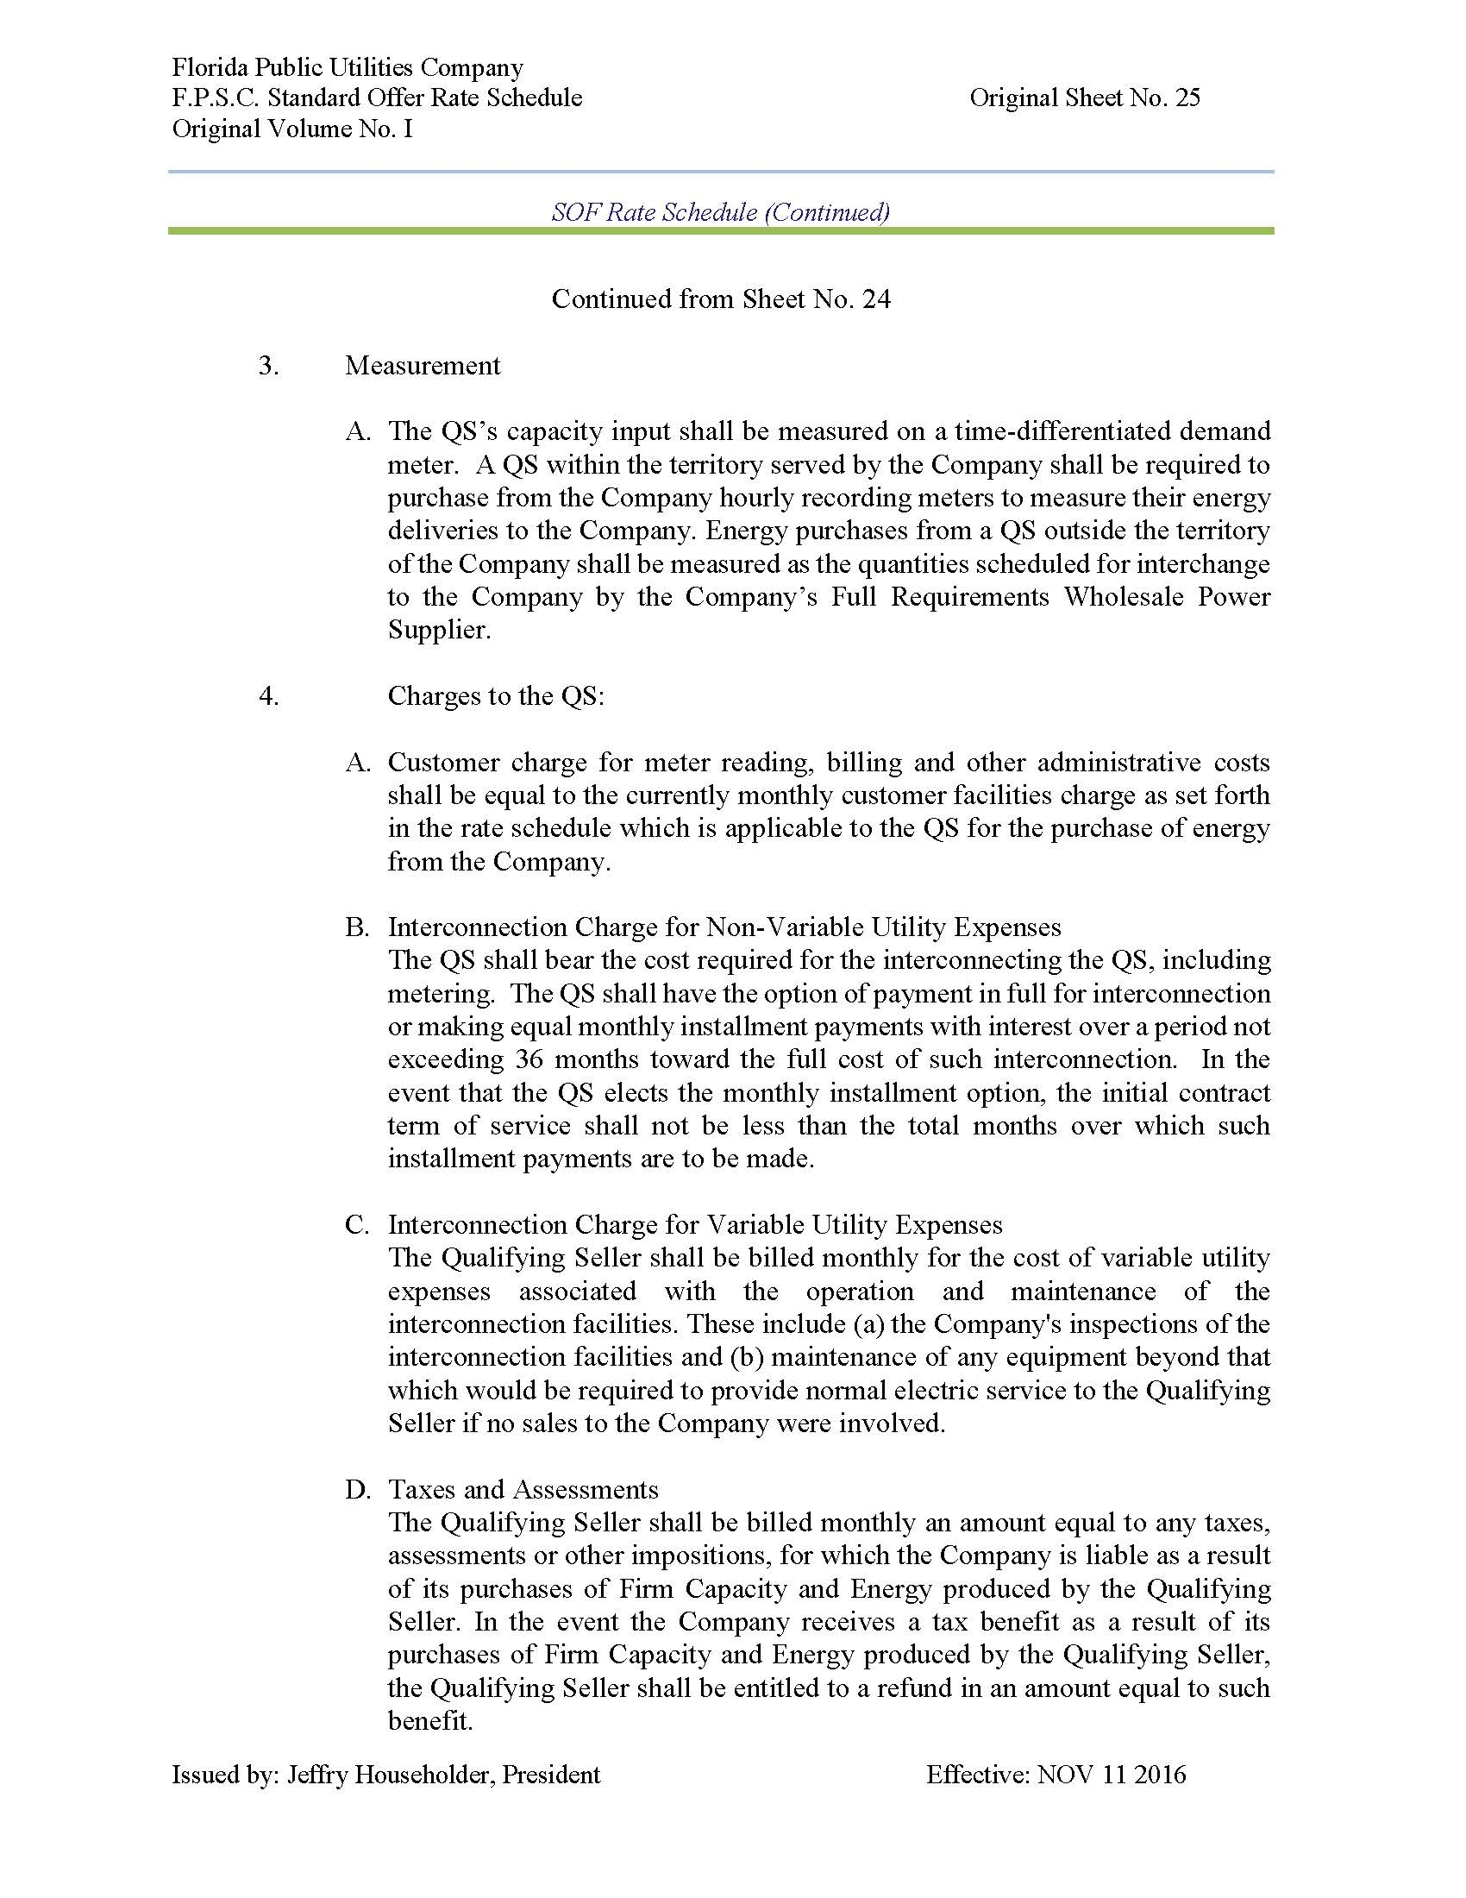

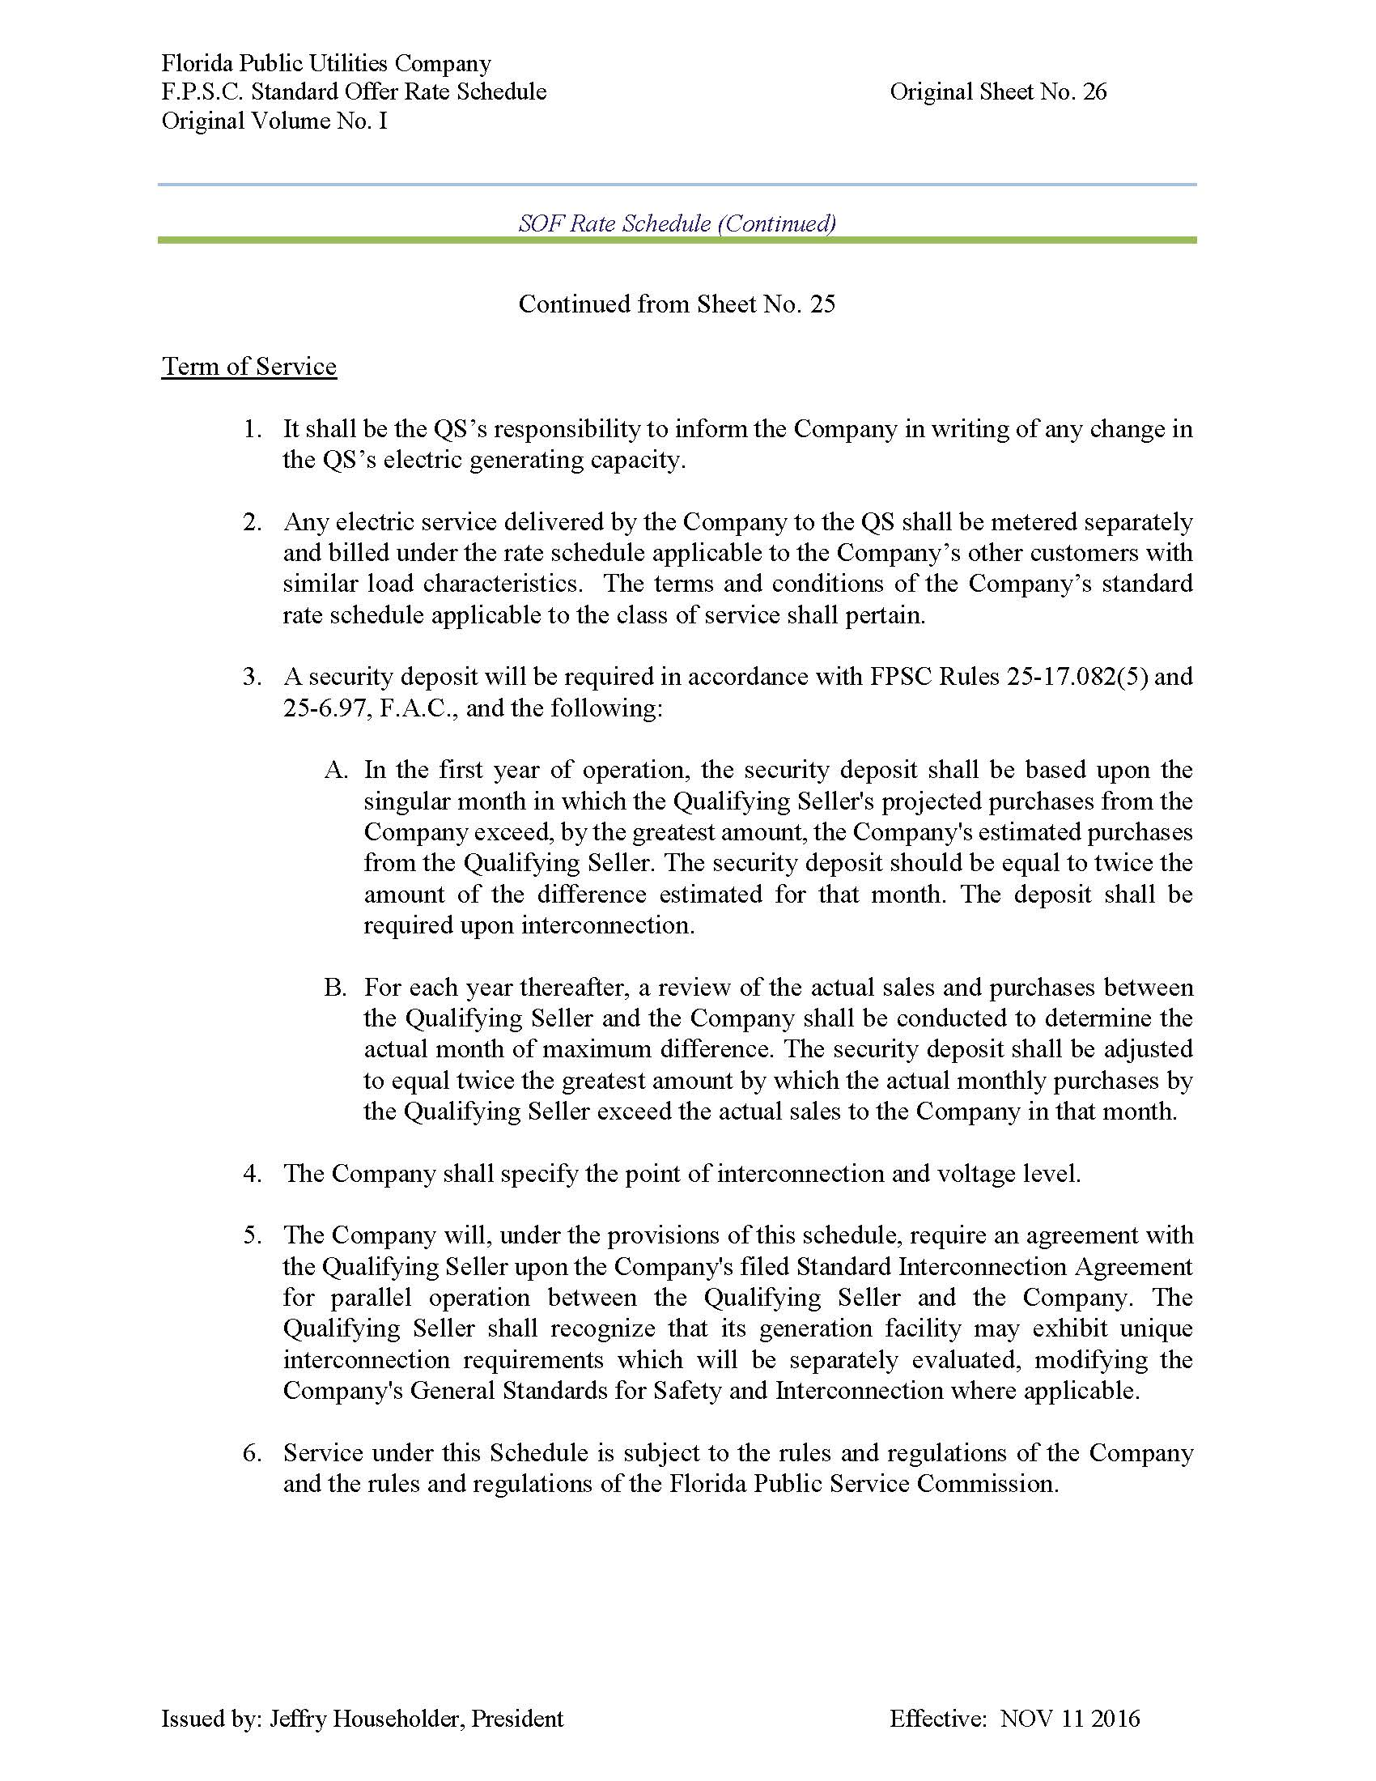

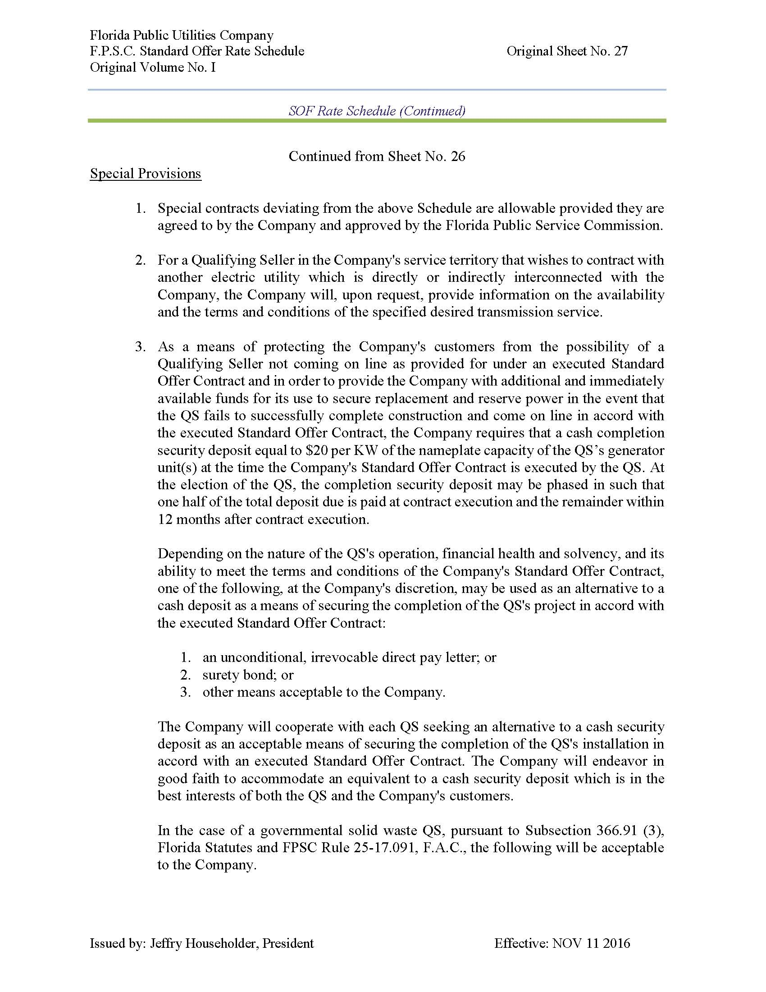

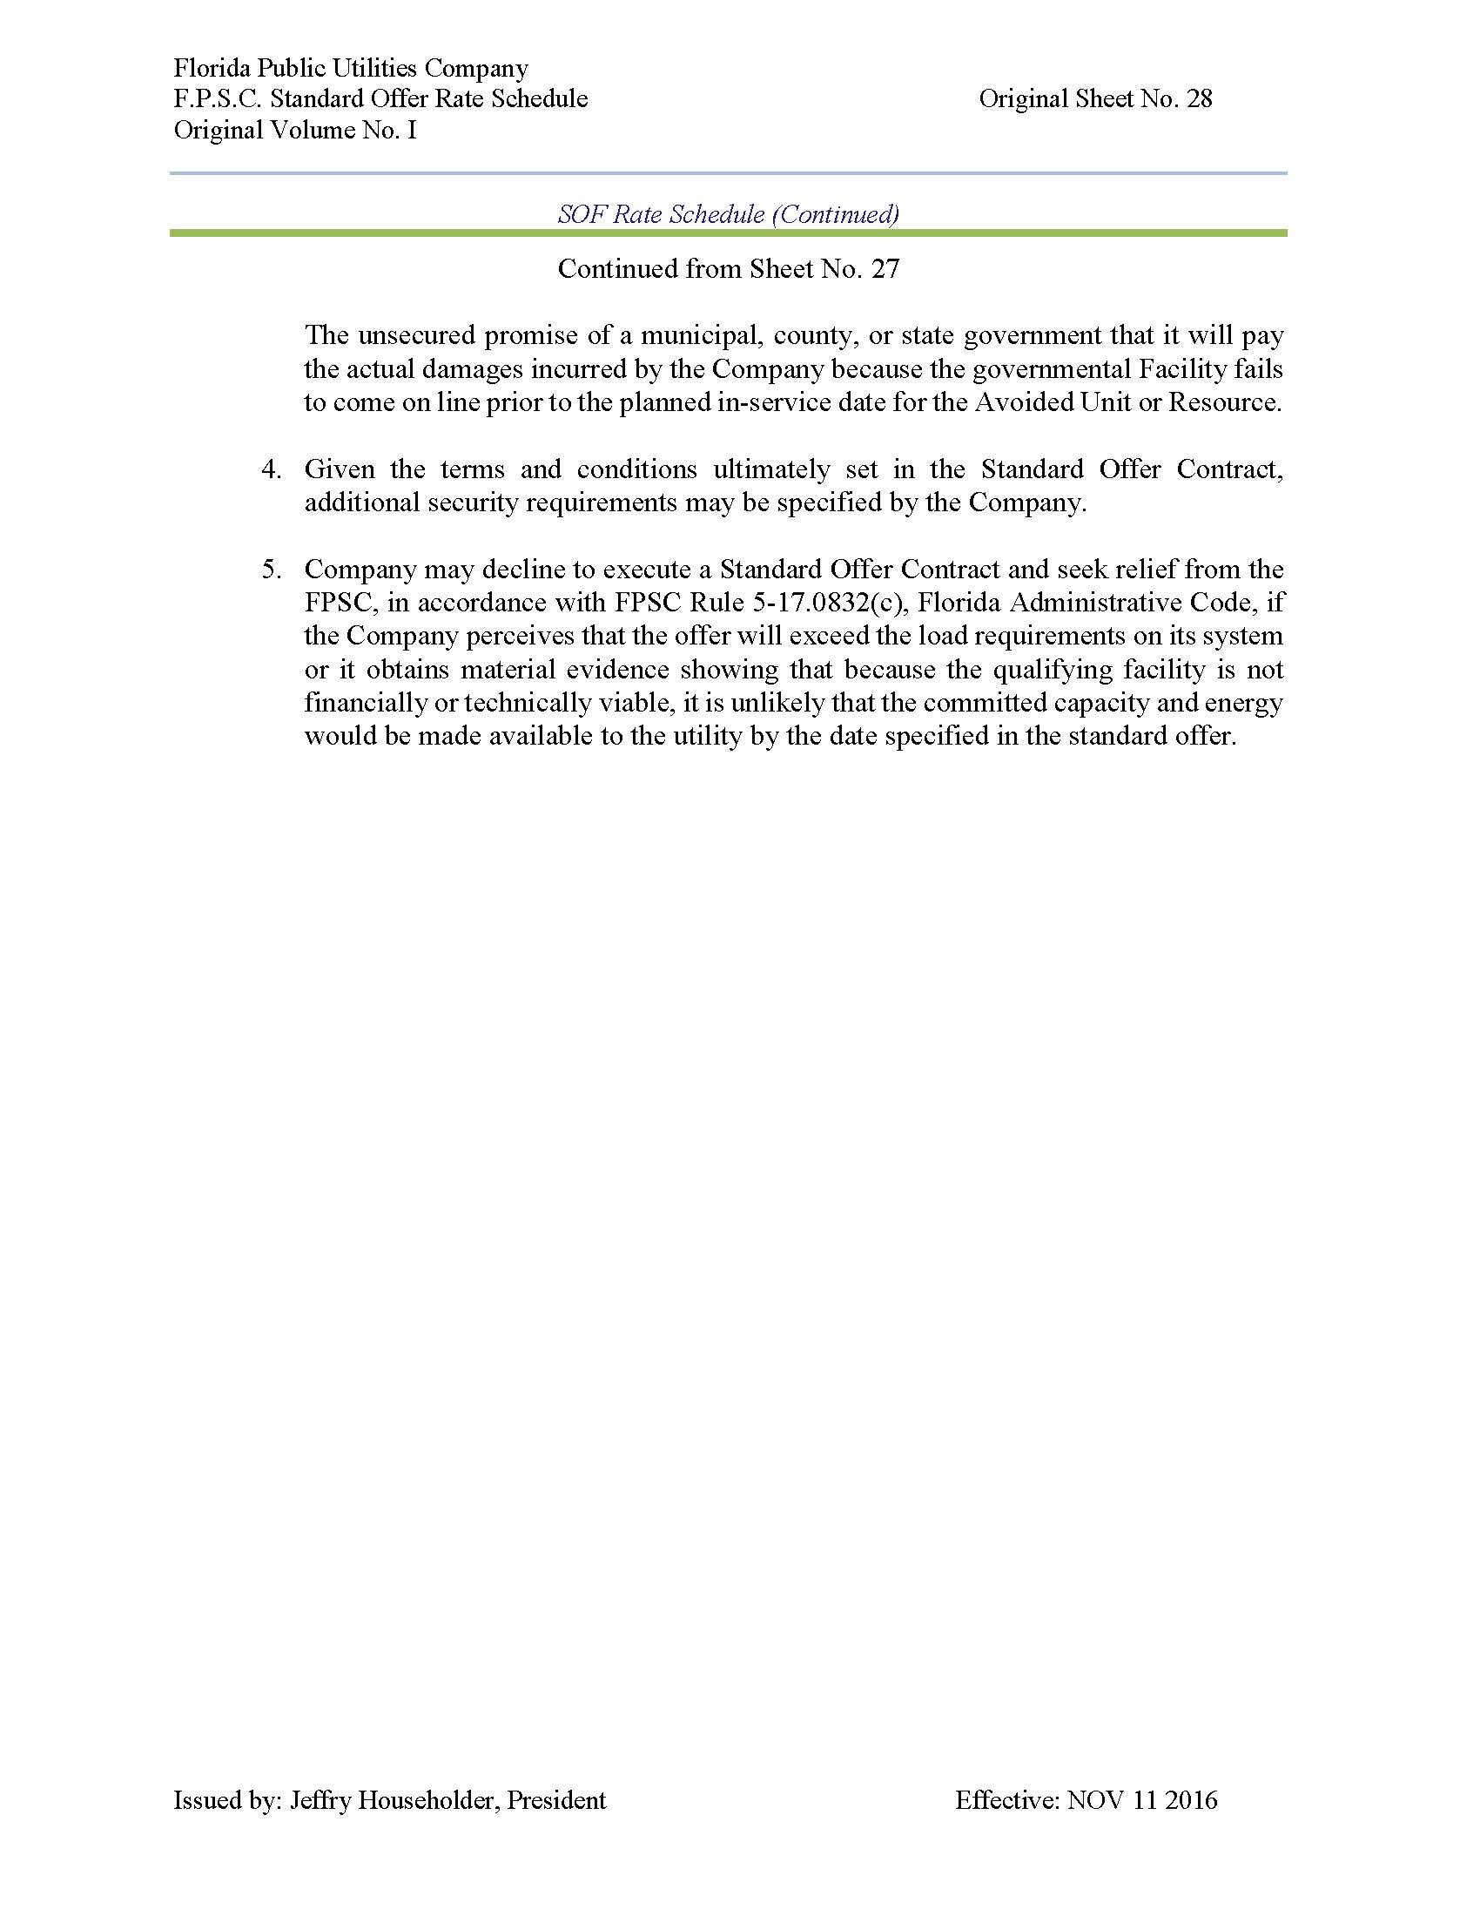

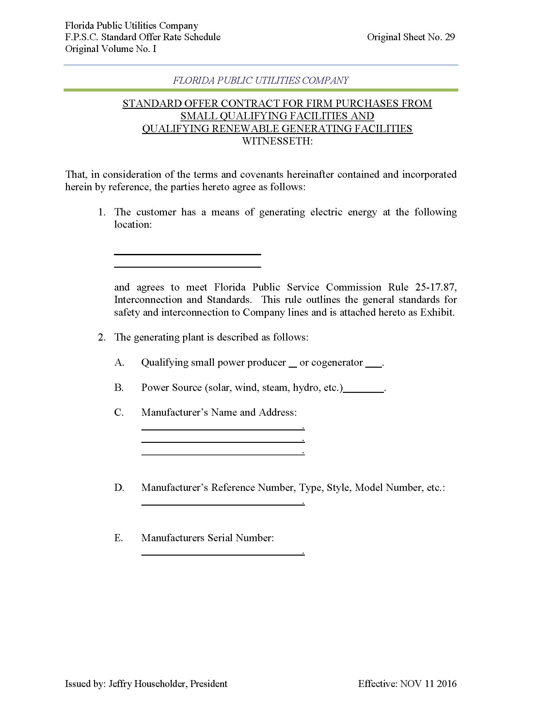

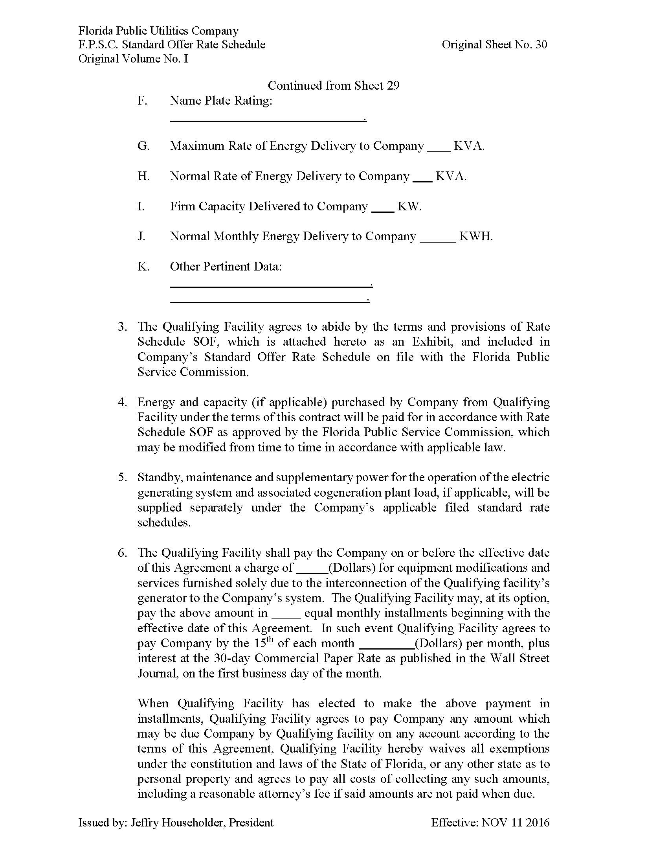

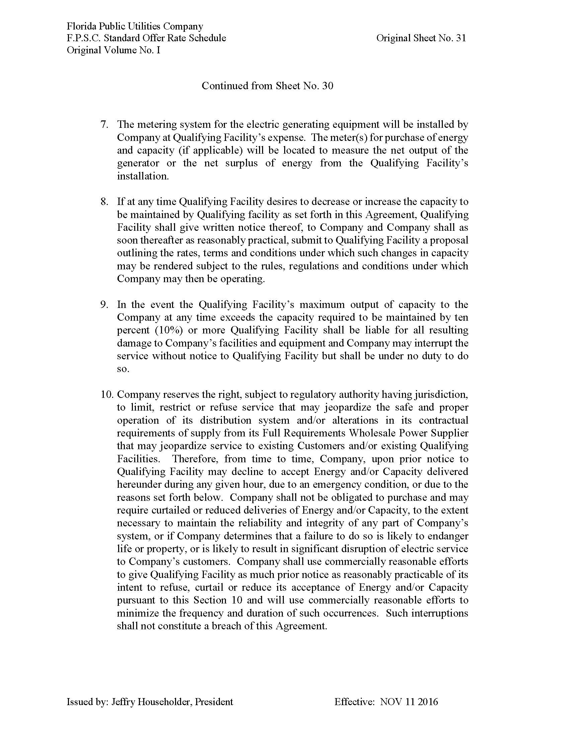

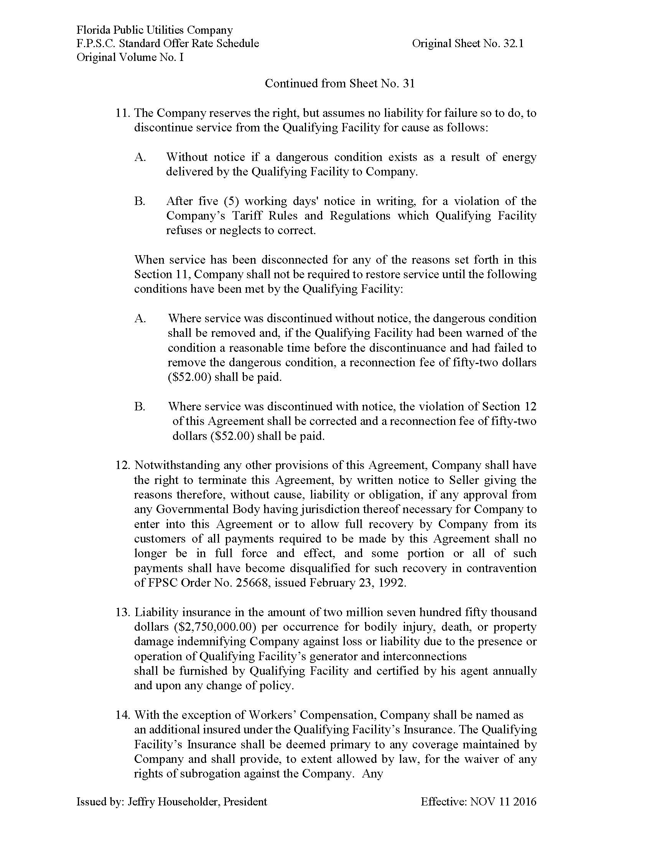

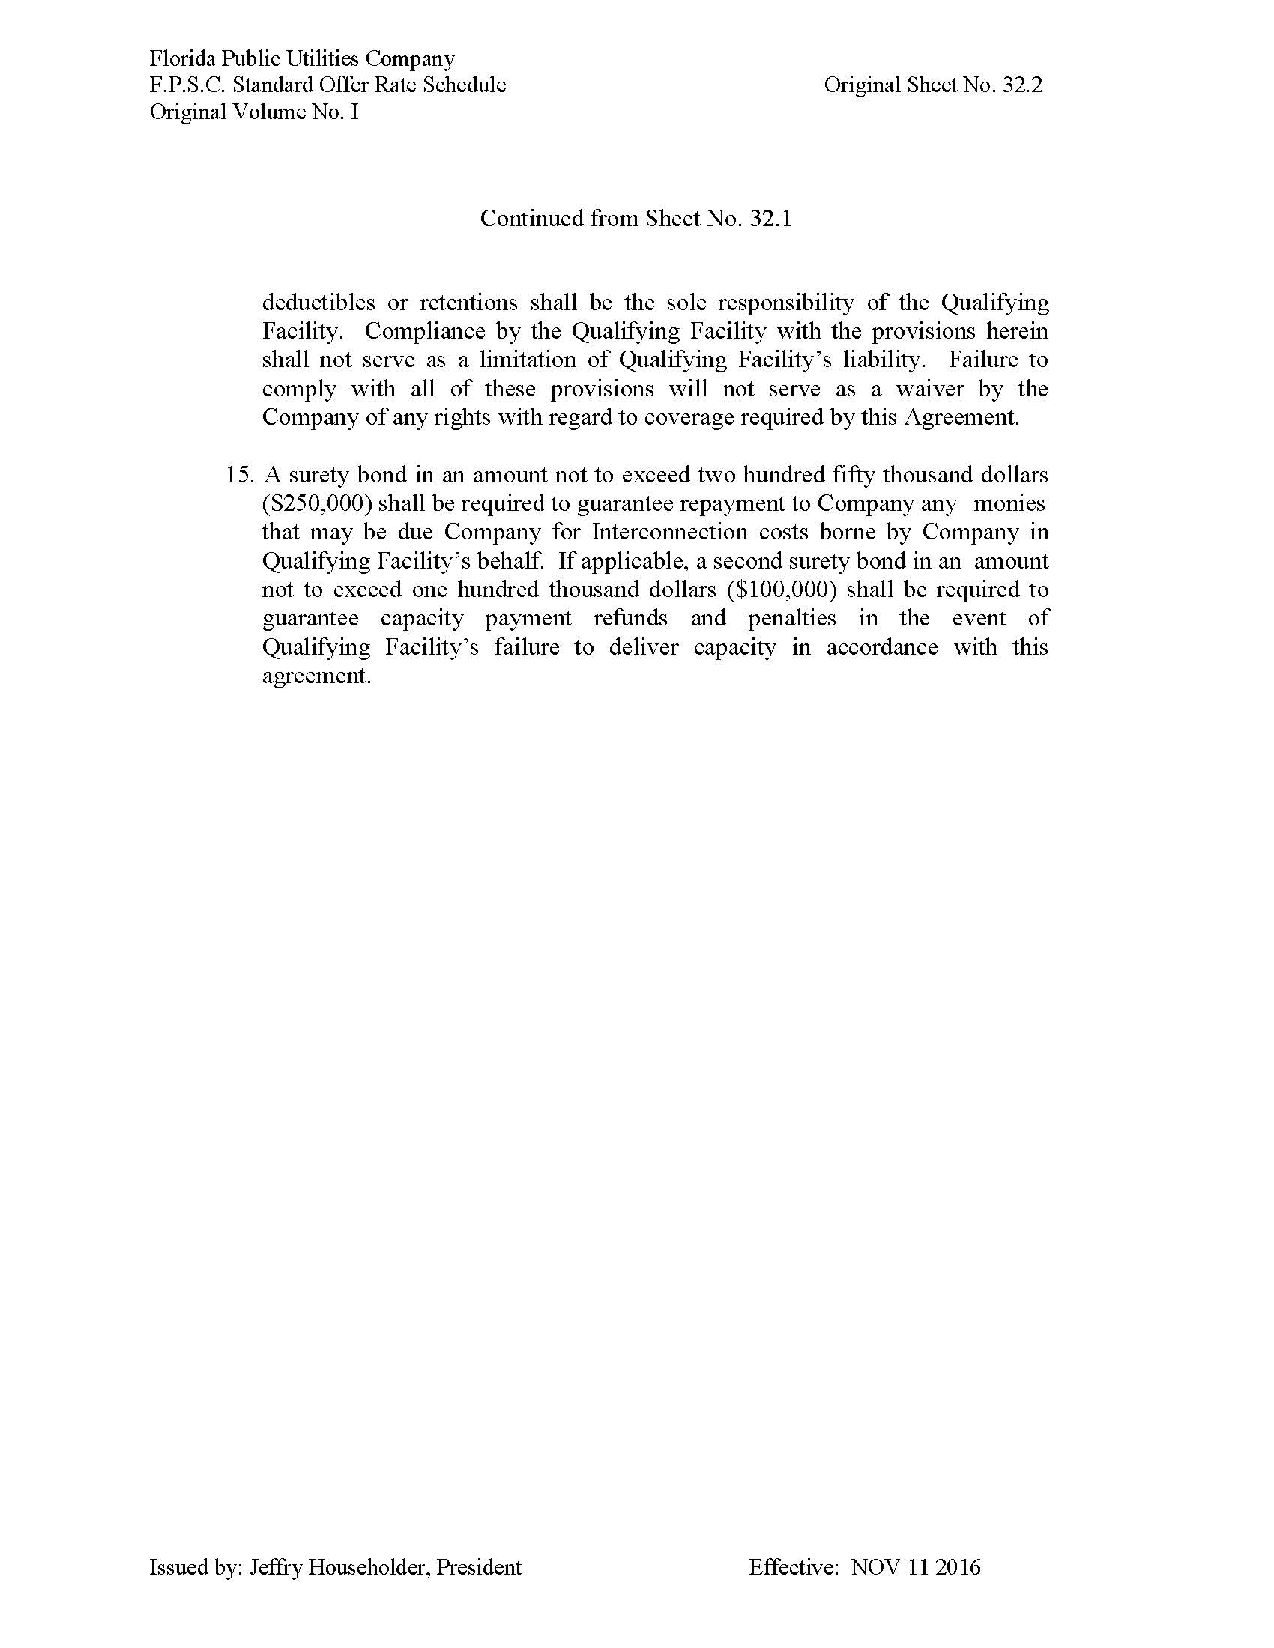

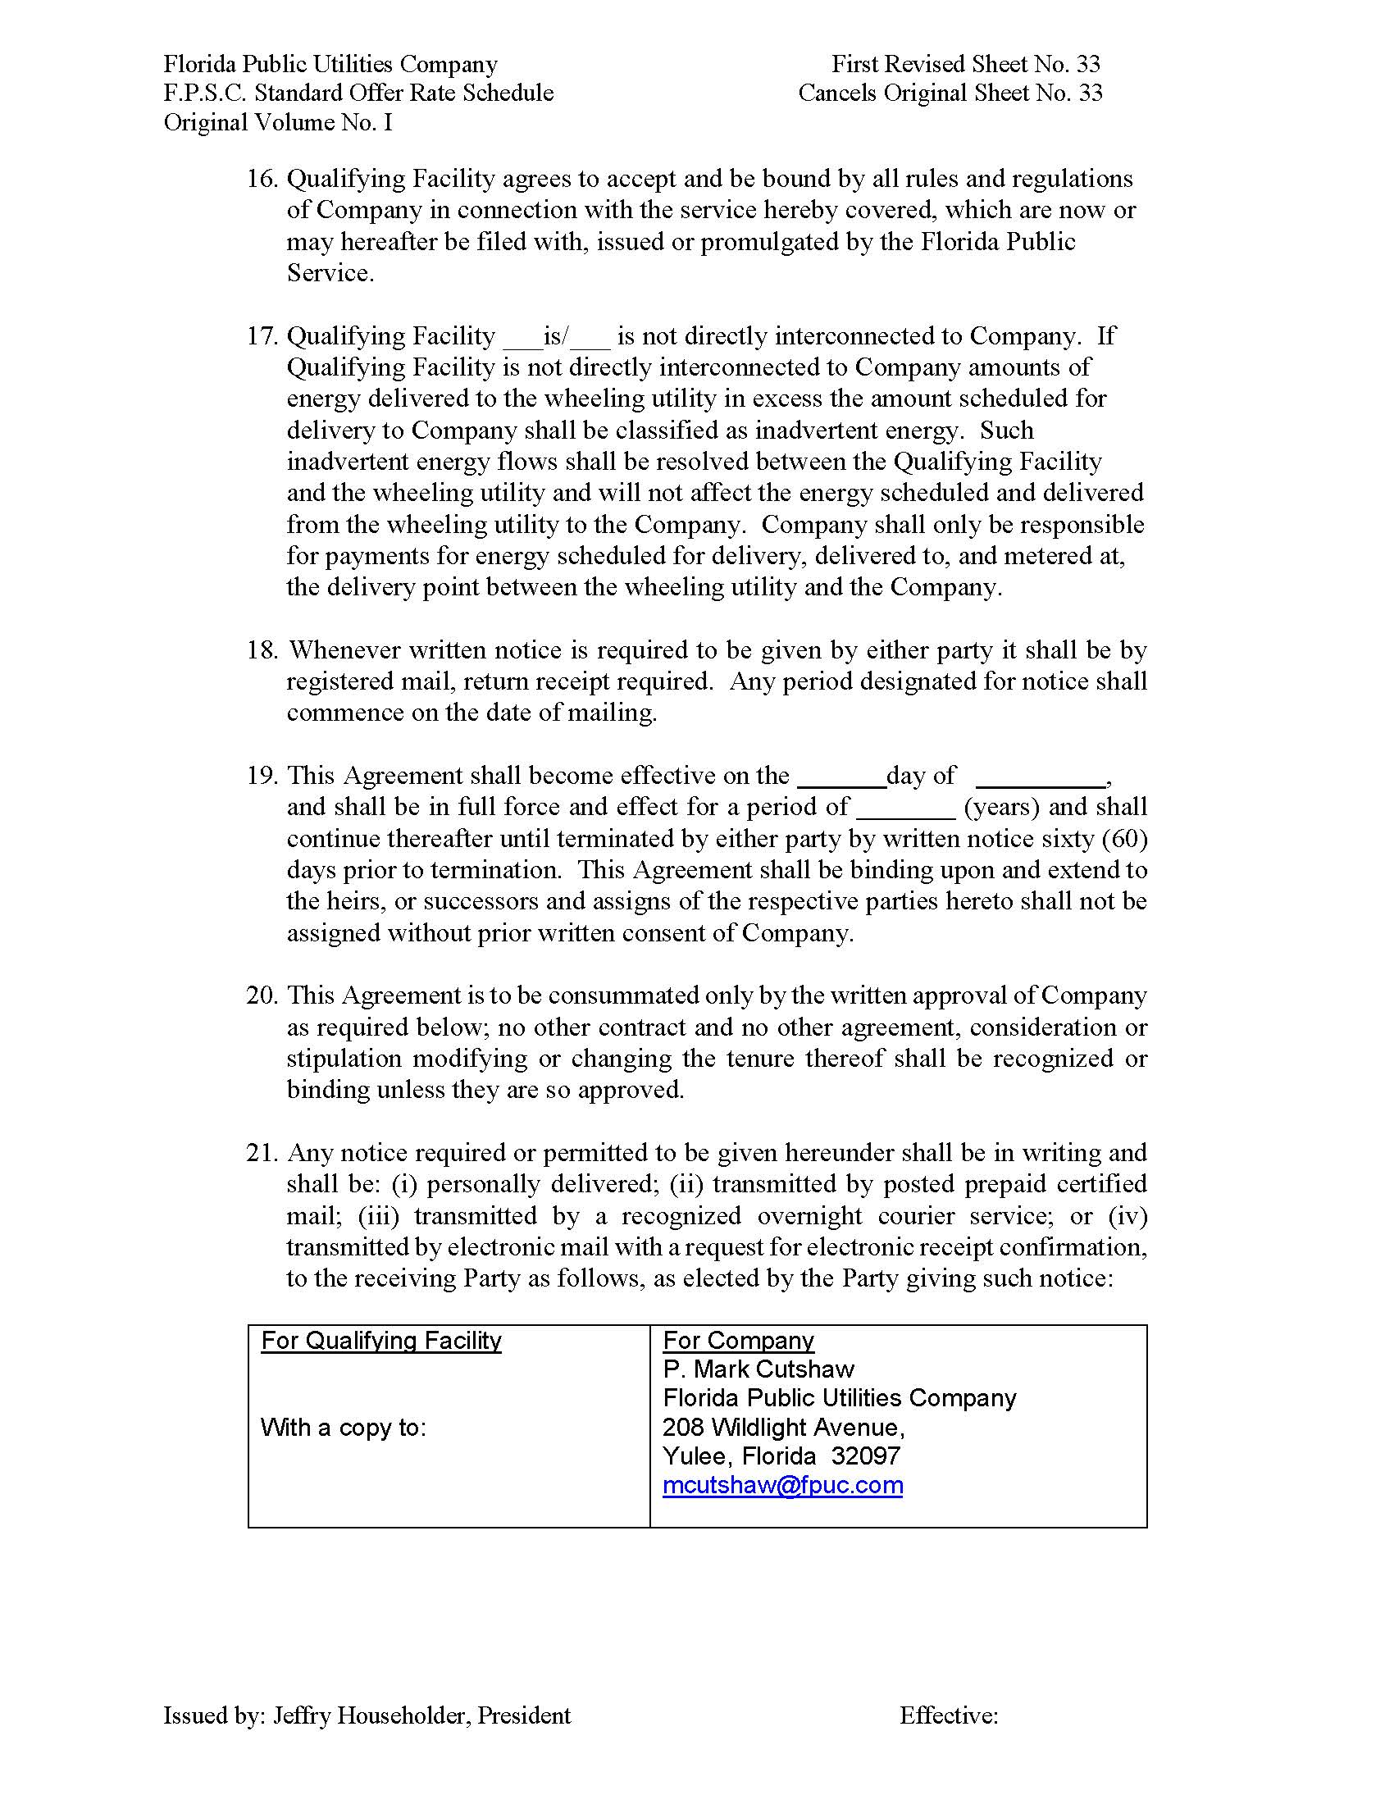

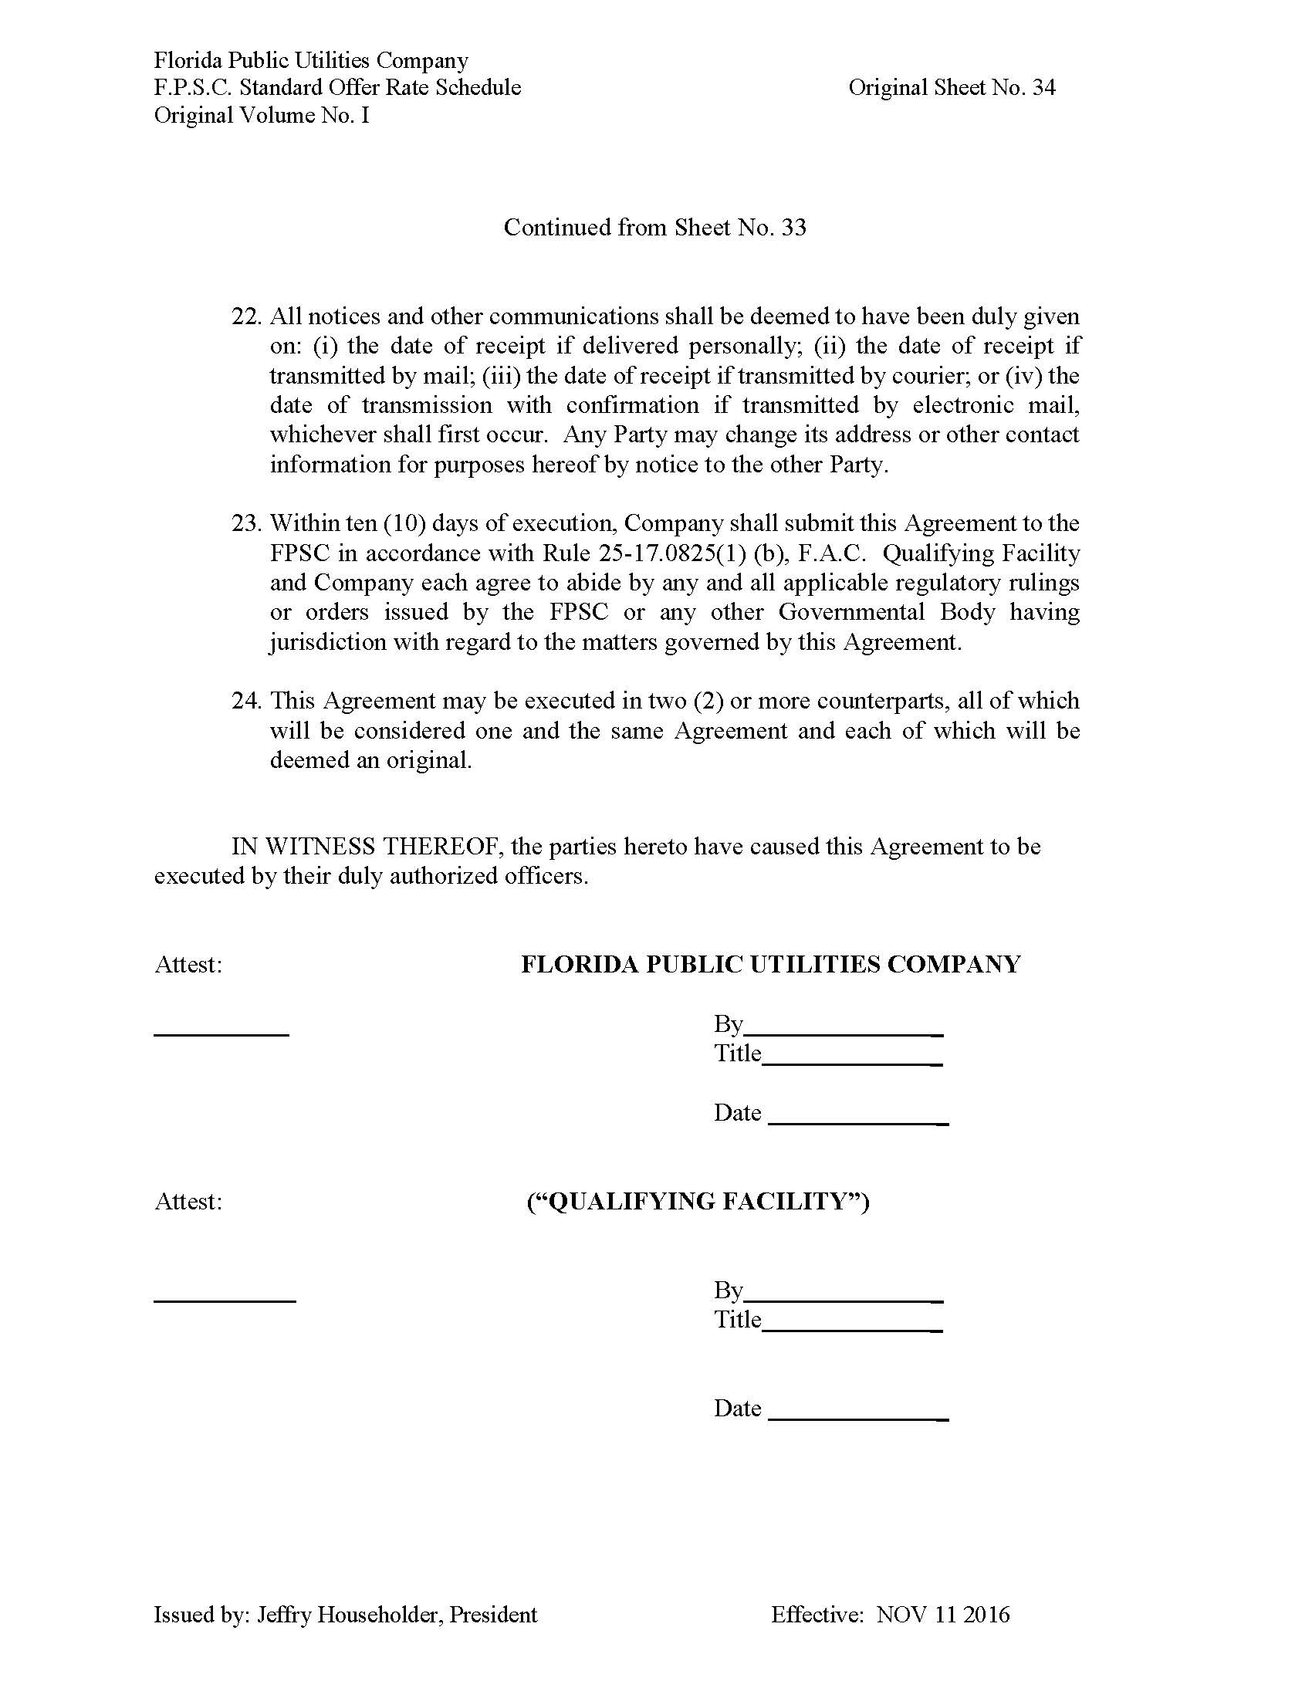

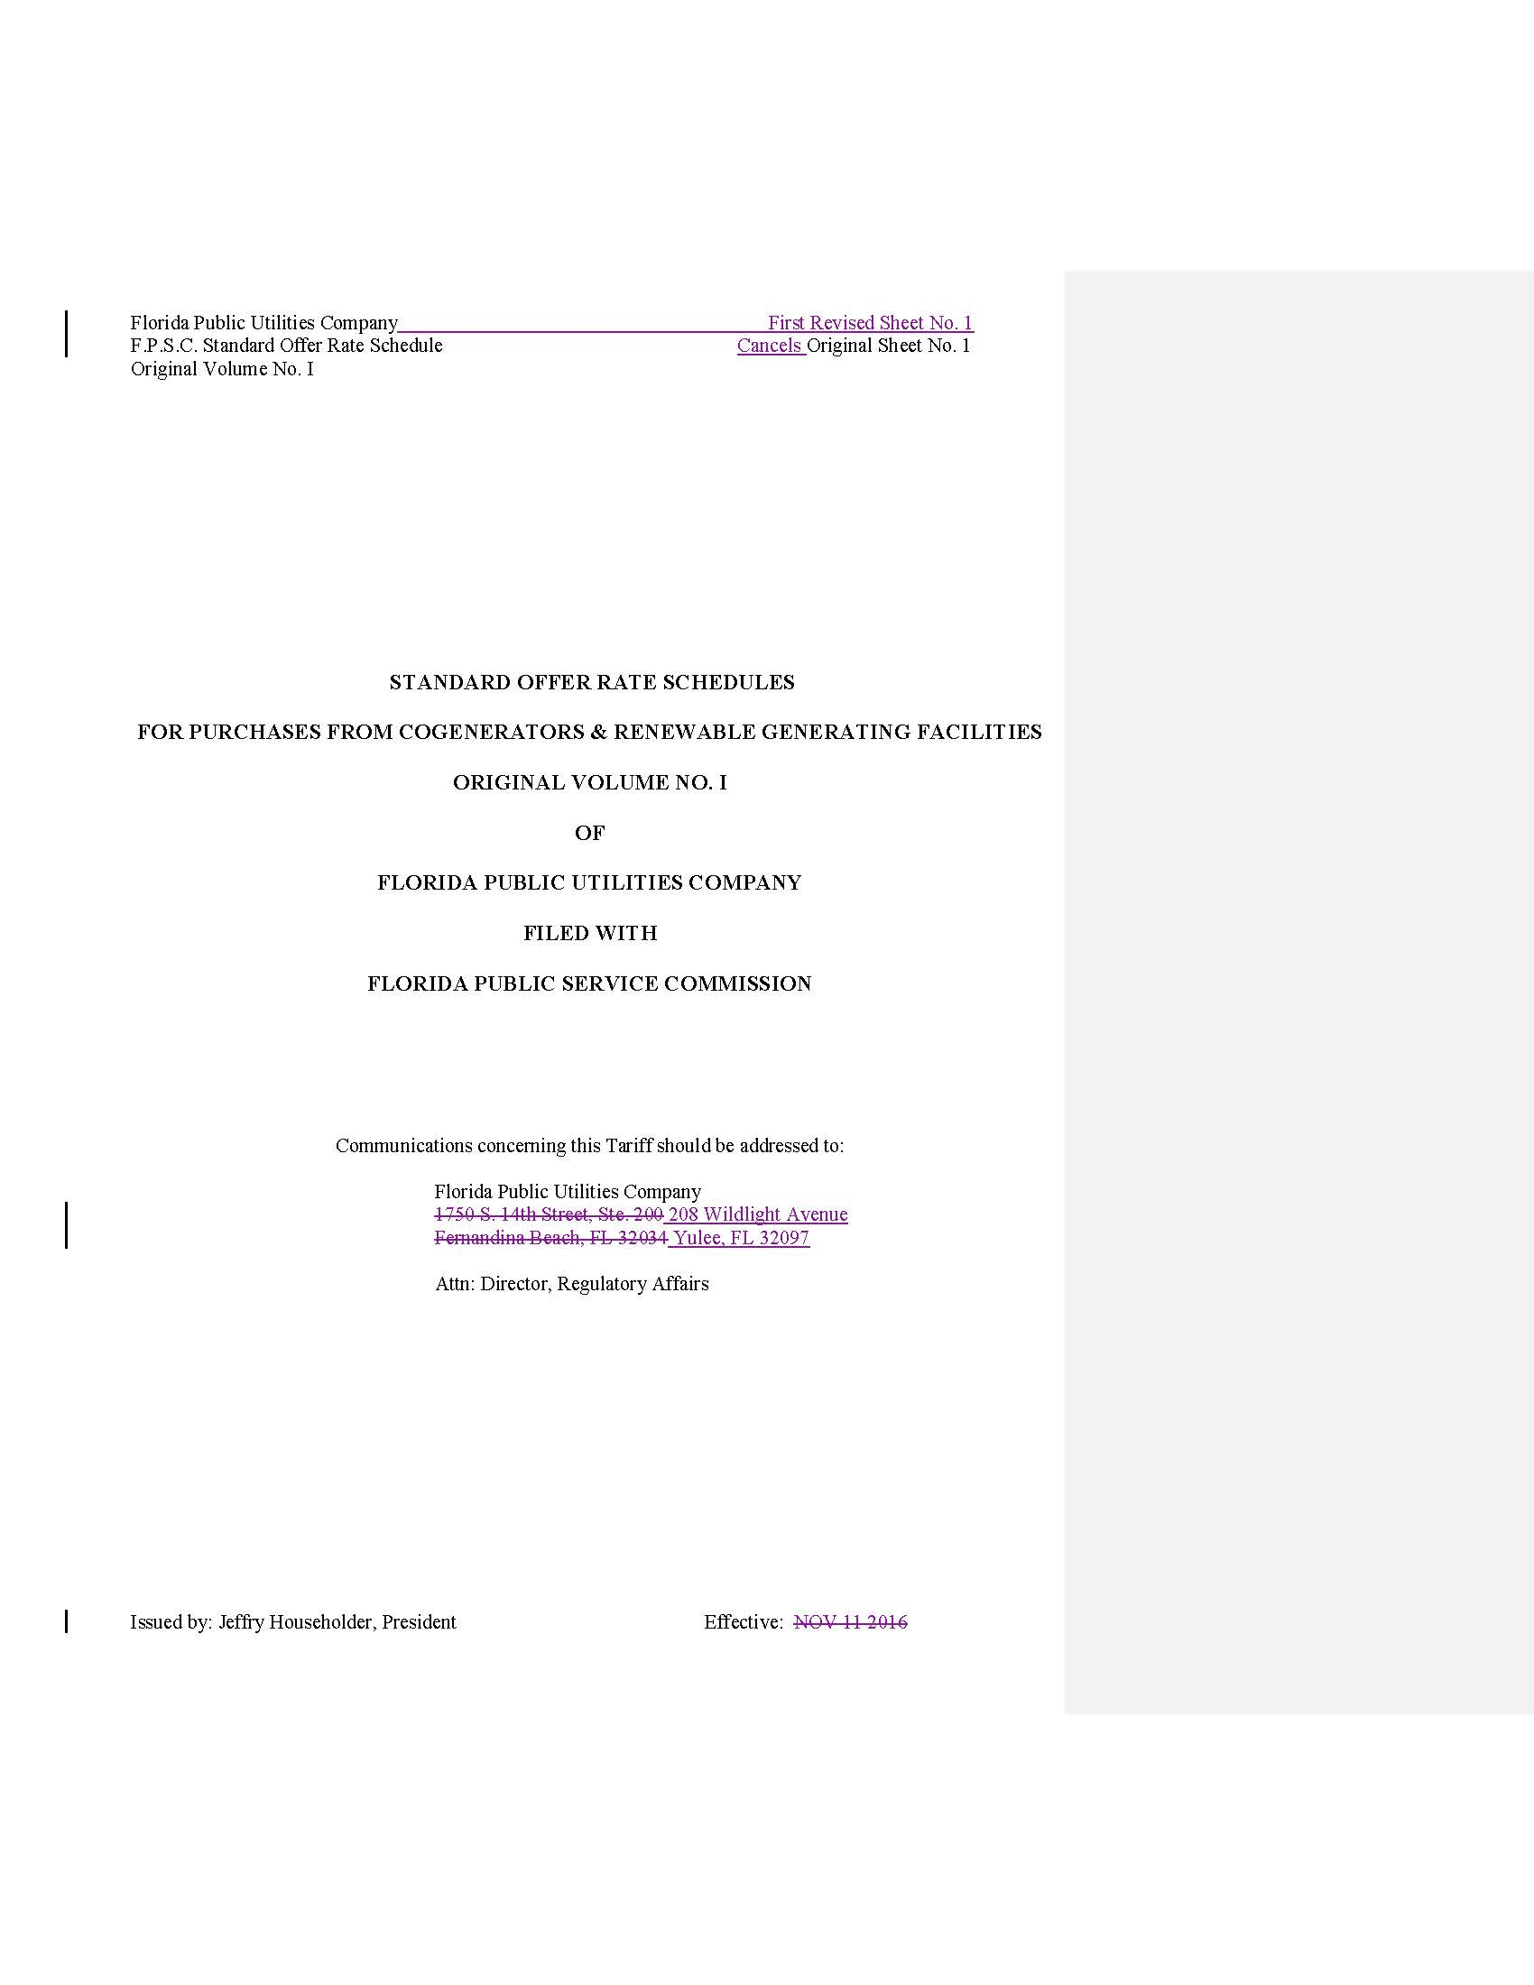

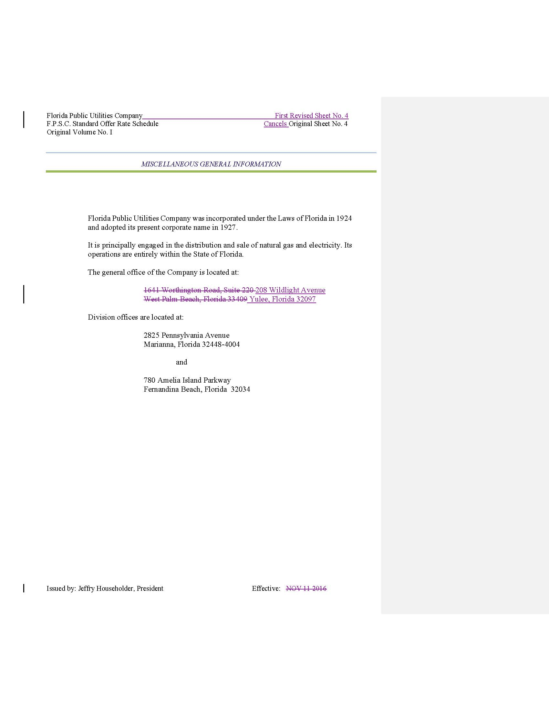

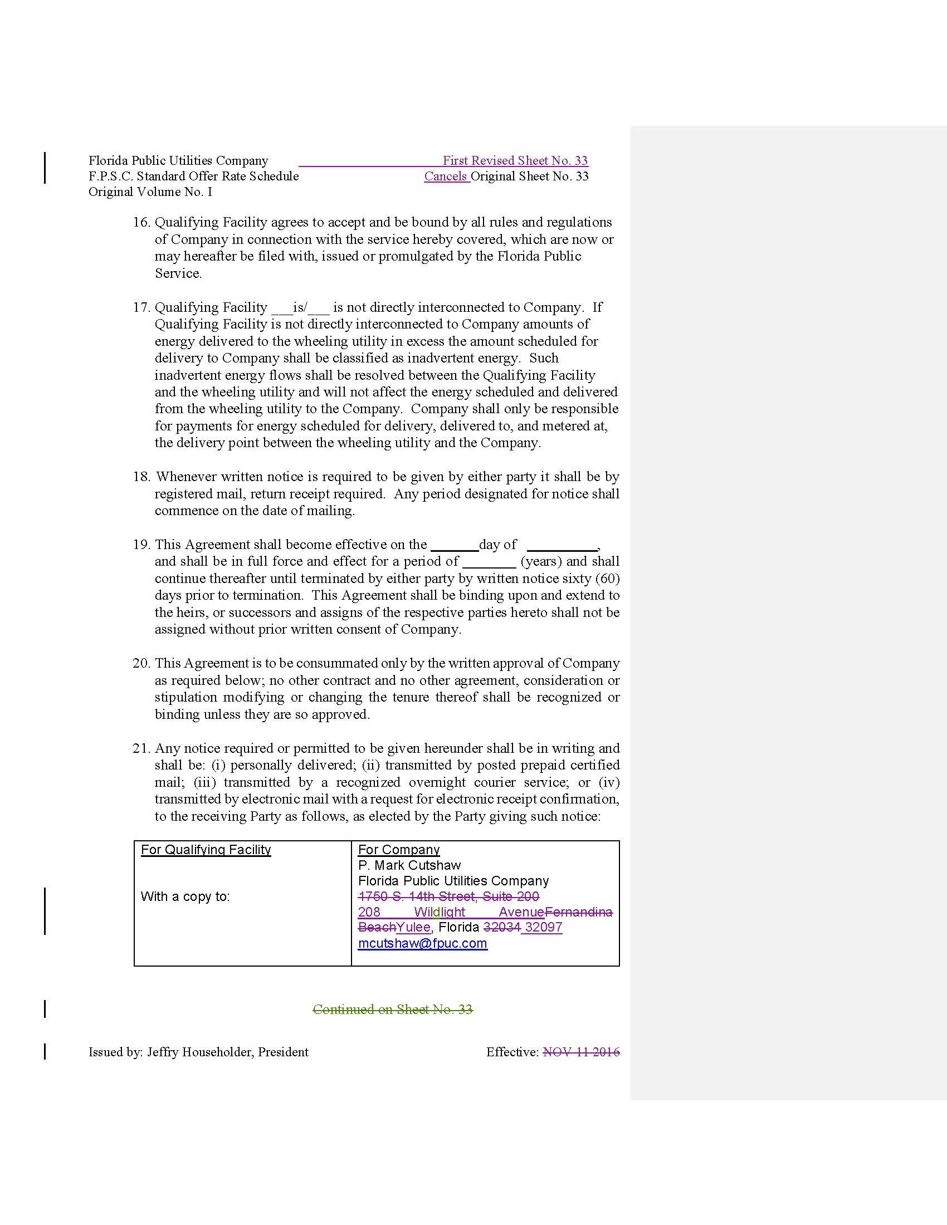

Order No. PSC-2020-0166-PAA-EQ, issued May 22, 2020, in Docket No. 20200109-EQ, In re: Florida Public Utilities Company's Petition for Approval of 2020 Standard Offer Contract.

