State of Florida |  | Public Service Commission  Capital Circle Office Center ● 2540 Shumard Oak Boulevard  Tallahassee, Florida 32399-0850  -M-E-M-O-R-A-N-D-U-M-
DATE: | September 30, 2021
TO: | Office of Commission Clerk (Teitzman)
FROM: | Office of the General Counsel (Cowdery)  Division of Accounting and Finance (T. Brown, Bulecza-Banks)  Division of Economics (Hudson, Sibley, Guffey)
RE: | Docket No. 20210122-WS – Proposed amendment of Rules 25-30.025, 25-30.4345, 25-30.445, 25-30.446, 25-30.455, 25-30.456, and 25-30.565, F.A.C., related to water and wastewater utilities.
AGENDA: | 10/12/21 – Regular Agenda – Rule Proposal – Interested Persons May Participate
COMMISSIONERS ASSIGNED: |  |  | All Commissioners
PREHEARING OFFICER: |  |  | La Rosa
RULE STATUS: |  |  | Proposal May Be Deferred
SPECIAL INSTRUCTIONS: |  |  | None

Case Background
This rulemaking was initiated to update water and wastewater utility rules related to applications for service availability charges, allowance for funds prudently invested, limited proceedings, and staff assistance in rate cases and in alternative rate setting. The draft amendments are intended to make these rules consistent with rule amendments recently adopted by the Commission in other electric, gas, water and wastewater rules that decrease the number of paper copies that utilities are required to file or distribute for public inspection; require utilities to notify customers that applications may be accessed on the Commission’s website; change the responsibility for determining the official date of filing to the Director of the office of primary responsibility; and clarify application filing requirements.
This recommendation addresses whether the Commission should propose the amendment of:
- Rule 25-30.025, Florida Administrative Code (F.A.C.), Official Date of Filing;
- Rule 25-30.4345, F.A.C., Notice of Requests for New or Revised Service Availability Charges or Policies and Notice of Requests for Allowance for Funds Prudently Invested (AFPI) Charges;
- Rule 25-30.445, F.A.C., General Information and Instructions Required of Water and Wastewater Utilities in an Application for a Limited Proceeding;
- Rule 25-30.446, F.A.C., Notice of and Public Information for Application for Limited Proceeding Rate Increase;
- Rule 25-30.455, F.A.C., Staff Assistance in Rate Cases;
- Rule 25-30.456, F.A.C., Staff Assistance in Alternative Rate Setting; and
- Rule 25-30.565, F.A.C., Application for Approval of New or Revised Service Availability Policy or Charges.
The Notice of Rule Development for these rules appeared in the April 7, 2021 edition of the Florida Administrative Register, Vol. 47, No. 67. No workshop was requested and none was held. The Commission has jurisdiction pursuant to Sections 120.54, 350.127(2), 367.081, 367.0812, 367.0814, 367.0822, 367.083, 367.091, 367.121, and 367.145(2), Florida Statutes (F.S.).

Discussion of Issues

Issue 1:
Should the Commission propose the amendment of Rules 25-30.025, 25-30.4345, 25-30.445, 25-30.446, 25-30.455, 25-30.456, and 25-30.565, F.A.C.?

Recommendation:
Yes, the Commission should propose the amendment of Rules 25-30.025, 25-30.4345, 25-30.445, 25-30.446, 25-30.455, 25-30.456, and 25-30.565, F.A.C., as set forth in Attachment A. The Commission should also certify Rules 25-30.025, 25-30.4345, 25-30.445, 25-30.446, 25-30.455, 25-30.456, and 25-30.565, F.A.C., as minor violation rules. (Cowdery, Hudson, Sibley, Guffey, T. Brown, Bulecza-Banks)

Staff Analysis:
All the draft amended rules have been revised with non-substantive changes to improve clarity. Staff’s recommendations on substantive revisions to these rules are discussed below.

Rule 25-30.025, F.A.C., Official Date of Filing
Rule 25-30.025(1), F.A.C., gives the Deputy Executive Director, Technical, the responsibility for determining the official date of filing, that is, the date on which the utility has filed completed sets of the Minimum Filing Requirements (MFRs) and the filing fee. Existing subsection (2) states that the Deputy Executive Director, Technical, shall determine the official date of filing for any utility’s application and for advising the applicant.

In Docket 20200193-PU, the Commission amended the gas, electric, water and wastewater rules for rate increase petitions to change the person responsible for determining whether the MFRs have been met from the Deputy Executive Director, Technical, to the Director of the division that is assigned as the office of primary responsibility (OPR) for the filing. The reason for the change was that it is administratively efficient for the OPR to have these responsibilities since it will be analyzing the application for completeness. For this same reason, staff recommends amending Rule 25-30.025, to make the Director of the OPR division the person who determines the official date of filing and advises the applicant for all applications filed under Chapter 25-30, F.A.C.

Rule 25-30.4345, F.A.C., Notice of Requests for New or Revised Service Availability Charges or Policies and Notice of Requests for Allowance for Funds Prudently Invested (AFPI) Charges
Rule 25-30.4345(2), F.A.C., requires utilities to place a copy of applications for service availability charges or policies or an application for AFPI charges at their official headquarters and at any business offices in the service areas included in the request. The rule requires that if there are no business offices in the service area, a copy must be placed at the main county library, local community center, or other appropriate location within or most convenient to the service area which is willing to accept and provide public access. The rule also states that the Commission may require that copies of the application be placed at other specified locations.

In Docket 20200193-PU, the Commission amended Rules 25-22.0406 and 25-22.0407, F.A.C., to delete the requirements to place paper copies of the rate applications at the utility’s official headquarters, business offices in the service area, and main county library or other appropriate location convenient to the service area. The reason for the amendments was to eliminate the costs of producing the copies that have historically been passed on to customers in their rates. Further, staff had found that public buildings, such as libraries and community centers, have indicated that they have limited space and prefer not to have the rate case filings in their facilities. The Commission amended Rule 25-22.0407(3)(b) to replace the requirements to place paper copies at physical locations with the requirement that the water or wastewater utility rate case synopsis and customer notice include a statement that the MFRs can be accessed on the Commission’s website.

For the same reasons that the Commission amended Rules 25-22.0406 and 25-22.0407, staff recommends that Rule 25-30.4345(2) be amended to delete the requirements to place application copies at physical locations and, instead, require that the notice of application include a statement that the utility’s application can be accessed on the Commission’s website.

Rule 25-30.445, F.A.C., General Information and Instructions Required of Water and Wastewater Utilities in an Application for a Limited Proceeding.
Paragraph (2)(c) of this rule requires that an original and seven copies of an application for a limited proceeding be filed with the Commission Clerk. Staff recommends that the number of copies required be reduced to three copies. Electronic filing is optional under the Commission Clerk’s e-filing guidelines, but the number of paper copies required by the rule must still be filed with the Commission Clerk. Prudent and reasonable copying costs resulting from these rule requirements have historically been included in rate case expense and recovered in rates. Staff believes that because the rate case documents are accessible on-line through the Commission’s website, the number of paper copies required by rule may be reduced. The proposed change could also marginally reduce rate case expense while still providing the number of hard copies needed by staff for analyzing a limited proceeding rate case.

Subsection (6) of the rule states that in evaluating whether the utility’s request is improper for a limited proceeding, the Commission will consider factors such as whether the filing includes more than four separate projects for which recovery is sought, whether the requested rate increase exceeds 30 percent, whether the utility has not had a rate case in more than seven years, and whether the limited proceeding is filed as result of the complete elimination of either the water or wastewater treatment process. In Docket 20200044-WS, the Commission amended Rule 25-30.457, Limited Alternative Rate Increase, which, like Rule 25-30.445 included a list of factors to be considered by the Commission that were phrased in terms of “whether the petitioner” had taken certain action. This phrasing was replaced with a listing of specific information that must be included in the application in order to clarify the specific criteria that are required for a utility to qualify for a limited alternative rate increase under Rule 25-30.457.

Similarly, staff is recommending that subsection (6) of Rule 25-30.445 be amended to change the phrasing in order to clarify the specific factors that will disqualify a utility from using the limited proceeding process. Currently, limited proceeding cases will not be accepted if a water and/or wastewater utility requests more than four projects. Staff is recommending increasing the maximum number of projects requested in a limited proceeding to six. Staff believes that expanding the number of projects to six will continue to allow the efficient processing of limited proceeding cases and may serve to reduce the number of staff assisted rate cases, which require significant Commission staff time. Moreover, staff does not believe that this change will result in utilities inappropriately using limited proceedings to avoid rate cases. Under paragraphs (6)(b) and (c) of the draft rule, a limited proceeding is not available to a utility if the requested rate increase exceeds 30 percent or if it has not had a rate case in the last seven years.
Water and wastewater utilities that are in need of repair, upgrade, or refurbishment may be required to engage in multiple projects to meet quality standards. Providing water and wastewater utilities a more expeditious process to obtain necessary rate relief can serve to minimize rate case expense and improve service to customers. Staff notes that allowing the use of a limited proceeding for requests of six or fewer projects only provides for the requestor to use the limited proceeding process; the Commission will determine whether any of the projects should be approved for cost recovery.

Rule 25-30.446, F.A.C., Notice of and Public Information for Application for Limited Proceeding Rate Increase.
Rule 25-30.446(2), F.A.C., currently requires a utility to mail a copy of its petition for limited proceeding rate increase to governing bodies, with a statement that the MFRs when accepted by the Commission may be obtained from the petitioner upon request. In Docket 20200193-PU, the Commission amended Rules 25-22.0406 and 25-22.0407, F.A.C., to delete this requirement. Rule 25-22.0407, relating to noticing for water and wastewater general rate cases, was amended to require the utility to notify the appropriate government officer that the utility has petitioned for a rate case; to clearly identify the Commission-assigned docket number; and to state that a copy of the petition and MFRs can be accessed on the Commission’s website. The reason for these amendments was to save costs incurred in rate cases by eliminating the cost of copying documents and providing them to various physical locations.

Consistent with the amendments to Rule 25-22.0407 and for the same reasons, staff recommends that Section (2) of Rule 25-30.446 be amended to delete the requirement for providing paper copies to the municipal and county governing bodies, and, instead, require that the notification to the government clearly identify the Commission-assigned docket number and state that a copy of the petition and MFRs can be accessed on the Commission’s website.

Subsection (3) of Rule 25-30.446 requires physical copies of the petition and MFRs for a limited proceeding rate increase to be placed at the utility’s official headquarters, its business offices in the service area, or at the main county library, local community center, or other appropriate location. As explained above, consistent with the Commission’s recent rule amendments decreasing the number of paper copies of applications required to be distributed, staff recommends that the requirement for placing paper copies at the locations identified in subsection (3) be deleted and replaced with a requirement in subsection (4) that the initial customer notice must include a statement that the MFRs and application can be accessed on the Commission’s website.

The effect of these recommended amendments is to save costs incurred in rate cases by eliminating the cost of copying documents and providing them to various physical locations. Instead, utilities would be required to provide clear information that these documents are available for review on the Commission’s website.

Rule 25-30.455, F.A.C., Staff Assistance in Rate Cases.
Subsection (7) of Rule 25-30.455, F.A.C., provides that in determining whether to grant or deny the application for a staff assisted rate case, the Commission will consider certain criteria, including whether the applicant has filed annual reports, paid applicable regulatory assessment fees, or has at least one year of experience in utility operation. As explained above concerning Rule 25-30.445, for applications for limited proceedings, and consistent with the Commission’s recent amendments to Rule 25-30.457, Limited Alternative Rate Increase, staff recommends that the subsection (7) list of criteria to be considered by the Commission be deleted and replaced in subsection (1) with specific criteria that must be met in order to qualify for a staff assisted rate case.

In this regard, consistent with the amendments made to Rule 25-30.457 and the recommended amendments in this docket to Rule 25-30.445, staff recommends that certain of the subsection (7) criteria currently considered by the Commission in determining whether to grant or deny an application for staff assistance in a rate case, should not be required as part of an application for a staff assisted rate case. Specifically, a utility should not be required to have organized its books and records consistent with Rule 25-30.110, F.A.C., or have had a rate case increase within the 2-year period prior to the Commission’s receipt of the application. Staff does not believe that these criteria are relevant in deciding whether a small utility should be granted a rate increase under the Rule 25-30.455. Because the rule as amended will set forth all information that is required to be filed in an application for limited proceeding, it is not necessary for a utility to file “additional relevant information” and this provision does not need to be retained.

Rule 25-30.456, F.A.C., Staff Assistance in Alternative Rate Setting
Rule 25-30.456, F.A.C., provides an alternative to a staff assisted rate case as described in Rule 25-30.455 for water and wastewater utilities whose total gross annual operating revenues are $300,000 or less for water service or for wastewater service, or $600,000 or less on a combined basis. The essential difference between this rule and Rule 25-30.455 is that this rule limits the maximum increase in operating revenues to 50 percent of test year operating revenues and the Commission votes on a Proposed Agency Action recommendation establishing rates no later than 90 days from the official filing date.

Subsection (7) of Rule 25-30.456 contains the same list of criteria the Commission will consider in determining whether to grant or deny the application as found in Rule 25-30.455. For the same reasons as described above for Rule 25-30.455, staff recommends that subsection (7) of Rule 25-30.456 be deleted and replaced in subsection (1) with specific criteria that are necessary for a utility to be eligible for staff assistance in alternative rate setting. As with Rule 25-30.455, there are certain criteria currently listed in subsection (7) of Rule 25-30.456 that staff does not believe should be required for a utility to qualify for staff assistance in an alternative rate setting. These criteria are: whether the applicant’s books and records are organized consistent with Rule 25-30.110; whether the applicant has filed additional relevant information in support of eligibility; and whether the utility was granted a rate case increase within the 2-year period prior to the receipt of the application under review. As stated with regard to Rule 25-30.455, staff does not believe these provisions are relevant to whether a utility qualifies for staff assistance in alternative rate setting.

Rule 25-30.565, F.A.C., Application for Approval of New or Revised Service Availability Policy or Charges.
Subsection (1) of Rule 25-30.565, F.A.C., requires each application for a service availability policy or charges to be filed in original and six copies. Staff recommends that an original and one copy be required. This recommended amendment lowers costs to utilities by reducing filing and copying costs, while at the same time providing the number of hard copies staff has determined is needed for analyzing service availability charges.

Subsection (5) of Rule 25-30.565 duplicates the requirement found in current Rule 25-30.4345 that the utility must place copies of its application at its local office in the service area affected by the application. Staff recommends that subsection (5) be deleted for the same reasons as this same requirement is being recommended to be deleted in Rule 25-30.4345, as explained above. Subsection (2) of Rule 25-30.565 requires the utility to provide notice of its application pursuant to Rule 25-30.4345. Under the recommended amendment to Rule 25-30.4345(2)(d), utilities would be required to include a statement in the notice of application that the utility’s application can be accessed on the Commission’s website.

Paragraph (3)(w) of Rule 25-30.565 requires utilities to file an original and three copies of the proposed tariff sheet. Staff recommends, consistent with the other filing requirements, that an original and one copy be required, which lowers costs to utilities by reducing filing and copying costs, while at the same time providing the number of hard copies staff has determined is needed for analyzing service availability charges.

Minor Violation Rules Certification
Pursuant to Section 120.695, F.S., the agency head must certify for each rule filed for adoption whether any part of the rule is designated as a rule the violation of which would be a minor violation. Rules 25-30.025, 25-30.4345, 25-30.445, 25-30.446, 25-30.455, 25-30.456, and 25-30.565 are currently listed on the Commission’s website as rules for which a violation would be minor because violation of the rules would not result in economic or physical harm to a person or have an adverse effect on the public health, safety, or welfare or create a significant threat of such harm. The amendments to the rules would not change their status as minor violation rules Thus, staff recommends that the Commission certify Rules 25-30.025, 25-30.4345, 25-30.445, 25-30.446, 25-30.455, 25-30.456, and 25-30.565 as minor violation rules.

Statement of Estimated Regulatory Costs
Pursuant to Section 120.54(3)(b), F.S., agencies are encouraged to prepare a statement of estimated regulatory costs (SERC) before the adoption, amendment, or repeal of any rule. The SERC is appended as Attachment B to this recommendation.
The SERC concludes that the rules will not likely directly or indirectly increase regulatory costs in excess of $200,000 in the aggregate in Florida within one year after implementation. Further, the SERC economic analysis concludes that the rules will not likely have an adverse impact on economic growth, private sector job creation or employment, private sector investment, business competitiveness, productivity, or innovation in excess of $1 million in the aggregate within five years of implementation. Thus, the rules do not require legislative ratification pursuant to Section 120.541(3), F.S. In addition, the SERC states that the rules will not have an adverse impact on small business and will have no impact on small cities or counties. The SERC concludes that there will be no transactional costs likely to be incurred by individuals and entities required to comply with the requirements of the rules. No regulatory alternatives were submitted pursuant to paragraph 120.541(1)(a), F.S. None of the impact/cost criteria established in paragraph 120.541(2)(a), F.S., will be exceeded as a result of the recommended amendments to Rules 25-30.025, 25-30.4345, 25-30.445, 25-3.446, 25-30.455, 25-30.456, and 25-30.565.

Conclusion
Based on the foregoing, staff recommends the Commission propose the amendment of Rules 25-30.025, 25-30.4345, 25-30.445, 25-30.446, 25-30.455, 25-30.456, and 25-30.565, F.A.C., as set forth in Attachment A. Staff also recommends that the Commission certify Rules 25-30.025, 25-30.4345, 25-30.445, 25-30.446, 25-30.455, 25-30.456, and 25-30.565, F.A.C., as minor violation rules.

Issue 2:
Should this docket be closed?

Recommendation:
Yes. If no requests for hearing, information regarding the SERC, proposals for a lower cost regulatory alternative, or JAPC comments are filed, the rules should be filed with the Department of State, and the docket should be closed. (Cowdery)

Staff Analysis:
If no requests for hearing, information regarding the SERC, proposals for a lower cost regulatory alternative, or JAPC comments are filed, the rules may be filed with the Department of State and the docket should be closed.

25-30.025 Official Date of Filing.
(1) The “official date of filing” is the date on which the Director of the division that has been assigned the primary responsibility for the filing Deputy Executive Director, Technical determines the utility has filed completed sets of the minimum filing requirements (MFRs), including testimony that may be required by subsection 25-30.436(2), F.A.C., and payment of the appropriate filing fee to the Office of the Commission Clerk.
(2) The Director of the division that has been assigned the primary responsibility for the filing will Deputy Executive Director, Technical shall determine the official date of filing for any utility’s application and advise the applicant. The Commission will shall resolve any dispute regarding the official date of filing.
Rulemaking Authority 350.127(2), 367.121(1) FS. Law Implemented 367.083 FS. History–New 3-26-81, Formerly 25-10.12, 25-10.012, Amended 11-10-86, 11-30-93.

25-30.4345 Notice of Applications Requests for New or Revised Service Availability Charges or Policies and Notice of Applications Requests for Allowance for Funds Prudently Invested (AFPI) Charges.
(1) This rule applies to all applications requests for new or revised service availability charges or policies and to all applications requests for allowance for funds prudently invested (AFPI) charges made by water and wastewater utilities, including those requests made in conjunction with an application a request for a general rate increase.
(2) Upon filing an application for new or revised service availability charges or policies or an application for AFPI charges, the utility shall place a copy of the application at its official headquarters and at any business offices it has in the service areas included in the request. Such copies shall be available for public inspection during the utility’s regular business hours. If the utility does not have a business office in a service area included in the request, the utility shall place a copy of the application at the main county library, the local community center or other appropriate location which is within or most convenient to the service area and which is willing to accept and provide public access to said copies. The Commission may require that copies of the application be placed at other specified locations.
(2)(3)(a) Upon filing an application for new or revised service availability charges or policies or an application for AFPI charges, the utility must publish shall have published a notice of application in a newspaper of general circulation in the service areas included in the application petition.
(b) Upon filing an application for new or revised service availability charges or policies or an application for AFPI charges, the utility must shall mail or hand deliver a notice of application to all persons in the service areas included in the application who have filed a written request for service or who have been provided a written estimate for service within the 12 calendar months prior to the month the application is filed.
(c) The Commission may require such other notice as it finds reasonably necessary.
(d) The notice of application must petition shall include the following:
1. The date the notice was issued;
2. A statement that the utility has filed an application a petition for new or revised service availability charges or policies or AFPI charges with the Commission;
3. A statement that the requested service availability charge or AFPI charge is to pay for growth in the utility system and the requested charges are to be paid by new, not existing customers;
4. A statement that the utility’s application can be accessed on the Commission’s website of the locations where copies of the application are available for public inspection and the times during which inspection may be made;
5. A comparison of the present and proposed policy and charges;
6. The utility’s address, telephone number and business hours; and
7. A statement that any comments concerning the policy or charges should be addressed to the Director of the Office of Commission Clerk at 2540 Shumard Oak Boulevard, Tallahassee, Florida 32399-0870.
Rulemaking Authority 350.127(2), 367.121(1)(f) FS. Law Implemented 367.091, 367.101, 367.111, 367.091 FS. History–New 5-27-93, Formerly 25-22.0408,____________.

25-30.445 General Information and Instructions Required of Water and Wastewater Utilities in an Application for a Limited Proceeding.
(1) Each applicant for a limited proceeding must shall provide the following general information to the Commission:
(a) The name of the applicant as it appears on the applicant’s certificate and the address of the applicant’s principal place of business.
(b) The type of business organization under which the applicant’s operations are conducted; if the applicant is a corporation, the date of incorporation; the names and addresses of all persons who own 5 percent or more of the applicant’s stock; or the names and addresses of the owners of the business.
(c) The number(s) of the Commission order(s), if any, in which the Commission most recently considered the applicant’s rates for the system(s) involved.
(d) The address within the service area where the application is available for customer inspection during the time the rate application is pending.
(e) A statement signed by an officer of the utility that the utility will comply with the noticing requirements in Rule 25-30.446, F.A.C.
(2) In a limited proceeding application:
(a) Each schedule must shall be cross-referenced to identify related schedules.
(b) Except for handwritten official company records, all data in the petition and application must shall be typed.
(c) The original and three seven copies must shall be filed with the Office of Commission Clerk. The copies must be clearly labeled “COPY.” If the application is e-filed, the utility must provide the required number of paper copies, clearly labeled “COPY,” to the Office of Commission Clerk within seven calendar days after electronic filing,
(3) A filing fee as required in Rule 25-30.020, F.A.C., must shall be submitted at the time of application.
(4) The following minimum filing requirements must shall be filed with the utility’s application for limited proceeding for a Class A or B water or wastewater utility:
(a) A detailed statement of the reason(s) why the limited proceeding has been requested.
(b) If the limited proceeding is being requested to recover costs required by a governmental or regulatory agency, provide the following:
1. A copy of any rule, regulation, order or other regulatory directive that has required or will require the applicant to make the improvement or the investment for which the applicant seeks recovery.
2. An estimate by a professional engineer, or other person, knowledgeable in design and construction of water and wastewater plants, to establish the projected cost of the applicant's investment and the period of time required for completion of construction.
(c) A schedule that provides the specific rate base components for which the utility seeks recovery. Supporting detail must shall be provided for each item requested, including:
1. The actual or projected cost(s),
2. The date the item will be or is projected to be placed in service,
3. Any corresponding adjustments that are required as a result of adding or removing the requested component(s) from rate base, which may include retirement entries; and,
4. Any other relevant supporting information.
(d) If the utility’s application includes a request for recovery of plant in service, accumulated depreciation and depreciation expense, supporting detail must shall be provided by primary account as defined by the NARUC Uniform System of Accounts, in accordance with Rule 25-30.110, F.A.C.
(e) A calculation of the weighted average cost of capital must shall be provided for the most recent 12-month period, using the mid-point of the range of the last authorized rate of return on equity, the current embedded cost of fixed-rate capital, the actual cost of short-term debt, the actual cost of variable-cost debt, and the actual cost of other sources of capital which were used in the last individual rate proceeding of the utility. If the utility does not have an authorized rate of return on equity, the utility must shall use the current leverage formula pursuant to Section 367.081(4)(f), F.S.
(f) If the utility is requesting recovery of operating expenses, the following information must shall be provided:
1. A detailed description of the expense(s) requested,
2. The total cost by primary account pursuant to the NARUC Uniform System of Accounts,
3. Supporting documentation or calculations; and,
4. Any allocations that are made between systems, affiliates or related parties. If allocations are made, submit full detail that shows the total amount allocated, a description of the basis of the allocation methodology, the allocation percentage applied to each allocated cost, and the workpapers supporting the calculation of the allocation percentages.
(g) Calculations for all items that will create cost savings or revenue impacts from the implementation of the requested cost recovery items.
(h) If the utility includes any other items where calculations are required, supporting documentation must shall be filed that reflects the calculations or assumptions made.
(i) A calculation of the revenue increase including regulatory assessment fees and income taxes, if appropriate.
(j) Annualized revenues for the most recent 12-month period using the rates in effect at the time the utility files its application for limited proceeding and a schedule reflecting this calculation by customer class and meter size.
(k) A schedule of current and proposed rates for all classes of customers.
(l) Schedules for the most recent 12-month period showing that, without any increased rates, the utility will earn below its authorized rate of return in accordance with Section 367.082, F.S. The schedules must shall consist of a rate base, net operating income and cost of capital schedule with adjustments to reflect those consistent with the utility’s last rate proceeding.
(m) If the limited proceeding is being requested to change the current rate structure, provide a copy of all workpapers and calculations used to calculate requested rates and allocations between each customer class. The test year must shall be the most recent 12-month period. In addition, the following schedules, which are incorporated herein by reference, from Form PSC 1028 (12/20) PSC/AFD 19-W (11/93), entitled “Class A Water and/or Wastewater Utilities Financial, Rate and Engineering Minimum Filing Requirements,” which is incorporated by reference in Rule 25-30.437, F.A.C., must shall be provided:. The schedules can be obtained from the Commission’s Division of Accounting and Finance.
1. Schedule E-2, entitled “Revenue Schedule at Present and Proposed Rates.,” is available at http://www.flrules.org/Gateway/reference.asp?No=Ref-08251.
2. Schedule E-14, entitled “Billing Analysis Schedules.,” is available at http://www.flrules.org/Gateway/reference.asp?No=Ref-08252. Only an original and one copy is two copies are required.
(n) Revised tariff sheets should not be filed with the application.
(o) A water utility’s application for limited proceeding must shall also include:
1. A copy of all customer complaints that the utility has received regarding DEP secondary water quality standards during the past five years; and,
2. A copy of the utility’s most recent secondary water quality standards test results.
(5) In addition to the requirements stated in subsections (1) through (3), the following minimum filing requirements must shall be filed with the utility’s application for limited proceeding for a Class C water or wastewater utility:
(a) A detailed statement of the reason(s) why the limited proceeding has been requested.
(b) If the limited proceeding is being requested to recover costs required by a governmental or regulatory agency, provide a copy of any rule, regulation, order or other regulatory directive that has required or will require the applicant to make the improvement or the investment for which the applicant seeks recovery.
(c) A schedule that provides the specific rate base components for which the utility seeks recovery, if known. Supporting detail must shall be provided for each item requested, including:
1. The actual or projected cost(s),
2. The date the item will be or is projected to be placed in service,
3. Any corresponding adjustments, if known, that are required as a result of adding or removing the requested component(s) from rate base, which may include retirement entries; and,
4. Any other relevant supporting information, if known.
(d) If the utility is requesting recovery of operating expenses, provide an itemized description of the expense(s), including the cost and any available supporting documentation or calculations.
(e) Provide a description of any known items that will create cost savings or revenue impacts from the implementation of the requested cost recovery items.
(f) A calculation of the revenue increase including regulatory assessment fees and income taxes, if applicable.
(g) Annualized revenues for the most recent 12-month period using the rates in effect at the time the utility files its application for limited proceeding and a schedule reflecting this calculation by customer class and meter size.
(h) A Class C water utility’s application for limited proceeding must shall also include:
1. A copy of all customer complaints that the utility has received regarding DEP secondary water quality standards during the past five years; and,
2. A copy of the utility’s most recent secondary water quality standards test results.
(6) A limited proceeding will not be allowed if: In evaluating whether the utility’s request is improper for a limited proceeding, the Commission will consider factors such as:
(a) Whether Tthe utility’s filing includes more than six 4 separate projects for which recovery is sought and the requested rate increase exceeds 30 percent. Corresponding adjustments for a given project are not subject to the above limitation;
(b) The requested rate increase exceeds 30 percent;
(c)(b) Whether Tthe utility has not had a rate case within in more than seven years of the date the petition for limited proceeding is filed with the Commission; and the requested rate increase exceeds 30 percent, or
(d)(c) Whether Tthe limited proceeding is filed as the result of the complete elimination of either the water or wastewater treatment process and the requested rate increase exceeds 30 percent.
(7) The utility must shall provide a statement in its filing to the Commission that which addresses whether the utility’s rate base has declined or whether any expense recovery sought by the utility is offset by customer growth since its most recent rate proceeding or will be offset by future customer growth expected to occur within one year of the date new rates are implemented.
Rulemaking Authority 350.127(2), 367.121(1)(a) FS. Law Implemented 367.081, 367.0812, 367.0822, 367.121(1)(a), 367.145(2) FS. History–New 3-1-04, Amended 5-30-17,___________.

25-30.446 Notice of and Public Information for Application for Limited Proceeding Rate Increase.
(1) This rule applies to all applications requests for limited proceeding rate increases made by a water or wastewater utility.
(2) Upon filing an application a petition for limited proceeding rate increase, the utility must notify shall mail a copy of the petition to the chief executive officer of the governing body of each municipality and county within the service areas included in the rate request that the utility has applied for a limited proceeding rate increase. The notification must clearly identify the Commission-assigned docket number and include Each copy of the petition shall be accompanied by a statement that a copy of the application and Mminimum Ffiling Rrequirements (MFRs) set forth in Rule 25-30.445, F.A.C., when accepted by the Commission can be accessed on the Commission’s website obtained from the petitioner upon request.
(3) Within 30 days after the official date of the filing established by the Commission, the utility shall place a copy of the petition and the MFRs at its official headquarters and at all business offices it has in the service areas included in the rate request. Such copies shall be available for public inspection during the utility’s regular business hours. If the utility does not have a business office in a service area included in its rate request, the utility shall place a copy of the petition and the MFRs at the main county library, the local community center or other appropriate location which is within or most convenient to the service area and which is willing to accept and provide public access to the copies. If the Commission determines that these locations will not provide adequate access, the Commission will require that copies of the petition and MFRs be placed at other specified locations.
(3)(4) Upon filing an application a petition and MFRs for a limited proceeding, the utility must shall publish a notice of application in a newspaper of general circulation in the service areas included in the application petition.
(4)(5)(a) Within 50 days after the official date of filing established by the Commission, the utility must shall provide, in writing, an initial customer notice to all customers within the service areas included in the rate request and to all persons in the same service areas who have filed a written request for service or who have been provided a written estimate for service within the 12 calendar months prior to the month the petition is filed.
(b) The initial customer notice must be approved by Commission staff prior to distribution and must shall include the following:
1. The date the notice is to be issued;
2. A statement that the utility has filed a rate request with the Commission and a statement of the general reasons for the request;
3. A statement that of the locations where copies of the MFRs and application petition are available on the Commission’s website for public inspection and the hours and days when inspection may be made;
4. A comparison of current rates and charges and the proposed new rates and charges;
5. The utility’s address, telephone number, and business hours;
6. A statement that written comments regarding utility service or the proposed rates and charges should be addressed to the Office of Commission Clerk, 2540 Shumard Oak Boulevard, Tallahassee, Florida 32399-0870, and that such comments should identify the docket number assigned to the proceeding;
7. A statement that complaints regarding service may be made to the Commission’s Office of Consumer Assistance and Outreach at the following toll-free number: 1(800) 342-3552; and
8. The docket number assigned by the Commission’s Office of Commission Clerk.
(c) The initial customer notice must shall be mailed to the out-of-town address of all customers who have provided the utility with an out-of-town address.
(5)(6) No less than 14 days and no more than 30 days prior to the date of a customer meeting conducted by the Commission staff, the utility must shall provide written notice of the date, time, location, and purpose of the customer meeting to all customers within the service areas designated by the Commission staff. The notice must be approved by Commission staff prior to distribution. The notice must shall be mailed to the out-of-town address of all customers who have provided the utility with an out-of-town address.
(6)(7) If a proposed agency action order issued in the case is protested and any hearings are subsequently held, the utility must give notice in accordance with subsection (5) of this rule shall give notice no less than 14 days and no more than 30 days prior to the date of each hearing held in or near a utility service area included in the rate request. The utility must shall also publish have published in a newspaper of general circulation in the area in which such hearing is to be held a display advertisement stating the date, time, location, and purpose of the hearing. The notice must be approved by Commission staff prior to publication.
(7)(8) After the Commission issues an order granting or denying a rate change, the utility must shall notify its customers of the order and any revised rates. The customer notification must be first approved by Commission staff and must shall be distributed no later than with the first bill containing any revised rates.
Rulemaking Authority 350.127(2), 367.121(1)(a) FS. Law Implemented 367.0822, 367.121(1)(a) FS. History–New 3-1-04,___________.

25-30.455 Staff Assistance in Rate Cases.
(1) Water and wastewater utilities whose total gross annual operating revenues are $300,000 or less for water service or $300,000 or less for wastewater service, or $600,000 or less on a combined basis, may file with the Office of Commission Clerk an application petition the Commission for staff assistance in rate applications by submitting a completed staff assisted rate case application. Reasonable and prudent rate case expense is shall be eligible for recovery through the rates developed by staff. Recovery of attorney fees and outside consultant fees related to the rate case is shall be determined based on the requirements set forth in Ssection 367.0814(3), F.S. To be eligible for staff assistance under this rule:
(a) The applicant or utility owner must have at least one year of experience operating the utility for which the rate increase is being requested;
(b) The utility must be in compliance with its annual report filing in accordance with subsection 25-30.110(3), F.A.C.; and
(c) The utility must have paid all required regulatory assessment fees or must be current on any approved regulatory assessment fee payment plan.
A utility that chooses not to exercise the option of staff assistance may file for a rate increase under the provisions of rule 25-30.443, F.A.C.
(2) The appropriate application form, Commission Form PSC/AFD 2-W (11/86) (Rev. 06/14), entitled “Application for a Staff Assisted Rate Case,” is incorporated into this rule by reference and is available at: http://www.flrules.org/Gateway/reference.asp?No=Ref-04415. The form is also available on the Commission’s website, www.floridapsc.com. may also be obtained from the Commission’s Division of Accounting and Finance, 2540 Shumard Oak Boulevard, Tallahassee, Florida 32399-0850.
(3) Upon completion of the form, the applicant shall file it with the Office of Commission Clerk, Florida Public Service Commission, 2540 Shumard Oak Boulevard, Tallahassee, Florida 32399-0870.
(4)(a) Within 30 days of receipt of the completed application, the Commission will evaluate the application and determine the applicant’s eligibility for staff assistance.
(b)(a) If the Commission has received four or more applications in the previous 30 days; or, if the Commission has 20 or more docketed staff assisted rate cases in active status on the date the application is received, the Commission will deny initial evaluation of an application for staff assistance and close the docket. When an application is denied under the provisions of this paragraph, the Commission staff will notify the applicant of the date on which the application may be resubmitted.
(c)(b) Initially, determinations of eligibility will be conditional, pending an examination of the condition of the applicant’s books and records.
(5) Upon making its final determination of eligibility, the Commission staff will notify the applicant in writing as to whether the application is officially accepted or denied. If the application is accepted, a staff assisted rate case will be initiated. If the application is denied, the notification of application denial will state the deficiencies in the application with reference to the criteria set out in subsection (7) of this rule.
(6) The date of Commission staff’s written notification to the utility that the utility is eligible for staff assistance under this rule will be considered the date of official acceptance of the application by the Commission. The official date of filing is will be 30 days after the official acceptance of the application by the Commission staff. date of the written notification to the applicant of the Commission’s official acceptance of the application.
(7) In determining whether to grant or deny the application, the Commission will consider the following criteria:
(a) Whether the applicant qualifies for staff assistance pursuant to subsection (1) of this rule;
(b) Whether the applicant’s books and records are organized consistent with rule 25-30.110, F.A.C., so as to allow Commission personnel to verify costs and other relevant factors within the 30-day time frame set out in this rule;
(c) Whether the applicant has filed annual reports;
(d) Whether the applicant has paid applicable regulatory assessment fees;
(e) Whether the applicant has at least one year of experience in utility operation;
(f) Whether the applicant has filed additional relevant information in support of eligibility, together with reasons why the information should be considered; and,
(g) Whether the utility was granted a rate case increase within the 2-year period prior to the receipt of the application under review.
(7)(8) The Commission will deny the application is deemed denied if the utility does not remit the filing fee, as provided by paragraph 25-30.020(2)(f), F.A.C., within 30 days after official acceptance.
(8)(9) An aggrieved applicant may request reconsideration of the application denial within 15 days of receipt of notification that the application is denied. The request, which will be decided by the full Commission.
(9)(10) A substantially affected person may file a petition to protest the Commission’s proposed agency action in a staff assisted rate case within 21 days of issuance of the Notice of Proposed Agency Action Order, as set forth in Rrule 28-106.111, F.A.C.
(10)(11) A petition to protest the Commission’s proposed agency action must shall conform to Rrule 28-106.201, F.A.C.
(11)(12) In the event of a protest of the Commission’s Notice of Proposed Agency Action Order in a staff assisted rate case, the utility must shall:
(a) Provide prefiled direct testimony in accordance with the Order Establishing Procedure issued in the case. At a minimum, that testimony must shall adopt the Commission’s Proposed Agency Action Order;
(b) Sponsor a witness to support source documentation provided to the Commission staff in its preparation of the staff audit, the staff engineering and accounting report and the staff proposed agency action recommendation in the case;
(c) Include in its testimony the necessary factual information to support its position on any issue that it chooses to take a position different than that contained in the Commission’s Proposed Agency Action Order; and,
(d) Meet all other requirements of the Order Establishing Procedure.
(12)(13) Failure to comply with the dates established in the Order Establishing Procedure, or to timely file a request for extension of time for good cause shown, may result in dismissal of the staff assisted rate case and closure of the docket.
(13)(14) In the event of a protest of the Commission’s Proposed Agency Action Order in a staff assisted rate case, the Commission staff will shall:
(a) File prefiled direct testimony to explain its analysis in the staff proposed agency action recommendation. In the event the staff wishes to alter its position on any issue, it will shall provide factual testimony to support its changed position;
(b) Meet all other requirements of the Order Establishing Procedure; and,
(c) Provide to the utility materials to assist the utility in the preparation of its testimony and exhibits. This material will shall consist of an example of testimony filed by a utility in another case, an example of testimony that would support the Proposed Agency Action Order in this case, an example of an exhibit filed in another case, and examples of prehearing statements and briefs filed in other cases.
Rulemaking Authority 350.127(2), 367.0814, 367.121 FS. Law Implemented 367.0814 FS. History–New 12-8-80, Formerly 25-10.180, Amended 11-10-86, 8-26-91, 11-30-93, 1-31-00, 12-16-08, 8-10-14, 2-19-17, 7-1-18,___________.

25-30.456 Staff Assistance in Alternative Rate Setting.
(1) As an alternative to a staff assisted rate case as described in Rrule 25-30.455, F.A.C., water and wastewater utilities whose total gross annual operating revenues are $300,000 or less for water service or $300,000 or less for wastewater service, or $600,000 or less on a combined basis, may file with the Office of Commission Clerk an application petition the Commission for staff assistance in alternative rate setting by submitting a completed staff assisted application for alternative rate setting. To be eligible for staff assistance under this rule:
(a) The applicant or utility owner must have at least one year of experience operating the utility for which the rate increase is being requested;
(b) The utility must be in compliance with its annual report filing in accordance with subsection 25-30.110(3), F.A.C.; and
(c) The utility must have paid all required regulatory assessment fees or must be current on any approved regulatory assessment fee payment plan.
(2) The appropriate application form, Commission Form PSC/AFD 25 (11/93) (Rev. 06/14), entitled “Application for Staff Assistance for Alternative Rate Setting,” is incorporated into this rule by reference and is available at: http://www.flrules.org/Gateway/reference.asp?No=Ref-04414. The form is also available on the Commission’s website, www.floridapsc.com. may also be obtained from the Commission’s Division of Accounting and Finance, 2540 Shumard Oak Boulevard, Tallahassee, Florida 32399-0850.
(3) Upon completion of the form, the applicant must shall file it with the Office of Commission Clerk, Florida Public Service Commission, 2540 Shumard Oak Boulevard, Tallahassee, Florida 32399-0870.
(4)(a) Within 30 days of receipt of the completed application, the Commission will evaluate the application and determine the applicant’s eligibility for staff assistance.
(b)(a) If the Commission has received four or more alternative rate setting applications in the previous 30 days; or, if the Commission has 20 or more docketed staff assisted rate cases in active status on the date the application is received, the Commission will deny initial evaluation of an application for staff assistance and close the docket. When an application is denied under the provisions of this paragraph, the Commission staff will notify the applicant of the date on which the application may be resubmitted.
(c)(b) Determinations of eligibility will be conditional, pending an examination of the condition of the applicant’s books and records.
(5) Upon making its final determination of eligibility, the Commission staff will notify the applicant in writing as to whether the application is officially accepted or denied. If the application is accepted, staff assistance in alternative rate setting will be initiated. If the application is denied, the notification of application denial will state the deficiencies in the application with reference to the criteria set out in subsection (7) of this rule.
(6) The date of Commission staff’s written notification to the utility that the utility is eligible for staff assistance under this rule will be considered the date of official acceptance of the application by the Commission. The official date of filing is will be 30 days after the date of official acceptance of the application. the written notification to the applicant of the Commission’s official acceptance of the application.
(7) In determining whether to grant or deny the application, the Commission will consider the following criteria:
(a) Whether the applicant qualifies for staff assistance pursuant to subsection (1) of this rule;
(b) Whether the applicant’s books and records are organized consistent with rule 25-30.110, F.A.C., so as to allow Commission personnel to verify costs and other relevant factors within the 30-day time frame set out in this rule;
(c) Whether the applicant has filed annual reports;
(d) Whether the applicant has paid applicable regulatory assessment fees;
(e) Whether the applicant has at least one year of experience in utility operation;
(f) Whether the applicant has filed additional relevant information in support of eligibility, together with reasons why the information should be considered; and,
(g) Whether the utility was granted a rate case increase within the 2-year period prior to the receipt of the application under review.
(7)(8) The Commission will deny the application is deemed denied if the utility does not remit the filing fee, as provided by paragraph 25-30.020(2)(f), F.A.C., within 30 days after official acceptance.
(8)(9) An aggrieved applicant may request reconsideration of the application denial within 15 days of receipt of notification that the application is denied. The request which will be decided by the full Commission.
(9)(10) The Commission will, for the purposes of determining the amount of rate increase, if any, compare the operation and maintenance expenses (O & M) of the utility to test year operating revenues. The Commission will consider an allowance for return on working capital using the one-eighth of O & M formula approach.
(10)(11) The Commission will limit the maximum increase in operating revenues to 50 percent of test year operating revenues.
(11)(12) The Commission will vote on a proposed agency action recommendation establishing rates no later than 90 days from the official filing date as established in subsection (6) of this rule.
(12)(13) A substantially affected person may file a petition to protest the Commission’s Proposed Agency Action Order regarding a staff assisted alternative rate setting application within 21 days of issuance of the Notice of Proposed Agency Action Order as set forth in Rrule 28-106.111, F.A.C.
(13)(14) A petition to protest the Commission’s proposed agency action must shall conform to Rrule 28-106.201, F.A.C.
(14)(15) In the event of protest of the Proposed Agency Action Order by a substantially affected person, the rates established in the Proposed Agency Action Order may be implemented on a temporary basis, subject to refund with interest in accordance with Rrule 25-30.360, F.A.C. At that time, the utility may elect to pursue rates set pursuant to the rate base determination provisions of Rrule 25-30.455, F.A.C.
(15)(16) In the event of a protest, the maximum increase established in subsection (10)(11) of this rule shall no longer applies apply.
(16)(17) In the event of a protest of the Commission’s Proposed Agency Action Order in a staff assisted alternative rate setting application, the utility must shall:
(a) Provide prefiled direct testimony in accordance with the Order Establishing Procedure issued in the case. At a minimum, that testimony must shall adopt the Commission’s Proposed Agency Action Order;
(b) Sponsor a witness to support source documentation provided to the Commission staff in its preparation of the staff engineering and accounting analysis and the staff proposed agency action recommendation in the case;
(c) Include in its testimony the necessary factual information to support its position on any issue that it chooses to take a position different than that contained in the Commission’s Proposed Agency Action Order; and,
(d) Meet all other requirements of the Order Establishing Procedure.
(17)(18) Failure to comply with the dates established in the Order Establishing Procedure, or to timely file a request for extension of time for good cause shown, may result in dismissal of the staff assisted alternative rate setting application and closure of the docket.
(18)(19) In the event of protest of the Commission’s Proposed Agency Action Order in a staff assisted alternative rate setting application, the Commission staff will shall:
(a) File prefiled direct testimony to explain its analysis in the proposed agency action recommendation. In the event the staff wishes to alter its position on any issue, it will shall provide factual testimony to support its changed position;
(b) Meet all other requirements of the Order Establishing Procedure; and,
(c) Provide to the utility materials to assist the utility in the preparation of its testimony and exhibits. This material will shall consist of an example of testimony filed by a utility in another case, a sample of testimony that would support the Proposed Agency Action Order in this case, an example of an exhibit filed in another case, and examples of prehearing statements and briefs filed in other cases.
Rulemaking Authority 350.127(2), 367.0814, 367.121 FS. Law Implemented 367.0814 FS. History–New 11-30-93, Amended 1-31-00, 12-16-08, 8-10-14, 7-1-18, ____________.

25-30.565 Application for Approval of New or Revised Service Availability Policy or Charges.
(1) An original and one copy of an Each application for a service availability policy or charges must shall be filed with the Office of Commission Clerk. The copy must be clearly labeled “COPY.” If the application is e-filed with the Commission Clerk, the utility must file one paper copy, clearly labeled “COPY,” with the Commission Clerk within seven calendar days after e-filing. in original and six copies.
(2) Upon filing an application for a new or revised service availability charge or policy, the utility must shall provide notice pursuant to Rule 25-30.4345, F.A.C.
(3) A filing fee as required in Rule 25-30.020, F.A.C., must shall be submitted at the time of application.
(4) Each application must shall include the following, if applicable:
(a) A statement describing how the notice provisions have been complied with, including a copy of the actual notice(s).
(b) The name of the applicant, the applicant’s principal place of business and each local office from which company operations are conducted. The applicant’s name must shall be as it appears on the certificate issued by the Commission if one has been issued.
(c) The number of the Commission order, if any, which previously considered the charges or service availability policy for the system involved.
(d) A statement explaining the basis for the requested changes in charges and conditions.
(e) A schedule showing the original cost of any existing treatment plants, the water transmission and distribution system, and the sewage collection system, by Uniform System of Accounting account numbers as required by Rule 25-30.115, F.A.C., and the related capacity of each system as of 90 days prior to application.
(f) A detailed statement of accumulated depreciation for the plant listed in paragraph (e) above as of 90 days prior to application.
(g) A schedule showing the number of active customers on line 90 days prior to the time of application by meter size, by customer class, and the related equivalent residential connections (ERC) as defined in subsection 25-30.515(8), F.A.C. Describe the method by which an ERC is defined.
(h) A detailed statement defining the capacity of the treatment facilities in terms of ERCs as used in developing the proposed service availability charges.
(i) A detailed statement defining the capacity of the distribution or collection system in terms of ERCs as used in developing the proposed service availability charges.
(j) Provide Aa list of outstanding developer agreements.
(k) For each developer agreement state whether the agreement is designed to result in contributed property, other than the approved system capacity charge, within the next 24 months; an estimate of the value of the contributed property to be added to the utility’s books; and a description of the property.
(l) A schedule showing total collections of contributions-in-aid-of-construction (CIAC) as of 90 days prior to the date of application. Detail any prepaid CIAC by amount, the related reserved ERCs, and the anticipated connection date. Reference any appropriate developer agreements.
(m) A detailed statement of accumulated amortization of CIAC as listed in subsection (l) above as of 90 days prior to application.
(n) Copies of approvals or permits for construction and operation of treatment facilities.
(o) A detailed statement by a registered professional engineer showing the cost, by Uniform System of Accounting account numbers, and capacity of proposed plant expansion, and a timetable showing projected construction time.
(p) A detailed statement by a registered professional engineer showing how the proposed construction will affect the capacity of the existing systems.
(q) If the expansion or plant upgrading is being undertaken to comply with the mandates of local, state or federal regulatory authorities, copies of the order(s) or correspondence directing the expansion or upgrading.
(r) A schedule showing the projected growth rate for utilization of the existing plant and line capacity and future plant and line capacity.
(s) A summary schedule of how the proposed service availability charge was calculated.
(t) A schedule showing, by meter size, the cost of meters, connecting fittings, meter boxes or enclosures and also showing sufficient data on labor and any other applicable costs to allow the determination of an average cost for meter installation by type.
(u) A statement of the existing and proposed on-site and off-site main installation charges or policy.
(v) The company’s present capital structure, including the cost of debt in the present capitalization. The availability and cost of other sources of financing the proposed expansion or upgrading of the system also shall be given.
(w) An original and three copies of Tthe proposed tariff sheets.
(5) Upon filing of the application and supporting exhibits, the utility shall place copies thereof at its local office of the utility serving the area affected by the charges and conditions, and such copies shall be made available for public inspection.
(5)(6) Each utility must shall demonstrate the appropriateness of the requested service availability charges and conditions.
Rulemaking Authority 350.127(2), 367.121(1), 367.101 FS. Law Implemented 367.101 FS. History–New 6-14-83, Amended 11-10-86, 11-30-93, 5-29-08_____________.

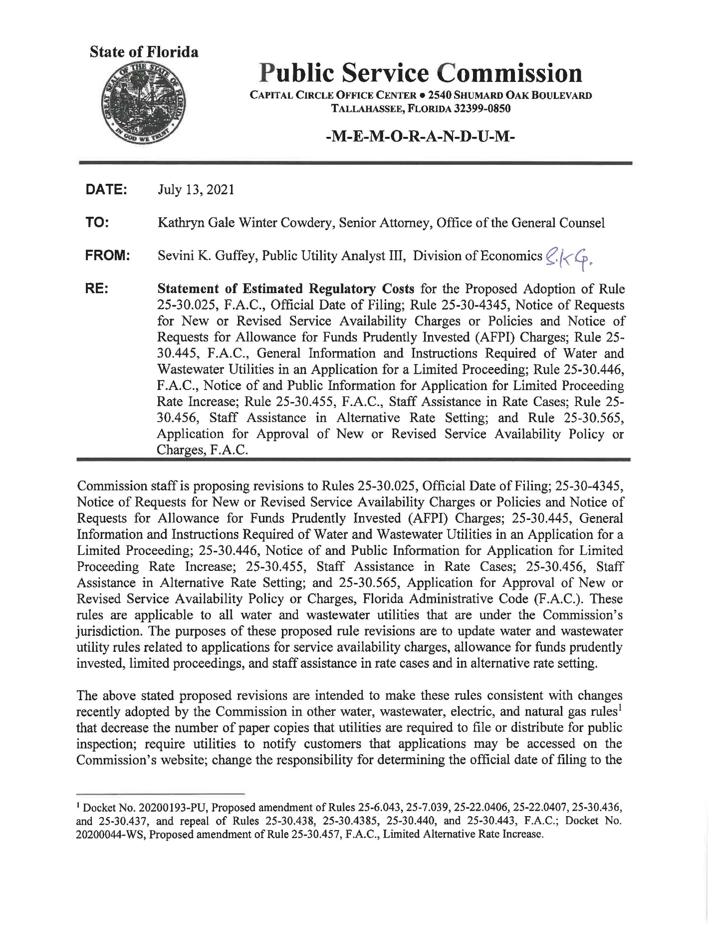

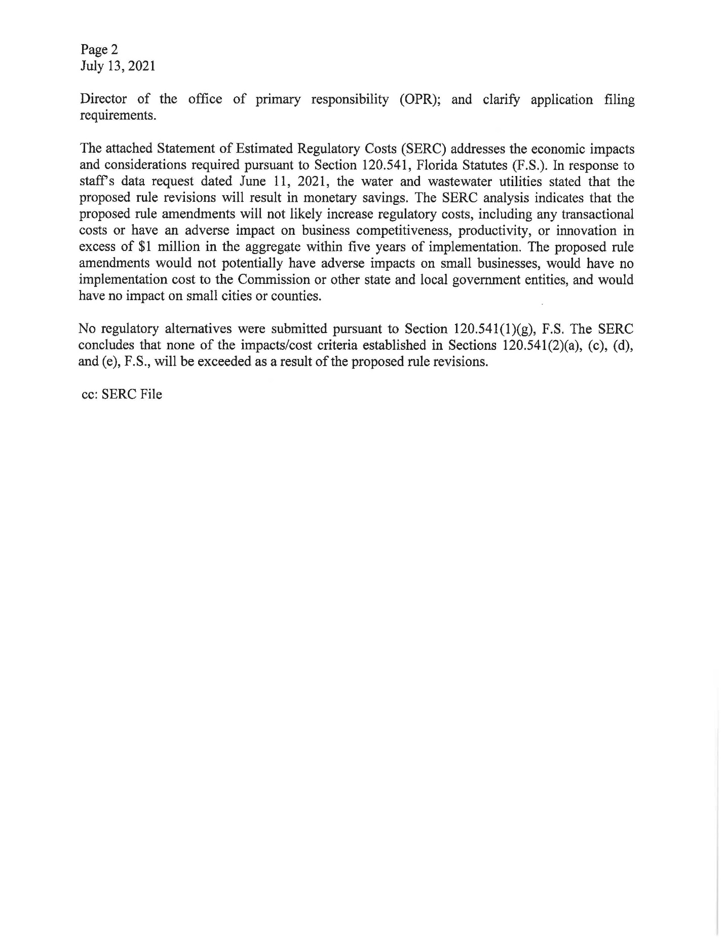

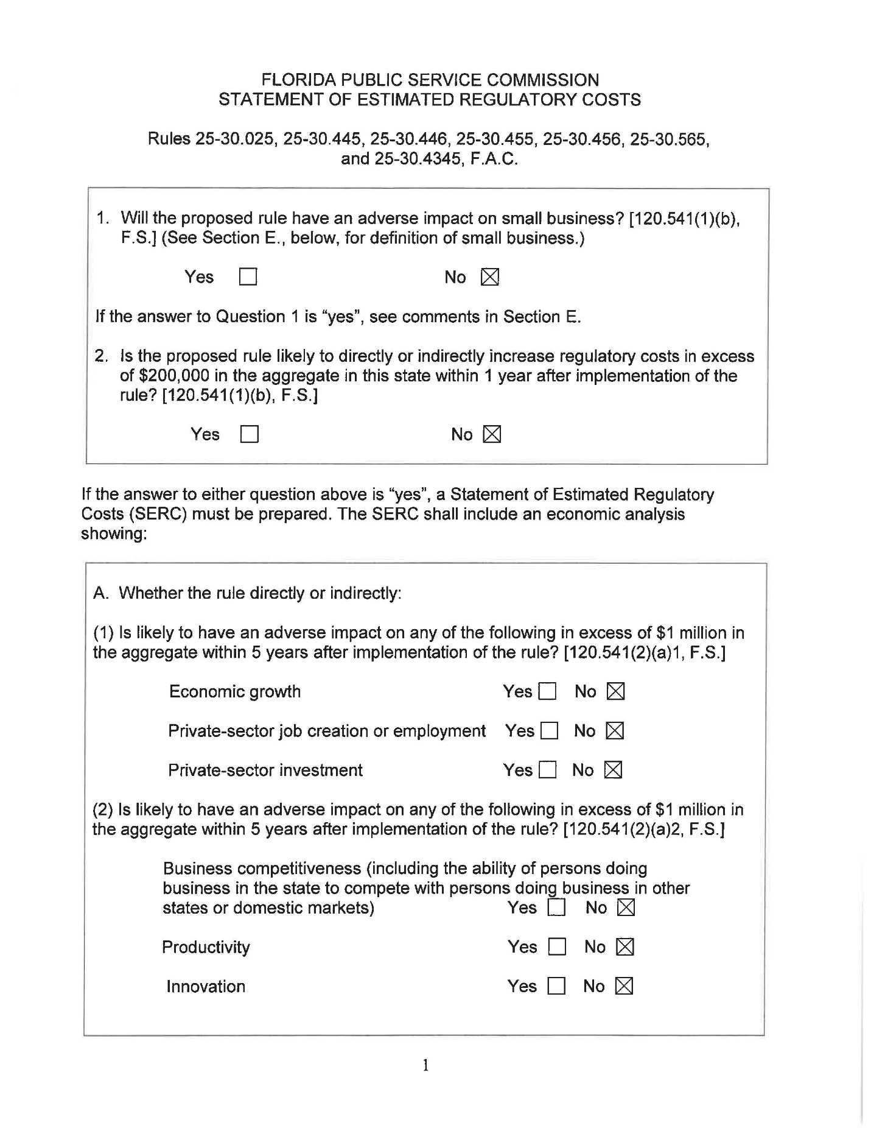

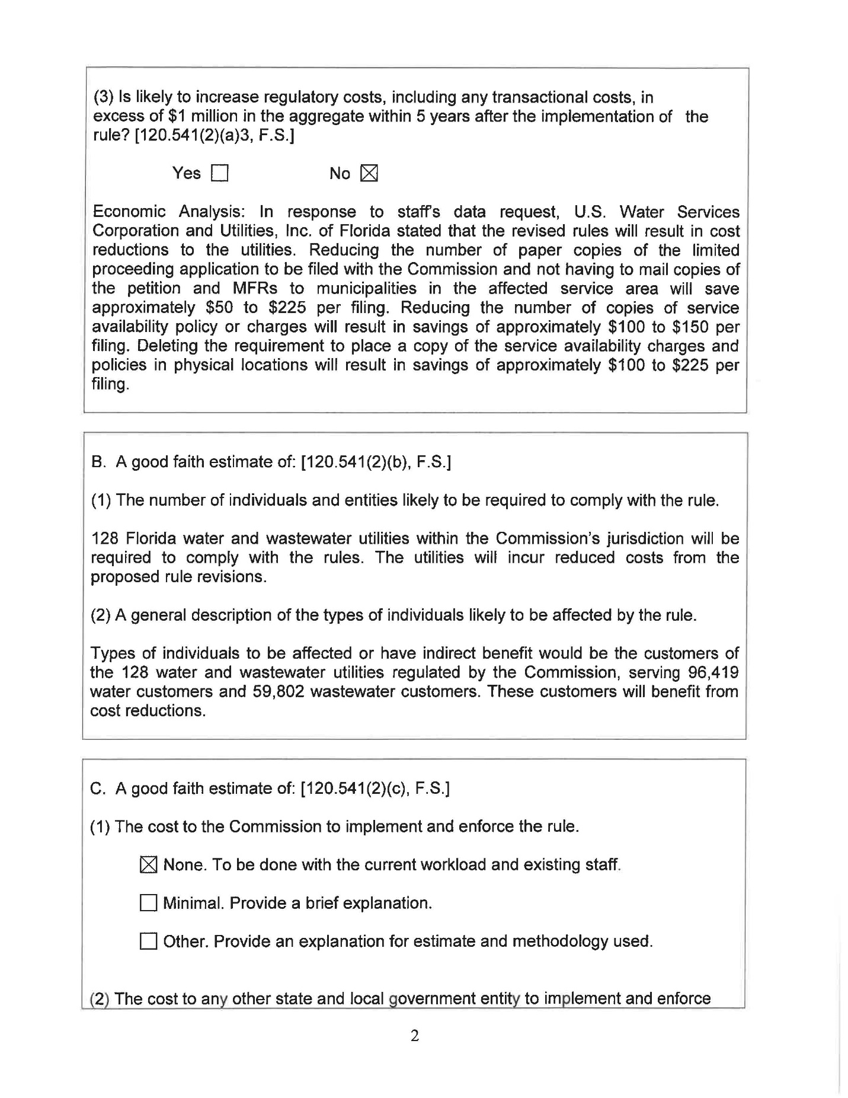

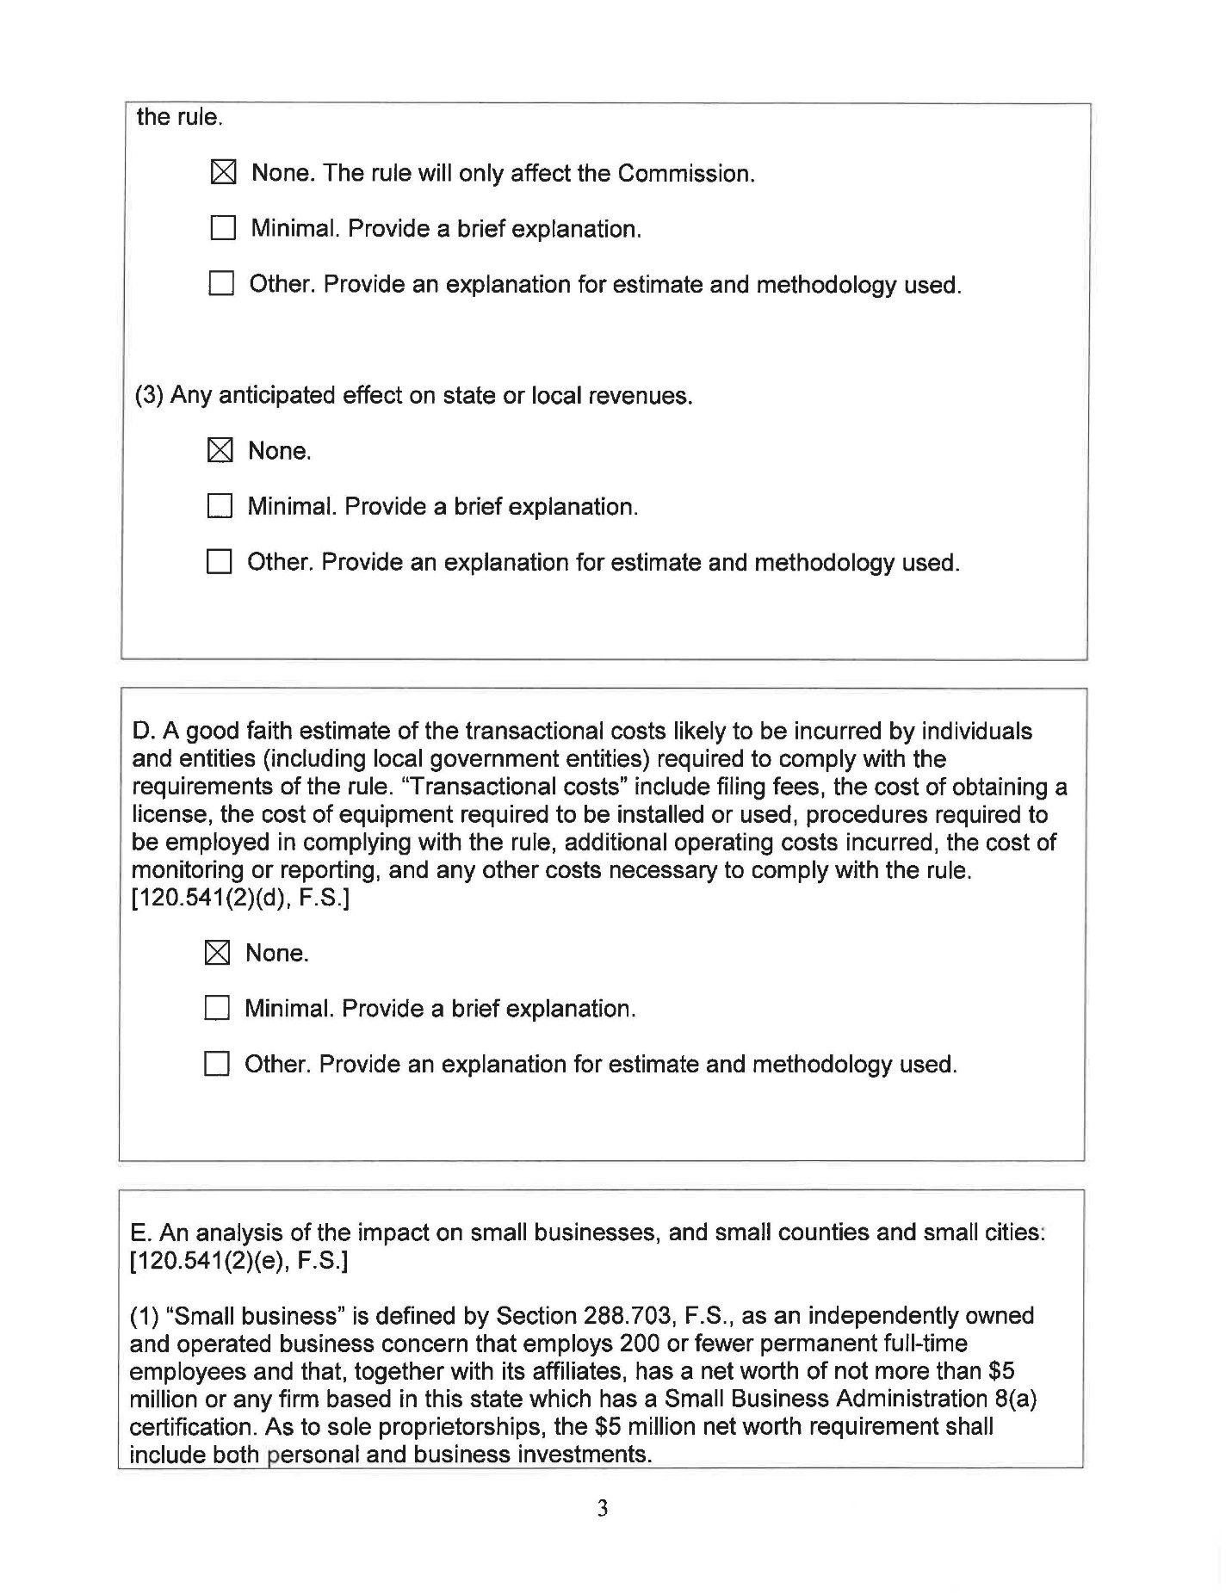

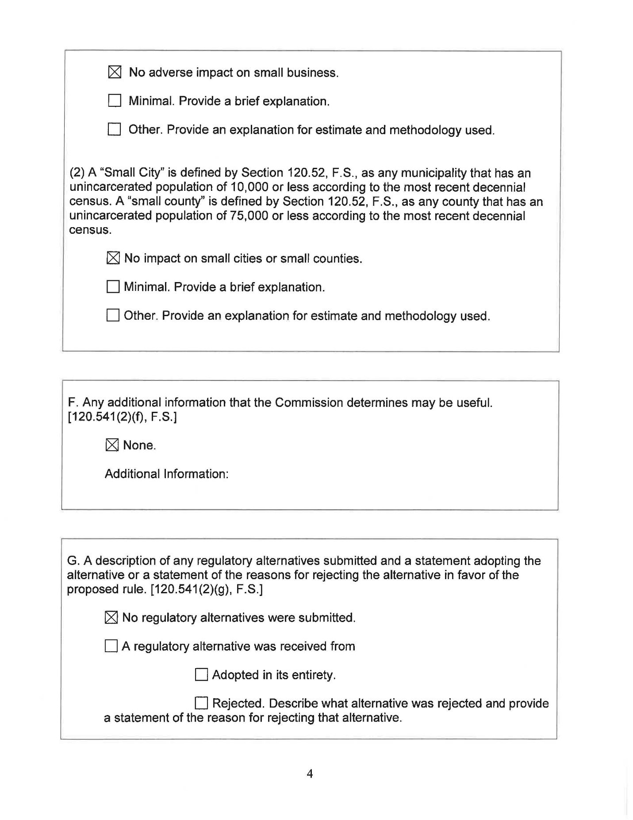

Docket No. 20200193-PU, Proposed amendment of Rules 25-6.043, 25-7.039, 25-22.0406, 25-22.0407, 25-30.436, and 25-30.437, and repeal of Rules 25-30.438, 25-30.4385, 25-30.440, and 25-30.443, F.A.C.; Docket No. 20200044-WS, Proposed amendment of Rule 25-30.457, F.A.C., Limited Alternative Rate Increase.
Rules 25-6.043(2), 25-7.039(2), 25-30.436 (6), F.A.C.
Rule 25-22.0406, F.A.C., Notice and Public Information on General Rate Increase Requests and Petitions for Limited Proceedings by Electric and Gas Utilities. Rule 25-22.0407, F.A.C., Notice of and Public Information for General Rate Increase Requests by Water and Wastewater Utilities.
Rule 25-22.0406, F.A.C., Notice and Public Information on General Rate Increase Requests and Petitions for Limited Proceedings by Electric and Gas Utilities. Rule 25-22.0407, F.A.C., Notice of and Public Information for General Rate Increase Requests by Water and Wastewater Utilities.

