State of Florida |  | Public Service Commission  Capital Circle Office Center ● 2540 Shumard Oak Boulevard  Tallahassee, Florida 32399-0850  -M-E-M-O-R-A-N-D-U-M-
DATE: | December 29, 2021
TO: | Office of Commission Clerk (Teitzman)
FROM: | Division of Engineering (Lewis)  Office of the General Counsel (Sandy, J. Crawford)
RE: | Docket No. 20210125-WS – Application for amendment of Certificate Nos. 677-W and 577-S to delete territory in Lake and Sumter Counties, by Gibson Place Utility Company, LLC.
AGENDA: | 01/11/22 – Regular Agenda – Interested Persons May Participate
COMMISSIONERS ASSIGNED: |  |  | Staff
PREHEARING OFFICER: |  |  | Administrative
CRITICAL DATES: |  |  | None
SPECIAL INSTRUCTIONS: |  |  | None

Case Background
Gibson Place Utility Company, LLC (GPU or Utility) is a water and wastewater Utility in Lake and Sumter Counties. The Utility is in the Southwest Florida Management District (SWFWMD) and is not in a water use caution area. The Utility was granted its original certificates on November 24, 2020, and the Commission also approved the Utility’s request for partial waiver of Rule 25-30.033, Florida Administrative Code (F.A.C.), for rates to be set at a later date.
On July 27, 2021, pursuant to Section 367.045, Florida Statutes (F.S.), the Utility applied for an amendment to delete part of its service territory from Certificate Nos. 677-W and 577-S. The proposed territory to be deleted consists of two separate areas within the Utility’s certificated service territory that are currently undeveloped. Of the two areas, one will consist of high density commercial customers, while the other will have some commercial customers along with mostly multi-family residential units. The Utility is requesting these two areas be deleted because they will be developed after the remaining territory, which will consist of single family age-restricted housing units. Based on the Utility’s November 10, 2021 Status Report, GPU anticipates it will begin to serve customers within the remaining territory the first quarter of 2023 and plans to file the financial information to establish rates and charges as part of Docket No. 20200185-WS. The Commission has jurisdiction pursuant to Section 367.045, F.S.

Discussion of Issues

Issue 1:
Should the Commission approve GPU’s application for amendment of Certificate Nos. 677-W and 577-S to delete territory from its certificated service area in Lake and Sumter Counties?

Recommendation:
Yes. The Commission should approve the application filed by GPU to delete portions of its service territory, as reflected in Attachment A, from its certificated service area. The resultant order should serve as GPU’s amended certificate and should be retained by the Utility. (Lewis)

Staff Analysis:
On July 27, 2021, GPU applied for an amendment to delete portions of its certificated service territory. GPU has not completed the construction of its water and wastewater plants, nor its water distribution or wastewater collection systems in either the area to be deleted or the remaining original service territory. GPU is requesting to delete this territory because it will be developed at a different pace than the rest of the certificated service area.
The Utility’s application is compliant with the filing requirements set forth in Rule 25-30.036, F.A.C. Revised tariff sheets were not provided with the Utility’s application, as the Utility has been granted a temporary waiver of this Rule requirement pursuant to Order No. PSC-2020-0473-PAA-WS. In addition, the Utility provided proof of compliance with the noticing provisions set forth in Rule 25-30.030, F.A.C. No objections to the application have been received and the time for filing such has expired.
Staff recommends that it is in the public interest to approve the application filed by GPU to amend its water and wastewater certificates to delete the territory as shown in Attachment A. The resultant Commission order should serve as GPU’s amended certificate and should be retained by the Utility.

Issue 2:
Should this docket be closed?

Recommendation:
Yes. If staff’s recommendation in Issue 1 is approved, no further action is required, and the docket should be closed. (Sandy)

Staff Analysis:
If Issue 1 is approved, no further action is required, and the docket should be closed.

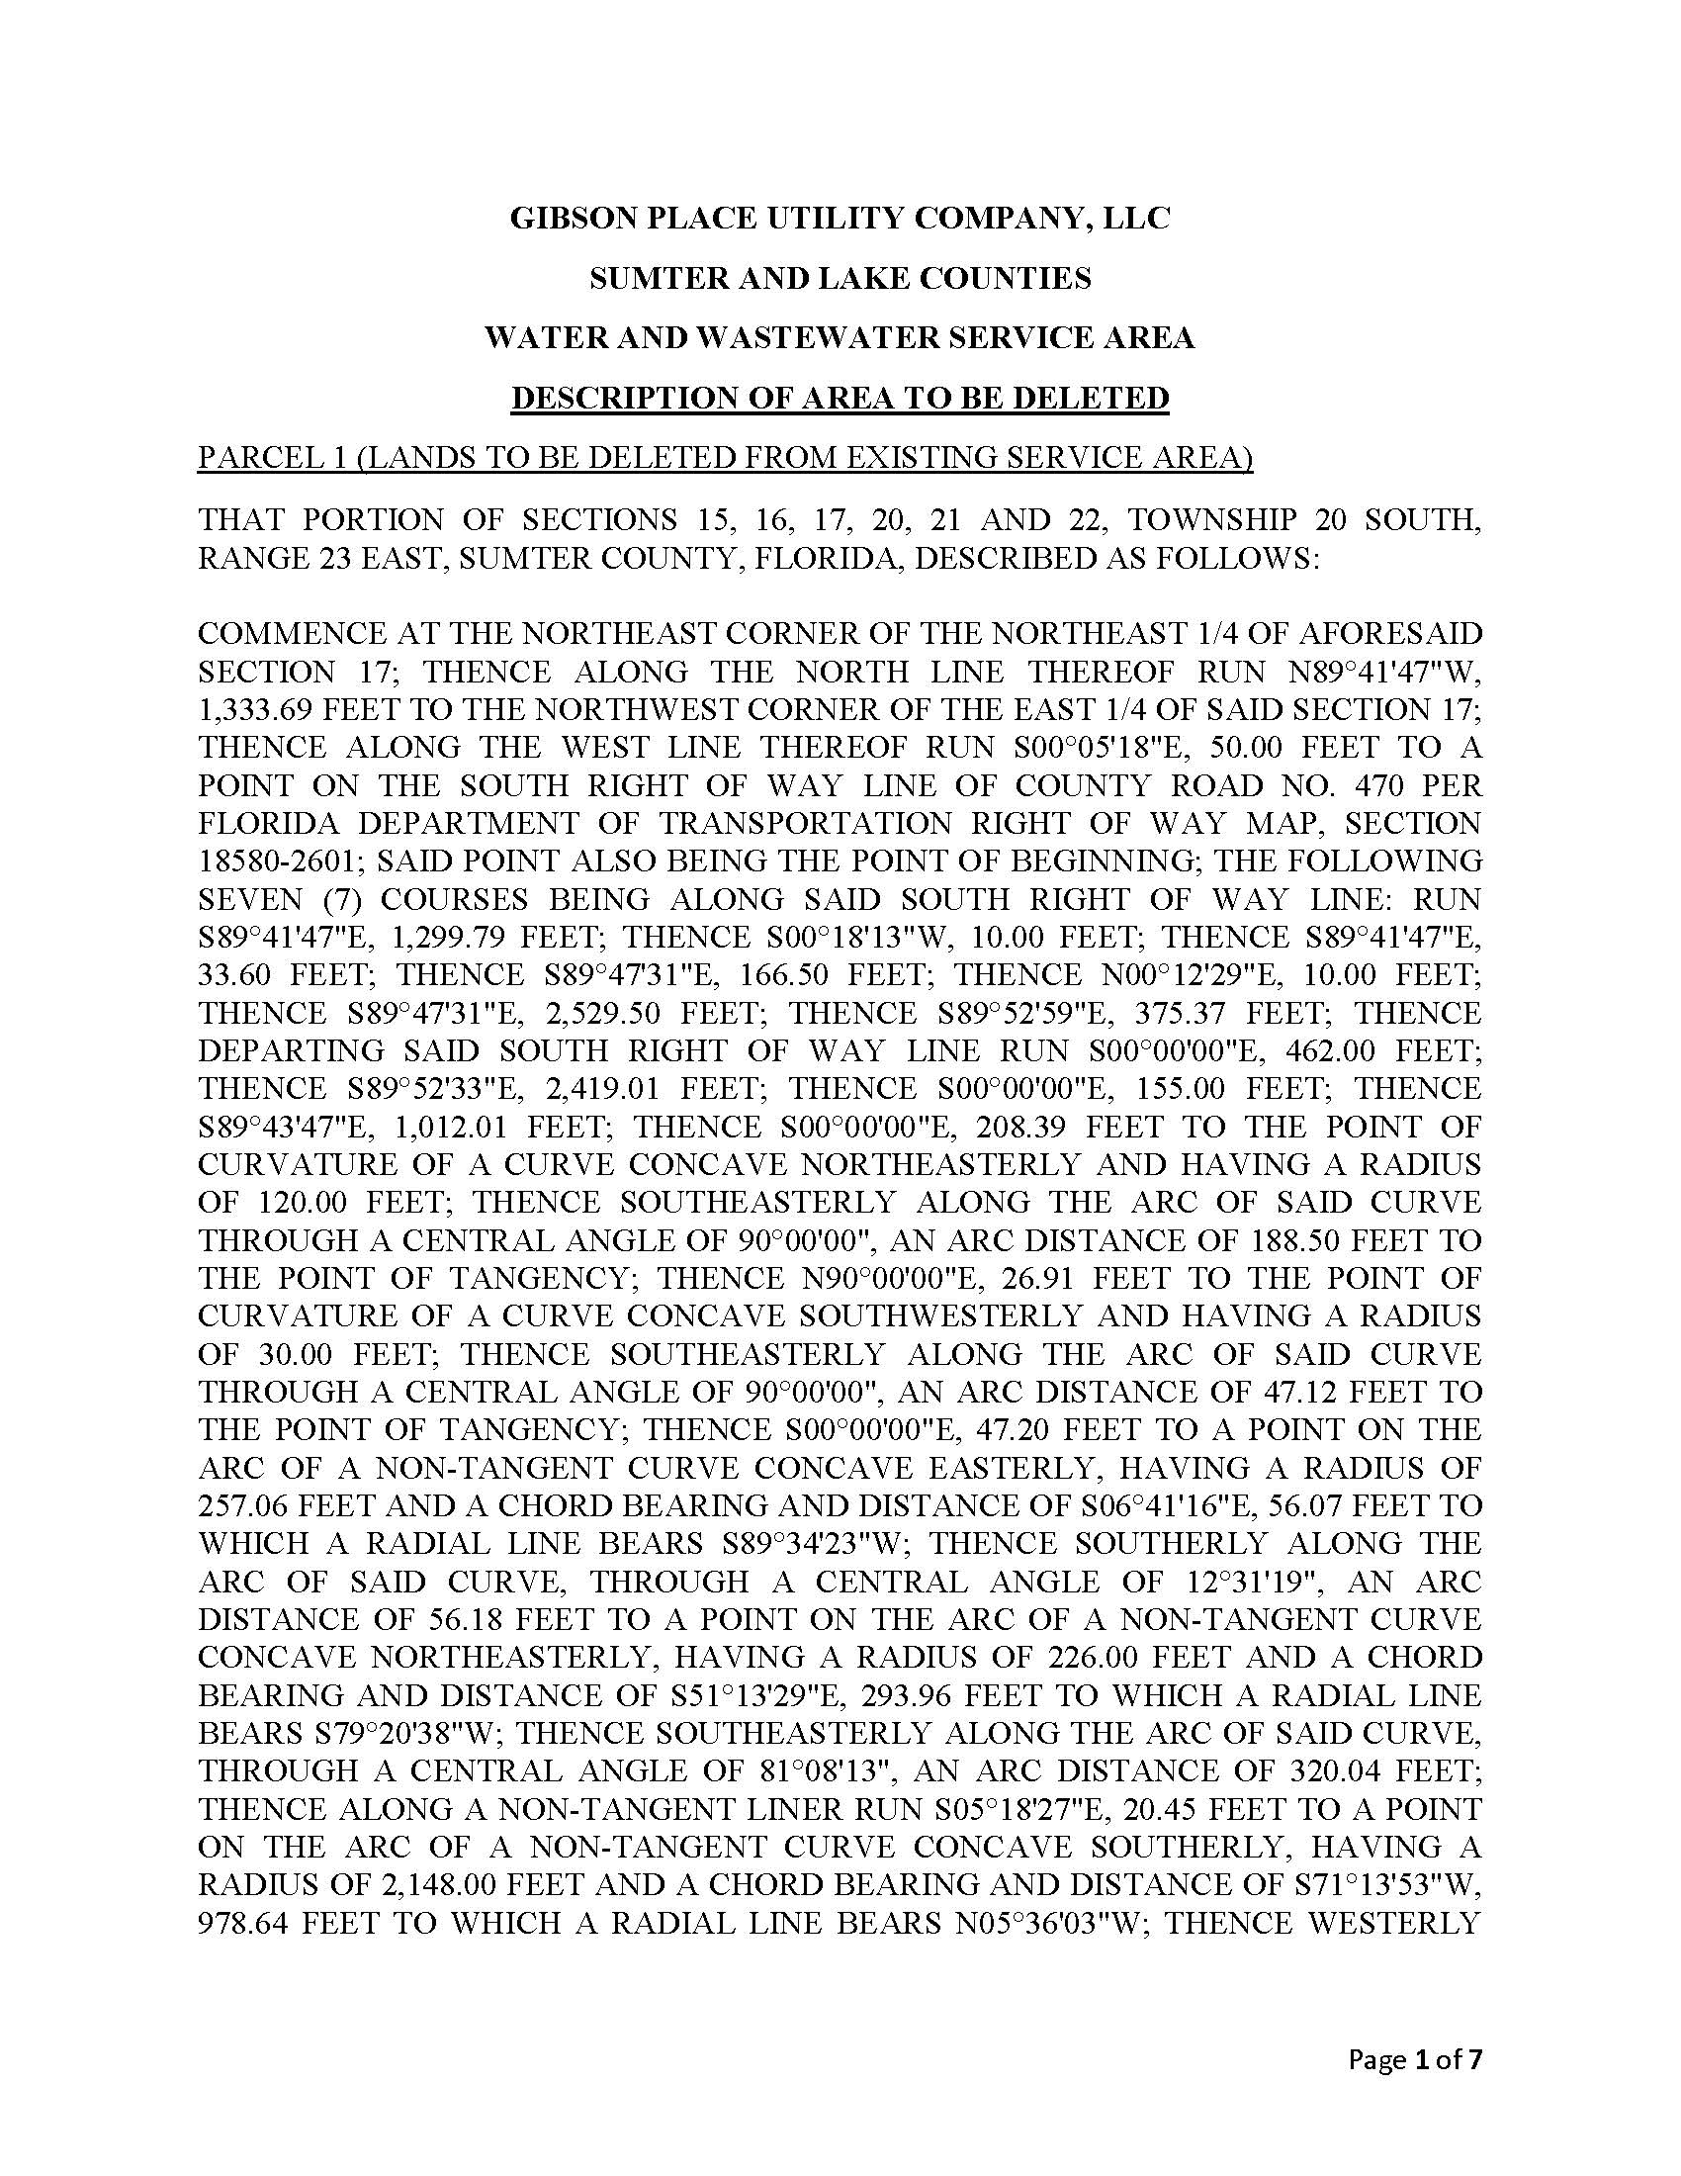

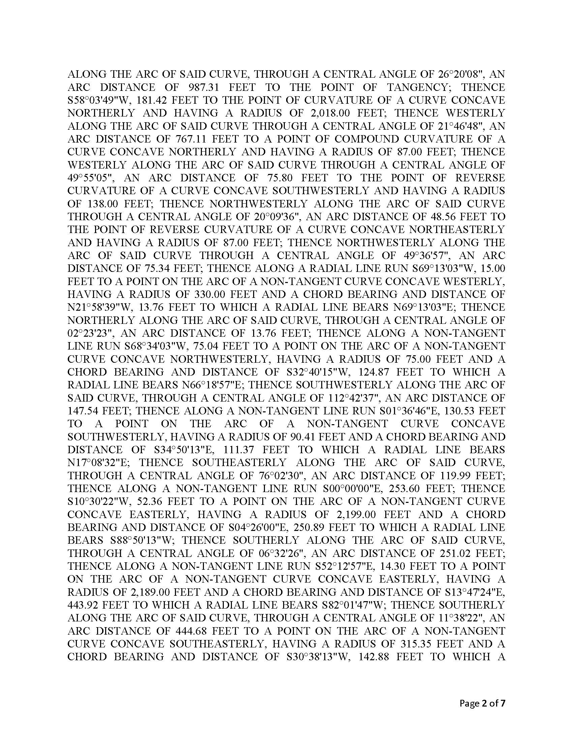

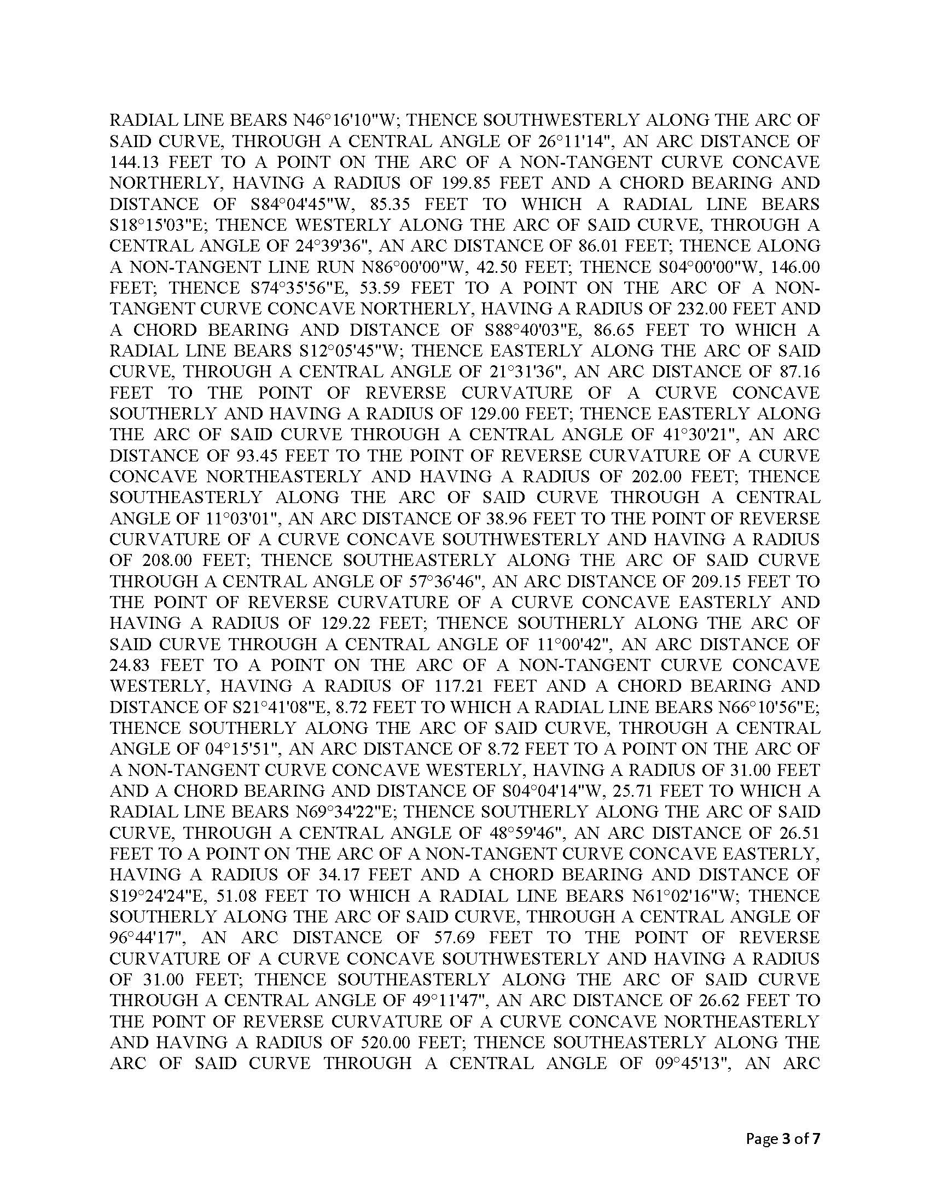

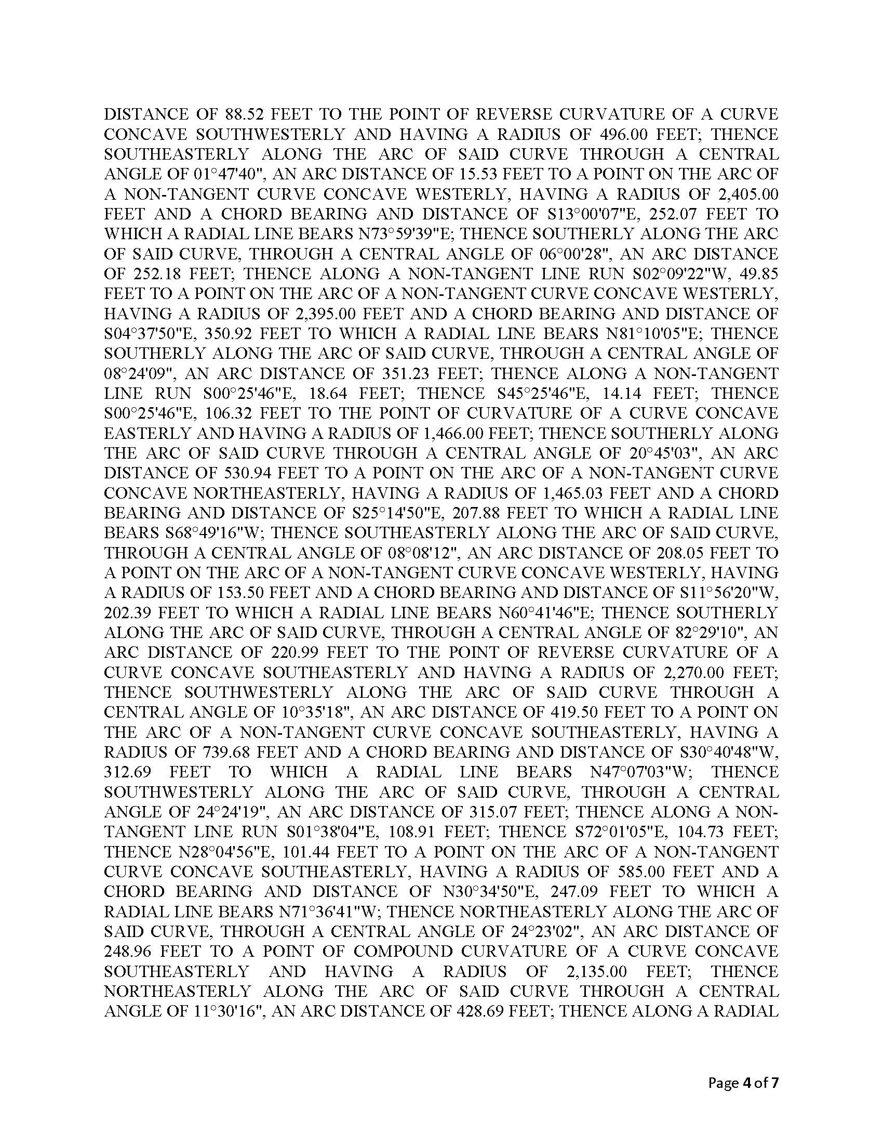

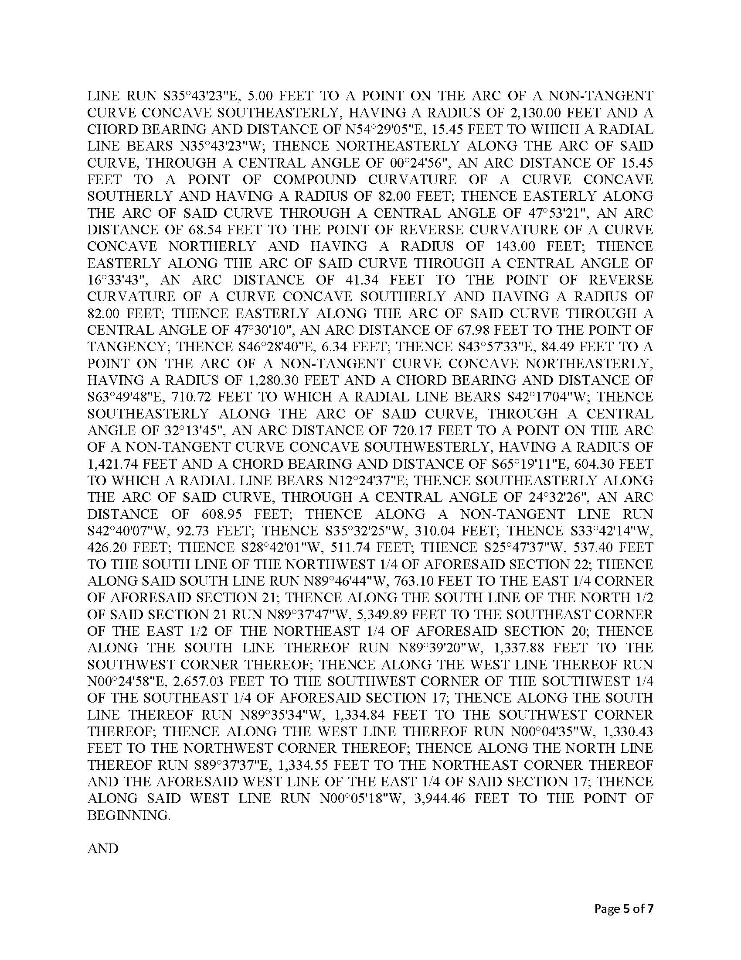

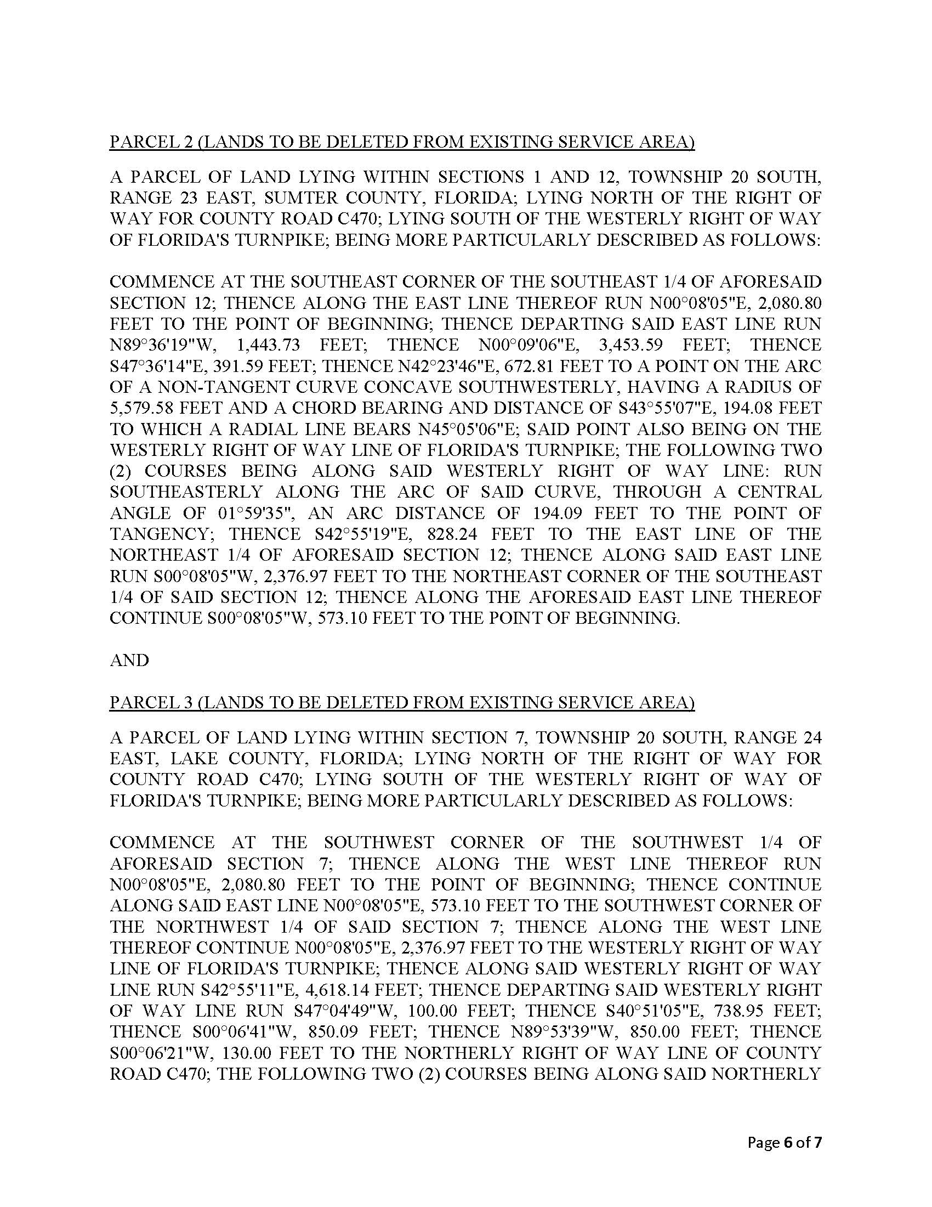

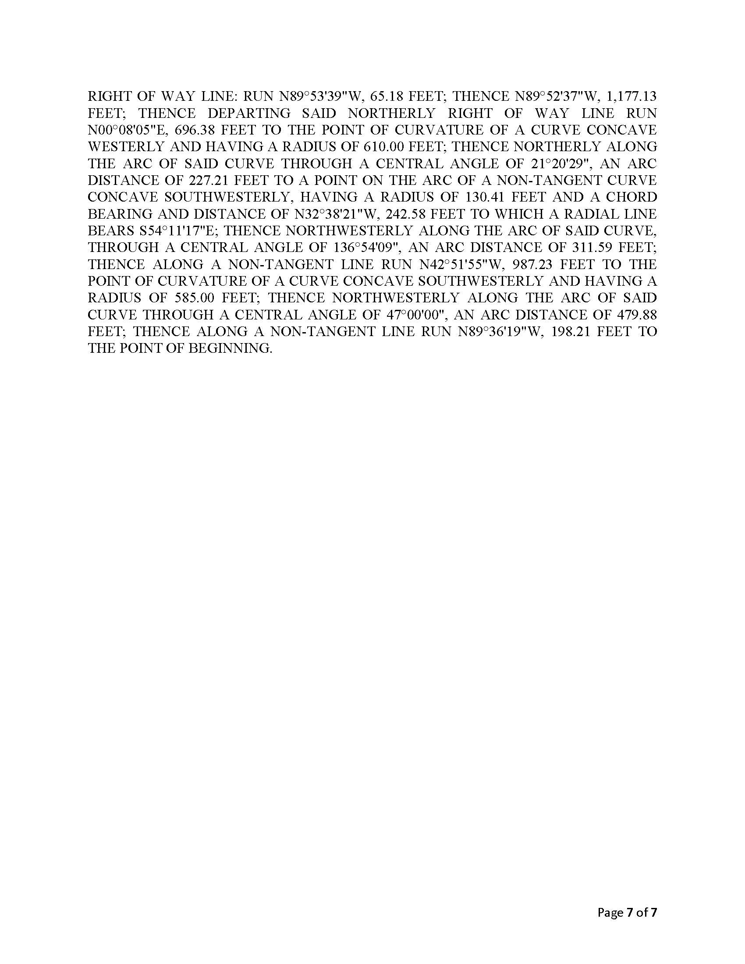

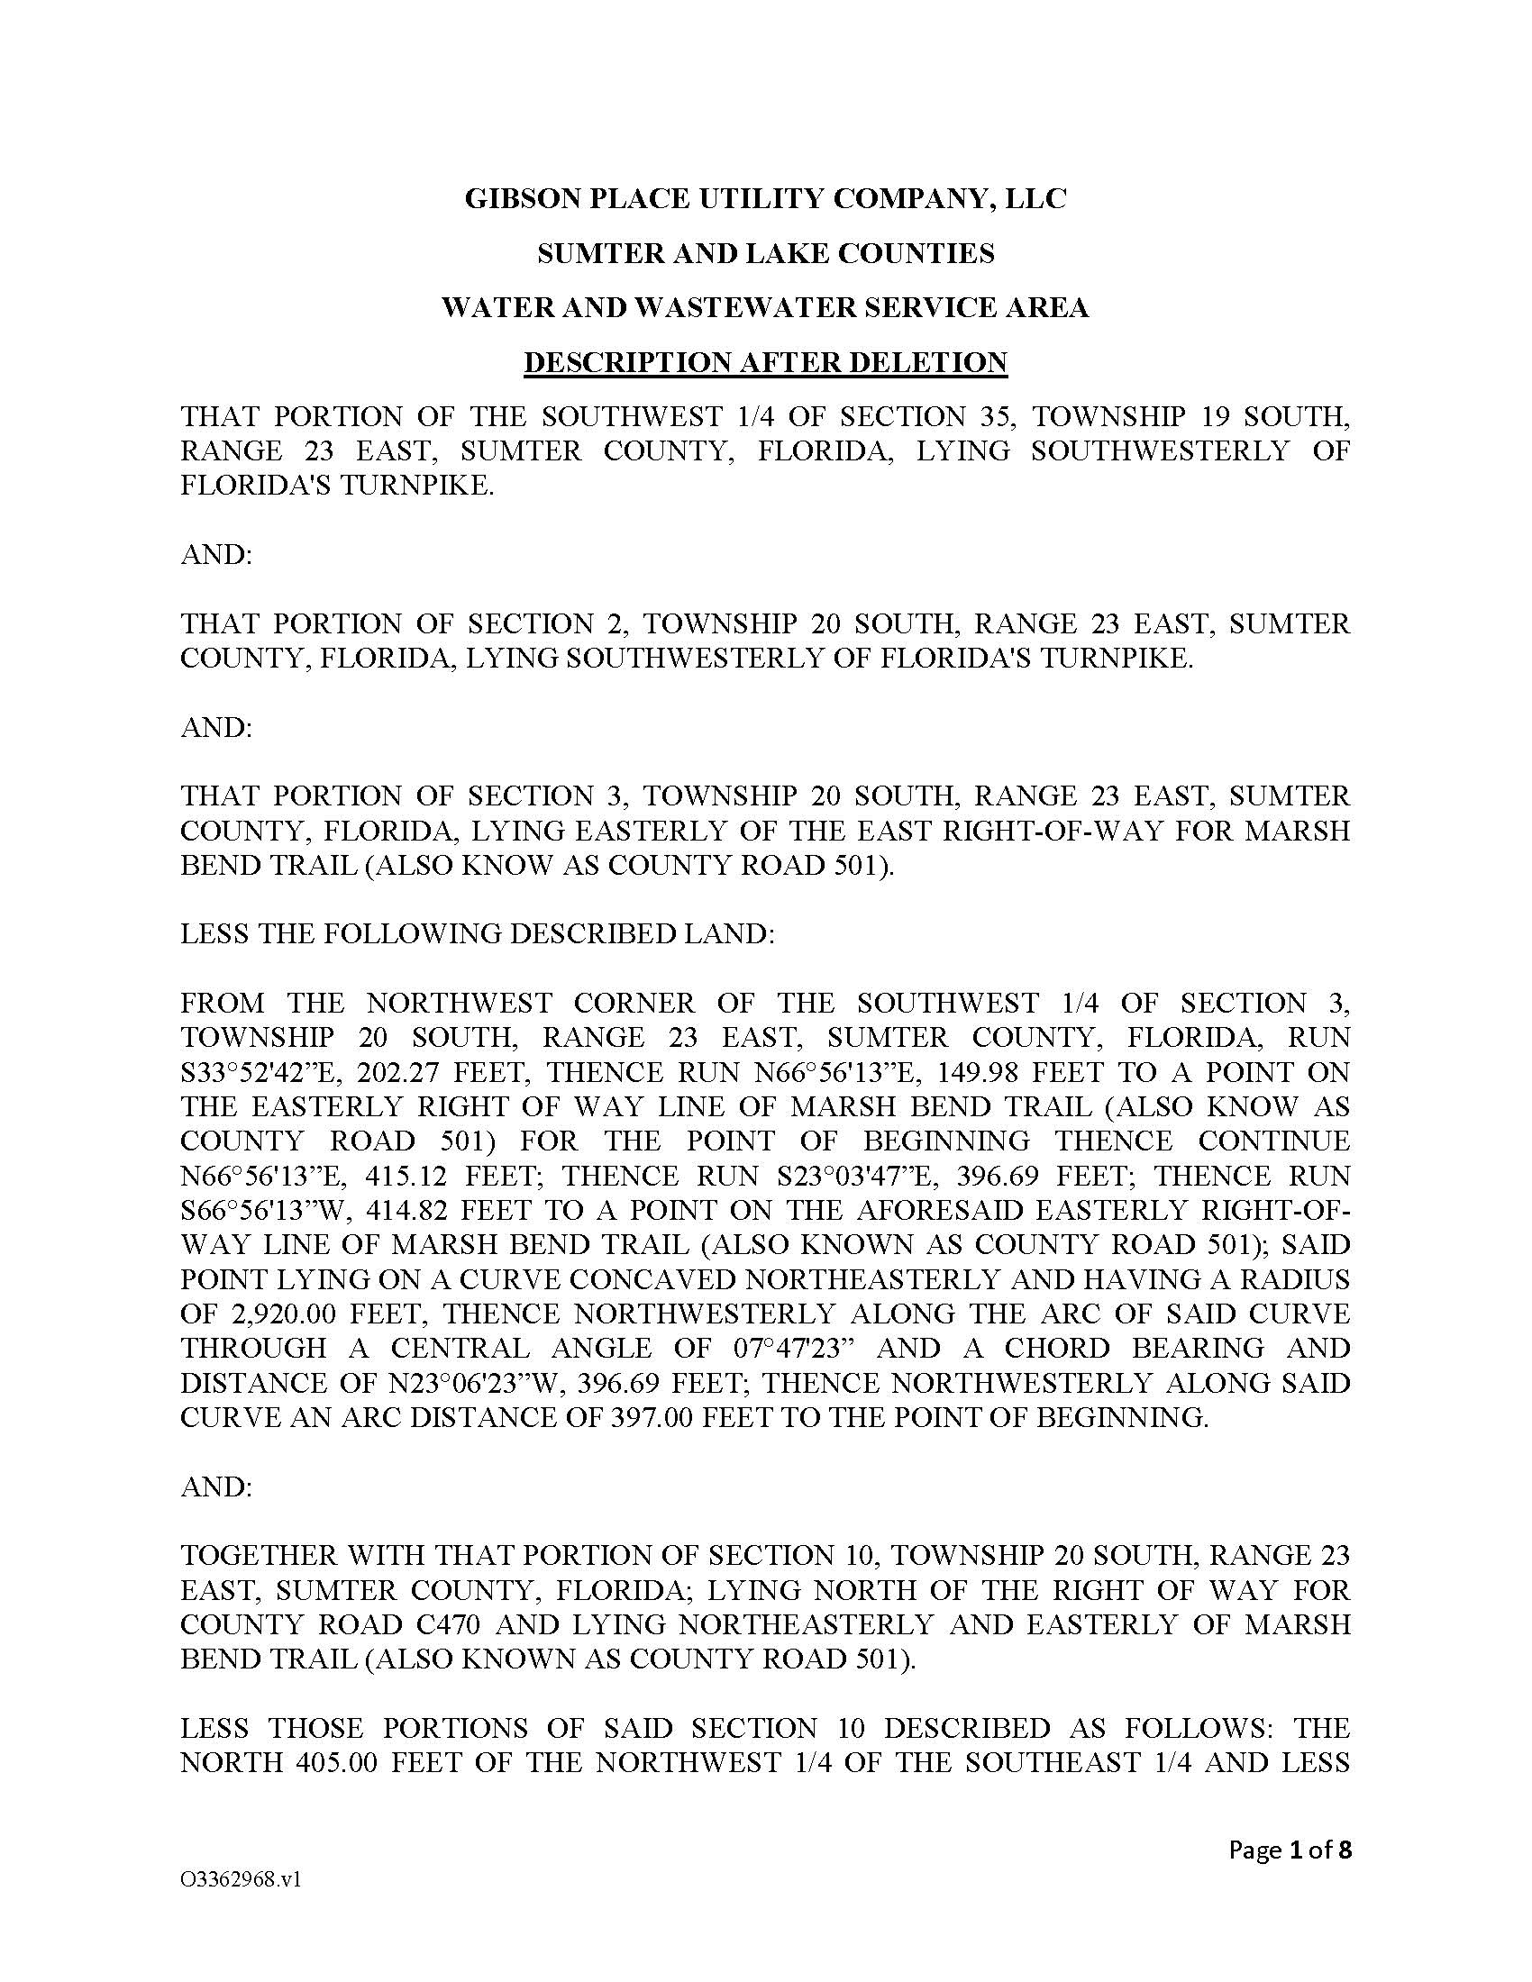

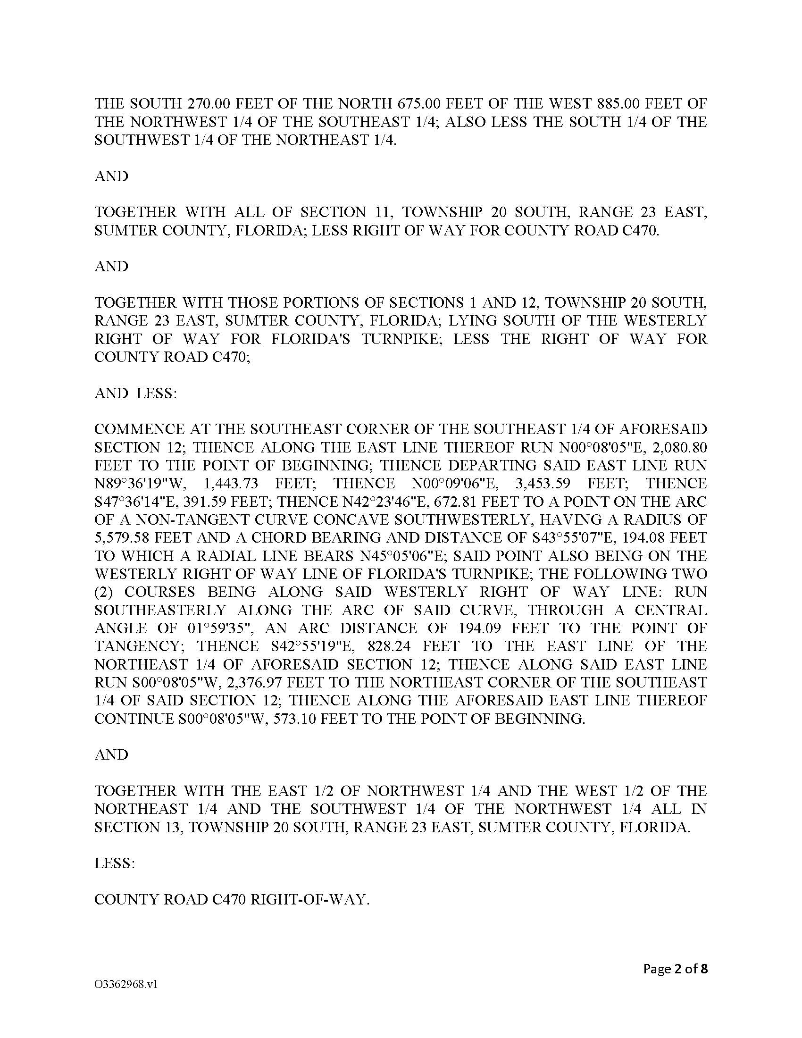

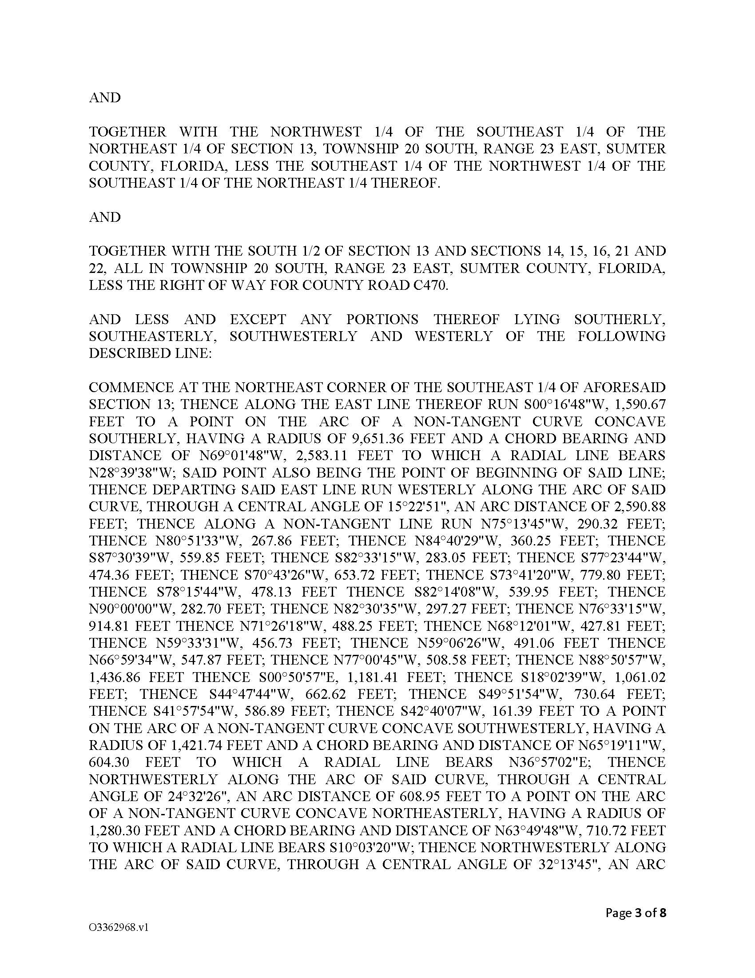

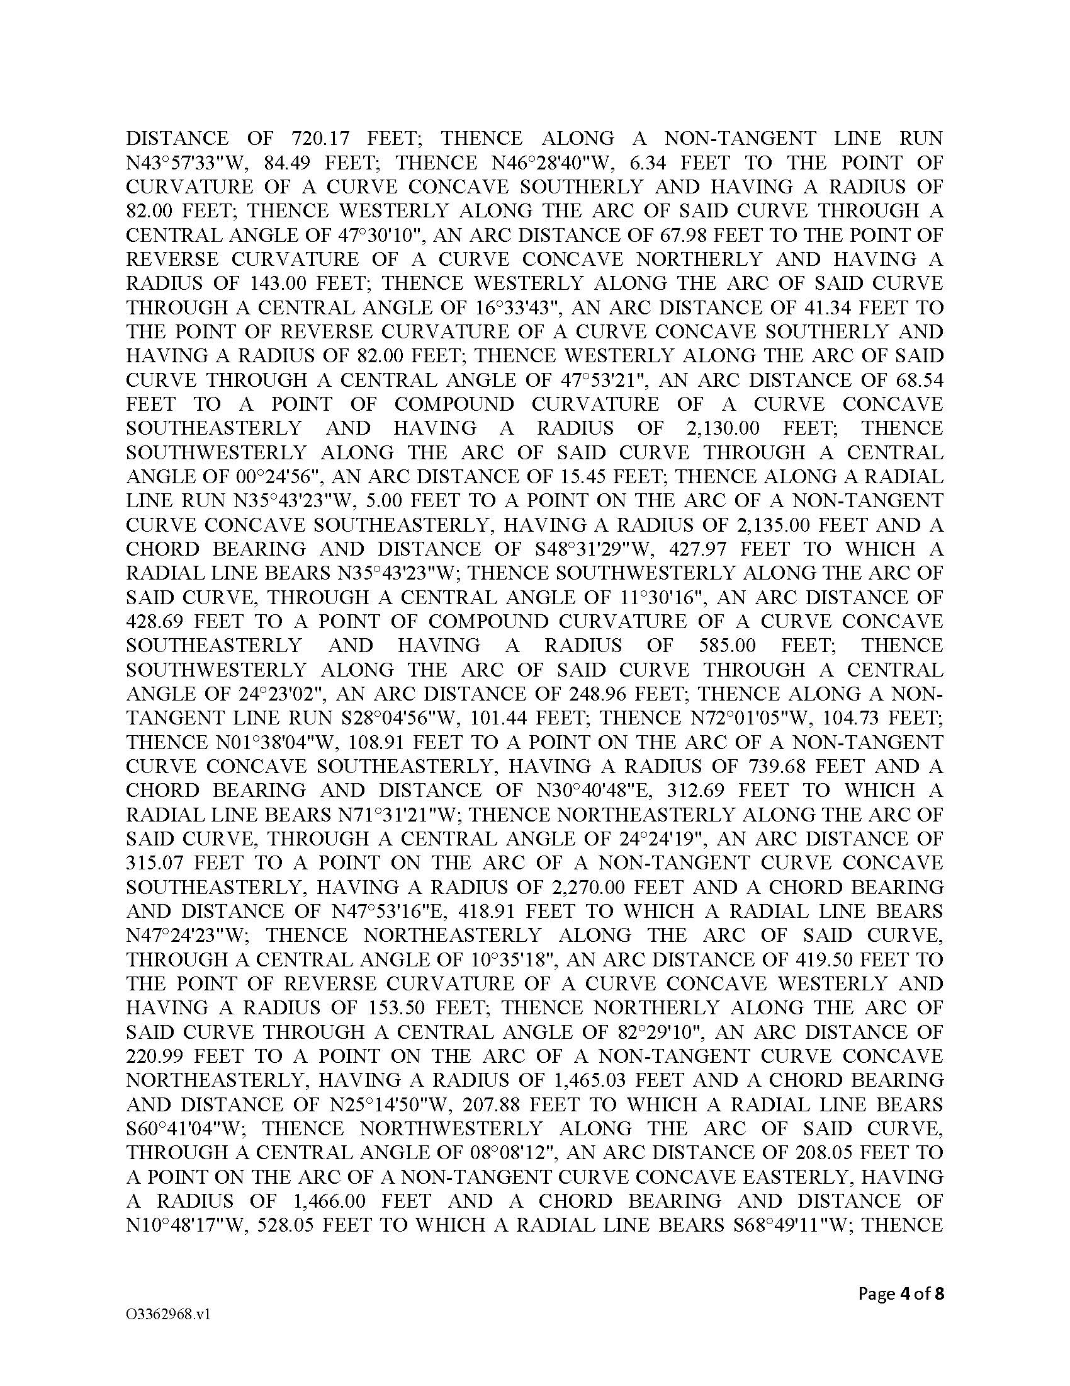

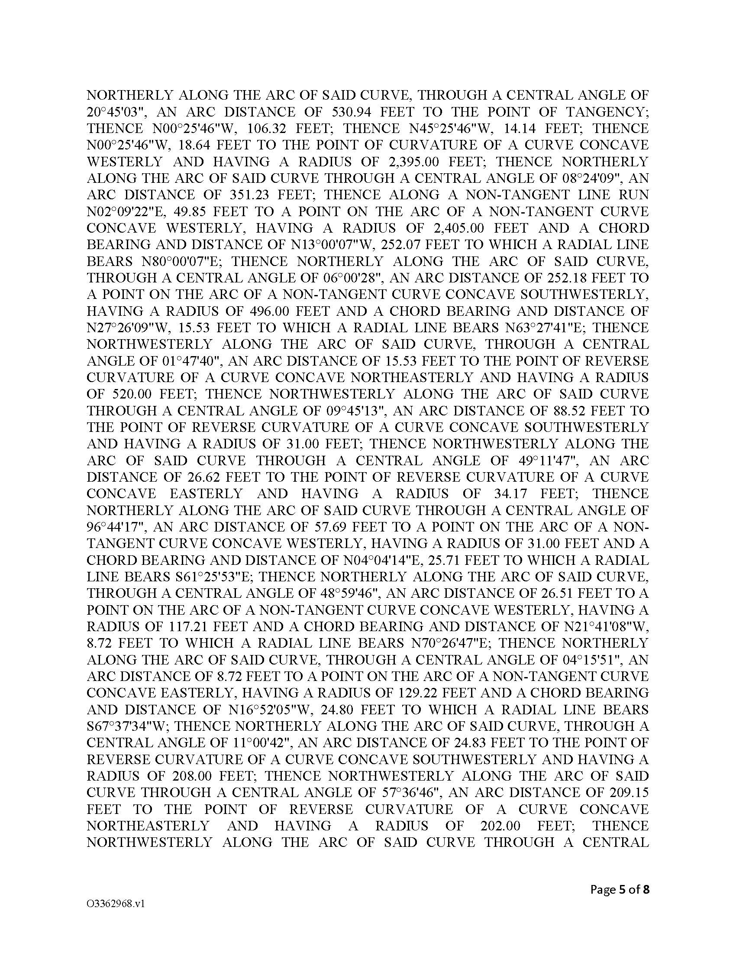

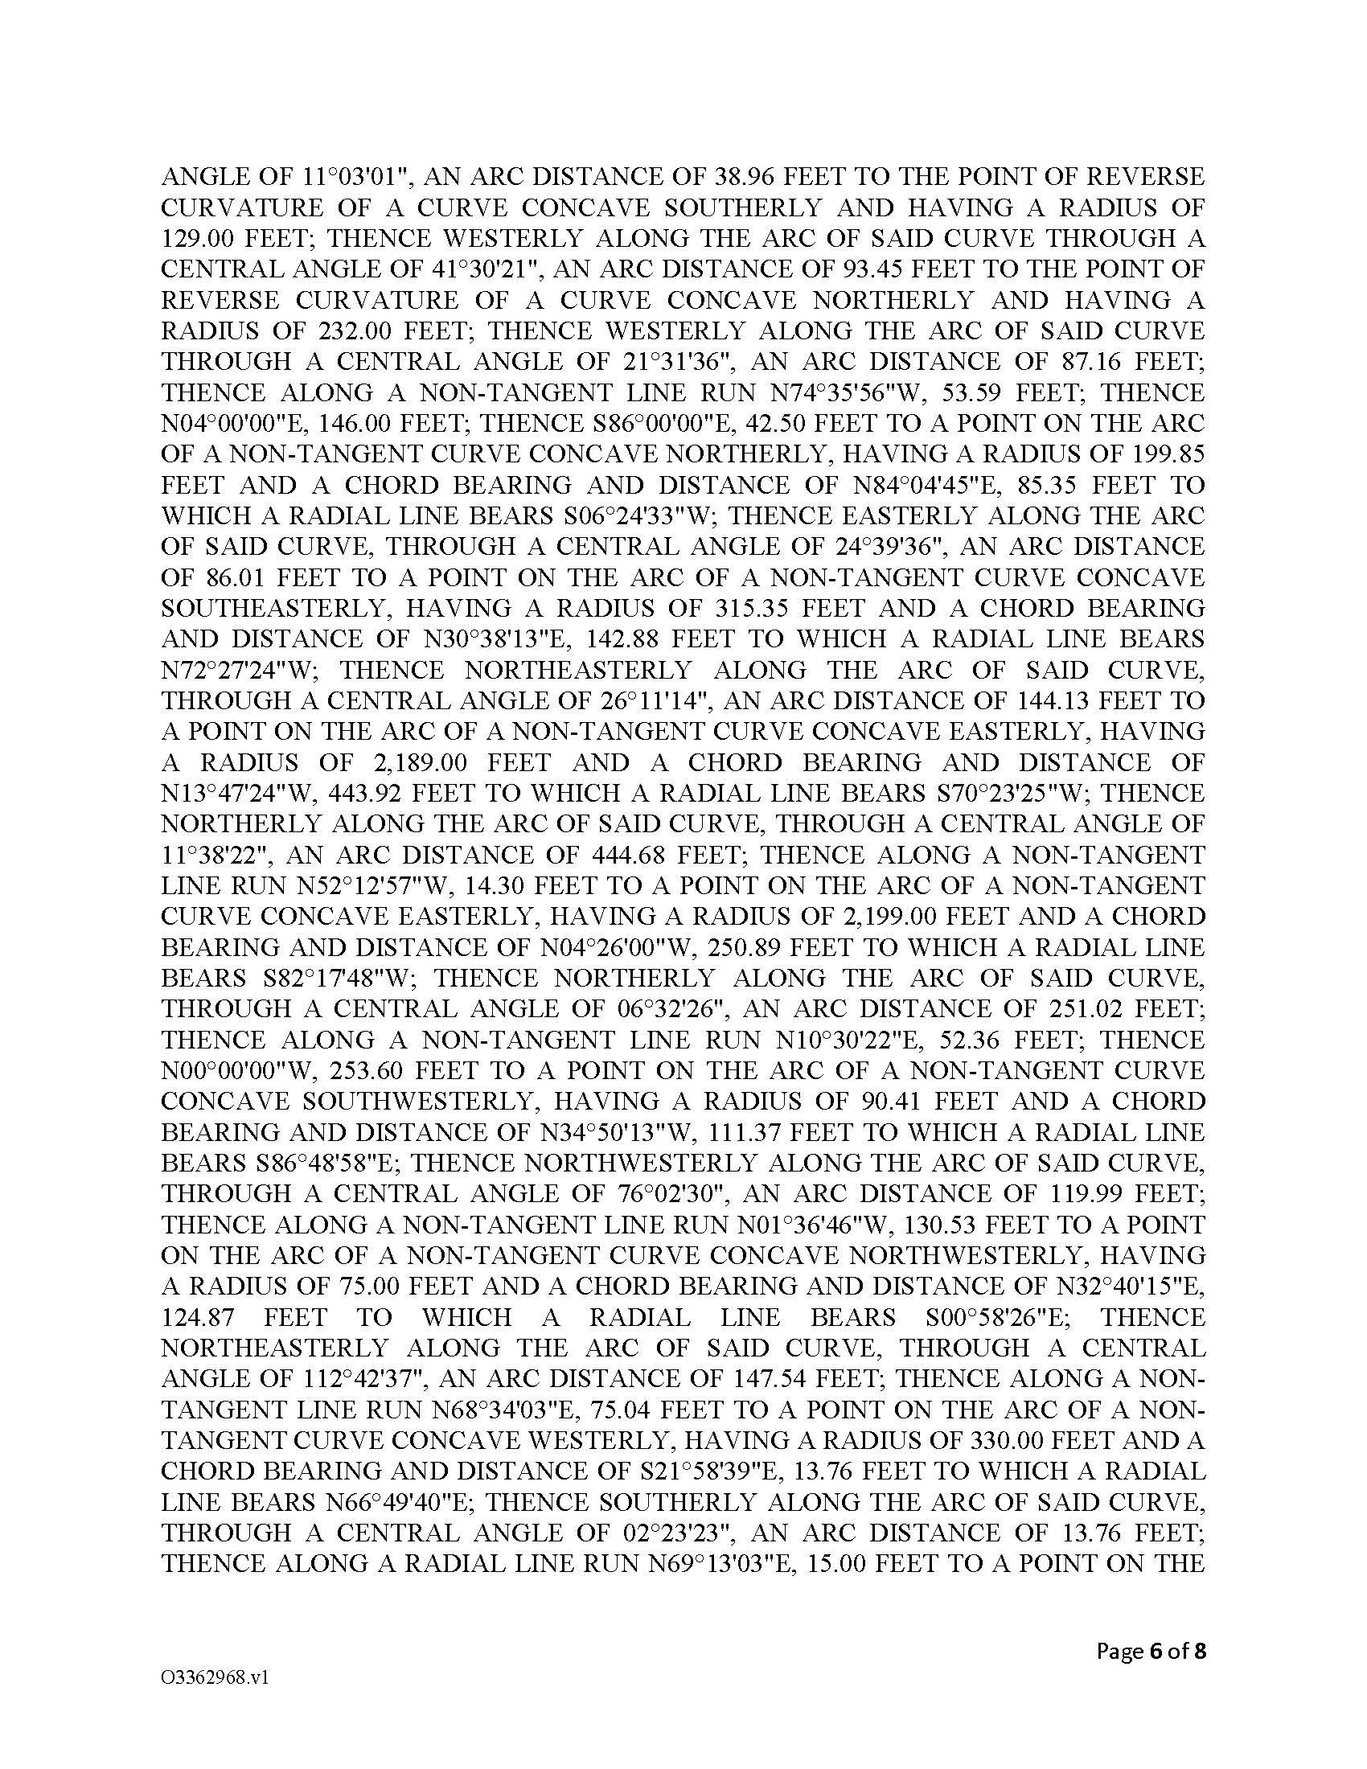

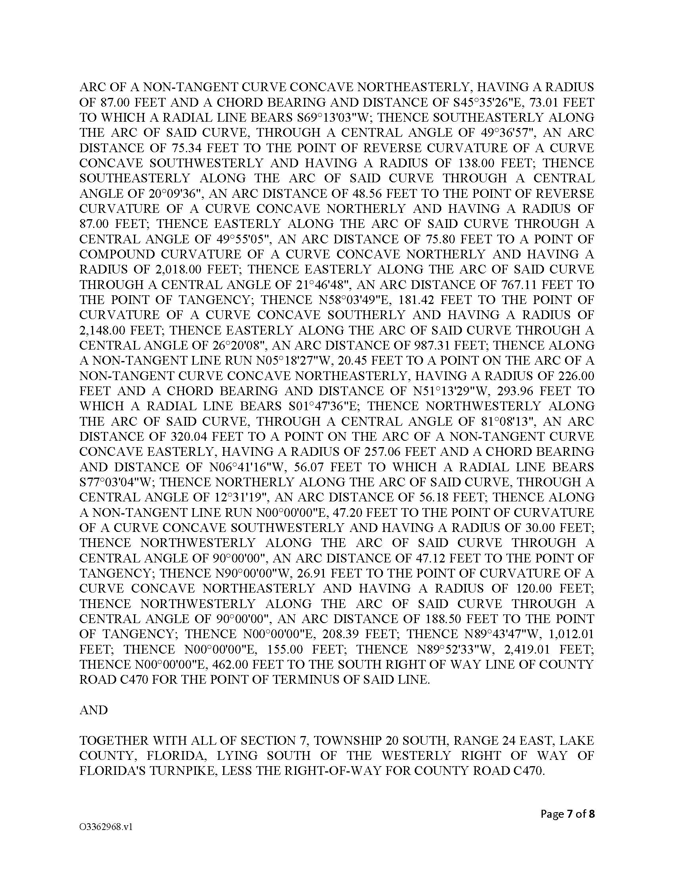

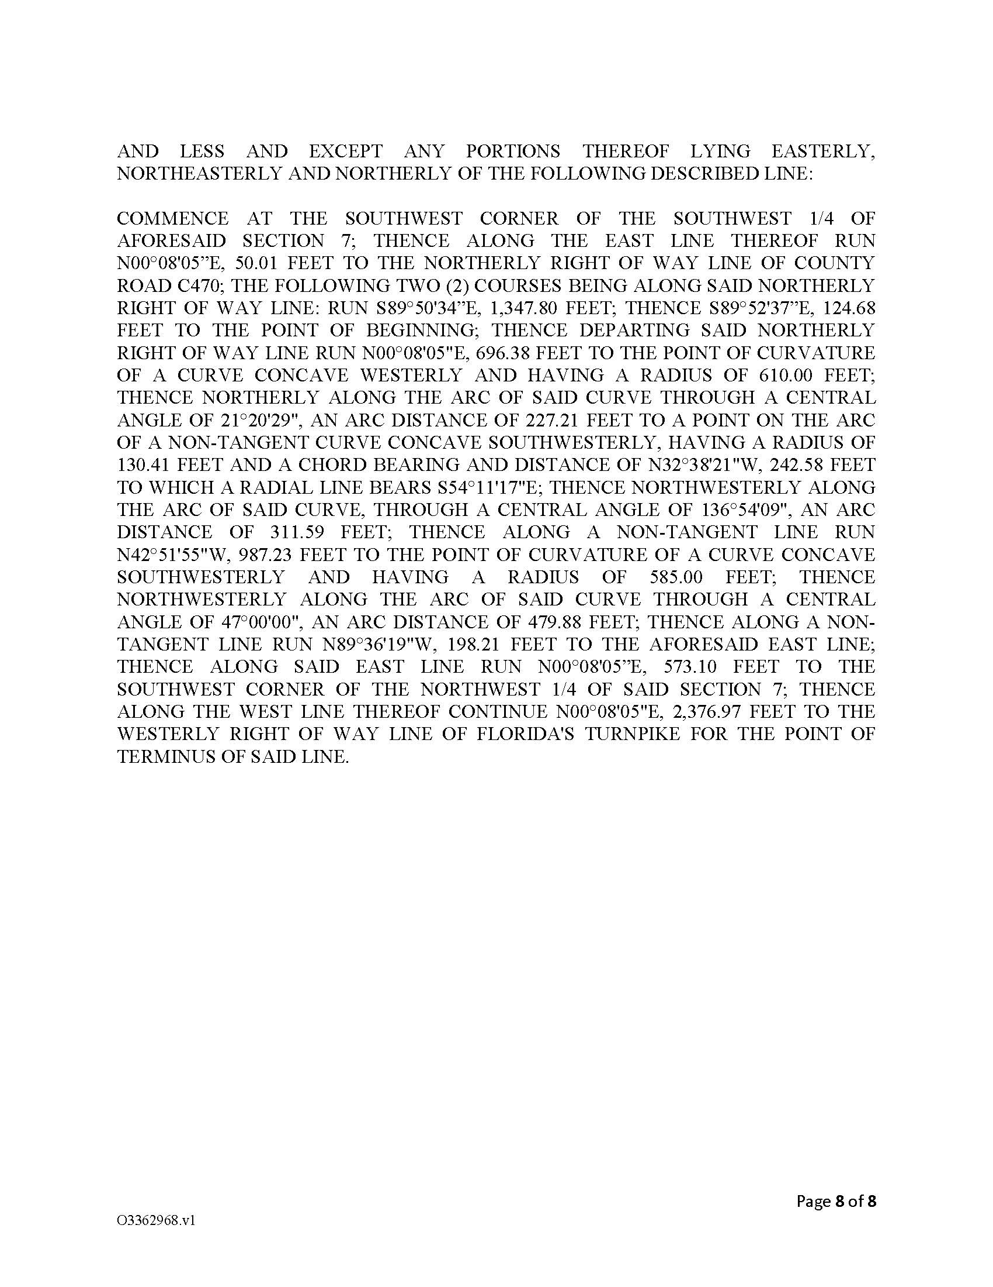

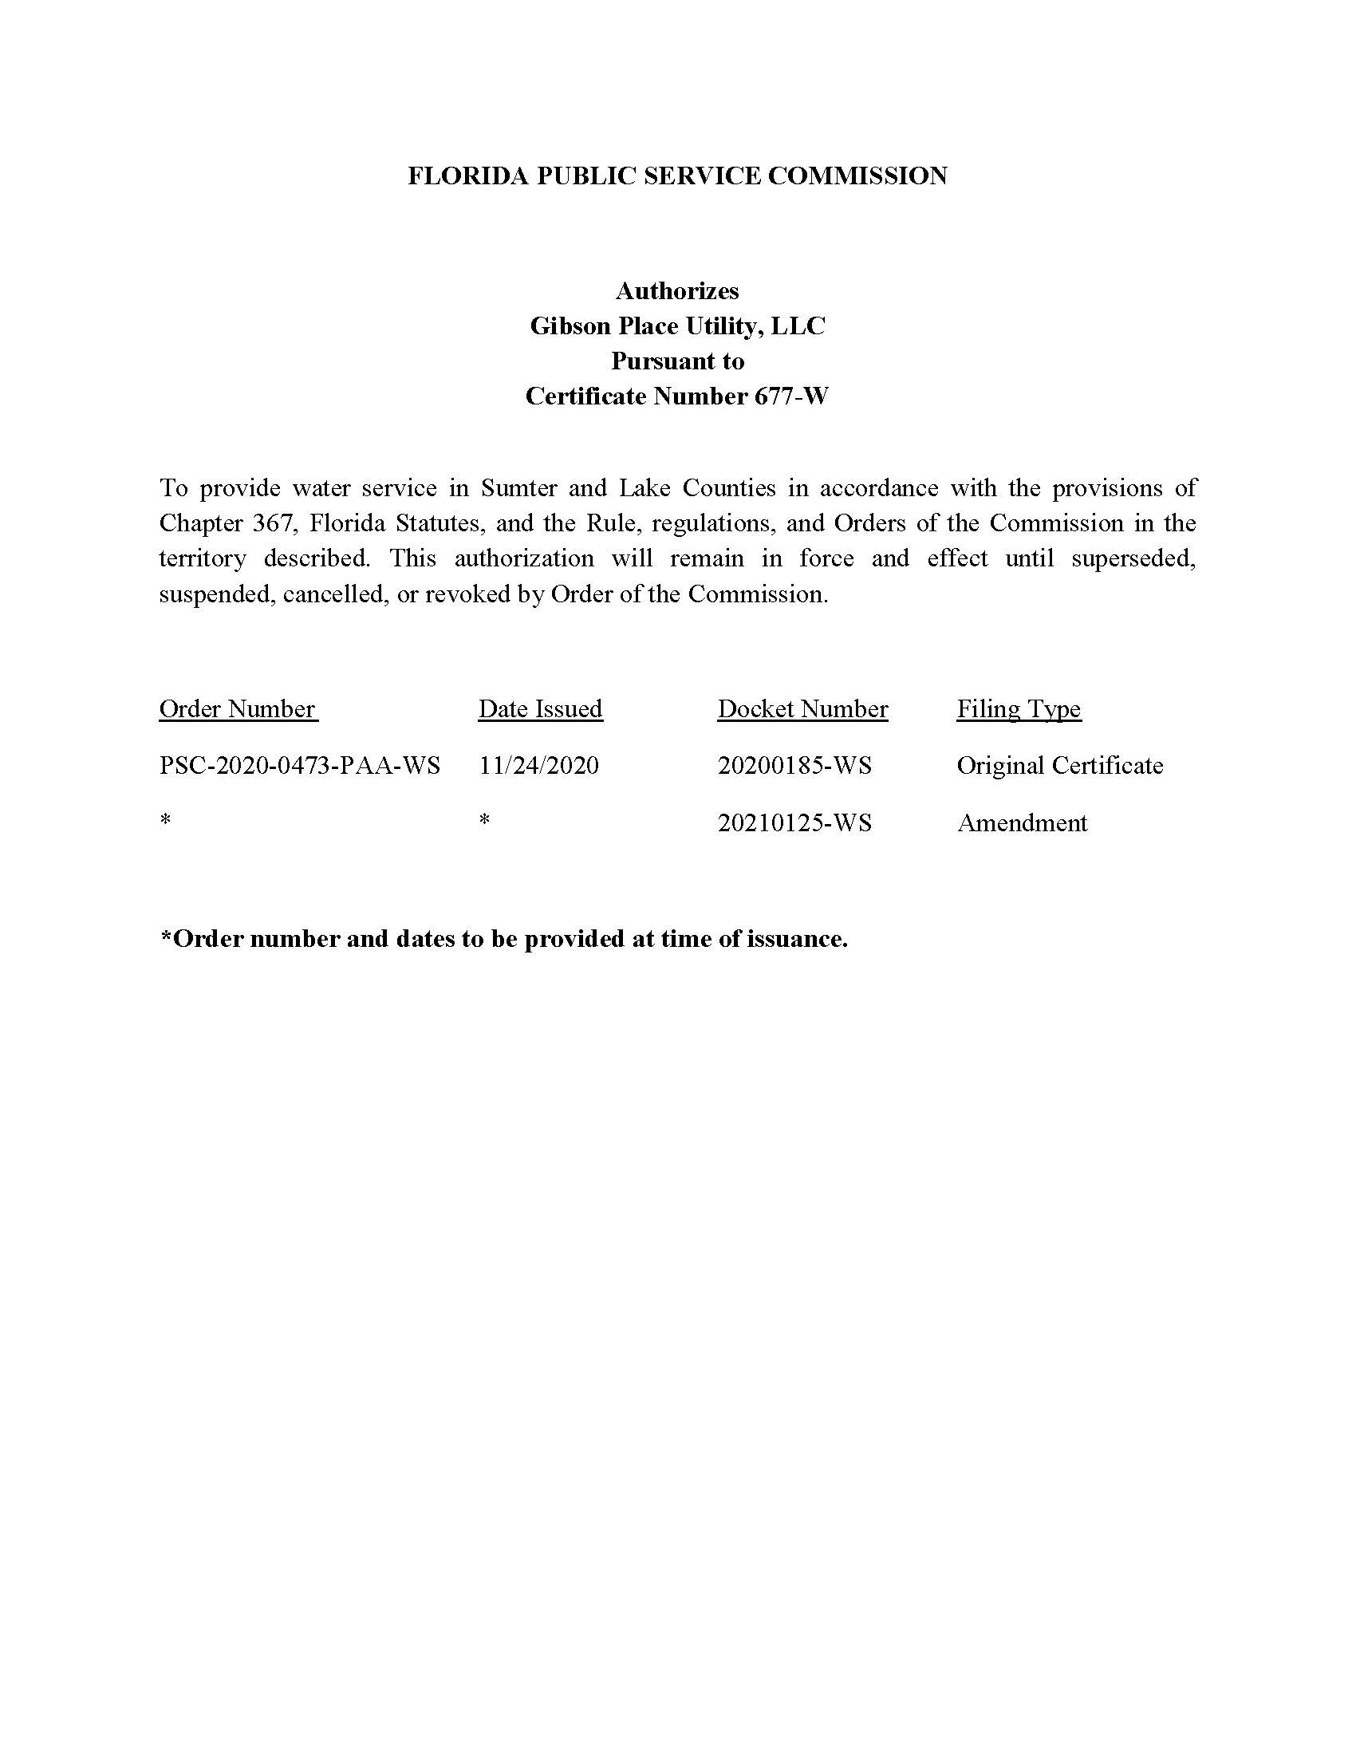

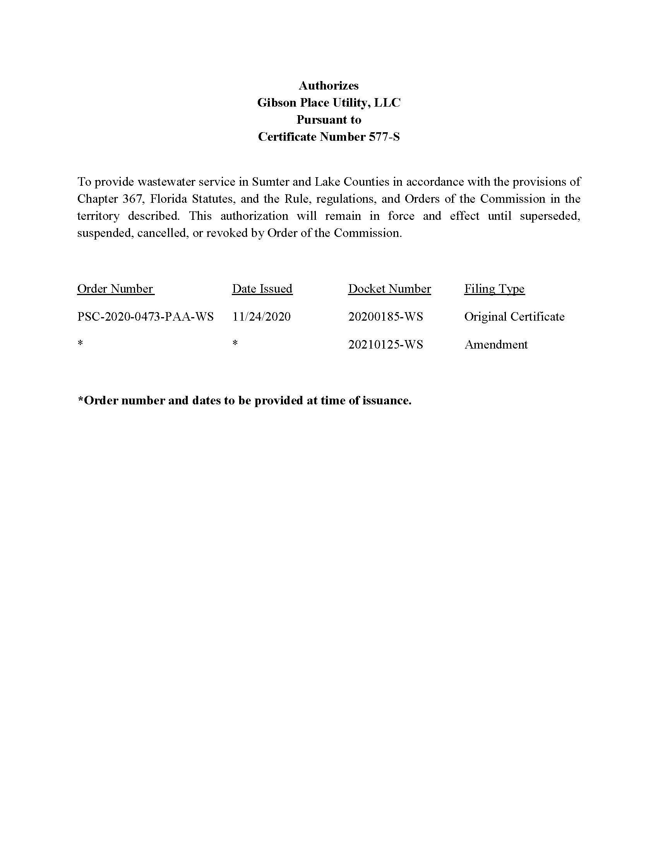

Order No. PSC-2020-0473-PAA-WS, issued November 24, 2020, in Docket No. 20200185-WS, In re: Application for certificates to provide water and wastewater service in Lake and Sumter Counties, by Gibson Place Utility Company, LLC.
Pursuant to Order No. PSC-2020-0473-PAA-WS, GPU is required to send a status report to the Commission every six months detailing the status of its permitting with the Florida Department of Environmental Protection and SWFWMD as well as the anticipated commencement date of its operations.
Document No. 12619-2021, filed November 10, 2021, in Docket No. 20200185-WS

