State of Florida |  | Public Service Commission  Capital Circle Office Center ● 2540 Shumard Oak Boulevard  Tallahassee, Florida 32399-0850  -M-E-M-O-R-A-N-D-U-M-
DATE: | January 20, 2022
TO: | Office of Commission Clerk (Teitzman)
FROM: | Division of Engineering (Maloy, Ramos)  Division of Accounting and Finance (Blocker, Fletcher)  Division of Economics (Sibley)  Office of the General Counsel (Lherisson)
RE: | Docket No. 20210095-WU – Application for transfer of water facilities of Sunshine Utilities of Central Florida, Inc. and Water Certificate No. 363-W to CSWR-Florida Utility Operating Company, LLC, in Marion County.
AGENDA: | 02/01/22 – Regular Agenda – Proposed Agency Action for Issues 2 and 3 - Interested Persons May Participate
COMMISSIONERS ASSIGNED: |  |  | All Commissioners
PREHEARING OFFICER: |  |  | Graham
CRITICAL DATES: |  |  | None
SPECIAL INSTRUCTIONS: |  |  | Please place item on Agenda immediately after Docket No. 20210093-WS.

Case Background

Sunshine Utilities of Central Florida, Inc. (SUCF, Utility, or Seller) is a Class A water utility providing service to approximately 3,934 residential customers in Marion County. The Utility is comprised of 23 water systems and is located in the St. Johns River Water Management District (SJRWMD) in the Water Resource Caution Area. Wastewater service is provided by septic tanks. In its 2020 Annual Report, SUCF reported total operating revenues of $1,104,634.
The Florida Public Service Commission (Commission) granted an original water certificate to Sunshine Utility Company in 1982. Subsequently, the Commission approved 21 certificate amendments and transfers, including the Quail Run system in 2002, the Sandy Acres system in 2002, and the Ponderosa Pines system in 2003. The rates for the Utility were last set by the Commission in 2012.
On May 5, 2021, CSWR-Florida Utility Operating Company, LLC (CSWR-Sunshine or Buyer) filed an application with the Commission for the transfer of Certificate No. 363-W from SUCF to CSWR-Sunshine in Marion County. The sale will close after the Commission has voted to approve the transfer. In its application, the Buyer has requested a positive acquisition adjustment, which is discussed in Issue 3.
Intervention by the Office of Public Counsel (OPC) was acknowledged on August 26, 2021. OPC and staff have issued a number of discovery or data requests to CSWR-Sunshine in this docket.
This recommendation addresses the transfer of the water system and Certificate No. 363-W, the appropriate net book value of the water system for transfer purposes, and the request for an acquisition adjustment. The Commission has jurisdiction pursuant to Sections 367.071 and 367.081, Florida Statutes (F.S.).

Discussion of Issues

Issue 1:
Should the transfer of Certificate No. 363-W in Marion County from Sunshine Utilities of Central Florida, Inc. to CSWR-Florida Utility Operating Company, LLC be approved?

Recommendation:
Yes. The transfer of the water system and Certificate No. 363-W is in the public interest and should be approved effective the date that the sale becomes final. The resultant Order should serve as the Buyer’s certificate and should be retained by the Buyer. The Buyer should submit the executed and recorded deed for continued access to the land upon which its facilities are located and copies of its permit transfer applications to the Commission within 60 days of the Order approving the transfer, which is final agency action. If the sale is not finalized within 60 days of the resultant Order, the Buyer should file a status update in the docket file. The Utility’s existing rates and charges, including the modification to miscellaneous service charges pursuant to Rule 25-30.460, Florida Administrative Code (F.A.C.), should remain in effect until a change is authorized by the Commission in a subsequent proceeding. The tariff pages reflecting the transfer should be effective on or after the stamped approval date on the tariff sheet, pursuant to Rule 25-30.475(1), F.A.C. The Seller is current with respect to annual reports and regulatory assessment fees (RAFs) through December 31, 2020. The Buyer should be responsible for filing annual reports and paying RAFs for all future years. (Maloy, Blocker, Sibley)

Staff Analysis:
On May 5, 2021, CSWR-Sunshine filed an application for the transfer of Certificate No. 363-W from SUCF to CSWR-Sunshine in Marion County. The application complies with Section 367.071, F.S., and Commission rules concerning applications for transfer of certificates. The sale to CSWR-Sunshine will become final after Commission approval of the transfer, pursuant to Section 367.071(1), F.S.
Noticing, Territory, and Land Ownership
CSWR-Sunshine provided notice of the application pursuant to Section 367.071, F.S., and Rule 25-30.030, F.A.C. No objections to the transfer were filed, and the time for doing so has expired. The application contains a description of the service territory, which is appended to this recommendation as Attachment A. In its response to staff’s September 8, 2021 deficiency letter, CSWR-Sunshine provided an unrecorded warranty deed as evidence that the buyer will have long-term use of the land upon which the treatment facilities are located pursuant to Rule 25-30.037(2)(s), F.A.C. CSWR-Sunshine should submit the executed and recorded deed to the Commission within 60 days of the Order.

Purchase Agreement and Financing
Pursuant to Rule 25-30.037(2)(g), (h), and (i), F.A.C., the application contains a statement regarding financing and a copy of the purchase and sale agreement, which includes the purchase price, terms of payment, and a list of the assets purchased. There are no guaranteed revenue contracts, customer advances, or debt of SUCF that must be disposed of with regard to the transfer. CSWR-Sunshine will review all leases and developer agreements and will assume or renegotiate those agreements on a case-by-case basis prior to closing. Any customer deposits will be refunded to customers by the Seller prior to the closing. According to the purchase and sale agreement, the total purchase price for the assets is $6,000,000. According to the Buyer, the closing has not yet taken place and is dependent on Commission approval of the transfer, pursuant to Section 367.071(1), F.S.
Facility Description and Compliance
The Utility consists of 23 separate water systems. Raw water is drawn from ground well(s), is primarily treated by hypochlorination, and stored in hydropneumatic tank(s) until distribution for each of the Utility’s respective water systems. The most recent inspections conducted by the Florida Department of Environmental Protection (DEP) determined all 23 systems were in compliance with DEP’s rules and regulations. On December 21, 2021, Sun Ray Estates, one of the Utility’s 23 systems, was issued a Warning Letter by the DEP for failure to monitor disinfection by-products (DBPs) contaminants during September 2021. Staff notes that the DEP has notified the Utility in the past of this same violation and once notified, it appears the Utility remits its monitoring reports for DBPs to the DEP as required.
CSWR-Sunshine provided copies of the Utility’s current permits from the DEP and SJRWMD pursuant to Rule 25-30.037(2)(r)(1), F.A.C. The Buyer should provide copies of its permit transfer applications, reflecting the change in ownership, to the Commission within 60 days of the Order. In Exhibit G of the Buyer’s application, CSWR-Sunshine provided its assessment of SUCF’s water systems, and lists several improvements and repairs it recommends be made to the systems. The Buyer’s suggested repairs and improvements, which do not appear to be required by a governmental authority, are discussed further in Issue 3.

Technical and Financial Ability
Pursuant to Rule 25-30.037(2)(l) and (m), F.A.C., the application contains statements describing the technical and financial ability of the Buyer to provide service to the proposed service area. As referenced in the transfer application, the Buyer will fulfill the commitments, obligations, and representation of the Seller with regards to Utility matters. CSWR-Sunshine’s application states that it owns and operates more than 257 water/wastewater systems in Missouri, Arkansas, Kentucky, Louisiana, Texas, and Tennessee that service more than 48,860 water and 77,595 wastewater customers. The Buyer plans to use qualified and licensed contractors to provide routine operation and maintenance of the systems, as well as to handle billing and customer service. Staff reviewed the financial statements of CSWR-Sunshine and believes the Buyer has documented adequate resources to support the Utility’s water operations. Based on the above, staff recommends that the Buyer has demonstrated the technical and financial ability to provide service to the existing service territory.

Rates and Charges

Sunshine’s rates and charges were last approved in a file and suspend rate case in 2012. Since the Utility’s last rate case, the rates have been changed by four price index rate increases and a rate decrease to remove an expired rate case amortization. Rule 25-9.044(1), F.A.C., provides that, in the case of a change of ownership or control of a utility, the rates, classifications, and regulations of the former owner must continue unless authorized to change by the Commission. Therefore, staff recommends that Sunshine’s existing rates and charges as shown on Schedule No. 1-A, remain in effect, until a change is authorized by the Commission.
With respect to miscellaneous service charges, effective June 24, 2021, Rule 25-30.460, F.A.C., was amended to remove initial connection and normal reconnection charges. The definitions for initial connection charges and normal reconnection charges were subsumed in the definition of the premises visit charge. It was envisioned that the utility tariffs would be reviewed by staff on a prospective basis to ensure conformance with the amended rule.
The Utility’s miscellaneous service charges consist of initial connection and normal reconnection charges. These charges are the same as the premises visit charge. Therefore, staff believes it is appropriate at this time to remove the initial connection and normal reconnection charges and update the definition for the premises visit charge to comply with amended Rule 25-30.460, F.A.C. The appropriate miscellaneous service charges are shown on Schedule No. 1-B.

Regulatory Assessment Fees and Annual Report
Staff has verified that the Utility is current with respect to annual reports and RAFs through December 31, 2020. CSWR-Sunshine will be responsible for filing annual reports and paying RAFs upon the date of closing and thereafter.

Conclusion
Based on the foregoing, staff recommends the transfer of the water system and Certificate No. 363-W is in the public interest and should be approved effective the date that the sale becomes final. The resultant Order should serve as the Buyer’s certificate and should be retained by the Buyer. The Buyer should submit the executed and recorded deed for continued access to the land upon which its facilities are located and copies of its permit transfer applications to the Commission within 60 days of the Order approving the transfer, which is final agency action. If the sale is not finalized within 60 days of the transfer Order, the Buyer should file a status update in the docket file. The Utility’s existing rates and charges including the modification to miscellaneous service charges pursuant to Rule 25-30.460, F.A.C., should remain in effect until a change is authorized by the Commission in a subsequent proceeding. The tariff pages reflecting the transfer should be effective on or after the stamped approval date on the tariff sheet, pursuant to Rule 25-30.475(1), F.A.C. The Seller is current with respect to annual reports and RAFs through December 31, 2020. CSWR-Sunshine should be responsible for filing annual reports and paying RAFs for 2021 and all future years.

Issue 2:
What is the appropriate net book value for the CSWR-Sunshine water system for transfer purposes?

Recommendation:
For transfer purposes, the net book value (NBV) of the water system is $248,089 as of May 31, 2021. Within 90 days of the date of the Consummating Order, CSWR-Sunshine should be required to notify the Commission in writing, that it has adjusted its books in accordance with the Commission’s decision. The adjustments should be reflected in CSWR-Sunshine’s 2022 Annual Report when filed. (Blocker)

Staff Analysis:
Rate base was last established on July 10, 2012, by Order No. PSC-12-0357-PAA-WU. The purpose of establishing NBV for transfers is to determine whether an acquisition adjustment should be approved. CSWR-Sunshine’s request for a positive acquisition adjustment is addressed in Issue 3. The NBV does not include normal ratemaking adjustments for used and useful plant or working capital. The Utility’s NBV has been updated to reflect balances as of May 31, 2021. Staff’s recommended NBV, as described below, is shown on Schedule No. 2.

Utility Plant in Service (UPIS)
According to the Utility’s general ledger, the total UPIS balance was $3,331,335 as of May 31, 2021. Staff auditors reviewed the Utility’s records since the last rate case and determined that several Commission-ordered adjustments were incorrectly recorded. Additionally, staff auditors reviewed plant additions and retirements to UPIS from December 31, 2010, to May 31, 2021, and determined that several other adjustments are necessary. Accordingly, staff recommends that the UPIS balance be reduced by $131,410 as of May 31, 2021.

Land
The Utility’s general ledger reflected a land balances of $80,777 as of May 31, 2021. There have been no additions to land since December 31, 2010. Therefore, staff recommends no adjustments to its land balances.

Accumulated Depreciation
According to the Utility’s general ledger, the total accumulated depreciation balance was $2,686,158 as of May 31, 2021. Staff auditors recalculated depreciation accruals for all water accounts since that last rate case through May 31, 2021, using audited UPIS balances and the depreciation rates established by Rule 25-30.140, F.A.C. Accordingly, staff recommends that the accumulated depreciation balance be increased by $50,210 as of May 31, 2021.

Contributions-in-Aid-of-Construction (CIAC) and Accumulated Amortization of CIAC
According to the Utility’s general ledger, the balances for CIAC and accumulated amortization of CIAC were $2,036,044, and $1,574,029, respectively, as of May 31, 2021. Staff auditors traced CIAC and accumulated amortization of CIAC balances from December 31, 2010, to May 31, 2021, using supporting documentation. Staff determined that the Utility did not start with the Commission-approved balances in Order No. PSC-12-0357-PAA-WU. Staff recalculated CIAC using the audited plant balances and depreciation rates established by Rule 25-30.140(2), F.A.C. Staff also recalculated accumulated amortization of CIAC using the audited CIAC balances and the rates established by Rule 25-30.140(2), F.A.C. Accordingly, staff recommends that the CIAC balance be reduced by $3,015 as of May 31, 2021. Staff also recommends that the accumulated amortization of CIAC balance be increased by $162,755 as of May 31, 2021.

Net Book Value
The Utility’s general ledger reflected a NBV of $263,939 as of May 31, 2021. Based on the adjustments described above, staff recommends a NBV of $248,089 as of May 31, 2021. Staff’s recommended NBV and the National Association of Regulatory Utility Commissioners, Uniform System of Accounts (NARUC USOA) balances for UPIS and accumulated depreciation are shown on Schedule No. 2 as of May 31, 2021. As addressed in Issue 3, a positive acquisition adjustment should not be recognized for rate making purposes.

Conclusion
Based on the above, staff recommends a NBV of $248,089 as of May 31, 2021, for transfer purposes. Within 90 days of the date of the Consummating Order, the Buyer should be required to notify the Commission in writing, that it has adjusted its books in accordance with the Commission’s decision. The adjustments should be reflected in CSWR-Sunshine’s 2022 Annual Report when filed.

Issue 3:
Should a positive acquisition adjustment be recognized for ratemaking purposes?

Recommendation:
No. Pursuant to Rule 25-30.0371, F.A.C., a positive acquisition adjustment should not be granted as CSWR-Sunshine failed to demonstrate extraordinary circumstances. (Blocker, Maloy)

Staff Analysis:
In its filing, the Utility requested a positive acquisition adjustment be included in the calculation of CSWR-Sunshine’s rate base. An acquisition adjustment results when the purchase price differs from the NBV of the assets at the time of acquisition. Pursuant to Rule 25-30.0371, F.A.C., a positive acquisition adjustment results when the purchase price is greater than the NBV and a negative acquisition adjustment results when the purchase price is less than the NBV. A positive acquisition adjustment, if approved, increases rate base.
According to the purchase agreement, the Buyer will purchase the Utility for $6,000,000. As discussed in Issue 2, staff is recommending a total NBV of $248,089. This would result in a total positive acquisition adjustment of $5,751,911.
Any entity that believes a full or partial positive acquisition adjustment should be made has the burden to prove the existence of extraordinary circumstances. Rule 25-30.0371(2), F.A.C., states:
In determining whether extraordinary circumstances have been demonstrated, the Commission shall consider evidence provided to the Commission such as anticipated improvements in quality of service, anticipated improvements in compliance with regulatory mandates, anticipated rate reductions or rate stability over a long-term period, anticipated cost efficiencies, and whether the purchase was made as part of an arms-length transaction.
One of the Buyer’s justifications for the purchase price is to ensure sale proceeds are sufficient to cover the fair market value of the Utility’s land. While the factors listed in the rule are listed by way of example and other evidence may be offered, the purpose of the rule is to provide incentive for the acquisition of small, troubled systems, the elimination of substandard operating conditions, and allow customers to receive benefits which amount to a better quality of service at a reasonable rate. Order No. PSC-02-0997-FOF-WS, issued July 23, 2002, in Docket No. 20001502-WS, In re: Proposed Rule 25-30.0371, F.A.C., Acquisition Adjustment. The items enumerated in the rule are consistent with the promotion of benefits to customers and bringing troubled systems into regulatory compliance; covering the fair market value of land is not.
Staff believes the Buyer failed to demonstrate the extraordinary circumstances necessary to support the inclusion of a positive acquisition adjustment, as discussed below.
Improvements in Quality of Service and Compliance with Regulatory Mandates
In its application, CSWR-Sunshine listed six business practices that it believes will improve the quality of service to its customers: (1) provision of 24-hour emergency service phone numbers; (2) on-call emergency service personnel who are required to respond to emergency service calls within prescribed time limits; (3) a computerized maintenance management system; (4) access to resources not usually available to comparably sized systems and the ability to supplement local personnel with resources owned by the parent and sister companies; (5) online bill payment options; and (6) an updated website for customer communication, bulletins, procedures, etc. In response to staff’s data requests, CSWR-Sunshine provided a list of several improvements it plans to make after its acquisition which it believes will improve both quality of service and compliance with regulatory mandates relating to the Utility’s chemical storage, electrical system, ground well, as well as the installation of new flow meters on wells, blow off valves in distribution systems, and remote monitoring system.

Staff reviewed the complaints filed with the Commission for the five-year period prior to the application, May 2016 to May 2021. For the five-year period, the Commission recorded a total of 13 complaints, out of its approximately 3,934 customers, of which pertaining to billing (7 complaints), communication with customers (3 complaint), outages caused by electrical issues (2 complaints), or safety issues (1 complaint). Of the 3 communication-related customer complaints, 2 were regarding the timing of a boil water notice and the third was regarding a situation where the utility was digging in the right-of-way near the customer’s residence, and the customer was not provided advanced notice of the digging. In response, the Utility provided its contact information to these customers to improve future communications. There were 2 customer complaints attributable to incoming power fluctuations which caused outages; the Utility installed adjustable voltage controls in the pumps to remedy the unstable electricity. Further, in the analyzed period, 1 customer reported a safety concern with a plastic water meter cover that was damaged from vehicle traffic and the Utility replaced it with a concrete cover and installed a pole in front of the meter box to resolve this issue. Based on the foregoing analysis, the Utility appears to respond and resolve customer complaints in a timely manner. As discussed in Issue 1, the Utility is currently in compliance with the DEP’s rules and regulations. Staff also reviewed the DEP inspection reports for the three years prior to the Utility’s transfer application and found that the Utility was also in compliance during that time frame. If an area of concern was identified by the DEP, it was corrected promptly by SUCF. There was no record of DEP compliance enforcement action within the past three years and there appears to be no pending regulatory requirements from any governmental authority, with the exception of the recently issued DEP Warning Letter regarding a monitoring violation, as discussed previously in Issue 1.

Based on the Commission’s complaint data and the DEP’s reports, it does not appear that the Utility currently has issues with respect to quality of service and regulatory compliance, such that they would warrant extraordinary efforts to remedy. For this reason, staff does not believe CSWR-Sunshine has demonstrated extraordinary circumstances for its requested positive acquisition adjustment. Instead, staff believes that the proposed anticipated improvements in quality of service and compliance with regulatory mandates demonstrates CSWR-Sunshine’s intention to responsibly execute its obligations as a utility owner. While staff does not believe the Utility’s anticipated improvements justify its requested positive acquisition adjustment, these improvements may be considered for prudency and cost recovery in a future rate proceeding.

Anticipated Cost Efficiencies and Rates
In its application, the Buyer stated that based on its size and anticipated consolidation of many small systems under one financial and managerial entity would result in operational cost efficiencies particularly in the areas of:
- PSC and environmental regulatory reporting
- Managerial and operational oversight
- Utility asset planning
- Engineering planning
- Ongoing utility maintenance
- Utility record keeping
- Customer service responsiveness
- Improved access to capital necessary to repair and upgrade Sunshine’s systems to ensure compliance with all health and environmental requirements and ensure service to customers remains safe and reliable

The Buyer also stated that CSWR-Sunshine would bring long-term rate stability to the Utility, should the transfer be approved. Staff agrees that economies of scale and potential consolidation of several systems in Florida, as proposed by CSWR-Sunshine, could bring some amount of long-term rate stability. However, absent specific and detailed support for these assertions, the Buyer has failed to meet its burden for demonstrating extraordinary circumstances. Instead, much of the information provided by the Buyer lacks specificity and was provided nearly verbatim in each of the other two CSWR-Sunshine transfer dockets.

Staff and OPC made several requests for quantifiable information to support the Buyer’s assertions, such as anticipated rate impact and potential/projected cost efficiencies. The Buyer repeatedly stated that it was unable to provide quantitative information at the granularity requested by staff. However, staff does not believe its requests were unreasonable given that the burden of proof lies with the Buyer. This is particularly true in the instant case when the requested relief is a positive acquisition adjustment of $5,751,911, which is approximately 23 times greater than the system’s current NBV of $248,089. Further, in response to staff’s first data request for an estimate and breakdown of projected operation and maintenance (O&M) expenses, the Buyer stated that the benefit from the increase in economies of scale and other advantages provided by CSWR-Sunshine would not necessarily be reflected in cost savings compared to current Sunshine operations.

Staff’s recommendation is also consistent with the Commission’s decision in Order No. PSC-2020-0458-PAA-WS. In that docket, Royal Waterworks, Inc. (RWI) identified estimates of anticipated cost efficiencies, including a reduction in O&M expense and a reduction of cost of capital that would result from the transfer. Additionally, RWI provided several improvements it made to the water treatment plant and wastewater lift station since acquisition to improve the quality of service and compliance with regulatory mandates. While the Commission acknowledged that RWI accomplished cost savings, it did not believe the actions performed demonstrated extraordinary circumstances that would justify approval of a positive acquisition adjustment.

Conclusion
Pursuant to Rule 25-30.0371, F.A.C., staff believes a positive acquisition adjustment should not be granted, as CSWR-Sunshine did not demonstrate extraordinary circumstances. Staff believes the Buyer’s anticipated improvements in quality of service and compliance with regulatory mandates does not illustrate extraordinary circumstances and instead demonstrates CSWR-Sunshine’s intentions to responsibly execute its obligations as a utility owner. Additionally, the fair market value of the Utility’s land is not a factor considered in the request of a positive acquisition adjustment pursuant to Rule 25-30.0371(2), F.A.C.

Issue 4:
Should this docket be closed?

Recommendation:
Yes. If no protest to the proposed agency action is filed by a substantially affected person within 21 days of the date of the issuance of the Order, a Consummating Order should be issued and the docket should be closed administratively upon Commission staff’s verification that the revised tariff sheets have been filed, the Buyer has notified the Commission in writing that it has adjusted its books in accordance with the Commission’s decision, that the Buyer has submitted the executed and recorded warranty deed and that the Buyer has submitted copies of its applications for permit transfers to the DEP and the SJRWMD, within 60 days of the Commission’s Order approving the transfer, which is final agency action. (Lherisson)

Staff Analysis:
If no protest to the proposed agency action is filed by a substantially affected person within 21 days of the date of the issuance of the Order, a Consummating Order should be issued and the docket should be closed administratively upon Commission staff’s verification that the revised tariff sheets have been filed, the Buyer has notified the Commission in writing that it has adjusted its books in accordance with the Commission’s decision, that the Buyer has submitted the executed and recorded warranty deed and that the Buyer has submitted copies of its applications for permit transfers to the DEP and the SJRWMD, within 60 days of the Commission’s Order approving the transfer, which is final agency action.

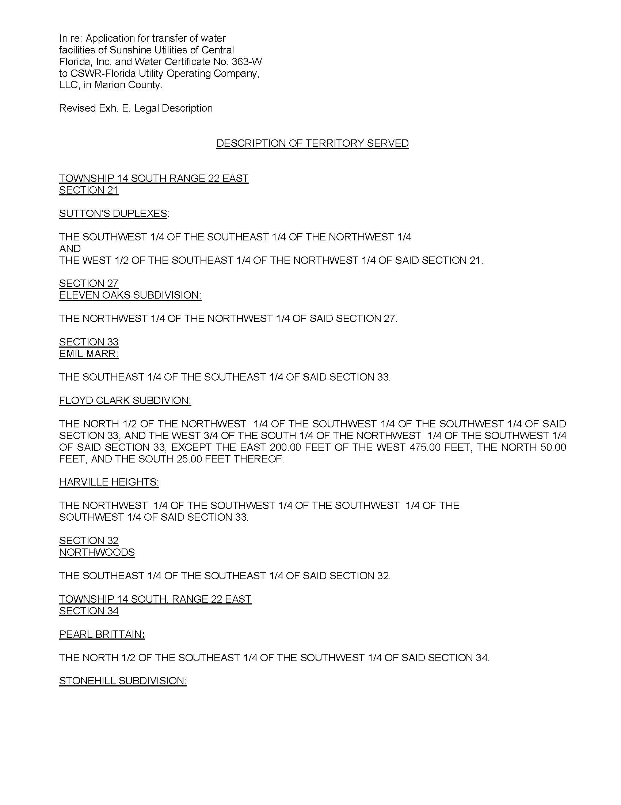
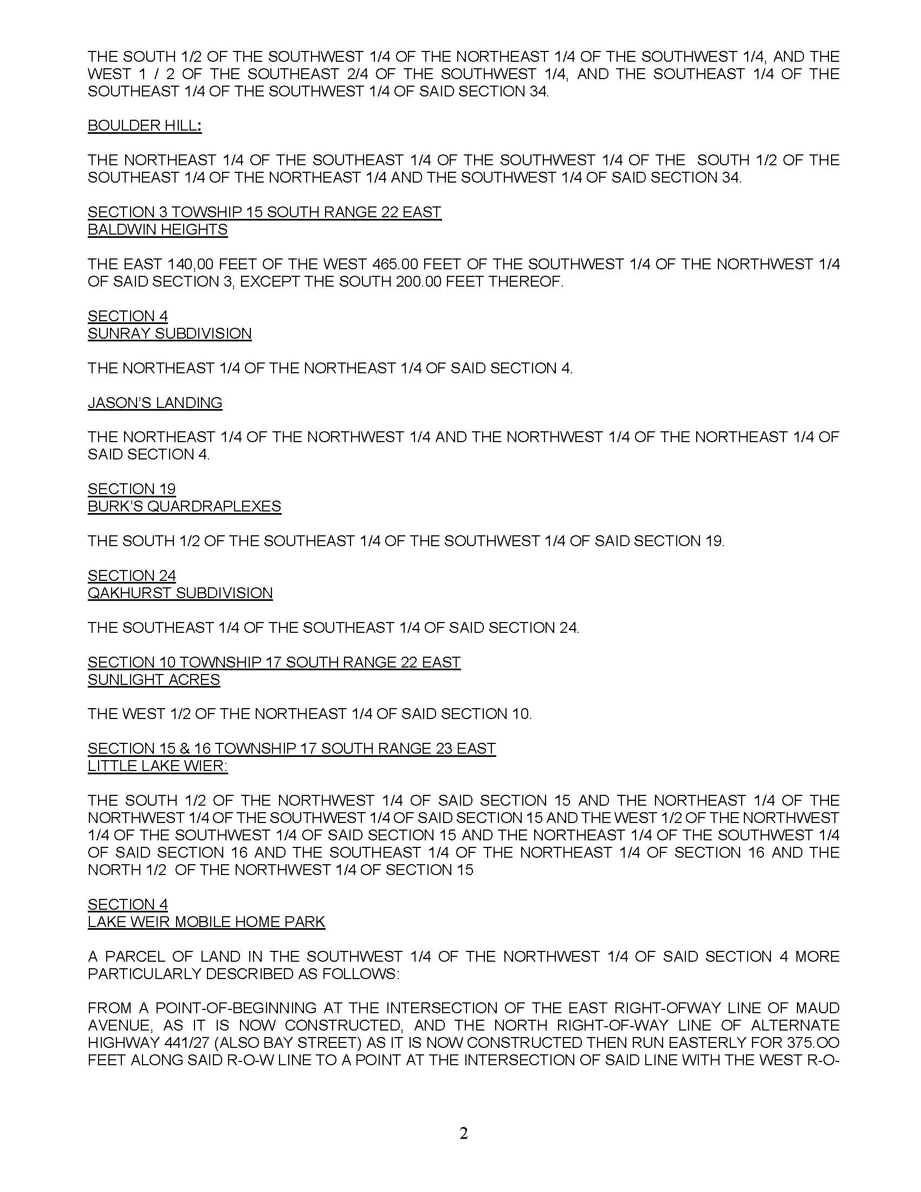
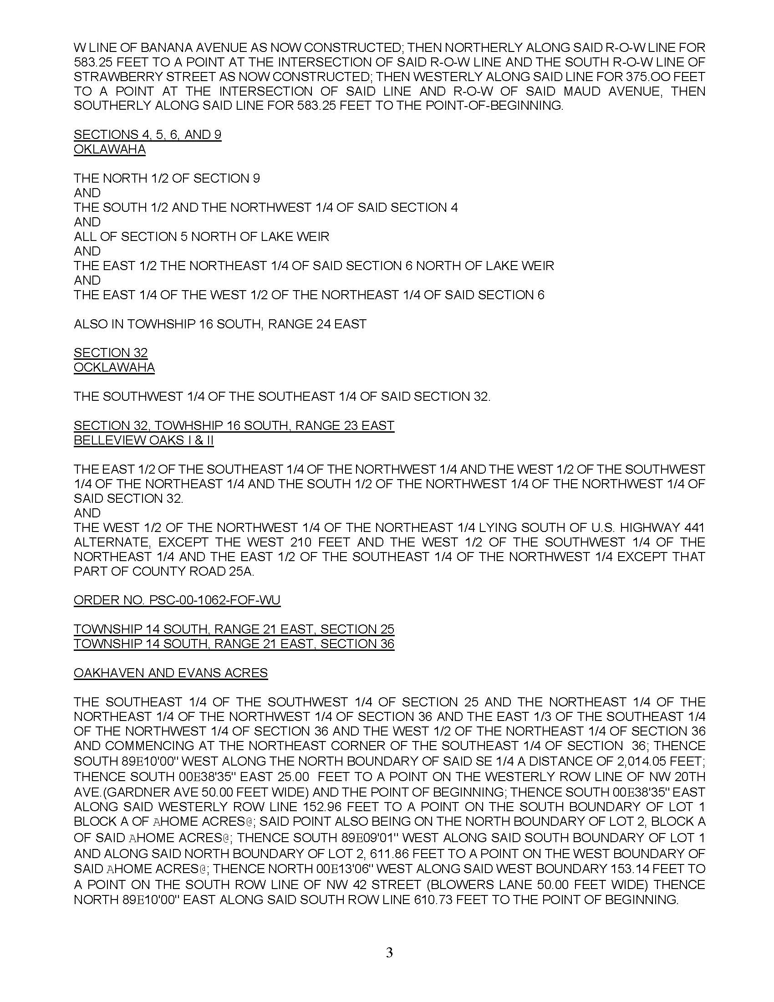
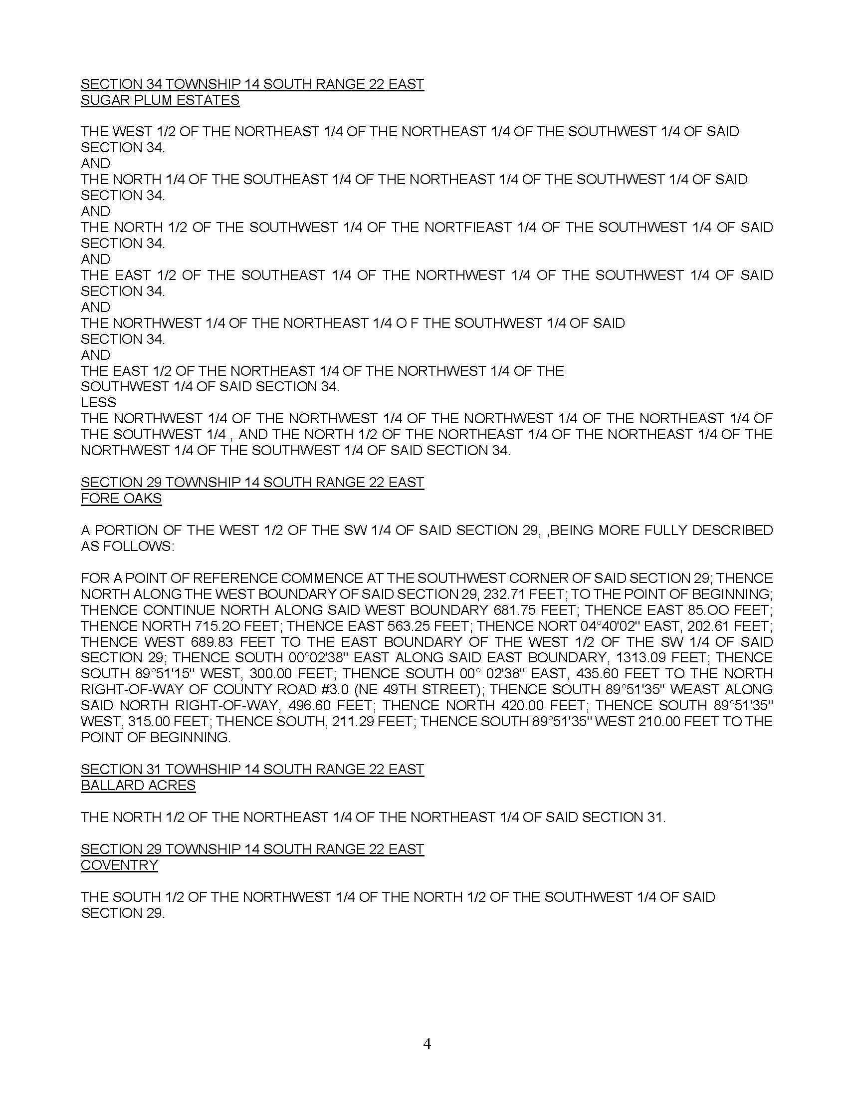
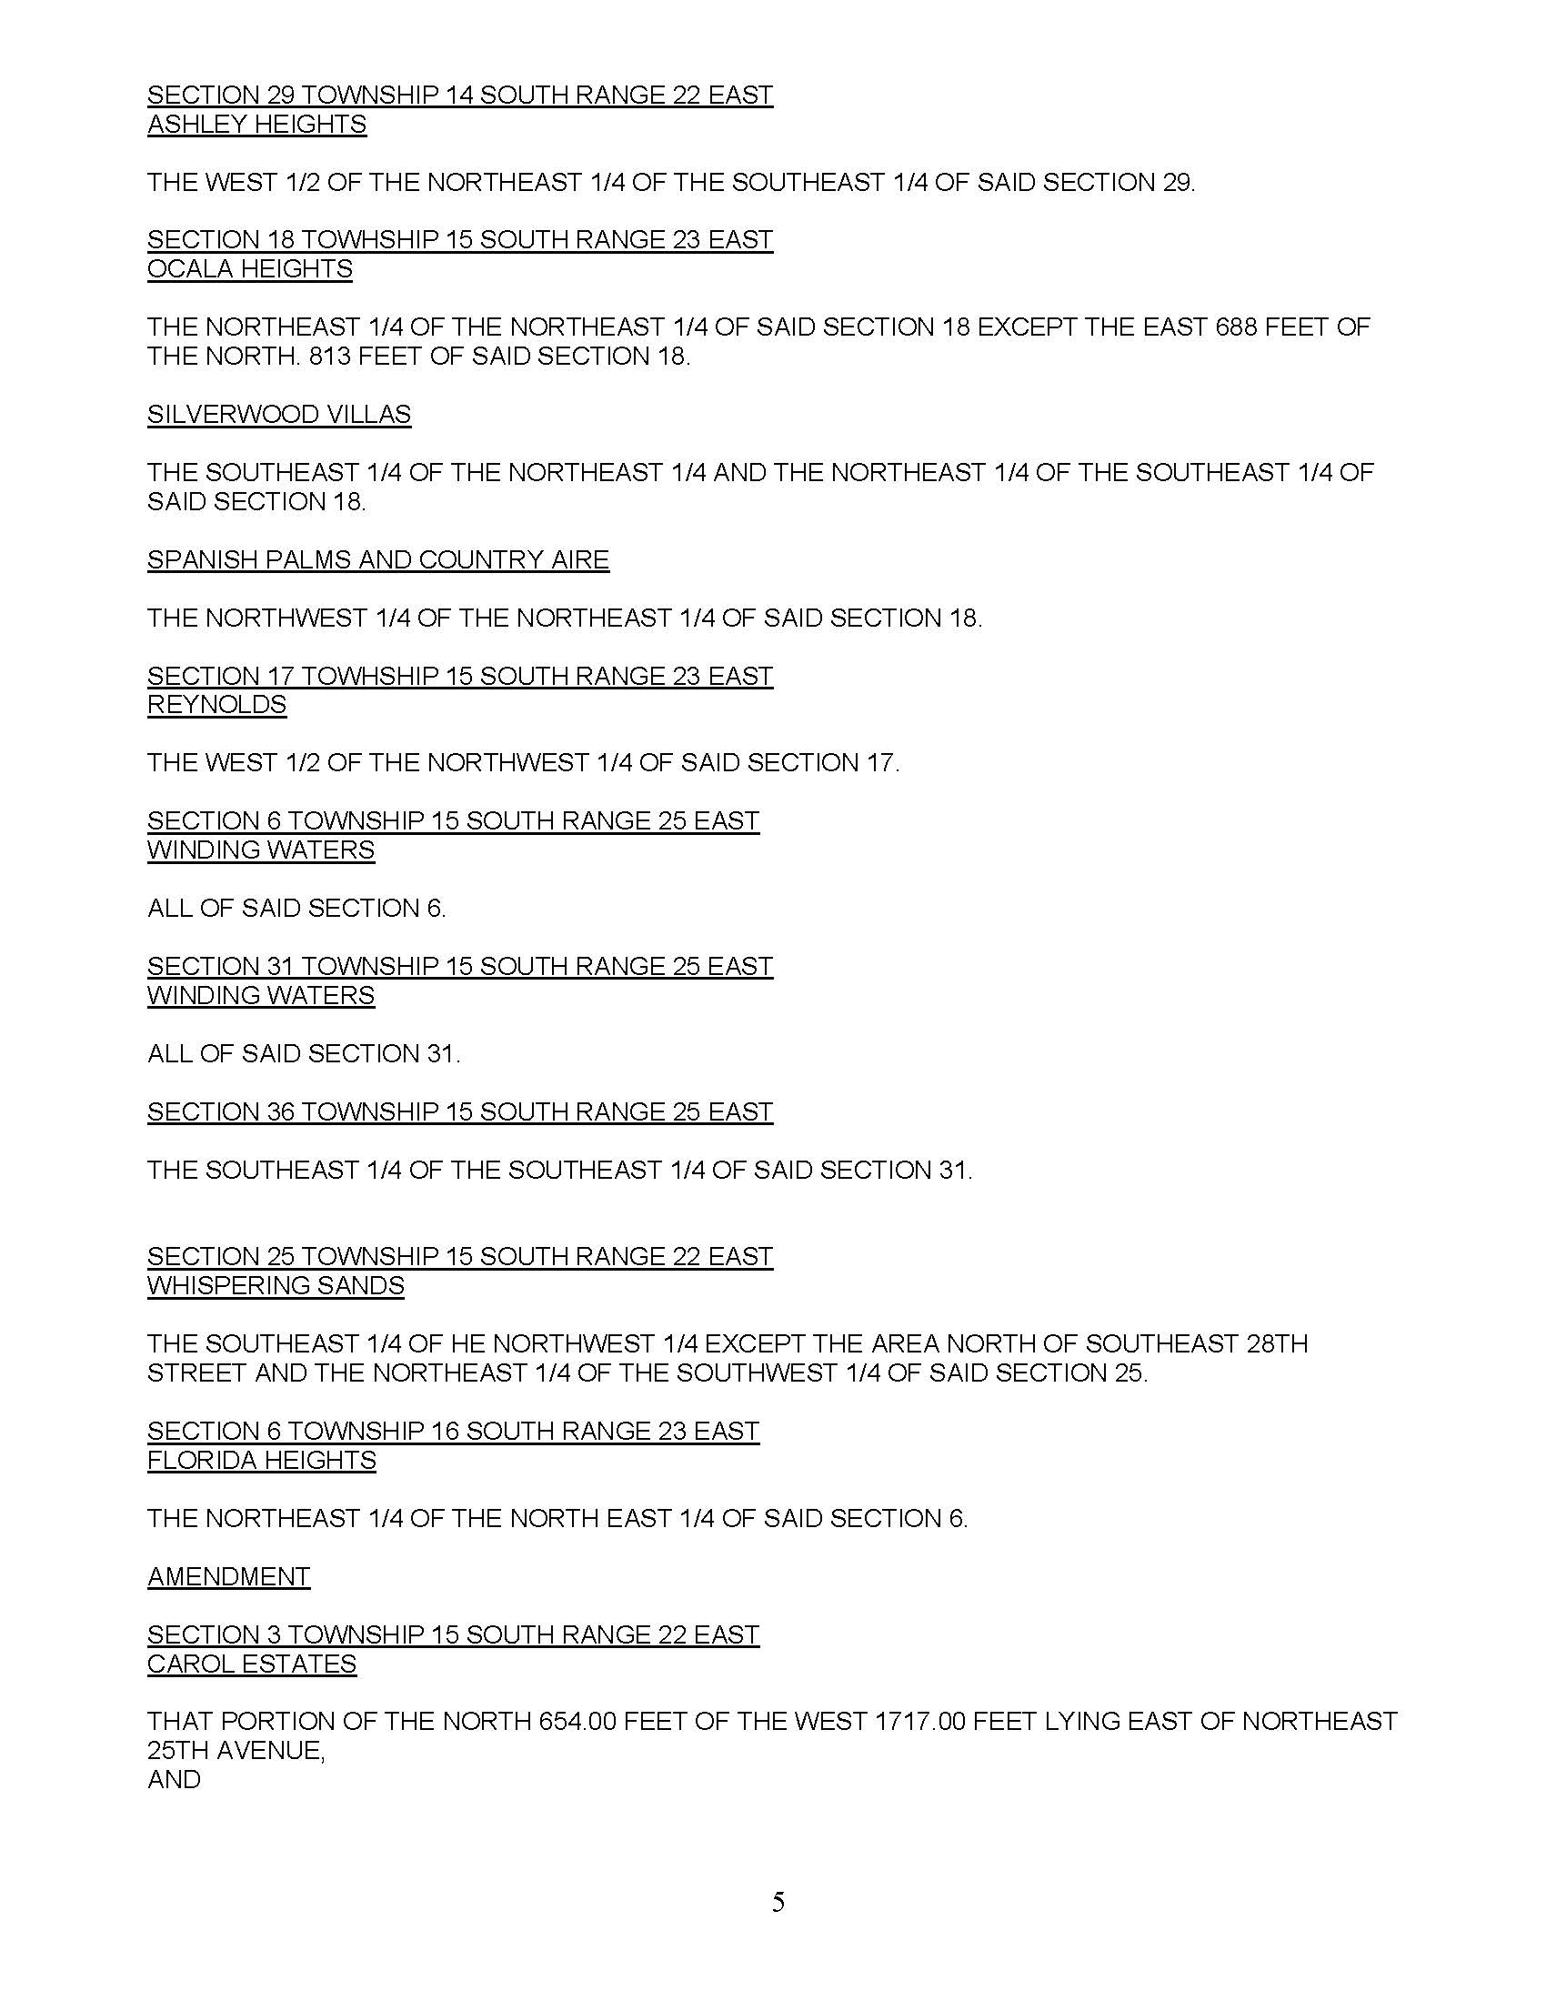
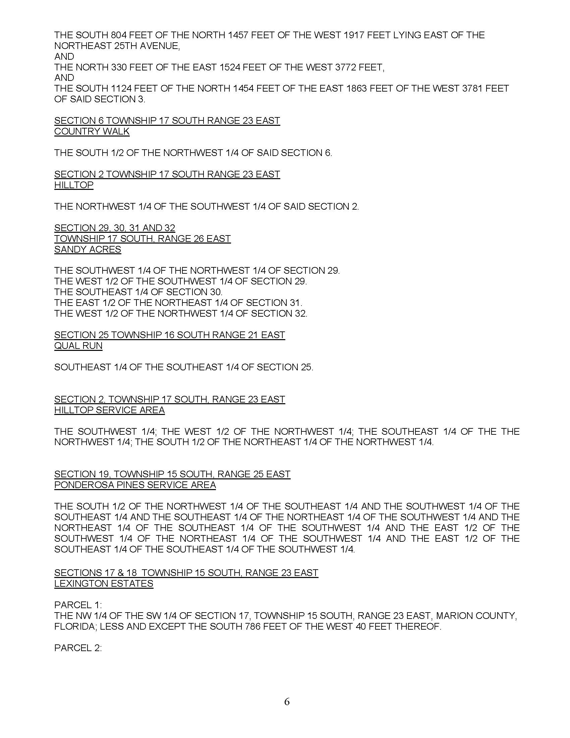

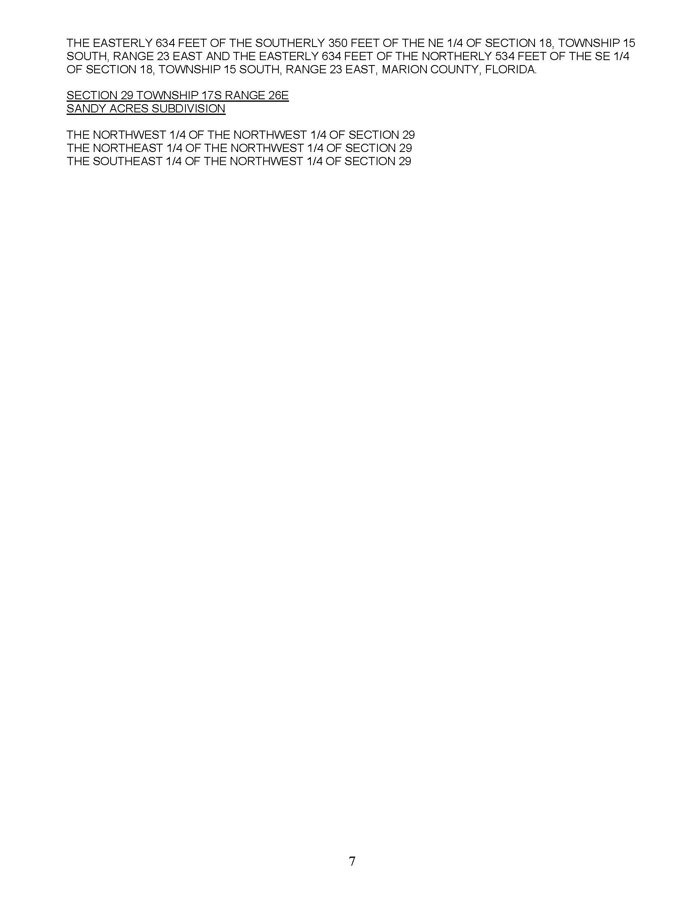

FLORIDA PUBLIC SERVICE COMMISSION
authorizes
CSWR- Florida Utility Operating Company, LLC
pursuant to
Certificate Number 363-W

to provide water service in Marion County in accordance with the provisions of Chapter 367, Florida Statutes, and the Rules, Regulations, and Orders of this Commission in the territory described by the Orders of this Commission. This authorization shall remain in force and effect until superseded, suspended, cancelled or revoked by Order of this Commission.

Order Number Date Issued Docket Number Filing Type
11138 09/03/82 19810386-W (MC) Grandfather
11680 03/07/83 19810423-W, 19810363-W, Transfer/Amendment
19820409-W, 19820408-W, 19820367-W
14206 03/21/85 19840087-WU Amendment
14978 09/20/85 19840089-WU Amendment
15296 10/25/85 19850280-WU Amendment
17161 02/06/87 19861526-WU Amendment
17733 06/22/87 19870181-WU Transfer/ Amendment
18081 09/01/87 19860724-WU Amendment
20707 02/06/89 19880907-WU Transfer
22239 11/29/89 19891177-WU Name Change
PSC-98-0385-FOF-WU 03/11/98 19971297-WU Amendment
PSC-99-2390-FOF -WU 12/07/99 19980543-WU Amendment
PSC-00-l 062-FOF-WU 06/02/00 19991681-WU Amendment
PSC-02-1832-PAA-WU 12/20/02 20011632-WU Amendment
PSC-02-1292-PAA-WU 09/23/02 20020256-WU Transfer/ Amendment
PSC-03-0244-FOF-WU 02/20/03 20021034-WU Amendment
PSC-03-1099-FOF-WU 10/02/03 20030128-WU Amendment
PSC-03-1333-PAA-WU 11/24/03 20030340-WU Transfer/Amendment
PSC-04-1032-FOF-WU 10/25/04 20040388-WU Amendment
PSC-06-0478-FOF-WU 06/05/06 20060283-WU Amendment
PSC-l 0-0557-FOF-WU 09/07/10 20100156-WU Amendment
PSC-l 0-0679-FOF-WU 11/15/10 20100377-WU Transfer/Amendment
* * 20210095-WU Transfer

*Order Number and date to be provided at time of issuance

CSWR- Florida Utility Operating Company, LLC
(Sunshine Utilities of Central Florida, Inc.)
Monthly Water Rates

Residential and General Service
Unified Systems and Sandy Acres
Base Facility Charge by Meter Size
5/8” x 3/4" |  |  |  | $8.72
3/4" |  |  |  | $13.08
1" |  |  |  | $21.80
1 1/4" |  |  |  | $32.70
1 1/2" |  |  |  | $43.60
2” |  |  |  | $69.76
3” |  |  |  | $139.52
4” |  |  |  | $218.00
6” |  |  |  | $436.00
8” |  |  |  | $784.80
10” |  |  |  | $1,264.40
Charge Per 1,000 gallons (RS1) |  |  |  | $2.03
0 – 5,000 gallons |  |  |  | $2.21
5,001 – 10,000 gallons |  |  |  | $4.42
Over 10,000 gallons
Charge Per 1,000 gallons (GS1) |  |  |  | $2.42
Residential and General Service
Ponderosa Pines and Quail Run
Base Facility Charge by Meter Size
5/8” x 3/4" |  |  |  | $9.57
3/4" |  |  |  | $14.36
1" |  |  |  | $23.93
1 1/4" |  |  |  | $35.89
1 1/2" |  |  |  | $47.85
3” |  |  | $153.12
4” |  |  | $239.25
6” |  |  | $478.50
8” |  |  | $861.30
10” |  |  | $1,387.65
Charge Per 1,000 gallons (GS2 & RS2) |  |  |  | $2.53

CSWR- Florida Utility Operating Company, LLC
(Sunshine Utilities of Central Florida, Inc.)

Service Availability Charges

Meter Installation Charge

5/8” x 3/4" $115.00
1” $195.00
1 1/2" $530.00
2" $700.00
3” $1,030.00
4" $2,035.00
6" $3,560.00

Customer Connection (Tap-in) Charge

Same Side of Road $750.00
Opposite Side of Road $1,115.00

Customer Deposits

 | Residential Service | General Service
All Meter Sizes | 2 x Average estimated bill | 2 x Average estimated bill

CSWR- Florida Utility Operating Company, LLC
(Sunshine Utilities of Central Florida, Inc.)

Miscellaneous Service Charges

 | Normal Hours | After Hours
Initial Connection Charge | $21.00 | $42.00
Normal Reconnection Charge | $21.00 | $42.00
Violation Reconnection Charge | $21.00 | $42.00
Premises Visit Charge | $21.00 | $42.00
(in lieu of disconnection)
Late Payment Charge | $5.00
Investigation of Meter Tampering Charge | $50.00 | $50.00

Staff Recommended
Miscellaneous Service Charges

 | Normal Hours | After Hours
Premises Visit Charge | $21.00 | $42.00
Violation Reconnection Charge | $21.00 | $42.00
Late Payment Charge | $5.00
Investigation of Meter Tampering Charge | $50.00 | $50.00

CSWR-Florida Utility Operating Company, LLC
(Sunshine Utilities of Central Florida, Inc.)
Water System

Schedule of Net Book Value as of May 31, 2021

Description | Balance  Per Utility | Adjustments |  | Staff
Utility Plant in Service | $3,331,335 | ($131,410) | A | $3,199,925
Land & Land Rights | 80,777 | - |  | 80,777
Accumulated Depreciation | (2,686,158) | (50,210) | B | (2,736,368)
CIAC | (2,036,044) | 3,015 | C | (2,033,029)
Accumulated Amortization of CIAC | 1,574,029 | 162,755 | D | 1,736,784
Total | $263,939 | ($15,850) |  | $248,089

CSWR-Florida Utility Operating Company, LLC
(Sunshine Utilities of Central Florida, Inc.)
Water System

Explanation of Adjustments to Net Book Value as of May 31, 2021

Explanation | Amount
- Utility Plant in Service
To reflect the appropriate amount of UPIS. | ($131,410)
- Accumulated Depreciation
To reflect the appropriate amount of accumulated depreciation. | (50,210)
- Contributions in Aid of Construction
To reflect the appropriate amount of CIAC. | 3,015
- Accumulated Amortization of CIAC
To reflect the appropriate amount of accumulated amortization of CIAC. | 162,755
Total Adjustments to Net Book Value as of May 31, 2021 | ($15,850)

CSWR-Florida Utility Operating Company, LLC
(Sunshine Utilities of Central Florida, Inc.)
Water System

Schedule of Staff’s Recommended Account Balances as of May 31, 2021

Account  No. | Description | UPIS | Accumulated Depreciation
301 | Organization | $1,660 | $1,521
304 | Structures & Improvements | 11,434 | 4,842
307 | Wells & Springs | 120,006 | 108,291
309 | Supply Mains | 110,236 | 47,589
310 | Power Generation Equip. | 92,882 | 67,840
311 | Pumping Equip. | 539,881 | 515,322
320 | Water Treatment Equip. | 204,274 | 200,216
330 | Distribution Reservoirs | 120,373 | 41,750
331 | Transmission and Distribution Mains | 1,083,369 | 1,011,498
333 | Services | 149,227 | 58,233
334 | Meters and Meter Install. | 235,187 | 181,711
339 | Other Plant And Misc. | 25,858 | 25,858
340 | Office Furniture & Equip. | 79,087 | 52,925
341 | Trans. Equip. | 113,594 | 113,562
342 | Stores Equip. | 4,425 | 3,815
343 | Tools, Shop and Garage Equip. | 39,491 | 32,454
345 | Power Operated Equip. | 5,200 | 5,200
346 | Communication Equip. | 10,912 | 10,912
347 | Misc. Equip. | 17,436 | 17,436
348 | Other Tangible Plant | 235,393 | 235,393
 | Total | $3,199,925 | $2,736,368

Order No. 11138, issued September 3, 1982, in Docket Nos. 19810386-W, In re: Application of Sunshine Utility Company for a certificate to operate a utility in Marion County, Florida.
Order No. PSC-02-1292-PAA-WU, issued September 23, 2002, in Docket No. 20020256-WU, In re: Application for transfer of Certificate No. 380-W from A. P. Utilities, Inc. in Marion County to Sunshine Utilities of Central Florida, Inc., holder of Certificate No. 363-W, for amendment of Certificate No. 363-W, and for cancellation of Certificate No. 380-W.
Order No. PSC-02-1832-PAA-WU, issued December 20, 2002, in Docket No. 20011632-WU, In re: Application for transfer of Certificate No. 364-W from Linadale Water Company in Marion County to Sunshine Utilities of Central Florida, Inc.
Order No. PSC-03-1333-PAA-WU, issued November 24, 2003, in Docket No. 20030340-WU, In re: Application for transfer of facilities of Community Water Co-Op, Inc., an exempt utility in Marion County, to Sunshine Utilities of Central Florida, Inc. (holder of Certificate No. 363-W); and for amendment of Certificate No. 363-W to add territory.
Order Nos PSC-12-0357-PAA-WU and PSC-12-0396-PAA-WU, issued July 10, 2012 and August 1, 2012, in Docket No. 20100048-WU, In re: Application for increase in water rates in Marion County by Sunshine Utilities of Central Florida, Inc.
Order No. PSC-12-0357-PAA-WU, issued July 10, 2012, in Docket No. 20100048-WU, In re: Application for increase in water rates in Marion County by Sunshine Utilities of Central Florida, Inc.
Order No. PSC-2021-0201-FOF-WS, issued June 4, 2020, in Docket No. 20200240-WS, In re: Proposed amended of Rule 25-30.460, F.A.C., Application for Miscellaneous Service Charges.
Order No. PSC-12-0357-PAA-WU, issued July 10, 2012, in Docket No. 20100048-WU, In re: Application for increase in water rates in Marion County by Sunshine Utilities of Central Florida, Inc.
Net book value is calculated through the date of the closing. According to the Utility’s application, the closing will not occur until after the transaction receives Commission approval. Therefore, staff is relying on the most current information provided to staff auditors at the time of the filing.
Order No. PSC-12-0357-PAA-WU, issued July 10, 2012, in Docket No. 20100048-WU, In re: Application for increase in water rates in Marion County by Sunshine Utilities of Central Florida, Inc.
Document Nos. 11931-2021 and 12743-2021.
Docket No. 20210093-WS, In re: Application for transfer of water and wastewater systems of Aquarina Utilities, Inc., Water Certificate No. 517-W, and Wastewater Certificate No. 450-S to CSWR-Florida Utility Operating Company, LLC, in Brevard County, and Docket No. 20210133-SU, In re: Application for transfer of water facilities of North Peninsula Utilities Corporation and Wastewater Certificate No. 249-S to CSWR-Florida Utility Operating Company, LLC, in Volusia County.
Order No. PSC-2020-0458-PAA-WS, issued November, 23, 2020, in Docket No. 20190170-WS, In re: Application for transfer of facilities and Certificate Nos. 259-W and 199-S in Broward County from Royal Utility Company to Royal Waterworks, Inc.
Although decided prior to the adoption of the acquisition adjustment rule in 2010, the Commission has previously denied a requested positive acquisition adjustment, stating that the utility relied primarily upon the improvement of service as a basis for a positive acquisition adjustment; however, “compliance with wastewater treatment standards is a requirement of statute and rule, and not an extraordinary circumstance which would warrant the allowance of a positive acquisition adjustment.” Order No. 13578, issued August 9, 1984, in Docket No. 19830568-SU, In re: Application of P.I. Utilities Co., Inc., for a Certificate to Operate a Sewer Utility in Volusia County, Florida, and Petition of Peninsula Utilities, Inc., to Substitute Applicant.

