BEFORE THE FLORIDA PUBLIC SERVICE COMMISSION

In re: Petition for authority to reinstate the non-firm energy program and tariff, Florida Public Utilities Company. | DOCKET NO. 20210180-EI  ORDER NO. PSC-2022-0064-TRF-EI  ISSUED: February 18, 2022

The following Commissioners participated in the disposition of this matter:

ANDREW GILES FAY, Chairman
ART GRAHAM
GARY F. CLARK
MIKE LA ROSA
GABRIELLA PASSIDOMO

TARIFF ORDER

BY THE COMMISSION:

Background

On November 12, 2021, Florida Public Utilities Company (FPUC) filed a petition for approval to reinstate its Non-Firm Energy Program tariff. The Non-Firm Energy Program tariff was initially approved by us as an experimental 15-month pilot program limited to a maximum of three participants. Under the pilot program, FPUC purchased non-firm energy from Florida Power & Light Company (FPL), pursuant to its wholesale purchased power contract with FPL, and resold the non-firm energy to qualifying industrial customers with self-generation capabilities. The pilot program expired on December 31, 2020. After evaluating the pilot program’s results, FPUC now proposes to reinstate the Non-Firm Energy Program tariff permanently and to expand the tariff to all eligible General Service – Large Demand 1 (GSLD1) and Standby customers.

On November 30, 2021, FPUC filed corrected tariff sheets to address errors identified in the tariff sheets filed in the original petition. At the January 11, 2022 Agenda Conference, the proposed tariff was suspended to allow Commission staff a sufficient opportunity to gather and evaluate all pertinent information in order to present us with an informed recommendation. During the evaluation of the petition, Commission staff issued one data request to FPUC and received responses on December 14, 2021. In addition, Commission staff held an informal conference call with FPUC representatives on January 5, 2022.
The corrected tariff sheets, as filed on November 30, 2021, are shown in Attachment A to this Order. We have jurisdiction over this matter pursuant to Sections 366.03, 366.04, 366.05, and 366.06, Florida Statutes.

Decision

The proposed Non-Firm Energy tariff is designed for FPUC to purchase non-firm energy from FPL and sell the non-firm energy to qualifying industrial customers. Non-firm energy is purchased typically for short periods of time and may be interrupted when necessary. To qualify for the proposed tariff, customers must own dispatchable self-generation and qualify for FPUC’s General Service Large-Demand 1 tariffs, Standby tariffs, or have executed a Special Contract approved by this Commission.

FPUC does not generate electricity to serve its customers; rather, FPUC currently purchases power, predominately from FPL, to serve its customers pursuant to wholesale purchased power agreements. FPUC recovers its payments for wholesale power from its customers through the fuel and purchased power cost recovery clause factors (fuel factors) we approve in the annual fuel clause hearing.

On April 10, 2017, FPUC and FPL executed a Native Load Firm All Requirements Power and Energy Agreement that includes a provision allowing FPUC to purchase non-firm energy from FPL pursuant to FPL’s wholesale TS-1 tariff. The TS-1 tariff is an economy energy tariff under which FPL sells non-firm energy at its forecasted incremental fuel cost to wholesale customers. The TS-1 tariff has been approved by the Federal Energy Regulatory Commission.

During the pilot program, service was limited to a maximum of three participants. Only two customers took service under the pilot program, both located in FPUC’s Northeast Division on Amelia Island in Nassau County. There were no eligible customers in FPUC’s Northwest Division, nor does FPUC expect there to be any potentially eligible customers in the foreseeable future. However, FPUC stated that the utility will be able to provide non-firm service under the tariff to its Northwest Division once FPL completes its transmission expansion to the former Gulf Power Company territory.

FPUC has included minor modifications to the Non-Firm Energy Program tariff from the prior pilot program. Specifically, FPUC has proposed modifications to the tariff including: expanding participation to any eligible customers, removing references to the tariff being experimental, and clarifying that times shown are Eastern Standard Time (EST) or daylight saving time.

Customers who choose to take service under the proposed tariff agree to a minimum of 12 months of service; service will continue thereafter until the customer submits a written notice of termination to FPUC. Pursuant to the proposed tariff, FPL will notify FPUC each Friday morning of the hourly non-firm energy prices starting Sunday at midnight. FPUC will then notify the participating customers of the non-firm energy prices by Friday 10 am EST. The customers must submit to FPUC their non-firm energy purchases, or nominations, for the following week by 2 pm of the same day and FPUC will forward that information to FPL. While participating customers are not obligated to nominate non-firm energy for any specific period, they must nominate a minimum of 1,500 megawatt-hours per year.

The non-firm energy costs charged by FPL to FPUC will be directly passed by the utility to the non-firm customers. Subject to the proposed tariff sheets, the utility would not assess any administrative, energy, or demand surcharges under the proposed tariff. In response to Commission staff’s data request in Docket No. 20190132-EI, FPUC explained it expects the Non-firm Energy program’s administrative costs to be minimal. During the call with Commission staff on January 5, 2022, FPUC confirmed that it had not incurred any additional administrative costs during the pilot program. However, if administrative charges are appropriate in the future, FPUC should petition us to modify the proposed tariffs. In response to Commission staff’s first data request, FPUC stated that the cost to purchase non-firm energy from FPL and revenues received from customers participating in the Non-Firm Energy Program would not be included in the utility’s annual fuel clause hearing.

Pilot Program Results

In response to Commission staff’s data request in Docket No. 20190132-EI, FPUC explained that it would determine the success or failure of the Non-Firm Energy pilot program based upon the total utilization of non-firm energy by customers participating in the pilot. Additionally, FPUC stated in its response that the goal of the pilot program is to provide a benefit to all customers while improving the overall load factor for the electrical usage on Amelia Island.

Pilot Program Participation

During the pilot program, FPUC provided service to two qualifying industrial customers: Rayonier Advanced Materials (Rayonier) and WestRock. Both customers produce paper and lumber products and operate on Amelia Island. Rayonier and WestRock have on-site generation that provides the majority of their energy and capacity requirements. FPUC serves as a back-up energy resource for these customers. The amount of energy Rayonier and WestRock purchase from the utility varies based on the operational status of the facilities. If approved, FPUC stated that both Rayonier and WestRock indicated they would participate in the program.

In this petition, FPUC states that the pilot program allowed the participants to purchase non-firm energy at a lower price than the cost to self-generate. In response to Commission staff’s first data request, FPUC demonstrated that electric utilization increased for non-firm energy customers during the pilot program. Specifically, in 2020 when the pilot program was effective, energy purchases increased by 156 percent and demand purchases increased by 3,923 percent compared to 2018. Furthermore, allowing participants to purchase non-firm energy at a lower price than the cost to self-generate could provide a benefit to participants by reducing their production costs.

Overall Load Factor on Amelia Island

FPUC states that, prior to the pilot program, the overall load factor on Amelia Island was impacted by the demand and energy purchases of these customers. When these customers made short term purchases of electricity from FPUC, it increased FPUC’s monthly maximum demand. However, this increase in demand did not increase the total energy amount by the same percentage, which resulted in a negative impact on the utility’s load factor. FPUC’s load factor is considered by wholesale energy providers when negotiating the pricing contained in purchased power contracts. An improved load factor should benefit FPUC’s general body of ratepayers through lower fuel factors when future agreements for wholesale power are negotiated.

In response to Commission staff’s first data request, the utility demonstrated that the Northeast Division’s load factor improved as a result of the pilot program. Without the Non-Firm Energy Program the overall load factor on Amelia Island was 46 percent, while the overall load factor with the Non-Firm Program was 52 percent, using data from the 12-month period ending December 31, 2020.

Conclusion

We hereby approve FPUC’s petition to reinstate the Non-Firm Energy Program tariffs. After evaluating the results of its pilot program, FPUC has demonstrated the program’s benefits to the general body of ratepayers and program participants. The proposed tariff sheets are shown in Attachment A to this Order.

Based on the foregoing, it is

ORDERED by the Florida Public Service Commission that Florida Public Utilities Company’s Petition for authority to reinstate the non-firm energy program and tariff, contained in Attachment A, is hereby approved. It is further

ORDERED that if a protest is filed within 21 days of issuance of the Order, the tariff shall remain in effect with any revenues held subject to refund, pending resolution of the protest. It is further

ORDERED that if no timely protest is filed, this docket shall be closed upon the issuance of a Consummating Order.

By ORDER of the Florida Public Service Commission this 18th day of February, 2022.

/s/ Adam J. Teitzman
ADAM J. TEITZMAN
Commission Clerk
Florida Public Service Commission
2540 Shumard Oak Boulevard
Tallahassee, Florida 32399
(850) 413-6770
www.floridapsc.com

Copies furnished: A copy of this document is provided to the parties of record at the time of issuance and, if applicable, interested persons.

BYL

NOTICE OF FURTHER PROCEEDINGS

The Florida Public Service Commission is required by Section 120.569(1), Florida Statutes, to notify parties of any administrative hearing or judicial review of Commission orders that is available under Sections 120.57 or 120.68, Florida Statutes, as well as the procedures and time limits that apply. This notice should not be construed to mean all requests for an administrative hearing or judicial review will be granted or result in the relief sought.

Mediation may be available on a case-by-case basis. If mediation is conducted, it does not affect a substantially interested person's right to a hearing.

The Commission’s decision on this tariff is interim in nature and will become final, unless a person whose substantial interests are affected by the proposed action files a petition for a formal proceeding, in the form provided by Rule 28-106.201, Florida Administrative Code. This petition must be received by the Office of Commission Clerk, 2540 Shumard Oak Boulevard, Tallahassee, Florida 32399-0850, by the close of business on March 11, 2022.

In the absence of such a petition, this Order shall become final and effective upon the issuance of a Consummating Order.

Any objection or protest filed in this docket before the issuance date of this order is considered abandoned unless it satisfies the foregoing conditions and is renewed within the specified protest period.

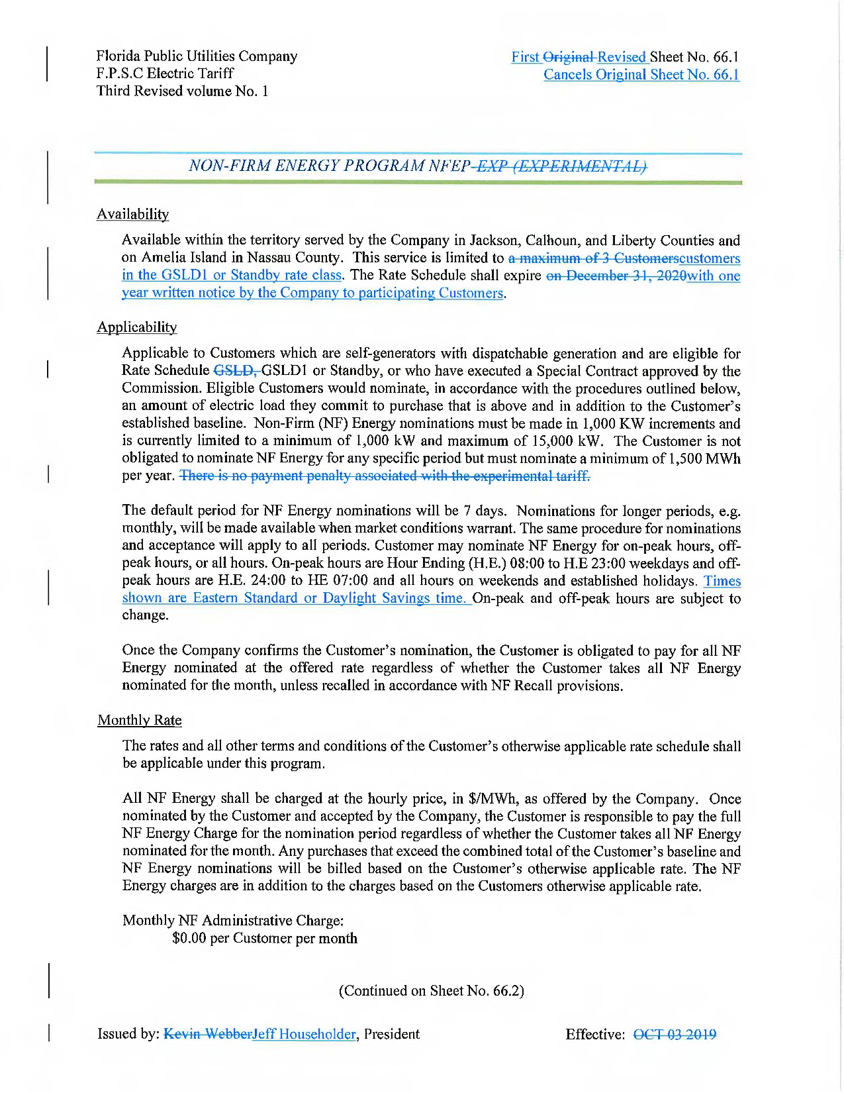
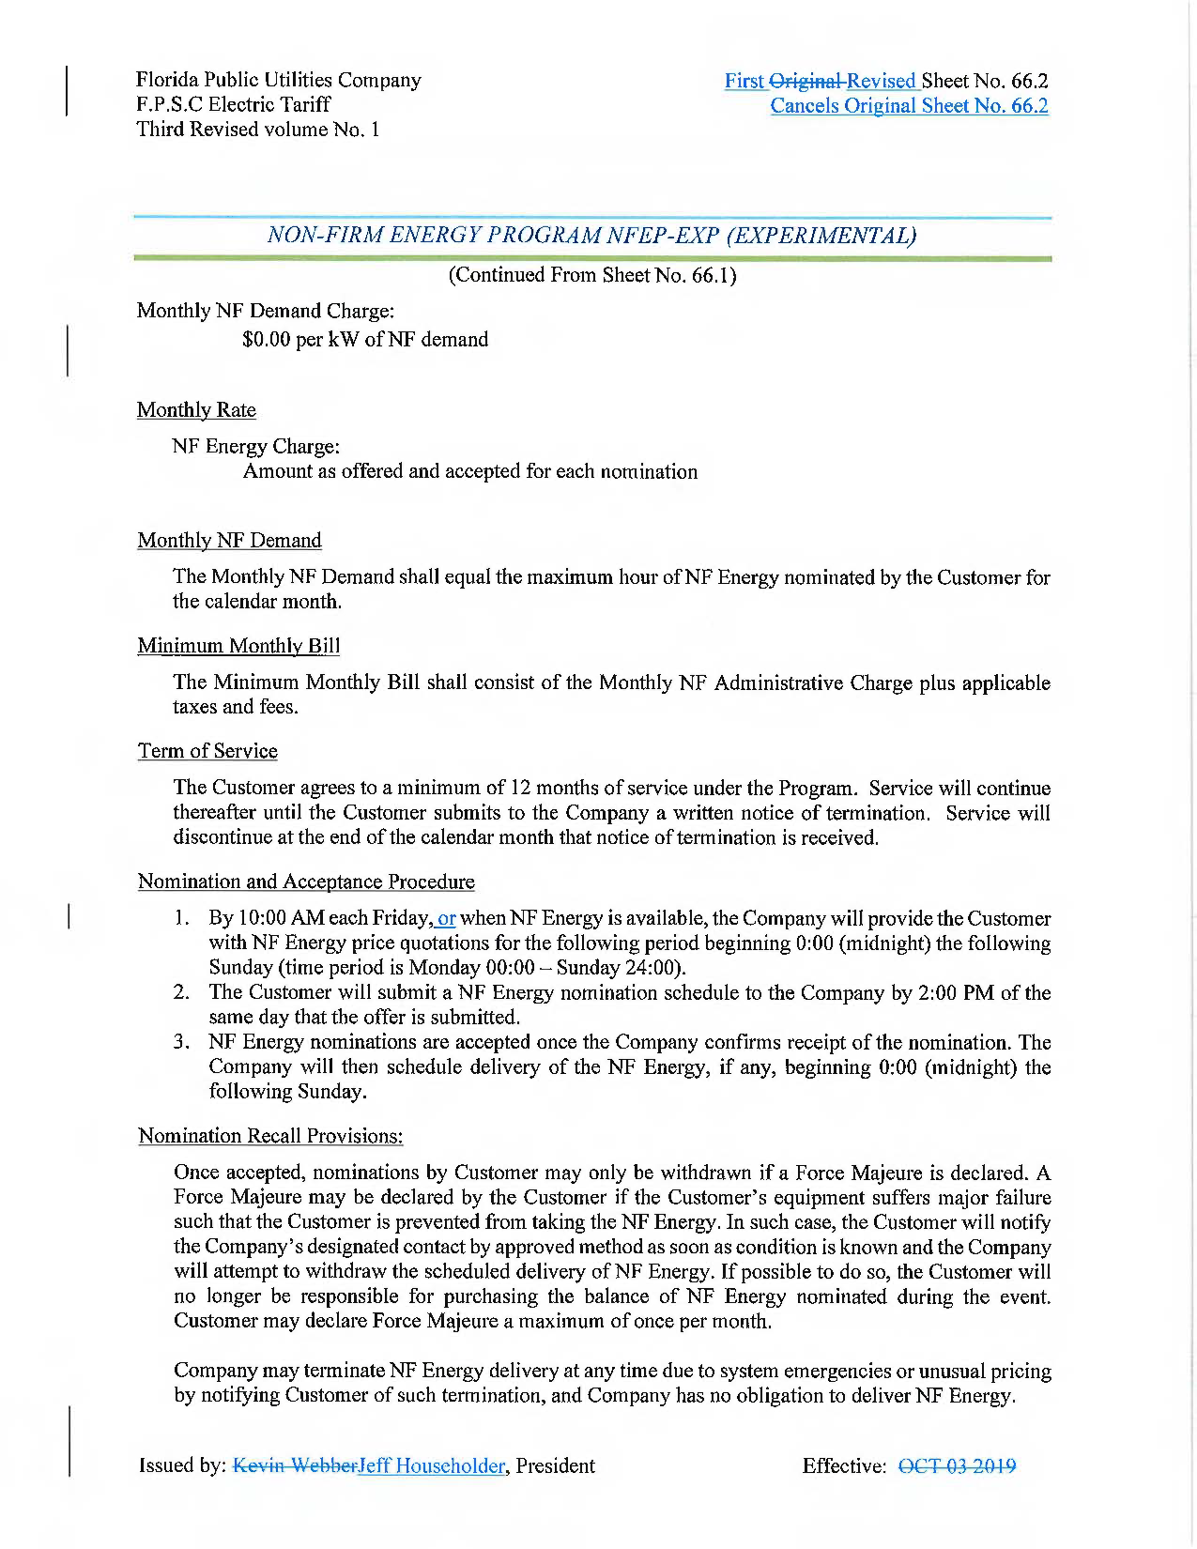

Order No. PSC-2019-0432-TRF-EI, issued October 22, 2019, in Docket No. 20190132-EI, In re: Petition for authority for approval of non-firm energy pilot program and tariff by Florida Public Utilities Company.
Document No. 12897-2021, filed November 30, 2021.
See Docket No. 20210001-EI.
Effective, January 1, 2022, FPL and Gulf merged into one company under the FPL name.
Responses to Commission staff’s first data request, Request No. 4, filed July 23, 2019, in Docket No. 20190132-EI (DN 05912-2019).
Responses to Commission staff’s first data request, Request No. 5 (DN 13055-2021).
Responses to Commission staff’s first data request, Request No. 11, filed July 23, 2019, in Docket No. 20190132-EI (DN 05912-2019).
Load Factor is defined as the average load divided by the peak load in a specified time period.
Responses to Commission staff’s first data request, Request No. 2a (DN 13055-2021).
Responses to Commission staff’s first data request, Request No. 10, filed July 23, 2019, in Docket No. 20190132-EI (DN 05912-2019).
Responses to Commission staff’s first data request, Request No. 2b (DN 13055-2021).

