State of Florida |  | Public Service Commission  Capital Circle Office Center ● 2540 Shumard Oak Boulevard  Tallahassee, Florida 32399-0850  -M-E-M-O-R-A-N-D-U-M-
DATE: | March 24, 2022
TO: | Office of Commission Clerk (Teitzman)
FROM: | Division of Economics (Forrest)  Office of the General Counsel (Brownless)
RE: | Docket No. 20220011-EI – Petition to modify tariff to close existing lighting tariff to new business and introduce new LED lighting tariff by Florida Public Utilities Company.
AGENDA: | 04/05/22 – Regular Agenda – Tariff Filing – Interested Persons May Participate
COMMISSIONERS ASSIGNED: |  |  | All Commissioners
PREHEARING OFFICER: |  |  | Administrative
CRITICAL DATES: |  |  | 08/03/2022 – 8 Month Effective Date
SPECIAL INSTRUCTIONS: |  |  | None

Case Background
On January 3, 2022, Florida Public Utilities Company (FPUC or utility) filed a petition requesting Commission approval to modify its Lighting Service tariff (Rate Schedule LS). Currently, Rate Schedule LS offers customers various High Pressure Sodium (HPS) and Metal Halide (MH) outdoor lighting options. In its petition, FPUC proposed to close the existing HPS and MH fixture options to new customers and offer new Light Emitting Diode (LED) fixture options.
Staff issued a data request on January 26, 2022, with responses filed by the utility on February 9, 2022. In its response, FPUC submitted revised tariff sheets Nos. 56, 57, and 58 to reflect corrections made to the cost support for the LED fixtures. The revised tariffs are included as Attachment A to this recommendation. On January 12, 2022, FPUC filed a letter in this docket waiving the 60-day file and suspend provision of Section 366.06(3), Florida Statutes (F.S.). The Commission has jurisdiction over this matter pursuant to Sections 366.04, 366.05, and 366.06 F.S.

Discussion of Issues

Issue 1:
Should the Commission approve FPUC’s proposed modifications to the Rate Schedule LS lighting tariff?

Recommendation:
Yes. The Commission should approve FPUC’s proposed modifications to the Rate Schedule LS lighting tariff as shown in Attachment A to the recommendation. The proposed new LED fixture options are cost based and expand the fixture options available to customers. Closing the current HPS and MH options for new lighting customers allows FPUC to recognize energy efficiencies and technological improvements in the lighting industry. The revised tariffs should be effective upon the issuance of a consummating order. (Forrest)

Staff Analysis:

FPUC, under Rate Schedule LS, currently provides outdoor lighting service offering HPS and MH fixtures. The utility requested approval to modify its Rate Schedule LS to close the existing HPS and MH fixture options to new customers and to offer new customers fifteen LED fixture options. Current customers served under Rate Schedule LS would remain on the HPS and MH fixture rates and would not see a change in their lighting bill. If a customer served under Rate Schedule LS needs to replace a light fixture, it would be replaced with an LED fixture and billed under the new LED fixture rates. All new lighting customers would be served under the proposed new LED lighting rates.

Closure of HPS and MH Fixtures
To support its petition, FPUC explained that as technology advances in the lighting market, the demand for HPS and MH fixtures has decreased, while the demand for LED lighting has increased. LED is a type of solid-state light that uses a semiconductor to convert electric current to visible light. LED lighting is a more energy efficient lighting source compared to its predecessors HPS and MH lights. Along with demand decreasing for HPS and MH lights, manufacturers have begun to phase out traditional product lines for HPS and MH lighting sources and replace them with the more energy efficient LED production.

New LED Fixtures
FPUC proposed to add fifteen new LED fixture rate options: five cobra heads, four decorative, four flood lights, and two shoe box with varying lamp lumens and watt sizes. The charges for the new LED lighting fixtures are comprised of three components: the fixture, maintenance, and energy charges. The fixture charge includes the estimated total cost to install an LED fixture and any carrying costs and taxes. The maintenance charge is the cost associated with maintaining the LED fixture for its expected service life. The energy charge is calculated by multiplying the estimated energy usage of the fixture by the lighting non-fuel energy charge. The new LED fixtures and associated charges can be seen on tariff sheet No. 57.

In conjunction with its petition, the utility submitted supporting cost information for the proposed LED fixture, maintenance, and energy charges. In its response to staff’s data request, the utility made two corrections to its originally-submitted calculations. With previous lighting options, there was a need to factor power loss into the calculation. However, with LED technology, there is no longer a need to factor in a power loss adjustment. Thus, the utility removed the eighteen percent power loss calculation that was originally submitted with the petition.

Along with that change, the utility stated that an adjustment was needed in its original overhead calculation. FPUC determined the correct percentage for the overhead calculation should be decreased from 35 percent to 34 percent. These two cost calculation adjustments resulted in a decrease to the proposed LED fixture rates submitted with the original petition. The revised tariff sheets, which include these corrections, were submitted with the utility’s data request responses and are attached as Attachment A to the recommendation. Staff has reviewed these changes and believes them to be appropriate and reasonable.
FPUC has provided staff with documentation that supports closing the HPS and MH lighting rates to new customers and to offer LED lighting rates in its place. As noted by FPUC, this should not only decrease energy used by FPUC subscribers, but should also lower operating and maintenance costs for the utility. The Commission has approved similar petitions to close existing HPS and MH fixture options to new customers and offer LED fixture options. Staff has reviewed all pertinent information in the docket and analyzed the cost support submitted to the Commission.

Conclusion
The Commission should approve FPUC’s proposed modifications to the Rate Schedule LS lighting tariff as shown in Attachment A to the recommendation. The proposed new LED fixture options are cost based and expand the fixture options available to customers. Closing the current HPS and MH options for new installations allows FPUC to recognize energy efficiencies and technological improvements in the lighting industry. The revised tariffs should be effective upon the issuance of a consummating order.

Issue 2:
Should this docket be closed?

Recommendation:
If a protest is filed within 21 days of the issuance of the order approving the proposed tariffs, the current tariffs should remain in effect pending resolution of the protest. If no timely protest is filed, the approved tariffs should go into effect, and the docket be closed, upon the issuance of a consummating order. (Brownless)

Staff Analysis:
If a protest is filed within 21 days of the issuance of the order approving the proposed tariffs, the current tariffs should remain in effect pending resolution of the protest. If no timely protest is filed, the approved tariffs should go into effect, and the docket be closed, upon the issuance of a consummating order.

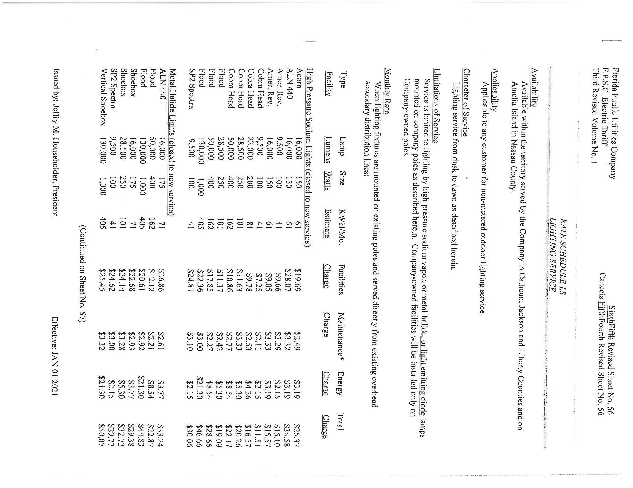
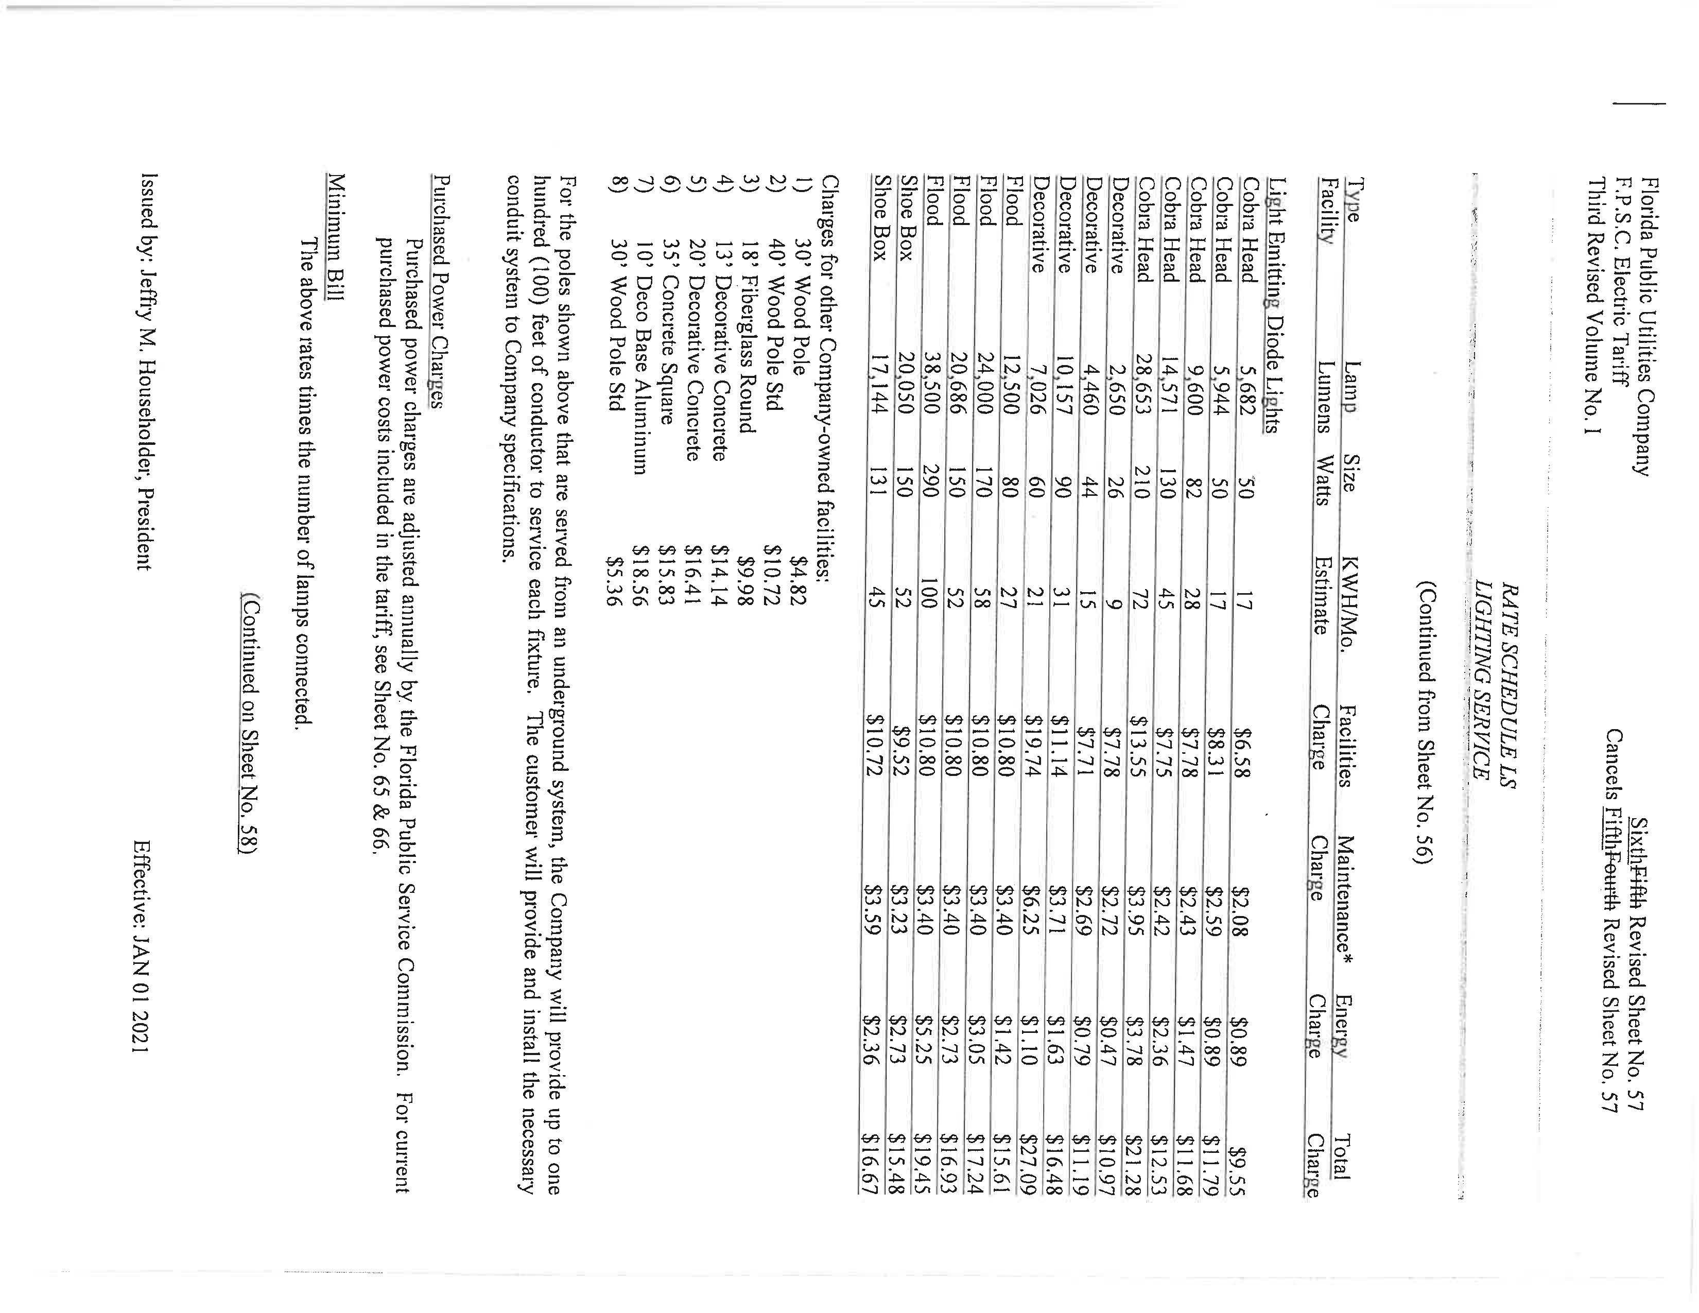
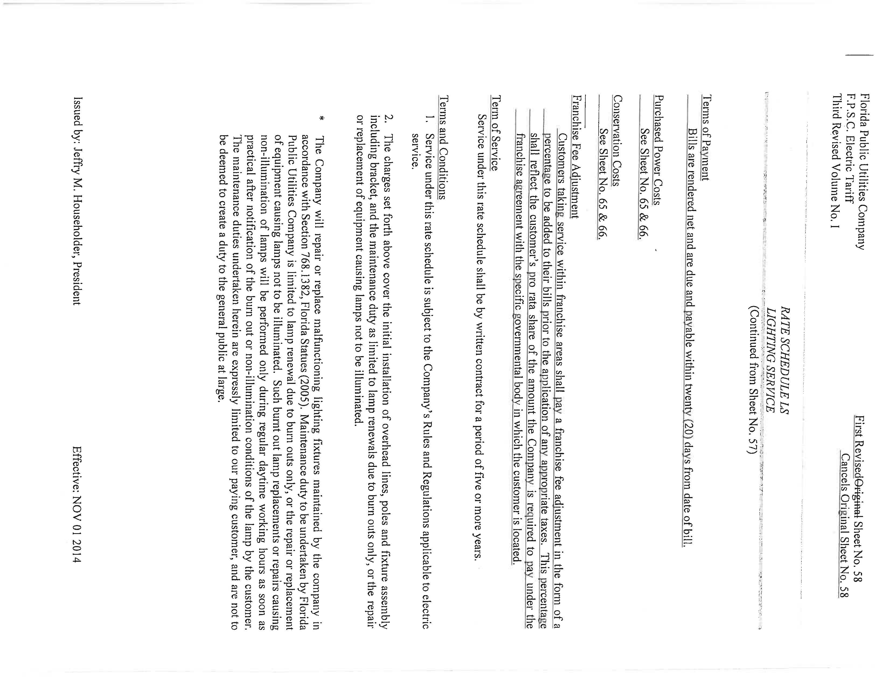

Order No. PSC-2019-0100-TRF-EI, issued March 13, 2019, in Docket No. 20190023-EI, in re: Petition for approval of modifications to rate schedule LS-1, lighting service, by Duke Energy Florida, LLC., and Order No. PSC-15-0094-TRF-EI, issued February 5, 2015, in Docket No. 20140232-EI, In re: Petition for approval of revised lighting tariff by Tampa Electric Company.

