BEFORE THE FLORIDA PUBLIC SERVICE COMMISSION

In re: Petition for limited proceeding to approve 2021 settlement agreement, including general base rate increases, by Duke Energy Florida, LLC. | DOCKET NO. 20210016-EI  ORDER NO. PSC-2022-0147-PAA-EI  ISSUED: April 15, 2022

The following Commissioners participated in the disposition of this matter:

ANDREW GILES FAY, Chairman
ART GRAHAM
GARY F. CLARK
MIKE LA ROSA
GABRIELLA PASSIDOMO

NOTICE OF PROPOSED AGENCY ACTION
ORDER GRANTING MOTION FOR APPROVAL
OF CALCULATION OF TAX IMPACTS

BY THE COMMISSION:

NOTICE is hereby given by the Florida Public Service Commission that the action discussed herein is preliminary in nature and will become final unless a person whose interests are substantially affected files a petition for a formal proceeding, pursuant to Rule 25-22.029, Florida Administrative Code (F.A.C.).

BACKGROUND
On September 14, 2021, the Florida Department of Revenue issued a Tax Information Publication (TIP) that stated the “Florida corporate income/franchise tax rate is reduced from 4.458% to 3.535% for taxable years beginning on or after January 1, 2021, but before January 1, 2022. The tax rate returns to 5.5% for taxable years beginning on or after January 1, 2022.”
Paragraph 18 of Duke Energy Florida’s (DEF) 2021 Settlement Agreement describes the methodology for calculating tax impacts and flow back associated with tax reform, including changes such as those provided for in the TIP. On December 9, 2021, DEF filed a motion requesting that the Commission approve its calculation of tax impacts resulting from the change in the Florida corporate income tax rate.

We have jurisdiction over this matter pursuant to Sections 366.076 and 366.06(3), Florida Statutes.
DECISION
Duke’s 2021 Settlement Agreement contained provisions for addressing tax changes including changes to tax rates, changes to deductibility of certain costs, and changes to the timing of the deductibility of certain costs. DEF used the 2021 Forecasted Earnings Surveillance Report to calculate the impact of the Florida corporate income tax rate changing from 4.458% to 3.535% for 2021. The change in the Florida corporate income tax rate resulted in a revenue requirement increase of $98,969. Although the lowered Florida corporate income tax rate results in tax savings on a system-wide basis, the benefit is more than offset by the tax impact associated with our prior adjustments at the retail level. Commission adjustments that reduce revenues also reduce taxes. When the tax rate is lowered, the tax benefit associated with reduced revenues is also lowered. In the instant case, as shown on Attachment 1, we note that DEF’s retail tax savings of $356,484 were offset by the tax impacts of $431,905 associated with our adjustments at the base rates retail level, resulting in a revenue requirement increase of $75,421, which increases to $98,969 after grossing-up for taxes. We acknowledge DEF’s agreement to forego collection of the $98,969 deficiency.
We reviewed DEF’s calculation of the tax reform impacts and found no errors. As indicated in its motion, DEF has conferred with the signatories to the 2021 Settlement and Nucor Steel Florida, Inc., PCS Phosphate d/b/a White Springs and the Office of Public Counsel concur with DEF’s calculation. DEF represents that the Florida Industrial Power Users Group takes no position.
For the reasons discussed above, we hereby approve DEF’s calculation of the tax reform impacts and acknowledge that DEF has agreed to forego collection of the associated deficiency of $98,969.
Based on the foregoing, it is

ORDERED by the Florida Public Service Commission that Duke Energy Florida, LLC’s Motion for Approval of Calculation of Tax Reform Impacts is hereby granted as set forth in the body of this order. It is further

ORDERED that DEF’s retail tax savings of $356,484 were offset by the tax impacts of $431,905 associated with our adjustments at the base rates retail level resulting in a revenue requirement increase of $75,421, which increases to $98,969 after grossing-up for taxes, as reflected in Attachment 1. It is further

ORDERED that we acknowledge DEF’s agreement to forego collection of the associated deficiency of $98,969. It is further

ORDERED that the provisions of this order, issued as proposed agency action, shall become final and effective upon the issuance of a Consummating Order unless an appropriate petition, in the form provided by Rule 28-106.201, F.A.C., is received by the Office of Commission Clerk, 2540 Shumard Oak Boulevard, Tallahassee, Florida 32399-0850, by the close of business on the date set forth in the “Notice of Further Proceedings” attached hereto. It is further

ORDERED that if no person whose substantial interests are affected by the proposed agency action files a protest within 21 days of the issuance of this order, this docket should be closed upon the issuance of a consummating order. If a protest is timely filed, the docket shall remain open pending resolution of the proceeding.

By ORDER of the Florida Public Service Commission this 15th day of April, 2022.

/s/ Adam J. Teitzman
ADAM J. TEITZMAN
Commission Clerk
Florida Public Service Commission
2540 Shumard Oak Boulevard
Tallahassee, Florida 32399
(850) 413-6770
www.floridapsc.com

Copies furnished: A copy of this document is provided to the parties of record at the time of issuance and, if applicable, interested persons.

WLT

NOTICE OF FURTHER PROCEEDINGS OR JUDICIAL REVIEW
The Florida Public Service Commission is required by Section 120.569(1), Florida Statutes, to notify parties of any administrative hearing that is available under Section 120.57, Florida Statutes, as well as the procedures and time limits that apply. This notice should not be construed to mean all requests for an administrative hearing will be granted or result in the relief sought.
Mediation may be available on a case-by-case basis. If mediation is conducted, it does not affect a substantially interested person's right to a hearing.
The action proposed herein is preliminary in nature. Any person whose substantial interests are affected by the action proposed by this order may file a petition for a formal proceeding, in the form provided by Rule 28-106.201, Florida Administrative Code. This petition must be received by the Office of Commission Clerk, 2540 Shumard Oak Boulevard, Tallahassee, Florida 32399-0850, by the close of business on May 6, 2022.
In the absence of such a petition, this order shall become final and effective upon the issuance of a Consummating Order.
Any objection or protest filed in this/these docket(s) before the issuance date of this order is considered abandoned unless it satisfies the foregoing conditions and is renewed within the specified protest period.

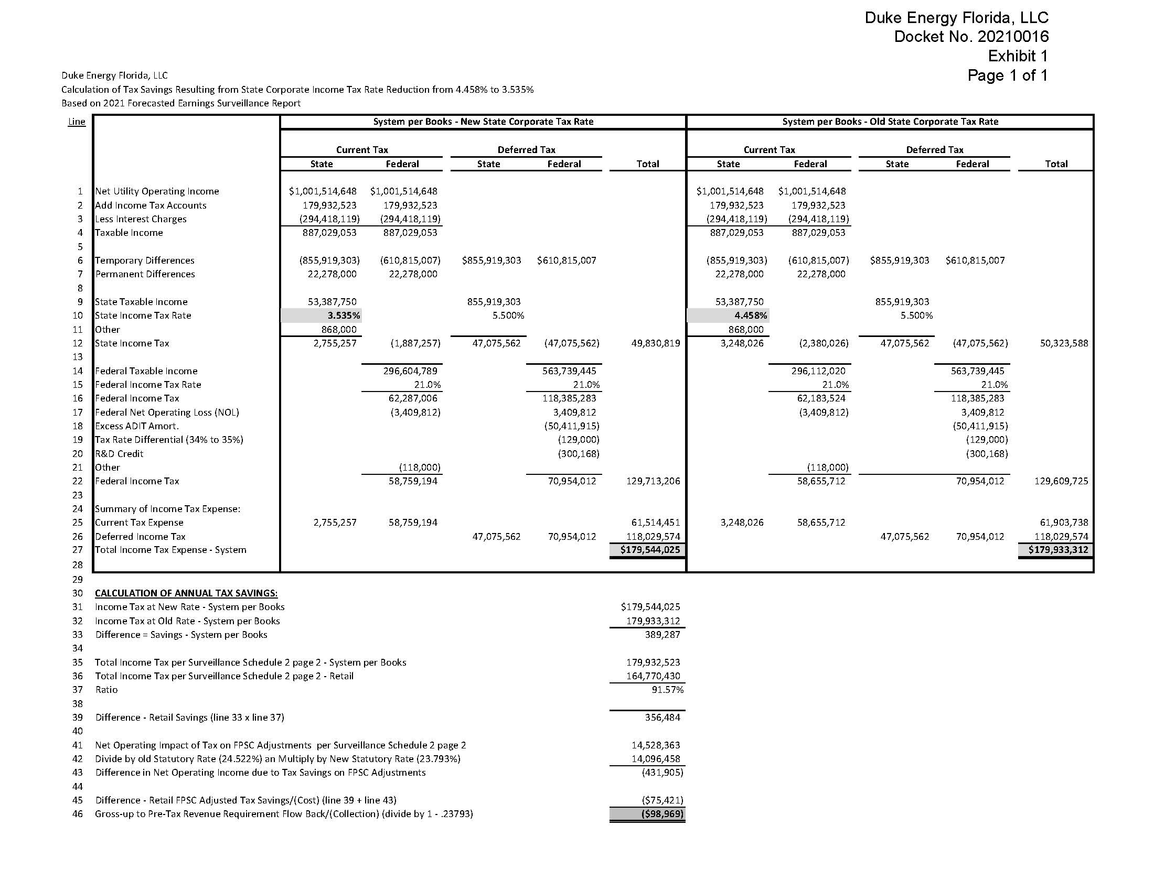

Order No. PSC-2021-0202-AS-EI, issued June 4, 2021, in Docket No. 20210016-EI, In re: Petition for limited proceeding to approve 2021 settlement agreement, including general base rate increases, by Duke Energy Florida, LLC, as amended by Order No. PSC-20210020A-AS-EI, issued June 28, 2021.
Document No. 13005-2021.

