State of Florida |  | Public Service Commission  Capital Circle Office Center ● 2540 Shumard Oak Boulevard  Tallahassee, Florida 32399-0850  -M-E-M-O-R-A-N-D-U-M-
DATE: | April 21, 2022
TO: | Office of Commission Clerk (Teitzman)
FROM: | Office of Industry Development and Market Analysis (Deas, Fogleman)  Office of the General Counsel (Weisenfeld, Imig)
RE: | Docket No. 20220036-TP – Petition of North American Numbering Plan Administrator on behalf of the Florida telecommunications industry, in the matter of the implementation for relief of the 904 numbering plan area.
AGENDA: | 05/03/22 – Regular Agenda – Interested Persons May Participate
COMMISSIONERS ASSIGNED: |  |  | All Commissioners
PREHEARING OFFICER: |  |  | Passidomo
CRITICAL DATES: |  |  | The estimated exhaust date for the 904 area code is the third quarter of 2024.
SPECIAL INSTRUCTIONS: |  |  | None

Case Background
On February 17, 2022, the North American Numbering Plan Administrator (NANPA), on behalf of Florida’s telecommunications industry (Industry), filed a petition with the Florida Public Service Commission (Commission) for approval of its area code relief plan for the 904 Numbering Plan Area (NPA). The Industry reached a consensus decision to recommend an all-services distributed overlay as the form of relief for the 904 NPA. NANPA projects that the supply of central office codes in the 904 NPA will exhaust during the third quarter of 2024. Consequently, NANPA is also requesting that the Commission approve the recommended 13-month implementation schedule.
NANPA is the neutral third-party administrator of the North American Numbering Plan, which is the area code system shared by the United States, Canada, Bermuda, and 17 Caribbean countries. The area served by NANPA is divided into NPAs, which are each identified by a three-digit NPA code, commonly called an area code. NANPA’s responsibilities include assigning area codes and prefixes, and tracking numbering usage to ensure effective and efficient utilization. NANPA is also responsible for forecasting the exhaust of geographic area codes and area code relief planning. NANPA publishes its forecasted exhaust of all area codes on a semi-annual basis. This forecast is used to determine when to start the area code relief process.
The 904 area code was introduced in 1965 when the 305 area code needed relief due to substantial growth. It was the third area code assigned in Florida. Originally, the 904 area code covered the entire northern part of Florida. The first geographic split of the 904 NPA occurred in 1995, resulting in the creation of the 352 NPA. In 1997, as a result of additional growth the 904 NPA was split again creating the 850 NPA. The last geographic split of the 904 NPA was implemented in 2001, which created the 386 NPA. The 386 area code serves the only non-contiguous NPA in Florida, with one part at the western boundary of the 904 NPA and the other at the southeastern boundary. Currently, the 904 area code includes all or most of Nassau, Duval, Baker, Bradford, Clay, St Johns and Union Counties.
In January 2022, NANPA forecasted that the 904 area code would exhaust during the third quarter of 2024. NANPA convened an industry meeting on January 13, 2022, to review and approve the area code relief filing. On February 17, 2022, NANPA filed a petition with the Commission on behalf of the Industry requesting approval of an all services distributed overlay for the 904 area code (see map Attachment A). The Commission has jurisdiction to address this issue pursuant to Sections 364.16(7) and 120.80(13)(d), Florida Statutes, and 47 Code of Federal Regulations (C.F.R.) § 52.19.

Discussion of Issues

Issue 1:
Should the Commission approve the Industry's consensus recommendation of an all-services distributed overlay as the area code relief plan for the 904 area code?

Primary Recommendation:
Yes. The Commission should approve the Industry’s consensus recommendation of an all-services distributed overlay as the area code relief plan for the 904 area code. (Deas, Weisenfeld)

Alternative Recommendation:
No. Staff recommends a modified overlay of a new area code with boundary elimination as the area code relief plan for the 904 area code. Staff recommends an immediate overlay of a new area code over the 904 area code, with a boundary elimination between the 904 and 386 geographic areas once the 386 area code reaches exhaust. (Fogleman, Imig)

Staff Analysis:
Area code relief responsibilities have been delegated to the states by the Federal Communication Commission (FCC) pursuant to 47 C.F.R. § 52.19. In Florida, the Commission is responsible for determining the appropriate form of area code relief when telephone numbers exhaust within an area code. There are a number of methods available to address area code exhaust issues; however, the two most commonly used methods are a geographic split or an overlay.
Geographic Split
The geographic split method divides the exhausting NPA into two, leaving the existing area code to serve one NPA and assigning a new area code to serve the other NPA. This method generally acknowledges jurisdictional or natural boundaries, but for technical reasons and number optimization considerations, the actual boundaries must conform to existing rate center boundaries. Under this method, customers on both sides of the split would retain seven digit dialing; however, it would require customers in the new NPA to change their area code. The last split implemented in Florida was 20 years ago. Industry guidelines specify that in the case of a geographic split, the difference in area code life expectancies between the split areas should be 10 years or less.
Overlay
The overlay method adds a new area code to the same geographic area served by the area code requiring relief. This results in the assignment of more than one area code to the same NPA. Current customers keep their existing area code and number, while new customers or customers adding additional lines would receive the new area code. Once an overlay is implemented, the FCC requires 10-digit dialing for all local calls within the NPA. There are four potential implementation strategies for an overlay, which are as follows:
a) All-Services Distributed Overlay - The distributed overlay strategy may be considered in situations when growth in telephone numbers is expected to be more or less evenly distributed throughout the existing NPA. The new area code is added to the same geographic area as the area code requiring relief and shares exactly the same geographic boundaries.
b) Concentrated Growth Overlay - A concentrated growth overlay may be considered in situations when the majority of need for the new telephone numbers is expected to be concentrated in one section of the existing NPA. For example, a fast growing metropolitan area and a sparsely populated rural area could exist within the same NPA. The overlay area code would be assigned initially to the section of the NPA experiencing the fastest growth, and new phone numbers in that section would be assigned from the new area code. As more relief is required, the geographic area served by multiple area codes could expand to the rest of the NPA.

c) Boundary Elimination Overlay - With a boundary elimination overlay, the NPA requiring relief is adjacent to an NPA with available numbering resources. The boundary between these NPAs is eliminated, and spare telephone numbers from the adjacent area code are assigned within the NPA boundary where relief is required.

During the February 17, 2022, Industry meeting hosted by NANPA, the following six relief plans were considered.
Alternative No. 1 - All-Services Distributed Overlay (see map in Attachment A)
A new area code would be assigned to the same geographic area occupied by the existing 904 area code. Customers would retain their current telephone numbers; however, 10-digit dialing would be required by all customers within the NPA. At the exhaust of the 904 area code, all future assignments will be made from the new area code. The projected life of this method would be approximately 29 years.

Alternative No. 2 - Boundary Elimination Overlay (see map in Attachment B)
The boundary between the existing 904 and 386 area codes would be eliminated and both area codes would be assigned to the combined geographic area. This alternative would allow customers assigned the 904 and 386 area codes to retain their telephone numbers and would eliminate the need for a new area code. However, it would require 10-digit dialing for all customers within the combined NPA. The projected life of this method would be approximately 9 years.

Alternative No. 3 - Overlay of a New Area Code with Boundary Elimination (see map in Attachment C)
The boundary between the 904 and 386 area codes would be eliminated and a new area code would be assigned to the combined geographic area. This alternative would allow customers assigned the 904 and 386 area codes to retain their telephone numbers. However, it would require 10-digit dialing for all customers within the NPA. At the exhaust of the 904 and 386 area codes all future assignments would be made from the new area code. The projected life of this method would be approximately 26 years.

Alternative No. 4 - Overlay of a New Area Code with Boundary Elimination (see map in Attachment D)
The boundary between the existing 904, 386, and 352 area codes would be eliminated and a new area code would be assigned to the combined geographic area. This alternative would allow customers assigned the 904, 386, and 352 area codes to retain their telephone numbers. However, it would require 10-digit dialing for all customers within the combined NPA. At the exhaust of the 904, 386, and 352 area codes all future assignments would be made from the new area code. The projected life of this method would be approximately 17 years.

Alternative No. 5 - Overlay of a New Area Code with Boundary Elimination (see map in Attachment E)
The boundary between the 904 and 352 area codes would be eliminated and a new area code would be assigned to the combined geographic area. This alternative would allow customers assigned the 904 and 352 area codes to retain their telephone numbers. However, it would require 10-digit dialing for all customers within the combined NPA. At the exhaust of the 904 and 352 area codes all future assignments would be made from the new area code. The projected life of this method would be approximately 17 years.

Alternative No. 6 – A Geographic Split (see map in Attachment F and G)
The 904 area code would be split into two geographic areas. The split boundary would separate the Jacksonville rate center which consist of the city of Jacksonville (Area A) and the remaining 18 rate centers which includes Jacksonville Beach (Area B). The 904 area code would serve one area and the new area code would serve the other. The Commission would have to determine which geographic area would retain the 904 area code. Customers on both sides of the split would retain seven digit dialing. The projected life of this method would be approximately 26 years for Area A and 33 years for Area B.

Industry Consensus

After review of the six alternatives, the Industry reached a consensus recommending alternative No. 1, an all-services distributed overlay, as the form of relief for the 904 NPA. The Industry decided against the other alternatives due to the fact that they have shorter projected exhaust dates. Also, the complicated technical and customer education issues would potentially prolong implementation.

Industry Proposed Dialing Plan
If an all-services distributed overlay is approved by the Commission, the Industry recommends the dialing plan be set forth as follows:
Local Calls 10-digit dialing (as required by the FCC)
Toll Calls 1 + 10-digit dialing
Operator Calls 0 + 10-digit dialing
The Industry has also recommended a 13-month implementation schedule. This schedule includes six-months for network preparation, followed by a six-month permissive 10-digit dialing and customer education period. During the permissive dialing period, calls within the 904 area code can be completed using either 7-digits or 10-digits. The purpose of the permissive dialing period is to facilitate transition from 7-digit to 10-digit dialing by educating customers on the impending changes without impacting the calls. Following the six-month permissive dialing, mandatory 10-digit dialing will be required. If the required 10-digits are not dialed, the caller will receive a recorded message advising them that the area code is required to complete the call.
Staff Workshop
In an effort to educate and receive customer input, staff held a virtual customer workshop on March 23, 2022. During this workshop Commission staff and a representative from NANPA explained the area code relief process, the relief options being considered, and customer impact. Four customer comments were filed with the Commission. Two customers offered suggestions concerning what the new area code should be and the others expressed that they didn’t want their area code to change.
Summary
Staff reviewed the petition and analyzed all alternatives. Staff considered which alternative would provide the longest length of time before needing relief and the impact on customers and Industry. Staff notes that except for alternative No. 6, all the alternatives would require customers to dial 10-digits for all local calls. Alternatives No. 2, 3 and 4 would impose 10-digit local dialing for customers in the 386 area code who otherwise potentially would not be affected for another 17 years. Alternative No. 6 is the geographic split option which would allow customers to continue 7-digit local dialing but would require some customers to change their area code. As a result, those customers and businesses receiving the new area code would be forced to incur costs to implement the area code change on advertisements, bill-boards, etc. Additionally, the Commission would have to determine which customers would receive the new area code. Staff notes that Industry has indicated alternative’s No. 2-6 would require additional time to implement.
Primary Conclusion
Primary staff concludes that alternative No. 1 provides the longest projected exhaust date, it minimizes the number of customers impacted by 10-digit local dialing, and it would take the least amount of time to implement. Therefore, staff agrees with the Industry and recommends the Commission approve the all-services distributed overlay as the form of relief for the 904 area code. Additionally, staff recommends Commission approval of the proposed 13-month implementation schedule. Finally, staff recommends the Commission order that central office codes in the new area code be available only when all assignable prefixes in the 904 area code have been assigned.

Alternative Conclusion
Staff’s alternative recommendation is to implement a modified version of alternative No. 3, which would be implemented in two parts. The first part would implement a new area code overlay over the 904 geographic area. The second part would be to eliminate the boundary between the 904 and 386 NPAs when the 386 area code reaches exhaust. NANPA projects the 386 area code will exhaust by fourth quarter 2039.
As previously mentioned, the area currently covered by the 386 area code was part of the 904 NPA prior to 2001. The area code split resulted in the assignment of the 386 area code created the only non-contiguous NPA in Florida. Nationally, there are only five other non-contiguous NPAs. One of the considerations when implementing area code relief relates to the community of interest. Currently, because the northwestern and southeastern portions of the 386 NPA are not connected, there is no community of interest joining them. Staff’s alternative recommendation would reunite the areas covered by the 904 and 386 area codes into a single NPA. In addition, the two-part implementation approach would minimize customer impact by not prematurely requiring 10-digit local dialing for customers with the 386 area code. While this proposal has a slightly shorter projected exhaust length than the primary recommendation, the difference is only three years.
Staff recommends that the Commission approve the implementation of an all-services distributed overlay over the 904 geographic area and a boundary elimination between the 904 and 386 NPAs at the exhaust of the 386 area code. In addition, staff recommends Commission approval of the proposed 13-month implementation schedule for the new area code overlay. Staff recommends the Commission direct NANPA to reconvene the Industry to set an implementation schedule for the boundary elimination once the 386 area code reaches 36 months to exhaust. Staff recommends NANPA officially notify the Commission prior to reconvening with Industry. Finally, staff recommends the Commission order that central office codes in the new area code be available only when all assignable prefixes in the 904 area code have been assigned.

Issue 2:
Should this docket be closed?

Recommendation:
No. If no person whose substantial interests are affected by the proposed agency action files a protest within 21 days of the issuance of the PAA Order, a Consummating Order should be issued. The docket should remain open pending the full implementation of the all-services distributed overlay of the 904 area code. Once this action is complete the docket should be closed administratively. (Weisenfeld, Imig)

Staff Analysis:

The docket should remain open pending the full implementation of the all-services distributed overlay of the 904 area code. Once this action is complete the docket should be closed administratively.

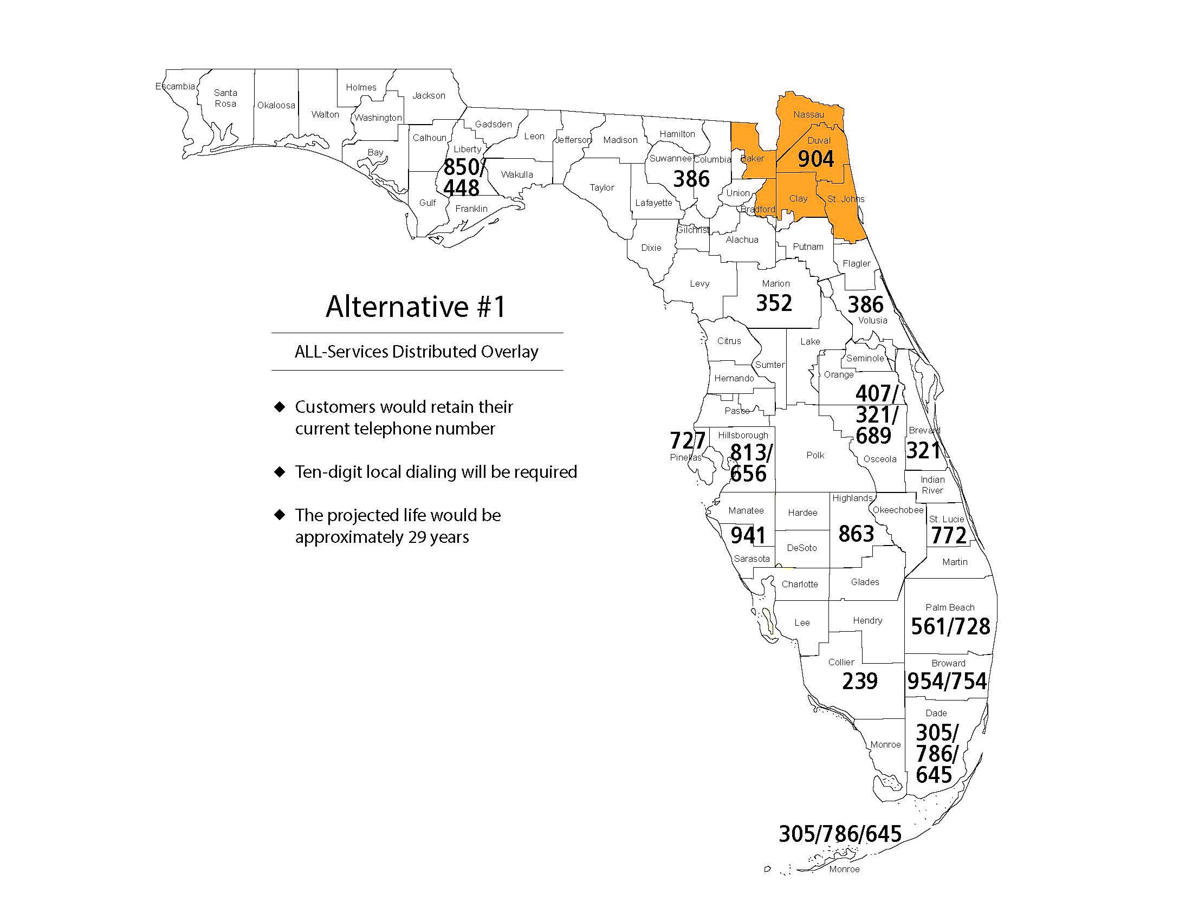

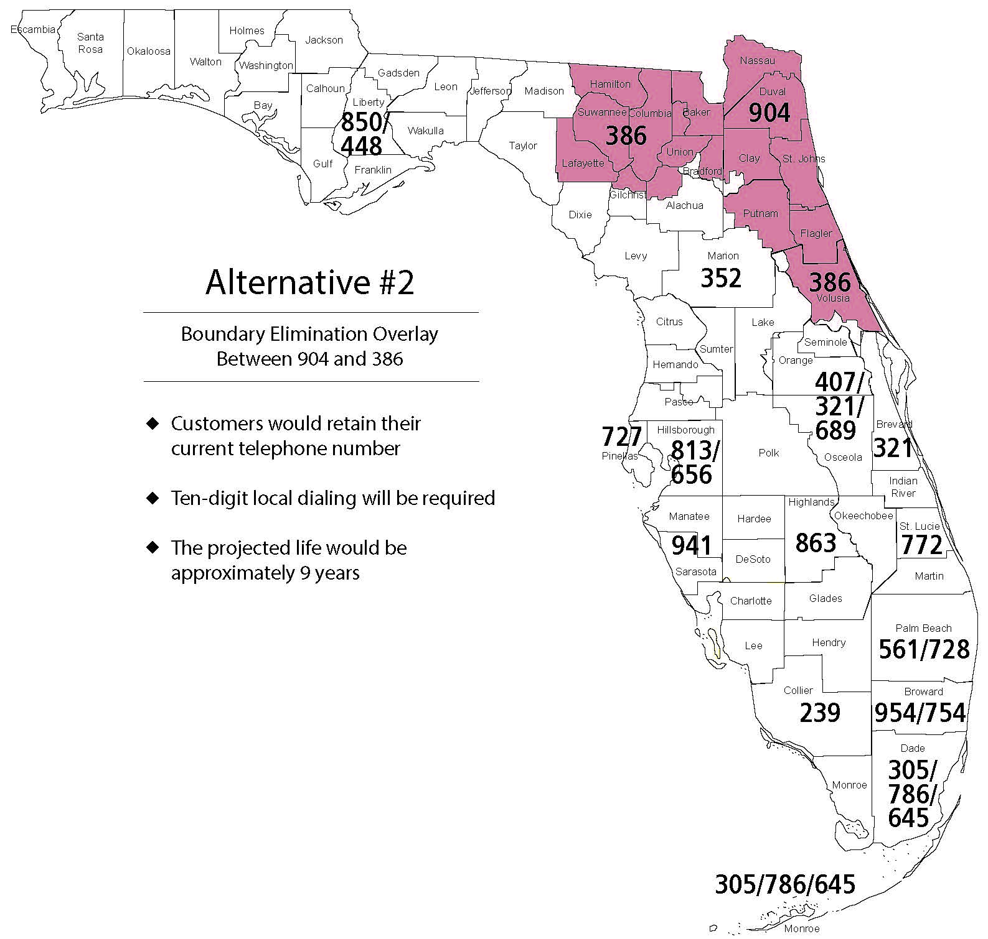

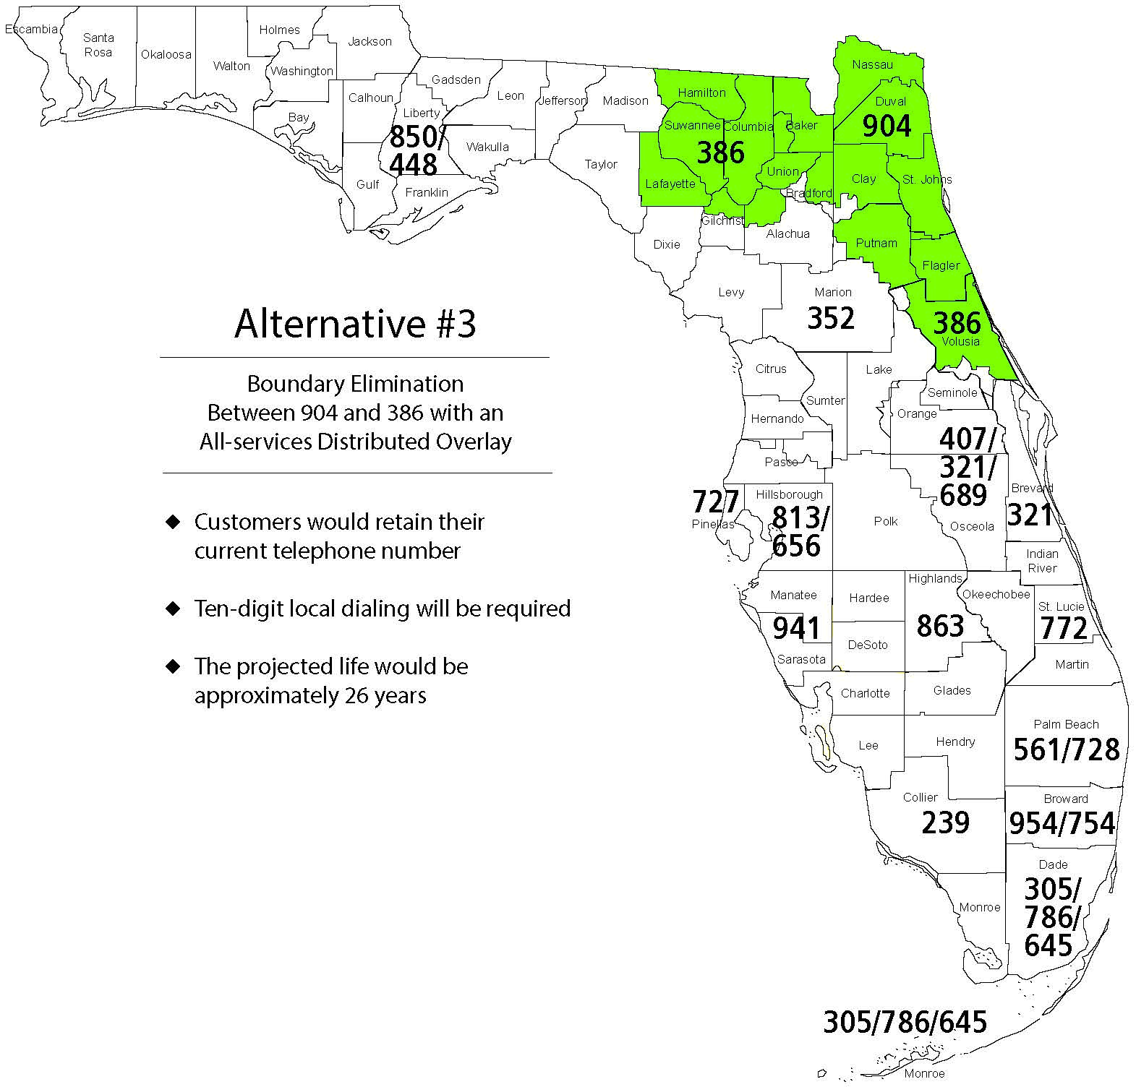

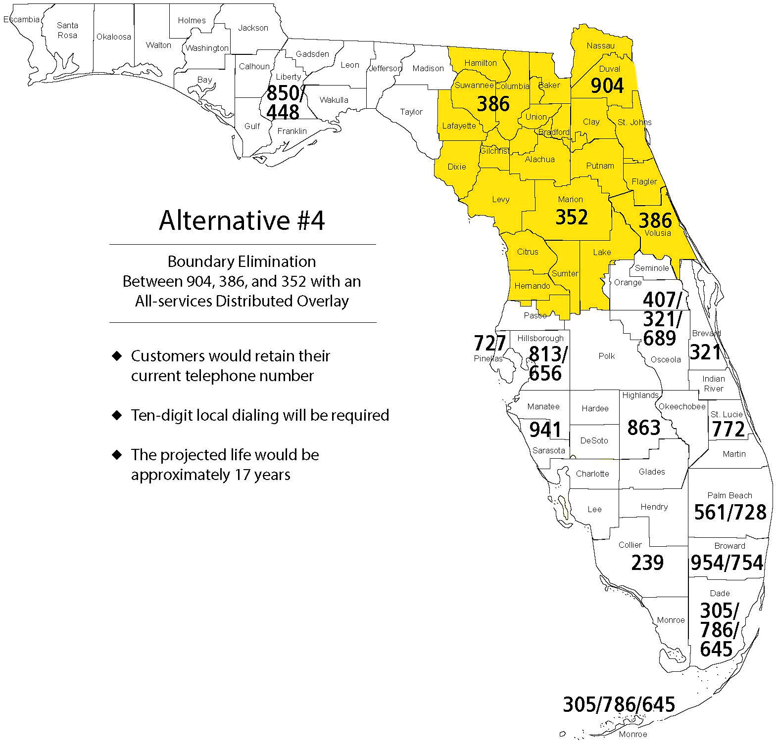

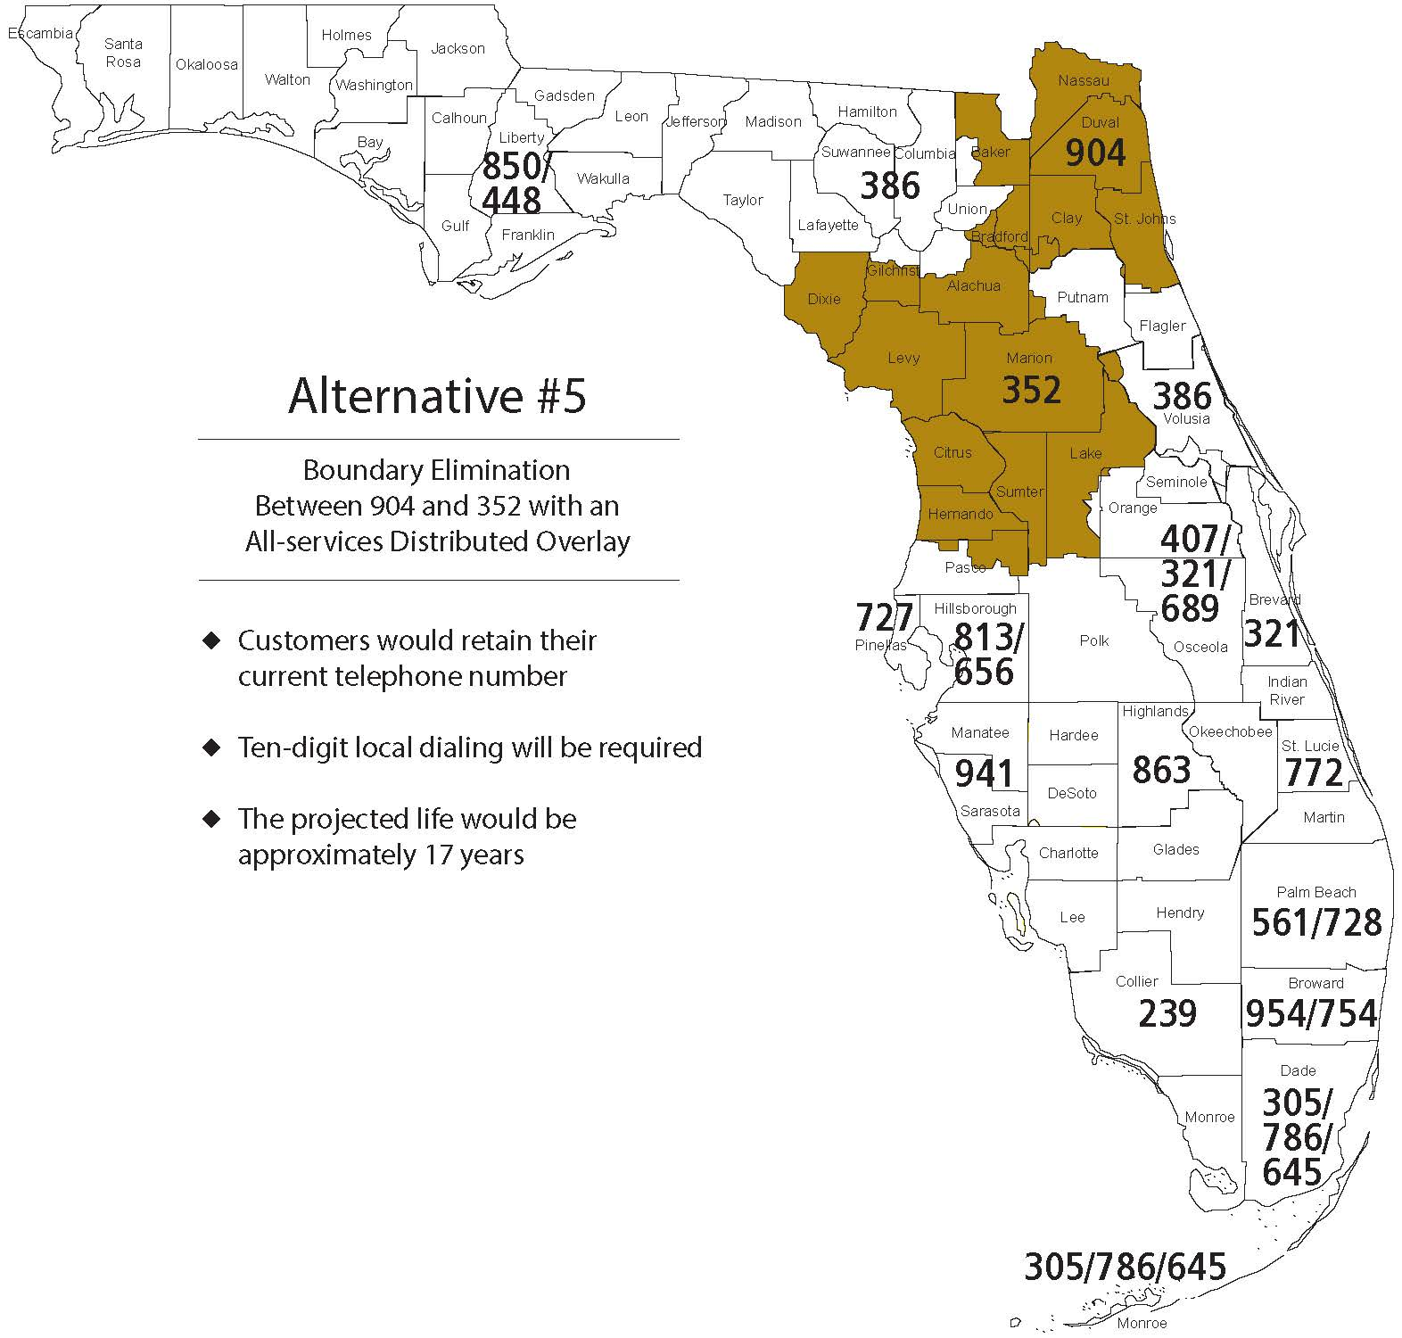

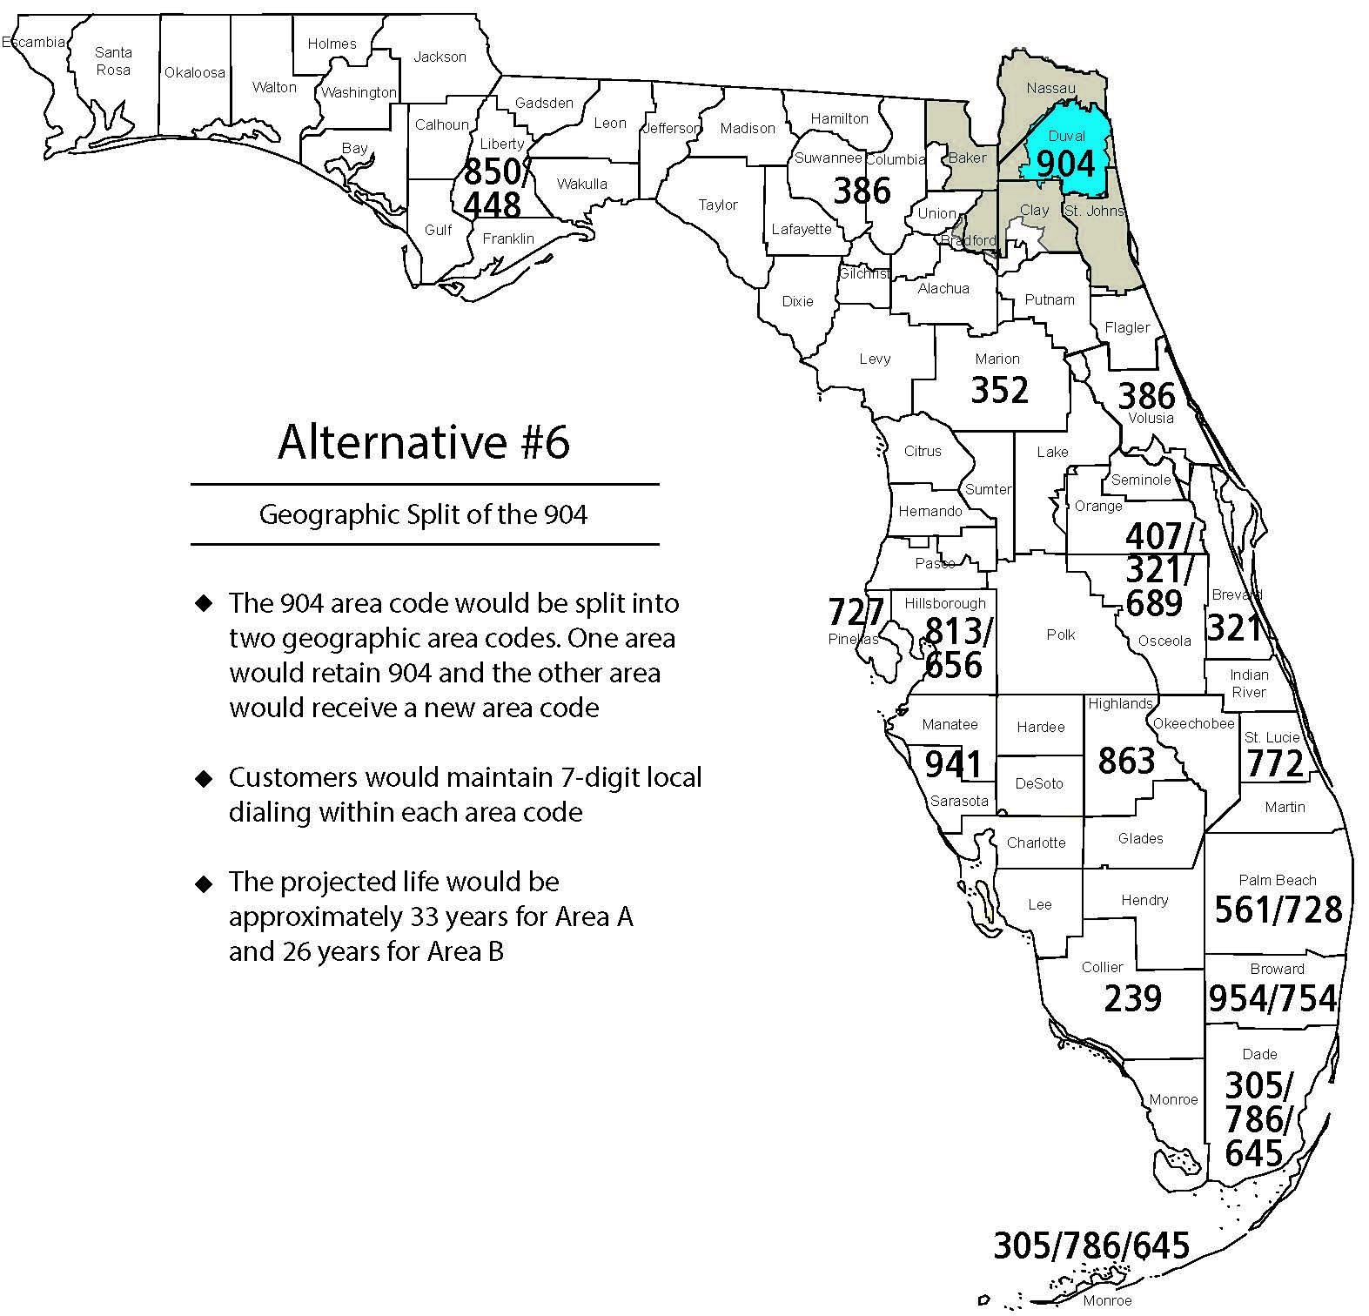

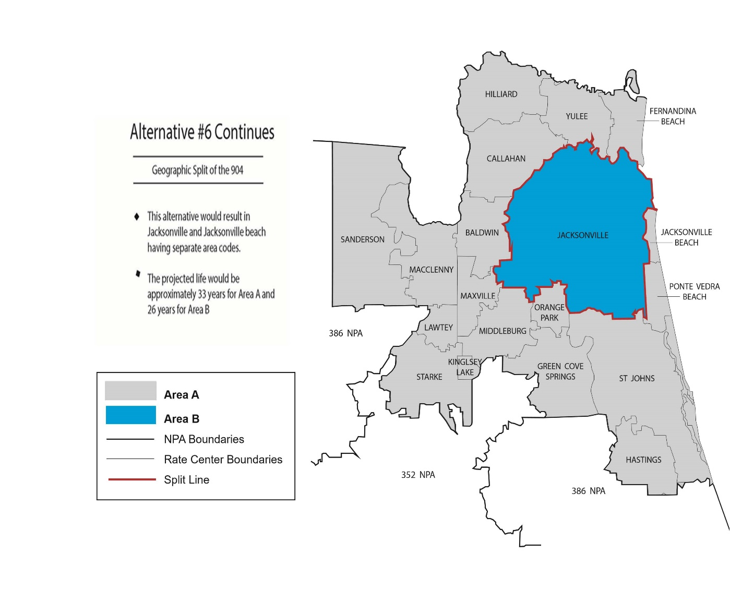
Alternative #6 Continues
Geographic Split of the 904
- This alternative would result in Jacksonville and Jacksonville Beach having separate area codes

- The projected life would be approximately 33 years for Area A and 26 years for Area B

NPA Code Relief Planning & Notification Guidelines ATIS-0300061 - Section 5.0 (g).
NANPA has identified the following states and rea codes as non-contiguous: Florida (386), Georgia (706/762), Tennessee (423), Washington (360/564), Texas (409), and Ohio (440).
According to NANPA, many things can be considered as a “Community of Interest” such as a city, closely located cities, a neighborhood, a business with multiple locations, government agencies that serve a wide area (not just one entity, i.e., county sheriff department), or other agencies/businesses with multiple locations. Basically, a Community of Interest involves common interests and common needs.

