BEFORE THE FLORIDA PUBLIC SERVICE COMMISSION

In re: Petition for rate increase by Florida Public Utilities Company, Florida Division of Chesapeake Utilities Corporation, Florida Public Utilities Company - Fort Meade, and Florida Public Utilities Company - Indiantown Division. | DOCKET NO. 20220067-GU  ORDER NO. PSC-2022-0308-PCO-GU  ISSUED: August 19, 2022

The following Commissioners participated in the disposition of this matter:

ANDREW GILES FAY, Chairman
GARY F. CLARK
GABRIELLA PASSIDOMO

ORDER APPROVING INTERIM RATES

BY THE COMMISSION:

Background
On May 24, 2022, Florida Public Utilities Company (FPUC), Florida Division of Chesapeake Utilities Corporation (Chesapeake), Florida Public Utilities Company-Fort Meade (Ft. Meade), and Florida Public Utilities Company-Indiantown Division (Indiantown) (collectively the Company) filed a petition seeking our approval to increase rates and charges and to consolidate the four natural gas utilities into one utility operating under the name Florida Public Utilities Company. The four natural gas utilities provide sales and transportation of natural gas and are public utilities subject to our regulatory jurisdiction under Chapter 366, Florida Statutes (F.S.).

In 2009, Chesapeake Utilities Corporation (CUC), a Delaware corporation, which owned and operated the Florida Division of Chesapeake Utilities Corporation, acquired Florida Public Utilities Company’s electric and gas divisions. In 2010, Florida Public Utilities Company acquired Indiantown Gas Company and in 2013 the natural gas assets of Fort Meade, a municipal utility. Since the acquisitions, Indiantown Gas Company operates as Florida Public Utilities Company-Indiantown Division and Fort Meade as Florida Public Utilities Company-Fort Meade.

The Company currently serves approximately 92,000 residential, commercial, and industrial customers in 26 counties throughout the state of Florida. In its petition, the Company requested an increase of $43.8 million in additional annual revenues. Of that amount, $19.8 million is associated with moving the Company’s current investment in our approved Gas Reliability Infrastructure Program (GRIP), which is being recovered through a separate surcharge on customers’ bills, into base rates. The remaining $24 million, according to FPUC, is necessary for the Company to earn a fair return on its investment and a requested return on equity of 11.25 percent. The Company based its request on a 13-month average rate base of $454.9 million for the projected test year January through December 2023. The requested overall rate of return is 6.43 percent.

FPUC’s last approved rate case was in 2008, Chesapeake’s last rate case was in 2009, and Indiantown’s last rate case was in 2003, prior to its acquisition in 2013. Ft. Meade was a municipal utility prior to its acquisition in 2013 and has not had a rate case prior to this pending docket. More recently, in Order No. PSC-2021-0148-TRF-GU, the four individual utilities’ tariffs were consolidated without modifications to customer rates. Prior to the consolidation of the tariffs, the utilities provided natural gas service under four separate Commission-approved tariffs.

The Company stated that the key drivers for the proposed rate increase are: capital investments to expand service, technology and safety investments, increased insurance premiums, and an increase in cost of materials and labor as a result of high inflation. As part of the petition, the Company filed a new 2023 depreciation study, a cost recovery environmental surcharge, revisions to its Area Expansion Program (AEP), and consolidated rate structures.

Pursuant to Sections 366.06(2) and (4), F.S., FPUC requested that this rate case be processed using the our hearing process. Accordingly, an administrative hearing has been scheduled for this matter from October 25 through 28, 2022. At the July 7, 2022 Agenda Conference, we suspended the proposed permanent increase in rates and charges.

In its petition, the Company requested an interim rate increase of $7.13 million. Section 366.071, F.S., addresses interim rates and procedures and requires us to authorize within 60 days of a filing for an interim rate increase the collection of interim rates. On June 7, 2022, the Company waived the 60-day provision of Section 366.071(2), F.S., and agreed to defer implementation of the proposed interim rates until the issue is addressed at the scheduled August 2, 2022 Agenda Conference.

We have jurisdiction over this request pursuant to Sections 366.06 and 366.071, F.S.

Decision
- FPUC’s, Chesapeake’s, Indiantown’s, and Ft. Meade’s Proposed Interim Rate Bases
In its filing, the Company proposed interim year-end rate bases of $319,224,069, $111,929,536, $1,998,095, and $1,294,682 for FPUC, Chesapeake, Indiantown, and Ft. Meade, respectively, for the period ended December 31, 2021. Pursuant to Section 366.071(5)(a), F.S., the Company is permitted to elect either an average or year-end rate base to calculate its interim revenue request. We reviewed the rate base adjustments made in the current interim filing for consistency with our approved adjustments in each utility’s last rate case proceeding, where appropriate, as well as other applicable dockets. Based on our review, it appears that the Company made applicable and appropriate adjustments that are consistent with our prior Orders. We find that the appropriate interim rate base for FPUC, Chesapeake, Indiantown, and Ft. Meade shall be $319,224,069, $111,929,536, $1,998,095, and $1,294,682, respectively, for the reasons subsequently articulated in this order. The calculations supporting this finding are shown on Attachment A attached hereto.

- FPUC’s, Chesapeake’s, Indiantown’s, and Ft. Meade’s Proposed Interim Returns on Equity and Overall Rates of Return
For purposes of its interim rate request, FPUC, Chesapeake, Indiantown, and Ft. Meade used an overall cost of capital of 5.41 percent, 5.30 percent, 5.35 percent, and 4.73 percent, respectively, based on a return on equity (ROE) of 9.85 percent, 9.80 percent, 10.50 percent, and 10.00 percent, respectively. Each utility reflected a capital structure for the 13-month average historical interim test year ended December 31, 2021. We find that several adjustments are necessary.
Pursuant to Section 366.071(2)(a), F.S., the appropriate ROE for purposes of determining an interim rate increase is the minimum of the Company’s currently authorized ROE range. We find that the ROE is consistent with each utility’s last rate case proceeding as well as other applicable dockets for FPUC, Chesapeake, and Indiantown. However, the minimum of Ft. Meade’s authorized ROE range is 9.85 percent. Ft. Meade was acquired by FPUC in 2013 and has not had a rate case before us to determine ROE. Therefore, Ft. Meade’s authorized ROE range is set equal to FPUC’s until another determination can be made; Ft. Meade’s authorized ROE shall be 9.85 percent for the purpose of determining interim rates.
Minimum Filing Requirement (MFR) Schedule F-8 for Indiantown and Ft. Meade reflected negative per book balances for long-term debt, short-term debt, and common equity. However, there is no such thing as negative long-term debt or negative short-term debt. Consequently, the Company used the ratio of the parent company capital structure components to make pro rata adjustments in order to reconcile the capital structure to rate base. In order to be consistent, we made an adjustment to use the ratio of the parent company capital structure components to make pro rata adjustments for all four systems.
The capital structure for each utility shall be reconciled to the year-end rate bases, as each utility’s requested revenue increase is calculated based on year-end rate base. Pursuant to Section 366.071(5)(a), F.S., the Company is permitted to elect either average or year-end rate base to calculate its interim revenue request. The Company’s election to use year-end rate base shall be applied consistently. However, the MFR Schedule F-8 for each individual utility reflected a capital structure reconciled to average rate base. We made an adjustment to reconcile each utility’s capital structure to year-end rate base and made an additional correction to the pro rata adjustment of Indiantown. We made Indiantown’s pro rata adjustment across all sources of capital to stay consistent with its last rate case.
The capital structure of FPUC, Chesapeake, Indiantown, and Ft. Meade for the historical interim test year ending on December 31, 2021, shall reflect an ROE of 9.85 percent, 9.80 percent, 10.50 percent, and 9.85 percent, respectively, resulting in an overall cost of capital of 5.50 percent, 5.33 percent, 6.86 percent, and 4.28 percent, respectively, based on our adjustments. Attachment B attached hereto details the calculations of the each utility’s overall cost of capital for each utility.

- FPUC’s, Chesapeake’s, Indiantown’s, and Ft. Meade's Proposed Interim Test Year Net Operating Incomes
The proposed historical interim test year net operating income for FPUC, Chesapeake, Indiantown, and Ft. Meade of $17,267,622, $5,927,716, $106,898, $61,238 are the twelve-month amounts for the historical interim test year ended December 31, 2021. We reviewed the net operating income adjustments made in the current interim filing for consistency with our approved adjustments in the last rate case proceeding for each individual utility, as well as other applicable dockets. Based on our review, it appears that each utility made the applicable and appropriate adjustments that are consistent with our prior Orders. However, we have made adjustments to each system’s cost of capital as addressed in Section II of this Order, and bad debt expense rate as addressed in Section IV. These adjustments have fallout effects which have altered the proposed net operating income for FPUC, Chesapeake, Indiantown, and Ft. Meade.
We address whether the Company is entitled to its proposed interim increases in Section V of this Order. Based on our analysis in Section V, we find that for FPUC, Chesapeake, Indiantown, and Ft. Meade, the appropriate amounts of net operating income are $17,555,780, $5,961,365, $137,069, and $55,412, respectively, for the historical interim test year ended December 31, 2021. The calculations are shown on Attachment A attached hereto.
- FPUC’s, Chesapeake’s, Indiantown’s, and Ft. Meade's Proposed Interim Net Operating Income Multipliers
On MFR Schedule F-6, FPUC, Chesapeake, Indiantown, and Ft. Meade calculated an interim revenue expansion factor of 74.1443 using a 21 percent federal income tax rate, a 5.5 percent state income tax rate, and a 0.5030 percent factor for regulatory assessment fees. Additionally, the Company reflected the same factor of 0.1811 percent for bad debt expense in each utility’s calculation. Upon review, we determined that the bad debt expense rate was a consolidated calculation reflecting all of the utilities. The appropriate bad debt expense rate for each utility’s interim revenue expansion factor shall be calculated on a stand-alone basis, as we have not yet approved the request to consolidate rate structure for the four utilities. Therefore, FPUC, Chesapeake, Indiantown, and Ft. Meade shall use a bad debt expense factor of 0.9977 percent, 0.3199 percent, 1.3779 percent, and 2.4786 percent, respectively. Therefore, we find that 1.3599, 1.3506, 1.3652, and 1.3807 are the appropriate interim NOI multipliers for FPUC, Chesapeake, Indiantown, and Ft. Meade, respectively. The calculations are subsequently shown on Tables 1 - 4.

Table 1
FPUC – Interim NOI Multiplier
Description
Revenue Requirement | 100.0000%
Regulatory Assessment Fee | -0.5030%
Bad Debt Rate | -0.9977%
Net Before Income Tax | 98.4993%
State Income Tax @ 5.5% | -5.4175%
Federal Income Tax @ 21% | -19.5472%
Revenue Expansion Factor | 73.5347%
NOI Multiplier (100/73.5347) | 1.3599

Table 2
Chesapeake – Interim NOI Multiplier
Description
Revenue Requirement | 100.0000%
Regulatory Assessment Fee | -0.5030%
Bad Debt Rate | -0.3199%
Net Before Income Tax | 99.1771%
State Income Tax @ 5.5% | -5.4547%
Federal Income Tax @ 21% | -19.6817%
Revenue Expansion Factor | 74.0407%
NOI Multiplier (100/74.0407) | 1.3506
Table 3
Indiantown – Interim NOI Multiplier
Description
Revenue Requirement | 100.0000%
Regulatory Assessment Fee | -0.5030%
Bad Debt Rate | -1.3779%
Net Before Income Tax | 98.1191%
State Income Tax @ 5.5% | -5.3966%
Federal Income Tax @ 21% | -19.4717%
Revenue Expansion Factor | 73.2509%
NOI Multiplier (100/73.2509) | 1.3652
Table 4
Ft. Meade – Interim NOI Multiplier
Description
Revenue Requirement | 100.0000%
Regulatory Assessment Fee | -0.5030%
Bad Debt Rate | -2.4786%
Net Before Income Tax | 97.0184%
State Income Tax @ 5.5% | -5.3360%
Federal Income Tax @ 21% | -19.2533%
Revenue Expansion Factor | 72.4291%
NOI Multiplier (100/72.4291) | 1.3807

- FPUC, Chesapeake, Indiantown, and Ft. Meade's Requested Interim Revenue Increases
FPUC, Chesapeake, Indiantown, and Ft. Meade requested interim rate relief of $4,852,243, $2,281,056, $31,095, and $35,138, respectively, for the historical interim test year ended December 31, 2021. As discussed in Sections II and IV of this Order, we find it necessary to make adjustments to each system’s cost of capital and bad debt expense rate. These adjustments result in fallout adjustments to the total interim revenue increase for FPUC, Chesapeake, Indiantown, and Ft. Meade. However, in the petition, the Companies applied a downward adjustment to the interim rate relief for Indiantown and Ft. Meade in an effort to mitigate the upward rate pressure customers would experience if they were charged the full rate increase necessary to meet their required rates of return. We find that these adjustments are reasonable.
Our fallout adjustments result in interim rate relief that is higher than the adjusted amount requested by the Companies for Indiantown and Ft. Meade. Thus, Indiantown’s and Ft. Meade’s requested interim revenue increases of $31,095 and $35,138, respectively, shall be granted. The fallout adjustments discussed above result in increases to the interim revenue increase for FPUC and Chesapeake of $432,091 and $48,641, respectively. Therefore, we find that the appropriate revenue increases for FPUC, Chesapeake, Indiantown, and Ft. Meade are $5,284,334, $2,329,697, $31,095, and $35,138, respectively, for the historical interim test year ending on December 31, 2021. A summary of the rate increases for all four utilities is shown in Table 5.

Table 5
Interim Revenue Increases
 | Requested Increase | Comm. Adjustment | Comm. Approved  Increase
FPUC | $4,852,243 | $432,091 | $5,284,334
Chesapeake | $2,281,056 | $48,641 | $2,329,697
Indiantown | $31,095 | $0 | $31,095
Ft. Meade | $35,138 | $0 | $35,138

The interim revenue increases would allow FPUC and Chesapeake an opportunity to earn an overall rate of return of 5.50 percent and 5.33 percent, respectively, and the minimum of the range of return on equity of 9.85 percent and 9.80 percent, respectively. As a result of the Company’s election to cap the level of rate increases for Indiantown and Ft. Meade, the interim rate increases requested will provide these systems an opportunity to earn returns below the minimum of their respective range of return on equity.
After a determination of the permanent rate increase has been made, the interim rate increases will be reviewed to determine if any portion should be refunded to customers. The calculations of interim rate relief are shown in Tables 6 through 9.
Table 6
FPUC – Interim Revenue Increase
Description
Jurisdictional Adjusted Rate Base | $319,224,069
Overall Rate of Return | 5.50%
Jurisdictional Net Operating Income | $17,555,780
Jurisdictional Adjusted Net Operating Income | $13,669,962
Revenue Deficiency | $3,885,818
Net Operating Income Multiplier | 1.3599
Interim Revenue Increase | $5,284,334
Base Rate Revenues | $42,307,452
Recommended Percentage Increase Factor | 12.49%

Table 7
Chesapeake – Interim Revenue Increase
Description
Jurisdictional Adjusted Rate Base | $111.929.536
Overall Rate of Return | 5.33%
Jurisdictional Net Operating Income | $5,961,365
Jurisdictional Adjusted Net Operating Income | $4,236,442
Revenue Deficiency | $1,724,923
Net Operating Income Multiplier | 1.3506
Interim Revenue Increase | $2,329,697
Base Rate Revenues | $14,548,672
Recommended Percentage Increase Factor | 16.01%
Table 8
Indiantown – Interim Revenue Increase
Description
Jurisdictional Adjusted Rate Base | $1,998,095
Overall Rate of Return | 6.86%
Jurisdictional Net Operating Income | $137.069
Jurisdictional Adjusted Net Operating Income | ($138,334)
Revenue Deficiency | $275.403
Net Operating Income Multiplier | 1.3652
Interim Revenue Increase | $375.973
Less: Adjustment for Decrease in Indiantown | ($344,878)
Adjusted Interim Revenue Requested | $31,095
Base Rate Revenues | $129,024
Recommended Percentage Increase Factor | 24.10%

Table 9
Ft. Meade – Interim Revenue Increase
Description
Jurisdictional Adjusted Rate Base | $1,294,682
Overall Rate of Return | 4.28%
Jurisdictional Net Operating Income | $55,412
Jurisdictional Adjusted Net Operating Income | $3,172
Revenue Deficiency | $52,240
Net Operating Income Multiplier | 1.3807
Interim Revenue Increase | $72,126
Less: Adjustment for Decrease in Indiantown | ($36,988)
Adjusted Interim Revenue Requested | $35,138
Base Rate Revenues | $189,935
Recommended Percentage Increase Factor | 18.50%

- FPUC, Chesapeake, Indiantown, and Ft. Meade's Proposed Interim Rates and Associated Tariffs
As discussed in Section V of this Order, we approve of Indiantown and Ft. Meade’s requested interim revenue increase. However, we find that adjustments to the interim revenue requests for FPUC and Chesapeake are necessary.
Attachment C attached hereto shows, for each respective utility, the allocation of the interim increase and the resulting cents-per-therm increases to be applied to the rate classes. Pages 1 – 3 of Attachment C show the allocation of the increase for FPUC and Chesapeake, as adjusted by us, to recover the approved interim revenue increase. Pages 4 and 5 of Attachment C show the allocation of the increase for Indiantown and Ft. Meade, as proposed by the Company. These increases were calculated using the methodology contained in Rule 25-7.040, F.A.C., which requires that any increase be applied evenly across the board to all rate classes based on their base rate revenues. Attachment D attached hereto shows the resulting interim per-therm distribution charges for all rate classes of each utility.
The interim rates shall be made effective for all meter readings occurring on or after thirty days from the date of our vote and decision herein. The Company included proposed interim tariffs in its petition. However, the Company shall file revised interim tariffs for FPUC and Chesapeake for administrative approval by our staff. Pursuant to Rule 25-22.0406(8), F.A.C., the Company shall provide notice to customers of the revised rates with the first bill containing the new rates and a copy of the customer notice shall be submitted to our staff for approval prior to its use.

- A Corporate Undertaking to Guarantee the Amount Subject to Refund
The Company has requested a corporate undertaking in the amount of $5,136,247 as security to guarantee the interim funds approved herein, collected subject to refund.. The criteria for a corporate undertaking include sufficient liquidity, ownership equity, profitability, and interest coverage to guarantee any potential refund. We reviewed the financial statements of the parent company, Chesapeake Utilities Corporation (CUC), to determine if it can support a corporate undertaking for the requested amount. CUC’s 2021, 2020, and 2019 financial statements were used to determine the condition of CUC. CUC has experienced an increase in liquidity over the three-year review period. CUC’s average equity ratio over the three-year period has been stable at 47.7 percent which is sufficient in this instance based on CUC’s overall financial condition. In addition, CUC has experienced a strong and improving interest coverage ratio. Finally, net income has been on average fourteen times greater than the requested corporate undertaking amount. CUC’s financial performance has demonstrated adequate levels of profitability, interest coverage, and equity capitalization.

We find that CUC has adequate resources to support a corporate undertaking for the Company in the amount requested. Also, CUC has provided a written guarantee in the amount of its requested interim increase, which supports the corporate undertaking. Therefore, we find that a corporate undertaking of $5,136,247 is acceptable.

Based on the foregoing, it is

ORDERED by the Florida Public Service Commission that the appropriate interim revenue increases for Florida Public Utilities Company, Florida Division of Chesapeake Utilities Corporation, Florida Public Utilities Company-Indiantown Division, and Florida Public Utilities Company-Fort Meade are $5,284,334, $2,329,697, $31,095, and $35,138, respectively, for the historical interim test year ending on December 31, 2021. It is further

ORDERED that the interim rates shall be made effective for all meter readings occurring on or after thirty days from the date of our vote and decision herein. The Company shall file revised interim tariffs for Florida Public Utilities Company and Florida Division of Chesapeake Utilities Corporation for administrative approval by our staff. Pursuant to Rule 25-22.0406(8), F.A.C., notice shall be provided to customers of the revised rates with the first bill containing the new rates and a copy of the customer notice shall be submitted to our staff for approval prior to its use. It is further

ORDERED that Chesapeake Utilities Corporation shall furnish a corporate undertaking subject to refund in the amount of $5,136,247. It is further

ORDERED that this docket shall remain open pending our final resolution of the Company’s requested rate increase.

By ORDER of the Florida Public Service Commission this 19th day of August, 2022.

/s/ Adam J. Teitzman
ADAM J. TEITZMAN
Commission Clerk
Florida Public Service Commission
2540 Shumard Oak Boulevard
Tallahassee, Florida 32399
(850) 413-6770
www.floridapsc.com

Copies furnished: A copy of this document is provided to the parties of record at the time of issuance and, if applicable, interested persons.

RPS

NOTICE OF FURTHER PROCEEDINGS OR JUDICIAL REVIEW

The Florida Public Service Commission is required by Section 120.569(1), Florida Statutes, to notify parties of any administrative hearing or judicial review of Commission orders that is available under Sections 120.57 or 120.68, Florida Statutes, as well as the procedures and time limits that apply. This notice should not be construed to mean all requests for an administrative hearing or judicial review will be granted or result in the relief sought.

Any party adversely affected by this order, which is non-final in nature, may request (1) reconsideration within 10 days pursuant to Rule 25-22.0376, Florida Administrative Code, or (2) judicial review by the Florida Supreme Court, in the case of an electric, gas or telephone utility, or the First District Court of Appeal, in the case of a water or wastewater utility. A motion for reconsideration shall be filed with the Office of Commission Clerk, in the form prescribed by Rule 25-22.0376, Florida Administrative Code. Citizens of the State of Florida v. Mayo, 316 So.2d 262 (Fla. 1975), states that an order on interim rates is not final or reviewable until a final order is issued. Such review may be requested from the appropriate court, as described above, pursuant to Rule 9.100, Florida Rules of Appellate Procedure.

Florida Public Utilities Company
FPUC
Docket No. 20220067-GU
Interim Base Year
December 31, 2021

 |  | Adjusted Base |  | Adjusted Base
 |  | Year Per Company | Adjustments | Year Per Comm.
 | Rate Base
 | Plant in Service | $366,153,578 | - | $366,153,578
 | Common Plant Allowed | 7,900,957 | - | 7,900,957
 | Customer Advances | (695,131) | - | (695,131)
 | Acquisition Adjustment | 35,456,269 | - -- | 35,456,269
 | Accumulated Depreciation | (101,243,731) | - -- | (101,243,731)
 | Net Plant in Service | $307,571,942 | - -- | $307,571,942
 | Construction Work In Progress | 4,690,537 | - -- | 4,690,537
 | Net Utility Plant | $312,262,479 | - -- | $312,262,479
 | Working Capital Allowance | 6,961,590 | - - | 6,961,590
 | Total Rate Base | $319,224,069 | - | $319,224,069
 | Income Statement
 | Operating Revenues | $57,836,957 | $5,284,334 | $63,121,291
 | Operating Expenses:
 | Operation & Maintenance | $24,620,563 | $52,720 | $24,673,283
 | Depreciation | 8,837,925 | - | 8,837,925
 | Amortizations | 2,548,711 | - | 2,548,711
 | Taxes Other Than Income | 5,134,340 | 26,580 | 5,160,920
 | Income Taxes - Federal | 1,188,290 | 1,032,939 | 2,221,229
 | Income Taxes - State | (153,377) | 286,277 | 132,900
 | Deferred Income Taxes - Federal | 1,100,758 | - | 1,100,758
 | Deferred Income Taxes - State | 889,785 | - | 889,785
 | Total Operating Expenses | $44,166,995 | $1,398,516 | $45,565,511
 | Net Operating Income | $13,669,962 | $3,885,818 | $17,555,780
 | Overall Rate of Return | 4.28% |  | 5.50%

Florida Public Utilities Company
Chesapeake
Docket No. 20220067-GU
Interim Base Year
December 31, 2021

 |  | Adjusted Base |  | Adjusted Base
 |  | Year Per Company | Adjustments | Year Per Comm.
 | Rate Base
 | Plant in Service | $140,726,977 | - | $140,726,977
 | Common Plant Allowed | 3,401,222 | - | 3,401,222
 | Customer Advances |  | - | 0
 | Acquisition Adjustment |  | - | 0
 | Accumulated Depreciation | (34,295,795) | - | (34,295,795)
 | Net Plant in Service | $109,832,404 | - | $109,832,404
 | Construction Work In Progress | 1,259,290 | - | 1,259,290
 | Net Utility Plant | $111,091,694 | - | $111,091,694
 | Working Capital Allowance | 837,842 | - | 837,842
 | Total Rate Base | $111,929,536 | - | $111,929,536
 | Income Statement
 | Operating Revenues | $20,530,527 | $2,329,697 | $22,860,224
 | Operating Expenses:
 | Operation & Maintenance | $10,242,786 | $7,452 | $10,250,238
 | Depreciation | 3,770,056 | - | 3,770,056
 | Amortizations | (124,248) | - | (124,248)
 | Taxes Other Than Income | 1,525,492 | 11,718 | 1,537,210
 | Income Taxes - Federal | 275,981 | 458,524 | 734,505
 | Income Taxes - State | (66,463) | 127,079 | 60,616
 | Deferred Income Taxes - Federal | 427,271 | - | 427,271
 | Deferred Income Taxes - State | 243,210 | - | 243,210
 | Total Operating Expenses | $16,294,085 | $604,773 | $16,898,858
 | Net Operating Income | $4,236,442 | $1,724,923 | $5,961,365
 | Overall Rate of Return | 3.78% |  | 5.33%

Florida Public Utilities Company
Indiantown
Docket No. 20220067-GU
Interim Base Year
December 31, 2021

 |  | Adjusted Base |  | Adjusted Base
 |  | Year Per Company | Adjustments | Year Per Comm.
 | Rate Base
 | Plant in Service | $2,807,409 | - | $2,807,409
 | Common Plant Allowed | (16,983) | - | (16,983)
 | Customer Advances | 0 | - | 0
 | Acquisition Adjustment | 745,800 | - | 745,800
 | Accumulated Depreciation | (1,795,804) | - | (1,795,804)
 | Net Plant in Service | $1,740,422 | - | $1,740,422
 | Construction Work In Progress | 9,540 | - | 9,540
 | Net Utility Plant | $1,749,962 | - | $1,749,962
 | Working Capital Allowance | 248,133 | - | 248,133
 | Total Rate Base | $1,998,095 | - | $1,998,095
 | Income Statement
 | Operating Revenues | $140,075 | $ | $516,048
 | Operating Expenses:
 | Operation & Maintenance | $168,302 | $5,180 | $173,482
 | Depreciation | 79,674 | - | 79,674
 | Amortizations | 44,904 | - | 44,904
 | Taxes Other Than Income | 35,943 | 1,891 | 37,834
 | Income Taxes - Federal | (40,911) | 73,208 | 32,297
 | Income Taxes - State | (6,049) | 20,290 | 14,241
 | Deferred Income Taxes - Federal | (4,073) | - | (4,073)
 | Deferred Income Taxes - State | 619 | - | 619
 | Total Operating Expenses | $278,409 | $100,570 | $378,979
 | Net Operating Income | ($138,334) | $275,403 | $137,069
 | Overall Rate of Return | -6.92% |  | 6.86%

Florida Public Utilities Company
Ft. Meade
Docket No. 20220067-GU
Interim Base Year
December 31, 2021

 |  | Adjusted Base |  | Adjusted Base
 |  | Year Per Company | Adjustments | Year Per Comm.
 | Rate Base
 | Plant in Service | $1,329,032 | - | $1,329,032
 | Common Plant Allowed | 33,091 | - | 33,091
 | Customer Advances | - | - | -
 | Acquisition Adjustment | - | - | -
 | Accumulated Depreciation | (240,611) | - | (240,611)
 | Net Plant in Service | $1,121,512 | - | $1,121,512
 | Construction Work In Progress | 12,857 | - | 12,857
 | Net Utility Plant | $1,134,369 | - | $1,134,369
 | Working Capital Allowance | 160,313 | - | 160,313
 | Total Rate Base | $1,294,682 | - | $1,294,682
 | Income Statement
 | Operating Revenues | $229,197 | $72,126 | $301,323
 | Operating Expenses:
 | Operation & Maintenance | $174,325 | $1,788 | $176,113
 | Depreciation | 37,292 | - | 37,292
 | Amortizations | (6,432) | - | (6,432)
 | Taxes Other Than Income | 23,954 | 363 | 24,317
 | Income Taxes - Federal | (16,673) | 13,887 | (2,786)
 | Income Taxes - State | (2,556) | 3,849 | 1,293
 | Deferred Income Taxes - Federal | 10,348 | - | 10,348
 | Deferred Income Taxes - State | 5,767 | - | 5,767
 | Total Operating Expenses | $226,025 | $19,886 | $245,911
 | Net Operating Income | $3,172 | $52,240 | $55,412
 | Overall Rate of Return | 0.25% |  | 4.28%

Florida Public Utilities Company
FPUC
Docket No. 20220067-GU
Interim Base Year
December 31, 2021

 |  | Jurisdictional
 |  | Capital |  | Cost | Weighted
 | Capital Component | Structure | Ratio | Rate | Cost Rate
 | Long-Term Debt | $95,615,922 | 29.95% | 3.60% | 1.08%
 | Short-Term Debt | 33,865,614 | 10.61% | 1.42% | 0.15%
 | Customer Deposits | 8,766,028 | 2.75% | 2.41% | 0.07%
 | Common Equity | 136,231,707 | 42.68% | 9.85% | 4.20%
 | Deferred Income Taxes | 44,744,797 | 14.02% | 0.00% | 0.00%
 | Investment Tax Credits | - | 0.00% | 0.00% | 0.00%
 | Total | $319,224,069 | 100.00% |  | 5.50%

Florida Public Utilities Company
Chesapeake
Docket No. 20220067-GU
Interim Base Year
December 31, 2021
 |  | Jurisdictional
 |  | Capital |  | Cost | Weighted
 | Capital Component | Structure | Ratio | Rate | Cost Rate
 | Long-Term Debt | $32,810,549 | 29.31% | 3.60% | 1.06%
 | Short-Term Debt | 11,620,966 | 10.38% | 1.42% | 0.15%
 | Customer Deposits | 1,510,544 | 1.35% | 2.19% | 0.03%
 | Common Equity | 46,747,833 | 41.77% | 9.80% | 4.09%
 | Deferred Income Taxes | 19,239,644 | 17.19% | 0.00% | 0.00%
 | Investment Tax Credits | - | 0.00% | 0.00% | 0.00%
 | Total | $111,929,536 | 100.00% |  | 5.33%

Florida Public Utilities Company
Indiantown
Docket No. 20220067-GU
Interim Base Year
December 31, 2021
 |  | Jurisdictional
 |  | Capital |  | Cost | Weighted
 | Capital Component | Structure | Ratio | Rate | Cost Rate
 | Long-Term Debt | $718,783 | 35.97% | 3.60% | 1.30%
 | Short-Term Debt | 254,581 | 12.74% | 1.42% | 0.18%
 | Customer Deposits | 10 | 0.00% | 2.19% | 0.00%
 | Common Equity | 1,024,108 | 51.25% | 10.50% | 5.38%
 | Deferred Income Taxes | 612 | 0.03% | 0.00% | 0.00%
 | Investment Tax Credits | - | 0.00% | 0.00% | 0.00%
 | Total | $1,998,095 | 100.00% |  | 6.86%

Florida Public Utilities Company
Ft. Meade
Docket No. 20220067-GU
Interim Base Year
December 31, 2021
 |  | Jurisdictional
 |  | Capital |  | Cost | Weighted
 | Capital Component | Structure | Ratio | Rate | Cost Rate
 | Long-Term Debt | $304,237 | 23.50% | 3.60% | 0.85%
 | Short-Term Debt | 107,756 | 8.32% | 1.42% | 0.12%
 | Customer Deposits | 7,344 | 0.57% | 2.19% | 0.01%
 | Common Equity | 433,472 | 33.48% | 9.85% | 3.30%
 | Deferred Income Taxes | 441,873 | 34.13% | 0.00% | 0.00%
 | Investment Tax Credits | - | 0.00% | 0.00% | 0.00%
 | Total | $1,294,682 | 100.00% |  | 4.28%

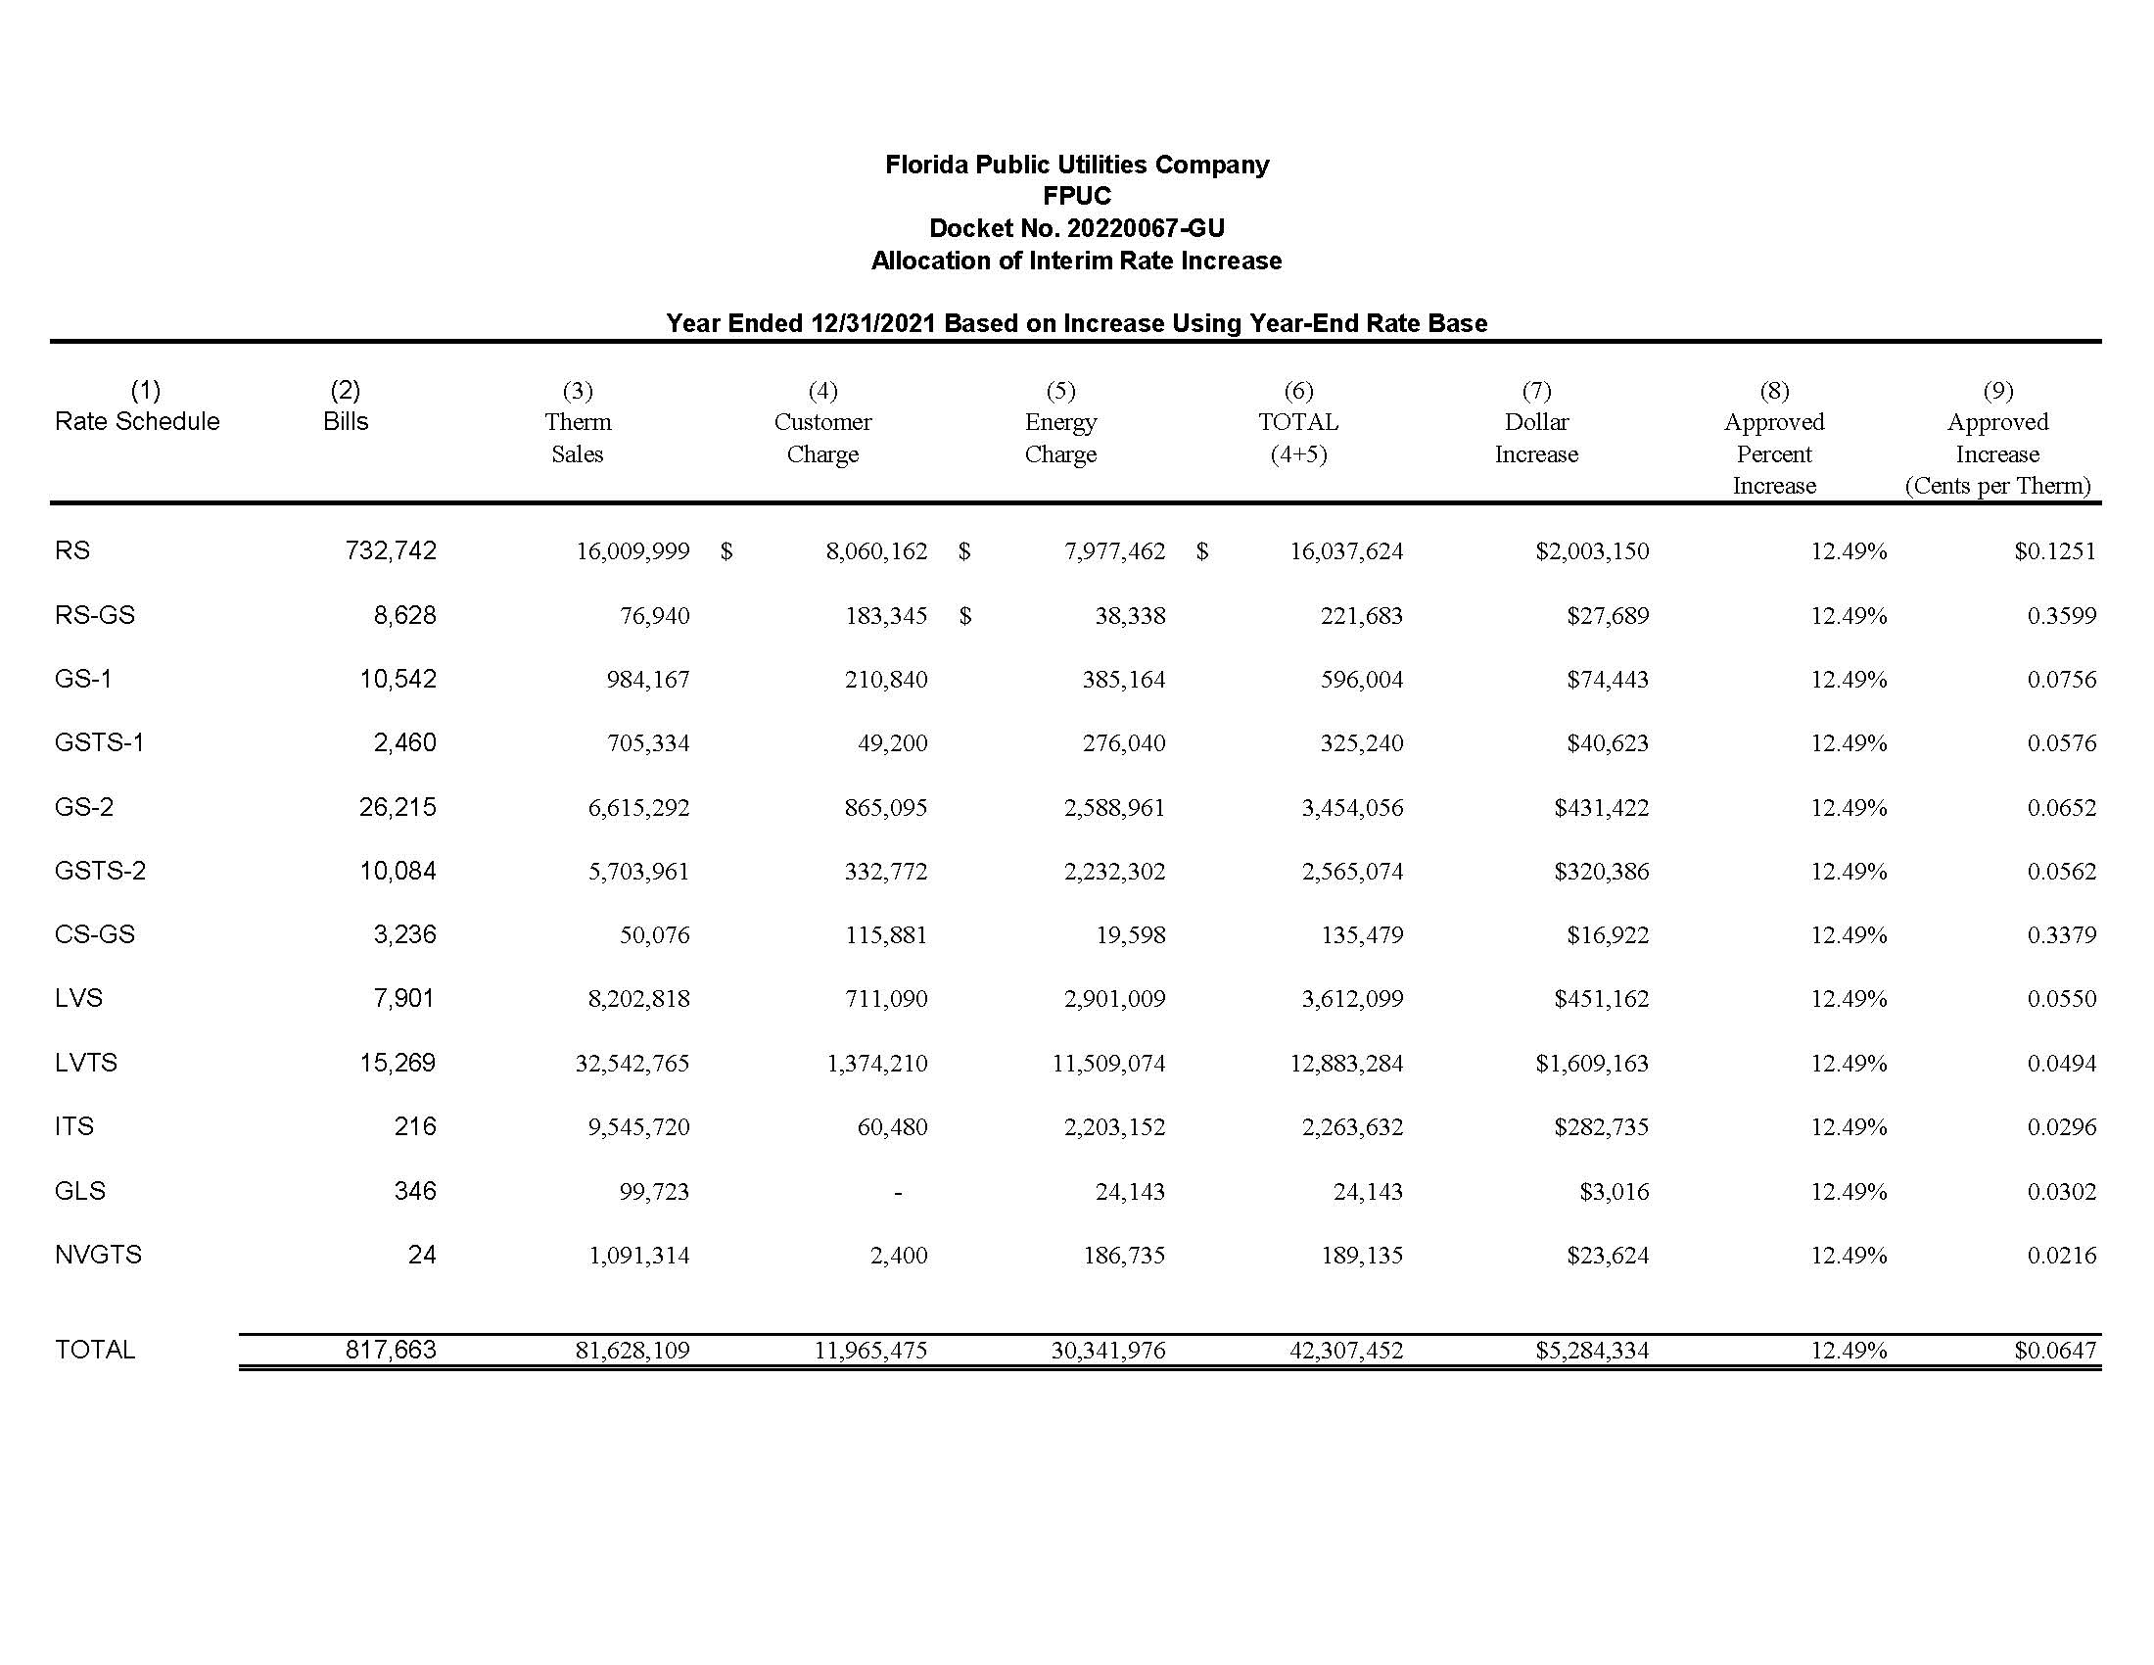
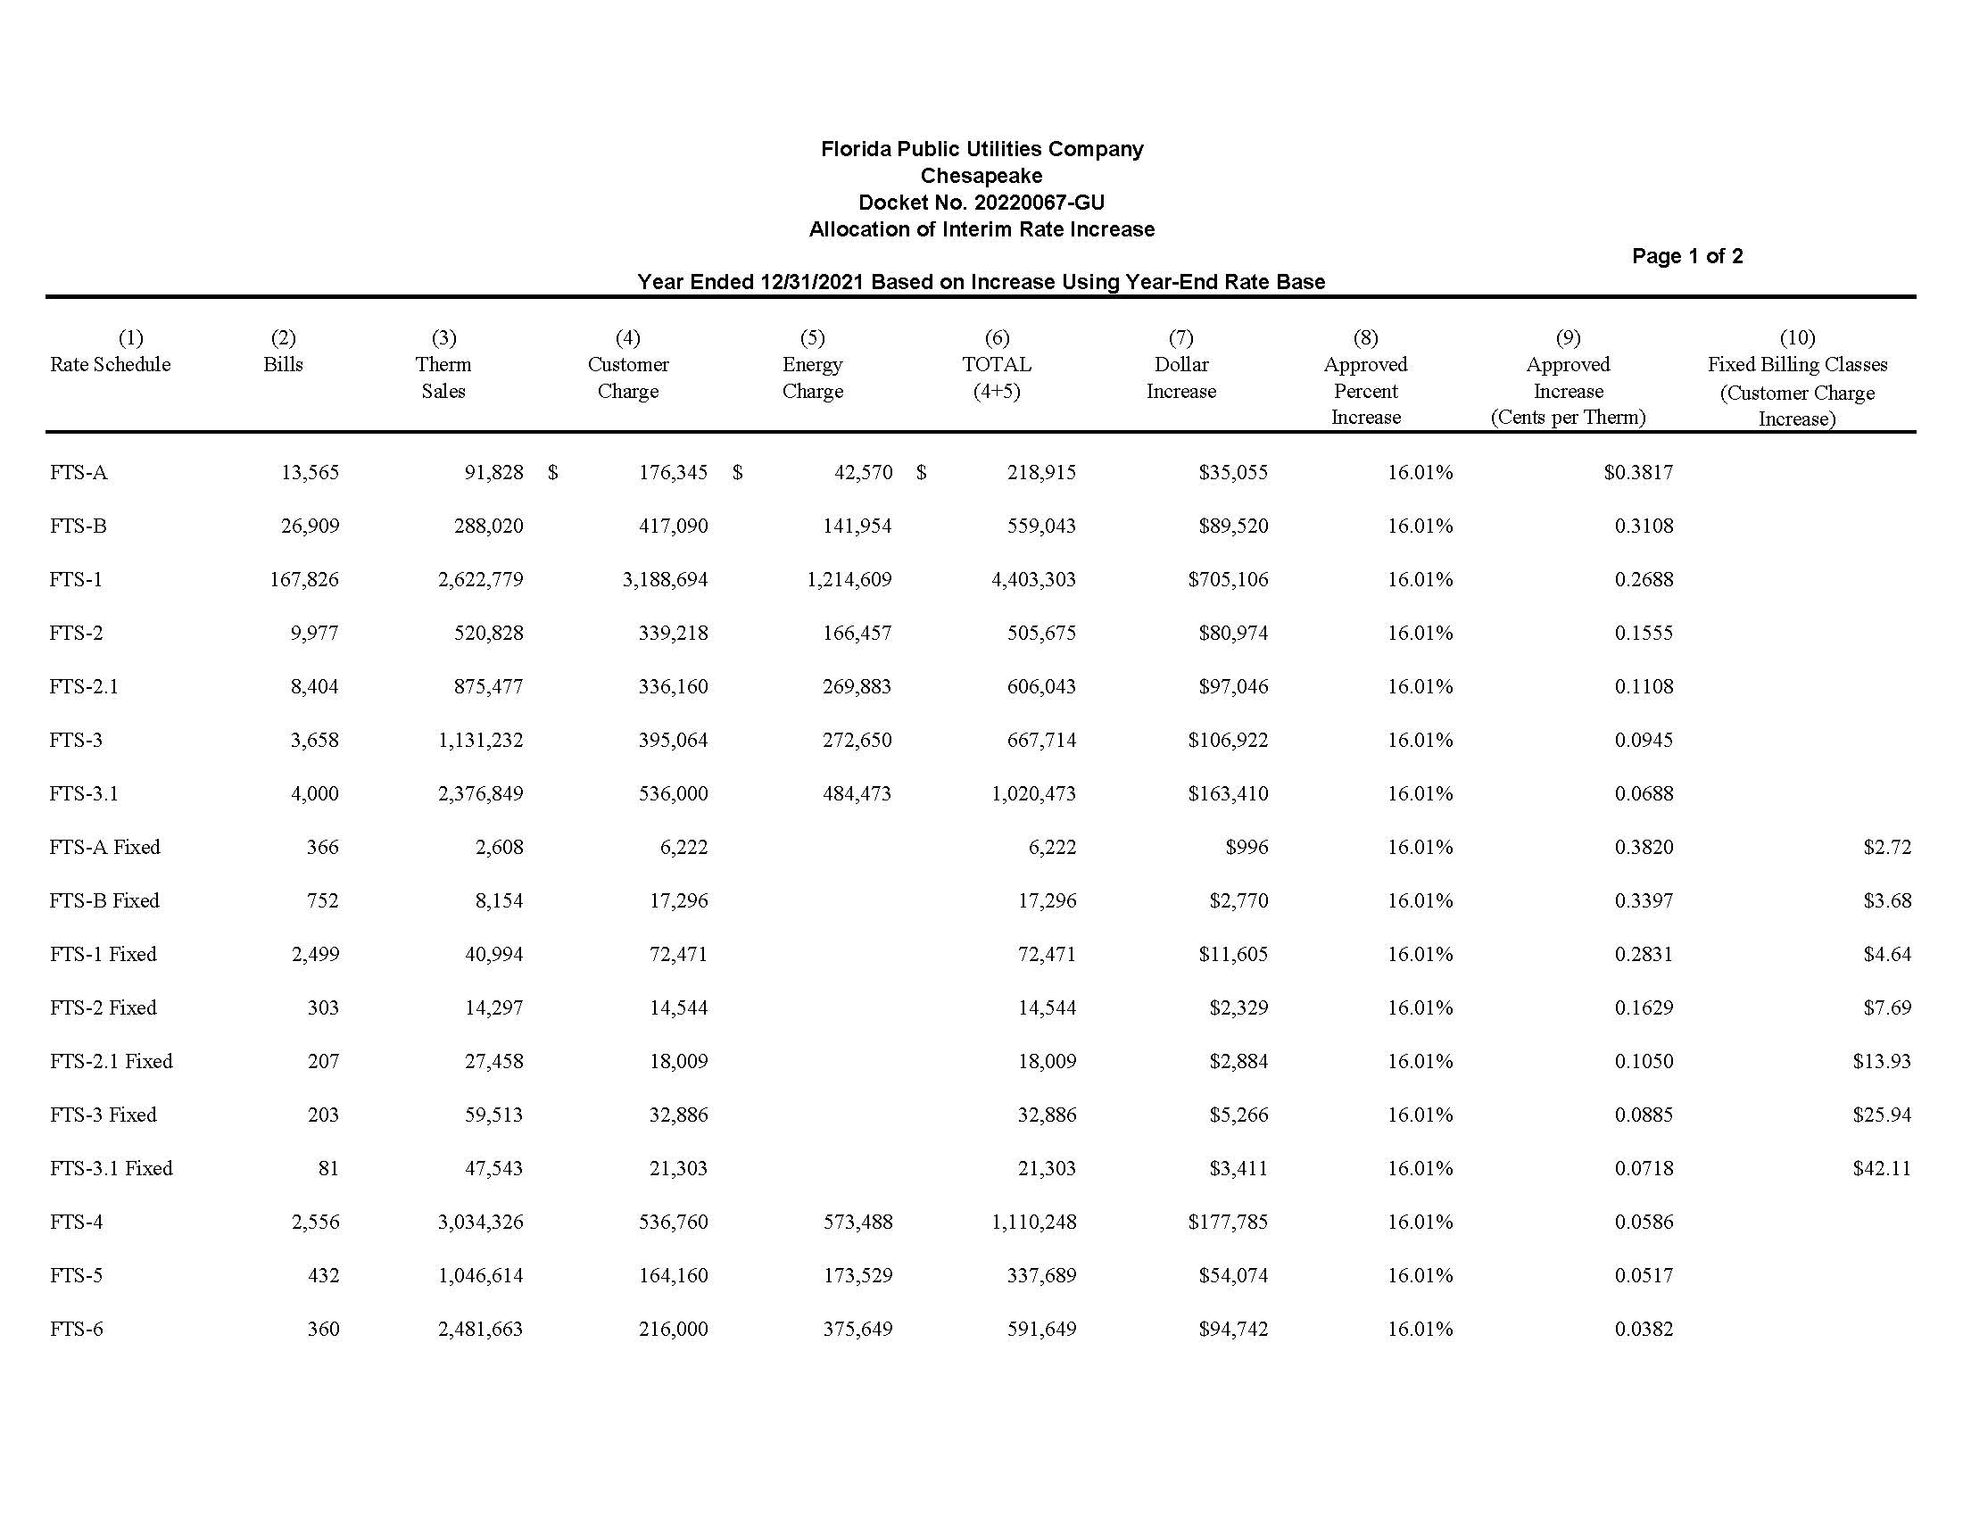
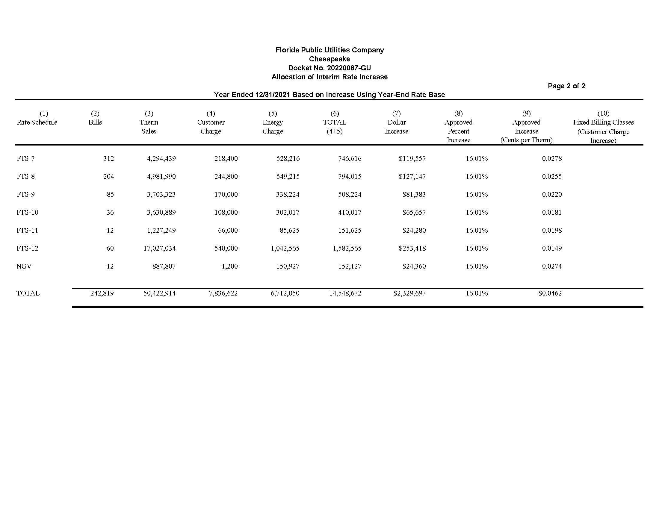
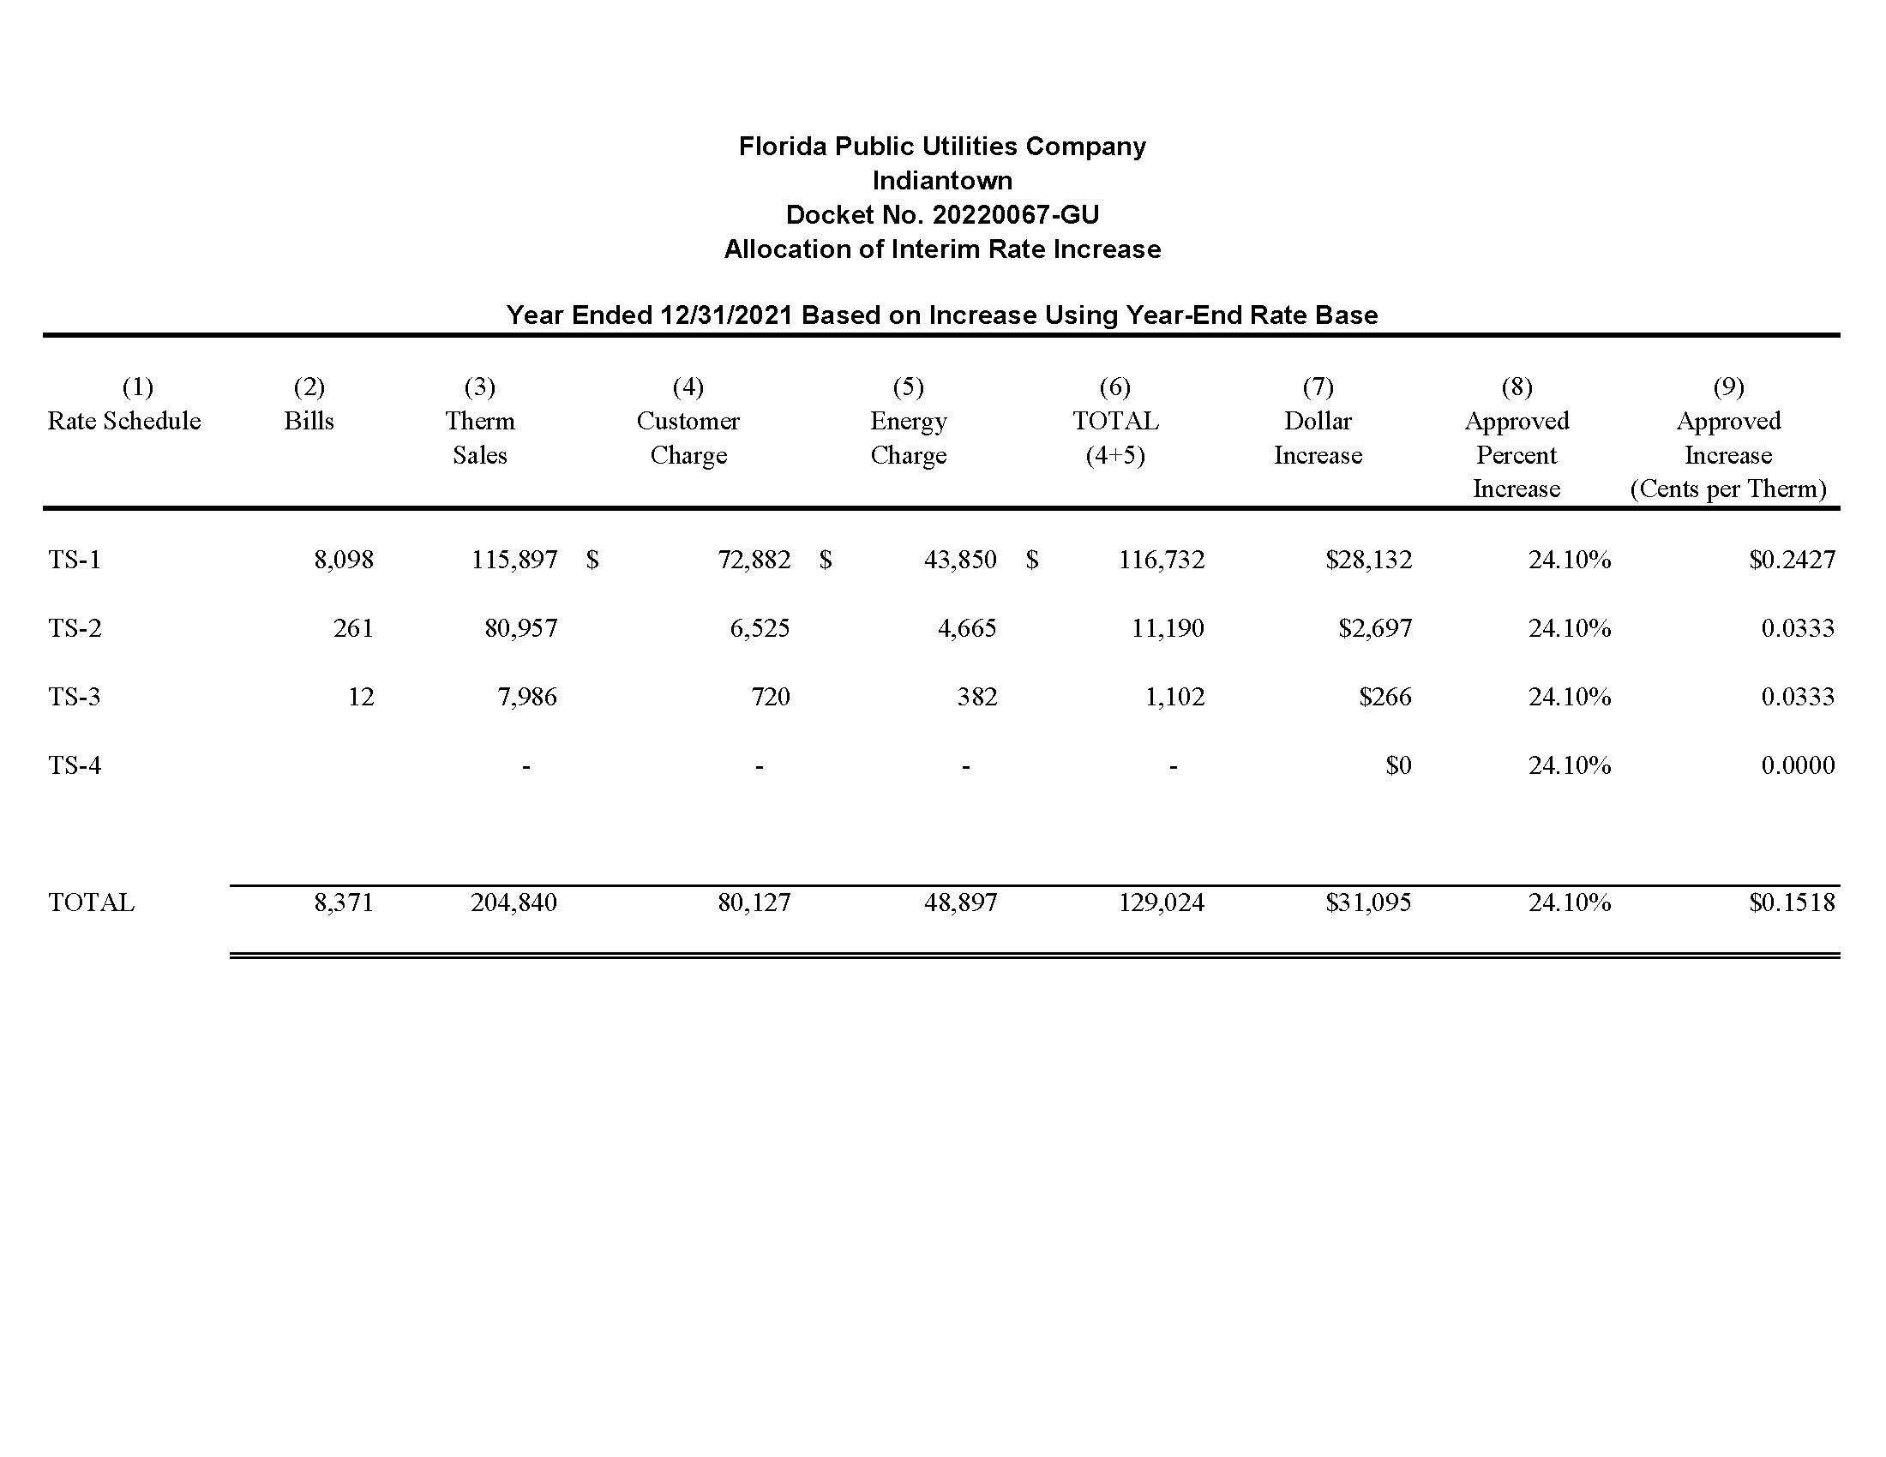
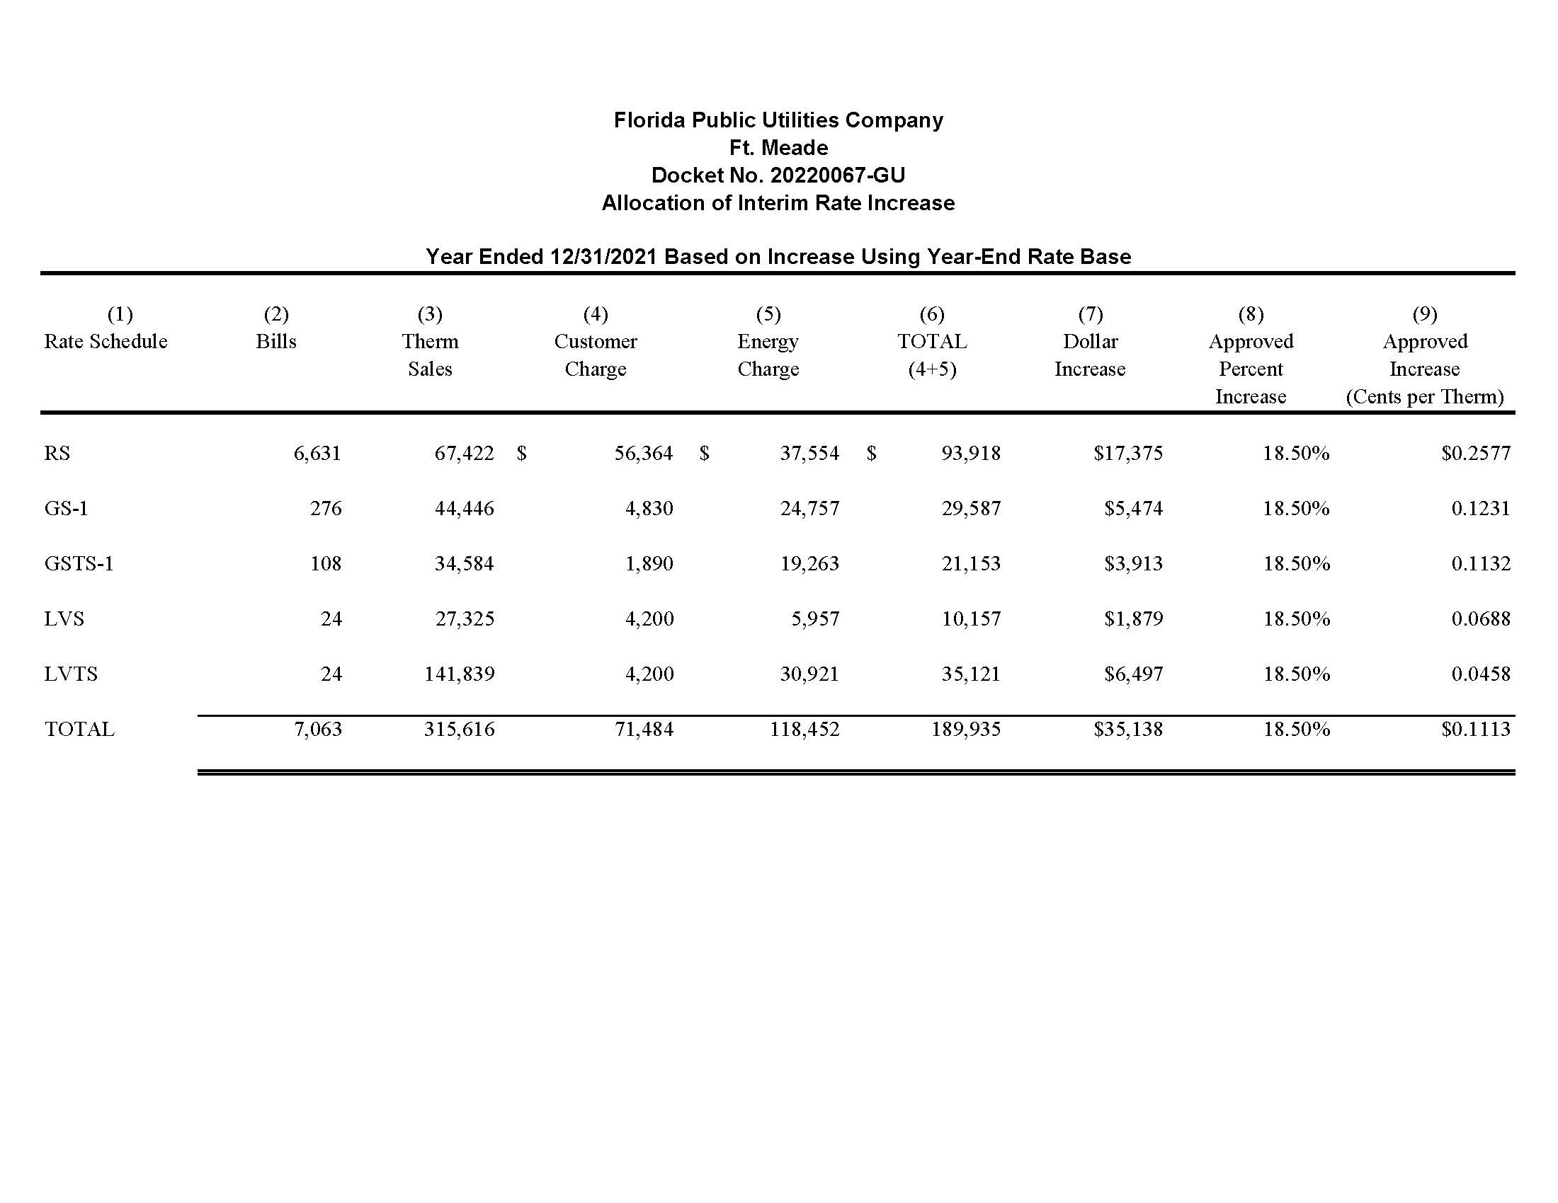
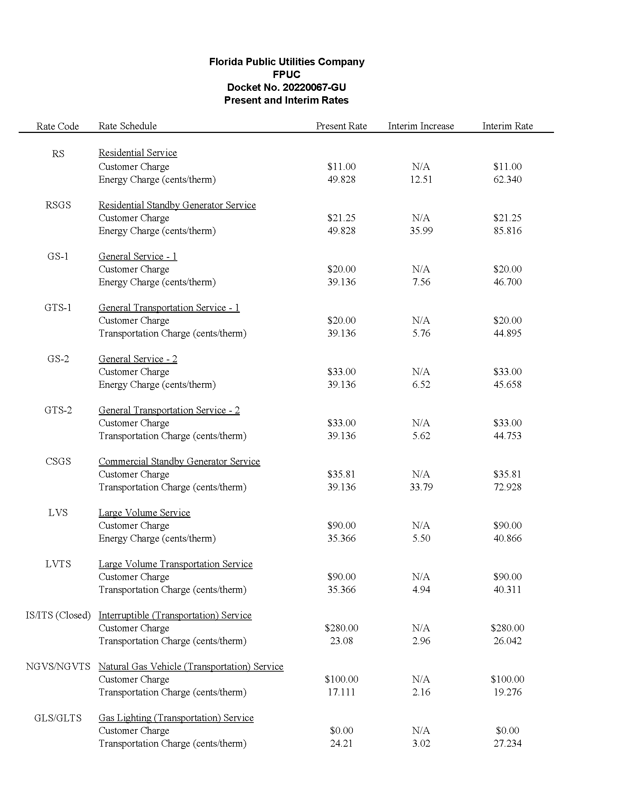
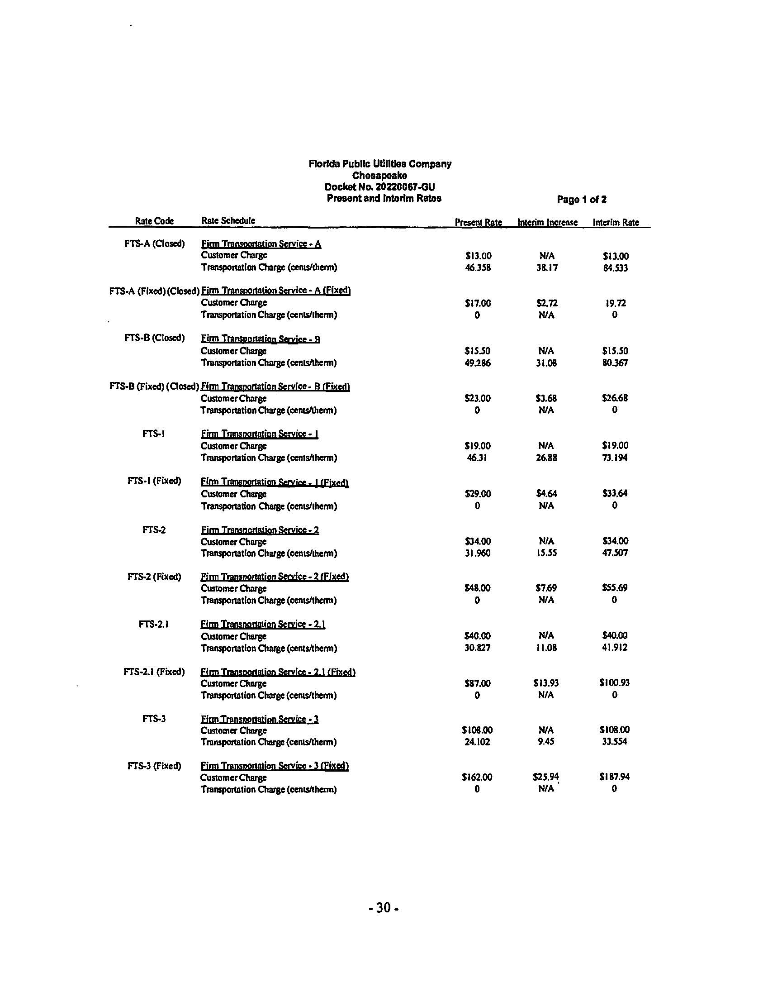
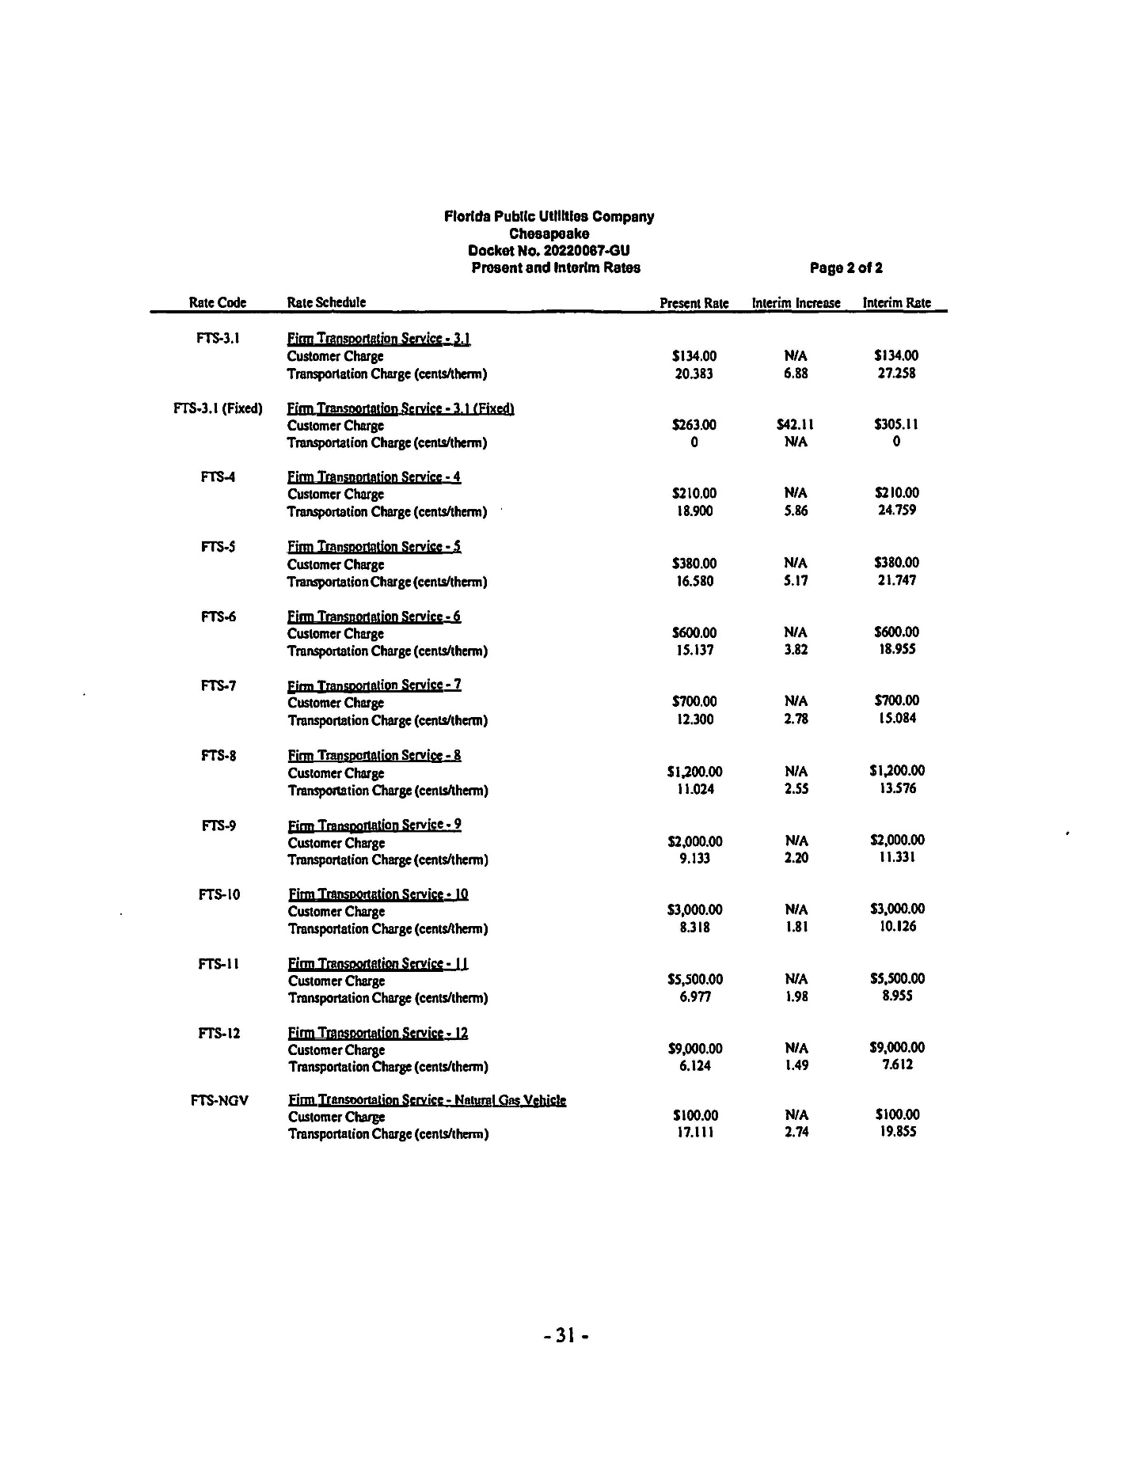
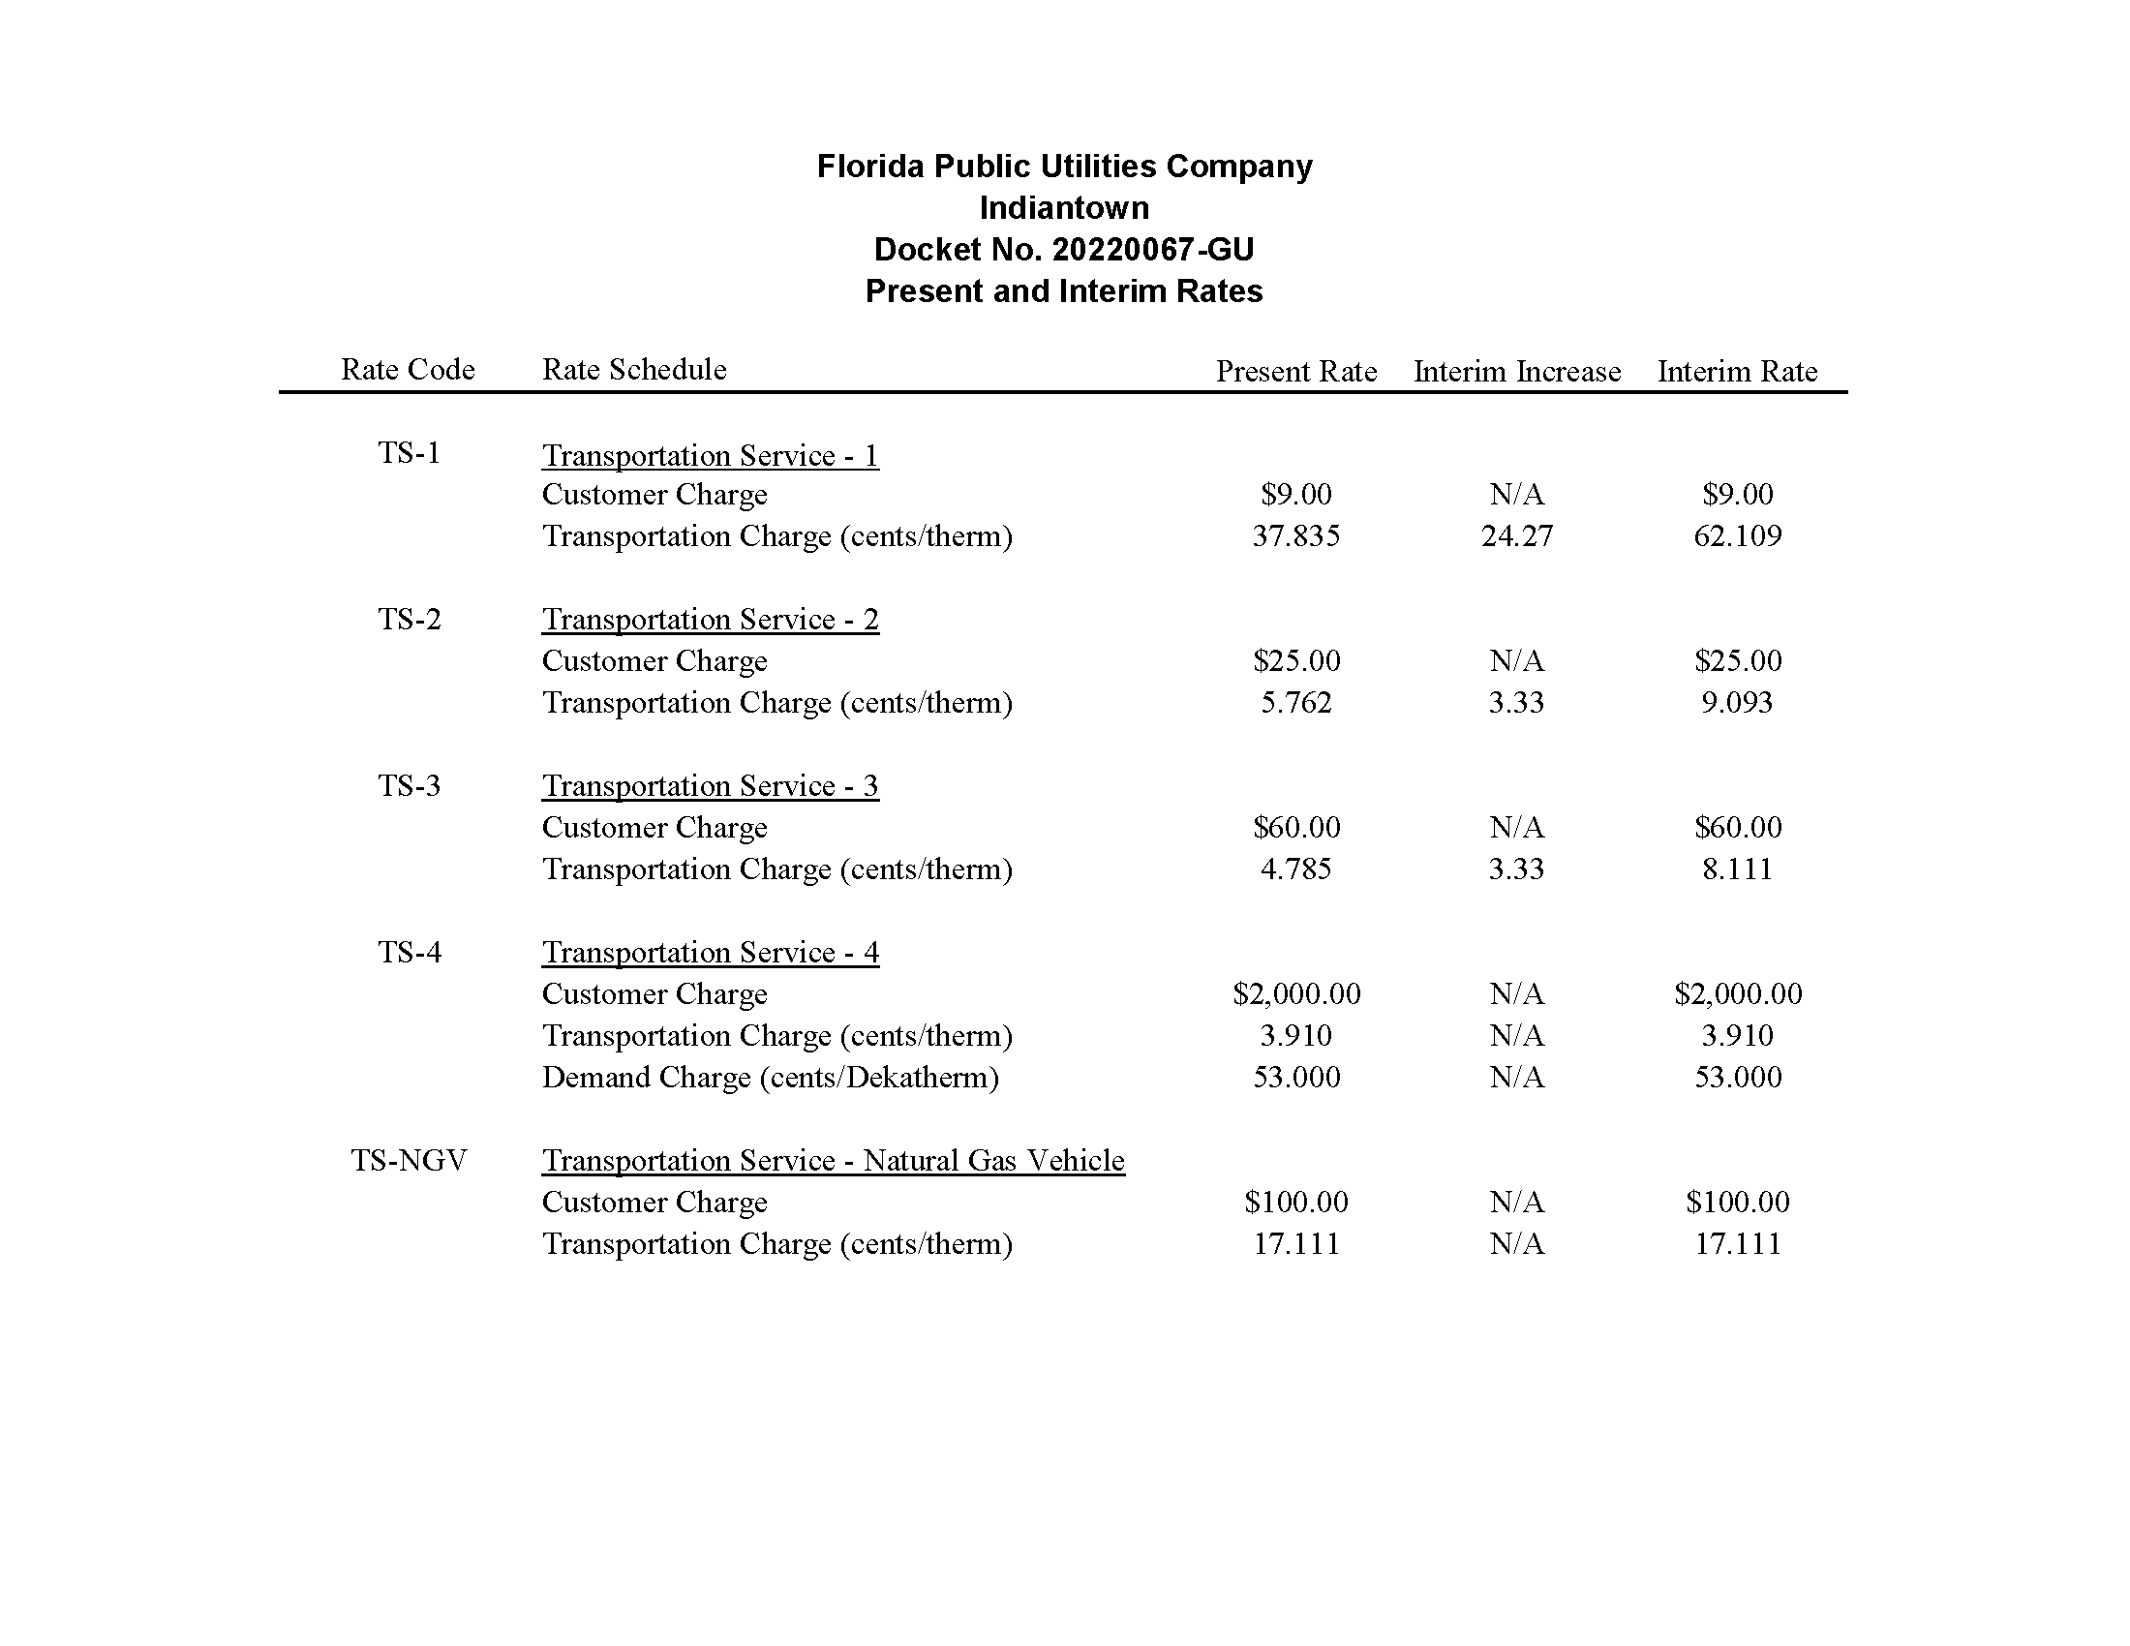
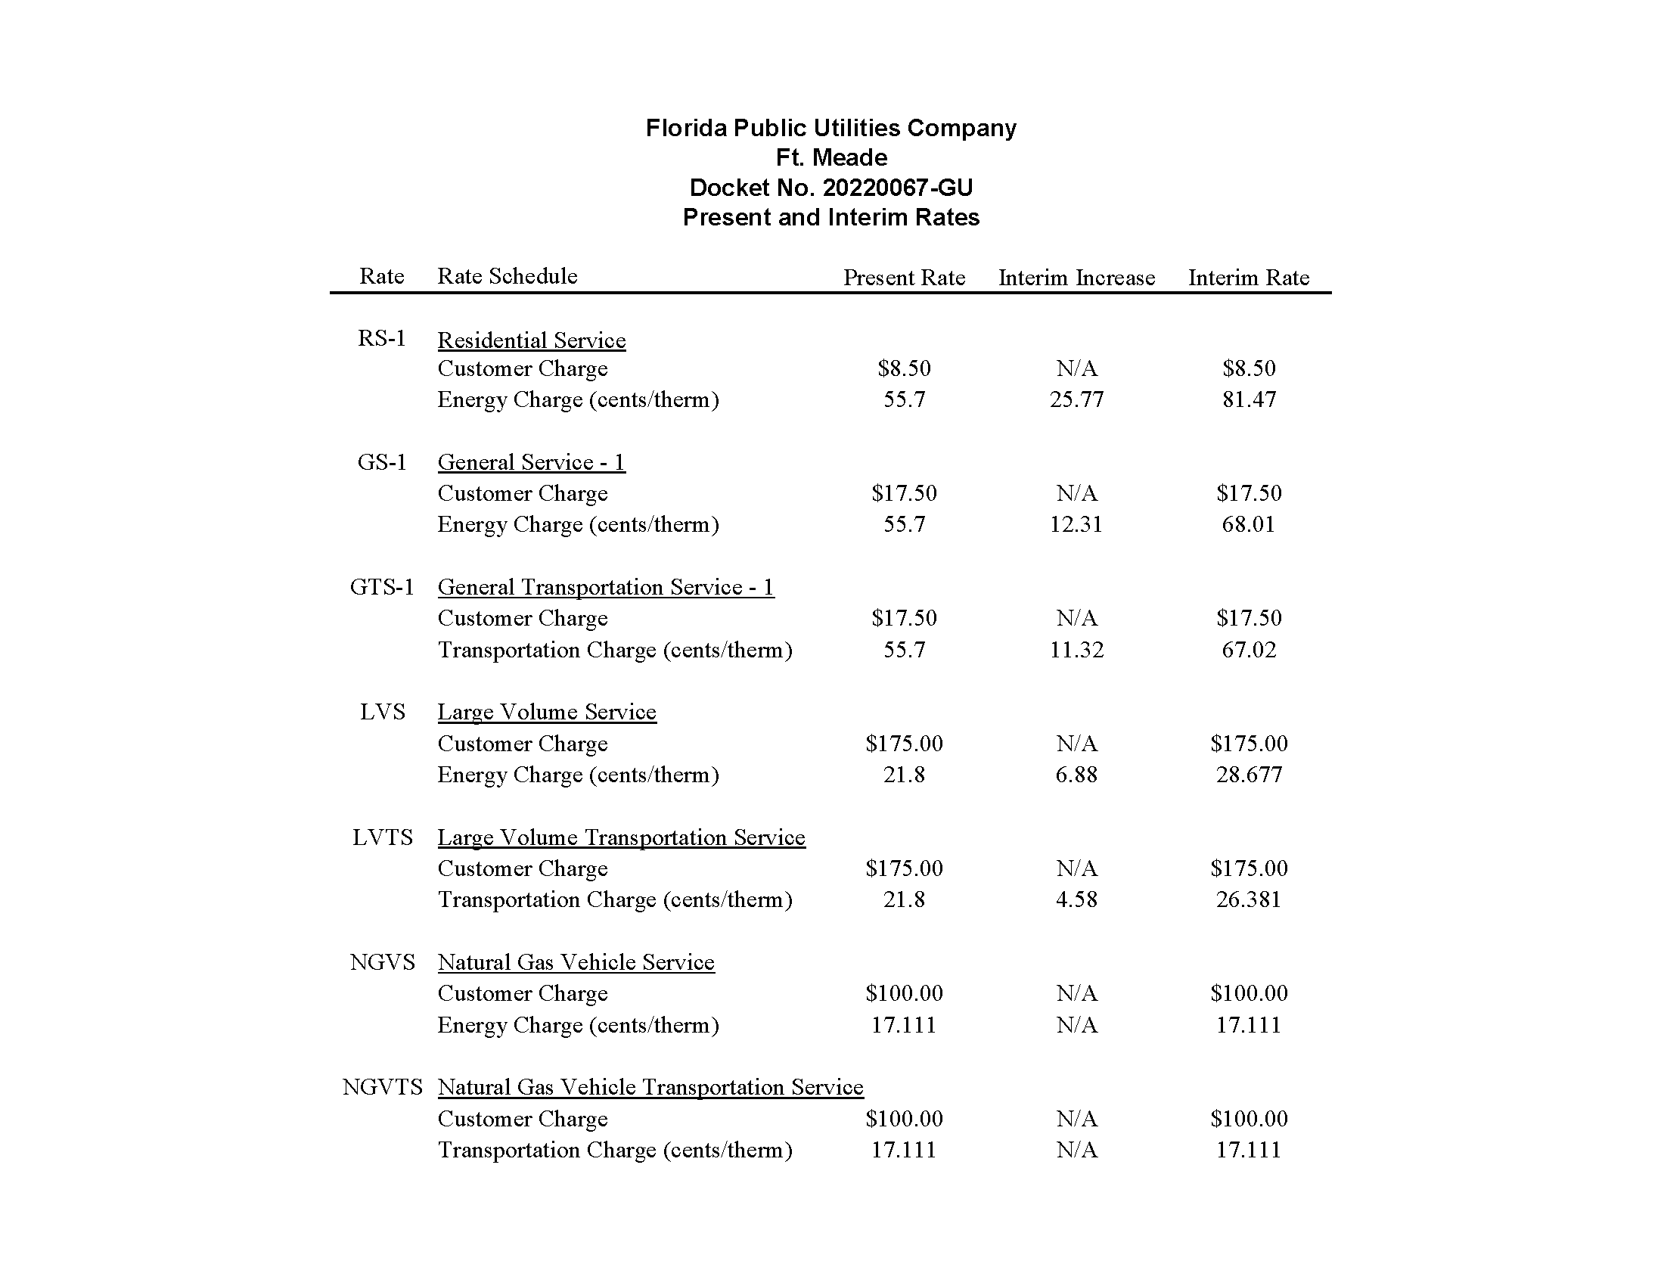

Order Nos. PSC-2009-0375-PAA-GU, issued May 27, 2009, and PSC-2009-0848-S-GU, issued December 28, 2009, in Docket No. 20080366-GU, In re: Petition for rate increase by Florida Public Utilities Company.
Order No. PSC-2010-0029-PAA-GU, issued January 14, 2010, in Docket No. 20090125-GU, In re: Petition for increase in rates by Florida Division of Chesapeake Utilities Corporation.
Order No. PSC-2004-0565-PAA-GU, issued June 2, 2004, in Docket No. 20030954-GU, In re: Petition for rate increase by Indiantown Gas Company.
Order No. PSC-2021-0148-TRF-GU, issued April 22, 2021, in Docket No. 20200214-GU, In re: Joint petition of Florida Public Utilities Company, Florida Public Utilities Company-Indiantown Division, Florida Public Utilities Company-Fort Meade, and the Florida Division of Chesapeake Utilities Corporation for approval of consolidation of tariffs, for modifications to retail choice transportation service programs, and to change the MACC for Florida Public Utilities Company.
Document No. 03478-2022, filed June 7, 2022.
Order Nos. PSC-2009-0375-PAA-GU, issued May 27, 2009, in Docket No. 20080366-GU, In re: Petition for rate increase by Florida Public Utilities Company; PSC-2010-0029-PAA-GU, issued January 14, 2010, in Docket No. 20090125-GU, In re: Petition for increase in rates by Florida Division of Chesapeake Utilities Corporation; and PSC-2004-0565-PAA-GU, issued June 2, 2004, in Docket No. 20030954-GU, In re: Petition for rate increase by Indiantown Gas Company.
Order No. PSC-2013-0676-TRF-GU, issued December 20, 2013, in Docket No. 20130258-GU, In re: Petition for approval of tariff sheets reflecting gas service to customers in the City of Ft. Meade, by Florida Public Utilities Company.
Order No. PSC-2004-0565-PAA-GU, issued June 2, 2004, in Docket No. 20030954-GU, In re: Petition for rate increase by Indiantown Gas Company.
Order Nos. PSC-2009-0375-PAA-GU, issued May 27, 2009, in Docket No. 20080366-GU, In re: Petition for rate increase by Florida Public Utilities Company; PSC-2010-0029-PAA-GU, issued January 14, 2010, in Docket No. 20090125-GU, In re: Petition for increase in rates by Florida Division of Chesapeake Utilities Corporation; and PSC-2004-0565-PAA-GU, issued June 2, 2004, in Docket No. 20030954-GU, In re: Petition for rate increase by Indiantown Gas Company.
The Companies stated that the calculated interim rate increases for Indiantown and Ft. Meade would be 257.58 percent and 41.23 percent, respectively. For interim purposes, the Companies limited the interim rate increase request for Indiantown and Ft. Meade to the proposed total final rate increases of 24.1 percent and 18.5 percent.

