State of Florida |  | Public Service Commission  Capital Circle Office Center ● 2540 Shumard Oak Boulevard  Tallahassee, Florida 32399-0850  -M-E-M-O-R-A-N-D-U-M-
DATE: | September 22, 2022
TO: | Office of Commission Clerk (Teitzman)
FROM: | Division of Engineering (Lewis, Ramos)  Division of Accounting and Finance (Sewards)  Division of Economics (Bethea)  Office of the General Counsel (Sandy)
RE: | Docket No. 20220085-WS – Application for transfer of water and wastewater facilities of River Grove Utilities, Inc., water Certificate No. 674-W, and wastewater Certificate No. 575-S to Cobblestone II RVG LLC; and amendment of water Certificate No. 674-W, and wastewater certificate 575-S, in Brevard County.  Docket No. 20220090-WS – Application for quick-take amendment of Certificate Nos. 674-W and 575-S, to delete territory in Brevard County by Cobblestone II RVG LLC, a Delaware limited liability company d/b/a River Grove Utility.
AGENDA: | 10/04/22 – Regular Agenda – In Proposed Agency Action for Issues 2 and 3 - Interested Persons May Participate
COMMISSIONERS ASSIGNED: |  |  | All Commissioners (20220085-WS and 20220090-WS)
PREHEARING OFFICER: |  |  | Graham (20220085-WS)  Administrative (20220090-WS)
CRITICAL DATES: |  |  | None
SPECIAL INSTRUCTIONS: |  |  | None

Case Background
River Grove Utilities, Inc. (RGU or Seller) is a Class C water and wastewater utility providing service to approximately 179 residential customers in Brevard County. RGU is located in the St. Johns River Management District. According to RGU’s 2021 Annual Report, the Utility had gross revenues of $166,257 and a net operating loss of $2,365. The Florida Public Service Commission (Commission) granted an original certificate to RGU in 2019. On April 22, 2022, Cobblestone II RVG LLC, (Cobblestone or Buyer) filed an application for the transfer of Certificate Nos. 674-W and 575-S from RGU to Cobblestone (Docket No. 20220085-WS).
On May 5, 2022, Cobblestone filed a separate application for a quick-take amendment of Certificate Nos. 674-W and 575-S, to delete part of the service territory (Docket No. 20220085-WS). The property being deleted contains two single-family residences with additional undeveloped acreage. These residences are not receiving water or wastewater services from the Utility. This property is owned by the seller of RGU and he does not object to this deletion of the service territory.
This recommendation addresses, the transfer of Certificate Nos. 674-W and 575-S, the appropriate net book value of the system for transfer purposes, the need for an acquisition adjustment (Docket No. 20220085-WS), and the request for a service territory deletion (Docket No. 20220090-WS). The Commission has jurisdiction pursuant to Sections 367.045, 367.071, and 367.081, Florida Statutes (F.S).

Discussion of Issues

Issue 1:
Should the transfer of Certificate Nos. 674-W and 575-S from River Grove Utilities, Inc., to Cobblestone II RVG LLC, be approved?

Recommendation:
Yes. The transfer of Certificate Nos. 674-W and 575-S is in the public interest and should be approved effective the date of the Commission’s vote. The resultant Order should serve as the Buyer’s certificate and should be retained by the Buyer. The existing rates and charges shown on Schedule No. 2 should remain in effect until a change is authorized by the Commission in a subsequent proceeding. The tariffs reflecting the transfer should be effective for services rendered or connections made on or after the stamped approval date on the tariffs pursuant to Rule 25-30.475, Florida Administrative Code (F.A.C.). The Seller is current with respect to annual reports and Regulatory Assessment Fees (RAFs) through December 31, 2021. The Buyer should be responsible for filing the Utility’s annual reports and paying RAFs after April 21, 2022, and all future years. (Lewis, Sewards, Bethea)

Staff Analysis:
On April 22, 2022, the Buyer filed an application for the transfer of Certificate Nos. 674-W and 575-S from RGU to Cobblestone. The application is in compliance with Section 367.071, F.S., and the Commission rules concerning applications for transfer of certificates. The sale to the Buyer occurred on April 21, 2022, contingent upon the Commission’s approval, pursuant to Section 367.071(1), F.S.
Noticing, Territory, and Land Ownership
Cobblestone provided notice of the application pursuant to Section 367.071, F.S., and Rule 25-30.030, F.A.C. No objections to the transfer were filed, and the time for doing so has expired. The application contains a description of the service territory, which is appended to this recommendation as Attachment A. The Buyer provided a copy of the warranty deed executed on April 15, 2022, as evidence that the Utility has rights to long-term use of the land upon which the treatment facilities are located pursuant Rule 25-30.30.037(2)(s), F.A.C.
Purchase Agreement and Financing
Pursuant to Rule 25-30.037(2)(g), (h), and (i), F.A.C., the application contains a statement regarding financing and a copy of the Purchase Agreement, which includes the purchase price, terms of payment, and a list of the assets purchased. There are no customer deposits, guaranteed revenue contracts, developer agreements, customer advances, leases, or debt of River Grove that must be disposed of with regard to the transfer. According to the Purchase Agreement, the total purchase price for the mobile home community, as well as the water and wastewater assets is $19,000,000. In response to staff’s data request, the Buyer stated the specific purchase price of the water and wastewater assets should be set equal to the depreciated original cost as established by this Commission. As discussed later, staff has calculated a net book value of $159,093 for water and $2,250 for wastewater. Therefore, staff recommends a purchase price of $161,343 ($159,093 + $2,250) for the water and wastewater assets should be recognized
.
Facility Description and Compliance
In March 2019, RGU interconnected its water distribution system with Brevard County’s Barefoot Bay and now purchases bulk water service from Barefoot Bay. RGU’s wastewater treatment plant (WWTP) has the permitted capacity of 0.030 million gallons per day and consists of flow equalization, influent screening, aeration, secondary clarification, chlorination, and aerobic digestion of biosolids. Based on the Utility’s application and staff’s investigation, the systems appear to be in satisfactory condition and compliant with the Florida Department of Environmental Protection standards.
Financial and Technical Ability
Pursuant to Rule 25-30.037(2)(l), and (m), F.A.C., the Buyer provided statements describing its financial and technical ability to provide water and wastewater service. As referenced in the transfer application, the Buyer will fulfill the commitments, obligations, and representation of the Seller with regards to utility matters. Staff reviewed the financial statements of the parent company, Cobblestone MHC Fund II LP, and believes the Buyer has documented adequate resources to support the Utility’s operations.
In its application, the Buyer indicated that it has no experience in the water or wastewater industry; however, it will rely on one of its related parties which operates a wastewater system serving one of its other mobile home communities in Florida. Additionally, the Seller contracted its WWTP operations to US Water Services Corporation and the Buyer indicated that it intends to keep this contract in place. Based on the above, staff recommends that the Buyer has demonstrated the technical and financial ability to provide service to the existing service territory.
Rates, Charges, and Customer Deposits
The Utility's rates, charges, and initial customer deposits were last approved in its 2019 application for original certificates to provide water and wastewater. Rule 25-9.044(1), F.A.C., provides that, in the case of a change of ownership or control of a Utility, the rates, classifications, and regulations of the former owner must continue unless authorized to change by this Commission. In regard to the Utility’s miscellaneous service charges, the late payment charge of $7.50 is appropriate. However, the remaining miscellaneous service charges do not conform to Rule 25-30.460, F.A.C., and are discussed in Issue 3. Therefore, staff recommends that the Utility’s existing rates, late payment charge, service availability charges, non-sufficient funds charges, and initial customer deposits as shown Schedule No. 2, should remain in effect, until authorized to change by this Commission in a subsequent proceeding. The tariff pages reflecting the transfer should be effective on or after the stamped approval date on the tariff sheet pursuant to Rule 25-30.475(1), F.A.C.

Regulatory Assessment Fees (RAFs) and Annual Reports
Staff has verified that the Seller is current on the filing of annual reports and RAFs through December 31, 2021. The Buyer should be responsible for filing the Utility’s annual reports and paying RAFs after April 21, 2022, and all future years.

Conclusion
Based on the foregoing, staff recommends the transfer of Certificate Nos. 674-W and 575-S is in the public interest and should be approved effective the date of the Commission’s vote. The resultant Order should serve as the Buyer’s certificate and should be retained by the Buyer. The existing rates and charges shown on Schedule No. 2 should remain in effect until a change is authorized by the Commission in a subsequent proceeding. The tariffs reflecting the transfer should be effective for services rendered or connections made on or after the stamped approval date on the tariffs pursuant to Rule 25-30.475, F.A.C. The Utility is current with respect to annual reports and RAFs through December 31, 2021. The Buyer should be responsible for filing the Utility’s annual reports and paying RAFs after April 21, 2022, and all future years.

Issue 2:
What is the appropriate net book value (NBV) for the River Grove water and wastewater systems for transfer purposes, and should an acquisition adjustment be approved?

Recommendation:
The appropriate NBV of the water and wastewater systems for transfer purposes are $159,093 and $2,250, respectively, as of April 1, 2022. No acquisition adjustment is necessary as the purchase price is equal to the NBV. Within 90 days of the date of the final order, the Utility should be required to notify the Commission in writing that it has adjusted its books in accordance with the Commission’s decision. The adjustments should be reflected in Cobblestone’s 2022 Annual Report when filed. (Sewards)

Staff Analysis:
Rate base has never been established for the Utility. The purpose of establishing NBV for transfers is to determine whether an acquisition adjustment should be approved. The NBV does not include normal ratemaking adjustments for used and useful plant or working capital. The Utility’s NBV has been updated to reflect balances as of April 1, 2022. Staff’s recommended NBV is shown on Schedule No. 1.

Utility Plant in Service (UPIS)
The Utility’s general ledger reflects UPIS balances of $661,426 for water and $8,100 for wastewater as of April 1, 2022. Staff does not have any adjustments to the Utility’s UPIS balances. Therefore, staff recommends UPIS balances of $661,426 for water and $8,100 for wastewater as of April 1, 2022.

Land
The Utility’s general ledger reflects land balances of $2,250 for water and $2,250 for wastewater as of April 1, 2022. Staff does not have any adjustments to the Utility’s land balances. Therefore, staff recommends land balances of $2,250 for water and $2,250 for wastewater as of April 1, 2022.

Accumulated Depreciation
The Utility’s general ledger reflects accumulated depreciation balances of $73,163 for water and $8,100 for wastewater as of April 1, 2022. Staff does not have any adjustments to the Utility’s accumulated depreciation balances. Therefore, staff recommends accumulated depreciation balances of $73,163 for water and $8,100 for wastewater as of April 1, 2022.

Contributions-in-Aid-of-Construction (CIAC) and Accumulated Amortization of CIAC
The Utility’s general ledger reflects CIAC balances of $476,202 for water and $0 for wastewater as of April 1, 2022. The Utility’s general ledger also reflects accumulated amortization of CIAC balances of $44,782 for water and $0 for wastewater as of April 1, 2022. Staff does not have any adjustments to the Utility’s CIAC or Accumulated Amortization of CIAC balances. Therefore, staff recommends CIAC balances of $476,202 for water and $0 for wastewater, and accumulated amortization of CIAC balances of $44,782 for water and $0 for wastewater, as of April 1, 2022.

Net Book Value
The Utility’s general ledger reflects NBV of $159,093 for water and $2,250 for wastewater as of April 1, 2022. Staff does not recommend any adjustments. As such, staff recommends NBV of $159,093 for water and $2,250 for wastewater. Staff’s recommended NBV and the National Association of Regulatory Utility Commissioners, Uniform System of Accounts (NARUC USOA) balances for UPIS and accumulated depreciation are shown on Schedule No. 1, as of April 1, 2022.

Acquisition Adjustment
An acquisition adjustment results when the purchase price differs from the NBV of the assets at the time of the acquisition. The Utility and its assets were purchased for $161,343. As stated above, staff recommends the appropriate NBV total to be $161,343. Pursuant to Rule 25-30.0371, F.A.C., a positive acquisition adjustment may be appropriate when the purchase price is greater than the NBV, and a negative acquisition adjustment may be appropriate when the purchase price is less than NBV. As the purchase price is equal to the NBV, staff recommends that no acquisition adjustment is warranted.

Conclusion
Based on the above, staff recommends that the NBV of the water and wastewater systems for transfer purposes is $159,093 and $2,250, respectively, as of April 1, 2022. No acquisition adjustment should be included in rate base. Within 90 days of the date of the final order, the buyer should be required to notify the Commission in writing that it has adjusted its books in accordance with the Commission’s decision. The adjustments should be reflected in the Utility’s 2022 Annual Report when filed.

Issue 3:
Should Cobblestone’s miscellaneous service charges be revised to conform to amended Rule 25-30.460, F.A.C.?

Recommendation:
Yes. Staff recommends the miscellaneous service charges be revised to conform to the recent amendment to Rule 25-30.460, F.A.C. The tariff should be revised to reflect the removal of initial connection and normal reconnection charges. The approved charges should be effective on or after the stamped approval date on the tariff sheet pursuant to Rule 25-30.475(1), F.A.C. Cobblestone should be required to charge the approved miscellaneous service charges until authorized to change them by the Commission in a subsequent proceeding. (Bethea)

Staff Analysis:
Effective June 24, 2021, Rule 25-30.460, F.A.C., was amended to remove initial connection and normal reconnection charges. The definitions for initial connection charges and normal reconnection charges were subsumed in the definition of the premises visit charge. It was envisioned that the utility tariffs would be reviewed by staff on a prospective basis to ensure conformance with the amended rule. The Utility’s miscellaneous service charges consist of initial connection and normal reconnection charges. Therefore, staff recommends that the initial connection and normal reconnection charges be removed and the definition for the premises visit charge be updated to comply with amended Rule 25-30.460, F.A.C. The Utility’s proposed and staff’s recommended miscellaneous service charges are shown below in Tables 3-1 and 3-2.
Table 3-1
Utility Proposed Miscellaneous Service Charges
 | Normal Hours
Initial Connection Charge | $30.00
Normal Reconnection Charge | $30.00
Violation Reconnection Charge | $30.00
Premises Visit Charge  (in lieu of disconnection) | $30.00
Table 3-2
Staff Recommended Miscellaneous Service Charges
 | Normal Hours
Violation Reconnection Charge | $30.00
Premises Visit Charge | $30.00

Conclusion
Based on the above, the miscellaneous service charges should be revised to conform to the recent amendment to Rule 25-30.460, F.A.C. The tariff should be revised to reflect the removal of initial connection and normal reconnection charges. The approved charges should be effective on or after the stamped approval date on the tariff sheet pursuant to Rule 25-30.475(1), F.A.C. Cobblestone should be required to charge the approved miscellaneous service charges until authorized to change them by the Commission in a subsequent proceeding.

Issue 4:
Should the Commission approve Cobblestone’s application for amendment of Certificate Nos. 674-W and 575-S to delete territory from its certificated service area in Brevard County?

Recommendation:
Yes. The Commission should approve the application filed by Cobblestone to delete a portion of its service territory, as reflected in Attachment A. The resultant Order should serve as Cobblestone’s amended certificates and should be retained by the Utility. (Lewis)

Staff Analysis:
On May 5, 2022, Cobblestone applied for an amendment to delete a portion of its certificated service territory. In its application, Cobblestone provided a legal description of the territory proposed to be deleted in the format prescribed in Rule 25-30.029, F.A.C., along with a complete legal description of the remaining territory. Cobblestone also provided a detailed system map with the territory proposed to be deleted and retained plotted thereon.

In addition to their application, Cobblestone filed a notice with the Commission Clerk on June 14, 2022. As set forth in the application and notice, the area to be deleted is undeveloped acreage with two single-family homes that are not served by the Utility. The property is owned by the Seller of RGU, who does not object to this deletion. No objections to the application have been received and the time for filing such has expired. The Utility’s application is compliant with the filing requirements set forth in Rule 25-30.036(4), F.A.C.

Conclusion
Based on the above, staff recommends that it is in the public interest to approve the application filed by Cobblestone to amend its water and wastewater certificates to delete territory with the resulting territory as shown in Attachment A. The resultant Order should serve as Cobblestone’s amended certificates and should be retained by the Utility.

Issue 5:
Should this docket be closed?

Recommendation:
Yes. If no protest to the proposed agency action is filed by a substantially affected person within 21 days of the date of the issuance of the Order, a Consummating Order should be issued and the docket should be closed administratively upon Commission staff’s verification that within 90 days of the date of the final order, the buyer has notified Commission staff in writing that it has adjusted its books in accordance with the Commission’s Order approving the transfer. (Sandy)

Staff Analysis:
If no protest to the proposed agency action is filed by a substantially affected person within 21 days of the date of the issuance of the Order, a Consummating Order should be issued and the docket should be closed administratively upon Commission staff’s verification that within 90 days of the date of the final order, the buyer has notified Commission staff in writing that it has adjusted its books in accordance with the Commission’s Order approving the transfer.

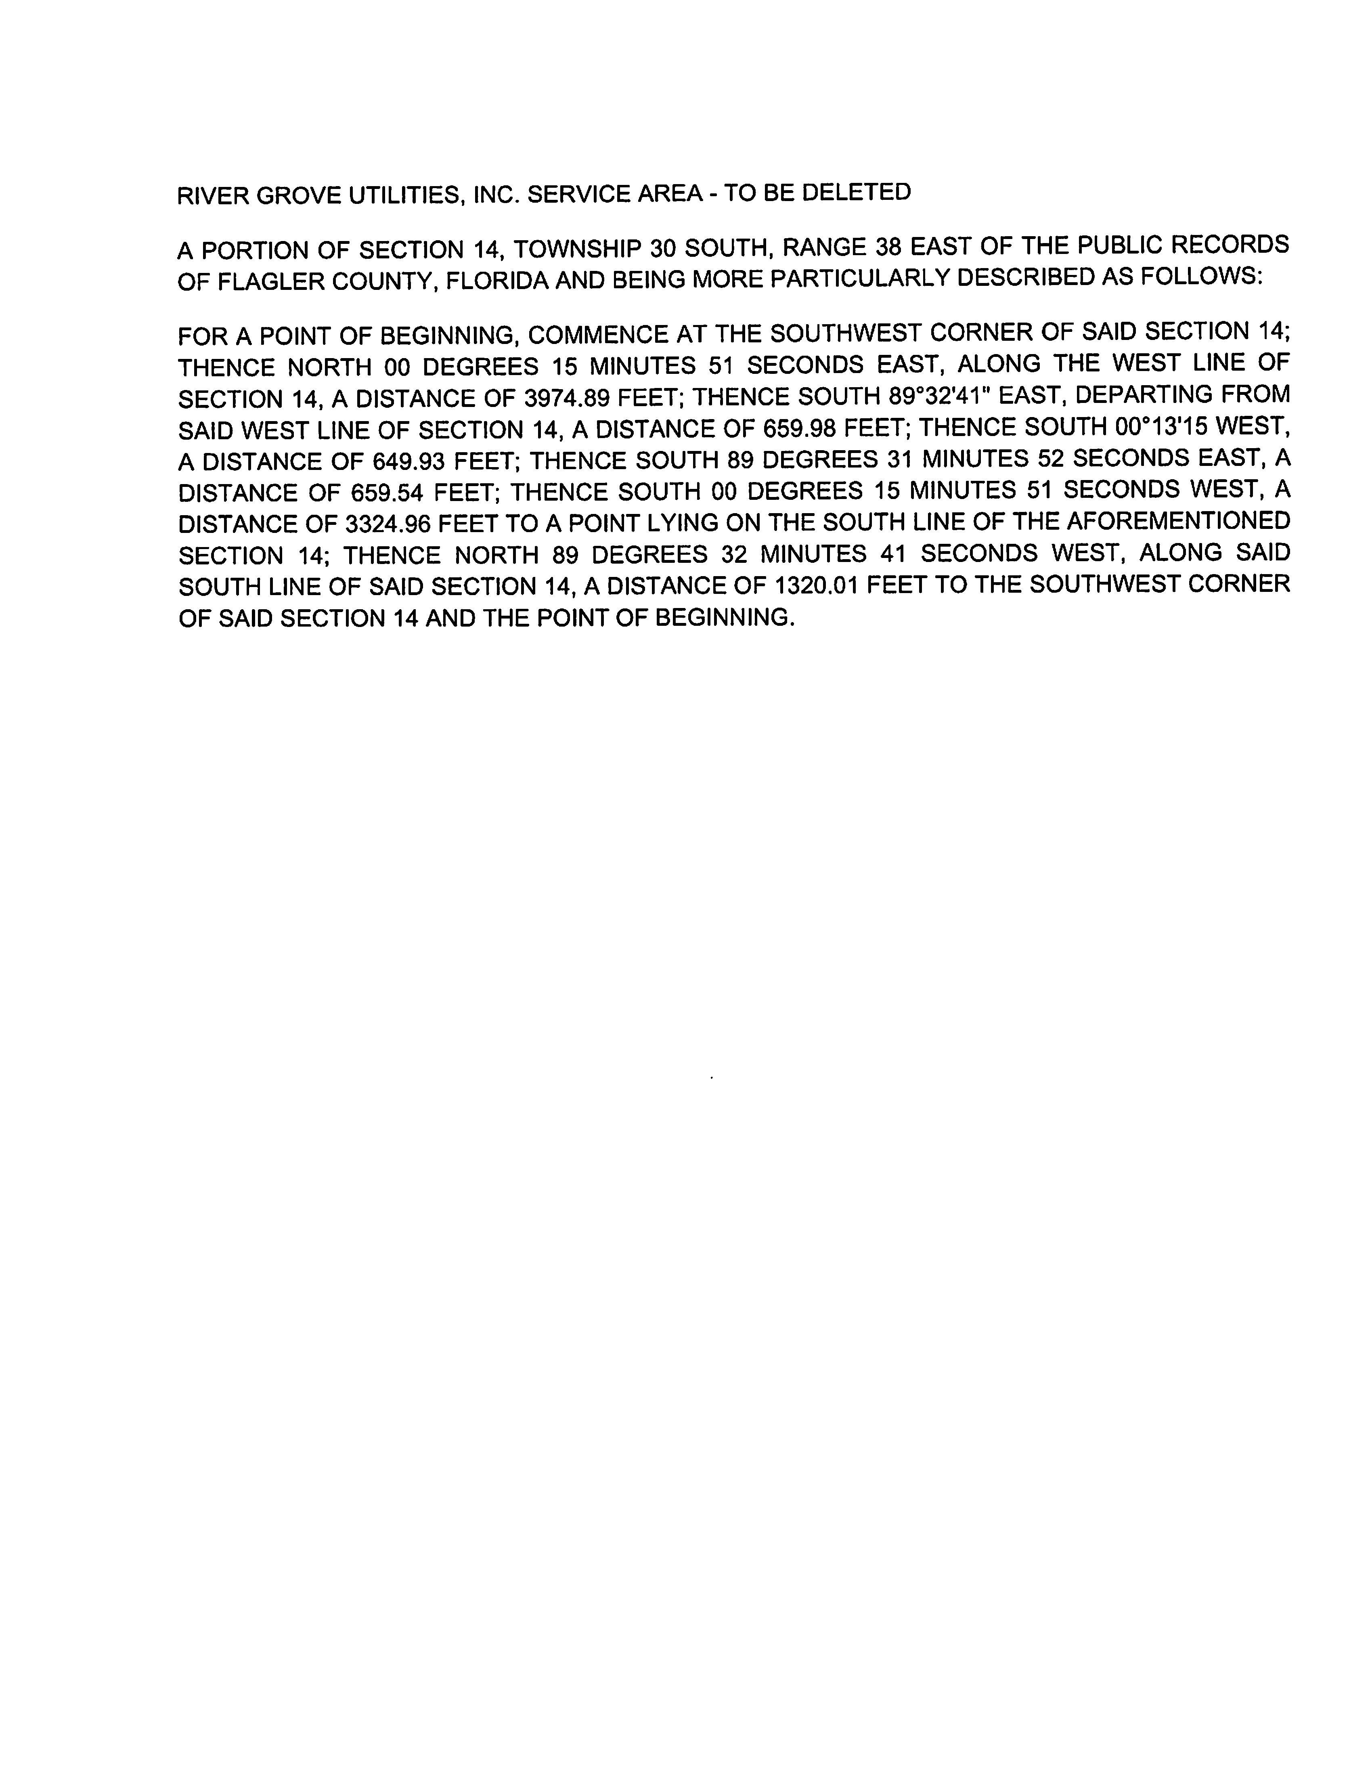

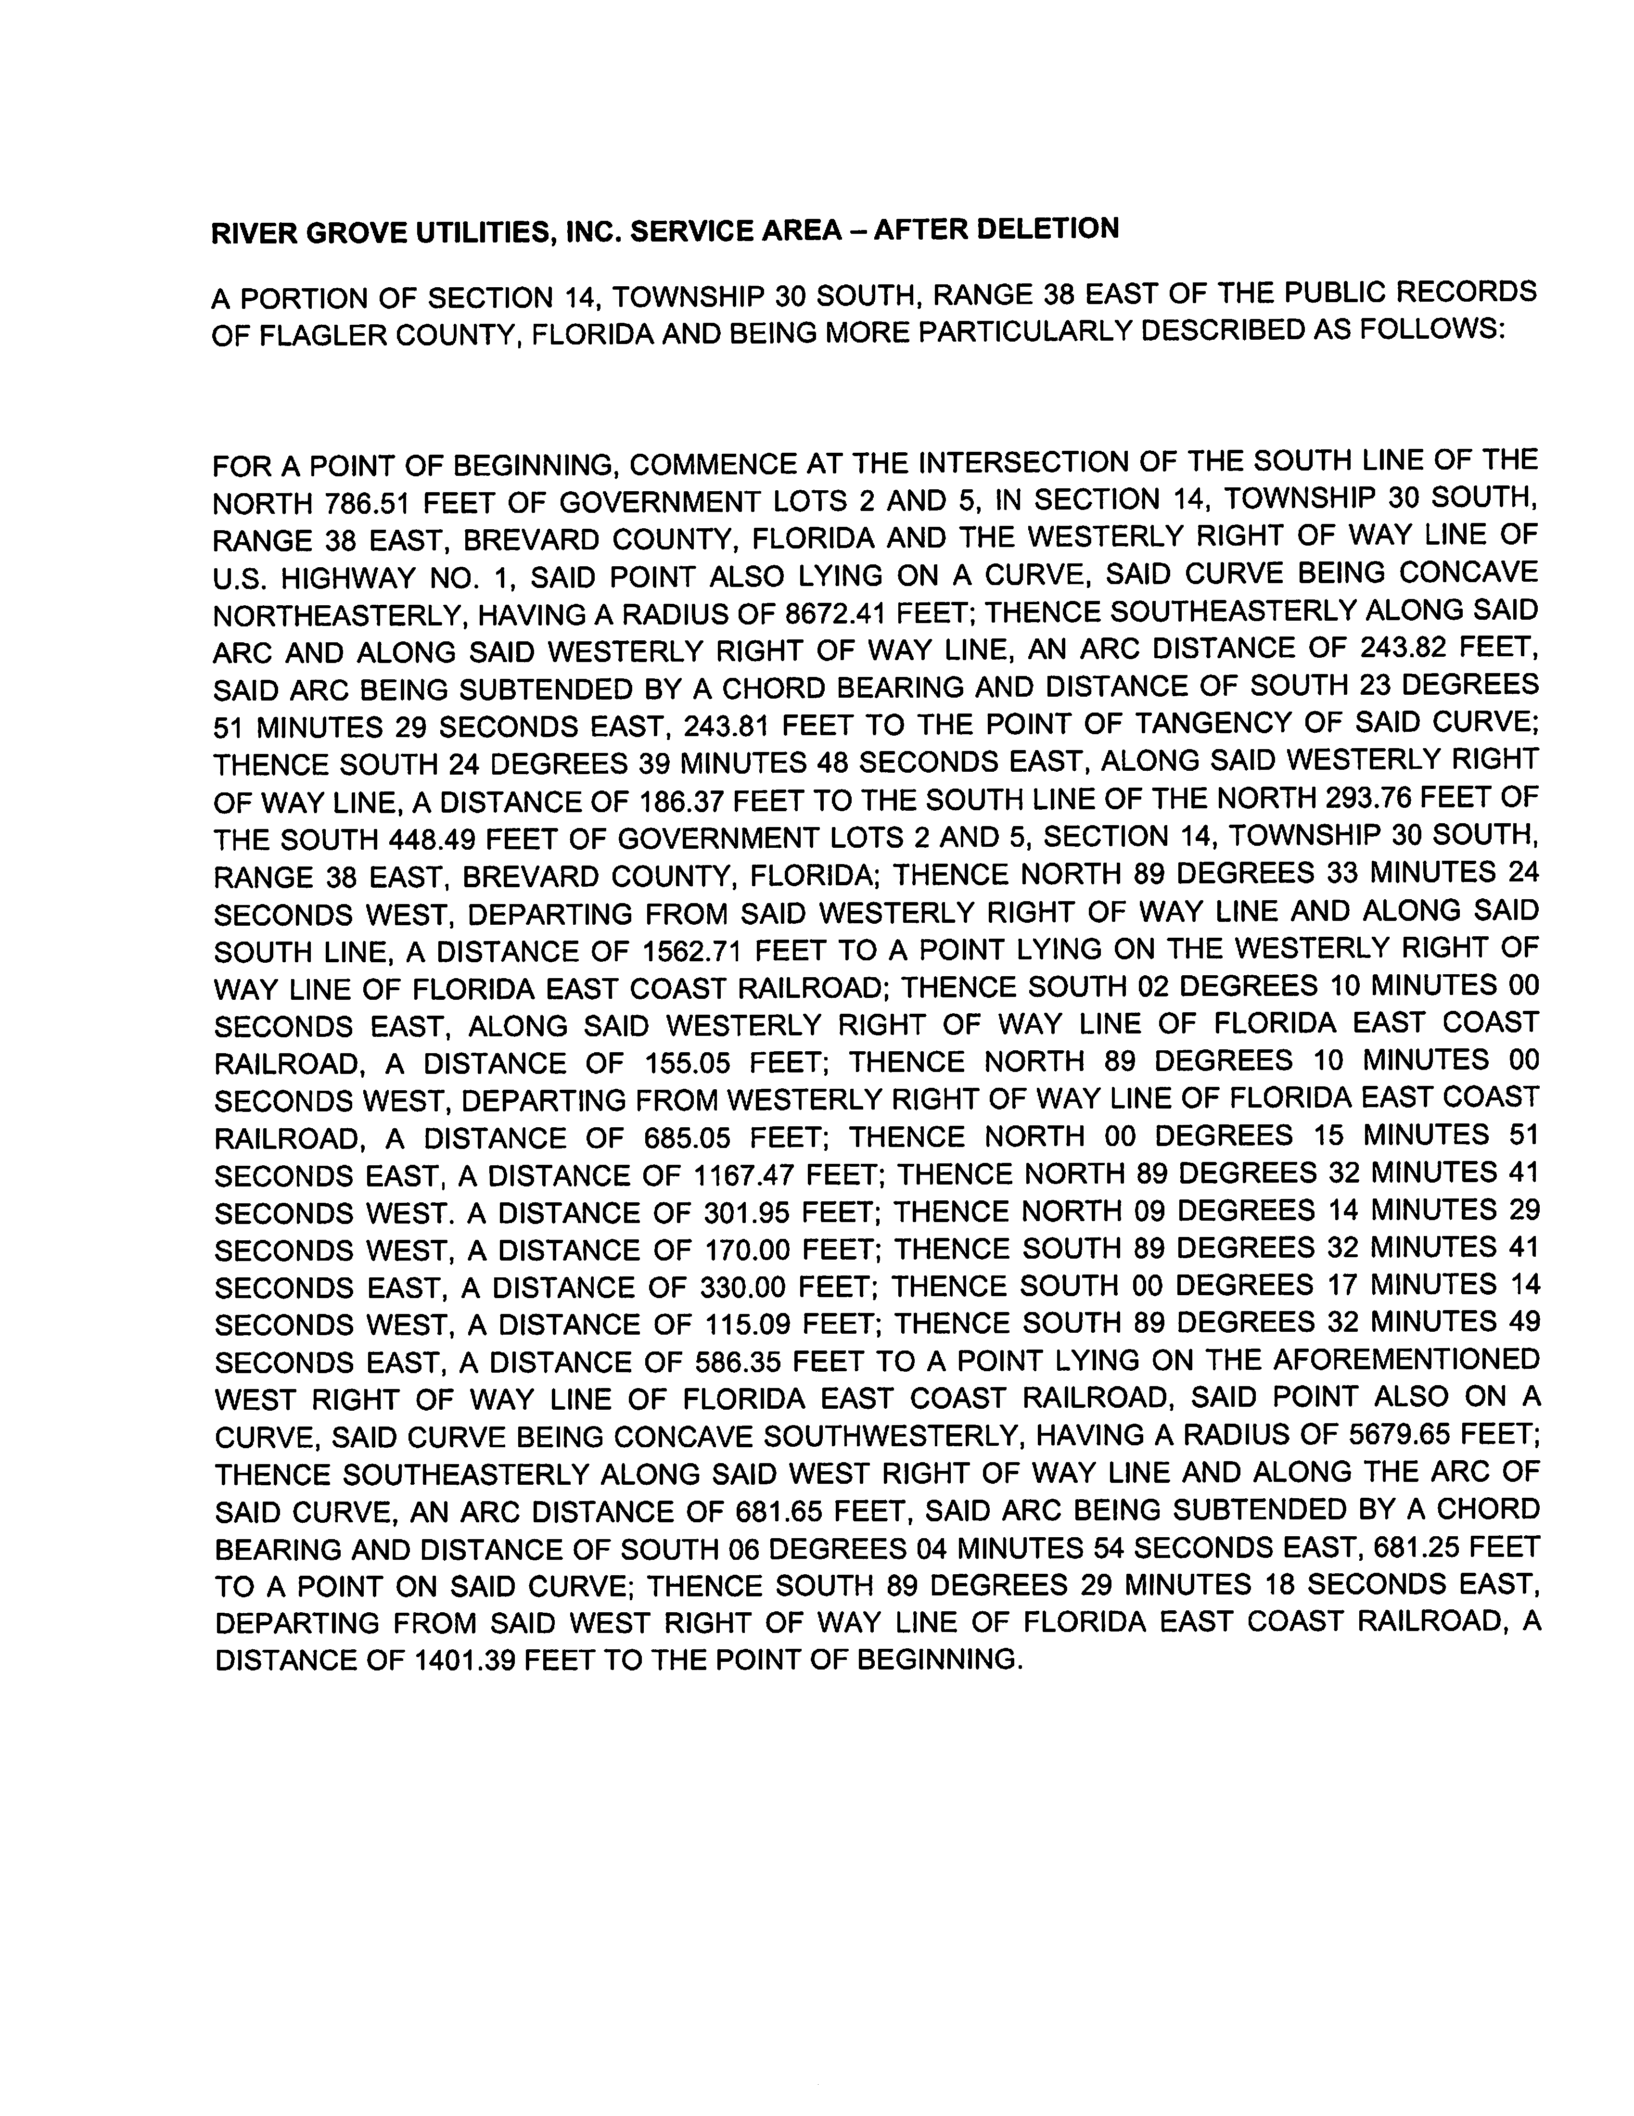

FLORIDA PUBLIC COMMISSION
Authorizes
Cobblestone II RVG LLC
Pursuant to
Certificate Number 674-W
To provide water services in Brevard County in accordance with the provisions of Chapter 367, Florida Statutes, and the Rules, Regulations, and Order of this Commission in the territory described by the Orders of the Commission. The authorization shall remain in the force and effect until superseded, suspended, concealed or revoked by Order of the Commission.

Order Number Date Issued Docket Number Filing Type
PSC-2020-0059-PAA-WS 02/24/2020 20190147-WS Original Certificate
* * 20220085-WS Transfer
* * 20220090-WS Territory Amendment

FLORIDA PUBLIC COMMISSION
Authorizes
Cobblestone II RVG LLC
Pursuant to
Certificate Number 575-S
To provide wastewater services in Brevard County in accordance with the provisions of Chapter 367, Florida Statutes, and the Rules, Regulations, and Order of this Commission in the territory described by the Orders of the Commission. The authorization shall remain in the force and effect until superseded, suspended, concealed or revoked by Order of the Commission.

Order Number Date Issued Docket Number Filing Type
PSC-2020-0059-PAA-WS 02/24/2020 20190147-WS Original Certificate
* * 20220085-WS Transfer
* * 20220090-WS Territory Amendment

Cobblestone II RVG LLC
Water System

Schedule of Net Book Value as of April 1, 2022

Description | Balance  Per Utility | Adjustments | Staff
Utility Plant in Service | $661,426 | $0 | $661,426
Land & Land Rights | 2,250 | 0 | 2,250
Accumulated Depreciation | (73,163) | 0 | (73,163)
CIAC | (476,202) | 0 | (476,202)
Amortization of CIAC | 44,782 | 0 | 44,782
Total | $159,093 | $0 | $159,093

Wastewater System

Schedule of Net Book Value as of April 1, 2022

Description | Balance  Per Utility | Adjustments | Staff
Utility Plant in Service | $8,100 | $0 | $8,100
Land & Land Rights | 2,250 | 0 | 2,250
Accumulated Depreciation | (8,100) | 0 | (8,100)
CIAC | 0 | 0 | 0
Amortization of CIAC | 0 | 0 | 0
Total | $2,250 | $0 | $2,250

Cobblestone II RVG LLC

Water System
Schedule of Staff Recommended Account Balances as of April 1, 2022

Account  No. | Description | UPIS | Accumulated Depreciation
303 | Land and Land Rights | $2,250
310 | Power Generation Equipment | 4,000 | 4,000
320 | Water Treatment Equipment | 8,100 | 8,100
331 | Transmission and Distribution Mains | 287,909 | 22,730
333 | Services | 303,598 | 26,023
334 | Meter and Meter Install. | 51,308 | 9,054
340 | Office Furniture & Equip. | 6,511 | 3,256
 |  | $663,676 | $73,163

Wastewater System
Schedule of Staff Recommended Account Balances as of April 1, 2022

Account  No. | Description | UPIS | Accumulated Depreciation
353 | Land and Land Rights | $2,250
380 | Treatment and Disposal Equipment | 8,100 | 8,100
 |  | $10,350 | $8,100

Cobblestone II RVG, LLC.
Monthly Water Rates

Residential and General Service
All Meter Sizes |  |  |  | $34.92
Charge Per 1,000 gallons |  |  |  | $7.15
Initial Customer Deposits
Meter Sizes | Residential |  |  |  | General Service
5/8” x 3/4” | $175.00 |  | 2x Average Estimated Bill
All Other Meter Sizes | 2x Average Estimated Bill |  | 2x Average Estimated Bill

Service Availability Charges
Meter Installation Charge
5/8" x 3/4" $353.00
All Other Meter Sizes Actual Cost

Cobblestone II RVG, LLC.
Monthly Wastewater Rates

Residential and General Service
All Meter Sizes |  |  |  | $24.66
Charge Per 1,000 gallons |  |  |  | $3.36
Initial Customer Deposits
Meter Sizes | Residential |  |  |  | General Service
5/8” x 3/4” | $99.00 |  | 2x Average Estimated Bill
All Other Meter Sizes | 2x Average Estimated Bill |  | 2x Average Estimated Bill

Order No. PSC-2020-0059-PAA-WS, issued February 24, 2020, in Docket No. 20190147-WS, In re: Application for certificates to provide water and wastewater service in Brevard County by River Grove Utilities, Inc.
Attachment A represents the proposed service territory to be served, including the deleted territory discussed in Issue 4.
Order No. PSC-2020-0059-PAA-WS, issued February 24, 2020, in Docket No. 20190147-WS, In re: Application for certificates to provide water and wastewater service in Brevard County by River Grove Utilities, Inc.
Order No. PSC-2021-0201-FOF-WS, issued June 4, 2020, in Docket No. 20200240-WS, In re: Proposed amendment of Rule 25-30.460, F.A.C., Application for Miscellaneous Service Charges.
Document No. 03882-2022, filed in Docket No. 20220085-WS and Document No. 03881-2022, filed in Docket No. 20220090-WS.

