State of Florida |  | Public Service Commission  Capital Circle Office Center ● 2540 Shumard Oak Boulevard  Tallahassee, Florida 32399-0850  -M-E-M-O-R-A-N-D-U-M-
DATE: | October 20, 2022
TO: | Office of Commission Clerk (Teitzman)
FROM: | Division of Economics (Kunkler, Draper, Hampson)  Division of Accounting and Finance (Gatlin, Norris)  Office of the General Counsel (Dose, Crawford)
RE: | Docket No. 20220161-EI – Petition to adjust clean energy transition mechanism to reflect revised authorized return on equity, by Tampa Electric Company.
AGENDA: | 11/01/22 – Regular Agenda – Tariff Filing – Interested Persons May Participate
COMMISSIONERS ASSIGNED: |  |  | All Commissioners
PREHEARING OFFICER: |  |  | Administrative
CRITICAL DATES: |  |  | 11/15/22 (60-Day Suspension Date)
SPECIAL INSTRUCTIONS: |  |  | None

Case Background
On September 16, 2022, Tampa Electric Company (TECO or Company) filed a petition to adjust the Clean Energy Transition Mechanism (CETM) revenue requirement established in Paragraph 5 of the 2021 Stipulation and Settlement Agreement (2021 Agreement). The Commission previously approved the 2021 Agreement in Order No. PSC-2021-0423-S-EI. Paragraph 5 of the 2021 Agreement provides for initial CETM charges, or rates, to recover an annual revenue requirement of $68,550,000, effective January 1, 2022. Per the 2021 Agreement, the CETM is a levelized annual recovery amount that extends through 2036, and is subject to periodic factor updates (every three years) as well as adjustments to account for all rate of return adjustments (i.e. resets to the Company’s mid-point return on equity) and corporate income tax rate changes.
The CETM is made up of two cost categories. The first category includes Big Bend Units One, Two, and Three retirements, as well as the Company’s dismantlement reserve deficiency for the Big Bend Assets. The second category includes costs associated with Automated Meter Reading (AMR) meter retirements. All such costs were identified in testimony and minimum filing requirements (MFRs) in Docket No. 20210034-EI.
In the instant petition, TECO requests that the Commission increase the CETM to $69,168,529, and approve revised customer rates resulting from this change effective January 1, 2023. Such rates are reflected in the proposed revisions to the Company’s tariff page submitted with its Petition, and included as Attachment A to the recommendation. Consistent with Subparagraph 5(f) of the 2021 Agreement, TECO seeks this increase in order to reflect TECO’s Revised Authorized Return on Equity (ROE) mid-point of 10.20 percent effective July 1, 2022, as approved in Order No. PSC-2022-0322-FOF-EI.
The Commission has jurisdiction over this matter pursuant to Sections 366.06 and 366.076, Florida Statutes (F.S.).

Discussion of Issues

Issue 1:
Should the Commission approve the updated Clean Energy Transmission Mechanism (CETM) amount of $69,168,529?

Recommendation:
Yes, the updated 2023 CETM amount of $69,168,529 should be approved. (Norris, Gatlin)

Staff Analysis:
Subparagraphs 5(a) and 5(c) of the 2021 Agreement provided that TECO transfer retiring AMR assets and certain retiring Big Bend assets into regulatory asset accounts and recover the costs of those assets from customers using a levelized CETM tariff with a revenue requirement of $68,550,000 effective with the first billing cycle in January 2022. TECO is required to update CETM factors periodically beginning in 2024 and every three years thereafter until the 15-year CETM period expires as stated in subparagraph 5(d). However, in subparagraph 5(f), TECO is required to adjust CETM factors to reflect changes to the Company’s updated overall rate of return, including, but not limited to, operation of the ROE Trigger mechanism.
As memorialized in Order No. PSC-2022-0322-FOF-EI, the Commission approved TECO’s petition to implement the ROE Trigger provisions of subparagraph 2(b) of the 2021 Agreement following an evidentiary hearing on August 16, 2022. As a result, the Company’s authorized ROE mid-point was increased by 25 basis points from 9.95 percent to 10.20 percent, effective as of July 1, 2022, for all regulatory purposes. In its petition to implement the 2023 CETM, TECO provided a calculation adjusting the CETM revenue requirement amount to $69,168,529 to reflect the Company’s 10.20 percent authorized ROE mid-point. Staff reviewed the Company’s calculations and recommends the updated amount be approved.

Issue 2:
Should the Commission approve TECO's revised CETM rates and tariff, effective with the first billing cycle of January 2023?

Recommendation:
Yes, the Commission should approve TECO’s revised CETM rates and tariff, as shown in Attachment A to the recommendation, effective with the first billing cycle of January 2023. (Draper, Hampson, Kunkler)

Staff Analysis:
TECO’s petition included proposed Fourth Revised Tariff Sheet No. 6.025 (Exhibits 5 and 6 to the petition), the allocation of the updated CETM amount of $69.17 million to the rate classes, (Exhibit 3 to the petition), and the updated CETM factor calculations (Exhibit 4 to the petition).
As required by the 2021 Agreement, the allocations of the updated CETM amount to the rate classes are the same used in the initial CETM calculations. Accordingly, each rate class receives an increase in the allocated CETM revenue requirement. However, the residential CETM rate decreases from 0.441 cents per kilowatt-hour (kWh) to 0.430 cents per kWh. Actual revenues collected from the residential rate class exceeded projected revenues when the CETM rate was first calculated, requiring a downward adjustment to the residential CETM rate.
Staff confirmed that the billing determinants used to calculate the proposed CETM factors are consistent with the billing determinants in TECO’s most recent Energy Conservation Cost Recovery Clause (ECCR) filing, and are in compliance with the 2021 Settlement Agreement. TECO’s most current ECCR filing, in Docket No. 20220002-EI, was filed on August 5, 2022.
Staff has reviewed TECO’s tariff sheets and supporting documentation. The calculations are accurate. The Commission should approve TECO’s revised CETM rates and tariff, as shown in Attachment A to the recommendation, effective with the first billing cycle of January 2023.
Issue 3:
Should this docket be closed?

Recommendation:
If a protest is filed within 21 days of the issuance of the order, the tariffs should remain in effect, with any revenues held subject to refund, pending resolution of the protest. If no timely protest is filed, this docket should be closed upon the issuance of a consummating order. (Dose)

Staff Analysis:
If a protest is filed within 21 days of the issuance of the order, the tariffs should remain in effect, with any revenues held subject to refund, pending resolution of the protest. If no timely protest is filed, this docket should be closed upon the issuance of a consummating order.

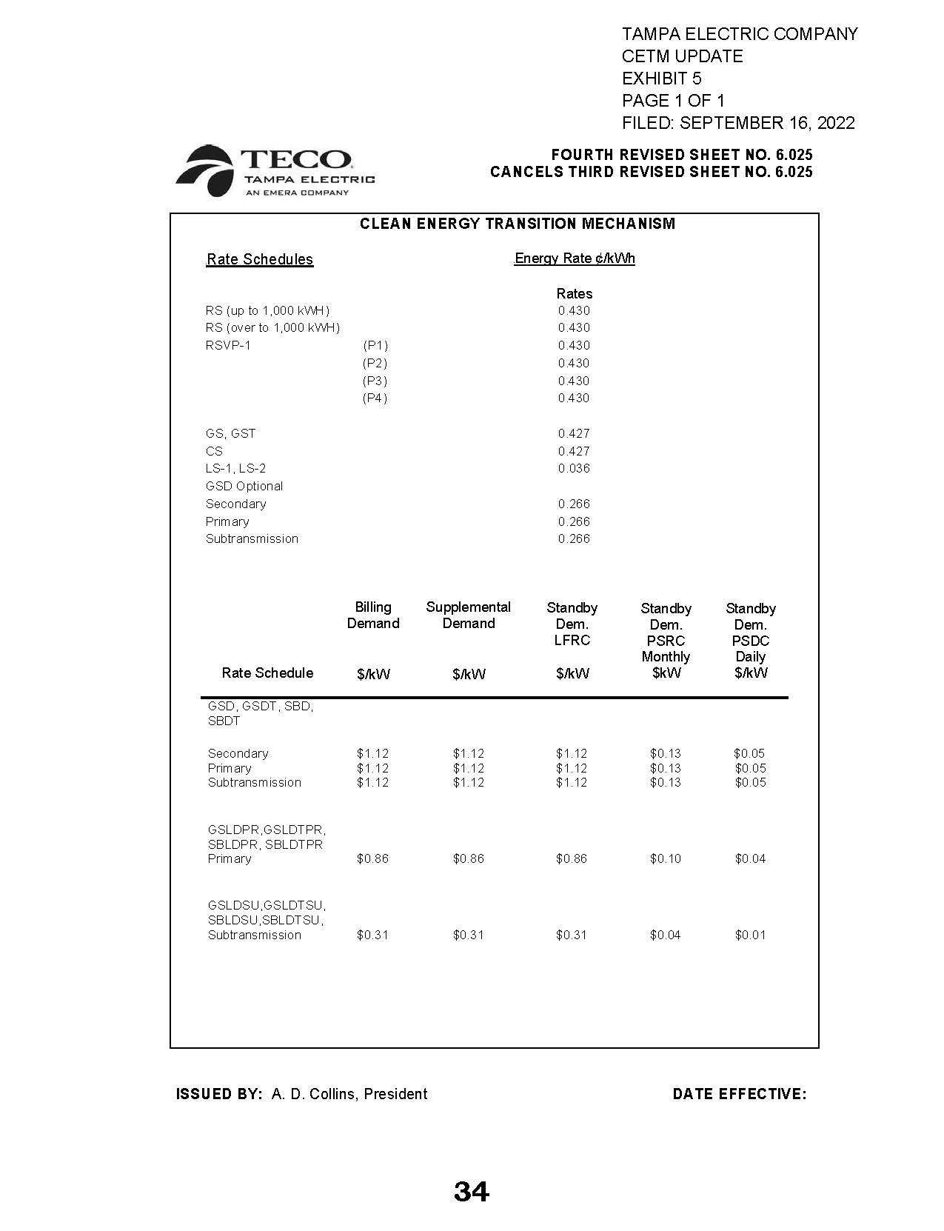

Order No. PSC-2021-0423-S-EI, issued November 10, 2021, in Docket No. 20210034-EI, In re: Petition for rate increase by Tampa Electric Company.
Order No. PSC-2022-0322-FOF-EI, issued September 12, 2022, in Docket No. 20220122-EI, In re: Petition for limited proceeding rate increase to implement return on equity provisions in 2021 agreement, by Tampa Electric Company.
Order No. PSC-2021-0423-S-EI.
Order No. PSC-2022-0322-FOF-EI, issued September 12, 2022, in Docket No. 20220122-EI, In re: Petition for limited proceeding rate increase to implement return on equity provisions in 2021 agreement, by Tampa Electric Company.
Document No. 05237-2022, filed August 5, 2022, in Docket No. 20220002-EI, In re: Energy Conservation Cost Recovery Clause.

