State of Florida |  | Public Service Commission  Capital Circle Office Center ● 2540 Shumard Oak Boulevard  Tallahassee, Florida 32399-0850  -M-E-M-O-R-A-N-D-U-M-
DATE: | October 20, 2022
TO: | Office of Commission Clerk (Teitzman)
FROM: | Division of Accounting and Finance (D. Buys, Cordell, Higgins, Mouring)  Division of Economics (Draper)  Office of the General Counsel (Brownless)
RE: | Docket No. 20220165-EI – Petition for limited proceeding to approve refund and rate reduction resulting from implementation of Inflation Reduction Act, by Florida Power & Light Company.
AGENDA: | 11/01/22 – Regular Agenda – Tariff Filing – Interested Persons May Participate
COMMISSIONERS ASSIGNED:
PREHEARING OFFICER: |  |  | Graham
CRITICAL DATES: |  |  | Tariff 60-Day Suspension Date 11/22/22  2021 Settlement Agreement Date 11/14/22
SPECIAL INSTRUCTIONS: |  |  | None

Case Background
Florida Power & Light Company (FPL or Company) is an investor-owned utility providing electric service to approximately 5.8 million customers in Florida. On September 23, 2022, FPL filed a petition requesting Commission approval of a refund and rate reduction resulting from the Inflation Reduction Act (IRA or Tax Reform) that was signed into law on August 16, 2022. The Company’s request is being made pursuant to Paragraph 13 of the 2021 Settlement that was approved on December 2, 2021, in Docket No. 20210015-EI. Paragraph 13 of the 2021 Settlement requires, in part, that the impacts of any tax reform on base revenue requirements be adjusted for retail customers within 90 days of when the tax reform becomes law. The Commission has jurisdiction over this matter pursuant to Sections 366.05 and 366.06, Florida Statutes (F.S.).

Discussion of Issues

Issue 1:
Should the Commission approve FPL's calculation of the tax savings associated with the IRA for 2022?

Recommendation:
Yes. The Commission should approve FPL’s calculations for the net tax savings of $25,043,705 for 2022 resulting from the Company’s election to use PTCs instead of ITCs as allowed by the IRA. (D. Buys, Mouring)

Staff Analysis:
Effective January 1, 2022, the IRA expanded federal income tax benefits for renewable energy by allowing owners of solar projects which begin construction before 2025 the option to elect to receive Production Tax Credits (PTCs) instead of Investment Tax Credits (ITCs). FPL has elected to use PTCs instead of ITCs because it provides a greater tax benefit and customer savings. The application of PTCs to FPL’s six rate base solar facilities results in a tax savings of $31,195,561. In comparison, the amortization of ITCs is $1,773,277 per year. The ITC amortization, and a $3,155,569 adjustment to account for the impact to the capital structure due to a net decrease of unamortized ITCs and accumulated deferred income taxes (ADITs), is deducted from the PTC balance. In addition, State income tax expense increased by $1,223,010 due to the removal of the ITCs and is also offset against PTC tax savings. In total, the net change in FPL’s jurisdictional adjusted base revenue requirement is a reduction of $25,043,705. Staff reviewed FPL’s calculations in the direct testimony of Ina P. Laney filed on September 23, 2022, in the instant docket, and believes they are reasonable and appropriate. FPL’s calculations are summarized in Table 1-1. Based on the aforementioned, staff recommends the Commission approve FPL’s calculations of net tax savings of $25,043,705 for 2022 resulting from the Company’s election to use PTCs instead of ITCs as allowed by the IRA.

Table 1-1
Calculation of PTC impact on 2022 Revenue Requirement

Production Tax Credits | $31,195,561
ITC Amortization Removal | (1,773,277)
State Income Tax Expense | (1,223,010)
ITC Capital Structure Impact | (3,155,569)
Net Reduction in 2022 Revenue Requirement | $25,043,705
Source: DN 07679-2022.

Issue 2:
Should the Commission approve FPL’s request to flow back to customers the full 2022 tax reform impact through a one-time reduction to its Capacity Cost Recovery Clause (CCR) factors in January 2023?

Recommendation:
Yes. Staff recommends the Commission approve a refund of $25,043,705 in January 2023 through a one-time reduction to FPL’s CCR factors. (Cordell)

Staff Analysis:
As discussed in Issue 1, FPL’s application of PTCs has reduced its 2022 jurisdictional adjusted revenue requirement by $25,043,705. Paragraph 13(a) of the 2021 Settlement states: “[a]ny effects of tax reform on the retail revenue requirements (but no earlier than January 1, 2022) through the date of the base rate adjustment shall be flowed back to, or collected from, customers through the [CCR] Clause on the same basis as used in any base rate adjustment.”
The impact of this refund on the capacity cost portion of a 1,000 kilowatt-hour (kWh) residential bill for January 2023 will be a credit of $0.75 on the 1,000 kWh residential bill. The Company believes applying the entire 2022 refund to a single month, with a commensurate one-month rate impact, will provide a more noticeable reduction to customers’ bills than spreading the refund over a full twelve months. After January, or from February through December 2023, the proposed residential capacity charge will be $2.12 per 1,000 kWh. Staff has reviewed the Company’s calculation of the net tax savings from the effective date of the IRA, through the base rate adjustment, and recommends the Commission approve a refund of $25,043,705 in January 2023 through a one-time reduction to FPL’s CCR factors.

Issue 3:
Should the Commission approve FPL's calculation of the projected tax savings associated with the IRA for 2023?

Recommendation:
Yes. The Commission should approve FPL’s calculations of net tax savings of $69,743,460 for 2023 resulting from the Company’s election to use PTCs instead of ITCs as allowed by the IRA. (D. Buys, Mouring)

Staff Analysis:
As discussed in Issue 1, FPL has selected the option to receive PTCs instead of ITCs as allowed by the IRA. The application of PTCs to FPL’s ten solar facilities results in a tax savings of $82,432,142, which is offset by a reduction to the ITC amortization balance of $12,688,682, for a net tax savings of $69,743,460. The incremental change in 2023 jurisdictional adjusted base revenue requirement is a reduction of $44,699,755, in addition to the 2022 net tax savings of $25,043,705, for a total reduction in base revenue requirement of $69,743,460. FPL will not finalize its 2023 Forecast Earnings Surveillance Report until early 2023, and consequently, did not take into account the impacts to the capital structure which would likely decrease the 2023 tax savings. FPL did not include the 2023 State income tax impact which may also slightly decrease the tax savings similar to its effect on the 2022 calculation. The projected change in FPL’s base revenue requirements is comprised of a $82.4 million reduction due to lower operating income tax expense resulting from the inclusion of PTCs associated with the Company’s base rate solar plants, offset by a $12.7 million increase due to the removal of ITC amortization associated with the 2022 and 2023 solar plants. FPL’s calculations are summarized in Table 3-1. Staff reviewed FPL’s calculations in the direct testimony of Ina P. Laney filed on September 23, 2022, in the instant docket, and believe they are reasonable and appropriate. Based on the aforementioned, staff recommends the Commission approve FPL’s calculations of net tax savings of $69,743,460 for 2023 resulting from the Company’s election to use PTCs instead of ITCs as allowed by the IRA.

Table 3-1

Calculation of PTC impact on 2023 Revenue Requirement
Production Tax Credits | $82,432,142
ITC Amortization Removal | (12,688,682)
Net Reduction in 2023 Revenue Requirement | $69,743,460
Decrease in 2022 Revenue Requirement | (25,043,705)
Incremental Reduction in 2023 Revenue Requirement | $44,699,755
Source: DN 07679-2022.

Issue 4:
Should the Commission approve FPL's request to flow back to customers the projected 2023 tax savings through a reduction to base rates beginning January 1, 2023?

Recommendation:
Yes. The Commission should approve FPL’s request to flow back to customers the projected net $69,743,460 tax savings through a reduction to base rates beginning January 1, 2023. (D. Buys, Mouring)

Staff Analysis:
As discussed in Issue 3, the Company’s election to utilize PTCs instead of ITCs under the IRA has resulted in a projected net tax savings of approximately $69.7 million. Under the provisions of Paragraph 13 of the 2021 Settlement, the Company is required to quantify the impacts of federal or state tax reform on its jurisdictional base revenue requirement as projected in its Forecast Earnings Surveillance Report and adjust its jurisdictional base revenue requirement through a uniform percentage decrease or increase to customer, demand, and energy base rates for all retail customer classes. Staff has reviewed the Company’s calculation of the projected net tax savings associated with the IRA and the proposed method to flow back those tax savings to customers and recommends that the proposed permanent reduction in jurisdictional base rates is consistent with the terms of the 2021 Settlement and should be approved.

Issue 5:
Should the Commission approve FPL’s revised tariffs to implement the IRA base revenue decrease effective January 2023?

Recommendation:
Yes. The Commission should approve FPL’s revised tariffs to implement the IRA base revenue decrease effective January 2023. The revised tariffs are shown in Attachment A to the recommendation. (Draper)

Staff Analysis:
FPL’s petition includes the proposed tariff sheets (Exhibit D to the petition) and the calculation of the IRA adjustment factor of (0.775) percent (Exhibit C to the petition). The IRA adjustment factor was calculated by dividing the $69.7 million reduction in the 2023 base revenue requirement by the 2023 projected retail base revenue sales of electricity ($8,999.9 million). The IRA adjustment factor was applied to the base rates for all rate classes (Exhibit C to the petition, Part 2).
In Order No. PSC-2021-0446-S-EI, the Commission approved an increase of $560 million in FPL’s base rates effective January 2023. This Commission-approved increase is also reflected in the revised tariffs, as both the approved $560 million base rate increase and the proposed IRA base revenue decrease are effective January 2023.
A residential customer who uses 1,000 kWh per month currently pays $75.82 on the base rate portion of their monthly bill. Without the IRA adjustment, the base rate portion on the 1,000 kWh residential bill would be $80.73 effective January 2023. As a result of the IRA adjustment, the base rate portion of the 1,000 kWh residential bill will be $80.11 effective January 2023, an increase of $4.29 from the current $75.82.
Staff has reviewed FPL’s tariff sheets and supporting documentation. The calculations are accurate. The Commission should approve FPL’s revised tariffs to implement the IRA base revenue decrease effective January 2023. The revised tariffs are shown in Attachment A to the recommendation.

Issue 6:
Should this docket be closed?

Recommendation:
Yes. At the conclusion of the protest period, if no protest is filed this docket should be closed upon the issuance of a consummating order. If a protest is filed within 21 days of the issuance of the order, the tariffs should remain in effect, subject to adjustment, pending the resolution of the protest. (Brownless)

Staff Analysis:
At the conclusion of the protest period, if no protest is filed this docket should be closed upon the issuance of a consummating order. If a protest is filed within 21 days of the issuance of the order, the tariffs should remain in effect, subject to adjustment, pending the resolution of the protest.

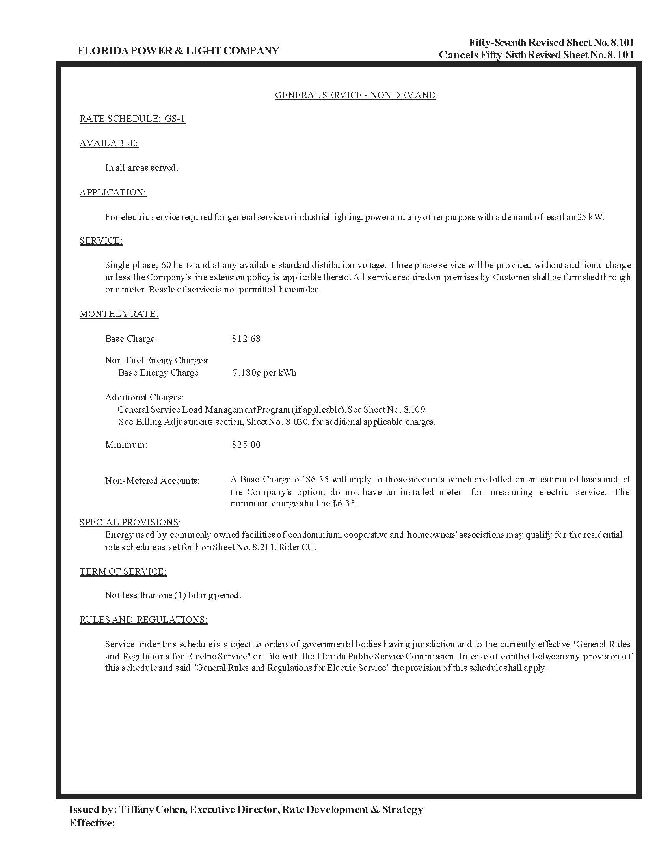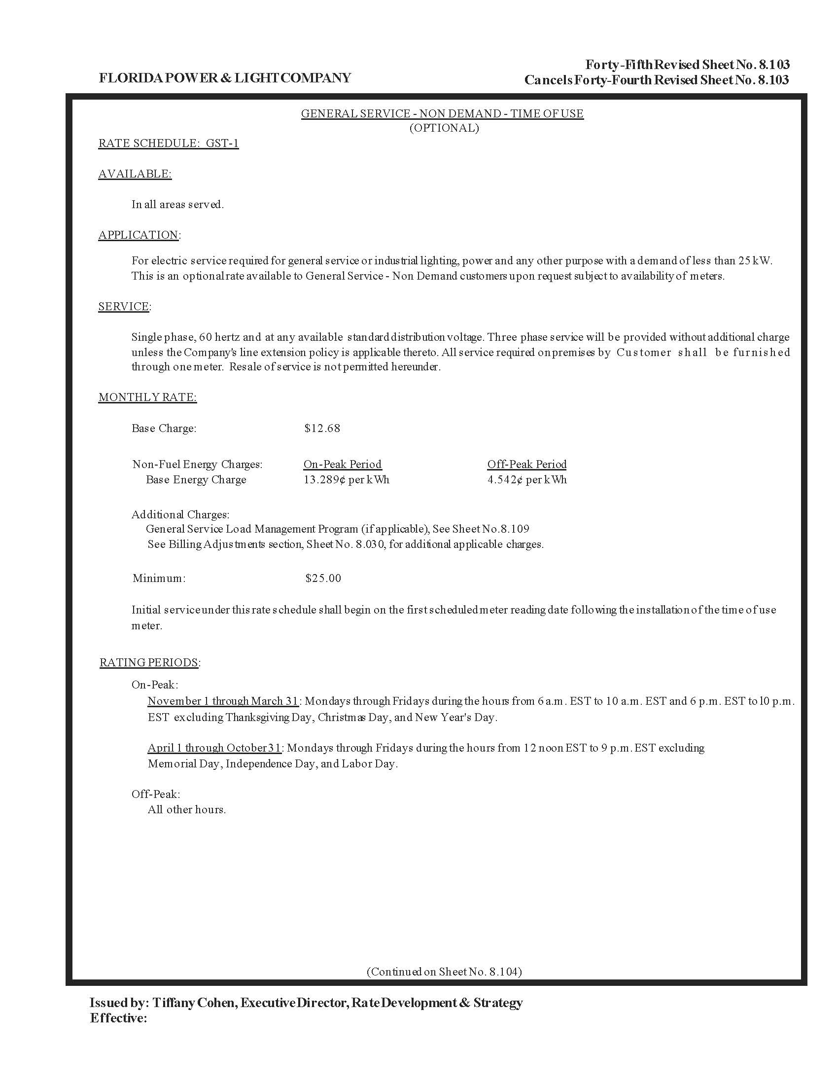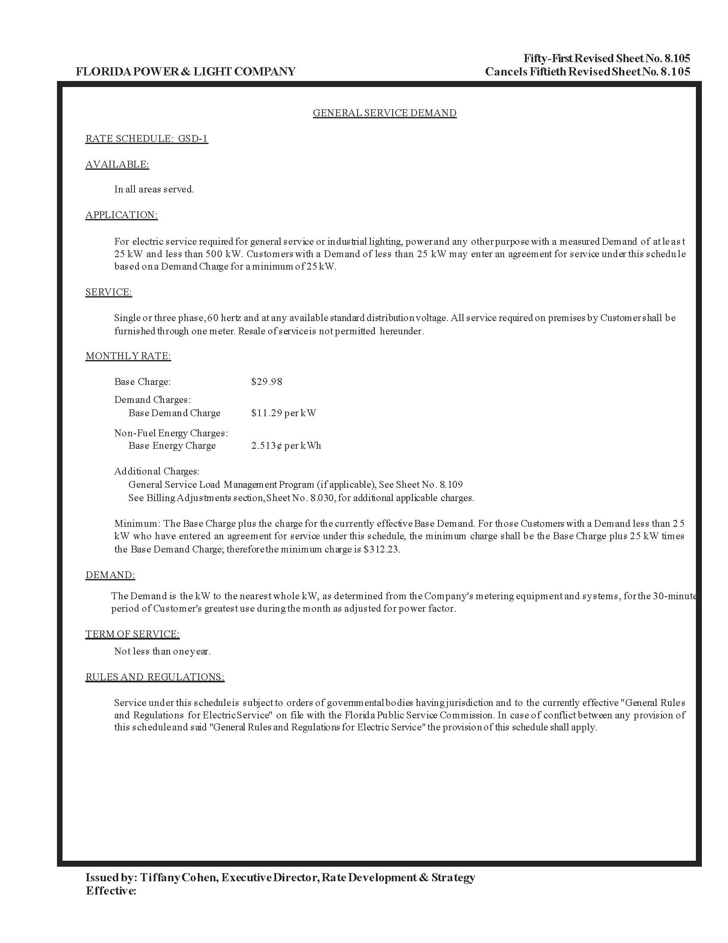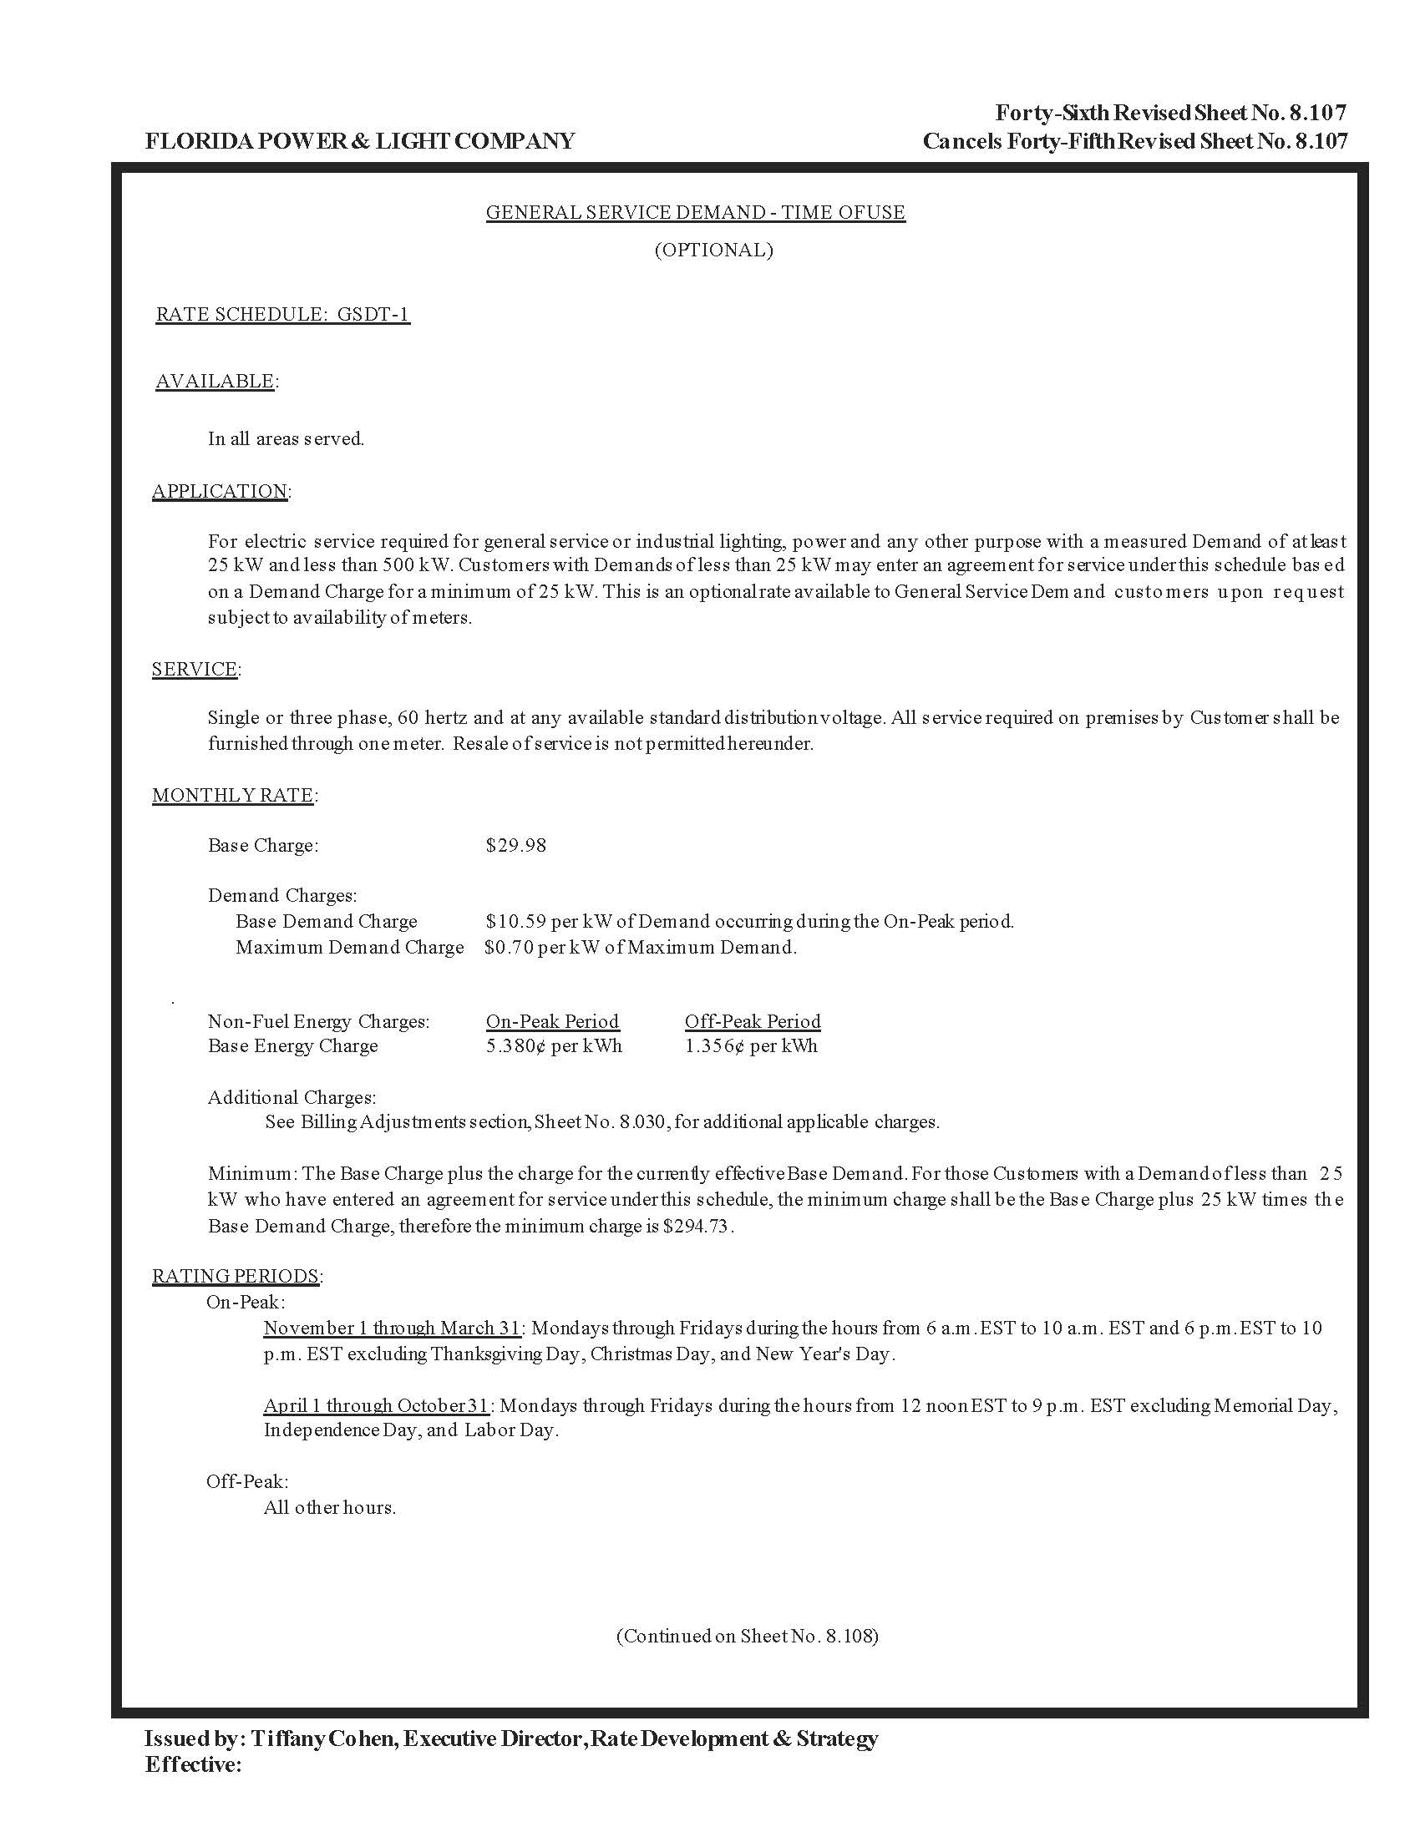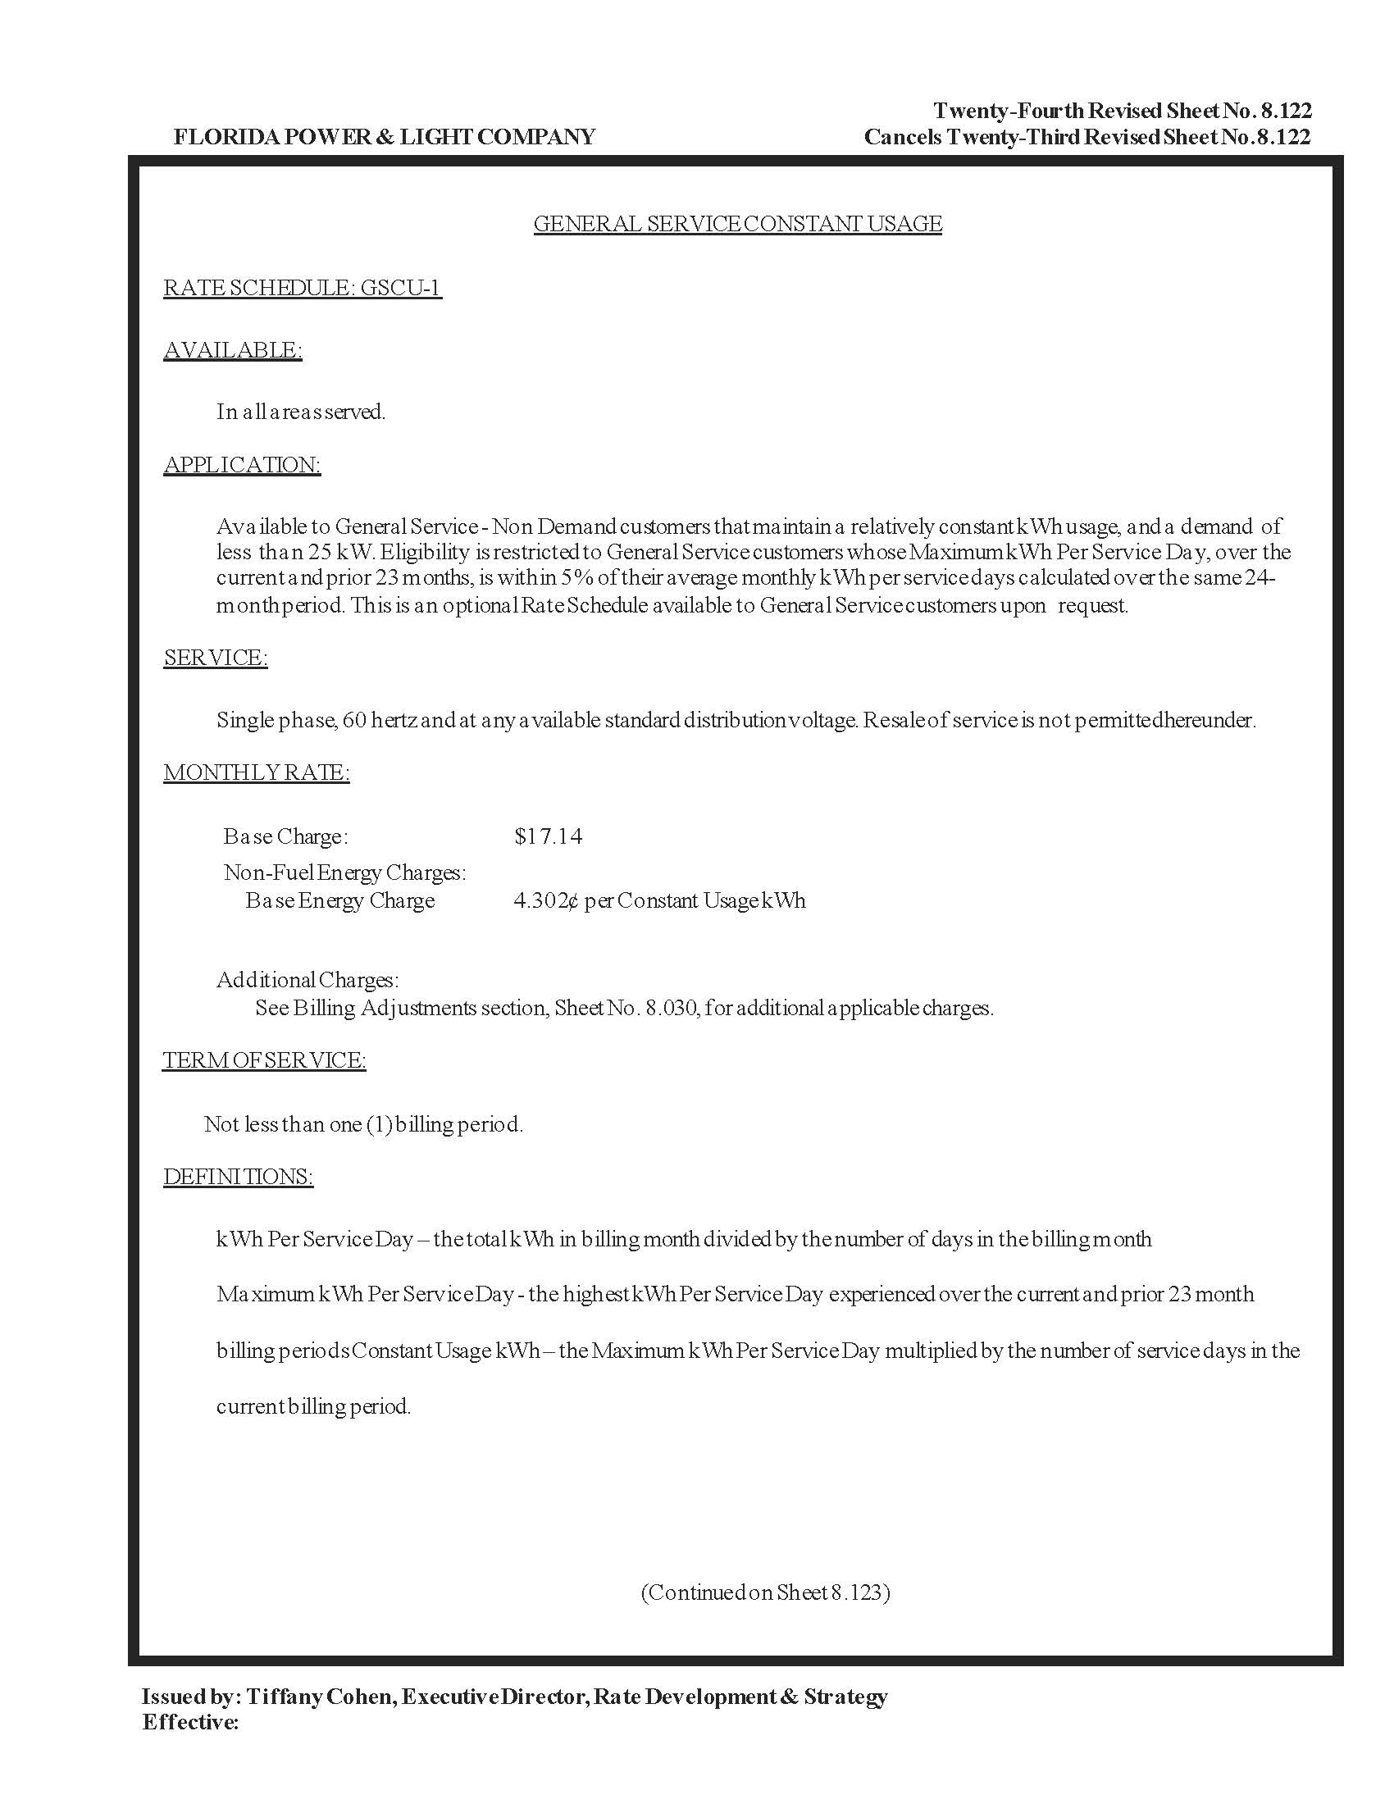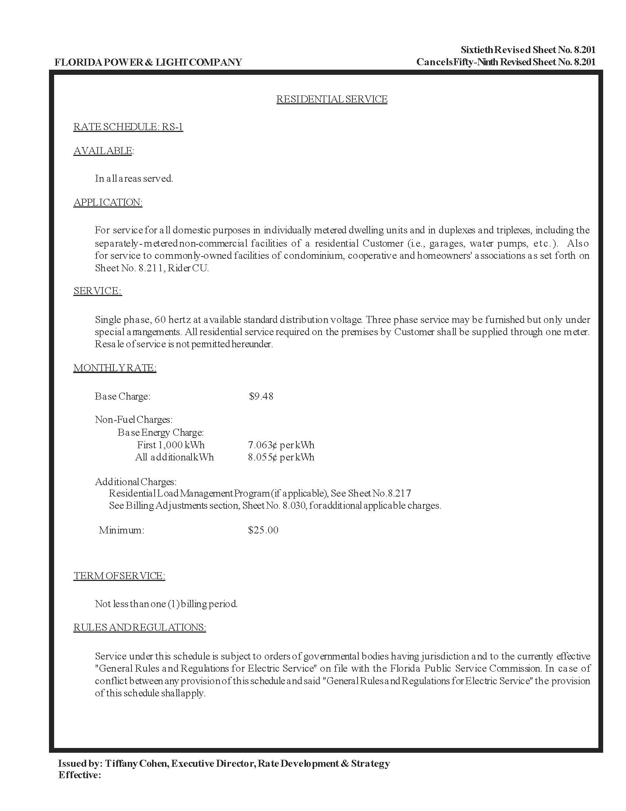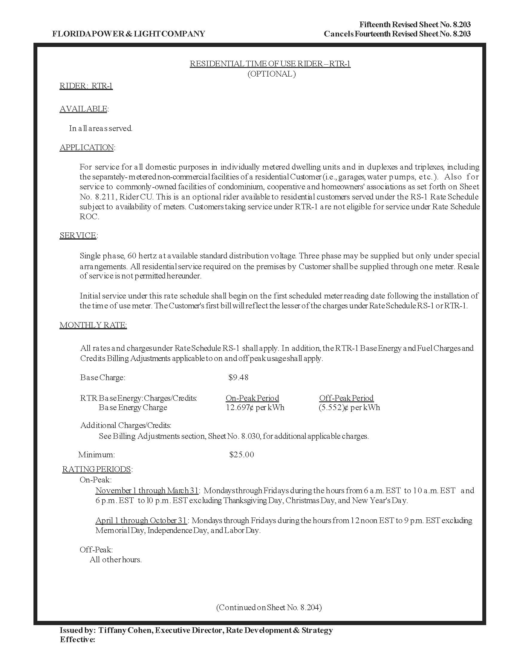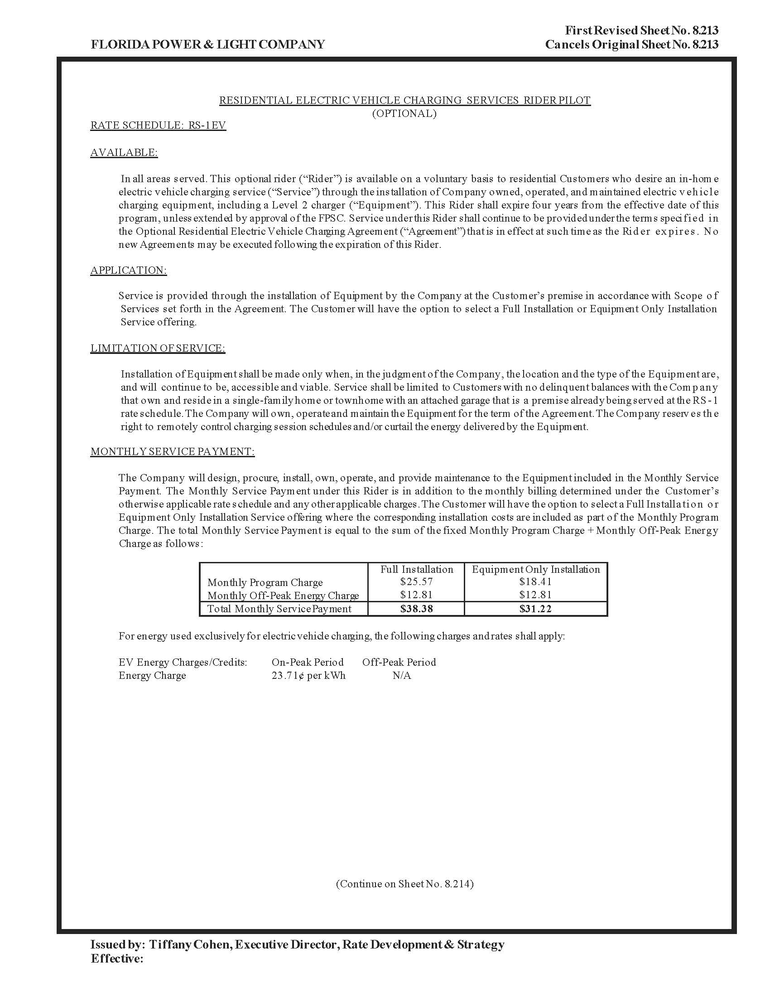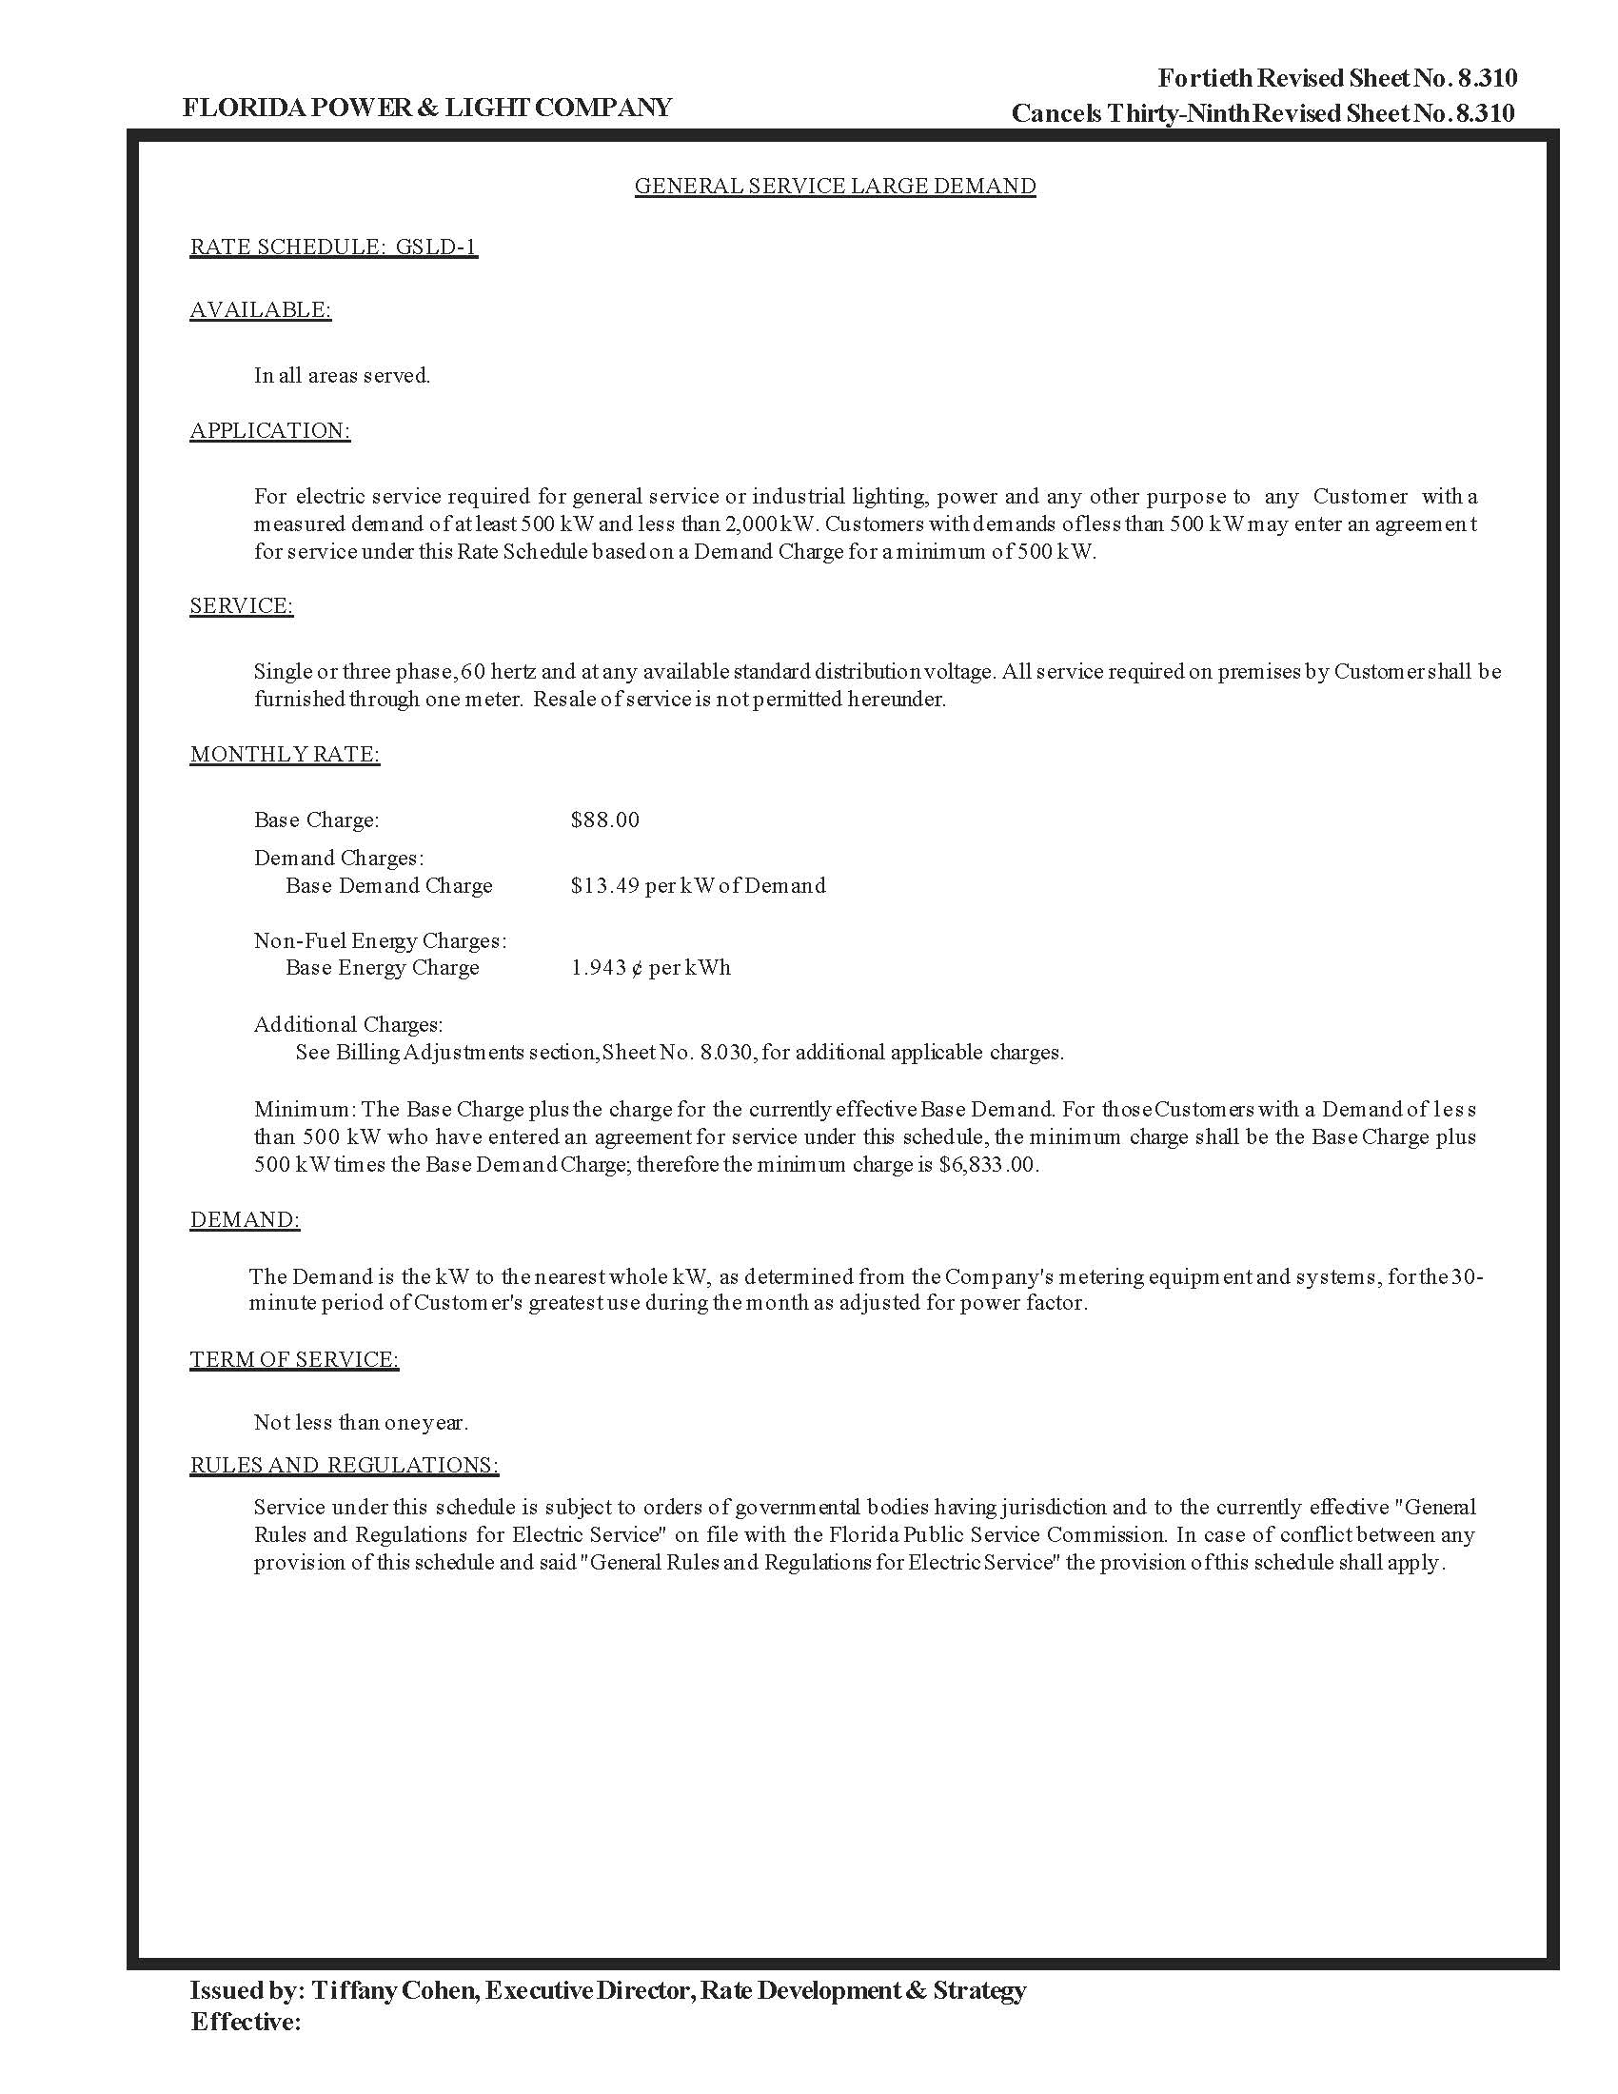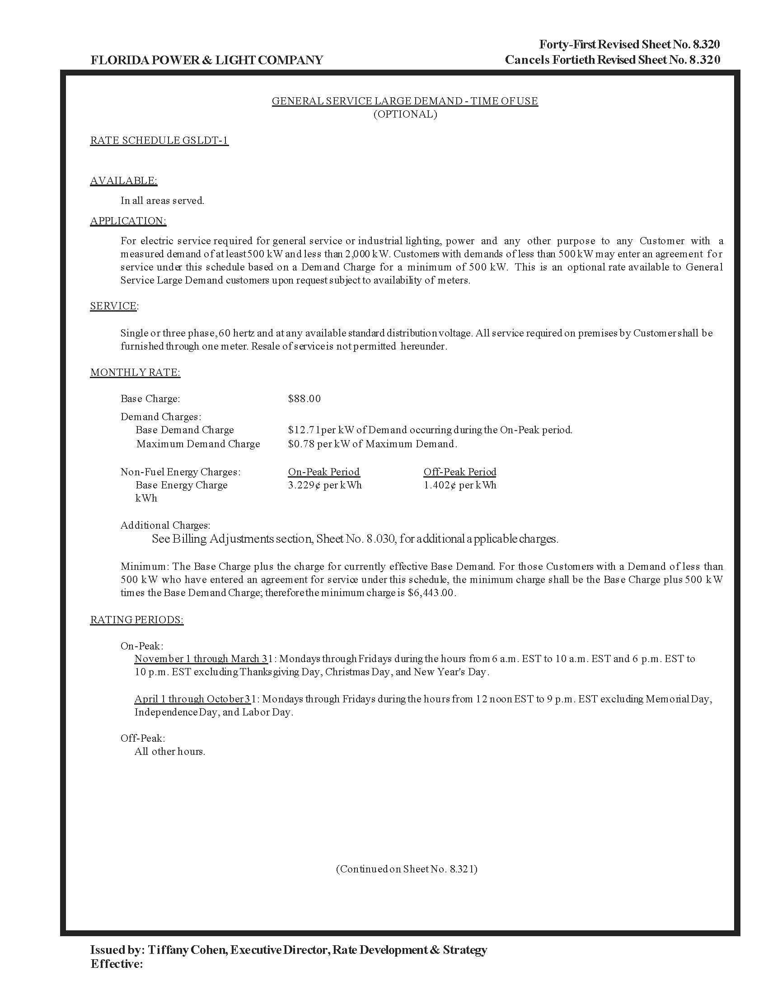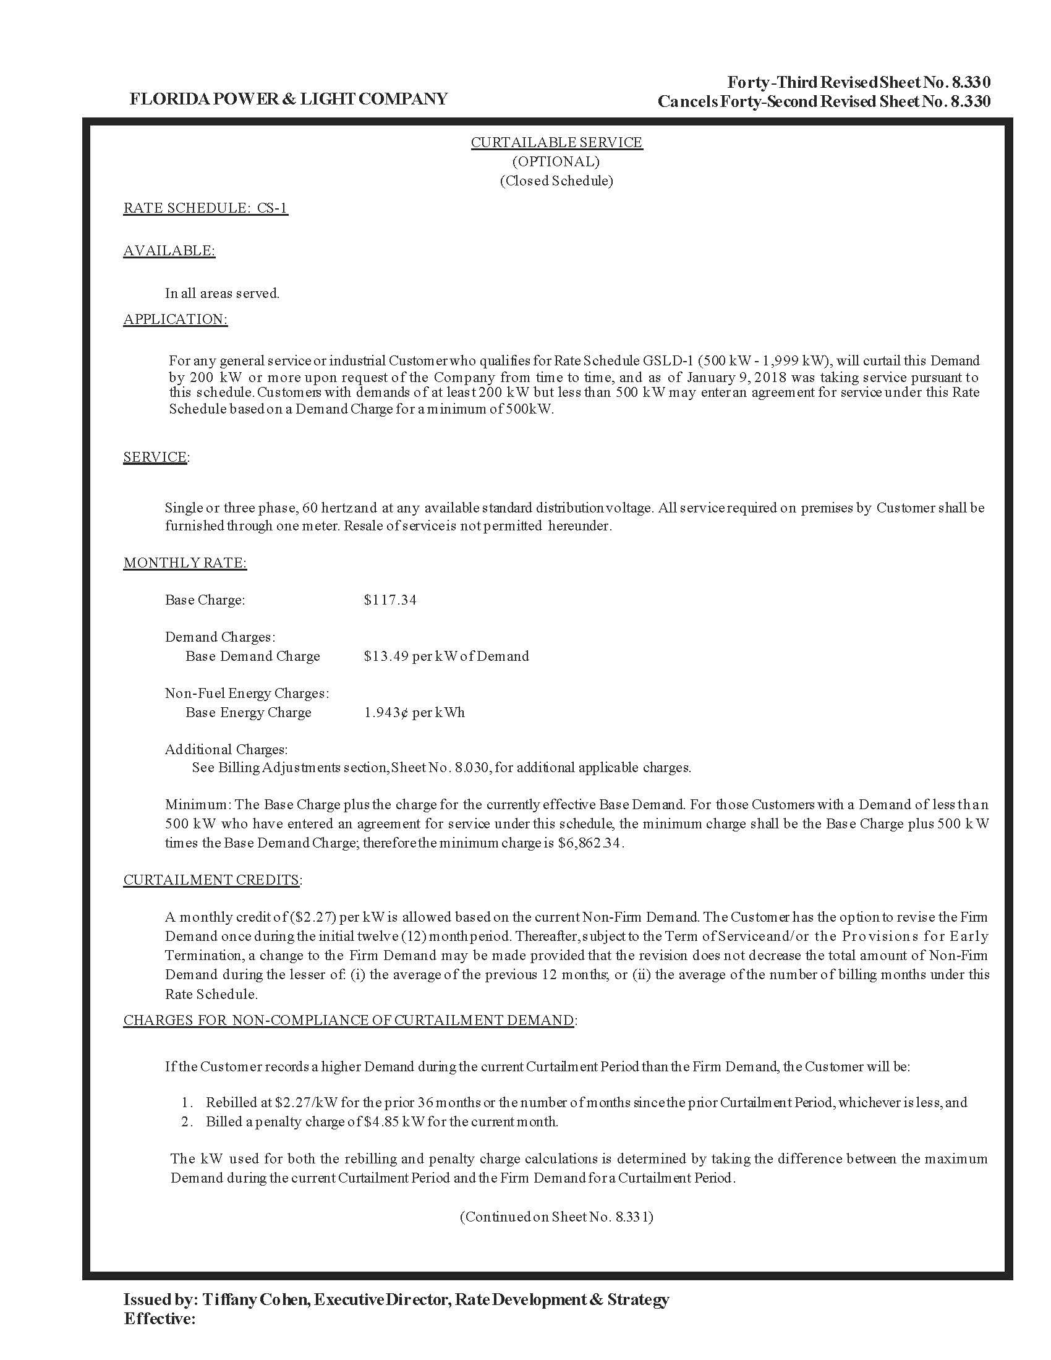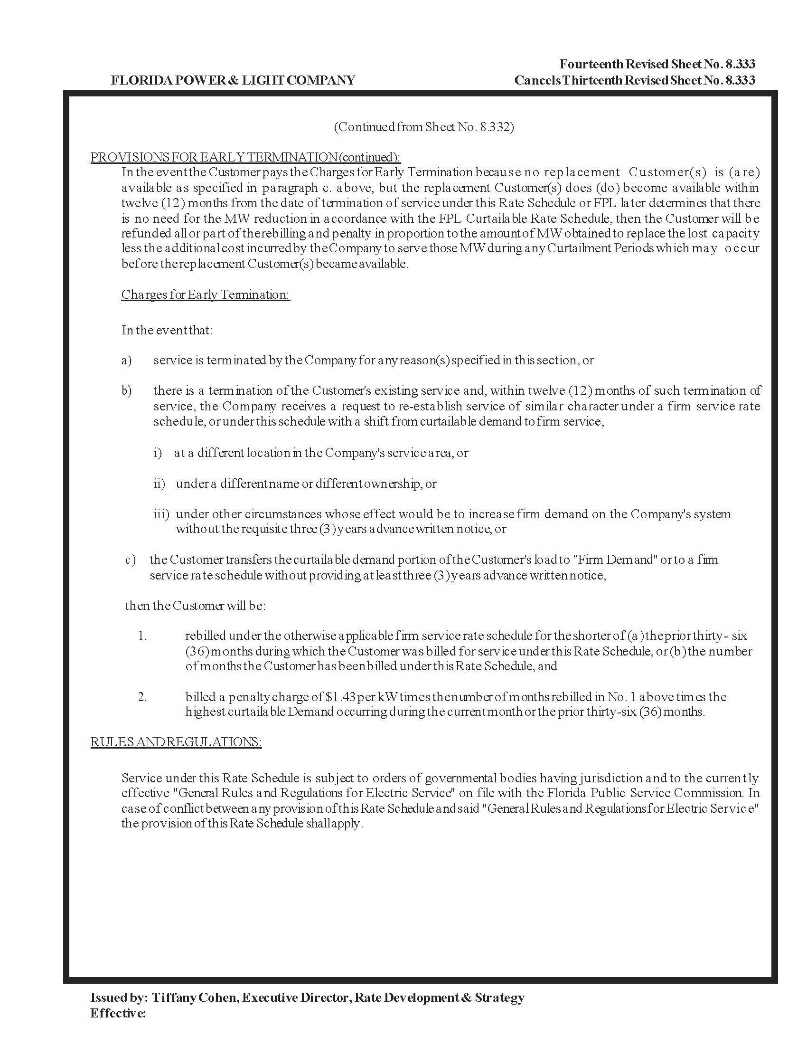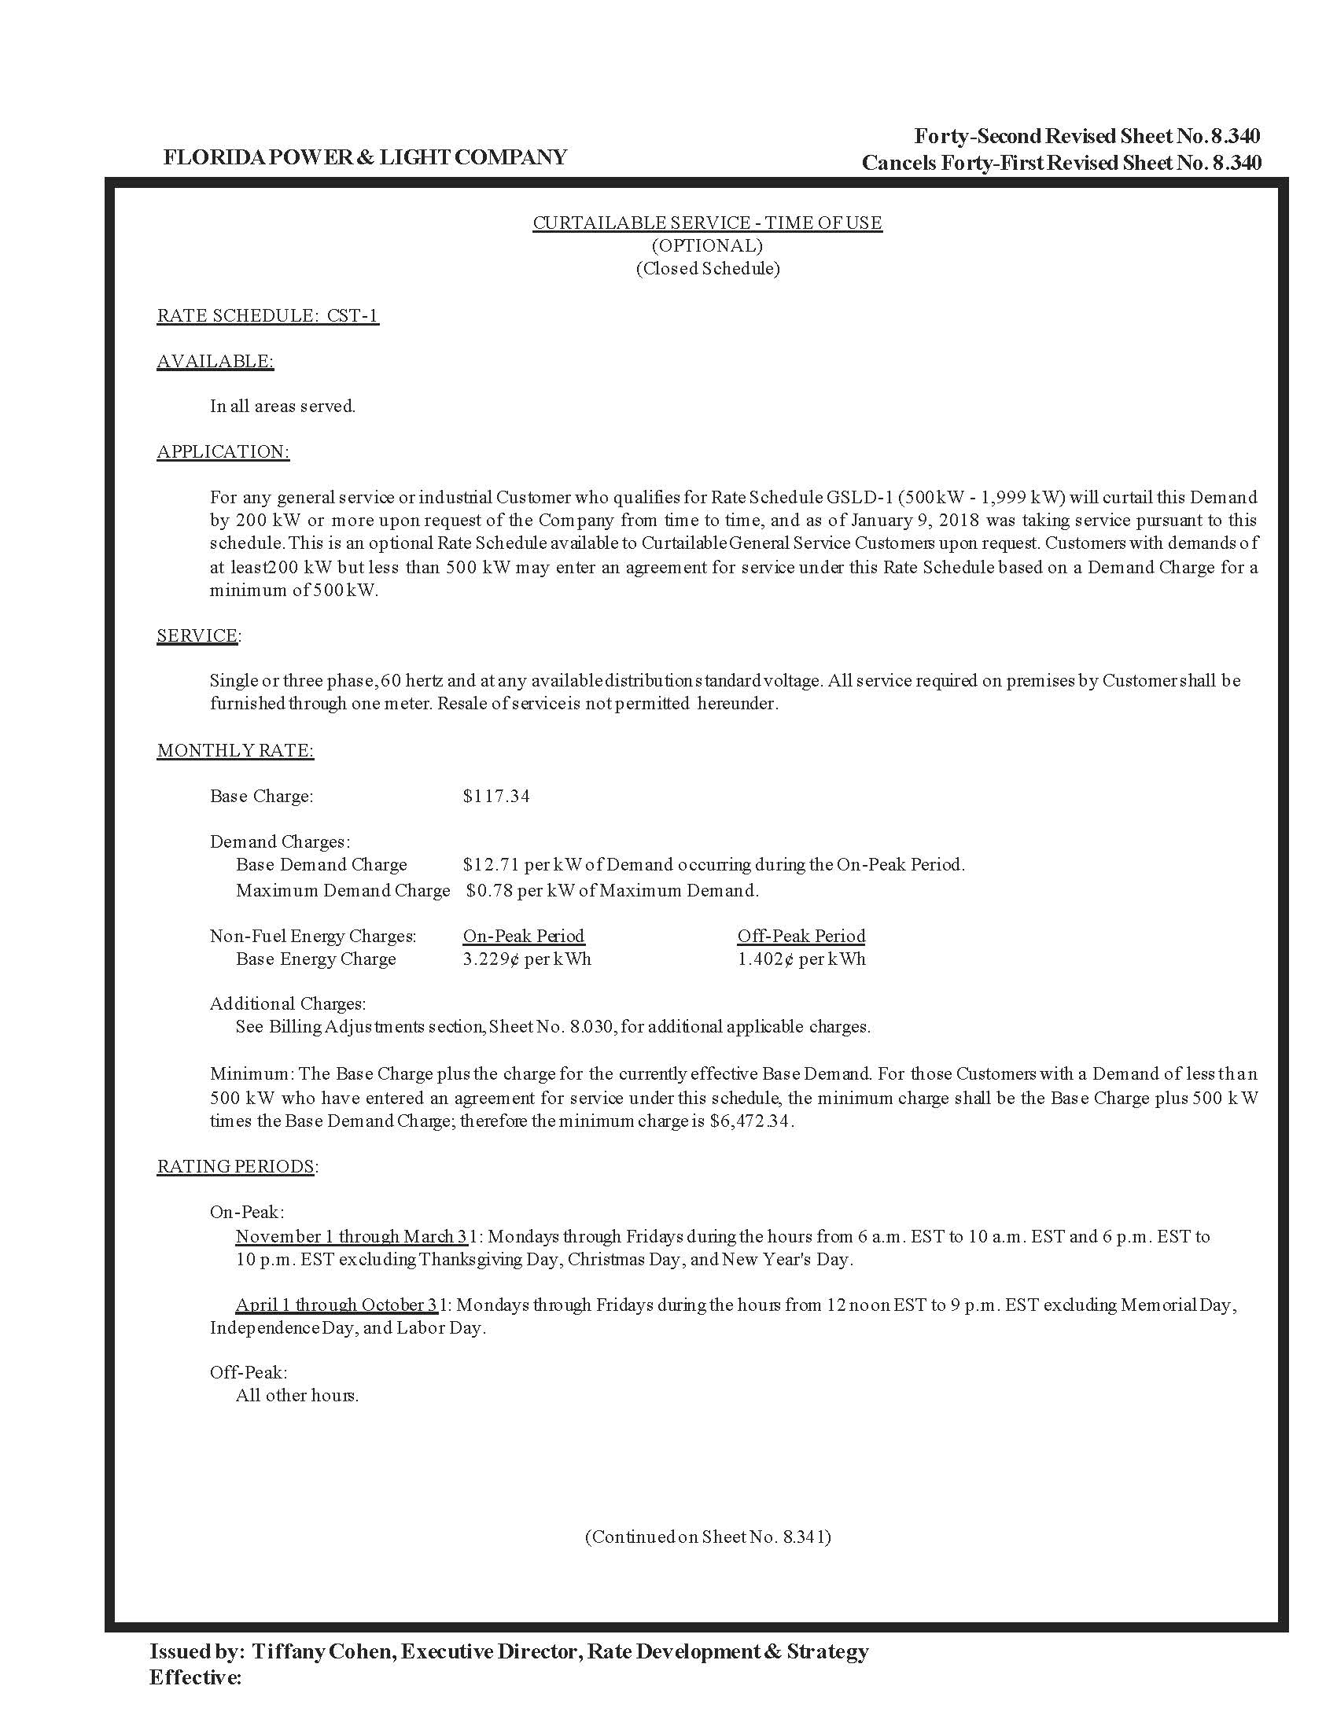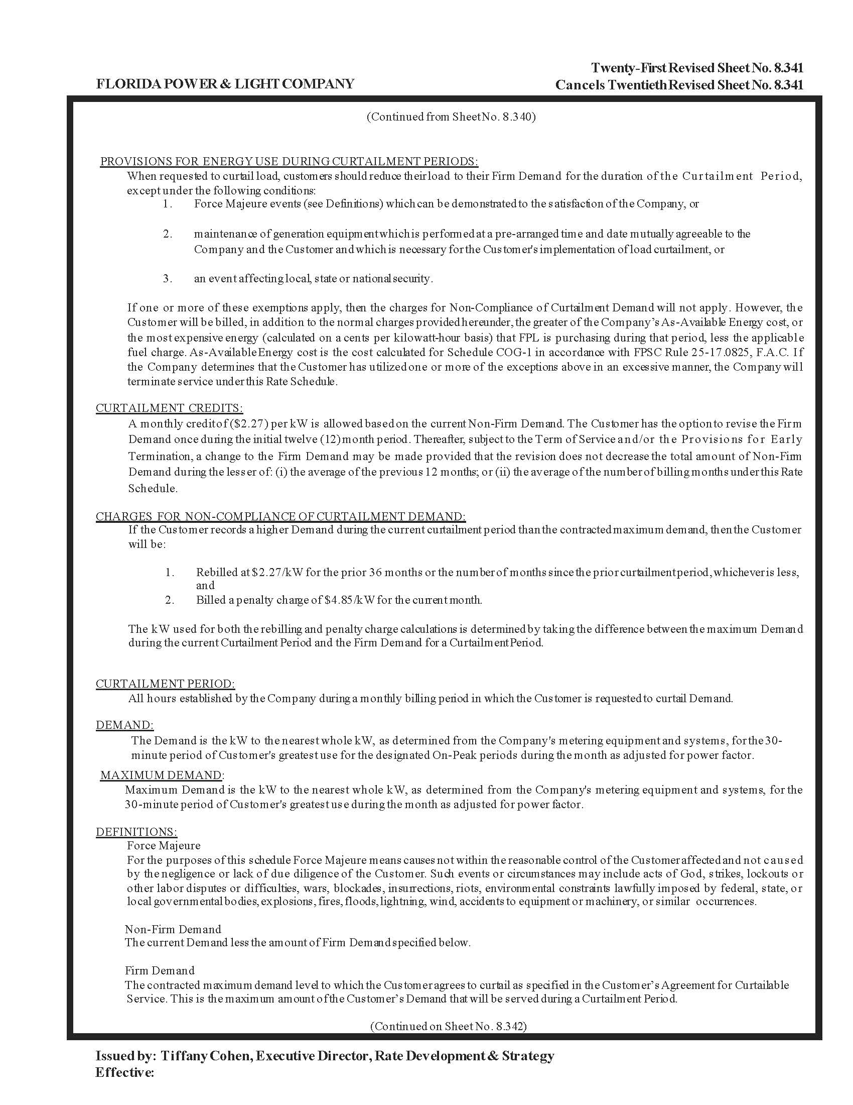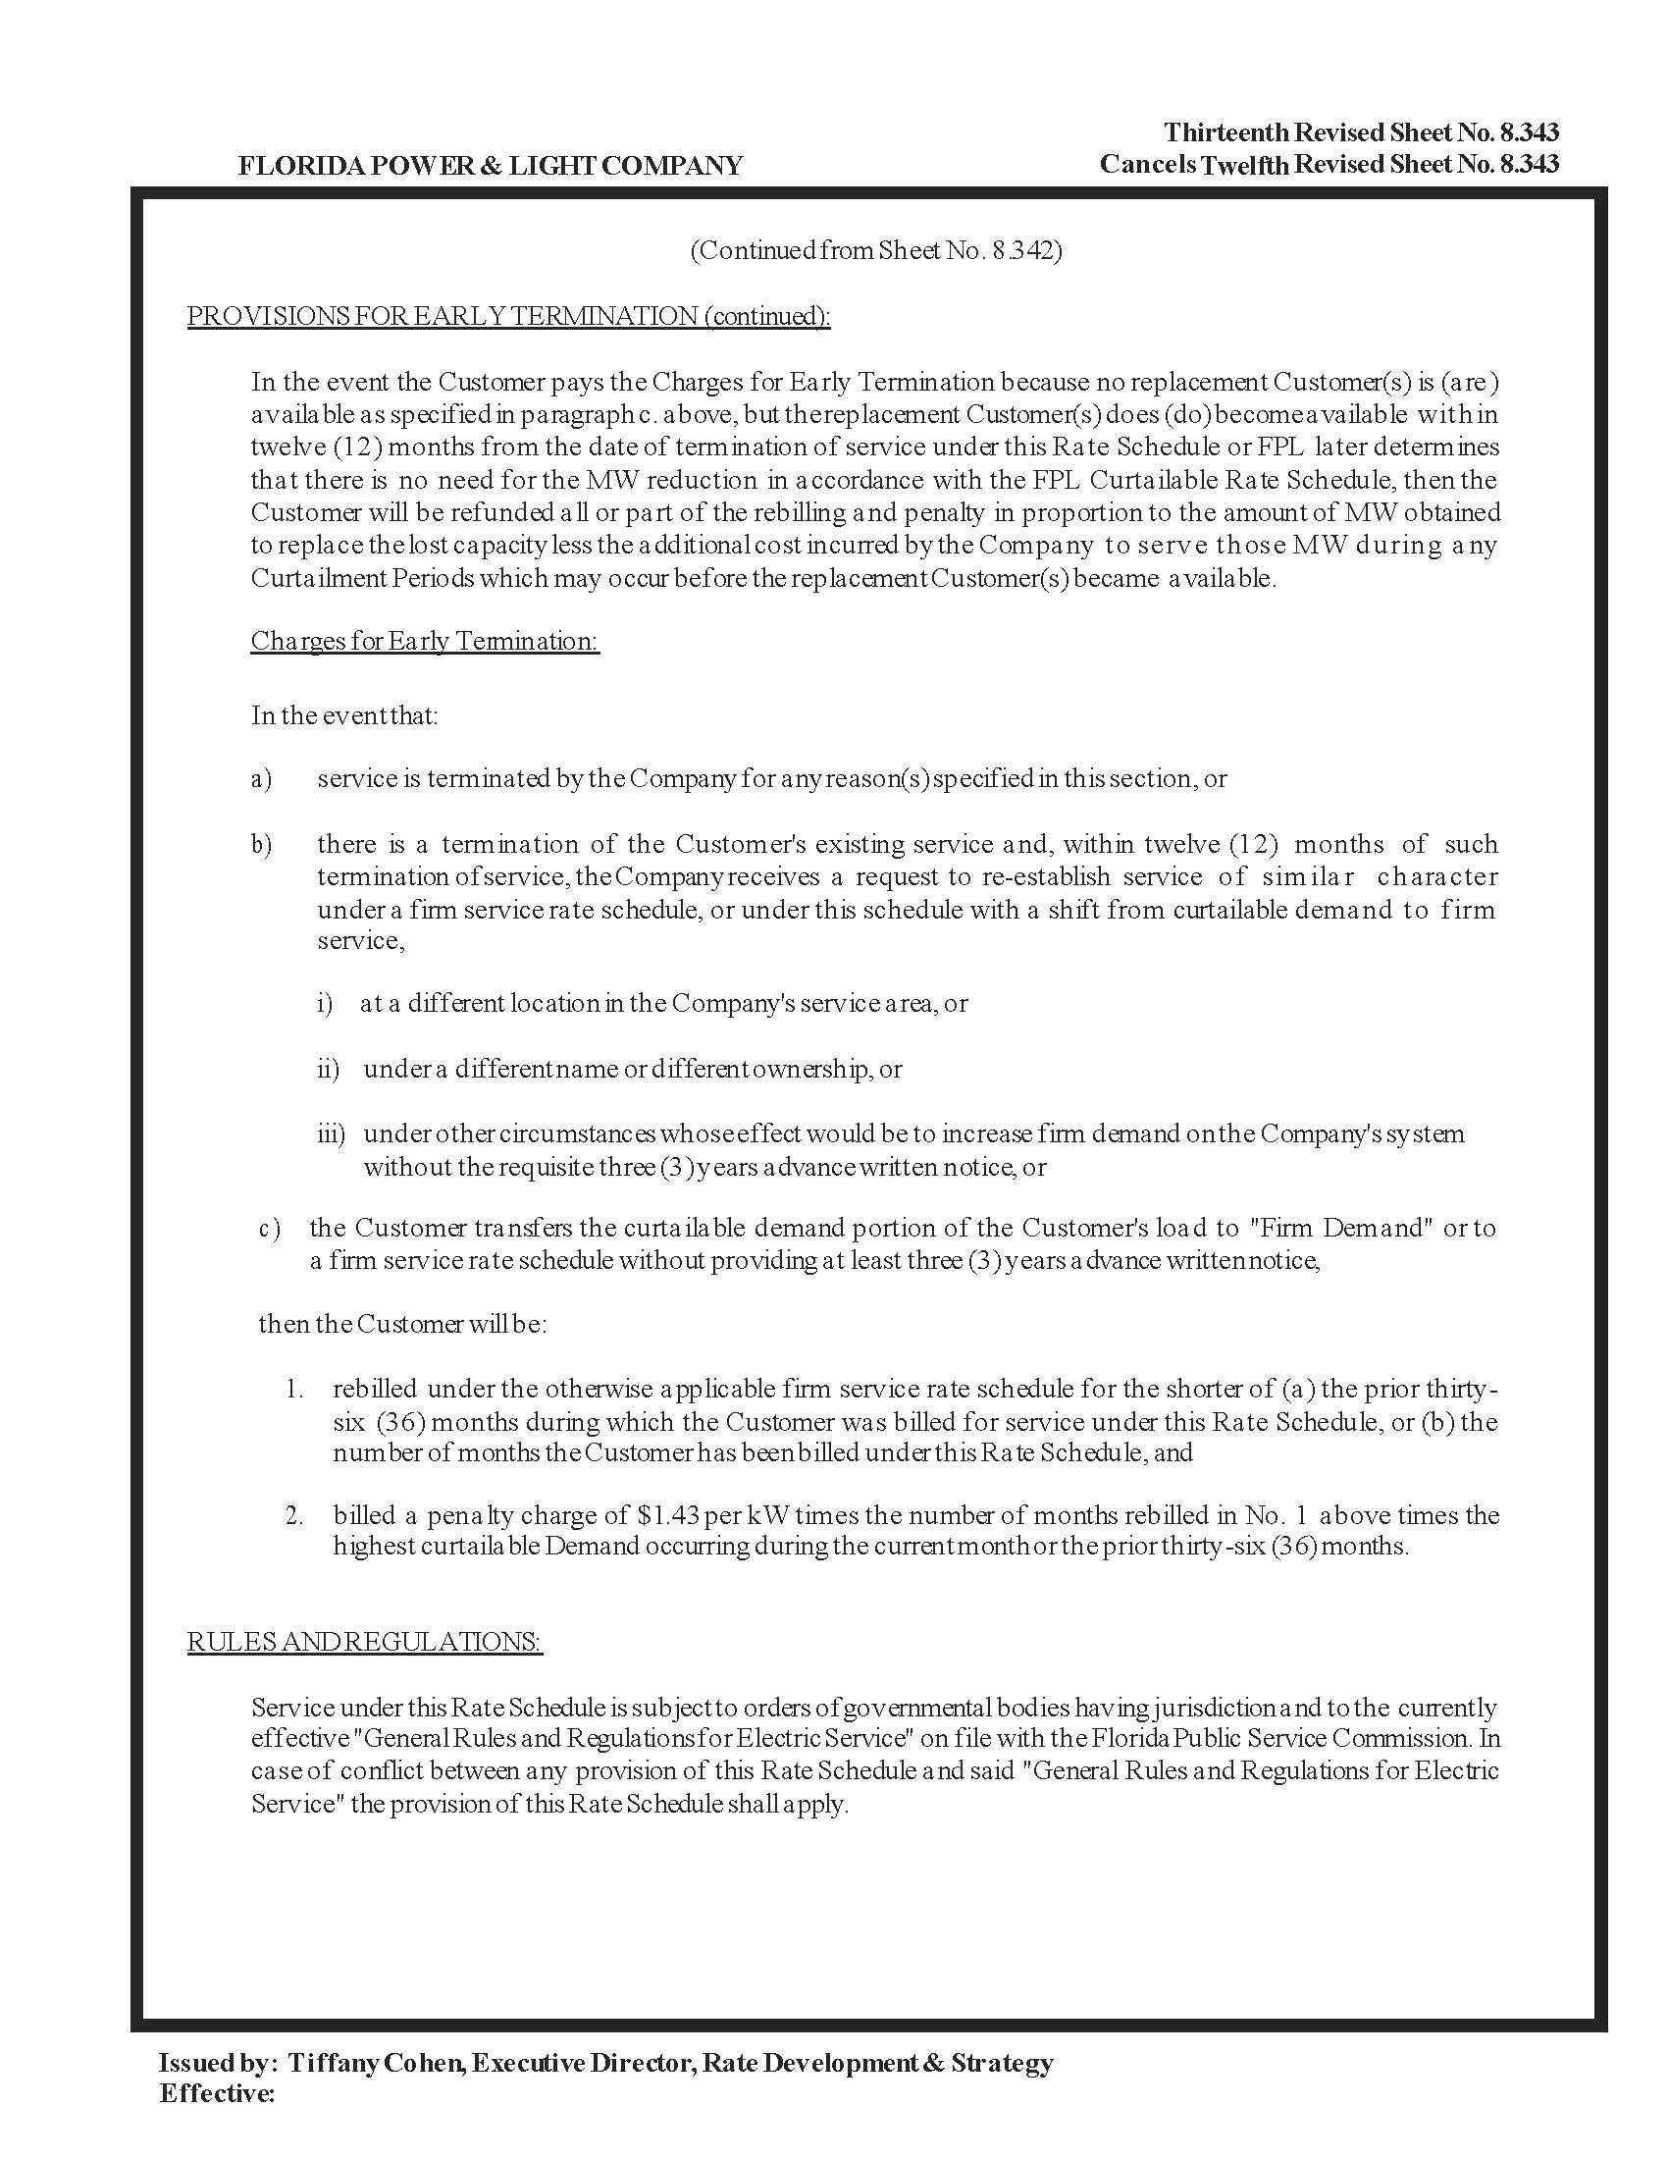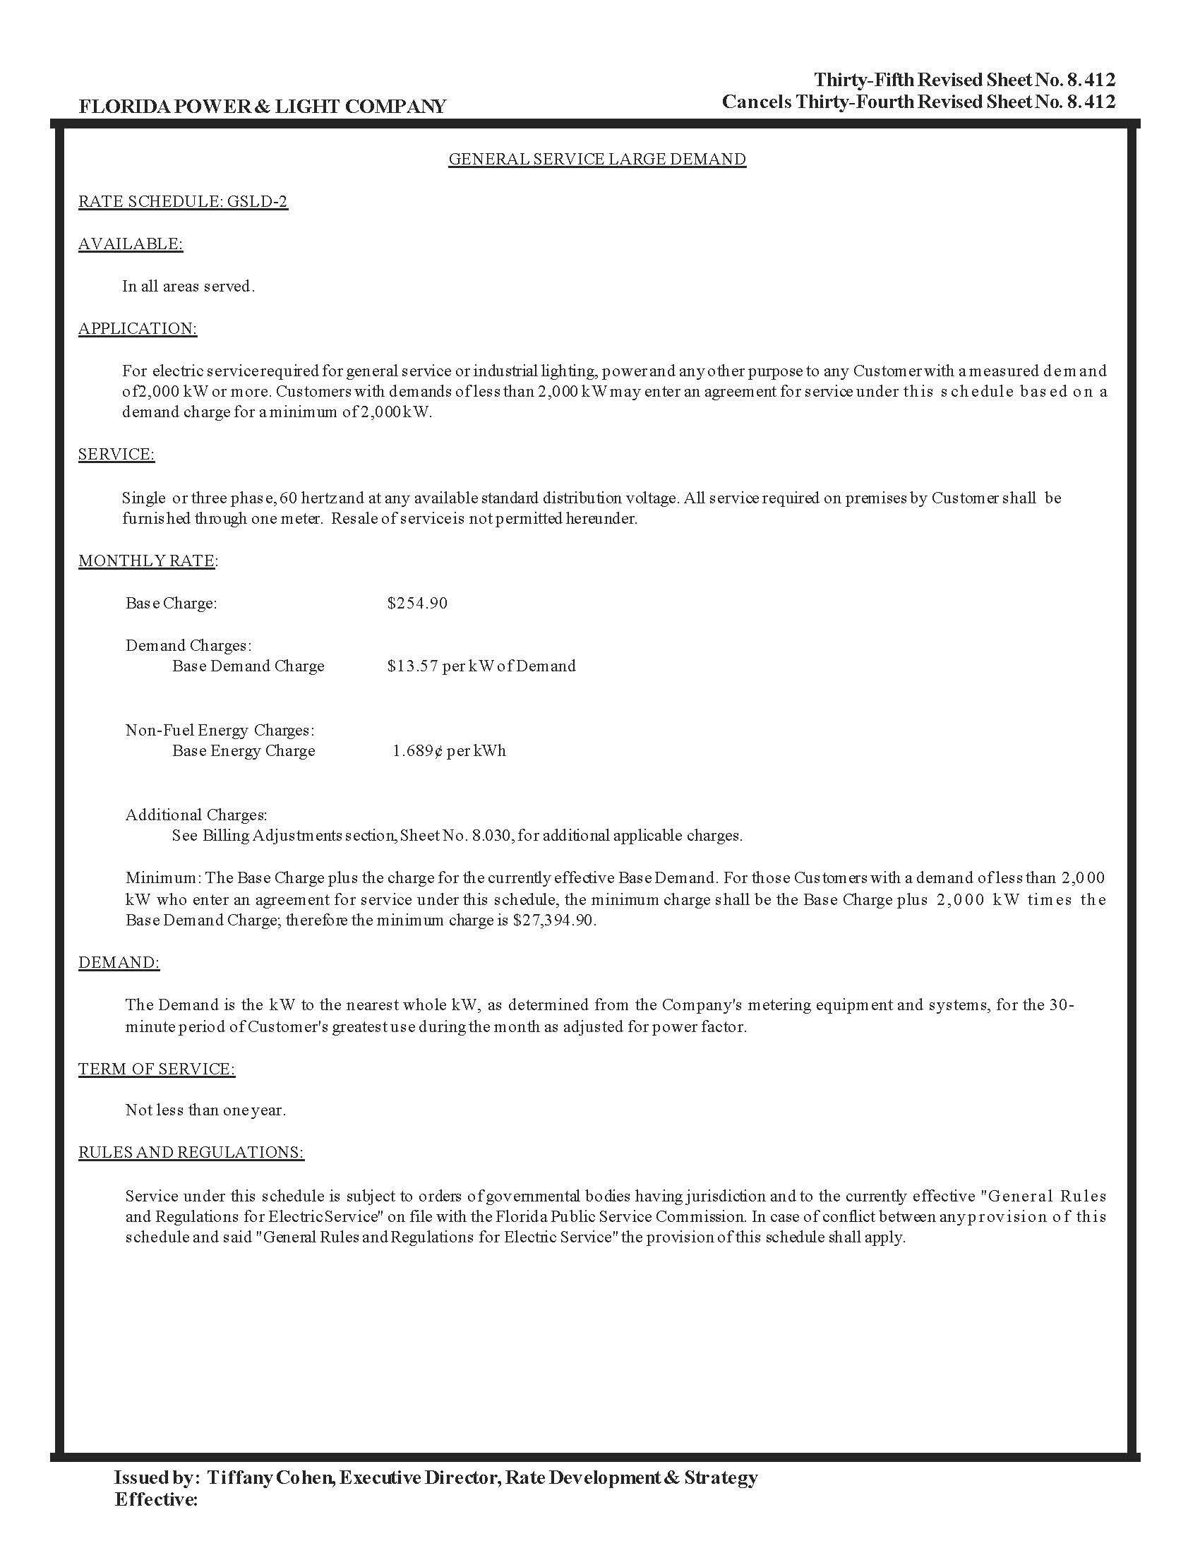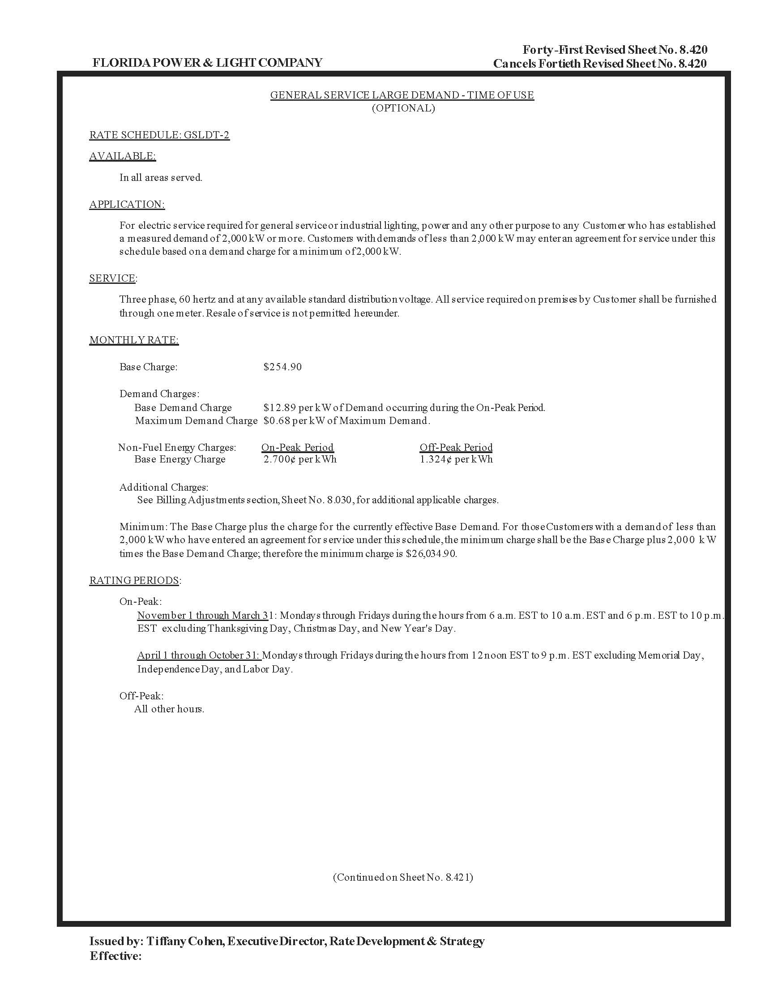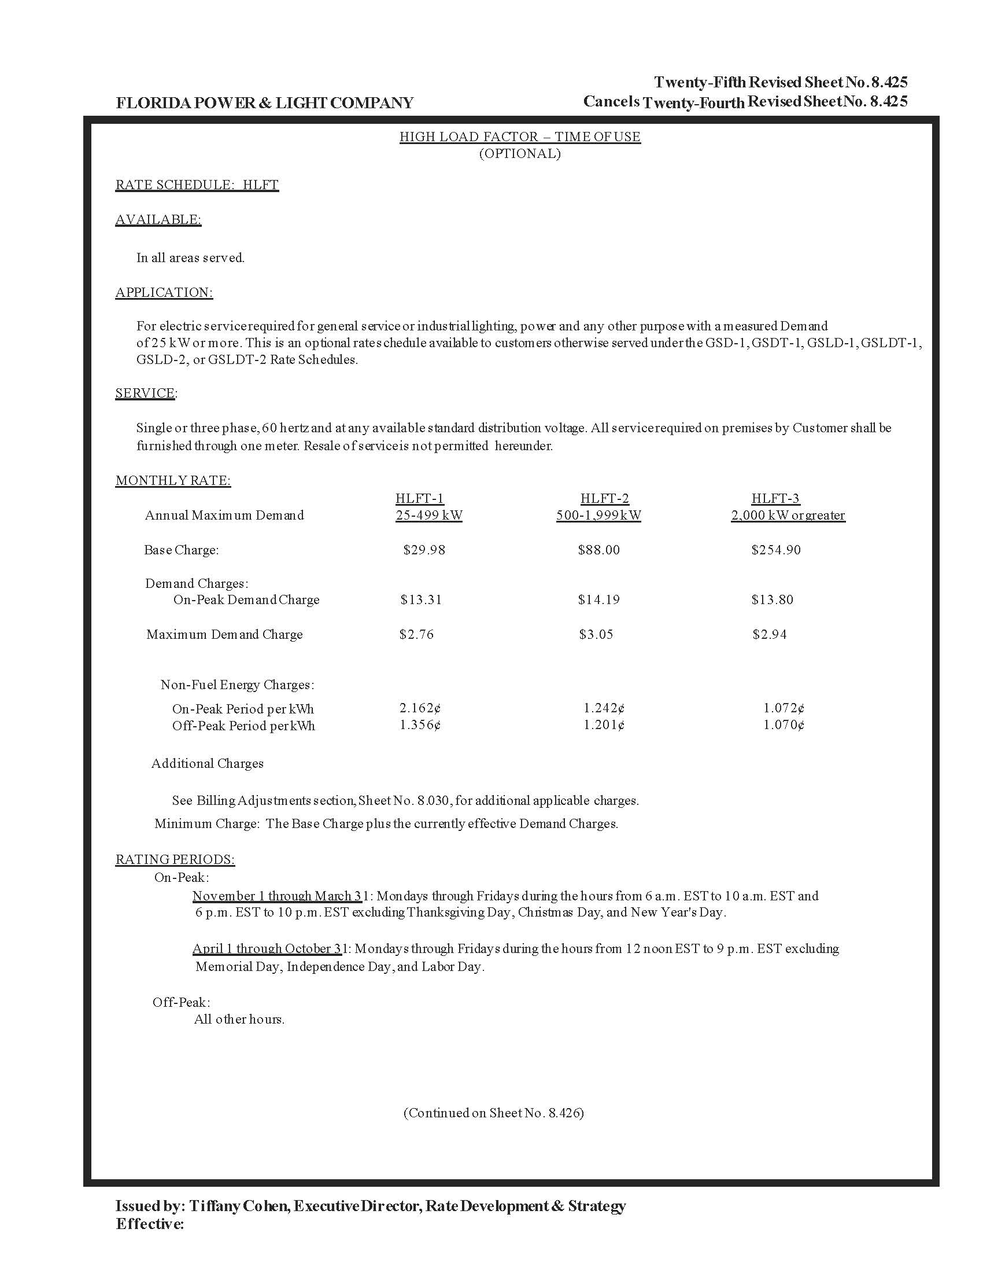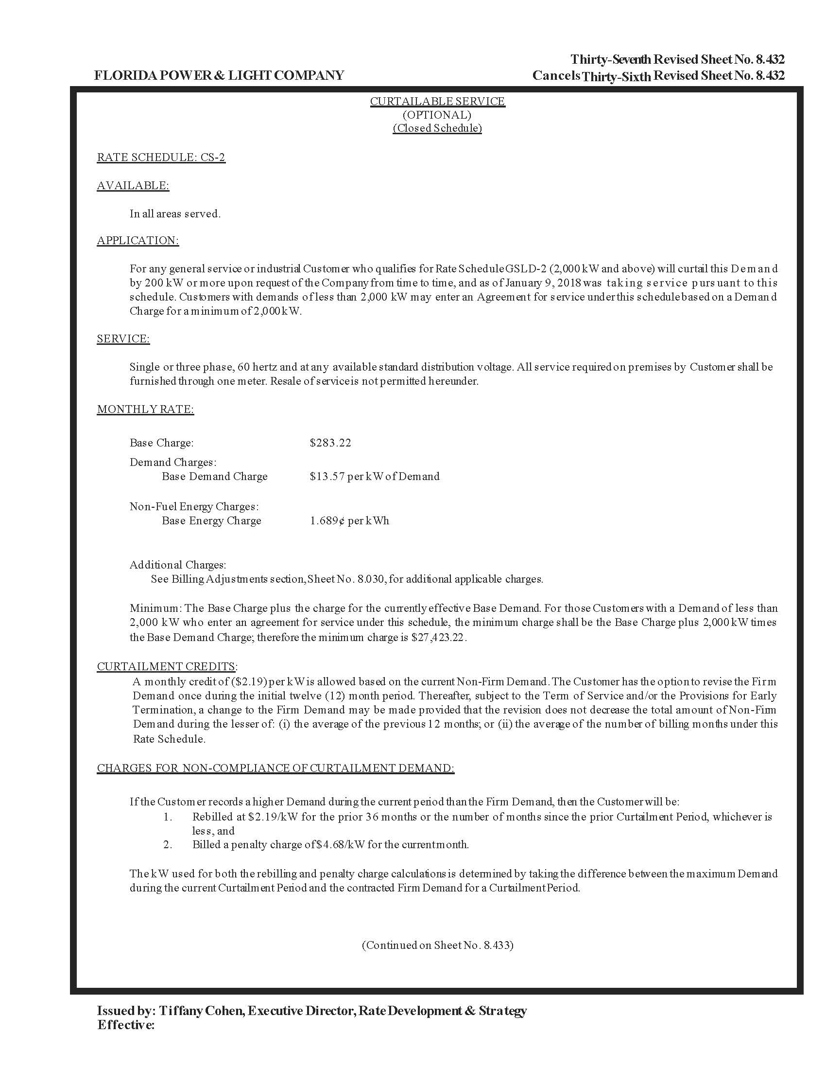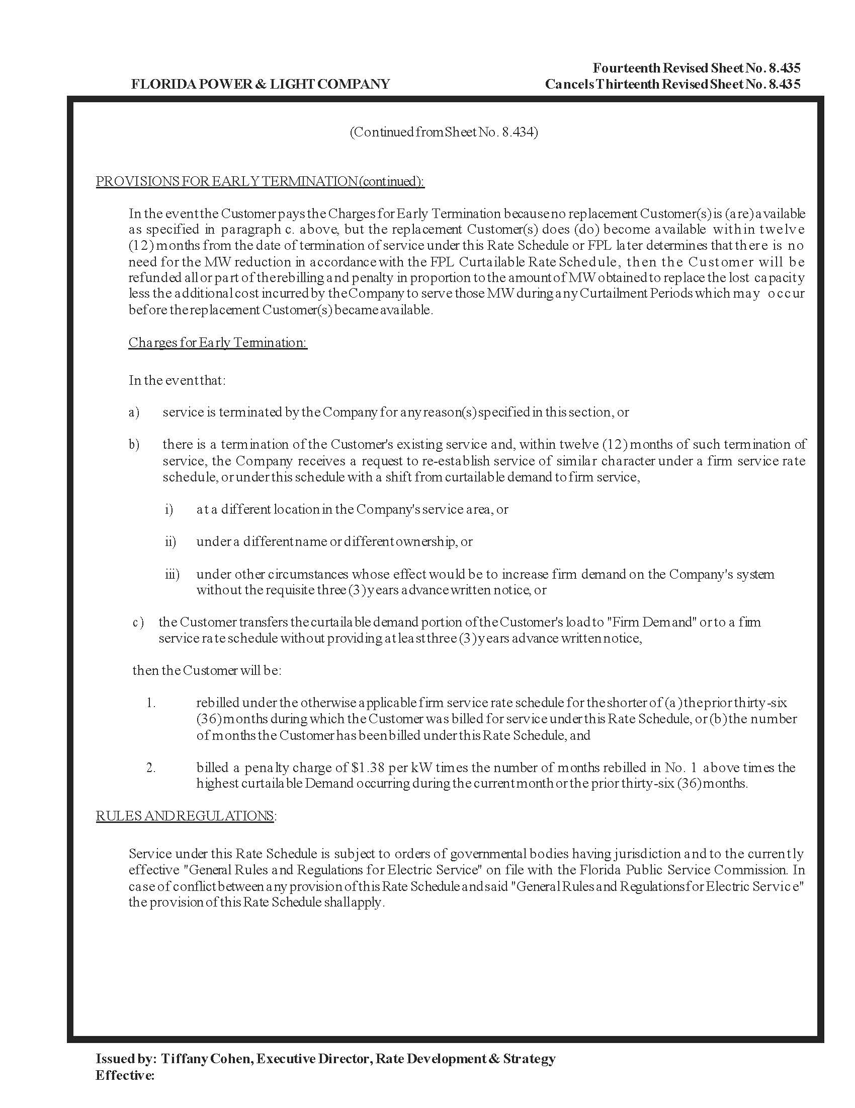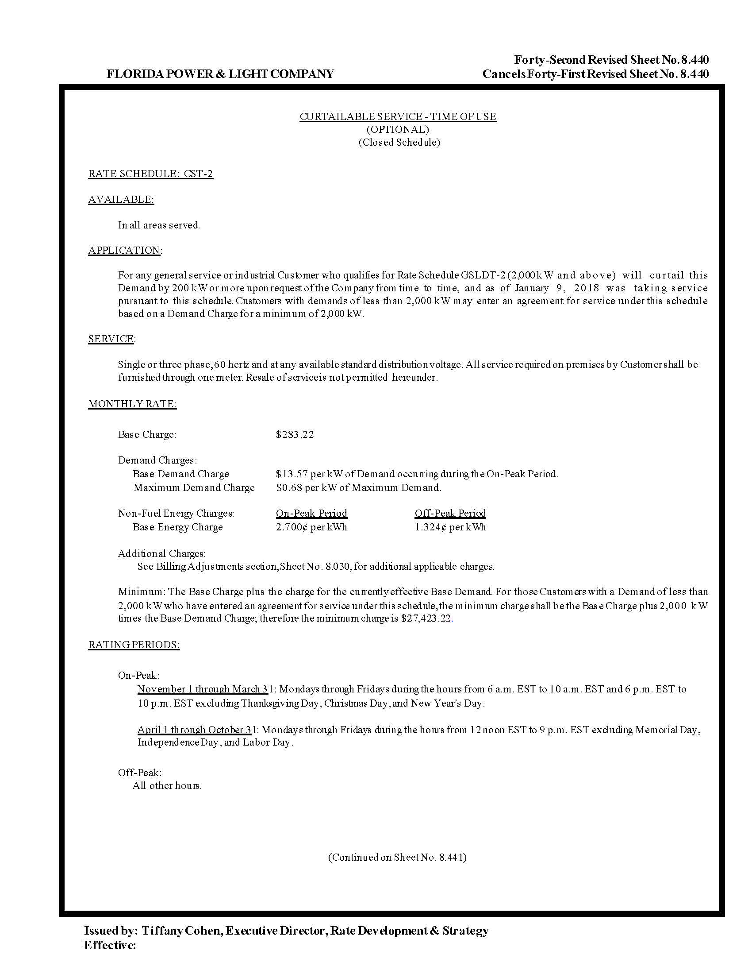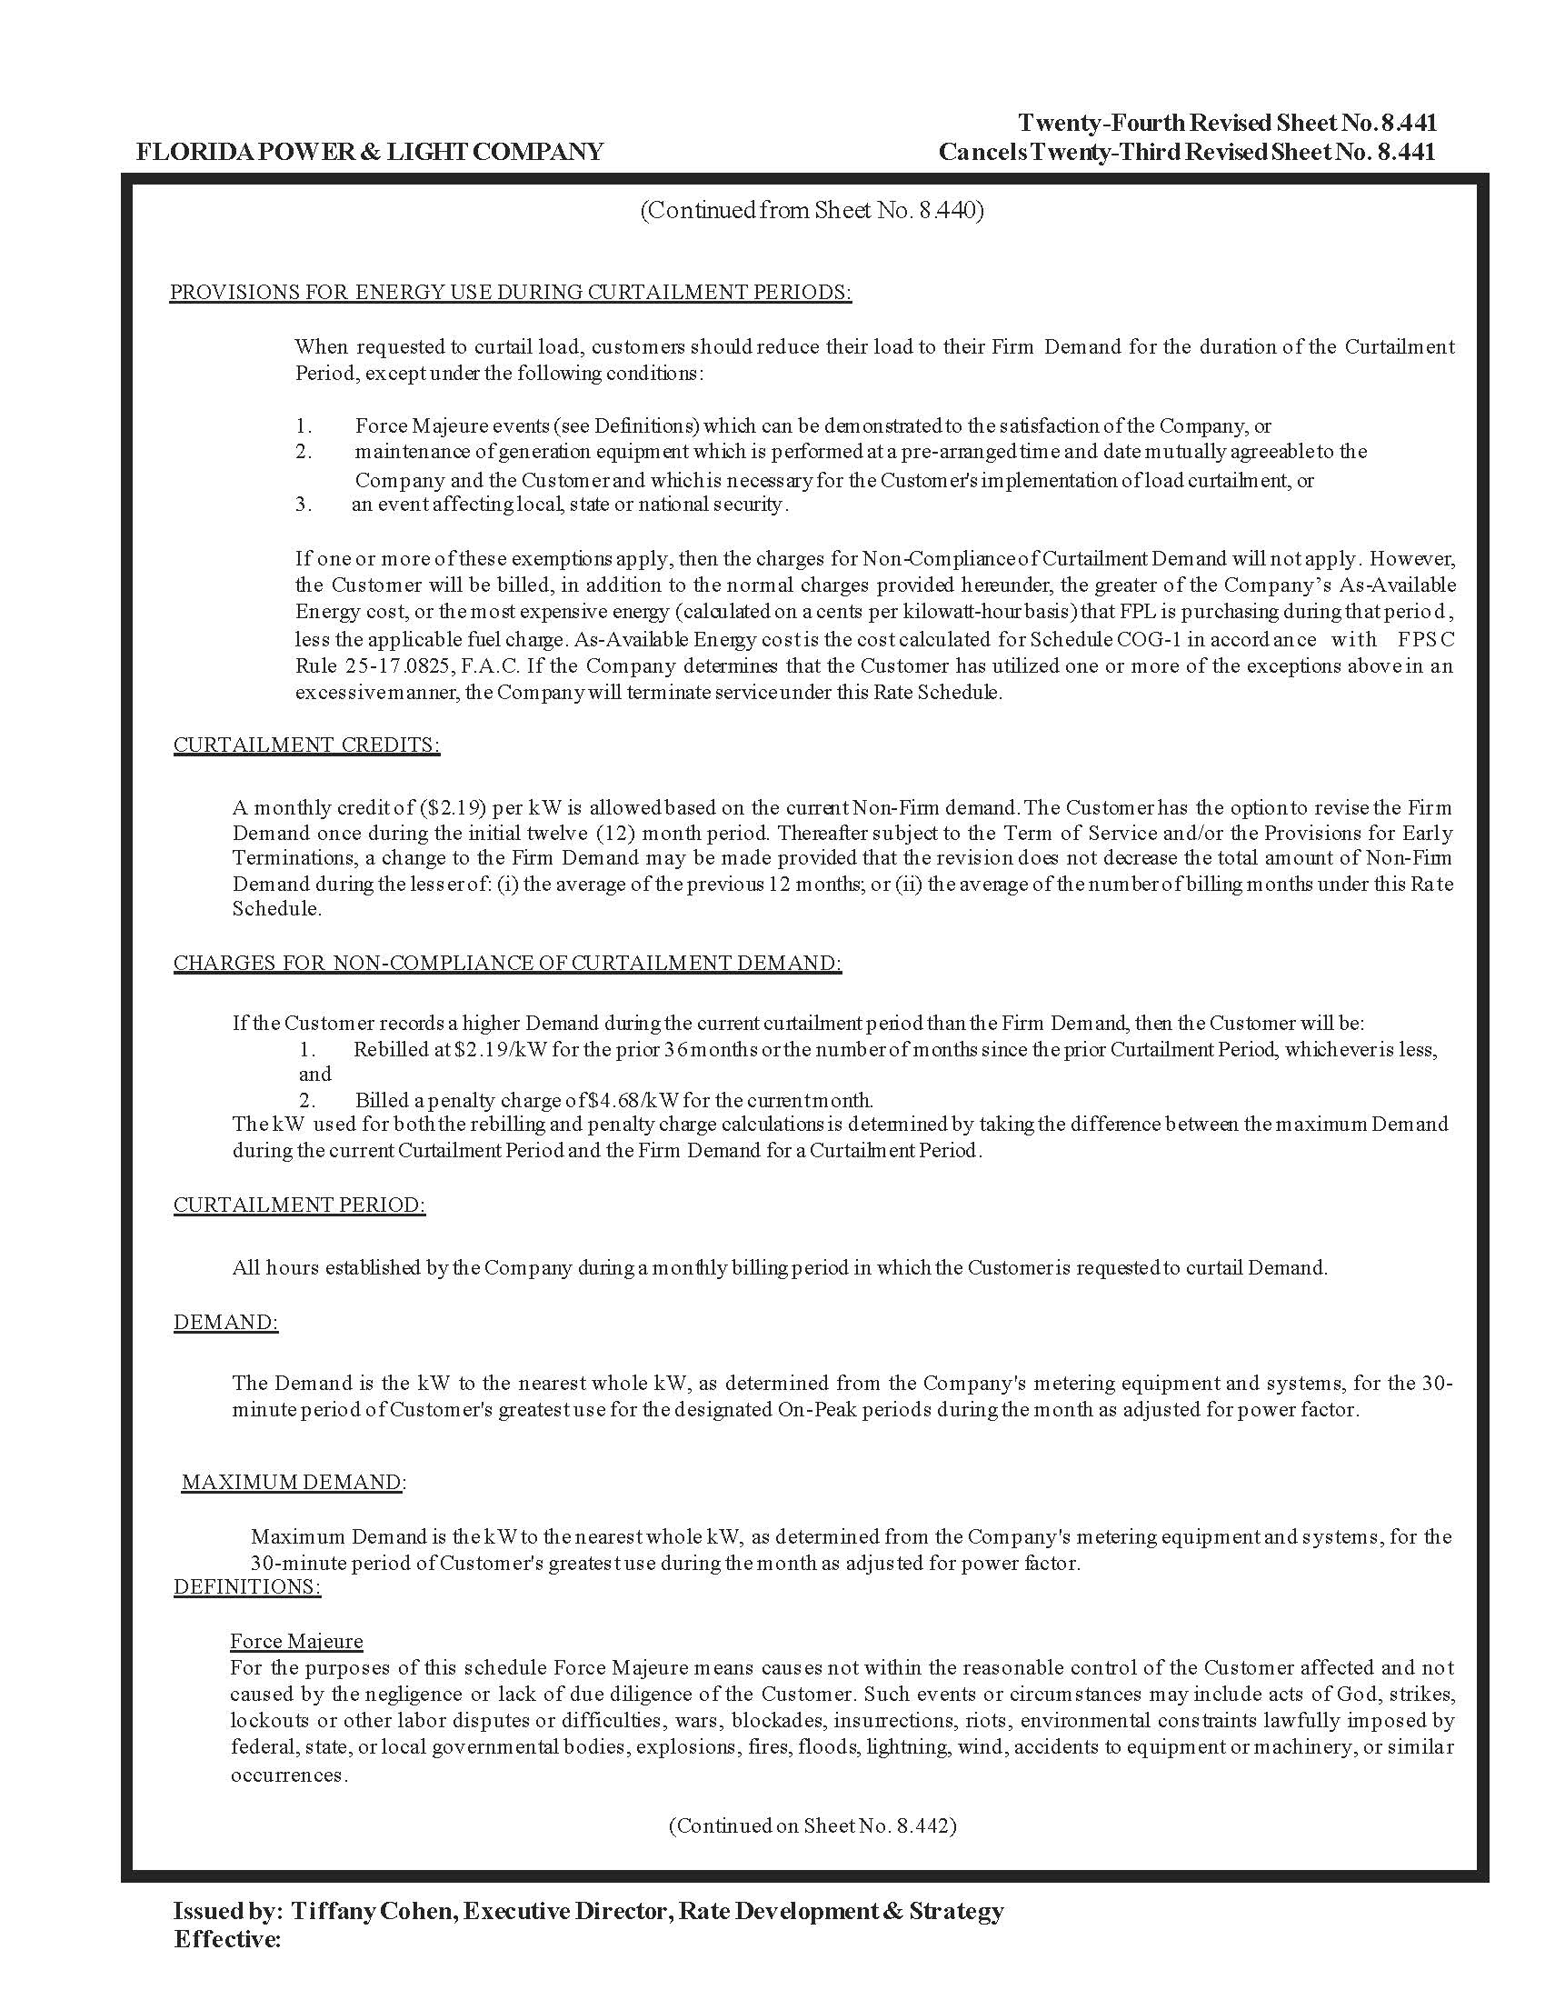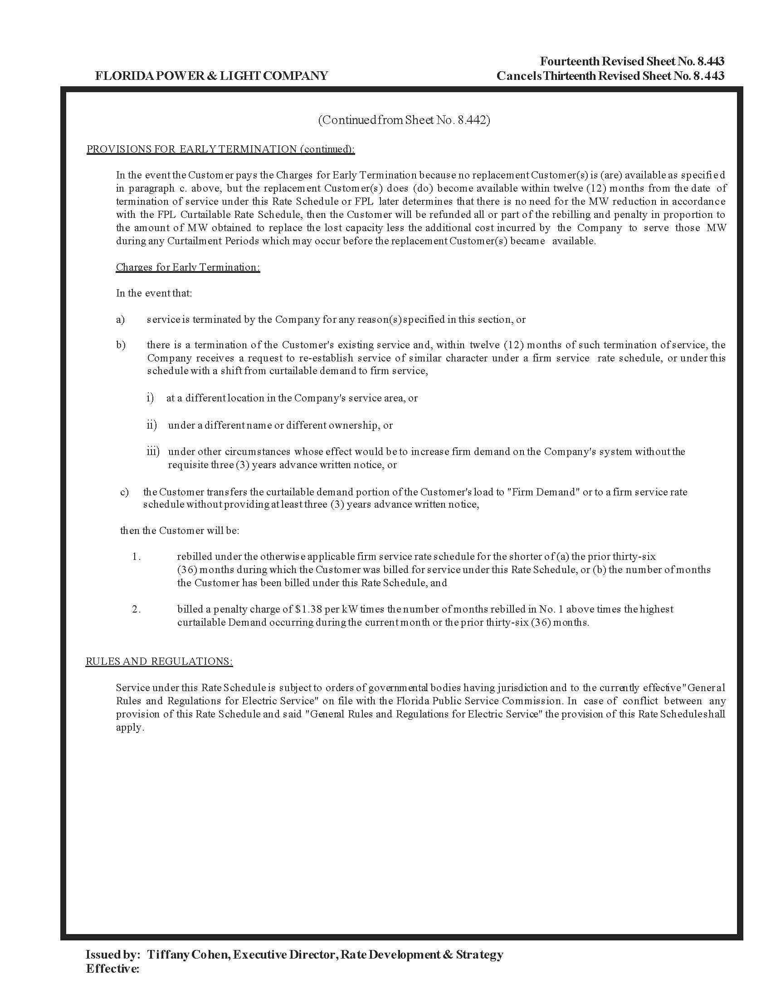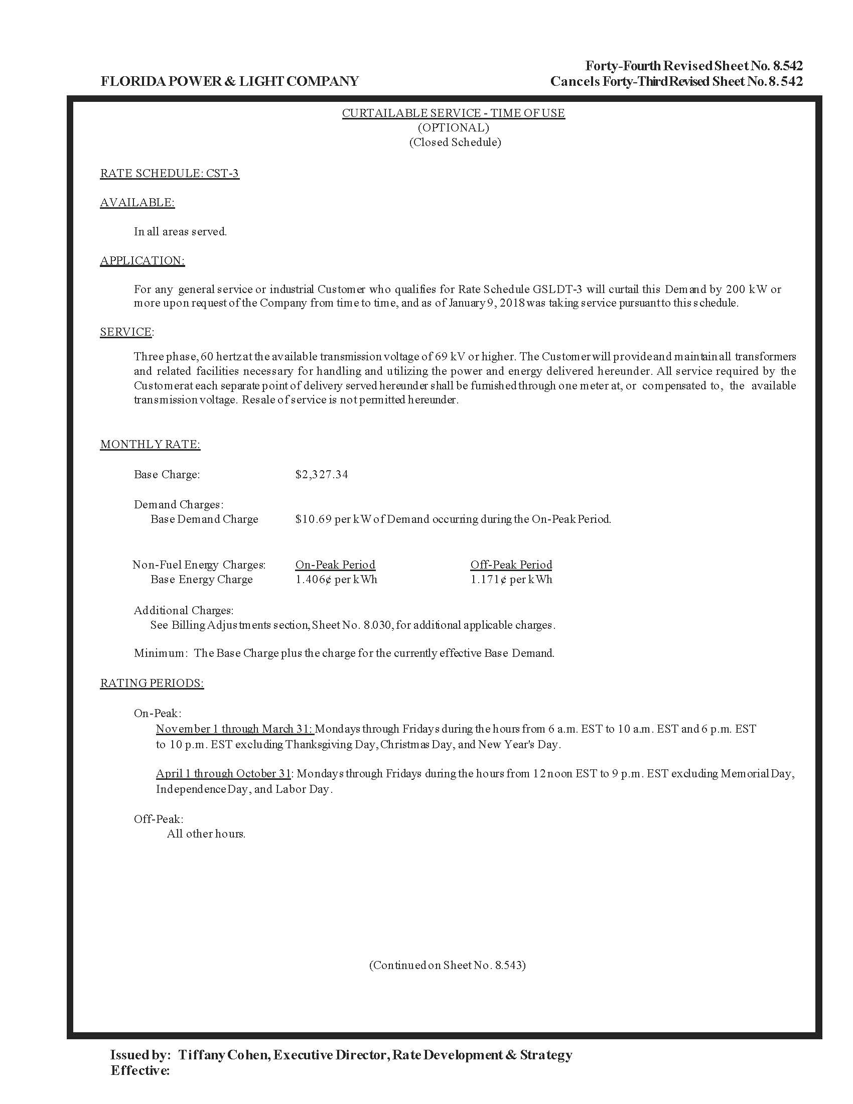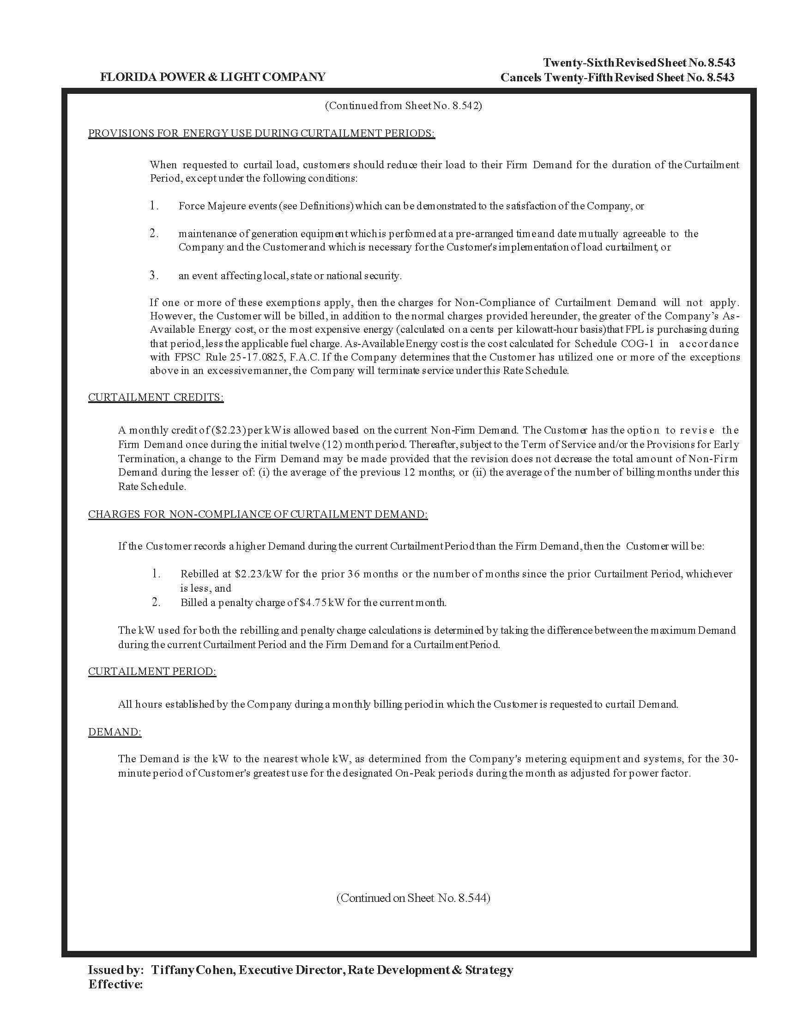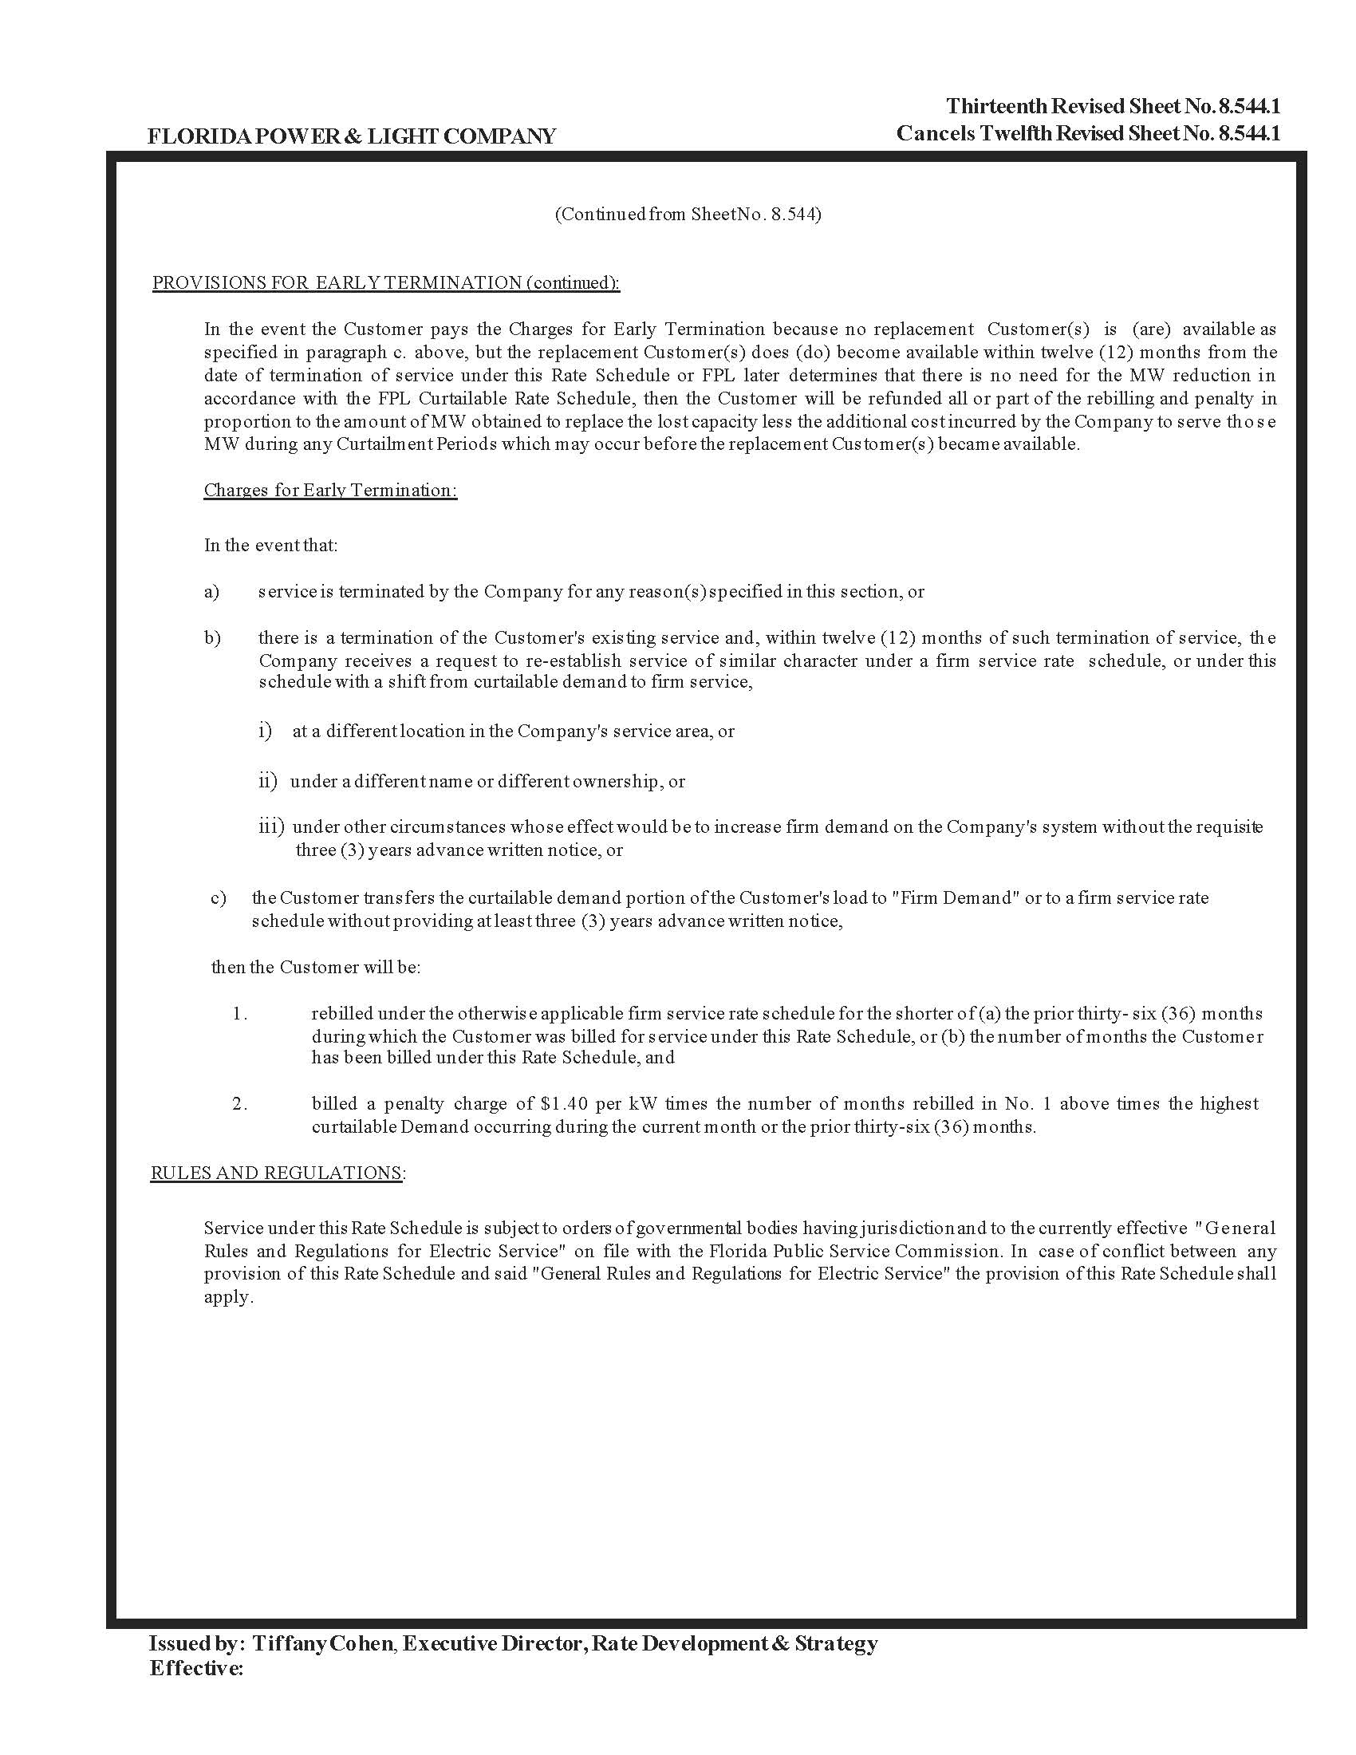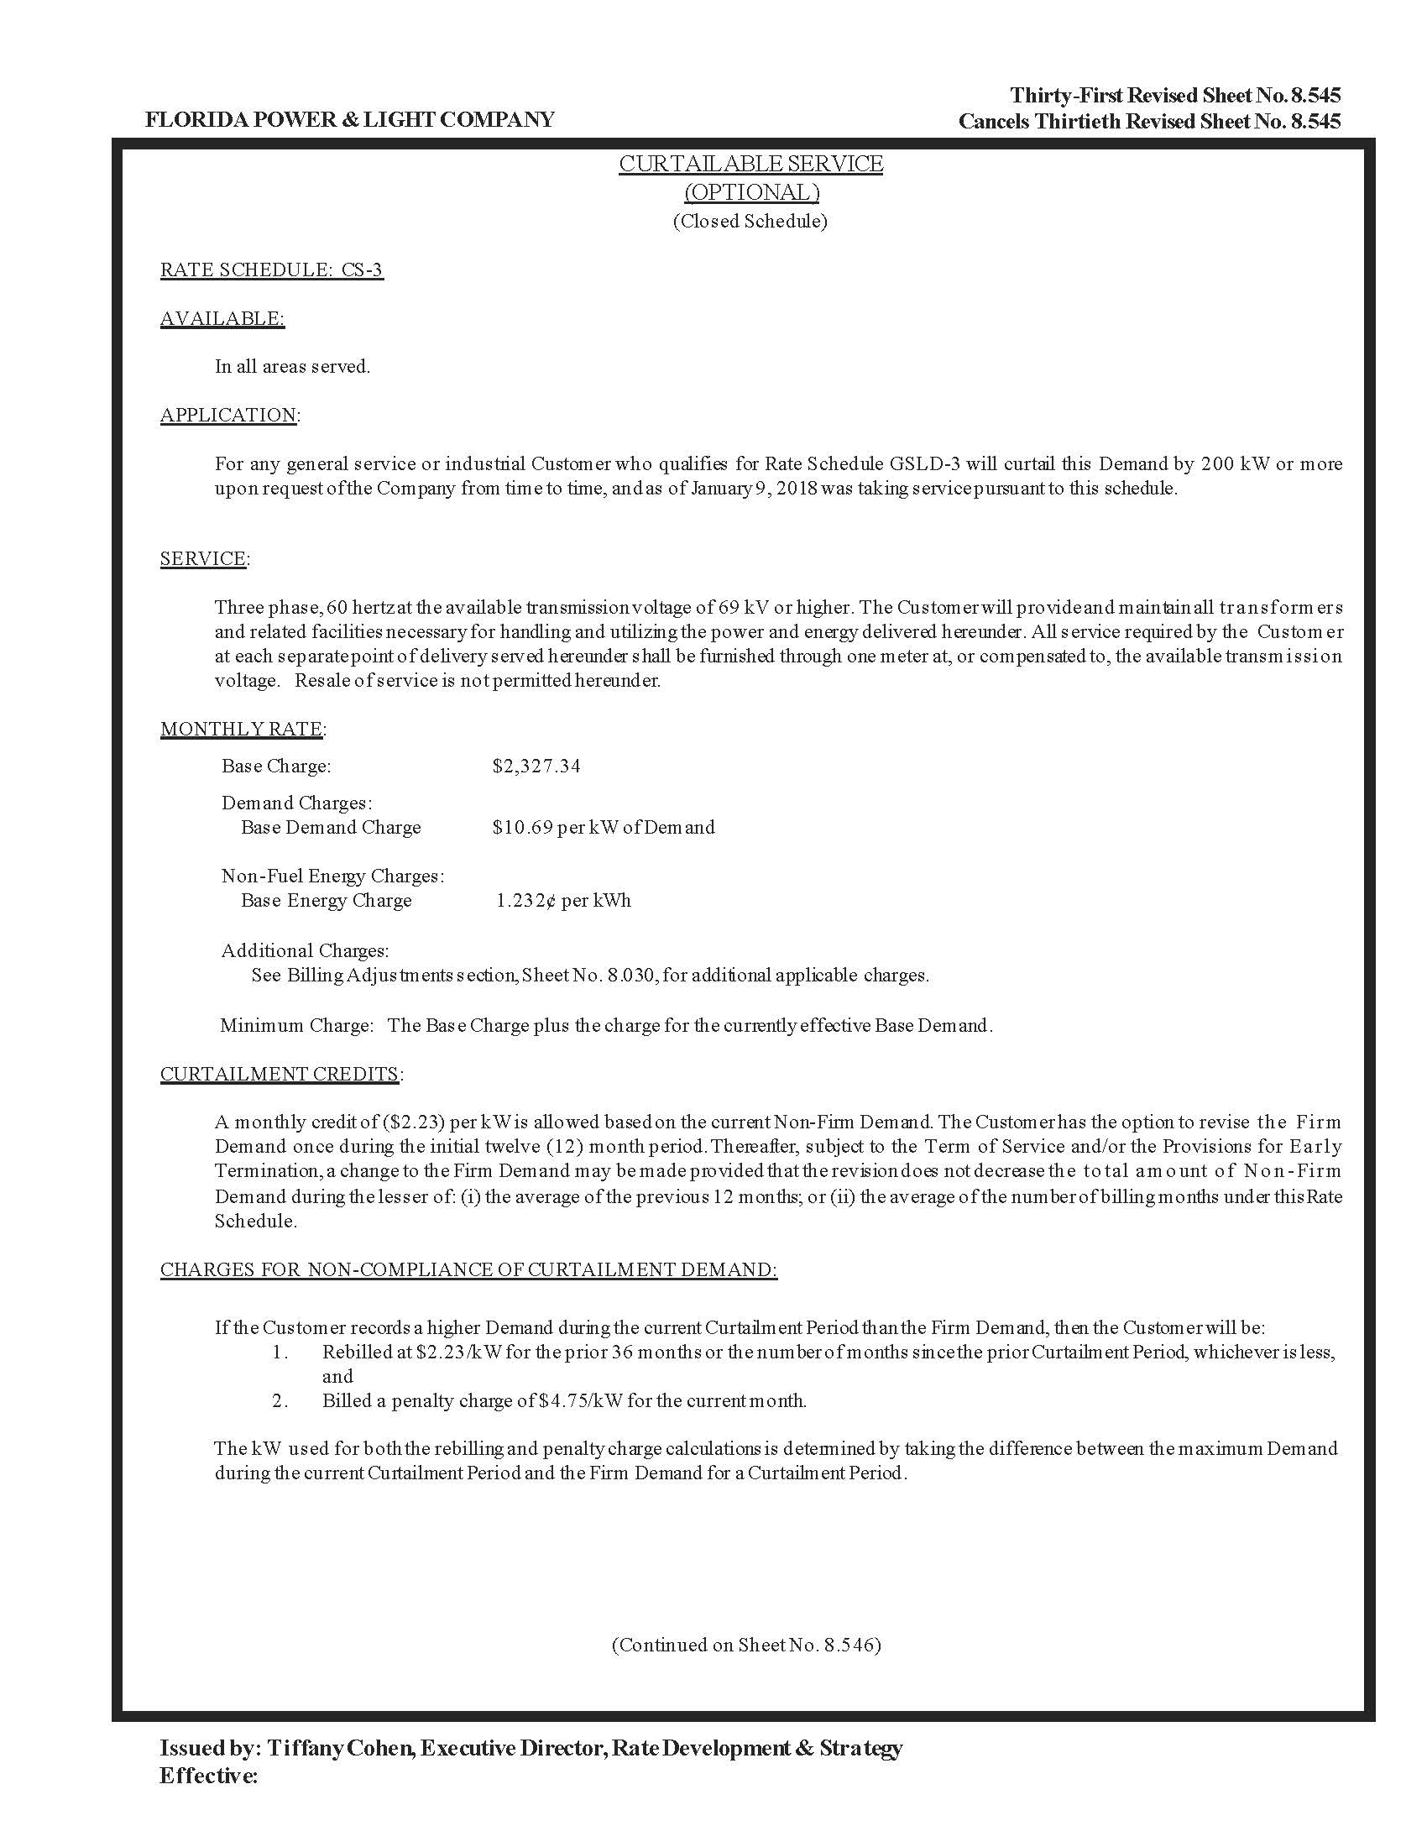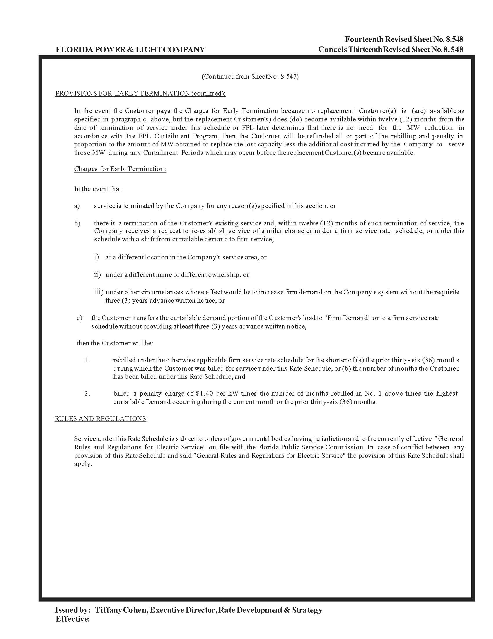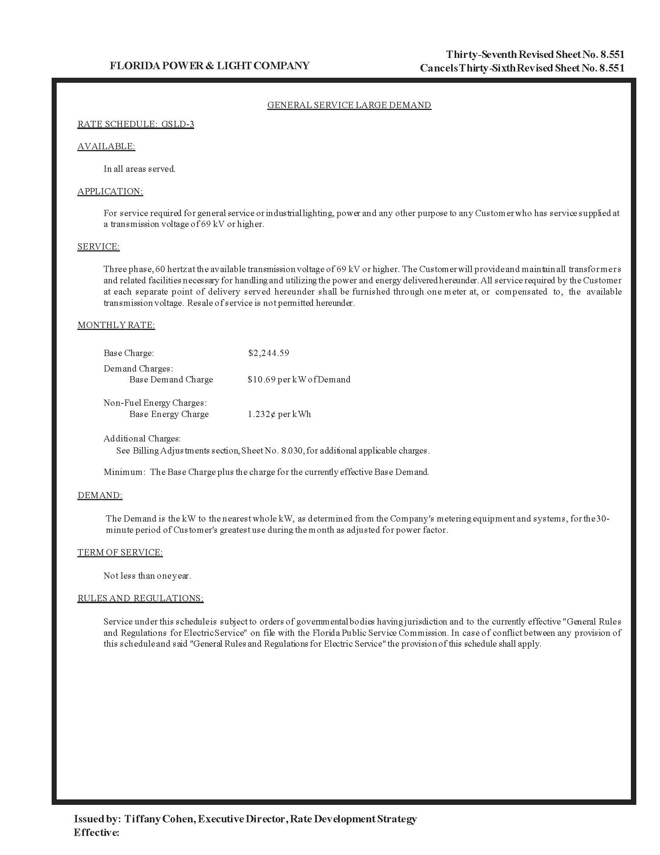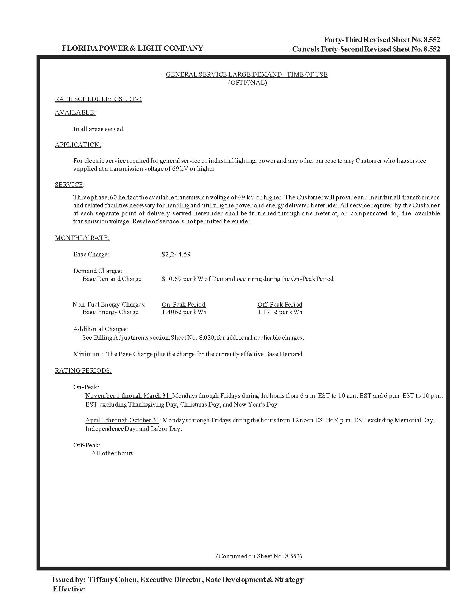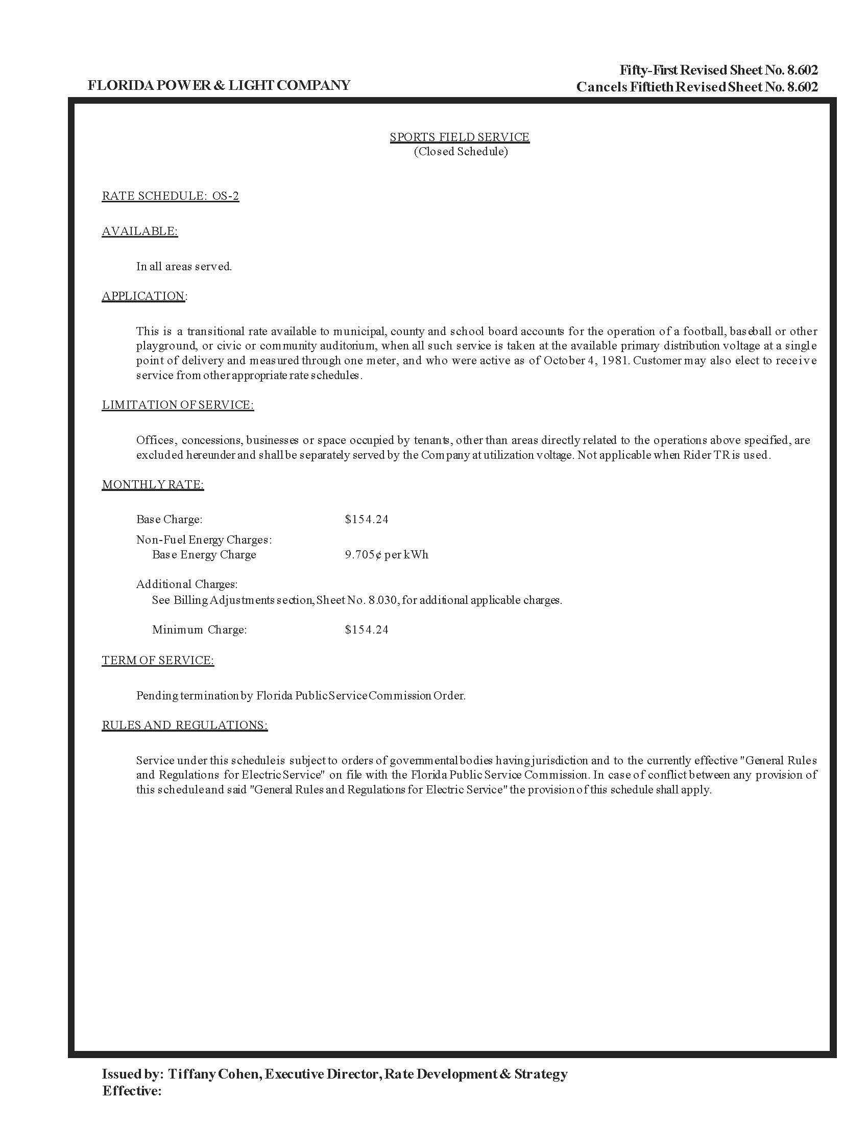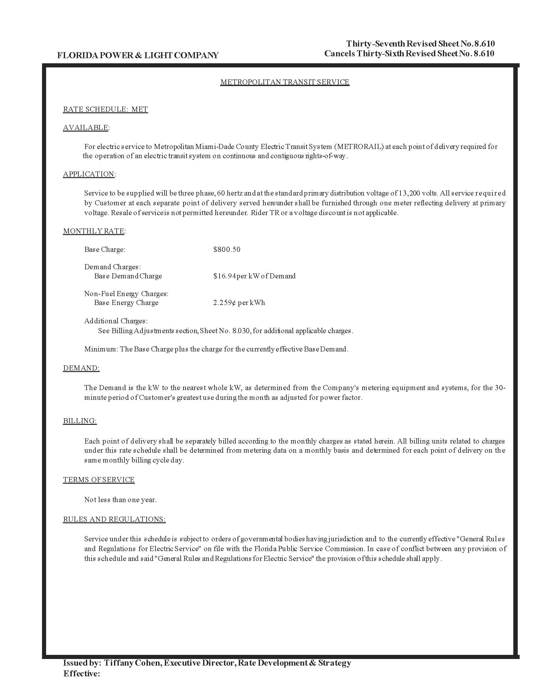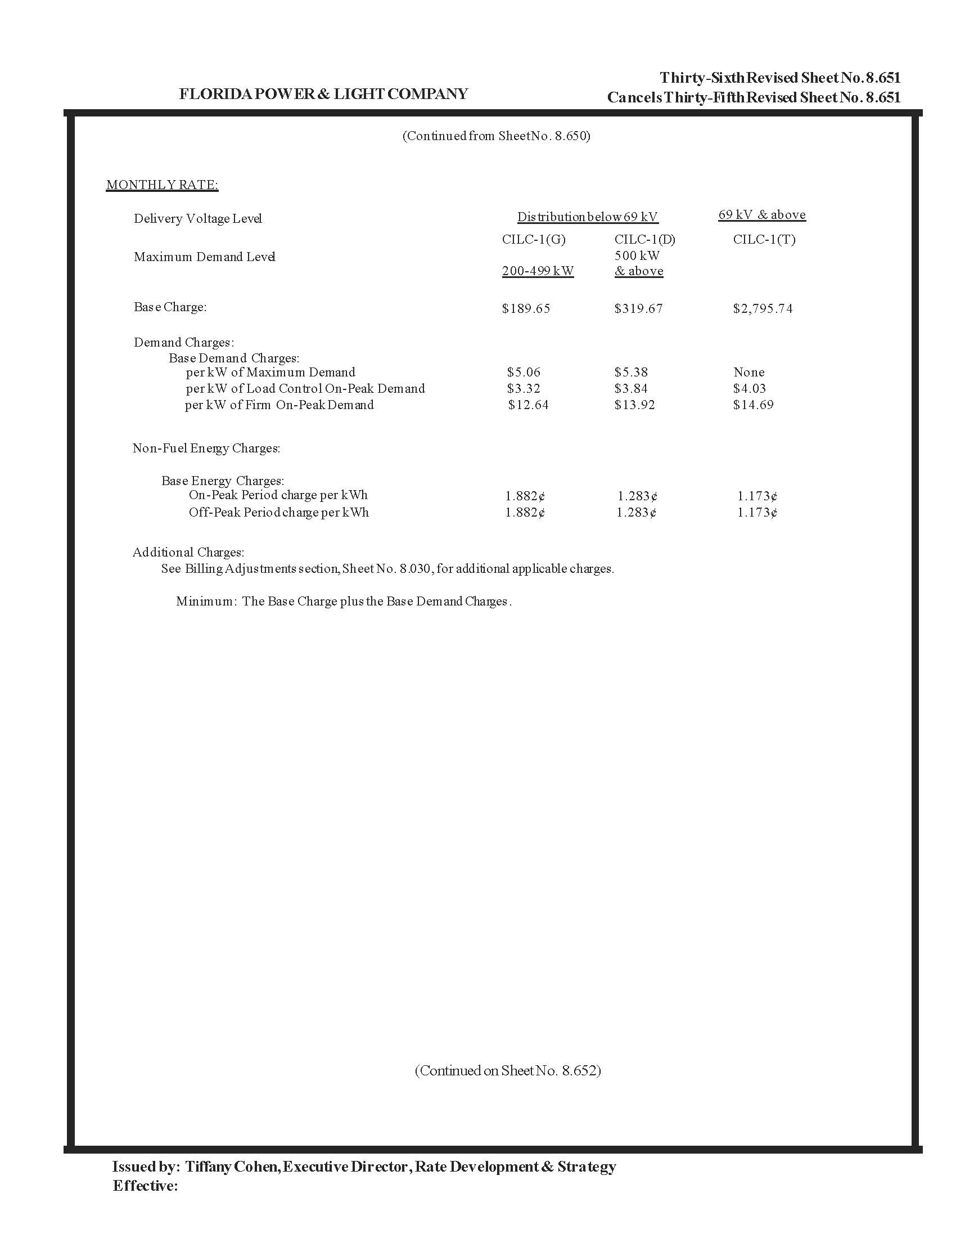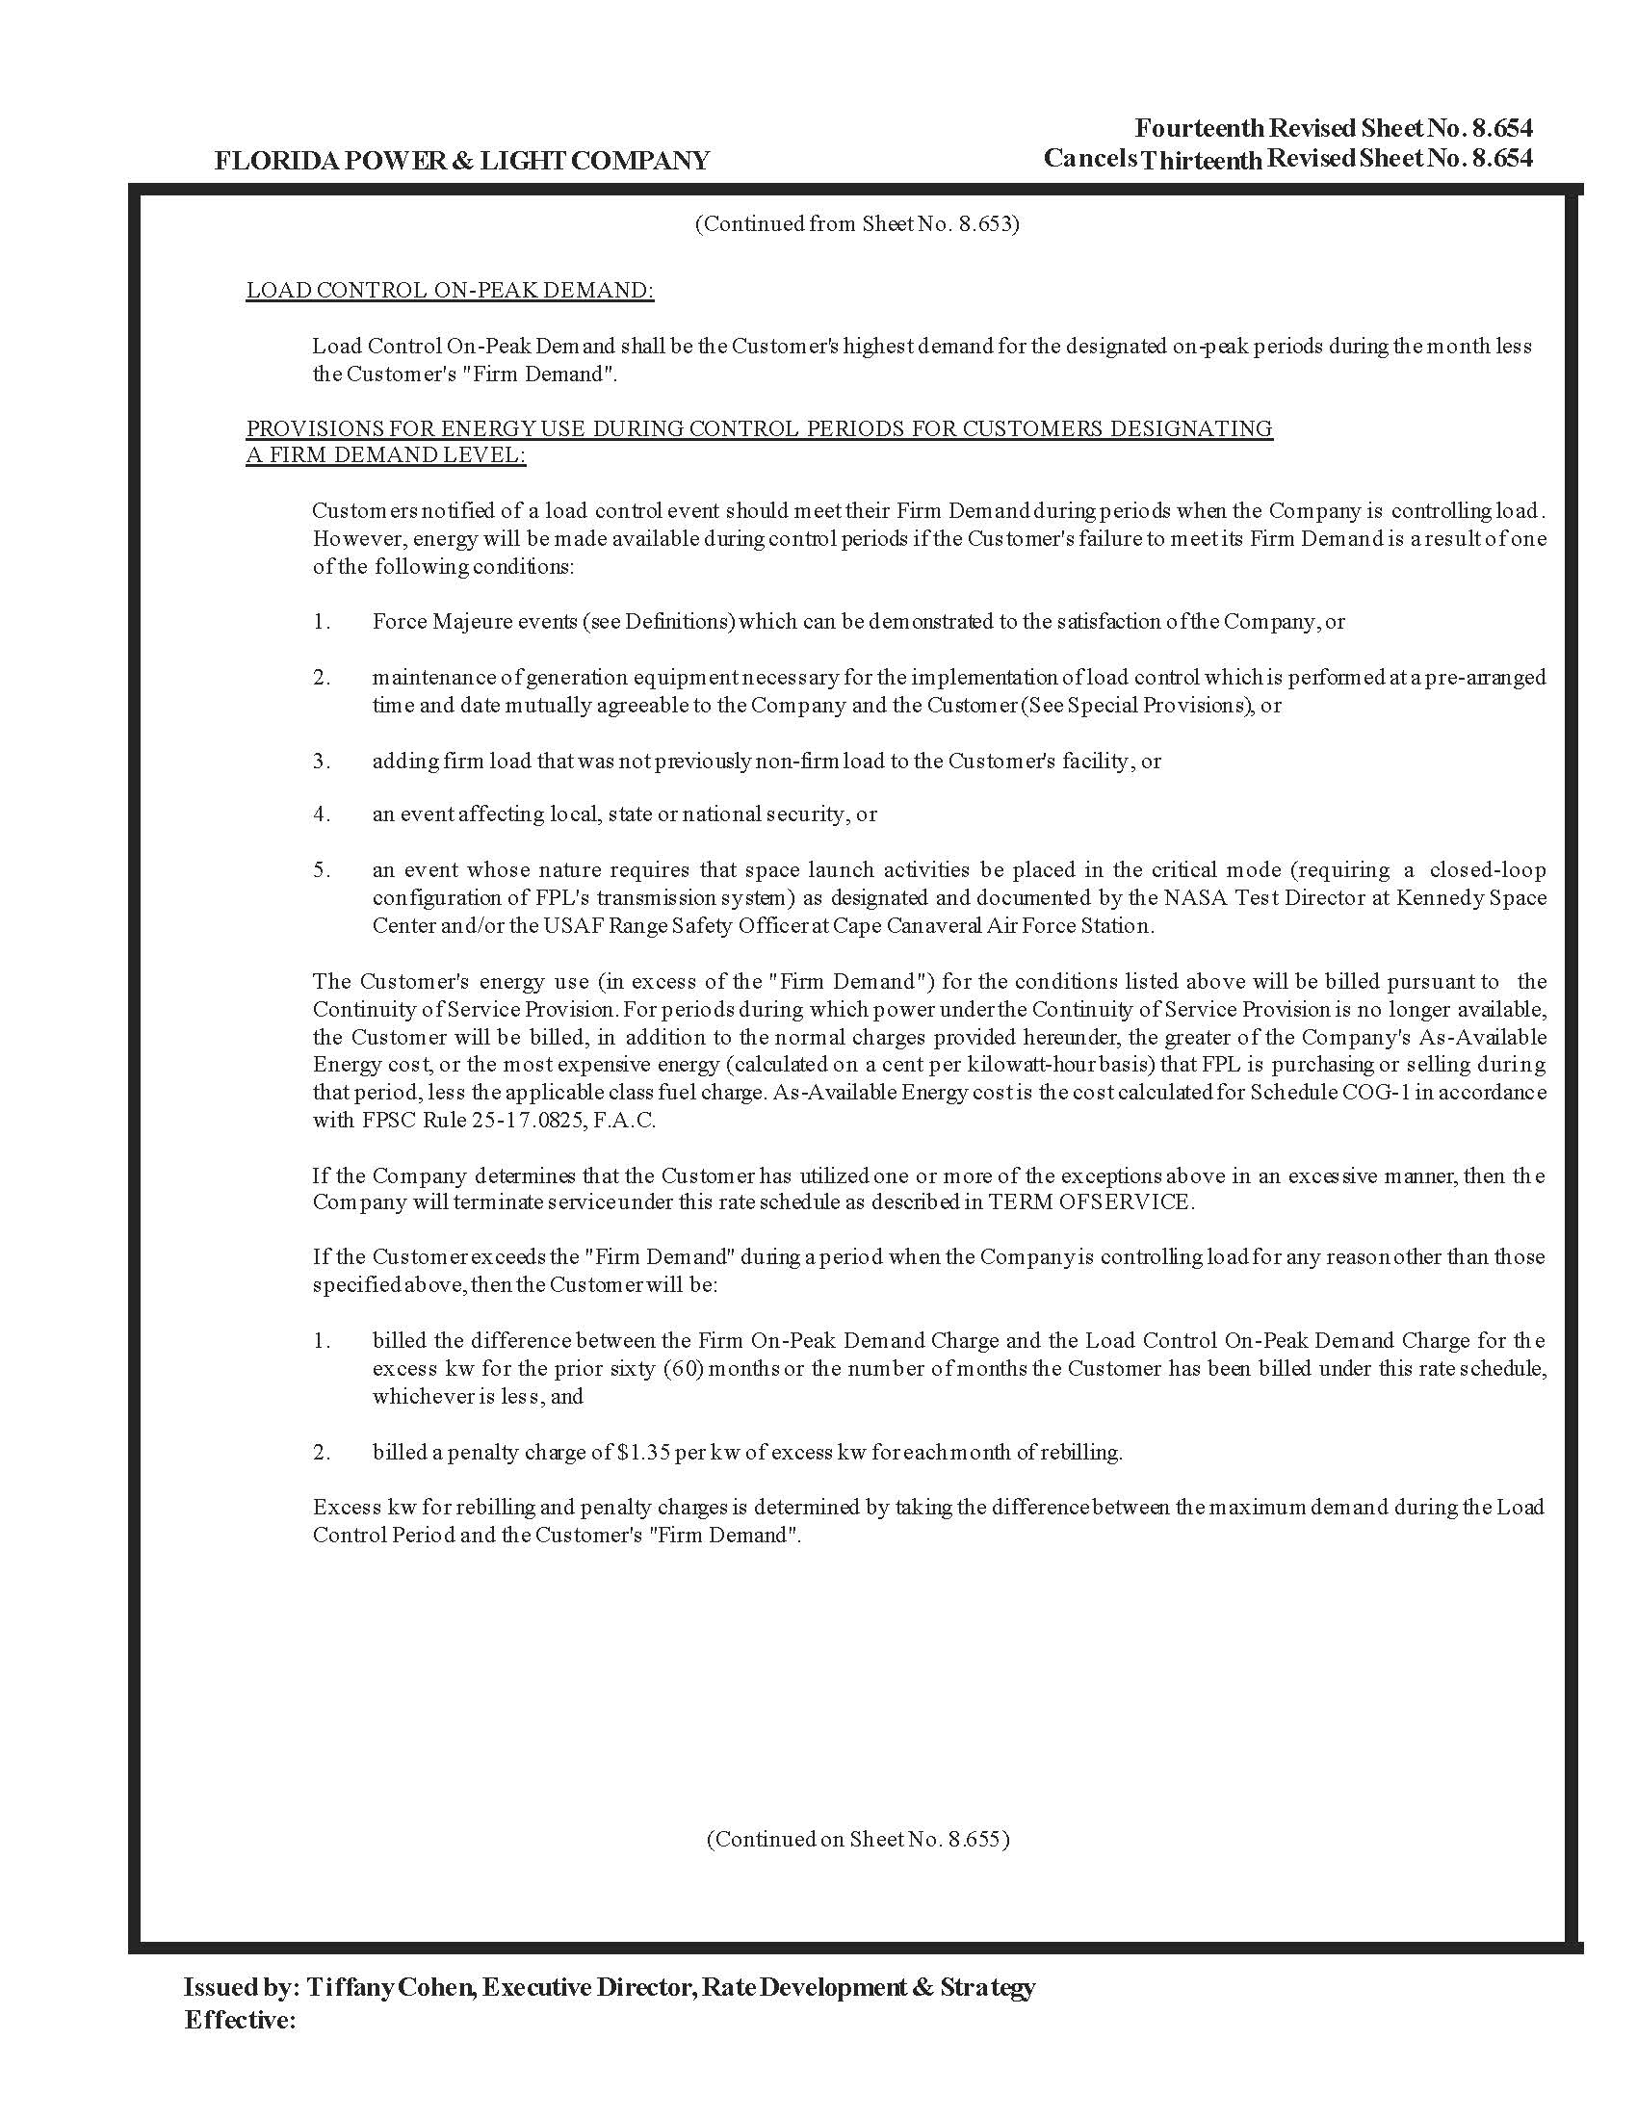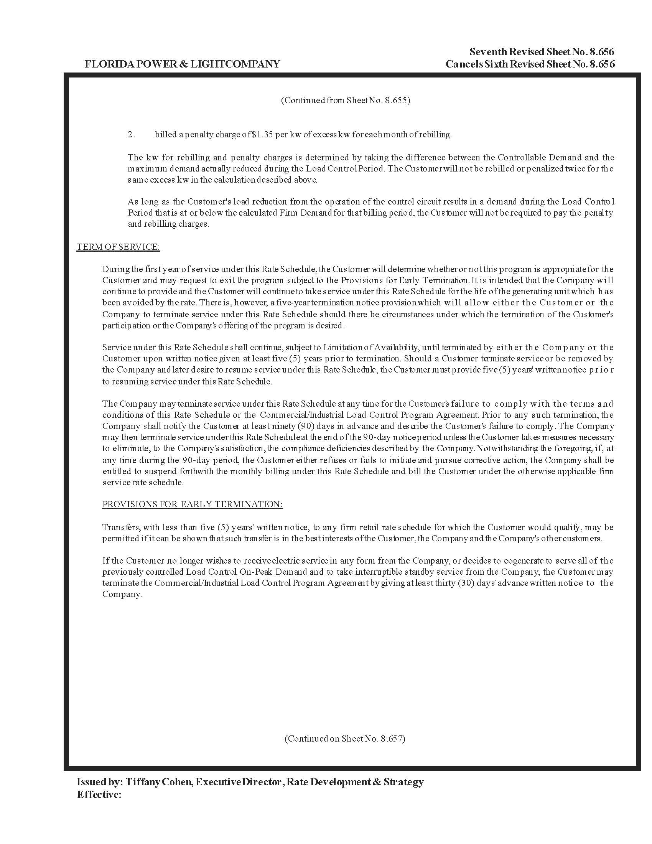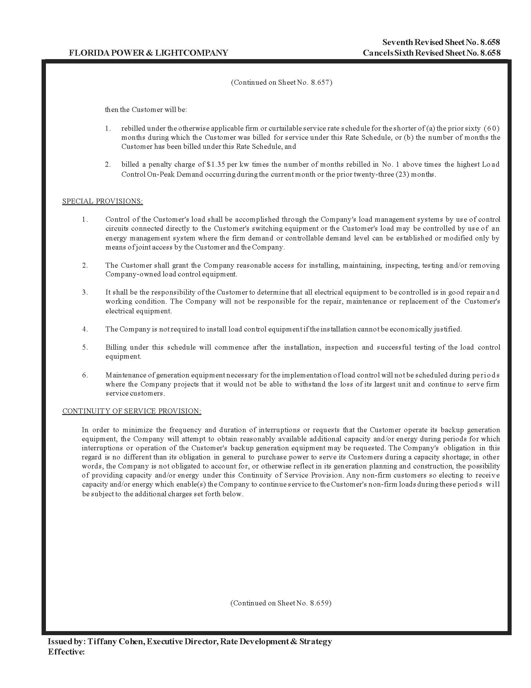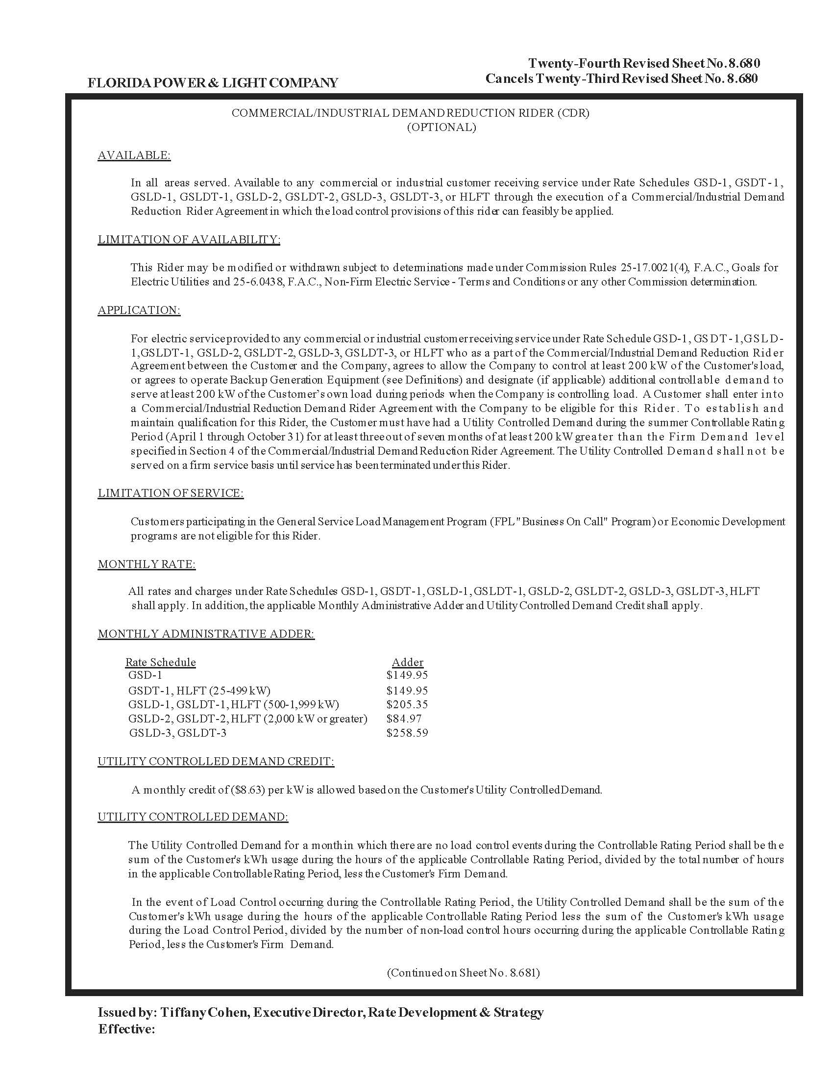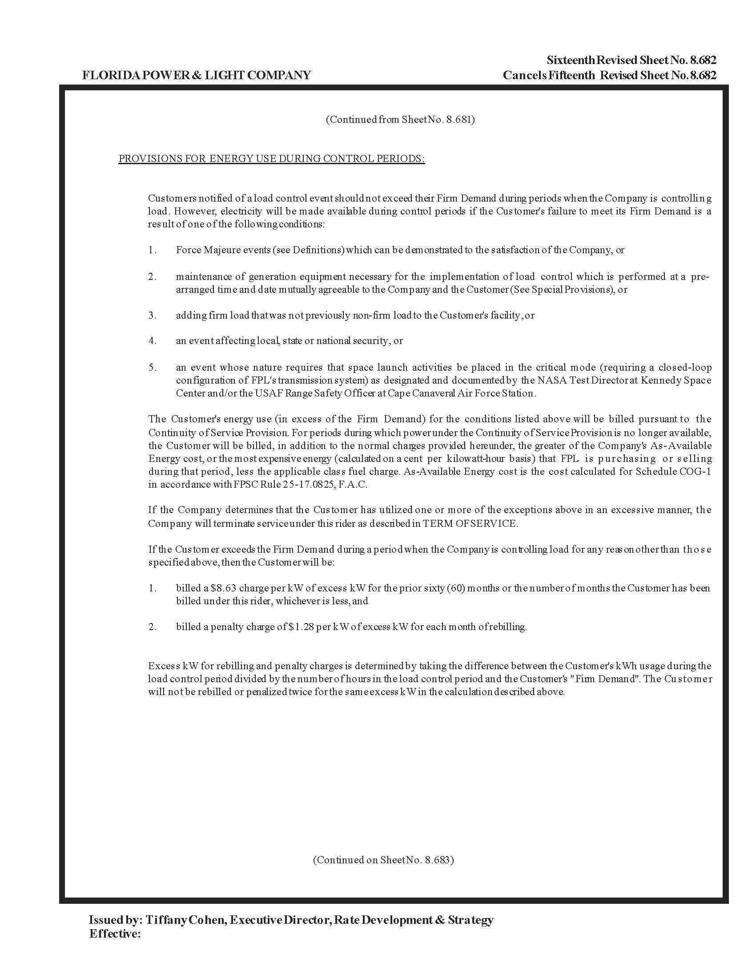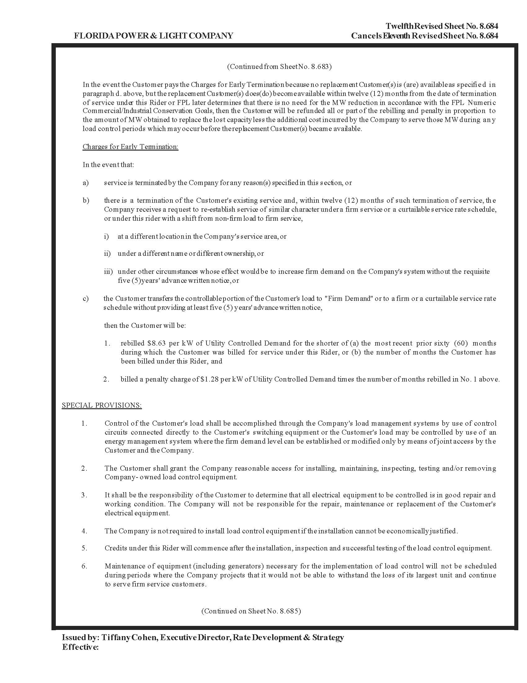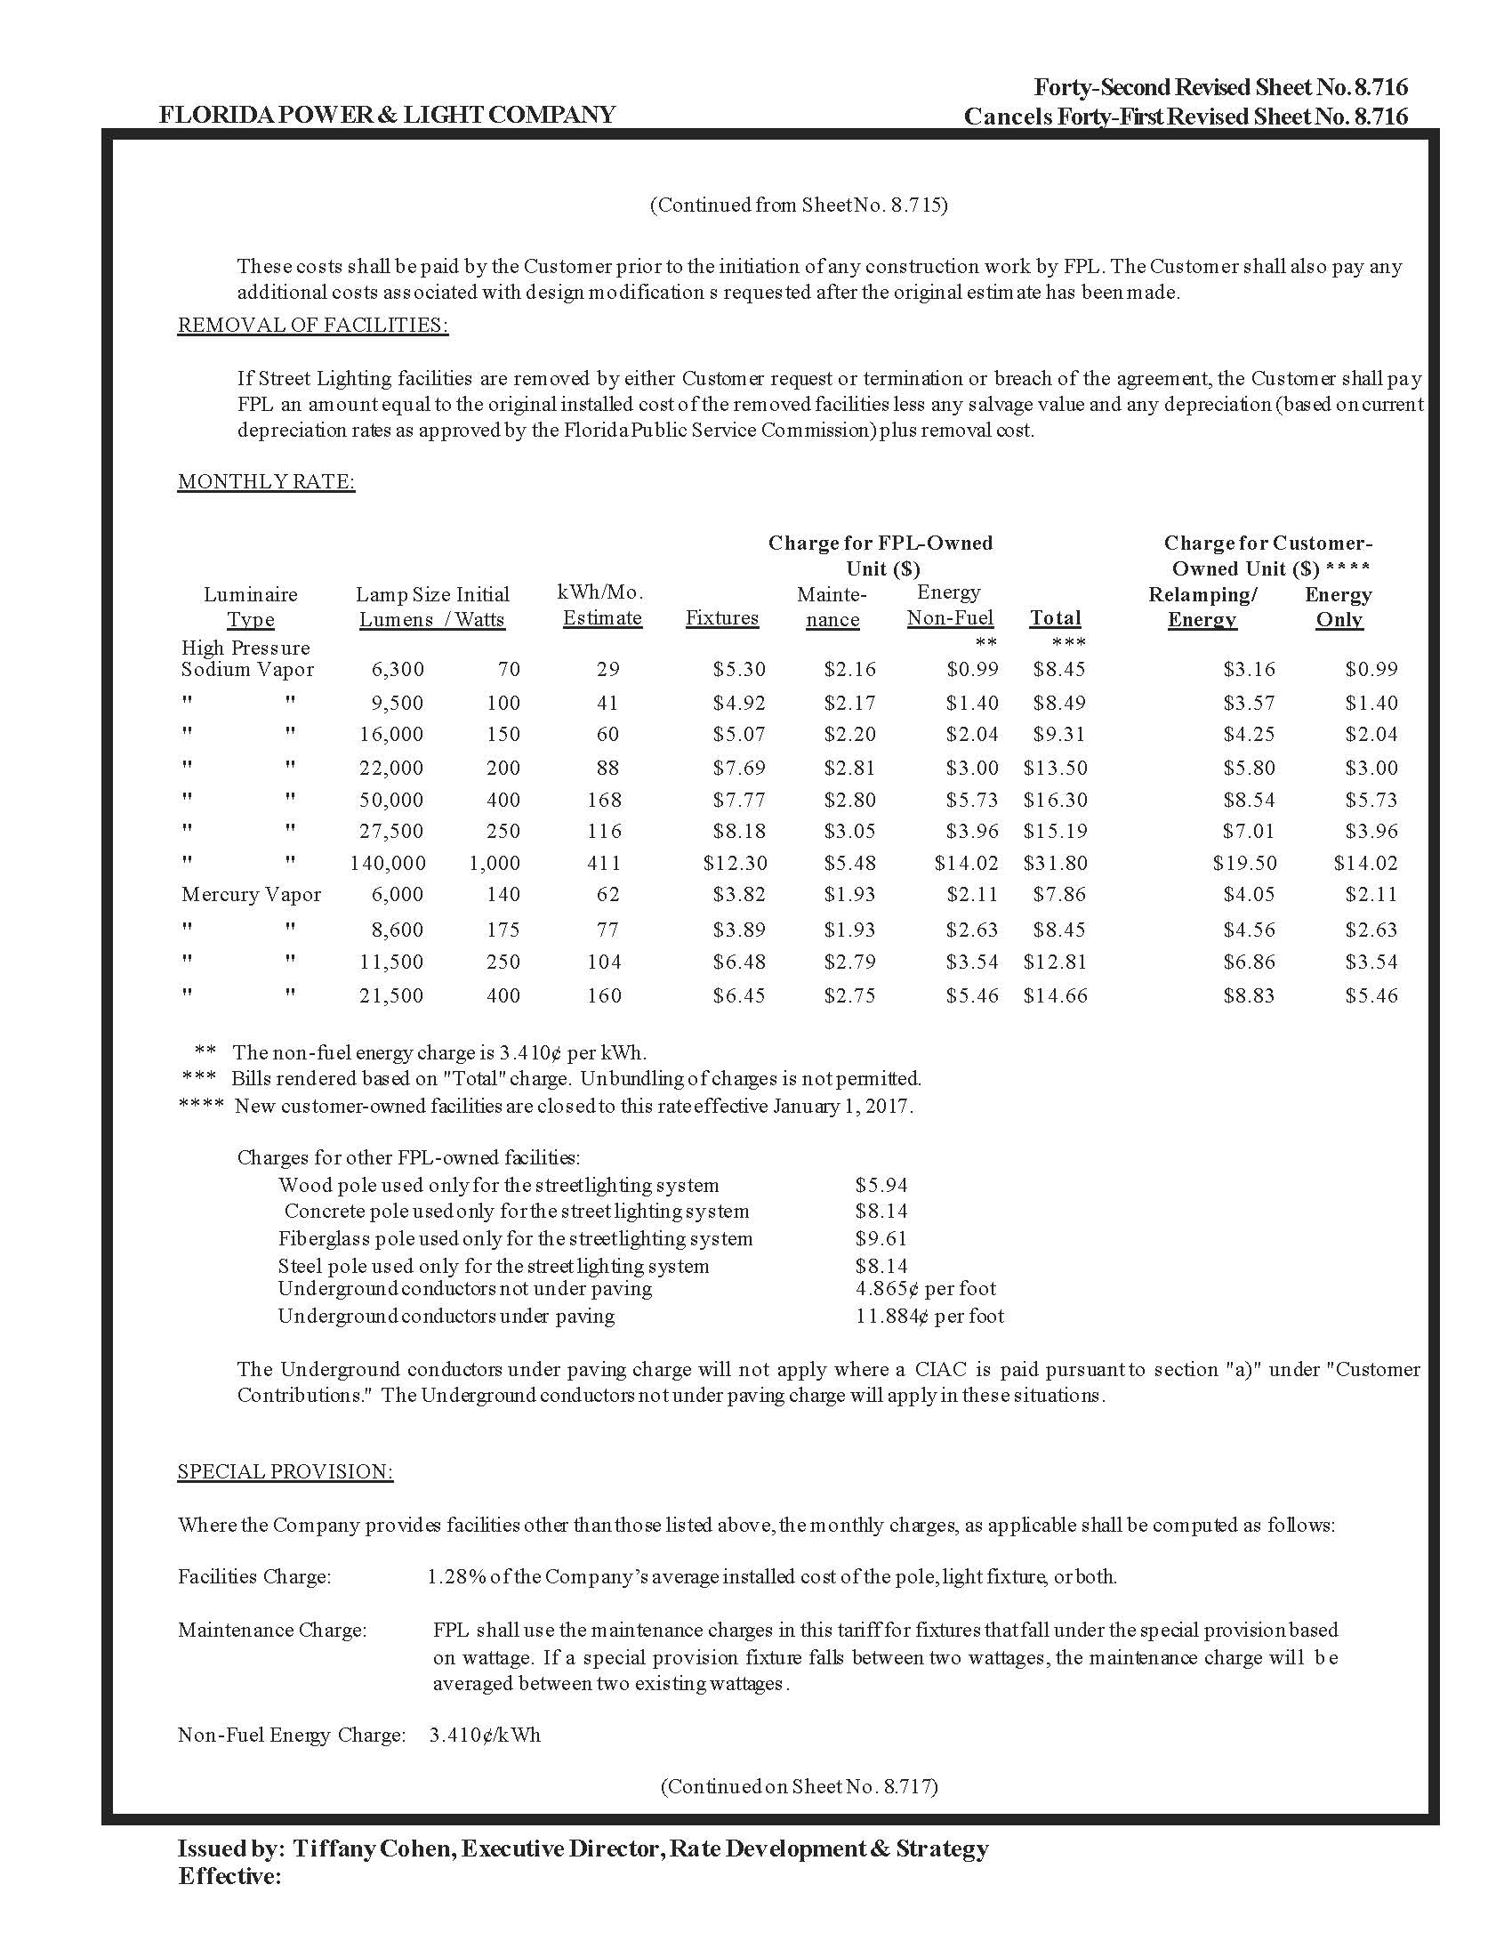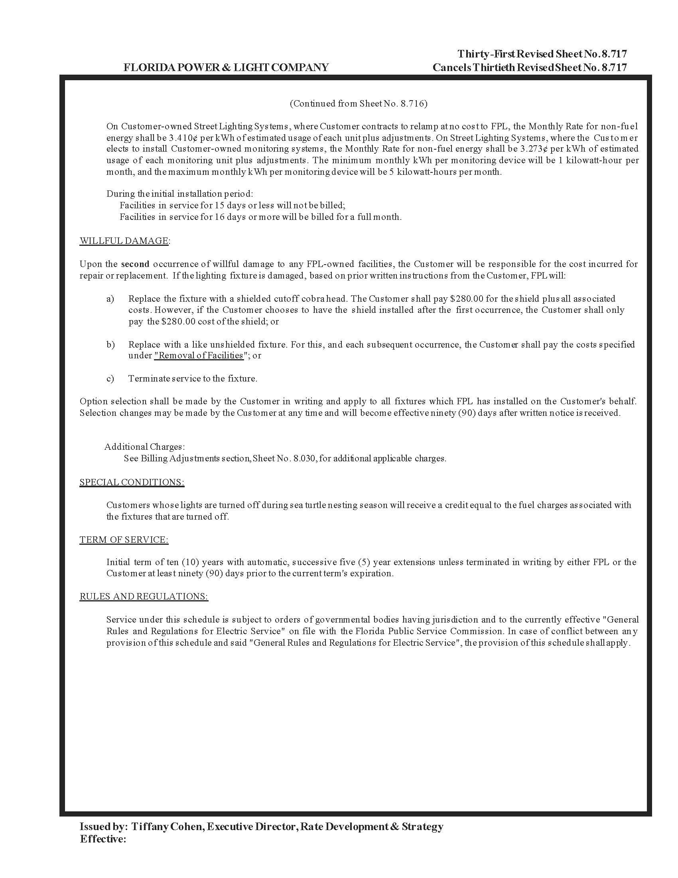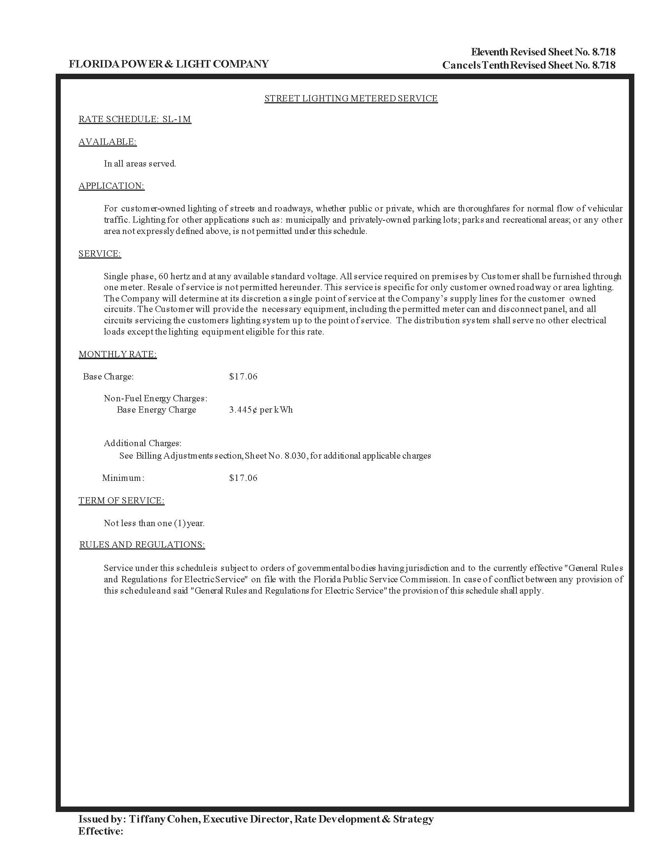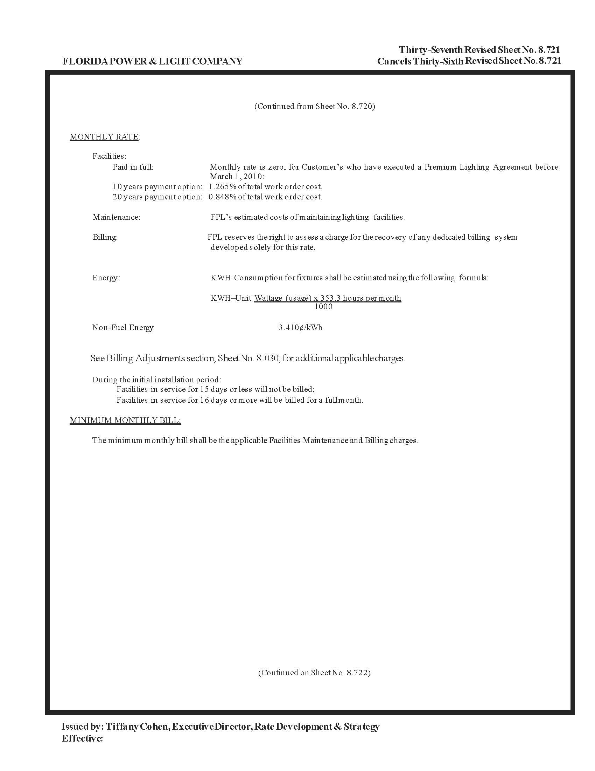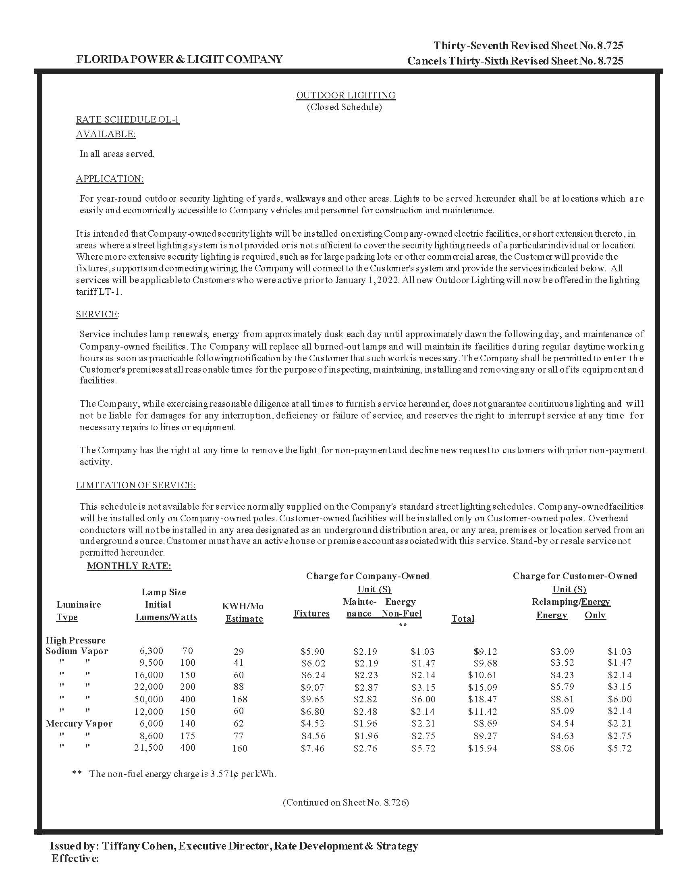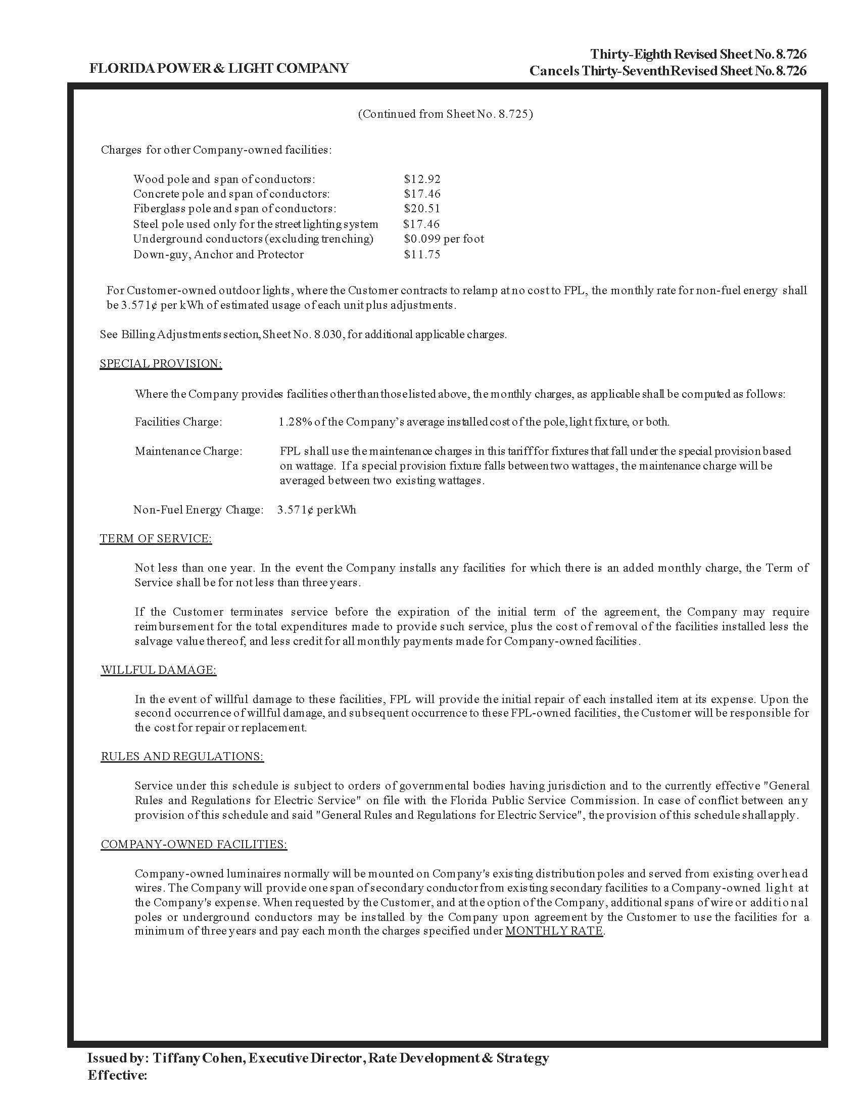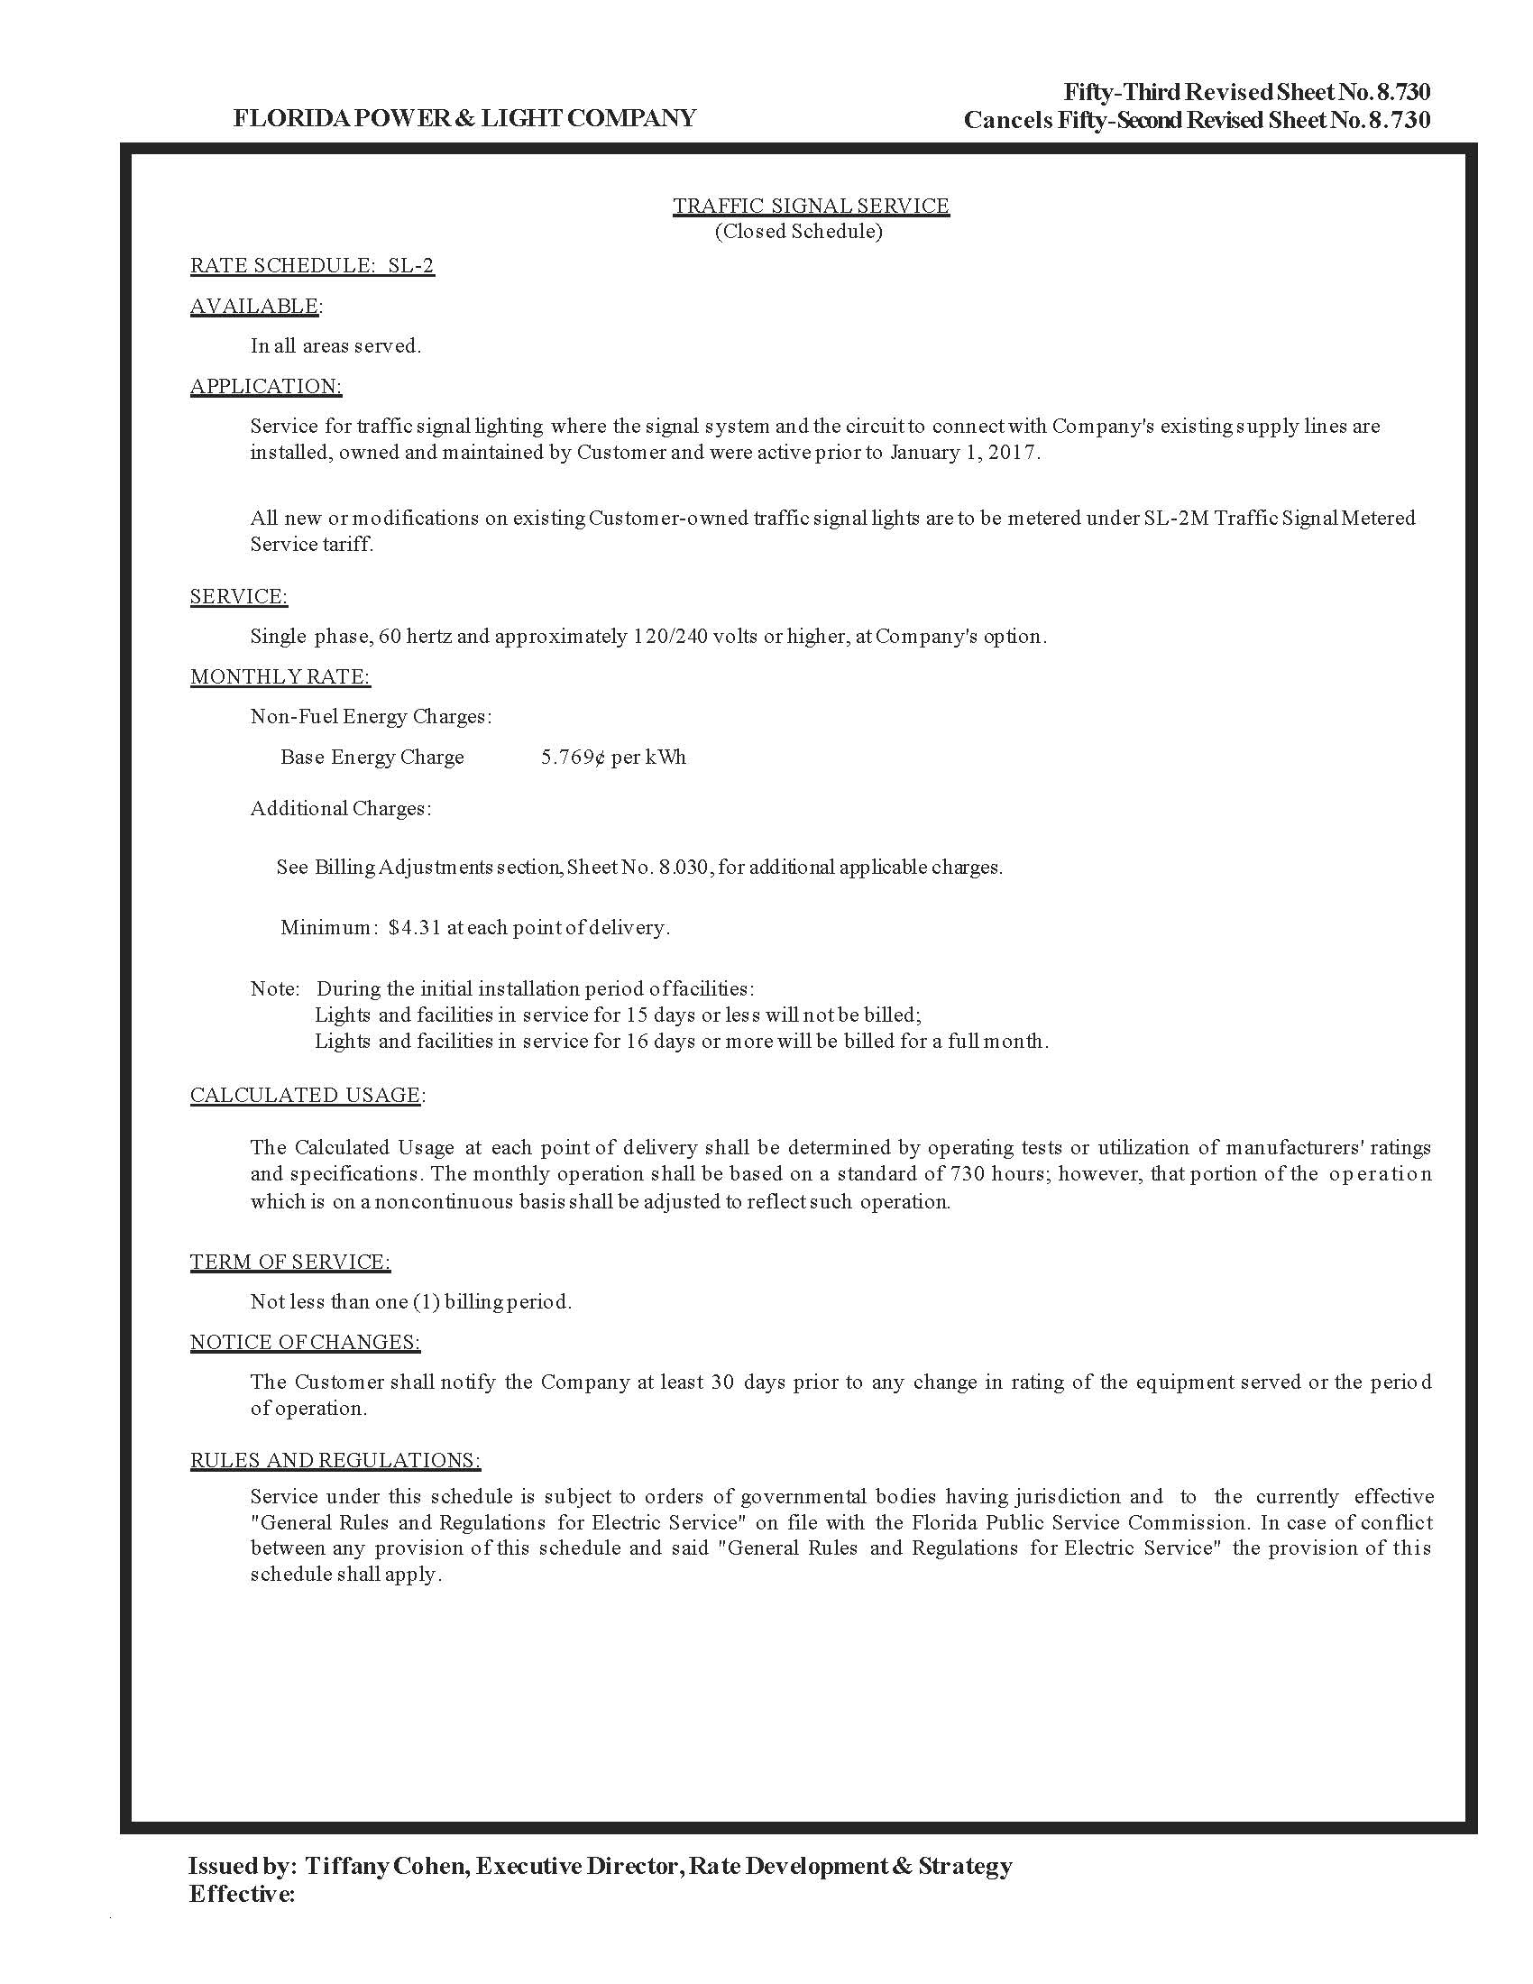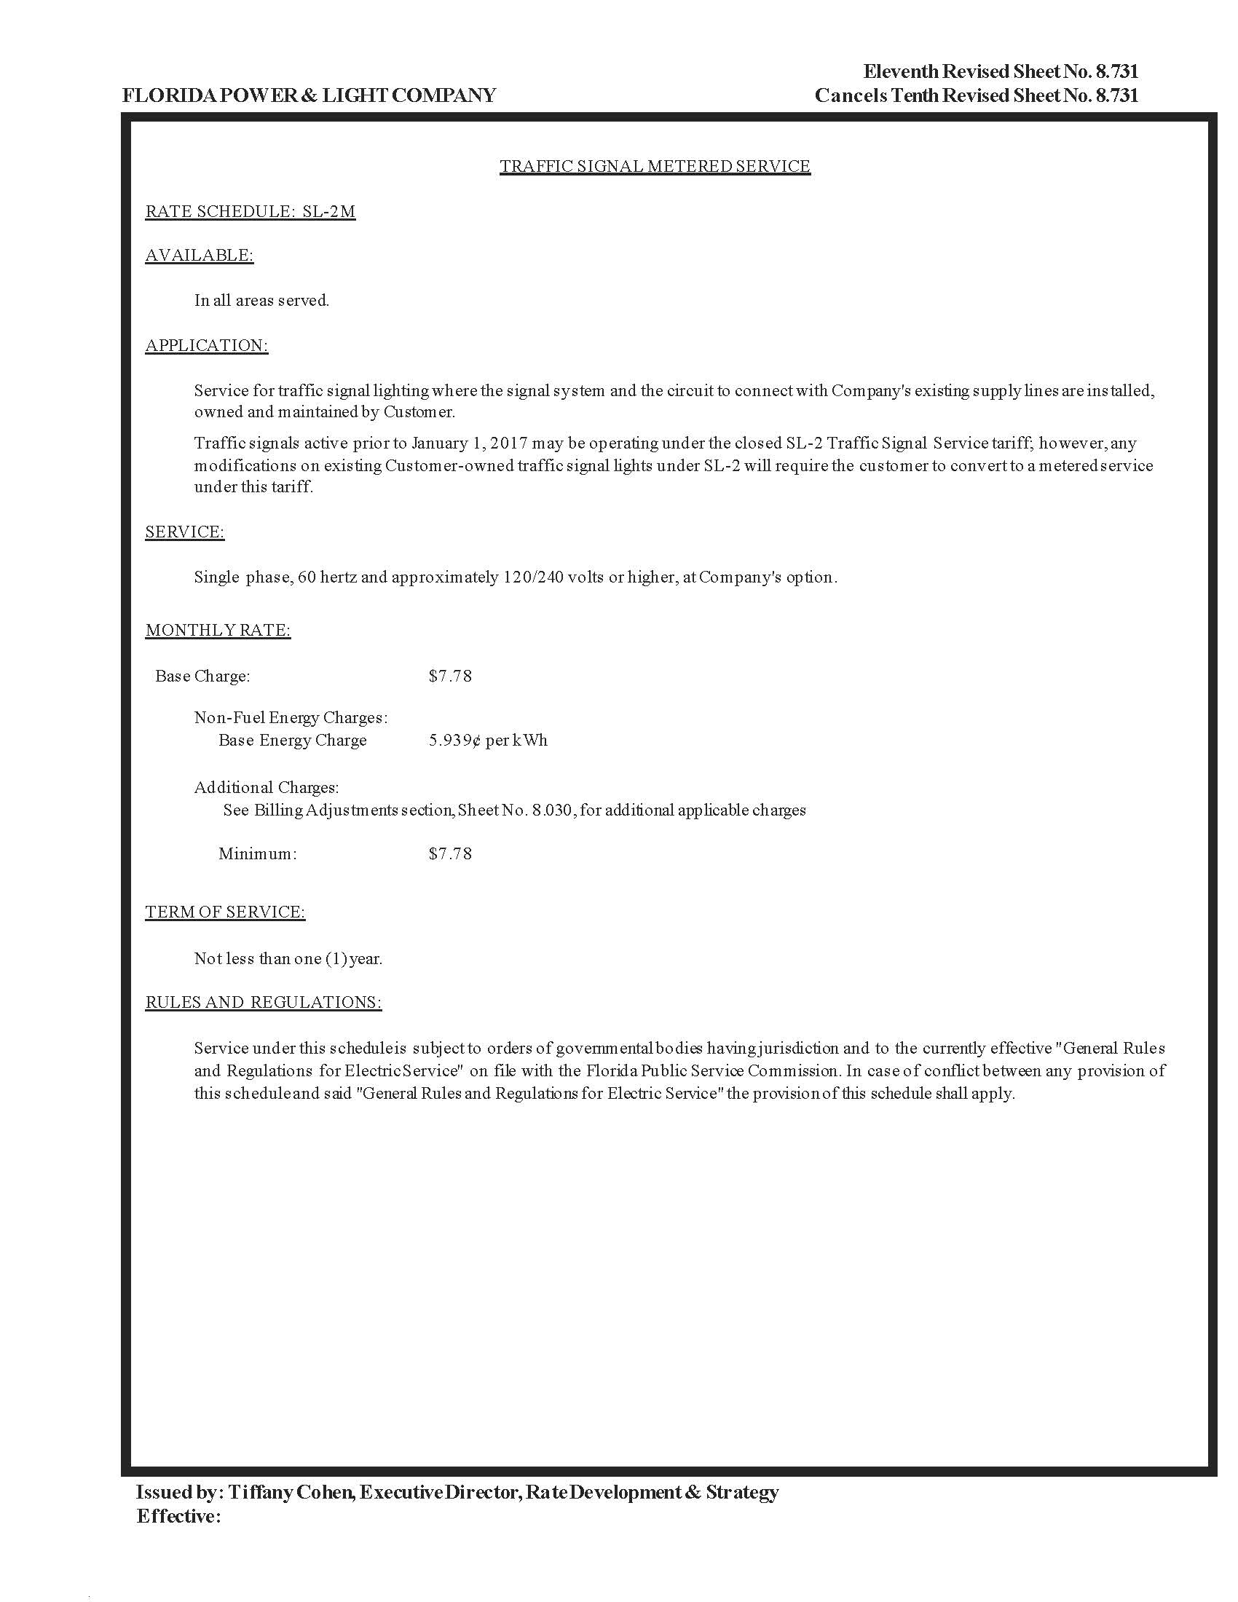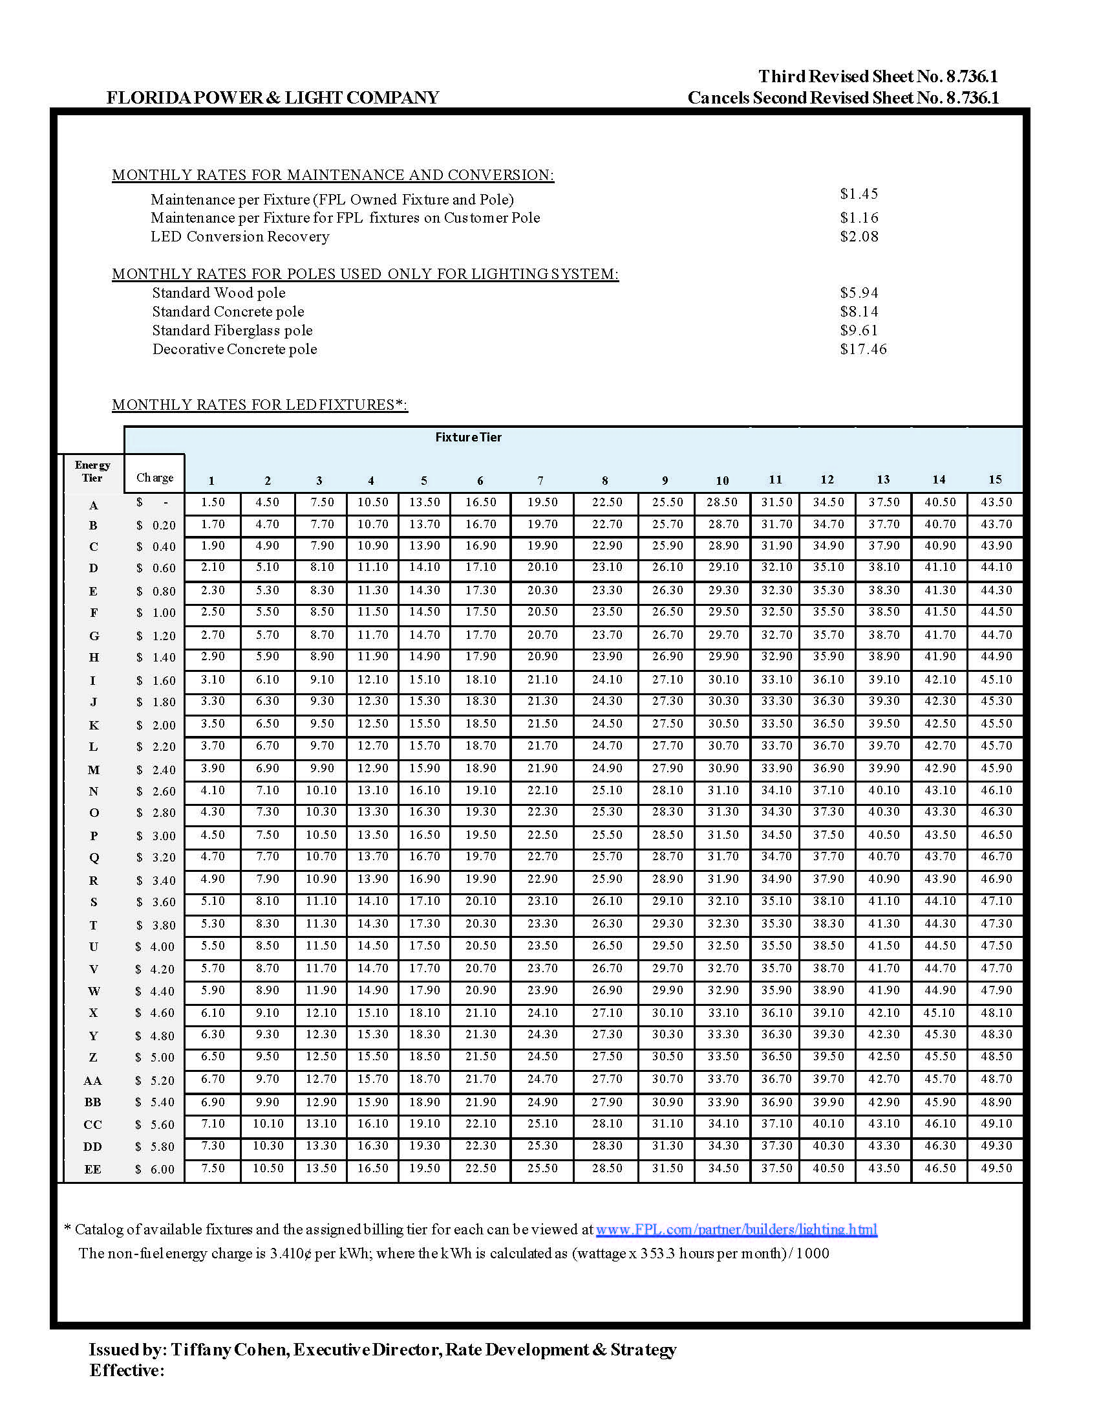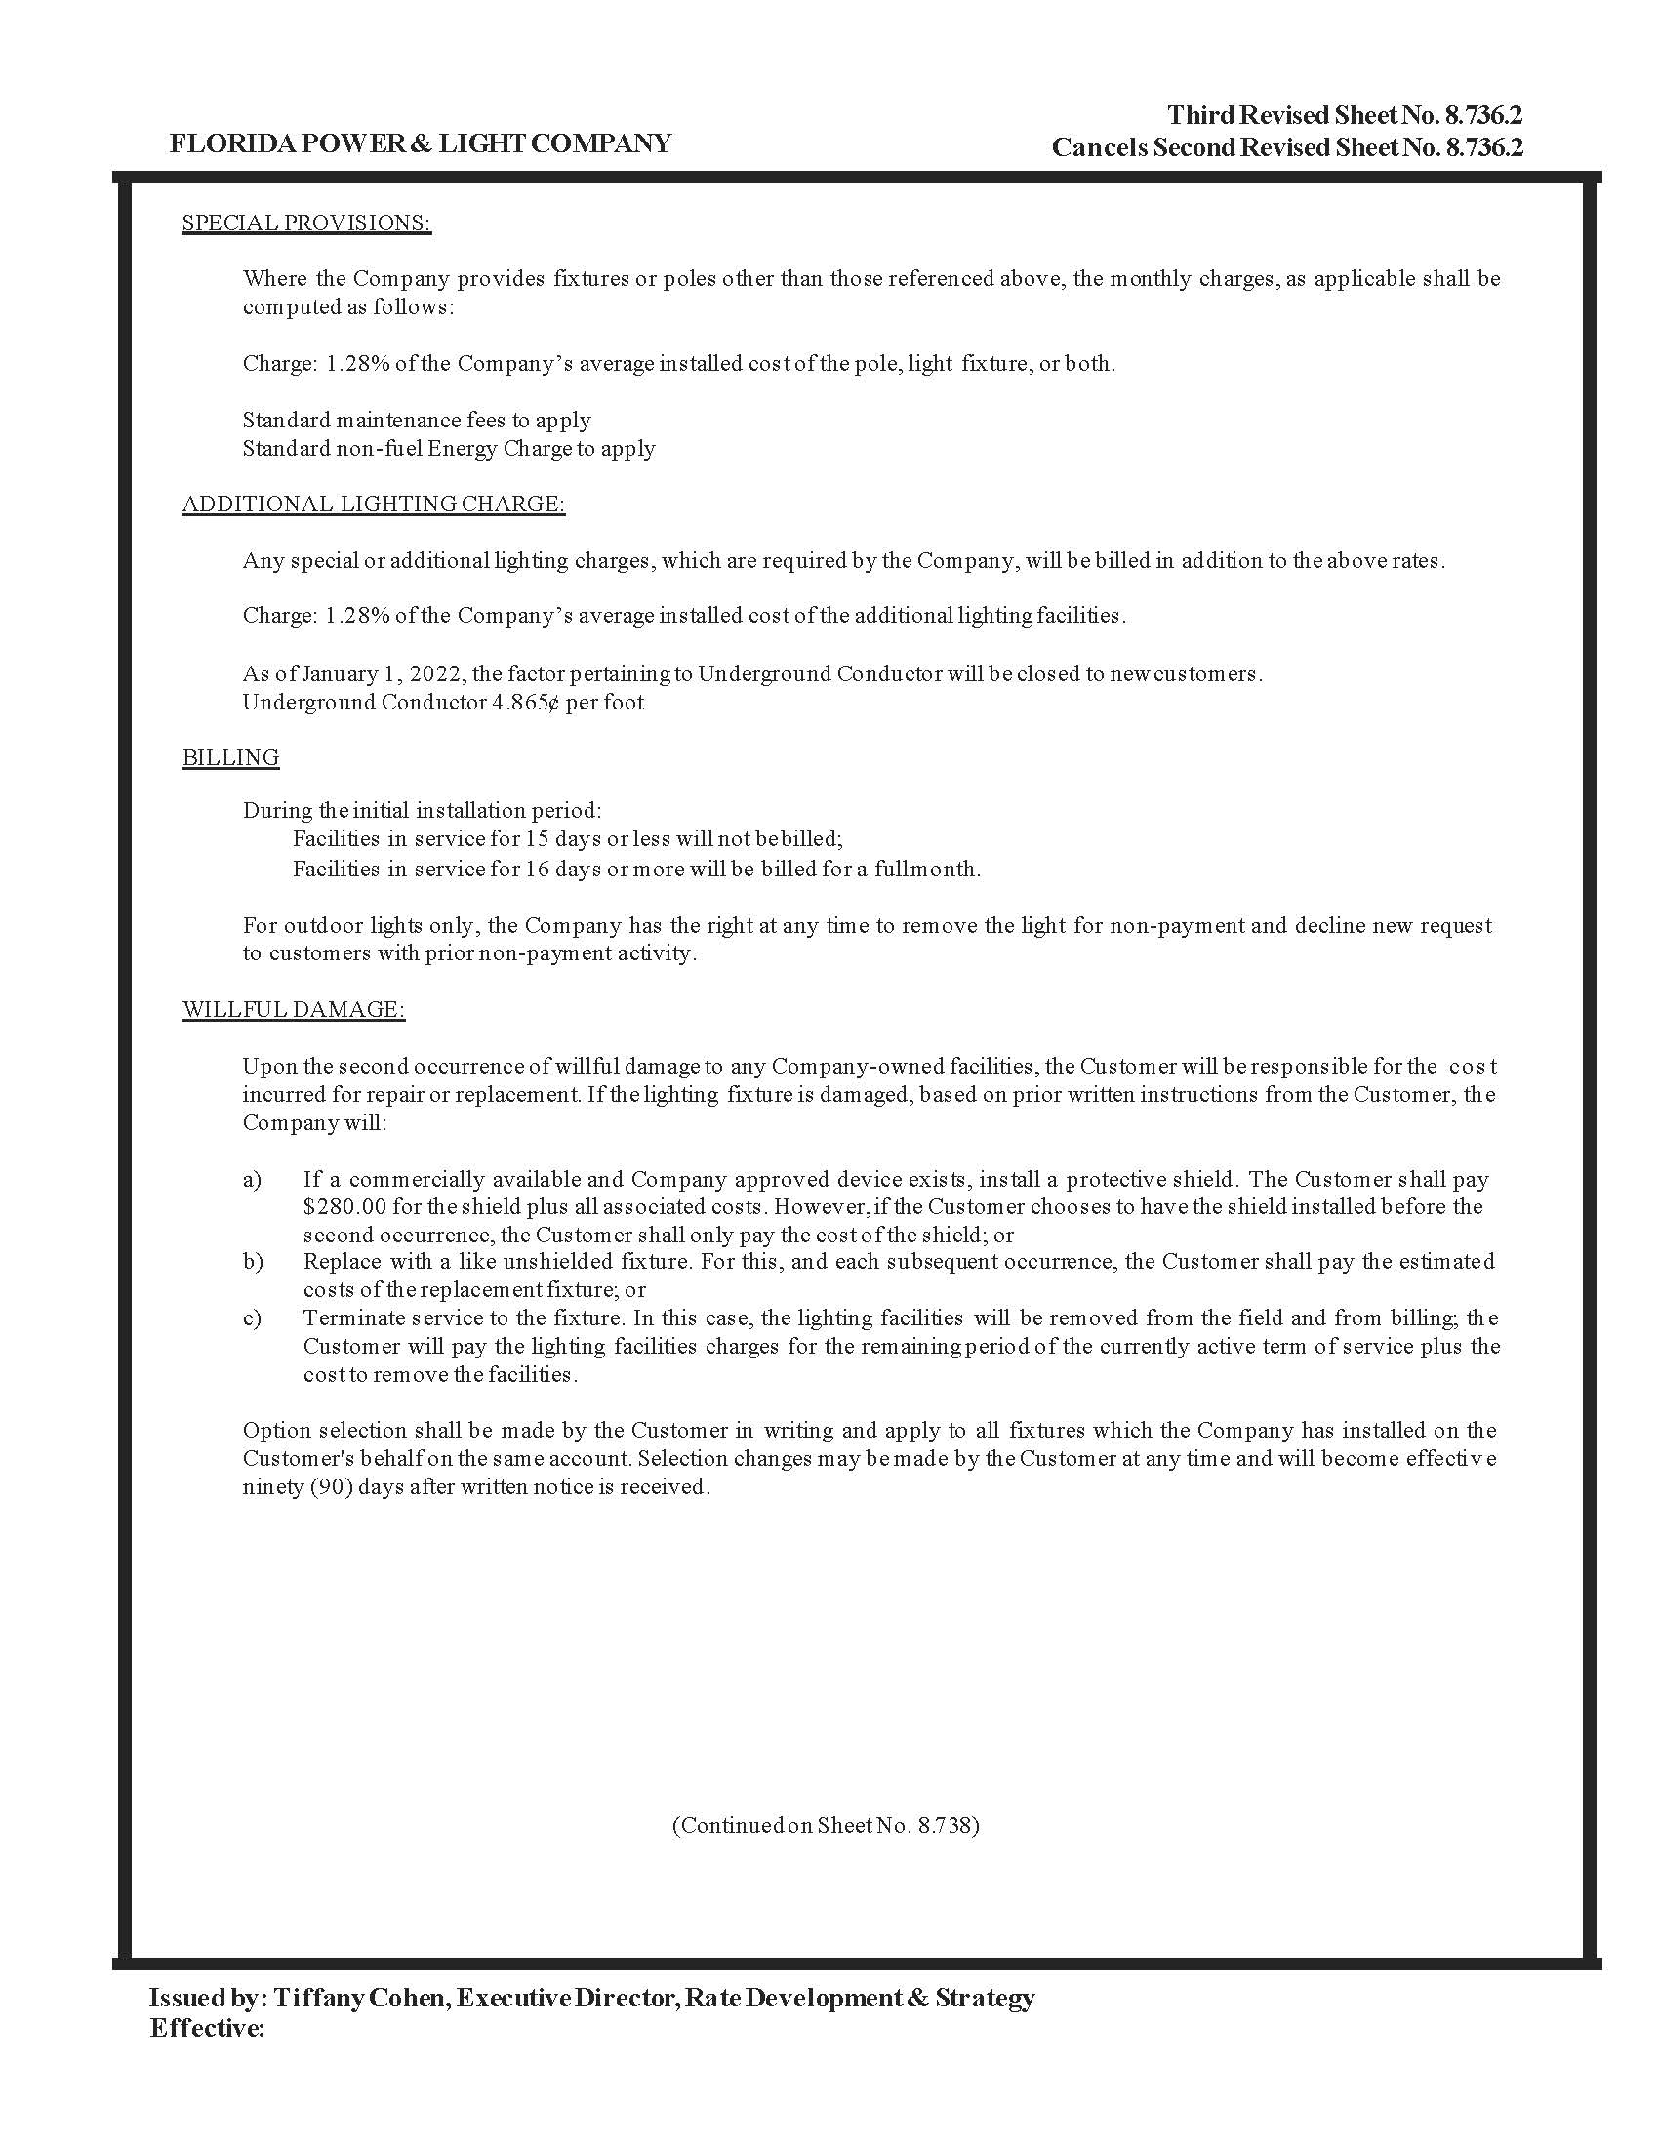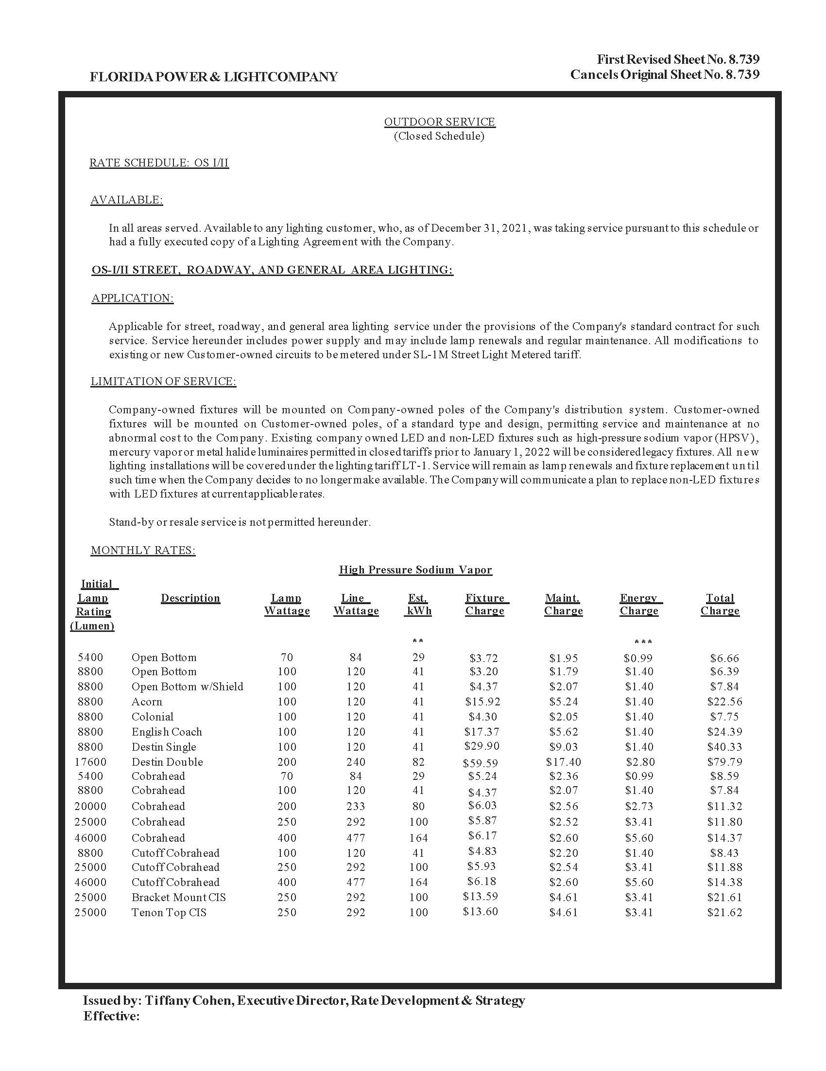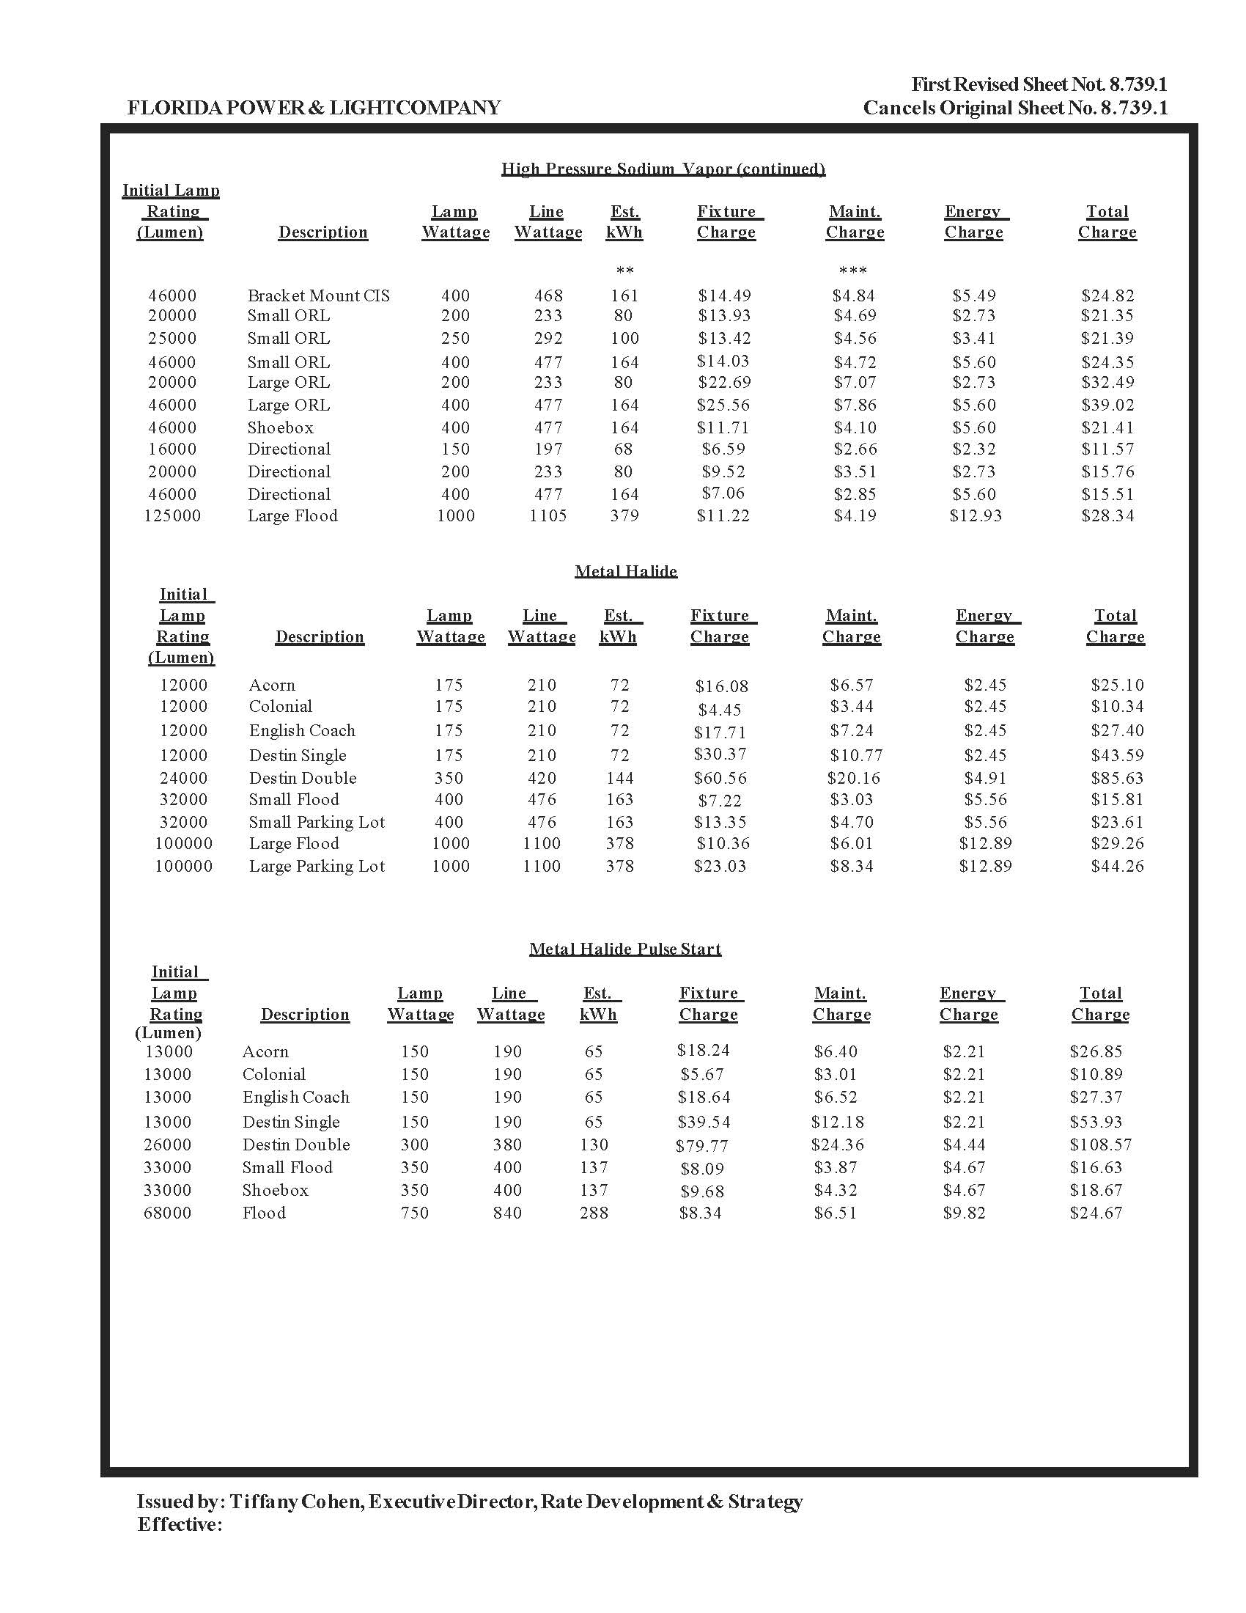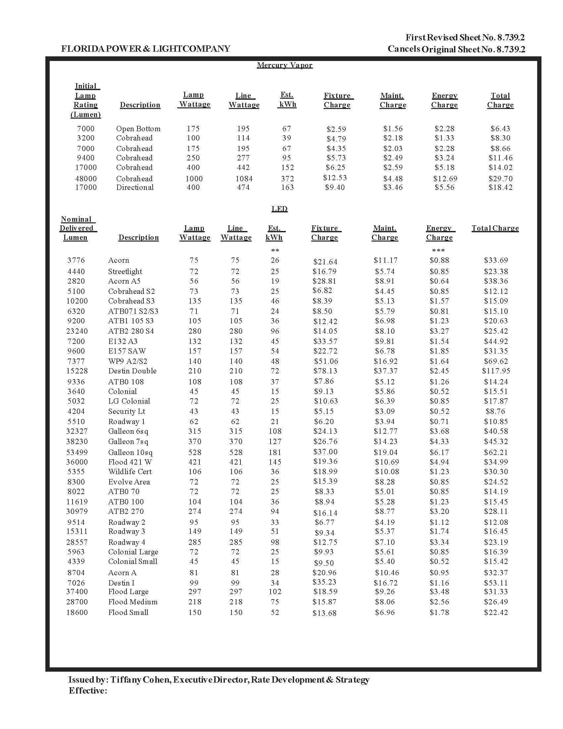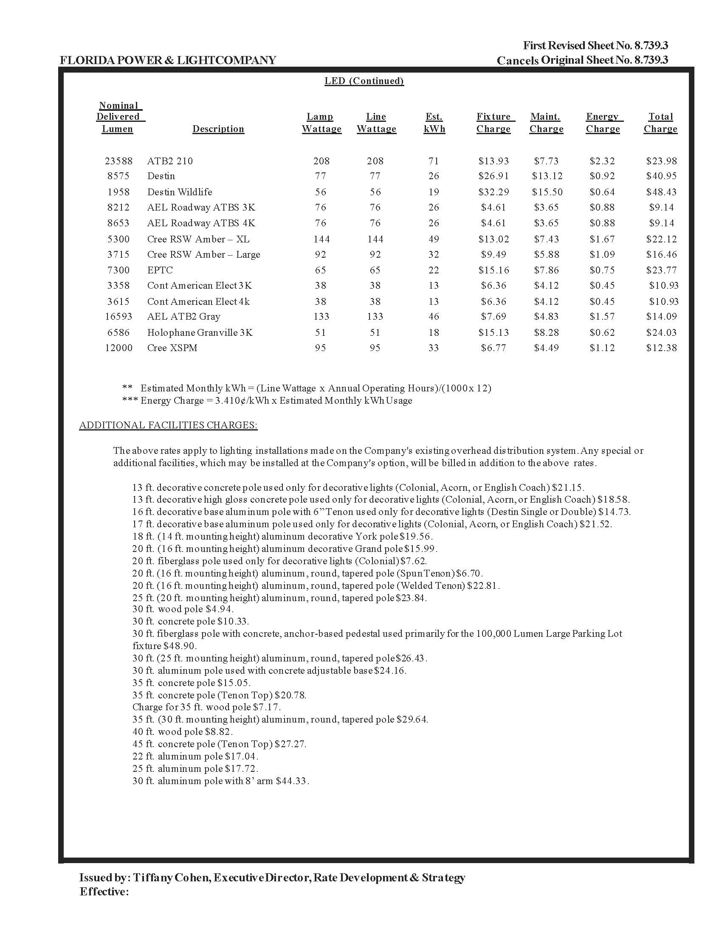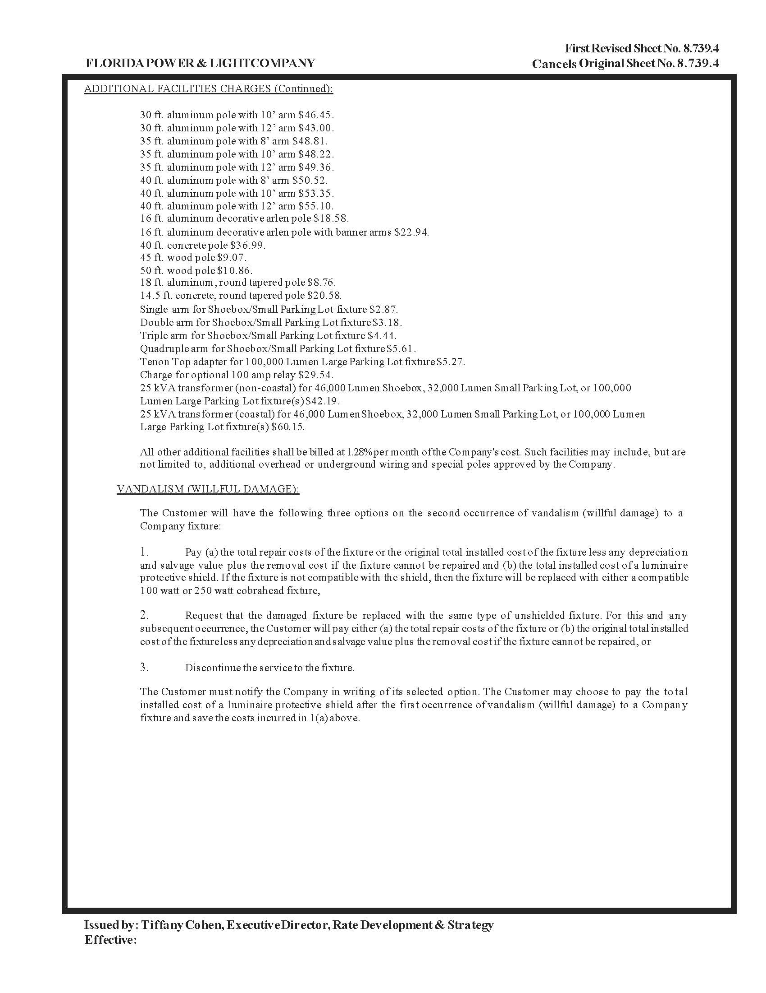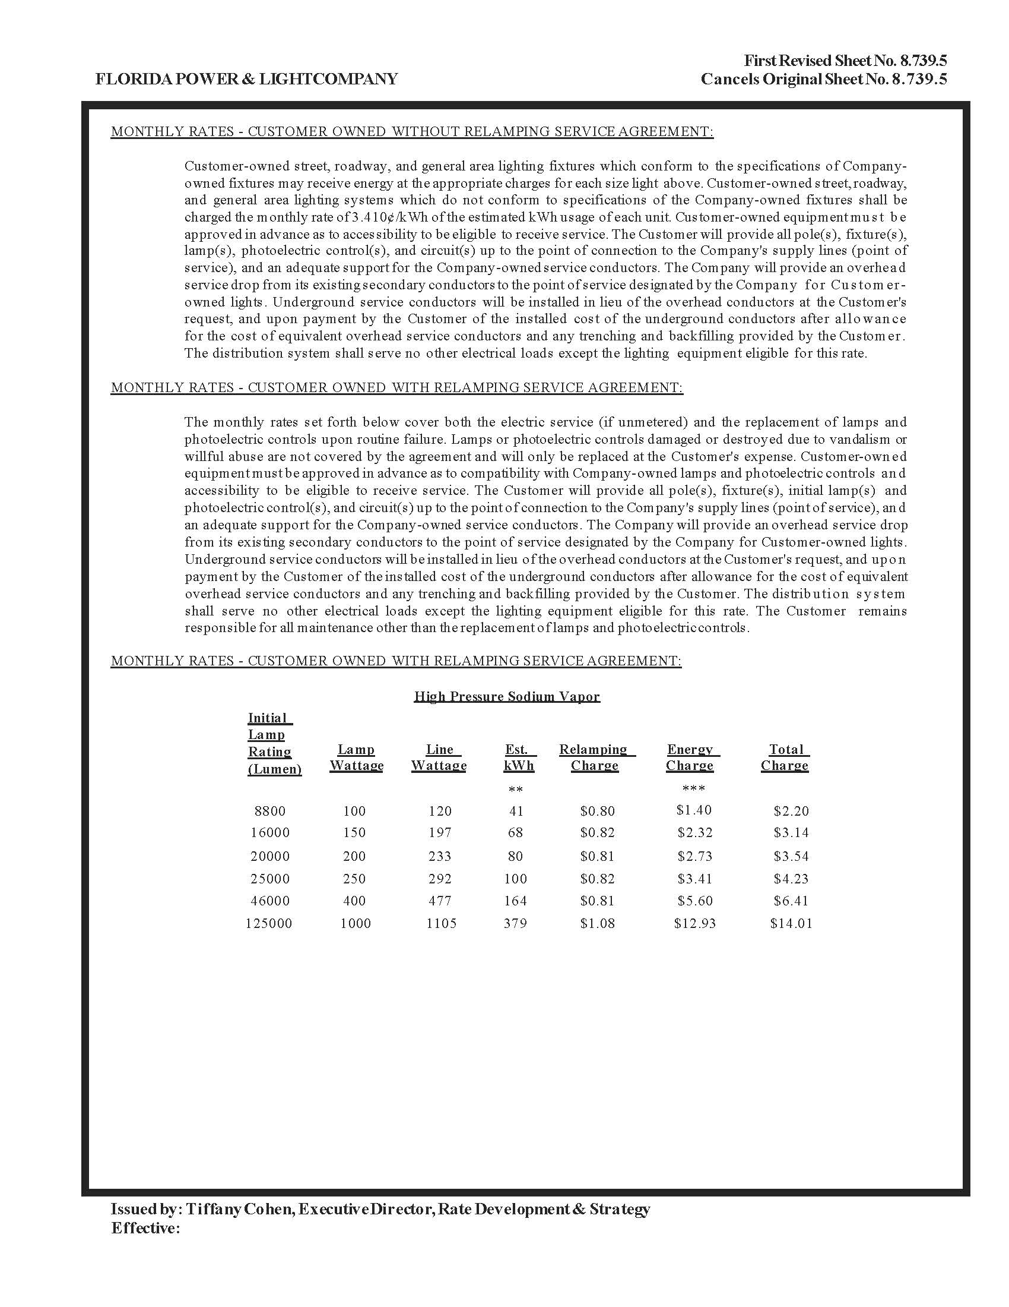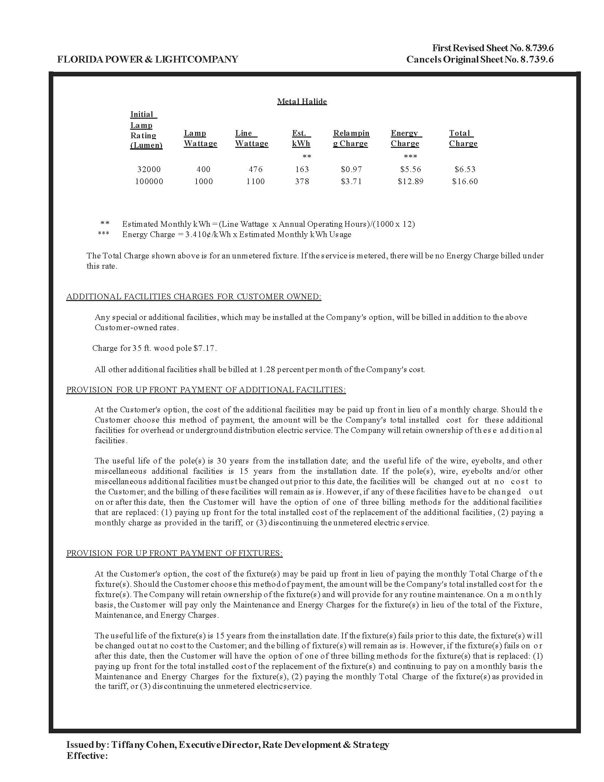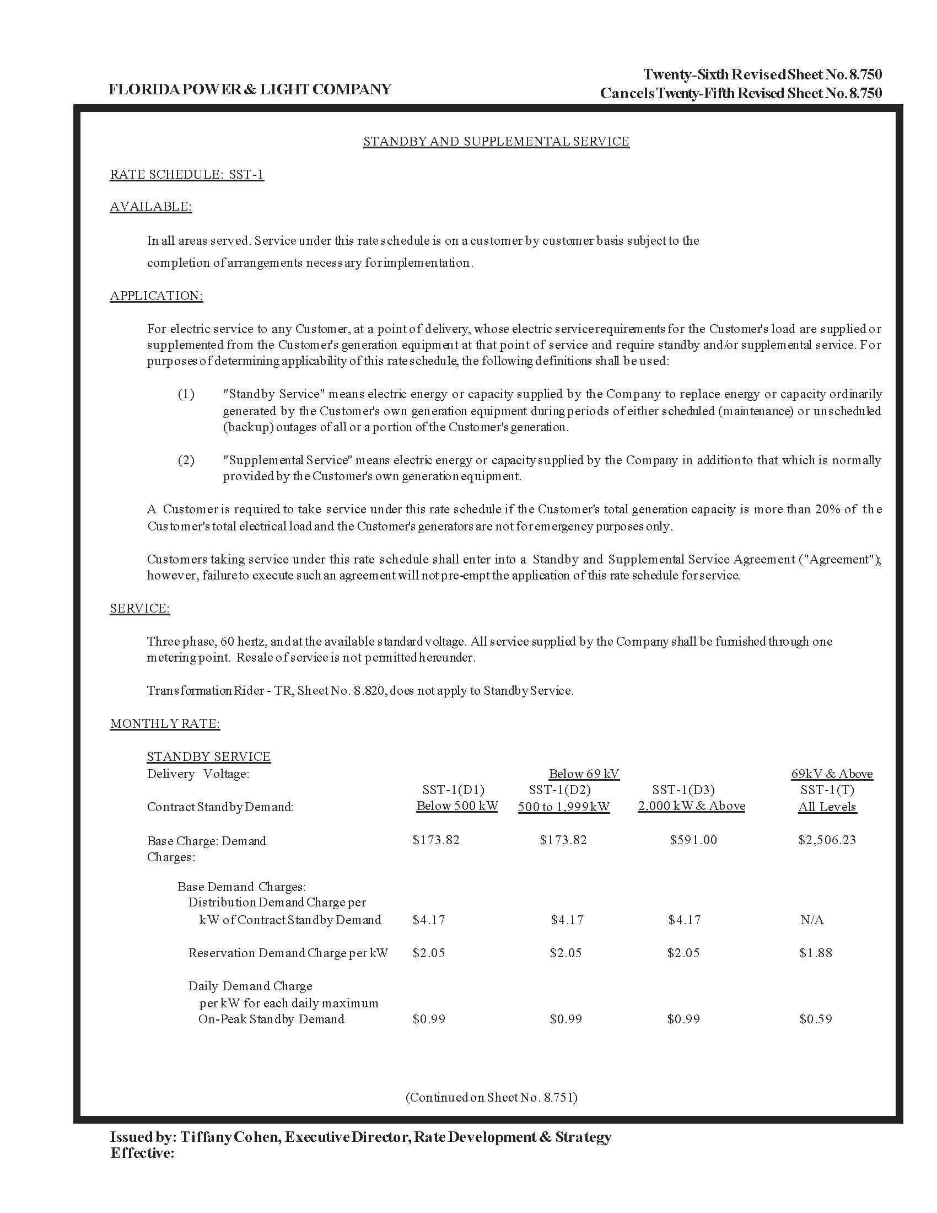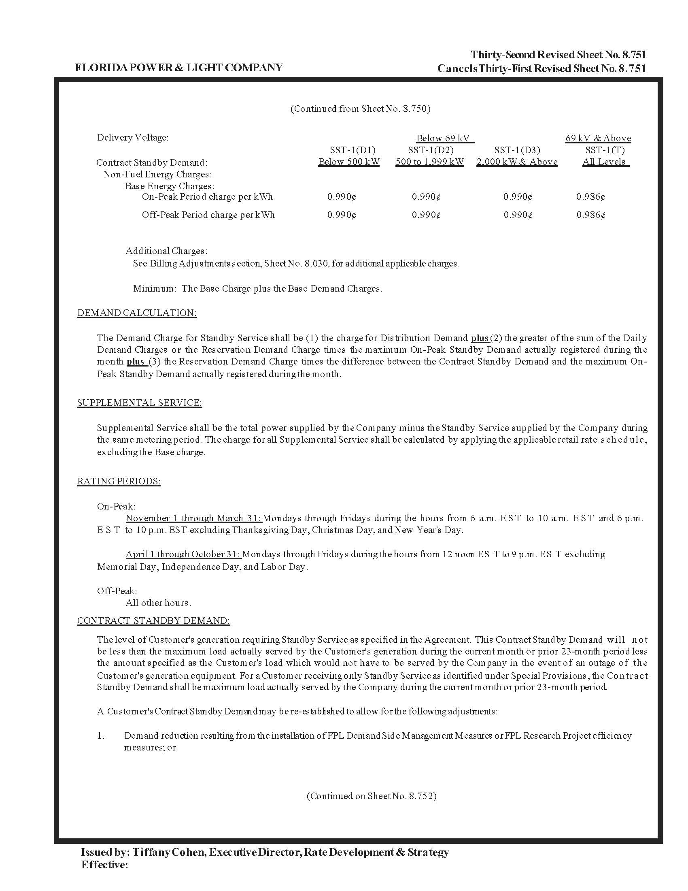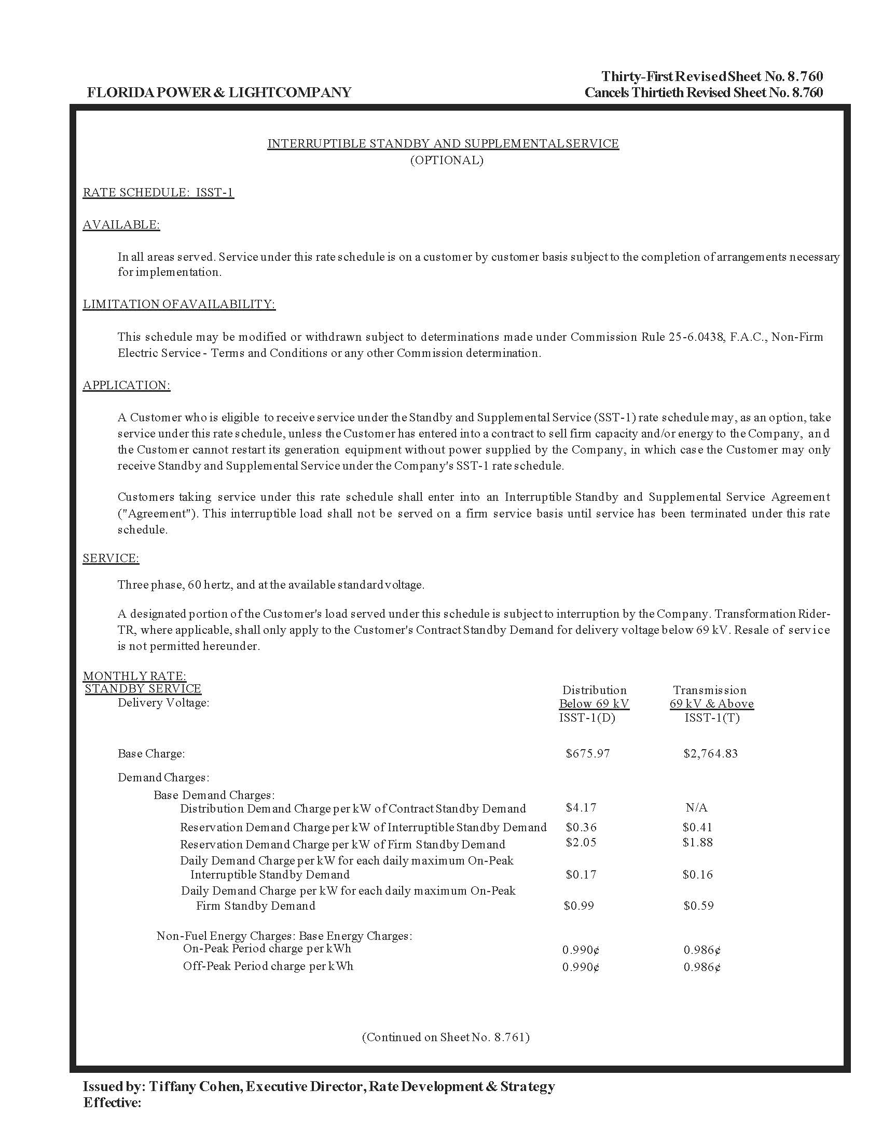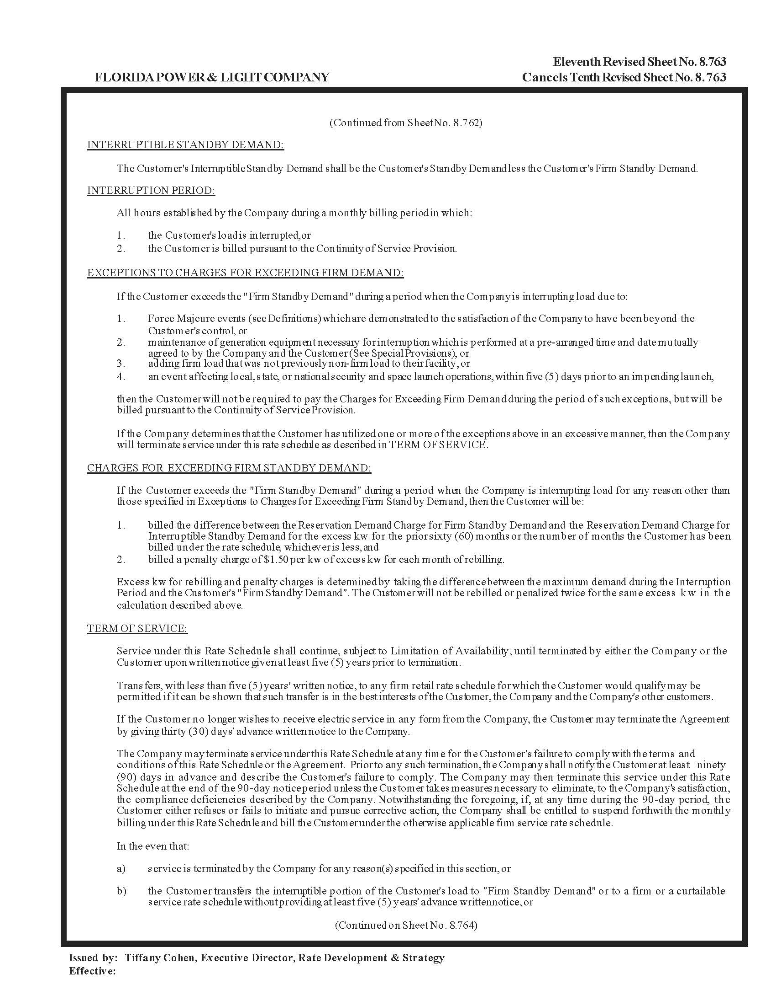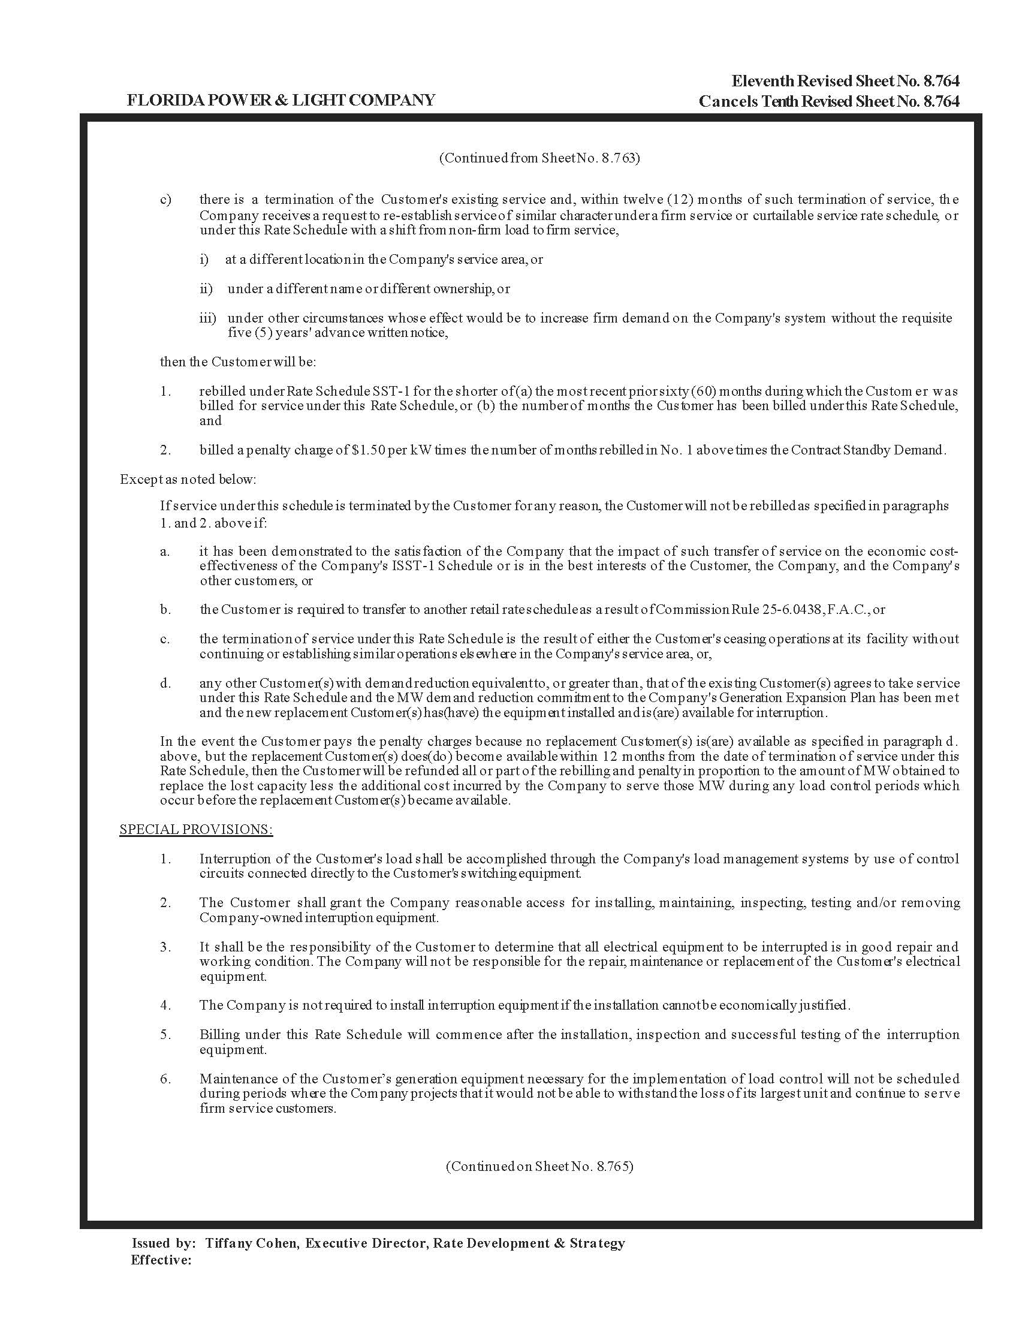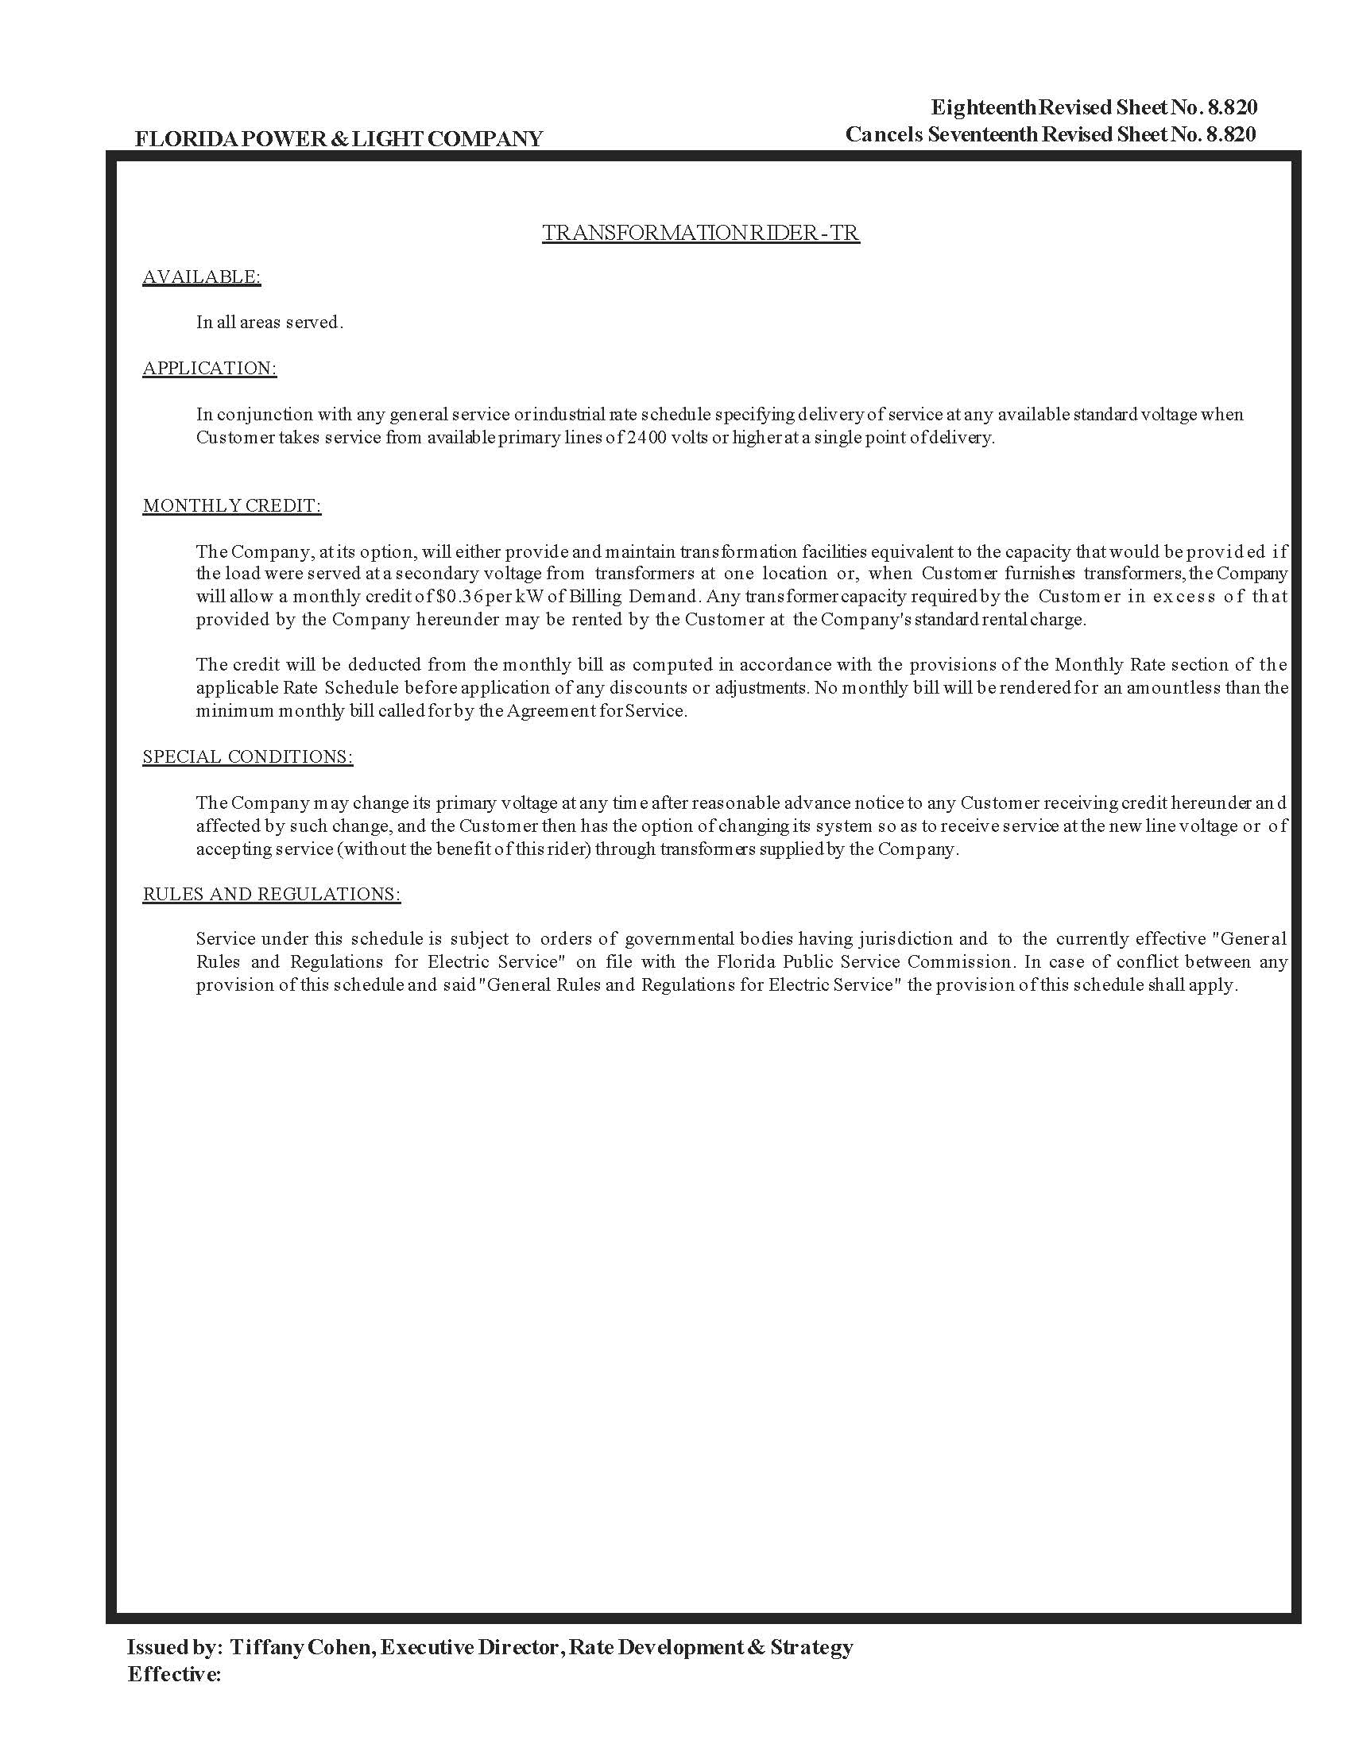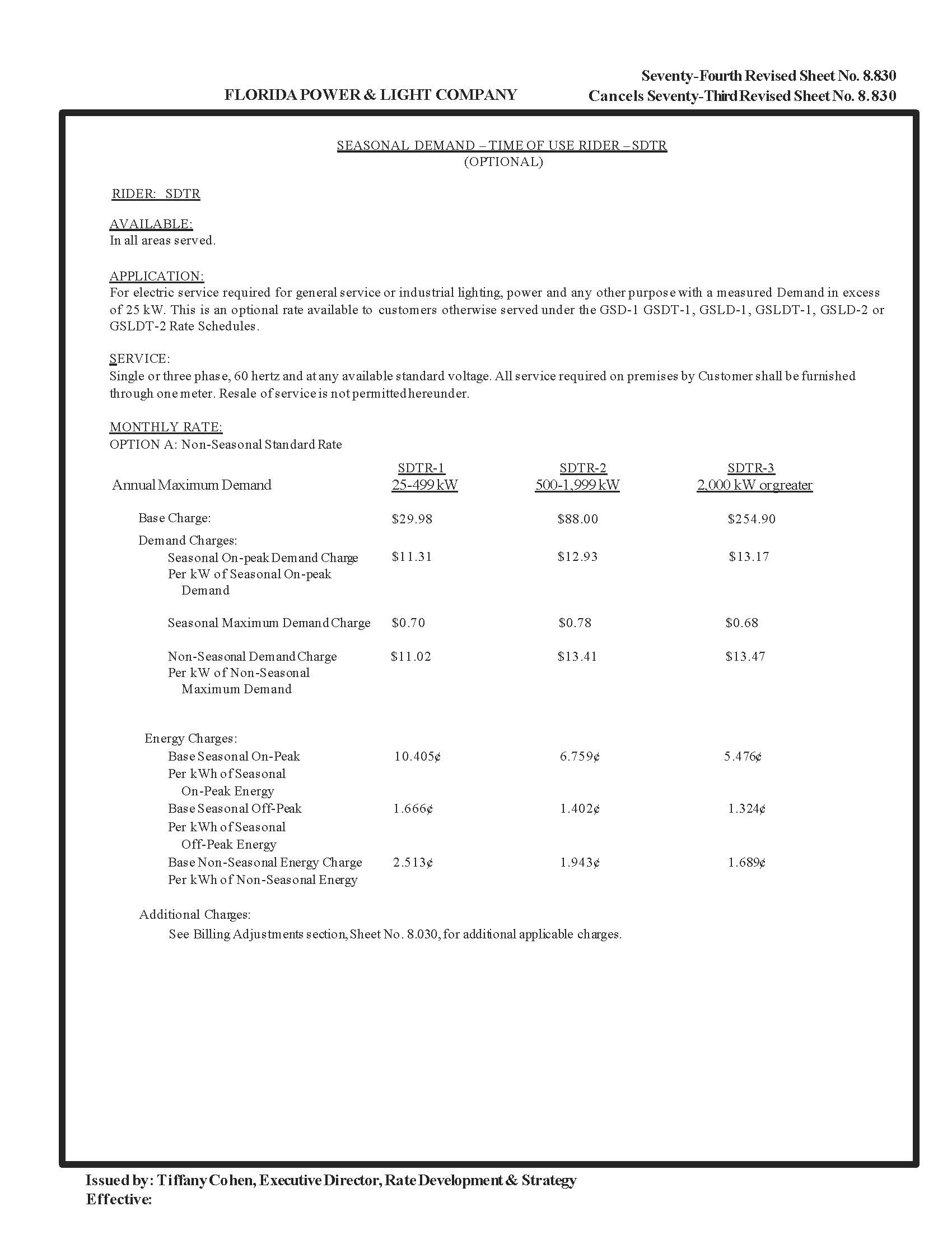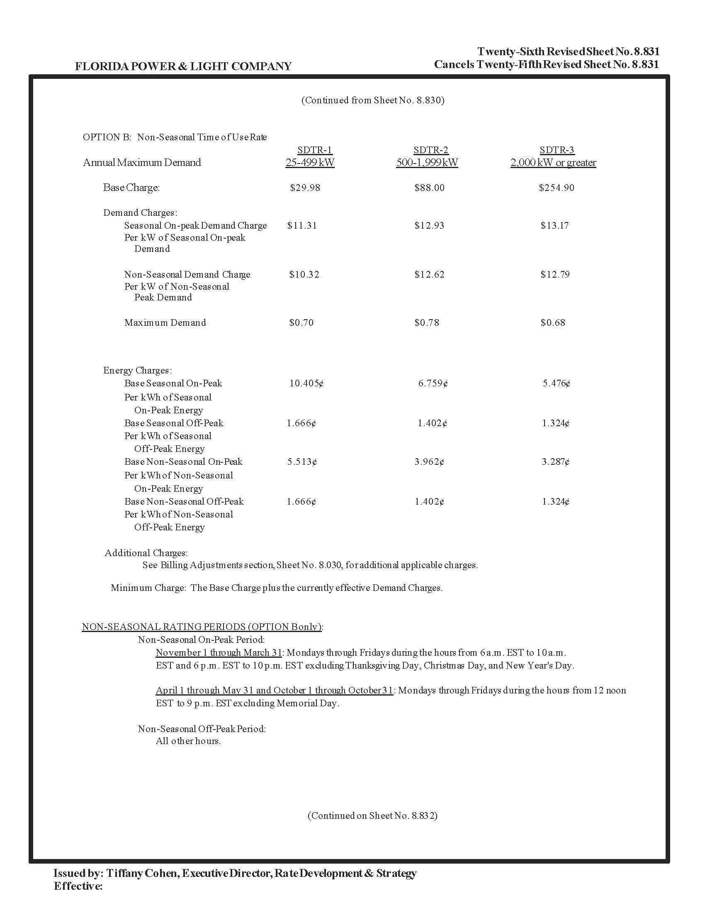

Order No. PSC-2021-0446-S-EI, issued December 2, 2021, in Docket No. 20210015-EI, Petition for rate increase by Florida Power & Light Company; and Order No. PSC-2021-0446A-S-EI, issued December 9, 2021, in Docket No. 20210015-EI, Petition for rate increase by Florida Power & Light Company.
Document No. 07679-2022, Exhibit IPL-5, page 1 of 1, Line 5.
Order No. PSC-2021-0446-S-EI, issued December 2, 2021, in Docket No. 20210015-EI, Petition for rate increase by Florida Power & Light Company; and Order No. PSC-2021-0446A-S-EI, issued December 9, 2021, in Docket No. 20210015-EI, Petition for rate increase by Florida Power & Light Company.
Proposed in Docket No. 20220001-EI.
Document No. 07679-2022, Exhibit IPL-6, page 1 of 1, Line 3.

