BEFORE THE FLORIDA PUBLIC SERVICE COMMISSION

In re: Joint petition for approval of swing service rider rates for January through December 2023, by Florida Public Utilities Company, Florida Public Utilities Company-Indiantown Division, Florida Public Utilities Company-Fort Meade, and Florida Division of Chesapeake Utilities Corporation. | DOCKET NO. 20220154-GU  ORDER NO. PSC-2022-0378-TRF-GU  ISSUED: November 7, 2022

The following Commissioners participated in the disposition of this matter:

ANDREW GILES FAY, Chairman
ART GRAHAM
GARY F. CLARK
MIKE LA ROSA
GABRIELLA PASSIDOMO

ORDER APPROVING SWING SERVICE RIDER RATES

BY THE COMMISSION:

Background
On September 1, 2022, Florida Public Utilities Company, Florida Public Utilities Company-Indiantown Division, Florida Public Utilities Company-Fort Meade, and Florida Division of Chesapeake Utilities Corporation d/b/a Central Florida Gas (jointly, FPUC) filed a petition for approval of revised swing service rider rates and associated tariffs for the period January through December 2023. FPUC is a local natural gas distribution company (LDC) subject to our regulatory jurisdiction pursuant to Chapter 366, Florida Statutes (F.S.). FPUC is a wholly-owned subsidiary of Chesapeake Utilities Corporation, which is headquartered in Dover, Delaware. Chesapeake is also an LDC subject to our jurisdiction under Chapter 366, F.S., and is an operating division of Chesapeake Utilities Corporation.

We first approved FPUC’s swing service rider tariff in Order No. PSC-16-0422-TRF-GU (swing service order) and the initial swing service rider rates were in effect for the period March through December 2017. As required in the swing service order, FPUC submitted the instant petition with revised 2023 swing service rider rates for our approval by September 1, 2022. The January through December 2022 swing service rider rates were approved in Order No. PSC-2021-0417-TRF-GU. The swing service rider is a cents per therm charge that is included in the monthly gas bill of transportation customers.
In the pending rate case Docket No. 20220067-GU, FPUC proposed to consolidate the current 54 rate classes across the four natural gas utilities into 16 rate classes. If we approve the consolidated rate classes in the rate case docket, FPUC would need to allocate the swing service rider costs to the appropriate revised rate classes and recalculate the swing service rider rates. If we deny FPUC’S proposal to consolidate the rate classes, the 2023 swing service rider rates as approved in this docket would stay in effect.
On September 15, 2022, FPUC waived the 60-day file and suspend provision of Section 366.06(3), F.S., via an e-mail, which has been placed in the docket file. During the evaluation of the petition, our staff issued a data request to FPUC for which responses were received on October 6, 2022. The updated swing service rider rates and associated revised tariff sheets are shown in Attachment A to this order. We have jurisdiction over this matter pursuant to Sections 366.04, 366.05, and 366.06, F.S.

Decision

FPUC incurs intrastate capacity costs when it transports natural gas on intrastate pipelines (i.e., pipelines operating within Florida only). FPUC has two types of natural gas customers: sales and transportation. Sales customers are primarily residential and small commercial customers that purchase natural gas from an LDC and receive allocations of intrastate capacity costs through the Purchased Gas Adjustment (PGA) charge. Of the joint petitioners in the instant docket, only Florida Public Utilities Company and Florida Public Utilities Company – Fort Meade have sales customers. Transportation customers receive natural gas from third party marketers, also known as shippers and, therefore, do not pay the PGA charge to the LDC. The swing service rider allows FPUC to also recover allocations of intrastate capacity costs from transportation customers.

- Updated 2023 Swing Service Rider Rates

The updated 2023 swing service rider rates were calculated based on the same methodology approved in the 2016 swing service order. As stated in paragraph 9 of FPUC’s instant petition, the total intrastate capacity costs for the period July 2021 through June 2022 are $26,231,749. The total intrastate capacity costs reflect payments by FPUC to intrastate pipelines for the transportation of natural gas, pursuant to Commission-approved transportation agreements. In addition, the intrastate capacity costs include payments associated with a software tool to manage customer usage and assist in determining the gas supply and capacity needs for FPUC, legal and consulting fees, and subscription fees to obtain market data and gas daily pricing.
Of these costs, $6,455,937 will be billed directly to certain large special contract customers. The remaining costs of $19,775,812 are allocated between sales and transportation customers and will be recovered during the period January 1, 2023 through December 31, 2023.
FPUC used actual therm usage data for the period July 2021 through June 2022 to allocate the intrastate capacity costs. Based on the usage data, the appropriate split for allocating the cost is 71.16 percent or $14,072,343 to transportation customers and 28.84 percent or $5,703,469 to sales customers. The transportation customers’ share of $14,072,343 is further allocated to the various transportation rate schedules in proportion with each rate schedule’s share of FPUC’s total throughput. The sales customers’ share of the cost of $5,703,469 is embedded in the PGA.
To calculate the swing service rider rates, the transportation customers’ share of the cost is allocated to each rate schedule and is divided by the rate schedule’s number of therms. The swing service rider charge is billed directly to the customers. The swing service revenues FPUC is projected to receive in 2023 total $14,072,343.
- Credit to the PGA

The total intrastate capacity costs are embedded in the PGA with the projected 2023 swing service rider revenues incorporated as a credit in the calculation of the 2023 PGA. The amount credited to the 2023 PGA is $14,072,343 plus $6,455,937 received from special contract customers, for a total of $20,528,280.
- COVID-19 Regulatory Asset Settlement Agreement

FPUC, in its 2023 swing service rider calculation, included additional costs in accordance with the COVID-19 Regulatory Asset Settlement Agreement (Agreement) approved in Order No. PSC-2021-0266-S-PU. This Agreement allows FPUC’s natural gas utilities and electric division to recover in 2022 and 2023 a total of $2,085,759 of incremental expenses for costs incurred due to COVID-19. Of this amount, $731,639 ($365,820 annually) is attributable to natural gas customers, while the remainder ($1,354,120) is attributable to FPUC’s electric division. Using the same allocation methodology in the calculation of the swing service rider, 71.16 percent, or $520,630 ($260,315 annually), will be allocated to the transportation customers and 28.84 percent, or $211,010 ($105,505 annually), will be allocated to sales customers and recovered through the PGA. The proposed swing service rider rates include both the intrastate capacity costs and the COVID-19 costs approved in the Agreement.
- Conclusion

Based on our review of the information provided in the petition and in response to our staff’s data requests, we find that FPUC’s proposed swing service rider is reasonable. We reviewed the total projected intrastate capacity costs and verified that the costs included are appropriate, and the methodology for calculating the swing service rider rates is consistent with the swing service order. We therefore approve the proposed swing service rider rates for the period January through December 2023.
If we approve FPUC’s proposal to consolidate the rate classes in rate case Docket No. 20220067-GU, within 10 business days after we vote in the rate case docket, FPUC shall recalculate the swing service rider rates for the consolidated rate classes. The revised swing service rider rates shall be submitted for our staff’s administrative approval and shall be effective concurrent with any revised Commission-approved base rates in the rate case docket. If we deny FPUC’s proposal to consolidate the rate classes, the swing service rider rates as approved in this docket shall stay in effect for the period January through December 2023.

Based on the foregoing, it is

ORDERED by the Florida Public Service Commission that Florida Public Utilities Company’s, Florida Public Utilities Company – Indiantown Division’s, Florida Public Utilities Company – Fort Meade’s, and Florida Division of Chesapeake Utilities Corporation’s Joint Petition for approval of swing service rider rates for the period January through December 2023 is hereby granted. It is further

ORDERED that if we approve Florida Public Service Commission that Florida Public Utilities Company’s, Florida Public Utilities Company – Indiantown Division’s, Florida Public Utilities Company – Fort Meade’s, and Florida Division of Chesapeake Utilities Corporation’s proposal to consolidate rate classes in rate case Docket No. 20220067-GU, within 10 business days after we vote in the rate case docket, the utilities shall recalculate the swing service rider rates for the consolidated rate classes. The revised swing service rider rates shall be submitted for our staff’s administrative approval and shall be effective concurrent with any revised Commission-approved base rates in the rate case docket. If we deny the utilities proposal to consolidate the rate classes, the swing service rider rates as approved in this docket shall stay in effect for the period January through December 2023. It is further

ORDERED that if a protest is filed within 21 days of issuance of the Order, the tariff shall remain in effect with any charges held subject to refund pending resolution of the protest. It is further

ORDERED that if no timely protest is filed, this docket shall be closed upon the issuance of a Consummating Order.

By ORDER of the Florida Public Service Commission this 7th day of November, 2022.

/s/ Adam J. Teitzman
ADAM J. TEITZMAN
Commission Clerk
Florida Public Service Commission
2540 Shumard Oak Boulevard
Tallahassee, Florida 32399
(850) 413-6770
www.floridapsc.com

Copies furnished: A copy of this document is provided to the parties of record at the time of issuance and, if applicable, interested persons.

DD

NOTICE OF FURTHER PROCEEDINGS

The Florida Public Service Commission is required by Section 120.569(1), Florida Statutes, to notify parties of any administrative hearing or judicial review of Commission orders that is available under Sections 120.57 or 120.68, Florida Statutes, as well as the procedures and time limits that apply. This notice should not be construed to mean all requests for an administrative hearing or judicial review will be granted or result in the relief sought.

Mediation may be available on a case-by-case basis. If mediation is conducted, it does not affect a substantially interested person's right to a hearing.

The Commission's decision on this tariff is interim in nature and will become final, unless a person whose substantial interests are affected by the proposed action files a petition for a formal proceeding, in the form provided by Rule 28-106.201, Florida Administrative Code. This petition must be received by the Office of Commission Clerk, 2540 Shumard Oak Boulevard, Tallahassee, Florida 32399-0850, by the close of business on November 28, 2022.

In the absence of such a petition, this Order shall become final and effective upon the issuance of a Consummating Order.

Any objection or protest filed in this docket before the issuance date of this order is considered abandoned unless it satisfies the foregoing conditions and is renewed within the specified protest period.

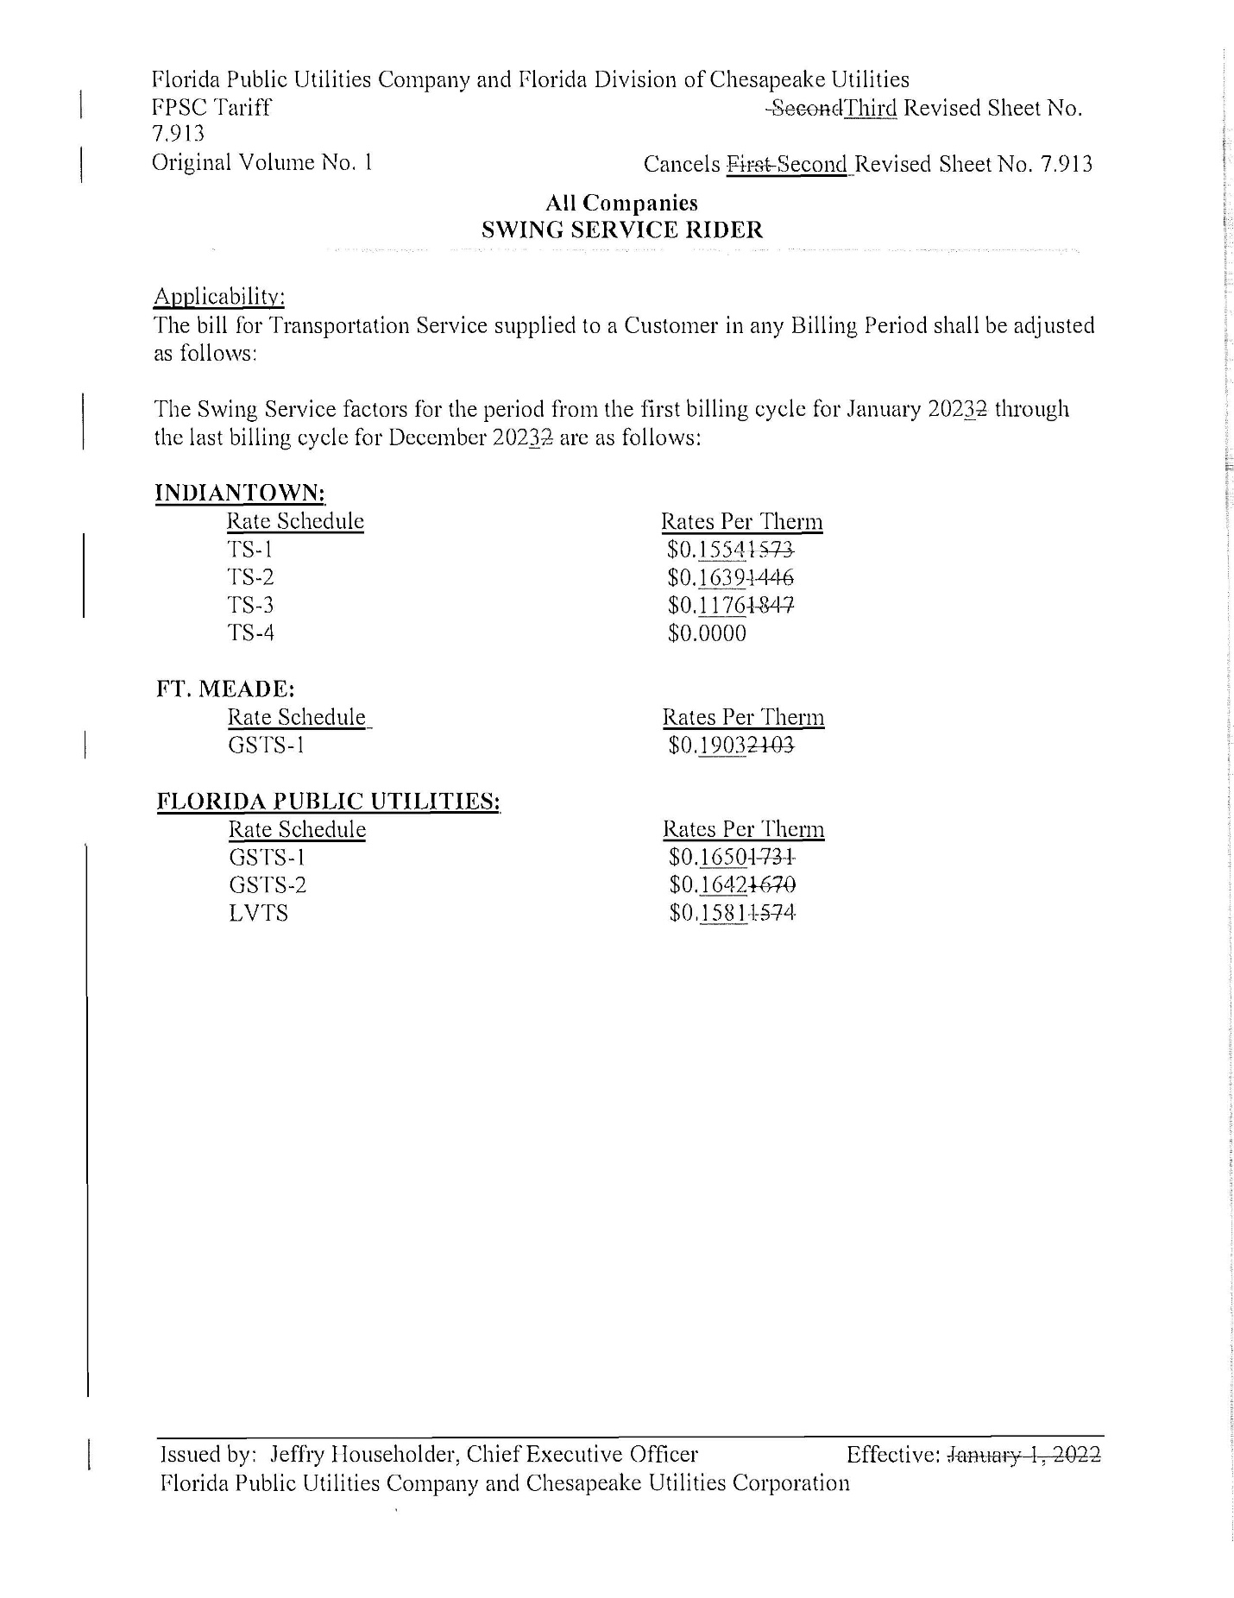
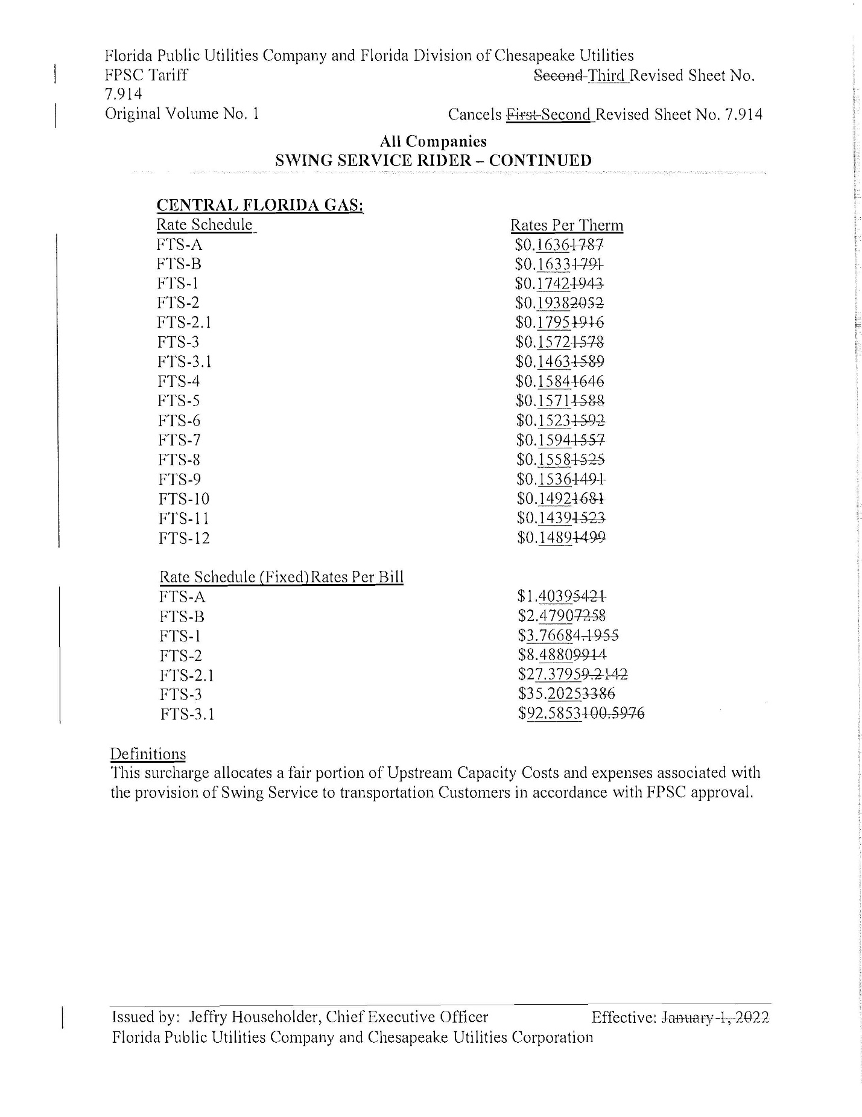

Order No. PSC-16-0422-TRF-GU, issued October 3, 2016, in Docket No. 160085-GU, In re: Joint petition for approval of swing service rider, by Florida Public Utilities Company, Florida Public Utilities Company-Indiantown Division, Florida Public Utilities Company-Fort Meade, and Florida Division of Chesapeake Utilities Corporation.
Order No. PSC-2021-0417-TRF-GU, issued November 8, 2021, consummated by Order No. PSC-2021-0450-CO-GU, issued December 3, 2021, Docket No. 20210147-GU, In re: Joint petition for approval of swing service rider rates for January through December 2022, by Florida Public Utilities Company, Florida Public Utilities Company-Indiantown Division, Florida Public Utilities Company-Fort Meade, and Florida Division of Chesapeake Utilities Corporation. This order denied the 2022 swing service rider rates and gave FPUC the option to file revised rates and charges for administrative approval by our staff that reflect our vote. On November 3, 2021, FPUC filed updated tariff sheets in accordance with our decision. See Document No. 12529-2021.
Docket No. 20220067-GU: Petition for rate increase by Florida Public Utilities Company, Florida Division of Chesapeake Utilities Corporation, Florida Public Utilities Company-Fort Meade, and Florida Public Utilities Company-Indiantown Division.
Total costs recovered through the swing service rider rates are at issue in this docket and not subject to change in the rate case docket.
The PGA charge is set by us in the annual PGA cost recovery clause proceeding.
We do not regulate the shippers or their charges for the gas commodity.
See direct testimony of Robert Waruszewski, page 5, lines 13-21, filed on September 1, 2022, Document No. 05938-2022, in Docket No. 20220154-GU.
See direct testimony of witness Robert Waruszewski on behalf of FPUC, filed on August 5, 2022, Document No. 05268-2022, in Docket No. 20220003-GU, Exhibit No. RCW-2, Schedule E-1, line 8 on Page 1 of 6 and direct testimony of Robert Waruszewski, page 6 lines 9-12, filed on September 1, 2022, Document No. 05938-2022, in Docket No. 20220154-GU.
Order No. PSC-2021-0266-S-PU, issued July 22, 2021 and Order No. PSC-2021-0266-S-PU Amendatory Order No. PSC-2021-0266A-S-PU, issued August 26, 2021, in Docket No. 20200194-PU, In re: Petition for approval of regulatory assets to record costs incurred due to COVID-19, by Florida Public Utilities Company, Florida Public Utilities Company – Indiantown Division, Florida Public Utilities Company - Fort Meade, Florida Division of Chesapeake Utilities Corporation.
Exhibit A in Document No. 07608-2021, filed July 8, 2021, in Docket No. 20200194-PU.

