|  |  |  |  |
| --- | --- | --- | --- |
| State of Florida  pscSEAL | | Public Service Commission  Capital Circle Office Center ● 2540 Shumard Oak Boulevard Tallahassee, Florida 32399-0850  -M-E-M-O-R-A-N-D-U-M- | |
| DATE: | January 11, 2023 | | |
| TO: | Office of Commission Clerk (Teitzman) | | |
| FROM: | Division of Economics (Guffey, Barrett, Draper, Galloway, Hampson, Kunkler, McNulty, Smith II, Ward, Wu)  Division of Accounting and Finance (Andrews, D. Buys, Cicchetti, Fletcher, Gatlin, Hinson, Mouring, Norris, Snyder)  Division of Engineering (Ellis, King, Knoblauch, Ramos, Wooten)  Office of the General Counsel (Sandy, Crawford) | | |
| RE: | Docket No. 20220067-GU – Petition for rate increase by Florida Public Utilities Company, Florida Division of Chesapeake Utilities Corporation, Florida Public Utilities Company - Fort Meade, and Florida Public Utilities Company - Indiantown Division. | | |
| AGENDA: | 01/24/23 – Special Agenda – Post-Hearing Decision – Participation is Limited to Commissioners and Staff | | |
| COMMISSIONERS ASSIGNED: | | | Clark, Fay, Passidomo |
| PREHEARING OFFICER: | | | Passidomo |
| CRITICAL DATES: | | | 06/21/23 (12-Month Effective Date) |
| SPECIAL INSTRUCTIONS: | | | None |

Table of Contents

Issue Description Page

Case Background 4

**Test Period and Forecasting** 6

1 Projected Test Year (Kunkler) 6

2 Customer and Therm Forecasts (Kunkler) 8

3 Estimated Gas Revenues (Kunkler) 13

**Quality of Service** 16

4 Quality of Service (Knoblauch) 16

**Depreciation Study** 19

5 Depreciation Parameters (Wu, Smith) 19

6 Resulting Imbalances (Wu, Smith) 28

7 Corrective Depreciation Measures (Wu, Smith) 30

8 Type 2 Stipulation 33

**Rate Base** 34

9 Adjustments to Reflect GRIP Investments (Wooten, Andrews) 34

10 Type 2 Stipulation 36

11 Environmental Costs (Knoblauch) 37

12 Safety Town Plant-in-Service (Wooten) 39

13 Florida Common and Corporate Common Plant (Gatlin, Wu, Smith) 41

14 Non-utility Activities (Gatlin) 43

15 Type 2 Stipulation 45

16 Plant in Service (Gatlin) 46

17 Accumulated Depreciation (Hinson) 48

18 Acquisition Adjustment (Andrews) 50

19 Type 2 Stipulation 54

20 Type 2 Stipulation 55

21 Unamortized rate case expense (Hinson) 56

22 Prepaid Directors and Officers Liabiltiy Insurance (Andrews) 60

23 Working capital (Andrews) 62

24 Rate base (Hinson) 66

**Cost of Capital** 68

25 Short-term Debt (D. Buys) 68

26 Long-term Debt (D. Buys) 70

27 Customer Deposits (D. Buys) 72

28 Accumulated Deferred Taxes (D. Buys) 74

29 Equity Ratio (D. Buys) 76

30 Return on Equity (D. Buys) 81

31 Weighted Average Cost of Capital (D. Buys) 94

**Net Operating Income** 99

32 Type 2 Stipulation 99

33 Non-utility Activities (Gatlin) 100

34 Number of Employees (Andrews) 102

35 Partial Type 2 Stipulation 104

36 Type 2 Stipulation 110

37 D&O Insurance Expense (Andrews) 111

38 O&M Expenses (Kunkler, Barrett, Andrews) 115

39 Storm Damage Accrual and Cap (Knoblauch, Andrews) 118

40 Parent Debt Adjustment (D. Buys) 120

41 Regulatory Commission Expense (Hinson) 123

42 Uncollectible Accounts and Bad Debt (Gatlin) 127

43 Type 2 Stipulation 132

44 O&M Expenses (Hinson, Wooten) 133

45 Florida Common and Corporate Common Depreciation Expense (Gatlin, Wu, Smith) 137

46 GRIP Program Depreciation Expense (Wu, Smith) 139

47 Depreciation and Amortization Expense (Hinson, Wu, Smith) 141

48 Interest Synchronization (Gatlin) 143

49 Acquisition Expense Amortization Adjustment (Andrews) 145

50 Taxes Other Than Income (Hinson) 147

51 Income Tax Expense (Gatlin, D. Buys) 149

52 Total Operation Expense (Hinson) 151

53 Net Operating Income (Hinson) 153

**Revenue Requirements** 155

54 Revenue Expansion Factor (Gatlin) 155

55 Annual Operating Revenue Increase (Gatlin) 158

**Cost of Service and Rate Design** 160

56 Cost of Service Consolidation (Guffey, Hampson) 160

57 Cost of Service Study (Guffey, Hampson) 163

58 Residential and Commercial Rate Classes (Ward) 165

59 Customer Charges (Ward) 168

60 Per Therm Distribution Charges (Ward) 169

61 Consolidated Miscellaneous Service Charges (Hampson) 170

62 Type 2 Stipulation 173

63 Environmental Cost Recovery Surcharge (Hampson, Knoblauch) 174

64 Non-rate Related Tariff Charges (Hampson) 180

65 Rates and Charges Effective Date (Guffey) 182

**Other Issues** 183

66 Rate Adjustment Mechanism (D. Buys) 183

67 Type 2 Stipulation 186

68 Interim Increase (Hinson) 187

69 Description of Adjustments (Hinson) 189

70 Close Docket (Sandy) 191

Attachment 1 192

Attachment 2 198

Attachment 3 199

Attachment 4 205

Attachment 5 206

Case Background

This proceeding commenced on May 24, 2022, with the filing of a petition for a permanent rate increase and to consolidate the four natural gas utilities into one utility operating under the name Florida Public Utilities Company, by Florida Public Utilities Company (FPUC), Florida Division of Chesapeake Utilities Corporation (Chesapeake), Florida Public Utilities Company-Fort Meade (Ft. Meade), and Florida Public Utilities Company-Indiantown Division (Indiantown) (collectively the Company). The four natural gas utilities provide sales and transportation of natural gas and are public utilities subject to the Commission’s regulatory jurisdiction under Chapter 366, Florida Statutes (F.S.). Pursuant to Section 366.06(2) and (4), F.S., the Company requested that this rate case be processed using the Commission’s hearing process.

In 2009, Chesapeake Utilities Corporation (CUC), a Delaware corporation, which owned and operated Chesapeake, acquired FPUC’s electric and gas divisions. In 2010, Florida Public Utilities Company acquired Indiantown Gas Company, and in 2013 the natural gas assets of Fort Meade, a municipal utility.

The Company currently serves approximately 92,000 residential, commercial, and industrial customers in 26 counties throughout the state of Florida. In its petition, the Company requested an increase of $43.8 million in additional annual revenues. Of that amount, $19.8 million is associated with moving into base rates the Company’s current investment in the Commission-approved Gas Reliability Infrastructure Program (GRIP), which is being recovered through a separate surcharge on customers’ bills, into base rates. The remaining $24 million, according to FPUC, is necessary for the Company to earn a fair return on its investment and a requested return on equity of 11.25 percent. The Company based its request on a 13-month average rate base of $454.9 million for the projected test year January through December 2023. The requested overall rate of return is 6.43 percent.

FPUC’s last approved rate case was in 2008,[1] Chesapeake’s last rate case was in 2009,[2] and Indiantown’s last rate case was in 2003, prior to its acquisition in 2010.[3] Ft. Meade was a municipal utility prior to its acquisition in 2013 and has not had a rate case prior to this pending docket. More recently, by Order No. PSC-2021-0148-TRF-GU,[4] the four individual utilities’ tariffs were consolidated without modifications to customer rates. Prior to the consolidation of the tariffs, the utilities provided natural gas service under four separate Commission-approved tariffs.

The Company stated that the key drivers for the proposed rate increase are: capital investments to expand service, technology and safety investments, increased insurance premiums, and an increase in cost of materials and labor as a result of high inflation. As part of its petition, the Company filed a new 2023 depreciation study, a cost recovery environmental surcharge, revisions to its Area Expansion Program (AEP), and consolidated rate structures.

The Company also requested an interim rate increase of $7.13 million. Section 366.071, F.S., addresses interim rates and procedures and requires the Commission to authorize within 60 days of a filing for an interim rate increase the collection of interim rates. On June 7, 2022, the Company waived the 60-day provision of Section 366.071(2), F.S., and agreed to defer implementation of the proposed interim rates until the issue was addressed at the scheduled August 2, 2022 Agenda Conference.[5] In Order No. PSC-2022-0308-PCO-GU, the Commission approved interim rates effective for all of the Company’s meter readings occurring on or after thirty days from the date of the vote.

Order No. PSC-2022-0195-PCO-GU acknowledged intervention by the Office of the Public Counsel (OPC). In Order No. PSC-2022-0320-PCO-GU, intervention was granted to the Florida Industrial Power Users Group (FIPUG). In Order No. PSC-2022-0288-PCO-GU, the Commission suspended the proposed permanent increase in rates and charges.

Three virtual customer service hearings were held on August 30 and 31, 2022. Four customers testified at the virtual service hearings and expressed concern about a rate increase. In addition, two in-person customer service hearings were held at the following locations and dates: West Palm Beach, September 20, 2022 and Winter Haven, September 21, 2022. No customers testified at the in-person service hearings. An administrative hearing was held from October 25 through 26, 2022. At the hearing, the Commission approved the following stipulated Issues: 8, 10, 15, 19, 20, 32, 35 (partial stipulation), 36, 43, 62, and 67.

The Commission received approximately 470 customer letters that have been placed in correspondence in the docket. A majority of the customers urged the Commission to not increase their gas rates during these financially challenging times.

This recommendation addresses the requested permanent rate increase. The Commission has jurisdiction over this matter pursuant to Chapter 366, F.S., including Sections 366.06 and 366.071, F.S.

Discussion of Issues

**Test Period and Forecasting**

Issue 1:

 Is FPUC's projected test period of the twelve months ending December 31, 2023, appropriate?

Recommendation:

 Yes. FPUC’s projected test period of the twelve months ending December 31, 2023, is appropriate. (Kunkler)

Position of the Parties

FPUC:

 Yes. FPUC’s forecasts of customer and therm sales by rate class are based upon reliable methods utilized by the Company, and accepted by the Commission, in prior rate cases for FPUC.

OPC:

 Yes, although FPUC has the burden of demonstrating that the projected period of twelve months ending December 31, 2023 is appropriate and representative of conditions that will exist when new rates go into effect. The projected test year should reflect all applicable OPC adjustments.

FIPUG:

 Adopt the position of OPC.

Staff Analysis:

PARTIES’ ARGUMENTS

FPUC

FPUC witness Cassel testified that the projected 12-month period ending December 31, 2023, is the appropriate test period as it provides an accurate reflection of the economic conditions that the Company will be expected to operate under during the first 12 months that new rates are in effect. (TR 43; TR 48) FPUC argued that the Intervenors did not challenge the appropriateness of the 2023 test period. (FPUC BR 3) FPUC stated in its brief that there was “no readily apparent difference of opinion” between FPUC and the Intervenors as it “relates to the identified test period itself.” (FPUC BR 3)

OPC

OPC argued in its brief that FPUC has the burden of demonstrating that the projected test year is representative of conditions that will exist when new rates go into effect and that the 2023 projected test year should reflect all applicable adjustments recommended by OPC. (OPC BR 4) Also addressed in OPC’s brief were concerns about potential merger activities. However, these concerns seemed to be satisfied by CUC Chief Accounting Officer Galtman’s testimony confirming there were no merger impacts under consideration that would affect the expenses the Commission is approving in this case, as well as the affirmation that he would be in the position to know of any such activities, were they to be occurring. (TR 180-184) OPC argued that Commission Order No. PSC-2009-0375-PAA-GU found that a merger in the near future could make the rates set by the Commission “inappropriate.” (OPC BR 4) By referencing that Order, as well as FPUC witness Galtman’s testimony, OPC argued that the Commission should accept these representations as an assurance that the 2023 test year can be relied upon as being fairly representative of operations for setting fair, just, and reasonable rates. (OPC BR 4)

FIPUG

FIPUG adopted the position of OPC. (FIPUG BR 1)

ANALYSIS

In general, a projected test year methodology uses forecasted data for a 12-month period to match average revenues with the average expenses and rate base investment. OPC and FIPUG do not disagree with the appropriateness of the 2023 test year, if appropriate adjustments are made (OPC BR 4). However, no Intervenors have cited any specific adjustments be made in this case to the test period. (FPUC BR 3; OPC BR 4) Further, staff notes that “adjustments” are not typically germane to this issue and agrees with FPUC that there was no readily apparent difference of opinion between the Intervenors as it related to the identified test period itself. (FPUC BR 3)

The projected 2023 test year also will incorporate the effects of FPUC’s 2023 depreciation study for which the implementation date coincides with the requested effective date of new base rates. (EXH 14; TR 507) Staff believes this synchronized timing will provide FPUC the opportunity to earn the targeted returns established by the Commission in this case.

Staff believes that FPUC’s proposed 2023 test year will result in a matching of the Company’s revenues to be produced, during the first twelve months in which the new rates would be in effect, with average rate base investment and average expenses for the same period. Therefore, staff agrees with the parties that the projected test year period of the twelve months ending December 31, 2023, is appropriate.

CONCLUSION

Yes, FPUC’s projected test period of the twelve months ending December 31, 2023, is appropriate.

Issue 2:

 Are FPUC's forecasts of customer and therms by rate class for the projected test year ending December 31, 2023, appropriate? If not, what adjustments should be made?

Recommendation:

 FPUC’s test year customer forecasts and test year therm forecasts are reasonable with one exception: FPUC’s therm forecast for the FPUC-Natural Gas Vehicle Transportation Service customer class should be adjusted (increased) in the amount of 446,798 therms. (Kunkler)

Position of the Parties

FPUC:

Yes. FPUC’s forecasts of customer and therm sales by rate class are based upon reliable methods utilized by the Company, and accepted by the Commission, in prior rate cases for FPUC.

OPC:

Yes, although FPUC has the burden of demonstrating that the forecasts of customer and therms by rate class for the projected test year ending December 31, 2023, is appropriate. The forecasts of customer and therms by rate class for the projected test year ending December 31, 2023, should reflect all applicable OPC adjustments.

FIPUG:

 Adopt the position of OPC.

Staff Analysis:

PARTIES’ ARGUMENTS

FPUC

FPUC argued in its brief that witness Taylor sufficiently addressed this issue, detailing his five-step process used to prepare the Company’s 2023 test year forecasts of customer counts and therm sales. (FPUC BR 4) Witness Taylor’s calculations relied upon ten years’ worth of data over the historic period 2012-2021. (TR 541-543, 564; EXH 18; EXH 75; EXH 89) While FPUC acknowledged the Intervenors’ position that the Company’s forecasts of customers and therms by rate class for the projected test year are appropriate, with applicable adjustments, the Company noted that no Intervenor witnesses suggested any specific adjustments to the Company’s customer and therm sales forecasts. (FPUC BR 4-5)

At hearing, witness Taylor provided rationale for the method he used to prepare FPUC’s test year therm forecast for the FPUC-Natural Gas Vehicle Transportation Service customer class (FPUC-NGVTS), relative to an optional method raised by staff counsel during cross examination. (FPUC BR 5)

Ultimately, FPUC argued that the Company’s forecasts of customer and therm sales by rate class are based upon reliable and robust methods accepted by the Commission in prior rate cases for FPUC. (FPUC BR 5) The Company further maintained that the record of this case fully supports its projected customers and therm sales as reflected in the Company’s MFRs and the exhibits of Witness Taylor. (FPUC BR 5; EXH 123; EXH 17; EXH 18)

OPC

OPC argued that FPUC has the burden of demonstrating that its forecasts of customer and therms by rate class for the 2023 test year are appropriate. OPC also noted that the forecasts of customers and therms should reflect all applicable OPC adjustments. (OPC BR 5)

FIPUG

FIPUG adopted the position of OPC. (FIPUG BR 1)

ANALYSIS

In this case, FPUC provided forecast models which detail the Company’s historical and forecasted customer counts and therm sales across the four legacy Company divisions and 54 tariffed rate classes. FPUC witness Taylor stated that the Company’s customer and therm sales estimates were developed by rigorously analyzing historical data and applying robust ARIMA and Multiple Linear Regression models, commonly used for demand forecasting across multiple industries. (TR 543) Witness Taylor further explained that for each rate class, the Company selected one of five different forecasting methods to determine the billing determinants, which are as follows:

* Use per Customer (UPC) - the forecasted customer counts are multiplied by the use per customer projections developed in the Company’s regression analysis.
* Use per Customer Growth Rate - current use per customer is escalated using the projected percent change produced by the regression analysis.
* Historical Base – utilizes 2021 customer and usage figures to forecast 2022 and 2023 with no changes.
* Historical Average – utilizes 2019-2021 billing determinants to compute an average for 2022 and 2023.
* Historical Adjusted – rate classes are adjusted to known events that will impact their forecasted usage in 2022 and 2023. (TR 542-543)

Staff analyzed FPUC’s forecast models and assumptions, historical customer and usage data (2012-2021), year-to-date accuracy (2022), and year-over-year growth rates. (EXH 75; EXH 89) The Intervenors did not present testimony or evidence to rebut FPUC’s forecast models or assumptions. Staff believes FPUC’s forecasting models and assumptions are reasonable, resulting in reasonable test year customer and therm forecasts in all instances except one. Staff believes that FPUC has under-stated the test year therm forecast for the FPUC-NGVTS customer class based on the following analysis.

The tariff associated with the FPUC-NGVTS customer class became effective on August 13, 2013, pursuant to Order No. PSC-2013-0395-PAA-GU. The tariff applies to non-residential customers buying natural gas for the purpose of compression and delivery into motor vehicle fuel tanks.[6] Staff asked the Company to reconcile its projected negative growth rate for this class for the historic base year +1 and its zero percent growth rate for 2023 test year, despite the customer class experiencing positive growth over the last five years. The Company responded that, due to “historical data variations, the historical three-year average actual data was used for forecasting purposes as no known and measurable changes were anticipated for this customer class.” The Company did not provide any additional market information relating to any anticipated changes in the number of customers and/or therm usage for this particular customer class. (EXH 110)

FPUC’s witness Taylor elected to utilize a “historical average” methodology for FPUC-NGVTS’s therm usage. (EXH 89) As shown in Table 2-1 below, this methodology uses the average of the customer class’s therm use per customer (UPC) over the historical years 2019-2021 to forecast the 2022 historic base year + 1 and 2023 test year. (TR 543) Thus, FPUC’s therm UPC decreases from 545,657 in 2021 (actual) to its forecast of 461,073 in 2022 and 2023. For FPUC, this methodology results in a negative 16 percent UPC growth rate for 2022 and 0 percent UPC growth for 2023. (EXH 89) In other words, FPUC-NGVTS had consistent, robust growth for 2019-2021, but FPUC’s methodology projects negative growth for 2022, and no growth for 2023.

Table 2-1

FPUC NGVTS Therm UPC Forecast

(FPUC and Staff Recommended)

|  |  |  |  |  |  |  |  |  |
| --- | --- | --- | --- | --- | --- | --- | --- | --- |
| **FPUC – Natural Gas Vehicle Transportation Service** | 2017 | 2018 | 2019 | 2020 | 2021 | 2022 | 2023 |  |
| **Therm UPC** | 203,625 | 321,468 | 365,987 | 471,576 | 545,657 | 461,073 | 461,073 | **FPUC Forecast**  **(2022 and 2023)** |
| 611,136 | 684,472 | **Staff Recommended**  **Forecast**  **(2022 and 2023)** |
| **UPC Growth (Y/O/Y)** | 0%* | 0%* | 14% | 29% | 16% | -16% | 0% | **FPUC Forecast**  **(2022 and 2023)** |
| 12% | 12% | **Staff Recommended**  **Forecast**  **(2022 and 2023)** |

*0 percent growth represented for 2017 and 2018 due to service being initiated during the 2016-2018 period.

Source: EXH 110; EXH 89

Witness Taylor explained that when he elected to utilize a “base period” or “historical average” forecasting methodology for a particular customer class, it was because there was “not robust progression analysis resulting from analyzing those particular rate classes, or the rate class was small enough in which a statistical analysis would not be appropriate.” (TR 570) Witness Taylor concluded that, due to the fact the FPUC–NGVTS customer class had a very small number of customers, he decided to utilize a “historical average” approach. (TR 570-571)

Witness Taylor further argued, for forecasting purposes for the FPUC–NGVTS class, a three-year average for the class was preferable, as opposed to five years, due to the predictive value of the last three years being higher than the last five years. (TR 571) Witness Taylor also noted that he prefers utilizing actual figures over just relying on percentage increases as they “better serve to illustrate the magnitude of the changes and what is occurring with the data.” (TR 574-575)

During hearing, witness Taylor agreed with staff counsel that the customer class was experiencing an increase year-over-year in usage over the 2019-2021 period. (TR 573) Staff questioned witness Taylor about how, with the noted year-over-year increases in mind, he reconciled the Company’s projected 16 percent decrease in therm UPC for this particular customer class. (TR 573) Witness Taylor responded that he believed the Company’s response to Staff’s Second Request For Production of Documents, No. 10 was supplemented with updated bills and usage figures for 2019, 2020, and 2021, which would better align with the Company’s forecast. (TR 569, TR 573) However, staff notes that the 2019-2021 usage amounts contained in the supplemented document referenced by witness Taylor steadily increased during this period, while the customer count (2) remained static, resulting in increasing UPC amounts for the time period as shown in Table 2-1 above. Thus, staff believes the Company’s historical usage amounts for the FPUC-NGVTS customer class do not align with the Company’s forecasted UPC decrease in 2022 and static UPC growth in 2023. (EXH 89; EXH 110)

In addition to the “historical average” forecasting review, staff also reviewed the year-to-date therm UPC (January 2022-June 2022) for the FPUC-NGVTS customer class. (EXH 75) The Company’s therm UPC for the first half of 2022 shows that FPUC’s monthly UPC forecast for the customer class in question had been under-forecasted by an average of 20.8 percent. (EXH 75)

Staff believes this resulting test year forecast by the Company is not reasonable, given the consistent experienced growth in UPC over the past 3.5 years. (EXH 89; EXH 110) Taking into account the consistent experienced historic UPC growth, as well as the year-to-date UPC under-forecast by the Company for this customer class, staff believes an adjustment to increase FPUC’s therm sales forecast for the FPUC-NGVTS customer class is appropriate.

Staff notes that, since this customer class did not have any customers prior to 2016, when service was initiated during the 2016–2018 period, extremely high usage growth was experienced by this customer class. For this reason, as a conservative estimate of trend, staff believes that the Company’s application of a 0 percent growth rate for 2017 and 2018 is appropriate. (EXH 110)

As shown in Table 2-1, averaging the past 5 years of therm UPC growth for the class (including the zero percent growth for 2017 and 2018) results in an average 12 percent growth for the customer class over the historic years 2017-2021. Staff believes that extending the average 12 percent growth experienced over the historic period from 2017-2021 to the 2022 historic base year +1 and 2023 test year presents a reasonable projection of this customer class’s therm UPC for the 2023 test year.

As mentioned above, the FPUC–NGVTS customer class experienced therm UPC of 545,657 in 2021. (EXH 89) Staff recommends applying a 12 percent growth rate, resulting in a forecasted therm UPC of 611,136 for the historic base year +1, and a forecasted therm UPC of 684,472 for the projected test year, as shown in Table 2-1. This represents an increase in the amount of 223,399 therm UPC to FPUC’s test year forecast of 461,073 therm UPC for the customer class. After multiplying the staff recommended UPC increase of 223,399 by the class’s customer count (2), staff calculated an adjustment (increase) to the test year therm sales for the FPUC-NGVTS customer class in the amount of 446,798 therms.

Based on the foregoing, staff believes an adjustment (increase) of 446,798 therms in the 2023 test year to the Company’s therm sales forecast for the FPUC–NGVTS customer class is appropriate and necessary.

CONCLUSION

FPUC’s test year customer forecasts are reasonable and FPUC’s test year therm forecasts are reasonable with one exception: FPUC’s therm forecast for the FPUC-Natural Gas Vehicle Transportation Service customer class should be adjusted (increased) in the amount of 446,798 therms to account for the trend in growth for this class.

Issue 3:

 Are FPUC's estimated revenues from sales of gas by rate class at present rates for the projected test year appropriate? If not, what adjustments should be made?

Recommendation:

 If staff’s recommended adjustment in Issue 2 is approved, FPUC’s estimated revenues from sales of gas by rate class at present rates should be increased by $179,063 to reflect the adjustment (increase) to therm sales for the FPUC-Natural Gas Vehicle Transportation Service customer class for the projected test year. If staff’s recommended adjustment in Issue 2 is not approved and the Commission approves FPUC’s customer and therm forecasts as-filed, then no adjustment to FPUC’s estimated revenues from sales of gas by rate class at present rates is necessary. (Kunkler)

Position of the Parties

FPUC:

 Yes. FPUC applied the Company’s present rates to the forecasted billing determinants, which produced the estimated gas sales revenues for the 2023 projected test year.

OPC:

 Yes, although FPUC has the burden of demonstrating that the estimated revenues from sales of gas by rate class at present rates for the projected test year is appropriate. The estimated revenues from sales of gas by rate class at present rates for the projected test year should reflect all applicable OPC adjustments.

FIPUG:

 Adopts the position of OPC.

Staff Analysis:

PARTIES’ ARGUMENTS

FPUC

In its brief, FPUC explained how witness Taylor formulated the Company’s projections of revenues from sales of gas at current rates by rate class. (FPUC BR 6) FPUC acknowledged that while the Intervenors’ agreed with the Company’s estimated revenues from sales of gas by rate class at current rates for the projected test year, the Intervenors include the caveat of “with applicable adjustments.” (FPUC BR 6) The Company noted no Intervenor witnesses suggested any specific adjustments to the projected test year revenues be made. (FPUC BR 6)

FPUC maintained that the Company’s estimated revenues from sales of gas by rate class at current rates for the projected 2023 test year are based upon reliable and robust methods accepted by the Commission in prior rate cases for FPUC, and are appropriate as filed. (FPUC BR 6) The Company asserted that the record of this case fully supports its revenues from sales of gas by rate class at current rates as reflected in the Company’s MFRs and the testimony and exhibits of Witness Taylor. (EXH 123; EXH 17; EXH 18)

OPC

OPC argued in its brief that FPUC has the burden of demonstrating that the Company’s forecasts of revenues from sales of gas by rate class at current rates for the projected 2023 test year are appropriate. OPC also noted that the forecasts of revenues from sales of gas by rate class at current rates should reflect all applicable OPC adjustments. (OPC BR 5)

FIPUG

FIPUG adopted the position of OPC. (FIPUG BR 1)

ANALYSIS

This issue reflects FPUC’s estimated revenues from sales of gas by rate class at present rates for the projected test year. As explained in Issue 2, FPUC provided forecast models which detail the Company’s forecasted customer counts and therm sales across the four legacy Company divisions and 54 tariffed rate classes for the 2023 test year. Once the forecasted customer counts and therm sales are established, they are multiplied by FPUC’s current rates for each customer class and summed to yield total revenues.

Staff determined that FPUC used the correct current rates for all customer classes in its calculations of test year revenue. (EXH 123) Staff also determined that in all instances, the revenue forecasts for all customer classes were reasonable, with the exception of the FPUC –FPUC-NGVTS customer class, as discussed in Issue 2. Furthermore, staff notes that the Intervenors did not present testimony or evidence to rebut FPUC’s test year forecast of revenues from sales of gas at current rates.

As detailed in MFR Schedule G-2, as well as FPUC witness Taylor’s filed Average Annual Bill Impact, the current energy charge with GRIP for the FPUC-Natural Gas Transportation Service customer class is $0.40077 per therm. (EXH 123; EXH 20) Table 3-1 illustrates FPUC-NGVTS test year revenue (energy) at current rates according to FPUC and staff. Projected energy revenue for this customer class, according to FPUC, is $369,569. However, as explained in Issue 2, staff believes the Company’s therm UPC projections for this customer class are significantly understated, resulting in understated projected revenues at current rates.

As shown in Table 3-1, Row 2, the staff-adjusted 2023 therm UPC of 684,472 (per Issue 2) yields a total 2023 Test year therm sales projection of 1,368,944 therms for the FPUC-NGVTS customer class. Applying the current energy charge of $0.40077 per therm to this forecasted therm total, staff calculates 2023 projected energy revenue from sales at current rates for the customer class equal to $548,632 (1,368,944 X $0.40077). This represents an adjustment (increase) in the amount of $179,063 to FPUC’s as-filed 2023 revenue projection, as detailed in Table 3-1 below.

Table 3-1

2023 Projected Test Year Revenues for FPUC-NGVTS Customer Class at Current Rates

(FPUC and Staff Recommended)

|  |  |  |  |  |  |  |
| --- | --- | --- | --- | --- | --- | --- |
|  |  | A | B | C | D | E |
| **Row** | **FPUC – Natural Gas Vehicle Transportation Service** | Therm UPC | Customer Count | Therm Sales  (A x B) | Current Energy Charge (w/GRIP) | Projected Revenue from Therm Sales at Current Rates  (C x D) |
| **1** | **FPUC** | 461,073 | 2 | 922,147 | $0.40077 | $369,569 |
| **2** | **Staff Recommended** | 684,472 | 2 | 1,368,944 | $0.40077 | $548,632 |
| **3** | **Difference**  **(Staff Rec Less FPUC)** | 223,399 | - | 446,797 | - | $179,063 |

Source: EXH 123; EXH 17; EXH 20; EXH 89

Based on the foregoing, staff believes this recommended adjustment (increase) in the amount of $179,063 to revenues from sales of gas at current rates for the FPUC–NGVTS customer class is necessary and appropriate.

CONCLUSION

If staff’s recommended adjustment in Issue 2 is approved, FPUC’s estimated revenues from sales of gas by rate class at present rates should be increased by $179,063 to reflect the adjustment (increase) to therm sales for the FPUC-Natural Gas Vehicle Transportation Service customer class for the projected test year. If staff’s recommended adjustment in Issue 2 is not approved and the Commission approves FPUC’s customer and therm forecasts as-filed, then no adjustment to FPUC’s estimated revenues from sales of gas by rate class at present rates is necessary.

**Quality of Service**

Issue 4:

 Is the quality of service provided by FPUC adequate?

Recommendation:

 Staff recommends that FPUC’s quality of service is adequate. (Knoblauch)

Position of the Parties

FPUC:

 Yes. FPUC provides a high quality of service as indicated by its reduced complaint levels, which reflect an average 31% annual reduction in customer complaint levels from 2013 to 2021.

OPC:

 FPUC has the burden of demonstrating that quality of service is appropriate. The multiple customer comments filed in the docket urge the Commission not to allow a rate increase at this time due to the extremely challenging times. There were 126 complaints over 5 years, 65% regarding billing and 35% regarding quality of service. Apart from the demonstrable complaints, the quality of service appears otherwise adequate.

FIPUG:

 Adopts the position of OPC.

Staff Analysis:

PARTIES’ ARGUMENTS

FPUC

FPUC argued that as outlined in the testimony of FPUC witness Parmer, the Company’s quality of service is very good, and it continues to make improvements as demonstrated by the reduction in complaints. This was further shown by the lack of quality of service concerns raised at the service hearings and that only 126 customer complaints were filed with the Commission over a five-year period. FPUC argued that several witnesses presented testimony on the advancements the Company is making to it customer service, including FPUC witness Galtman’s testimony on core values and website enhancements. (FPUC BR 7) FPUC argued that while the time period used in staff witness Calhoun’s testimony differed from that of witness Parmer’s testimony, the number of complaints was still low. Additionally, the Company argued that the customer comments filed in the docket were not sworn testimony and had not been confirmed to be FPUC customers. (FPUC BR 8) FPUC argued that consistent with its obligations under Section 366.03, F.S., its quality of service is reasonably sufficient, adequate, and efficient. (FPUC BR 9)

OPC

OPC argued when comparing the customer complaints presented by staff witness Calhoun and FPUC witness Parmer, there were discrepancies between the testimonies. Therefore, the number of complaints and the reduction of complaints identified by witness Parmer did not appear to be supported. (OPC BR 6) OPC also argued that while customers were encouraged to mail or email their comments regarding the Company, no witness testified to the customer correspondence filed in the docket. (OPC BR 6-7) OPC argued the number of individual comments filed in the docket was over 100, not considering duplicate comments, which were from customers in opposition to the rate increase due to “extremely challenging times.” OPC argued that FPUC has the burden to demonstrate that its quality of service is appropriate and apart from the recorded complaints, the quality of service appears to be adequate. (OPC BR 7)

FIPUG

FIPUG adopted the position of OPC. (FIPUG BR 1)

ANALYSIS

Pursuant to Section 366.041, F.S., in fixing rates the Commission is authorized to give consideration, among other things, to the efficiency, sufficiency, and adequacy of the facilities provided and the services rendered. The Commission held three virtual service hearings on August 30 and 31, 2022. Additionally, the Commission held two in-person service hearings within FPUC’s service territory on September 20 and 21, 2022. The service hearings provide an opportunity for customers to raise concerns regarding FPUC’s quality of service and its request for a rate increase. Four customers participated at the virtual service hearings, all of whom spoke to the requested rate increase with one customer also discussing FPUC’s customer service. The customer stated that they had contacted the Company several times and had not received a response regarding a billing inquiry. No customers spoke at the in-person service hearings, which were held in West Palm Beach and Winter Haven. FPUC serves approximately 92,000 customers.

The Company indicated that it received 143 customer complaints between the years 2013 through 2021, which included 61 service complaints and 82 billing complaints. (EXH 79, BSP 89) FPUC witness Parmer testified that since 2013, there had been a 35 percent or more annual reduction in the number of complaints logged. (TR 374) Witness Parmer also testified to the customer service improvements that had been made by FPUC, which included enhancements to call systems, customer satisfaction tracking, payment options, and Company-to-customer communications. (TR 367-369, 371-378) Additionally, FPUC witness Gadgil testified that a variety of technologies had been employed to protect the personal identifiable information of its customers. (TR 583-584)

Staff witness Calhoun testified to the number of consumer complaints logged with the Commission against FPUC, Chesapeake, Indiantown, and Fort Meade from July 1, 2017, to June 30, 2022. (TR 933)

* FPUC: 104 complaints. Of those complaints, 29 were transferred to the Company, and approximately 64 percent of the complaints were related to billing issues and approximately 36 percent involved quality of service issues. Additionally, 16 billing complaints and 3 service quality complaints appeared to demonstrate a violation of Commission Rules. (TR 933, 935)
* Indiantown: two complaints, both concerning quality of service issues. (TR 933, 936)
* Chesapeake: 19 complaints. Of those complaints, 1 was transferred to the Company, 13 were related to billing issues, and 5 involved quality of service issues. Additionally, two billing complaints and two service quality complaints appeared to demonstrate a violation of Commission Rules. (TR 934, 936)
* Fort Meade: one complaint concerning a billing issue. Additionally, one complaint appeared to demonstrate a violation of Commission Rules. (TR 934, 936)

Pursuant to Rule 25-7.018, Florida Administrative Code (F.A.C.), each utility shall keep a complete record of all interruptions affecting the lesser of 10 percent or 500 or more of its division meters. Based on the Company’s filing, there were no customer interruptions affecting either 10 percent or 500 meters during the historic test year. (EXH 123) Based on a review of all witness and customer testimony and consideration of the information presented above, staff recommends that FPUC’s quality of service is adequate.

CONCLUSION

Staff recommends that FPUC’s quality of service is adequate.

**Depreciation Study**

Issue 5:

 Based on FPUC's Revised 2023 Depreciation Study, what are the appropriate depreciation parameters (e.g., service life, remaining life, net salvage percentage, and reserve percentage) and resulting depreciation rate for each distribution and general plant account?

Recommendation:

 Staff’s recommended depreciation parameters and resulting depreciation rates for each distribution and general plant account are shown on Table 5-1. (Smith, Wu)

Position of the Parties

FPUC:

 The appropriate depreciation parameters and rate components are set forth in the depreciation study submitted as Revised Exhibit PSL-2 to the direct testimony of Patricia Lee on behalf of the Company.

OPC:

 The Commission should adopt the following service lives: Acct. 378-M&R Equip. – General (46 years); Acct. 3801, M&R Equip. – City Gate (49 years); Services – Plastic (57 years); and Acct. 381 – Meters (30 years). EX 57, 62, and 63. Adopting witness Garrett’s depreciation rates results in an adjustment reducing the Company’s proposes annual depreciation accrual by $250,098 when applied to the filed plant and reserve balances and a reduction to FPUC’s 2023 revenue request by $2.073 million for new lower depreciation rates. (TR 773; 858; EX 64)

FIPUG:

 Adopts the position of OPC.

Staff Analysis:

PARTIES’ ARGUMENTS

FPUC

FPUC argued in its brief that the appropriate depreciation parameters are those presented in Revised Exhibit PSL-2 to the direct testimony of FPUC witness Lee. (FPUC BR 9) Further, the Company stated the depreciation study was conducted in accordance to Rule 25-7.045, F.A.C. (the Depreciation Rule). In keeping with the Depreciation Rule, FPUC explained that witness Lee proposed several changes to certain account life and salvage parameters. (FPUC BR 10) These proposed changes in depreciation parameters result in a reduction in depreciation expense of approximately $1.5 million, based on estimated investments and reserves as of January 1, 2023. (FPUC BR 10)

The Company also argued for and supported witness Lee’s reliance on life characteristics for similar plant of other Florida gas companies to make a complete analysis. (FPUC BR 12) Witness Lee explained that retirement rates for FPUC averaged less than one percent since the last depreciation study for many accounts, which provided insufficient data to perform any meaningful statistical analyses for life characteristics, which led her to rely on life characteristics for similar plant of other Florida gas companies to make a complete analysis. (FPUC BR 12) The Company argued that this is a common and accepted industry practice. (TR 521; FPUC BR 12)

FPUC argued in support of witness Lee’s approach for conducting the Depreciation Study. (FPUC BR 10) Witness Lee conducted the Depreciation Study with the same approach as the Company’s previous studies. (FPUC BR 10) This approach did not include statistical analysis in order to produce Iowa curves for each account.[7] (FPUC BR 10) Instead, witness Lee examined the currently-approved Iowa curves for each account and found them all to be reasonable. (FPUC BR 10) The remaining lives for each account were developed using the average life, Iowa Curve, and average age as of January 1, 2023. (FPUC BR 10)

Supporting the approach to the Depreciation Study analysis, FPUC argued that witness Lee used her recommended average service lives and Iowa curve, along with the average age of each account, and applied those to the GTE life tables contained in Hearing Exhibits 15 and 72, in order to determine her recommended remaining lives. (FPUC BR 12) As stated previously, the depreciation rates which result from witness Lee’s recommended depreciation parameters reflect a decrease in depreciation expense of approximately $1.5 million based on estimated investment and reserves as of January 1, 2023. (FPUC BR 12-13)

In its brief, FPUC stated that OPC witness Garrett took issue with witness Lee’s analysis. (FPUC BR 13) FPUC pointed out that witness Garrett’s service life recommendations flowed through to OPC witness Smith’s analysis regarding accumulated depreciation and depreciation expense. (FPUC BR 13) FPUC argued that witness Garrett’s criticisms of witness Lee’s analysis “was her lack of actuarial analysis, which isn’t a requirement in Florida, and a reliance on a comparative analysis utilizing only Florida-based gas companies.” (FPUC BR 13) FPUC stated that witness Garrett’s argument is that witness Lee’s reliance on a comparison of only Florida-based gas companies can create a feedback loop which can result in less accurate historical data. (FPUC BR 13) FPUC argued that witness Garrett’s methodology relied on the same process as witness Lee’s. FPUC argued that witness Garrett’s peer group, with the addition of three non-Florida-based gas companies, Northern Indiana Public Service Company, Liberty Utilities, and Piedmont Natural Gas, is very similar to witness Lee’s peer group. (FPUC BR 13)

FPUC stated that witness Garrett made adjustments to the service lives of only four accounts (FPUC BR 13) FPUC continued by stating that witness Garrett adjusted additional accounts without a clear explanation. (FPUC BR 13) FPUC argued that, while witness Garrett did not offer a different service life, curve shape, average age, or net salvage, he arrived at a different average remaining life and depreciation rate for Account 396 with no clear explanation. (FPUC BR 13)

FPUC argued that, even with OPC witness Garrett’s criticism of witness Lee’s use of Florida-based gas companies in her analysis, witness Garrett conceded that witness Lee’s proposed service lives for FPUC’s accounts were generally longer than the service lives for the same accounts he included in his analysis. (FPUC BR 13) FPUC pointed out that witness Garrett further stated that it was “not unreasonable” to use data only from other Florida utilities. (FPUC BR 13)

FPUC also argued that witness Garrett conceded he had not done any analysis with regard to the impact of environmental conditions on service lives. (FPUC BR 14) FPUC stated that the observed life tables from Northern Indiana Public Service Company do not show any consideration for impacts of environmental conditions, such as hurricanes, saltwater intrusion, or the resulting corrosion. (FPUC BR 14) FPUC further stated that, based on the above, witness Garrett’s use of a utility from Indiana for comparison purposes does not result in an “apples to apples” comparison. (FPUC BR 14)

FPUC stated that witness Garrett reflected the wrong service lives for certain accounts of his peer group utilities. (FPUC BR 14) FPUC argued that witness Lee demonstrated, in Exhibit PSL-6, that even when the companies from witness Garrett’s peer group are added to the Florida group, the average service lives proposed by witness Garrett are longer than the average of this combined group. (EXH 71; FPUC BR 14)

OPC

OPC argued that one primary component of depreciation that relies on estimation is service lives. (OPC BR 7) OPC witness Garrett’s main disagreement with FPUC’s proposed service lives is that they rely on a Florida-only peer group and that they do not rely on historical data. (OPC BR 7) OPC argued that a “feedback loop” can be created when relying only on Florida-based utilities. (OPC BR 7)

Witness Garrett testified that the Company must meet the legal standard showing that its proposed depreciation rates are not overestimated. (OPC BR 7) Witness Garrett argued that underestimating service lives (and, as a result, overestimating depreciation rates) can lead to economic inefficiencies and can harm customers. (OPC BR 8) In contrast, if service lives are overestimated, the utility can rely on regulators to ensure customers are not economically harmed. (OPC BR 8)

OPC stated that, since historical data was not available in this case, witness Garrett utilized a peer group to estimate service lives, including utilities from within Florida and other coastal areas. (OPC BR 8) These utilities were selected by witness Garrett due to the large amount of historical data available for actuarial analysis and his involvement in those studies. (OPC BR 8) Based on his peer group, witness Garrett proposed longer lives for four of FPUC’s accounts. (OPC BR 8)

OPC stated that FPUC witness Lee’s main criticism of witness Garrett’s peer group is that it contains data from outside the state of Florida. (OPC BR 8) OPC argued that witness Lee conceded that she had not done any studies that show that the conditions in which Florida companies operate are any harsher than the conditions confronting companies in witness Garrett’s peer group. OPC stated that the Commission should adopt the following service lives: Account 378 – M&R Equipment – General (46 years); Account 3801 – M&R Equipment – City Gate (49 years); Services – Plastic (57 years); and Account 381 – Meters (30 years). (OPC BR 8)

FIPUG

FIPUG adopted the position of OPC. (FIPUG BR 1)

ANALYSIS

This issue addresses the depreciation parameters and appropriate resulting depreciation rates for FPUC’s plant accounts which are categorized as distribution and general accounts. Staff’s recommended depreciation parameters include the average service life (ASL) and the remaining life (in years), net salvage percentage, reserve percentage, and curve shape.

In order to arrive at the appropriate resulting depreciation rates, each parameter plays a part in the calculation. Combining these parameters provides the account-specific depreciation rates on a going-forward basis, which is the remaining life rate. The remaining life rate is designed to recover the remaining unrecovered balance (investment less net salvage less reserve) over the remaining life of the associated investment. The formula for the remaining life rate is the plant investment (represented as 100 percent) minus net salvage percent minus reserve percent divided by the average remaining life in years.[8]

For each account, FPUC provided a proposal for a curve and an ASL, both of which are used in the calculation of the remaining life. OPC witness Garrett also provided proposals for curves as well as ASLs. However, the only parameters in dispute in this case are the ASL and average remaining life (ARL) for certain accounts.

Average Service Life

The first parameter is the ASL, which denotes the average number of years that the asset (within a particular account) is expected to be in-service. While the ASL may be based, at least in part, on historical data, it is prospective in its outlook and implementation. Based on FPUC’s Revised Depreciation Study and OPC witness Garrett’s Direct Testimony, five average service lives were in dispute. (TR 958-959) Despite the fact that FPUC witness Lee studied Accounts 3801 – Service – Plastic and Account 380G – Services – GRIP together, OPC witness Garrett offered two different depreciation rates for these assets. (TR 958) Therefore, only four ASLs were originally in dispute. In his supplemental testimony, witness Garrett agreed with FPUC on a 28-year ASL for Account 381 – Meters. (TR 875-876) Therefore, the average service lives that remain in dispute are:

Account 378 – M&R – General

Account 379 – M&R – City Gate

Account 3801 – Services – Plastic. (TR 876)

Witness Garrett takes issue with the fact that FPUC did not provide adequate aged data in which to conduct an actuarial service life analysis. (TR 772) However, as witness Lee points out, performing statistical analysis is not required by Rule 25-7.045, F.A.C. (TR 961) She further testifies that the level of retirements (less than 1 percent) experienced by the accounts witness Garrett challenges is insufficient for conducting meaningful statistical analysis. (TR 961) Witness Lee testified that such statistical analysis can lead to unrealistically long service lives. (TR 979) She stated that statistical analysis only shows how those assets have performed in the past, but not how those assets may survive into the future. (TR 961)

Since statistical analysis was not expected to yield useful results in this case, both witness Lee and Garrett used proxy groups in order to determine the reasonableness of their proposed average service lives in this case. Witness Lee’s proxy groups consists of all four of the other natural gas distribution companies currently operating in Florida, while witness Garrett’s proxy group contained two companies operating in Florida and three companies from outside of the state. (EXH 99; TR 855) Witness Garrett explained that his reasons for using these companies were that he was involved in the depreciation analysis in each of those cases and that each of those studies involved large amounts of historical data which made actuarial analysis possible. (TR 855) Witness Garrett points out that for each of the utilities in his peer group from outside of Florida, the approved lives are generally longer than the approved lives of the Florida-based utilities. (TR 855)

Witness Lee does not believe that the three companies in witness Garrett’s proxy group from outside of Florida are similar to Florida companies for determining life expectancies. (TR 964-965) She points out that witness Garrett does not provide any analysis which shows that his out-of-state companies are similar enough to FPUC for comparison purposes. (TR 964-965) In particular, she points to Florida’s meteorological conditions (e.g. hurricane incidence) and subsurface conditions (e.g. karst geology, saltwater intrusion, and corrosion). (TR 965) As witness Lee testifies, the range of ASLs for companies operating in Florida has historically been used by the Commission to test the reasonableness of proposed ASLs. (TR 961)

Witness Lee further explains that the regulatory environment these out-of-state companies operate in could also be different than that of Florida’s. (TR 965) These regulatory practices could have an effect on maintenance, retirements, and expensing/capitalization practices. (TR 965) For these reasons, she argued that using companies that operate inside of Florida is more appropriate for comparison purposes. (TR 965) She continues by stating that all of these differences warrant a recommendation of shorter lives than witness Garrett’s out-of-state companies. (TR 965) This is evidenced by the approved lives of the two Florida companies in witness Garrett’s proxy group that are based on large amounts of company-specific data and statistical analysis. (TR 965)

Witness Lee also testified that the customer sizes of witness Garrett’s out-of-state proxy companies make them poor proxies for FPUC. She points out that Liberty has approximately 60,000, NIPSCO has approximately 821,000, and Piedmont Natural Gas has 157,000 customers, while FPUC has approximately 108,000. (TR 965-966) Witness Lee stated that, “The operational characteristics and demand on assets between these different sized companies can create different accounting and operation process dynamics for each company.” (TR 966) Witness Garrett did not provide any analysis showing that his proxy group was comparable to Florida-based utilities.

Based on the foregoing, along with consideration of prior Commission practice of using Florida-based companies for comparison purposes,[9] staff is persuaded that witness Lee’s proxy group is more appropriate for establishing the ASLs for FPUC’s assets. (EXH 99) Staff believes that both the operating conditions and the regulatory environment in which Florida-based gas companies operate make them more suitable for estimating the depreciation parameters in this case.

Account 378 – M&R - General

The currently-approved ASL for this account is 31 years. (EXH 99) Witness Lee proposed increasing the ASL for this account to 40 years. (EXH 99) Witness Garrett proposed extending it to 46 years. (EXH 63) Staff believes that a 40-year ASL is reasonable because witness Lee’s use of a Florida-based proxy group mimics the conditions (meteorological, subsurface, regulatory) more likely to impact FPUC’s assets in a similar way than does OPC’s proxy group containing a mix of Florida and non-Florida utilities. (EXH 99; TR 855) In addition, the use of a Florida-based proxy group in instances of inadequate historical data, such as this, is consistent with past Commission practice. (TR 961)

Account 379 – M&R – City Gate

The currently-approved ASL for this account is 32 years. (EXH 99) Witness Lee proposed increasing the ASL for this account to 40 years. (EXH 99) Witness Garrett proposed extending it to 49 years. (EXH 63) Staff believes that a 40-year ASL is reasonable. Similar to staff’s analysis above for Account 378 – M&R – General, witness Lee’s use of a Florida-based proxy group mimics the conditions (meteorological, subsurface, regulatory) more likely to impact FPUC’s assets than does OPC’s proxy group. (EXH 99; TR 855) Additionally, the use of a Florida-based proxy group in instances of insufficient historical data, similar to this situation, is consistent with past Commission practice. (TR 961)

Account 3801 – Services - Plastic

The currently-approved ASL for this account is 55 years. (EXH 99) Witness Lee did not propose any change to the ASL for this account. (EXH 99) Witness Garrett proposed extending it to 57 years. (EXH 63) Staff believes that a 55-year ASL is reasonable for the same reasons as stated above for Accounts 378 and 379. Witness Lee’s use of a Florida-based proxy group mimics the conditions (meteorological, subsurface, regulatory) more likely to impact FPUC’s assets in a similar way than does OPC’s proxy group containing a mix of Florida and non-Florida utilities. (EXH 99; TR 855) Also, as stated above, the use of a Florida-based proxy group in instances of inadequate historical data, such as this, is consistent with past Commission practice. (TR 961)

Average Remaining Life

The next parameter is the remaining life, which is the average number of in-service years left for plant that is currently in service, or average remaining life. Beyond the accounts in which OPC witness Garrett proposes different ASLs, there are seven accounts in which his resultant average remaining lives differ from those calculated by witness Lee. (TR 956-957; EXH 70) As a result, with the exception of Account 396 – Power Operated Equipment, his resulting remaining life depreciation rates also differ from those proposed by FPUC. (TR 957; EXH 70) Witness Lee testifies as to her method of calculating the average remaining lives and resulting remaining life depreciation rates as follows:

As discussed in my testimony, I developed the average remaining lives for each account using the average service life, and the selected Iowa Curve life table. The Life Tables I used in the remaining life expectancy determinations were obtained from GTE-INC. These are standard Iowa Curve life tables that can also be replicated from other sources. Rebuttal Exhibit PSL-7 shows the remaining life determinations for the accounts where the average service life and average age are not in dispute but the remaining lives between OPC and FPUC differ. FPUC’s calculated depreciation rates follow the formula for the remaining life technique in Rule 25-7.045, Florida Administrative Code, as indicated in Revised Exhibit PSL-2, Schedule B. (TR 957-958)

In response to staff’s discovery, witness Garrett stated that his method for calculating the average remaining life for an account was to subtract the age of the account from the average service life. (EXH 102) This methodology completely removes the function of the selected Iowa curve from the calculation. Witness Garrett did not cite any resources which show this as an acceptable method of calculating the average remaining life for a depreciable account.

The average remaining life (ARL) is a component of the remaining life rates, reserve imbalances, and annual depreciation expenses. Using industry-accepted methodology, staff was able to verify FPUC witness Lee’s proposed average remaining life calculations for all of FPUC’s accounts. Since OPC witness Garrett’s ARL calculations are not based on any industry-accepted methodology, staff does not agree with OPC’s proposed ARLs. Therefore, staff believes that FPUC’s proposed average remaining lives are reasonable. (EXH 99)

Net Salvage

The third parameter for determining depreciation rates, net salvage, is based on historical data but is also prospective in outlook. Net salvage is gross salvage minus cost of removal. FPUC proposed changes to the net salvage percentages for twelve accounts, while leaving twelve accounts unchanged. (TR 518) No intervenor disagreed with FPUC’s proposed net salvage percentages. Staff has reviewed FPUC’s proposed net salvage percentages and believes them all to be reasonable based on the evidence in the record. (TR 874-875) Therefore, based on the evidence, staff recommends approval of FPUC’s proposed net salvages percentages. (EXH 99)

Reserve Percentage

After net salvage, the next parameter for calculating depreciation rates is the reserve percentage, which represents the portion of the investment accumulated through depreciation expense to date unless restated to another level.[10] The reserve percent is calculated by dividing the book reserve by the original cost of plant. The reserve percent or reserve position, with regard to a surplus or deficit, is discussed in Issue 6. (EXH 99)

Iowa Curves

The last parameter used to determine remaining life, and thus depreciation rates, is the curve shape, typically represented by the industry-standard Iowa Curves. These are well-established depreciation tools. Each curve is denoted by a letter that defines when retirements are more likely to occur. An L curve implies that retirements tend to occur prior to the ASL, while an R curve implies that retirements tend to occur after the ASL. Iowa curves are used to determine the remaining life of a particular type of asset by graphically representing the retirement patterns of utility assets.

FPUC did not propose any changes to the currently-approved Iowa Curves for any of its accounts. (EXH 99) No intervenors proposed changing any of the curve shapes either. (TR 874) Witness Lee stated that FPUC’s proposed Iowa curves are primarily based on the currently-approved curves and have remained the same since 2006. (TR 511) Witness Lee continued by stating that any proposed changes to the curves would be based on retirements since the last depreciation study. (TR 511) Witness Lee testified that “FPUC has no planned near-term retirements that could affect the curve shape, but the continued lack of retirements does indicate longer lives.” (TR 511) Staff has reviewed FPUC’s proposed curves and believes them all to be reasonable based on the retirement patterns for each account. Therefore, based on the evidence, staff recommends that FPUC’s proposed Iowa Curves are reasonable.

General Accounts

For FPUC’s General Plant accounts, witness Lee proposed extending the ASLs for four accounts. Additionally, witness Lee proposed decreasing the net salvage percentage for Account 396 from ten percent to five percent. Witness Garrett did not challenge witness Lee’s proposed changes, or the continuation of the currently-approved parameters, for any of the General Plant accounts, including the Amortizable General Plant accounts. Staff reviewed the retirement and net salvage data for all of the General Plant accounts and recommends that witness Lee’s proposed parameters are all reasonable.

CONCLUSION

Staff’s recommended depreciation parameters and resulting depreciation rates for each distribution and general plant accounts are shown on Table 5-1. The resultant test year depreciation expenses based on the staff’s recommendation in this issue are addressed in Issue 48.

**Table 5-1**

**Staff Recommended Depreciation Parameters and Resulting Rates**

Source: EXH 99

Issue 6:

 Based on the application of the depreciation parameters that the Commission has deemed appropriate, and a comparison of the theoretical reserves to the book reserves, what are the resulting imbalances, if any?

Recommendation:

 Using the life and salvage parameters that staff recommends in Issue 5, the resulting reserve imbalance is a surplus of $19.7 million. (Smith, Wu)

Position of the Parties

FPUC:

 The comparison of book to theoretical reserve results in a total difference of $19.7 million, which is comprised of a positive $20.7 million for the Distribution function and a negative $1 million for the General function.

OPC:

 The depreciation parameters and resulting depreciation rates which incorporate flowing back any imbalances are as shown in OPC witness Garrett’s direct and supplemental testimonies and EX 63, Exhibit DJG-21.

FIPUG:

 Adopts the position of OPC.

Staff Analysis:

PARTIES’ ARGUMENTS

FPUC

FPUC argued that FPUC witness Lee correctly calculated each account’s theoretical reserve as part of the depreciation study. (FPUC BR 11) Witness Lee also provided a comparison of the theoretical reserve to the January 1, 2023 book reserves for each account, which is included in Schedule D of Hearing Exhibit 14. (FPUC BR 11; EXH 14) Based on the recommended service life and net salvage values proposed by witness Lee, FPUC argued that some accounts reflected reserve imbalances. (FPUC BR 11) FPUC further argued that the resulting reserve imbalance is a reserve surplus of $19.7 million. (FPUC BR 9) FPUC clarified that this reserve surplus is “comprised of a positive $20.7 million for the Distribution function and a negative $1 million for the General function.”[11] (FPUC BR 9)

OPC

OPC argued in its brief that there are four accounts in which OPC witness Garrett recommended longer lives than those proposed by FPUC. (OPC BR 10) Witness Garrett calculated depreciation rates based on those longer lives, which resulted in a reduction to annual depreciation expense of $250,098. (OPC BR 10) Using the remaining life technique, witness Garrett then recalculated the depreciation rates and incorporated the reserve imbalances resulting from his proposed depreciation parameters. (OPC BR 10) According to OPC, since “witness Garrett utilized FPUC’s depreciation study as the basis of his adjustments, the general plant depreciation rate incorporates the 5-year flow back in the depreciation rates recommended by FPUC witness Lee.” (OPC BR 10)

FIPUG

FIPUG adopted the position of OPC. (FIPUG BR 1)

ANALYSIS

FPUC witness Lee calculated a $20.7 million theoretical reserve surplus for FPUC’s distribution accounts and a $1 million reserve deficit related to its general plant accounts (this is inclusive of the amortizable General plant accounts). (EXH 14) OPC did not provide a calculation for a reserve imbalance in this case.

The formula for the prospective theoretical reserve is provided in Rule 25-7.045(4)(k), F.A.C.[12] Using this formula and the life and salvage components that staff recommends in Issue 5, staff calculates a reserve imbalance of $19.7 million, as shown in Table 6 below:

Table 6-1

Reserve Imbalances

|  |  |
| --- | --- |
| Account Type | Reserve Imbalance ($000) |
| Distribution | $20,747.0 |
| General | ($1,003.0) |
| Total Reserve Imbalance | $19,744.0 |

Source: EXH 99

CONCLUSION

Using the life and salvage parameters that staff recommends in Issue 5, the resulting reserve imbalance is a surplus of $19.7 million.

Issue 7:

 What, if any, corrective depreciation reserve measures should be taken with respect to any imbalances identified in Issue 6?

Recommendation:

 Staff recommends using the remaining life technique for correcting the reserve imbalance of $19.7 million identified in Issue 6 for FPUC’s Distribution and non- amortizable General Plant accounts. Staff recommends amortizing the $1,444,096 reserve deficit associated with the amortizable accounts (vintage accounting) over a 5-year period. Starting on January 1, 2023, this results in an annual amortization expense to customers of $288,819 associated with the vintage group accounts over a five-year period. (Smith, Wu)

Position of the Parties

FPUC:

 The remaining life technique will correct the reserve imbalances existing in the distribution and non-amortizable general plant accounts over the associated remaining life of each account. However, for the amortizable general plant accounts subject to vintage group accounting, the calculated $1.4 million reserve imbalance set forth in the depreciation study submitted as Revised Exhibit PSL-2 to the direct testimony of Witness Lee on behalf of the Company should be amortized over 5 years at an annual amount of $288,819. The amortization reflects a true-up of that approved in the 2019 depreciation study to correct a mismatch of the different account systems that were being used for the different companies. All FPUC consolidated companies have since adopted the Chesapeake Uniform System of Accounts.

OPC:

 Any imbalances identified by adoption of the depreciation parameters and resulting depreciation rates shown in OPC Witness Garrett’s direct and supplemental testimonies and exhibits should be allocated over the service life of the assets using the parameters included in OPC witness Garrett’s direct and supplemental testimonies and exhibits.

FIPUG:

 Adopts the position of OPC.

Staff Analysis:

PARTIES’ ARGUMENTS

FPUC

FPUC contends that the remaining life technique should be used to correct the reserve imbalances associated FPUC’s distribution and non-amortizable general plant accounts. (FPUC BR 11) FPUC argued that witness Garrett acknowledged that the practice of amortizing imbalances associated with the general plant accounts subject to vintage accounting is not uncommon. (FPUC BR 14) FPUC stated that, even though witness Garrett believed the $1.4 million amount is largely immaterial, he stills recommends amortizing the balance over the remaining life of the assets. (FPUC BR 15) FPUC noted that witness Garrett did not seem to dispute witness Lee’s recommendation of the amortization of this imbalance. (FPUC BR 15)

OPC

OPC contended that witness Garrett’s depreciation rates incorporate the reserve imbalances, which will flow back the imbalances over the remaining life of the assets, as reflected on Exhibit DJG-S21. (OPC BR 11; EXH 63) In its brief, OPC recounted FPUC witness Lee’s methodology for calculating and proposed treatment of the calculated theoretical reserve. (OPC BR 11) OPC further stated that, based on witness Garrett’s recommended depreciation rates, there is a reduction of $250,098 to the Company’s proposed annual depreciation accrual. (OPC BR 11) OPC stated that since witness Garrett used FPUC’s depreciation study as a basis for his adjustments, the 5-year flow back of the reserve imbalances related to the vintage year general plant accounts were incorporated into the depreciation rates for those accounts. (OPC BR 11) OPC further stated in its brief that witness Garrett did not contest the 5-year amortization period since the amount is de minimis. (OPC BR 11)

FIPUG

FIPUG adopted the position of OPC. (FIPUG BR 1)

ANALYSIS

This issue addresses whether any corrective measures should be taken with regard to the reserve imbalances discussed in Issues 6. There is more than one approach for addressing reserve imbalances. One method is the use of remaining life depreciation rates which self-corrects any imbalances over the remaining life of the assets. Another method of addressing reserve imbalances is to transfer a portion of the reserve of one account to another. If a shorter period of time is preferable for correcting the imbalance, amortizing the imbalance over a certain period of time may be appropriate.

FPUC witness Lee proposed using the remaining life technique for correcting the reserve imbalance related to the distribution and non-amortizable general plant accounts. (TR 514) OPC did not propose an alternate treatment of the imbalance. Since these accounts reflect a surplus, the remaining life technique will have the effect of lowering the depreciation rates for these accounts. Given the magnitude of the imbalance in relation to FPUC’s total plant and reserve balances for these accounts, staff agrees with witness Lee’s use of the remaining life technique for these accounts. (EXH 99)

Through FPUC’s last depreciation study (2019 Study), the Company requested to adopt vintage year accounting for certain General Plant accounts. Vintage year accounting lessens the work involved in plant record-keeping by simplifying accounting procedures for high volume, low value assets, such as office furniture or computer hardware.[13] The Commission approved FPUC’s request by Order No. PSC-2019-0433-PAA-GU. When accounts are transferred to vintage year accounting, they must be transferred at their theoretically correct level. This is achieved by comparing the book reserves to the theoretical reserves to determine if an imbalance exists and correcting the reserve if one exists. The resulting imbalance in the 2019 Study was a $1,350,980 deficiency. The Commission approved a 5-year amortization period for this imbalance, which resulted in an annual expense to customers of $270,196.

Witness Lee testified that since FPUC’s last depreciation study, it was discovered that not all of the FPUC divisions were using the same accounting system. (TR 515) This caused a mismatch of the investment and reserve for each of the affected accounts. (TR 515) Witness Lee stated that all FPUC consolidated companies have now adopted the Chesapeake Uniform System of Accounts, and that the reserve and investment balances have been transferred to the proper accounts. (TR 515) Witness Lee stated, “However, the 2019 mismatch resulted in inaccurate theoretical reserve and resulting deficiency calculations in that Study.” (TR 515) Witness Lee provided the corrected investment and reserve levels for these accounts on Revised Exhibit PSL-2, Schedule E. (EXH 99) This Exhibit reflects a reserve deficiency of $1,444,096. OPC witness Garrett did not challenge the reserve deficiency amount or the proposed amortization period. (TR 871; EXH 63)

CONCLUSION

Staff recommends using the remaining life technique for correcting the reserve imbalance of $19.7 million identified in Issue 6 for FPUC’s Distribution and non-amortizable General Plant accounts. Staff recommends amortizing the $1,444,096 reserve deficit associated with the amortizable accounts (vintage accounting) over a 5-year period. Starting on January 1, 2023, this results in an annual amortization expense to customers of $288,819 associated with the vintage group accounts over a five-year period.

Issue 8:

 What should be the implementation date for revised depreciation rates, and amortization schedules?

Approved Type II Stipulation:

 The effective date should be January 1, 2023.

**Rate Base**

Issue 9:

 Has FPUC made the appropriate adjustments to reflect GRIP investments as of December 31, 2022, in rate base?

Recommendation:

 Yes. FPUC has made the appropriate adjustments for the GRIP investments. Staff recommends the $174,713,469, net of accumulated depreciation, associated with GRIP investments be moved into FPUC’s rate base. The revenue requirement associated with GRIP investments is $19,755,931. (Wooten, Andrews)

Position of the Parties

FPUC:

 The appropriate amount to include for GRIP at December 31, 2022, net of accumulated depreciation, is $174,713,469 which will be offset by resetting the GRIP surcharge to recover only the remaining true-up amount.

OPC:

 FPUC will have outstanding GRIP costs as of December 31, 2022, subject to true-up in 2023 factors. The GRIP revenue requirement that is being transferred to base rates is $19,755,931.

FIPUG:

 Adopts the position of OPC.

Staff Analysis:

PARTIES’ ARGUMENTS

FPUC

FPUC asserts that its current GRIP investments should be moved into rate base. (FPUC BR 16) FPUC further asserts that while the GRIP replacements were scheduled to be completed by the end of 2022, there is a half-mile of main facilities in the West Palm Beach area that remain to be completed but are expected to be completed in early 2023. (FPUC BR 16) FPUC argues that no other parties provided any argument or testimony contesting the amounts reflected for GRIP. (FPUC BR 17)

OPC

OPC asserts that GRIP was implemented to meet federal safety requirements by accelerating replacement of aging infrastructure. (OPC BR 11) OPC agrees with FPUC that the appropriate amount of revenue requirement to transfer to base rates is $19,755,931. (OPC BR 12)

FIPUG

FIPUG adopted the position of OPC. (FIPUG BR 1)

ANALYSIS

The GRIP for FPUC and Chesapeake was first approved in Order No. PSC-2012-0490-TRF-GU (2012 Order) to recover the cost of accelerating the replacement of cast iron and bare steel distribution mains and services, including a return on investment, through a surcharge on customers' bills. [14] Pursuant to the 2012 Order, FPUC’s GRIP investment would be transferred to base rates via rate case proceedings as they occur. On November 17, 2022, the Commission decided how the GRIP surcharge would go into effect after the GRIP investments were transferred into base rates.[15] In this docket, FPUC is requesting to move the $174,713,469, net of accumulated depreciation, of GRIP investments into base rates which would result in a $19,755,931 increase in FPUC’s revenue requirement. (TR 43) Staff notes that no witnesses testified in opposition of FPUC’s GRIP revenue requirements being moved into base rates and in its brief OPC agreed with the amount to be transferred. (OPC BR 12) Staff believes that FPUC has made the appropriate adjustments for the GRIP investments and these are consistent with the Commission’s 2012 Order.

CONCLUSION

FPUC has made the appropriate adjustments for the GRIP investments. Staff recommends the $174,713,469 associated with GRIP investments be moved into FPUC’s rate base. The revenue requirement associated with GRIP investments is $19,755,931.

Issue 10:

 Is FPUC's adjustment to move existing Area Extension Program (AEP) projects into rate base appropriate? If so, what additional adjustments, if any, should be made?

Approved Type II Stipulation:

 FPUC’s Accumulated Depreciation related to the AEP shall be increased by $85,698.

Issue 11:

 What is the appropriate amount of existing environmental costs, if any, that should be removed from rate base and recovered through the Company's proposed environmental cost recovery surcharge mechanism?

Recommendation:

 If the Commission approves staff’s recommendation in Issue 63, the appropriate amounts to be removed from rate base, relating to environmental remediation costs, are $3,545,624 from working capital and $456,348 of amortization to be expensed. If the Commission does not approve staff’s recommendation in Issue 63, the environmental remediation costs should be recovered through base rates. (Knoblauch)

Position of the Parties

FPUC:

 In order to effectuate the Company’s requested environmental surcharge mechanism, $3,545,624 should be removed from working capital related to the existing environmental assets and liabilities, along with $456,348 of amortization currently being expensed. If the mechanism is not approved, the Company’s expense needs to be increased by $627,995 and the revenue requirement increased by $632,644.

OPC:

The existing environmental costs should be recovered in base rates, not through a surcharge. There is no rationale for changing long standing Commission practice of recovery in base rates. These costs are generally known and relatively stable. $456,348 was subtracted on Exhibit RCS-2R. Schedule C-1, page 1 of 5, line 13, based on the Company’s proposal. To reflect recovery in base rates, the $456,348 needs to be added back to 2023 test year operating expense.

FIPUG:

 Adopts the position of OPC.

Staff Analysis:

PARTIES’ ARGUMENTS

FPUC

FPUC argued that it had been recovering environmental remediation costs related to manufactured gas plant sites through base rates; however, with the Company’s proposed consolidation, a surcharge similar to that granted to Chesapeake was being requested in this proceeding. (FPUC BR 17) FPUC argued that a surcharge provides more clarity on the costs being recovered, and a surcharge can more easily be terminated once the remediation costs are recovered. Therefore, the Company argued an environmental surcharge would be the most appropriate mechanism to address environmental remediation costs going forward. FPUC argued that while OPC and FIPUG asserted that these environmental remediation costs should remain in rate base, neither offered testimony specific to the surcharge or the amount to be recovered. (FPUC BR 18) The Company argued that a surcharge is not a new concept and has been granted by the Commission previously, such as Chesapeake’s surcharge in 2009. If a surcharge is granted in this proceeding, the environmental costs should be removed from base rates. (FPUC BR 19)

OPC

OPC argued that FPUC requested the removal of existing environmental costs from rate base and implementation of a surcharge similar to the Chesapeake division’s surcharge. (OPC BR 12) However, Chesapeake’s environmental “surcharge” had been approved by the Commission for four years and then later extended for 20 months. OPC further argued that Indiantown and Ft. Meade do not have environmental remediation requirements and do not require cost recovery. OPC argued that the current environmental costs required by FPUC are on-going and the recovery period could be up to 15 years. OPC argued that while it does not dispute the environmental cost amount, it does take issue with the mechanism. The costs are largely known and stable, thus the Commission’s long-standing practice of recovering costs through base rates should be followed. (OPC BR 13)

FIPUG

FIPUG adopted the position of OPC. (FIPUG BR 1)

ANALYSIS

In its MFRs, FPUC requested the removal of $3,545,624 from working capital and $456,348 of amortization currently being expensed. (EXH 123, BSP 1545, 1609) These costs relate to environmental remediation costs at former manufactured gas plant (MGP) sites. FPUC witness Cassel testified that environmental costs have historically been recovered through the Company’s base rates. (TR 57) However, a temporary surcharge was approved for Chesapeake in 2009, but has since been terminated. (TR 56-57) Witness Cassel testified that FPUC is seeking a consolidated methodology for recovering remediation costs specific to MGP sites and was therefore requesting an environmental cost recovery surcharge. (TR 57) This surcharge will be discussed further in Issue 63.

OPC’s witnesses did not testify to the requested environmental cost amount or the surcharge mechanism, and FIPUG did not sponsor any witness testimony. However, OPC argued in its brief that environmental costs should be recovered through base rates, though it did not dispute the environmental cost amount. Staff recommends that if the environmental cost recovery surcharge is approved in Issue 63, the appropriate amounts to be removed are $3,545,624 from working capital and $456,348 of amortization currently being expensed.

CONCLUSION

If the Commission approves staff’s recommendation in Issue 63, the appropriate amounts to be removed from rate base, relating to environmental remediation costs, are $3,545,624 from working capital and $456,348 of amortization to be expensed. If the Commission does not approve staff’s recommendation in Issue 63, the environmental remediation costs should be recovered through base rates.

Issue 12:

 Is FPUC's proposed Safety Town project reasonable? If so, what is the appropriate amount for plant in service for the project?

Recommendation:

 Yes. The local safety training provided by the Florida Safety Town to company employees offers the most cost-effective means to further enhance safety and reliability for customers. The appropriate amount of plant-in-service for the project is $3 million. (Wooten)

Position of the Parties

FPUC:

 Yes, this project is prudent because it will improve the training and overall safety of our system. The appropriate amount for plant in service is $3 million.

OPC:

 FPUC has the burden of demonstrating that its proposed Safety Town project costs are reasonable, properly recorded on its books and records, and reflected in the MFRs. OPC is not proposing an adjustment.

FIPUG:

 Adopts the position of OPC.

Staff Analysis:

PARTIES’ ARGUMENTS

FPUC

FPUC argues that a pro-active approach to safety benefits both its employees and its customers and the evidence in the record demonstrates that Safety Town is a prudent project. (FPUC BR 19) FPUC further argues that the facility provides the benefit of more realistic training for company employees and provides a venue for “first responders” to train on the same facilities and apparatus in the event of an emergency. (FPUC BR 20)

OPC

OPC does not propose any adjustments for the Florida Safety Town; but, asserts that FPUC has the burden of demonstrating that project costs are reasonable and recorded properly. (OPC BR 13)

FIPUG

FIPUG adopted the position of OPC. (FIPUG BR 1)

ANALYSIS

FPUC’s proposed Safety Town project is a field training facility under construction on property owned by FPUC in DeBary, Florida. (TR 618) The proposed Florida Safety Town has an estimated cost of $3 million and estimated completion date of spring 2023. (TR 619, 623)

Similar to its Delaware Safety Town, the Florida Safety town will consist of custom built facilities to allow various training opportunities ranging from leak investigations to evacuation safety training. (EXH 24) In his testimony, FPUC witness Bennet detailed the main benefits provided by the Florida Safety Town – which include the ability for the Company to provide dedicated local training facilities that provide opportunities for both classroom time and hands-on experience with simulated real world and emergency scenarios. (TR 618) The facility will also provide a location where employees can be evaluated in simulated situations and obtain operator qualifications as required by federal law. (TR 618 – 619) Witness Bennet also testified that the facility will allow more efficient training and result in increased safety and reliability for the distribution system. (TR 619)

As the benefits provided by the proposed Florida Safety Town are not unique to FPUC facilities, staff asked if FPUC explored other alternatives for safety training. In response to a staff interrogatory, FPUC stated that it had investigated using the local gas training facilities of other utilities, state college apprenticeship programs, and/or out-of-state training facilities. Due to a lack of availability and legal concerns, other local utilities would not allow contractors from other utilities, such as FPUC, to utilize their training facilities. Further, state apprenticeship programs and out-of-state training alternatives would not allow training with local first responders, and both have additional requirements such as enrollment in a local apprenticeship program or extended periods of absence out of state. (EXH 78)

Staff recognizes the benefits of providing employees real world and emergency scenario training experience that cannot be captured completely in a classroom learning environment. Staff also recognizes that providing a local area for Company employees to be evaluated for their work and obtain qualifications should lead to more competent employees that would improve safety for both employees and FPUC’s customers. Staff notes that no witnesses testified in opposition of the proposed Florida Safety Town, and in its brief OPC proposes no adjustments to the project plant-in-service. (OPC BR 13) Based on the evidence in the record, staff believes that there are no cost-effective alternatives available to FPUC that would provide the benefits afforded by the Florida Safety Town. Additionally, staff believes that a dedicated local training facility that would allow training with local first responders is beneficial for the Company and its customers. Staff recommends the approval of the proposed Florida Safety Town with no adjustments to plant-in-service.

CONCLUSION

The local safety training provided by the Florida Safety Town to company employees offers the most cost effective means to further enhance safety and reliability for ratepayers. The appropriate amount of plant-in-service for the project is $3 million.

Issue 13:

 Do FPUC's adjustments to Florida Common and Corporate Common plant and accumulated depreciation allocated appropriately reflect allocations among FPUC's gas division, FPUC's electric division, and non-regulated operations? If not, what additional adjustments, if any, should be made?

Recommendation:

 Yes, no additional adjustments are necessary. (Gatlin, Wu, Smith)

Position of the Parties

FPUC:

 Yes, the adjustments made by FPUC to allocate Florida and Corporate Common plant and accumulated depreciation across the electric, gas, and non-regulated operations are appropriate. No further adjustments should be made.

OPC:

 FPUC has the burden of demonstrating that it’s Florida Common and Corporate Common plant and accumulated depreciation costs are allocated appropriately, properly recorded on its books and records, and reflected in the MFRs. OPC is not proposing an adjustment.

FIPUG:

 Adopts the position of OPC.

Staff Analysis:

PARTIES’ ARGUMENTS

FPUC

In its brief, FPUC summarized and explained the total allocations of Florida Common and Corporate Common allocations reflected in its original petition. (FPUC BR 21-22; EXH 123; EXH 79; EXH 90) FPUC stated that allocations have been made from either of the common business units to the utility business units based upon the percentage of total depreciation expense that was recorded to the operating company from the parent company. (FPUC BR 22; TR 197) FPUC witness Napier stated that for Florida Common working capital, the allocation methods varied by account. (FPUC BR 22) Witness Napier also noted that there was no Chesapeake corporate allocation for working capital. (FPUC BR 22; TR 197-198) Regarding the allocation of Florida Common, the Company used allocation factors based on plant in service, base revenues, and payroll. (FPUC BR 22; TR 198) FPUC asserted that the Florida Common and Corporate Common plant and accumulated depreciation were allocated using the 2021 allocation factors and based on estimated usage of assets. (FPUC BR 22) FPUC further affirmed that the allocation of the Florida corporate office was reduced in 2023 based on changes in the use of the employees working in the building. (FPUC BR 22; EXH 123)

FPUC stated that neither OPC’s witness nor Commission staff’s witness proposed any adjustment to FPUC’s allocated common plant amounts or the associated accumulated depreciation amount. (FPUC BR 23; EXH 60; EXH 66) FPUC claimed that the evidence in the record supported the Company’s allocation of both Florida and Corporate Common plant across the Florida operations. (FPUC BR 23)

OPC

OPC stated that FPUC’s Florida Common and Corporate Common plant and accumulated depreciation costs are allocated appropriately, properly recorded on its books and records, and reflected in the MFRs. (OPC BR 14) OPC stated that it is not proposing an adjustment. (OPC BR 14)

FIPUG

FIPUG adopted the position of OPC. (FIPUG BR 1)

ANALYSIS

Due to the multiple gas utilities that fall under FPUC and the multiple business units under the parent company of Chesapeake Utilities Corporation, it is the Company’s responsibility to make all adjustments between what the Company has labeled as Florida Common and Corporate Common plant costs, as well as accumulated depreciation costs allocated between FPUC’s natural gas division, FPUC’s electric division, and non-regulated operations. (TR 197) FPUC witness Napier clarified that Florida Common Plant referred to plant assets that are Florida based common plant. (TR 197) Witness Napier explained that Corporate Common Plant referred to plant assets of FPUC’s parent company, Chesapeake that are used for all of Chesapeake’s business units and allocated to natural gas business units based on their shared utilization. (TR 197)

As reflected in MFR Schedule G-6, Page 1 of 4, Florida Common and Corporate Common were allocated using the 2021 allocation factors, which are based on the estimated usage of the asset. (EXH 123) The only exception to this method is the allocation of the Florida Corporate Office, which was changed in 2023 based on changes in the use of the employees working in the building. (EXH 123) As shown in the Company’s MFR Schedule G-1, pages 18 and 18a, for the projected test year, there was a total of $11,639,284 of Florida Common Plant allocated with 71.3 percent allocated to non-utility activities and a total of 28.7 percent allocated to the four gas utilities involved in this rate case. (EXH 79; EXH 123) Pages 18b and 18c of MFR Schedule G-1, reflect a total of $19,747,365 of Corporate Common Plant allocated with 72.92 percent allocated to non-utility activities and a total of 27.08 percent allocated to the four gas utilities. (EXH 79; EXH 123) The total allocation of Common Plant (Florida and Corporate), by system, is reflected on Attachment 1.

As asserted in Issue 45 of the Company’s brief, the new depreciation rates determined by FPUC witness Lee for the projected test year 2023 resulted in a reduction to the total accumulated deprecation reserve for Common Plant. (FPUC BR 69) This adjustment is a fallout of new depreciation rates and not improper Common Plant allocations. As such, it is addressed in Issue 17. Further, OPC witness Smith did not propose any adjustments to any of FPUC’s allocations of common plant or accumulated depreciation. (EXH 60) Additionally, staff witness Brown’s testimony did not reflect any findings in the audit report related to FPUC’s allocations. (EXH 66) As such, staff recommends no additional adjustments to the Company’s filing.

CONCLUSION

Staff recommends no additional adjustments to the Company’s filing.

Issue 14:

 Has FPUC made the appropriate adjustments to remove all non-utility activities from Plant in Service, Accumulated Depreciation, and Working Capital?

Recommendation:

 Yes, no additional adjustments are necessary. (Gatlin)

Position of the Parties

FPUC:

 Yes.

OPC:

 FPUC has the burden of demonstrating that all non-utility activities from Plant in Service, Accumulated Depreciation, and Working Capital have been appropriately removed, properly recorded on its books and records, and reflected in the MFRs. OPC is not proposing an adjustment.

FIPUG:

 Adopts the position of OPC.

Staff Analysis:

PARTIES’ ARGUMENTS

FPUC

In its brief, FPUC described the adjustments to remove all non-utility activities from Plant in Service, Accumulated Depreciation, and Working Capital. (FPUC BR 23) FPUC witness Napier stated that for the historic test year, rate base was adjusted by $1,443,957 to remove both plant and the associated reserve for assets used for non-utility operations, and the Company also removed depreciation expense of $173,088 for a portion of the assets used for non-utility operations from the historic year. (FPUC BR 23; TR 198; TR 208) Witness Napier commented that the Company made the same adjustments to the projected test year as were made to the historic test year. (FPUC BR 23; TR 204)

FPUC asserted that neither OPC or FIPUG produced any evidence that would have lead to any other adjustments being made, other than to remove Director’s and Officer’s Liability expense, which is addressed in Issue 22. (FPUC BR 23-24)

OPC

OPC stated that FPUC has demonstrated that all non-utility activities have been removed from Plant in Service, Accumulated Depreciation, and Working Capital and that all adjustments have been properly recorded on FPUC’s books and records, as reflected in the MFRs. (OPC BR 14) As such, OPC stated that it is not proposing an adjustment. (OPC BR 14)

FIPUG

FIPUG adopted the position of OPC. (FIPUG BR 1)

ANALYSIS

The responsibility of demonstrating that all non-utility activities have been removed from plant in service, accumulated depreciation, and working capital falls onto FPUC. FPUC witness Napier testified that the following adjustments have been made for the historic test year to remove plant, accumulated depreciation, and depreciation expense associated with non-utility operations: rate base was decreased by $1,443,957 and depreciation expense was reduced by $173,088. (TR 198; TR 208) Witness Napier explained that there were no non-utility activities in working capital. (TR 199) Witness Napier concluded that the Company made the same adjustments to the projected test year. (TR 204; TR 205) As reflected on MFR Schedule G-4 for FPUC and Chesapeake, the Company made a net adjustment to reduce rate base by $1,917,720 (-$3,064,246 + $1,149,526) and $76,812 (-$113,082 + $36,270), respectively, to remove non-utility activities from plant in service and accumulated depreciation. The Company’s adjustments for non-utility activities, by system, are reflected on Attachment 1.

OPC did not have any proposed adjustments to remove any non-utility activities from plant, accumulated depreciation, or working capital. In its brief, FPUC noted OPC’s proposed adjustment to remove Director’s and Officer’s liability expense, thus necessitating a corresponding adjustment to working capital. (FPUC BR 23-24) However, this proposed adjustment is addressed in Issue 22. Additionally, staff witness Brown’s testimony did not reflect any findings in the audit report related to any non-utility activities. (EXH 66) As such, staff recommends no additional adjustments to the Company’s filing.

CONCLUSION

FPUC made the appropriate adjustments to remove all non-utility activities from Plant in Service, Accumulated Depreciation, and Working Capital. Staff recommends no additional adjustments to the Company’s filing.

Issue 15:

 What is the appropriate level of Miscellaneous Intangible Plant for the projected test year?

Approved Type II Stipulation:

 FPUC shall continue amortizing balances related to rights granted for Wayside and Deland South natural gas stations until fully amortized and a true-up amortization entry shall lower FPUC’s projected average rate base by $85,839.

Issue 16:

 What is the appropriate level of plant in service for the projected test year? (Fallout Issue)

Recommendation:

 The appropriate level of plant in service for FPUC, Chesapeake, Indiantown, and Ft. Meade is $406,967,114, $150,477,561, $2,928,180, and $1,483,998, respectively. (Gatlin)

Position of the Parties

FPUC:

 The appropriate level is $561,942,691, which is a combination of direct plant of $553,254,413 and common plant allocations of $8,688,278.

OPC:

 The appropriate level of plant in service for the projected test year should reflect all OPC adjustments resulting in a balance of $553,168,574.

FIPUG:

 Adopts the position of OPC.

Staff Analysis:

PARTIES’ ARGUMENTS

FPUC

FPUC Witness Napier testified that the historic test year provided an accurate representation of the plant in service for the projected test year and that the Company has included all adjustments to remove items that were eliminated by the Commission in previous rate proceedings from the historic year ending December 31, 2021. (FPUC BR 24; TR 198) FPUC stated that the appropriate adjustments to plant in service are set forth in Issues 9 through 15. (FPUC BR 24) FPUC declared that the plant in service for the projected test year should be $561,942,691. (FPUC BR 24)

OPC

OPC stated that the appropriate level of plant in service for the projected test year should reflect all OPC adjustments, which would be a balance of $553,168,574. (OPC BR 15)

FIPUG

FIPUG adopted the position of OPC. (FIPUG BR 1)

ANALYSIS

This is a fallout issue. Based on staff’s recommendation on previous issues and the stipulation of Issue 15, the appropriate level of plant in service for FPUC, Chesapeake, Indiantown, and Ft. Meade is $406,967,114, $150,477,561, $2,928,180, and $1,483,998, respectively. Staff’s recommended plant in service balances and adjustments are reflected in Table 16-1.

Table 16-1

Projected Test Year Plant in Service

|  |  |  |  |
| --- | --- | --- | --- |
| **System** | **Amount Requested** | **Staff Adjustments** | **Staff Adjusted Amount** |
| FPUC | $407,052,953 | ($85,839) | $406,967,114 |
| Chesapeake | 150,477,561 | 0 | 150,477,561 |
| Indiantown | 2,928,180 | 0 | 2,928,180 |
| Ft. Meade | 1,483,998 | 0 | 1,483,998 |
| Total-Consolidated | $561,942,692 | ($85,839) | $561,856,853 |

Source: EXH 94 (Excel MFR G-1 Schedules)

CONCLUSION

The appropriate level of plant in service is for FPUC, Chesapeake, Indiantown, and Ft. Meade is $406,967,114, $150,477,561, $2,928,180, and $1,483,998, respectively.

Issue 17:

 What is the appropriate level of accumulated depreciation for the projected test year? (Fallout Issue)

Recommendation:

 The appropriate level of accumulated depreciation for the projected test year is $96,673,413, $38,882,934, $1,335,853, and $302,808 for FPUC, Chesapeake, Indiantown, and Ft. Meade, respectively. (Hinson)

Position of the Parties

FPUC:

 The total revised accumulated depreciation is $137,280,847.  This amount is a combination of direct accumulated depreciation of $134,992,960 and the allocated portion of common plant of $2,966,035 reduced based on the current depreciation study of $849,685. The amount was increased for the self-reported corrections identified over the course of discovery $85,839,[16] as well as the stipulated AEP adjustment reflected in Issue 10 of $85,698.

OPC:

 The appropriate level of accumulated depreciation for the projected test year should reflect all OPC adjustments. These adjustments result in the following balances for the accumulated depreciation accounts: Utility Plant: ($134,208,281), Common Plant: ($2,966,035) and Acquisition Adjustment: ($1,541,698).

FIPUG:

 FIPUG adopts the position of OPC.

Staff Analysis:

PARTIES’ ARGUMENTS

FPUC

FPUC stated that, consistent with the prior rate case, appropriate adjustments were made to accumulated depreciation, including the removal of accumulated depreciation associated with Flexible Gas Service contracts, and Special Contracts. (FPUC BR 26; TR 198; TR 204) The Company asserted that accumulated depreciation associated with non-utility plant has also been removed, as well as expense associated with franchise cost. (FPUC BR 26; EXH 123) FPUC further asserted that the amounts have been adjusted in reflection of FPUC witness Lee’s revised Depreciation Study, as well as adjustments consistent with Stipulation 10 and certain errors. (FPUC BR 26; EXH 14; EXH 16) FPUC maintained that there is no basis for OPC witness Smith's arguments for additional adjustments based on revisions of FPUC's Depreciation Study by OPC witness Garrett. (FPUC BR 26; TR 1141-1142) As such, FPUC maintained that the revised accumulated depreciation should be $137,280,847. (FPUC BR 25)

OPC

OPC stated that the appropriate level of accumulated depreciation for the projected test year should reflect all OPC adjustments. (OPC BR 15) OPC asserted that these adjustments result in the balances of $134,208,281, $2,966,035, $1,541,698 for the accumulated depreciation accounts of Utility Plant, Common Plant, and Acquisition Adjustment, respectively. (OPC BR 15)

FIPUG

FIPUG adopted the position of OPC. (FIPUG BR 1)

ANALYSIS

This is a fallout issue. Based on staff’s recommendation on Issue 5 regarding the Company’s Depreciation Study, the following adjustments should be made to accumulated depreciation.

Table 17-1

Depreciation Study—Accumulated Depreciation Adjustments

|  |  |  |  |  |
| --- | --- | --- | --- | --- |
|  | **FPUC** | **Chesapeake** | **Indiantown** | **Ft. Meade** |
| Utility Plant | $584,304 | $282,200 | $5,748 | $4,658 |
| Common Plant | (18,858) | (8,101) | (171) | (95) |
| Total | $565,446 | $274,099 | $5,577 | $4,563 |

Source: EXH 94 (MFR G-1 Schedules)

Based on the stipulation of Issue 10 and adjustments above, the appropriate level of accumulated depreciation for the projected test year is $96,673,413, $38,882,934, $1,335,853, and $302,808 for FPUC, Chesapeake, Indiantown, and Ft. Meade, respectively. Staff’s recommended accumulated depreciation balances and adjustments are reflected in the table below.

Table 17-2

Projected Test Year Accumulated Depreciation

|  |  |  |  |
| --- | --- | --- | --- |
| **System** | **Amount Requested** | **Staff Adjustments** | **Staff Adjusted Amount** |
| FPUC | ($97,153,161) | $479,748 | ($96,673,413) |
| Chesapeake | (39,157,034) | 274,099 | (38,882,934) |
| Indiantown | (1,341,430) | 5,577 | (1,335,853) |
| Ft. Meade | (307,370) | 4,563 | (302,808) |
| Total-Consolidated | ($137,958,995) | $763,988 | ($137,195,007) |

Source: EXH 94 (Excel MFR G-1 Schedules)

CONCLUSION

The appropriate level of accumulated depreciation for the projected test year is $96,673,413, $38,882,934, $1,335,853, and $302,808 for FPUC, Chesapeake, Indiantown, and Ft. Meade, respectively.

Issue 18:

 Should any adjustments be made to the amounts included in the projected test year for acquisition adjustment and accumulated amortization of acquisition adjustment?

Recommendation:

 No adjustments should be made to the amounts included in the projected test year for the acquisition adjustment and accumulated amortization of the acquisition adjustment. Further, the actual cost savings supporting the FPUC acquisition adjustment should be subject to review in FPUC’s next rate proceeding, unless it is fully amortized prior to said proceeding. However, the requirement to review the Indiantown acquisition adjustment should be removed. (Andrews)

Position of the Parties

FPUC:

 No. The acquisition of FPUC by Chesapeake Utilities Corporation continues to produce savings and benefits for FPUC’s customers. The acquisition and the benefits derived therefrom continue to be in the public interest; therefore, no adjustments should be made.

OPC:

 Yes, there should be an adjustment. The FPUC acquisition adjustment should not be included in rate base, and the related amortization expense should not be allowed to be included in 2023 test year operating expenses. The Commission should disallow ($34,192,493) resulting in an adjusted balance of $2,009,576.

FIPUG:

 Adopts the position of OPC.

Staff Analysis:

PARTIES’ ARGUMENTS

FPUC

FPUC stated that in Order No. PSC-2012-0010-PAA-GU, the Commission allowed the Company to record the acquisition adjustment to be amortized over 30 years.[17] (FPUC BR 26; TR 65) In that order, it is mentioned that the level of cost savings should be subject to review in FPUC’s next rate case, and, if the cost savings no longer exist, the acquisition adjustment may be partially or totally removed. (FPUC BR 26) FPUC argued that the subsequent review of the approved acquisition adjustments was meant to focus on the level of savings. (FPUC BR 27) FPUC argued that savings do continue to exist and at levels in the approximate range of the savings as in the first five years of the acquisitions. (FPUC BR 27; EXH 8) FPUC stated that the Company provided extensive testimony regarding the various ongoing benefits to customers in terms of quality of service, operating costs, ability to attract capital at cost savings, and enhanced managerial, technical, and financial resources. (FPUC BR 27; TR 65-70, 134-135, 219-221, 299-302, 309-311, 343-354, 365-371, 721-722, 728-729, 737; EXH 8)

FPUC witness Deason testified that Rule 25-30.0371, F.A.C., provides guidance for the appropriate regulatory treatment of positive acquisition adjustments for natural gas utilities. (TR 280) Witness Deason explained that the rule provides the Commission with five factors to take into account when determining the appropriateness of a positive acquisition adjustment. (TR 280) These five factors include: quality of service to customers, regulatory compliance, rate levels and stability of rates, cost efficiencies, and whether the purchase was an arms-length transaction. (TR 280)

FPUC contended that OPC’s witness Smith disregarded FPUC witness Napier’s exhibits demonstrating ongoing savings. (FPUC BR 28; TR 1148, 1089) FPUC claimed that OPC was unable to refute witness Napier’s testimony that cost savings remain and that OPC’s analysis should be rejected because its application would unfairly assign factors outside the Company’s control that have occurred over an extended period to reduce or eliminate the cost savings analysis. (FPUC BR 29) FPUC argued that witness Napier was clear that her analysis of the cost savings reflected an apples-to-apples comparison of costs. (FPUC BR 29; TR 260; EXH 8) FPUC stated that the record in this case clearly reflects that the acquisitions of both FPUC by Chesapeake and Indiantown by FPUC were, and continue to be, in the public interest, and asked the Commission to determine that further review of the acquisition adjustments in a subsequent rate proceeding for the Company is not required. (FPUC BR 30-31)

OPC

OPC witness Smith testified that the Commission allowed CUC to record a $34,192,493 purchase price premium in regards to the acquisition of FPUC as a positive acquisition adjustment to be amortized over a 30-year period beginning in November 2009. (OPC BR 15; TR 1146) Witness Smith noted that in Order No. PSC-2012-0010-PAA-GU, page 17, the Commission decided the level of cost saving supporting CUC’s request would be subject to review in the next rate case. (OPC BR 15; TR 1147) OPC described the issues with witness Napier’s claim that FPUC had a net cost savings of $4,462,872. (OPC BR 16; EXH 8) OPC claimed that there is no continuing cost savings for customers. (OPC BR 16) Witness Smith testified that the large rate increases being sought in the current rate case are indicators that customers would be adversely impacted if the acquisition adjustment is allowed to be included in rate base. (OPC BR 17; TR 1151) Witness Smith testified that the cost to provide service has increased significantly when all operations and maintenance (O&M) costs are added back into the 2023 projected test year. (OPC BR 17-18; TR 1152; EXH 8) OPC stated that the FPUC acquisition adjustment should not be included in rate base, and the related amortization expense should not be allowed to be included in the 2023 projected test year. (OPC BR 18) Witness Smith contended that FPUC witnesses Cassel and Deason’s reliance on the five factors discussed in Order No. PSC-2012-00120-PAA-GU do not support the inclusion of the acquisition adjustment in rate base. (OPC BR 16; TR 1149-1150)

FIPUG

FIPUG adopted the position of OPC. (FIPUG BR 1)

ANALYSIS

The acquisition adjustments at issue in this proceeding pertain to the acquisition of FPUC by Chesapeake and the acquisition of Indiantown Gas Company by FPUC, which were approved by the Commission in prior dockets.[18] (TR 64) The Commission approved each of these acquisition adjustments, to be amortized over 30 and 15 years, respectively, and specifically required that the level of cost savings should be subject to review in the next rate proceeding. FPUC witness Napier testified that the Company projected new cost savings of $4,462,872 for FPUC and $479,805 for Indiantown for the projected test year 2023. (TR 220; EXH 8) FPUC witness Deason argued that both acquisition adjustments should be approved and the requirement to review them again at the next rate case should be removed. (TR 290)

OPC argued that witness Napier’s exhibit shows that the cost savings are neither acquisition-related nor an apples-to-apples comparison. (OPC BR 16) OPC argued that cost savings for fuel could be related to market fluctuations as opposed to the acquisition. (OPC BR 16) OPC also argued that witness Napier removed many O&M expense items from the projected 2023 test year which will be recovered from customers. (OPC BR 16)

OPC witness Smith argued that FPUC had not fully satisfied the five standards specified in Order No. PSC-2012-0010-PAA-GU in order to charge customers for the acquisition adjustment. (TR 1149-1150) Witness Smith testified that the Company failed to prove that cost savings, improved quality of service, and financial benefits exist solely from the acquisition. (TR 1152) Therefore, witness Smith argued that there should be adjustments to remove the acquisition adjustment and accumulated amortization of the acquisition adjustment from rate base. (TR 1153) Witness Smith testified that there are similar concerns to the remaining acquisition adjustment for Indiantown. (TR 1154) However, that acquisition adjustment is substantially smaller and will be fully amortized in 2025. Therefore, witness Smith only addressed the FPUC acquisition adjustment. (TR 1154) Staff agrees that due to the minimal amount and time remaining for the Indiantown acquisition adjustment, no adjustment is necessary. Also due to the short period of time remaining, staff recommends that the requirement to review the Indiantown acquisition adjustment be removed.

In his rebuttal testimony, witness Deason testified that the FPUC acquisition adjustment has already been thoroughly reviewed by the Commission and presumed to be in the public interest twelve years ago. (TR 1108) Witness Deason argued that the issue now is to determine if there have been any material changes that warrant a different conclusion. (TR 1108) Witness Deason testified that witness Smith offered no evidence that anything has materially changed to conclude that the acquisition is no longer in the public interest. (TR 1108)

Staff agrees with FPUC that the primary directive from the order allowing the initial acquisition adjustment was to review the level of the cost savings and to review the amounts for reasonableness.[19] Staff has reviewed witness Napier’s exhibit which shows the estimated cost savings attributable to Chesapeake’s acquisition of FPUC. Although witness Smith argued the adjustments made in witness Napier’s exhibit do not reflect an apples-to-apples comparison of expenses before and after the acquisition, staff believes that the adjustments are necessary to provide a more accurate comparison of expenses.

Additionally, staff believes the record shows that the acquisition of FPUC has resulted in capacity and commodity savings regardless of the volatility in the natural gas market. (TR 721-729) It is the Commission’s prerogative to evaluate the testimony of competing experts and accord whatever weight to the conflicting opinions it deems appropriate. *United Telephone Co. v. Mayo, 345 So. 2d 648.654 (Fla. 1977)* Therefore, staff recommends that there is sufficient evidence that cost savings still exist from the initial acquisition. However, there are still approximately 17 years remaining until the FPUC acquisition adjustment is fully amortized. Due to the extended period of time remaining, staff recommends that the level of the actual cost savings supporting the FPUC acquisition adjustment still should be subject to review in FPUC’s next rate case proceeding unless it is fully amortized prior to said proceeding.

CONCLUSION

Based on the foregoing, no adjustments should be made to the amounts included in the projected test year for the acquisition adjustment and accumulated amortization of the acquisition adjustment. Further, the actual cost savings supporting the FPUC acquisition adjustment should be subject to review in FPUC’s next rate proceeding, unless it is fully amortized prior to said proceeding. However, the requirement to review the Indiantown acquisition adjustment should be removed.

Issue 19:

 What is the appropriate level of Construction Work in Progress (CWIP) to include in the projected test year?

Approved Type II Stipulation:

 The appropriate amount related to CWIP that should be included in rate base is $7,130,484.

Issue 20:

 Have under recoveries and over recoveries related to the Purchased Gas Adjustment and Energy Conservation Cost Recovery been appropriately reflected in the Working Capital Allowance?

Approved Type II Stipulation:

 The projection assumed over/under recoveries for 2021 would be collected in 2022 and therefore, no under or over recoveries were included in 2023’s working capital.

Issue 21:

 Should an adjustment be made to remove unamortized rate case expense from working capital?

Recommendation:

 No. Unamortized rate case expense should not be removed from working capital. However, an adjustment should be made to decrease working capital for FPUC, Chesapeake, Indiantown, and Ft. Meade by $25,819, $9,636, $62, and $88, respectively, to reflect half of unamortized rate case expense. (Hinson)

Position of the Parties

FPUC:

 No. The Commission has previously allowed recovery of one-half of the unamortized rate case expense in working capital in our rate cases in both electric and natural gas.

OPC:

 Yes, an adjustment should be made. The unamortized rate case expense should be adjusted $158,169 by to remove to correct for error, and by $1,713,787 to remove FPUC’s updated remaining amount for the unamortized balance of rate case expense from the working capital, thereby reducing rate base by $1,871,956.

FIPUG:

 Adopts the position of OPC.

Staff Analysis:

PARTIES’ ARGUMENTS

FPUC

FPUC stated that the Company made adjustments to reduce the deferred rate case account by half of the unamortized rate case expense from working capital, which is consistent with the Commission's direction in prior rate proceedings. (FPUC BR 31; TR 205) In response to OPC witness Smith’s recommended removal of unamortized rate case expense, FPUC witness Baugh stated that while the Commission has excluded unamortized rate case expense from working capital for other companies, it has only done so for FPUC on one occasion. (FPUC BR 31; TR 1025) Witness Baugh cited five Commission Orders in which one-half of rate case expense was allowed in working capital and stated that the Company included half of the unamortized rate case expense in its filing consistent with these orders.[20] (FPUC BR 31; TR 1025-1026)

FPUC contended that the Commission policy of allowing one-half of unamortized rate case expense in working capital differs as it relates to FPUC as opposed to larger IOUs. (FPUC BR 32; TR 1027) FPUC asserted that, with one exception, the Commission has historically allowed the unamortized amount in working capital for FPUC.[21] (FPUC BR 32) FPUC explained that a rationale for this precedent is related to FPUC staffing methods in rate cases and stated that unlike the larger companies, it does not retain sufficient personnel on staff that would enable it to process a rate case without utilizing external resources. (FPUC BR 32; TR 1027) Witness Baugh also cited a Commission order recognizing and concluding that, if rate case expense is prudent and reasonable, the Company should be allowed to earn a return on investment on the unamortized balance, as it is a cost of doing business in the regulated arena.[22] (FPUC BR 32-33; TR 1025)

OPC

OPC witness Smith testified that FPUC requested an estimated $3,427,527 in total rate case expense, to be amortized over five years, resulting in $685,515 of rate case expense amortization in the projected 2023 test year. (OPC BR 18; TR 71, 1142) OPC explained that although FPUC requested to include half of unamortized rate case expense, it incorrectly included $1,871,956 and later corrected to reflect $1,713,787. (OPC BR 19; TR 1143) Further, witness Smith argued that the Company failed to provide justification for overturning a long-standing policy in similar rate cases of excluding unamortized rate case expense from working capital. (OPC BR 19; TR 1143; TR 1145)

OPC asserted that the rationale of the 2009 Progress Energy Florida, Inc. (PEF) Rate Case cited by witness Smith was that customers and shareholders should share the cost of a rate case.[23] (OPC BR 19; TR 1143) OPC stated that this is based on the belief that customers should not be required to pay a return on funds used to increase their rates. (OPC BR 19; TR 1143) OPC stated in the 2009 PEF Rate Case, the Commission also noted the difference between water and wastewater cases, which include unamortized rate case expense in working capital, and electric and gas cases. (OPC BR 19; TR 1143) OPC asserted that the main difference between the two is that water and wastewater utilities reduce rates after the amortization period of rate case expense, which is not done in electric and gas cases. (OPC BR 19; TR 1143) OPC stated that FPUC is a natural gas company with a rate case under Chapter 366, F.S., which does not require a reduction in rates for rate case expense after the amortization period. (OPC BR 20) OPC further stated that even in water and wastewater cases, the Legislature has recognized that the unamortized balance of rate case expense must be excluded from working capital. (OPC BR 20)

FIPUG

FIPUG adopted the position of OPC. (FIPUG BR 1)

ANALYSIS

FPUC witness Napier testified that the Company reflected half of the unamortized rate case expense in working capital for the projected test year, as it was consistent with Commission direction in prior rate proceedings. (TR 205) OPC witness Smith testified that the Company should not be permitted to include unamortized rate case expense in rate base based on long-standing Commission policy to disallow it in working capital. (TR 1143)

Witness Smith asserted that the Commission policy was reaffirmed in the 2009 PEF Rate Case Order, which also referenced other examples from electric and gas rate cases. He cited to a passage of the Order that stated that customers and shareholders should share the cost of a rate case based on the belief that customers should not be required to pay a return on funds used to increase their rates.[24] (TR 1143) In the same order, the Commission noted that the difference in water and wastewater cases, which at the time included unamortized rate case expense in working capital, stems from a statutory requirement that water and wastewater utilities reduce rates after the amortization period of rate case expense, which is not done in electric and gas cases. (TR 1143) Witness Smith concluded that the Company failed to provide justification for overturning a long-standing policy in electric and gas rate cases of excluding unamortized rate case expense from working capital. (TR 1143; TR 1145)

In response to witness Smith’s recommended removal of unamortized rate case expense, FPUC witness Baugh stated that while the Commission has excluded unamortized rate case expense from working capital for other companies, it has only done so for FPUC on one occasion. (TR 1025) Witness Baugh cited Commission Orders for five FPUC rate cases (three electric division and two natural gas division) in which one-half of rate case expense was allowed in working capital and stated that the Company included half of the unamortized rate case expense in its filing consistent with these orders.[25] (TR 1025-1026) She further noted that in the 1993 FPUC Rate Case (electric division) she cited, the Commission recognized and concluded that if rate case expense is prudent and reasonable, the Company should be allowed to earn a return on investment on the unamortized balance, as it is a cost of doing business in the regulated arena. (TR 1025) Witness Baugh explained that a rationale for including unamortized rate case expense is related to FPUC’s size and staffing methods in rate cases, stating that unlike the larger companies, the Company does not retain sufficient personnel on staff that would enable it to process a rate case without utilizing more external resources, such as consultants. (TR 1027) As such, she concluded that the costs incurred over the course of a rate case are prudent, necessary expenditures used to obtain rate relief, which helps the Company provide high quality and safe service to its customers. (TR 1027)

In light of the ample cases cited by both parties, staff recognizes the complicated nature and history of this issue. OPC and the Company both also raise valid arguments. "It is the Commission's prerogative to evaluate the testimony of competing experts and accord whatever weight to the conflicting opinions it deems appropriate." *United Telephone Co. v. Mayo*, 345 So. 2d 648, 654 (Fla. 1977). Ultimately, witness Baugh’s rationale specific to the size and circumstances helps distinguish the Company’s request, and staff believes that it is appropriate to include half of unamortized rate case expense in this specific situation. As such, additional adjustments are necessary to correctly reflect half of unamortized rate case expense.

As explained in OPC witness Smith’s testimony, in its response to OPC Interrogatory No. 139(b), the Company identified an error in its adjustment to reflect half of unamortized rate case expense. (TR 1142-1143) The Company stated that it included $1,871,956 in the working capital component of its original filing instead of $1,713,787, which is half of the total rate case expense in its request ($3,427,574 / 2). (TR 1143; EXH 97, BSP) As such an adjustment should be made to decrease working capital by $158,169 ($1,871,956 - $1,713,787).

However, this adjustment should also be offset by an adjustment to reflect the updated total rate case expense staff is recommending in Issue 41. Staff is recommending an additional $245,128 in rate case expense, which would result in a corresponding increase of $122,564 ($245,128 / 2) to working capital. The net adjustment results in a decrease of $35,605 (-$158,169 + $122,564). Based on the updated allocation percentages for each system addressed in Issue 41, working capital should be reduced by $25,819, $9,636, $62, and $88 for FPUC, Chesapeake, Indiantown, and Ft. Meade, respectively.

CONCLUSION

Unamortized rate case expense should not be removed from working capital. However, an adjustment should be made to decrease working capital for FPUC, Chesapeake, Indiantown, and Ft. Meade by $25,819, $9,636, $62, and $88, respectively, to reflect half of unamortized rate case expense.

Issue 22:

 Should an adjustment be made to remove a portion of prepaid Directors and Officers (D&O) Liability Insurance from working capital?

Recommendation:

 Yes. Working capital should be reduced by $13,031, $4,907, $62, and $49 for FPUC, Chesapeake, Indiantown, and Ft. Meade, respectively, to reflect half of the D&O Liability Insurance included in the projected test year. (Andrews)

Position of the Parties

FPUC:

 No. Purchasing a D&O insurance policy is necessary to attract and retain qualified employees and directors. Reducing these amounts negatively impacts fiduciary oversight, governance and overall risk management.

OPC:

 Yes, an adjustment should be made. Due the nature of D&O Liability Insurance protecting shareholders from harmful Board of Director decisions, one half of D&O Liability Insurance should be removed from working capital (sharing costs between shareholders and ratepayers) which reduces projected 2023 test year rate base by $18,049.

FIPUG:

 Adopts the position of OPC.

Staff Analysis:

PARTIES’ ARGUMENTS

FPUC

FPUC stated that working capital appropriately includes $18,049 for D&O Liability Insurance. (FPUC BR 33) FPUC reiterated its justification for the inclusion of D&O Liability Insurance expense, as discussed in greater detail in Issue 37, and argued that the Company has supported the inclusion of the requested amount included in its filing. (FPUC BR 33-35) FPUC maintained that, as a result, no adjustments should be made to remove a portion working capital associated with D&O Liability Insurance. (FPUC BR 35)

OPC

OPC reiterated its arguments in support of removing half of D&O Liability Insurance expense, as addressed in Issue 37, in order to reflect cost sharing between shareholders and customers. OPC BR 20-21) OPC witness Smith testified that working capital should be decreased by $18,049, as a corresponding adjustment to reflect half of the $36,098 associated with D&O Liability Insurance in the projected test year balance of working capital. (OPC BR 21)

FIPUG

FIPUG adopted the position of OPC. (FIPUG BR 1)

ANALYSIS

In addition to identifying expense in the projected test year associated with D&O Liability Insurance in Issue 37, the Company also identified the corresponding amount of D&O Liability Insurance included in working capital. The 13-month average of the insurance included in the consolidated balance of working capital is $36,098 in the projected test year. (EXH 95, BSP 352) Based on staff’s recommendation in Issue 37 to remove half of D&O Liability Insurance expense, a corresponding adjustment should be made to remove half of the D&O Liability Insurance reflected in working capital. As such, working capital should be reduced by $13,031, $4,907, $62, and $49 to FPUC, Chesapeake, Indiantown, and Ft. Meade, respectively. (EXH 103, BSP 481)

CONCLUSION

Working capital should be reduced by $13,031, $4,907, $62, and $49 for FPUC, Chesapeake, Indiantown, and Ft. Meade, respectively, to reflect half of the D&O Liability Insurance included in the projected test year.

Issue 23:

 What is the appropriate level of working capital for the projected test year?

Recommendation:

 The appropriate level of working capital for the projected test year is $4,735,335, $197,346, $250,245, and $147,732 for FPUC, Chesapeake, Indiantown, and Ft. Meade, respectively. (Andrews)

Position of the Parties

FPUC:

 The total revised working capital is $5,227,362.

OPC:

 The appropriate level of working capital for the projected test year should reflect all OPC adjustments. The appropriate amount of working capital is $(128,318,270) based on adjusting FPUC’s proposed amount of $(469,046) for the Working Capital Allowance under the Balance Sheet Method by the Accounts Payable to Associated Companies amount of $(127,849,224).

FIPUG:

 Adopts the position of OPC.

Staff Analysis:

PARTIES’ ARGUMENTS

FPUC

FPUC argued that the appropriate amount in working capital is $5,227,362. (FPUC BR 35) This amount reflects the removal of $127,849,224 in the projected year for amounts reflected as receivables from affiliated companies. (FPUC BR 35) FPUC stated that to arrive at the projected amount, working capital balances were projected using either trend factors applied to the thirteen-month average balances for the historic test year of December 31, 2021, or year-end balances, as appropriate. (FPUC BR 35) For some accounts, the balance that existed at the historic year-end was used, when there were no fluctuations and some accounts were projected directly. (FPUC BR 36)

On cross examination, FPUC witness Galtman refuted OPC’s suggestion that the intercompany receivables equate to a loan and explained that the intercompany transactions reflect the funding of Chesapeake’s centralized cash management program, which is used to support the Company’s business needs, including operating expense or capital needs. (FPUC BR 37-38; TR 169-170; TR 1008) He further explained that as part of the centralized cash management program, cash is swept up to the parent each night and goes towards the short-term revolver to pay that off or, if more cash is needed, borrowings are available. (FPUC BR 38; TR 1008) He also testified that the Company does not generate the cash flow to meet all the growth needs and investment that takes place, so it relies on the debt structure of its parent company to fund capital investment, thus reflecting a liability balance for intercompany transactions. (FPUC BR 38; TR 1008-1009) Witness Galtman maintained that it was appropriate to remove the balance from working capital, as it represents the funding needs, including plant reflected in the Company’s rate base, provided by Chesapeake. (OPC BR 38; TR 1008-1009) Thus, he argued that the liability was removed to reflect the true rate base that should be considered for ratemaking purposes and reflected in the Company’s adjusted cost of capital. (FPUC BR 38-39; TR 1009; EXH 94; EXH 123)

FPUC also acknowledged additional working capital adjustments proposed by OPC witness Smith and contested by the Company in Issues 21 and 22. (FPUC BR 39) The Company concluded that it has properly demonstrated that the correct amount for working capital is $5,227,362. (FPUC BR 39)

OPC

OPC asserted that no utility should be authorized to set rates that are based on a set of fictitious conditions that will not be in place over the period when rates are in effect and earnings being monitored by the regulator. (OPC BR 21-22) OPC asserted that the proper application of the Parent Debt Rule addressed in Issue 40, also affected Issue 23. (OPC BR 21)

OPC explained its concerns with FPUC’s adjustment to remove the credit balance of $127,849,224 from Account 146 Accounts Receivables—Associated Companies from working capital, which in turn, increased working capital and thus rate base by the same $127,849,224. (OPC BR 22-28) OPC stated that although FPUC witness Napier confirmed that the adjustments were made consistent with prior cases as directed by the Commission, she provided no additional support or referenced the authority, and the three prior cases cited by FPUC witness Cassel do not include such an adjustment or directive. (OPC BR 23; TR 47; TR 271) Further, OPC argued that there is precedent by the Commission for including the net of Account 146 and Account 234 Accounts Payable—Associated Companies in working capital in a prior rate case for Tampa Electric Company (TECO).[26] (OPC BR 24) OPC argued that based on this precedent, the Commission should reverse the “elimination” of the “contra-receivable” and reduce working capital or include the balance in capital structure as a zero cost source of funds. (OPC BR 26) OPC stated that based on an adjustment to address the intercompany transactions, the revenue requirement should be reduced by an amount within a range of $8,304,791 to $10,502,774 depending on the use of OPC or FPUC’s capital structure and ROE. (OPC BR 26) OPC also suggested that in addition to recognizing a reversal of the adjustment, the appropriate level of working capital for the projected test year should reflect the adjustment to remove the one-half of unamortized rate case expense and one-half of D&O Liability Insurance. (OPC BR 28-29)

FIPUG

FIPUG adopted the position of OPC. (FIPUG BR 1)

ANALYSIS

At the hearing, OPC engaged both witness Napier and witness Galtman in a line of questioning related to a working capital adjustment made to remove the credit balance of $127,849,224 from Account 146 Accounts Receivables—Associated Companies in the projected test year. (TR 164-179; 235-248) OPC did not address any issues related to this adjustment in the prefiled testimony of either of its witnesses. Thus, OPC raised an issue about the adjustment in its brief and argued that FPUC made an inappropriate adjustment to increase working capital by $127,849,224, which was designated in the MFRs as an adjustment to “eliminate receivables from associated companies.” (OPC BR 23; EXH 123, P 1537) Further, OPC cited Commission precedent from TECO’s 2009 Rate Case to support the inclusion of the net intercompany accounts.[27] (OPC BR 24)

Staff notes that reversing FPUC’s adjustment to remove the credit balance of $127,849,224 from Account 146, as suggested by OPC, would result in a negative working capital balance of approximately $122.5 million under the balance sheet approach. Staff further notes that this negative amount represents approximately 22 percent of staff’s recommended plant balance. A negative working capital balance is not typical of a “normal” utility or the expected future condition of the utility.[28]

As explained by witness Galtman, the intercompany transactions reflect the funding of Chesapeake’s centralized cash management program, which is used to support the Company’s business needs, including operating expense or capital needs. (TR 169-170; TR 1008) He further explained that as part of the centralized cash management program, cash is swept up to the parent each night and goes towards the short-term revolver to pay that off or, if more cash is needed, borrowings are available. (TR 1008) There is no interest or carrying costs charged on any of the intercompany transactions. (TR 172, TR 174) He also testified that the Company does not generate the cash flow to meet all the growth needs and investment that takes place, so it relies on the debt structure of its parent company to fund capital investment, thus reflecting a liability balance for intercompany transactions. (TR 1008-1009) Witness Galtman maintained that it was appropriate to remove the balance from working capital, as it represents the funding needs, including plant reflected in the Company’s rate base, provided by Chesapeake. (TR 1008-1009) Thus, he argued that the liability was removed to reflect the true rate base that should be considered for ratemaking purposes. (TR 1009; EXH 94; EXH 123)

Based on the explanation of witness Galtman, staff does not believe the Company’s adjustment to remove intercompany transactions is inappropriate. Staff also considered the 2009 TECO Rate Case Order cited by OPC. In that case, the Commission rejected OPC’s proposal to remove intercompany receivables, as there was not a corresponding proposal to also remove the intercompany payables. As emphasized by OPC in its brief, the Commission found that it was important to be even-handed in making adjustments and that it would be inappropriate to remove the receivables without removing the offsetting payables. In the instant docket, the Company’s adjustment did not run afoul of the Commission’s decision, as it reflected the removal of both receivables and payables. Account 146 incorrectly carried a credit balance, because it reflects the net of intercompany transactions. Account 234 reflects a balance of zero. Therefore, staff recommends no adjustments to working capital related to the Company’s intercompany accounts.

Based on staff’s recommended adjustments in Issues 21 and 22, the appropriate level of working capital for the projected test year is $4,735,335, $197,346, $250,245, and $147,732 for FPUC, Chesapeake, Indiantown, and Ft. Meade, respectively. Staff’s recommended working capital balances and adjustments are reflected in Table 23-1.

Table 23-1

Projected Test Year Working Capital

|  |  |  |  |
| --- | --- | --- | --- |
| **System** | **Amount Requested** | **Staff Adjustments** | **Staff Adjusted Amount** |
| FPUC | $4,774,185 | ($38,850) | $4,735,335 |
| Chesapeake | 211,888 | (14,543) | 197,346 |
| Indiantown | 250,368 | (124) | 250,245 |
| Ft. Meade | 147,869 | (137) | 147,732 |
| Consolidated Total | $5,384,311 | ($53,654) | $5,330,657 |

Source: EXH 94 (Excel MFR G-1 Schedules)

CONCLUSION

Based on staff’s recommended adjustments in Issues 21 and 22, the appropriate level of working capital for the projected test year is $4,735,335, $197,346, $250,245, and $147,732 for FPUC, Chesapeake, Indiantown, and Ft. Meade, respectively.

Issue 24:

 What is the appropriate level of rate base for the projected test year?

Recommendation:

 The appropriate level of rate base for the projected test year is $339,449,538, $112,786,995, $1,946,193, and $1,328,922 for FPUC, Chesapeake, Indiantown, and Ft. Meade, respectively. (Hinson)

Position of the Parties

FPUC:

 The appropriate level of total rate base for the projected test year is $455,408,353. This amount is based on the filed amount of $454,887,154, increased for the current depreciation study by $849,685. This amount was then reduced by self-reported adjustments in the amount of $242,788,[29] as well as the $85,698 of accumulated depreciation associated with the stipulated resolution of Issue 10.

OPC:

 The appropriate level of rate base for the projected test year should reflect all OPC adjustments and results in a balance of $435,080,074. If all or part of the Affiliated Payables Adjustment is reversed by the Commission as is recommended in Issue 23, the rate base balance should be adjusted downward accordingly and revenue requirements reduced as shown on Exhibit 1 to this Brief.

FIPUG:

 Adopts the position of OPC.

Staff Analysis:

PARTIES’ ARGUMENTS

FPUC

FPUC stated that it fully supported the amount of rate base in its petition through the testimony of its witnesses, information in its MFRs, discovery responses, and arguments in specific issues regarding OPC’s proposed adjustments. (FPUC BR 40) The Company also addressed satellite leak surveys, which are addressed in Issue 44. (FPUC BR 40)

OPC

OPC stated that the appropriate level of rate base for the projected test year should reflect all OPC adjustments, including the Affiliated Payables adjustment it recommended in Issue 23, if removed by the Commission. (OPC BR 29)

FIPUG

FIPUG adopted the position of OPC. (FIPUG BR 1)

ANALYSIS

This is a fallout issue. Based on staff’s recommendations in previous rate base issues, the appropriate level of rate base for the projected test year is $339,449,538, $112,786,995, $1,946,193, and $1,328,922 for FPUC, Chesapeake, Indiantown, and Ft. Meade, respectively. Staff’s recommended rate base and total adjustments are reflected in Table 24-1.

Table 24-1

Projected Test Year Rate Base

|  |  |  |  |
| --- | --- | --- | --- |
| **System** | **Amount Requested** | **Staff Adjustments** | **Staff Adjusted Amount** |
| FPUC | $339,094,480 | $355,059 | $339,449,538 |
| Chesapeake | 112,527,439 | 259,556 | 112,786,995 |
| Indiantown | 1,940,739 | 5,454 | 1,946,193 |
| Ft. Meade | 1,324,497 | 4,426 | 1,328,922 |
| Total-Consolidated | $454,887,154 | $624,495 | $455,511,648 |

Source: EXH 94 (Excel MFR G-1 Schedules)

CONCLUSION

The appropriate level of rate base for the projected test year is $339,449,538, $112,786,995, $1,946,193, and $1,328,922 for FPUC, Chesapeake, Indiantown, and Ft. Meade, respectively.

**Cost of Capital**

Issue 25:

 What is the appropriate amount and cost rate for short-term debt to include in the projected test year capital structure?

Recommendation:

 The appropriate amount of short-term debt in the projected test year capital structure is $20,824,631 at a cost rate of 3.28 percent. (D. Buys)

Position of the Parties

FPUC:

 The appropriate amount of short-term debt for inclusion in capital structure is $20,789,980 at a cost rate of 3.28%.

OPC:

 The appropriate cost rate for short-term debt is 3.28%. The amount and cost rate are shown on EX 64 (Exhibit RCS-2R, Schedule D).

FIPUG:

 Adopts the position of OPC.

Staff Analysis:

PARTIES’ ARGUMENTS

FPUC

FPUC argued the appropriate amount of short-term debt for inclusion in capital structure is $20,789,980 at a cost rate of 3.28%. (FPUC BR 41; EXH 123, MFR Schedule G-3, page 2 of 11) FPUC has access to CUC’s short-tem debt at rates that are comparable to pricing available to many of the publicly traded gas utilities that also have investment grade debt. (FPUC BR 41; TR 300) FPUC argued it has fully supported its cost of short-term debt, as well as the amount to be included in its capital structure. (FPUC BR 41)

OPC

OPC argued the appropriate cost rate for short-term debt is 3.28%. OPC argued the appropriate amount is $19,884,725 as shown on Exhibit RCS-2R, Schedule D, attached to OPC witness Smith’s direct testimony. (OPC BR 29; TR 1137-1138; EXH 64) OPC did not provide specific arguments for the cost rate or appropriate amount of short-term debt to include in the capital structure.

FIPUG

FIPUG adopted the position of OPC. (FIPUG BR 1)

ANALYSIS

Both FPUC and OPC agree the appropriate cost rate for short-term debt is 3.28 percent. (FPUC BR 41; OPC BR 29; TR 418; EXH 123, Schedule G-3; TR 766, EXH 64) The recommended amount of short-term debt in the projected test year capital structure differs slightly between FPUC’s and OPC’s recommendations. CUC provides all the investor-provided capital to FPUC at the ratios of CUC. (TR 416) FPUC applied the capital structure of CUC, which includes 5.51 percent of short-term debt, to its projected test year capital structure and reconciled the amounts to the rate base balance for the projected test year. (EXH 123, Schedule G-3) After reconciliation with all capital structure components, the ratio of short-term debt in the consolidated projected test year capital structure is 4.57 percent. (EXH 123, MFR Schedule G-3, page 2 of 11) This ratio equates to a short-term debt balance of $20,789,980. (EXH 123, MFR Schedule G-3, page 2 of 11) OPC recommends the same ratio of 4.57 percent in the projected test year capital structure, but has recommended a reduction to rate base. (EXH 64) When the capital structure is reconciled to OPC’s recommended lower rate base balance, the corresponding amount of short-term debt is $19,884,725. (EXH 64) FIPUG adopted the position of OPC and did not proffer a witness or testimony on this issue. In Issue 24, staff recommends a total rate base of $455,511,649, that when reconciled to the capital structure via pro rata over investor sources only, results in an increase of $34,651, for a total amount of $20,824,361 for short-term debt.

CONCLUSION

Both FPUC and OPC agree on the cost rate and ratio of short-term debt in the projected test year capital structure. To reflect the appropriate amount of investor sources of capital when reconciled to staff’s recommended rate base, the appropriate amount of short-term debt to include in the capital structure is s $20,824,631 at a cost rate of 3.28 percent.

Issue 26:

 What is the appropriate amount and cost rate for long-term debt to include in the projected test year capital structure?

Recommendation:

 The appropriate amount and cost rate for long-term debt to include in the projected test year capital structure is $148,749,087 at a cost rate of 3.48 percent. (D. Buys)

Position of the Parties

FPUC:

 The appropriate amount and cost rate for long-term debt to include in the capital structure is $148,546,502 at a cost rate of 3.48%.

OPC:

 The appropriate cost rate for long-term debt is 3.48%. The amount and cost rate are shown on Exhibit RCS-2R, Schedule D.

FIPUG:

 Adopts the position of OPC.

Staff Analysis:

PARTIES’ ARGUMENTS

FPUC

FPUC argued the appropriate amount and cost rate for long-term debt to include in the capital structure is $148,546,502 at a cost rate of 3.48 percent. (FPUC BR 41; EXH 123, MFR Schedule G-3) FPUC argued it has fully supported its cost of long-term debt as more fully set forth in Issue 29, and therefore, asserted that its requested cost and amount be approved. (FPUC BR 42)

OPC

OPC argued the appropriate cost rate for long-term debt is 3.48% and the appropriate amount to include in the projected test year capital structure is $165,892,585. (OPC BR 30; EXH 64, Schedule D) OPC argues FPUC’s requested long-term debt ratio is too low and increases costs beyond a reasonable level for customers because it does not contain enough low-cost debt relative to high-cost equity. (OPC BR 31; TR 848)

FIPUG

FIPUG adopted the position of OPC. (FIPUG BR 1)

ANALYSIS

Both FPUC and OPC agree the appropriate cost rate for long-term debt is 3.48 percent. (TR 312; EXH 123, MFR Schedule G-3; TR 766, EXH 64) The recommended amount of long-term debt in the projected test year capital structure differs between FPUC’s and OPC’s recommendations. Chesapeake Utilities Corporation provides all the investor-provided capital to FPUC at the capital structure ratios of CUC. (TR 416) FPUC applied the capital structure of CUC, which includes 39.39 percent of long-term debt, to its projected test year capital structure and reconciled the amounts to the rate base balance for the projected test year. (EXH 64, MFR Schedule G-3) After reconciliation with all capital structure components, the ratio of long-term debt in the consolidated projected test year capital structure is 32.66 percent. (EXH 123, MFR Schedule G-3, page 2 of 11) This ratio equates to a long-term debt balance of $148,546,502.

OPC recommends the Commission reject FPUC’s requested long-term debt ratio and impute a debt ratio equal to that of the average debt ratio of the proxy group of companies used to determine an appropriate ROE. (TR 848) OPC witness Garrett opined that his analysis strongly indicates that FPUC’s proposed long-term debt ratio of 39.40 percent for the newly consolidated company is too low to be considered fair for ratemaking. (TR 848) Witness Garrett asserted that an insufficiently low debt ratio causes the weighted average cost of capital to be unreasonably high and recommended the Commission impute a capital structure for ratemaking purposes consisting of long-term debt of 52 percent. (TR 848) OPC witness Smith used witness Garrett’s recommended debt ratio of 38.13 to develop his recommended projected test year capital structure in his Exhibit RCS-2R attached to his direct testimony. (EXH 64, Schedule D) When the capital structure is reconciled pro rata over all sources to OPC’s recommended rate base balance, the corresponding amount of long-term debt is $165,892,585. (EXH 64, Schedule D) OPC’s proposed adjustment to increase the debt ratio would contain more debt than the actual amount of long-term debt outstanding for FPUC. (TR 1055) FIPUG adopted the position of OPC and did not proffer a witness or testimony on this issue.

OPC is proposing an adjustment to increase the amount of debt in the projected test year capital structure as a result of lowering the equity ratio. (TR 766) However, as pointed out by witness Moul, the adjustment would not reflect the actual amount of debt outstanding for FPUC. (TR 1055) Further, a long-term debt ratio of 39.39 percent is within a reasonable range when compared to the gas proxy group and is supported by the record. (TR 1054-1055) The cost rate of 3.48 percent is also reasonable based on record evidence that future interest rates are increasing. (TR 1051) On cross-examination, FPUC witness Russell confirmed its most recent debt issuance was at a rate of 5.43 percent, indicating that the cost rate of 3.48 percent for long-term debt included in this filing is more than reasonable. (TR 341) In Issue 24, staff recommends a total rate base of $455,511,649, that when reconciled to the capital structure via pro rata over investor sources only, results in an increase of $247,584, for a total amount of $148,794,087 for long-term debt.

CONCLUSION

Based on staff’s analysis of the record a long-term debt amount of $148,794,087 based on a ratio of 39.39 percent from investor sources at a cost rate of 3.48 percent is reasonable. Therefore, based on staff’s recommended rate base balance the appropriate amount of long-term debt to include in the capital structure is $148,749,087 at a cost rate of 3.48 percent.

Issue 27:

 What is the appropriate amount and cost rate for customer deposits to include in the projected test year capital structure?

Recommendation:

 The appropriate amount and cost rate for customer deposits to include in the projected test year capital structure is $10,782,475 at a cost rate of 2.37 percent. (D. Buys)

Position of the Parties

FPUC:

 The appropriate amount and cost rate for customer deposits to include in the capital structure is $10,782,475 at a cost rate of 2.37%.

OPC:

 The appropriate customer deposits amount is $10,312,975 and the appropriate cost rate is 2.37%. The amount and cost rate are shown on EX 64 (Exhibit RCS-2R, Schedule D).

FIPUG:

 Adopts the position of OPC.

Staff Analysis:

PARTIES’ ARGUMENTS

FPUC

The appropriate amount and cost rate for customer deposits to include in the capital structure is $10,782,475 at a cost rate of 2.37 percent as set forth in MFR Schedules D-1 and D-6. (FPUC BR 42; TR 218)

OPC

The appropriate customer deposits amount is $10,312,975 and the appropriate cost rate is 2.37 percent. (OPC BR 30) The amount and cost rate is shown on Exhibit RCS-2R, Schedule D. (OPC BR 30; EXH 64)

FIPUG

FIPUG adopted the position of OPC. (FIPUG BR 1)

ANALYSIS

Both FPUC and OPC agree the appropriate cost rate for customer deposits is 2.37 percent. (FPUC BR 42; OPC BR 30) Both FPUC and OPC agree on the ratio of 2.37 percent for customer deposits to include in the projected test year capital structure. (EXH 123, Schedule G-3, page 7 of 11; TR 766; EXH 64) FPUC did not provide testimony specific to the amount of customer deposits to include in the test year capital structure. FPUC witness Napier stated the Company specifically indentified customer deposits in developing its capital structure. (TR 218) The recommended amount of customer deposits in the projected test year capital structure differs slightly between FPUC’s and OPC’s recommendations. FPUC requested a customer deposit balance of $10,782,475 to include in the projected test year capital structure which is presented on MFR Schedule G-3, page 7 of 11, and MFR Schedule G-3, page 2 of 11. (EXH 123) OPC recommended a customer deposit balance of $10,312,975 be included in the projected test year capital structure. (EXH 64) The difference in the recommended amounts arises from OPC’s recommendation to make adjustments to reduce rate base and reconcile the lower rate base amount pro rata over all capital sources, which by function of math, lowers the customer deposit balance proportionately. (EXH 64)

CONCLUSION

FPUC included a projected balance of customer deposits in its projected test year capital structure on MFR Schedule G-3. No parties objected to the ratio for customer deposits of 2.37 percent or the cost rate of 2.37 percent. No adjustment is being made to the customer deposit balance in the projected test year ending December 31, 2023. Therefore, the appropriate amount and cost rate for customer deposits to include in the projected test year capital structure is $10,782,475 at a cost rate of 2.37 percent.

Issue 28:

 What is the appropriate amount of accumulated deferred taxes to include in the projected test year capital structure?

Recommendation:

 The appropriate amount of accumulated deferred taxes to include in the projected test year capital structure is $42,232,204, including an additional amount of $27,185,601 for regulatory tax liabilities. (D. Buys)

Position of the Parties

FPUC:

 The appropriate amount of for accumulated deferred taxes to include in the capital structure is $42,232,204 which is a combination of direct of $42,152,613 and allocated common of $79,591.

OPC:

 The appropriate accumulated deferred taxes amount is $40,317,168. The amount and cost rate are shown on Exhibit RCS-2R, Schedule D.

FIPUG:

 Adopts the position of OPC.

Staff Analysis:

PARTIES’ ARGUMENTS

FPUC

FPUC argued the appropriate amount of accumulated deferred taxes to include in the capital structure is $42,232,204 which is a combination of direct of $42,152,613 and allocated common of $79,591. (FPUC BR 43; Exhibit 123, MFR Schedule G-3) FPUC asserted staff witness Brown found no discrepancies as reflected in the Staff Audit Report. (FPUC BR 43; EXH 66). FPUC argued it has fully supported the amount of accumulated deferred taxes to be included in its capital structure, as more fully set forth under Issue 29. (FPUC BR 43)

OPC

OPC asserted that appropriate accumulated deferred income taxes amount is $40,317,168 at a zero cost rate as shown in Exhibit RCS-2R, Schedule D. (OPC BR 30; EXH 64)

FIPUG

FPUC adopted the position of OPC. (FIPUG BR 1)

ANALYSIS

Both FPUC and OPC agree on the ratio of 9.25 percent for deferred taxes, plus 0.02 percent for deferred taxes - common, and 5.96 percent for regulatory tax liabilities, plus 0.01 percent for regulatory tax liabilities - common. (EXH 123, Schedule G-3; TR 766; EXH 64, Schedule D) The cost rate for all deferred tax components, including the regulatory tax liability is zero percent. The recommended amount of deferred taxes and regulatory tax liability in the projected test year capital structure differs slightly between FPUC’s and OPC’s recommendations. FPUC requested a total deferred tax balance of $42,232,204, and a total regulatory tax liability balance of $27,185,601 to include in the projected test year capital structure which is presented on MFR Schedule G-3, page 7 of 11. (EXH 123) OPC recommended a total deferred tax balance of $40,317,168, and a total regulatory tax liability balance of $26,001,863 to be included in the projected test year capital structure. (EXH 64) The difference in the recommended amounts arises from OPC’s recommendation to make adjustments to reduce rate base and reconcile the lower rate base amount pro rata over all capital sources which, by function of math, lowers the deferred tax and regulatory liability balances proportionately. (EXH 64) FIPUG adopted the position of OPC and did not proffer a witness or testimony on this issue.

CONCLUSION

FPUC included a projected balance of deferred taxes and regulatory liabilities in its projected test year capital structure as presented on MFR Schedule G-3. No parties objected to the ratio of deferred taxes or regulatory liabilities included in FPUC’s projected test year capital structure. Therefore, the appropriate amount of deferred taxes to include in the projected test year capital structure is $42,232,204, including a balance of $27,185,601 for regulatory tax liabilities.

Issue 29:

 What is the appropriate equity ratio to use in the capital structure for ratemaking purposes?

Recommendation:

 The appropriate equity ratio is 55.1 percent as a percentage of investor-supplied capital, which equates to a common equity balance of $205,692,651 in the capital structure. (D. Buys)

Position of the Parties

FPUC:

 The equity to debt ratio is 55.10%. The equity ratio taking into consideration customer deposits, deferred taxes and the regulatory tax liability is 45.143%.

OPC:

 The appropriate equity ratio to be used in the capital structure for ratemaking purposes is 48% equity.

FIPUG:

 Adopts the position of OPC.

Staff Analysis:

PARTIES’ ARGUMENTS

FPUC

FPUC argued the appropriate common equity ratio to include in the capital structure is 55.1 percent, the same as its parent company, CUC. (FPUC BR 44) FPUC argued that the use of the actual capital structure of the parent company comports with Commission practice. (FPUC BR 44; TR 1053) FPUC also asserts the equity ratio of 55.1 percent is reasonable and appropriate because it is within the range of equity ratios of the gas utilities in witness Moul’s proxy group. (FPUC BR 44; TR 454) FPUC argued that using a 48 percent equity ratio as proposed by OPC would create a mismatch because the resulting amount of debt in the rate making capital structure would be more than the debt that is actually held by FPUC and reflected in the MFRs. (FPUC BR 44-45; TR 1055; EXH 123, Schedule G-3) FPUC asserted that it has demonstrated that the appropriate equity ratio is 55.1 percent based on investor sources, and when reconciled with customer deposits, deferred taxes and the regulatory tax liability the equity ratio is 45.14 percent. (FPUC BR 45; EXH 123).

OPC

OPC argued the appropriate equity ratio that should be used in the capital structure for ratemaking purposes is 48 percent and that the Commission should reject FPUC’s proposed common equity ratio of 55.1 percent. (OPC BR 33; TR 766) OPC argued that since the gas utility proxy group is considered when estimating the cost of equity, it would be appropriate to consider the financing mix of the gas companies when assessing a fair ratemaking equity ratio for FPUC. (OPC BR 31; Garrett TR 844) OPC contended that the appropriate equity ratio to use in the capital structure for ratemaking purposes is the average equity ratio of FPUC’s proxy group which is 48 percent. (OPC BR 33; TR 766) OPC asserts FPUC’s proposed equity ratio has the effect of increasing capital costs beyond a reasonable level for customers because it does not contain enough low-cost debt relative to high-cost equity. (TR 766) OPC argued that FPUC’s 55.1 percent equity ratio is an aspirational target that has yet to be achieved by CUC. (OPC BR 31; TR 1078) OPC asserted that the actual equity ratio for CUC is currently 52.2 percent as acknowledged by FPUC witness Russell. (OPC BR 31; TR 320, 340) Further, OPC argued that FPUC’s assertion that its proposed equity ratio is reasonable because it is within the range of equity ratios of the gas proxy group is flawed because the company with the highest equity ratio, Atmos, was not accurate and closer to 52 percent. (OPC BR 31-32; TR 1074-1076) In its brief, OPC asserted that all subsidiaries of CUC, regulated and unregulated, are not capitalized the same way. (OPC BR 33) OPC asserted that one unregulated company, Marlin, benefitted from a debt issuance that carried the lowest interest rate among all the CUC debt issuances and may be improperly benefitting from a subsidy provided by the regulated subsidiary equity ratio. (BR 33; TR 337-338; EXH 118, P 28) Finally, OPC argued that given the evidence in the case it’s imperative that the Commission assert its authority to independently determine the capitalization based on the relative risks of FPUC based on witness Garrett’s analysis of similarly-situated companies as well as the divergence of risk within the CUC operations. (OPC BR 34)

FIPUG

FIPUG adopted the position of OPC. (FIPUG BR 1)

ANALYSIS

In its filing, FPUC requested a projected test year capital structure consisting of an equity ratio of 55.1 percent based on investor-supplied capital for rate setting purposes. (EXH 3, P 1719) FPUC witness Moul testified that an equity ratio of 55.1 percent is reasonable and appropriate because FPUC is using the same equity ratio of its parent, CUC, and it is within the range of the equity ratios of the companies in his gas utility proxy group. (TR 454) Historically, the companies in the gas utility proxy group have maintained a 50.50 percent equity ratio on average. (TR 1054; EXH 12, P 5) Witness Moul also compared FPUC’s projected equity ratio to the projected equity ratios of the companies in the gas utility proxy group as published by Value Line. (TR 1054) The data from Value Line projected a range of equity ratios during 2025 through 2027 of 39.50 percent to 60.00 percent for the eight companies in the gas utility proxy group. However, the Value Line equity ratios are based on only long-term debt and equity. (TR 1055, EXH 100, P 27433) Upon review, CUC was among the highest in the group with a projected equity ratio of 60 percent. (TR 1055) Further, Exhibit PRM-1, page 10 of 30, attached to witness Moul’s direct testimony indicates CUC’s actual equity ratio in 2021 was 51.20 percent, the estimated equity ratio in 2022 is 52.01 percent and the projected equity ratio in 2023 is 55.1 percent. (EXH 12)

OPC witness Garrett recommended a debt ratio of 52 percent which equates to an equity ratio of 48 percent. (TR 845) In his testimony, witness Garrett evaluated the capital structures of the companies in the gas utility proxy group and other competitive industries to assess the reasonableness of his recommendation. (OPC BR 31; TR 845) Both witness Moul and witness Garrett used the same proxy group of gas utilities in their respective analyses. (TR 845) Witness Garrett testified that the average equity ratio of the companies in the gas utility proxy group is 48 percent which is lower than FPUC’s proposed equity ratio. (TR 848; EXH 49) Witness Garrett attested that his analysis strongly indicates that FPUC’s proposed long-term debt ratio of 39.40 percent is too low to be considered fair for ratemaking. (TR 848) Witness Garrett contended that an insufficiently low debt ratio causes the weighted average cost of capital to be unreasonably high. (TR 848) Based on the analysis in his testimony, witness Garrett recommended the Commission impute a capital structure for ratemaking purposes consisting of long-term debt of 52 percent, or an equity ratio of 48 percent, which is the average equity ratio of the gas utility proxy group. (TR 848)

Further, OPC argued that the 55.1 percent equity ratio requested by FPUC is aspirational and has yet to be achieved by CUC. (OPC BR 31; TR 1078) On cross examination by OPC counsel, FPUC witness Russell acknowledged that FPUC’s 55.1 percent equity ratio is a forecasted amount for 2023 and that the current equity ratio of CUC is 52.2 percent. (OPC BR 31; TR 320) Witness Russell testified that an equity ratio of 55.10 is the midpoint of the target equity ratio range of 50 percent to 60 percent approved by CUC’s board of directors and the Company strives to achieve that target range. (OPC BR 31; TR 298, 327-330) OPC also contested witness Moul’s interpretation on the range of equity ratios employed by the companies in his gas utility proxy group. OPC argued that the only company in the gas utility proxy group with an equity ratio above 52 percent is Atoms Energy Corp., which witness Moul asserted is 60 percent. (OPC BR 31; TR 1055) On cross examination, witness Moul acknowledged that CUC has only achieved an equity ratio of 60 percent if short-term debt is excluded from the calculation. (TR 1077-1078) OPC argued that it is improper to exclude short-term debt in the determination of the investor sources of capital to calculate the equity ratio for ratemaking purposes. (OPC BR 32) FPUC witness Russell confirmed that the equity ratio for CUC as of June 30, 2022 is 52.2 percent including common equity, long-term debt, and short-term debt. (OPC BR 32; TR 324-325)

In its brief, OPC argued that the Commission should consider CUC’s actual practice of capitalizing its utilities and unregulated operations. (OPC BR 33) OPC suggested that there are at least three other non-regulated operations, in addition to Marlin, that are all capitalized in the same manner as proposed for FPUC despite having a presumptively different risk profile. (OPC BR 33-34) However, OPC’s concern was raised for the first time during cross-examination and there is insufficient evidence in the record to determine if the capitalization of other non-regulated entities under CUC’s corporate umbrella is material to the determination of the appropriate equity ratio to use in this case for FPUC. Therefore, staff believes that OPC’s argument in its post hearing brief on this point is unsupported and should be given little weight.

In rebuttal, witness Moul disputed witness Garrett’s proposed hypothetical equity ratio of 48 percent for FPUC and contended witness Garrett failed to demonstrate that the Company's proposed capital structure is unreasonable. (TR 1054) Witness Moul opined that witness Garrett’s proposed equity ratio merely lowers the Company's revenue requirements. (TR 1054) Witness Moul further explained that by using a hypothetical debt ratio as proposed by OPC witness Garrett, a mismatch is created between the amount of long-term debt included in the ratemaking capital structure and the actual amount of long-term debt outstanding for FPUC. (TR 1055) Witness Moul rebutted that a capital structure that includes more financial leverage, i.e., the 48 percent common equity ratio as recommended by witness Garrett as compared to the Company’s actual 55.1 percent common equity ratio, would threaten the credit quality rating of CUC, which is the source of all investor provided capital for FPUC. (TR 1053) Witness Moul explained:

I say this because the actual 55.05% common equity ratio of CUC is the one that supports the Company’s “2b” designation in the NAIC credit quality ranking system. As noted in my direct testimony, the “2b” designation is equivalent to the Baa/BBB ratings by Moody’s and S&P. By proposing the more highly leverage[d] capital structure, Mr. Garrett’s proposal could move the Company’s credit quality toward the “junk” bond status. (TR 1053)

During cross examination FPUC witness Russel confirmed CUC’s NAIC 2B credit quality rating is based on CUC’s actual financial metrics which includes an equity ratio greater than 50 percent, and on average between 52 and 53 percent since 2009. (TR 326-328) Witness Russel also confirmed that FPUC has benefited as a wholly-owned subsidiary of CUC to attract debt capital at lower rates on longer terms given CUC’s investment grade ratings of NAIC-2B, based on the financial strength of CUC’s capitalization. (TR 303, 332) Witness Russel agreed that CUC’s financial metrics that generated a NAIC-2B rating contain an equity ratio “just a little bit north of 50 percent.” (TR 333)

In his rebuttal testimony, witness Moul stated the use of the actual capital structure ratios of CUC comports with Commission practice. (TR 1054) In prior rate cases for FPUC’s electric utility and Chesapeake’s gas utility, the Commission approved a rate making capital structure, including the equity ratio, based on the relationship between the parent company CUC and its subsidiaries. In the 2014 FPUC electric rate case, the parties entered into a settlement that included FPUC’s actual capital structure with a pro rata share of parent company debt and equity.[30] The investor sources equity ratio in the 2014 FPUC electric rate case was approximately 58 percent. In its 2009 Chesapeake gas rate case, the Commission approved a capital structure and equity ratio based on the consolidated capital structure of CUC.[31] The investor sources equity ratio approved in the 2009 Chesapeake gas rate case was 54.11 percent. Accordingly, witness Moul is correct in his testimony that applying CUC’s equity and debt ratio to FPUC’s rate making capital structure is consistent with Commission practice and previous rate cases involving CUC’s other Florida subsidiaries. Should the Commission decide to give more weight to OPC’s arguments, the equity ratio should be based on the equity ratio at the end of the historic test year ended in December 31, 2022, which is based on record evidence and includes 52.06 percent for common equity. OPC’s recommendation to impute a hypothetical debt ratio to reduce the revenue requirement without any basis or analyses other than it matches the average equity ratio of the gas proxy group and lowers rates for customers was less persuasive than FPUC’s arguments. In Issue 24, staff recommends a total rate base of $455,511,649, that when reconciled to the capital structure via pro rata over investor sources only, results in an increase of $342,260, for a total amount of $205,692,651 for common equity.

CONCLUSION

Based on record evidence and past Commission practice of using a capital structure that approximates the utility’s actual sources of capital, FPUC’s projected equity ratio of 55.1 percent for the test year ending December 31, 2023, is reasonable and appropriate. Further, the equity ratio and allowed return on equity are inversely related. Based on the risk-return paradigm which is discussed in more detail in Issue 30, a company with a higher equity ratio in its capital structure, all else being equal, will have less financial risk and should have a comparatively lower return on equity. The higher the proportion of equity, the lower the financial risk which must be factored into the allowed return on equity. Accordingly, staff recommends the appropriate equity ratio is 55.10 percent as a percentage of investor-supplied capital, which equates to a common equity balance of $205,692,651 in the capital structure.

Issue 30:

 What is the appropriate authorized return on equity (ROE) to use in establishing FPUC's projected test year revenue requirement?

Recommendation:

 The appropriate authorized ROE midpoint is 10.25 percent with a range of plus or minus 100 basis points. (D. Buys)

Position of the Parties

FPUC:

 The appropriate ROE midpoint is 11.25%.

OPC:

 The appropriate ROE is 9.25%. FPUC’s requested 11.25% ROE and 55.1% equity ratio are excessive and extravagant under current market conditions. Awarded ROEs have remained under 10% since before 2015 and the market accounts for flotation costs which are not an out-of-pocket cost. Applying the DCF checked by the CAPM with a proxy group-based 48% equity ratio, the appropriate ROE is 9.25% to gradually bring the ROE in-line with FPUC’s market-based cost of equity.

FIPUG:

 Took no position.

Staff Analysis:

PARTIES’ ARGUMENTS

FPUC

FPUC argued that it has supported its requested midpoint ROE of 11.25 percent through well-reasoned analysis supported by actual data and evaluation of the financial and operational risks of a proxy group of gas companies comparable to CUC and FPUC. (FPUC BR 49-50) FPUC argued that an ROE of 11.25 percent is consistent with the regulatory compact that the allowed ROE be set to cover FPUC’s interest and dividend payments, provide a reasonable level of earnings retention, produce an adequate level of internally generated funds to meet capital requirements, be commensurate with the risk to which the Company’s capital is exposed, assure confidence in the financial integrity of the Company, support reasonable credit quality, and allow the Company to raise capital on reasonable terms. (FPUC BR 47; TR 401) FPUC argued that witness Moul’s cost of equity determination should be viewed in the context of the need for supportive regulation at a time of increased infrastructure improvements now underway for the Company. (FPUC BR 46; TR 397) FPUC further argued its requested ROE is commensurate with returns available on investments having corresponding risk and meets the established standards of a fair rate of return set forth by the landmark *Bluefield*[32] and *Hope*[33] cases. (FPUC BR 48; TR 401)

OPC

OPC opined that pursuant to the *Bluefield* and *Hope* standards, the financial integrity of a company should be sufficient to attract capital on reasonable terms under a variety of market and economic conditions. (OPC BR 34; TR 774-776) OPC argued that the legal standard governing the cost of equity does not mandate that the awarded ROE equate to a particular financial model, but rather is reasonable under the circumstances. (OPC BR 36; TR 765) OPC argued that the market-based cost of equity for FPUC is 7.80 percent based on the numerical results from witness Garrett’s application of the DCF and CAPM models to the proxy group of gas companies used by FPUC witness Moul. (OPC BR 36; TR 765) OPC argued that it is not appropriate to consider an awarded ROE that is significantly higher than a regulated utility’s cost of equity. (OPC BR 36; TR 765) Further, OPC opined the national average of awarded gas ROEs have remained lower than 10 percent since before 2015. (OPC BR 36; TR 779) OPC argued that although witness Garrett’s recommended authorized ROE midpoint of 9.25 percent is above witness Garrett’s estimate for the Company’s market-based cost of equity of 7.80 percent, it represents a gradual yet meaningful move towards a market-based cost of equity. (OPC BR 36; TR 765) OPC asserted that under cross-examination, witness Moul acknowledged that he has not conducted a numeric analysis that demonstrates FPUC could not attract capital or provide safe and reliable service with an allowed midpoint ROE of 9.25 percent. (OPC BR 36; TR 1070) OPC opined that witness Moul also agreed that a ROE lower than 11.25 percent could still allow FPUC to attract capital and provide safe and reliable service. (OPC BR 36; TR 1069)

FIPUG

FIPUG took no position. (FIPUG BR 1)

ANALYSIS

The ROE is the allowed cost of common equity included within a utility’s regulatory capital structure to determine the overall rate of return used to establish a revenue requirement. FPUC’s common equity is not publicly traded, and as such, a market-based cost rate for the Utility cannot be directly observed. Consequently, both OPC witness Garrett and FPUC witness Moul applied cost of equity financial models to a proxy group of publicly traded gas distribution companies (gas proxy group) with similar risk to FPUC to derive estimates of the required return on equity (ROE). (TR 401; TR 784) OPC witness Garrett used the same gas proxy group as that of FPUC witness Moul. (TR 784) Both OPC and FPUC witnesses used the Discounted Cash Flow (DCF) model and the Capital Asset Pricing Model (CAPM) to estimate the cost of equity. In addition, witness Moul employed a risk premium analysis and a comparable earnings approach to estimate the cost of equity. (TR 399) Witness Garrett also applied the Hamada Formula to his CAPM as well. (TR 839) In general, witness Moul employed assumptions that produced a high ROE estimate, while OPC witness Garrett used assumptions that produced a low ROE estimate. (TR 403; TR 839) As a result of their respective assumptions used in the cost of equity models, the staff recommended ROE is greater than OPC’s recommended ROE of 9.25 percent and lower than FPUC’s requested ROE of 11.25 percent. The range of results of the witnesses’ cost of equity models is 6.70 percent to 14.41 percent. The witnesses’ cost of equity model results are summarized in Table 30-1.

Table 30-1

Summary of Cost of Equity Model Results

|  |  |  |
| --- | --- | --- |
| ROE Model | FPUC witness Moul | OPC witness Garrett |
| DCF – with analyst growth estimates | 11.65% | 8.30% |
| DCF – with sustainable growth estimates |  | 6.70% |
| CAPM | 14.41% | 7.90% |
| CAPM with Hamada Formula |  | 8.50% |
| Risk Premium | 10.92% |  |
| Comparable Earnings | 12.05% |  |
| Average of Results | 12.22% | 7.80% |
| **Recommended ROE** | **11.25%** | **9.25%** |

Source: (TR 403, 839)

Legal Standard

The landmark *Bluefield* and *Hope* cases established standards for setting a fair rate of return for equity investment for utilities providing monopoly service to the public.[34] (TR 401) Simply stated, a fair rate of return is commensurate with returns available on investments having comparable risks. (TR 401; TR 775) The rate of return should also be sufficient to assure financial soundness and integrity, support reasonable credit quality, and allow a company to raise capital on reasonable terms. (TR 401; TR 775) Witness Garrett opined that the *Hope* standard ultimately requires that the end result should be just and reasonable and based upon a utility’s actual cost of equity. (TR 769) Witness Garrett further opined that an allowed ROE that is far above the cost of equity runs the risk of being at odds with the *Hope* and *Bluefield* standards and results in an excess transfer of wealth from the customers to the utility. (TR 769-770)

Proxy Group of Gas Companies

FPUC witness Moul selected eight companies from the Value Line Investment Survey included in the Natural Gas Utility Group. (TR 401-402) The gas proxy group includes Atmos Energy Corp., Chesapeake Utilities Corporation, New Jersey Resources Corp., NiSource, Inc., Northwest Natural Holding Co., ONE Gas, Inc., Southwest Gas Holdings, and Spire, Inc. (TR 408) Witness Moul testified that, on balance, the risk factors between the gas proxy group and FPUC and CUC average out and the gas proxy group provides a reasonable basis for estimating FPUC’s cost of equity. (TR 414) Witness Moul summarized the risk comparisons as follows:

The investment risk of CUC parallels that of the Gas Group in certain respects. CUC has lower risk as shown by its lower beta, historically higher common equity ratio, its lower variability of earnings, and its higher interest coverages, but its operating ratio, quality of earnings and internally generated funds factors are comparable to those of the Gas Group. The Company’s overall risk is higher than the Gas Group due to its smaller size. In addition, the higher levels of short-term debt and the absence of a formal credit rating could also impact the overall risk. (TR 413)

OPC witness Garrett did not take issue with witness Moul’s proxy group and opined, “There could be reasonable arguments made for the inclusion or exclusion of a particular company in a proxy group; however, the cost of equity results are influenced far more by the underlying assumptions and inputs to the various financial models than the composition of the proxy group.” (TR 784) One major risk factor difference to note is the five-year average common equity ratios, based on permanent capital, were 60.10 percent for CUC as compared to 50.50 percent for the gas proxy group indicating increased balance sheet strength and lower financial risk for FPUC as compared to the gas proxy group. (TR 411) One other difference pointed out by witness Moul is the capitalization of CUC as compared to the gas proxy group. (TR 410) CUC is much smaller than the average size of the gas proxy group; if all other risk factors are equal, a smaller company is riskier than a larger company because a given change in revenue and expenses has a proportionately greater impact on a small firm. (TR 410)

Cost of Equity Models

DCF

The DCF model is based on the theory that a stock’s current price represents the present value of all expected future cash flows in the form of dividends discounted at the appropriate risk-adjusted rate of return. (TR 419; TR 792) In its basic form, the DCF model is expressed as the dividend yield of a stock plus the expected long-term growth rate. Expressed mathematically as: ROE = (dividend ÷ stock price) + growth rate. (TR 419) The difference between witness Garrett’s and witness Moul’s DCF model results are primarily driven by differences in growth rates and witness Moul’s leverage adjustment. (TR 795) The dividend yield is higher in witness Moul’s DCF calculation (3.45 percent) than that of witness Garrett (3.00 percent) due to the timing of when they obtained their stock prices. (TR 421; TR 793, EXH 38)

FPUC

Witness Moul estimated a cost of equity of 11.65 percent using the DCF model with his leverage adjustment, and 10.20 percent without his leverage adjustment. (TR 420) To derive his DCF result, witness Moul used an estimated growth rate of 6.75 percent based on a consensus of investment analysts’ 5-year growth forecasts of earnings per share for the companies in his gas proxy group. (TR 425-426) The range of average earnings per share growth rates ranged from 4.83 percent to 7.44 percent. (TR 427; EXH 12, Schedule 9). Witness Moul asserted that growth rates should not be determined by a math formula and opined that 6.75 percent is a reasonable estimate of investor-expected growth for the gas proxy group. (TR 427-428) Witness Moul contended the growth rate used in a DCF calculation should measure investor expectations and asserted the reasonableness of his growth rate is supported by the expected continuation of gas utility spending. (TR 423, 428) Witness Moul added his estimated growth rate of 6.75 percent to his adjusted estimated dividend yield of 3.45 percent to obtain a result of 10.20 percent. (TR 421) Witness Moul made an upward leverage adjustment of 1.45 percent to his DCF model result of 10.20 to account for the risk differential between market-value and book-value capital structures. (TR 428)

FPUC DCF Leverage Adjustment

Witness Moul testified that a leverage adjustment to the DCF model results is necessary in this case because the DCF return applies to a capital structure that is based on book-value weighting that is used for ratemaking purposes rather than market-value weighting. (TR 429) Witness Moul opined that his leverage adjustment is calculated using well recognized analytical procedures that are widely accepted in the financial literature. (TR 429) However, in cross-examination, witness Moul admitted that none of the financial literature to which he referred reference regulated utilities and that his leverage adjustment was not derived specifically for regulated gas utilities. (TR 470-471) Witness Moul also admitted that he was not aware of, or has knowledge of, any instances where the Commission has used a leverage adjustment such as the one used in his DCF analysis for a gas utility. (TR 472) Witness Moul also acknowledged that the Commission uses book values to set rates as opposed to market-based values. (TR 472) Nonetheless, witness Moul contended that when a market-determined cost of equity is developed from the DCF model, it reflects a level of financial risk that is lower than the capital structure used for rate-setting purposes. (TR 432-433) That is, the companies in the gas proxy group have a higher market-value equity ratio (58.66 percent) than the projected book-value equity ratio in the capital structure in FPUC’s MFR Schedule G-3 (45.14 percent). However, the average book-value equity ratio of the companies in the gas proxy group is 47 percent which is comparable to FPUC’s projected book-value equity ratio. (EXH 12, Schedule 10) Further, witness Moul’s gas proxy group includes holding companies. Those holding companies are parent companies of other subsidiary operating gas companies similarly situated as FPUC is to CUC. Witness Moul incorrectly used the equity ratios of holding companies in an apples to oranges comparison to FPUC’s book-value equity ratio. A more appropriate apples to apples comparison would have been to compare the subsidiary operating gas companies’ equity ratio to that of FPUC.

In the instant case, witness Moul calculated a leverage adjustment of 1.45 percent. To derive his leverage adjustment, witness Moul calculated an ROE of 7.70 percent for his gas proxy group based on a book-value equity ratio with zero debt, plus 3.88 percent to compensate investors for the financial risk of a 51.27 percent debt ratio, and 0.07 percent for a 1.73 percent preferred stock ratio, for a total ROE of 11.65 percent. (TR 431-432; EXH 12, Schedule 10) The difference between his 10.20 percent ROE result and the 11.65 percent ROE result calculated using his leverage adjustment is 1.45 percent. (TR 432) Witness Moul opined that under his leverage adjustment approach, there is no need to use the DCF model. (TR 432) In rebuttal, witness Moul explained he used the Modigliani & Miller (M&M) approach to derive his leverage adjusted DCF result. (TR 1060) In response to Staff Interrogatory No. 134, witness Moul explained that the M&M approach deals with pre-tax returns on capital. (EXH 84) In retrospect, witness Moul did not actually use the DCF result in his determination of the appropriate ROE for FPUC. By matching his DCF result to the result of his M&M approach, he simply inflated his DCF results to equal that of his M&M approach. (TR 432) Simply put, the M&M theory states that a company’s capital structure is not a factor in its value and that market-value is determined by the present value of future earnings. (EXH 100, FPUC’s response to OPC’s 1st PODs No. 2, P 27536-27572) Further, on cross-examination, witness Moul agreed that should his leverage adjustment be accepted, stock price fluctuations in the market could cause the allowed ROE to vary substantially, not from changes in risks of FPUC, but from volatility in the market. (TR 1080) Witness Moul further explained that the leverage adjustment he made is a mathematical calculation based on the available evidence; that there is no judgement involved. (TR 1080) On cross-examination, witness Moul agreed that when evaluating a utility’s risk, credit rating agencies look at book value as opposed to market value. (TR 470)

OPC witness Garrett contended the original DCF model does not have an input for a leverage adjustment. (TR 812) Further, witness Garrett testified that in recent rate cases before the Pennsylvania Public Utility Commission (PPUC), the PPUC disallowed witness Moul’s leverage adjustment. (TR 812-813) In response to Staff Interrogatory 71, witness Moul indicated a leverage adjustment was accepted by the PPUC in a 2007 Order. (EXH 80) Testimony by FPUC witness Moul indicates the PPUC recognized and implemented a leverage adjustment 15 years ago, but more recent rate cases cited by witness Garrett show that more recent rate cases decided by the PPUC have disallowed the very same leverage adjustment. (TR 812-813) Further, on cross-examination, witness Moul agreed that when evaluating a utility’s risk, credit rating agencies look at book value as opposed to market value. (TR 470) Based on the record evidence, staff believes witness Moul has not proven that his leverage adjustment to the DCF model is appropriate in the context of a ratemaking proceeding nor has it been accepted in contemporary rate case proceedings.

OPC

Witness Garrett asserts a fundamental concept in finance is that no firm can grow forever at a rate higher than the growth of the economy which is represented by the Gross Domestic Product (GDP). (TR 800) Witness Garrett testified that the Congressional Budget Office’s 2021 long-term budget outlook forecast for the U.S. GDP is 3.80 percent. (TR 800) Thus, the growth rate in the constant growth DCF model should be no more than the growth rate of the GDP, or 3.80 percent. (TR 801) Witness Garrett opines that the stable growth DCF model considers only sustainable growth rates which is appropriate for estimating the growth for utilities because they are in the sustainable growth stage of the industry life cycle. (TR 799). Witness Garrett opined it is reasonable to assume that a regulated utility would grow at a rate that is less than GDP. (TR 800) To derive his DCF result, witness Garrett calculated an average dividend yield for the gas proxy group of 3.00 percent based on a 30-day average stock price from June-July 2022 and the most recent quarterly dividend paid by each company and annualized the dividends. (TR 794) Witness Garrett calculated a DCF result of 6.70 percent using his estimated sustainable growth rate of 3.80 percent. (TR 808; EXH 41) Witness Garrett derived a second DCF estimate using analyst growth forecasts of 8.30 percent. (TR 809; EXH 41) Witness Garrett did not recommend his analyst growth rate should be considered, but nonetheless, used it to illustrate the sensitivity of using an analyst growth rate in the DCF model. (TR 809)

FPUC witness Moul disagreed with OPC witness Garrett’s DCF approach and opined that witness Garrett’s analysis fails to reflect investor expectations of growth that are specific to the natural gas companies included in the gas proxy group. (TR 1045) Witness Moul rebutted that the GDP growth rates used by witness Garrett are not reflective of investor growth rate expectations which are reflected in earnings per share. (TR 1056) Witness Moul opined that according to Professor Myron Gordon, the foremost proponent of the use of the DCF model in setting utility rates, the correct input for growth in the DCF model is analysts’ forecasted earnings growth. (TR 427, 1057) Witness Moul contended that witness Garrett’s use of a sustainable growth rate based on the GDP is problematic because it doesn’t recognize that utilities can cycle through growth phases due to replacement of aging infrastructure. (TR 1057-1058) Witness Moul opined that replacement of aging infrastructure can only be accomplished by raising large amounts of new capital which can only be accomplished with supportive regulation, including a reasonable ROE. (TR 1058) Witness Moul contended that witness Garrett’s use of a growth rate of 3.80 percent is well below analysts’ projections of earnings growth and produces a nonsensical DCF cost rate of 6.70 percent. (TR 1058)

CAPM

The CAPM is a market-based model that estimates the cost of equity for a stock as a function of a risk-free return plus a market risk premium. (TR 815) The market risk premium is defined as the incremental return of the stock market as a whole less the risk-free rate multiplied by the beta for the individual security. The beta is expressed as the volatility of an individual security compared against the stock market as a whole. A beta value of 1.0 indicates the individual security has the same volatility as the stock market. A beta value of less than 1.0 is considered less risky than the stock market as a whole and a beta value greater than 1.0 is considered more risky. (TR 817) The basic CAPM equation requires only three inputs to estimate the cost of equity: (1) the risk-free rate; (2) the beta coefficient; and (3) the ERP expressed in this equation: ROE = risk-free rate + Beta (market return – risk-free rate). (TR 816)

FPUC

Witness Moul obtained a CAPM result of 14.41 percent for his gas proxy group using a risk-free rate of 2.75 percent, a leverage adjusted Beta of 1.04, and a market risk premium of 10.23 percent, including a size adjustment of 1.02 percent. (TR 443)

**Beta:** Witness Moul used the beta measurements published by Value Line Investment Survey on February 22, 2022, to determine the average beta value of 0.86 for his gas proxy group. (TR 439) Witness Moul adjusted the Value Line average beta upward to 1.04 to “be reflective of the financial risk associated with the ratemaking capital structure that is measured at book value.” (TR 439) Witness Moul contended that because the Value Line betas are based on market value data, they must be adjusted to reflect the higher book-value capital structure used in setting rates. (TR 439-440) Similar to his M&M adjustment used in his DCF model, witness Moul used the Hamada formula to adjust the published Value Line beta values of the gas proxy group upward. (TR 439-440; EXH 12, Schedule 10)

**Risk-free Rate:** Witness Moul’s risk-free rate of 2.75 percent is based on forecasted 30-year Treasury rates published by Blue Chip as of March 1, 2022. (TR 441)

**Equity Risk Premium:** Witness Moul’s market risk premium, or equity risk premium (ERP), was derived from historical equity risk premiums during low interest periods published by SBBI Yearbook (9.29 percent), and forecast market returns calculated using a DCF model applied to the S&P 500 Composite (15.25 percent) and the projected Value Line return (12.57 percent). (TR 441; EXH 12, Schedule 13, 14) Witness Moul averaged his historical market risk premium of 9.29 percent with his average forecast market risk premium of 11.16 percent to arrive at a CAPM market risk premium of 10.23 percent. (TR 442; EXH 12, Schedule 14)

**Size Adjustment:** Witness Moul then added 1.02 percent to his CAPM result for a size adjustment. (TR 443) Witness Moul asserted that as the size of a firm decreases, its risk and required return on equity increases. (TR 442) In his testimony, witness Moul provided academic and industry support for his position. (TR 442) Witness Moul used the SBBI Yearbook’s published size decile portfolio to determine his size adjustment wherein he chose the mid-cap size adjustment of 1.02 percent. (TR 443; EXH 12, Schedule 14)

As a point of reference, the simple CAPM without a leverage or size adjustment used by witness Moul yields an ROE result of 11.54 percent, which includes a market risk premium of 10.23 percent which is almost twice that of OPC witness Garrett’s ERP estimate of 5.60 percent. (TR 443; TR 824)

OPC witness Garrett asserted that the Commission should reject witness Moul’s CAPM results for his beta input alone. (TR 827). Witness Garrett contended that by using a beta of 1.04, witness Moul is implying that FPUC is riskier than the market portfolio of stocks in the U.S. market. (TR 826) The average beta for the companies in the gas proxy group is only 0.83 which indicate the gas proxy group is less risky than the market as a whole. (TR 826) Witness Garrett used more recent Value Line data than did witness Moul to determine the gas proxy group average beta. Witness Garrett also disagreed with witness Moul’s ERP of 10.23 percent, reiterating that the highest ERP he found from his research and analysis is only 5.8 percent. (TR 827) Further, witness Garrett disagreed with witness Moul’s size adjustment which arose from a study in 1981 which indicated that the common stock of small firms had on average higher risk-adjusted returns that larger firms. (TR 829) Witness Garrett also testified that there were subsequent studies that found the size effect phenomenon disappeared within a few years and the authors of the study concluded it is inappropriate to automatically expect there to be a small-cap premium on every stock. (TR 829-830)

The record evidence indicates that smaller size companies may experience greater business risk than larger companies due to a lack of economies of scale. However, witness Moul did not provide persuasive testimony that a size adjustment of the magnitude of his recommended adjustment is appropriate for a regulated gas distribution utility. Further, in response to Staff Interrogatory No. 135, witness Moul agreed that stock prices reflect investors’ expected returns which include all anticipated risks, including business risk. (EXH 84) Finally, witness Moul included CUC in his proxy group used to derive the cost of equity, and therefore, reflects one-eighth of the risks related to CUC, including its smaller size. Accordingly, the record demonstrates that any risk related to size is already partly accounted for in the cost of equity for CUC and the gas proxy group.

OPC

OPC argued that witness Garrett used the CAPM to estimate investor expected return. (OPC BR 35) Witness Garrett’s CAPM yielded an ROE estimate of 7.90 percent based on a risk-free rate of 3.22 percent, a Beta for the gas proxy group of 0.83 and an ERP of 5.60 percent. (TR 824; EXH 46)

**Beta:** For his Beta value, witness Garrett used betas published by Value Line Investment Survey on May 27, 2022, and determined the average for the gas proxy group was 0.83. (TR 818; EXH 43)

**Risk-free Rate:** Witness Garrett used the 30-day average of daily Treasury yield curve rates on 30-year Treasury bonds from June 3, 2022, through July 18, 2022, to estimate his risk-free rate of 3.00 percent. (TR 817; EXH 43)

**Equity Risk Premium:** Witness Garrett’s ERP was developed using the average of four estimates. The first ERP of 5.60 percent was obtained from a 2022 survey published by the IESE Business School. (TR 820-821) Witness Garrett explained the survey involves conducting a survey of experts including professors, analysts, chief financial officers and other executives around the country about what they believe the ERP is. (TR 820-821) A second ERP estimate published by Kroll, formerly Duff & Phelps, was 5.50 percent. (TR 823) A third estimate using an implied ERP from Dr. Aswath Damodaran published in the *Implied Equity Risk Premium Update* on Damodaran Online, indicated an ERP of 5.50 percent. (TR 823) For the fourth estimate, witness Garrett employed the DCF Model to calculate the return on the S&P 500 index data over the past six years. (TR 823) He calculated the S&P 500 dividend yield, buyback yield, and gross cash yield for each year, and calculated the compound annual growth rate from earnings. (TR 823) He used these inputs, along with a risk-free rate of 3.22 percent and current value of the index (3,862) to calculate a current expected return on the entire market of 9.0 percent. (TR 823; EXH 44) He then subtracted the risk-free rate to arrive at the implied equity risk premium of 5.80 percent. (TR 823; EXH 44) The average of all four estimates used by witness Garrett was 5.60 percent. (TR 824)

FPUC witness Moul took issue with witness Garrett’s application of the CAPM stating it is totally unrealistic as compared to his CAPM result of 14.41 percent. (TR 1061) Witness Moul contended that on its face a CAPM result of 7.90 percent is not credible. (TR 1061) Witness Moul disagreed with all of witness Garrett’s inputs for his CAPM and opined that the principal issue with witness Garrett’s calculation is his estimate of the ERP because it uses published surveys as opposed to the use of both historic and projected ERPs calculated based on projected market returns. (TR 1062) Witness Moul rebutted that:

There is no evidence that investors use this source [expert surveys] of the ERP in their CAPM calculations. Furthermore, the implied total market return using Mr. Garrett's final inputs is just 8.82% (3.22% + 5.6%), which is clearly incompatible with actual stock market returns of 18.40% in 2020, 28.71% in 2021, and 12.33% on average for the past 96 years (1926-2021). (TR 1062)

Comparing the witnesses’ results, both FPUC witness Moul and OPC witness Garrett used comparable beta values and risk-free rates in their CAPM analyses. The biggest difference is the ERP estimate. Witness Moul used an ERP of 10.23 percent as compared to witness Garrett’s ERP estimate of 5.6 percent. As a point of reference, witness Moul’s estimate for the market return ranges from 12.09 percent to 15.25 percent, as compared to witness Garrett’s estimated implied market return of 9.00 percent. Both witness Moul and witness Garrett used the DCF model applied to the S&P 500 index to calculate the market return but obtained vastly different results: 15.25 percent for witness Moul, and 9.00 percent for witness Garrett. Witness Garrett used historical data from 2011 to 2021, whereas witness Moul calculated the forecasted return based on a growth rate of 13.70 percent. Witness Moul’s growth rate for the S&P 500 index is almost twice that of the growth rate of 6.75 percent he opined was appropriate for the gas proxy group in his DCF approach. On cross-examination, witness Moul admitted a higher market risk premium would result in a higher estimate produced by the CAPM. (TR 465) Witness Moul admitted he did not consider any third-party surveys or estimates for the market risk premium and recommended the Commission should reject the approach to use the surveys relied upon by witness Garrett. (TR 868) On cross-examination, witness Moul opined “. . . the Commission should base the determination on the cost of equity on what investors expect or require, which, in my analysis, is based upon an independent objective measure of the market risk premium.” (TR 467)

Risk Premium Approach

In a risk premium approach, the cost of equity is determined by adding an equity risk premium to the return on a risk-free investment. Only FPUC witness Moul used a separate risk premium approach to calculate an estimated ROE. (TR 434) The simple equation is ROE = risk premium + bond yield. FPUC witness Moul used a risk premium approach to estimate the cost of equity by adding a risk premium of 6.75 percent to an estimated yield of 4.00 percent on long-term “A” rated public utility corporate bonds. (TR 434-435) To project a forecast of the yields on A-rated public utility bonds, witness Moul combined the forecast yields on long-term Treasury bonds published by Blue Chip Financial Forecasts, on March 1, 2022, and a yield spread of 1.25 percent, derived from historical data. (TR 435) Witness Moul opined, “All the data I used to formulate my conclusion as to a prospective yield on A-rated public utility debt are available to investors, who regularly rely upon such data to make investment decisions. Recent FOMC pronouncements have moved the forecasts of interest rates to higher levels.” (TR 437)

To develop his equity risk premium, witness Moul analyzed the results from the 2022 Stocks, Bonds, Bills and Inflation (SBBI) Yearbook. (TR 437) Witness Moul testified that his investigation, “. . . reveals that the equity risk premium varies according to the level of interest rates. That is to say, the equity risk premium increases as interest rates decline, and it declines as interest rates increase.” (TR 437) Based on witness Moul’s analysis of the historical data,

. . . the equity risk premium was 6.81 percent when the marginal cost of long-term government bonds was low (i.e., 2.80%, which was the average yield during periods of low rates). Conversely, when the yield on long-term government bonds was high (i.e., 7.03% on average during periods of high interest rates), the spread narrowed to 5.05%. Over the entire spectrum of interest rates, the equity risk premium was 5.93% when the average government bond yield was 4.92%. I have utilized a 6.75% equity risk premium. The equity risk premium of 6.75% that I employed is near the risk premiums (i.e., 6.81%) associated with low interest rates (i.e., 2.80%)

(TR 437-438)

Staff agrees with FPUC witness Moul that interest rates are no longer at the low levels. Thus, it would suggest that interest are increasing which indicates a lower risk premium as explained by witness Moul. (TR 437) Hence, the results of witness Moul’s risk premium approach should be lower than 10.75 percent. In response to a Commissioner question during cross-examination, witness Moul explained that if FPUC filed its rate case earlier in the year his recommendation regarding ROE probably would have been lower, and if it were filed later in the year it would be higher because interest rates have moved up quite dramatically this year. (TR 476) In rebuttal, witness Moul opined he incorporated the trend toward higher interest rates when he developed his Risk Premium cost of equity of 10.75 percent and the recent increase in interest rates would support a higher rate today. (TR 1064) However, staff believes this is contrary to his explanation of the relationship between risk premiums and interest rates wherein that they are inverse of each other.

Comparable Earnings Approach

Witness Moul was the only witness to employ the comparable earnings approach. The comparable earnings approach estimates a fair return on equity by comparing returns realized by non-regulated companies to returns that a public utility with similar risk characteristics would need to realize in order to compete for capital. (TR 443) Because regulation is a substitute for competitively determined prices, he argued, the returns realized by non-regulated firms with comparable risks to a public utility provide useful insight into investor expectations for public utility returns. (TR 443) Witness Moul used a comparable earnings approach that compares the returns of non-regulated companies from different industries with similar risk traits as his gas proxy group. (TR 444) Witness Moul used six risk characteristics published by Value Line to make his comparison. (TR 445) Witness Moul reasoned that because many of the comparability factors, as well as the published returns, are used by investors in selecting stocks, and the fact that investors rely on the Value Line service to gauge returns, Value Line is an appropriate database for measuring comparable return opportunities. (TR 445) Witness Moul excluded returns above 20 percent as those returns he explained could be viewed as excessive and would not be reasonable for a regulated utility. (TR 446) Witness Moul’s comparable earnings result was 12.05 percent. (TR 446; EXH 12, Schedule 1)

OPC witness Garrett disagreed with witness Moul’s use of the comparable earnings approach and explained there are three problems with his analysis. (TR 834) First, the comparable earnings approach uses historic earned returns to indicate the cost of equity, whereas in a regulatory preceding prospective required returns need to be considered. (TR 834). Second, the comparable earnings approach using earned returns does not reflect the actual cost of equity for a regulated utility, which is most appropriately determined by the application of the CAPM and DCF Model. (TR 835) Third, witness Garrett contended that comparing earned returns of non-regulated, non-utility companies as an indication of FPUC’s cost of equity are relatively incomparable to FPUC because the risk profiles of competitive firms will tend to be higher than those of low-risk utilities; thus, their earned returns will generally be higher. (TR 835)

Flotation Costs

FPUC witness Moul included flotation costs equal to 17 basis points (0.17 percent) to the results of his DCF model, CAPM, and Risk Premium approach. (TR 403) Flotation costs are defined as the out-of-pocket cost associated with the issuance of common stock. (TR 403) Those costs typically include the underwriters’ discount and company issuance expenses. (TR 403)

OPC argued FPUC is asking the Commission to award FPUC a cost of equity that is more than 300 basis points above its market-based cost of equity. Under these circumstances, it is especially inappropriate to suggest that flotation costs should be considered in any way to increase an already inflated ROE proposal. (TR 838) OPC witness Garrett disagreed with the inclusion of flotation costs in the cost of equity for FPUC. (TR 836) Witness Garrett contended that FPUC has not experienced any out-of-pocket costs for flotation, and if it did, those costs should be included as an expense. (TR 836-837) Also, underwriters are not compensated through out-of-pocket costs, but are compensated through an underwriting spread which is the difference between the price at which the underwriter purchases the shares from the firm, and the price at which the underwriter sells the shares to investors. (TR 836) Furthermore, FPUC is not a publicly traded company, which means it does not issue securities to the public and thus would have no need to retain an underwriter. (TR 836) Witness Garrett also opined that when an underwriter markets a firm’s securities to investors, the investors are well aware of the underwriter’s fees and have already considered and accounted for flotation costs when making their decision to purchase shares at the quoted price. (TR 837) As a result, OPC argued, there is no need for FPUC’s shareholders to receive additional compensation to account for costs they have already considered and to which they agreed. (TR 837)

Staff believes OPC’s argument is more persuasive than FPUC’s argument. FPUC witness Moul calculated flotation costs for public offerings of common stock by the companies in his gas proxy group over the past twenty years. (EXH 12, Schedule 11) However, witness Moul did not testify to why it is appropriate to add flotation costs, nor did he rebut witness Garrett’s testimony against adding flotation costs to the recommended ROE.

Risk Analysis

There are two types of risk affecting FPUC, financial risk and business risk, or firm-specific risk. (TR 404; TR 785) Financial risk relates to the amount of debt included in a company’s capital structure. (TR 410) A company with a higher common equity ratio in its capital structure has lower financial risk, and vice-versa. (TR 411) Business risk includes all the other risks affecting FPUC and natural gas utilities. (TR 404) These risks include, but are not limited to, competition from alternative energy sources, customer usage patterns, supply side issues, a national decarbonation energy policy, cybersecurity, and the continuing cost of expanding and updating infrastructure. (TR 404-406) Witness Moul conducted a fundamental risk analysis to establish CUC’s and FPUC’s risk as compared to the gas proxy group and concluded that the investment risk of CUC parallels that of the gas proxy group. (TR 413) Witness Garrett testified that all companies face business risks which are not unique to FPUC. (TR 832) The risk factors discussed by witness Moul are business risks specific to FPUC for which investors do not require an additional return and have no effect on the cost of equity estimate. (TR 832) In response to Staff Interrogatory No. 135, witness Moul agreed that stock prices reflect investors’ expected returns which include all anticipated risks, including business risk. (EXH 84) Witness Moul testified that the credit quality rating for CUC is slightly lower than the gas group. (TR 409) CUC does not have a public credit rating, but instead, carries a designation of “2b” from the National Association of Insurance Commissioners, which is equivalent to an investment grade of Baa/BBB by Standard & Poor’s and Moody’s Investor Service. (TR 409) The average credit rating for the gas proxy group is A- from Standard and Poor’s, and A3 from Moody’s Investor Service. (TR 409) Witness Moul testified that CUC’s and FPUC’s common equity ratio is higher than the gas proxy group indicating FPUC has lower financial risk than the gas proxy group. (TR 411) The five-year average common equity ratio, based on permanent capital (common equity and long-term debt) was 50.50 percent for the gas proxy group as compared to 60.10 percent for CUC. (TR 411) In cross-examination, witness Moul agreed that as financial risk decreases the required return on equity would decrease as well. (TR 470) Accordingly, if FPUC’s common equity ratio from CUC is higher than the average equity ratio of the gas proxy group, FPUC’s appropriate return on equity should be lower than the average of the gas proxy group, not higher as opined by FPUC witness Moul. (TR 454)

Summary

Record evidence supports the risk-return concept that, all other things being equal, utilities with lower financial risk should be allowed lower returns. Hence, the allowed return on equity and the equity ratio are inversely related. The record evidence demonstrates FPUC has a higher equity ratio than the average of the gas proxy group, and as such, it has less financial risk. Therefore, FPUC’s required return on equity should be lower than the average return on equity of the gas proxy group. Record evidence established that witness Moul’s leverage adjustment for his DCF model result and the beta used in his CAPM was not supported by persuasive evidence and should be rejected. Without the leverage adjustment, FPUC witness Moul’s DCF and CAPM results were 10.20 percent and 11.54 percent, respectively. Witness Moul’s CAPM result used a market risk premium of 10.23 which was inflated due to unsupported market return estimates. OPC witness Garrett’s DCF and CAPM results ranged from 6.70 percent to 8.50 percent, but he recommended an ROE of 9.25 percent. Staff agrees with FPUC that witness Garrett’s approach is understated and is below the national average of allowed ROEs. Staff believes the application of the DCF Model and CAPM are the most objective methods to determine the cost of equity. As such, the Commission should place greater weight on the traditional forms of the DCF Model and the CAPM. The average of the witnesses’ traditional DCF Models using reasonable growth estimates is 9.25 percent (10.20% + 8.30% = 18.50% ÷ 2 = 9.25%). The average of the witnesses’ CAPM is 11.16 percent (14.41% + 7.90% = 22.31% ÷ 2 = 11.155%). The average of the composite DCF Model results and the composite CAPM results is 10.20 percent (9.25% + 11.155% = 20.405% ÷ 2 = 10.20%). Accordingly, an objective composite result from both witnesses’ DCF and CAPM analyses is 10.20 percent. On cross-examination, witness Moul indicated prospectively the cost of equity would be higher due to rising interest rates. However, FPUC’s requested increase in its equity ratio from 52 percent to 55.1 percent, on balance, offsets that risk by strengthening its balance sheet. Based on an equity ratio of 55.1 percent from investor sources and taking into consideration rising interest rates, a fair and balanced cost of equity for FPUC for ratemaking purposes is 10.25 percent. As confirmed by FPUC witness Moul during cross-examination, the average awarded ROE for gas utilities in the United States is currently 9.33 percent, based on a report from Regulatory Research Associates (RRA). (TR 457-458). The recommended ROE for FPUC from witness Moul is 11.25 percent, almost 200 basis points above the national average.

CONCLUSION

Based on the analysis of the record evidence discussed above, the appropriate authorized ROE midpoint is 10.25 percent with a range of plus or minus 100 basis points.

Issue 31:

 What is the appropriate weighted average cost of capital to use in establishing FPUC's projected test year revenue requirement?

Recommendation:

 The appropriate capital structure consists of 55.1 percent common equity, 39.39 percent long-term debt, and 5.51 percent short-term debt as a percentage of investor sources. Based on the proper components, amounts, and cost rates associated with the projected capital structure for the 13-month average test year ending December 31, 2023, as discussed in Issues 25 through 30, the appropriate weighted average cost of capital for FPUC for purposes of setting rates in this proceeding is 5.97 percent. (D. Buys)

Position of the Parties

FPUC:

 The appropriate weighted average cost of capital to use is 6.43%.

OPC:

 Pursuant to the standards set forth in *Bluefield* and *Hope*, financial integrity should be sufficient to attract capital on reasonable terms under a variety of market and economic conditions. Under OPC’s gradual approach of moving toward market expected ROEs should allow for FPUC to maintain financial integrity. OPC’s [sic] recommends capital structure of 9.25% equity return with 48% common equity with a 5.20% overall rate of return.

FIPUG:

 Adopts the position of OPC.

Staff Analysis:

PARTIES’ ARGUMENTS

FPUC

FPUC argued the Company’s capital structure and resulting overall cost of capital of 6.43 percent, will establish a compensatory level of return for the use of capital and, if achieved, will provide the Company with the ability to attract capital on reasonable terms. (FPUC BR 51; TR 398) The cost of capital calculations are reflected in MFR Schedule G-3. (EXH 123) FPUC argued that the use of the actual capital structure ratios for the parent, CUC, comports with Commission practice. (FPUC BR 46; TR 1054) CUC’s actual capital structure ratios (including the 55.1% common equity ratio) fall within the range of the proxy group, which complies with the reasonableness standard in terms of use of the actual CUC capital structure. (FPUC BR 46; TR 1054) As such, FPUC asks that the Commission approve the Company’s capital structure and cost of capital as set forth in its filing and the testimony of its witnesses. (FPUC BR 52)

OPC

OPC affirmed the term cost of capital, or Weighted Average Cost of Capital (WACC), refers to the weighted average cost of the components within a company’s capital structure, including the cost rates of both debt and equity. (OPC BR 37; TR 767) As witness Garrett explained, there are three primary components of WACC: (1) cost of debt; (2) cost of equity; and (3) capital structure. (OPC BR 37; TR 767) The cost of capital is expressed as a weighted average because it is based upon a company’s relative levels of debt and equity, as defined by the particular capital structure of that company. (OPC BR 37; TR 767) As witness Garrett noted, companies in the competitive market often use their WACC as the discount rate to determine the value of capital projects, so it is important that this figure be estimated accurately. (BR 37; TR 768) OPC argued that pursuant to the standards set forth in *Bluefield Water Works and Improvement Co. v. Public Service Commission of West Virginia*, 262 U.S. 679 (1923) and *Federal Power Commission v. Hope Natural Gas Co.*, 320 U.S. 591 (1944), FPUC’s financial integrity should be sufficient to attract capital on reasonable terms under a variety of market and economic conditions. (OPC BR 37) OPC argued that its gradual approach theory of moving toward market expected ROEs should allow FPUC to maintain financial integrity. (OPC BR 37) OPC recommended a capital structure of 9.25 percent ROE with a 48 percent common equity ratio resulting in a 5.20 percent overall rate of return. (OPC BR 37)

FIPUG

FIPUG adopted the position of OPC. (FIPUG BR 1)

ANALYSIS

To reconcile its projected capital structure to its projected rate base, FPUC specifically identified customer deposits, deferred taxes, and regulatory tax liabilities, for the consolidated gas divisions in developing its capital structure. (FPUC BR 45; TR 218). FPUC witness Napier explained that FPUC subtracted the projected direct customer deposits, deferred taxes and regulatory tax liability from its projected rate base and used the remaining investment in rate base to multiply by the percentage of CUC’s equity, long term debt, and short-term debt to allocate the sources of capital of CUC. (TR 218) In other words, FPUC reconciled its projected capital structure to its projected rate base over investor sources (common equity, long-term debt, and short-term debt) only, while keeping the book balances for customer deposits, deferred taxes, and regulatory liabilities whole. (TR 218; EXH 123, MFR Schedule G-3)

In MFR Schedule G-3, FPUC presented its requested projected test year capital structure based on a 13-month average as of December 31, 2023, consisting of common equity in the amount of $205,350,391 (55.10 percent), long-term debt in the amount of $148,546,502 (39.39 percent) and short-term debt in the amount of $20,789,980 (5.51 percent) as a percentage of investor supplied capital. (EXH 123) FPUC witness Moul explained the ratios of FPUC’s investor supplied capital are based on the actual capital structure of FPUC’s parent company, CUC. (TR 414, EXH 123) When reconciled to FPUC’s rate base which includes customer deposits, deferred taxes, and regulatory liabilities, the ratios are reduced to 45.14 percent for common equity, 32.66 percent for long-term debt, and 4.57 percent for short-term debt. (EXH 123) FPUC’s requested capital structure is summarized in Table 31-1.

Table 31-1

FPUC Requested Weighted Average Cost of Capital

|  |  |  |  |  |
| --- | --- | --- | --- | --- |
| Capital Component | Amount | Ratio | Cost Rate | Weighted Cost |
| Common Equity | $205,350,391 | 45.14% | 11.25% | 5.08% |
| Long-Term Debt | $148,546,503 | 32.66% | 3.48% | 1.14% |
| Short-Term Debt | $20,789,980 | 4.57% | 3.28% | 0.15% |
| Customer Deposits | $10,782,475 | 2.37% | 2.37% | 0.06% |
| Deferred Taxes | $42,152,613 | 9.27% | 0.00% | 0.00% |
| Deferred Taxes Common | $79,591 | 0.02% | 0.00% | 0.00% |
| Regulatory Tax Liability | $27,159,827 | 5.98% | 0.00% | 0.00% |
| Regulatory Tax Liab Common | $25,774 | 0.01% | 0.00% | 0.00% |
| Total | $454,887,154 | 100.00% |  | 6.43% |

Source: EXH 123, MFR Schedule G-3 Consolidated

As discussed in Issues 26 and 29, OPC recommended to reduce the amount of common equity in the projected capital structure and increase the amount of long-term debt. (TR 766) In his testimony, OPC witness Garrett summarized OPC’s recommended WACC as follows.

I recommend the Commission reject FPUC’s proposed capital structure equating to a long-term debt ratio of 39.4% and a common equity ratio of 55.1% or a debt-equity ratio of 0.72. This is entirely inconsistent with the capital structures of FPUC’s proxy group which I adopted. The proxy group’s average capital structure equates to a long-term debt ratio of 52% and a common equity ratio of 48%. The debt-equity ratio of the proxy group is 1.08, which means that debt exceeds equity in the capital structure. The Company’s proposed capital structure has the effect of increasing capital costs beyond a reasonable level for customers because it does not contain enough low-cost debt relative to high-cost equity. My recommended ROE of 9.25% coupled with adjustments to the Company’s proposed capital structure equate to an overall weighted average rate of return of 5.2%.

(TR 766)

OPC witness Smith utilized witness Garrett’s recommended capital structure in OPC’s proposed calculation for the WACC on Exhibit RCS-2R, Schedule D. (TR 905; EXH 64, Schedule D) To reflect OPC’s recommended equity ratio in the capital structure, OPC witness Smith removed $24,898,365 from the equity balance in FPUC’s projected capital structure and added it to the long-term debt balance. (EXH 64, Schedule D). OPC also recommended to reduce rate base by approximately $19.8 million and made a corresponding adjustment to reduce the capital structure by the same amount pro-rata over all sources of capital. (EXH 64, Schedule D) OPC’s recommended adjustments and WACC are summarized in Table 31-2.

Table 31-2

OPC Recommended Weighted Average Cost of Capital

|  |  |  |  |  |
| --- | --- | --- | --- | --- |
| Capital Component | Amount | Ratio | Cost Rate | Weighted Cost |
| Common Equity | $172,594,632 | 39.67% | 9.25% | 3.67% |
| Long-Term Debt | $165,892,585 | 38.13% | 3.48% | 1.33% |
| Short-Term Debt | $19,884,725 | 4.57% | 3.28% | 0.15% |
| Customer Deposits | $10,312,975 | 2.37% | 2.37% | 0.06% |
| Deferred Taxes | $40,317,168 | 9.27% | 0.00% | 0.00% |
| Deferred Taxes Common | $76,125 | 0.02% | 0.00% | 0.00% |
| Regulatory Tax Liability | $25,977,211 | 5.97% | 0.00% | 0.00% |
| Regulatory Tax Liab Common | $24,652 | 0.01% | 0.00% | 0.00% |
| Total | $435,080,074 | 100.00% |  | 5.20% |

Source: EXH 64, Schedule D

The weighted average cost of capital is a fallout issue that combines the cost rates and amounts of the capital components into a final rate of return. As recommended in Issue 26, the appropriate amount of short-term debt is $20,824,631 at a cost rate of 3.28 percent. As recommended in Issue 27, the recommended amount of long-term debt is $148,794,087 at a cost rate of 3.48 percent. As recommended in Issue 27, the appropriate amount of customer deposits is $10,782,475 at a cost rate of 2.37 percent. As recommended in Issue 28, the appropriate amount of deferred taxes, including both direct and allocated common is $42,232,204, in addition to amounts related to FPUC’s regulatory tax liabilities of $27,185,601. Both deferred taxes and regulatory liabilities are included in the capital structure at zero cost. As recommended in Issue 29, the appropriate amount of common equity is $205,692,651 at a cost rate of 10.25 percent. Record evidence indicates that using the capital structure of FPUC’s parent, CUC, is reasonable, comparable to the equity ratios of other regulated gas utility companies in the gas proxy group, and consistent with Commission practice. Therefore, staff agrees with FPUC that the appropriate capital structure consists of 55.1 percent common equity, 39.39 percent long-term debt, and 5.51 percent short-term debt as a percentage of investor sources. In Issue 24, staff is recommending an increase to rate base of $624,495. To reconcile the capital structure with the increased rate base balance of $455,511,649, the appropriate adjustment is a pro rata increase to investor sources only. After the reconciliation adjustment, the WACC is 5.97 percent. The appropriate WACC is presented in Table 31-3 and Attachment 2.

Table 31-3

Staff Recommended Weighted Average Cost of Capital

|  |  |  |  |  |
| --- | --- | --- | --- | --- |
| Capital Component | Amount | Ratio | Cost Rate | Weighted Cost |
| Common Equity | $205,692,651 | 45.16% | 10.25% | 4.627% |
| Long-Term Debt | $148,794,087 | 32.67% | 3.48% | 1.136% |
| Short-Term Debt | $20,824,631 | 4.57% | 3.28% | 0.150% |
| Customer Deposits | $10,782,475 | 2.37% | 2.37% | 0.056% |
| Deferred Taxes | $42,152,613 | 9.25% | 0.00% | 0.00% |
| Deferred Taxes Common | $79,591 | 0.02% | 0.00% | 0.00% |
| Regulatory Tax Liability | $27,159,827 | 5.96% | 0.00% | 0.00% |
| Regulatory Tax Liab Common | $25,774 | 0.01% | 0.00% | 0.00% |
| Total | $455,511,649 | 100.00% |  | 5.97% |

Source: EXH 123, MFR Schedule G-3 Consolidated; Staff Work papers

CONCLUSION

Based on the aforementioned, the appropriate capital structure consists of 55.1 percent common equity, 39.39 percent long-term debt, and 5.51 percent short-term debt as a percentage of investor sources. Based on the proper components, amounts, and cost rates associated with the projected capital structure for the 13-month average test year ended December 31, 2023, as discussed in Issues 25 through 30, the appropriate weighted average cost of capital for FPUC for purposes of setting rates in this proceeding is 5.97 percent.

**Net Operating Income**

Issue 32:

 Has FPUC properly removed Purchased Gas Adjustment and Natural Gas Conservation Cost Recovery Revenues, Area Extension Plan Revenues, Expenses, and Taxes Other than Income from the projected test year?

Approved Type II Stipulation:

 Yes.

Issue 33:

 Has FPUC made the appropriate adjustments to remove all non-utility activities from operation expenses, including depreciation and amortization expense?

Recommendation:

 Yes, no additional adjustments are necessary. (Gatlin)

Position of the Parties

FPUC:

 Yes.

OPC:

 FPUC has the burden of demonstrating that all non-utility activities from operating expense have been appropriately removed, properly recorded on its books and records, and reflected in the MFRs. OPC is not proposing an adjustment.

FIPUG:

 Adopts the position of OPC.

Staff Analysis:

PARTIES’ ARGUMENTS

FPUC

In its brief, FPUC described its accounting policy and the appropriate adjustments to remove all non-utility activities from operation expenses. (FPUC BR 51-53) FPUC witness Galtman stated that FPUC’s parent company, Chesapeake Utilities Corporation’s accounting policy is to allocate costs to the business units that either incurred the cost directly or benefit from the cost being incurred. (FPUC BR 51; TR 137)

FPUC maintained that OPC did not specifically identify a concern with the Company’s removal of all non-utility activities. (FPUC BR 53) However, the Company highlighted in its brief adjustments discussed in other issues, such as OPC’s recommended adjustments to depreciation expense based on OPC witness Garrett’s proposed revisions to the Company’s proposed depreciation account lives and associated depreciation rates. (FPUC BR 53; TR 1155-1156) OPC also recommended the removal of amortization expense associated with the acquisition adjustment for Chesapeake’s acquisition of FPUC, consistent with its recommendation to remove the acquisition adjustment from the Company’s books. (FPUC BR 53; TR 1155-1156) FPUC requested that these adjustments be rejected and stated that the Company has made all appropriate adjustments to remove non-utility activities. (FPUC BR 53)

OPC

OPC stated that FPUC has shown that all non-utility activities from operating expense have been appropriately removed, properly recorded on its books and records, and reflected in the MFRs. (OPC BR 38) OPC has not proposed an adjustment. (OPC BR 38)

FIPUG

FIPUG adopted the position of OPC. (FIPUG BR 1)

ANALYSIS

The responsibility of demonstrating that all non-utility activities have been removed from operation expenses, including depreciation and amortization expense, is the burden of the Company. FPUC witness Galtman asserted that it is CUC’s accounting policy to allocate costs to the business units that incurred the cost or the business units that benefited. (TR 137) Witness Galtman further testified that all appropriate adjustments were made to remove non-utility activity from the depreciation and amortization expenses. (TR 138) The Company stated that the appropriate adjustments have been made to remove depreciation and amortization expense in regards to non-utility activities, as indicated on MFR Schedule G-2, Page 2. (EXH 123) Witness Galtman explained the different methodologies used in the allocation of costs depending on the type expense. (TR 138-139) Not only do these methodologies help reflect the relative size and benefit of each business unit receiving the shared functions, but they are also reviewed and updated at the beginning of each fiscal year and sometimes adjusted during the year if there is a change in circumstance. (TR 138-139). The Company’s adjustments for non-utility activities, by system, are reflected in Attachment 3.

OPC did not propose any adjustments to operating expenses due to non-utility activities. In FPUC’s brief, FPUC noted OPC’s proposed adjustments to depreciation expense due to OPC witness Garrett’s testimony, including the proposed depreciation account lives and the associated depreciation rates, along with the proposed removal of the amortization expense that is associated with CUC’s acquisition of FPUC. (FPUC BR 53) However, these proposed adjustments are addressed in Issues 47 and 49, respectively. Additionally, staff witness Brown’s testimony did not reflect any findings in the audit related to any non-utility activities. (EXH 66) As such, staff recommends no additional adjustments are needed to the Company’s filing.

CONCLUSION

FPUC made the appropriate adjustments to remove all non-utility activities from operation expenses, including depreciation and amortization expense. Staff recommends no additional adjustments to the Company’s filing.

Issue 34:

 Should an adjustment be made to the number of employees in the projected test year?

Recommendation:

 No. Staff recommends no adjustment to the number of employees in the projected test year. (Andrews)

Position of the Parties

FPUC:

 No.

OPC:

 FPUC has the burden of demonstrating the need for any additional employees in the 2023 project test year, particularly if there is any potential for a merger in near future years.

FIPUG:

 Adopts the position of OPC.

Staff Analysis:

PARTIES’ ARGUMENTS

FPUC

FPUC argued that there is no basis to rely upon a potential merger as a basis to reduce the number of employees included in the projected test year. (FPUC BR 53) FPUC witness Galtman testified at the hearing that he was not aware of any proposed merger. (FPUC BR 53; TR 184) As such, the Company disputed witness Smith’s argument that the number of employees in the test year had not been fully supported due to his speculative suggestion of an anticipated merger in the projected test year. (FPUC BR 53)

OPC

OPC argued that FPUC has the burden of demonstrating the need for any additional employees in the 2023 projected test year, particularly in light of any potential merger in the near future. (OPC BR 38)

FIPUG

FIPUG adopted the position of OPC. (FIPUG BR 1)

ANALYSIS

OPC witness Smith testified that FPUC increased its employee complement of 221.83 in 2021 to 240.02 in the projected 2023 test year. (TR 893) Witness Smith stated that “this type of cost is especially susceptible to modification in merger synergies.” (TR 893) Witness Smith argued that payroll related costs would not likely be reflective of going forward operations if there is a sale or merger of the Company under discussion or likely to occur while rates are to be in effect. (TR 893) Although witness Smith did not propose a specific adjustment to the number of employees in the projected test year, OPC asserted in its post-hearing brief that the Company has the burden of demonstrating the need for any additional employees in the 2023 projected test year, particularly in light of any potential merger in the near future. (OPC BR 38)

FPUC witness Cassel testified that since its last rate case, FPUC has had to operate in a very different environment when it comes to recruiting and retaining employees. (TR 74) In discussing benchmarking variances, FPUC witness Cassel explained that the complexity of the Company’s business, the markets, as well as more frequent and detailed reporting requirements from governmental agencies have increased significantly since the last test year. (TR 73) The systems were formally stand alone entities, so by nature of scale, governmental filings become more complex. (TR 73) The increased level of activity, especially in the area of safety, necessitates specialization for positions that may have previously handled multiple areas of the business and the creation of new positions to meet the Company’s demand for higher-level professional staff. (TR 73) Witness Rudloff also testified that FPUC has an aging workforce with an average age of 49, and that the Company will be strategic in making sure it has successful knowledge transfer before employees retire. (TR 653) In response to discovery, FPUC indicated that, as of June 30, 2022, FPUC’s actual headcount total was 225.72 and affirmed the employee complement will be 240.50 for the projected 2023 test year. (EXH 97, BSP 413-414)

At the hearing, witness Galtman testified that he was not aware of anything that the Commission should be aware of that would affect the expenses that are at issue in this case in terms of mergers and acquisitions. (TR 184) FPUC argued that given the speculative nature of the suggestion by witness Smith, there is no basis to reduce the number of employees included by the Company. (FPUC BR 53) Staff agrees with FPUC and recommends no adjustment to the number of employees in the projected test year.

CONCLUSION

Staff recommends no adjustment to the number of employees in the projected test year.

Issue 35:

 What is the appropriate amount of salaries and benefits to include in the projected test year?

Recommendation:

 The appropriate amount of salaries to include in the projected test year is $12,672,189, $5,086,185, $91,077, and $56,535 for FPUC, Chesapeake, Indiantown, and Ft. Meade, respectively. As stipulated by the parties, the appropriate amount of benefits is $2,914,960, which reflects OPC’s adjustment for the supplemental executive retirement plan (SERP). Based on the stipulated total, the appropriate amount of benefits to include in the projected test year is $1,757,738, $1,126,400, $19,139, and $11,684, for FPUC, Chesapeake, Indiantown, and Ft. Meade, respectively. The benefits expense should be decreased by $519,024 and $78,890 for FPUC and Chesapeake, respectively, and increased by $597 and $1,611 for Indiantown and Ft. Meade, respectively. (Andrews)

Position of the Parties

FPUC:

 The appropriate amount of payroll is $17,900,960. No adjustment should be made to remove a portion of incentive compensation expense from projected test year cost of service, nor to remove the associated payroll tax expense. The overall compensation paid by FPUC is reasonable. Likewise, no adjustments should be made to remove stock-based compensation expense from projected test year cost of service. OPC’s recommended disallowances are inconsistent with sound regulatory policy and basic principles of ratemaking.

OPC:

 The appropriate amount of salaries and benefits in the 2023 projected test year should be adjusted consistent with OPC’s recommended adjustments of $1.098 million for incentive compensation, and $1.376 million for executive/management stock-based compensation. The appropriate amount of benefits is $2,914,960, which reflects OPC’s adjustment for SERP (Stipulated). *The appropriate amount of salaries remains in dispute*.

FIPUG:

 Adopts the position of OPC.

Staff Analysis:

PARTIES’ ARGUMENTS

FPUC

FPUC witness Rudloff testified that the Company’s overall compensation package is designed to recognize that its employees perform the most critical role for FPUC by ensuring that it provides safe, reliable, and efficient service to its customers. (FPUC BR 54; TR 636) FPUC asserted that it offers employees both their base pay and short-term incentive pay through the Company’s Incentive Performance Plan (IPP) which is based upon four key categories. (FPUC BR 54; TR 640-641) Employees in certain leadership roles are also eligible for long-term incentive pay. (FPUC BR 54; TR 640) Witness Rudloff explained that this rewards structure is comparable to what is available in the market in both the utility and non-utility industry. (FPUC BR 54; TR 640) Witness Rudloff further testified that the Company has utilized a third-party vendor, Willis, Towers & Watson, to assist the Company in evaluating its salaries and benefits. (FPUC BR 55; TR 645) This analysis resulted in a limited number of upward salary adjustments, but otherwise reflected that the Company’s compensation package is comparable to the market. (FPUC BR 55; TR 645) Another third-party vendor, F.W. Cook, was hired to review executive compensation in the market and make recommendations to the Board of Directors on potential adjustments. (FPUC BR 55; TR 645) The results of that analysis indicated that CUC’s CEO’s total pay is within a reasonable range when compared to peer companies, as it is slightly below the total median pay given to CEOs at the other peer companies over the past three years. (FPUC BR 55; TR 645-647)

Compensation in the form of stock is also paid out as a supplemental employer contribution in the event certain corporate goals are met. (FPUC BR 56; TR 649-650) Witness Rudloff also noted that stock-based compensation programs are common in the industry. (FPUC BR 56; TR 659) FPUC noted that OPC witness Smith argued that 50 percent of the Company’s IPP should be disallowed to share the costs between customers and shareholders. (FPUC BR 56; TR 1158-1159) Witness Smith specifically tied this adjustment to disallowing compensation that is based on the performance of the Company’s stock price. (FPUC BR 56; TR 1158) FPUC witness Galtman testified that the Company benchmarks its compensation approach to its peers and other companies with whom it competes for talent. (FPUC BR 57; TR 993-994) Witness Galtman elaborated that the compensation package, including incentive compensation, represents a cost that is prudent and reasonable to attract, retain, and motivate employees. (FPUC BR 57; TR 993) If the Commission disallowed costs for incentive compensation, witness Galtman testified that base salaries would need to be increased for the Company to remain competitive with other companies. (FPUC BR 57; TR 994) FPUC witness Deason argued that sharing the cost between shareholders and customers does not align with the fact that incentive compensation is a cost of providing service to customers, and, as such, it is properly paid for by customers in their rates just like any other cost of providing service. (FPUC BR 58; TR 1118) Thus, FPUC requested that the amount reflected in the projected test year for its employee compensation package be approved. (FPUC BR 59)

OPC

OPC stated that this issue is stipulated on the appropriate amount of benefits that should be included in the projected test year. (OPC BR 38; EXH 126 P 2) The appropriate amount of salaries remains in dispute and is discussed below.

OPC stated that the Company has an IPP available to its employees. (OPC BR 38; TR 1156) The IPP has four categories: (1) the individual’s performance rating (PR) annual score; (2) CUC’s Corporate Earnings Per Share (EPS) overall annual results; (3) consolidated return on equity (ROE); and (4) identified non-financial goals, including safety for 2021, and added other non-financial goals each year such as Equity, Diversity and Inclusion; Net Promoter; Engagement, etc. (OPC BR 38; TR 1157) Witness Smith testified that 50 percent of the incentive compensation should be charged to shareholders. (OPC BR 39; TR 1158) Specifically, witness Smith recommended disallowance for the 25 percent related to CUC’s EPS performance category and 25 percent related to the consolidated ROE category, because that would provide an equal sharing of cost between shareholders and customers. (OPC BR 39; TR 1158) OPC acknowledged that FPUC disagreed and argued that a financially sound utility is better able to ensure safe and reliable service to customers. (OPC BR 39; TR 994-995) However, OPC argued that customers already compensate the Company for being a financially sound company in the ROE award. (OPC BR 39)

Witness Smith also recommended disallowing stock-based compensation to officers and executives of CUC and its Board of Directors. (OPC BR 39; TR 1160) Witness Smith argued that customers should not be required to pay executive or management compensation that is based on the parent company’s stock price. (OPC BR 39; TR 1161) Witness Smith also noted that FPUC failed to provide any studies that demonstrate a quantitative benefit to FPUC’s customers from the provision of stock-based compensation directly charged to the Company and/or allocated to FPUC from CUC. (OPC BR 39; TR 1161)

FIPUG

FIPUG adopted the position of OPC. (FIPUG BR 1)

ANALYSIS

FPUC witness Rudloff testified that the Company’s compensation philosophy recognizes that its employees perform the most critical role in ensuring that the Company is providing safe, reliable, and efficient service to customers. (TR 636) Witness Rudloff further elaborated on the components of the Company’s total compensation package: competitive salaries; annual incentive performance plans (IPP); sign-on bonuses; driver incentives; relocation assistance; tuition reimbursement; life insurance and long-term disability provided by the Company; four medical plan options, including a Health Saving Account; prescription plan; vision plan; Flexible Spending Accounts; and generous 401k retirement plan and a Roth 401(k) Savings Plan. (TR 639) In the projected test year, the Company reflected $12,672,189, $5,086,185, $91,077, and $56,535 in Payroll and $2,276,761, $1,205,289, $18,542, and $10,073 in Employee Pensions and Benefits for FPUC, Chesapeake, Indiantown, and Ft. Meade, respectively. (EXH 94)

OPC witness Smith’s testimony reflects adjustments to several components of the Company’s total compensation package. Additionally, the appropriate amount of benefits to include in the projected test year was stipulated by the parties. (EXH 126, P 2) The proposed adjustments to the Company’s amount of salaries and benefits in the projected test year are further discussed below.

Incentive Compensation

FPUC offers the Company’s Incentive Performance Plan (IPP) for non-officer, eligible employees to earn a portion of their salary in a onetime payment if certain Company and individual goals are achieved. (TR 640) The Company’s IPP has four distinct performance categories: (1) the individual’s performance rating (PR) annual score, (2) CUC’s EPS overall annual results, (3) ROE, and (4) identified non-financial goals (Safety for 2021). (TR 641) Witness Smith argued that 50 percent of the incentive compensation included in the projected 2023 test year should be charged to shareholders. (TR 1158) He further explained that the recommended decrease includes 25 percent related to the EPS performance category and 25 percent related to the consolidated ROE category, as presented in the IPP Payout Opportunity in the Company’s 2021 IPP. (TR 1158) Witness Smith also argued that the removal of 50 percent of the incentive compensation expense, in essence, provides an equal sharing of such cost, therefore providing an appropriate balance between shareholders and ratepayers. (TR 1159) Witness Smith argued that both shareholders and customers benefit from the achievement of performance goals, but shareholders are the primary beneficiary of the EPS and consolidated ROE goals. (TR 1159)

In his rebuttal testimony, FPUC witness Galtman emphasized that incentive compensation is an important part of the total compensation package offered by the Company to attract, retain, and motivate qualified employees. (TR 994) As a result, witness Galtman concluded that if the Company did not offer incentive compensation, or if it was disallowed, that FPUC could need to increase base salaries to remain competitive in attracting and retaining qualified employees, which would increase overall costs to the customers regardless of performance. (TR 994)

Witness Deason cited a prior order in a rate case for Florida Power Corporation, which found: “Incentive plans that are tied to the achievement of corporate goals are appropriate and provide an incentive to control costs.”[35] (TR 1115) Witness Deason also testified that the Commission has approved incentive compensation in at least three rate cases for Gulf Power Company. (TR 1115) He also argued that FPUC’s customers benefit from incentive compensation goals tied to CUC’s financial performance, because FPUC is dependent solely on CUC to raise new equity capital in the equity market in order to continue to serve the customers. (TR 1112)

Witness Galtman also argued that OPC witness Smith’s recommendation to remove 50 percent of the IPP due to the share of the EPS and consolidated ROE goals is misguided, because those goals are only applicable to director level employees, which is only 6.4 percent of employees. Other employees with the target bonus opportunity of 6 percent only tie a 30 percent share of their incentive compensation to the EPS and consolidated ROE goals. (TR 996) Therefore, witness Galtman argued that if witness Smith’s proposal to reduce incentive compensation is accepted, it would not be appropriate to reduce the cost by 50 percent. (TR 996) Witness Galtman further maintained that a strong financial performance of the Company is ultimately in the best interests of the customers, as it is better able to ensure safe and reliable service, and have greater access to capital at lower cost. (TR 995)

Stock-Based Compensation

Witness Smith also argued that “ratepayers should not be required to pay executive or management compensation that is based on the performance of the Company’s (or its parent company’s) stock price.” (TR 1161) Witness Smith stated that the cost of stock-option based compensation was typically a cost borne by shareholders. (TR 1161) Witness Smith maintained that although stock-option based compensation is now required to be expensed on a company’s financial statements, it does not alter the rationale for not charging customers. (TR 1162) Therefore, witness Smith argued that FPUC’s projected 2023 test year cost of service should be reduced by $1.376 million to remove all stock-based compensation, which includes $169,107 that is provided to the Board of Directors at the parent company level. (TR 1162)

Witness Galtman testified that stock-based compensation is also an important part of the total compensation package the Company offers to attract, retain, and motivate key employees. (TR 998) Witness Galtman argued that if stock-based compensation was not offered by the Company or if the associated expenses were disallowed by the Commission, FPUC would need to consider increasing base compensation in order to attract and retain a qualified leadership team. (TR 998)

Total Compensation

In response to witness Smith’s proposed adjustments to both incentive compensation and stock-based compensation, witness Galtman emphasized the point that the total compensation package, including both incentive compensation and stock-based compensation, represents a cost that is prudent and reasonable to attract, retain and motivate employees who are qualified to perform the functions necessary for the benefit of customers. (TR 993) FPUC witness Deason argued that witness Smith did not provide any analysis of the net amount of compensation to employees from the recommended adjustments, nor whether that net amount is reasonable. (TR 1111)

As testified by witness Rudloff, the Company engaged a third-party vendor, Willis, Towers & Watson, to help evaluate the labor market and benchmark FPUC’s compensation and benefit programs against the external market. (TR 645) Based on this third-party study, the Company adjusted the salaries of four employees to a comparable market rate. (TR 645) The results indicated that overall compensation for other employees in Florida was comparable to market. (TR 645) Additionally, officer compensation is reviewed by the Compensation Committee of CUC’s Board of Directors, who engages an outside consulting firm, F.W. Cook, to perform a market-based review of executive compensation and make recommendations to the Board of Directors on potential adjustments. (TR 645) The Company also engaged Institutional Shareholder Services, Inc. (ISS) to evaluate the CEO’s pay and the Company’s performance over the past three years. (TR 646) This analysis concluded that the Company’s CEO’s total pay is within a reasonable range and slightly below the total median pay given to CEOs at peer companies over the past three years. (TR 646) ISS also concluded that the Company’s performance has exceeded all of its peers over the past three years. (TR 647)

Witness Deason argued that FPUC would be justified in rethinking its approach to employee compensation, which could mean adopting a plan with little or no incentive pay, if the Commission were to accept witness Smith’s recommendation. (TR 1113) This approach would presumably eliminate this issue in future rate precedings. However, witness Deason argued that this could have adverse effects on FPUC’s employees’ efficiency and productivity.

Staff agrees with the Company’s position that the total compensation package as a whole should be assessed and reviewed for reasonableness, as opposed to individual subparts such as incentive compensation. As argued by both witness Galtman and witness Deason, it would be problematic to adjust one component of compensation that was determined as one part of a total package designed to attract and retain a quality workforce. In Order No. PSC-2002-0787-FOF-EI, the Commission considered adjustments proposed by OPC to individual components of Gulf Power Company’s total compensation and ultimately concluded that the total compensation plan should be compared and assessed based on the market value for similar jobs groups.[36]

So long as the level of the total compensation package is appropriate, it is not reasonable to make further adjustments to individual components. As such, staff is compelled by the third-party studies commissioned by FPUC which determined that the Company’s compensation package is comparable to its market peers. Therefore, staff recommends no adjustments to salaries for the projected 2023 test year.

Benefits

The amount of benefits to include in the projected test year has been stipulated to the amount of $2,914,960. (EXH 126, P 2) This amount reflects OPC’s adjustment to decrease benefits by $1,762 for SERP. As such, a reduction should be made to reflect the difference between the projected test year consolidated amount of $3,513,411 and the stipulated amount. This results in a reduction of $519,024 and $78,890 for FPUC and Chesapeake, respectively, and an increase of $597 and $1,611 for Indiantown and Ft. Meade, respectively.[37] Thus, the appropriate amount of benefits to include in the projected test year is $1,757,738, $1,126,400, $19,139, and $11,684, for FPUC, Chesapeake, Indiantown, and Ft. Meade, respectively.

CONCLUSION

The appropriate amount of salaries to include in the projected test year is $12,672,189, $5,086,185, $91,077, and $56,535 for FPUC, Chesapeake, Indiantown, and Ft. Meade, respectively. As stipulated by the parties, the appropriate amount of benefits is $2,914,960, which reflects OPC’s adjustment for SERP. Based on the stipulated total, the appropriate amount of benefits to include in the projected test year is $1,757,738, $1,126,400, $19,139, and $11,684, for FPUC, Chesapeake, Indiantown, and Ft. Meade, respectively. The benefits expense should be decreased by $519,024 and $78,890 for FPUC and Chesapeake, respectively, and increased by $597 and $1,611 for Indiantown and Ft. Meade, respectively.

Issue 36:

 What is the appropriate amount of pensions and post-retirement benefits expense to include in the projected test year?

Approved Type II Stipulation:

The total revised pension expense is a $34,320 credit, which is based on the filed amount of $42,900 credit and increased for the self-reported corrections in response to Citizen’s Production of Documents number 56 of $8,580.[38]

Issue 37:

 Should an adjustment be made to remove a portion of Directors and Officers Liability (D&O) insurance expense from projected test year cost of service?

Recommendation:

 Yes. The projected test year cost of service for FPUC, Chesapeake, Indiantown, and Ft. Meade should be decreased by $61,524, $23,430, $319, and $255, respectively, to reflect half of D&O Liability Insurance expense. (Andrews)

Position of the Parties

FPUC:

 No. Purchasing a D&O Liability insurance policy is necessary to attract and retain qualified employees and directors. Reducing these amounts negatively impacts fiduciary oversight, governance and overall risk management. It also increases the risk of exposure to material legal fees.

OPC:

 Yes, due the nature of D&O Liability Insurance protecting shareholders from harmful Board of Director decisions, one half of D&O Liability Insurance should be removed (sharing costs between shareholders and ratepayers), an adjustment should be made to remove $85,528 for D&O insurance expense from projected test year cost of service.

FIPUG:

 Adopts the position of OPC.

Staff Analysis:

PARTIES’ ARGUMENTS

FPUC

FPUC witness Russell explained that standard liability insurance is for losses or advancement of defense costs in the event of a legal action brought for alleged wrongful acts in their capacity as directors and officers. (FPUC BR 59) FPUC referred to the arguments it made in its post-hearing brief on Issue 22 to refute OPC witness Smith’s proposal to remove half of the expense. (FPUC BR 59) Witness Russell testified that D&O Liability Insurance coverage protects the ratepayers and shareholders from the impact of potential expense associated with a claim filed against the Company and serves to attract and retain qualified candidates. (FPUC BR 33) While witness Russell did not dispute that D&O Liability Insurance provides benefits to shareholders, he emphasized that it also provides coverage for lawsuits brought by other parties, such as customers and vendors. (FPUC BR 34) The Company also contended that witness Smith’s rationale for removing half of the expense is inconsistent with prior Commission decisions on the D&O Liability Insurance expense of other natural gas utilities.[39] (FPUC BR 59) FPUC maintained that witness Smith’s argument should be rejected and no adjustment should be made to remove any portion of D&O Liability Insurance expense. (FPUC BR 59-60)

OPC

Witness Smith recommended adjusting the D&O Liability Insurance expense by half, because he contended that it is primarily for the benefit of shareholders. As such, he argued that shareholders should cover at least some of the costs. (OPC BR 40-41) Witness Smith acknowledged the argument that D&O Liability Insurance is a necessary business expense which protects customers; however, he asserted that the primary purpose of D&O Liability Insurance is the protection of shareholders from the imprudent decisions of the Board and the officers of the Company. (OPC BR 41) Witness Smith noted that unlike an unregulated entity, criteria exists for recovery of costs, and he further testified he would recommend either complete disallowance or at the very least equal sharing of D&O policy costs because the benefit is primarily for shareholders. (OPC BR 41) However, witness Smith acknowledged that this issue had been addressed in prior cases where the Commission allowed electric companies to place one-half the cost of the D&O Liability Insurance expense in test year expenses and working capital.[40] (OPC BR 41) Therefore, OPC asserted that an adjustment should be made to remove half of the cost, or $85,528, for D&O Liability Insurance expense from the projected test year cost of service. (OPC BR 41; TR 1166)

FIPUG

FIPUG adopted the position of OPC. (FIPUG BR 1)

ANALYSIS

OPC witness Smith argued that D&O Liability Insurance is primarily for the benefit of shareholders because it is designed to protect shareholders from decisions made by the officers and board members who are elected by shareholders to represent shareholders. (TR 1165) Due to shareholders being the primary beneficiary of D&O Liability Insurance, witness Smith argued that there should be either a complete disallowance or equal sharing between the customers and shareholders. (TR 1166) Witness Smith also testified that this issue has been addressed by the Commission in prior electric cases. (TR 1165) Witness Smith cited the 2011 GPC Rate Case and the 2009 PEF Rate Case, both of which determined that D&O Liability Insurance expense should be shared equally between customers and shareholders.[41]

In rebuttal testimony, FPUC witness Russell recognized that D&O Liability Insurance does provide benefits to shareholders, but he maintained that the coverage also protects the customers from the impact of potential expense associated with a claim filed against the Company. (TR 985) Witness Russell also testified that “many officers and non-employee directors would refuse to accept a position with a company that doesn’t have a D&O policy.” (TR 985) The Company argued that there should be no adjustment to remove any expense for D&O Liability Insurance because the D&O policy benefits customers by making it easier to hire qualified officers and directors, as well as mitigating risk from potential lawsuits. (TR 985-986)

Additionally, in its post-hearing brief, FPUC cited the 2008 PGS Rate Case and argued that witness Smith’s rationale for removing half of the expense is inconsistent with prior Commission decisions on D&O Liability Insurance expense within natural gas utilities.[42] (FPUC BR 59) As summarized in FPUC’s brief, the Commission allowed PGS full recovery of costs for D&O Liability Insurance allocated from its parent, TECO, and recognized that D&O Liability Insurance had become a necessary part of conducting business for any company. (FPUC BR 34) The 2008 PGS Rate Case Order also cited the necessity of maintaining D&O Liability Insurance in order to protect customers from allegations of corporate misdeeds and to attract and retain competent directors and officers that facilitate efficient operations.

The 2009 PEF Rate Case Order further considered the Commission’s conclusions in the 2008 PGS Rate Case Order regarding D&O Liability Insurance expense. The Commission reiterated all of the factors cited for supporting the inclusion of the total cost in the 2008 PGS Rate Case. These factors include the necessity of D&O Liability Insurance in attracting and retaining competent directors and officers, recognizing that the insurance has become a necessary part of conducting business effectively, especially for a large public company, and in turn, the benefit customers receive from being part of a large public company. The Commission also affirmed that these factors benefit not only shareholders of the Company, but customers as well.[43] In prior dockets, this demonstration of benefits to customers justified the full recovery of the cost. However, the Commission’s decision in the 2009 PEF Rate Case further recognized that the same demonstration of benefits to shareholders justified recovery of costs from shareholders as well. Thus, the Commission decided that because the D&O Liability Insurance benefits both customers and shareholders, the costs should be shared, and an adjustment was made to remove half of the expense to reflect the cost sharing.[44]

The 2011 GPC Rate Case Order further elaborated that the primary argument related to D&O Liability Insurance rests on who benefits from a company’s decision to acquire it—the shareholders, the customers, or both. While the Commission agreed with Gulf’s assertion that the insurance cost is prudent and necessary for a publicly held company, it also recognized the benefit to Gulf’s shareholders, by deciding that, consistent with its prior decision in the 2009 PEF Rate Case, the cost of D&O Liability Insurance would be a shared cost.[45] Staff acknowledges that the rate cases previously discussed reflect different conclusions in regards to the inclusion of costs for D&O Liability Insurance. However, the chronological order of the cases also demonstrates how the Commission’s view of the expense has evolved over time.

Staff believes that the more recent cases provide a reasonable basis for continuing to recognize the benefits to both customers and shareholders through cost sharing. Therefore, staff recommends an adjustment to remove half of the D&O Liability Insurance expense from the projected test year. The projected test year cost of service for FPUC, Chesapeake, Indiantown, and Ft. Meade should be decreased by $61,524, $23,430, $319, and $255, respectively, to reflect half of D&O Liability Insurance expense. (EXH 103, BSP 481)

CONCLUSION

The projected test year cost of service for FPUC, Chesapeake, Indiantown, and Ft. Meade should be decreased by $61,524, $23,430, $319, and $255, respectively, to reflect half of D&O Liability Insurance expense.

Issue 38:

 Should the projected test year O&M expenses be adjusted to reflect changes to the non-labor trend factors for inflation and customer growth?

Recommendation:

 The non-labor trend factors for inflation and customer growth, as proposed and applied by FPUC, are reasonable; and thus, no adjustment is needed to FPUC’s projected test year O&M expenses to reflect changes to such factors. (Barrett, Kunkler)

Position of the Parties

FPUC:

 No additional adjustments are necessary. The trend factors used by the Company were based on the best estimates at the time and any changes would still be estimates. Current inflation estimates are higher than filed estimates, but the Company is not seeking an additional adjustment.

OPC:

 FPUC has the burden of demonstrating that the changes to the non-labor trend factors for inflation and customer growth included in the projected test year O&M expenses are appropriate.

FIPUG:

 Adopts the position of OPC.

Staff Analysis:

 This issue addresses the non-labor trend factors used by FPUC to project test year O&M expenses, and whether adjustments are needed to these factors.

PARTIES’ ARGUMENTS

FPUC

The Company separated FERC accounts for O&M expenses into two groups: payroll-related and non-payroll-related. (FPUC BR 60) Witness Napier testified that FPUC’s O&M expenses were projected using the historic test year as the starting point, and after adjustments, payroll and non-payroll trend factors were used by the Company to derive historic year +1 and projected test year O&M expenses. (TR 209-210, 212-213) Table 38-1 below shows all five of the trend factors the Company proposed, although FPUC clarifies that only the Inflation and the Inflation and Customer Growth trend factors were used to calculate non-payroll expenses. (FPUC BR 36; EXH 123, BSP 1689-1693)

**Table 38-1**

**Trend Factors used by FPUC to Project O&M Expenses[46]**

|  |  |  |
| --- | --- | --- |
| Trend Factors | Historic Base Year +1  12/21/22 | Projected Test Year  12/31/23 |
| Inflation | 5.88% | 9.17% |
| Customer Growth | 2.38% | 5.05% |
| Payroll | 3.50% | 7.12% |
| Inflation and Customer Growth | 8.40% | 14.68% |
| Payroll and Customer Growth | 5.96% | 12.53% |

Source: EXH 123, BSP 1693 (MFR Schedule G-2, Calculation of the Projected Test Year – Net Operating Income)

FPUC contends that the non-labor trend factors for inflation and customer growth used in this case were “conservative,” and “consistent with the factors used in the Company’s last rate case.” (EXH 75, BSP 00038) The Company states that current inflation estimates are higher than those used at the time it filed its MFRs for this case, yet the Company is not seeking any inflation-related adjustments. (FPUC BR 60) Additionally, the Utility asserts that the absence of testimony and evidence from OPC and FIPUG is an indication that there is some level of agreement with its position on this issue. (FPUC BR 61)

OPC

OPC argues that FPUC has the burden of demonstrating that the changes to the non-labor trend factors for inflation and customer growth included in the projected test year O&M expenses are appropriate. (OPC BR 42) None of the witnesses from OPC provided direct or rebuttal testimony on this issue. In addition, OPC did not issue discovery requests to probe whether test year O&M expenses should be adjusted to reflect changes to the non-labor trend factors for inflation and customer growth.

FIPUG

FIPUG states that it adopts the position offered by OPC. (FIPUG BR 1) FIPUG did not sponsor a witness in this proceeding, cross-examine FPUC witness Napier, or issue discovery requests on topics pertaining to this issue.

ANALYSIS

This issue addresses whether FPUC’s non-payroll trend factors shown on Table 38-1, and as applied in this case, should be modified, and if so, what changes would result to test year O&M expenses.

Staff notes that FPUC’s inflation trend factors used for calculating 2022 and 2023 O&M expenses were based on the January 2022 Bloomberg Weighted Average of Consumer Price Index (CPI) for those years. (EXH 75, BSP 00035-00036) The Bloomberg forecast used monthly and quarterly data that incorporated more than 40 different economists’ expectations for CPI.

According to FPUC, 2022 and 2023 CPI forecasts prepared by Bloomberg in August 2022 have increased, compared to its forecasts prepared in January 2022, due to a multitude of factors, including tight labor markets that pushed wages higher, supply chain disruptions, and the Russia-Ukraine conflict and its impact on commodity prices. (EXH 75, BSP 00040) Staff notes that the actual CPI for the first six months of 2022 was higher than the January 2022 projection for those months.[47] In addition, the August 2022 forecasted CPI for July 2022 through December 2023 (Bloomberg) is higher than the January 2022 CPI forecast for that time period. (EXH 75, BSP 00037) For the 2023 test period, the revised compound inflation factor is 12.17%, compared to the January 2022 compound inflation factor for 2023 of 9.17%.[48] (EXH 75 Attachment, Staff ROG 11 CPI New Forecast)

Staff notes that the trend factors for inflation used by the Company at the time it made its filing were “conservative,” and were based on using data from more than 40 different economists’ expectations for CPI. (EXH 75, BSP 00035-00036) Staff believes that by incorporating the economic expectations from more than 40 sources, the resulting averages are reasonable, since they balance the most optimistic and pessimistic projections for CPI. Staff acknowledges that numerous factors outside of the Utility’s control (such as tight labor markets, supply chain challenges, and the Russia-Ukraine conflict) may exert an upward influence on estimates of inflation. Staff agrees with FPUC that the trend factor used in this case for inflation, CPI, is conservative, yet reasonable.

Witness Napier testified that the trend factors for FPUC’s customer growth are based on a detailed analysis, and are consistent with those used in prior rate proceedings. (TR 212) Staff believes that the customer growth trend factors utilized by the Company for determining test year O&M expenses are reasonable and consistent with those used in Issue 2.

The various operating and maintenance accounts to which non-payroll trend factors for inflation and customer growth are applied are identified in MFR Schedule G-2 Consolidated (Calculation of the Projected Test Year Net Operating Income), Pages 19a through 19d.[49] (EXH 123, BSP 1689-1693) Staff believes the non-labor trend factors as-filed were appropriately applied to the O&M expenses identified in MFR Schedule G-2. Therefore, staff agrees that using the as-filed trend factors is appropriate, and recommends that no adjustment is needed for FPUC’s projected test year O&M expenses due to changes in non-payroll trend factors.

CONCLUSION

The non-labor trend factors for inflation and customer growth, as proposed and applied by FPUC, are reasonable; and thus, no adjustment is needed to FPUC’s projected test year O&M expenses to reflect changes to such factors.

Issue 39:

 What is the appropriate annual storm damage accrual and cap?

Recommendation:

 Staff recommends the appropriate annual storm damage accrual is $10,000 with a cap of $1,000,000. (Knoblauch, Andrews)

Position of the Parties

FPUC:

 The appropriate annual accrual to the reserve is $10,000 with retention of the current cap on the reserve of $1,000,000.

OPC:

 While FPUC has not demonstrated the need to increase the storm accrual, all FPUC business units should be covered by the current storm reserve. TR 214, 216. FPUC proposal to maintain the maximum reserve amount at $1,000,000 is appropriate without an increase in the annual accrual. TR 216. The annual accrual should remain at $6,000 annually.

FIPUG:

 Adopts the position of OPC.

Staff Analysis:

PARTIES’ ARGUMENTS

FPUC

FPUC argued that its annual accrual should be increased to $10,000 from its current accrual of $6,000. This requested increase is to cover the entire consolidated entity and is due to the projected increased storm activity. (FPUC BR 61) The Company argued that by applying the inflation and growth compound multiplier of 1.7307, the increased accrual amount was determined. (FPUC BR 61-62) No increase to the reserved cap was requested at this time. (FPUC BR 61) FPUC argued that based on the questions asked by OPC at the hearing, it was suggested that the storm balance had not fallen below $600,000; however, the storm balance had been trending downward since 2016. While OPC and FIPUG took a position that the accrual should remain at current levels, the Company argued that neither party had offered testimony on this issue. FPUC argued that it demonstrated a need for an increase in the accrual amount and it was in the best interests of customers to have a well-funded reserve in the event storm damage is incurred. (FPUC BR 62)

OPC

OPC argued that while FPUC requested an increase to the storm accrual due to a change in storm activity since its last rate case, no support was provided for this assertion. Additionally, FPUC witness Napier testified that the consolidation and expanded territory provided further need for an increase to the accrual; however, OPC argued that no study was presented by the witness to demonstrate this need. OPC argued that the ending 2021 balance for the storm reserve was over $662,000, and between 2016- 2021, the storm reserve never had a negative balance and remained over $600,000. (OPC BR 42) OPC argued that FPUC’s maximum reserve amount of $1,000,000 was appropriate and the annual accrual should remain at $6,000. (OPC BR 42-43)

FIPUG

FIPUG adopted the position of OPC. (FIPUG BR 1)

ANALYSIS

Rule 25-7.0143, F.A.C., addressed the establishment of a storm reserve account and outlines the types of storm related costs that an investor-owned natural gas utility can charge to the storm reserve. FPUC witness Napier testified that in the Company’s prior rate proceeding, the Commission approved an annual storm accrual of $6,000 with a maximum reserve amount of $1,000,000. In the current rate proceeding, FPUC requested an increase of $4,000 to the annual accrual, bringing the accrual amount to $10,000. Witness Napier testified that the increase was needed to expand coverage for Ft. Meade, Indiantown, and Chesapeake, all of which had no provision for storms. Witness Napier also stated that the Company considers the current maximum reserve amount of $1,000,000 to be adequate to cover any future storms. (TR 216)

OPC’s witnesses did not testify to FPUC’s requested annual storm damage accrual increase of $4,000, and FIPUG did not sponsor any witness testimony on this issue. However, in its brief, OPC stated there was no need at this time to increase the Company’s annual storm damage accrual. At the hearing, witness Napier testified that the increase was necessary for coverage of the three divisions, but the $4,000 increase was not mathematically determined. (TR 267-268) In response to discovery, FPUC stated that by applying the inflation and growth compound multiplier of 1.7307 from its MFRs, this would increase the annual storm accrual expense from $6,000 to approximately $10,000, which it deemed was a conservative approach. (EXH 79, BSP 92)

Considering the consolidation of the four entities and that no previous storm provision was in place for Ft. Meade, Indiantown, and Chesapeake, staff considers an increase to the storm accrual to be reasonable. Although OPC disagreed on the accrual amount, it did note in its brief that “all FPUC business units should be covered by the current storm reserve.” (OPC BR 42) Given the testimony presented by witness Napier and the information provided in discovery, staff recommends the annual storm damage accrual should be increased by $4,000 to $10,000 and there should be no change to the cap of $1,000,000.

CONCLUSION

Staff recommends the appropriate annual storm damage accrual is $10,000 with a cap of $1,000,000.

Issue 40:

 Is a parent debt adjustment, pursuant to Rule 25-14.004, Florida Administrative Code, appropriate, and if so, what is the appropriate amount?

Recommendation:

 No, a parent debt adjustment pursuant to Rule 25-14.004, Florida Administrative Code, is not appropriate. (Cicchetti)

Position of the Parties

FPUC:

 No. FPUC is not a borrower under any third-party debt arrangement. As FPUC has no third-party debt, there is no tax deduction for interest expense recorded on the subsidiary’s Federal income tax return. (FPUC BR 62)

OPC:

 Yes, a Parent Debt Adjustment is required. The adjustment reduces federal income tax expense by $679,973. FPUC has failed to rebut the presumption that parent debt is embedded in FPUC’s equity. (OPC BR 43)

FIPUG:

 Adopts the position of OPC.

Staff Analysis:

PARTIES’ ARGUMENTS

FPUC

FPUC witness Reno testified that application of the parent debt adjustment (PDA) in this case would be inappropriate because there is no “double leverage” tax benefit that needs to be captured. (TR 1013). Witness Reno stated further that FPUC is not a borrower under any third-party debt arrangement, and instead relies upon the debt of its parent, CUC. Because FPUC has no debt, there is no deduction for income tax expense recorded on its federal tax return; and thus, no duplicated tax benefit between CUC and FPUC. While it has no debt of its own, an allocated portion of CUC’s capital structure is taken into account in FPUC’s rate base. As such, an allocated portion of the parent’s tax benefit of interest expense is also allocated to FPUC and deducted from tax expense. (TR 1014) This interest synchronization fully addresses the duplicative tax benefit contemplated by the Parent Debt Adjustment, because FPUC has no debt of its own. (TR 1015)

OPC

OPC argued the parent debt rule presumes that the customers of the regulated subsidiary who pay a statutory tax rate in the calculation of their rates, are paying an excessive return on equity because the true nature of the equity component upon which that return is based is actually partially supported by debt. In effect, where this fact situation occurs, the customers are paying a gross-up on the ROE for the income taxes applicable to that profit earned by the shareholders. If and to the extent that there is debt invested in the equity of the subsidiary, the shareholders – here CUC - would not owe the IRS income taxes on the full amount of the profit they earn.

OPC further argued, where debt may be invested in the equity that is included in the equity portion of the capital structure that is intended to support the regulated subsidiary’s rates, the PDA rule requires that the parent share some of the tax deductions with the subsidiary as an income tax offset. This is intended to ameliorate the customer harm from the affiliate transaction that effectively transfers an excessive profit to the parent/shareholders. Thus, the PDA mandates that in a situation where debt at the parent company may be invested in the subsidiary equity, the affiliate benefit provided to the parent’s shareholder must be equitably shared with the customers who provide the benefit. (OPC BR 43- 44).

Finally, OPC argued that FPUC failed to rebut the presumption allowed by the PDA rule and the mandatory application of the rule should be made in the amount of $679,973. (OPC BR 46).

FIPUG

FIPUG adopted the position of OPC. (FIPUG BR 1)

ANALYSIS

The parent debt adjustment provides that the income tax expense of a regulated utility will be adjusted to reflect the tax benefit of the interest expense of the parent company where the parent company’s debt may be invested in the equity of the regulated utility and both join in the filing of a consolidated income tax return.

OPC argued that the parent debt rule presumes customers of the regulated subsidiary are paying an excessive return on equity because the true nature of the equity component upon which that return is based is partially supported by debt. (BR 43). However, staff finds no evidence in the record or the rule as to what the parent debt rule presumes. It should be noted, the required return on equity is a function of risk, i.e. the greater the risk the greater the required return, and not a function of from where the funds came. For example, if an investor took out a second mortgage to buy a stock, the required and expected return on the stock would be a function of the risk to which the capital was exposed and would not be limited to the rate on the investor’s second mortgage.

More importantly, FPUC does not issue its own debt or equity and the capital structure being used for regulatory purposes is based on the ratios of investor capital at the parent company, CUC. (TR 414) As correctly pointed out by OPC, because FPUC has not issued any stock, the only equity on the balance sheet of FPUC is retained earnings. (EXH 119, BR 45). In calculating the parent debt adjustment, the rule states:

The adjustment shall be made by multiplying the debt ratio of the parent by the debt cost of the parent. This product shall be multiplied by the statutory tax rate applicable to the consolidated entity. This result shall be multiplied by the equity dollars of the subsidiary, excluding retained earnings. The resulting dollar amount shall be used to adjust the income tax expense of the utility.

In calculating OPC’s parent debt adjustment, witness Smith ignored FPUC’s retained earnings. (TR 1169). Had witness Smith included FPUC’s retained earnings when calculating the adjustment, the result would have been an amount of zero because all of FPUC’s equity is retained earnings. Consequently, no parent debt adjustment is necessary.

CONCLUSION

OPC argued that the parent debt rule presumes customers of the regulated utility are paying an excessive return on equity because the true nature of the equity component upon which that return is based is partially supported by debt. However, the required return on equity is a function of the risk to which the capital is exposed and not a function of from where the funds came.

In calculating OPC’s parent debt adjustment, witness Smith ignored FPUC’s retained earnings. Had witness Smith included FPUC’s retained earnings when calculating the adjustment, the result would have been an amount of zero because all of FPUC’s equity is retained earnings. Consequently, no parent debt adjustment is necessary.

Issue 41:

 Should an adjustment be made to Regulatory Commission Expense for Rate Case Expense for the projected test year, and what is the appropriate amortization period?

Recommendation:

 Yes. Rate Case Expense Amortization should be increased by $39,911, $9,038, and $108 for FPUC, Chesapeake, and Indiantown, respectively, and decreased by $32 for Ft. Meade. The appropriate amortization period for the expense is five years. (Hinson)

Position of the Parties

FPUC:

 The amount should be adjusted to reflect the Company’s most recent estimate. Otherwise, no further adjustment is necessary, and the appropriate amortization period is five years.

OPC:

 The rate case expense should be no more that estimated provided in FPUC witness Cassel testimony of $3,427,574 million, amortized over five-years. The projected test year should include no more than $685,515 in the projected 2023 test year for rate case expense.

FIPUG:

 Adopts the position of OPC.

Staff Analysis:

PARTIES’ ARGUMENTS

FPUC

FPUC witness Cassel testified that the Company was requesting total rate case expense of $3,427,574 and that this amount should be amortized over five years. (FPUC BR 64; TR 71) FPUC noted that, in response to discovery, the Company provided the updated rate case expense amount of $3,672,702, which reflects updated projections based on workload associated with the rate case. (FPUC BR 64; EXH 85) FPUC stated the rate case expense reflects the cost of consultants hired to help prepare and support the rate case, as well as legal representation. (FPUC BR 64) The Company explained the necessity of these costs by stating that it does not retain a sufficient number of employees to adequately support a full-rate proceeding. FPUC further explained that while in-house staff assisted with the case, additional expertise in specific areas of the rate case is necessary, such as legal assistance for administrative litigation. (FPUC BR 64; TR 71-72) The Company asserted that overall payroll expense would be much higher if FPUC were to maintain the staffing levels necessary to support a rate proceeding, which would be unreasonable given the infrequency of its rate case filings, and maintained that this method allowed the Company to keep payroll expense lower with the ability to retain the appropriate resources when necessary. (FPUC BR 64; TR 71) FPUC additionally stated that the five-year amortization period is appropriate given the frequency between rate cases. (FPUC BR 64; TR 71) FPUC noted that neither OPC nor FIPUG presented testimony or other evidence disputing FPUC’s rate case expense amount, aside from OPC’s prehearing position, as adopted by FIPUG, suggesting that it would object to any increase in rate case expense. (FPUC BR 64)

OPC

OPC asserted that total rate case expense should be limited to $3,427,574, the amount reflected in witness Cassel’s testimony and it should not be increased to reflect the Company’s updated request of $3,672,702. (OPC BR 46-47) OPC argued against the inclusion of the updated actual and estimated rate case expense due to the timing of the additional information and the potential inclusion of expense associated with the Company’s errors. (OPC BR 47) OPC acknowledged that it had the opportunity to vet the projected amount of rate case expense reflected in FPUC witness Cassel’s testimony, but it opined that the updated expense information, provided in response to staff’s discovery, arrived after intervenor testimony was filed and days before the hearing. (OPC BR 47) Additionally, OPC cited the timing of FPUC witness Lee’s revised direct testimony, filed on September 9, 2022, to correct errors discovered when responding to discovery, and stated that some of the additional rate case expense would be due to the correction of the Company’s errors in her revised filing. (OPC BR 47; TR 530) OPC argued in its brief that customers should not have to pay the expense associated with these corrections. (OPC BR 47)

FIPUG

FIPUG adopted the position of OPC. (FIPUG BR 1)

ANALYSIS

In its initial filing, the Company requested $3,427,574 in total rate case expense. The Company also requested a five-year amortization period for the expense, resulting in total Rate Case Expense Amortization of $685,515. FPUC witness Cassel testified that the five-year amortization period is appropriate given the frequency between rate cases. (TR 71) The five-year amortization period requested by the Company is not disputed by any of the intervenors, and staff believes it is reasonable.

FPUC allocated the total rate case expense to each system based on the projected net operating revenue for each system as a percentage of the consolidated net operating revenue projected for 2022. (EXH 85, BSP 242) However, in response to staff’s discovery, the Company recognized that its calculation of the allocation percentages did not use the correct, final net operating revenues reflected in its initial filing and provided a corrected calculation of the percentages. (EXH 85, BSP 242-243) Although this correction results in a net zero adjustment, the rate case expense for each system should reflect the correct allocations, since each revenue requirement is calculated separately. Based on a five-year amortization period, the Rate Case Expense Amortization should be increased by $4,360 and $23 for FPUC and Indiantown, respectively, and decreased by $4,230 and $153 for Chesapeake and Ft. Meade, respectively. The original and revised allocations of the Company’s initially requested total rate case expense and amortization expense is reflected in Table 41-1.

Table 41-1

Rate Case Expense Allocations by System

|  |  |  |  |  |
| --- | --- | --- | --- | --- |
| **System** | **Total Expense** | | **Amortization Expense** | |
| **Initial** | **Reallocated** | **Initial** | **Reallocated** |
| FPUC | $2,463,741 | $2,485,540 | $492,748 | $497,108 |
| Chesapeake | 948,753 | 927,604 | 189,751 | 185,521 |
| Indiantown | 5,827 | 5,942 | 1,165 | 1,188 |
| Ft. Meade | 9,254 | 8,490 | 1,851 | 1,698 |
| Total-Consolidated | $3,427,575 | $3,427,575 | $685,515 | $685,515 |

Source: EXH 85, BSP 242-243; EXH 94 (Excel MFR C Schedules)

As part of its analysis, staff requested all updates to actual and estimated rate case expense, and the Company provided a breakdown as of August 31, 2022. (EXH 85, BSP 241; EXH 94) The revised requested total rate case expense through completion of the hearing process is $3,672,702. (EXH 85, BSP 241; EXH 94) The components of the Company’s estimated rate case expense are reflected in table 41-2.

Table 41-2

Consolidated Total Rate Case Expense

|  |  |  |  |  |
| --- | --- | --- | --- | --- |
| **Category** | **Initial Filing** | **Actual as of 8/31/22** | **Additional Estimated** | **Total Revised** |
| Outside Consultants | $1,404,752 | $832,409 | $821,245 | $1,653,654 |
| Legal Services | 462,719 | 184,526 | 292,193 | 476,719 |
| Travel Expenses | 81,259 | 8,798 | 82,461 | 91,259 |
| Addtl Staffing | 1,166,782 | 607,480 | 505,791 | 1,113,271 |
| Other Expenses | 312,063 | 130,324 | 207,475 | 337,799 |
| Total | $3,427,575 | $1,763,537 | $1,909,165 | $3,672,702 |

Source: EXH 94 (Excel MFR C Schedules)

OPC witness Smith did not dispute the total amount of rate case expense requested by the Company in his testimony, nor did OPC raise any issue with it at the hearing. However, OPC maintained in its brief that total rate case expense should be limited to $3,427,575, the amount in the Company’s initial filing, and not increased to reflect the updated request of $3,672,702. (OPC BR 46-47) OPC argued against the inclusion of the updated actual and estimated rate case expense due to the timing of the additional information and the potential inclusion of expense associated with the Company’s errors. (OPC BR 47)

OPC acknowledged that it had the opportunity to vet the projected amount of rate case expense reflected in FPUC witness Cassel’s testimony, but it opined that the updated expense information, provided in response to staff’s discovery, arrived after intervenor testimony was filed and days before the hearing. (OPC BR 47) As noted by OPC, staff’s discovery requesting updated rate case expense was sent September 27, 2022. (OPC BR 47) The timing of the Company’s response was a function of when it was sent by staff and should not be a basis for disallowing the additional rate case expense. OPC was afforded an opportunity to request and further vet rate case expense throughout the discovery process leading up to and after intervenor testimony. Further, the Company’s response was filed on October 13, 2022, 12 days before the hearing, and the issue still could have been raised at the hearing by OPC through cross examination.

Additionally, OPC cited the timing of FPUC witness Lee’s revised direct testimony, filed on September 9, 2022, to correct errors discovered when responding to discovery, and stated that some of the additional rate case expense would be due to the correction of the Company’s errors in her revised filing. (OPC BR 47; TR 530) OPC argued in its brief that customers should not have to pay the expense associated with these corrections. (OPC BR 47) Based on the updated rate case expense documentation, the projected consulting expense for witness Lee included in the Company’s initial request was not increased in the update to rate case expense. (EXH 94) The total expense includes a flat fee for preparation of the depreciation study and hours associated with responding to discovery, rebuttal testimony, and the hearing. (EXH 94) As such, the additional rate case expense should not be disallowed on the basis of witness Lee’s fees.

Staff has examined the requested actual and estimated expenses, along with supporting documentation and believes these expenses are reasonable for a rate case processed on the hearing track. As cited in MFR Schedule C-13, examples of factors impacting the level of rate case expense, especially in comparison to previous dockets, can be attributed to the complexity of pursuing consolidation, increases in consulting and legal rates due to inflation and the market, processing the case with a full hearing instead of PAA, and the length of time between last rate cases, with prior dockets filed between 13 to 19 years ago and no prior rate case for Ft. Meade. (EXH 94; EXH 123) Further, none of the intervenors raised any issues or concerns with the Company’s initial requested rate case expense. The additional $245,127 of rate case expense included in the Company’s updated request is only a 7 percent increase, and the breakdown of the additional expense and hours is reasonable. As such, Rate Case Expense Amortization should be increased by $35,551, $13,268, and $85, and $121 for FPUC, Chesapeake, Indiantown, and Ft. Meade, respectively, to reflect the additional rate case expense.

Based on staff’s recommended adjustments to reallocate and update the Company’s requested rate case expense, Rate Case Expense Amortization should be increased by $39,911 ($4,360 + $35,551), $9,038 (-$4,230 + $13,268), and $108 ($23 + $85) for FPUC, Chesapeake, and Indiantown, respectively, and decreased by $32 (-$153 + $121) for Ft. Meade.

CONCLUSION

Rate Case Expense Amortization should be increased by $39,911, $9,038, and $108 for FPUC, Chesapeake, and Indiantown, respectively, and decreased by $32 for Ft. Meade. The appropriate amortization period for the expense is five years.

Issue 42:

 Should an adjustment be made to Uncollectible Accounts and for Bad Debt in the Revenue Expansion Factor?

Recommendation:

 Yes. The expense associated with uncollectable accounts in the projected test year should be increased by $104,008, $19,771, $371, and $1,219 for FPUC, Chesapeake, Indiantown, and Ft. Meade, respectively, to maintain the recovery of bad debt in base rates. The bad debt rate reflected in the Revenue Expansion Factor for each system should be adjusted to 0.2381 percent, 0.2034 percent, 1.0751 percent, and 0.6844 percent for FPUC, Chesapeake, Indiantown, and Ft. Meade, respectively. (Gatlin)

Position of the Parties

FPUC:

 No adjustment is necessary for Uncollectible Accounts, but the expansion factor should include bad debt since the projected test year uncollectible expense is based on the current level of revenue.  In addition, the Company’s proposal to remove bad debt expense from base rates for recovery in the clauses should be approved or an additional $125,369 of bad debt expense needs to be added back in to the base rate calculation.

OPC:

 FPUC has the burden of demonstrating that the amount of Uncollectible Accounts and Bad Debt in the Revenue Expansion Factor are appropriate and the total amount of bad debt should be included in the projected test year base rates.

FIPUG:

 Adopts the position of OPC.

Staff Analysis:

PARTIES’ ARGUMENTS

FPUC

FPUC maintained that there is no contention between the parties related to the Company’s calculation of the revenue expansion factor of 74.1067 percent and net income multiplier of 1.3494. (FPUC BR 65; EXH 123, P 1751; EXH 60, P 4) FPUC witness Napier also explained that the bad debt rate used in the revenue expansion factor for the individual systems was calculated on a consolidated basis due to the Commission’s decision to allow the Company to file consolidated MFRs in the instant docket.[50] (FPUC BR 65; EXH 85, BSP 247)

FPUC witness Cassel also proposed that a portion of bad debt expense be assigned to each rate component based on the percentage of projected revenues recovered through each rate component. (FPUC BR 65-66; TR 62-63) Witness Cassel argued that because bad debt is a function of the Company’s total revenue and not just base rates, it is more appropriate to have the costs associated with bad debt recovered from each rate component instead of collecting the total cost through base rates. (FPUC BR 66; TR 63)

However, if the Commission rejects the Company’s request to move bad debt expense associated with the cost recovery clauses into the respective clauses for recovery, the Company asked that bad debt expense included in the calculation of the Company’s revenue requirement be increased by $125,369. (FPUC BR 67-68; EXH 123; MFR Schedule G-2 Consolidated)

OPC

OPC stated that FPUC witness Grimard testified that the Company is proposing to recover bad debt expense associated with individual cost recovery mechanisms and riders within each specific recovery mechanism or rider, more specifically, the Purchased Gas Cost Recovery Factor, Energy Conservation Cost Recovery clause, and Swing Service Riders. (OPC BR 47; TR 672) OPC claimed that witness Grimard’s only justification for seeking a change from the Commission’s practice of recovering bad debt expense in base rates was that the Company felt it was more appropriate. (OPC BR 48; TR 686) OPC also claimed that the fact that FPUC has not come to the Commission for a base rate increase in thirteen years shows that recovery of bad debt expense is not a problem. (OPC BR 48) OPC also maintained that FPUC needed to demonstrate the amount of Bad Debt and Uncollectible Accounts is appropriate in the Revenue Expansion Factor. (OPC BR 48)

FIPUG

FIPUG adopted the position of OPC. (FIPUG BR 1)

ANALYSIS

Bad Debt Rate

Staff reviewed the Company’s calculation of the revenue expansion factor and determined that the Company calculated a single, consolidated revenue expansion factor and net operating income multiplier, instead of calculating a rate for each system. (EXH 94) As reflected in MFR Schedule G-4 for each system, the bad debt rate used in the Company’s calculations was based on the total consolidated revenues and bad debt expense, instead of a system specific basis. (EXH 94). FPUC witness Napier explained that it was appropriate to calculate the bad debt rate on a consolidated basis, because the Commission approved the Company’s variance from Rule 25-7.039(1), F.A.C., in anticipation of FPUC’s consolidation filing.[51] (EXH 85, BSP 247) She maintained that the Commission’s decision to grant the rule waiver permitted the Company to file the rate case based on consolidated data, with the exception of specific MFR schedules identified in Attachment A to its petition. (EXH 85, BSP 247)

However, the Company’s joint petition addressed in the Order was to provide the data for certain MFR schedules on a system specific basis, as the comparison and benchmarking of certain data would not be comparable on a consolidated basis. The Company’s waiver request was based on its intention to file consolidated MFRs in support of its requested rate consolidation, and the permissibility of consolidated MFRs was not addressed by the Commission. The Commission has not yet approved the Company’s request to consolidate its rates. Therefore, the Company’s requested revenue requirement is evaluated on a stand alone basis for each system. As such, staff recalculated the bad debt rate for each system based on the revenues and uncollectable accounts expense for each specific system. (EXH 94)

Staff also reviewed the bad debt expense used to calculate the bad debt rate in light of the Company’s proposal to transfer recovery of a portion of bad debt expense from base rates into clauses. In its initial filing, the Company made an adjustment to decrease total O&M expense by $104,008, $19,771, $371, and $1,219 for FPUC, Chesapeake, Indiantown, and Ft. Meade, respectively, to reflect the transfer of bad debt expense. The uncollectable accounts expense used in the Company’s calculation of the bad debt rate did not include an adjustment to reflect the Company’s proposed decrease. For reasons addressed below, staff recommends reversing the Company’s adjustment to transfer bad debt expense. Therefore, a corresponding adjustment to decrease the bad debt expense used in the calculation of each system’s bad debt rate is not necessary.

The bad debt rates calculated by the Company and adjusted by staff are reflected in the table below.

Table 42-1

Bad Debt Rate by System

|  |  |  |
| --- | --- | --- |
| **System** | **Per MFRs** | **Staff Adjusted** |
| FPUC | 0.2314 % | 0.2381 % |
| Chesapeake | 0.2314 % | 0.2034 % |
| Indiantown | 0.2314 % | 1.0751 % |
| Ft. Meade | 0.2314 % | 0.6844 % |

Source: EXH 94 (Excel MFR Schedules)

Transfer of Bad Debt Expense

FPUC’s methodology to determine the amount of bad debt expense that is transferred into the clauses is based on the percentage of projected revenues recovered through each particular rate component. (TR 62) The example given in FPUC witness Cassel’s testimony is that if 70 percent of the Company’s projected revenues were recovered through base rates, 70 percent of the projected bad debt expense would be allocated to base rates and the remainder would be allocated proportionally for recovery through the clauses. (TR 62) He further clarified that the Company will apply the write-off factor for each customer class to the corresponding rate components for that customer class and adjust the clause rate accordingly. (TR 63) As part of the Company’s justification for the proposed change in recovery, witness Cassel testified that it would be more appropriate to recover costs associated with bad debt expense from each component instead of collecting through base rates, since bad debt expense is a function of the Company’s total revenue and not just base rates. (TR 63) Witness Cassel also contended that this methodology of bad debt revenue recovery allows the Company to more accurately recover the actual bad debt expense because the rates are changed more frequently for the clauses, and the Company would not have to wait until the next rate case to update the bad debt recovered in base rates. (TR 63)

The Commission has previously addressed this requested change in recovery of bad debt expense and has a long-standing practice of maintaining the collection of bad debt expense through base rates. In Order No. PSC-2009-0411-FOF-GU, the Commission denied the request of Peoples Gas System (PGS) to recover a portion of its uncollectible accounts through the Purchased Gas Adjustment (PGA) Clause instead of base rates.[52] In its decision, the Commission cited OPC witness Schultz’s testimony that transferring a portion of bad debt expense into the PGA clause would provide PGS with an automatic pass-through and would take away incentive for it to minimize write-offs between rate cases. In Order No. PSC-2010-0153-FOF-EI, the Commission also denied the request of Florida Power & Light Company (FPL) to remove portions of bad debt being recovered in base rates and transfer them into recovery clauses.[53] The Commission agreed with OPC witness Brown’s argument that FPL’s proposal would create a need for more regulatory oversight and lessen its incentive to reduce uncollectible accounts. In regards to the increased regulatory oversight, witness Brown testified to the potential complexities of FPL’s proposal, such as having to develop separate write-off rates and establishing separate accrual provisions for each clause, as the components of uncollectible accounts would vary by month and customer.

FPUC acknowledged both of these cases in its brief and contended that the Commission’s decision was due to the companies not providing sufficient justification for changing existing Commission practice. (FPUC BR 67) However, the Company did not address the specific problems considered by the Commission, such as the potential to reduce or eliminate a company’s efforts to minimize bad debt. Further, the potential for additional regulatory oversight is a consideration that extends far beyond the instant docket. The Company has outlined details of executing its proposal, such as quarterly updates of the write-off factors for each clause, a higher frequency of updating allocations, and an additional true-up component to address potential over-recovery due to allocations that also require additional regulatory oversight in multiple filings.

Although OPC did not provide any testimony addressing the Company’s proposal, it did maintain in its brief that FPUC did not sufficiently demonstrate a need for the departure from the Commission’s long-standing practice of collecting bad debt expense through base rates. (OPC BR 48) OPC also argued that because FPUC has not come before the Commission in thirteen years for a base rate increase, bad debt expense being recovered in base rates is not a significant issue. (OPC BR 48)

Staff agrees with OPC that the Company has not justified the proposed departure from Commission practice. As such, staff recommends that projected O&M expense for FPUC, Chesapeake, Indiantown, and Ft. Meade be increased by $104,008, $19,771, $371, and $1,219, respectively, to reflect continued recovery of bad debt expense in base rates.

CONCLUSION

The expense associated with uncollectable accounts in the projected test year should be increased by $104,008, $19,771, $371, and $1,219 for FPUC, Chesapeake, Indiantown, and Ft. Meade, respectively, to maintain the recovery of bad debt in base rates. The bad debt rate reflected in the Revenue Expansion Factor for each system should be adjusted to 0.2381 percent, 0.2034 percent, 1.0751 percent, and 0.6844 percent for FPUC, Chesapeake, Indiantown, and Ft. Meade, respectively.

Issue 43:

 Should an adjustment be made to reduce rental expense from the projected test year?

Approved Type II Stipulation:

 The rental expense shall be reduced by $78,249 in the projected 2023 test year.

Issue 44:

 What is the appropriate amount of projected test year O&M expenses? (Fallout Issue)

Recommendation:

 The appropriate amount of projected test year O&M expenses for FPUC, Chesapeake, Indiantown, and Ft. Meade is $29,481,239, $12,091,454, $185,460, and $184,225, respectively. (Hinson, Wooten)

Position of the Parties

FPUC:

 The total revised O&M expense is $43,913,407.

OPC:

 The amount of projected test year O&M expense should reflect all OPC’s recommended adjustments and results in a balance of $41,314,859.

FIPUG:

 Adopts the position of OPC.

Staff Analysis:

PARTIES’ ARGUMENTS

FPUC

FPUC witness Napier testified that O&M expenses were projected using the historic year as the starting point and then making all necessary adjustments as reflected in this rate proceeding either trending those forward with an appropriate trend factor or directly projecting the expense using specific information, such as the expertise of internal managers. (FPUC BR 68; TR 209) FPUC emphasized the testimony of staff witness Brown, which reflected that the O&M expense balances were adequately supported by source documentation, utility in nature, and recorded consistent with the Uniform System of Accounts. (FPUC BR 68; EXH 66) FPUC concluded its argument by stating that it had provided sufficient evidence and testimony to support O&M expense of $43,913,407. (FPUC BR 68)

OPC

OPC stated that the amount of projected test year O&M expense should reflect all of OPC’s recommended adjustments and results in a balance of $41,314,859. (OPC BR 49)

FIPUG

FIPUG adopted the position of OPC. (FIPUG BR 1)

ANALYSIS

Although this issue is identified as a fallout issue of stipulations and staff’s recommendations on previous NOI issues, additional expenses included in projected test year O&M expenses will also be addressed.

Lobbying Costs

OPC witness Smith testified that the Company included lobbying costs in its cost of service. (TR 1167) The Company stated that its normal practice is to record all lobbying costs below the line in FERC Account 426.4. (TR 1167) However, in response to OPC Interrogatory No. 54, the Company identified $35,366 of lobbying costs inadvertently included in the projected 2023 test year. (TR 1167) The lobbying costs were associated with the following industry associations: the American Gas Foundation, Associated Gas Distributors of Florida, and the American Gas Association. (TR 1167) In a subsequent response to OPC Interrogatory No. 138, the Company identified two additional invoices associated with lobbying that totaled $6,515. (TR 1167) Witness Smith testified that the Company agreed with the removal of the lobbying costs from the projected 2023 test year O&M expenses. (TR 1167) As such, staff recommends that projected test year O&M expenses should be decreased by $41,881 ($35,366 + $6,515) to reflect the removal of lobbying costs. Based on witness Smith’s work papers, this results in a decrease of $26,112, $14,960, $404, and $404 for FPUC, Chesapeake, Indiantown, and Ft. Meade, respectively. (EXH 103, BSP 481)

Company Sponsored Events

Witness Smith also testified that the Company included costs totaling $38,835 for company-sponsored events. (TR 1700) As described by the Company in response to OPC Interrogatory No. 101, the costs are related to events and luncheons for team building and networking. (TR 1170; EXH 95; BSP 367) Witness Smith argued that the costs for these type of events are not necessary for the provision of safe and reliable gas service to the Company’s customers. (TR 1170) As such, his testimony reflected an adjustment to remove these costs. (TR 1170)

FPUC witness Baugh disagreed with witness Smith’s proposed adjustment to remove costs associated with company-sponsored events. (TR 1030) He further elaborated on the nature of the events in his rebuttal testimony. (TR 1030) Witness Baugh testified that company-sponsored events are productive events, not social events, that include events such as motivational presentations by the management. (TR 1030) He explained that the purpose of the events are to show employees appreciation, to increase focus and consideration of safety by employees, to keep employees informed on the status of the Company as a whole, and to acknowledge employee achievements and impacts. (TR 1030) The networking aspect of the events is intended to strengthen peer relationships in order to improve teamwork and customer service. (TR 1030) The events are also forums for feedback between employees and management, such as providing input and suggestions to management. (TR 1030) The Company also stated that these types of events help foster a work environment that attracts and retains quality staff. (EXH, 95; BSP 367) At the hearing, witness Baugh also clarified that while the Company might have to hold these events in a larger venue to accommodate the number of attendees, such as a hotel auditorium, these events are not held at social places, such as restaurants, festivals, and athletic events. (TR 1038)

Witness Baugh’s clarification of the purpose and details of the company sponsored events demonstrates how these events are beneficial to improving service provided by the Company, which in turn, benefits its customers. "It is the Commission's prerogative to evaluate the testimony of competing experts and accord whatever weight to the conflicting opinions it deems appropriate." *United Telephone Co. v. Mayo*, 345 So. 2d 648, 654 (Fla. 1977). Therefore, staff is persuaded by FPUC witness Baugh and does not recommend disallowing the costs associated with these company sponsored events.

Satellite Leak Detection Project

FPUC’s current Leak Detection Program consists primarily of ground-based leak surveys, and involves crews manually using handheld methane detection equipment over the length of the pipeline. Pipeline and Hazardous Materials Administration (PHMSA) requires that leak surveys be conducted on a 1-year, 3-year or 5-year interval dependent upon several factors.[54] (TR 614)

FPUC is requesting to add to its existing Leak Detection Program the use of satellite scanning technology to detect leaks on its gas pipeline system. FPUC plans to accomplish this by purchasing services from a third-party vendor that would combine satellite scans of the gas pipelines, including surrounding areas, and system data from the Company. (TR 615) The estimated costs for utilization of this system would be approximately $1.5 million in 2023. (TR 616)

According to FPUC witness Bennet, the use of satellite scans in lieu of ground surveys would provide better quantitative data regarding leaks, an increase in frequency of system surveys, including on-demand surveys after natural disasters, and by not using on-the-ground personnel for leak detections, reduce environmental impacts and safety risks. (TR 615 – 616) However, witness Bennet testified that PHMSA does not accept satellite scans for its leak survey requirements, and the Company would still have to conduct its current ground-based leak surveys, with any cost savings only potentially materializing after acceptance by PHMSA. (TR 616, 629) Witness Bennet asserts that the Company, in conjunction with its satellite vendor, was attempting to gain acceptance by PHMSA. (TR 616) However, witness Bennet was uncertain about satellite scans becoming a PHMSA-accepted practice, and if it were to occur, in what capacity that would manifest. (TR 630 – 631) No other witness provided testimony regarding the Leak Detection Program modification.

While staff can recognize the potential advantages provided by the use of satellite scans, PHMSA has not accepted their use as a primary method of leak detection and the program would result in no identified cost savings during the projected 2023 test year. Staff believes that the Company could benefit from the advantages provided by the use of satellite scanning technology, but this should not come at a cost to customers given the lack of requirement or acceptance by PHMSA. Because of the increase in leak detection costs and uncertainty regarding potential PHMSA acceptance of satellite leak surveys, staff recommends the costs associated with FPUC’s modification to its current Leak Detection Program be removed from the Company’s 2023 base rates. This removal of program costs should be reflected by a reduction of $1,005,632, $428,172, $12,369, and $12,319 to O&M expenses for FPUC, Chesapeake, Indiantown, and Ft. Meade, respectively.

Summary

Based on staff’s recommendation on adjustments above and previous NOI issues, the appropriate amount of projected test year O&M expenses for FPUC, Chesapeake, Indiantown, and Ft. Meade is $29,481,239, $12,091,454, $185,460, and $184,225, respectively. Staff’s recommended projected test year O&M expenses and adjustments are reflected in Table 44-1.

Table 44-1

Projected Test Year O&M Expenses

|  |  |  |  |
| --- | --- | --- | --- |
| **System** | **Amount Requested** | **Staff Adjustments** | **Staff Adjusted Amount** |
| FPUC | $30,949,611 | ($1,468,373) | $29,481,239 |
| Chesapeake | 12,686,345 | (594,891) | 12,091,454 |
| Indiantown | 197,476 | (12,016) | 185,460 |
| Ft. Meade | 194,405 | (10,180) | 184,225 |
| Total-Consolidated | $44,027,837[55] | ($2,085,459) | $41,942,378 |

Source: EXH 94 (Excel MFR G-2 Schedules)

CONCLUSION

The appropriate amount of projected test year O&M expenses for FPUC, Chesapeake, Indiantown, and Ft. Meade is $29,481,239, $12,091,454, $185,460, and $184,225, respectively.

Issue 45:

 Do FPUC’s adjustments to Florida Common and Corporate Common depreciation and amortization expense allocated appropriately reflect allocations among FPUC’s gas division, FPUC’s electric division, and non-regulated operations? If not, what additional adjustments, if any, should be made?

Recommendation:

 Yes, the adjustments are appropriately made and no additional adjustments are necessary. (Gatlin, Wu, Smith)

Position of the Parties

FPUC:

 Yes, the allocations reflect allocations to both electric and non-regulated divisions.

OPC:

 FPUC has the burden of demonstrating that the amount of Florida Common and Corporate Common depreciation and amortization expense allocated appropriately reflect allocations among FPUC’s gas division, FPUC’s electric division, and non-regulated operations included in the projected test year are appropriate. These amounts should reflect all applicable OPC depreciation adjustments.

FIPUG:

 Adopts the position of OPC.

Staff Analysis:

PARTIES’ ARGUMENTS

FPUC

FPUC stated that CUC uses allocation factors based on plant in service, base revenues, and payroll. (FPUC BR 69; TR 198; TR 139) FPUC also noted that Florida Common and Corporate Common plant and accumulated depreciation were allocated using the 2021 allocation factors which were based on estimated usage of the assets. (FPUC BR 69; EXH 123) The Company also emphasized that staff witness Brown noted no exceptions related to intercompany allocations. (FPUC BR 69; EXH 66) FPUC asserted that neither OPC nor FIPUG took issue with the Company’s allocation and concluded that no adjustments should be made to the allocations. (FPUC BR 69)

OPC

OPC stated that FPUC is responsible for demonstrating that the amount of Florida Common and Corporate Common depreciation and amortization expense allocated appropriately reflect allocations among FPUC’s gas division, FPUC’s electric division, and non-regulated operations included in the projected test year. OPC maintained that these amounts should reflect all OPC depreciation adjustments. (OPC BR 49)

FIPUG

FIPUG adopted the position of OPC. (FIPUG BR 1)

ANALYSIS

Due to the multiple gas utilities that fall under FPUC and the multiple business units under the parent company of CUC, it is the Company’s responsibility to make all adjustments between what the Company has labeled as Florida Common and Corporate Common, as well as the depreciation and amortization expense allocated between FPUC’s gas division, FPUC’s electric division, and the non-regulated operations. (TR 197) The Company has adapted the allocation principles of its parent company, CUC, which relies on factors such as plant in service, base revenues, and payroll. (TR 198; TR 139)

As shown in the Company’s MFR Schedule G-2, for the projected test year, there was a total of $262,652 of Florida Common depreciation and amortization expense, allocated with 71.3 percent allocated to non-utility activities and a total of 28.7 percent allocated to the four systems. (EXH 123) The schedule also reflects a total of $2,531,243 of Corporate Common depreciation and amortization expense, allocated with 72.92 percent allocated to non-utility activities and a total of 27.08 percent allocated to the four systems. (EXH 123)

Staff witness Brown did not reflect any findings during the staff audit. (EXH 66) OPC did not have any additional adjustments to be made; however, it was noted in FPUC’s brief that OPC witness Smith analyzed the depreciation rates and OPC witness Garrett determined a different depreciation expense. (EXH 60; FPUC BR 69) However, this is a fallout adjustment of staff’s recommendation on the Company’s Depreciation Study and addressed in Issue 47. As such, staff recommends no additional adjustments to the Company’s filing.

CONCLUSION

Staff recommends no additional adjustments to the Company’s filing.

Issue 46:

 What is the appropriate amount of depreciation expense to include in the projected test year for FPUC’s GRIP program?

Recommendation:

 Using the life and salvage parameters that staff recommends in Issue 5, the appropriate amount of depreciation expense to include in the projected test year for FPUC’s GRIP program is $3,575,342. (Smith, Wu)

Position of the Parties

FPUC:

 The appropriate amount of depreciation expense to include in the projected test year for the FPUC’s GRIP program is $3,575,342 which is based on the adjusted GRIP-related plant investment amount multiplied by the respective new proposed depreciation rates for mains and services.

OPC:

 FPUC has the burden of demonstrating that the amount of depreciation expense included in the projected test year for FPUC’s GRIP program are appropriate. These amounts should reflect all applicable OPC depreciation adjustments as shown on EXH 63.

FIPUG:

 Adopts the position of OPC.

Staff Analysis:

PARTIES’ ARGUMENTS

FPUC

FPUC stated that the appropriate annual amount of GRIP-related depreciation expense includes $2,350,496 for Account 376G – Plastic Mains and $1,224,846 for Account 380G – Plastic Services. (FPUC BR 70) FPUC also stated that these amounts result in a total annual GRIP-related depreciation expense of $3,575,342. (FPUC BR 70) FPUC further stated that these depreciation expense amounts result from the application of the Company’s proposed revised depreciation rates applied to an investment amount of $195,899,859. (FPUC BR 70) FPUC explained that this investment amount is $13,356 lower than the amount reflected on Schedule G-1 due to a retirement not being properly reclassified from Account 376G to Account 3762. (FPUC BR 70)

FPUC argued that OPC did not propose any adjustments related to GRIP depreciation expense, but based on OPC witness Garrett’s proposed depreciation rates, OPC witness Smith did propose adjustments to overall depreciation expense. (FPUC BR 70) FPUC further stated that, if the Commission’s decision on this issue relies on arguments related to Issues 5-7, FPUC would incorporate its own arguments on those issues here. (FPUC BR 70) FPUC additionally argued that it has met the burden of proof for this issue. (FPUC BR 70)

OPC

OPC stated that the burden is on FPUC to show that the projected test year depreciation expense related to the GRIP investments is appropriate. (OPC BR 49) It argued that these amounts should include the adjustments that are reflected on EXH 63. (OPC BR 49)

FIPUG

FIPUG adopted the position of OPC. (FIPUG BR 1)

ANALYSIS

FPUC witness Lee’s proposed depreciation expense related to the Company’s GRIP program is $3,575,342. (EXH 99) Despite FPUC’s argument that OPC did not propose an adjustment to GRIP-related depreciation expense, staff calculated OPC witness Garrett’s proposed expense of $3,705,475 using EXH 63.[56] This difference is due solely to the proposed depreciation rates that were proposed by each party. (EXH 63; EXH 99)

Based on staff’s recommended depreciation rates in Issue 5, and staff’s recommended level of GRIP investments in Issue 9, the appropriate amount of depreciation expense to include in the projected test year for FPUC’s GRIP program is $3,575,342. (EXH 99)

CONCLUSION

Using the life and salvage parameters that staff recommends in Issue 5, staff recommends the appropriate amount of depreciation expense to include in the projected test year for FPUC’s GRIP program is $3,575,342.

Issue 47:

 What is the appropriate amount of Depreciation and Amortization Expense for the projected test year? (Fallout Issue)

Recommendation:

 The appropriate amount of Depreciation and Amortization Expense for the projected test year is $11,125,245, $3,389,506, $122,815, and $35,270 for FPUC, Chesapeake, Indiantown, and Ft. Meade, respectively. (Hinson, Wu, Smith)

Position of the Parties

FPUC:

 The appropriate amount is $14,674,376.

OPC:

 FPUC has the burden of demonstrating that the amount of Depreciation and Amortization Expense included in the projected test year are appropriate. These amounts should reflect all applicable OPC adjustments and results in a balance of $13,103,290.

FIPUG:

 Adopts the position of OPC.

Staff Analysis:

PARTIES’ ARGUMENTS

FPUC

FPUC stated that based upon adjustments reflected in its petition, as well as the Company’s proposed Depreciation Study and new depreciation rates, the appropriate amount of depreciation and amortization expense in the projected test year is $14,674,376. (FPUC BR 71; EXH 123, EXH 14, EXH 79, and EXH 93)

OPC

OPC stated that FPUC has the burden of demonstrating that the amount of Depreciation and Amortization Expense included in the projected test year are appropriate and that these amounts should reflect all applicable OPC adjustments, resulting in a balance of $13,103,290. (OPC BR 50)

FIPUG

FIPUG adopted the position of OPC. (FIPUG BR 1)

ANALYSIS

This is a fallout issue. Based on staff’s recommendation on Issue 5 regarding the Company’s Depreciation Study, the appropriate amount of Depreciation and Amortization Expense for the projected test year is $11,125,245, $3,389,506, $122,815, and $35,270 for FPUC, Chesapeake, Indiantown, and Ft. Meade, respectively. Staff’s recommended Depreciation and Amortization Expense and adjustments for each system are reflected in Table 47-1.

Table 47-1

Projected Test Year Depreciation and Amortization Expense

|  |  |  |  |
| --- | --- | --- | --- |
| **System** | **Amount Requested** | **Staff Adjustments** | **Staff Adjusted Amount** |
| FPUC | $12,207,363 | ($1,082,118) | $11,125,245 |
| Chesapeake | 3,931,048 | (541,542) | 3,389,506 |
| Indiantown | 133,914 | (11,100) | 122,815 |
| Ft. Meade | 44,336 | (9,066) | 35,270 |
| Total-Consolidated | $16,316,661 | ($1,643,826) | $14,672,836 |

Source: EXH 94 (Excel MFR G-2 Schedules)

CONCLUSION

The appropriate amount of Depreciation and Amortization Expense for the projected test year is $11,125,245, $3,389,506, $122,815, and $35,270 for FPUC, Chesapeake, Indiantown, and Ft. Meade, respectively.

Issue 48:

 What adjustments, if any, are appropriate to account for interest synchronization?

Recommendation:

The appropriate corresponding adjustment to account for interest synchronization is a decrease of $1,792, $669, $4, and $6 to the income tax expense for FPUC, Chesapeake, Indiantown, and Ft. Meade, respectively. (Gatlin)

Position of the Parties

FPUC:

 No adjustments are necessary. The Company has appropriately accounted for interest synchronization.

OPC:

 The federal income tax expense should be reduced by $134,104 for an interest synchronization adjustment. This amount should be adjusted as shown in Exhibit 1 to this Brief, to the extent the Commission reverses the Affiliate Payable Adjustment in Issue 23 and reduces rate base.

FIPUG:

 Adopts the position of OPC.

Staff Analysis:

PARTIES’ ARGUMENTS

FPUC

FPUC witness Reno stated that OPC witness Smith’s interest synchronization adjustment to reduce income tax expense is only appropriate if FPUC’s rate base and debt/equity ratios are modified as OPC has recommended. (OPC BR 71; TR 1015) Based on the Company’s position that OPC’s recommended adjustments to rate base and capital structure are not appropriate, FPUC argued that no adjustment should be made for interest synchronization. (FPUC BR 71-72)

OPC

OPC witness Smith testified that an interest synchronization adjustment allows the adjusted rate base and cost of debt to coincide with the income tax calculation. (OPC BR 50; TR 1168) OPC asserted that the recommended adjustments to rate base would result in a reduction to income tax expense in the amount of $134,104. (OPC BR 50)

FIPUG

FIPUG adopted the position of OPC. (FIPUG BR 1)

ANALYSIS

As explained by OPC witness Smith, an interest synchronization adjustment allows the adjusted rate base and the cost of debt to correspond with the income tax calculations. (TR 1168) He further explained that any change in the rate base or weighted cost of debt will have a corresponding impact to income tax expense, due to the associated changes in deductible interest expense related to the amount of regulated jurisdictional debt supporting the jurisdictional rate base. (TR 1168) OPC’s proposed adjustments reflected in witness Smith’s testimony result in an increased debt ratio, which results in a greater interest deduction and a reduction to income tax expense in the amount of $134,104. (TR 1168; EXH 64, P 30)

FPUC’s witness Reno contended that witness Smith’s interest synchronization adjustment is only necessitated by OPC’s proposed adjustments to the Company’s rate base and debt to equity ratios. (TR 1015) She stated that without these modifications, an adjustment to the Company’s filing is not necessary. (TR 1015)

The Company’s basis for disputing witness Smith’s specific interest synchronization adjustment is not based on the concept of making the adjustment. In fact, FPUC witness Napier testified that the Company’s requested net operating income was adjusted to reflect interest synchronization, consistent with prior Commission practice and the Company’s last rate case. (TR 209) The Company’s position is a function of its disagreement with OPC’s adjustments to the components that comprise the interest synchronization adjustment. As such, staff believes an interest synchronization adjustment is necessary to reflect staff’s recommended adjustments. The appropriate corresponding adjustment to account for interest synchronization is a decrease of $1,792, $669, $4, and $6 to the income tax expense for FPUC, Chesapeake, Indiantown, and Ft. Meade, respectively.

CONCLUSION

The appropriate corresponding adjustment to account for interest synchronization is a decrease of $1,792, $669, $4, and $6 to the income tax expense for FPUC, Chesapeake, Indiantown, and Ft. Meade, respectively.

Issue 49:

 Should any adjustments be made to the amounts included in the projected test year for amortization expense associated with the acquisition adjustment?

Recommendation:

 No. Consistent with staff’s recommendation on the inclusion of the acquisition adjustments in Issue 18, no adjustments are necessary. (Andrews)

Position of the Parties

FPUC:

 No. The amount of amortization expense should be $1,139,808.

OPC:

 Yes, the acquisition adjustment amortization expense of $1,139,750 should not be allowed to be included in 2023 test year operating expenses related to the FPUC merger acquisition adjustment. FPUC has failed to demonstrate the synergy from the merger are still occurring.

FIPUG:

 Adopts the position of OPC.

Staff Analysis:

PARTIES’ ARGUMENTS

FPUC

FPUC stated that, for all of the reasons set forth under Issue 18, which FPUC adopted and incorporated for purposes of Issue 49, the amortization expense in the amount of $1,139,808 should not be adjusted, consistent with retention of the acquisition adjustment on the Company’s books. (FPUC BR 49)

OPC

OPC witness Smith testified that in Order No. PSC-2012-0010-PAA-GU, the Commission ordered that the level of cost saving supporting CUC’s request will be subject to review in FPUC’s next rate case, and if cost savings no longer existed the adjustment may be reduced or removed. (OPC BR 51) OPC acknowledged that FPUC witness Napier created an exhibit which purported to show net cost savings related to the acquisition, and the acquisition adjustment of $4,463,872. (OPC BR 51) OPC argued that the cost savings are neither acquisition-related nor an apples-to-apples comparison. (OPC BR 51) OPC argued that witness Napier included cost savings for fuel, but that witness Napier could not answer if those savings were largely due to market fluctuations. Witness Napier also removed many O&M expense items included in the 2023 projected test year and added only one O&M expense item. (OPC BR 51)

Witness Smith testified that FPUC’s witnesses Cassel and Deason attempted to show they are relying on the five factors discussed in Order No. PSC-2012-0010-PAA-GU. Witness Smith testified that the Company failed to demonstrate that the acquisition fully meets all five criteria. (OPC BR 51) Witness Smith also argued that employees have been added and the costs to provide service have increased significantly, which shows that there is no on-going economic justification to allow the acquisition adjustment. (OPC BR 53) As such, OPC argued that the acquisition adjustment amortization expense of $1,139,750 should not be included in the 2023 test year operating expenses. (OPC BR 53)

FIPUG

FIPUG adopted the position of OPC. (FIPUG BR 1)

ANALYSIS

As addressed in Issue 18, staff is recommending the inclusion of the acquisition adjustments associated with the acquisitions of FPUC and Indiantown. Additionally, none of the parties, nor staff witness Brown, reflected any issues specifically with the amortization of the acquisition adjustments. (EXH 66) Based on staff’s review, no adjustments to the amortization expense associated with the acquisition adjustments are necessary.

CONCLUSION

Consistent with staff’s recommendation on the inclusion of the acquisition adjustments in Issue 18, no adjustments are necessary.

Issue 50:

 What is the appropriate amount of projected test year Taxes Other than Income?

Recommendation:

 The appropriate amount of Taxes Other than Income (TOTI) for the projected test year is $5,677,631, $1,825,683, $37,885, and $26,030 for FPUC, Chesapeake, Indiantown, and Ft. Meade, respectively. (Hinson)

Position of the Parties

FPUC:

 The appropriate amount of projected test year Taxes Other Than Income is $7,566,334.

OPC:

 FPUC has the burden of demonstrating that the amount of projected test year Taxes Other than Income is appropriate. These amounts should reflect all applicable OPC adjustments and results in a balance of $7,377,715.

FIPUG:

 Adopts the position of OPC.

Staff Analysis:

PARTIES’ ARGUMENTS

FPUC

FPUC stated that the appropriate level of TOTI is $7,566,334. (FPUC BR 72; EXH 123) FPUC noted that OPC witness Smith suggested a reduction of $188,619 for payroll tax expense based on his recommended adjustment to reduce the Company’s incentive performance plan (IPP) by half. (FPUC BR 72; TR 1158) FPUC maintained that this adjustment was not appropriate, as the record demonstrates that the Company’s IPP should be fully allowed. (FPUC BR 72) Therefore, FPUC concluded that the associated payroll tax expense should not be disallowed. (FPUC BR 72)

OPC

OPC stated that FPUC has the burden of demonstrating that the amount of projected test year TOTI is appropriate and that the amounts should reflect all applicable adjustments proposed by OPC, resulting in a balance of $7,377,715. (OPC BR 53)

FIPUG

FIPUG adopted the position of OPC. (FIPUG BR 1)

ANALYSIS

Per MFR Schedule G-2, Page 1 of 31, for each individual system, the Company reflected TOTI of $5,676,736, $1,825,683, $37,885, and $26,030 for FPUC, Chesapeake, Indiantown, and Ft. Meade, respectively. The Company projected Regulatory Assessment Fees (RAFs) by multiplying total revenues by 0.00503. (EXH 94) Pursuant to Rule 25-7.0131(1)(a), F.A.C., the RAF rate for investor-owned gas utilities is 0.005. Recalculating the Company’s RAFs with the correct rate results in an immaterial difference. Therefore, staff does not recommend an adjustment to the RAFs included in TOTI.

Based on staff’s recommendation on Issue 3, a corresponding adjustment to increase TOTI by $895 is necessary to reflect the RAFs associated with the increase in revenues for FPUC. Therefore, the appropriate amount of TOTI for the projected test year is $5,677,631, $1,825,683, $37,885, and $26,030 for FPUC, Chesapeake, Indiantown, and Ft. Meade, respectively. Staff’s recommended amount of TOTI for each system is reflected in the table below.

Table 50-1

Projected Test Year TOTI

|  |  |  |  |
| --- | --- | --- | --- |
| **System** | **Amount Requested** | **Staff Adjustments** | **Staff Adjusted Amount** |
| FPUC | $5,676,736 | $895 | $5,677,631 |
| Chesapeake | 1,825,683 | 0 | 1,825,683 |
| Indiantown | 37,885 | 0 | 37,885 |
| Ft. Meade | 26,030 | 0 | 26,030 |
| Total-Consolidated | $7,566,334 | $895 | $7,567,230 |

Source: EXH 94 (Excel MFR G-2 Schedules)

CONCLUSION

The appropriate amount of TOTI for the projected test year is $5,677,631, $1,825,683, $37,885, and $26,030 for FPUC, Chesapeake, Indiantown, and Ft. Meade, respectively.

Issue 51:

 What is the appropriate amount of projected test year Income Tax Expense? (Fallout Issue)

Recommendation:

 The appropriate amount of projected test year Income Tax Expense, including current and deferred income taxes and interest synchronization, is $2,579,727, $445,076, ($55,773), and ($13,661) for FPUC, Chesapeake, Indiantown, and Ft. Meade, respectively. (Gatlin, D. Buys)

Position of the Parties

FPUC:

 The appropriate amount of projected test year income tax expense is $2,422,856.

OPC:

 FPUC has the burden of demonstrating that the amount of projected test year Income Tax Expense is appropriate. These amounts should reflect all applicable OPC adjustments and results in a balance of $709,626 for Federal and ($239,987) for State.

FIPUG:

 Adopts the position of OPC.

Staff Analysis:

PARTIES’ ARGUMENTS

FPUC

FPUC stated that total income taxes for the test year ending December 31, 2023 were projected using the projected taxable operating income less calculated interest expense and other deductions multiplied by the current state and federal tax rates, with additional adjustments made as necessary. (FPUC BR 73; TR 215; TR 492-493; EXH 123) FPUC’s witness Reno explained that FPUC uses an effective tax rate of 25.35 percent, which accounts for both the applicable federal and state tax rates. (FPUC BR 73; TR 492-493) FPUC also argued that OPC witness Smith’s additional interest synchronization adjustment should be not be accepted. (FPUC BR 74) FPUC witness Napier testified that the Net Operating Income in the Company’s initial filing was adjusted to reflect the tax effect of synchronizing interest expense to rate base, which is also consistent with Commission practice and the Company’s last rate case. (FPUC BR 73; TR 209) FPUC stated that the appropriate amount of Income Tax Expense in the projected test year should be $2,422,856. (FPUC BR 74)

OPC

OPC stated that FPUC has the burden of demonstrating that the amount of projected test year Income Tax Expense is appropriate and maintained that these amounts should reflect all applicable OPC adjustments, resulting in a balance of $709,626 for Federal and ($239,987) for State. (OPC BR 54)

FIPUG

FIPUG adopted the position of OPC. (FIPUG BR 1)

ANALYSIS

This is a fallout issue. Based on staff’s recommendations in previous issues, the appropriate amount of projected test year Income Tax Expense, including current and deferred income taxes and interest synchronization, is $2,579,727, $445,076, ($55,773), and ($13,661) for FPUC, Chesapeake, Indiantown, and Ft. Meade, respectively, as reflected in the table below.

Table 51-1

Projected Test Year Income Tax Expense

|  |  |  |  |  |
| --- | --- | --- | --- | --- |
|  | **FPUC** | **Chesapeake** | **Indiantown** | **Ft Meade** |
| Amount Requested | $1,899,562 | $157,716 | ($61,627) | ($18,533) |
| Staff Adjustments: |  |  |  |  |
| Effect of Other Adjustments | $681,957 | $288,029 | $5,859 | $4,878 |
| Interest Synchronization | (1,792) | (669) | (4) | (6) |
| Total Staff Adjustments | $680,165 | $287,360 | $5,854 | $4,872 |
|  |  |  |  |  |
| Staff Adjusted Amount | $2,579,727 | $445,076 | ($55,773) | ($13,661) |

Source: EXH 94 (Excel MFR G-2 Schedules)

CONCLUSION

Based on staff’s recommendations in previous issues, the appropriate amount of projected test year Income Tax Expense, including current and deferred income taxes and interest synchronization, is $2,579,727, $445,076, ($55,773), and ($13,661) for FPUC, Chesapeake, Indiantown, and Ft. Meade, respectively.

Issue 52:

 What is the appropriate amount of Total Operation Expenses for the projected test year? (Fallout Issue)

Recommendation:

 The appropriate amount of Total Operation Expenses for the projected test year is $48,863,842, $17,751,719, $290,386, and $231,863 FPUC, Chesapeake, Indiantown, and Ft. Meade, respectively. (Hinson)

Position of the Parties

FPUC:

 The appropriate amount of total operating expenses for the projected test year is $68,576,974.

OPC:

 FPUC has the burden of demonstrating that the amount of Total Operation Expenses for the projected test year is appropriate. These amounts should reflect all applicable OPC adjustments.

FIPUG:

 Adopts the position of OPC.

Staff Analysis:

PARTIES’ ARGUMENTS

FPUC

FPUC stated that based on the testimony of its witnesses, as well as stipulations in this proceeding, the appropriate amount of total operating expenses for the projected test year is $68,576,974. (FPUC BR 74)

OPC

OPC stated that FPUC has the burden of demonstrating that the amount of Total Operation Expenses for the projected test year is appropriate and maintained that these amounts should reflect all applicable OPC adjustments, resulting in a balance of $16,795,756. (OPC BR 54)

FIPUG

FIPUG adopted the position of OPC. (FIPUG BR 1)

ANALYSIS

This is a fallout issue. Based on staff’s recommendations in previous issues, the appropriate amount of Total Operation Expenses for the projected test year is $48,863,842, $17,751,719, $290,386, and $231,863 FPUC, Chesapeake, Indiantown, and Ft. Meade, respectively. Staff’s recommended Total Operation Expenses and adjustments for each system are reflected in Table 52-1.

Table 52-1

Projected Test Year Total Operation Expenses

|  |  |  |  |
| --- | --- | --- | --- |
| **System** | **Amount Requested** | **Staff Adjustments** | **Staff Adjusted Amount** |
| FPUC | $50,733,273 | ($1,869,431) | $48,863,842 |
| Chesapeake | 18,600,793 | (849,074) | 17,751,719 |
| Indiantown | 307,649 | (17,263) | 290,386 |
| Ft. Meade | 246,237 | (14,374) | 231,863 |
| Total-Consolidated | $69,887,952 | ($2,750,141) | $67,137,810 |

Source: EXH 94 (Excel MFR G-2 Schedules)

CONCLUSION

The appropriate amount of Total Operation Expenses for the projected test year is $48,863,842, $17,751,719, $290,386, and $231,863 FPUC, Chesapeake, Indiantown, and Ft. Meade, respectively.

Issue 53:

 What is the appropriate amount of Net Operating Income for the projected test year? (Fallout Issue)

Recommendation:

 The appropriate amount of Net Operating Income for the projected test year is $12,011,060, $2,514,493, ($147,493), and ($31,489) for FPUC, Chesapeake, Indiantown, and Ft. Meade, respectively, as shown on Attachment 3. (Hinson)

Position of the Parties

FPUC:

 The appropriate amount of Net Operating Income for the projected test year is $12,728,343.

OPC:

 FPUC has the burden of demonstrating that the amount of Net Operating Income for the projected test year is appropriate. These amount should reflect all applicable OPC adjustments and results in a balance of $16,795,756.

FIPUG:

 Adopts the position of OPC.

Staff Analysis:

PARTIES’ ARGUMENTS

FPUC

FPUC stated that the Company has made all of the appropriate adjustments to net operating income, as set forth in the testimony of witness Napier. (FPUC BR 74-75; TR 205-209; EXH. 123) FPUC explained that OPC witness Smith made an additional adjustment of $5,378,053, which is the combined amount of his adjustments to depreciation expense for OPC witness Garrett’s depreciation study adjustments, to amortization expense related to the Acquisition Adjustment, Incentive Compensation expense, Stock-Based Compensation expense, Payroll Tax expense, Supplemental Executive Retirement Program (SERP) expense, D&O Liability Insurance Expense, rent expense, lobbying costs, interest synchronization, Parent Debt Adjustment, and Company Sponsored Events. FPUC asserted that other than OPC witness Smith’s SERP adjustment addressed in the approved stipulation of Issue 35, all other adjustments are inappropriate and should not be approved. (FPUC BR 75; EXH. 60, EXH 64) The Company concluded its argument by stating that it had met its burden and fully supported the appropriate amount of Net Operating Income for the projected test year of $12,728,343. (FPUC BR 75)

OPC

OPC stated that FPUC has the burden of demonstrating that the amount of Net Operating Income for the projected test year is appropriate and maintained that these amounts should reflect all applicable OPC adjustments, resulting in a balance of $16,795,756. (OPC BR 55)

FIPUG

FIPUG adopted the position of OPC. (FIPUG BR 1)

ANALYSIS

This is a fallout issue. Based on staff’s recommendations in previous issues, the appropriate amount of Net Operating Income for the projected test year is $12,011,060, $2,514,493, ($147,493), and ($31,489) for FPUC, Chesapeake, Indiantown, and Ft. Meade, respectively, as shown on Attachment 3.

CONCLUSION

The appropriate amount of Net Operating Income for the projected test year is $12,011,060, $2,514,493, ($147,493), and ($31,489) for FPUC, Chesapeake, Indiantown, and Ft. Meade, respectively, as shown on Attachment 3.

**Revenue Requirements**

Issue 54:

 What are the appropriate revenue expansion factor and the appropriate net operating income multiplier, including the appropriate elements and rates for FPUC?

Recommendation:

 The appropriate revenue expansion factor for FPUC, Chesapeake, Indiantown, and Ft. Meade is 74.1040 percent, 74.1299 percent, 73.4791 percent, and 73.7708 percent, respectively. The appropriate net operating income multiplier for FPUC, Chesapeake, Indiantown, and Ft. Meade is 1.3495, 1.3490, 1.3609, and 1.3555, respectively. (Gatlin)

Position of the Parties

FPUC:

 The appropriate revenue expansion factor is 74.1067% and the appropriate net operating income multiplier is 1.3494.

OPC:

 FPUC has the burden of demonstrating that the amount of the revenue expansion factor and the appropriate net operating income multiplier, including the appropriate elements and rates for FPUC is appropriate. These amounts should reflect all applicable OPC adjustments.

FIPUG:

 Adopts the position of OPC.

Staff Analysis:

PARTIES’ ARGUMENTS

FPUC

FPUC stated that the appropriate revenue expansion factor and the net income multiplier is 74.1067 percent and 1.3494, respectively, which is consistent with the Company’s evidence and arguments addressed in Issue 42. (FPUC BR 75)

OPC

OPC asserted that FPUC has the burden of demonstrating that the amount of the revenue expansion factor and net operating income multiplier is appropriate, including the elements and rates for FPUC. (OPC BR 55) OPC maintained these amounts should reflect all applicable OPC adjustments. (OPC BR 55)

FIPUG

FIPUG adopted the position of OPC. (FIPUG BR 1)

ANALYSIS

Staff reviewed the Company’s calculations and made an adjustment to reflect the adjusted bad debt rate recommended in Issue 42. Staff also made an adjustment to reflect the RAF rate of 0.005, pursuant to Rule 25-7.0131(1)(a), F.A.C. The calculations of the Company and staff are reflected in Table 54-1 and 51-2 below.

Table 54-1

Revenue Expansion Factor & NOI Multiplier Per MFRs

|  |  |  |
| --- | --- | --- |
| **Line No.** | **Description** | **Company** |
| 1 | Revenue Requirement | 100.000% |
| 2 | Gross Receipts Tax Rate | 0.0000% |
| 3 | Regulatory Assessment Rate | 0.5030% |
| 4 | Bad Debt Rate | 0.2314% |
| 5 | Net Before Income Taxes (1)-(2)-(3) | 99.2656% |
| 6 | State Income Tax Rate | 5.5000% |
| 7 | State Income Tax (5 x 6) | 5.4596% |
| 8 | Net Before Federal Income Tax (5-7) | 93.8060% |
| 9 | Federal Income Tax Rate | 21.0000% |
| 10 | Federal Income Tax (8 x 9) | 19.6993% |
| 11 | Revenue Expansion Factor (8)-(10) | 74.1067% |
| 12 | Net Operating Income Multiplier 100% /Line 11 | 1.3494 |

Source: EXH 123

Table 54-2

Staff Recommended Revenue Expansion Factor & NOI Multiplier by System

|  |  |  |  |  |  |
| --- | --- | --- | --- | --- | --- |
| **Line No.** | **Description** | **FPUC** | **Chesapeake** | **Indiantown** | **Ft. Meade** |
| 1 | Revenue Requirement | 100.0000% | 100.0000% | 100.0000% | 100.0000% |
| 2 | Gross Receipts Tax Rate | 0.0000% | 0.0000% | 0.0000% | 0.0000% |
| 3 | Regulatory Assessment Rate | 0.5000% | 0.5000% | 0.5000% | 0.5000% |
| 4 | Bad Debt Rate | 0.2381% | 0.2034% | 1.0751% | 0.6844% |
| 5 | Net Before Income Taxes (1)-(2)-(3) | 99.2619% | 99.2966% | 98.4249% | 98.8156% |
| 6 | State Income Tax Rate | 5.5000% | 5.5000% | 5.5000% | 5.5000% |
| 7 | State Income Tax (5 x 6) | 5.4594% | 5.4613% | 5.4134% | 5.4349% |
| 8 | Net Before Federal Income Tax (5-7) | 93.8025% | 93.8353% | 93.0115% | 93.3808% |
| 9 | Federal Income Tax Rate | 21.0000% | 21.0000% | 21.0000% | 21.0000% |
| 10 | Federal Income Tax (8 x 9) | 19.6985% | 19.7054% | 19.5324% | 19.6100% |
| 11 | Revenue Expansion Factor (8)-(10) | 74.1040% | 74.1299% | 73.4791% | 73.7708% |
| 12 | Net Operating Income Multiplier 100% /Line 11 | 1.3495 | 1.3490 | 1.3609 | 1.3555 |

Source: EXH 94 (Excel MFR G-4 & G-5 Schedules)

CONCLUSION

The appropriate revenue expansion factor for FPUC, Chesapeake, Indiantown, and Ft. Meade is 74.1040 percent, 74.1299 percent, 73.4791 percent, and 73.7708 percent, respectively. The appropriate net operating income multiplier for FPUC, Chesapeake, Indiantown, and Ft. Meade is 1.3495, 1.3490, 1.3609, and 1.3555.

Issue 55:

 What is the appropriate annual operating revenue increase for the projected test year? (Fallout Issue)

Recommendation:

 The appropriate annual operating revenue increase for the projected test year is $11,144,623, $5,693,243, $358,887, and $150,254 for FPUC, Chesapeake, Indiantown, and Ft. Meade, respectively, or $17,347,007 on a consolidated basis. Including GRIP revenues transferred to base rates, the total appropriate annual operating revenue increase for the projected test year is $27,212,495, $9,371,546, $358,887, and $160,010 for FPUC, Chesapeake, Indiantown, and Ft. Meade, respectively, or $37,102,938 on a consolidated basis. (Gatlin)

Position of the Parties

FPUC:

 The appropriate annual operating revenue increase for the projected test year is $42,094,548, which includes the roll in of the GRIP revenues of $19,755,931.

OPC:

 FPUC has the burden of demonstrating that the amount of annual operating revenue increase for the projected test year is appropriate. These amounts should reflect all applicable OPC adjustments. With all of OPC’s recommended adjustments, the increase in the revenue requirement should be no more than $7.8 million.

FIPUG:

 Adopts the position of OPC.

Staff Analysis:

PARTIES’ ARGUMENTS

FPUC

FPUC stated that the appropriate annual operating revenue increase for the projected test year is $42,094,548, which includes the roll in of the GRIP revenues of $19,755,931. (FPUC BR 76)

OPC

OPC maintained that the annual operating revenue increase should reflect all applicable OPC adjustments. (OPC BR 54) OPC stated that based on the inclusion of OPC witness Smith’s adjustments, the increase in the revenue requirement should be no more than $7.8 million. (OPC BR 54) However, OPC argued that a further reduction of $8.3 million was warranted due to its proposed reversal of FPUC’s adjustment to Affiliated Payables, as addressed in Issue 23. (OPC BR 54) OPC concluded that this reduction results in as much as a $500,000 reduction to rates and demonstrates that the Company is not entitled to any revenue increase, exclusive of the GRIP transfer into base rates. (OPC BR 54)

FIPUG

FIPUG adopted the position of OPC. (FIPUG BR 1)

ANALYSIS

This is a fallout issue. Based on staff’s recommendations in the previous issues, the appropriate annual operating revenue increase for the projected test year for FPUC, Chesapeake, Indiantown, and Ft. Meade is reflected in the table below, as well as in Attachment 5.

Table 55-1

Staff’s Recommended Annual Operating Revenue Increase

|  |  |  |  |  |
| --- | --- | --- | --- | --- |
|  | **FPUC** | **Chesapeake** | **Indiantown** | **Ft. Meade** |
| Operating Revenue Increase | $11,144,623 | $5,693,243 | $358,887 | $150,254 |
| GRIP Surcharge Revenue | 16,067,872 | 3,678,303 | 0 | 9,757 |
| Total Revenue Increase | $27,212,495 | $9,371,546 | $358,887 | $160,010 |

Source: EXH 94 (Excel MFR G-2 Schedules)

CONCLUSION

The appropriate annual operating revenue increase for the projected test year is $11,144,623, $5,693,243, $358,887, and $150,254 for FPUC, Chesapeake, Indiantown, and Ft. Meade, respectively, or $17,347,007 on a consolidated basis. Including GRIP revenues transferred to base rates, the total appropriate annual operating revenue increase for the projected test year is $27,212,495, $9,371,546, $358,887, and $160,010 for FPUC, Chesapeake, Indiantown, and Ft. Meade, respectively, or $37,102,938 on a consolidated basis.

**Cost of Service and Rate Design**

Issue 56:

 Should FPUC’s proposal to consolidate its cost of service for Florida Public Utilities Company, Chesapeake, Fort Meade, and Indiantown be approved?

Recommendation:

 Yes. The proposed consolidated cost of service for Florida Public Utilities Company, Chesapeake, Fort Meade, and Indiantown should be approved. The consolidated cost of service is reasonable and will allow the Company to achieve its goal to combine its four natural gas business units into a single unified utility under the name Florida Public Utilities Company. (Guffey, Hampson)

Position of the Parties

FPUC:

 Yes. The proposed consolidated structure balances concepts of cost of service, efficiency in rates, simplicity, and feasibility – ultimately resulting in alignment and modernization.

OPC:

  No, unless the proposed consolidation of its cost of service is non-discriminatory and consistent with OPC’s recommendation on the other issues in this docket.

FIPUG:

 Adopts the position of OPC.

Staff Analysis:

PARTIES’ ARGUMENTS

FPUC

In its brief, FPUC asserted that consolidation of the four natural gas business units will ensure that: (1) customers continue to receive safe and reliable natural gas service from an efficient, unified company; and (2) the utility continues to be able to meet the growing demand for natural gas service in all of its service areas. As such, the Company requested a unified rate structure and recognition that these entities are now a single operation unified under the name Florida Public Utilities Company. (FPUC BR 76)

FPUC stated that the Company used the Commission-prescribed, excel-based cost-of-service model. (FPUC BR 78) Furthermore, FPUC asserted that while not proposing to fully consolidate rates across all four divisions, consolidation of rate structure is consistent with sound principles of rate design and balances concepts of cost of service and efficiency in rates. (FPUC BR 76) The Company alleges that it has met its burden of proof to demonstrate that consolidation is in the best interest of its ratepayers, because a unified structure is consistent with sound principles of rate design and will promote a simpler, more modern rate structure. As such, FPUC’s proposal to consolidate should be approved. (FPUC BR 77)

OPC

OPC stated in its brief that assuming the proposed consolidation of its cost of service for Florida Public Utilities Company, Chesapeake, Fort Meade, and Indiantown are non-discriminatory and consistent with OPC’s recommendation on the other issues in this docket, the Commission may approve the proposed consolidation of its cost of service. If the proposed consolidation of its cost of service is not consistent with OPC’s recommended adjustments in the other issues then the proposed consolidation of its cost of service should be adjusted accordingly. (OPC BR 55-56)

FIPUG

FIPUG adopted the position of OPC. (FIPUG BR 1)

ANALYSIS

Witness Cassel contended that one purpose of this rate case filing is to seek permission to consolidate rates and implement a unified rate structure. (TR 30) To achieve the goal of a unified rate structure, witness Taylor explained in his direct testimony that all of the cost of service data was extracted from the total cost of service, i.e., total revenue requirement, and schedules in this filing. (TR 547)

Staff agrees with witness Cassel who stated in the summary of his direct testimony that the Company over the last few years has taken a number of steps to combine parts of the four utilities. (TR 29) Specifically, in 2014, the Commission approved consolidation of the Companies’ conservation programs.[57] In 2015, the Commission approved a modified cost allocation methodology and revised Purchased Gas Adjustment (PGA) calculation to enable the Companies to have the ability to better balance the costs of individual projects across its entire system, rather than on a system-by-system basis.[58] In 2016, the Commission approved a modification to the swing service rider to allow the Companies to allocate costs in a more equitable manner across customer classes.[59] In 2019, the Commission approved modifications to the transportation imbalance tariffs of FPUC and Ft. Meade to allow the Companies to have consistent tariff provisions across their Florida business units.[60] Finally, in 2021, the Commission approved to consolidation of the Companies' four different Commission-approved tariffs to the extent possible, without modification to any of the four utilities’ rates and charges.[61] The Company’s proposal to consolidate the cost of service is consistent with the Commission’s approval to combine parts of the operations, as listed in the orders above.

Staff further agrees with FPUC’s assertion that consolidation of the cost of service will allow the Company to implement a unified rate structure and recognize the four regulated business units as a single operating unit under the name of Florida Public Utilities Company. (TR 30) Prior the filing of the rate case, the Commission approved the Company’s petition to file consolidated MFR schedules in accordance with the Company’s intent to operate, going forward, on a fully consolidated basis.[62] Neither OPC nor FIPUG provided any testimony or evidence to contradict the testimony from the Company’s witness regarding a consolidated cost of service.

CONCLUSION

Staff recommends that FPUC’s proposal to consolidate its cost of service for Florida Public Utilities Company, Chesapeake, Fort Meade, and Indiantown be approved. The consolidated cost of service is reasonable and will allow the Company to achieve its goal to combine its four natural gas business units into a single unified utility under the name Florida Public Utilities Company.

Issue 57:

 Is FPUC’s proposed cost of service study appropriate?

Recommendation:

 Yes. FPUC’s proposed cost of service study is reasonable and should be approved. (Guffey, Hampson)

Position of the Parties

FPUC:

  Yes. The Excel-based cost of service model provided by the PSC as part of the Minimum Filing Requirements was utilized to develop proposed cost of service study in this filing.

OPC:

  No, unless the proposed cost of service study is non-discriminatory and consistent with OPC’s recommendation on the other issues in this docket.

FIPUG:

 Adopts the position of OPC.

Staff Analysis:

PARTIES’ ARGUMENTS

FPUC

In its brief, FPUC contended that the Company “developed a consolidated cost-of-service study to appropriately assign costs to serve based upon a more modern, simplified, and consolidated rate structure, rather than the current structure, which could be characterized as antiquated, overly complicated and ripe for alignment.” (FPUC BR 77) The Company had used the prescribed excel model in its three previous rate filings and this cost-of-service study aligned with prior studies for the Company. (FPUC BR 78) FPUC asserts that the inputs to the model were obtained from the Company’s revenue requirement information and where more detailed information was necessary, the data were derived from the historical books and records of the Company and information provided by Company personnel. (FPUC BR 78; TR 547) Thereafter, FPUC asserts that the overall rate design process consists of finding a reasonable balance between the various principles applicable to rate design. (FPUC BR 78)

OPC

OPC stated that assuming the proposed cost of service study is non-discriminatory and consistent with OPC’s recommendation on the other issues in this docket, the Commission may approve the cost of service study. If the cost of service study is not consistent with OPC’s recommended adjustments in the other issues then the cost of service study should be adjusted accordingly. (OPC BR 56)

FIPUG

FIPUG adopted the position of OPC. (FIPUG BR 1)

ANALYSIS

FPUC witness Taylor in direct testimony addressed the cost of service study. Witness Taylor explained that the purpose of the cost of service study is to allocate the overall test year cost to each rate class in a manner that reflects the cost of providing service to each class. (TR 564) This approach is consistent with cost of service rate making. Neither OPC nor FIPUG offered any testimony or other evidence contrary to FPUC witness Taylor’s testimony and proposed cost of service study. Based on the evidence in the record, staff agrees with FPUC that the proposed cost of service study is reasonable and appropriate.

CONCLUSION

Based on the record, staff recommends that FPUC’s proposed cost of service study is reasonable and should be approved.

Issue 58:

 Are FPUC’s proposed consolidated residential and commercial rate classes appropriate?

Recommendation:

 Yes. FPUC’s proposed consolidated residential and commercial rate classes are appropriate and should be approved. (Ward)

Position of the Parties

FPUC:

 Yes. The proposed rate case structure provides simplicity and transparency as the current rate structures are overly stratified and unnecessary.

OPC:

  No, unless the proposed consolidated residential and commercial rate classes are non-discriminatory and consistent with OPC’s recommendation on the other issues in this docket.

FIPUG:

 Adopts the position of OPC.

Staff Analysis:

PARTIES’ ARGUMENTS

FPUC

FPUC explained that the current rate structures are overly stratified and the overall number of different rate classes are unnecessary. (FPUC BR 79) The consolidation is one of rate structure and not full consolidation of rates, as there will be three sets of proposed rates applicable to three service areas. (TR 552) The three service areas are as follows: (1) Florida Public Utilities Company and Chesapeake, (2) Fort Meade, and (3) Indiantown. (TR 552)

Witness Taylor testified that Atrium Economics performed a detailed analysis of the customers’ premises and related annual consumption of therms based on the historical year 2021 to recommend customer transitions to the proposed classes. (FPUC BR 79; TR 553) Given the differences in the current rate structures across the business units, the consolidation process could not match each present rate class to a proposed rate class. (FPUC BR 79) Nonetheless, FPUC emphasized that the main consideration was to move customers from existing classes to new ones that reflected similar customer type and annual consumption. (FPUC BR 79) Other factors such as tariff schedule simplicity and transparency, customer transition and impact, and gas usage applicability levels were also considered in the analysis while developing the proposed consolidated rate structure. (FPUC BR 79-80)

OPC

OPC stated in its brief assuming the proposed consolidated rate classes are non-discriminatory and consistent with OPC’s recommendation on other issues in this docket, the Commission may approve the consolidated rate classes. If the consolidated rate classes are not consistent with OPC’s recommended adjustments in other issues, then the consolidated residential and commercial rate classes should be adjusted accordingly. (OPC BR 56)

FIPUG

FIPUG adopted the position of OPC. (FIPUG BR 1)

ANALYSIS

Currently, the rate schedules, or rate classes, for the four natural gas utilities differ. FPUC proposed to consolidate its currently existing 54 rate classes into 16 rate classes. (TR 551; TR 566; EXH 19) The current number of rate schedules between the four utilities differ greatly. Ft. Meade currently has four rate schedules (Residential, General Service-1, Large Volume Service, and Natural Gas Vehicle Service). Indiantown’s current tariff has five rate schedules (Transportation Service 1 through 4 and Natural Gas Vehicle). FPUC’s and Chesapeake’s current tariff, on the other hand, includes a larger number of rate schedules for commercial and industrial customers.

As stated in FPUC’s brief on this issue, FPUC witness Taylor testified that the Company undertook a review of its current rate structures and found that they are overly stratified and the overall number of rate classes are unnecessary. (TR 552) Witness Taylor went on to note that the primary guiding principles to transition customers from existing rate classes to proposed new ones were customer type and annual consumption. (TR 553) Witness Taylor provided a summary of the present and proposed customer classes as an attachment to his direct testimony. (EXH 19)

With respect to the residential customers, a review of the current tariffs shows that FPUC and Ft. Meade have one residential rate schedule applicable to all residential customers. Indiantown and Chesapeake’s tariff provides volumetric rates, based on annual consumption, and not end-use type (residential, commercial, etc.). Chesapeake’s tariff also includes rate schedules FTS-A and FTS-B, for low volume users, that have been closed to new customers since 2009. Witness Taylor explained in direct testimony that residential customers were migrated to three proposed residential rate schedules (RES-1, RES-2, and RES-3) based on annual consumption. Witness Taylor explained that large bill impacts were occurring from consolidating all residential customers into a single residential rate. (TR 559) Witness Taylor, therefore, proposed to separate the residential customers into three distinct groups to provide bill impact relief to the smallest customers. (TR 559)

Witness Taylor also explained that while the proposed rates structures are consolidated, proposed rates will differ. (TR 552) There will be three proposed rates: FPUC and Chesapeake, Ft. Meade, and Indiantown. (TR 552) FPUC proposed to set lower rates for Ft. Meade and Indiantown customers, compared to the proposed rates for FPUC and Chesapeake customers, which results in lower average increases for these business units. (EXH 82, BSP 182) Specifically, witness Taylor testified that given the relatively low total revenue contributions from Ft. Meade and Indiantown, FPUC proposed to set the Ft. Meade average increase to 19 percent and to 24 percent for Indiantown to protect these customers from significant increases resulting from the consolidation. (TR 555) The Ft. Meade and Indiantown divisions provide services to about one percent of the Company’s total customers (mostly residential) and less than one percent of the total cost of service. (EXH 82, BSP 182) Witness Taylor provided calculations to show the cost of service for each business unit and on a consolidated basis, which support the assertion that Ft. Meade and Indiantown’s combined cost of service represents less than one percent of the total Company cost of service. (EXH 82, Attachment)

Proposed rates will be discussed in Issues 59 and 60 and are scheduled for the Commission’s vote at the rates Agenda Conference, currently scheduled for February 21, 2023. Staff agrees with FPUC’s approach to consider bill impacts for the Ft. Meade and Indiantown customers.

Upon cross-examination by FIPUG, witness Taylor testified that he did not identify any negative effects on industrial customers through the consolidation of rates. (TR 566) Witness Taylor also asserted that he developed a block rate structure for one of the larger industrial classes to take into account bill impacts and to try to moderate the increase that certain customers would have seen through the alignment of rates. (TR 566) The proposed block rate structure applies to rate schedule General Service-8 (GS-8) that applies to customers with annual usage over 1 million therms. (EXH 82, BSP 183)

Staff believes that the consolidated rate classes provide clarity to customers and will allow the Company to operate as one utility under the Florida Public Utilities Company name. Additionally, staff has noted that no party submitted testimony or other evidence demonstrating that the consolidated rate classes are inappropriate and should not be approved.

CONCLUSION

Based on the evidence in the record, staff believes that the proposed consolidated residential and commercial rate classes are appropriate and should be approved.

Issue 59:

 Are FPUC’s proposed customer charges for Florida Public Utilities Company, CFG, Fort Meade, and Indiantown appropriate?

Recommendation:

 This is a fall-out issue and will be decided at the February 21, 2023 Commission Conference. (Ward)

Position of the Parties

FPUC:

 Yes. Customer charges for the consolidated rate classes were set to minimize bill impacts for customers with different usage ranges and differing existing customer charges.

OPC:

 No, unless the proposed customer charges for Florida Public Utilities Company, CFG, Fort Meade, and Indiantown are non-discriminatory and consistent with OPC’s recommendation on the other issues in this docket.

FIPUG:

 Adopts the position of OPC.

Staff Analysis:

PARTIES’ ARGUMENTS

FPUC

The Company stated that the customer charges for the consolidated rate classes were set in a way that would minimize bill impacts for customers with different usage ranges and differing existing customer charges. (FPUC BR 80)

OPC

OPC stated that FPUC’s proposed customer charges are not appropriate unless they are non-discriminatory and consistent with OPC’s recommendation on other issues. (OPC BR 56)

FIPUG

FIPUG adopted the position of OPC. (FIPUG BR 1)

ANALYSIS

This is a fall-out issue and will be decided at the February 21, 2023 Commission Conference.

CONCLUSION

This is a fall-out issue and will be decided at the February 21, 2023 Commission Conference.

Issue 60:

 Are FPUC’s proposed per therm distribution charges for Florida Public Utilities Company, CFG, Fort Meade, and Indiantown appropriate?

Recommendation:

 This is a fall-out issue and will be decided at the February 21, 2023 Commission Conference. (Ward)

Position of the Parties

FPUC:

 The appropriate methodology for developing rates by first calculating the portion of revenues recovered through the customer charge and then recovering the remaining targeted revenues through the volumetric charges is that set forth by FPUC Witness Taylor. The rates, however, should be adjusted to reflect approved depreciation rates, and the adjustments and stipulations otherwise reflected herein.

OPC:

 No, unless the proposed per therm distribution charges for Florida Public Utilities Company, CFG, Fort Meade, and Indiantown are non-discriminatory and consistent with OPC’s recommendation on the other issues in this docket.

FIPUG:

 Adopts the position of OPC.

Staff Analysis:

PARTIES’ ARGUMENTS

FPUC

FPUC stated that the per therm, or volumetric, charges are set forth in MFR Schedule H-1. (FPUC BR 82; EXH 123) Monthly forecasted volumes were derived by allocating the total annual forecasted volumes among the months based on the historical monthly data. (FPUC BR 82) The monthly therm use per customer was derived by dividing the monthly forecasted volumes by the forecasted annual total customers. (FPUC BR 82; EXH 75)

OPC

OPC stated that FPUC’s proposed per therm distribution charges are not appropriate unless they are non-discriminatory and consistent with OPC’s recommendation on other issues. (OPC BR 57)

FIPUG

FIPUG adopted the position of OPC. (FIPUG BR 1)

ANALYSIS

This is a fall-out issue and will be decided at the February 21, 2023 Commission Conference.

CONCLUSION

This is a fall-out issue and will be decided at the February 21, 2023 Commission Conference.

Issue 61:

 Are FPUC’s proposed consolidated miscellaneous service charges appropriate?

Recommendation:

 Yes, FPUC’s proposed consolidated miscellaneous service charges, as shown on Table 61-1, are appropriate. (Hampson)

Position of the Parties

FPUC:

 Yes. The consolidated and standardized miscellaneous service charges are appropriate and reflect the cost to the Company to provide each of the individual charges to customers.

OPC:

 The consolidation of miscellaneous service charges are appropriate. However, the increases of greater than $10 for most miscellaneous service charges may lead to rate shock for customers.

FIPUG:

 Adopts the position of OPC.

Staff Analysis:

PARTIES’ ARGUMENTS

FPUC

FPUC explained that the Company proposed to increase its miscellaneous service charges, apply them across the consolidated companies, and apply certain new charges. (FPUC BR 82) Differences in current and proposed charges are a result of consolidation and standardization of processes, expenses, as well as the impact over time on the Company’s costs to perform each service since the last time miscellaneous service charges were calculated. (FPUC BR 83) FPUC asserted that all charges were evaluated in order to determine the appropriate cost, such as labor and transportation costs, and overhead costs were applied to the tasks based upon the estimated time to perform the job. (FPUC BR 83) FPUC asserted that some of the costs have gone up by more than $10 over the years. (FPUC BR 84) Finally, FPUC explained that some charges are new for a particular division and customer base as a result of applying the same charges across the consolidated Company. (FPUC BR 83)

OPC

OPC stated that many of the miscellaneous service charges are increasing by more than $10 for those charges that existed and some appear to be set at or greater than 1.5 times the previous rate. (OPC BR 57) In its brief, OPC requested that the Commission should consider the requested amounts and set them to reduce potential rate shock. (OPC BR 57)

FIPUG

FIPUG adopted the position of OPC. (FIPUG BR 1)

ANALYSIS

FPUC provided the cost support for the proposed miscellaneous service charges in MFR Schedule E-3, pages 1-6. (EXH 123, BSP 259-264) MFR Schedule E-3 provides, for each charge, the estimated time for customer contact, a description of the tasks performed at the customer’s premises, a list of the materials and supplies needed to perform the task, and overhead costs.

The proposed miscellaneous service charges are shown in the table below.

Table 61-1

Proposed Consolidated Miscellaneous Service Charges

|  |  |  |
| --- | --- | --- |
|  | Residential | Non-Residential |
| Service Connection Charge | $75 | $125 |
| Service Reconnection Charge | $60 | $70 |
| Change of Account Charge | $45 | $45 |
| Failed Trip Charge | $55 | $55 |
| Temporary Disconnection Charge | $55 | $55 |
| Field Collection Charge | $50 | $50 |
| Bill Collection with Service Disconnect Charge | $50 | $50 |
| Same Day or Outside Normal Business Hours Charge | $200 | $200 |
| Late Payment Charge | 1.5% of past due balance or $5.00, whichever is greater | 1.5% of past due balance or $5.00, whichever is greater |
| Worthless Check Charge | Per Section 68.065, F.S. | Per Section 68.065, F.S. |

Source: Proposed Tariff Sheet No. 6.375 and EXH 33

The service charges currently vary by rate class (with the exception of Ft. Meade) and by utility. For instance, the current residential service connection charge is $52 for Chesapeake, $35 for Indiantown, $50 for Ft. Meade, and $52 for Ft. Meade. Witness Grimard stated that given the similarity of the field activities required to perform each of these miscellaneous services, it is no longer necessary to stratify the charges by rates class. (TR 670) Instead, the miscellaneous service charges are calculated for residential and non-residential customers, as shown in Table 61-1 above. Furthermore, as described by witness Grimard, the utilities currently do not have the same service charges; therefore, certain charges will be entirely new for customers in those areas. (TR 670-671).

Witness Grimard commented that the miscellaneous service charges have been determined using consolidated processes across all four business units and that the rate changes are fully supported by the cost of service, with the exception of the returned check charge that was established pursuant to Florida Statute. (TR 680-681) Upon cross examination by OPC, witness Grimard agreed that some charges increased by more than $10. However, witness Grimard asserted that these charges were derived from cost of service, and the Company’s cost to provide these services have gone up more than $10 over the years. (TR 684)

Staff acknowledges OPC’s argument that some miscellaneous service charges are increasing more than 1.5 times the original amount; however, staff agrees with FPUC that the cost to provide these services has increased in the years since the Company’s prior rate cases. Typically, revenues collected through the miscellaneous service charges offset the requested base revenue increase. To the extent miscellaneous service charges are set below cost, the difference in revenues would be recovered through base rates. Upon review of MFR Schedule E-3, staff confirmed that the proposed charges are based on the costs shown in the MFRs. Based on the evidence in the record, staff agrees that FPUC’s proposed miscellaneous service charges are reasonable and appropriate.

CONCLUSION

Staff recommends that FPUC’s proposed miscellaneous service charges are reasonable and should be approved.

Issue 62:

 Is FPUC’s proposal to modify its existing AEP appropriate?

Approved Type II Stipulation:

 Yes.

Issue 63:

 Is FPUC’s proposed Environmental Cost Recovery Surcharge an appropriate mechanism to recover environmental remediation costs related to FPUC’s former manufactured gas plant sites?

Recommendation:

 Yes, the proposed 10-year Environmental Cost Recovery Surcharge, as shown in Table 63-1, is an appropriate mechanism to recover environmental remediation costs related to FPUC and Chesapeake’s three former manufactured gas plant (MGP) sites in West Palm Beach, Key West, and Winter Haven. Recovery through a surcharge is preferable to base rates because the surcharge would allow for annual monitoring of remediation costs recovered and would allow the Company to remove the charge outside of a rate case after costs are recovered. Additionally, the Company should provide an annual report with the Commission Clerk on the status of the clean-up efforts at the remediation sites, as well as a schedule reflecting both the clean-up costs and the amounts recovered from customers. The annual reports should be filed annually by March 15, starting in 2024, for data for the prior calendar year.

At the end of the remediation period, the Company should be required to file a petition for final true-up to dispose of any over- or under-recovery of the surcharge for Commission review and approval. If the environmental remediation costs or length of recovery period changes, the Company should petition the Commission to request a modification to the surcharge. (Hampson, Knoblauch)

Position of the Parties

FPUC:

 Yes. A surcharge will provide the Company with a timely mechanism to recover necessary environmental remediation costs, which can then be terminated when all clean-up costs are incurred and recorded. If the surcharge is not approved, the Company’s expenses should be increased by $627,995.21 a year with a revenue requirement of $632,644.

OPC:

 No. The Commission should provide for recovery of any environmental costs through base rates.

FIPUG:

 Adopts the position of OPC.

Staff Analysis:

PARTIES’ ARGUMENTS

FPUC

In its brief, FPUC argued that a surcharge was the more appropriate mechanism for recovery of environmental remediation costs, because the surcharge can be set and recovered over a more defined period of time. (FPUC BR 85) FPUC further contended that a consolidated surcharge approach provides consistency across the consolidated platform, as well as rate predictability and standardization for the recovery of environmental costs. (FPUC BR 85) Additionally, FPUC’s proposed surcharge will provide a means for timely recovery of environmental costs, while also allowing for an efficient termination of the surcharge when recovery is complete. (FPUC BR 85)

Witness Cassel stated that the Company would provide an annual report on the status of the clean-up efforts at the remediation sites, as well as a schedule reflecting both the clean-up costs and the amounts recovered from customers. All costs and recovery amounts would continue, as appropriate, to be subject to a Commission audit. The Company further proposed that a final true-up filing be made after all expenses have been incurred and recorded, with a proposal addressing disposal of any over-or under-recovery. (TR 60-61)

FPUC argued in its brief that using a surcharge for recovery of these types of costs is not novel, given that the Commission has approved this approach for Chesapeake in the past, and currently uses a similar approach for recovery of these types of costs by electric investor-owned utilities as reflected by the ongoing Environmental Cost Recovery Clause. (FPUC BR 85) The Company also noted that although both OPC and FIPUG took positions opposing FPUC’s request to use a surcharge mechanism, neither party presented testimony nor other evidence to controvert the Company’s proposed surcharge. (FPUC BR 85)

OPC

In its brief, OPC argued that while Chesapeake was allowed in its previous rate case to recover environmental clean-up costs as a surcharge over four years, this was a temporary environmental surcharge. (OPC BR 58) OPC noted that when the Commission approved this temporary environmental surcharge, it stated that “the surcharge ha[d] the advantage over collection through base rates because once the costs have been recovered, Chesapeake can remove the charge from customer bills without having to file a rate proceeding for modification to its base rates.” (OPC BR 58) OPC argued that this request is unlike the prior surcharge because witness Cassel testified that the Company’s outside consultant expected clean-up efforts and monitoring to continue for at least 15 years. (OPC BR 59)

OPC further noted that the FPUC division currently recovers environmental costs in base rates and that neither Ft. Meade nor Indiantown have environmental remediation requirements. (OPC BR 58) OPC also contended that rate predictability and standardization of cost recovery will also be achieved through recovery in base rates, which FPUC suggested as its rationale for proposing a surcharge. (OPC BR 59)

OPC argued in its brief that “Given the long-term nature of these costs, there is no benefit to customers from a possible removal of these costs after a defined short-term recovery period.” (OPC BR 59) OPC further stated the long-term nature of the environmental costs supports the traditional approach used by FPUC division of inclusion of these costs in base rates and that there is no rationale for adopting the prior Chesapeake temporary surcharge approach. (OPC BR 59)

FIPUG

FIPUG adopted the position of OPC. (FIPUG BR 1)

ANALYSIS

Environmental Remediation Costs

FPUC witness Cassel testified that FPUC has three former manufactured gas plant sites located in West Palm Beach, Key West, and Winter Haven. (TR 58) As discussed in prior Commission orders approving the recovery of environmental remediation costs for the Company, the routine operations at the MGPs resulted in releases of waste materials and it was not until 1980 that the Federal Government and subsequently Florida began regulating such releases.

The West Palm Beach MGP is an active remediation site, and the other two sites require annual monitoring. (TR 58) Witness Cassel testified that remediation work had already begun at the West Palm Beach site on the East Parcel. Similar work would need to be completed on the West Parcel, starting with delineation of light non-aqueous phase liquid (LNAPL) and pockets of coal tar that were present as dense non-aqueous phase liquid (DNAPL). Following the delineation phase, the Company would utilize a LNAPL recovery system and would implement an excavation program to address the coal tar. Once the majority of the subsurface LNAPL is removed, FPUC would construct an extraction system, which is expected to be completed by 2025. Additionally, witness Cassel stated that groundwater monitoring would need to be completed on a continuous basis and would likely continue after the remedial activities have concluded. (TR 59)

Witness Cassel testified that the Company employed an outside consultant, Michelle Ruth and Associates, to complete an analysis of the anticipated costs and timing of the remediation. (TR 59-60) The consultant’s report provided to the Company regarding anticipated remediation efforts and the expected costs associated with those efforts was provided as an exhibit to witness Cassel’s testimony. (TR 38; TR 60; EXH 4)

The consultant estimated the costs of environmental clean-up activities for the Company’s three MGP sites to be between $7.5 million to $13.9 million over the next 5 to 15 years. (TR 60) The Company stated that it used the median estimate of the consultant’s costs which were based on a 10-year remediation. (EXH 82, BSP 169-170) The Company’s calculations of the proposed surcharge show the median estimate to be $10.7 million. (EXH 82, BSP 169, Attachment) After accounting for environmental costs already recovered from FPUC and Chesapeake’s general body of ratepayers (referred to as liabilities by the Company), the remaining amount of $6,279,952 was divided by 10 years to arrive at the annual surcharge amount of $627,995. (EXH 82, BSP 169-170, Attachment) The $6,279,952 amount is associated with clean-up sites on both FPUC and Chesapeake’s systems.

OPC did not dispute the projected environmental clean-up costs. Specifically, OPC stated in its brief that “While this recovery request amount is not in dispute, the mechanism is in dispute. There is no rationale for moving to a surcharge as opposed to the Commission’s long standing practice of recovery in base rates.” (OPC BR 13) The environmental surcharge is discussed below.

Environmental Cost Recovery Mechanism

In Chesapeake’s 2009 rate case, the Commission approved a 4-year temporary environmental surcharge to collect costs related to the environmental remediation of a former MGP site in Winter Haven for Chesapeake.[63] The environmental costs had previously been approved for recovery in base rates in Chesapeake’s 2000 rate case.[64] Upon approval of the 4-year surcharge, costs related to the environmental remediation were removed from base rates. In the 2010 Order approving the surcharge for Chesapeake, the Commission found that “in addition to timely collection, the surcharge has the advantage over collection through base rates because once the costs are recovered Chesapeake can remove the charge from customer bills without having to file a rate proceeding for modification to base rates.”

The 2010 Order also referenced previously Commission-approved temporary surcharges to collect known costs for Gulf Power Company and Duke Energy Florida, LLC (Progress Energy Florida at the time). Similar to the proposed environmental surcharge, the previous Chesapeake surcharge was calculated as a monthly fixed surcharge, as opposed to a variable cents per therm rate, to provide more certainty regarding the revenues generated.

In 2013, the Commission approved a 20-month extension (January 1, 2014 through August 31, 2015) of the environmental surcharge for Chesapeake.[65] The Commission addressed the disposition of the final true-up for the environmental surcharge in Order No. PSC-2016-0562-PAA-GU.[66] When the surcharge terminated in 2016, the Commission allowed Chesapeake to retain the over-recovered amount of $313,430 as a regulatory liability for proposes of addressing future expected remediation costs. (FPUC BR 17) Based on the above, staff believes the Commission has clear authority to establish a surcharge to recover a discreet set of costs. Additionally, staff believes that the environmental remediation costs associated with the prior MGP sites are unusual costs, and as such are not routine O&M costs appropriate for recovery in base rates.

With respect to FPUC, Ft. Meade, and Indiantown, witness Cassel testified that historically an amount to recover environmental costs has been included in FPUC’s base rates, while Ft. Meade and Indiantown currently have no environmental remediation requirements and therefore are not incurring any environmental costs. (TR 57) Witness Cassel contended that due to the Company’s requested consolidation, the Company is seeking approval for a consolidated recovery mechanism. (TR 57) Since the Commission has approved environmental cost recovery through base rates and a surcharge mechanism, the Commission has discretion to approve either methodology for the approved costs.

In response to cross examination by OPC, witness Cassel explained that the proposed surcharge would not be subject to change on a year-to-year basis to maintain predictability and to avoid rates fluctuating year-to-year. (TR 120) The proposed annual cleanup amount is $627,995, which would terminate when all environmental clean-up costs are incurred and have been trued-up. (TR 60) Witness Cassel further testified that if the costs, however, are recovered through base rates, the revenue requirement would stay the same until base rates are next set. (TR 120)

The Company provided a calculation of the proposed monthly fixed surcharge for each consolidated rate class. (EXH 82, TR 169, Attachment) The annual cleanup amount has been allocated proportionally to each rate class based on projected base rate revenues. The increase allocated to each rate class was divided by the projected number of bills for each rate class to calculate a fixed monthly surcharge. The proposed monthly fixed surcharge for each rate class is shown below in Table 63-1.

Table 63-1

Environmental Cost Recovery Surcharge

|  |  |
| --- | --- |
| Rate Schedule | Monthly Fixed Surcharge Per Bill |
|  |  |
| Residential - 1 | $0.1193 |
| Residential - 2 | $0.1728 |
| Residential - 3 | $0.3861 |
| Residential Standby Generator | $0.2619 |
| General Service - 1 | $0.3612 |
| General Service - 2 | $1.4713 |
| General Service - 3 | $3.2628 |
| General Service - 4 | $7.0999 |
| General Service - 5 | $33.9018 |
| General Service - 6 | $104.4985 |
| General Service - 7 | $181.7176 |
| General Service - 8A | $263.3536 |
| General Service - 8B | $356.9502 |
| General Service - 8C | $266.2188 |
| General Service - 8D | $652.4581 |
| Commercial - Interruptible | $110.2525 |
| Commercial - NGV | $88.8062 |
| Commercial - Outdoor Lighting | $1.1731 |
| Commercial Standby Generator | $0.4203 |

Source: EXH 82, BSP 169, Attachment

Staff has reviewed the calculation and believes it is appropriate. Staff also agrees with the Company that a fixed monthly surcharge, as opposed to a variable per therm surcharge, provides greater certainty regarding the amounts recovered.

The Company explained that the proposed surcharge would be in effect for the duration of the remediation efforts, which is currently estimated to be 10 years. (EXH 82, BSP 169-170) As stated above, the record shows that the environmental clean-up activities for the Company’s three MGPs could to take 5 to 15 years. (TR 60) Therefore, there is uncertainty on the time frame, and the remediation efforts could be completed as soon as in five years. Given the potential lag between rate cases, the possibility of a recovery period shorter than the proposed 10-year recovery period further supports the implementation of a surcharge. As the Commission found in the 2010 Order approving the surcharge for Chesapeake, a surcharge can be removed outside a rate case proceeding from customer bills ensuring that customers stop paying once remediation is complete.

The Company should provide an annual report with the Commission Clerk on the status of the clean-up efforts at the remediation sites, as well as a schedule reflecting both the clean-up costs and the amounts recovered from customers. Staff believes that annual reporting would enhance the Commission’s ability to actively monitor the costs and revenues and would allow staff to easily initiate a docket if staff believes that the level of costs or revenues collected should be reevaluated.

The Company further stated if the remediation costs or length of time change, the Company would file a petition for a rate change. (EXH 82, BSP 169-170) Furthermore, at the end of the remediation period, currently estimated to be 10 years, the Company should be required to file a true-up with the Commission to dispose of any over- or under-recovery of the surcharge.

Staff believes that witness Cassel’s contention that a surcharge allows for a “means to immediately terminate the surcharge when all clean-up costs are incurred and recorded, without an expensive rate filing to eliminate base rate revenues” has merit. (TR 60) On balance, and after reviewing the record, staff believes recovery through a surcharge is preferable to base rates because the surcharge would enhance the Commission’s active supervision of the recovery of environmental remediation costs and would allow the Company to request Commission-approval to revise, if needed, and remove the charge outside of a rate case after costs are recovered. Further, the final true-up will ensure actual recovery and actual costs are equal.

CONCLUSION

Staff recommends that the proposed 10-year Environmental Cost Recovery Surcharge, as shown in Table 63-1, is an appropriate mechanism to recover environmental remediation costs related to FPUC and Chesapeake’s three former manufactured gas plant (MGP) sites in West Palm Beach, Key West, and Winter Haven. Recovery through a surcharge is preferable to base rates because the surcharge would allow for annual monitoring of remediation costs recovered and would allow the Company to remove the charge outside of a rate case after costs are recovered. Additionally, the Company should provide an annual report with the Commission Clerk on the status of the clean-up efforts at the remediation sites, as well as a schedule reflecting both the clean-up costs and the amounts recovered from customers. The annual reports should be filed annually by March 15, starting in 2024, for data for the prior calendar year.

At the end of the remediation period, the Company should be required to file a petition for final true-up to dispose of any over- or under-recovery of the surcharge for Commission review and approval. If the environmental remediation costs or length of recovery period changes, the Company should petition the Commission to request a modification to the surcharge.

Issue 64:

 Are FPUC’s non-rate-related tariff changes appropriate?

Recommendation:

 Yes, FPUC’s non-rate-related tariff changes are appropriate and should be approved. (Hampson)

Position of the Parties

FPUC:

 Yes.

OPC:

 No, unless the tariffs are non-discriminatory and consistent with OPC’s recommendations on the other issues in this docket.

FIPUG:

 Adopts the position of OPC.

Staff Analysis:

PARTIES’ ARGUMENTS

FPUC

The Company explained that by and large the proposed changes, as described in the direct testimony of witness Grimard, to non-rate-related tariff provisions are for the purpose of clarification and to reflect consolidation of the business units. (FPUC BR 86) Changes that rise to the level above administrative changes are proposed changes to make the Individual Transportation Service requirements and the telemetry equipment requirement for transportation customers consistent across the consolidated platform. (FPUC BR 86) The Company noted that the telemetry requirement is not expected to impact any existing customers, as they would already have the telemetry equipment installed. (FPUC BR 86). The Company also proposed a revision to its Letter of Authorization (LOA) to require non-residential transportation customers and pool managers to execute the LOA prior to the electronic enrollment of the customer into the transportation program. (FPUC BR 86) Finally, the Company requested to correct the security requirements calculation for pool managers and clarify and correct certain tariff provisions related to pool managers. (FPUC BR 86)

The Company noted in its brief that neither OPC nor FIPUC offered any testimony or evidence to rebut the evidence put forth by FPUC witness Grimard. (FPUC BR 86)

OPC

OPC stated in its brief that assuming the tariffs are non-discriminatory and consistent with OPC’s recommendations on the other issues in this docket, the Commission may approve the proposed tariffs. If the proposed tariffs are not consistent with OPC’s recommended adjustments in other issues then these proposed tariffs should be adjusted accordingly. (OPC BR 59)

FIPUG

FIPUG adopted the position of OPC. (FIPUG BR 1)

ANALYSIS

Witness Grimard provided in her direct testimony an overview of the non-rate-related tariff changes proposed by the Company. (TR 675-679) Administrative changes include updating the title page to reflect the company name Florida Public Utilities Company, updated system maps, and updated definitions to reflect that Ft. Meade, Indiantown, FPUC, and Chesapeake are part of the Company’s service area. (TR 676) Other changes described by witness Grimard include corrections to the tariff. (TR 678-679)

In addition to the changes listed above, the Company proposed to make the telemetry requirement consistent in its tariff and applicable to transportation customers whose annual consumption exceeds the therm threshold stated in the tariff. Telemetry equipment is a remote reading device owned, installed, and maintained by the Company, at the customer’s expense, and required for large industrial customers receiving transportation service. The Company explained that no existing customers would be required to have telemetry installed who otherwise do not have telemetry in place at this time. (EXH 82, BSP 176-177)

According to the Company’s tariff, transportation service is provided under individual or aggregated transportation service programs. Under individual transportation service, the customer chooses the pool manager to deliver the natural gas while under the aggregated transportation service program, the customers receive the natural gas from a Company-approved pool manager. Witness Grimard explained that the Company is proposing to make the individual transportation service availability consistent across the four business units. (TR 677)

The LOA is an agreement executed by the customer and the customer’s selected pool manager which authorizes the Company to assign the customer to the selected pool manager and affirms the customer’s and pool manager’s acceptance of the Company’s tariff provisions. As described by witness Grimard, with the initiation of an electronic sign-up process for transportation service, the Company proposed to require that customers and pool managers execute the LOA prior to the electronic enrollment into transportation service. (TR 677)

Staff has reviewed the proposed non-rate-related tariff changes and believes they are appropriate and reasonable, and consistent with the Company’s request to fully consolidate all the tariff-related provisions for natural gas service. OPC and FIPUG have provided no evidence to dispute the proposed non-rate related tariff changes.

CONCLUSION

FPUC’s non-rate-related tariff changes are appropriate and should be approved.

Issue 65:

 What is the appropriate effective date of FPUC’s revised rates and charges?

Recommendation:

 This is a fall-out issue and will be decided at the February 21, 2023 Commission Conference. (Guffey)

Position of the Parties

FPUC:

 The appropriate effective date for FPUC’s revised rates and charges should provide an appropriate period for providing notice to customers, but in no instance should it be set beyond the 1st quarter of 2023.

OPC:

 The effective date of FPUC’s revised rates and charges should allow time for adequate notice to customer and prompt implementation after the Commission’s final order in this matter.

FIPUG:

 Adopts the position of OPC.

Staff Analysis:

PARTIES’ ARGUMENTS

FPUC

No additional argument was provided in FPUC’s brief on this issue.

OPC

OPC stated that once the Commission determines the appropriate rates and charges and tariffs, the effective date of FPUC’s revised rates and charges should allow time for adequate notice to customers and prompt implementation after the Commission’s final order in this matter. (OPC BR 59)

FIPUG

FIPUG adopted the position of OPC. (FIPUG BR 1)

ANALYSIS

This is a fall-out issue and will be decided at the February 21, 2023 Commission Conference.

CONCLUSION

This is a fall-out issue and will be decided at the February 21, 2023 Commission Conference.

**Other Issues**

Issue 66:

 Should the Commission approve a rate adjustment mechanism in the event State or Federal income tax rates change in the future?

Recommendation:

 No. If there is a change in State or Federal tax laws, FPUC or OPC has the opportunity to file a petition for a limited proceeding pursuant to Section 366.076, Florida Statutes, requesting that the Commission consider the issues and expenses affected by a potential corporate tax law change. (D. Buys)

Position of the Parties

FPUC:

 Yes. The Company’s proposed mechanism provides a fair mechanism to ensure an appropriate amount of State and Federal taxes are collected should there be adjustments to tax rates due to future tax reform changes.

OPC:

 No. The Commission must follow its own policy that speculation about future tax changes is an inappropriate subject of rate case decisions. The Commission should require the Company to file a limited proceeding for any future tax changes if they are earning outside of their range.

FIPUG:

 Adopts position of OPC.

Staff Analysis:

PARTIES’ ARGUMENTS

FPUC

FPUC argued that its proposed rate adjustment mechanism provides the fairest method for both its customers and FPUC to ensure a consistent and predictable practice of collecting taxes by adjusting base rates to reflect the appropriate tax rate when State or Federal tax rates change. (FPUC BR 87; TR 56) FPUC argued that the Commission has approved similar mechanisms in the context of approved settlements for Tampa Electric Company in Docket No. 20210034-EI, and Florida Power & Light Company in Docket No. 20210015-EI. (FPUC BR 88; TR 56) FPUC argued that while settlements may not, generally, be considered precedential or binding upon the Commission, it is worth noting that the proposed mechanism is not a novel proposal. (FPUC BR 88) Further, FPUC argued that it is well-established that the Commission enjoys broad authority over rates and ratemaking, and therefore does not need a settlement process to establish a regulatory mechanism. (FPUC BR 88) FPUC asserted that counsel for OPC suggested, on cross examination, that the proposed mechanism does not take into consideration potential tax credits, but FPUC witness Cassel noted that the proposed mechanism is intended only to address the impact on rates of tax rate changes. (FPUC BR 89; TR 115) FPUC argued that implementation of this mechanism will reduce regulatory lag for the benefit of both the Company and its customers. (FPUC BR 90) FPUC asserted that it has met its burden and demonstrated that its proposal is reasonable, efficient, and fair and should therefore be approved. (FPUC BR 90)

OPC

OPC argued the Commission should reject FPUC’s proposal to create a tax rate change mechanism. (OPC BR 60) The Commission policy has been, absent a negotiated settlement, to address tax changes if and when they happen. (OPC BR 60) OPC asserted that this policy is enshrined in a prehearing order of the Commission (Order No. PSC-2017-0099-PHO-EI) that forbade OPC from even raising the issue of tax law changes, much less having the Commission approve a preemptory mechanism in case there was a tax law change. (OPC BR 60) OPC asserted in a footnote in its brief that the prehearing order became final and has the full force and effect of any final order regardless if it was the order of a single Commissioner. (OPC BR 60) OPC argued that consistent application of the agency’s stated policy requires that the edict delivered in the prehearing order be followed in this case. (OPC BR 60) OPC asserted that the two electric rate cases that FPUC points to as examples of other tax rate adjustment mechanisms that were approved by the Commission were incorporated in settlements that also included stay-out provisions and compromised revenue requirement provisions. (OPC BR 61; TR 56). OPC argued that FPUC has the opportunity to seek recovery of any now speculative future tax changes, if and when one occurs, through a separate limited proceeding or base rate case as ordered in the Gulf Power Company policy decision in Order No. PSC-2017-0099-PHO-EI, if they are earning outside their range. (OPC BR 61)

FIPUG

FIPUG adopted the position of OPC. (FIPUG BR 1)

ANALYSIS

FPUC witness Cassell proposed a rate adjustment mechanism to change base rate charges over a uniform percentage for each customer class within 120 days of the effective date of any change to State or Federal corporate income tax law. (TR 55-56) Witness Cassell explained FPUC’s proposed method to calculate the adjustment would use the forecasted surveillance report for the calendar year to calculate the impact on current rates and develop a uniform percentage change to base rate charges for each customer class. (TR 56) Witness Cassell pointed out that the Commission has approved similar mechanisms in the context of approved settlements for Tampa Electric Company in Docket No. 20210034-EI,[67] and Florida Power & Light Company in Docket No. 20210015-EI.[68] (TR 56) OPC argued in its brief that the two cases cited by witness Cassell were for electric utilities and the provisions in the settlement provided a much more detailed mechanism to adjust rates. (OPC BR 61) The Company’s proposed mechanism only addresses a change in the corporate tax rate and doesn’t address provisions for refunding potential over-collections of taxes back to customers or potential new tax credits that may benefit FPUC. (OPC BR 61; TR 113-114) In its brief, OPC argued that a Prehearing Order has the full force and effect of any final order. (OPC BR 60) However, the purpose of a Prehearing Order is to determine the relevant issues to be addressed at hearing. A Prehearing Order is not intended to establish or declare substantive Commission policy. Staff agrees with OPC that FPUC has the opportunity to seek recovery of any future corporate tax law changes through a limited proceeding pursuant to Section 366.076, Florida Statutes. (OPC BR 61) Accordingly, a limited proceeding is available for the parties to address potential State or Federal income tax law changes which would allow the Commission and interested parties an opportunity to consider all the issues that may arise from State or Federal tax law changes and establish the appropriate rates at that time.

CONCLUSION

If there is a change in State or Federal tax laws FPUC or OPC has the opportunity to file a petition for a limited proceeding pursuant to Section 366.076, Florida Statutes, requesting that the Commission consider the issues and expenses affected by a potential corporate tax law change.

Issue 67:

 Should FPUC’s proposal to modify its Extension of Facilities tariff to provide the Company with the option of requiring a Minimum Volume Commitment from non-residential customers be approved?

Approved Type II Stipulation:

 Yes.

Issue 68:

 Should any portion of the interim increases granted be refunded to the customers?

Recommendation:

 No. The proper refund amount should be calculated by using the same data used to establish final rates, excluding rate case expense and other items not in effect during the interim period. This revised revenue requirement for the interim collection period should be compared to the amount of interim revenues granted. Based on this calculation, no refund is required. Further, upon issuance of the final order in this docket, the corporate undertaking should be released. (Hinson)

Position of the Parties

FPUC:

 No. The Company’s interim rates, and interim revenue requirement, do not exceed the final rates and revenue requirement that should be approved.

OPC:

 Yes, if the Commission approves final rates that are less than the amount allowed to be collected as interim rates or any portion of the interim revenue requirement related to the improper Affiliate Payables Adjustment by the Company – as discussed in Issue 23.

FIPUG:

 Adopts the position of OPC.

Staff Analysis:

PARTIES’ ARGUMENTS

FPUC

FPUC stated that the appropriate final revenue requirement for FPUC exceeds that amount of the interim increase approved by Order No. PSC-2022-0308-PCO-GU. (FPUC BR 89) As such, the Company maintained that no refund of the interim increase is appropriate. (FPUC BR 89)

OPC

OPC stated that if the Commission approves final rates that are less than the amount allowed to be collected as interim rates, then the portion of the interim rates over-collected should be refunded to customers. (OPC BR 62) Furthermore, OPC argued that the interim rates revenue requirement was increased by $12,058,569 based on an improper rate base increase of $122,658,297 to eliminate receivables from associated companies, as discussed in Issue 23. (OPC BR 62; TR 43, 205) OPC asserted that this created a revenue requirement greater than the overall consolidated requested interim revenue increase of $7,129,255 and that there should be a refund of interim rates if the Affiliated Payables Adjustment in Issue 23 is reversed. (OPC BR 64; TR 43, 250; EXH 123)

FIPUG

FIPUG adopted the position of OPC. (FIPUG BR 1)

ANALYSIS

By Order No. PSC-2022-0308-PCO-GU, issued August 19, 2022, the Commission authorized the collection of interim rates, subject to refund, pursuant to Section 366.071, F.S. The approved interim revenue requirements for FPUC, Chesapeake, Indiantown, and Ft. Meade were $42,307,452, $14,548,672, $129,024, and $189,935, respectively. The interim collection period is September 2022 through March 2023.

According to Section 366.071, F.S., adjustments made in the rate case test period that do not relate to the period interim rates are in effect should be removed. Rate case expense is an example of an adjustment which is recovered only after final rates are established.

In this proceeding, the test period for establishment of interim rates is the 12-month period ended December 31, 2021. FPUC’s approved interim rates did not include any provisions for pro forma or projected operating expenses or plant. The interim increase was designed to allow recovery of actual interest costs, and the lower limit of the last authorized range for return on equity.

To establish the proper refund amount, staff has calculated a revised interim revenue requirement utilizing the same data used to establish final rates for the 2023 projected test year. Items, such as rate case expense, were excluded because these items are prospective in nature and did not occur during the interim collection period. Using the principles discussed above, because the revenue requirements, granted in Order No. PSC-2022-0308-PCO-GU, for the December 2021 interim test year are less than the revenue requirements of $71,376,837, $25,710,254, $512,800, and $360,792 for FPUC, Chesapeake, Indiantown, and Ft. Meade, respectively, in the interim collection period. Therefore, staff recommends that no refund is required. Further, upon issuance of the final order in this docket, the corporate undertaking should be released.

CONCLUSION

The proper refund amount should be calculated by using the same data used to establish final rates, excluding rate case expense and other items not in effect during the interim period. This revised revenue requirement for the interim collection period should be compared to the amount of interim revenues granted. Based on this calculation, no refund is required. Further, upon issuance of the final order in this docket, the corporate undertaking should be released.

Issue 69:

 Should FPUC be required to file, within 90 days after the date of the final order in this docket, a description of all entries or adjustments to its annual report, rate of return reports, and books and records which will be required as a result of the Commission’s findings in this rate case?

Recommendation:

 Yes. FPUC should be required to file, within 90 days after the date of the final order in this docket, a description of all entries or adjustments to its annual report, rate of return reports, and books and records which will be required as a result of the Commission’s findings in this rate case. (Hinson)

Position of the Parties

FPUC:

 Yes.

OPC:

 Yes, the Commission should require FPUC file, within 90 days after the date of the final order in this docket, a description of all entries or adjustments to its annual report, rate of return reports, and books and records which will be required as a result of the Commission’s findings in this rate case.

FIPUG:

 Adopts the position of OPC.

Staff Analysis:

PARTIES’ ARGUMENTS

FPUC

FPUC agreed that the Company should be required to file, within 90 days after the date of the final order in this docket, a description of all entries or adjustments to its annual report, rate of return reports, and books and records which will be required as a result of the Commission’s findings in this rate case. (FPUC BR 90)

OPC

OPC stated that the Commission should require FPUC to file, within 90 days after the date of the final order in this docket, a description of all entries or adjustments to its annual report, rate of return reports, and books and records which will be required as a result of the Commission’s findings in this rate case. (OPC BR 63)

FIPUG

FIPUG adopted the position of OPC. (FIPUG BR 1)

ANALYSIS

FPUC should be required to file, within 90 days after the date of the final order in this docket, a description of all entries or adjustments to its annual report, rate of return reports, and books and records, which will be required as a result of the Commission’s findings in this rate case.

CONCLUSION

FPUC should be required to file, within 90 days after the date of the final order in this docket, a description of all entries or adjustments to its annual report, rate of return reports, and books and records, which will be required as a result of the Commission’s findings in this rate case.

Issue 70:

 Should this docket be closed?

Recommendation:

 This docket should remain open for the Commission to determine the final rates at a subsequent Special Agenda. (Sandy)

Position of the Parties

FPUC:

 Yes. This docket should be closed after the time for filing an appeal has run.

**OPC**:

 Yes, after the time for appeal of any final order fully resolving this case has passed.

**FIPUG**:

 Adopts the position of OPC.

Staff Analysis:

PARTIES’ ARGUMENTS

FPUC

Yes. This docket should be closed after the time for filing an appeal has run.

OPC

Yes, after the time for appeal of any final order fully resolving this case has passed.

FIPUG

FIPUG adopted the position of OPC. (FIPUG BR 1)

CONCLUSION

This docket should remain open to allow the Commission to determine the final rates at a subsequent Special Agenda.

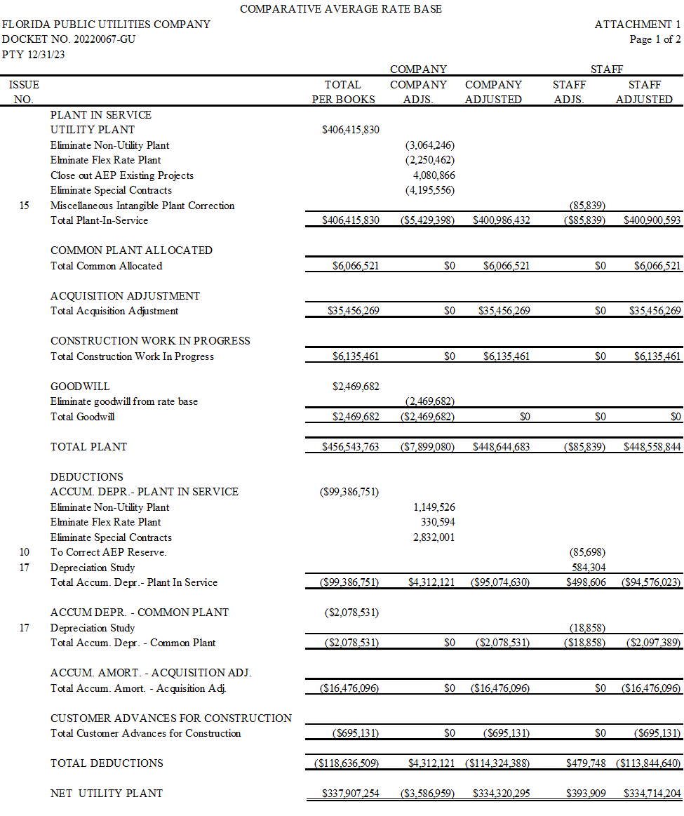

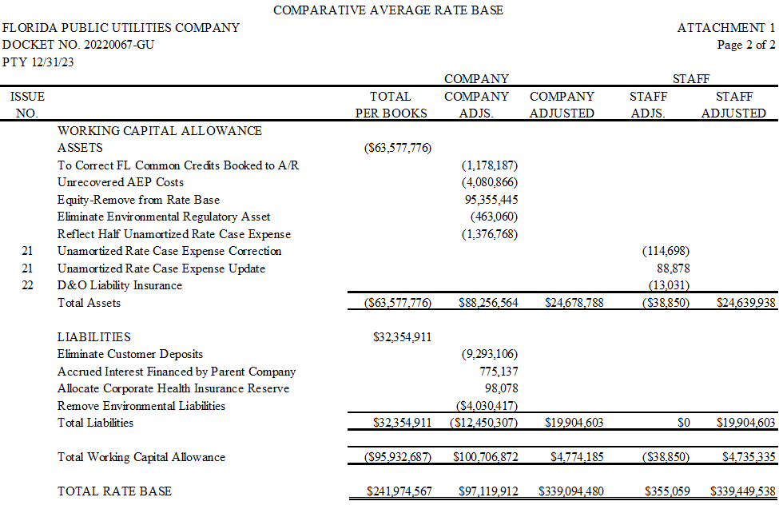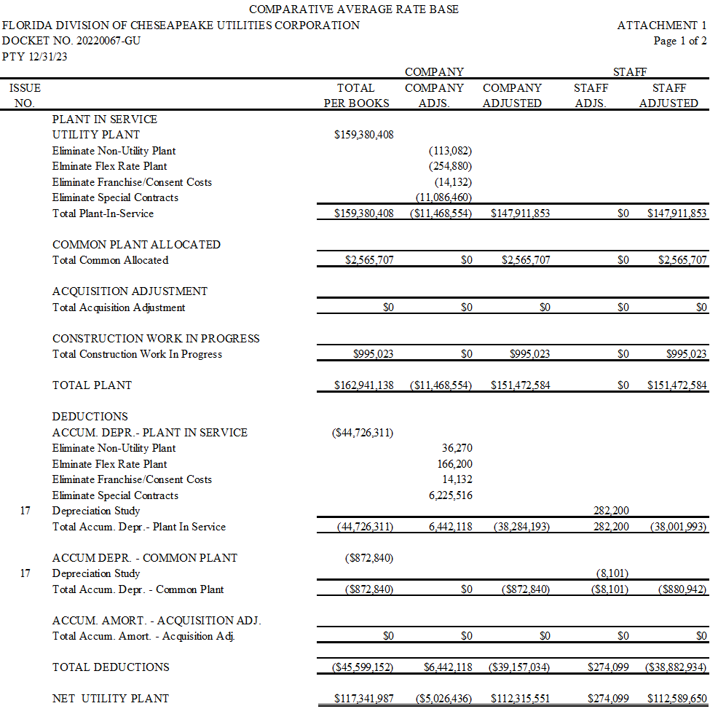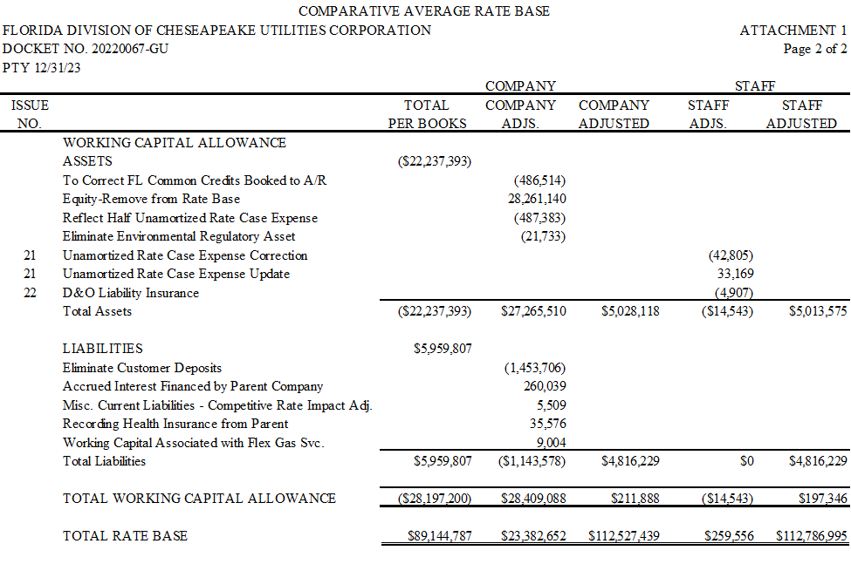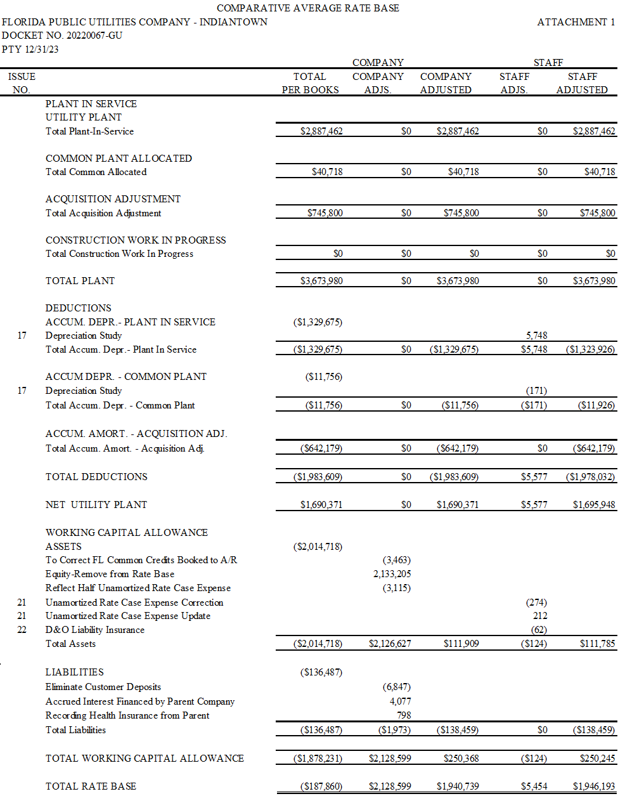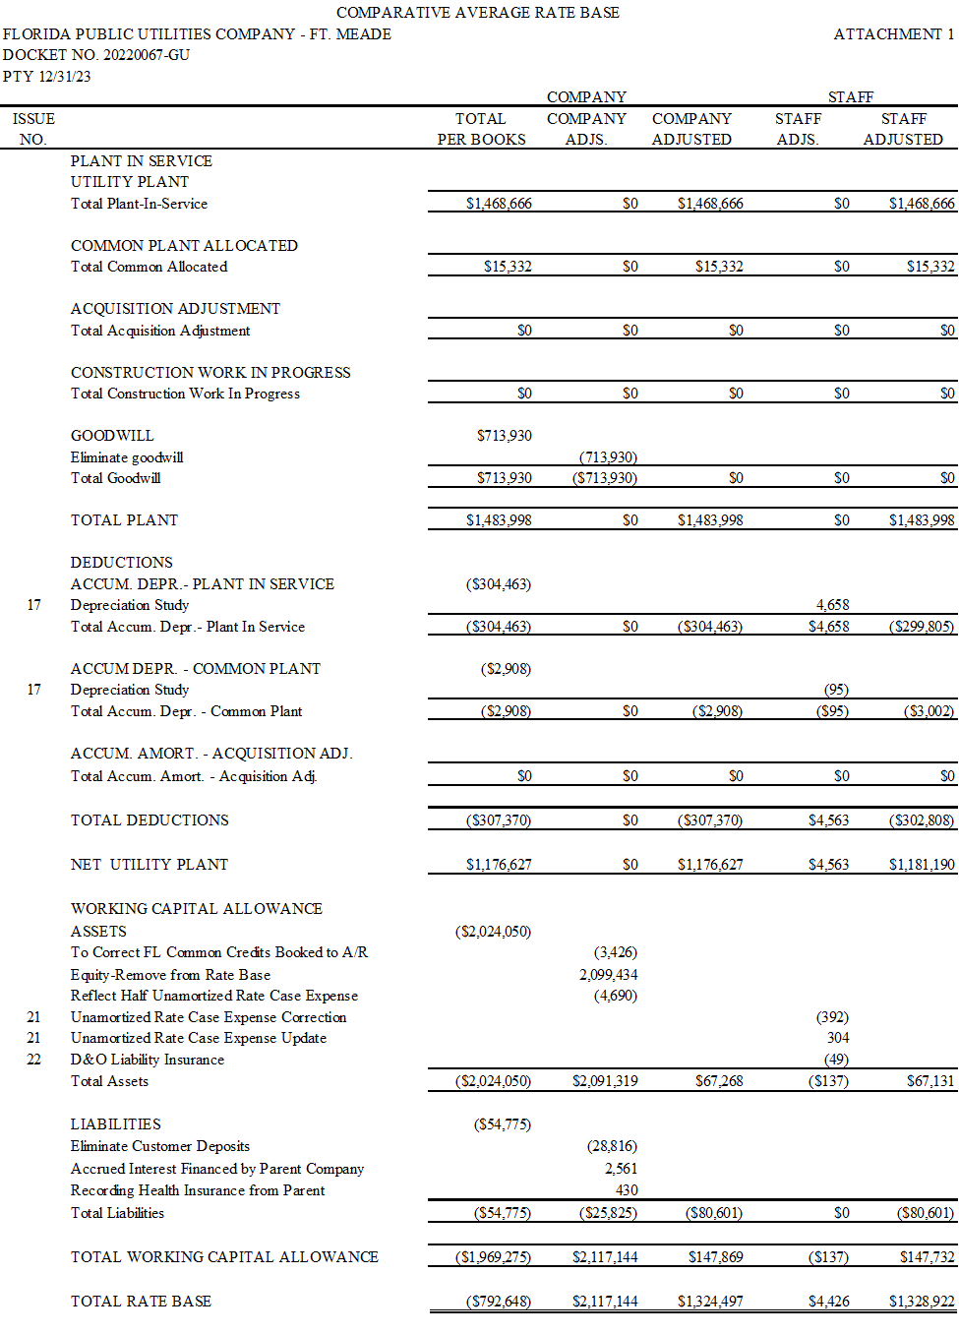

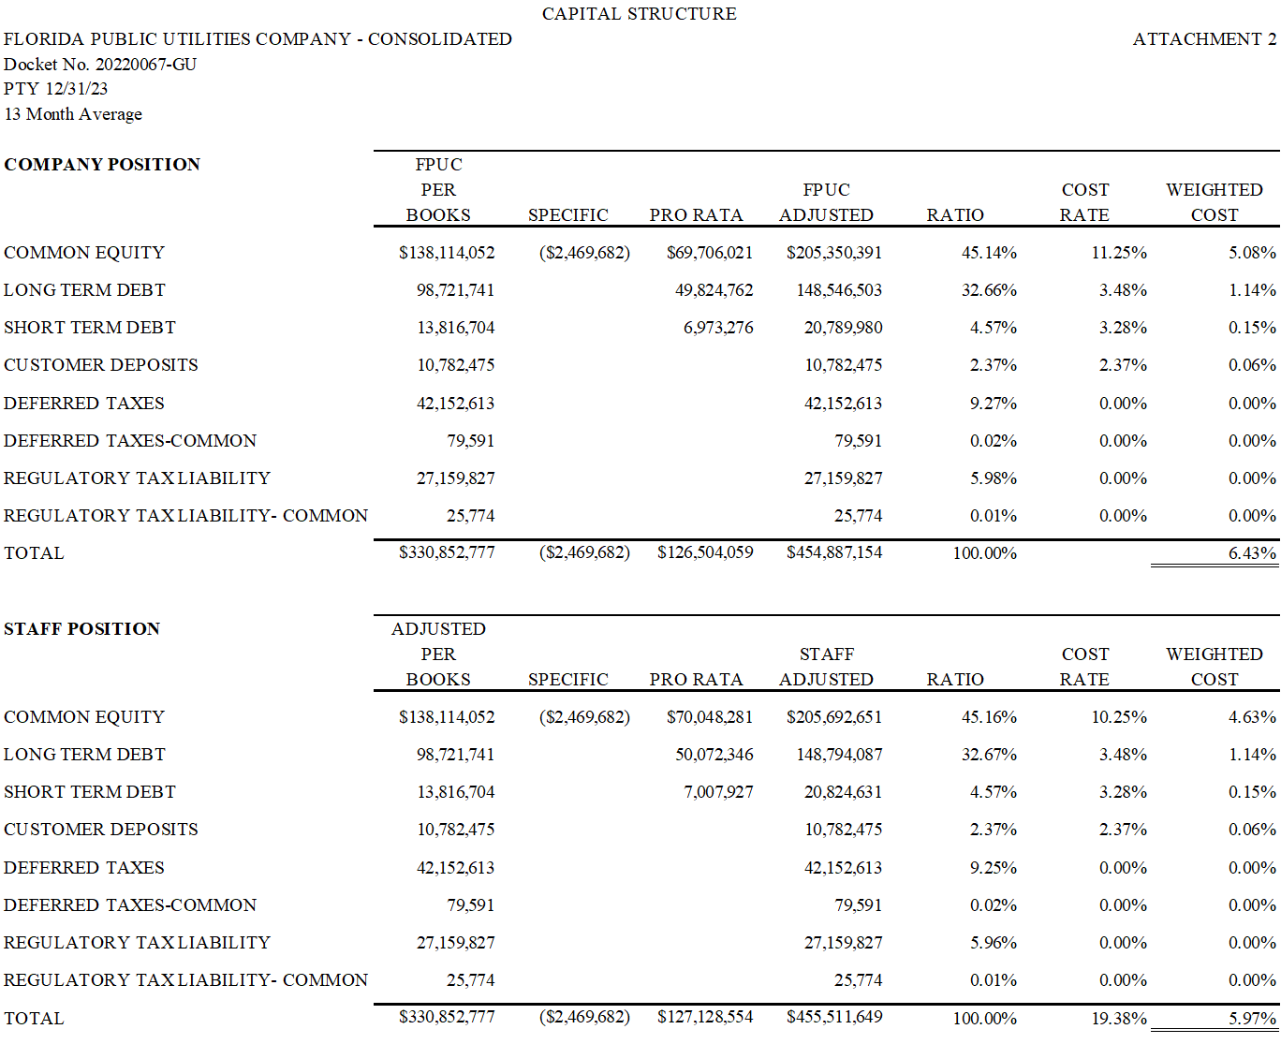

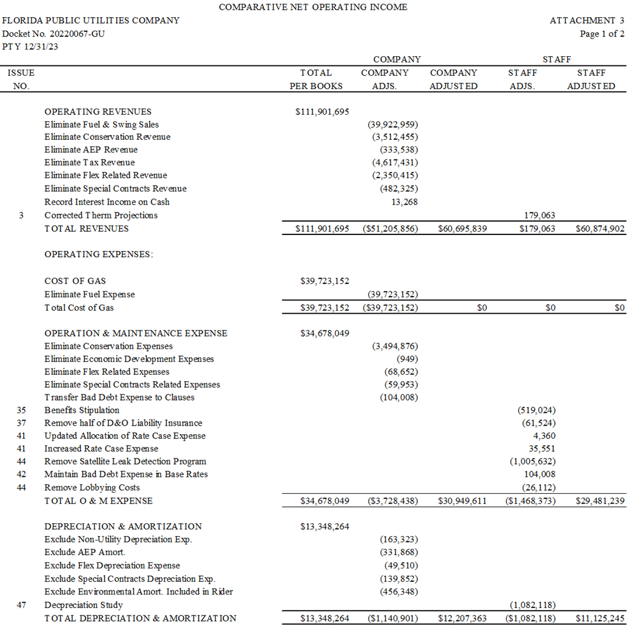

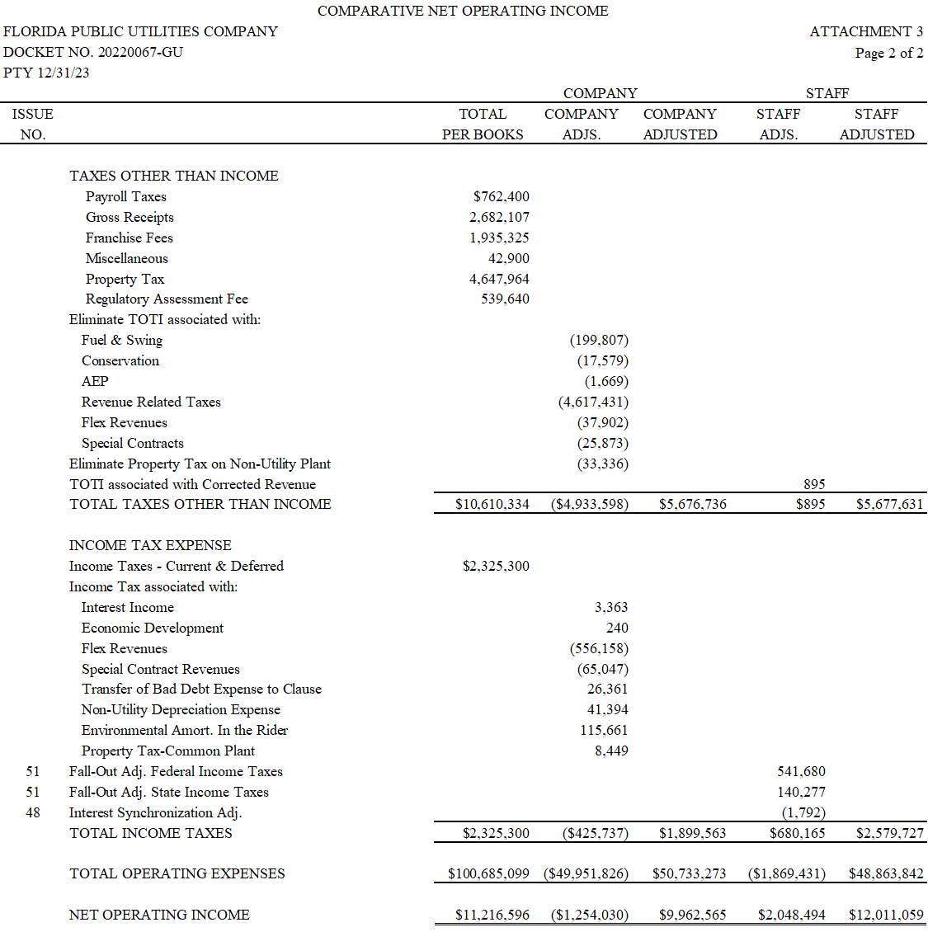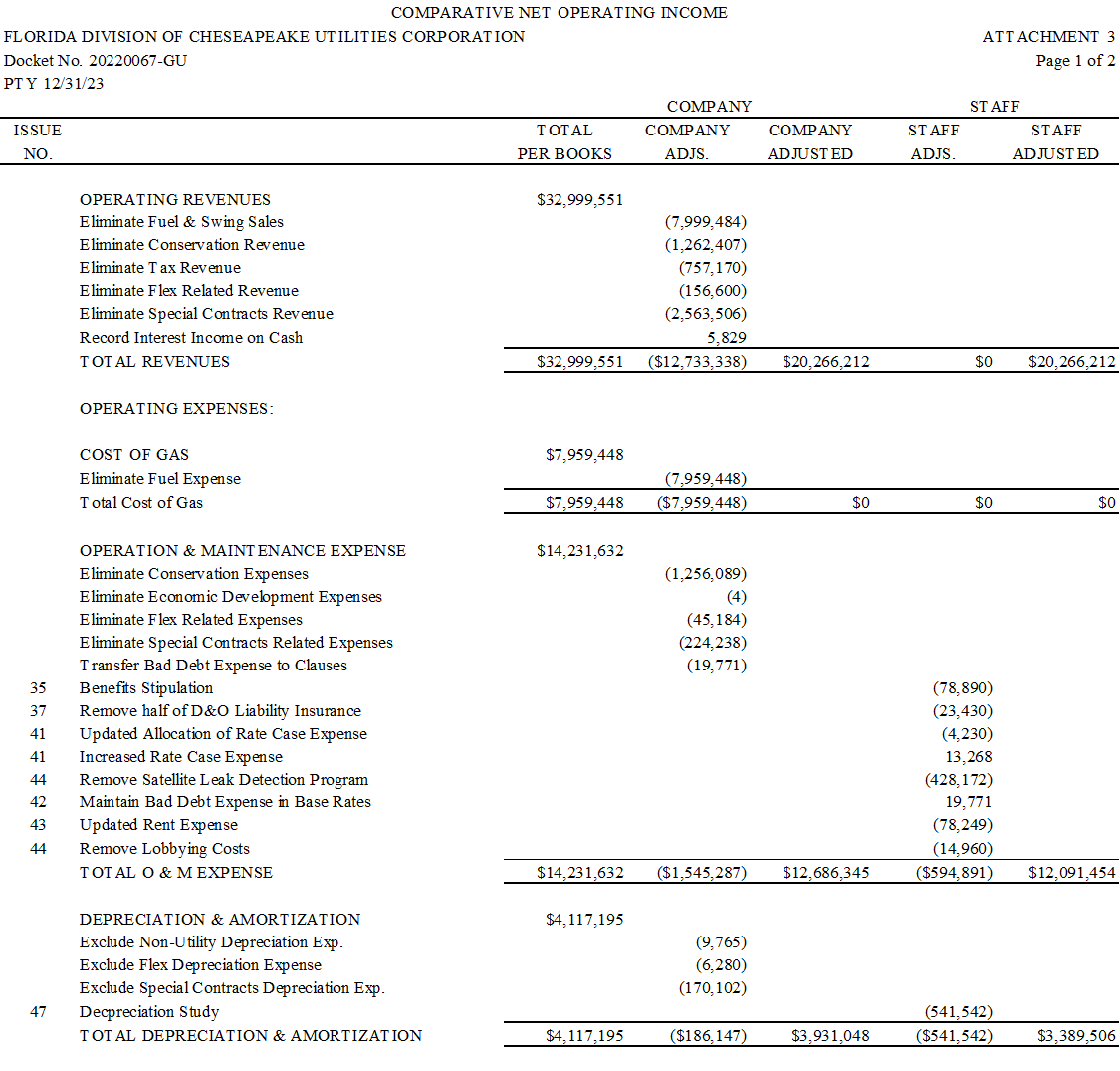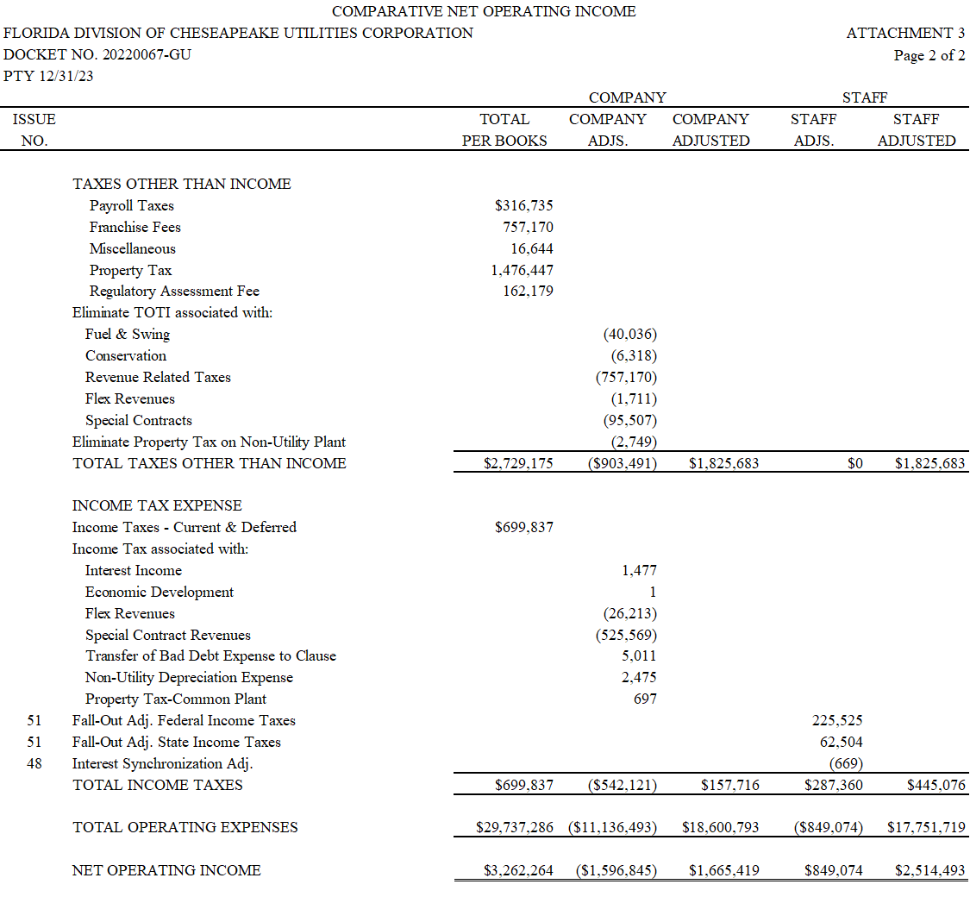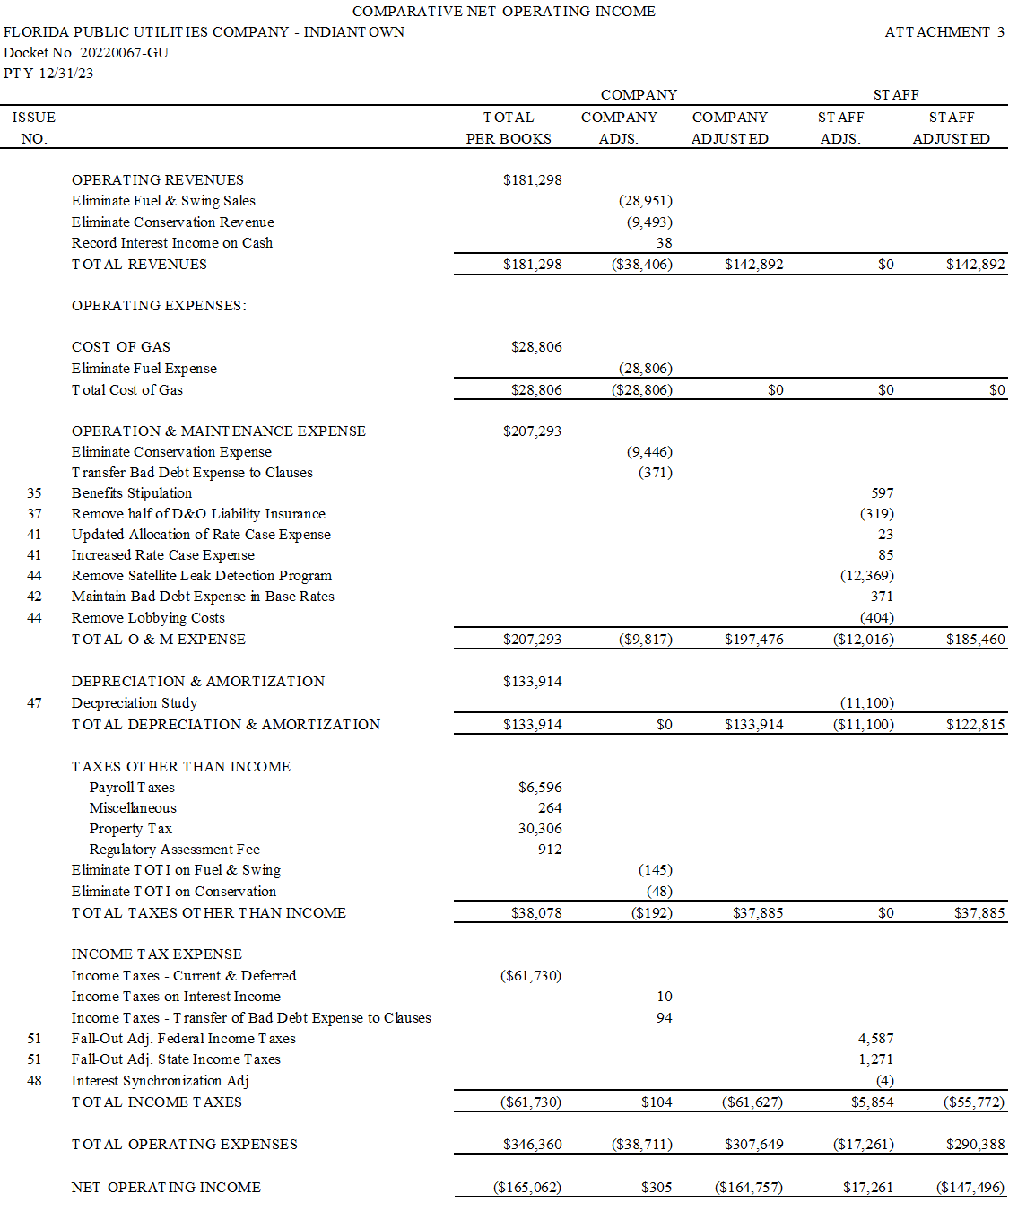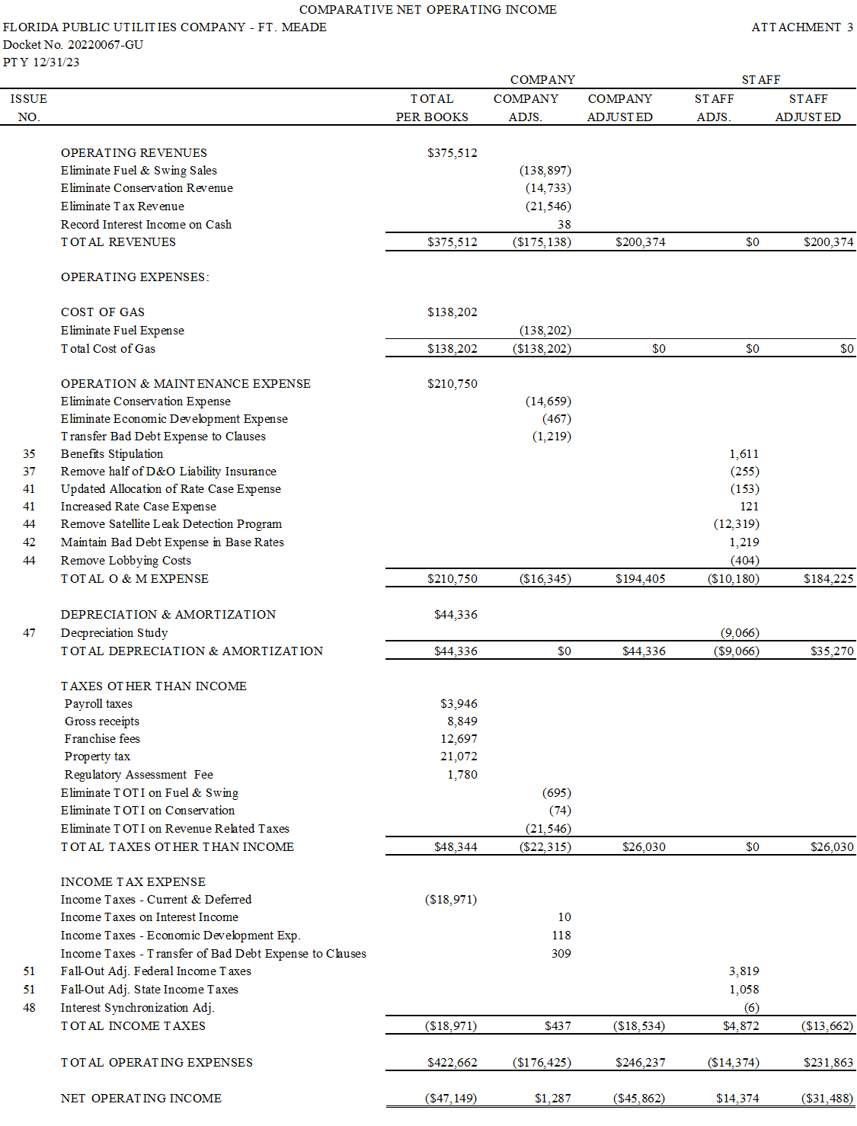

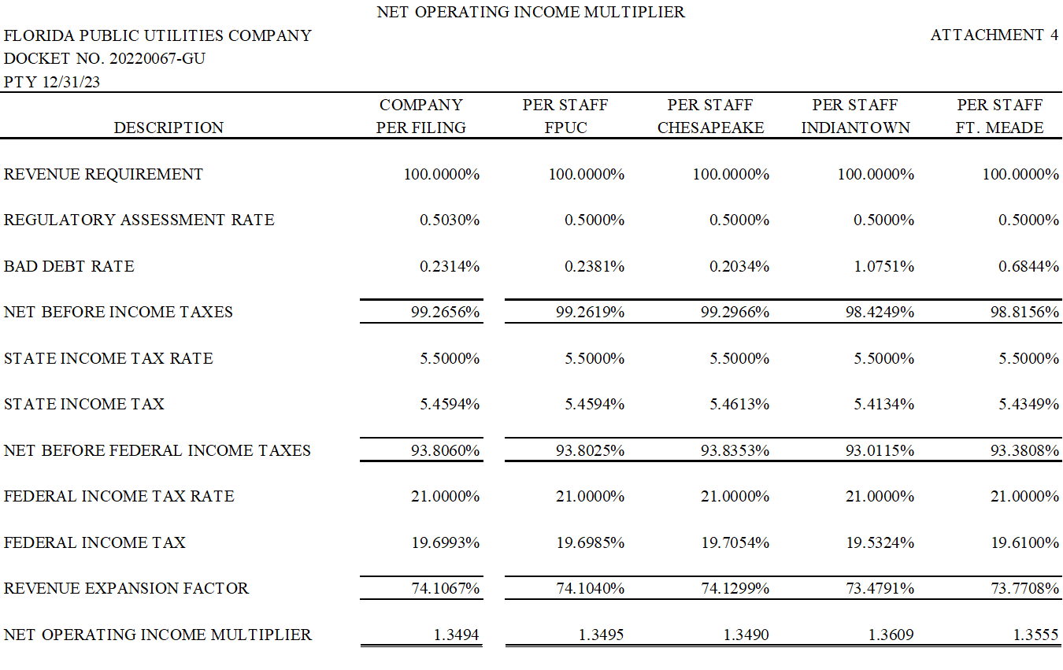

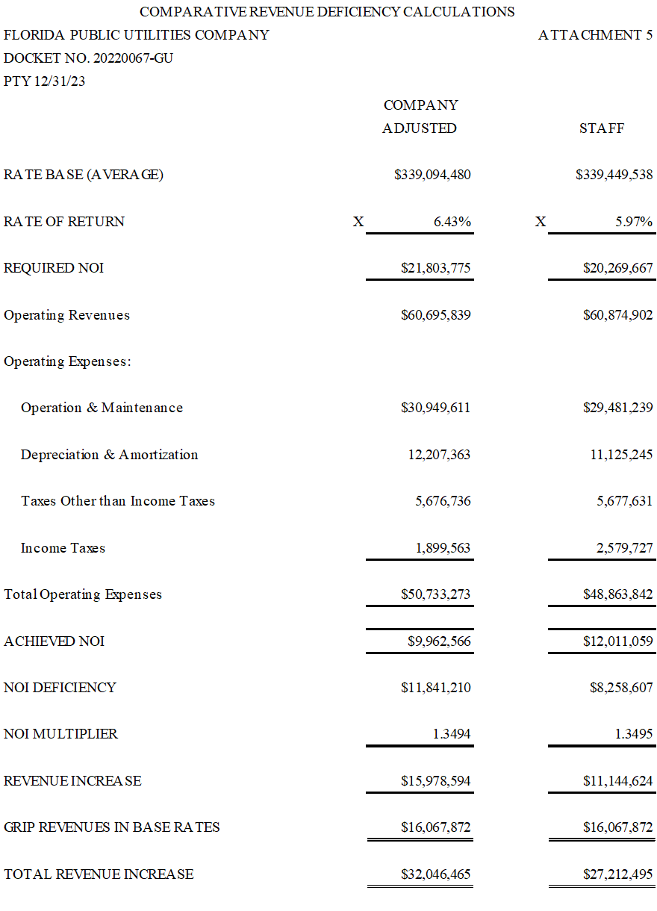

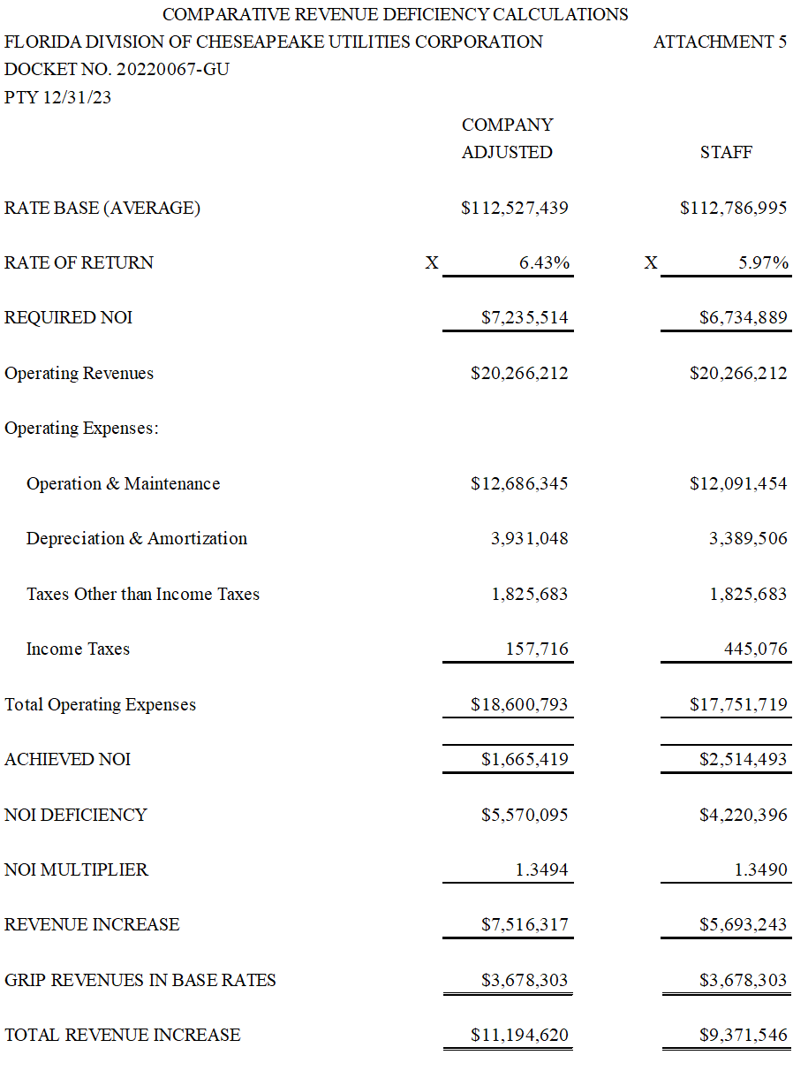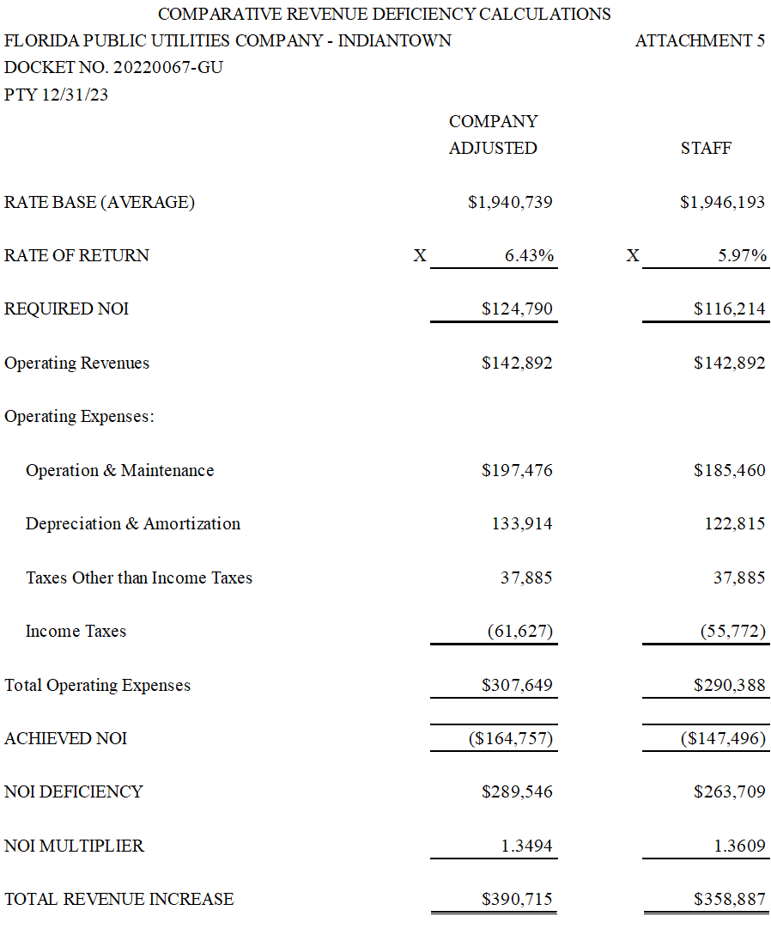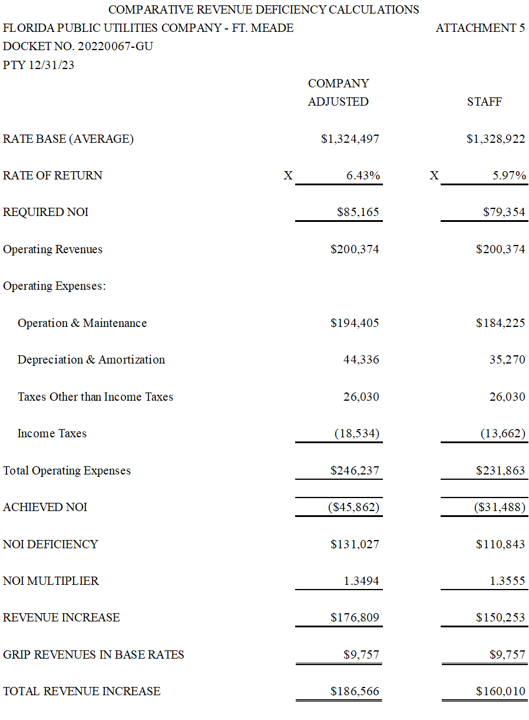

1. Order Nos. PSC-2009-0375-PAA-GU, issued May 27, 2009, and PSC-2009-0848-S-GU, issued December 28, 2009, in Docket No. 20080366-GU, *In re:* *Petition for rate increase by Florida Public Utilities Company.*
2. Order No. PSC-2010-0029-PAA-GU, issued January 14, 2010, in Docket No. 20090125-GU, *In re: Petition for increase in rates by Florida Division of Chesapeake Utilities Corporation.*
3. Order No. PSC-2004-0565-PAA-GU, issued June 2, 2004, in Docket No. 20030954-GU, *In re: Petition for rate increase by Indiantown Gas Company*.
4. Order No. PSC-2021-0148-TRF-GU, issued April 22, 2021, in Docket No. 20200214-GU, *In re: Joint petition of Florida Public Utilities Company, Florida Public Utilities Company-Indiantown Division, Florida Public Utilities Company-Fort Meade, and the Florida Division of Chesapeake Utilities Corporation for approval of consolidation of tariffs, for modifications to retail choice transportation service programs, and to change the MACC for Florida Public Utilities Company.*
5. Document No. 03478-2022, filed June 7, 2022, in Docket No. 20220067-GU.
6. Order No. PSC-2013-0395-PAA-GU, issued August 28, 2013, in Docket No. 20130135-GU, *In re: Joint petition for approval of commercial natural gas vehicle service program by Florida Public Utilities Company, Florida Public Utilities-Indiantown Division, and Florida Division of Chesapeake Utilities Corporation.*
7. Iowa curves are a graphical representation of the retirement patterns for a group of assets.
8. See Rule 25-7.045(1)(e), F.A.C.; (100% - Reserve % - Average Future Net Salvage %) ÷ Average Remaining Life in Years
9. Order No. PSC-2019-0433-PAA-GU, issued October 22, 2019, in Docket No. 20190056-GU, *In re: Petition for approval of 2019 consolidated depreciation study by Florida Public Utilities Company, Florida Public Utilities Company-Indiantown Division, Florida Public Utilities Company-Fort Meade, and Florida Division of Chesapeake Utilities Corporation*; Order No. PSC-2022-0153-PAA-GU, issued April 22, 2022, in Docket No. 20210183-GU, *In re: Petition for approval of 2021 depreciation study by Sebring Gas System, Inc.*; Order No. PSC-2018-0368-PAA-GU, issued July 25, 2018, in Docket No. 20170265-GU, *In re: Application for approval of new depreciation rates effective January 1, 2018, by St. Joe Natural Gas Company, Inc.*
10. Rule 25-7.045, F.A.C.
11. It is generally understood that by using Distribution function the utility is referring to its Distribution Plant Accounts and by General function the utility is referring to its General Plant Accounts.
12. Theoretical Reserve = Book Investment – Future Accruals – Future Net Salvage.
13. Order No. PSC-2019-0433-PAA-GU, issued October 22, 2019, in Docket No. 20190056-GU, *In re: Request for approval of 2019 depreciation study by Florida Public Utilities Company, Florida Public Utilities Company-Indiantown Division, Florida Public Utilities Company-Fort Meade, and Florida Division of Chesapeake Utilities Corporation.*
14. Order No. PSC-2012-0490-TRF-GU, issued September 24, 2012, in Docket No. 20120036-GU, *In re: Joint petition for approval of Gas Reliability Infrastructure Program (GRIP) by Florida Public Utilities Company and the Florida Division of Chesapeake Utilities Corporation*
15. Order No. PSC-2022-0401-TRF-GU, issued November 17, 2022, in Docket No. 20220155-GU, *In re: Joint petition for approval of GRIP cost recovery factors, by Florida Public Utilities Company, Florida Public Utilities Company, Fort Meade, and Florida Division of Chesapeake Utilities Corporation*
16. See Errata included with Hearing Exhibit 123, as modified by the approved stipulation of Issue 15.
17. Order No. PSC-2012-0010-PAA-GU, issued January 3, 2012, in Docket No. 20110133-GU, *In re: Petition for approval of acquisition adjustment and recovery of regulatory assets, and request for consolidation of regulatory filings and records of Florida Public Utilities Company and Florida Division of Chesapeake Utilities Corporation*
18. Order Nos. PSC-2012-0010-PAA-GU; and PSC-2015-0015-PAA-GU, issued January 6, 2014, in Docket No. 20120311-GU, *In re: Petition for approval of positive acquisition adjustment to reflect the acquisition of Indiantown Gas Company by Florida Public Utilities Company*.
19. Order No. PSC-2012-0010-PAA-GU.
20. Order No. PSC-1994-0170-FOF-EI, issued on February 10, 1994 ,in Docket No. 19930400-EI, *In re: Application for a Rate Increase for Marianna electric operations by Florida Public Utilities Company*; Order No. PSC-2008-0327-FOF-EI, issued on May 19, 2008, in Docket Nos. 20070300-EI and 20070304-EI, *In re: Petition for rate increase by Florida Public Utilities Company*; Order No. PSC-2004-0369-AS-EI, issued on July 2, 2004, in Docket No. 20030438-EI, *In re: Petition for rate increase by Florida Public Utilities Company*; Order No. PSC-2004-1110-PAA-GU, issued on November 8, 2004, in Docket No. 20040216-GU, *In re: Application for rate increase by Florida Public Utilities Company*; and Order No. PSC-1995-0518-FOF-GU, issued on April 26, 1995, in Docket No. 19940620-GU, *In Re: Application for a rate increase by FLORIDA PUBLIC UTILITIES COMPANY*.
21. Order No. PSC-2009-0375-PAA-GU, issued on May 27, 2009, in Docket No. 20080366-GU, *In re: Petition for rate increase by Florida Public Utilities Company*.
22. Order No. PSC-1994-0170-FOF-EI.
23. Order No. PSC-2010-0131-FOF-EI, issued on March 5, 2010, in Docket Nos. 20090079-EI, *In re: Petition for increase in rates by Progress Energy Florida, Inc.;* 20090144-EI, *In re: Petition for limited proceeding to include Bartow repowering project in base rates, by Progress Energy Florida, Inc.;* and 20090145-EI, *In re: Petition for expedited approval of the deferral of pension expenses, authorization to charge storm hardening expenses to the storm damage reserve, and variance from or waiver of Rule 25-6.0143(1)(c), (d), and (f), F.A.C., by Progress Energy Florida, Inc*. (2009 PEF Rate Case)
24. Order No. PSC-2010-0131-FOF-EI.
25. Order Nos. PSC-1994-0170-FOF-EI; PSC-2008-0327-FOF-EI; PSC-2004-0369-AS-EI; PSC-2004-1110-PAA-GU; and PSC-1995-0518-FOF-GU.
26. Order No. PSC-2009-0283-FOF-EI, issued April 30, 2009, Docket No. 20080317-EI, *In re: Petition for rate increase by Tampa Electric Company.*
27. Order No. PSC-2009-0283-FOF-EI, issued April 30, 2009, in Docket No. 20080317-EI, *In re: Petition for rate increase by Tampa Electric Company.*
28. Order No. PSC-2010-0168-PAA-SU, issued March 23, 2010, in Docket No. 20090182-SU, *In re: Application for increase in wastewater rates in Pasco County by Ni Florida, LLC.*
29. Reflects adjustment for stipulation of Issue 15.
30. Order No. PSC-2014-0517-S-EI, issued September 29, 2014, in Docket No. 20140025-EI, *In re: Application for rate increase by Florida Public Utilities Company.*
31. Order No. PSC-2010-0029-PAA-GU, issued January 14, 2010, in Docket No. 20090125-GU, *In re: Petition for increase in rates by Florida Division of Chesapeake Utilities Corporation.*
32. *Bluefield Water Works & Improvement Co. v. Public Service Commission of West Virginia*, 262 U.S. 679, 692–93 (1923).
33. *Federal Power Commission v. Hope Natural Gas Co.*, 320 U.S. 591, 603 (1944).
34. *Bluefield Water Works & Improvement Co. v. Public Service Commission of West Virginia*, 262 U.S. 679, 692–93 (1923), and *Federal Power Commission v. Hope Natural Gas Co*., 320 U.S. 591, 603 (1944).
35. Order No. PSC-1992-1197-FOF-EI, issued October 22, 1992, in Docket No. 19910890-EI, *In re: Petition for a rate increase by Florida Power Corporation.*
36. Order No. PSC-2002-0787-FOF-EI, issued June 10, 2002, in Docket No. 20010949-EI, *In re; Request for rate increase by Gulf Power Company*.
37. The non-labor trend factor used to project Account 926 Employees Pension & Benefits expense is based on payroll and customer growth. The factor used to calculate the consolidated total of $3,513,411 is different than each system specific factor, resulting in system specific totals that do not sum to equal the consolidated total. Staff’s adjustment reflects the consolidated factor applied to each system to reach the stipulated total. This produces an increase for Indiantown and Chesapeake, despite the net adjustment being a decrease.
38. Pensions and pot-retirement benefits expense is recorded under Account 926 Employees Pensions & Benefits, and the stipulated total of that account is discussed in Issue 35.
39. *See* Order No. PSC-2009-0411-FOF-GU, issued on June 9, 2009, in Docket No. 20080318-GU, *In re: Petition for rate increase by Peoples Gas System*, p. 37. (“PGS 2008 Rate Case”)
40. *See* Order No. PSC-2012-0179-FOF-EI, issued April 3, 2012, in Docket No. 20110138-EI, *In re: Petition for increase by Gulf Power Company*, at p. 101 (“2011 GPC Rate Case”); Order No. PSC-2010-0131-FOF-EI, issued March 5, 2010, in Docket No. 20090079-EI, *In re: Petition for increase in rates by Progress Energy Florida, Inc.*, at p. 99 (“2009 PEF Rate Case”).
41. Id*.*
42. Order No. PSC-2009-0411-FOF-GU.
43. Order No. PSC-2009-0411-FOF-GU, at p. 37.
44. Order No. PSC-2010-0131-FOF-EI, at p. 99.
45. Order No. PSC-2012-0179-FOF-EI, at p. 101.
46. According to witness Napier, O&M expenses for some accounts were projected directly, rather than having a trend factor applied, based on managerial expertise or known items impacting such expenses, and are thereby addressed in other issues. (TR 209; FPUC BR 60) Staff notes that the values shown for the Projected Test Year are compounded (2022 and 2023 combined).
47. The August 2022 forecast indicates the revised inflation factor for 2022 was 8.05%, compared to the 5.88% factor developed in the earlier (January 19, 2022) forecast.
48. The compound inflation factor is the multiplier of 2022 and 2023 CPI.
49. Amounts are shown for the Historic Base Year, the Historic Base Year +1, and also for the Projected Test year.
50. Order No. PSC-2022-0058-PAA-GU, issued on February 15, 2022, in Docket No. 20210188-GU, *In re: Joint petition for variance from Rule 25-7.039(1), F.A.C., by Florida Public Utilities Company and Florida Division of Chesapeake Utilities Corporation*.
51. Order No. PSC-2022-0058-PAA-GU, issued on February 15, 2022, in Docket No. 20210188-GU, *In re: Joint petition for variance from Rule 25-7.039(1), F.A.C., by Florida Public Utilities Company and Florida Division of Chesapeake Utilities Corporation*.
52. Order No. PSC-2009-0411-FOF-GU, issued June 9, 2009, in Docket No. 20080318-GU, *In re: Petition for rate increase by Peoples Gas System*.
53. Order No. PSC-2010-0153-FOF-EI, issued March 17, 2010, in Docket No. 20080677-EI, *In re: Petition for increase in rates by Florida Power & Light Company*.
54. PHMSA Rule 49 C.F.R. § 192.723(b)(1)
55. Due to inconsistent linking sources and rounding errors in the Excel MFRs included in Exhibit 94, the aggregate of the projected test year O&M expenses from each system’s separate MFR Schedule G-2, Page 1 of 31, is $1,118 higher than the total projected test year O&M expenses reflected on the Consolidated MFR Schedule G-2, Page 1 of 31.
56. $2,476,104 (Account 376G – Plastic Mains) + $1,224,846 (Account 380G – Plastic Services) = $3,705,475
57. Order No. PSC-2014-0655-FOF-GU, issued November 6, 2014, in Docket No. 20140004-GU, *In re: Natural gas conservation cost recovery.*
58. Order No. PSC-2015-0321-PAA-GU, issued August 10, 2015, in Docket No. 20150117-GU, *In re: Joint petition for approval of modified cost allocation methodology and revised purchased gas adjustment calculation, by Florida Public Utilities Company, Florida Public Utilities Company – Indiantown Division, Florida Public Utilities Company - Fort Meade, and Florida Division of Chesapeake Utilities Corporation.*
59. Order No. PSC-2016-0422-TRF-GU, issued October 3, 2016, in Docket No. 20160085-GU, *In re: Joint petition for approval of swing service rider, by Florida Public Utilities Company, Florida Public Utilities Company- Indiantown Division, Florida Public Utilities Company-Fort Meade, and Florida Division of Chesapeake Utilities Corporation.*
60. Order No. PSC-2019-0153-TRF-GU, issued April 24, 2019, in Docket No. 20190036-GU, *In re: Petition for authority for approval of revised transportation imbalance tariffs, by Florida Public Utilities Company; Florida Public Utilities Company-Ft. Meade.*
61. Order No. PSC-2021-0148-TRF-GU, issued April 22, 2021, in Docket No. 20200214-GU, *In re: Joint petition of Florida Public Utilities Company, Florida Public Utilities Company-Indiantown Division, Florida Public Utilities Company-Fort Meade, and the Florida Division of Chesapeake Utilities Corporation for approval of consolidation of tariffs, for modifications to retail choice transportation service programs, and to change the MACC for Florida Public Utilities Company.*
62. Order No. PSC-2022-0058-PAA-GU, issued February 15, 2022, in Docket No. 20210188-GU, *In re: Joint petition for variance from Rule 25-7.039(1), F.A.C., by Florida Public Utilities Company and Florida Division of Chesapeake Utilities Corporation.*
63. Order No. PSC-2010-0029-PAA-GU, issued January 14, 2010, in Docket No. 090125-GU, *In re: Petition for increase in rates by Florida Division of Chesapeake Utilities Corporation.*
64. Order No. PSC-2000-2263-FOF-GU, issued November 28, 2000, in Docket No. 20000108-GU, *In re: Petition for rate increase by Florida Division of Chesapeake Utilities.*
65. Order No. PSC-2014-0052-PAA-GU, issued January 27, 2014, in Docket No. 20130273-GU, *In re: Petition for approval to extend environmental surcharge by Florida Division of Chesapeake Utilities Corporation*.
66. Order No. PSC-2016-0562-PAA-GU, issued December 16, 2016, in Docket No. 20160153-GU, *In re: Petition for approval of final true-up of environmental surcharge by Florida Division of Chesapeake Utilities Corporation.*
67. Order No. PSC-2021-0423-S-EI, issued November 10, 2021, in Docket No. 20210034-EI, *In re: Petition for rate increase by Tampa Electric Company.*
68. Order No. PSC-2021-0446-S-EI, issued December 2, 2021, in Docket No. 20210015-EI, *In re: Petition for rate increase by Florida Power & Light.*