State of Florida |  | Public Service Commission  Capital Circle Office Center ● 2540 Shumard Oak Boulevard  Tallahassee, Florida 32399-0850  -M-E-M-O-R-A-N-D-U-M-
DATE: | February 23, 2023
TO: | Office of Commission Clerk (Teitzman)
FROM: | Division of Accounting and Finance (Snyder, D. Buys, Norris)  Division of Economics (Draper, Hampson)  Office of the General Counsel (Brownless, Watrous)
RE: | Docket No. 20230020-EI – Petition for limited proceeding for recovery of incremental storm restoration costs related to Hurricanes Elsa, Eta, Isaias, Ian, Nicole, and Tropical Storm Fred, by Duke Energy Florida, LLC.
AGENDA: | 03/07/23 – Regular Agenda – Interested Persons May Participate
COMMISSIONERS ASSIGNED: |  |  | All Commissioners
PREHEARING OFFICER: |  |  | Graham
CRITICAL DATES: |  |  | 03/24/23 (60-Day Interim Deadline)
SPECIAL INSTRUCTIONS:

Case Background
On January 23, 2023, Duke Energy Florida, LLC (DEF or Company) filed a petition for a limited proceeding seeking authority to implement an interim storm restoration recovery charge to recover $442.1 million for the incremental restoration costs related to Hurricanes Elsa, Eta, Ian, Isaias, and Nicole and Tropical Storm Fred, as well as to replenish its storm reserve. This amount includes approximately $4.5 million in interest.
DEF filed its petition pursuant to the provisions of the 2017 Second Revised and Restated Settlement Agreement (2017 Settlement) approved by the Commission in Order No. PSC-2017- 0451-AS-EU and the 2021 Settlement Agreement (2021 Settlement) approved by the Commission in Order No. PSC-2021-0202-AS-EI. Pursuant to Order No. PSC-2021-0425-FOF-EI (2021 Rate Mitigation Agreement), DEF charged the remaining uncollected storm restoration costs resulting from Hurricanes Eta and Isaias, estimated at $9.2 million, to the storm reserve, while reserving the right to collect the remainder of the unrecovered storm cost balance at a later time. DEF also voluntarily agreed to forego recovering costs related to Hurricane Elsa through a storm surcharge and instead reserved the right to collect an estimated $15 to $18 million of storm restoration costs at a later date. As a result of the 2021 Rate Mitigation Agreement, DEF deferred collection of approximately $24.4 million in storm-related costs. DEF is now seeking to recover those costs as part of its petition. Pursuant to the 2017 Settlement and 2021 Settlement, the Company can recover storm costs, without a cap on the level of charges on customer bills, on an interim basis beginning 60 days following the filing of a petition for recovery. DEF has proposed interim storm restoration charges applicable to all rate classes over a 12-month recovery period, effective with the first billing cycle of April 2023.

The Commission has jurisdiction over this matter pursuant to Sections 366.04, 366.05, 366.06, and 366.076, Florida Statutes.

Discussion of Issues

Issue 1:
Should the Commission authorize DEF to implement an interim storm restoration recovery charge?

Recommendation:
Yes. The Commission should authorize DEF to implement an interim storm restoration recovery charge, subject to refund. Once the total actual storm costs are known, DEF should be required to file documentation of the total storm costs for Commission review and true-up of any excess or shortfall. (Snyder)

Staff Analysis:
DEF filed a petition for a limited proceeding seeking authority to implement an interim storm restoration recovery charge to recover $442.1 million for the incremental restoration costs related to Hurricanes Elsa, Eta, Ian, Isaias, Nicole and Tropical Storm Fred, and to replenish its storm reserve. In its petition, DEF requested to replenish the storm reserve to $131.9 million.
The petition was filed pursuant to the provisions of the 2017 Settlement approved by the Commission in Order No. PSC-2017-0451-AS-EU and 2021 Settlement approved by the Commission in Order No. PSC-2021-0202-AS-EI. Storm restoration costs for Eta, Elsa, Isaias, and Fred were incurred while the 2017 Settlement Agreement was in effect. Storm restoration costs for Ian and Nicole were incurred during the term of the 2021 Settlement Agreement. The Storm Cost Recovery provisions of the respective Settlement Agreements are identical. Pursuant to Paragraph 38 of the 2017 Settlement and Paragraph 30c of the 2021 Settlement, DEF can begin recovery of storm costs, without a cap, 60 days following the filing of a petition for recovery. DEF has proposed an interim storm recovery charge of $13.14 per 1,000 kilowatt-hours (kWh) on a residential customer bill over a 12-month recovery period effective the first billing cycle of April 2023.
In its petition, DEF asserted that it incurred total retail recoverable costs of approximately $442.1 million as a result of Hurricanes Elsa, Eta, Ian, Isaias, and Nicole and Tropical Storm Fred, as well as to replenish its storm reserve. The Company further asserted that this amount was calculated in accordance with the Incremental Cost and Capitalization Approach methodology prescribed in Rule 25-6.0143, Florida Administrative Code (F.A.C.).
The approval of an interim storm restoration recovery charge is preliminary in nature and is subject to refund pending further review once the total actual storm restoration costs are known. After the actual costs are reviewed for prudence and reasonableness, and are compared to the actual amount recovered through the interim storm restoration recovery charge, a determination will be made whether any over/under recovery has occurred. The disposition of any over/under recovery, and associated interest, will be considered by the Commission at a later date.
Based on a review of the information provided by DEF in its petition, staff recommends that the Commission authorize the Company to implement an interim storm restoration recovery charge subject to refund. Once the total actual storm costs are known, DEF should be required to file documentation of the storm costs for Commission review and true-up of any excess or shortfall.

Issue 2: What is the appropriate security to guarantee the amount collected subject to refund through the interim storm restoration recovery charge?

Recommendation: The appropriate security to guarantee the funds collected subject to refund is a corporate undertaking. (D. Buys)
Staff Analysis: Staff recommends that all funds collected subject to refund be secured by a corporate undertaking. The criteria for a corporate undertaking include sufficient liquidity, ownership equity, profitability, and interest coverage to guarantee any potential refund. DEF requested a 12-month collection period from April 2023 to March 2024 for Interim Storm Cost Recovery Charges of $442,074,721 related to Hurricanes Elsa, Eta, Ian, Isaias, Nicole and Tropical Storm Fred. Staff reviewed DEF’s three most recent annual reports filed with the Commission (2021, 2020, and 2019) to determine if the Company can support a corporate undertaking to guarantee the funds collected for recovery of incremental storm restoration costs related to all the weather events. DEF’s financial information indicates the Company’s liquidity is deficient, that is, that current assets are less than current liabilities. However, the Company participates in Duke Energy Corporation’s (DEF’s parent company) money pool and has access to additional funds if needed. In addition, DEF’s ownership equity, profitability, and interest coverage are sufficient to support a potential refund of $442 million. Moreover, it is improbable DEF will be required to refund the entire requested amount.

Staff believes that DEF has adequate resources to support a corporate undertaking in the amount requested. Therefore, staff recommends that a corporate undertaking of $442 million is acceptable. This brief financial analysis is only appropriate for deciding if the Company can support a corporate undertaking in the amount proposed and should not be considered a finding regarding staff's position on other issues in this proceeding.

Issue 3: Should the Commission approve DEF's proposed interim storm restoration recovery charge tariff as shown in Attachment A to this recommendation?

Recommendation: Yes. The Commission should approve DEF’s proposed interim storm restoration recovery charge tariff, as shown in Attachment A to this recommendation, effective with the first billing cycle of April 2023 and ending the earlier of full recovery or with the last billing cycle of March 2024, whichever occurs first. The interim storm restoration recovery charge should be subject to a final true-up. (Hampson)
Staff Analysis: DEF is seeking approval of interim storm cost recovery surcharges associated with Hurricanes Elsa, Eta, Isaias, Ian, Nicole, and Tropical Storm Fred as shown in proposed Tariff Sheet Nos. 6.105 and 6.106 (Attachment A to this recommendation). The surcharges would be applicable to all rate classes. Tariff Sheet No 6.105 indicates the proposed interim storm cost recovery surcharges and Tariff Sheet No. 6.106 defines the storm cost recovery surcharge.
DEF explained that it has allocated the storm cost recovery amount to the rate classes consistent with the rate design approved in the 2021 Settlement. Staff reviewed the storm cost recovery allocation and calculation of rates and it appears that DEF has calculated rates in accordance with the 2021 Settlement, using the most recent load research study and projected billing determinants for the recovery period.
The interim storm restoration recovery charge calculations are shown on pages 9 and 10 in Appendix A to DEF’s petition. For residential customers, the surcharge would be 1.314 cents per kWh, which would equate to $13.14 on a 1,000 kWh residential bill. If approved by the Commission, the storm cost recovery surcharge would be included in the non-fuel energy charge on customer bills.

CONCLUSION
Staff recommends that the Commission approve DEF’s proposed interim storm restoration recovery charge tariff, as shown in Attachment A to this recommendation, effective with the first billing cycle of April 2023 and ending the earlier of full recovery or with the last billing cycle of March 2024, whichever occurs first. Furthermore, the interim storm restoration recovery charge should be subject to a final true-up.

Issue 4: Should this docket be closed?
Recommendation: No. This docket should remain open pending final reconciliation of actual recoverable storm costs with the amount collected pursuant to the interim storm restoration recovery charge and the calculation of a refund or additional charge if warranted. (Brownless)
Staff Analysis: No, this docket should remain open pending final reconciliation of actual recoverable storm costs with the amount collected pursuant to the interim storm restoration recovery charge and the calculation of a refund or additional charge if warranted.

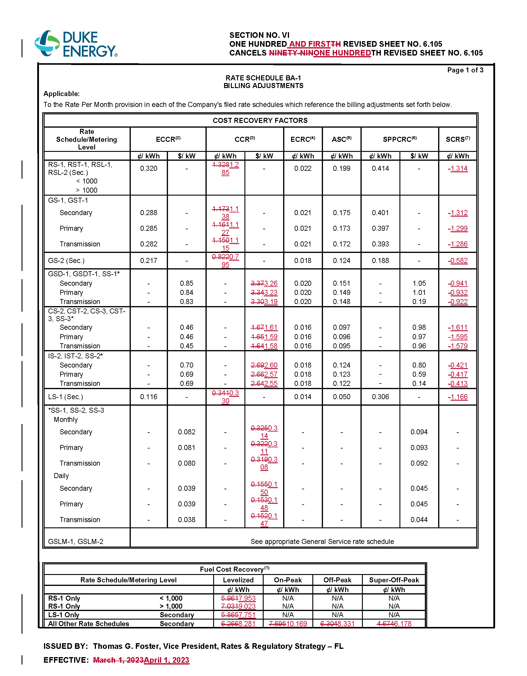
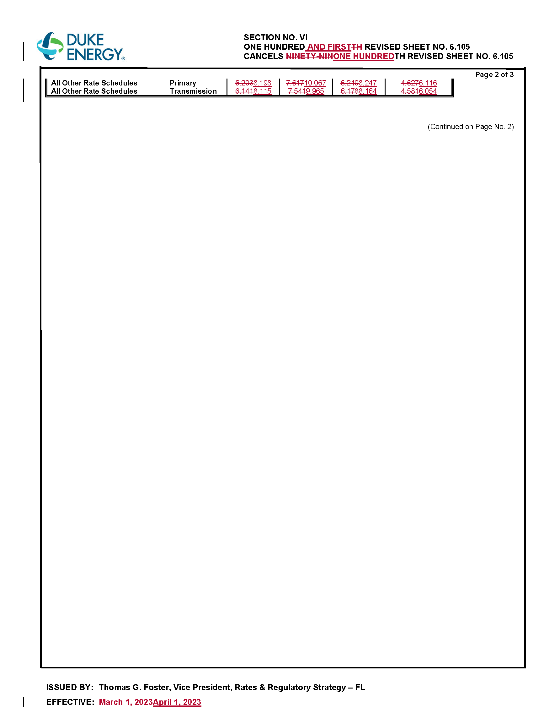

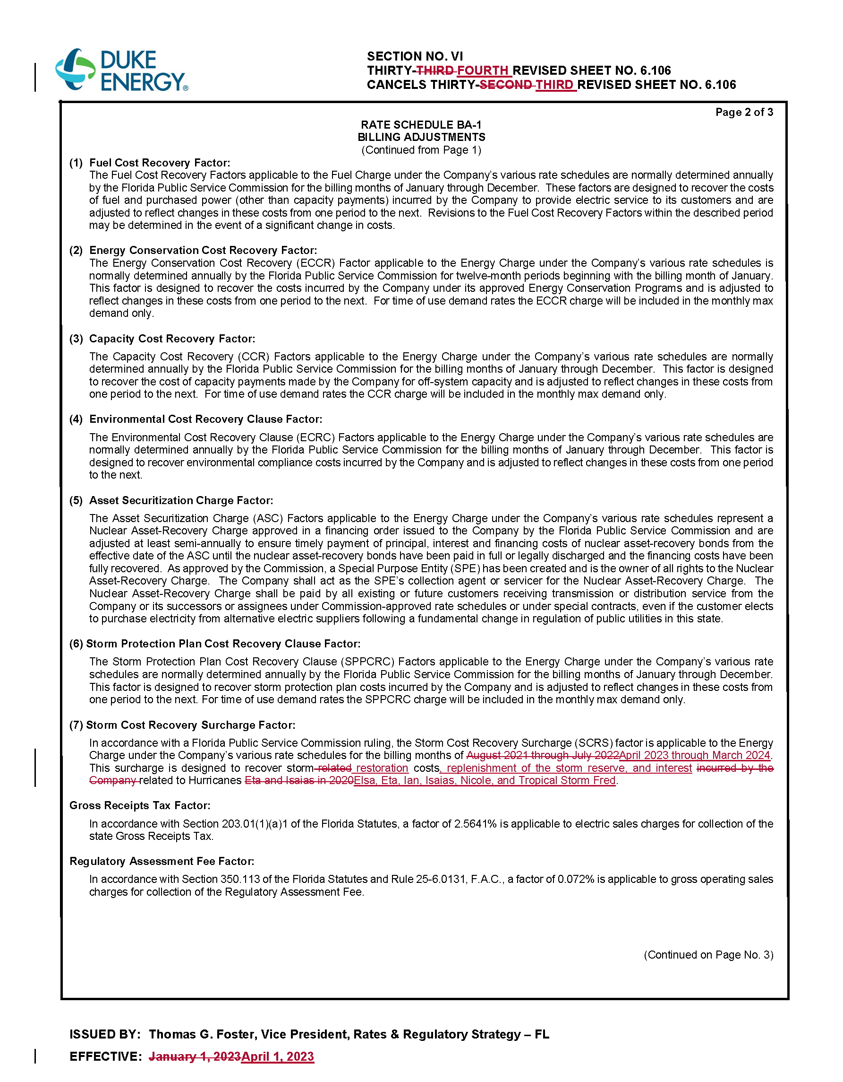

Order No. PSC-2017-0451-AS-EU, issued November 20, 2017, in Docket No. 20170183-EI, In re: Application for limited proceeding to approve 2017 second revised and restated settlement agreement, including certain rate adjustments, by Duke Energy Florida, LLC. and Order No. PSC-2021-0202-AS-EI, issued June 4, 2021, in Docket No. 20210016-EI, In re: Petition for limited proceeding to approve 2021 settlement agreement, including general base rate increases, by Duke Energy Florida, LLC.
Order No. PSC-2021-0425-FOF-EI, issued November 16, 2021, in Docket No. 20210158-EI, In re: Limited proceeding to consider Duke Energy Florida, LLC's unopposed motion to approve rate mitigation agreement.
Order No. PSC-2017-0451-AS-EU, issued November 20, 2017, in Docket No. 20170183, In re: Application for limited proceeding to approve 2017 second revised and restated settlement agreement, including certain rate adjustments, by Duke Energy Florida, LLC. and Order No. PSC-2021-0202-AS-EI, issued June 4, 2021, in Docket No. 20210016-EI, In re: Petition for limited proceeding to approve 2021 settlement agreement, including general base rate increases, by Duke Energy Florida, LLC.
Order No. PSC-2021-0202-AS-EI, issued June 4, 2021, in Docket No. 20210016-EI, In re: Petition for limited proceeding to approve 2021 settlement agreement, including general base rate increases, by Duke Energy Florida, LLC.

