BEFORE THE FLORIDA PUBLIC SERVICE COMMISSION

In re: Petition for recovery of costs associated with named tropical systems during the 2019-2022 hurricane seasons and replenishment of storm reserve, by Tampa Electric Company. | DOCKET NO. 20230019-EI  ORDER NO. PSC-2023-0116-PCO-EI  ISSUED: March 27, 2023

The following Commissioners participated in the disposition of this matter:

ANDREW GILES FAY, Chairman
ART GRAHAM
GARY F. CLARK
MIKE LA ROSA
GABRIELLA PASSIDOMO

ORDER APPROVING TAMPA ELECTRIC COMPANY’S
INTERIM STORM COST RECOVERY CHARGE

BY THE COMMISSION:

BACKGROUND
On January 23, 2023, Tampa Electric Company (TECO or Company) filed a petition for a limited proceeding seeking authority to implement an interim storm restoration recovery charge to recover $131 million for the incremental restoration costs related to Tropical Storms Alberto, Nestor, and Eta, and Hurricanes Dorian, Elsa, Ian, and Nicole, as well as the replenishment of its storm reserve (collectively, the Storms). Included in the $131 million is interest charged for Hurricanes Ian and Nicole. Pursuant to the 2021 Stipulation and Settlement Agreement (2021 Settlement) approved by us in Order No. PSC-2021-0423-S-EI, the recovery of storm costs from customers will begin, on an interim basis, 60 days after the filing of a cost recovery petition and tariff. TECO requested a 12-month recovery period, applied to all bills starting with the first billing cycle of April 2023.
We have jurisdiction over this matter pursuant to Sections 366.04, 366.05, 366.06, and 366.076, Florida Statutes.

DECISION
TECO filed a petition to seek recovery of $131 million in incremental storm restoration costs for the Storms as well as the replenishment of its storm reserve. In its petition, TECO requested to replenish the storm reserve to $55.8 million.
The petition was filed pursuant to the provisions of the 2021 Settlement. Pursuant to paragraph 8(a) of the 2021 Settlement, TECO is authorized to seek recovery of costs associated with any tropical storms named by the National Hurricane Center. Recovery of storm costs will begin, on an interim basis, 60 days following the filing of a petition for recovery.
In its petition, TECO asserted that it incurred approximate recoverable costs in the amounts of $7,499,858 for Hurricane Dorian; $1,874,575 for Hurricane Elsa; $119,216,291 for Hurricane Ian; $1,152,980 for Hurricane Nicole; $1,944 for Tropical Storm Alberto; $8,282 for Tropical Storm Nestor; and $729,515 for Tropical Storm Eta. The remaining $397,518 is for GPS software used to track vendor crews identified by TECO as ARCOS, implemented pursuant to the 2019 Settlement Agreement under the provision of Future Process Improvements. The Company further asserted that all amounts were calculated in accordance with the Incremental Cost and Capitalization Approach methodology prescribed in Rule 25-6.0143, Florida Administrative Code.
The approval of an interim storm restoration recovery charge is preliminary in nature and is subject to refund pending further review once the total actual storm restoration costs are known. After the actual costs are reviewed for prudence and reasonableness, and are compared to the actual amount recovered through the interim storm restoration recovery charge, a determination will be made whether any over/under recovery has occurred. The disposition of any over or under recovery, and associated interest, will be considered by this Commission at a later date.
Based on our review of the information provided by TECO in its petition, we hereby authorize the Company to implement an interim storm restoration recovery charge subject to refund. Once the total actual storm costs are known, TECO shall be required to file documentation of the storm costs for our review and true-up of any excess or shortfall.

All funds collected subject to refund shall be secured by a corporate undertaking. The criteria for a corporate undertaking include sufficient liquidity, ownership equity, profitability, and interest coverage to guarantee any potential refund. TECO requested a 12-month collection period from April 2023 through March 2024 for Interim Storm Cost Recovery Charges of $130,881,964 related to the Storms, including the ARCOS cost. We have reviewed TECO’s three most recent annual reports filed with us (2021, 2020, and 2019) to determine if the Company can support a corporate undertaking to guarantee the funds collected for recovery of incremental storm restoration costs related to all the weather events. TECO’s financial information demonstrates the Company has a deficient level of liquidity; that is, current assets are less than current liabilities. However, the Company has sufficient levels of ownership equity, profitability, and interest coverage to support a potential refund of $131 million. TECO’s average net income for the three years 2021, 2020, and 2019 is almost three times the requested corporate undertaking amount ($352 million vs. $131 million). Moreover, it is improbable TECO will be required to refund the entire requested amount.
For these reasons, we find that TECO has adequate resources to support a corporate undertaking in the amount requested and that a corporate undertaking of $131 million is acceptable. This brief financial analysis is only appropriate for deciding if the Company can support a corporate undertaking in the amount proposed and will not be considered in our evaluation of other issues in this proceeding.

TECO is seeking approval of interim storm cost recovery surcharges associated with the Storms. The proposed interim storm cost recovery surcharges are shown in proposed Tariff Sheet No. 6.024, found in Attachment A to this order. The surcharges would be applicable to all rate classes. The Company has also proposed changes to several other tariffs to include references to the proposed interim storm cost recovery surcharge, as well as a definition for the storm surcharge in its technical terms and abbreviations section. These tariff modifications are included in Exhibits 6 and 7 to TECO’s petition.
TECO explained that it has allocated the storm cost recovery amount to the rate classes consistent with the rate design approved in the 2021 Settlement. We have reviewed the storm cost recovery allocation and calculation of rates and it appears that TECO has calculated rates in accordance with the 2021 Settlement, using projected billing determinants for the recovery period.
The interim storm restoration recovery charge calculations are shown in Exhibit 5 to TECO’s petition. For residential customers, the surcharge would be 1.022 cents per kilowatt-hour (kWh), which would equate to $10.22 on a 1,000 kWh residential bill.
Based on our review, we hereby approve TECO’s proposed interim storm restoration recovery charge tariff, as shown in Attachment A to this order, effective with the first billing cycle of April 2023 through March 2024. We also approve TECO’s other tariff revisions which refer to the proposed storm surcharge. The storm cost recovery surcharge shall be included in the non-fuel energy charge on customer bills. Furthermore, the interim storm restoration recovery charge shall be subject to a final true-up.

Based on the foregoing, it is

ORDERED by the Florida Public Service Commission that Tampa Electric Company’s limited petition for recovery of incremental storm restoration costs related to Tropical Storms Alberto, Nestor, and Eta, and Hurricanes Dorian, Elsa, Ian, and Nicole through the implementation of an interim storm restoration recovery charge subject to refund is hereby granted. Once the total actual storm costs are known, TECO shall file documentation of the total storm costs for our review and true-up of any excess or shortfall. It is further

ORDERED that the appropriate security to guarantee the funds collected subject to refund is a corporate undertaking in the amount of $131 million. It is further

ORDERED that Tampa Electric Company’s proposed interim storm restoration recovery charge tariff, as shown on Attachment A of this order, is hereby approved effective with the first billing cycle of April 2023 and ending the earlier of full recovery or with the last billing cycle of March 2024, whichever occurs first. This interim storm restoration recovery charge shall be subject to final true-up. It is further

ORDERED that this docket shall remain open pending final reconciliation of actual recoverable storm costs with the amount collected pursuant to the interim storm restoration recovery charge and the calculation of a refund or additional charge if warranted.

By ORDER of the Florida Public Service Commission this 27th day of March, 2023.

/s/ Adam J. Teitzman
ADAM J. TEITZMAN
Commission Clerk
Florida Public Service Commission
2540 Shumard Oak Boulevard
Tallahassee, Florida 32399
(850) 413-6770
www.floridapsc.com

Copies furnished: A copy of this document is provided to the parties of record at the time of issuance and, if applicable, interested persons.

MRT

NOTICE OF FURTHER PROCEEDINGS OR JUDICIAL REVIEW

The Florida Public Service Commission is required by Section 120.569(1), Florida Statutes, to notify parties of any administrative hearing or judicial review of Commission orders that is available under Sections 120.57 or 120.68, Florida Statutes, as well as the procedures and time limits that apply. This notice should not be construed to mean all requests for an administrative hearing or judicial review will be granted or result in the relief sought.

Mediation may be available on a case-by-case basis. If mediation is conducted, it does not affect a substantially interested person's right to a hearing.

Any party adversely affected by this order, which is preliminary, procedural or intermediate in nature, may request: (1) reconsideration within 10 days pursuant to Rule 25-22.0376, Florida Administrative Code; or (2) judicial review by the Florida Supreme Court, in the case of an electric, gas or telephone utility, or the First District Court of Appeal, in the case of a water or wastewater utility. A motion for reconsideration shall be filed with the Office of Commission Clerk, in the form prescribed by Rule 25-22.0376, Florida Administrative Code. Judicial review of a preliminary, procedural or intermediate ruling or order is available if review of the final action will not provide an adequate remedy. Such review may be requested from the appropriate court, as described above, pursuant to Rule 9.100, Florida Rules of Appellate Procedure.

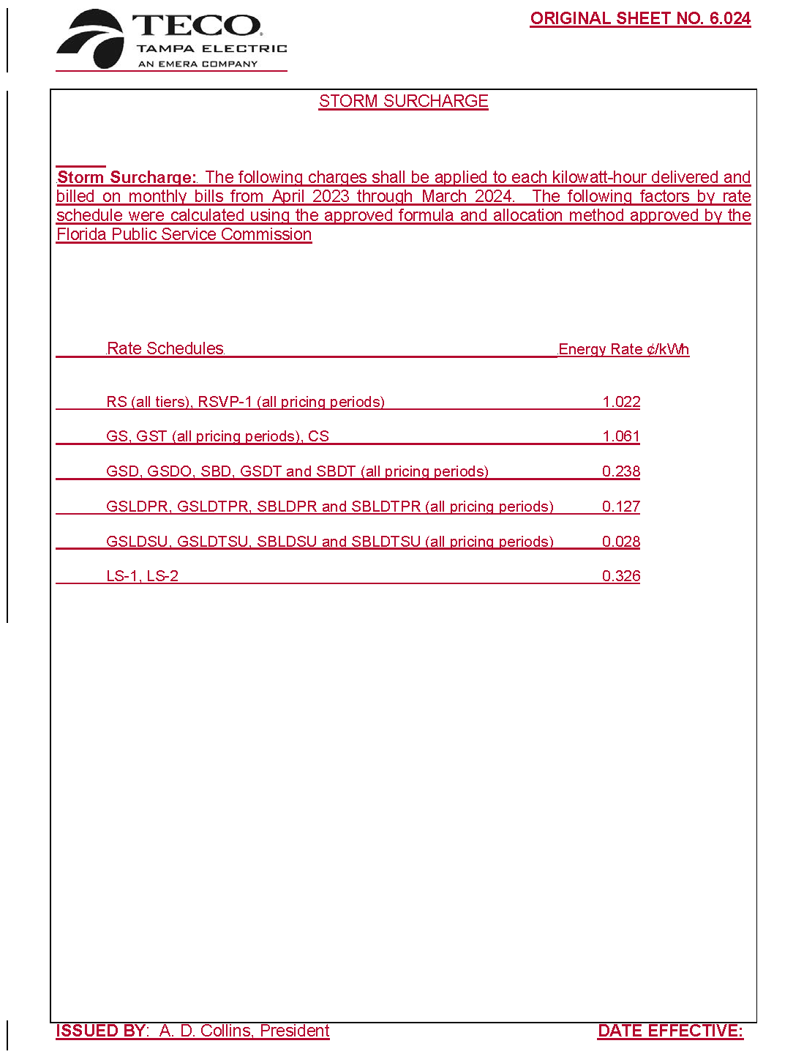

Order No. PSC-2021-0423-S-EI, issued November 10, 2021, in Docket No. 20210034-EI, In re: Petition for rate increase by Tampa Electric Company.
Order No. PSC-2019-0234-AS-EI, issued June 14, 2019, in Docket No. 20170271-EI, In re: Petition for recovery of costs associated with named tropical systems during the 2015, 2016, and 2017 hurricane seasons and replenishment of storm reserve subject to final true-up, Tampa Electric Company.
Order No. PSC-2021-0423-S-EI, issued November 10, 2021, in Docket No. 20210034-EI, In re: Petition for rate increase by Tampa Electric Company.

