BEFORE THE FLORIDA PUBLIC SERVICE COMMISSION

In re: Petition for approval of transportation service agreement with Florida Public Utilities Company by Peninsula Pipeline Company, Inc. | DOCKET NO. 20230032-GU  ORDER NO. PSC-2023-0133-PAA-GU  ISSUED: April 18, 2023

The following Commissioners participated in the disposition of this matter:

ANDREW GILES FAY, Chairman
ART GRAHAM
GARY F. CLARK
MIKE LA ROSA
GABRIELLA PASSIDOMO

NOTICE OF PROPOSED AGENCY ACTION
ORDER APPROVING TRANSPORTATION SERVICE AGREEMENT

BY THE COMMISSION:

NOTICE is hereby given by the Florida Public Service Commission that the action discussed herein is preliminary in nature and will become final unless a person whose interests are substantially affected files a petition for a formal proceeding, pursuant to Rule 25-22.029, Florida Administrative Code (F.A.C.).

Background
On March 2, 2023, Peninsula Pipeline Company, Inc. (Peninsula) filed a petition seeking approval of a firm transportation service agreement (Transportation Agreement) between Peninsula and Florida Public Utilities Company (FPUC) (collectively, the parties). The purpose of the Transportation Agreement is to ensure continuance of gas service to FPUC after the impending acquisition by Peninsula of certain pipeline facilities in the immediate area of the City of Lake Wales in Polk County. Peninsula operates as an intrastate natural gas transmission company as defined by Section 368.103(4), Florida Statutes (F.S). FPUC is a local distribution company (LDC) subject to our regulatory jurisdiction pursuant to Chapter 366, F.S.
By Order No. PSC-07-1012-TRF-GP, Peninsula received approval of an intrastate gas pipeline tariff that allows it to construct and operate intrastate pipeline facilities and to actively pursue agreements with natural gas customers. Peninsula provides gas transportation service only; it does not engage in the sale of natural gas. Pursuant to Order No. PSC-07-1012-TRF-GP, Peninsula is allowed to enter into certain gas transmission agreements without our prior approval. However, Peninsula is requesting our approval of this proposed Transportation Agreement as it does not fit any of the criteria enumerated in the tariff for which our approval would not be required. The parties are subsidiaries of Chesapeake Utility Corporation, a Delaware corporation, and agreements between affiliated companies must be approved by us pursuant to Section 368.105, F.S., and Order No. PSC-07-1012-TRF-GP.
In 1999, we approved a pipeline lease agreement (1999 agreement) between FPUC (Florida Division of Chesapeake Utilities Corporation at the time) and Citrosuco North America, Inc. (Citrosuco) for pipeline facilities in the Lake Wales area. Citrosuco owns and operates a citrus processing plant in Lake Wales. In 1999, Citrosuco constructed a natural gas pipeline that provides access for the Citrosuco processing plant to the Florida Gas Transmission (FGT) interstate natural gas pipeline. The Citrosuco-owned pipeline runs from the FGT Lake Wales gate station to Citrosuco’s meter at the entrance of its citrus processing plant.
Pursuant to the 1999 agreement, Citrosuco owns the pipeline and leases it to FPUC for operation and maintenance. FPUC receives certain quantities of natural gas at the Lake Wales Gate Station for Citrosuco’s use and transports the natural gas on the pipeline to Citrosuco’s facility. In addition, FPUC accesses the pipeline to serve customers in the Lake Wales area. The 1999 agreement expired in 2019 and has been renewed on a monthly basis.
Peninsula has been in discussions with Citrosuco to acquire the pipeline from Citrosuco through a Pipeline Purchase and Sale Agreement. This purchase agreement between Peninsula and Citrosuco, which contains a negotiated purchase price, does not require our approval. Upon acquisition, Peninsula would maintain and operate the pipeline and provide transportation service to FPUC pursuant to the proposed Transportation Agreement. Citrosuco would continue to receive natural gas service from the pipeline. Peninsula stated that the closing of the purchase agreement is contingent on our approval of the proposed Transportation Agreement.
The proposed Transportation Agreement and project map are shown as Attachments A and B to this order. Pursuant to the Transportation Agreement, FPUC will continue to utilize the Citrosuco pipeline system to serve its customers in and around Lake Wales, Florida. On March 8, 2023, our staff had an informal conference call with Peninsula and FPUC regarding the petition. During the evaluation of the petition, staff issued a data request to the parties for which responses were received on March 13, 2023. Peninsula requested expedited approval of the proposed Transportation Agreement and that we consider it at our April 4, 2023 Agenda Conference. We have jurisdiction over this matter pursuant to Sections 366.05(1), 366.06, and 368.105, F.S.

Decision

Proposed Transportation Service Agreement
The parties have entered into the proposed firm Transportation Agreement to enable FPUC to continue to serve natural gas customers in and around the area of Lake Wales once Peninsula has acquired the Citrosuco pipeline system.
The proposed Transportation Agreement specifies an initial term of 20 years and thereafter shall be extended on a year-to-year basis, unless either party gives no less than 90 days of written notification of termination. If either party desires to negotiate modifications to the rates or terms of this Transportation Agreement, they may do so no less than 120 days prior to expiration of the current active term. The proposed Citrosuco pipeline acquisition is discussed below and the project map depicting the pipeline is Attachment B to this order.

Citrosuco Pipeline Acquisition
The Citrosuco pipeline consists of approximately 11 miles of 8-inch steel pipeline and associated facilities. The pipeline runs from the FGT Lake Wales gate station to Citrosuco’s meter at the entrance of its citrus processing plant.
In the petition, Peninsula stated that it has negotiated an acquisition agreement with Citrosuco for the Citrosuco pipeline system and that the closing of the pipeline acquisition agreement is contingent on our approval of the proposed Transportation Agreement. If the proposed Transportation Agreement is approved, Peninsula stated that it will take over ownership of the pipeline, as well as operation and maintenance of the facilities from FPUC. Peninsula will provide service to FPUC pursuant to the proposed Transportation Agreement. In response to staff’s data request, the parties explained that the Citrosuco pipeline falls within the portfolio of projects typically operated by Peninsula, instead of FPUC.
The parties stated that after the closing of the acquisition, FPUC will serve Citrosuco for six years pursuant to the Commission-approved Contract Transportation Service Rider which allows FPUC to provide reduced rates to commercial or industrial customers with alternate fuel capabilities. Afterwards, FPUC asserts that Citrosuco would be served under a standard rate schedule.

Anticipated System Benefits
The parties assert that the proposed Transportation Agreement will enable FPUC to continue to obtain gas supply from FGT upon Peninsula’s acquisition of the Citrosuco pipeline. In response to staff’s first data request, FPUC stated that it believes there is too much risk involved in leasing key facilities from an unrelated entity such as Citrosuco. FPUC believes that Peninsula’s ownership of the pipeline will protect the general body of ratepayers from potential unforeseen price increases or service challenges tied to a leasing arrangement. FPUC stated that the Citrosuco pipeline is a key strategic asset for FPUC’s gas supply and operations in the City of Lake Wales. Additionally, FPUC stated that it anticipates growth in the immediate area of the pipeline, and that Peninsula owning the pipeline would position FPUC to meet the anticipated growth.
Furthermore, the parties asserted that purchasing the existing pipeline through a negotiated purchase price would be less costly than installing a new, separate pipeline to serve FPUC’s customers. FPUC estimated that it would cost approximately $15.46 million to build another, similar feed to its Lake Wales system. By instead acquiring the existing pipeline from Citrosuco, Peninsula would be avoiding additional costs, therefore reducing the total cost to be recovered from FPUC’s general body of ratepayers.

Negotiated Monthly Reservation Payments to Peninsula
The parties assert that the negotiated monthly reservation charge contained in the proposed Transportation Agreement is consistent with market rates, because the rates are substantially the same as rates set forth in similar agreements as required by Section 368.105(3)(b), F.S. The parties assert that Peninsula will recover the purchase price of the pipeline from Citrosuco through the monthly reservation charge (confidential) to FPUC as shown in Exhibit A to the proposed Transportation Agreement.
FPUC is proposing to recover its payments to Peninsula through Purchased Gas Adjustment (PGA) and swing service rider mechanisms. The PGA allows FPUC to periodically adjust the price of natural gas supplied to its customers to reflect the actual cost of gas purchased and delivered on behalf of the customers. The swing service rider allows FPUC to recover intrastate capacity costs from their transportation customers and is a cents per therm charge that is included in the monthly customer gas bill of transportation customers.

Conclusion
Based on the petition and the parties’ responses to our staff’s data request, we find that the proposed Transportation Agreement is reasonable and meets requirements of Section 368.105, F.S. Furthermore, the proposed Transportation Agreement benefits FPUC’s current and potential future customers by ensuring that there is a continuous supply of natural gas to the City of Lake Wales. Therefore, we approve the proposed Transportation Agreement between Peninsula and FPUC dated March 1, 2023.

Based on the foregoing, it is

ORDERED by the Florida Public Service Commission that the proposed firm transportation service agreement dated March 1, 2023 between Florida Public Utilities Company and Peninsula Pipeline Company, Inc., is approved. The proposed Transportation Agreement is reasonable and meets the requirements of Section 368.105, F.S. Furthermore, the proposed Transportation Agreement benefits FPUC’s current and potential future customers by ensuring that there is an uninterrupted supply of natural gas to Lake Wales, Florida. It is further

ORDERED that the provisions of this Order, issued as proposed agency action, shall become final and effective upon the issuance of a Consummating Order unless an appropriate petition, in the form provided by Rule 28-106.201, Florida Administrative Code, is received by the Commission Clerk, 2540 Shumard Oak Boulevard, Tallahassee, Florida 32399-0850, by the close of business on the date set forth in the “Notice of Further Proceedings” attached hereto. It is further

ORDERED that in the event this Order becomes final, this docket shall be closed.

By ORDER of the Florida Public Service Commission this 18th day of April, 2023.

/s/ Adam J. Teitzman
ADAM J. TEITZMAN
Commission Clerk
Florida Public Service Commission
2540 Shumard Oak Boulevard
Tallahassee, Florida 32399
(850) 413-6770
www.floridapsc.com

Copies furnished: A copy of this document is provided to the parties of record at the time of issuance and, if applicable, interested persons.

MRT

NOTICE OF FURTHER PROCEEDINGS OR JUDICIAL REVIEW

The Florida Public Service Commission is required by Section 120.569(1), Florida Statutes, to notify parties of any administrative hearing that is available under Section 120.57, Florida Statutes, as well as the procedures and time limits that apply. This notice should not be construed to mean all requests for an administrative hearing will be granted or result in the relief sought.

Mediation may be available on a case-by-case basis. If mediation is conducted, it does not affect a substantially interested person's right to a hearing.

The action proposed herein is preliminary in nature. Any person whose substantial interests are affected by the action proposed by this order may file a petition for a formal proceeding, in the form provided by Rule 28-106.201, Florida Administrative Code. This petition must be received by the Office of Commission Clerk, 2540 Shumard Oak Boulevard, Tallahassee, Florida 32399-0850, by the close of business on May 9, 2023.

In the absence of such a petition, this order shall become final and effective upon the issuance of a Consummating Order.

Any objection or protest filed in this/these docket(s) before the issuance date of this order is considered abandoned unless it satisfies the foregoing conditions and is renewed within the specified protest period.

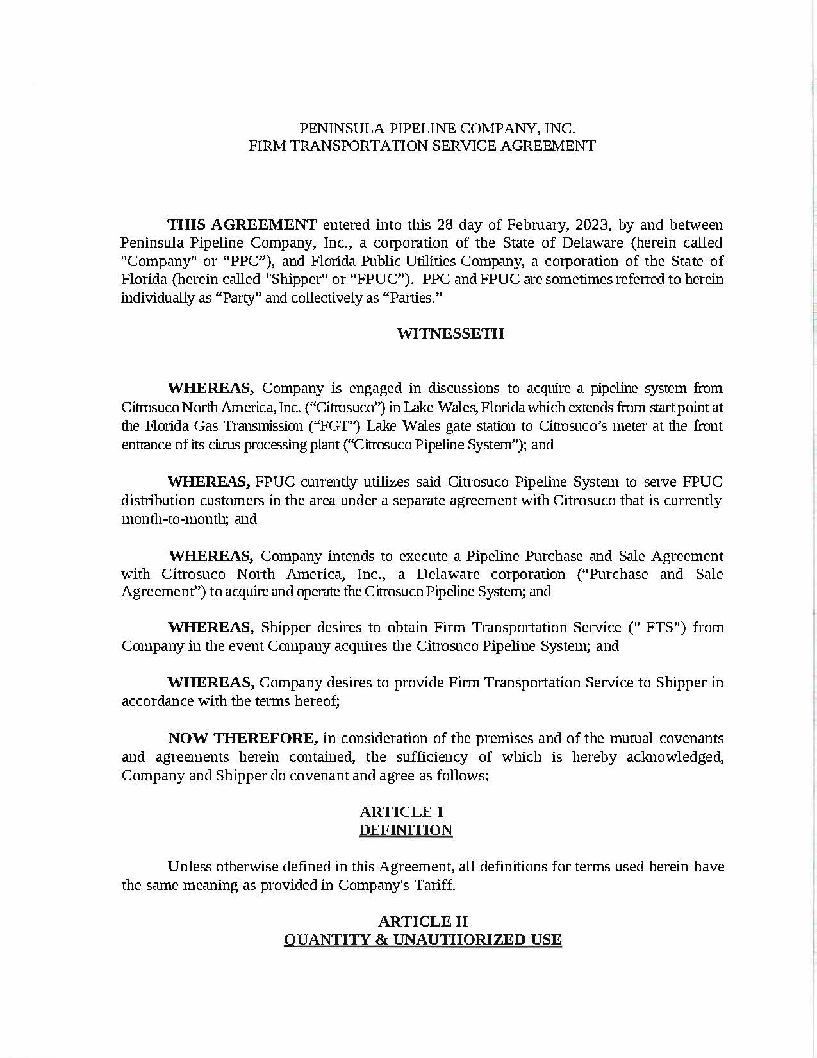
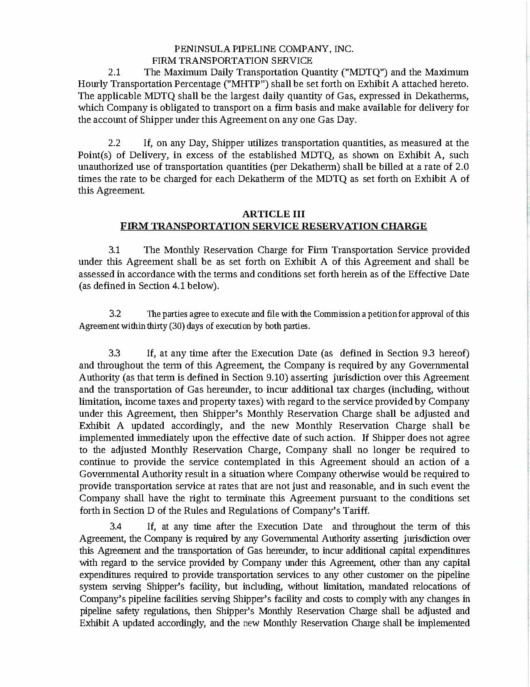
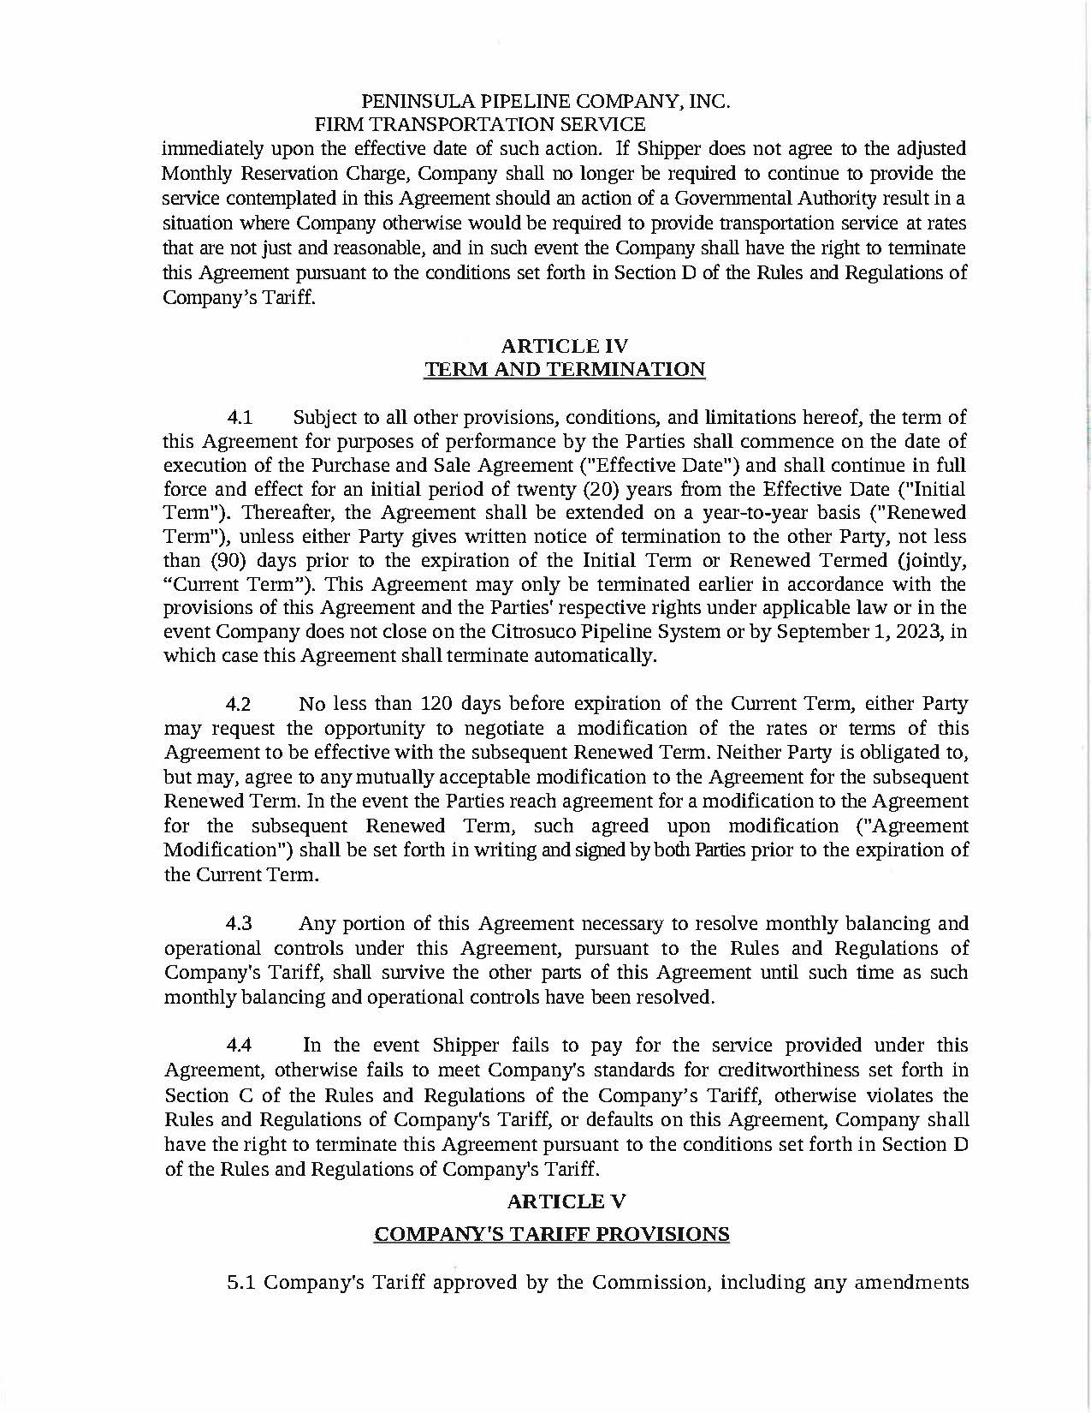
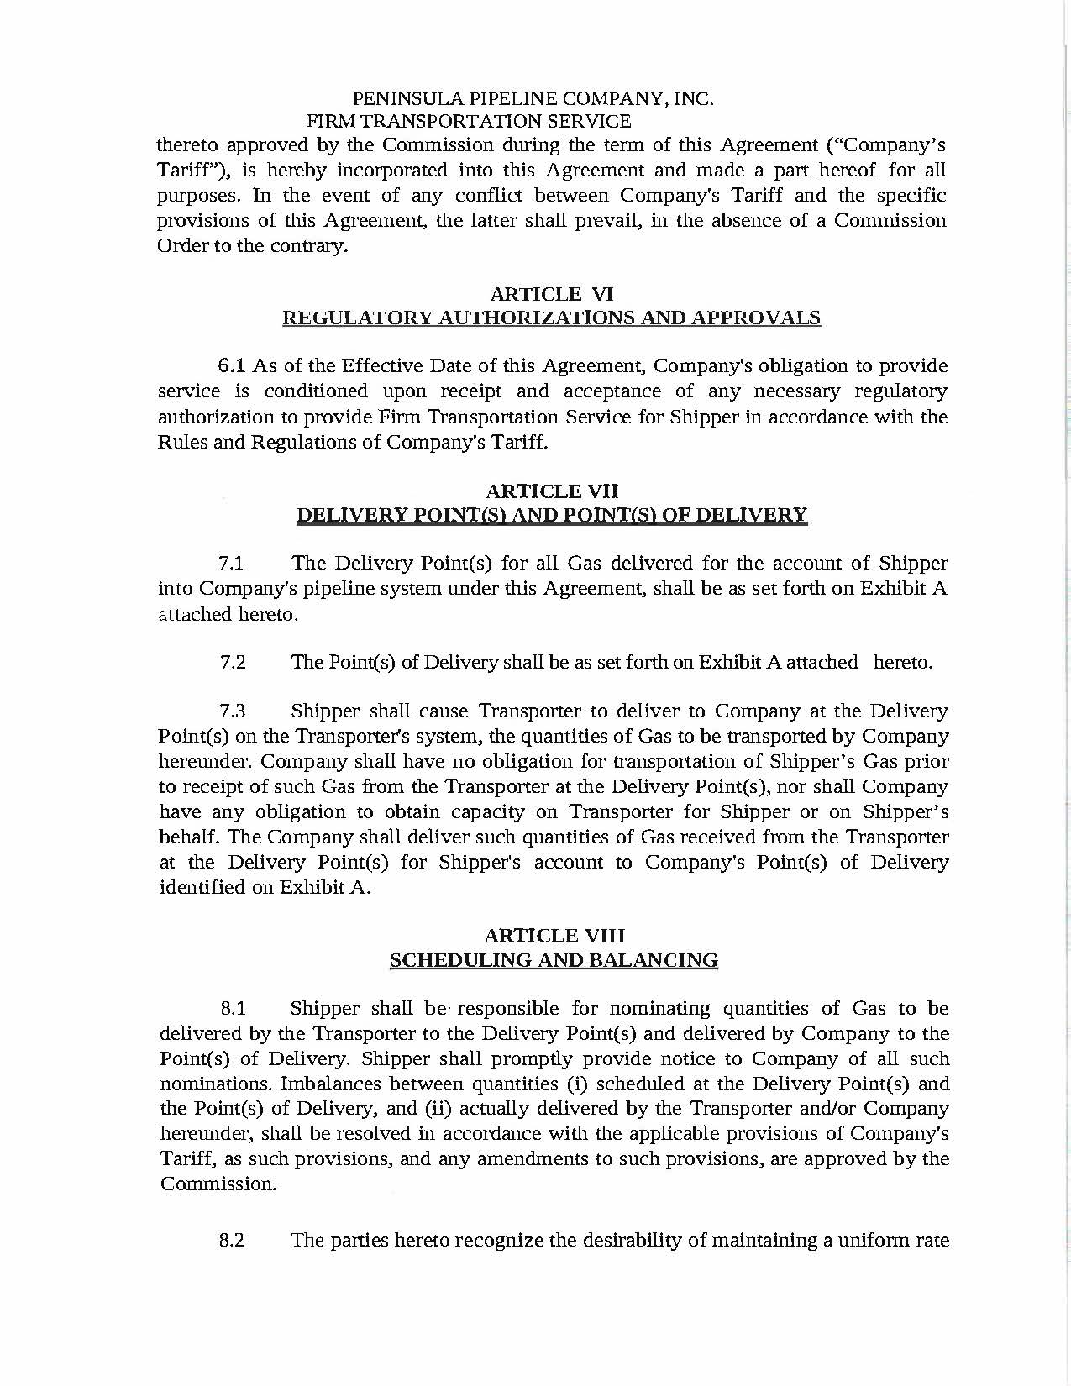
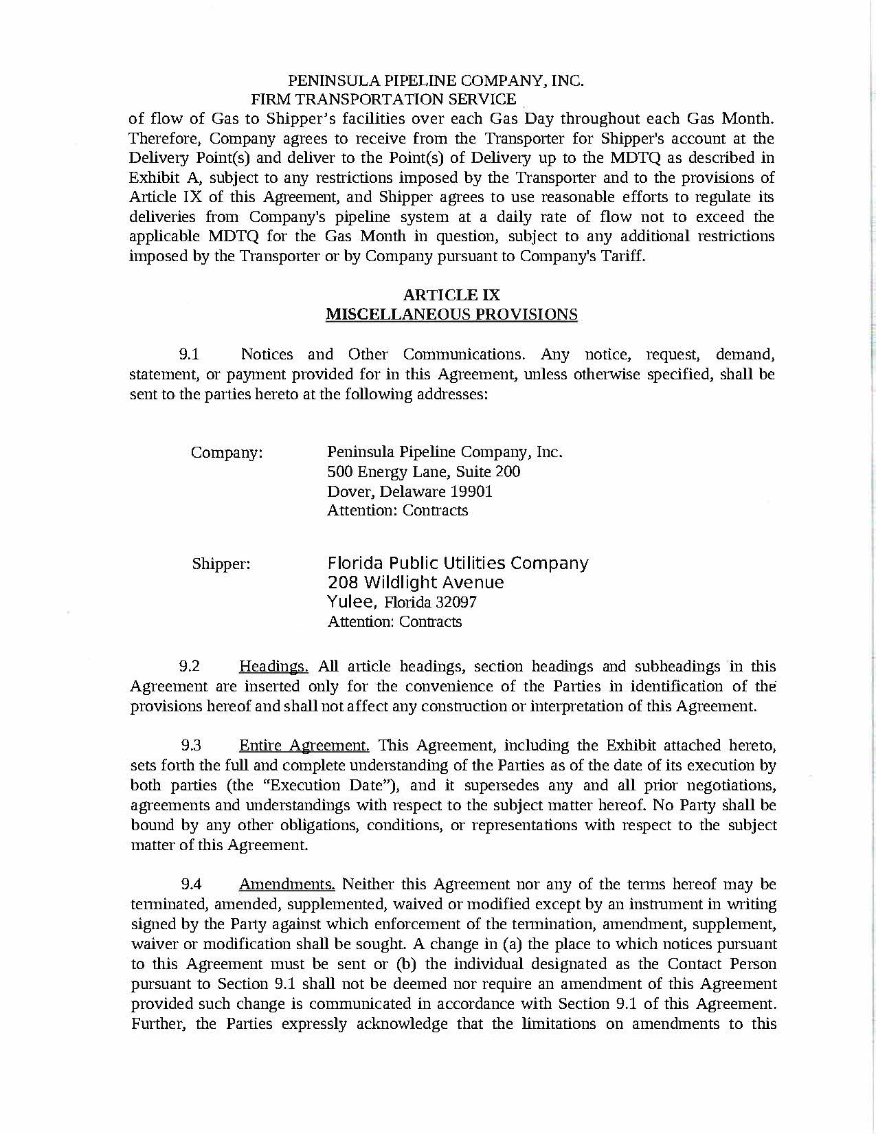
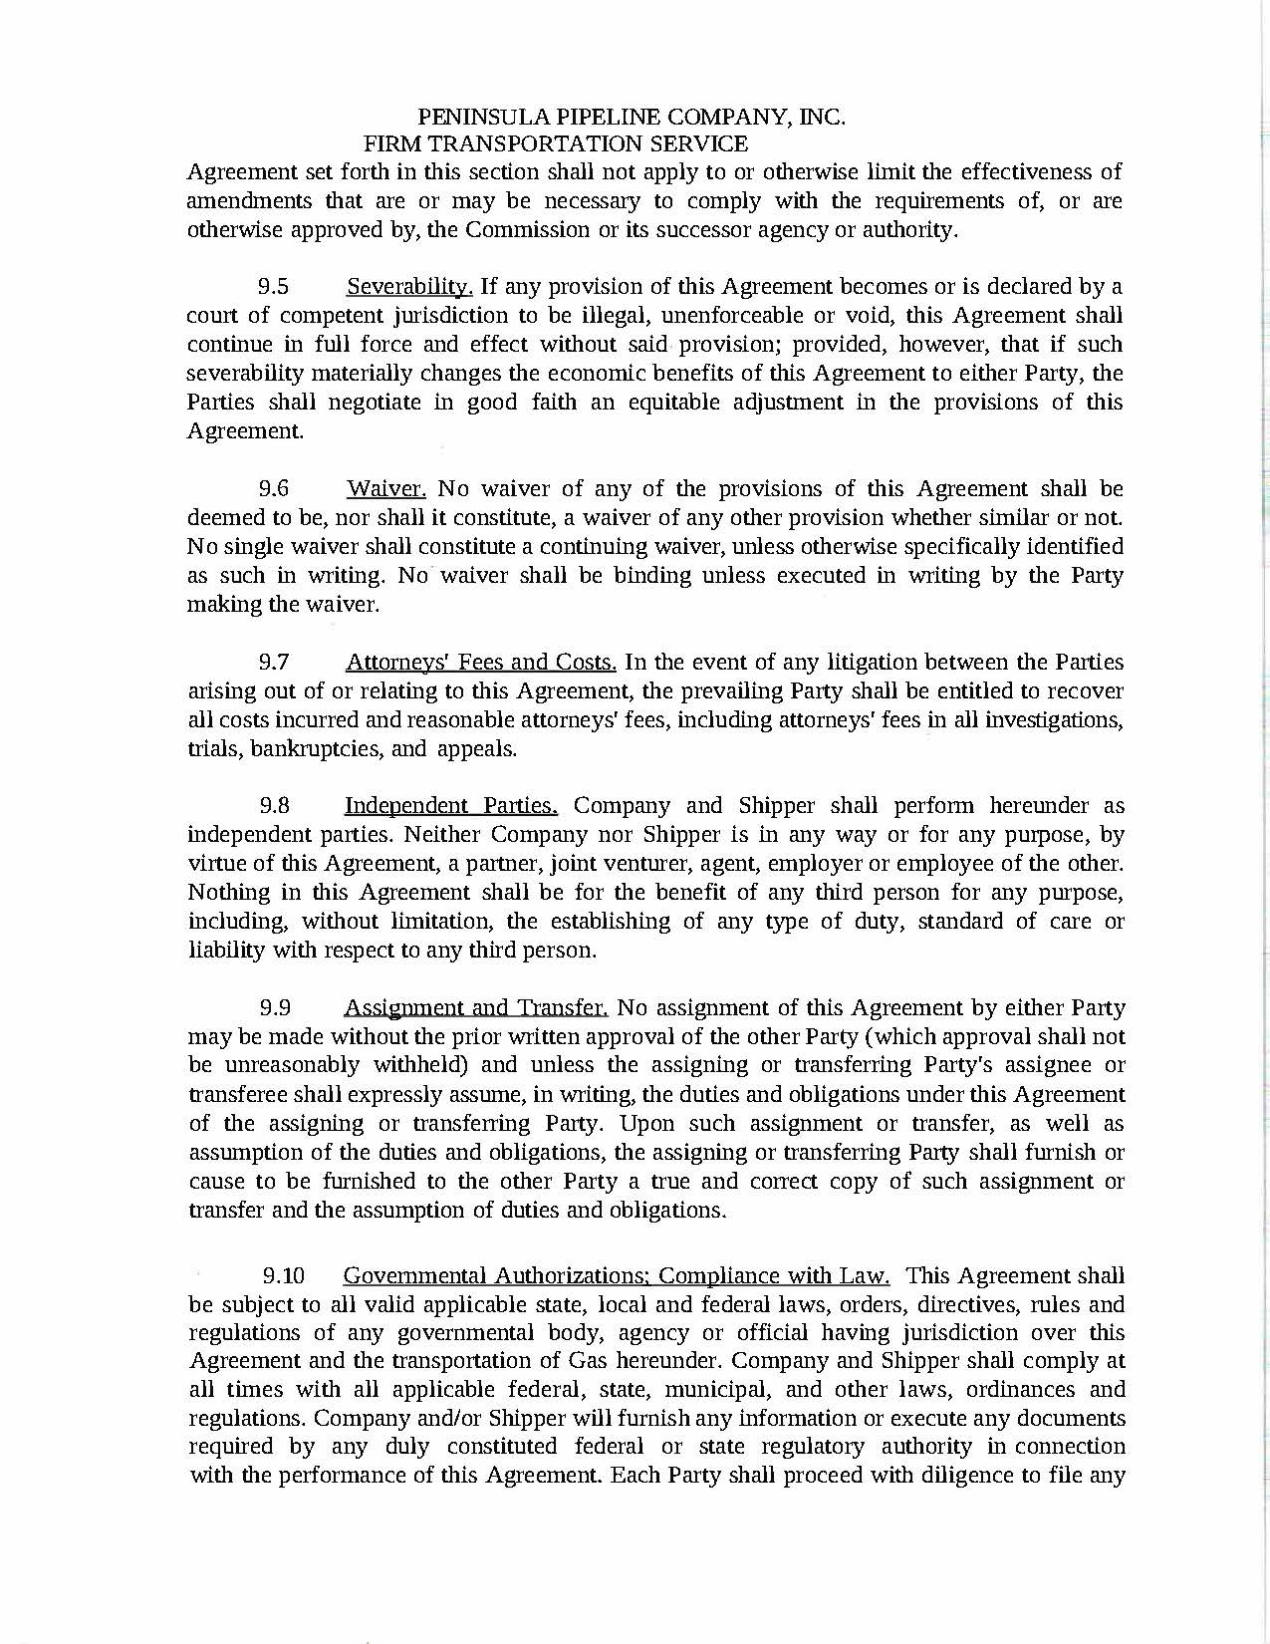
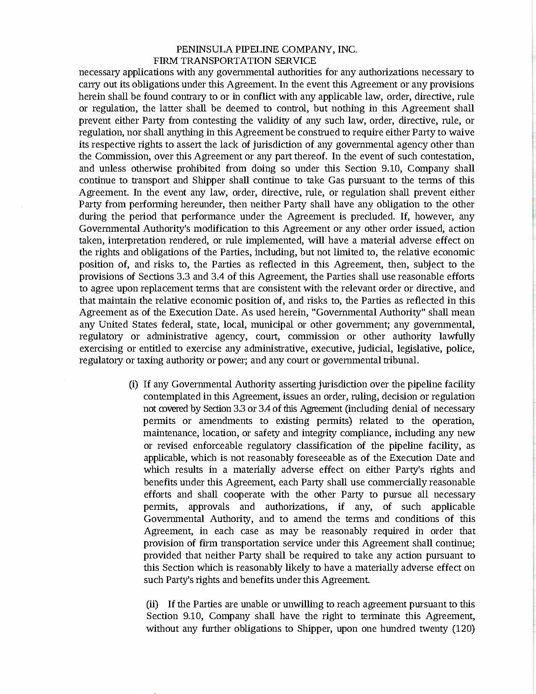
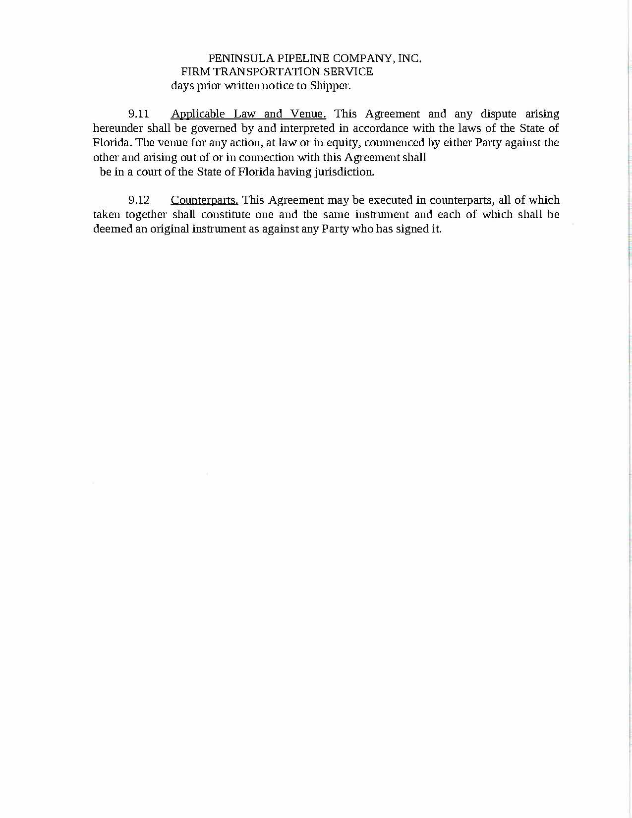
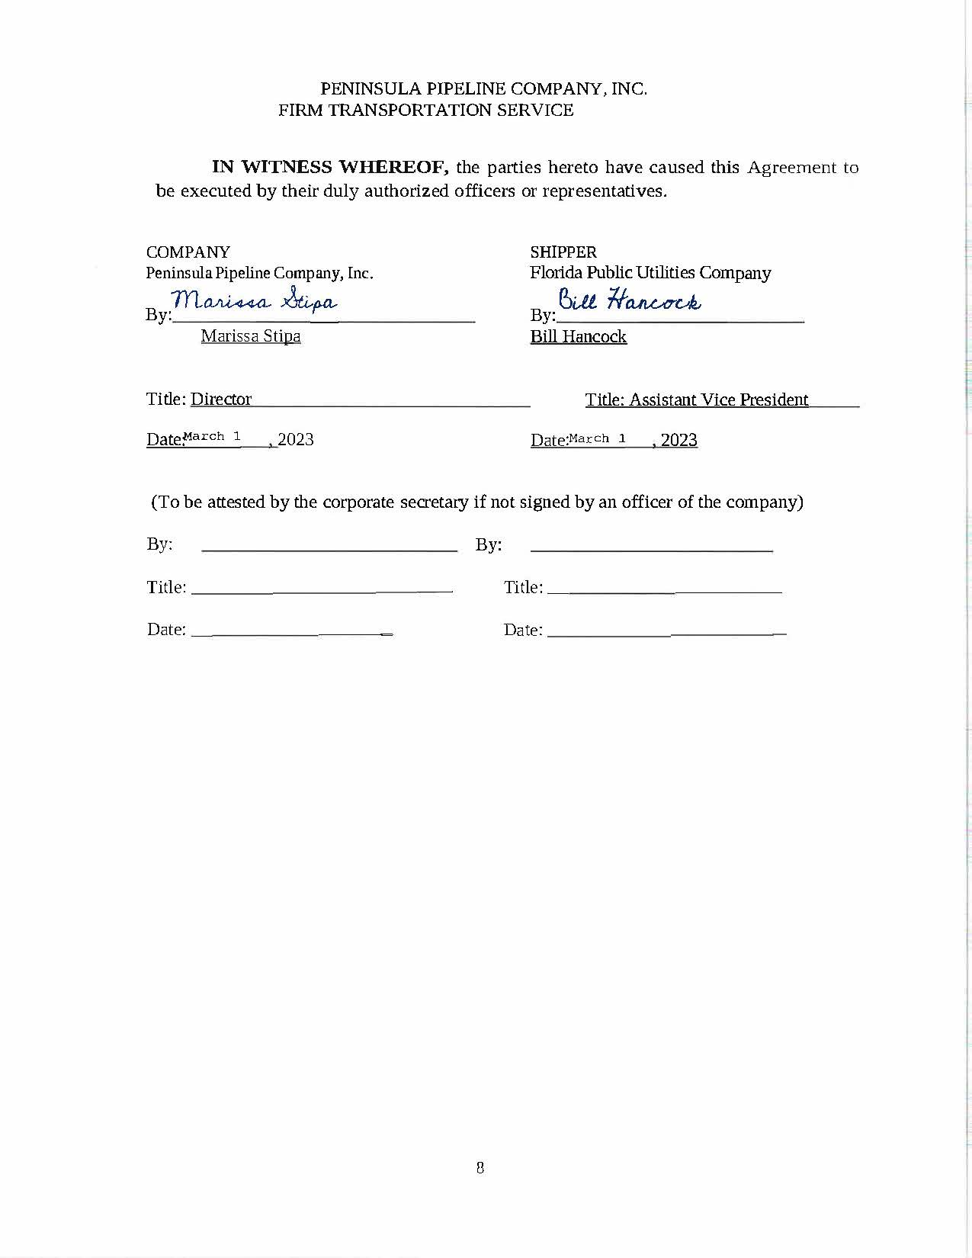
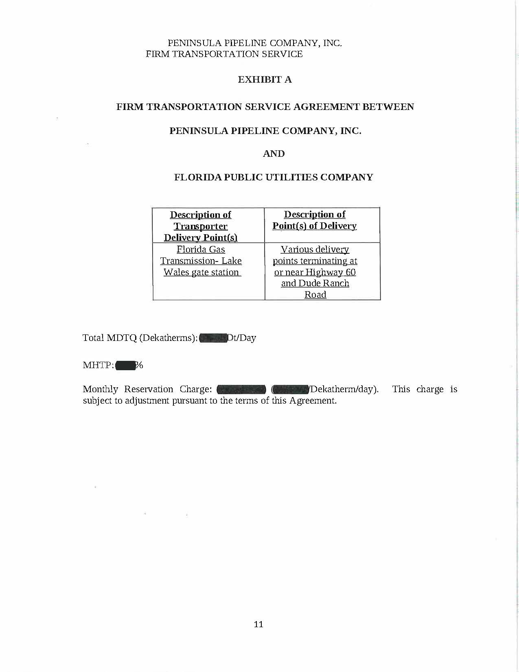
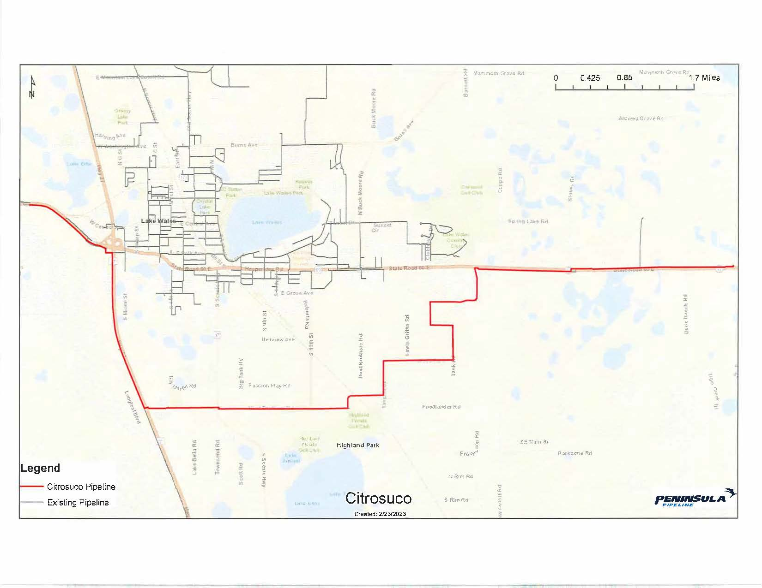

Order No. PSC-06-0023-DS-GP, issued January 9, 2006, in Docket No. 050584-GP, In re: Petition for declaratory statement by Peninsula Pipeline Company, Inc. concerning recognition as a natural gas transmission company under Section 368.101, F.S., et seq.
Order No. PSC-07-1012-TRF-GP, issued December 21, 2007, in Docket No. 070570-GP, In re: Petition for approval of natural gas transmission pipeline tariff by Peninsula Pipeline Company, Inc.
Peninsula Pipeline Company, Inc., Intrastate Pipeline Tariff, Original Vol. 1, Original Sheet No. 11, Section 3.
Peninsula Pipeline Company, Inc., Intrastate Pipeline Tariff, Original Vol. 1, Original Sheet No. 12, Section 4.
Order No. PSC-99-2106-PAA-GU, issued October 25, 1999, in Docket No. 991168-GU, In re: Petition by the Florida Division of Chesapeake Utilities Corporation for approval of CTS Gas Transportation Service Agreement with Citrosuco North America, Inc.
Document No. 02200-2023.
Document No. 02200-2023.

