State of Florida |  | Public Service Commission  Capital Circle Office Center ● 2540 Shumard Oak Boulevard  Tallahassee, Florida 32399-0850  -M-E-M-O-R-A-N-D-U-M-
DATE: | June 1, 2023
TO: | Office of Commission Clerk (Teitzman)
FROM: | Division of Accounting and Finance (Higgins, G. Kelley, Zaslow)  Division of Economics (Hampson)  Office of the General Counsel (Brownless, Sandy)
RE: | Docket No. 20230001-EI – Fuel and purchased power cost recovery clause with generating performance incentive factor.
AGENDA: | 06/13/23 – Regular Agenda – Interested Persons May Participate
COMMISSIONERS ASSIGNED: |  |  | All Commissioners
PREHEARING OFFICER: |  |  | La Rosa
CRITICAL DATES: |  |  | None
SPECIAL INSTRUCTIONS: |  |  | None

Case Background
On May 19, 2023, Florida Power & Light Company (FPL or Company), filed for a mid-course correction of its 2023 fuel cost recovery charges (MCC Petition). The Company last filed for a mid-course correction of its fuel charges in March 2023. The Company’s March 2023 mid-course correction was approved at the April 4, 2023 Commission Conference. Following the March 2023 mid-course correction, the Company’s projected fuel-related revenue requirement continued to shift downward. This projected cost shift prompted the Company to file for a subsequent mid-course correction (instant petition) to incorporate the reduction into customer rates.

Mid-Course Corrections
Mid-course corrections are used by the Florida Public Service Commission (Commission) between annual clause hearings whenever costs deviate from revenue by a significant margin. Under Rule 25-6.0424, Florida Administrative Code (F.A.C.), which is commonly referred to as the “mid-course correction rule,” a utility must notify the Commission whenever it expects to experience an under- or over-recovery of certain service costs greater than 10 percent. The notification of a 10 percent cost-to-revenue variance shall include a petition for mid-course correction to the fuel cost recovery or capacity cost recovery factors, or shall include an explanation of why a mid-course correction is not practical.

FPL’s Petition
In its MCC Petition, the Company currently estimates an additional $359 million reduction of fuel-related costs for the 2023 period relative to its previous estimate. FPL is proposing to apply approximately $256 million of this cost reduction to the time period July 2023 through December 2023, and the remaining approximately $103 million is proposed to be included in its 2024 fuel cost recovery factors. The Company is requesting that its revised fuel cost recovery factors and associated tariff become effective beginning with the July 2023 billing cycle. The proposed effective date is further discussed in both Issues 1 and 2.

The Commission is vested with jurisdiction over the subject matter of this proceeding by the provisions of Chapter 366, Florida Statutes (F.S.), including Sections 366.04, 366.05, and 366.06, F.S.

Discussion of Issues

Issue 1:
Should the Commission modify FPL’s currently-authorized fuel cost recovery factors for the purpose of incorporating its projected 2023 fuel cost reduction?

Recommendation:
Yes. Staff recommends the Commission authorize adjustments to FPL’s fuel cost recovery factors for the purpose of incorporating a portion of the Company’s projected 2023 fuel cost reduction. Accordingly, FPL’s currently-authorized 2023 fuel cost recovery factors should be reduced by $256,094,786. (Zaslow, G. Kelley, Higgins)

Staff Analysis:
FPL submitted its last mid-course correction petition on March 1, 2023, to address a predicted over-recovery of 2023 fuel costs. At that time, the Company’s 2023 net over-recovery of fuel costs was approximately $494 million. FPL proposed to account for approximately $379 million of the 2023 over-recovery during 2023 (specifically May 2023 through December 2023), and defer the remaining approximate $115 million to be included in 2024. FPL states the purpose of implementing the cost reduction over this period is to partially offset the bill impact associated with the storm restoration costs approved for collection from April 2023 through March 2024 in Docket No. 20230017-EI. Due to the corresponding change in 2023 interest expense by applying the fuel cost recovery factors approved in Order No. PSC-2023-0122-PCO-EI, that balance now amounts to approximately $109 million.

Following its last mid-course correction, the Company has subsequently updated its 2023 fuel cost projection. FPL now projects its 2023 fuel-related costs are approximately $359 million lower than estimated in February 2023. This reduction is primarily due to lower assumed prices for natural gas. The main factors influencing the decline in natural gas prices in 2023 are elevated quantities of natural gas in storage and increased natural gas production compared to previous years.

The Company developed its (instant) proposed mid-course correction factors using nine months of forecasted sales data (July 2023 through March 2024). The factors proposed in this proceeding are currently contemplated to be charged for six months in 2023. As is typical procedure, later this year newly developed 12-month-applicable factors will be proposed for authorization to begin with the first billing cycle of January 2024.

Projected 2023 Fuel Cost Recovery Position
FPL’s estimated 2023 fuel-related costs have decreased since the filing of its previous mid-course correction in March 2023. The Company now estimates a reduction to its 2023 fuel-related costs in the amount of $358,764,356. The Company proposes to apply $256,094,786 of this amount to rates in 2023, and $102,669,570 to rates in 2024.

The primary factor driving the change in projected 2023 fuel costs is lower assumed pricing for natural gas. The underlying market-based natural gas price data used for the 2023 fuel cost projection was sourced on February 1, 2023. This underlying data was used to produce an estimated average 2023 delivered natural gas cost of $4.95 per million British thermal unit (MMBtu). However, as noted above and indicated in its MCC Petition, FPL now estimates its average cost of delivered natural gas in 2023 will be $4.38 per MMBtu, representing a decrease of (11.5) percent. The updated cost estimate was based on natural gas futures/prices sourced on May 1, 2023, or roughly three months later than the previous estimate used to set current rates.

Staff compared the June through December 2023 commodity-only, i.e., excluding delivery cost, price projection for natural gas underlying the Company’s mid-course correction filing with current market prices. Staff observes the arithmetic average of FPL’s commodity-only natural gas price projection for the seven-month period June through December 2023 is $2.75 per MMBtu. As previously indicated, FPL’s pricing information was sourced on May 1, 2023. Using more current data, or information sourced on May 26, 2023, staff calculates an average natural gas (commodity-only) price of $2.71 per MMBtu for the same seven-month period. The results of this comparison indicate that natural gas prices over the relevant timeframe have decreased since the development of the MCC Petition. However, staff notes that natural gas prices are continuously subject to market-influencing forces and therefore can be volatile.

Mid-Course Percentage
Using the values shown on Schedule E1-B of the MCC Petition and following the methodology prescribed in Rule 25-6.0424(1)(a), F.A.C., the mid-course percentage is equal to the estimated end-of-period total net true-up, including interest, divided by the current period’s total actual and estimated jurisdictional fuel revenue applicable to period, or ($733,450,360) / $3,502,348,466. This calculation results in a mid-course correction level of (20.9) percent at December 31, 2023.

Fuel Factor
FPL’s currently-authorized annual levelized fuel factor is 3.526 cents per kilowatt-hour (kWh). The Company is requesting to decrease its currently-approved 2023 annual levelized fuel factor beginning July 2023 to 3.142 cents per kWh, or by (10.9) percent.

Bill Impacts
In Tables 1-1 and 1-2 below, staff displays the bill impacts of the mid-course correction proposal to typical residential customers using 1,000 kWh of electricity a month in FPL’s Peninsular and Northwest (former Gulf Power Company) service territories. Following Tables 1-1 and 1-2, staff addresses the impact of the proposed MCC on non-residential customers:
Table 1-1
FPL Peninsular Service Territory
Monthly Residential Billing Detail for the First 1,000 kWh
Invoice Component | Currently-Authorized Charges  June 2023  ($) | Proposed Charges  Beginning  July  2023  ($) | Difference  ($) | Difference  (%)
Base Charge | $80.11 | $80.11 | $0.00 | 0.0%
Fuel Charge | 32.24 | 28.39 | (3.85) | (11.9%)
Conservation Charge | 1.22 | 1.22 | 0.00 | 0.0%
Capacity Charge | 2.12 | 2.12 | 0.00 | 0.0%
Environmental Charge | 3.12 | 3.12 | 0.00 | 0.0%
Storm Protection Plan Charge | 3.82 | 3.82 | 0.00 | 0.0%
Storm Restoration Surcharge | 15.30 | 15.30 | 0.00 | 0.0%
Transition Rider | (1.58) | (1.58) | 0.00 | 0.0%
Gross Receipts Tax and Regulatory Assessment Fee | 3.60 | 3.50 | (0.10) | (2.8%)
Total | $139.95 | $136.00 | ($3.95) | (2.8%)
Source: Document No. 03296-2023.

FPL’s currently-authorized total residential charge for the first 1,000 kWh of usage for June 2023 is $139.95. If the Company’s mid-course correction proposal is approved, then the current total residential charge for the first 1,000 kWh of usage beginning in July will be $136.00, a decrease of approximately (2.8) percent. Concerning non-residential customers, FPL reported that bill decreases based on average levels of usage for small-sized commercial customers would range from approximately (2.8) to (3.6) percent, (3.6) percent for medium-sized commercial customers, (3.9) percent for large-sized commercial customers, and (6.4) percent for industrial customers.
Table 1-2
FPL Northwest Service Territory
Monthly Residential Billing Detail for the First 1,000 kWh
Invoice Component | Currently-Authorized Charges  June  2023  ($) | Proposed Charges  Beginning  July  2023  ($) | Difference  ($) | Difference  (%)
Base Charge | $80.11 | $80.11 | $0.00 | 0.0%
Fuel Charge | 32.24 | 28.39 | (3.85) | (11.9%)
Conservation Charge | 1.22 | 1.22 | 0.00 | 0.0%
Capacity Charge | 2.12 | 2.12 | 0.00 | 0.0%
Environmental Charge | 3.12 | 3.12 | 0.00 | 0.0%
Storm Protection Plan Charge | 3.82 | 3.82 | 0.00 | 0.0%
Storm Restoration Surcharge | 15.30 | 15.30 | 0.00 | 0.0%
Transition Rider | 16.85 | 16.85 | 0.00 | 0.0%
Gross Receipts Tax and Regulatory Assessment Fee | 4.08 | 3.98 | (0.10) | (2.5%)
Total | $158.86 | $154.91 | ($3.95) | (2.5%)
Source: Document No. 03296-2023.

FPL’s currently-authorized Northwest total residential charge for the first 1,000 kWh of usage for June 2023 is $158.86. If the Company’s mid-course correction proposal is approved, the current total Northwest residential charge for the first 1,000 kWh of usage beginning in July will be $154.91, a decrease of approximately (2.5) percent. Concerning non-residential customers, FPL reported that bill decreases based on average levels of usage for small-sized commercial customers would range from approximately (2.4) to (3.2) percent, and (3.2) percent for medium-size commercial customers, and (3.4) percent for large-size commercial customers. A figure associated with an industrial class for the Northwest service territory was not identified.

Summary
FPL’s MCC Petition indicates a need for its fuel recovery factors to be revised. The Company’s currently projected 2023 fuel-related costs have been reduced by $358,764,356. The Company proposes to account for $256,094,786 of this fuel cost reduction in the current period and defer $102,669,570 to 2024. The revised fuel cost recovery factors associated with staff’s recommendation are shown on Appendix A.

Conclusion
Staff recommends the Commission approve adjustments to FPL’s fuel cost recovery factors for the purpose of incorporating a portion of the Company’s projected 2023 fuel cost reduction. Accordingly, FPL’s currently-authorized 2023 fuel cost recovery factors should be reduced by $256,094,786.

Issue 2:
If approved by the Commission, what is the appropriate effective date for FPL’s revised fuel cost recovery factors?

Recommendation:
The fuel cost recovery factors, as shown on Appendix A, should become effective with the first billing cycle of July 2023. (Hampson, Brownless, Sandy)

Staff Analysis:
Over the last 20 years in the Fuel Clause docket, the Commission has considered the effective date of rates and charges of revised fuel cost recovery factors on a case-by-case basis. The Commission has approved fuel cost recovery factor rate decreases effective sooner than the next full billing cycle after the date of the Commission’s vote with the range between the vote and the effective date being from 25 to 2 days. The rationale for that action being that it was in the customers’ best interest to implement the lower rate as soon as possible.

In its MCC Petition, FPL proposes to lower its 2023 fuel factors, beginning with the July 2023 billing cycle. In the instant case, there are 20 days between the Commission’s vote on June 13, 2023, and the beginning of FPL’s July 2023 billing cycle (July 3, 2023).

Concerning advisement of the instant request, the Company has engaged in numerous outreach efforts regarding the potential bill impacts of this proceeding. Specifically, FPL issued a press release on May 19, 2023, informing its customers of the MCC proposal. Also on May 19, the Company informed its customers of the potential adjustments related to the mid-course correction through a web-based billing information portal titled “2023 Bills.” The Company also notified major business and governmental accounts/customers on May 22, 2023. General notification, or “billing inserts,” began to be added to customer bills on May 22nd as well.

Conclusion
Staff recommends that the fuel cost recovery factors, as shown on Appendix A, become effective with the first billing cycle of July 2023.

Issue 3:
Should this docket be closed?

Recommendation:
No. The 20230001-EI docket is an on-going proceeding and should remain open. (Brownless, Sandy)

Staff Analysis:
The fuel docket is an on-going proceeding and should remain open.

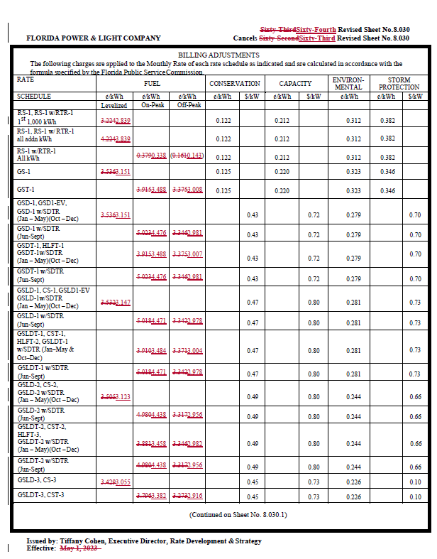
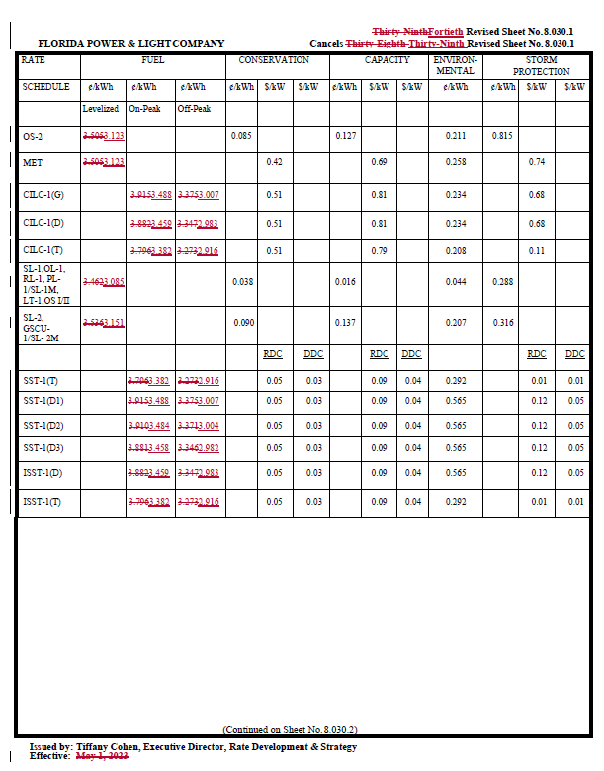

Document No. 03296-2023.
Order No. PSC-2023-0122-PCO-EI, issued April 11, 2023, Docket No. 20230001-EI, In re: Fuel and purchased power cost recovery clause with generating performance incentive factor.
Document No. 01638-2023.
Order No. PSC-2023-0110-PCO-EI, issued March 23, 2023, in Docket No. 20230017-EI, In re: Petition for limited proceeding for recovery of incremental storm restoration costs related to Hurricanes Ian and Nicole, by Florida Power & Light Company.
Document No. 03382-2023.
May 2023 U.S. Energy Information Administration Short-Term Energy Outlook, https://www.eia.gov/outlooks/steo/pdf/steo_full.pdf
Document No. 01638-2023.
Document No. 03296-2023.
Document No. 01638-2023.
Id.
Document No. 03296-2023.
Id.
Staff obtained its natural gas pricing information from the CME Group Inc. CME Group pricing information with respect to natural gas can be located through the following web address: https://www.cmegroup.com/markets/energy/natural-gas/natural-gas.quotes.html
Document No. 03382-2023.
Document No. 03296-2023, Schedule E1-B.
Through Order No. PSC-2023-0108-PCO-EI, FPL received authorization to defer ($1,201,340,636) of its 2022 fuel cost under-recovery to 2024. Additionally, through Order No. PSC-2023-0122-PCO-EI, FPL received authorization to defer $115,279,411 of its 2023 fuel cost over-recovery to 2024. Accounting for these deferrals, the mid-course percentage is equal to $352,610,865/$3,502,348,466, or 10.1 percent.
Document No. 03296-2023.
Order No. PSC-2023-0122-PCO-EI.
Document No. 03382-2023.
Order No. PSC-2023-0122-PCO-EI.
Document No. 03382-2023.
Order No. PSC-2023-0122-PCO-EI.
Document No. 03382-2023.
Id.

