BEFORE THE FLORIDA PUBLIC SERVICE COMMISSION

In re: Commission approval of Florida Telecommunications Relay, Inc.'s fiscal year 2023-2024 proposed budget. | DOCKET NO. 20230047-TP  ORDER NO. PSC-2023-0200-PAA-TP  ISSUED: July 18, 2023

The following Commissioners participated in the disposition of this matter:

ANDREW GILES FAY, Chairman
ART GRAHAM
GARY F. CLARK
MIKE LA ROSA
GABRIELLA PASSIDOMO

NOTICE OF PROPOSED AGENCY ACTION
ORDER GRANTING APPROVAL OF FLORIDA TELECOMMUNICATIONS RELAY, INC.’S FISCAL YEAR 2023/2024 PROPOSED BUDGET

BY THE COMMISSION:

NOTICE is hereby given by the Florida Public Service Commission that the action discussed herein is preliminary in nature and will become final unless a person whose interests are substantially affected files a petition for a formal proceeding, pursuant to Rule 25-22.029, Florida Administrative Code (F.A.C.).

Background
The Telecommunications Access System Act of 1991 (TASA) established a statewide telecommunications relay system. Section 427.704(1), Florida Statutes (F.S.), provides that the Florida Public Service Commission (Commission) shall establish, implement, promote, and oversee the administration of the statewide telecommunications access system to provide access to telecommunications relay services by persons who are deaf, hard of hearing, or speech impaired. TASA provides for the purchase and distribution of specialized telecommunications devices as defined in Section 427.703(11), F.S. As defined by Section 427.703(16), F.S., this system is to provide telecommunications service for deaf or hard of hearing persons that is functionally equivalent to the service provided to hearing persons.

The telecommunications access system provides deaf or hard of hearing persons access to basic telecommunications services by using a specialized Communications Assistant that relays information between the deaf or hard of hearing person and the other party to the call. The primary function of the telecommunications access system is accomplished by the deaf or hard of hearing person using a Telecommunications Device for the Deaf (TDD). The person using the TDD types a message to the Communications Assistant who in turn voices the message to the other party or types the message to a Captioned Telephone that displays real-time captions of the conversation.
Florida Telecommunications Relay, Inc. (FTRI), a non-profit corporation formed by the local exchange telephone companies, was selected by this Commission to serve as the telecommunications access system administrator. FTRI is primarily responsible for the purchase and distribution of specialized telecommunications equipment. As part of this process, FTRI contracts with other organizations to assist in the distribution of equipment and provide customer training on the proper use of the equipment and the relay service. FTRI also conducts marketing to raise awareness of available specialized equipment and related relay service. Finally, FTRI pays the relay services provider that is selected by this Commission through a request for proposals process. The current relay service provider is T-Mobile USA, Inc. (T-Mobile).
FTRI, as the TASA Administrator, is funded through the Telecommunications Relay Service (TRS) surcharge. This surcharge was capped by the Florida Legislature at a maximum of $0.25 per switched access line (landline) per month. The Florida Legislature limited collection of the surcharge to only 25 lines per account billed. Only local exchange telecommunications companies are required to collect and remit this surcharge to FTRI. The initial TRS surcharge was set at $0.05 per access line per month. Since then, we have changed the surcharge to meet FTRI’s budgetary needs. The monthly surcharge is currently $0.10 per access line.
As part of its oversight responsibilities of the telecommunications access system, we review and approve a budget submitted by FTRI on an annual basis. On March 30, 2023, FTRI submitted for approval its proposed Fiscal Year 2023/2024 budget, which is included as Attachment A to this Order. FTRI also compared its proposed budget to our approved budget, as well as the estimated revenue and expenses, for Fiscal Year 2022/2023. FTRI’s estimated revenue and expenses were based on actual data from the first two quarters and estimated data for the third and fourth quarters of the current fiscal year.
We sent data requests to FTRI on a number of issues included in its Fiscal Year 2022/2023 estimate of expenses and its proposed Fiscal Year 2023/2024 budget. FTRI’s responses to our data requests are included in the docket file. On May 15, 2023, FTRI filed third quarter financial information. With this updated information, we formulated our own estimated expenses for Fiscal Year 2022/2023, which is reflected in Attachment B.

This Order addresses FTRI’s approved budget and TRS surcharge for Fiscal Year 2023/2024. The TRS surcharge is the only rate we establish for telecommunications companies. This Commission is vested with jurisdiction pursuant to Chapter 427, F.S.

Decision and Analysis
I. FTRI's proposed iPad/Samsung Tablet Pilot Project (Tablet Pilot)
As part of FTRI’s proposed budget for Fiscal Year 2023/2024, FTRI included a Tablet Pilot. FTRI notes that equipment distribution and client servicing has been declining because clients and potential clients are transitioning to newer advanced technologies. The purpose of the Tablet Pilot is to address this issue by offering more advanced technologies as part of its equipment distribution program.

FTRI’s stated purpose of the Tablet Pilot is to make available iPad and Samsung (Android) Tablets for underserved Floridians with hearing loss, including those who are Deaf, hard of hearing, Deafblind, and those with speech disabilities. The tablets will be pre-loaded with communication applications. FTRI also seeks to evaluate the effectiveness of using these tablets with Wi-Fi broadband connection for the purposes of the communication application. The tablets will not connect directly to cellular networks and the cost associated with Internet access is not supported by the pilot. FTRI also states that:

It is our goal for this iPad/Samsung Tablet Pilot Project to become permanent once [the] State Legislature makes changes to TASA to allow FTRI to continue offering telecommunications equipment with broadband connectivity, including iPad/Samsung Tablets.

A. Tablet Procurement

FTRI seeks approval to purchase up to 220 iPad and/or Samsung S6 Lite (Android) Tablets. FTRI intends to purchase these tablets with warranty and support agreements through Teltex, a disability equipment supplier. FTRI projected start-up funding of $221,600 during the first year of the pilot project. The initial cost (as of 8/30/22 per Teltex) for each device is as follows: iPad 64GB Wi-Fi with a 10.2” screen or Samsung S6 Lite 64GB Wi-Fi with 10.4” screen, at $980.00 for Deaf and Hard of Hearing or $1,280.00 for Speech Disabilities. The Tablet Pilot budget proposed 200 TDD tablets and 20 tablets with the additional speech disability software.

B. Qualification Process

FTRI initially proposed to set income-eligibility for Deaf customers at 200 percent of the federal poverty level, and for individuals who are hard of hearing or speech impaired at 400 percent of the federal poverty level. Those receiving benefits from Supplemental Security Income/Social Security Disability Insurance, Veterans Affairs, Social Security, Supplemental Nutrition Program for Women, Infants, and Children, or Welfare would be exempt from this financial eligibility requirement. However, in response to a data request, FTRI modified its proposal to set a uniform financial eligibility threshold of 200 percent of the 2023 Federal Poverty Guidelines (income of less than $29,160 for one person). Clients can also be eligible to participate in the Tablet Pilot if they meet Lifeline eligibility requirements.

C. Other States

FTRI notes that some state programs are able to distribute more advanced types of equipment. In response to a data request, FTRI reports a survey it conducted via Telecommunications Equipment Distribution Program Association (TEDPA) members in November 2022 that showed at least 14 states have distribution programs providing various types of iPad and/or Android devices. FTRI also stated that Teltex has deployed over 20,000 Apple and Android devices to at least 25 state programs as of June 1, 2023.

According to FTRI, two states reported that they use a state relay surcharge on landlines to cover the cost of iPad and Android devices. Furthermore, of the 21 states that responded to FTRI’s survey, 14 have both landline and wireless surcharges, and 3 states responded that they rely on public funding instead of a surcharge to pay for the wireless services.

D. Legal Barriers

Because the TRS industry is evolving and basic TRS and Captioned Telephone Service (CapTel or CTS) users are transitioning to Internet Protocol (IP) Relay, Video Relay Service (VRS), IP CTS, and Wireless Service, FTRI’s Tablet Pilot may benefit FTRI’s clients’ current needs. The TASA statute provides that the specialized telecommunications devices and the relay service should utilize “state-of-the-art” technologies and encourages the incorporation of new beneficial technologies as they are developed. However, the question is whether tablets fall within that category in the context of TASA, which also provides in relevant part:

‘Specialized telecommunications device’ means a TDD, a volume control handset, a ring signaling device, or any other customer premises telecommunications equipment specifically designed or used to provide basic access to telecommunications services for a hearing impaired, speech impaired, or dual sensory impaired person.

Furthermore, TDD is defined as:

‘Telecommunications device for the deaf’ or ‘TDD’ means a mechanism which is connected to a standard telephone line, operated by means of a keyboard, and used to transmit or receive signals through telephone lines.

The Tablet Pilot equipment is basically a computer tablet. Consumers can use such tablets for browsing the web, reading and sending email, viewing and taking photos, watching videos, listening to music, playing games, and reading e-books. Software can be purchased for other productivity functions, such as drafting documents, creating spreadsheets, developing presentations, and editing photographs. While additional applications may be available that provide assistance to the deaf and hard of hearing community, we find that a tablet is not a specialized telecommunications device specifically designed or used to provide basic access to telecommunications service for a hearing impaired, speech impaired, or dual sensory impaired person. Thus, such computer tablets are not supported by TASA. Furthermore, the statutory definition for TDD equipment is even more restrictive, requiring that equipment be connected by a standard telephone line, which is not an option for either tablet proposed in the pilot project.

FTRI acknowledges that it intends to make the Tablet Pilot permanent once legislation is passed to authorize the use of such equipment. If the TASA statute is not updated before the end of the first-year project, FTRI has indicated that it may request second-year funding from this Commission. We contend that such a change in legislation is necessary for either a permanent or a pilot program. Simply limiting the number of tablets and scope of participants as FTRI proposed does not address the statutory barriers.

Further, even if the statute explicitly allowed for the use of such equipment as proposed in the Tablet Pilot, there remains a potential fairness/subsidization issue as to paying for such devices. Although access line revenues to support the relay program continue to decline as consumers move away from landlines in favor of other technologies, the current TASA statute allows for a surcharge to be applied only to basic telecommunications access lines. Thus, basic telecommunications service customers would be paying for computer tablets under FTRI’s proposed program, rather than just basic access to telecommunications services as TASA is currently designed.

E. Other Funding Sources

Although we understand the potential benefits of the Tablet Pilot, the Tablet Pilot shall be denied based on the current statute. However, we find nothing prevents FTRI from pursuing external funding for this or similar projects. Section 427.705(5)(c), F.S., provides for FTRI to apply for, contract for, receive, and expend for the purposes of this part any appropriation, grant, gift, or donation from the Federal Government or any other public or private source. We encourage FTRI to pursue such options, particularly in the absence of statutory changes granting authority to distribute advanced equipment. Potential funding and/or partner organizations may include: Florida Office of Broadband, Florida Alliance for Assistive Technology (FAAST), Florida Department of Education - Division of Vocational Rehabilitation (DVR), federal grants, and grants from corporate foundations.

F. Conclusion

FTRI’s proposed Tablet Pilot is denied based on the absence of statutory authority.

II. FTRI's budget for Fiscal Year 2023/2024

A. Traditional Telecommunications Relay Service

The traditional TRS cost to FTRI as approved in the T-Mobile contract is currently $1.60 per session minute. T-Mobile’s projections indicate that traditional TRS minutes of use during Fiscal Year 2023/2024 will decrease by 23 percent from the current fiscal year. It has been observed that traditional relay users are transitioning to the following services:

- IP Relay
- VRS
- IP CTS
- Wireless Service

B. CapTel Service

The CapTel cost to FTRI as approved in the T-Mobile contract is currently $1.67 per session minute. CapTel service uses a specialized telephone that provides captioning of the incoming call for a deaf or hard of hearing person. T-Mobile’s projections show that CapTel minutes of use during Fiscal Year 2023/2024 will decline by 35 percent from the current fiscal year. CapTel users are also transitioning to other forms of advanced services as listed above.

C. Florida Telecommunications Relay, Inc. Budget

Attachment A reflects FTRI’s Fiscal Year 2023/2024 proposed budget, which was reviewed and adopted by FTRI’s Board of Directors prior to filing with this Commission. FTRI submitted its budget on March 30, 2023, projecting total expenses of $3,734,638. FTRI presented two options for the TRS surcharge. FTRI proposed we establish a surcharge of $0.07 per line, which would result in total surcharge revenue of $2,413,410. As an option, FTRI proposed a $0.09 TRS surcharge that would generate total surcharge revenue of $3,102,955.

In addition, FTRI is expected to generate significantly more interest income than in previous years through investments in an Investment Trust Money Market account and 3-month T-bills. Interest income is projected to be $682,040 during Fiscal Year 2023/2024, resulting in total operating revenue of $3,095,450 at the $0.07 surcharge and $3,784,995 at the $0.09 surcharge. We will address both surcharge options in Section III of the Order.

T-Mobile’s forecasted Fiscal Year 2023/2024 traditional TRS minutes of use are 651,963, while its forecasted CapTel minutes of use are 153,345. FTRI’s proposed TRS and CapTel service provider expense for Fiscal Year 2023/2024 is $1,139,303. For comparison, our approved budget for the current fiscal year reflected traditional TRS minutes of 851,208 and CapTel minutes of 237,981, with a total TRS and CapTel service provider expense of $1,759,361.

D. FTRI Budget Expense

We developed an estimate of FTRI’s final expenses for Fiscal Year 2022/2023, which is presented in Attachment B. We used actual data from the first three quarters and took an average of those three quarters to estimate the fourth. Our estimates were then used as one element in evaluating FTRI’s proposed budget, along with analyzing our past approved FTRI budgets to identify and evaluate ongoing cost reduction measures.

Below is our review of selected items from FTRI’s proposed budget expense by category.

1. Category I – Relay Services

Category I captures Dual Party Relay (DPR) provider expenses for traditional TRS and CapTel service currently provided by T-Mobile. In Fiscal Year 2022/2023, basic TRS and CapTel minutes of use decreased from the prior fiscal year. Based on continued advancements in technology, along with the expansion of consumer choice, it appears that minutes of use for these services will continue to decline.

The relay service expenses are calculated using the minutes of use as projected by T-Mobile and relay service contract rates. The proposed budget presented $1,139,303 in relay service expense. However, we determined that this total expense was calculated using the previous contract rates of $1.35 for TRS and $1.69 for CapTel. The correct contract rates are $1.60 for TRS and $1.67 for CapTel, which when applied to the forecasted minutes of use increases relay service expense by $159,924, resulting in total expense of $1,299,227.

2. Category II – Equipment & Repairs

Category II expenses reflect the purchase of equipment to be distributed to clients and the repairs that FTRI must make to keep the equipment in working order. FTRI has requested $623,058 for Fiscal Year 2023/2024. FTRI’s proposed budget represents a $246,353 increase in expense from the current Commission-approved budget. The proposed increase in equipment and repairs expense is largely associated with its proposed Tablet Pilot. The Tablet Pilot is comprised of a $196,000 increase in TDD equipment expense and a $25,600 increase in VCP Speech Impaired equipment expense. Implementation of the proposed Tablet Pilot would represent 90 percent of the increase in expense for Category II. As discussed in Section I, we denied the additional equipment expense related to the Tablet Pilot based the absence of statutory authority.

We approve $401,458 for equipment and repairs expense.

3. Category III – Equipment Distribution & Training

Category III reflects the cost of distributing equipment throughout the state and the training of consumers in the use of that equipment. FTRI’s proposed budget requests $315,766 for distribution and training, which reflects a $95,046 increase from the current Commission-approved budget.

Expenses related to Regional Distribution Centers (RDCs) are the largest component of Category III expenses. FTRI’s proposed budget for RDCs is $249,291, which is $46,845 higher than the current Commission-approved budget. We support FTRI’s efforts to expand the quantity of RDCs and provide adequate funding to increase RDC contributions to FTRI’s equipment distribution efforts.

We find FTRI’s proposed budget for Category III expense is reasonable for budgeting purposes and provides FTRI flexibility while continuing to negotiate fees with the RDCs.

4. Category IV – Outreach

Outreach efforts are designed to promote FTRI’s equipment distribution services and to raise awareness about Florida relay service. FTRI’s proposed Fiscal Year 2023/2024 Outreach budget increases expense by $26,783.

FTRI employs various forms of communication in its outreach strategy. FTRI plans to continue advertising in newspapers using free-standing insert ads (flyers) in markets where effective. However, FTRI acknowledges that it has witnessed rapid changes in the newspaper industry. In response, FTRI will utilize other print tools such as direct mail post cards and coupon book advertisements. FTRI also plans to continue expanding its digital marketing campaign, including increased use of banner ads on websites, as well as targeted email and social media campaigns.

We have encouraged FTRI to research and consider more technologically advanced and cost-effective forms of outreach. For example, we encouraged FTRI to consider adding an online chat function to help with customer inquiries. FTRI implemented the chat function, termed “FTRI Chat”, in its proposed Fiscal Year 2022/2023 budget. We find that FTRI’s proposed budget for Category IV expense is reasonable.

5. Category V – General & Administrative

Category V reflects expenses associated with FTRI’s operations, such as office and furnishings, employee compensation, contracted services (auditors, attorney and computer consultants), computers, and other operating expenses. FTRI is proposed $1,094,079 for Fiscal Year 2023/2024, which represents a $24,770 increase in Category V expense from the current Commission-approved budget. We find that FTRI’s Category V expenses are reasonable.

E. Conclusion

We order that FTRI’s proposed budget expenses of $3,734,638 to increase relay service expense by $159,924, decrease TDD equipment expense by $196,000, decrease VCP Speech Impaired equipment expense by $25,600, and approve a total budget expense of $3,672,962 for Fiscal Year 2023/2024, effective upon issuance of the consummating order.

III. TRS surcharge for Fiscal Year 2023/2024
Based on current industry trends, FTRI estimates that access lines will decrease at the rate of approximately eight percent from the current fiscal year as more consumers transition from landline phones. Holding the TRS surcharge constant, a decrease in access lines results in a decrease in revenues to support FTRI’s activities. FTRI’s proposal to reduce the TRS surcharge from $0.10 to $0.07 per access line places further downward pressure on revenues. FTRI’s justification for reducing the surcharge by this amount is to reduce the reserve account. FTRI also filed an optional proposal to reduce the TRS surcharge to $0.09 per access line for our consideration.

If approved, a surcharge of $0.09 is expected to generate $3,102,955 in surcharge revenue, resulting in total operating revenue of $3,784,995 when combined with interest income. This represents a $112,033 surplus for Fiscal Year 2023/2024. We estimate that FTRI’s revenue less expenses at the current fiscal year-end will result in a surplus of $520,074, which will be added to the operating account for 2023/2024.

We note that reducing the surcharge to $0.07 would generate surcharge revenue of $2,413,410, resulting in total operating revenue of $3,095,450 when combined with interest income. This would result in a budget shortfall of $577,513. By comparison, a $0.08 surcharge would result in a budget shortfall of $232,740. In previous years, we have allowed FTRI to draw from the reserve account to cover shortfalls in the approved budget.

FTRI maintains a reserve account with a current balance of approximately $23 million. The reserve account represents funds that were originally set aside in anticipation that the Federal Communications Commission (FCC) might delegate intrastate costs associated with Video Relay Service (VRS) and Internet Protocol Caption Telephone Service (IP-CTS) to states. FTRI explained that based on its review and understanding, there is no indication that the FCC will delegate VRS and IP-CTS authority to states in the foreseeable future. Given the overall size of the surplus account, and the expected surplus from the current fiscal year, we find a reduction in the surcharge is reasonable.

We support the $0.09 option because it balances the budget more precisely. Further, maintaining the reserve account at or near current levels provides financial flexibility and support if FTRI obtains authority in the future to distribute more advanced equipment.

Conclusion

We approve FTRI’s optional proposal to reduce the TRS surcharge to $0.09. We order all local exchange companies to bill the $0.09 TRS surcharge for Fiscal Year 2023/2024, effective September 1, 2023.

Based on the foregoing, it is

ORDERED by the Florida Public Service Commission that Florida Telecommunications Relay, Inc.’s proposed Tablet Pilot is denied based on the absence of statutory authority. It is further

ORDERED that Florida Telecommunications Relay, Inc.’s proposed budget expenses of $3,734,638 to increase relay service expense by $159,924, decrease TDD equipment expense by $196,000, decrease Volume Control Phone (VCP) Speech Impaired equipment expense by $25,600, and approve a total budget expense of $3,672,962 for Fiscal Year 2023/2024, effective upon issuance of the consummating order. It is further

ORDERED that Florida Telecommunications Relay, Inc. reduce the TRS surcharge to $0.09. We order all local exchange companies to bill the $0.09 TRS surcharge for Fiscal Year 2023/2024, effective September 1, 2023. It is further

ORDERED that the provisions of this Order, issued as proposed agency action, shall become final and effective upon the issuance of a Consummating Order unless an appropriate petition, in the form provided by Rule 28-106.201, Florida Administrative Code, is received by the Commission Clerk, 2540 Shumard Oak Boulevard, Tallahassee, Florida 32399-0850, by the close of business on the date set forth in the “Notice of Further Proceedings” attached hereto. It is further

ORDERED that in the event this Order becomes final, this docket shall be closed.

By ORDER of the Florida Public Service Commission this 18th day of July, 2023.

/s/ Adam J. Teitzman
ADAM J. TEITZMAN
Commission Clerk
Florida Public Service Commission
2540 Shumard Oak Boulevard
Tallahassee, Florida 32399
(850) 413-6770
www.floridapsc.com

Copies furnished: A copy of this document is provided to the parties of record at the time of issuance and, if applicable, interested persons.

JDI

NOTICE OF FURTHER PROCEEDINGS OR JUDICIAL REVIEW

The Florida Public Service Commission is required by Section 120.569(1), Florida Statutes, to notify parties of any administrative hearing that is available under Section 120.57, Florida Statutes, as well as the procedures and time limits that apply. This notice should not be construed to mean all requests for an administrative hearing will be granted or result in the relief sought.

Mediation may be available on a case-by-case basis. If mediation is conducted, it does not affect a substantially interested person's right to a hearing.

The action proposed herein is preliminary in nature. Any person whose substantial interests are affected by the action proposed by this order may file a petition for a formal proceeding, in the form provided by Rule 28-106.201, Florida Administrative Code. This petition must be received by the Office of Commission Clerk, 2540 Shumard Oak Boulevard, Tallahassee, Florida 32399-0850, by the close of business on August 8, 2023.

In the absence of such a petition, this order shall become final and effective upon the issuance of a Consummating Order.

Any objection or protest filed in this/these docket(s) before the issuance date of this order is considered abandoned unless it satisfies the foregoing conditions and is renewed within the specified protest period.

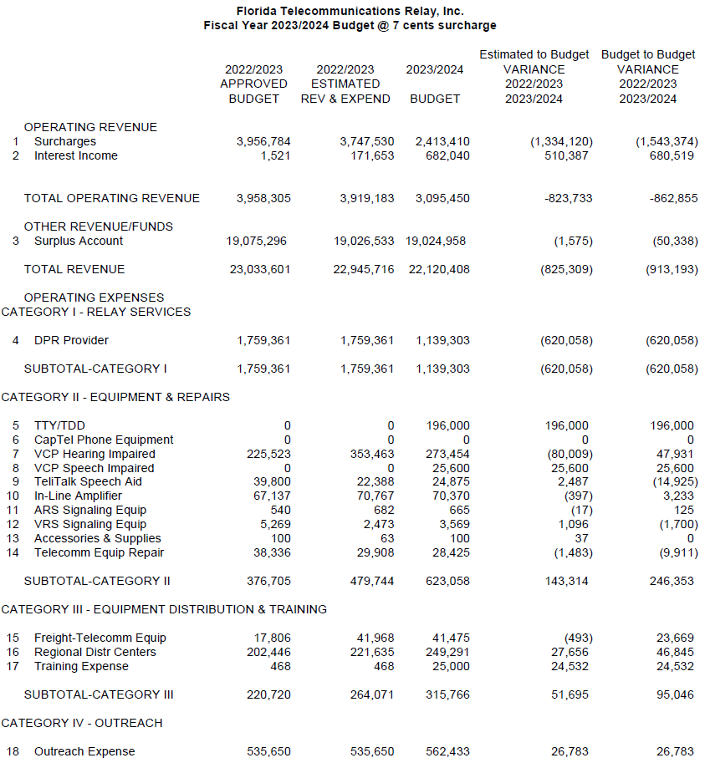

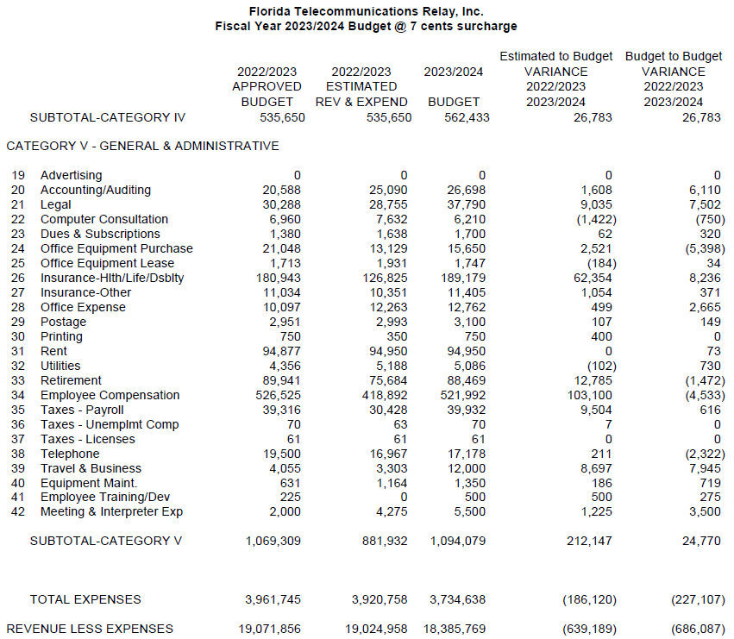

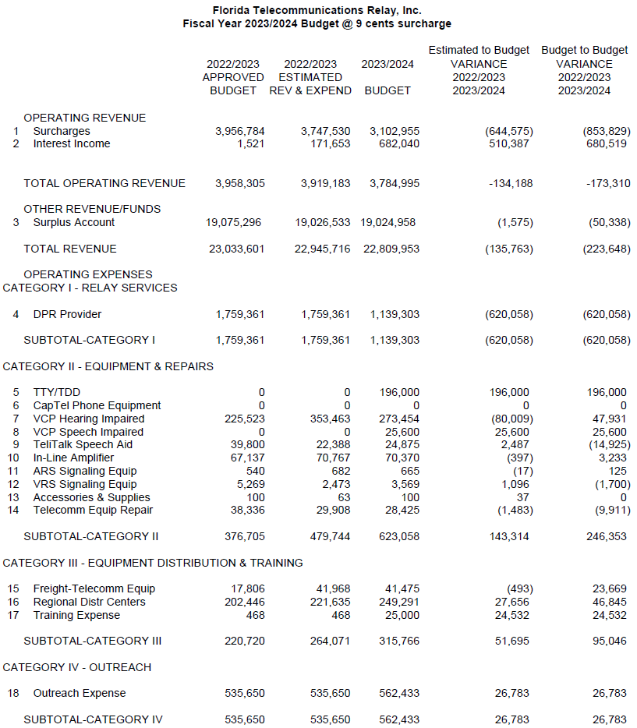

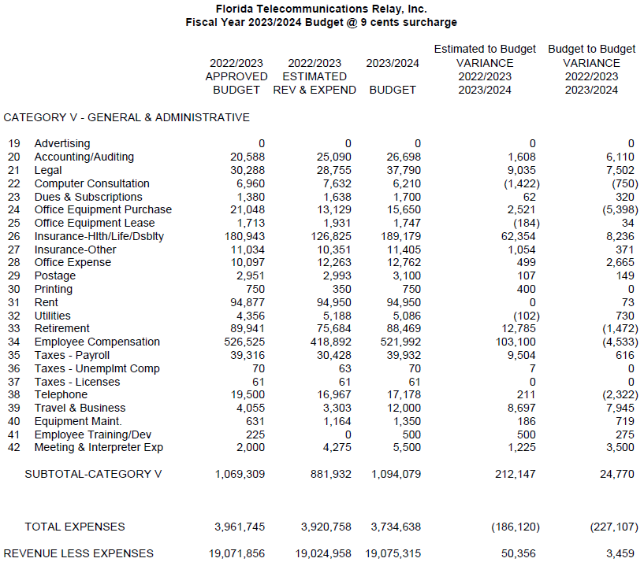

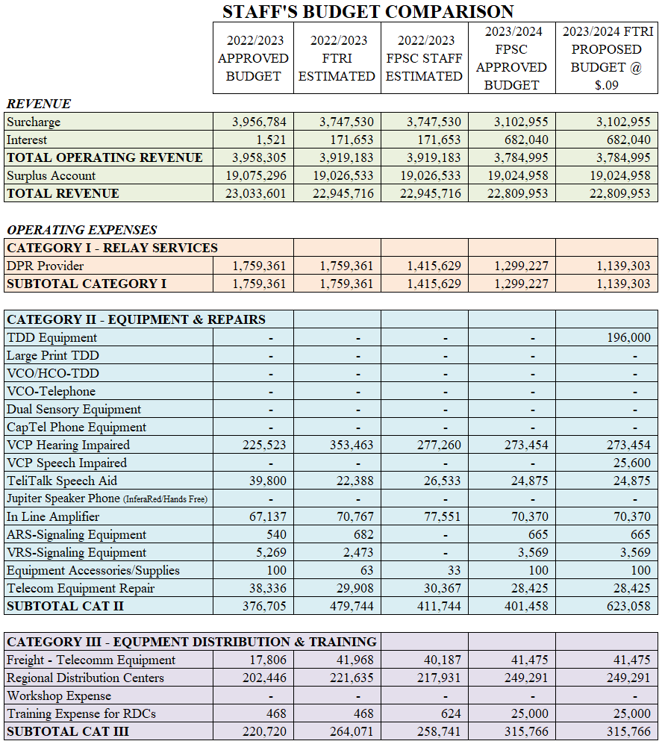

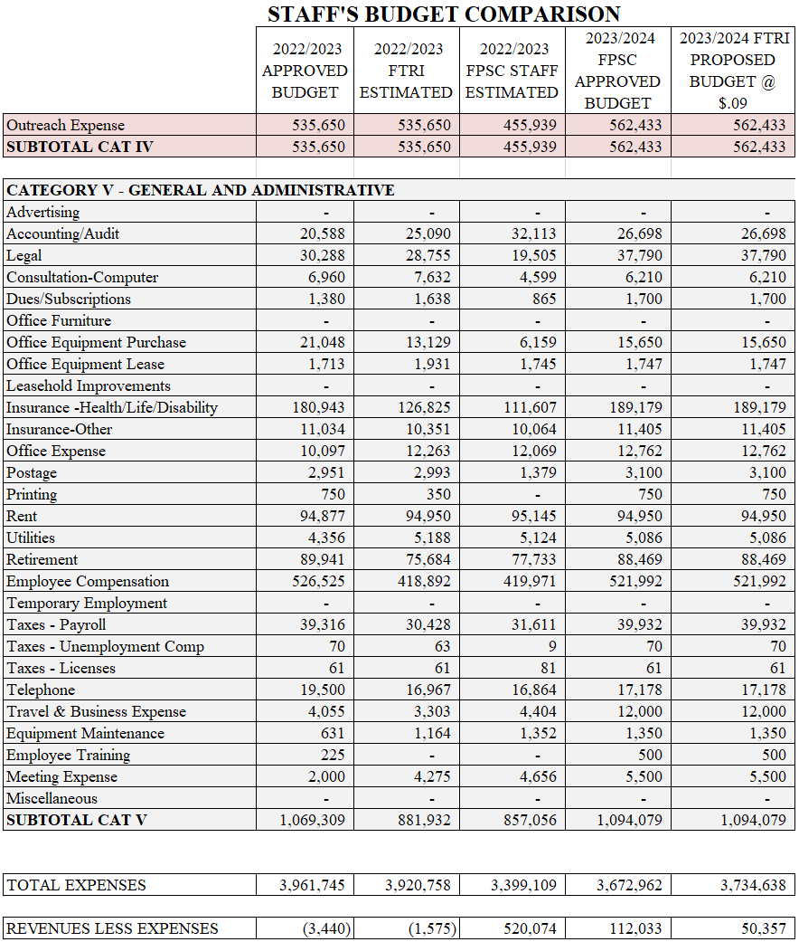

Order No. 24581, issued May 24, 1991, in Docket No. 910496-TP, In re: Implementation of Florida Telecommunications Access System Act of 1991.
Currently, eligibility programs include: SNAP, Medicaid, Federal Public Housing Assistance, Supplemental Security Income, Veterans or Survivors Pension Program.
IP Relay allows people who have difficulty hearing or speaking to communicate using a computer and the Internet, rather than a Text Telephone (TTY) and a telephone line.
VRS enables persons with hearing disabilities who use American Sign Language to communicate with voice telephone users through video equipment, rather than through typed text. Video equipment links the VRS user with a TRS operator so that the VRS user and the operator can see and communicate by signed conversation.
IP captioned telephone service allows users to simultaneously listen and read the text of what the other party in a telephone conversation has said, where the connection carrying the captions between the service and the user is via an IP addressed and routed link.
Wireless services offer applications such as text, instant messaging, and video chat.
Section 427.702(g), F.S. and Section 427.702(3)(c), F.S.
Section 427.703(14), F.S.
Section 427.703(11), F.S.
Section 427.704(4)(a)(1), F.S.
Budget surplus and shortfalls for each TRS surcharge are calculated using staff’s recommended budget expense amounts.

