State of Florida |  | Public Service Commission  Capital Circle Office Center ● 2540 Shumard Oak Boulevard  Tallahassee, Florida 32399-0850  -M-E-M-O-R-A-N-D-U-M-
DATE: | July 20, 2023
TO: | Office of Commission Clerk (Teitzman)
FROM: | Division of Engineering (M. Watts, Ramos)  Division of Accounting and Finance (Sewards, Thurmond)  Division of Economics (Bruce, Hudson)  Office of the General Counsel (Sandy)
RE: | Docket No. 20220061-SU – Application for transfer of wastewater Certificate No. 318-S from BFF Corp to CSWR-Florida utility Operating Company, LLC, in Marion County.
AGENDA: | 08/01/23 – Regular Agenda –Proposed Agency Action for Issues 2, 3, and 4 – Interested Persons May Participate
COMMISSIONERS ASSIGNED: |  |  | All Commissioners
PREHEARING OFFICER: |  |  | La Rosa
CRITICAL DATES: |  |  | None
SPECIAL INSTRUCTIONS: |  |  | Schedule immediately after Docket No. 20220206-WS

Case Background
BFF Corp. (BFF, Utility, or Seller) is a Class C wastewater utility operating in Marion County. BFF provides service to approximately 108 wastewater customers. The Utility is in the St. Johns River Water Management District (SJRWMD). The SJRWMD has year-round watering restrictions in place for the portion of Marion County within its district. In its 2022 Annual Report, BFF reported a net operating loss of $627. The Utility’s last rate case was in 2002.
In 1989, the Florida Public Service Commission (Commission) approved the transfer of wastewater Certificate No. 318-S from LTB Utility, Inc. to BFF. The certificated service territory has not been amended since that time.
On March 15, 2022, CSWR-Florida Utility Operating Company, LLC (CSWR-BFF or Buyer) filed an application with the Commission for the transfer of Certificate No. 318-S from BFF to CSWR-BFF in Marion County. The application was found to be deficient. The Buyer cured the deficiencies on May 1, 2023. The sale will close after the Commission votes to approve the transfer. In its application, the Buyer has requested a positive acquisition adjustment, which is discussed in Issue 3. The Office of Public Counsel’s (OPC) intervention was acknowledged by Order No. PSC-2022-0207-PCO-SU, issued June 14, 2022.
This recommendation addresses the transfer of the wastewater system and Certificate No. 318-S, the appropriate net book value of the wastewater system for transfer purposes, and the request for an acquisition adjustment. The Commission has jurisdiction pursuant to Sections 367.071 and 367.081, Florida Statutes (F.S.).

Discussion of Issues

Issue 1:
Should the transfer of Certificate No. 318-S in Marion County from BFF Corp to CSWR-Florida Utility Operating Company, LLC be approved?

Recommendation:
Yes. The transfer of the wastewater system and Certificate No. 318-S is in the public interest and should be approved effective the date that the sale becomes final. The resultant Order should serve as the Buyer’s certificate and should be retained by the Buyer. The Buyer should submit the executed and recorded deed for continued access to the land upon which its facilities are located, and a copy of its signed and executed contract for sale to the Commission within 60 days of the Order approving the transfer, which is final agency action. If the sale is not finalized within 60 days of the transfer Order, the Buyer should file a status update in the docket file. The Utility’s existing rates, service availability charges, and initial customer deposits, as shown on Schedule No. 4, should remain in effect until a change is authorized by the Commission in a subsequent proceeding. The tariff pages reflecting the transfer should be effective on or after the stamped approval date on the tariff sheets, pursuant to Rule 25-30.475(1), Florida Administrative Code (F.A.C.). The Seller is current with respect to annual reports and regulatory assessment fees (RAFs) through December 31, 2022. The Buyer should be responsible for filing annual reports and paying RAFs for all future years. (M. Watts, Thurmond, Bruce)

Staff Analysis:
On March 15, 2022, CSWR-BFF filed an application for the transfer of Certificate No. 318-S from BFF to CSWR-BFF in Marion County. The application is in compliance with Section 367.071, F.S., and Commission rules concerning applications for transfer of certificates. The sale to CSWR-BFF will become final after Commission approval of the transfer, pursuant to Section 367.071(1), F.S.

Noticing, Territory, and Land Ownership
CSWR-BFF provided notice of the application pursuant to Section 367.071, F.S., and Rule 25-30.030, F.A.C. No objections to the transfer were filed, and the time for doing so has expired. The application contains a description of the service territory, which is appended to this recommendation as Attachment A. In its application, CSWR-BFF provided a copy of an unrecorded warranty deed as evidence that the Buyer will have rights to long-term use of the land upon which the treatment facilities are located pursuant to Rule 25-30.037(2)(s), F.A.C. CSWR-BFF committed to providing the executed and recorded deed to the Commission within 60 days after the closing of the sale.

Purchase Agreement and Financing
Pursuant to Rule 25-30.037(2)(g), (h), and (i), F.A.C., the application contains a statement regarding financing and a copy of the purchase agreement, which includes the purchase price, terms of payment, and a list of the assets purchased. There are no guaranteed revenue contracts, or customer advances of BFF that must be disposed of with regard to the transfer. CSWR-BFF will review all leases and developer agreements and will assume or renegotiate those agreements on a case-by-case basis prior to closing. Any customer deposits will be refunded to customers by the Seller prior to the closing. According to the purchase and sale agreement, the total purchase price for the assets is $405,000. According to the Buyer, the closing has not yet taken place and is dependent on Commission approval of the transfer, pursuant to Section 367.071(1), F.S.

Facility Description and Compliance
BFF provides wastewater treatment service pursuant to a bulk service agreement with Marion County Utilities. Since the Utility does not have treatment facilities of its own, it has no permits, inspections, reports, or correspondence from the Florida Department of Environmental Protection. BFF has three lift stations and a master lift station that conveys wastewater to Marion County Utilities.

Technical and Financial Ability
Pursuant to Rule 25-30.037(2)(l) and (m), F.A.C., the application contains statements describing the technical and financial ability of the Buyer to provide service to the proposed service area. As referenced in the transfer application, the Buyer will fulfill the commitments, obligations, and representations of the Seller with regards to utility matters. CSWR-BFF’s application states that it owns and operates water and wastewater systems in Missouri, Arkansas, Kentucky, Louisiana, Texas, Mississippi, Arizona, North Carolina, and Tennessee that currently serve more than 73,000 water and 117,000 wastewater customers. The Commission has also approved CSWR’s purchase of five Florida certificated utilities in prior dockets.
The Buyer plans to use qualified and licensed contractors to provide routine operation and maintenance (O&M) of the systems, as well as to handle billing and customer service. Staff reviewed the financial statements of CSWR-BFF and believes the Buyer has documented adequate resources to support the Utility’s wastewater operations. Based on the above, the Buyer has demonstrated the technical and financial ability to provide service to the existing service territory.

Rates and Charges
BFF’s wastewater rates were last approved in 2002. Since the last rate case, the rates were subsequently amended by several price indexes and pass-through rate adjustments with the most recent being in 2022. The Utility’s current charges were approved in 1990. The initial customer deposits have been in effect since the Utility’s certification in the late 1990. Rule 25-9.044(1), F.A.C., provides that, in the case of a change of ownership or control of a Utility, the rates, classifications, and regulations of the former owner must continue unless authorized to change by this Commission. However, the miscellaneous service charges do not conform to Rule 25-30.460, F.A.C., and are discussed in Issue 4. Therefore, staff recommends that the Utility's existing rates, service availability charges, and initial customer deposits as shown on Schedule No. 4, should remain in effect, until a change is authorized by the Commission in a subsequent proceeding. The tariff pages reflecting the transfer should be effective on or after the stamped approval date on the tariff sheets, pursuant to Rule 25-30.475(1), F.A.C.

Regulatory Assessment Fees and Annual Report
Staff has verified that the Utility is current on the filing of annual reports and RAFs through December 31, 2022. The Buyer should be responsible for filing the Utility’s annual reports and paying RAFs for all future years.

Conclusion
Based on the foregoing, staff recommends that the transfer of the water and wastewater systems and Certificate No. 318-S is in the public interest and should be approved effective the date that the sale becomes final. The resultant Order should serve as the Buyer’s certificate and should be retained by the Buyer. The Buyer should submit the executed and recorded deed for continued access to the land upon which its facilities are located, and a copy of its signed and executed contract for sale to the Commission within 60 days of the Order approving the transfer, which is final agency action. If the sale is not finalized within 60 days of the transfer Order, the Buyer should file a status update in the docket file. The Utility’s existing rates, service availability charges, and initial customer deposits, as shown on Schedule No. 4, should remain in effect until a change is authorized by the Commission in a subsequent proceeding. The tariff pages reflecting the transfer should be effective on or after the stamped approval date on the tariff sheets, pursuant to Rule 25-30.475(1), F.A.C. The Seller is current with respect to annual reports and RAFs through December 31, 2022. The Buyer should be responsible for filing annual reports and paying RAFs for all future years.

Issue 2:
What is the appropriate net book value for CSWR-Florida Utility Operating Company LLC’s wastewater system for transfer purposes?

Recommendation:
For transfer purposes, the net book value (NBV) of the wastewater system is $39,708 as of February 28, 2022. Within 90 days of the date of the Consummating Order, CSWR-BFF should be required to notify the Commission in writing, that it has adjusted its books in accordance with the Commission’s decision. The adjustments should be reflected in the Utility’s 2023 Annual Report when filed. (Thurmond)

Staff Analysis:
Rate base was last established as of August 31, 2002. The purpose of establishing NBV for transfers is to determine whether an acquisition adjustment should be approved. CSWR-BFF’s request for a positive acquisition adjustment is addressed in Issue 3. The NBV does not include normal ratemaking adjustments for used and useful plant or working capital. The Utility’s NBV has been updated to reflect balances as of February 28, 2022. Staff’s recommended NBV, as described below, is shown on Schedule No. 1.
Utility Plant in Service (UPIS)
According to the Utility’s general ledger, the total UPIS balance was $270,192 as of February 28, 2022. Staff auditors compiled the plant additions and retirements to UPIS from August 31, 2002, to February 28, 2022, and traced supporting documentation. As a result, staff recommends a decrease to UPIS of $34,341 as of February 28, 2022. Accordingly, staff recommends a total UPIS balance of $235,851 as of February 28, 2022.

Land
The Utility’s general ledger reflected a land balance of $1,579 as of August 31, 2002. There have been no additions to land since August 31, 2002. Therefore, staff recommends no adjustments to its land balance.

Accumulated Depreciation
According to the Utility’s general ledger, the total accumulated depreciation balance was $214,723 as of February 28, 2022. Staff auditors recalculated depreciation accruals using the depreciation rates established by Rule 25-30.140, F.A.C. As a result, staff recommends that the accumulated depreciation balance be decreased by $24,057 as of February 28, 2022. Accordingly, staff recommends a total accumulated depreciation balance of $190,666 as of February 28, 2022.

Contributions-in-Aid-of-Construction (CIAC) and Accumulated Amortization of CIAC
According to the Utility’s general ledger, the CIAC balance and accumulated amortization of CIAC were $41,036 and $29,740, respectively, as of February 28, 2022. Staff auditors recalculated CIAC and accumulated amortization of CIAC balances from August 31, 2002, to February 28, 2022, using supporting documentation. As a result, staff recommends that the CIAC balance be decreased by $5,634 as of February 28, 2022. Staff also recommends that the accumulated amortization of CIAC balance be decreased by $1,394 as of February 28, 2022. Accordingly, staff recommends total CIAC and Accumulated Amortization of CIAC balances of $35,402 and $28,346, respectively, as of February 28, 2022.

Net Book Value
The Utility’s general ledger reflected a NBV of $45,752 as of February 28, 2022. Based on the adjustments described above, staff recommends a NBV of $39,708 as of February 28, 2022. Staff’s recommended NBV and the National Association of Regulatory Utility Commissioners, Uniform System of Accounts (NARUC USOA) balances for UPIS and accumulated depreciation are shown on Schedule No. 1 as of February 28, 2022. As addressed in Issue 3, staff recommends a positive acquisition adjustment not be recognized for ratemaking purposes.

Conclusion
Based on the above, staff recommends a NBV of $39,708 as of February 28, 2022, for transfer purposes. Within 90 days of the date of the Consummating Order, the Buyer should be required to notify the Commission in writing, that it has adjusted its books in accordance with the Commission’s decision. The adjustments should be reflected in the Utility’s 2023 Annual Report when filed.

Issue 3:
Should a positive acquisition adjustment be recognized for ratemaking purposes?

Recommendation:
No. Pursuant to Rule 25-30.0371, F.A.C., a positive acquisition adjustment should not be granted as the Buyer failed to demonstrate extraordinary circumstances. (Thurmond, M. Watts)

Staff Analysis:
In its filing, the applicant requested a positive acquisition adjustment be included in the calculation of the Utility’s rate base. An acquisition adjustment results when the purchase price differs from the NBV of the assets at the time of acquisition. Pursuant to Rule 25-30.0371, F.A.C., a positive acquisition adjustment results when the purchase price is greater than the NBV and a negative acquisition adjustment results when the purchase price is less than the NBV. A positive acquisition adjustment, if approved, increases rate base.
According to the purchase agreement, the Buyer will purchase the Utility for $405,000. As discussed in Issue 2, staff is recommending a NBV of $39,708. This would result in a positive acquisition adjustment of $365,292.
Any entity that believes a full or partial positive acquisition adjustment should be made has the burden to prove the existence of extraordinary circumstances. Rule 25-30.0371(2), F.A.C., states:
In determining whether extraordinary circumstances have been demonstrated, the Commission shall consider evidence provided to the Commission such as anticipated improvements in quality of service, anticipated improvements in compliance with regulatory mandates, anticipated rate reductions or rate stability over a long-term period, anticipated cost efficiencies, and whether the purchase was made as part of an arms-length transaction.

If a purchase price above depreciated original cost is used to determine rate base, without the requirement for extraordinary circumstances, it could encourage utilities to “swap assets” and inappropriately increase cost to customers.

Deferral
In discovery responses, CSWR-BFF stated that it intends to ask for deferral of a decision regarding the requested acquisition adjustment. In its application, the Buyer laid out factors such as improvements to quality of service, cost efficiencies, and rate stability. These are discussed below and staff finds these factors do not constitute extraordinary circumstances. In response to discovery, the Buyer agreed that after rate base is set, if a company provides support in a separate and subsequent case that there are utility assets that were not previously recorded, then the company can prospectively recover the unrecorded amount of that investment. Therefore, if the Buyer finds assets were incorrectly recorded on the Seller’s balance sheet, the Buyer can support those costs and recover them in a future rate case. That is normal Commission practice and are not considered extraordinary circumstances.
Pursuant to Commission practice, the Buyer has the burden to prove extraordinary circumstances at the time of transfer. Staff believes in the instant case the Buyer has failed to provide proof of extraordinary circumstances. Further, the Buyer had multiple opportunities to provide pertinent information needed to determine if a positive acquisition adjustment is appropriate. As such, staff recommends the Commission deny the request to defer a decision on the positive acquisition adjustment.
Finally, it is long-standing Commission practice to address the disposition of any positive or negative acquisition adjustment at the time of transfer. Pursuant to Section 120.68(7)(e)3., F.S., when agencies change their established policies, practices and procedures, they must give an explanation for the deviation. Staff does not believe the facts in this case warrant such a deviation. As such, staff believes the deferral of a positive acquisition adjustment decision in this docket would result in an unnecessary deviation from Commission practice.

Improvements in Quality of Service and Compliance with Regulatory Mandates
In its application, CSWR-BFF listed six business practices that it believes will improve the quality of service to its customers: (1) provision of 24-hour emergency service phone numbers; (2) on-call emergency service personnel who are required to respond to emergency service calls within prescribed time limits; (3) a computerized maintenance management system; (4) access to resources not usually available to comparably sized systems and the ability to supplement local personnel with resources owned by the parent and sister companies; (5) online bill payment options; and (6) an updated website for customer communication, bulletins, procedures, etc.
No complaints were filed with the Commission for the five-year period prior to the application, from March 2017 to March 2022. In its application, CSWR-BFF did not list any customer complaints related to the wastewater service.

In Exhibit H of its application, CSWR-BFF listed its plans for improvements of the Utility’s collection system. The improvements consist of installing a remote monitoring system, rehabilitating the four lift stations, and collection system repairs. However, no specific repairs or system deficiencies were noted. The Buyer stated in its application that no governmental authorities are presently requiring repairs or improvements to the systems.

Based on the above, it appears that BFF currently has no issues with respect to regulatory compliance. While the Buyer identified some general improvements it intends to implement, staff does not believe the Buyer has demonstrated extraordinary circumstances in support of its requested positive acquisition adjustment. Instead, staff believes that the proposed anticipated improvements in quality of service demonstrate CSWR-BFF’s intention to responsibly execute its obligations as a utility owner. While staff does not believe the Utility’s anticipated improvements justify its requested positive acquisition adjustment, these improvements may be considered for prudence and cost recovery in a future rate proceeding.

Anticipated Cost Efficiencies and Rates
In its application, the Buyer stated that its size and anticipated consolidation of many small systems under one financial and managerial entity would result in operational cost efficiencies, particularly in the areas of:
- PSC and environmental regulatory reporting
- Managerial and operational oversight
- Utility asset planning
- Engineering planning
- Ongoing utility maintenance
- Utility record keeping
- Customer service responsiveness
- Improved access to capital is necessary to repair and upgrade BFF’s systems to ensure compliance with all health and environmental requirements and ensure service to customers remains safe and reliable

In response to discovery, the Buyer provided an estimated annual reduction of O&M expense of approximately $11,000. However, with a requested acquisition adjustment of $365,292, the requested amount is over nine times greater than the system’s current NBV of $39,708. Even if the Buyer was able to achieve these savings in O&M expense, the inclusion of the requested acquisition adjustment in rate base and the inclusion of the annual amortization expense in the NOI calculation, would result in an increased revenue requirement. By operation of math, the overall impact would be a net increase to customer rates.
The Buyer also stated that CSWR-BFF would bring long-term rate stability to the Utility, should the transfer be approved. Staff agrees that economies of scale and potential consolidation of several systems in Florida, as proposed by CSWR-BFF, could bring some amount of long-term rate stability. However, absent specific and detailed support for these assertions, the Buyer has failed to meet its burden of demonstrating extraordinary circumstances.
Staff’s recommendation is consistent with the Commission’s decision in Order No. PSC-2020-0458-PAA-WS. In that docket, the Buyer identified estimates of anticipated cost efficiencies, including a reduction in O&M expense and a reduction of cost of capital that would result from the transfer. Additionally, the Buyer cited several improvements it made to the wastewater treatment plant and wastewater lift station since acquisition to improve the quality of service and compliance with regulatory mandates. While the Commission acknowledged that the Buyer accomplished cost savings, it did not believe the actions performed demonstrated extraordinary circumstances that would justify approval of a positive acquisition adjustment.
Staff’s recommendation is also consistent with the Commissions decisions to deny CSWR-Florida Utility Operating Company, LLC a positive acquisition adjustment in Order Nos. PSC-2022-0116-PAA-SU, PSC-2022-0120-PAA-WU, PSC-2022-0115-PAA-WS, PSC-2022-0364-PAA-WU, and Docket No. 20220149-WS. In those cases, it was determined the Buyer failed to provide sufficient evidence of extraordinary circumstances and was denied a positive acquisition adjustment in all five cases. In those cases, CSWR also requested a deferral of the decision regarding the positive acquisition adjustments which was denied by the Commission. Staff finds the facts of this case similar to the five cases discussed above.

Conclusion
Pursuant to Rule 25-30.0371, F.A.C., staff recommends a positive acquisition adjustment not be granted as the Buyer did not demonstrate extraordinary circumstances. Staff believes the Buyer’s anticipated improvements in quality of service and compliance with regulatory mandates do not illustrate extraordinary circumstances and instead demonstrates CSWR-BFF’s intentions to responsibly provide utility service.

Issue 4:
Should CSWR-Florida Utility Operating Company, LLC’s miscellaneous service charges be revised to conform to amended Rule 25-30.460, F.A.C.?

Recommendation:
Yes. Staff recommends the miscellaneous service charges be revised to conform to the recent amendment to Rule 25-30.460, F.A.C. The tariff should be revised to reflect the removal of initial connection and normal reconnection charges. The Utility should be required to file a proposed customer notice to reflect the Commission-approved charges. The approved charges should be effective on or after the stamped approval date on the tariff sheet pursuant to Rule 25-30.475(1), F.A.C. In addition, the approved charges should not be implemented until staff has approved the proposed customer notice and the notice has been received by customers. The Utility should provide proof of the date notice was given within 10 days of the date of the notice. The Utility should be required to charge the approved miscellaneous service charges until authorized to change them by the Commission in a subsequent proceeding. (Bruce)

Staff Analysis:
Effective June 24, 2021, Rule 25-30.460, F.A.C., was amended to remove initial connection and normal reconnection charges. The definitions for initial connection charges and normal reconnection charges were subsumed in the definition of the premises visit charge. The Utility’s miscellaneous service charges consist of initial connection and normal reconnection charges. The normal reconnection charge is more than the premises visit charge. Since the premises visit entails a broader range of tasks, staff believes the premises visit should reflect the amount of the normal reconnection charge of $15 for normal hours. Therefore, staff recommends that the initial connection and normal reconnection charges be removed, the premises visit should be revised to $15 for normal hours, and the definition for the premises visit charge be updated to comply with amended Rule 25-30.460, F.A.C. The Utility’s existing and staff’s recommended miscellaneous service charges are shown in Table 4-1.

Table 4-1
Utility Existing and Staff Recommended Miscellaneous Service Charges
 | Existing | Staff Recommended
 | Normal Hours | Normal Hours
Initial Connection Charge | $15.00 | N/A
Normal Reconnection Charge | $15.00 | N/A
Violation Reconnection Charge - Wastewater | Actual Cost | Actual Cost
Premises Visit Charge | $10.00 | $15.00

Conclusion
Based on the above, staff recommends the miscellaneous service charges be revised to conform to the recent amendment to Rule 25-30.460, F.A.C. The tariff should be revised to reflect the removal of initial connection and normal reconnection charges. The Utility should be required to file a proposed customer notice to reflect the Commission-approved charges. The approved charges should be effective on or after the stamped approval date on the tariff sheet pursuant to Rule 25-30.475(1), F.A.C. In addition, the approved charges should not be implemented until staff has approved the proposed customer notice and the notice has been received by customers. The Utility should provide proof of the date notice was given within 10 days of the date of the notice. The Utility should be required to charge the approved miscellaneous service charges until authorized to change them by the Commission in a subsequent proceeding.

Issue 5:
Should this docket be closed?

Recommendation:
Yes. If no protest to the proposed agency action is filed by a substantially affected person within 21 days of the date of the issuance of the Order, a Consummating Order should be issued and the docket should be closed administratively upon Commission staff’s verification that the revised tariff sheets have been filed, that proof has been provided that appropriate noticing has been done pursuant to Rule 25-30.4345, F.A.C., the Buyer has notified the Commission in writing that it has adjusted its books in accordance with the Commission’s decision, that the Buyer has submitted the executed and recorded warranty deed, that the Buyer has submitted a copy of its application for permit transfer to the DEP, and that the Buyer has submitted a signed and executed copy of its contract for sale within 60 days of the Commission’s Order approving the transfer. (Sandy)

Staff Analysis:
If no protest to the proposed agency action is filed by a substantially affected person within 21 days of the date of the issuance of the Order, a Consummating Order should be issued and the docket should be closed administratively upon Commission staff’s verification that the revised tariff sheets have been filed, that proof has been provided that appropriate noticing has been done pursuant to Rule 25-30.4345, F.A.C., the Buyer has notified the Commission in writing that it has adjusted its books in accordance with the Commission’s decision, that the Buyer has submitted the executed and recorded warranty deed, that the Buyer has submitted a copy of its application for permit transfer to the DEP, and that the Buyer has submitted a signed and executed copy of its contract for sale within 60 days of the Commission’s Order approving the transfer.

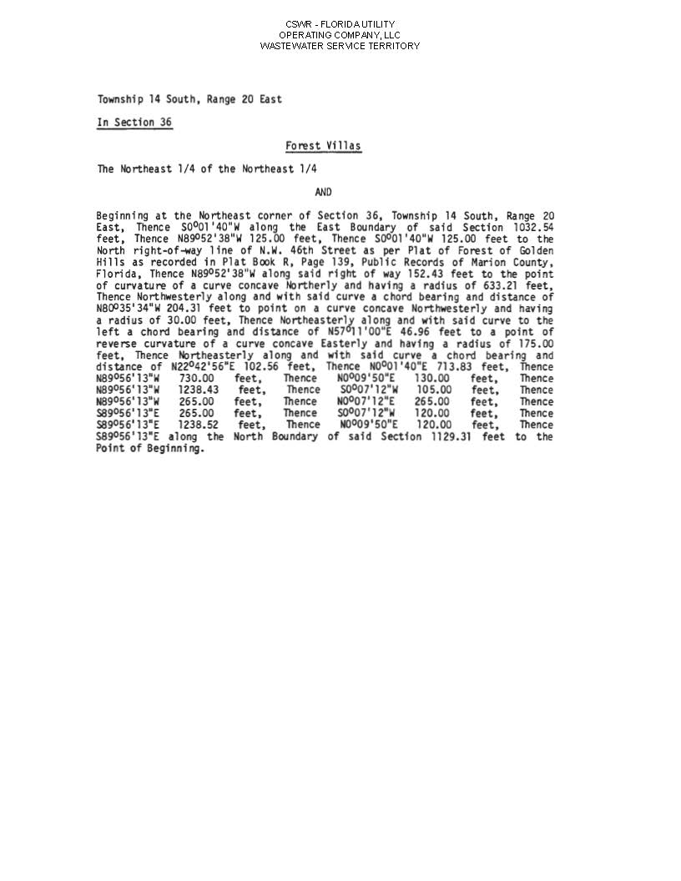

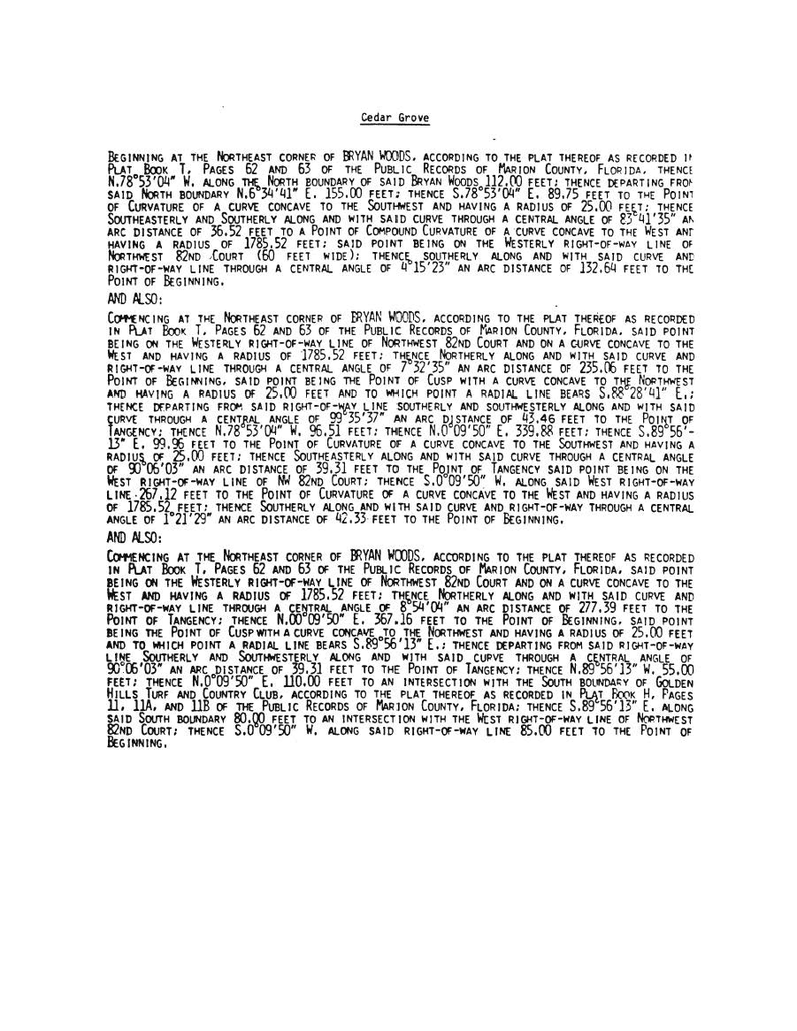

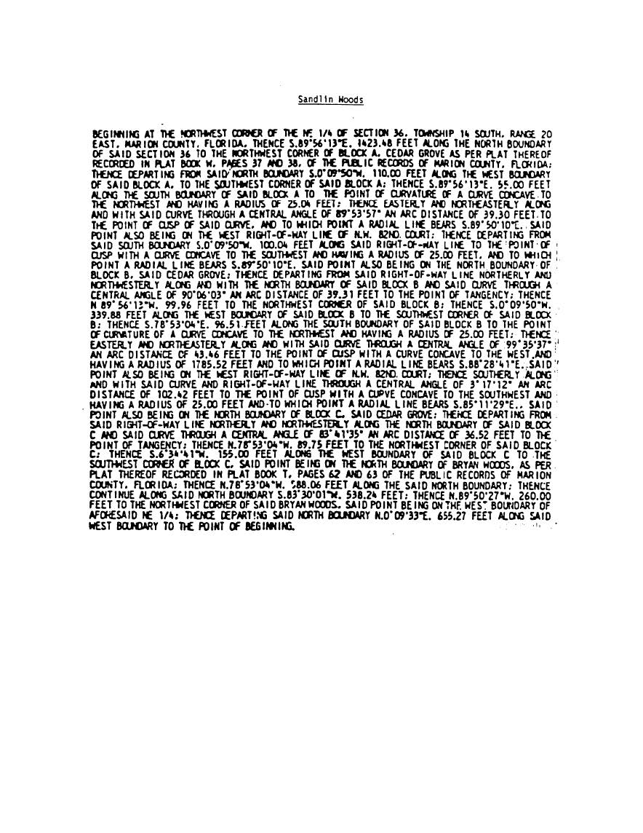

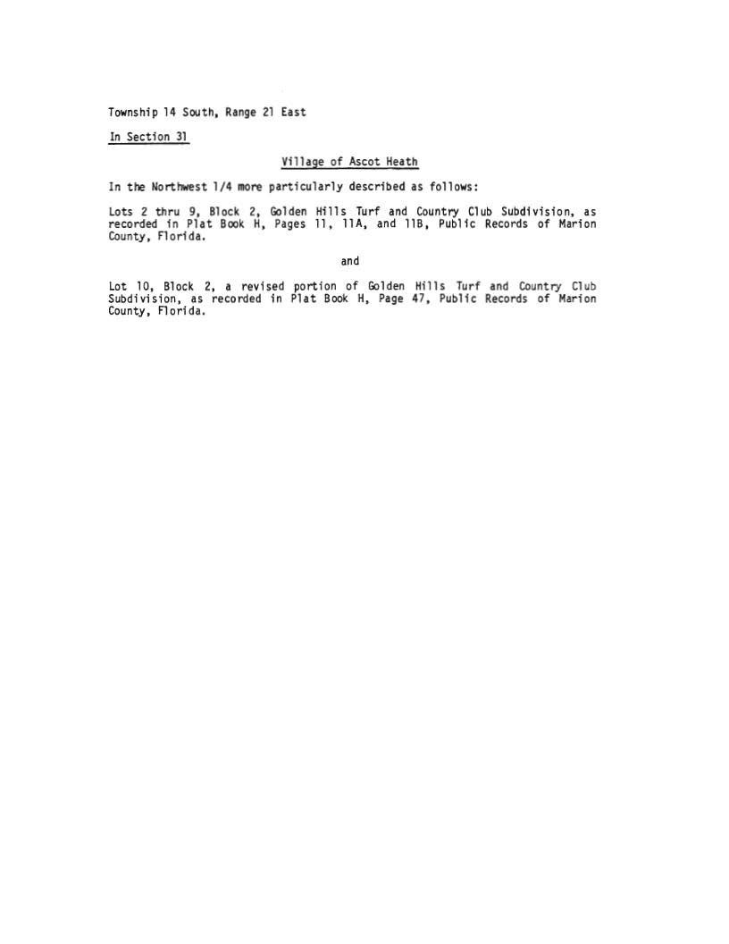

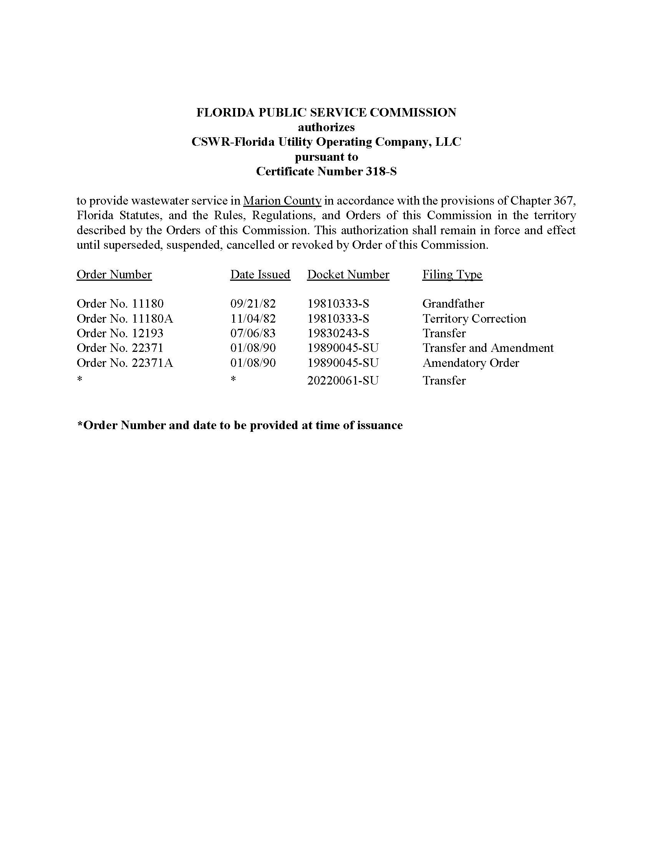

CSWR-Florida Utility Operating Company, LLC
BFF Corp

Schedule of Net Book Value as of February 28, 2022

Description | Balance  Per Utility  2/28/22 | Adjustments |  | Staff  2/28/22
Utility Plant in Service | $270,192 | ($34,341) | A | $235,851
Land & Land Rights | 1,579 | - |  | 1,579
Accumulated Depreciation | (214,723) | 24,057 | B | (190,666)
CIAC | (41,036) | 5,634 | C | (35,402)
Amortization of CIAC | 29,740 | (1,394) | D | 28,346
Total | $45,752 | ($6,044) |  | $39,708

CSWR-Florida Utility Operating Company, LLC
BFF Corp

Explanation of Adjustments to Net Book Value as of February 28, 2022

Explanation | Amount
- UPIS
To reflect the appropriate balance. | ($34,341)
- Accumulated Depreciation
To reflect the appropriate balance. | 24,057
- CIAC
To reflect the appropriate balance. | 5,634
- Accumulated Amortization of CIAC
To reflect the appropriate balance. | (1,394)
Total Adjustments to Net Book Value as of February 28, 2022 | ($6,044)

CSWR-Florida Utility Operating Company, LLC
BFF Corp

Schedule of Staff’s Recommended Account Balances as of February 28, 2022

Account  No. | Description | UPIS | Accumulated Depreciation
351 | Organization | $2,411 | ($1,918)
354 | Structures & Improvements | - | -
360 | Collection Sewers - Force | 110,666 | (86,210)
361 | Collection Sewers - Gravity | 77,795 | (74,581)
362 | Special Collection Structures | 17,043 | (9,323)
363 | Service to Customers | 6,219 | (6,219)
365 | Flow Measuring Installations | 383 | (218)
370 | Receiving Wells | 21,334 | (12,195)
 | Total | $235,851 | ($190,666)

CSWR – Florida Utility Operating Company, LLC.
BFF Corp.
Monthly Wastewater Rates

Residential Service
Base Facility Charge by Meter Size
All Meter Sizes |  |  |  | $32.98
Charge Per 1,000 gallons – Residential Service
10,000 gallon cap |  |  |  | $8.75
Flat Rate (for unmetered residential customers) |  |  |  | $75.35
General Service
Base Facility Charge by Meter Size
5/8” x 3/4" |  |  |  | $32.98
3/4" |  |  |  | $49.47
1" |  |  |  | $82.45
1 1/2" |  |  |  | $164.90
2" |  |  |  | $263.84
3" |  |  |  | $527.68
4" |  |  |  | $824.50
6" |  |  |  | $1,649.00
Charge Per 1,000 gallons |  |  |  | $10.18
Initial Customer Deposits
 | Residential Service |  |  | General Service
5/8” x 3/4” | $120.00 |  |  | $133.00
All Over 5/8”x 3/4” | $120.00 |  |  | 2x average estimated bill
Service Availability Charges
System Capacity Charge
Residential per ERC (350 gallons per day) |  |  |  |  | $1,620.00
All others – per gallon |  |  |  |  | $4.63

Order No. PSC-02-0487-PAA-SU, issued April 8, 2002, in Docket No. 20010919-SU, In re: Application for staff-assisted rate case in Marion County by BFF Corp.
Order No. 22371, issued January 8, 1990, in Docket No. 19890045-SU, In re: Application for transfer and amendment of Certificate No. 318-S in Marion County from LTB Utility, Inc. to BFF Corp.
See Order No. PSC-2022-0115-PAA-WS, issued March 15, 2022, in Docket No. 20210093-WS, In re: Application for transfer of water and wastewater systems of Aquarina Utilities, Inc., water Certificate No. 517-W, and wastewater Certificate No. 450-S to CSWR-Florida Utility Operating Company, LLC, in Brevard County; Order No. PSC-2022-0120-PAA-WU, issued March 18, 2022, in Docket No. 20210095-WU, In re: Application for transfer of water facilities of Sunshine Utilities of Central Florida, Inc. and water Certificate No. 363-W to CSWR-Florida Utility Operating Company, LLC, in Marion County; Order No. PSC-2022-0116-PAA-SU, issued March 17, 2022, in Docket No. 20210133-SU, In re: Application for transfer of facilities of North Peninsula Utilities Corporation and wastewater Certificate No. 249-S to CSWR-Florida Utility Operating Company, LLC, in Volusia County; Order No. PSC-2022-0364-PAA-WU, issued October 25, 2022, in Docket No. 20220019-WU, In re: Application for transfer of water facilities of Neighborhood Utilities, Inc. and water Certificate No. 430-W to CSWR-Florida Utility Operating Company, LLC, in Duval County; Docket No. 20220149-SU, In re: Application for transfer of wastewater Certificate No. 365-S of Sebring Ridge Utilities, Inc. to CSWR-Florida Utility Operating Company, LLC, in Highlands County (the Commission approved the transfer of this system at the July 11, 2023 Commission Conference; an order is forthcoming).
Order No. PSC-02-0487-PAA-SU, issued April 8, 2002, in Docket No. 20010919-SU, In re: Application for staff-assisted rate case in Marion County by BFF Corp.
Order No. 22570, issued February 19, 1990, in Docket No. 19890916-SU, In re: Application of BFF Corp. for a staff-assisted rate case in Marion County.
Order No. PSC-02-0487-PAA-SU, issued April 8, 2002, in Docket No. 20010919-SU, In re: Application for staff-assisted rate case in Marion County by BFF Corp.
Net book value is calculated through the date of the closing. According to the Utility’s application, the closing will not occur until after the transaction receives Commission approval. Therefore, staff is relying on the most current information provided to staff auditors at the time of the filing.
Order No. PSC-2020-0458-PAA-WS, issued November, 23, 2020, in Docket No. 20190170-WS, In re: Application for transfer of facilities and Certificate Nos. 259-W and 199-S in Broward County from Royal Utility Company to Royal Waterworks, Inc.
Order No. PSC-2022-0116-PAA-SU, issued March 17, 2022, in Docket No. 20210133-SU, In re: Application for transfer of facilities of North Peninsula Utilities Corporation and wastewater Certificate No. 249-S to CSWR-Florida Utility Operating Company, LLC, in Volusia County. ; Order No. PSC-2022-0120-PAA-WU, issued March 18, 2022, in Docket No. 20220095-WU, In re: Application for transfer of wastewater facilities of Sunshine Utilities of Central Florida, Inc. and wastewater Certificate No. 363-W to CSWR-Florida Utility Operating Company, LLC, in Marion County; Order No. PSC-2022-0115-PAA-WS, issued March 15, 2022, In Docket No. 20210093-WS, In re: Application for transfer of wastewater and wastewater systems of Aquarina Utilities, Inc., wastewater Certificate No. 517-W, and wastewater Certificate No. 450-S to CSWR-Florida Utility Operating Company, LLC, in Brevard County.; Order No. PSC-2022-0364-PAA-WU, issued October 25, 2022, in Docket No. 20220019-WU, In re: Application for the transfer of water facilities in Neighborhood Utilities, Inc. and water Certificate No. 430-W to CSWR-Florida Utility Operating Company, LLC, in Duval County; Docket No. 20220149-SU, In re: Application for transfer of wastewater Certificate No. 365-S of Sebring Ridge Utilities, Inc. to CSWR-Florida Utility Operating Company, LLC, in Highlands County (the Commission approved the transfer of this system at the July 11, 2023 Commission Conference; an order is forthcoming).
Order No. PSC-2021-0201-FOF-WS, issued June 4, 2021, in Docket No. 20200240-WS, In re: Proposed amendment of Rule 25-30.460, F.A.C., Application for Miscellaneous Service Charges.

