State of Florida |  | Public Service Commission  Capital Circle Office Center ● 2540 Shumard Oak Boulevard  Tallahassee, Florida 32399-0850  -M-E-M-O-R-A-N-D-U-M-
DATE: | July 20, 2023
TO: | Office of Commission Clerk (Teitzman)
FROM: | Division of Economics (Lang, Barrett, Hampson)  Office of the General Counsel (Watrous)
RE: | Docket No. 20230043-EI – Petition for approval of revised underground residential distribution tariffs, by Duke Energy Florida, LLC.
AGENDA: | 08/01/23 – Regular Agenda – Tariff Filing – Interested Persons May Participate
COMMISSIONERS ASSIGNED: |  |  | All Commissioners
PREHEARING OFFICER: |  |  | Administrative
CRITICAL DATES: |  |  | 11/30/23 (8-Month Effective Date)
SPECIAL INSTRUCTIONS: |  |  | None

Case Background
On March 31, 2023, Duke Energy Florida, LLC (DEF or utility) filed a petition for approval of revisions to its underground residential distribution tariffs (URD) and associated charges (2023 Petition). These tariffs represent the estimated additional cost, if any, DEF incurs to provide underground service in place of overhead service in new residential subdivisions. The current URD tariffs and charges were approved in 2020. The proposed URD tariffs are contained in the recommendation as Attachment A.

On May 22, 2023, the Commission suspended the proposed tariffs to allow staff sufficient time to analyze the utility’s filing. Staff issued its first data request on May 17, 2023, for which response was provided on June 1, 2023. Staff issued its second data request on June 21, 2023, for which response was provided on July 6, 2023.

The Commission has jurisdiction over this matter pursuant to Sections 366.03, 366.04, 366.05, and 366.06, Florida Statutes (F.S.).

Discussion of Issues

Issue 1:
Should the Commission approve DEF’s proposed underground distribution tariffs and associated charges?

Recommendation:
Yes. The Commission should approve DEF’s proposed underground residential distribution tariffs and associated charges effective on the date of the Commission vote. The proposed URD charges are cost-based and staff recommends approval of the tariffs shown in Attachment A. (Lang, Barrett, Hampson)

Staff Analysis:
Rule 25-6.078, Florida Administrative Code (F.A.C.), defines investor-owned utilities’ (IOU) responsibilities for filing updated URD tariffs. DEF has filed the instant petition pursuant to subsection (3) of the rule, which requires IOUs to file supporting data and analyses for updated URD tariffs if the cost differential, using current labor and material costs, varies from the Commission-approved differential by more than ten percent. On October 13, 2022, pursuant to Rule 25-6.078(3), F.A.C., DEF filed their annual Overhead/Underground Residential Differential Cost Data (Form PSC/ECO 13-E).
The URD tariffs provide charges for underground service in new residential subdivisions and represent the additional costs, if any, the utility incurs to provide underground service in place of overhead service. The cost of standard overhead construction is recovered through base rates from all ratepayers. In lieu of overhead construction, customers have the option of requesting underground facilities. Any additional cost is paid by the customer as a contribution-in-aid-of-construction (CIAC). Typically, the URD customer is the developer of a subdivision.
Traditionally, three standard model subdivision designs have been the basis upon which each IOU submits URD tariff changes for Commission approval: low density where there are one or more but less than six dwelling units per acre; high density where there are six or more dwelling units per acre; and a high density subdivision, where dwelling units take service at ganged meter pedestals (group of meters at the same physical location). While actual construction may differ from the model subdivisions, the model subdivisions are designed to reflect average overhead and underground subdivisions.
Costs for underground construction have historically been higher than costs for standard overhead construction, and the additional cost is paid by the customer as CIAC. However, DEF’s proposed URD differential charges remain $0 per lot for the low density and ganged meter subdivisions for single phase service. For the high density subdivision, the proposed differential increases from the current $0 to $332 per lot. The increase in the differentials is primarily attributable to significant changes in DEF’s labor, and material costs, since the last URD was approved for DEF in 2020.
Table 1-1 below compares the current and proposed URD differentials for the low density, high density, and ganged meter subdivisions for single phase service as appears in Section IV, Part 11.03 of the current and proposed URD tariff. The charges shown are per-lot charges. The proposed URD differential for the High Density subdivision is increasing due to an increase in labor and materials, but more so for underground than overhead. The increase shown below is due primarily to rising material costs as well as the utility contracting labor to perform underground activities as opposed to the native crews which perform overhead activities.

Table 1-1
Comparison of URD Differential per Lot (Single Phase Service)
Subdivision Designs | Current  URD Differential | Proposed  URD Differential
Low Density | $0 | $0
High Density | $0 | $332
Ganged Meter | $0 | $0
Source: Order No. PSC-2020-0266-TRF-EI (Current) and DEF’s 2023 Petition (Proposed).

The calculations of the proposed URD charges include (1) updated labor and material costs along with the associated loading factors and (2) operational costs. The costs are discussed below.

Updated Labor and Material Costs
The installation costs of both overhead and underground facilities include the labor and material costs to provide primary, secondary, and service distribution lines, as well as transformers. The costs of poles are specific to overhead service while the costs of trenching and backfilling are specific to underground service. The utilities are required by Rule 25-6.078(5), F.A.C., to use current labor and material costs.
DEF’s labor costs for overhead and underground construction are comprised of costs associated with work performed by both in-house employees and outside contractors. DEF’s contracted labor rates are based upon actual labor costs negotiated in bargaining unit contracts and labor rates with contractors. Table 1-2 shown below compares total 2020 and 2023 labor and material costs per lot for the three subdivision designs.

Table 1-2
Labor and Material Costs Per Lot for DEF Trench and Install Conduit
Subdivision Designs | 2020 Costs | 2023 Costs | Difference
Low Density
Underground Labor/Material Costs | $2,263 | $3,454 | $1,191
Overhead Labor/Material Costs | $2,343 | $2,749 | $406
Per Lot Differential | $(80) | $705 | $785
High Density
Underground Labor/Material Costs | $1,978 | $3,003 | $1,025
Overhead Labor/Material Costs | $1,642 | $2,121 | $479
Per Lot Differential | $336 | $882 | $550
Ganged Meter
Underground Labor/Material Costs | $774 | $1,205 | $431
Overhead Labor/Material Costs | $1,295 | $1,516 | $221
Per Lot Differential | $(521) | $(311) | $(210)
Source: Order No. PSC-2020-0266-TRF-EI (Current) and DEF’s 2023 Petition (Proposed).
As Table 1-2 shows, the majority of the proposed overhead and underground total labor and material costs have increased since the current URD charges were approved in 2020. As reflected, the 2023 costs for overhead and underground labor and materials are higher for each subdivision design, although a greater increase has occurred for underground, compared to overhead. In a data request response, DEF stated that the majority of all undergrounding work activities for subdivisions (such as boring, trenching, or installation of underground equipment) are performed by contracted work crews, whereas the costs for overhead placements are comparatively lower because native crews perform these work activities. As such, after adjusting for these changes in material and labor and also net present value (NPV) lifecycle costs, the High Density design differential increased from $0 to $332 per lot, as shown in Table 1-1 above.
Increasing labor and material costs have similarly affected the URD tariff charges applicable for the installation of underground feeder mains and service laterals. The changes in current labor and material costs impacted the differential for three-phase primary main conduit provided and installed by DEF, which is proposed to change from $0 per foot to $2.17 per foot. Increasing labor and material costs also impacted the credits that are available to an applicant (customer) when the applicant provides the trenching and backfill for both primary and/or secondary systems and service laterals. Such credits are proposed to increase from $3.35 to $4.06 per foot of trench.

Updated Operational Costs
Rule 25-6.078(4), F.A.C., requires that the differences in NPV of operational costs between overhead and underground systems, including average historical storm restoration costs over the life of the facilities, be included in the URD charge. The inclusion of the operational cost is intended to capture longer term costs and benefits of undergrounding.
Operational costs include operations and maintenance costs along with capital costs and represent the cost differential between maintaining and operating an underground versus an overhead system over the life of the facilities. Operational capital costs are the costs associated with replacement equipment needed during the lifespan of the facilities. The inclusion of the storm restoration cost in the URD calculations lowers the differential, since an underground distribution system generally incurs less damage than an overhead system as a result of a storm, and therefore, incurs less restoration costs when compared to an overhead system.
The utility used a 5-year average of historical, operational costs (2018-2022) for its calculations in this docket. The methodology used by DEF in this filing for calculating the NPV of operational costs was approved in Order No. PSC-12-0348-TRF-EI. Staff notes that operational costs may vary among IOUs due to multiple factors, including differences in size of service territory, miles of coastline, regions subject to extreme winds, age of the distribution system, or construction standards.
Table 1-3 shown below presents information on costs that are reflected in the URD tariffs for the three subdivision designs. The table shows the result of adding the proposed 2023 overhead and underground labor and materials cost differentials, as found in Table 1-2, and the NPV of operational costs differentials, including storm costs, to calculate the proposed total cost differential for each design. Note that the per lot differential costs appearing in parentheses are negative values, indicating the overhead costs exceed the underground costs.

Table 1-3
DEF Updated Overhead/Underground Cost Differential
Subdivision Design | 2023 Labor and Materials Differential  (A) | 2023 NPV of Operational  Costs Differential  (B) | Total Cost Differential Supporting Proposed URD  (C) = (A) + (B)
Low Density | $705 | $(741) | $(36)
High Density | $882 | $(550) | $332
Ganged Meter | $(311) | ($409) | $(720)
Source: DEF’s Response to Staff’s First Data Request, Items 2A and 2B.
Negative total cost differentials, as shown in Table 1-3 for Low Density and Ganged Meter designs, result in the proposed URD differential of $0, as shown in Table 1-1. For the Low Density subdivision design, DEF’s positive labor and material cost differential is completely offset by its negative NPV of operational costs differential. For the High Density subdivision design, the proposed 2023 NPV of operational costs differential only partially offsets the proposed 2023 labor and materials differential, resulting in the total cost differential of $332.

Other Proposed Tariff Changes
In addition, current labor and material costs for underground service laterals from overhead systems to newly constructed residential buildings (with less than five separate dwelling units) increased compared to the costs approved in 2020. Section IV, Part 11.04 of the utility’s proposed URD tariff reflects a requested increase in the charge for DEF supplied and installed conduit (service laterals, up to 80 feet) from $641 to $983. For customer supplied and installed conduit, the proposed increase is $339 to $619. Section IV, Part 11.05 of the utility’s proposed URD tariff reflects that the costs for underground service laterals replacing existing residential overhead services has also increased compared to costs approved in 2020. DEF proposes to increase its charge for installed conduit service lateral from $1,762 to $1,930 per service. The utility proposes to increase its customer installed conduit service lateral from $1,522 to $1,765 per service.

Conclusion
Staff has reviewed DEF’s proposed underground distribution tariffs and associated charges, its accompanying work papers, and the utility’s responses to staff’s data requests. Based on this review, staff believes the proposed URD tariffs and associated charges are cost-based and recommends approval of the tariffs shown in Attachment A.

Issue 2:
Should the Commission approve DEF’s proposed underground distribution tariffs and associated charges?

Recommendation:
If Issue 1 is approved and a protest is filed within 21 days of the issuance of the order, the tariffs should remain in effect, with any revenues held subject to refund, pending resolution of the protest. If no timely protest is filed, this docket should be closed upon the issuance of a consummating order. (Watrous)

Staff Analysis:
If Issue 1 is approved and a protest is filed within 21 days of the issuance of the order, the tariffs should remain in effect, with any revenues held subject to refund, pending resolution of the protest. If no timely protest is filed, this docket should be closed upon the issuance of a consummating order.

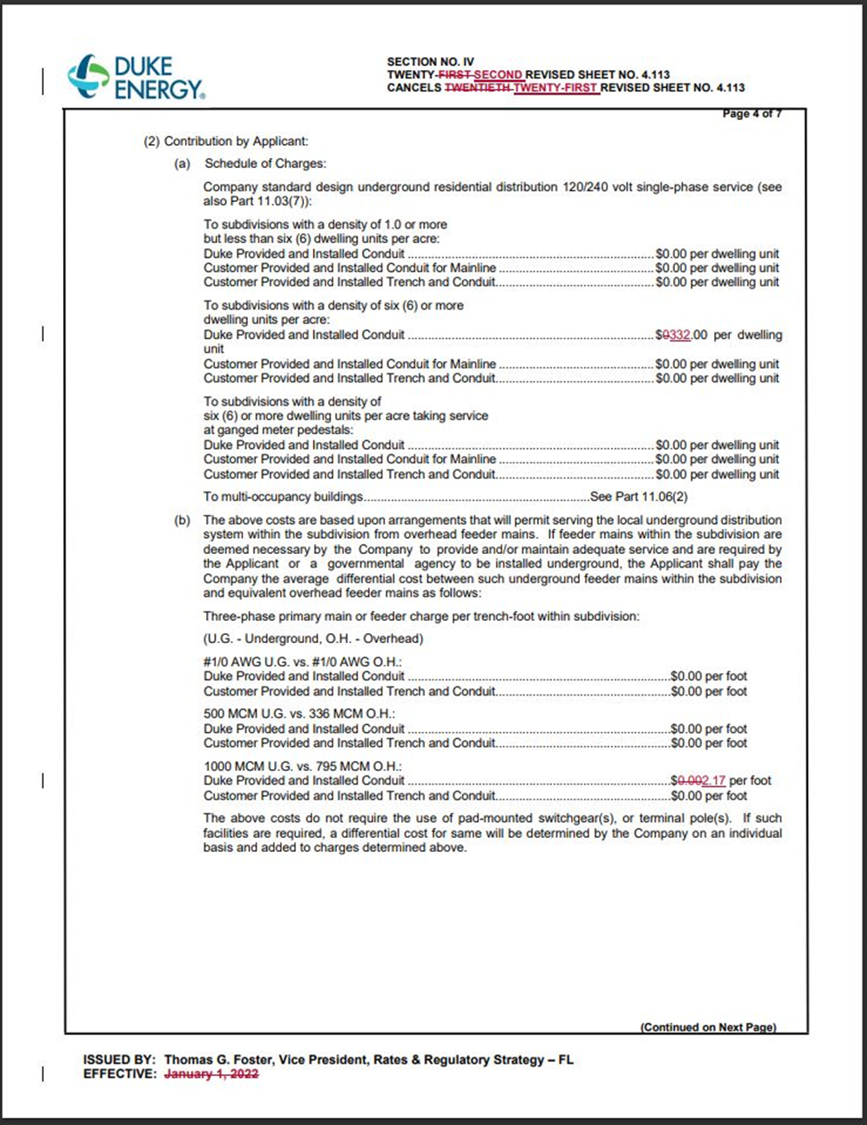

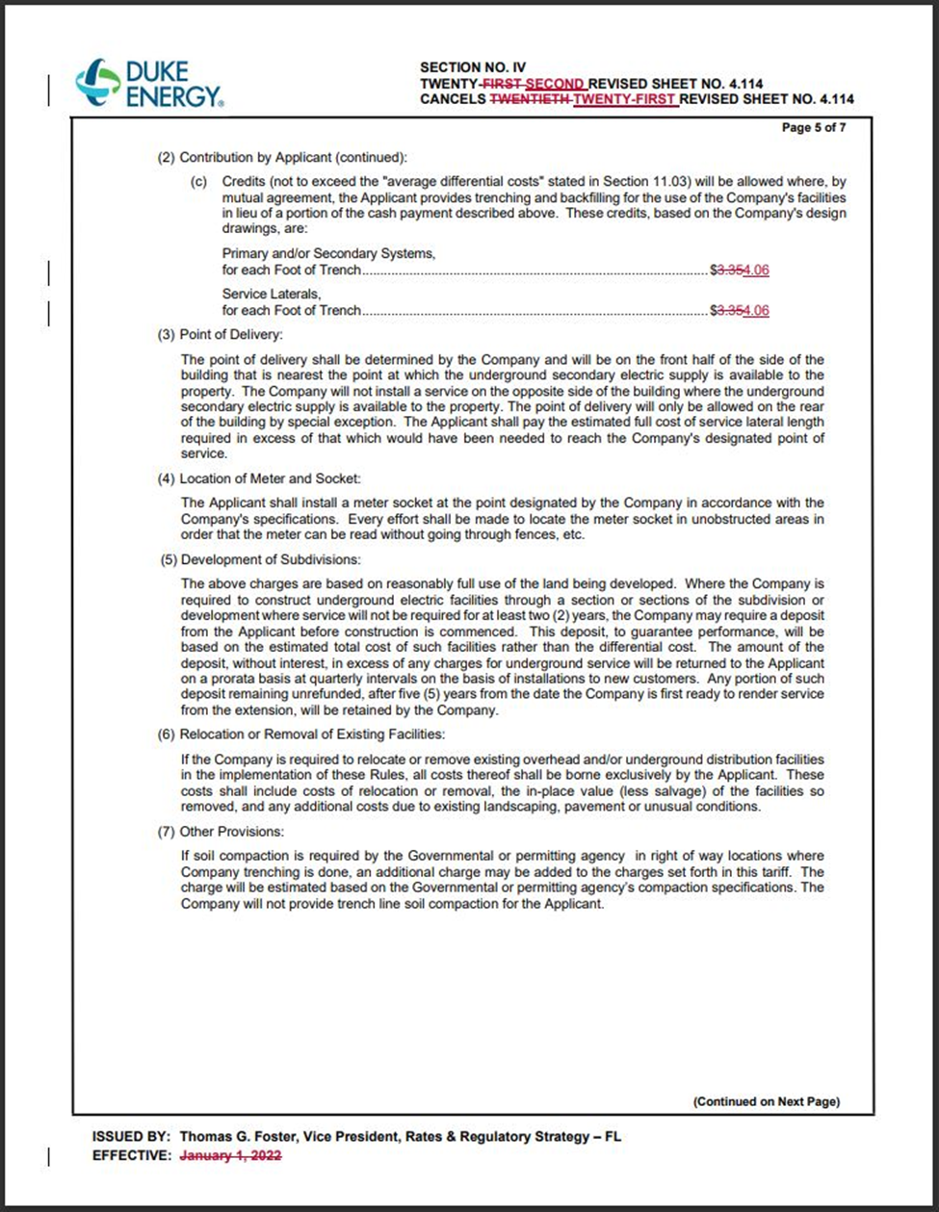

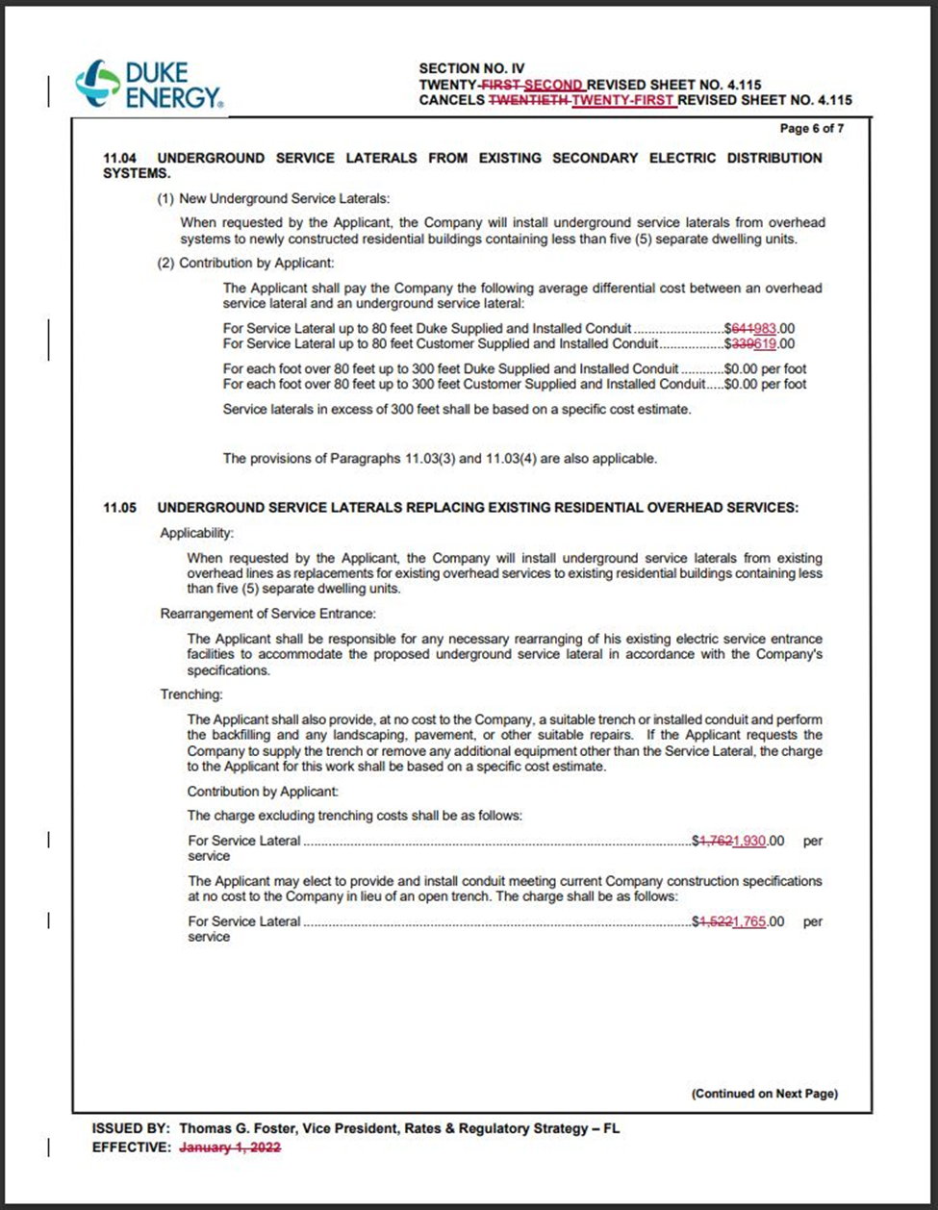

Order No. PSC-2020-0266-TRF-EI, issued July 27, 2020, in Docket No. 20200110-EI, In re: Petition for approval of revised underground residential distribution tariffs, by Duke Energy Florida, LLC.
Order No. PSC-2023-0168-PCO-EI, issued May 22, 2023, in Docket No. 20230043-EI, In re: Petition for approval of revised underground residential distribution tariffs, by Duke Energy Florida, LLC.
DEF’s Response to Staff’s Second Data Request, Item 4A.
Order No. PSC-12-0348-TRF-EI, issued July 5, 2012, in Docket No. 110293-EI, In re: Petition for approval of revised underground residential distribution tariffs, by Progress Energy Florida, Inc.

