BEFORE THE FLORIDA PUBLIC SERVICE COMMISSION

In re: Application for transfer of wastewater Certificate No. 318-S from BFF Corp to CSWR-Florida utility Operating Company, LLC, in Marion County. | DOCKET NO. 20220061-SU  ORDER NO. PSC-2023-0257-PAA-SU  ISSUED: August 21, 2023

The following Commissioners participated in the disposition of this matter:

ANDREW GILES FAY, Chairman
ART GRAHAM
GARY F. CLARK
MIKE LA ROSA
GABRIELLA PASSIDOMO

NOTICE OF PROPOSED AGENCY ACTION
ORDER ESTABLISHING NET BOOK VALUE, DECLINING
TO INCLUDE AN ACQUISITION ADJUSTMENT, AND
ESTABLISHING MISCELLANEOUS CHARGES
AND
GRANTING TRANSER OF CERTIFICATE NO. 318-S
AND CONTINUING EXISTING RATES AND CHARGES

BY THE COMMISSION:

NOTICE is hereby given by the Florida Public Service Commission that the action discussed herein, except for granting the transfer of Certificate No. 318-S and continuing existing rates and charges, is preliminary in nature and will become final unless a person whose interests are substantially affected files a petition for a formal proceeding, pursuant to Rule 25-22.029, Florida Administrative Code (F.A.C.).

Background
BFF Corp. (BFF, Utility, or Seller) is a Class C wastewater utility operating in Marion County. BFF provides service to approximately 108 wastewater customers. The Utility is in the St. Johns River Water Management District (SJRWMD). The SJRWMD has year-round watering restrictions in place for the portion of Marion County within its district. In its 2022 Annual Report, BFF reported a net operating loss of $627. The Utility’s last rate case was in 2002.
In 1989, we approved the transfer of wastewater Certificate No. 318-S from LTB Utility, Inc. to BFF. The certificated service territory has not been amended since that time.
On March 15, 2022, CSWR-Florida Utility Operating Company, LLC (CSWR-BFF or Buyer) filed an application with us for the transfer of Certificate No. 318-S from BFF to CSWR-BFF in Marion County. The application was found to be deficient. The Buyer cured the deficiencies on May 1, 2023. The sale will close after our vote to approve the transfer. In its application, the Buyer has requested a positive acquisition adjustment, which is discussed infra. The Office of Public Counsel’s (OPC) intervention was acknowledged by Order No. PSC-2022-0207-PCO-SU, issued June 14, 2022.
This order addresses the transfer of the wastewater system and Certificate No. 318-S, the appropriate net book value of the wastewater system for transfer purposes, and the request for an acquisition adjustment. We have jurisdiction pursuant to Sections 367.071 and 367.081, Florida Statutes (F.S.).

Decision

1. Transfer of Certificate No. 318-S

On March 15, 2022, CSWR-BFF filed an application for the transfer of Certificate No. 318-S from BFF to CSWR-BFF in Marion County. The application is in compliance with Section 367.071, F.S., and our rules concerning applications for transfer of certificates. The sale to CSWR-BFF will become final after our approval of the transfer, pursuant to Section 367.071(1), F.S.
- Noticing, Territory, and Land Ownership

CSWR-BFF provided notice of the application pursuant to Section 367.071, F.S., and Rule 25-30.030, F.A.C. No objections to the transfer were filed, and the time for doing so has expired. The application contains a description of the service territory, which is appended to this order as Attachment A. In its application, CSWR-BFF provided a copy of an unrecorded warranty deed as evidence that the Buyer will have rights to long-term use of the land upon which the treatment facilities are located pursuant to Rule 25-30.037(2)(s), F.A.C. CSWR-BFF committed to providing the executed and recorded deed to us within 60 days after the closing of the sale.
- Purchase Agreement and Financing

Pursuant to Rule 25-30.037(2)(g), (h), and (i), F.A.C., the application contains a statement regarding financing and a copy of the purchase agreement, which includes the purchase price, terms of payment, and a list of the assets purchased. There are no guaranteed revenue contracts, or customer advances of BFF that must be disposed of with regard to the transfer. CSWR-BFF will review all leases and developer agreements and will assume or renegotiate those agreements on a case-by-case basis prior to closing. Any customer deposits will be refunded to customers by the Seller prior to the closing. According to the purchase and sale agreement, the total purchase price for the assets is $405,000. According to the Buyer, the closing has not yet taken place and is dependent on our approval of the transfer, pursuant to Section 367.071(1), F.S.
- Facility Description and Compliance

BFF provides wastewater treatment service pursuant to a bulk service agreement with Marion County Utilities. Since the Utility does not have treatment facilities of its own, it has no permits, inspections, reports, or correspondence from the Florida Department of Environmental Protection. BFF has three lift stations and a master lift station that conveys wastewater to Marion County Utilities.
- Technical and Financial Ability

Pursuant to Rule 25-30.037(2)(l) and (m), F.A.C., the application contains statements describing the technical and financial ability of the Buyer to provide service to the proposed service area. As referenced in the transfer application, the Buyer will fulfill the commitments, obligations, and representations of the Seller with regards to utility matters. CSWR-BFF’s application states that it owns and operates water and wastewater systems in Missouri, Arkansas, Kentucky, Louisiana, Texas, Mississippi, Arizona, North Carolina, and Tennessee that currently serve more than 73,000 water and 117,000 wastewater customers. We have also approved CSWR’s purchase of five Florida certificated utilities in prior dockets.
The Buyer plans to use qualified and licensed contractors to provide routine operation and maintenance (O&M) of the systems, as well as to handle billing and customer service. We reviewed the financial statements of CSWR-BFF and find the Buyer has documented adequate resources to support the Utility’s wastewater operations. Based on the above, the Buyer has demonstrated the technical and financial ability to provide service to the existing service territory.

- Rates and Charges

BFF’s wastewater rates were last approved in 2002. Since the last rate case, the rates were subsequently amended by several price indexes and pass-through rate adjustments with the most recent being in 2022. The Utility’s current charges were approved in 1990. The initial customer deposits have been in effect since the Utility’s certification in the late 1990’s. Rule 25-9.044(1), F.A.C., provides that, in the case of a change of ownership or control of a Utility, the rates, classifications, and regulations of the former owner must continue unless authorized to change by us. However, the miscellaneous service charges do not conform to Rule 25-30.460, F.A.C., and are discussed infra. Therefore, we find that the Utility's existing rates, service availability charges, and initial customer deposits as shown on Schedule No. 4, shall remain in effect until a change is authorized by us in a subsequent proceeding. The tariff pages reflecting the transfer shall be effective on or after the stamped approval date on the tariff sheets, pursuant to Rule 25-30.475(1), F.A.C.
- Regulatory Assessment Fees and Annual Report

We have verified that the Utility is current on the filing of annual reports and RAFs through December 31, 2022. The Buyer shall be responsible for filing the Utility’s annual reports and paying RAFs for all future years.
- Conclusion

Based on the foregoing, we find that the transfer of the water and wastewater systems and Certificate No. 318-S is in the public interest and shall be approved effective the date that the sale becomes final. This Order serves as the Buyer’s certificate and shall be retained by the Buyer. The Buyer shall submit the executed and recorded deed for continued access to the land upon which its facilities are located, and a copy of its signed and executed contract for sale to us within 60 days of the Order approving the transfer, which is final agency action. If the sale is not finalized within 60 days of the transfer Order, the Buyer shall file a status update in the docket file. The Utility’s existing rates, service availability charges, and initial customer deposits, as shown on Schedule No. 4, shall remain in effect until a change is authorized by us in a subsequent proceeding. The tariff pages reflecting the transfer shall be effective on or after the stamped approval date on the tariff sheets, pursuant to Rule 25-30.475(1), F.A.C. The Seller is current with respect to annual reports and RAFs through December 31, 2022. The Buyer shall be responsible for filing annual reports and paying RAFs for all future years.

2. Net Book Value (NBV)
Rate base was last established as of August 31, 2002. The purpose of establishing NBV for transfers is to determine whether an acquisition adjustment should be approved. CSWR-BFF’s request for a positive acquisition adjustment is addressed infra. The NBV does not include normal ratemaking adjustments for used and useful plant or working capital. The Utility’s NBV has been updated to reflect balances as of February 28, 2022. Our approved NBV, as described below, is shown on Schedule No. 1.
- Utility Plant in Service (UPIS)
According to the Utility’s general ledger, the total UPIS balance was $270,192 as of February 28, 2022. We compiled the plant additions and retirements to UPIS from August 31, 2002, to February 28, 2022, and traced supporting documentation. Based on this review, we order a decrease to UPIS of $34,341 as of February 28, 2022. Accordingly, we find a total UPIS balance of $235,851 as of February 28, 2022.
- Land
The Utility’s general ledger reflected a land balance of $1,579 as of August 31, 2002. There have been no additions to land since August 31, 2002. Therefore, we find no adjustments to the Utility’s land balance.
- Accumulated Depreciation
According to the Utility’s general ledger, the total accumulated depreciation balance was $214,723 as of February 28, 2022. We recalculated depreciation accruals using the depreciation rates established by Rule 25-30.140, F.A.C. As a result, we find that the accumulated depreciation balance be decreased by $24,057 as of February 28, 2022. Accordingly, we find for a total accumulated depreciation balance of $190,666 as of February 28, 2022.
- Contributions-in-Aid-of-Construction (CIAC) and Accumulated Amortization of CIAC
According to the Utility’s general ledger, the CIAC balance and accumulated amortization of CIAC were $41,036 and $29,740, respectively, as of February 28, 2022. We recalculated CIAC and accumulated amortization of CIAC balances from August 31, 2002, to February 28, 2022, using supporting documentation. As a result, we find that the CIAC balance shall be decreased by $5,634 as of February 28, 2022. We also find that the accumulated amortization of CIAC balance shall be decreased by $1,394 as of February 28, 2022. Accordingly, total CIAC and Accumulated Amortization of CIAC balances shall be $35,402 and $28,346, respectively, as of February 28, 2022.
- Net Book Value
The Utility’s general ledger reflected a NBV of $45,752 as of February 28, 2022. Based on the adjustments described supra, we find a NBV of $39,708 as of February 28, 2022. The NBV and the National Association of Regulatory Utility Commissioners, Uniform System of Accounts (NARUC USOA) balances for UPIS and accumulated depreciation are shown as of February 28, 2022 on Schedule No. 1. As addressed infra, we do not recognize a positive acquisition adjustment for ratemaking purposes.
- Conclusion
We approve an NBV of $39,708 as of February 28, 2022, for transfer purposes. Within 90 days of the date of the Consummating Order, the Buyer shall be required to notify us in writing, that it has adjusted its books in accordance with our decision. The adjustments shall be reflected in the Utility’s 2023 Annual Report when filed.

3. Denying Positive Acquisition Adjustment
In its filing, the applicant requested a positive acquisition adjustment be included in the calculation of the Utility’s rate base. An acquisition adjustment results when the purchase price differs from the NBV of the assets at the time of acquisition. Pursuant to Rule 25-30.0371, F.A.C., a positive acquisition adjustment results when the purchase price is greater than the NBV and a negative acquisition adjustment results when the purchase price is less than the NBV. A positive acquisition adjustment, if approved, increases rate base.
According to the purchase agreement, the Buyer will purchase the Utility for $405,000. As discussed supra, we approve a NBV of $39,708. This would result in a positive acquisition adjustment of $365,292.
Any entity that believes a full or partial positive acquisition adjustment should be made has the burden to prove the existence of extraordinary circumstances. Rule 25-30.0371(2), F.A.C., states:
In determining whether extraordinary circumstances have been demonstrated, the Commission shall consider evidence provided to the Commission such as anticipated improvements in quality of service, anticipated improvements in compliance with regulatory mandates, anticipated rate reductions or rate stability over a long-term period, anticipated cost efficiencies, and whether the purchase was made as part of an arms-length transaction.

If a purchase price above depreciated original cost is used to determine rate base, without the requirement for extraordinary circumstances, it could encourage utilities to “swap assets” and inappropriately increase cost to customers.

- Deferral

In response to staff data requests, CSWR-BFF stated that it intends to ask for deferral of a decision regarding the requested acquisition adjustment. In its application, the Buyer laid out factors such as improvements to quality of service, cost efficiencies, and rate stability. These are discussed infra and we find that these factors do not constitute extraordinary circumstances. In response to staff data requests, the Buyer agreed that after rate base is set, if a company provides support in a separate and subsequent case that there are utility assets that were not previously recorded, then the company can prospectively recover the unrecorded amount of that investment. Therefore, if the Buyer finds assets were incorrectly recorded on the Seller’s balance sheet, the Buyer can support those costs and recover them in a future rate case. That is our normal practice and is not considered extraordinary circumstances.
Pursuant to our practice, the Buyer has the burden to prove extraordinary circumstances at the time of transfer. In the instant case the Buyer has failed to provide proof of extraordinary circumstances. Further, the Buyer had multiple opportunities to provide pertinent information needed to determine if a positive acquisition adjustment is appropriate. As such, we deny the request to defer a decision on the positive acquisition adjustment.
Finally, it is our long-standing practice to address the disposition of any positive or negative acquisition adjustment at the time of transfer. Pursuant to Section 120.68(7)(e)3., F.S., when agencies change their established policies, practices and procedures, they must give an explanation for the deviation. We do not believe the facts in this case warrant such a deviation. As such, we find that the deferral of a positive acquisition adjustment decision in this docket would result in an unnecessary deviation from our practice.

- Improvements in Quality of Service and Compliance with Regulatory Mandates

In its application, CSWR-BFF listed six business practices that it believes will improve the quality of service to its customers: (1) provision of 24-hour emergency service phone numbers; (2) on-call emergency service personnel who are required to respond to emergency service calls within prescribed time limits; (3) a computerized maintenance management system; (4) access to resources not usually available to comparably sized systems and the ability to supplement local personnel with resources owned by the parent and sister companies; (5) online bill payment options; and (6) an updated website for customer communication, bulletins, procedures, etc.
No complaints were filed with us for the five-year period prior to the application, from March 2017 to March 2022. In its application, CSWR-BFF did not list any customer complaints related to the wastewater service.

In Exhibit H of its application, CSWR-BFF listed its plans for improvements of the Utility’s collection system. The improvements consist of installing a remote monitoring system, rehabilitating the four lift stations, and collection system repairs. However, no specific repairs or system deficiencies were noted. The Buyer stated in its application that no governmental authorities are presently requiring repairs or improvements to the systems.

It appears that BFF currently has no issues with respect to regulatory compliance. While the Buyer identified some general improvements it intends to implement, we do not find that the Buyer has demonstrated extraordinary circumstances in support of its requested positive acquisition adjustment. Instead, the proposed anticipated improvements in quality of service demonstrate CSWR-BFF’s intention to responsibly execute its obligations as a utility owner. While we do not find that the Utility’s anticipated improvements justify its requested positive acquisition adjustment, these improvements may be considered for prudence and cost recovery in a future rate proceeding.
- Anticipated Cost Efficiencies and Rates

In its application, the Buyer stated that its size and anticipated consolidation of many small systems under one financial and managerial entity would result in operational cost efficiencies, particularly in the areas of:
- PSC and environmental regulatory reporting
- Managerial and operational oversight
- Utility asset planning
- Engineering planning
- Ongoing utility maintenance
- Utility record keeping
- Customer service responsiveness
- Improved access to capital is necessary to repair and upgrade BFF’s systems to ensure compliance with all health and environmental requirements and ensure service to customers remains safe and reliable

In response to staff data requests, the Buyer provided an estimated annual reduction of O&M expense of approximately $11,000. However, with a requested acquisition adjustment of $365,292, the requested amount is over nine times greater than the system’s current NBV of $39,708. Even if the Buyer was able to achieve these savings in O&M expense, the inclusion of the requested acquisition adjustment in rate base and the inclusion of the annual amortization expense in the NOI calculation, would result in an increased revenue requirement. By operation of math, the overall impact would be a net increase to customer rates.
The Buyer also stated that CSWR-BFF would bring long-term rate stability to the Utility, should the transfer be approved. Economies of scale and the potential consolidation of several systems in Florida, as proposed by CSWR-BFF, could bring some amount of long-term rate stability. However, absent specific and detailed support for these assertions, the Buyer has failed to meet its burden of demonstrating extraordinary circumstances.
Our decision in this docket is consistent with our previous decision in Order No. PSC-2020-0458-PAA-WS. In that docket, the Buyer identified estimates of anticipated cost efficiencies, including a reduction in O&M expense and a reduction of cost of capital that would result from the transfer. Additionally, the Buyer cited several improvements it made to the wastewater treatment plant and wastewater lift station since acquisition to improve the quality of service and compliance with regulatory mandates. While we acknowledged that the Buyer accomplished cost savings, we did not find the actions performed demonstrated extraordinary circumstances that would justify approval of a positive acquisition adjustment.
Our decision is also consistent with the our decisions to deny CSWR-Florida Utility Operating Company, LLC a positive acquisition adjustment as set out in Order Nos. PSC-2022-0116-PAA-SU, PSC-2022-0120-PAA-WU, PSC-2022-0115-PAA-WS, PSC-2022-0364-PAA-WU, and Order No. PSC-2023-0216-PAA-SU. In those cases, it was determined the Buyer failed to provide sufficient evidence of extraordinary circumstances and was denied a positive acquisition adjustment in all five cases. In those cases, CSWR also requested a deferral of the decision regarding the positive acquisition adjustments which was denied. The facts of this case are similar to those of the five cases discussed supra.
- Conclusion

Pursuant to Rule 25-30.0371, F.A.C., a positive acquisition adjustment shall not be granted as the Buyer did not demonstrate extraordinary circumstances. The Buyer’s anticipated improvements in quality of service and compliance with regulatory mandates do not illustrate extraordinary circumstances and instead demonstrate CSWR-BFF’s intentions to responsibly provide utility service.

4. Revising Miscellaneous Service Charges
Effective June 24, 2021, Rule 25-30.460, F.A.C., was amended to remove initial connection and normal reconnection charges. The definitions for initial connection charges and normal reconnection charges were subsumed in the definition of the premises visit charge. The Utility’s miscellaneous service charges consist of initial connection and normal reconnection charges. The normal reconnection charge is more than the premises visit charge. Since the premises visit entails a broader range of tasks, we find that the premises visit shall reflect the amount of the normal reconnection charge of $15 for normal hours. Therefore, the initial connection and normal reconnection charges shall be removed, the premises visit shall be revised to $15 for normal hours, and the definition for the premises visit charge shall be updated to comply with amended Rule 25-30.460, F.A.C. The Utility’s existing and our approved miscellaneous service charges are shown in Table 1.
Table 1
Utility Existing and Approved Miscellaneous Service Charges
 | Existing | Approved
 | Normal Hours | Normal Hours
Initial Connection Charge | $15.00 | N/A
Normal Reconnection Charge | $15.00 | N/A
Violation Reconnection Charge - Wastewater | Actual Cost | Actual Cost
Premises Visit Charge | $10.00 | $15.00

- Conclusion

The miscellaneous service charges shall be revised to conform to the recent amendment to Rule 25-30.460, F.A.C. The tariff shall be revised to reflect the removal of initial connection and normal reconnection charges. The Utility shall be required to file a proposed customer notice to reflect our approved charges. The approved charges shall be effective on or after the stamped approval date on the tariff sheet pursuant to Rule 25-30.475(1), F.A.C. In addition, the approved charges shall not be implemented until our staff has approved the proposed customer notice and the notice has been received by customers. The Utility shall provide proof of the date notice was given within 10 days of the date of the notice. The Utility shall be required to charge the approved miscellaneous service charges until authorized to change them by us in a subsequent proceeding.

Based on the foregoing, it is

ORDERED by the Florida Public Service Commission that the transfer of the wastewater system and Certificate No. 318-S in Marion County from BFF Corp. to CSWR-Florida Utility Operating Company, LLC is in the public interest and is hereby approved effective the date that the sale becomes final. The resultant Order shall serve as the Buyer’s certificate and shall be retained by the Buyer. It is further

ORDERED that the Buyer shall submit the executed and recorded deed for continued access to the land upon which its facilities are located, copies of its permit transfer applications, and a copy of its signed and executed contract for sale to the Commission within 60 days of the Order approving the transfer, which is final agency action. If the sale is not finalized within 60 days of the transfer Order, the Buyer shall file a status update in the docket file. It is further

ORDERED that the Utility’s existing rates, service availability charges, and initial customer deposits, as shown on Schedule No. 4 appended to this Order, shall remain in effect until a change is authorized by this Commission in a subsequent proceeding. The tariff pages reflecting the transfer shall be effective on or after the stamped approval date on the tariff sheets, pursuant to Rule 25-30.475(1), F.A.C. The Buyer shall be responsible for filing annual reports and paying RAFs for all future years. It is further

ORDERED that for transfer purposes, the net book value is $39,708 as of February 28, 2022. Within 90 days of the date of the Consummating Order, CSWR-Florida Utility Operating Company, LLC shall notify this Commission in writing that it has adjusted its books in accordance with our decision. The adjustments shall be reflected in CSWR-Florida Utility Operating Company, LLC’s 2023 Annual Report when it is filed. It is further

ORDERED that a positive acquisition adjustment shall not be granted as the Buyer failed to demonstrate extraordinary circumstances. It is further

ORDERED that CSWR-Florida Utility Operating Company, LLC’s miscellaneous service charges shall be revised to conform to amended Rule 25-30.460, F.A.C. The tariff shall be revised to reflect the removal of initial connection and normal reconnection charges. The Utility shall file a proposed customer notice to reflect the charges approved herein. The approved charges shall be effective for service rendered or connections made on or after the stamped approval date on the tariff sheets, provided customers have received notice pursuant to Rule 25-30.475(2), F.A.C. In addition, the approved charge shall not be implemented until Commission staff has administratively approved the proposed customer notice and the notice has been received by customers. CSWR-Florida Utility Operating Company, LLC shall provide proof of the date the notice was given within 10 days of the date of the notice. CSWR-Florida Utility Operating Company, LLC shall charge the approved miscellaneous service charges until authorized to change them in a subsequent proceeding. It is further

ORDERED that the provisions of this Order, issued as proposed agency action, shall become final and effective upon the issuance of a Consummating Order unless an appropriate petition, in the form provided by Rule 28-106.201, Florida Administrative Code, is received by the Commission Clerk, 2540 Shumard Oak Boulevard, Tallahassee, Florida 32399-0850, by the close of business on the date set forth in the “Notice of Further Proceedings” attached hereto. It is further

ORDERED that if no protest to the proposed agency action is filed by a substantially affected person within 21 days of the date of the issuance of the Order, a Consummating Order shall be issued and the docket shall be closed administratively upon Commission staff’s verification that: the revised tariff sheets have been filed, that proof has been provided that appropriate noticing has been done pursuant to Rule 25-30.4345, F.A.C., the Buyer has notified this Commission in writing that it has adjusted its books in accordance with our decision, the Buyer has submitted the executed and recorded warranty deed, the Buyer has submitted a copy of its application for permit transfer to the DEP and the SJRWMD, and the Buyer has submitted a signed and executed copy of its contract for sale within 60 days of our final Order approving the transfer.

By ORDER of the Florida Public Service Commission this 21st day of August, 2023.

ADAM J. TEITZMAN
Commission Clerk
Florida Public Service Commission
2540 Shumard Oak Boulevard
Tallahassee, Florida 32399
(850) 413-6770
www.floridapsc.com

Copies furnished: A copy of this document is provided to the parties of record at the time of issuance and, if applicable, interested persons.

RPS

NOTICE OF FURTHER PROCEEDINGS OR JUDICIAL REVIEW

The Florida Public Service Commission is required by Section 120.569(1), Florida Statutes, to notify parties of any administrative hearing or judicial review of Commission orders that is available under Sections 120.57 or 120.68, Florida Statutes, as well as the procedures and time limits that apply. This notice should not be construed to mean all requests for an administrative hearing or judicial review will be granted or result in the relief sought.

As identified in the body of this order, except for the transfer of Certificate No. 318-S and continuing existing rates and charges, the actions taken herein are preliminary in nature. Any person whose substantial interests are affected by the actions proposed by this order may file a petition for a formal proceeding, in the form provided by Rule 28-106.201, Florida Administrative Code. This petition must be received by the Office of Commission Clerk, 2540 Shumard Oak Boulevard, Tallahassee, Florida 32399-0850, by the close of business on September 11, 2023. If such a petition is filed, mediation may be available on a case-by-case basis. If mediation is conducted, it does not affect a substantially interested person's right to a hearing. In the absence of such a petition, this order shall become effective and final upon the issuance of a Consummating Order.

Any objection or protest filed in this docket before the issuance date of this order is considered abandoned unless it satisfies the foregoing conditions and is renewed within the specified protest period.

Any party adversely affected by the Commission's final action in this matter may request: (1) reconsideration of the decision by filing a motion for reconsideration with the Office of Commission Clerk, within fifteen (15) days of the issuance of this order in the form prescribed by Rule 25-22.060, Florida Administrative Code; or (2) judicial review by the Florida Supreme Court in the case of an electric, gas or telephone utility or the First District Court of Appeal in the case of a water or wastewater utility by filing a notice of appeal with the Office of Commission Clerk and filing a copy of the notice of appeal and the filing fee with the appropriate court. This filing must be completed within thirty (30) days after the issuance of this order, pursuant to Rule 9.110, Florida Rules of Appellate Procedure. The notice of appeal must be in the form specified in Rule 9.900(a), Florida Rules of Appellate Procedure.

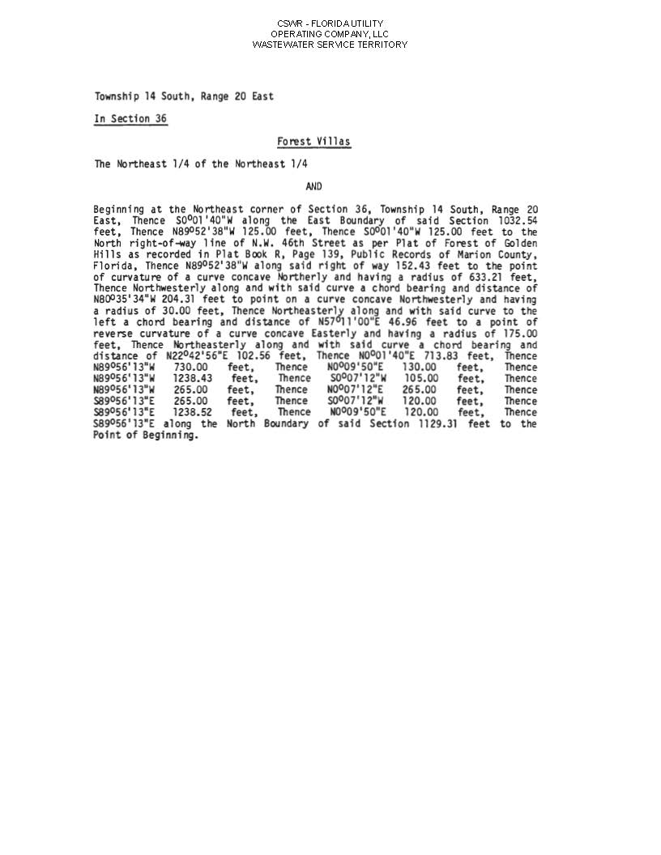
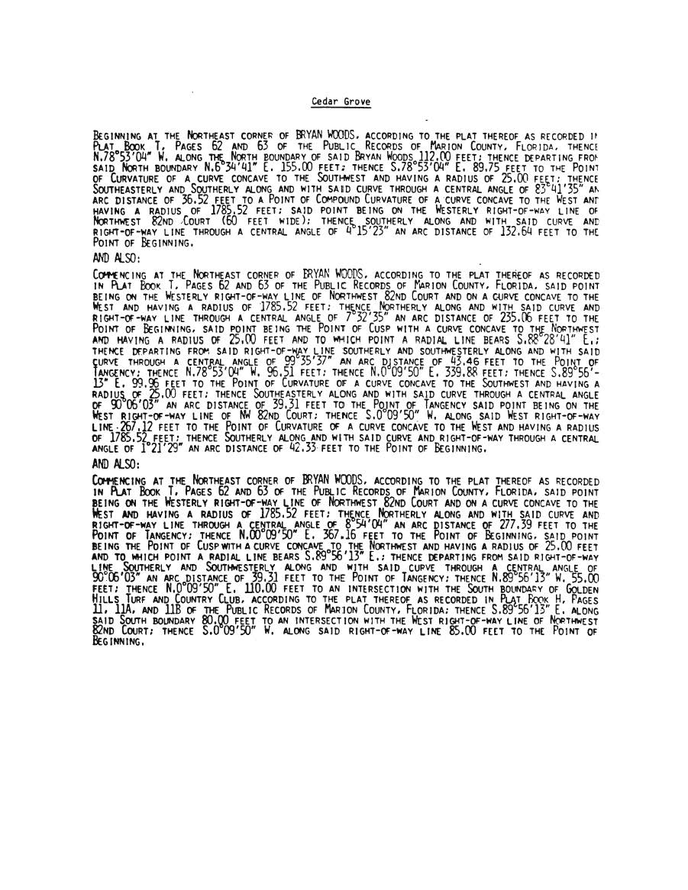
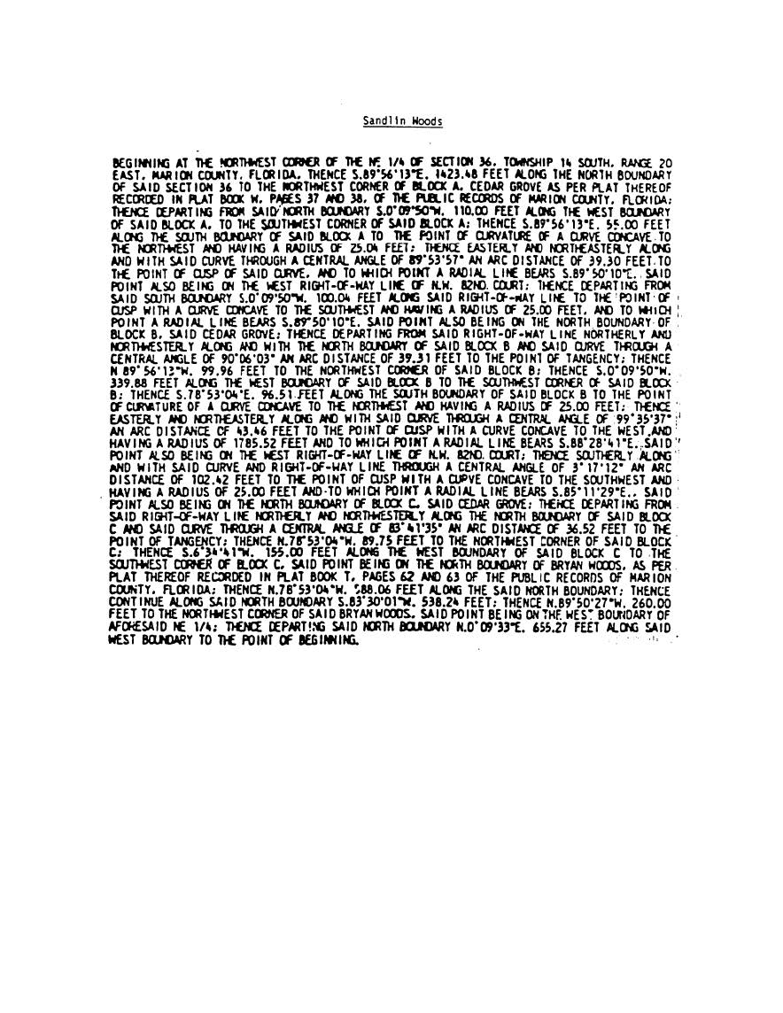
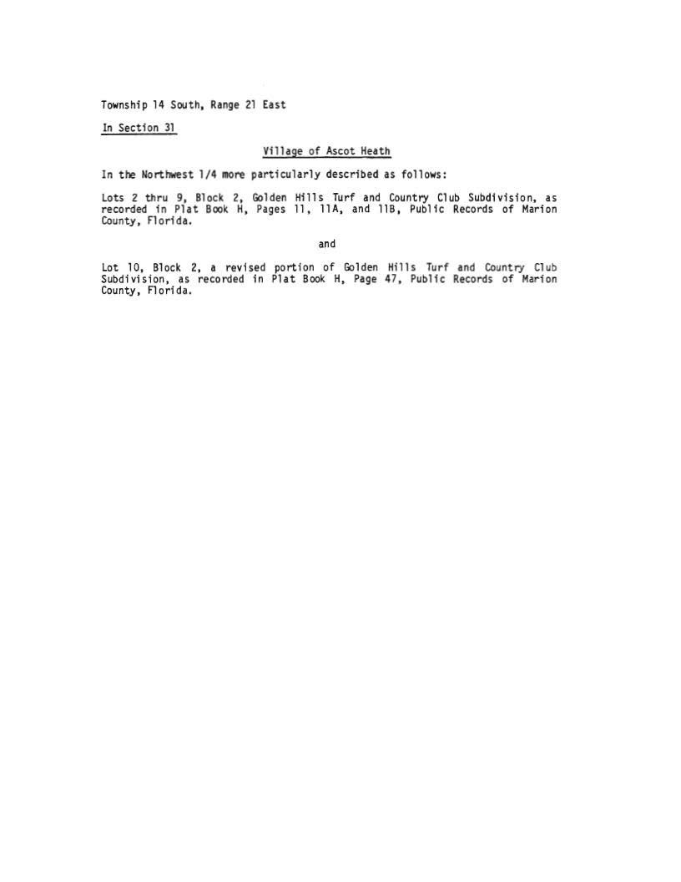

FLORIDA PUBLIC SERVICE COMMISSION
authorizes
CSWR-Florida Utility Operating Company, LLC pursuant to
Certificate Number 318-S

to provide wastewater service in Marion County in accordance with the provisions of Chapter 367, Florida Statutes, and the Rules, Regulations, and Orders of this Commission in the territory described by the Orders of this Commission. This authorization shall remain in force and effect until superseded, suspended, cancelled or revoked by Order of this Commission.

Order Number | Date Issued | Docket Number | Filing Type
Order No. 11180 | 09/21/82 | 19810333-S | Grandfather
Order No. 11180A | 11/04/82 | 19810333-S | Territory Correction
Order No. 12193 | 07/06/83 | 19830243-S | Transfer
Order No. 22371 | 01/08/90 | 19890045-SU | Transfer and Amendment
Order No. 22371A | 01/08/90 | 19890045-SU | Amendatory Order
PSC-2023-0257-PAA-SU | 08/21/23 | 20220061-SU | Transfer

CSWR-Florida Utility Operating Company, LLC
BFF Corp

Schedule of Net Book Value as of February 28, 2022

Description | Balance  Per Utility  2/28/22 | Adjustments |  | Commission Approved  2/28/22
Utility Plant in Service | $270,192 | ($34,341) | A | $235,851
Land & Land Rights | 1,579 | - |  | 1,579
Accumulated Depreciation | (214,723) | 24,057 | B | (190,666)
CIAC | (41,036) | 5,634 | C | (35,402)
Amortization of CIAC | 29,740 | (1,394) | D | 28,346
Total | $45,752 | ($6,044) |  | $39,708

CSWR-Florida Utility Operating Company, LLC
BFF Corp

Explanation of Adjustments to Net Book Value as of February 28, 2022

Explanation | Amount
- UPIS
To reflect the appropriate balance. | ($34,341)
- Accumulated Depreciation
To reflect the appropriate balance. | 24,057
- CIAC
To reflect the appropriate balance. | 5,634
- Accumulated Amortization of CIAC
To reflect the appropriate balance. | (1,394)
Total Adjustments to Net Book Value as of February 28, 2022 | ($6,044)

CSWR-Florida Utility Operating Company, LLC
BFF Corp

Schedule of Approved Account Balances as of February 28, 2022

Account  No. | Description | UPIS | Accumulated Depreciation
351 | Organization | $2,411 | ($1,918)
354 | Structures & Improvements | - | -
360 | Collection Sewers - Force | 110,666 | (86,210)
361 | Collection Sewers - Gravity | 77,795 | (74,581)
362 | Special Collection Structures | 17,043 | (9,323)
363 | Service to Customers | 6,219 | (6,219)
365 | Flow Measuring Installations | 383 | (218)
370 | Receiving Wells | 21,334 | (12,195)
 | Total | $235,851 | ($190,666)

CSWR – Florida Utility Operating Company, LLC.
BFF Corp.
Monthly Wastewater Rates

Residential Service
Base Facility Charge by Meter Size
All Meter Sizes |  |  |  | $32.98
Charge Per 1,000 gallons – Residential Service
10,000 gallon cap |  |  |  | $8.75
Flat Rate (for unmetered residential customers) |  |  |  | $75.35
General Service
Base Facility Charge by Meter Size
5/8” x 3/4" |  |  |  | $32.98
3/4" |  |  |  | $49.47
1" |  |  |  | $82.45
1 1/2" |  |  |  | $164.90
2" |  |  |  | $263.84
3" |  |  |  | $527.68
4" |  |  |  | $824.50
6" |  |  |  | $1,649.00
Charge Per 1,000 gallons |  |  |  | $10.18
Initial Customer Deposits
 | Residential Service |  |  | General Service
5/8” x 3/4” | $120.00 |  |  | $133.00
All Over 5/8”x 3/4” | $120.00 |  |  | 2x average estimated bill
Service Availability Charges
System Capacity Charge
Residential per ERC (350 gallons per day) |  |  |  |  | $1,620.00
All others – per gallon |  |  |  |  | $4.63

Order No. PSC-02-0487-PAA-SU, issued April 8, 2002, in Docket No. 20010919-SU, In re: Application for staff-assisted rate case in Marion County by BFF Corp.
Order No. 22371, issued January 8, 1990, in Docket No. 19890045-SU, In re: Application for transfer and amendment of Certificate No. 318-S in Marion County from LTB Utility, Inc. to BFF Corp.
See Order No. PSC-2022-0115-PAA-WS, issued March 15, 2022, in Docket No. 20210093-WS, In re: Application for transfer of water and wastewater systems of Aquarina Utilities, Inc., water Certificate No. 517-W, and wastewater Certificate No. 450-S to CSWR-Florida Utility Operating Company, LLC, in Brevard County; Order No. PSC-2022-0120-PAA-WU, issued March 18, 2022, in Docket No. 20210095-WU, In re: Application for transfer of water facilities of Sunshine Utilities of Central Florida, Inc. and water Certificate No. 363-W to CSWR-Florida Utility Operating Company, LLC, in Marion County; Order No. PSC-2022-0116-PAA-SU, issued March 17, 2022, in Docket No. 20210133-SU, In re: Application for transfer of facilities of North Peninsula Utilities Corporation and wastewater Certificate No. 249-S to CSWR-Florida Utility Operating Company, LLC, in Volusia County; Order No. PSC-2022-0364-PAA-WU, issued October 25, 2022, in Docket No. 20220019-WU, In re: Application for transfer of water facilities of Neighborhood Utilities, Inc. and water Certificate No. 430-W to CSWR-Florida Utility Operating Company, LLC, in Duval County; and Order No. PSC-2023-0216-PAA-SU, issued July 27, 2023, in Docket No. 20220149-SU, In re: Application for transfer of wastewater Certificate No. 365-S of Sebring Ridge Utilities, Inc. to CSWR-Florida Utility Operating Company, LLC, in Highlands County.
Order No. PSC-02-0487-PAA-SU, issued April 8, 2002, in Docket No. 20010919-SU, In re: Application for staff-assisted rate case in Marion County by BFF Corp.
Order No. 22570, issued February 19, 1990, in Docket No. 19890916-SU, In re: Application of BFF Corp. for a staff-assisted rate case in Marion County.
Order No. PSC-02-0487-PAA-SU, issued April 8, 2002, in Docket No. 20010919-SU, In re: Application for staff-assisted rate case in Marion County by BFF Corp.
Net book value is calculated through the date of the closing. According to the Utility’s application, the closing will not occur until after the transaction receives our approval. Therefore, we are relying on the most current information provided to auditors at the time of the filing.
Order No. PSC-2020-0458-PAA-WS, issued November, 23, 2020, in Docket No. 20190170-WS, In re: Application for transfer of facilities and Certificate Nos. 259-W and 199-S in Broward County from Royal Utility Company to Royal Waterworks, Inc.
Order No. PSC-2022-0116-PAA-SU, issued March 17, 2022, in Docket No. 20210133-SU, In re: Application for transfer of facilities of North Peninsula Utilities Corporation and wastewater Certificate No. 249-S to CSWR-Florida Utility Operating Company, LLC, in Volusia County; Order No. PSC-2022-0120-PAA-WU, issued March 18, 2022, in Docket No. 20220095-WU, In re: Application for transfer of wastewater facilities of Sunshine Utilities of Central Florida, Inc. and wastewater Certificate No. 363-W to CSWR-Florida Utility Operating Company, LLC, in Marion County; Order No. PSC-2022-0115-PAA-WS, issued March 15, 2022, in Docket No. 20210093-WS, In re: Application for transfer of wastewater and wastewater systems of Aquarina Utilities, Inc., wastewater Certificate No. 517-W, and wastewater Certificate No. 450-S to CSWR-Florida Utility Operating Company, LLC, in Brevard County; Order No. PSC-2022-0364-PAA-WU, issued October 25, 2022, in Docket No. 20220019-WU, In re: Application for the transfer of water facilities in Neighborhood Utilities, Inc. and water Certificate No. 430-W to CSWR-Florida Utility Operating Company, LLC, in Duval County; Order No. PSC-2023-0216-PAA-SU, issued July 27, 2023, in Docket No. 20220149-SU, In re: Application for transfer of wastewater Certificate No. 365-S of Sebring Ridge Utilities, Inc. to CSWR-Florida Utility Operating Company, LLC, in Highlands County.
Order No. PSC-2021-0201-FOF-WS, issued June 4, 2021, in Docket No. 20200240-WS, In re: Proposed amendment of Rule 25-30.460, F.A.C., Application for Miscellaneous Service Charges.

