State of Florida |  | Public Service Commission  Capital Circle Office Center ● 2540 Shumard Oak Boulevard  Tallahassee, Florida 32399-0850  -M-E-M-O-R-A-N-D-U-M-
DATE: | October 27, 2023
TO: | Office of Commission Clerk (Teitzman)
FROM: | Division of Economics (Guffey, Lang)  Division of Accounting and Finance (Mason, Norris)  Office of the General Counsel (Dose)
RE: | Docket No. 20230090-EI – Petition to implement 2024 generation base rate adjustment provisions in paragraph 4 of the 2021 stipulation and settlement agreement, by Tampa Electric Company.
AGENDA: | 11/09/23 – Regular Agenda – Tariff Filing – Interested Persons May Participate
COMMISSIONERS ASSIGNED: |  |  | All Commissioners
PREHEARING OFFICER: |  |  | Administrative
CRITICAL DATES: |  |  | 4/16/23 (8-Month Effective Date)
SPECIAL INSTRUCTIONS: |  |  | None

Case Background
On August 16, 2023, Tampa Electric Company (TECO or Company) filed a petition to implement the 2024 Generation Base Rate Adjustment (GBRA) provisions pursuant to its 2021 rate case Stipulation and Settlement Agreement (settlement agreement). The Commission previously approved the settlement agreement in Order No. PSC-2021-0423-S-EI (settlement order). In Order No. PSC-2022-0434-TRF-EI, the Commission approved TECO’s 2023 GBRA provision of the 2021 settlement agreement.
The GBRA provisions of the settlement order and agreement provide for an increase in base rates to reflect the 2024 GBRA amount of $21,376,909, effective with the first billing cycle of January 2024. In this petition, TECO proposed to increase the GBRA amount to $21,689,323 to reflect the updated 10.20 percent mid-point return on equity (ROE) allowed by a trigger provision of the 2021 settlement agreement and approved by the Commission on August 16, 2022, in Docket No. 20220122-EI. The Company also noted that it was evaluating the tax provisions of the Inflation Reduction Act (IRA) to address impacts of the IRA on the 2024 GBRA, consistent with paragraphs 4(c) and 11 of the settlement agreement. The IRA, which became effective August 16, 2022, does not contain a federal income tax rate change applicable to TECO, but it does allow for the substitution of the existing investment tax credit for solar generating facilities with a new production tax credit.
During the review process, staff issued a data request to TECO on September 7, 2023, for which the responses were received on September 14, 2023. On October 2, 2023, staff held an informal telephonic meeting with the parties to the 2021 settlement agreement to discuss TECO’s filing in this docket. The legislative version of the proposed tariffs is Attachment A to this recommendation. This is staff’s recommendation on the proposed tariffs. The Commission has jurisdiction over this matter pursuant to Sections 366.04, 366.05, and 366.06, Florida Statutes (F.S.)

Discussion of Issues

Issue 1:
Should the Commission approve the updated 2024 GBRA amount of $21,689,323?

Recommendation:
Staff recommends approving TECO’s updated 2024 GBRA amount of $21,689,323 with the requirement that the Company file updated 2023 and 2024 GBRAs, adjusted to reflect IRA impacts, by April 1, 2024. (Mason, Norris)

Staff Analysis:
As discussed in the Case Background, subparagraphs 4(a) and (b) of the 2021 settlement agreement provide that TECO’s base rates will increase by $21,376,909 effective with the first billing cycle in January 2024. The calculation of this GBRA amount was based on the authorized return on equity (ROE) mid-point of 9.95 percent as specified in subparagraph 2(a). However, subparagraph 4(d) states that if the Company’s authorized ROE mid-point changes by operation of subparagraph 2(b) prior to the effective date of the rate adjustment specified in subparagraph 4(b), the calculation of the 2024 GBRA amount shall be updated to reflect the new authorized ROE.
As memorialized in Order No. PSC-2022-0322-FOF-EI, the Commission approved TECO’s petition to implement the ROE trigger provisions of subparagraph 2(b) of the 2021 settlement agreement. As a result, the Company’s authorized ROE midpoint was increased by 25 basis points from 9.95 percent to 10.20 percent, effective as of July 1, 2022, for all regulatory purposes. In its petition to implement the 2024 GBRA, TECO provided a calculation updating the GBRA amount to $21,689,323 to reflect the Company’s 10.20 percent authorized ROE mid-point. The updated amount is correct based on staff’s review of the Company’s calculations.
When the Commission approved TECO’s 2023 GBRA last year, the Company said it was in discussions with the Office of Public Counsel (OPC) regarding the process for updating the 2023 GBRA to reflect the impact of the IRA. As reflected in Order No. PSC-2022-0434-TRF-EI, TECO agreed to collect the rate increase reflected in the 2023 GBRA subject to refund, so that the 2023 GBRA could go into effect with the first billing cycle of January 2023. The Company would refund the difference between the 2023 GBRA, as approved by the Commission, and the 2023 GBRA as adjusted for the IRA, once the 2023 GBRA adjusted for the IRA has been approved by the Commission.
Staff requested an update on this process, as there has not been a revised filing for the 2023 GBRA, and the impacts of the IRA would also adjust the 2024 GBRA. The Company indicated that it is still in the process of discussing the impacts of the IRA on the 2023 and 2024 GBRAs with OPC. As such, TECO is requesting the Commission consider staff’s recommendation now so the 2024 GBRA can go into effect with the first billing cycle of January 2024. As was the case with the 2023 GBRA, the Company agrees to collect the rate increase reflected in the 2024 GBRA subject to refund. The Company will refund the difference between the 2024 GBRA as approved by the Commission, and the 2024 GBRA as adjusted for the IRA once the 2024 GBRA adjusted for the IRA has been approved by the Commission.
In light of the extended timeframe for addressing the impacts of the IRA, staff recommends approving TECO’s updated 2024 GBRA amount of $21,689,323 with the requirement that the Company file updated 2023 and 2024 GBRAs, adjusted to reflect IRA impacts, by April 1, 2024.

Issue 2:
Should the Commission approve TECO's revised tariffs to implement the GBRA increase effective January 2024?

Recommendation:
Yes, the Commission should approve TECO’s revised tariffs to implement the GBRA increase effective with the first billing cycle of January 2024 as approved in the settlement order. (Guffey, Lang)

Staff Analysis:
TECO’s petition includes the proposed tariff sheets, the allocation of the revenue increase to the various rate classes and calculations showing the revenue from the sale of electricity by rate schedule under current and proposed rates. A residential customer who uses 1,000 kilowatt-hours (kWh) per month will see an increase of $1.58 on the base rate portion of their monthly bill as a result of the GBRA increase.
Subparagraph 4(e) of the settlement agreement, which addresses the GBRA increase and was approved by Order No. PSC-2021-0423-S-EI, states:
… the GBRAs shall be reflected on customer bills by allocating each GBRA revenue requirement to rate classes as shown in Exhibit K and demand and energy base rate charges shall be increased on an equal percentage basis (to the extent practicable) within each class to recover the allocated revenue requirement increase for each class, and shall be calculated based upon the billing determinants used in the company’s then-most-current-ECCR filing with the Commission for the twelve months following the effective date of any respective GBRA. For GSD, GSLDPR, and GSLDSU rate classes, the increase will be recovered exclusively based on demand charges.
TECO’s most current Energy Conservation Cost Recovery Clause (ECCR) filing in Docket No. 20230002-EG was filed on August 4, 2023. Staff has confirmed that the billing determinants used in calculating the proposed GBRA base rate charges are consistent with the billing determinants in TECO’s most recent ECCR filing and are in compliance with the language of the settlement agreement.
Staff has also reviewed TECO’s proposed 2024 GBRA tariff sheets and supporting documentation. The calculations are accurate and reflect the language of the approved settlement agreement. The Commission should approve TECO’s tariff rate changes to implement the updated GBRA increase of $21,689,323 due to the ROE trigger provision in the settlement agreement. Pursuant to the settlement order, the rate changes should become effective with the first billing cycle of January 2024. TECO should notify its customers of the approved new rates by way of bill notification in the December 2023 billing cycle.

Issue 3:
Should this docket be closed?

Recommendation:
No. If Issues 1 and 2 are approved and a protest is filed within 21 days of the issuance of the order, the tariffs should remain in effect, with any revenues held subject to refund, pending resolution of the protest. This docket should remain open in order for TECO to file updated 2023 and 2024 GBRAs, adjusted to reflect IRA impacts, by April 1, 2024. (Dose)

Staff Analysis:
If Issues 1 and 2 are approved and a protest is filed within 21 days of the issuance of the order, the tariffs should remain in effect, with any revenues held subject to refund, pending resolution of the protest. This docket should remain open in order for TECO to file updated 2023 and 2024 GBRAs, adjusted to reflect IRA impacts, by April 1, 2024.
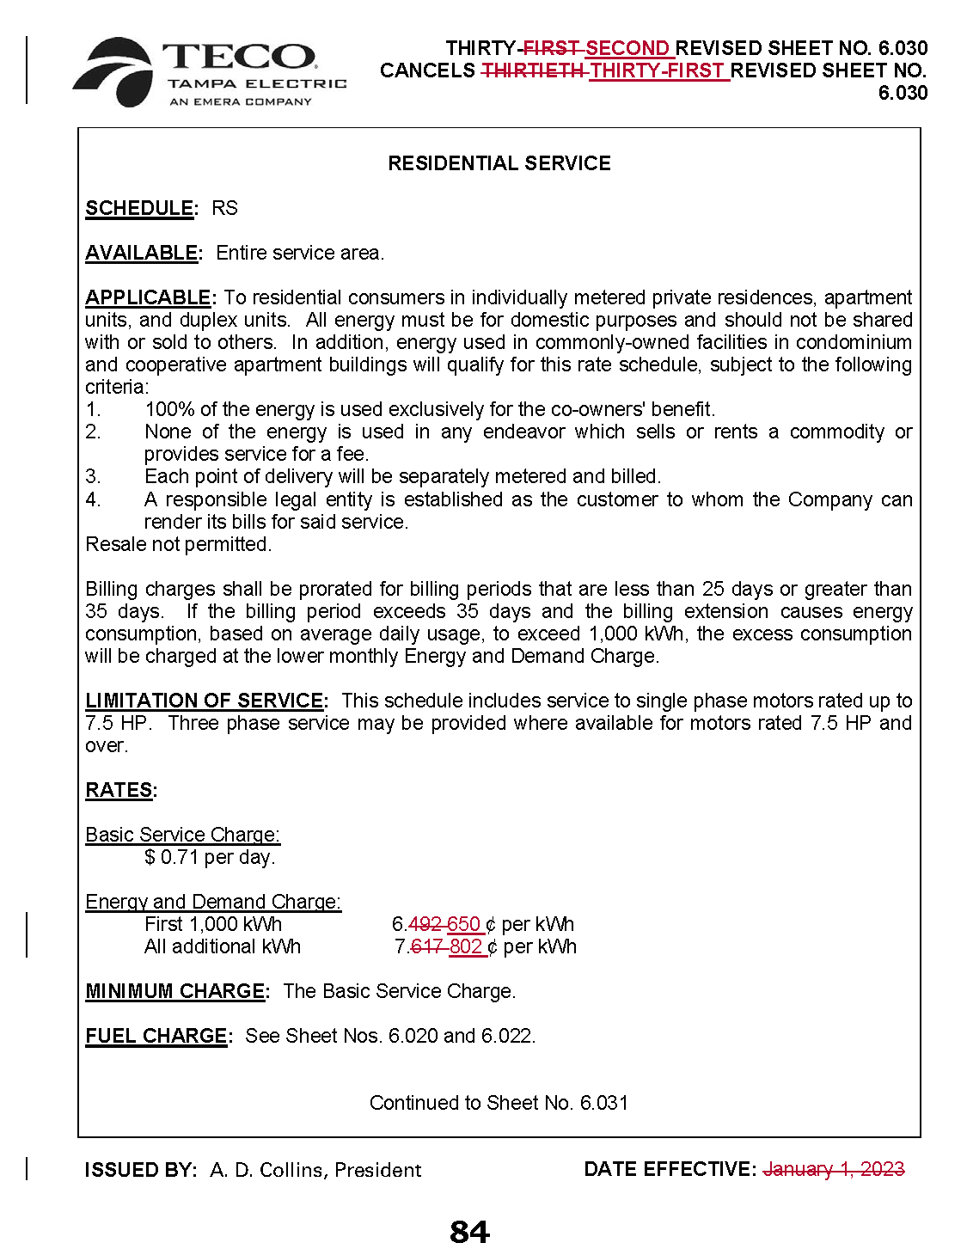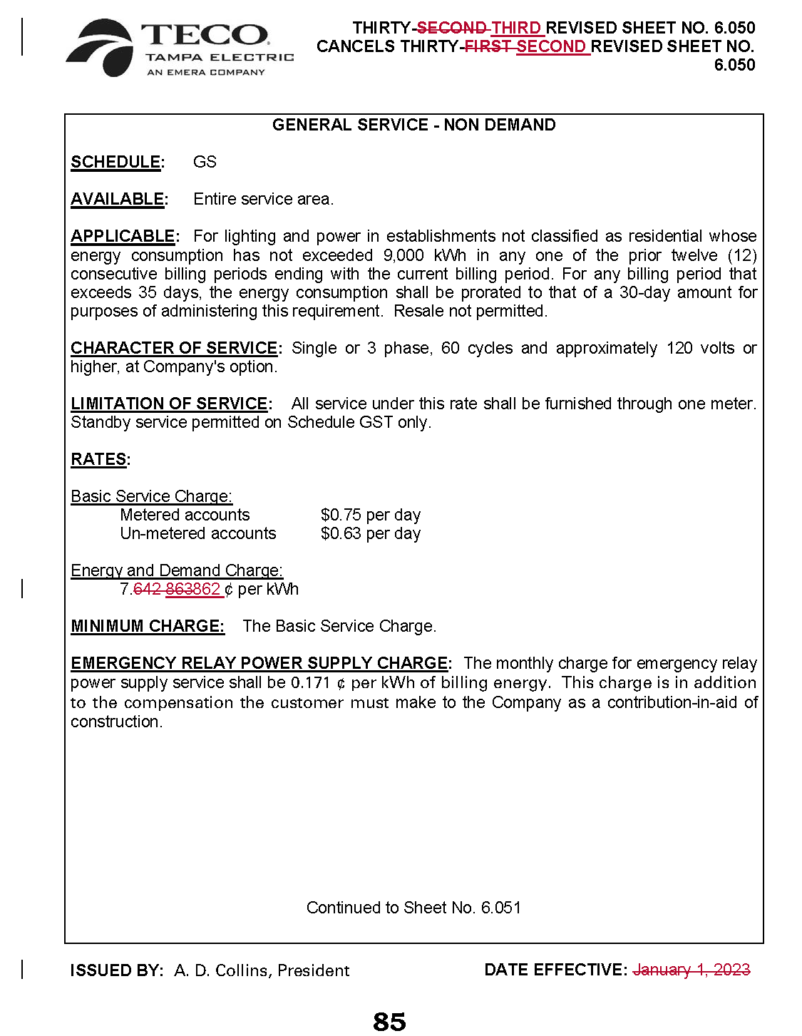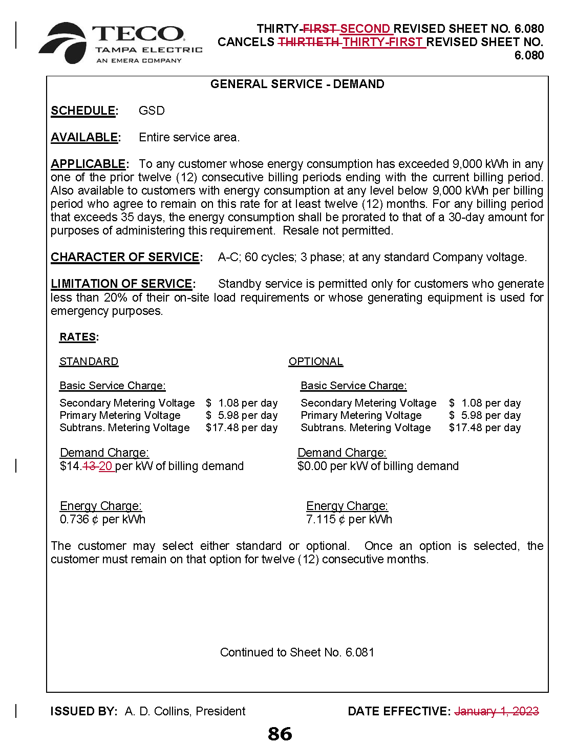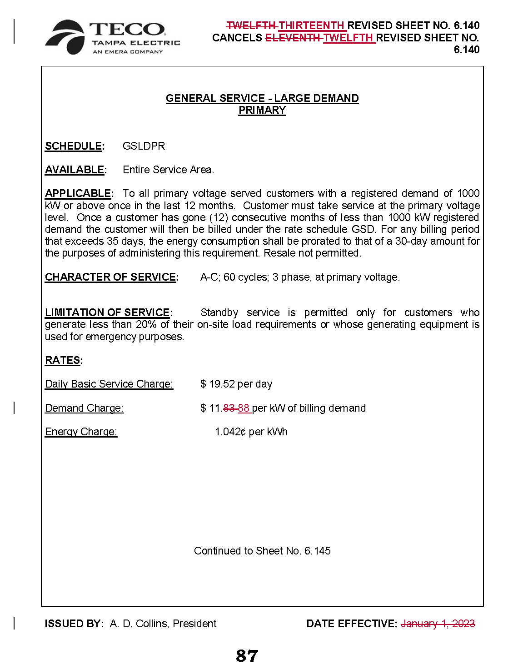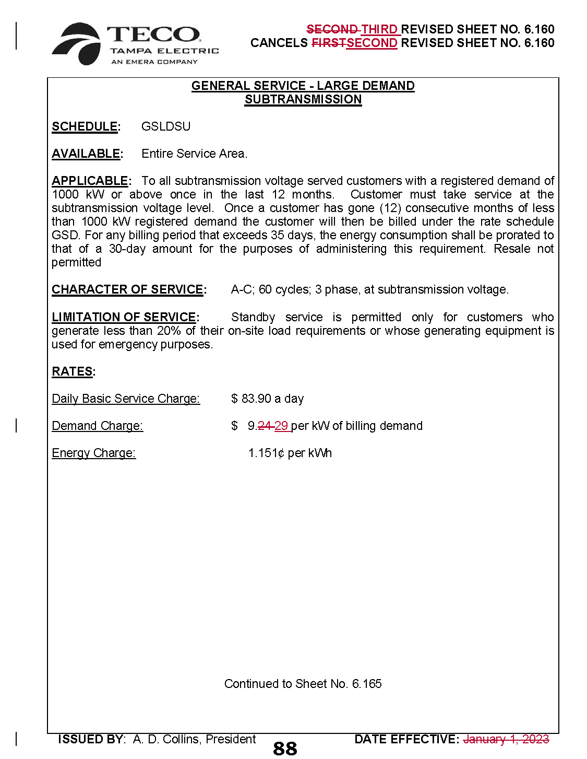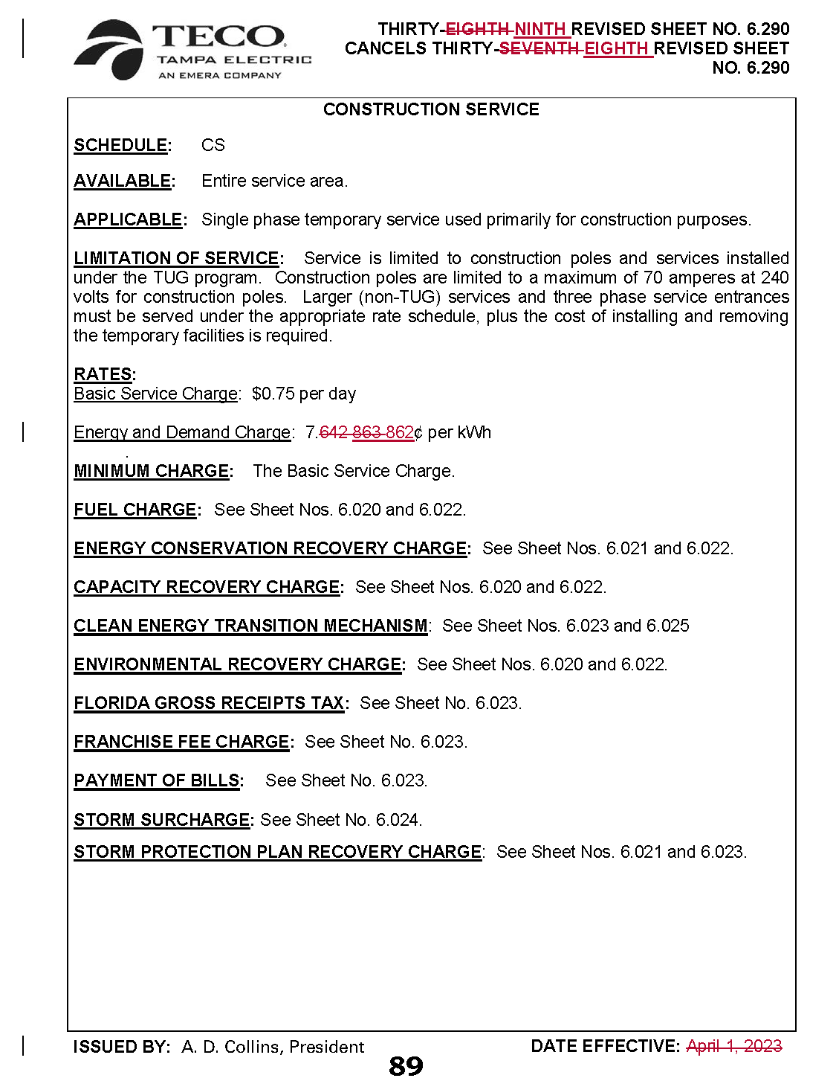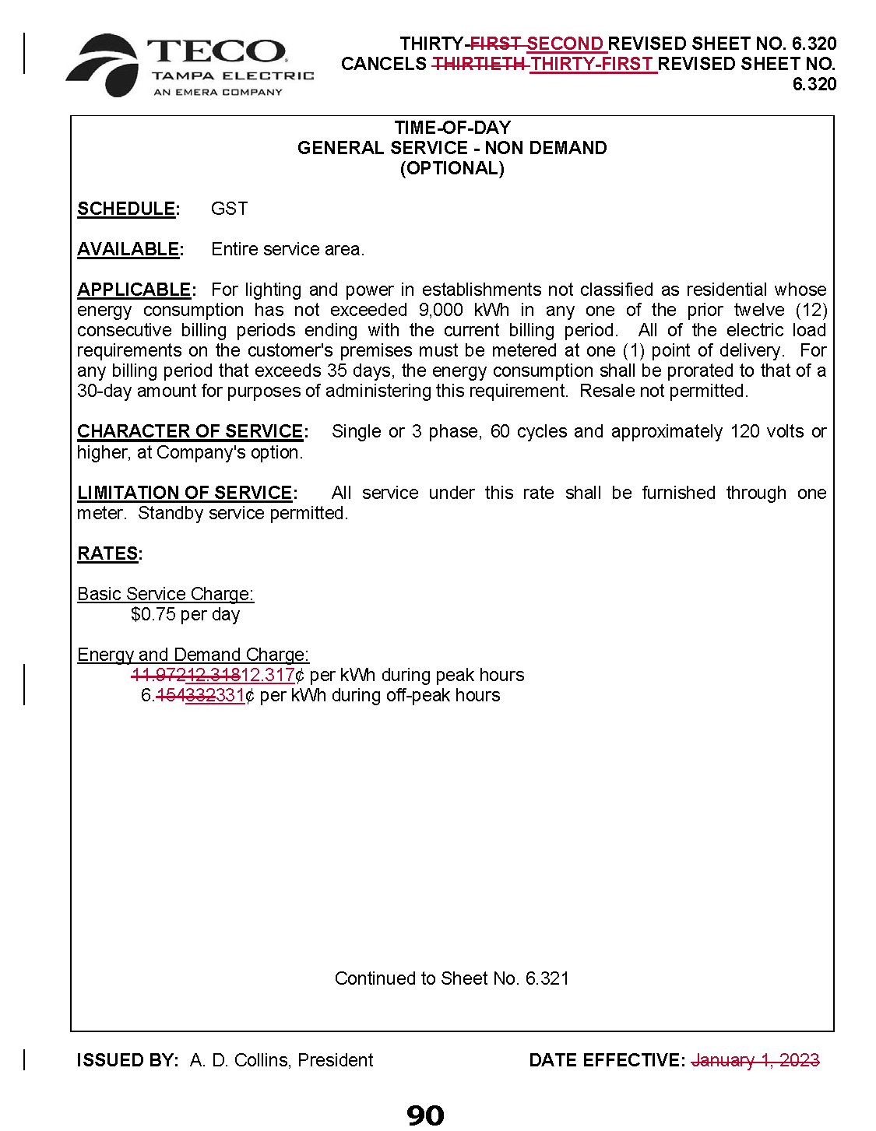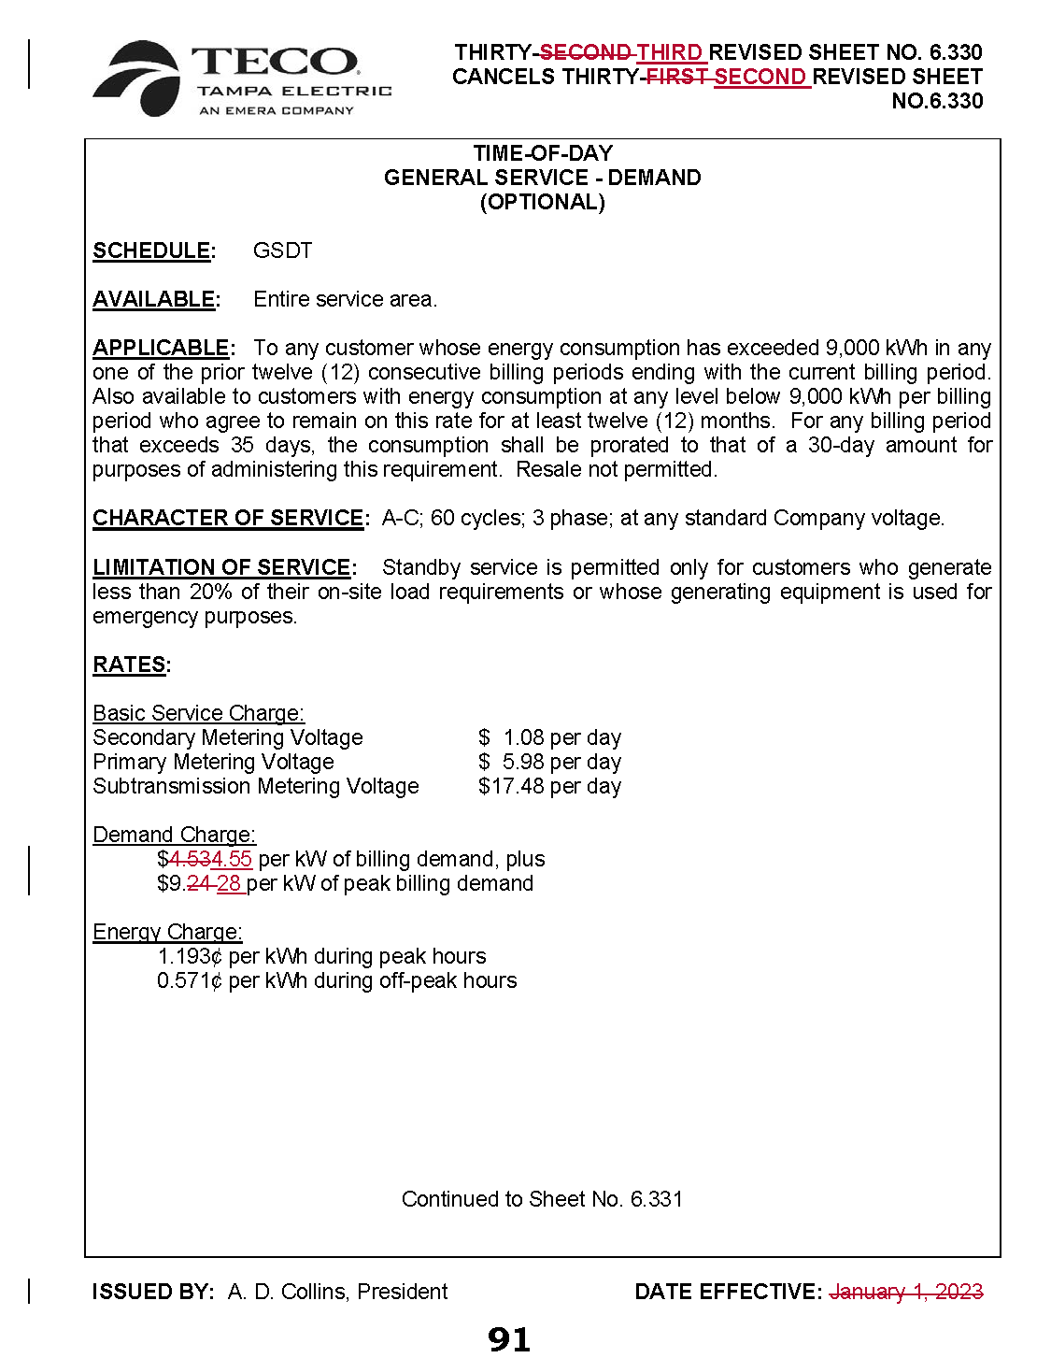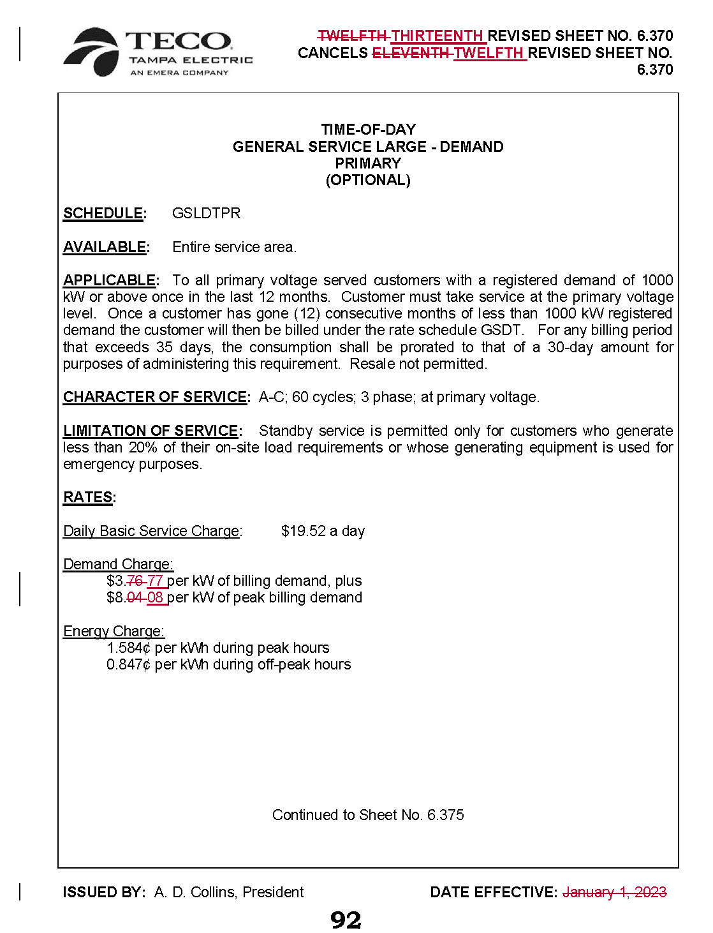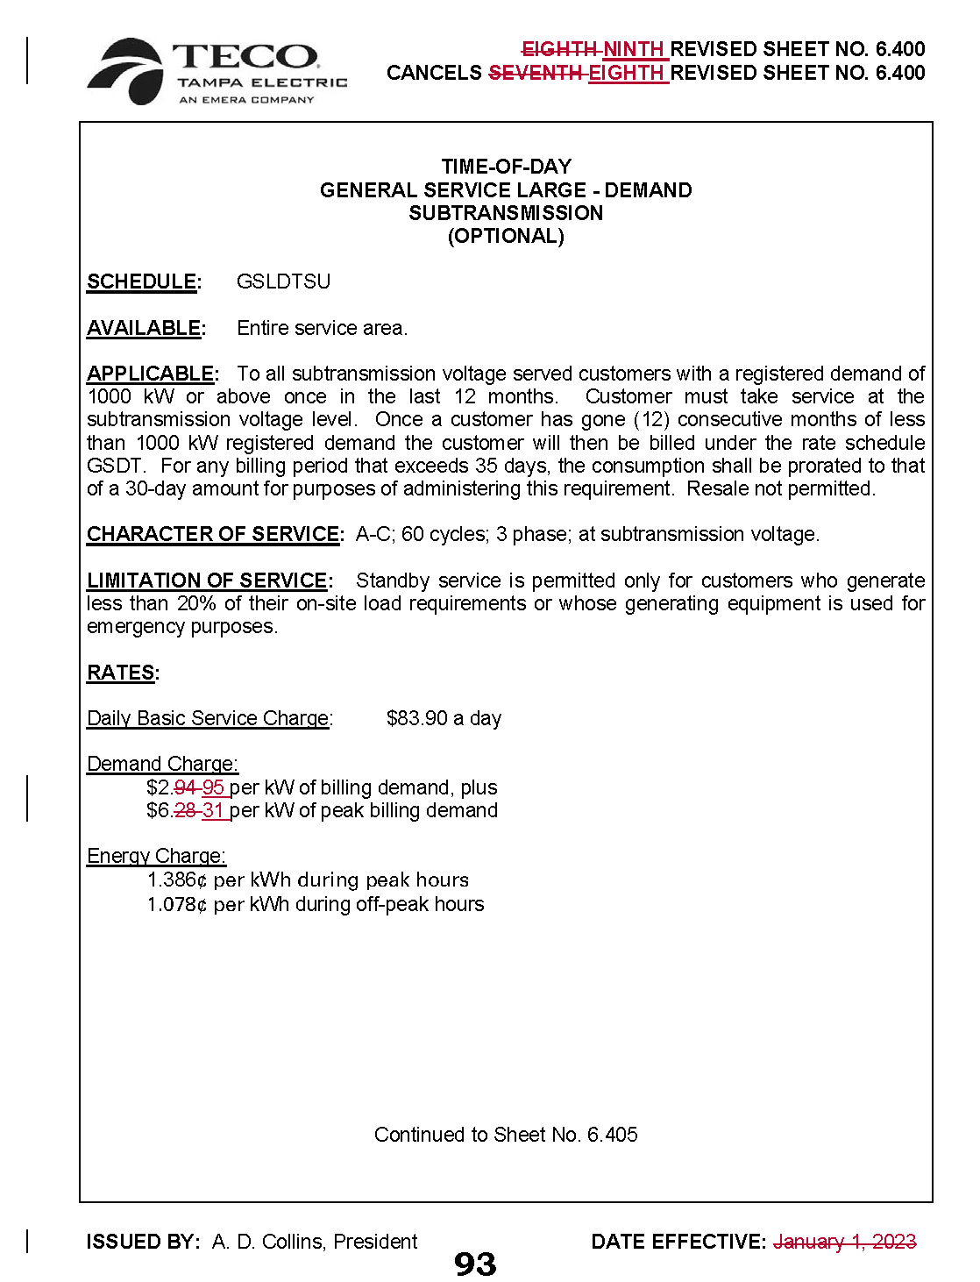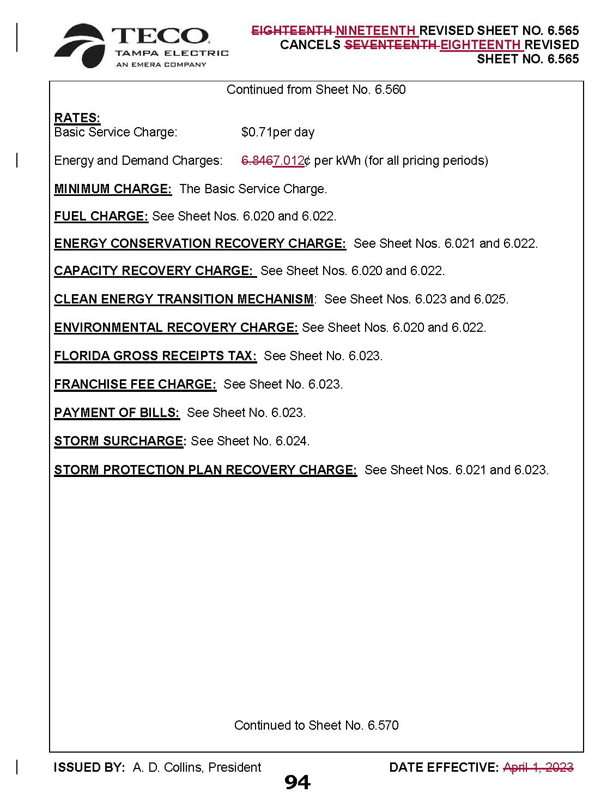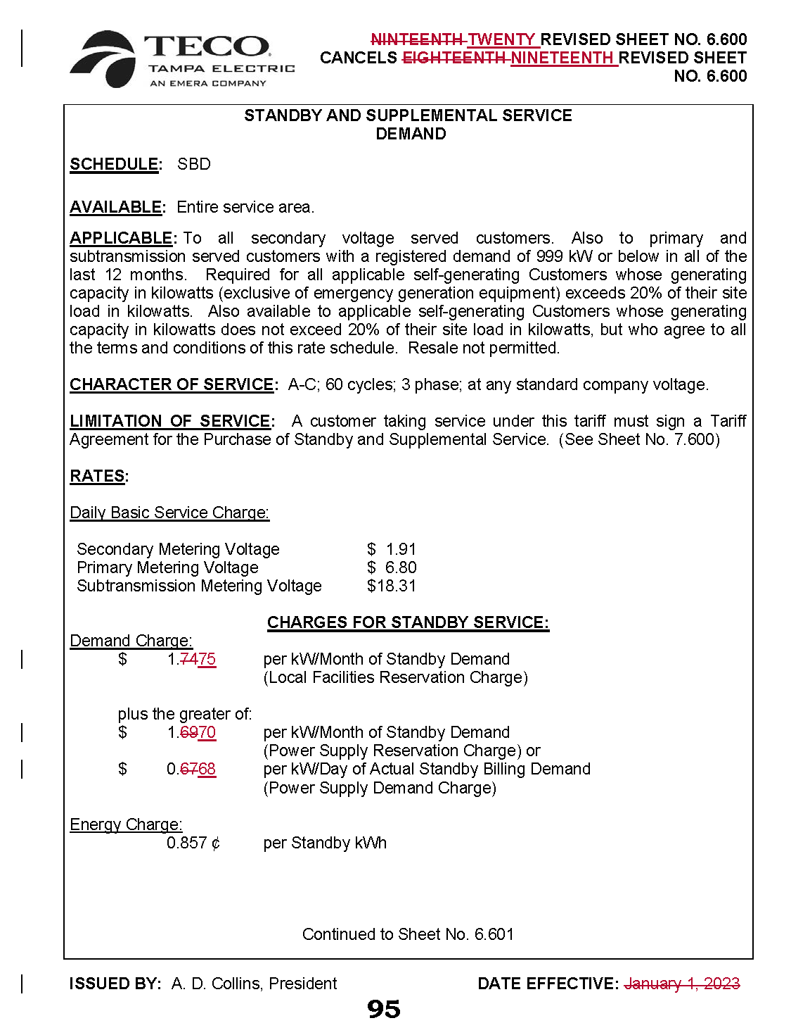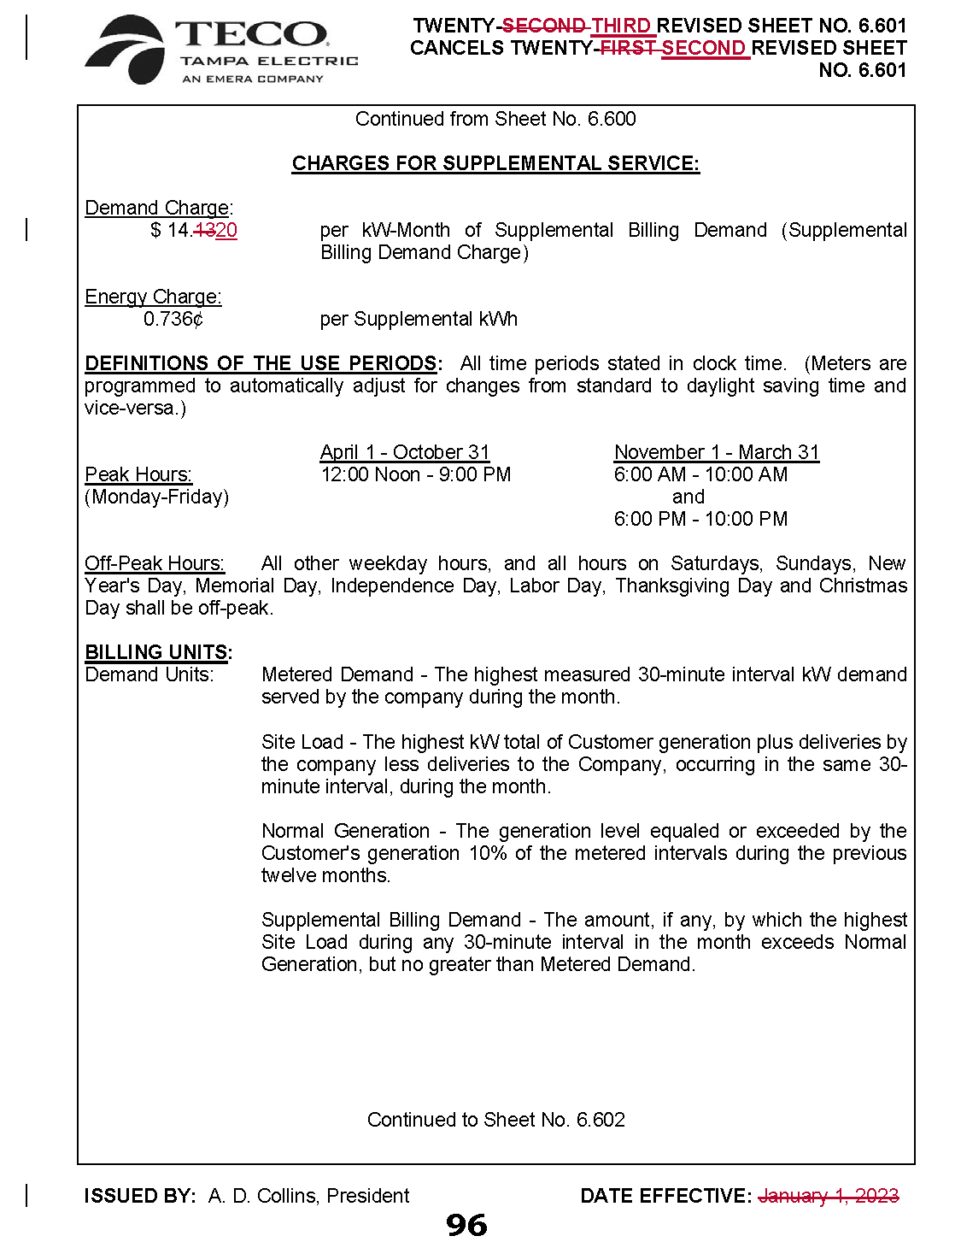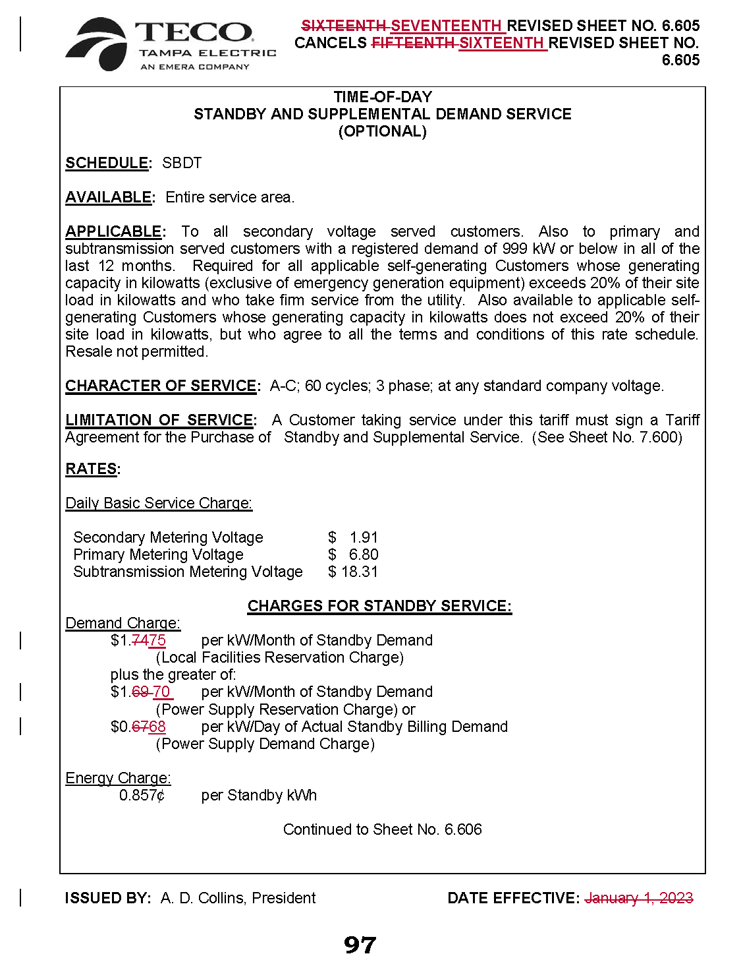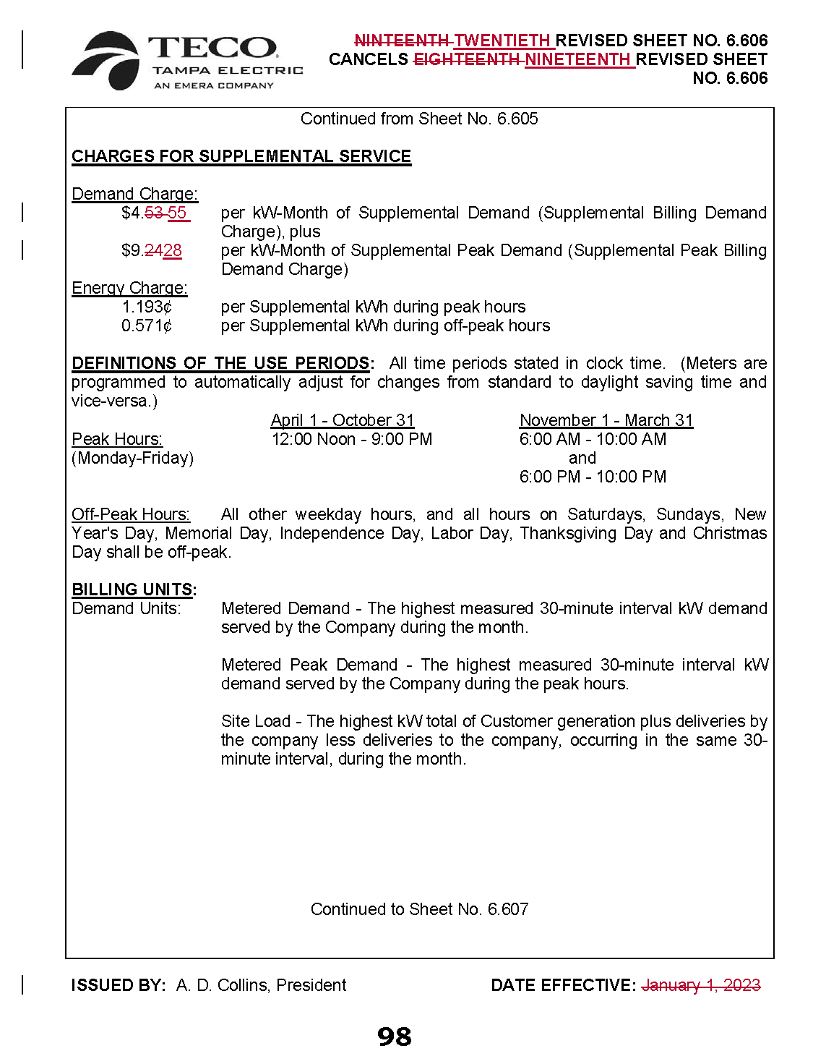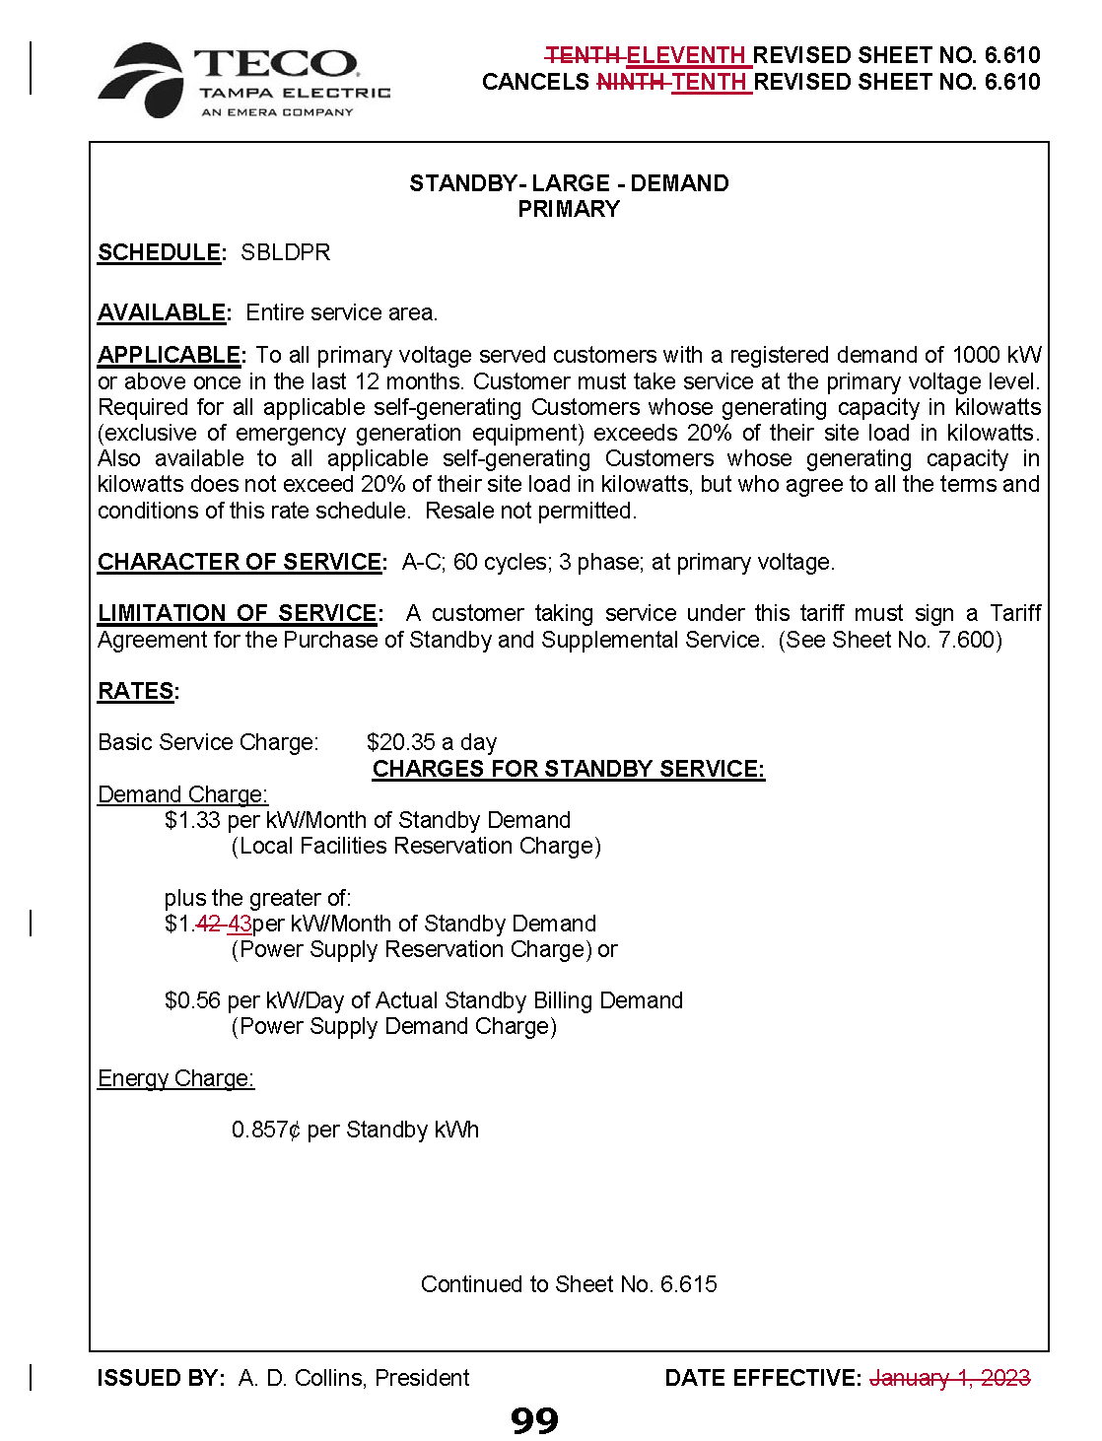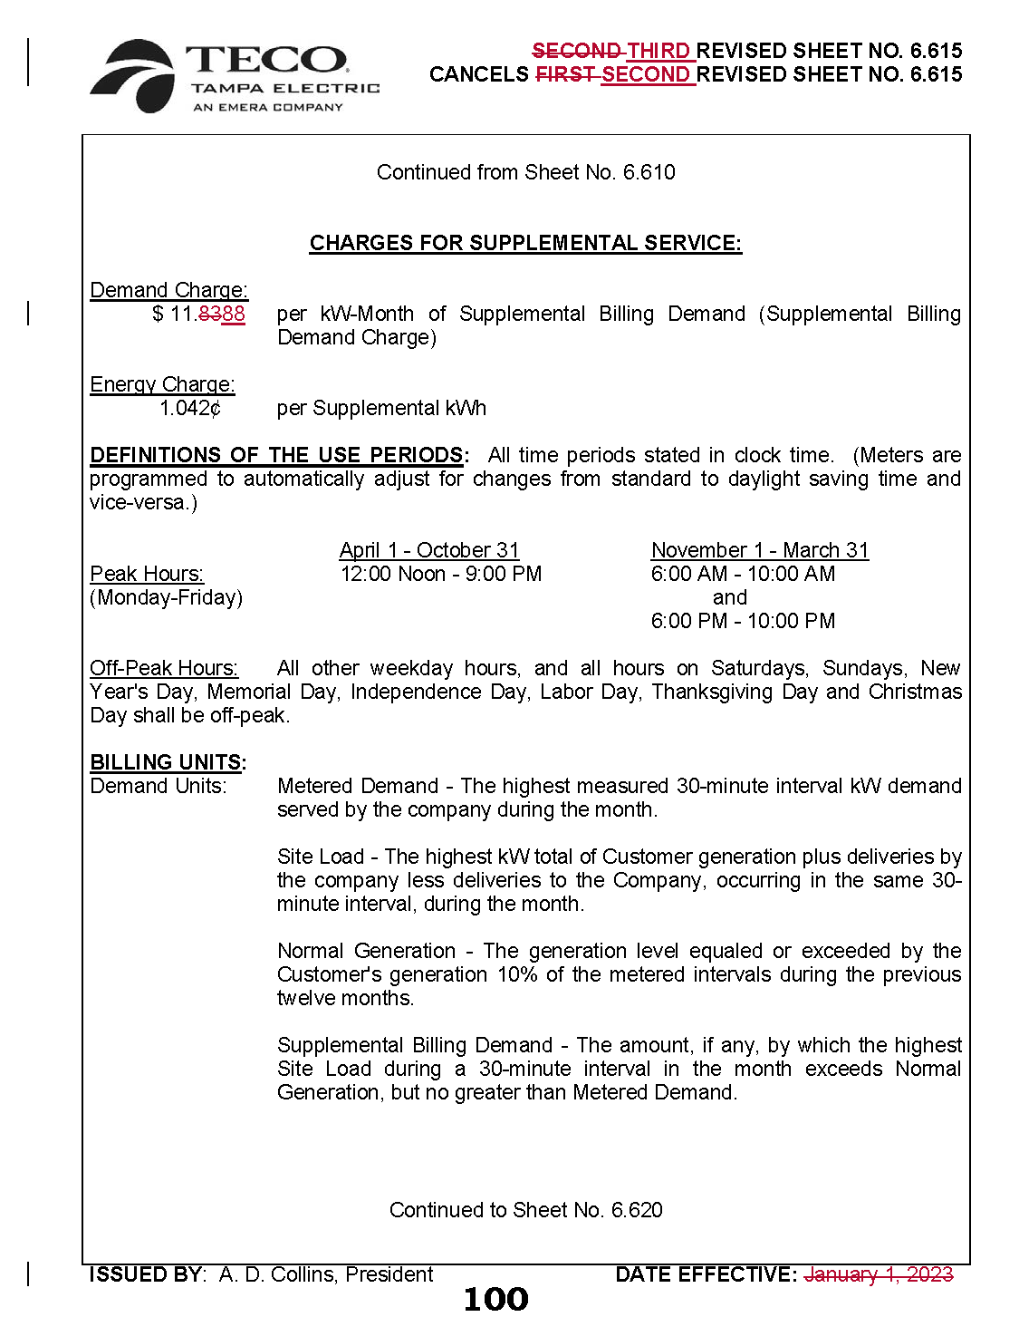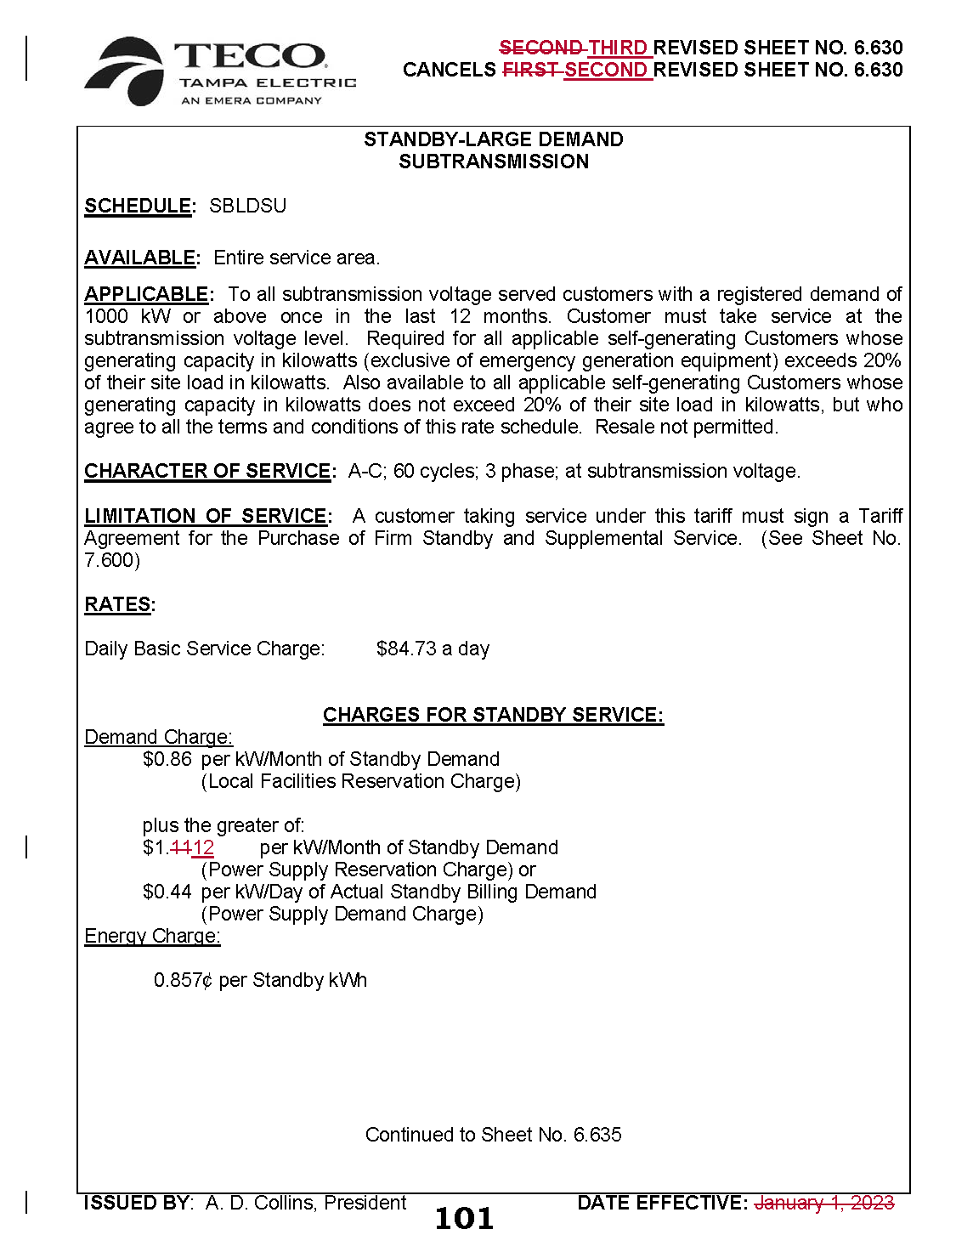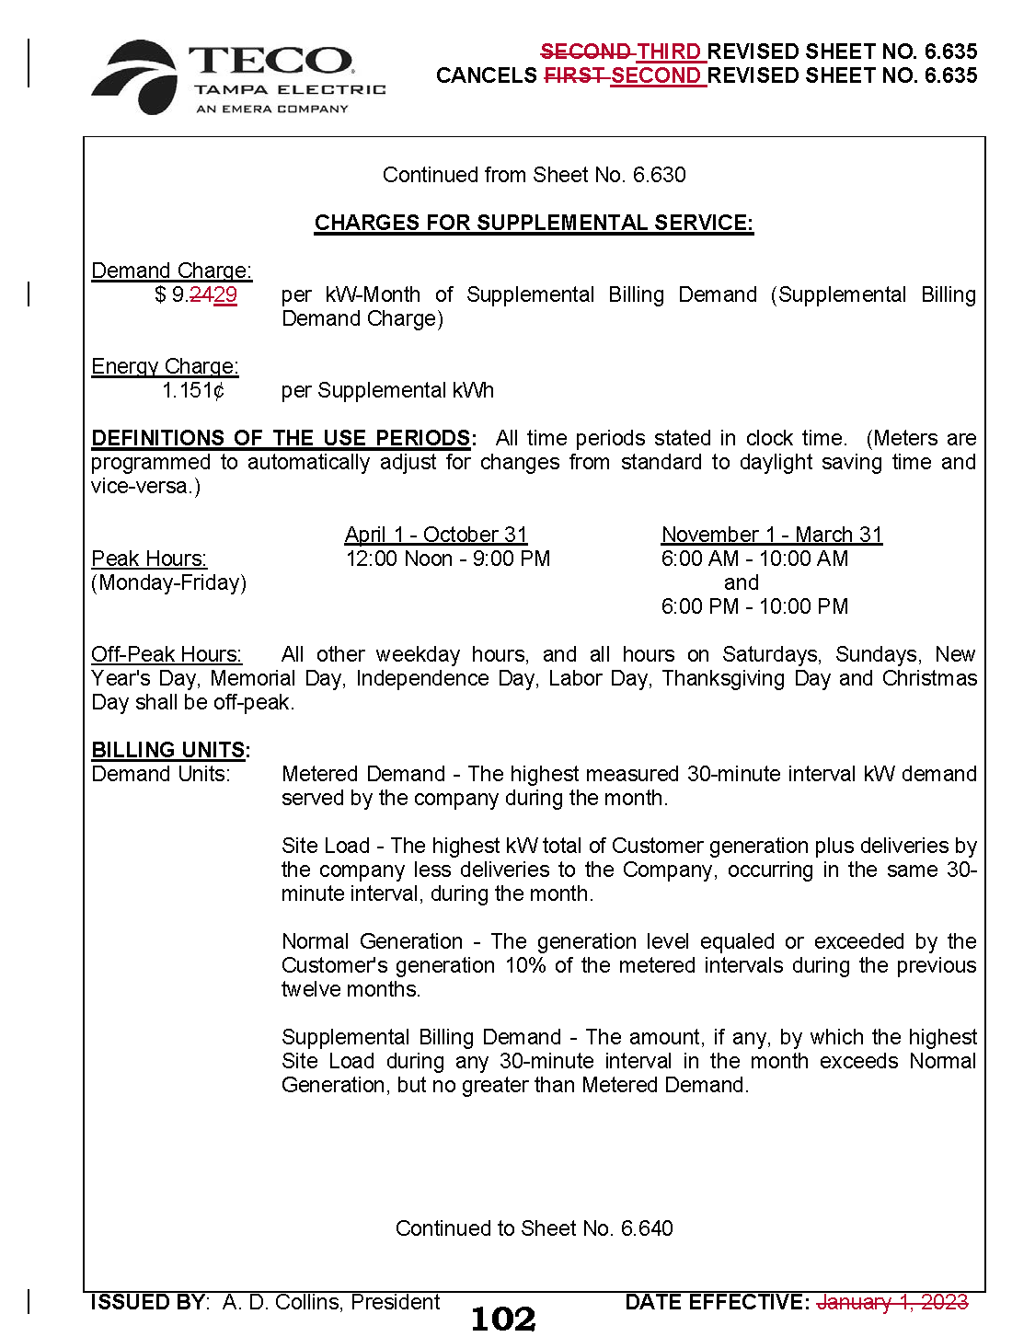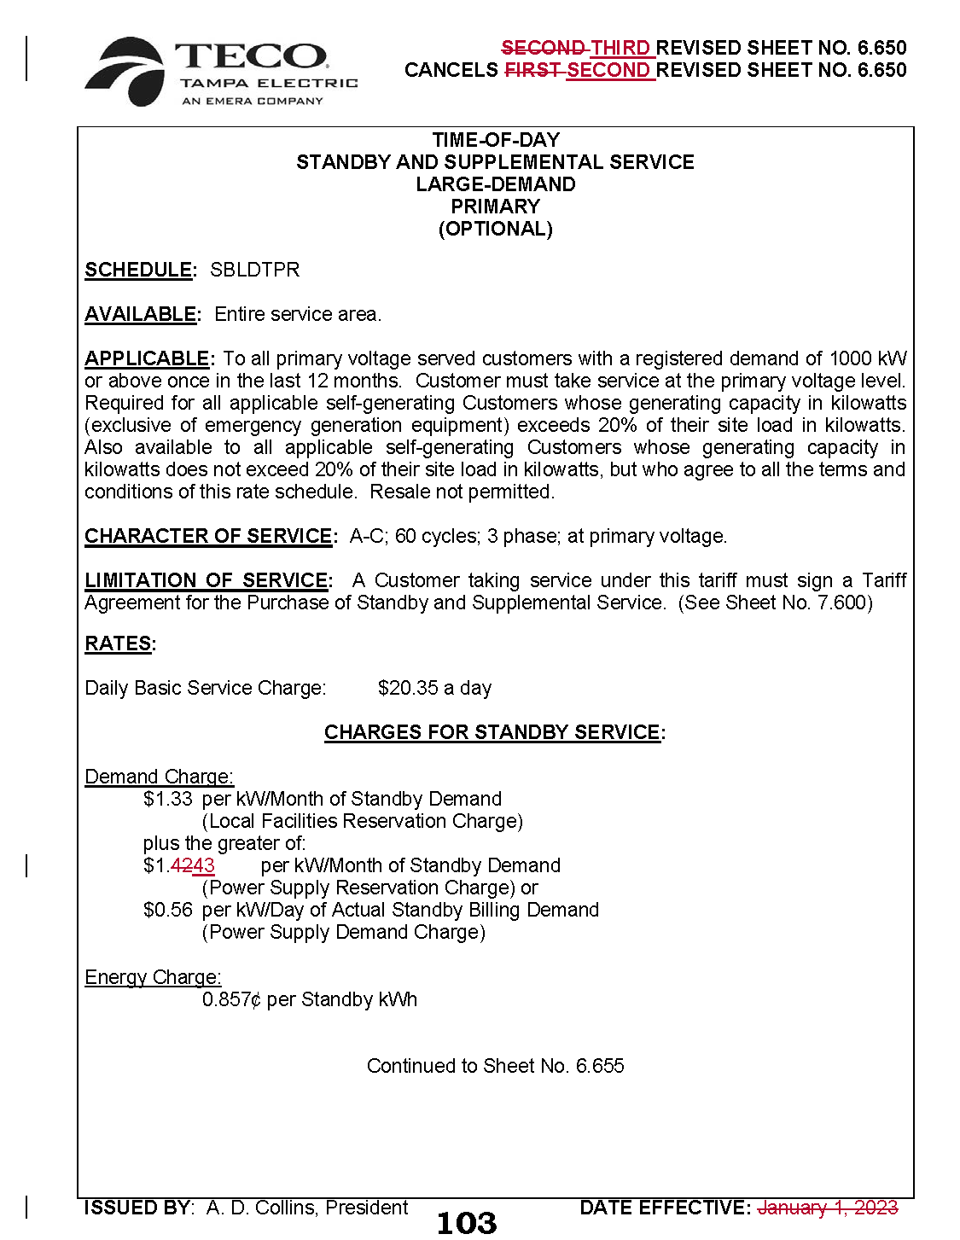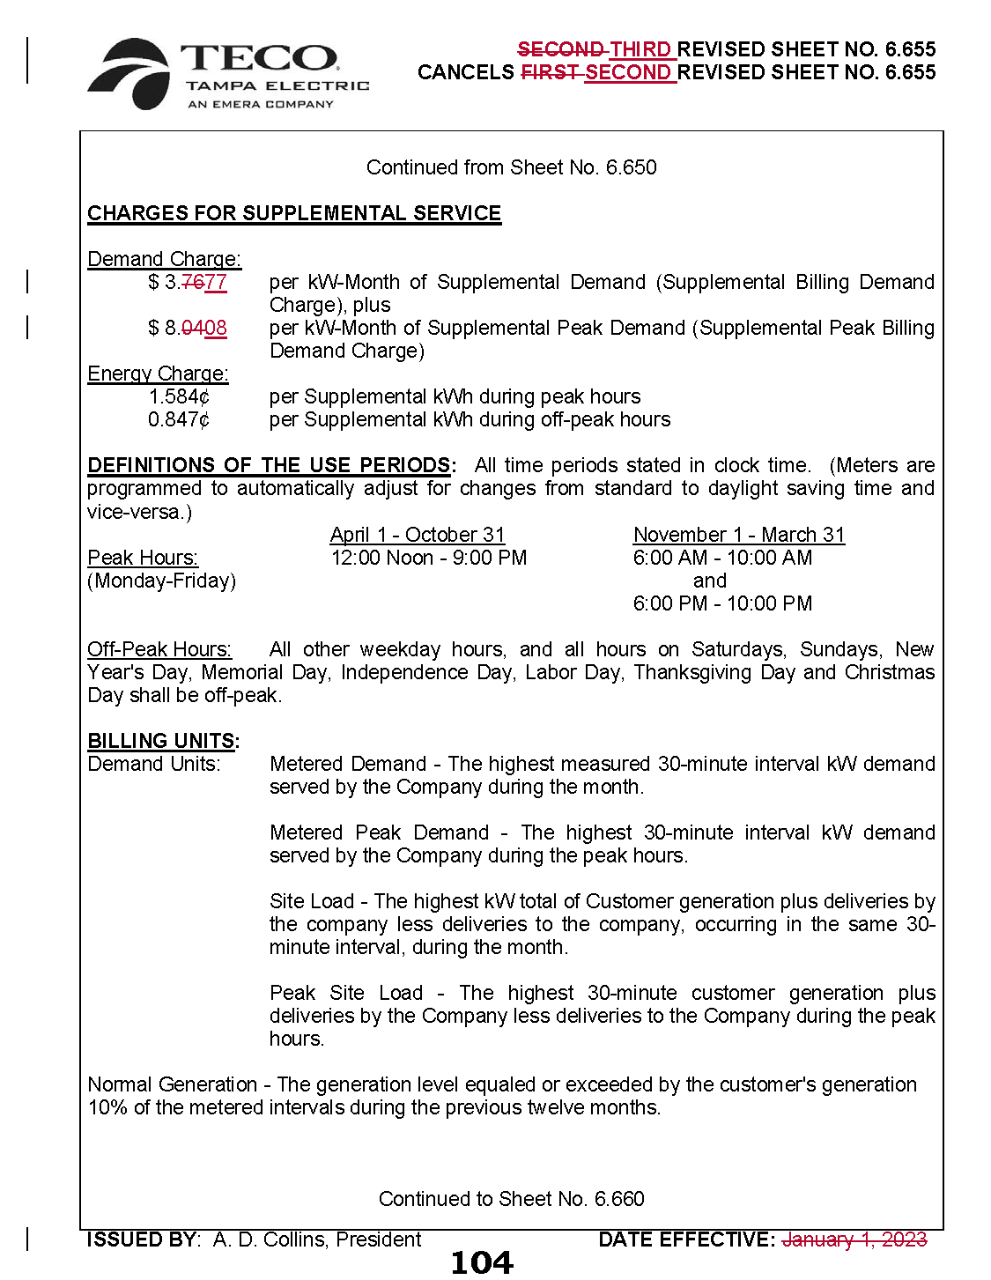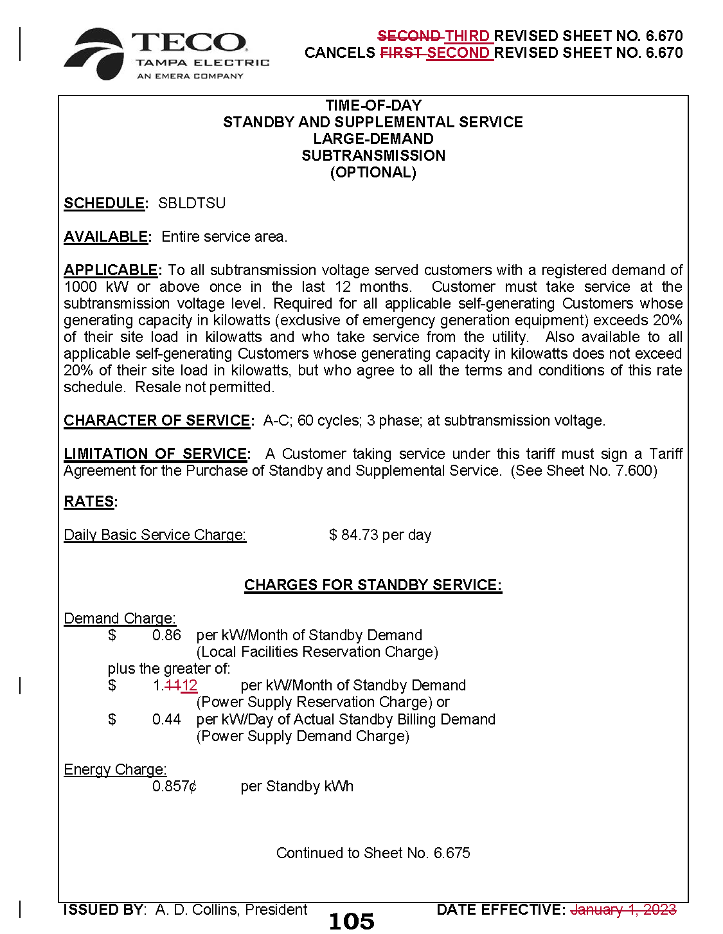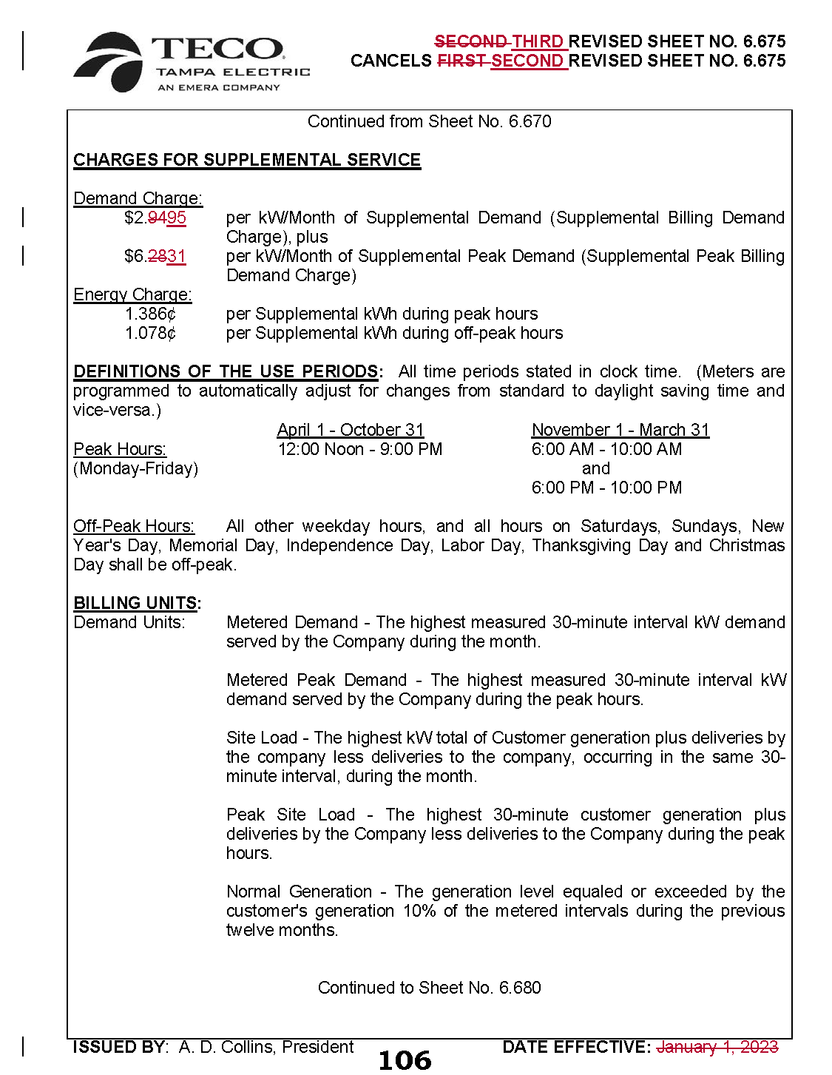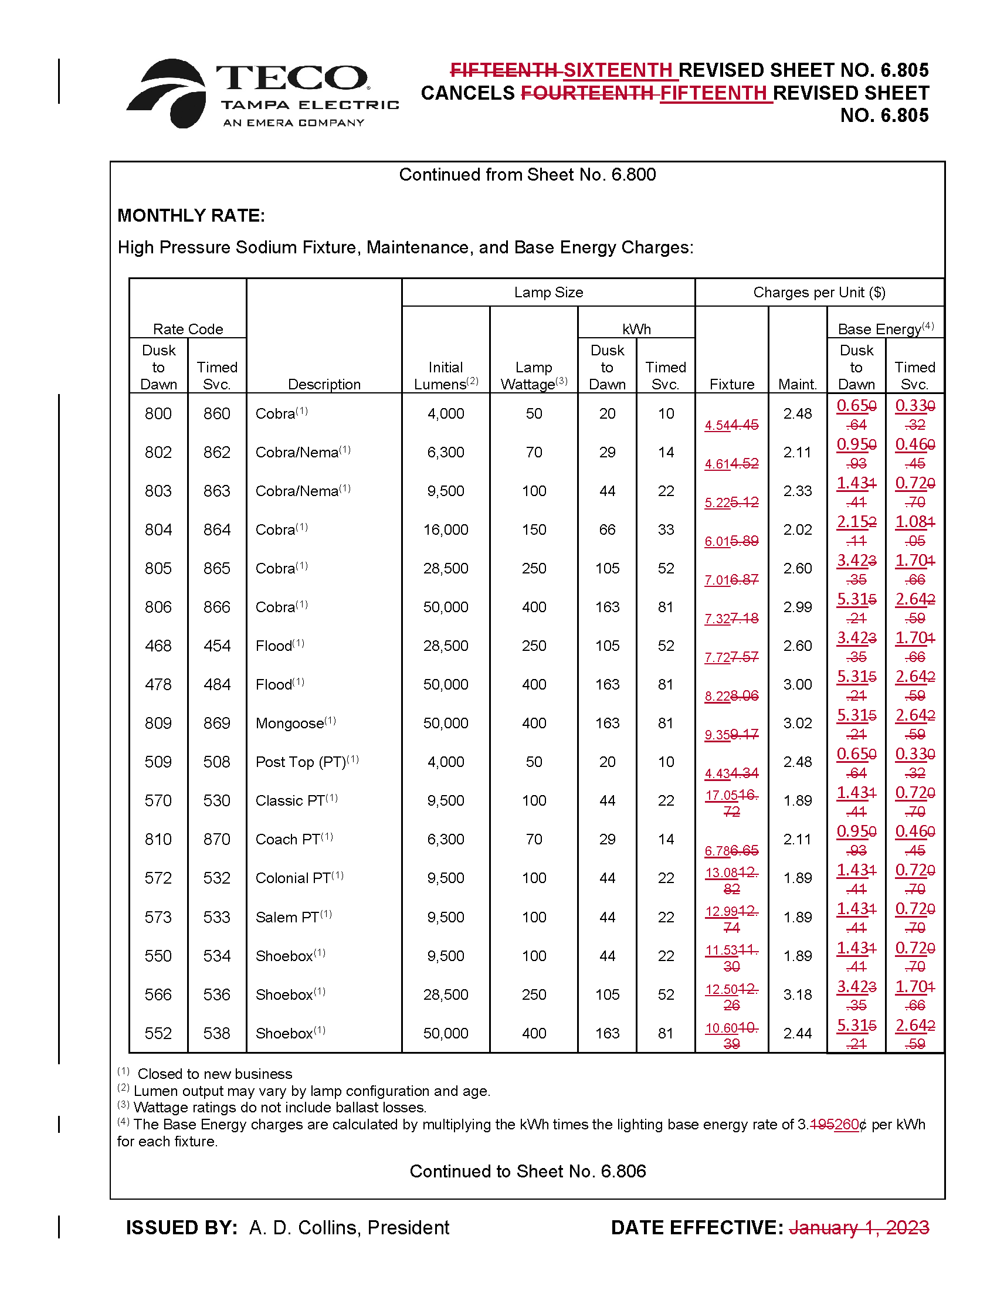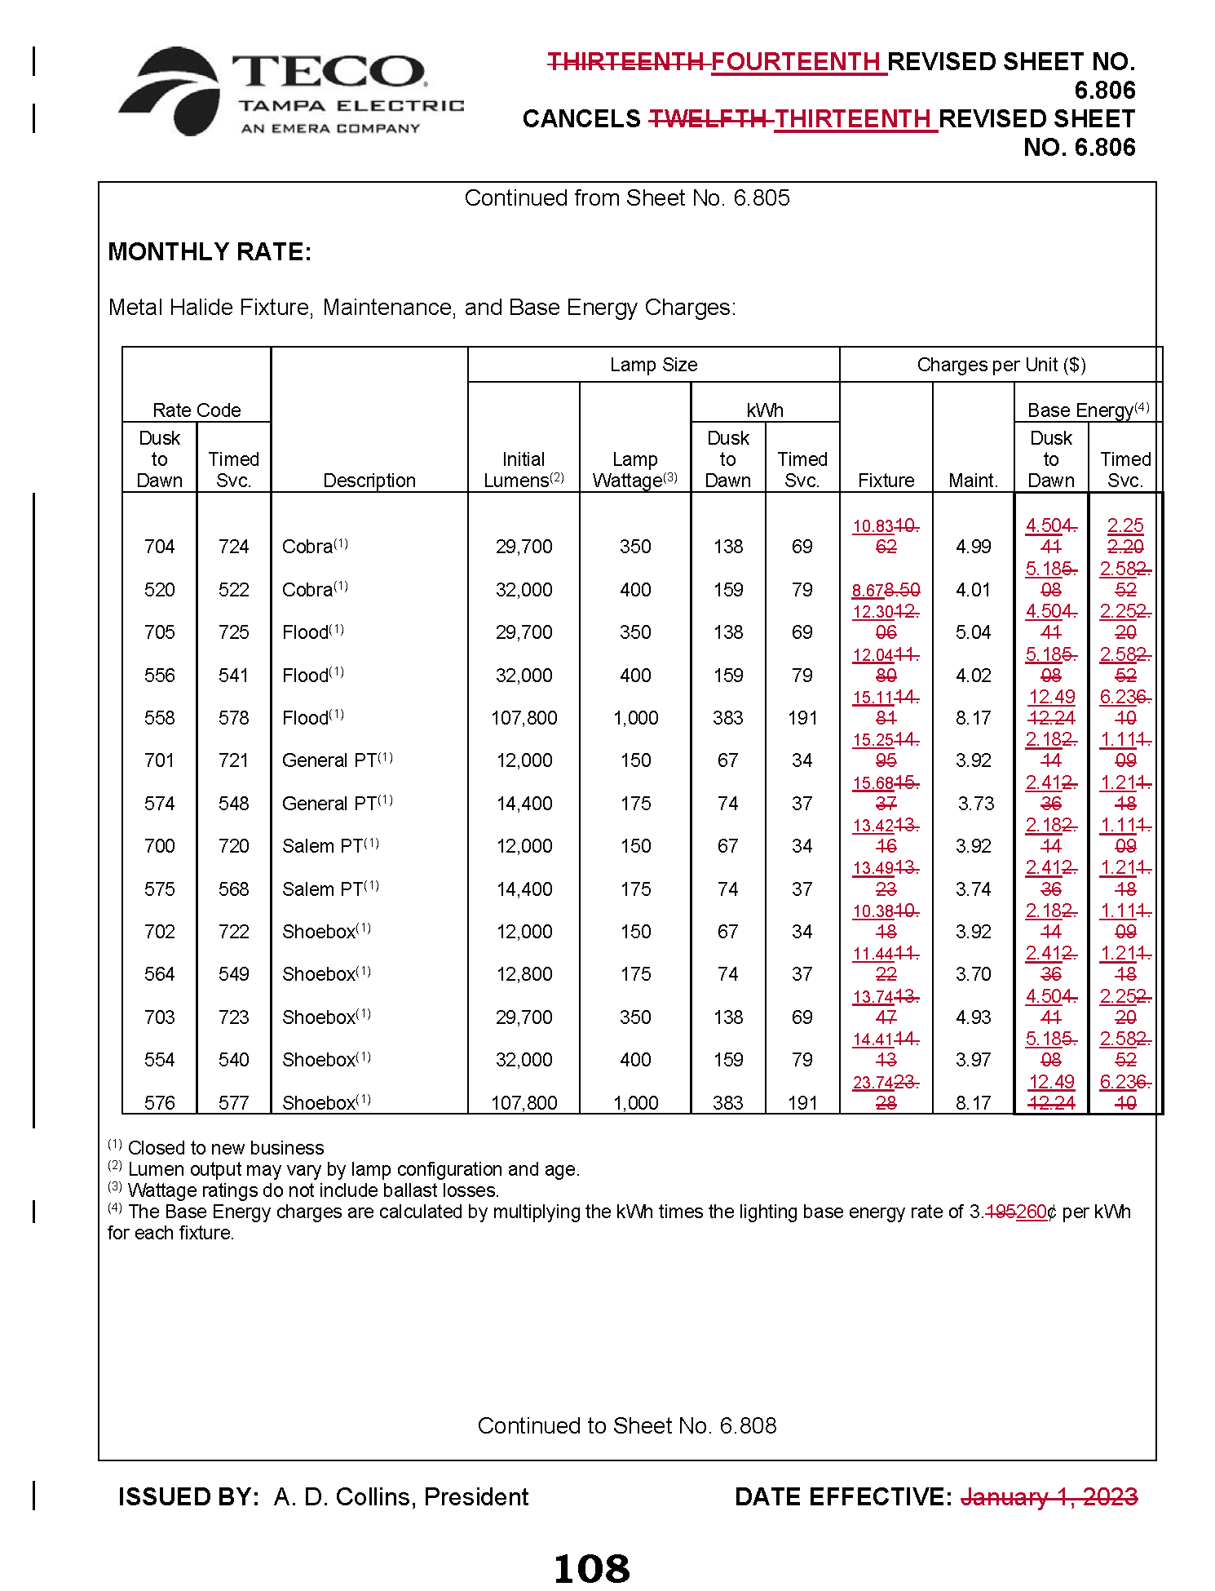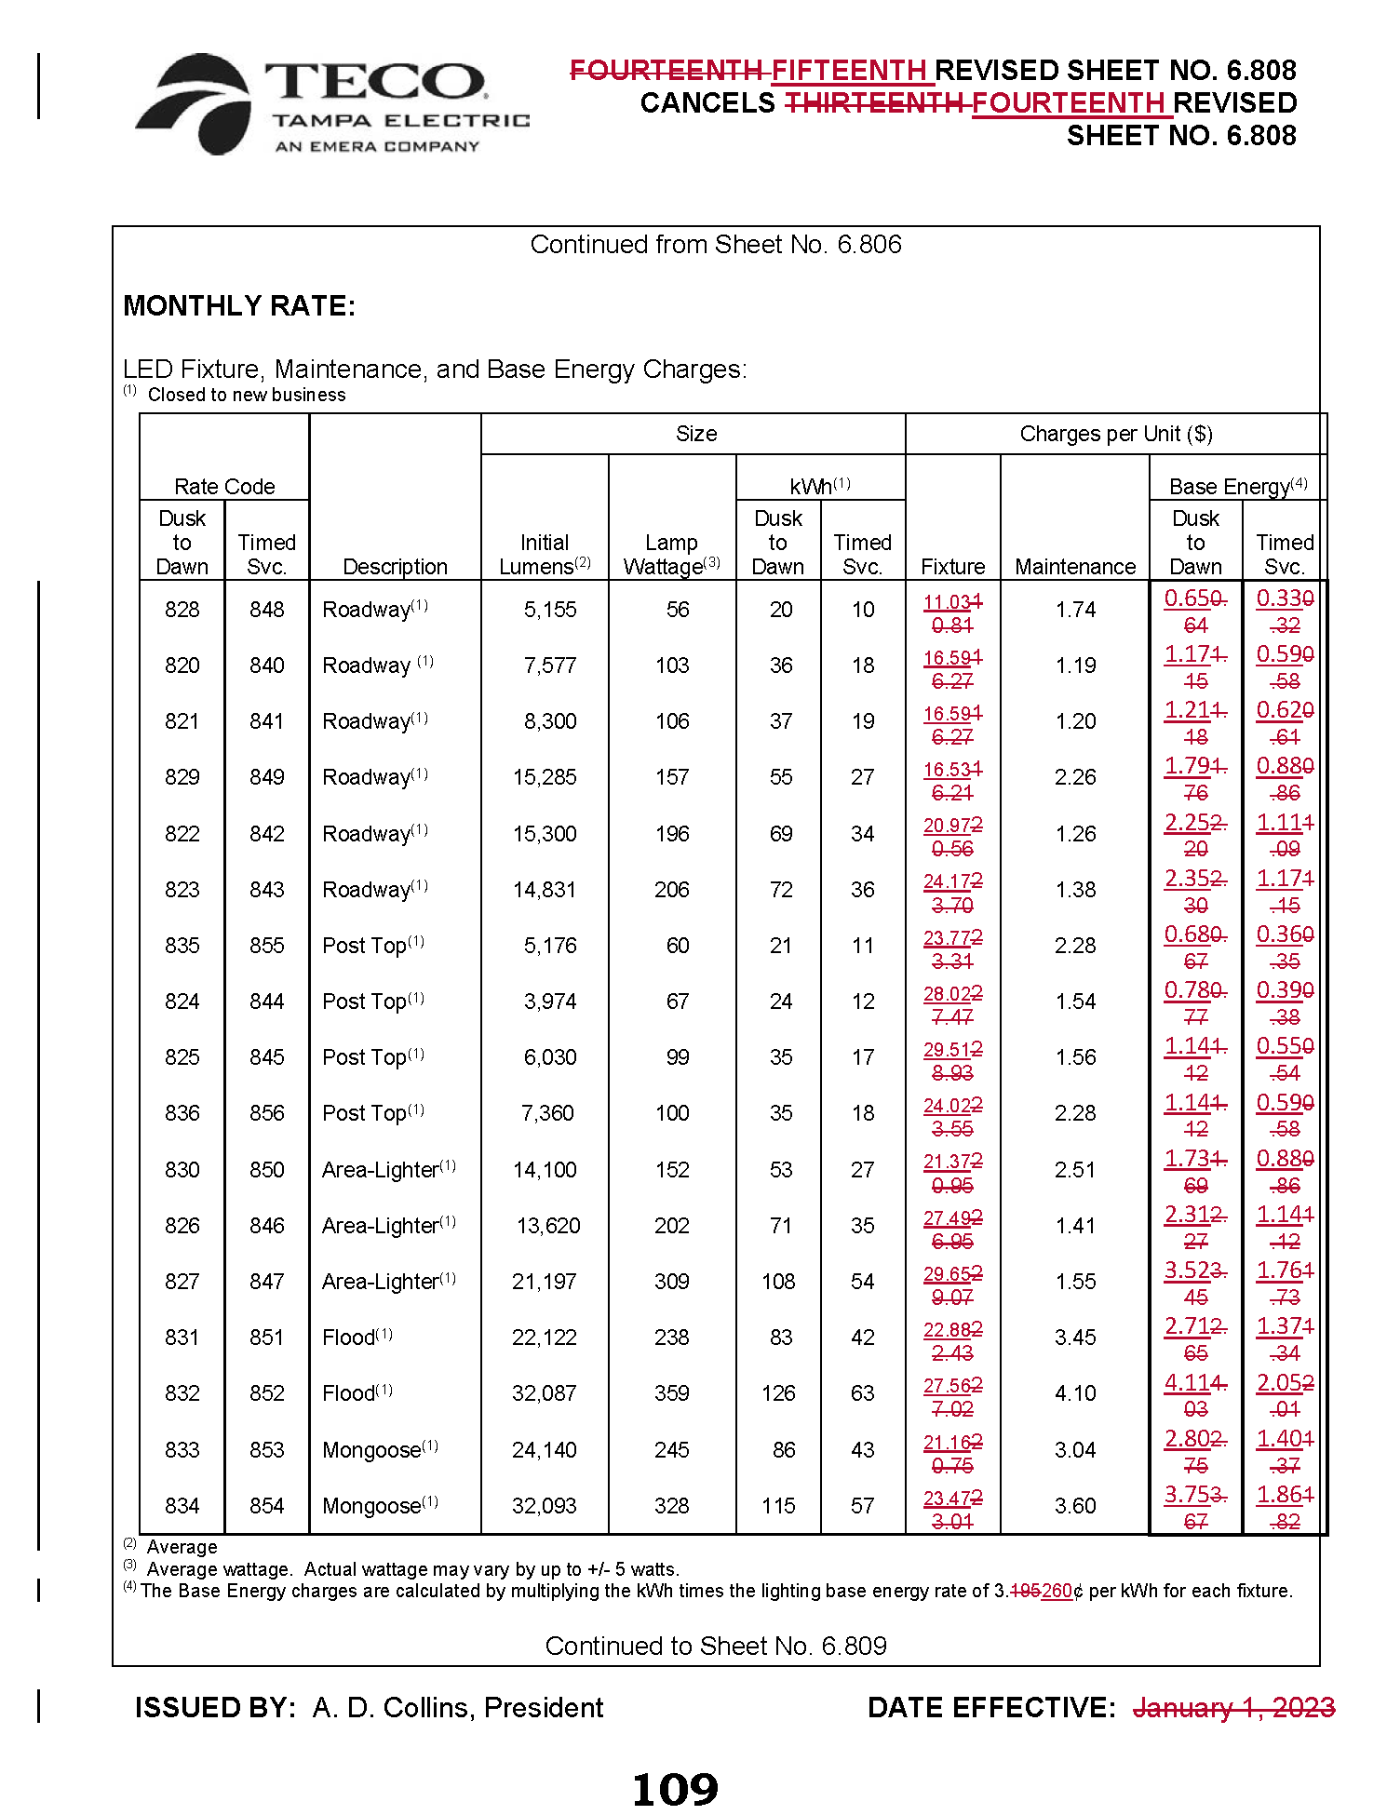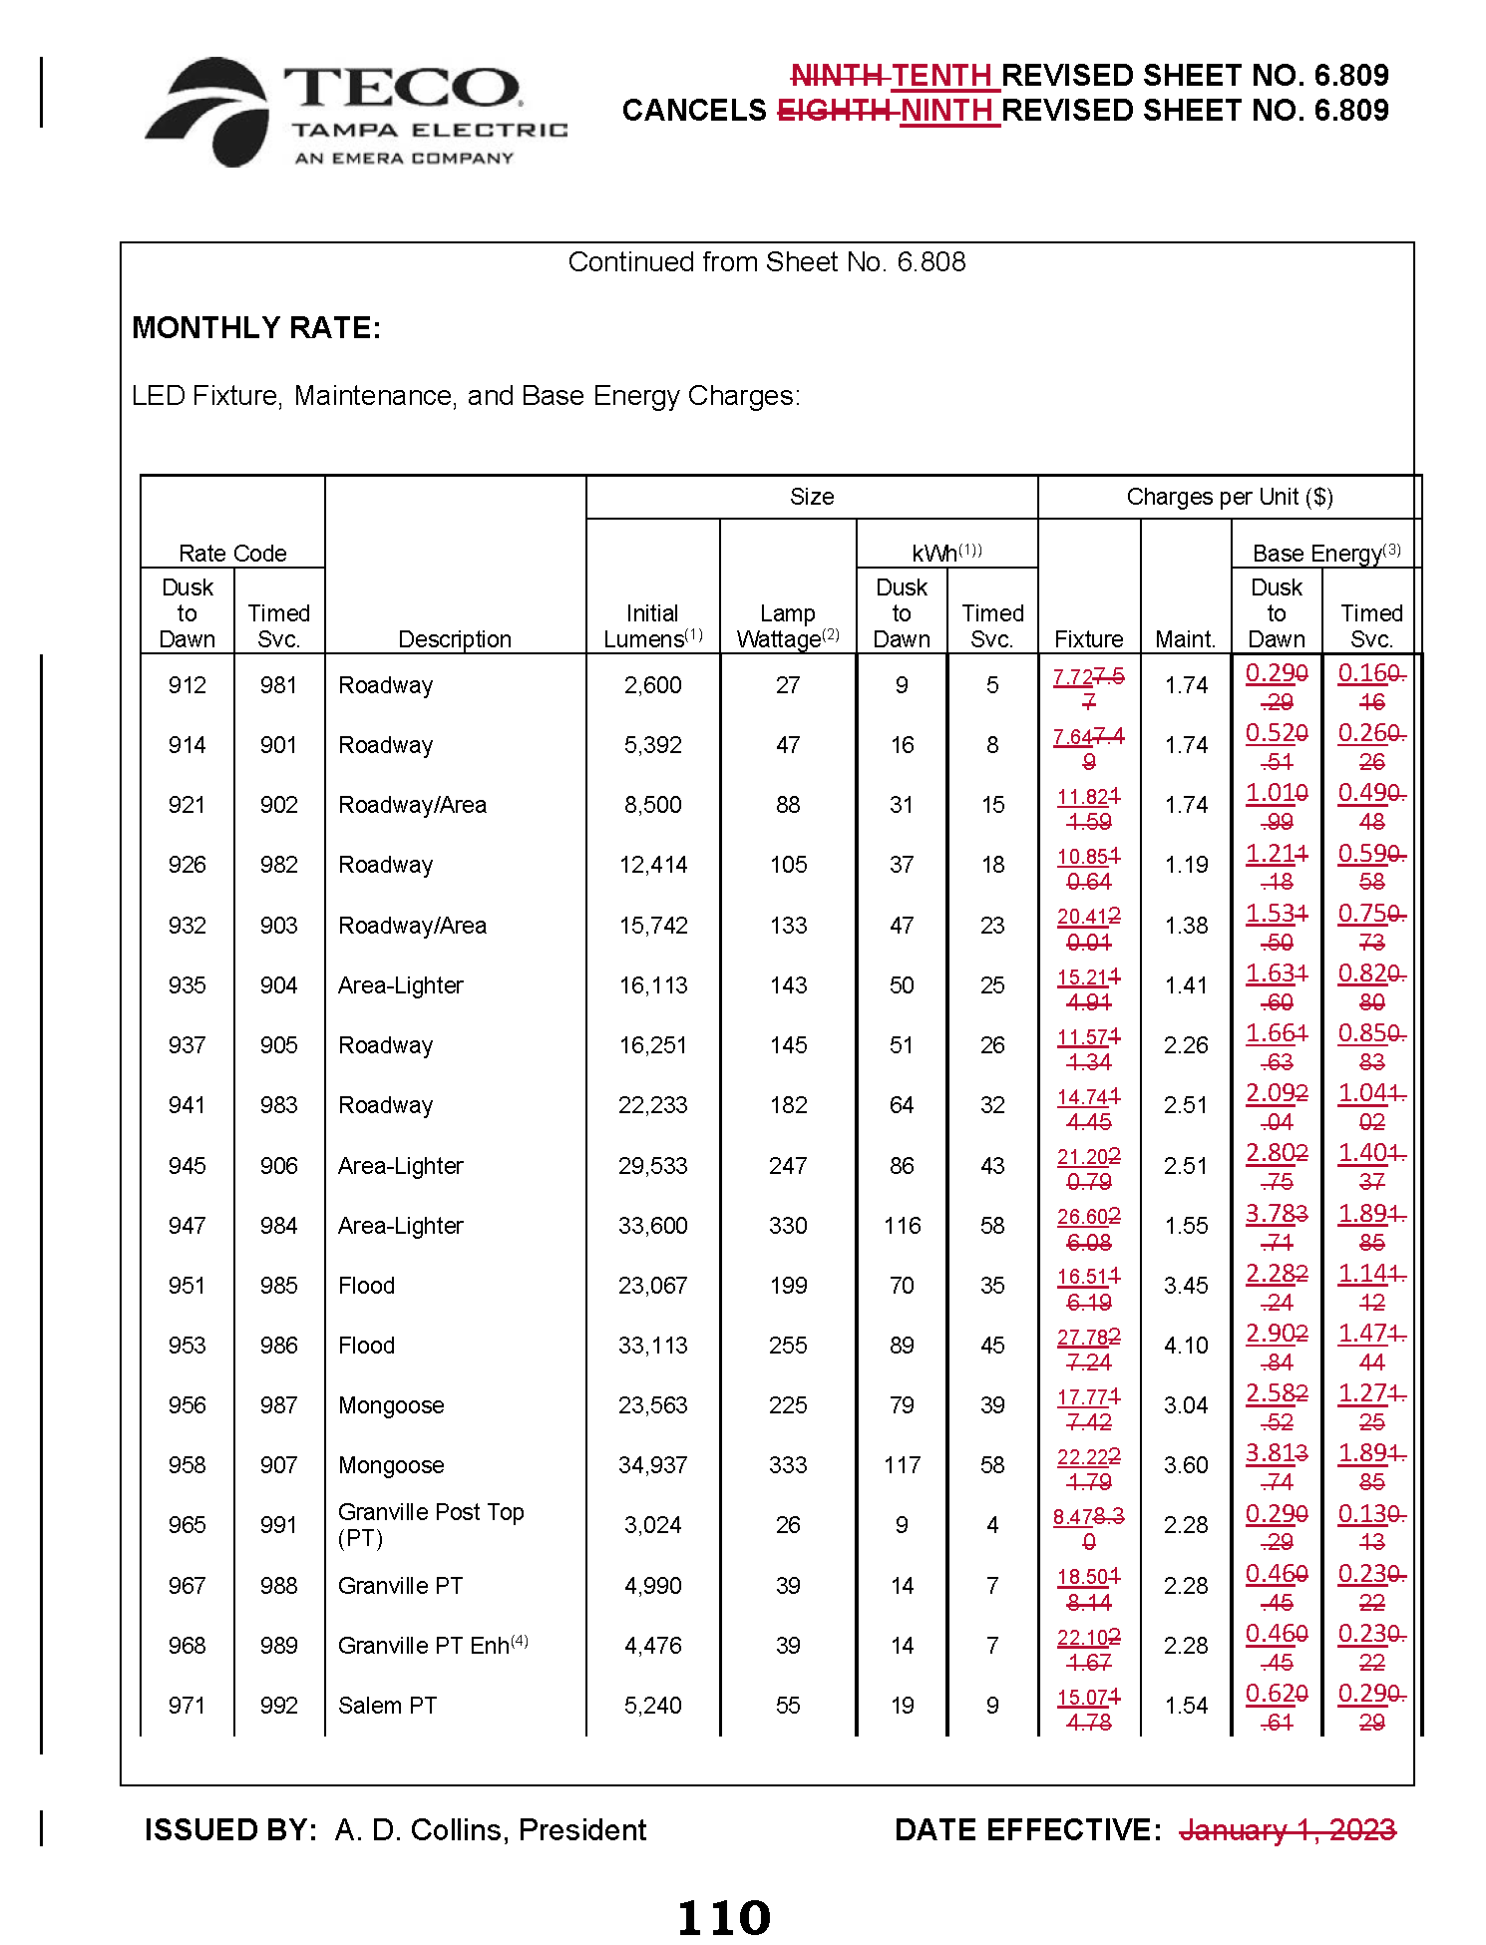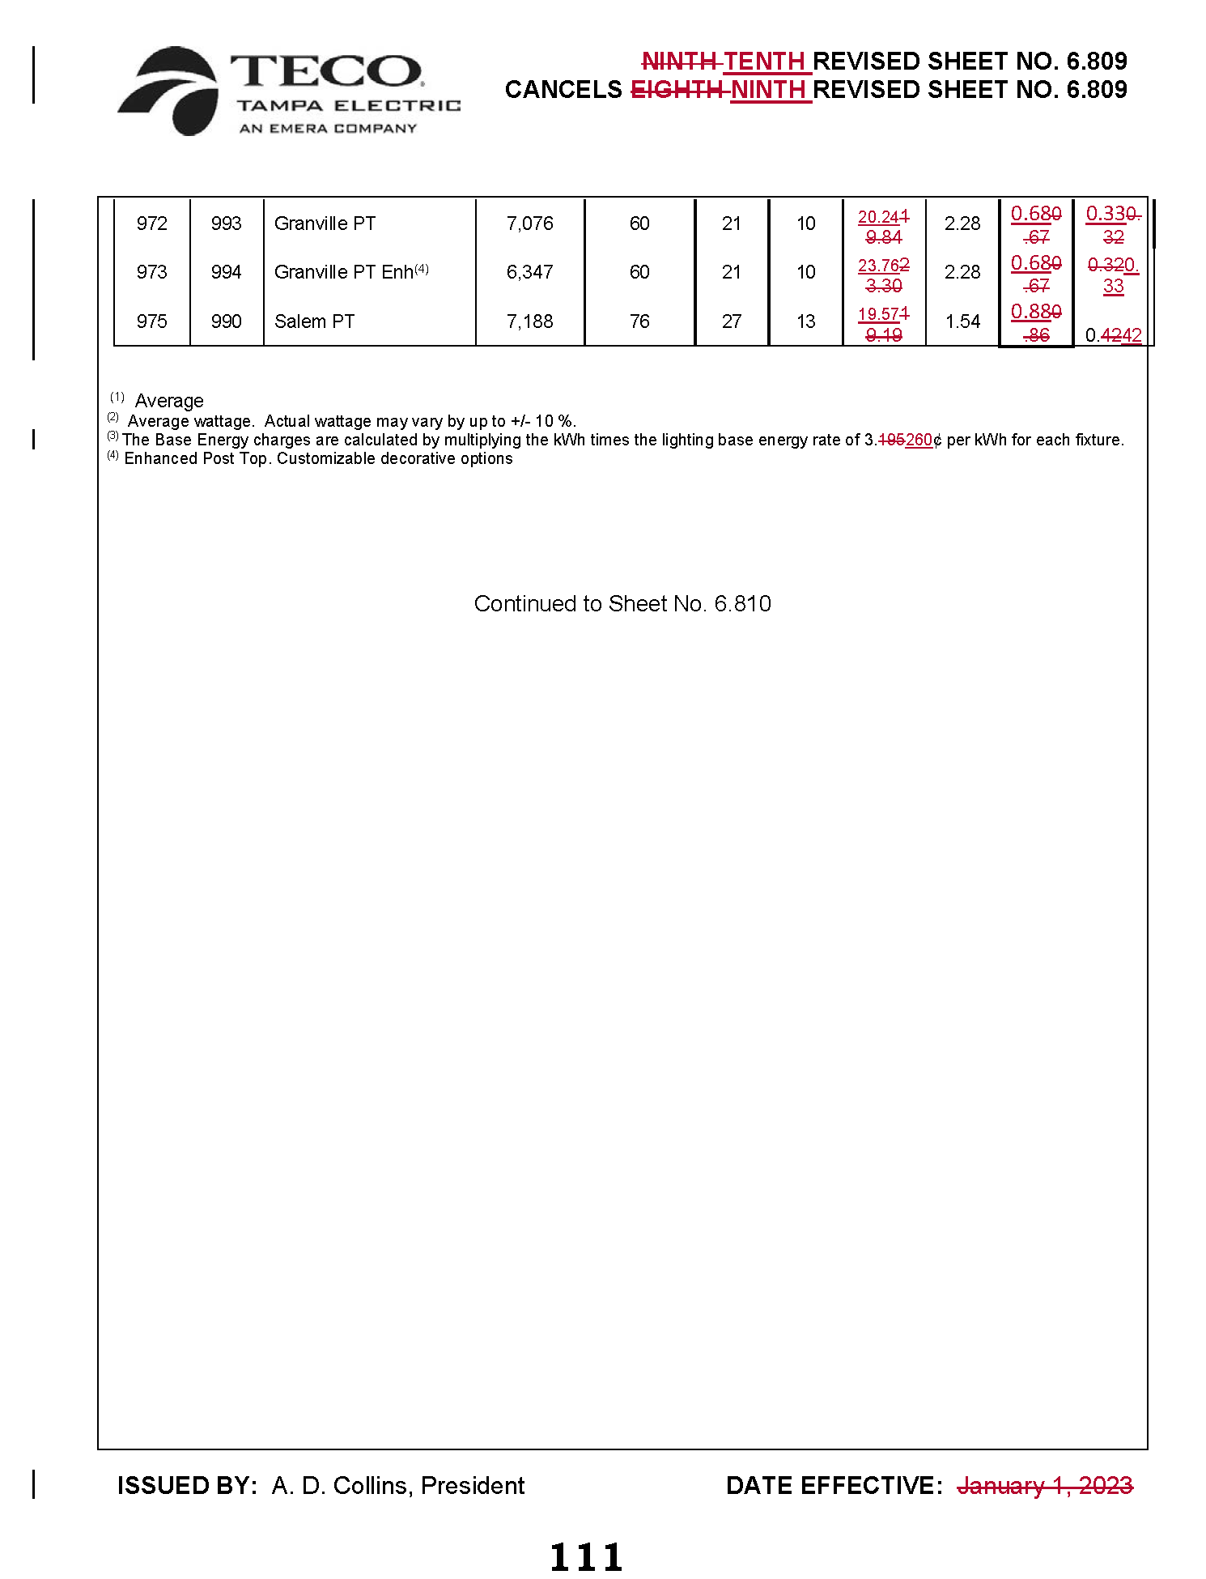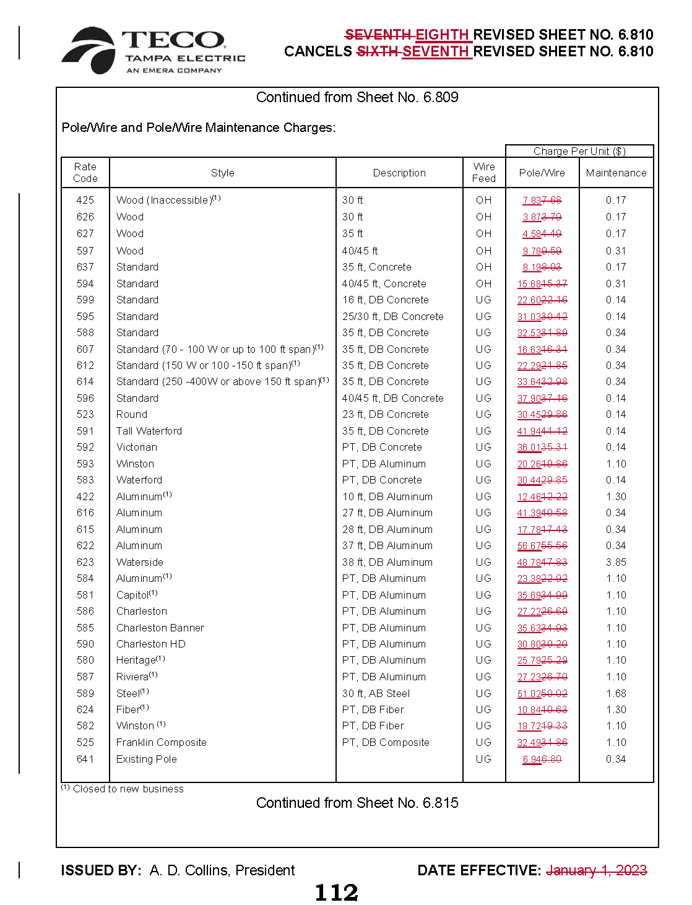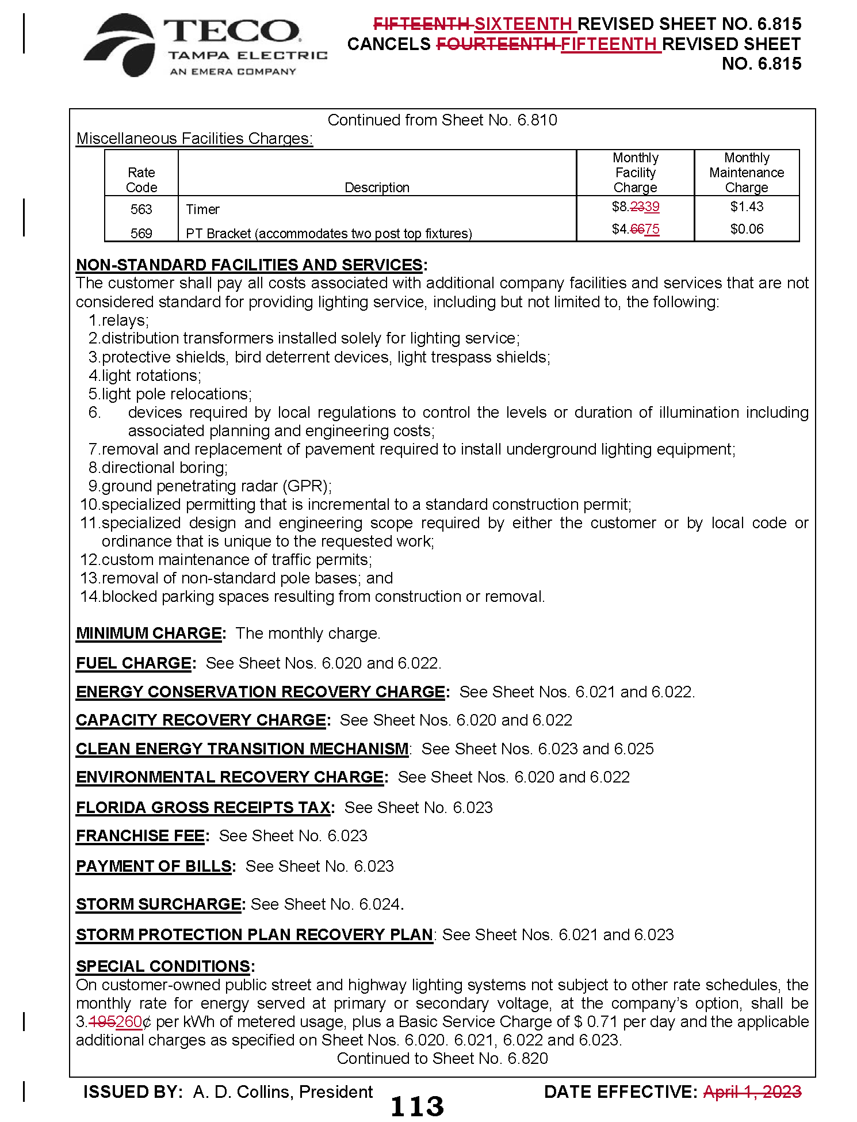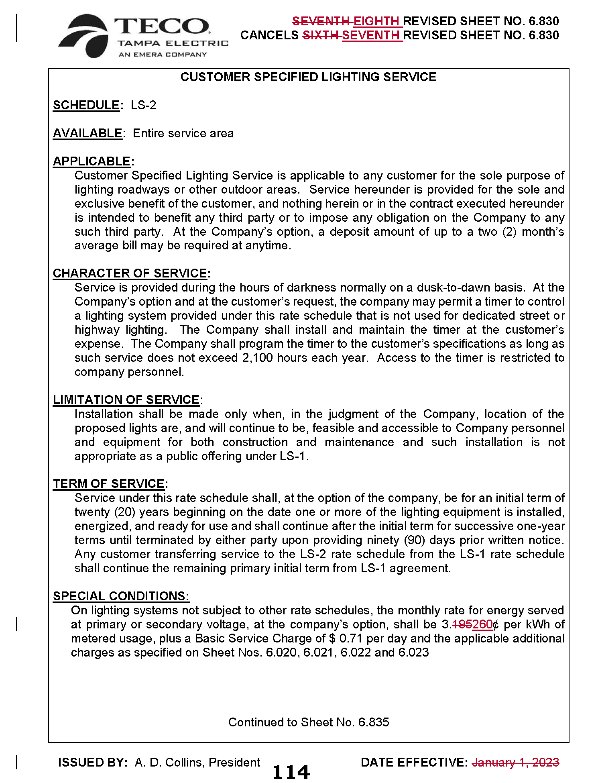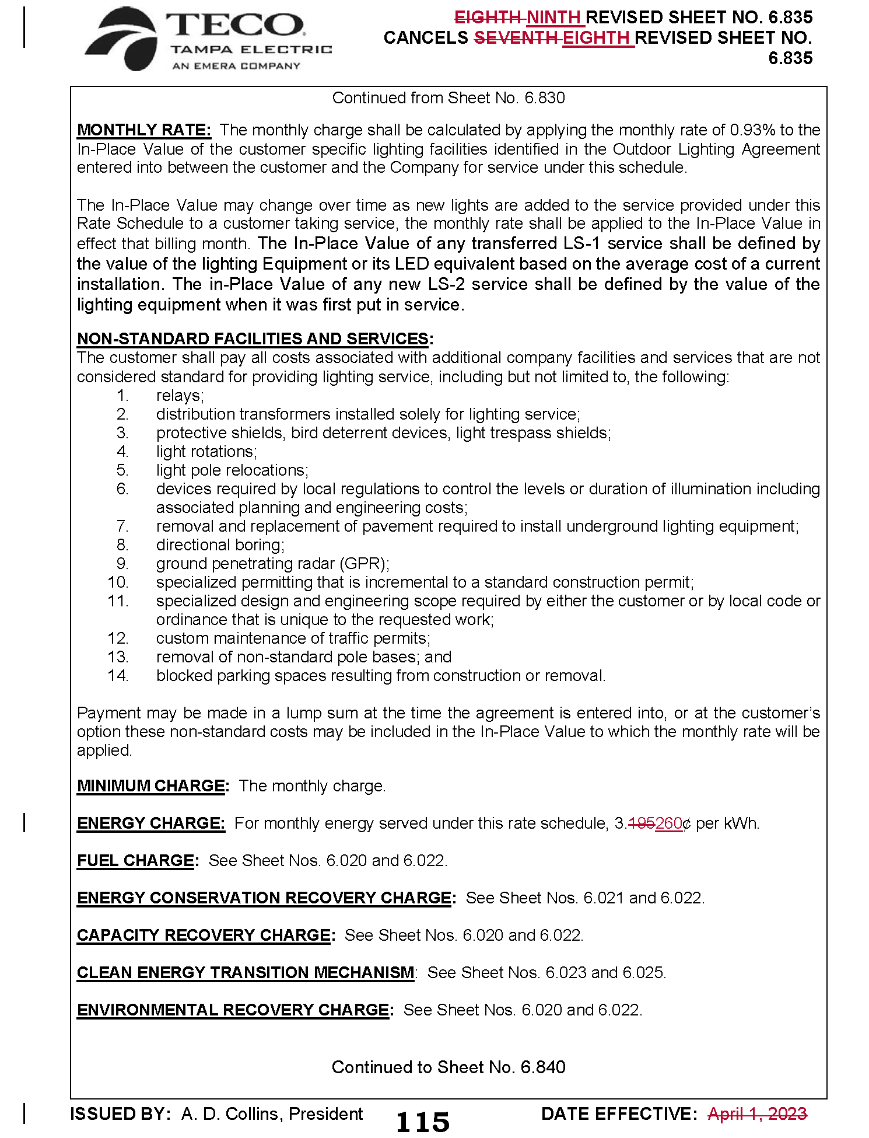

Order No. PSC-2021-0423-S-EI, issued November 10, 2021, in Docket No. 20210034-EI, In re: Petition for rate increase by Tampa Electric Company.
Order No. PSC-2022-0434-TRF-EI, issued December 21, 2022, in Docket No. 20220148-EI, In re: Petition to implement 2023 generation base rate adjustment provisions in 2021 agreement, by Tampa Electric Company.
See page 20 in Order No. PSC-2021-0423-S-EI, issued November 10, 2021, in Docket No. 20210034-EI, In re: Petition for rate increase by Tampa Electric Company.
Order No. PSC-2022-0322-FOF-EI, issued September 12, 2022, in Docket No. 20220122-EI, In re: Petition for limited proceeding rate increase to implement return on equity provisions in 2021 agreement, by Tampa Electric Company.
Document No. 04531-2023, filed August 4, 2023, in Docket No. 20230002-EG, In re: Energy Conservation Cost Recovery Clause.

