BEFORE THE FLORIDA PUBLIC SERVICE COMMISSION

In re: Petition to implement 2024 generation base rate adjustment provisions in paragraph 4 of the 2021 stipulation and settlement agreement, by Tampa Electric Company. | DOCKET NO. 20230090-EI  ORDER NO. PSC-2023-0348-TRF-EI  ISSUED: November 17, 2023

The following Commissioners participated in the disposition of this matter:

ANDREW GILES FAY, Chairman
ART GRAHAM
GARY F. CLARK
MIKE LA ROSA
GABRIELLA PASSIDOMO

ORDER APPROVING TAMPA ELECTRIC COMPANY’S
2024 GENERATION BASE RATE ADJUSTMENT

BY THE COMMISSION:

Background
On August 16, 2023, Tampa Electric Company (TECO or Company) filed a petition to implement the 2024 Generation Base Rate Adjustment (GBRA) provisions pursuant to its 2021 rate case Stipulation and Settlement Agreement (settlement agreement). We previously approved the settlement agreement in Order No. PSC-2021-0423-S-EI (settlement order). In Order No. PSC-2022-0434-TRF-EI, we approved TECO’s 2023 GBRA provision of the 2021 settlement agreement.
The GBRA provisions of the settlement order and agreement provide for an increase in base rates to reflect the 2024 GBRA amount of $21,376,909, effective with the first billing cycle of January 2024. In this petition, TECO proposed to increase the GBRA amount to $21,689,323 to reflect the updated 10.20 percent mid-point return on equity (ROE) allowed by a trigger provision of the 2021 settlement agreement and approved by us on August 16, 2022, in Docket No. 20220122-EI. The Company also noted that it was evaluating the tax provisions of the Inflation Reduction Act (IRA) to address impacts of the IRA on the 2024 GBRA, consistent with paragraphs 4(c) and 11 of the settlement agreement. The IRA, which became effective August 16, 2022, does not contain a federal income tax rate change applicable to TECO, but it does allow for the substitution of the existing investment tax credit for solar generating facilities with a new production tax credit.
During the review process, Commission staff issued a data request to TECO on September 7, 2023, for which the responses were received on September 14, 2023. On October 2, 2023, Commission staff held an informal telephonic meeting with the parties to the 2021 settlement agreement to discuss TECO’s filing in this docket. The legislative version of the proposed tariffs is Attachment A to this order. This is our order on the proposed tariffs. We have jurisdiction over this matter pursuant to Sections 366.04, 366.05, and 366.06, Florida Statutes (F.S.).

Decision
Updated 2024 GBRA Amount
As discussed above, subparagraphs 4(a) and (b) of the 2021 settlement agreement provide that TECO’s base rates will increase by $21,376,909 effective with the first billing cycle in January 2024. The calculation of this GBRA amount was based on the authorized return on equity (ROE) mid-point of 9.95 percent as specified in subparagraph 2(a). However, subparagraph 4(d) states that if the Company’s authorized ROE mid-point changes by operation of subparagraph 2(b) prior to the effective date of the rate adjustment specified in subparagraph 4(b), the calculation of the 2024 GBRA amount shall be updated to reflect the new authorized ROE.
As memorialized in Order No. PSC-2022-0322-FOF-EI, we approved TECO’s petition to implement the ROE trigger provisions of subparagraph 2(b) of the 2021 settlement agreement. As a result, the Company’s authorized ROE midpoint was increased by 25 basis points from 9.95 percent to 10.20 percent, effective as of July 1, 2022, for all regulatory purposes. In its petition to implement the 2024 GBRA, TECO provided a calculation updating the GBRA amount to $21,689,323 to reflect the Company’s 10.20 percent authorized ROE mid-point. The updated amount is correct based on our review of the Company’s calculations.
When we approved TECO’s 2023 GBRA last year, the Company said it was in discussions with the Office of Public Counsel (OPC) regarding the process for updating the 2023 GBRA to reflect the impact of the IRA. As reflected in Order No. PSC-2022-0434-TRF-EI, TECO agreed to collect the rate increase reflected in the 2023 GBRA subject to refund, so that the 2023 GBRA could go into effect with the first billing cycle of January 2023. The Company would refund the difference between the 2023 GBRA as approved by us and the 2023 GBRA as adjusted for the IRA once we have approved the 2023 GBRA adjusted for the IRA.
Commission staff requested an update on this process as there has not been a revised filing for the 2023 GBRA and the impacts of the IRA would also adjust the 2024 GBRA. The Company indicated that it is still in the process of discussing the impacts of the IRA on the 2023 and 2024 GBRAs with OPC. As such, TECO requested that we consider its petition now so that the 2024 GBRA can go into effect with the first billing cycle of January 2024. As was the case with the 2023 GBRA, the Company agreed to collect the rate increase reflected in the 2024 GBRA subject to refund. The Company will refund the difference between the 2024 GBRA as approved by us and the 2024 GBRA as adjusted for the IRA once we have approved the 2024 GBRA adjusted for the IRA.
In light of the extended timeframe for addressing the impacts of the IRA, we approve TECO’s updated 2024 GBRA amount of $21,689,323 with the requirement that the Company file updated 2023 and 2024 GBRAs, adjusted to reflect IRA impacts, by April 1, 2024.

Approval of Revised Tariffs
TECO’s petition includes the proposed tariff sheets, the allocation of the revenue increase to the various rate classes and calculations showing the revenue from the sale of electricity by rate schedule under current and proposed rates. A residential customer who uses 1,000 kilowatt-hours (kWh) per month will see an increase of $1.58 on the base rate portion of their monthly bill as a result of the GBRA increase.
Subparagraph 4(e) of the settlement agreement, which addresses the GBRA increase and was approved by Order No. PSC-2021-0423-S-EI, states:
… the GBRAs shall be reflected on customer bills by allocating each GBRA revenue requirement to rate classes as shown in Exhibit K and demand and energy base rate charges shall be increased on an equal percentage basis (to the extent practicable) within each class to recover the allocated revenue requirement increase for each class, and shall be calculated based upon the billing determinants used in the company’s then-most-current-ECCR filing with the Commission for the twelve months following the effective date of any respective GBRA. For GSD, GSLDPR, and GSLDSU rate classes, the increase will be recovered exclusively based on demand charges.
TECO’s most current Energy Conservation Cost Recovery Clause (ECCR) filing in Docket No. 20230002-EG was filed on August 4, 2023. The billing determinants used in calculating the proposed GBRA base rate charges are consistent with the billing determinants in TECO’s most recent ECCR filing and are in compliance with the language of the settlement agreement.
We have also reviewed TECO’s proposed 2024 GBRA tariff sheets and supporting documentation. The calculations are accurate and reflect the language of the approved settlement agreement. We approve TECO’s tariff rate changes to implement the updated GBRA increase of $21,689,323 due to the ROE trigger provision in the settlement agreement. Pursuant to the settlement order, the rate changes shall become effective with the first billing cycle of January 2024. TECO shall notify its customers of the approved new rates by way of bill notification in the December 2023 billing cycle.

Based on the foregoing, it is

ORDERED by the Florida Public Service Commission that Tampa Electric Company’s updated 2024 generation base rate adjustment amount of $21,689,323 is approved with the requirement that the Company file updated 2023 and 2024 generation base rate adjustments, adjusted to reflect Inflation Reduction Act impacts, by April 1, 2024. It is further

ORDERED that the Company’s revised tariffs to implement the generation base rate adjustment are approved and shall become effective with the first billing cycle of January 2024. It is further

ORDERED that if a protest is filed within 21 days of issuance of the Order, the tariff shall remain in effect with any charges held subject to refund pending resolution of the protest. It is further

ORDERED that this docket shall remain open in order for the Company to file updated 2023 and 2024 generation based rate adjustments, adjusted to reflect Inflation Reduction Act impacts, by April 1, 2024.

By ORDER of the Florida Public Service Commission this 17th day of November, 2023.

/s/ Adam J. Teitzman
ADAM J. TEITZMAN
Commission Clerk
Florida Public Service Commission
2540 Shumard Oak Boulevard
Tallahassee, Florida 32399
(850) 413-6770
www.floridapsc.com

Copies furnished: A copy of this document is provided to the parties of record at the time of issuance and, if applicable, interested persons.

DD

NOTICE OF FURTHER PROCEEDINGS

The Florida Public Service Commission is required by Section 120.569(1), Florida Statutes, to notify parties of any administrative hearing or judicial review of Commission orders that is available under Sections 120.57 or 120.68, Florida Statutes, as well as the procedures and time limits that apply. This notice should not be construed to mean all requests for an administrative hearing or judicial review will be granted or result in the relief sought.

Mediation may be available on a case-by-case basis. If mediation is conducted, it does not affect a substantially interested person's right to a hearing.

The Commission's decision on this tariff is interim in nature and will become final, unless a person whose substantial interests are affected by the proposed action files a petition for a formal proceeding, in the form provided by Rule 28-106.201, Florida Administrative Code. This petition must be received by the Office of Commission Clerk, 2540 Shumard Oak Boulevard, Tallahassee, Florida 32399-0850, by the close of business on December 8, 2023.

In the absence of such a petition, this Order shall become final and effective upon the issuance of a Consummating Order.

Any objection or protest filed in this docket before the issuance date of this order is considered abandoned unless it satisfies the foregoing conditions and is renewed within the specified protest period.

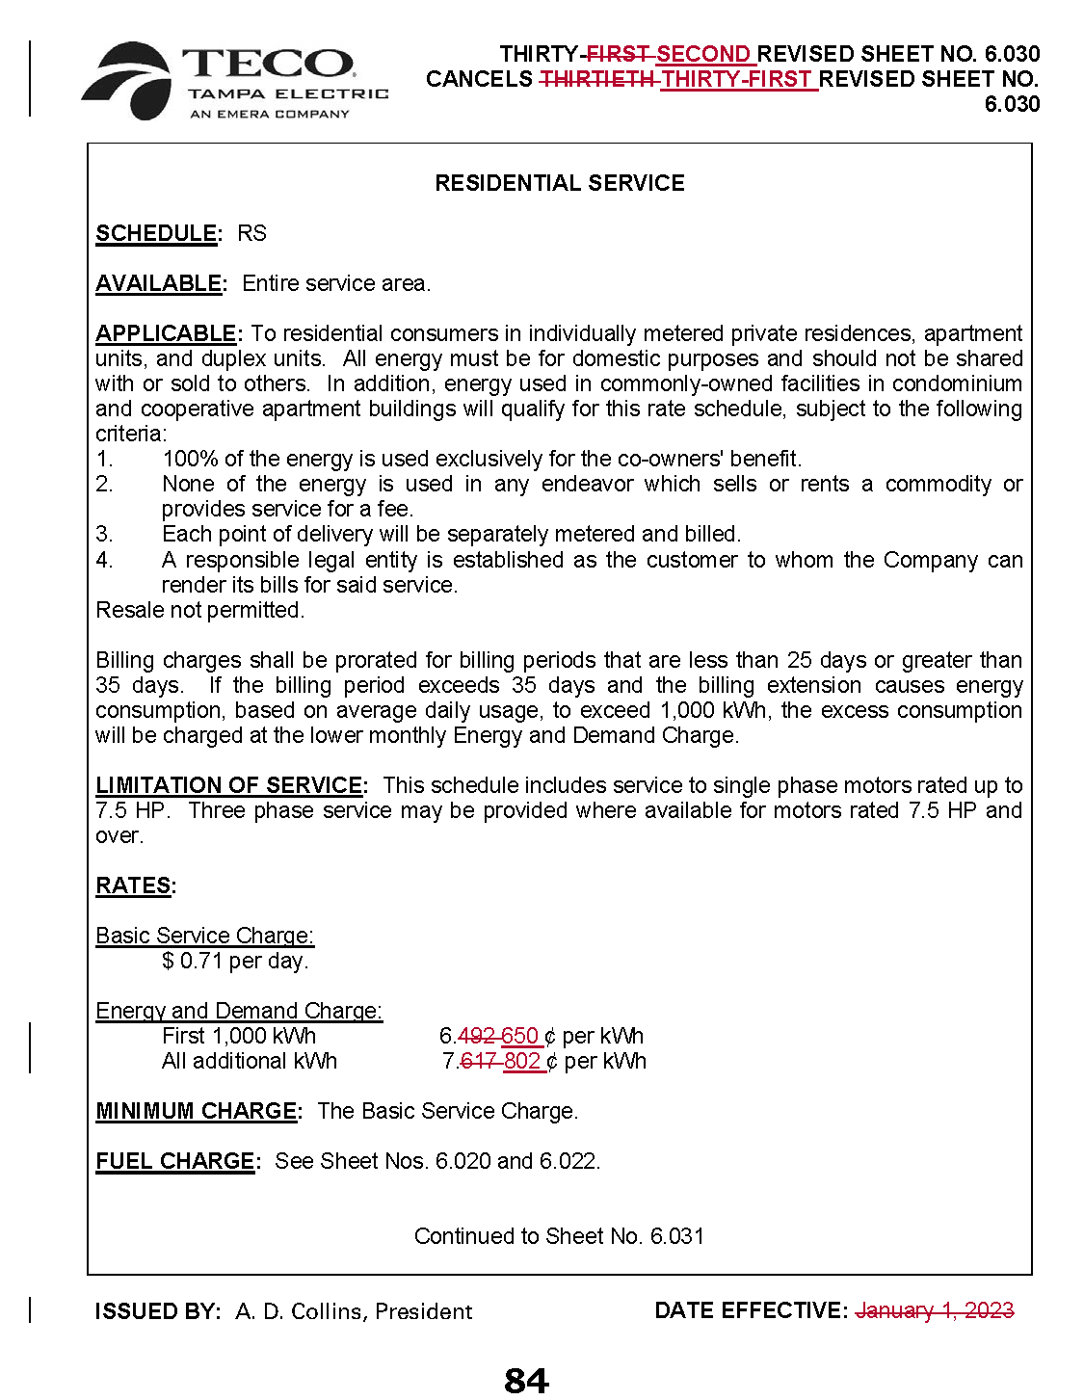
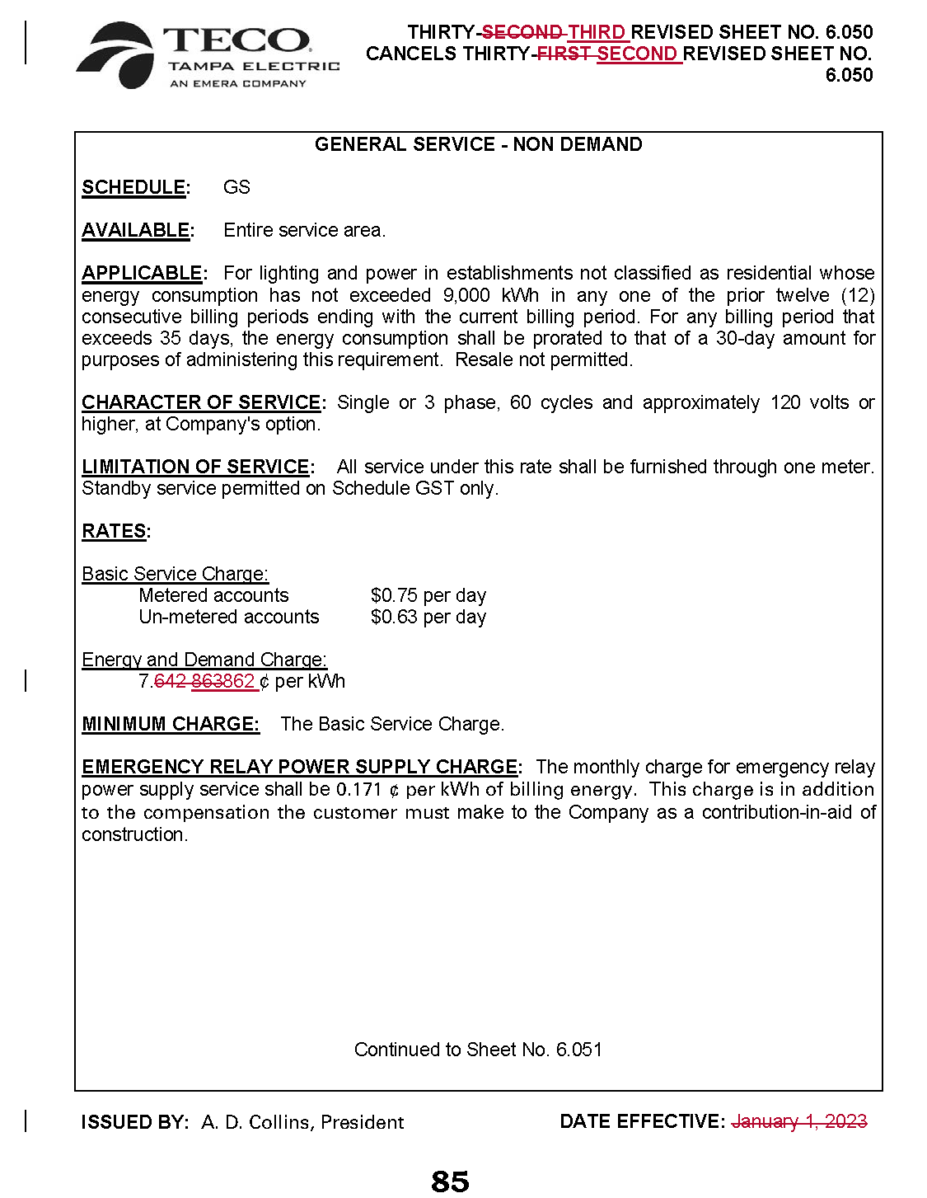
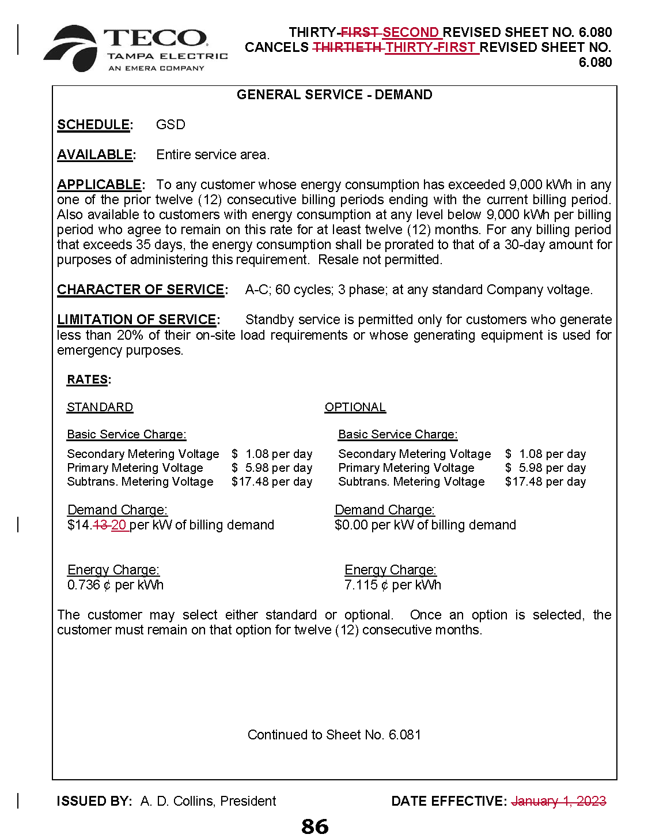
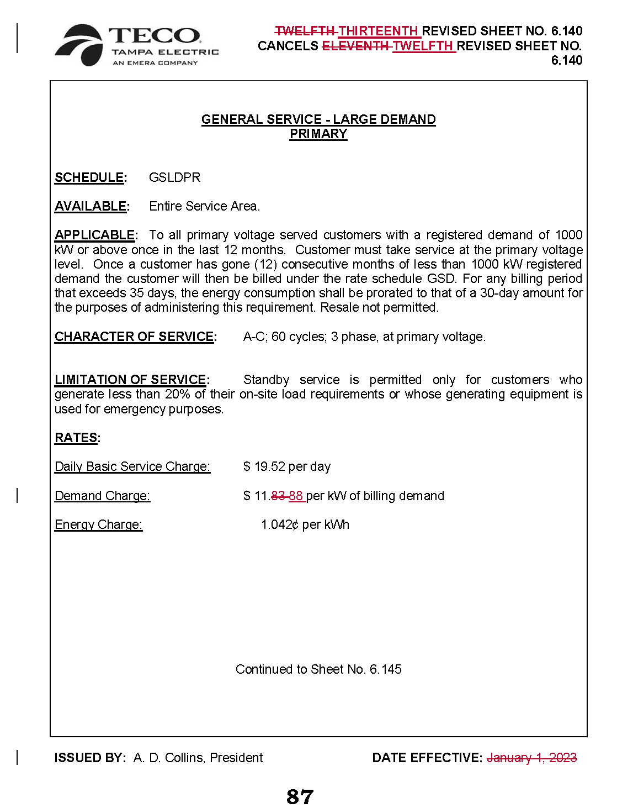
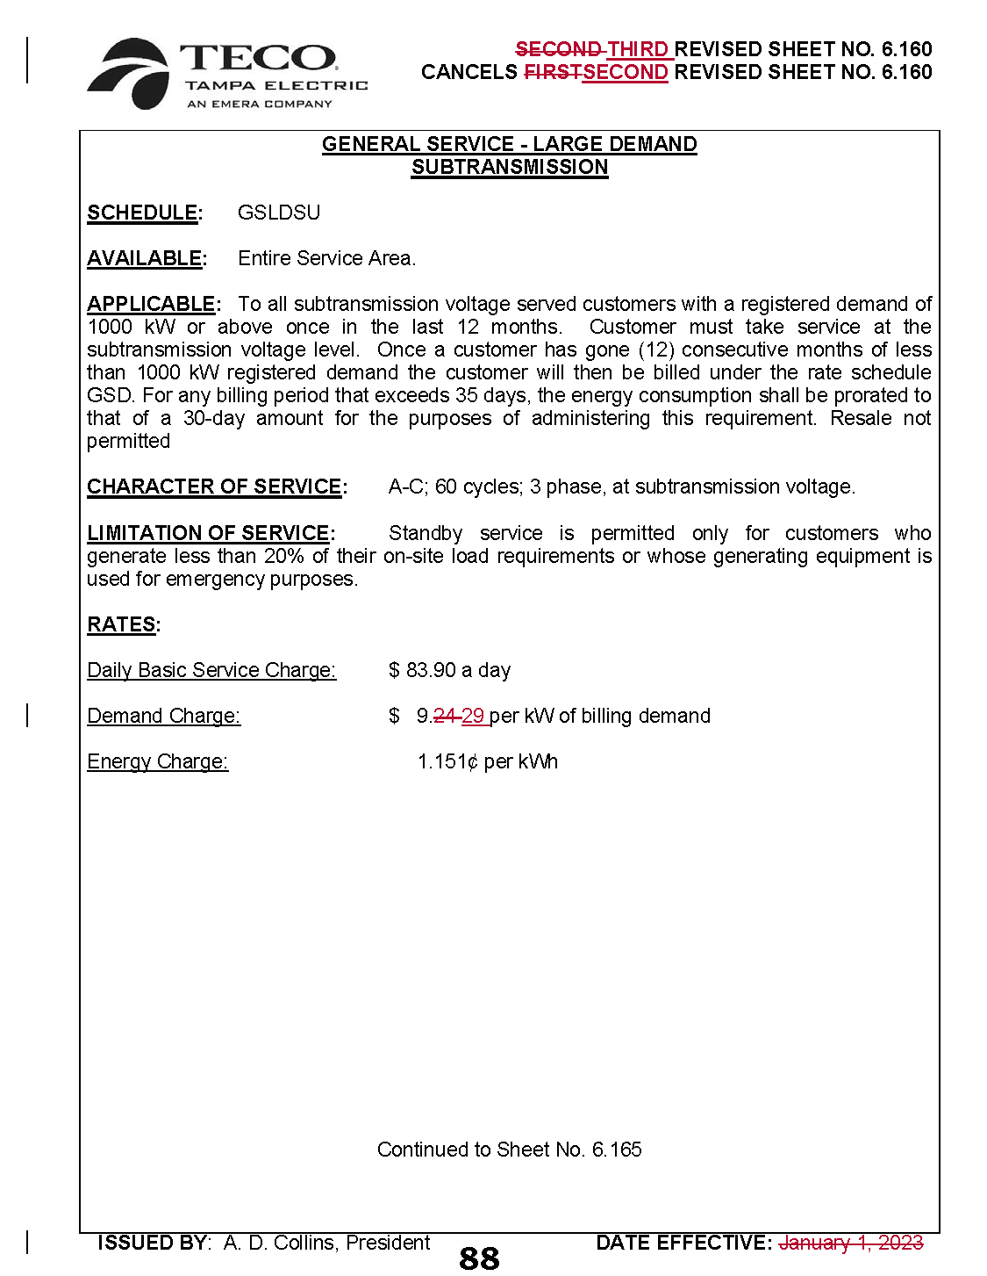
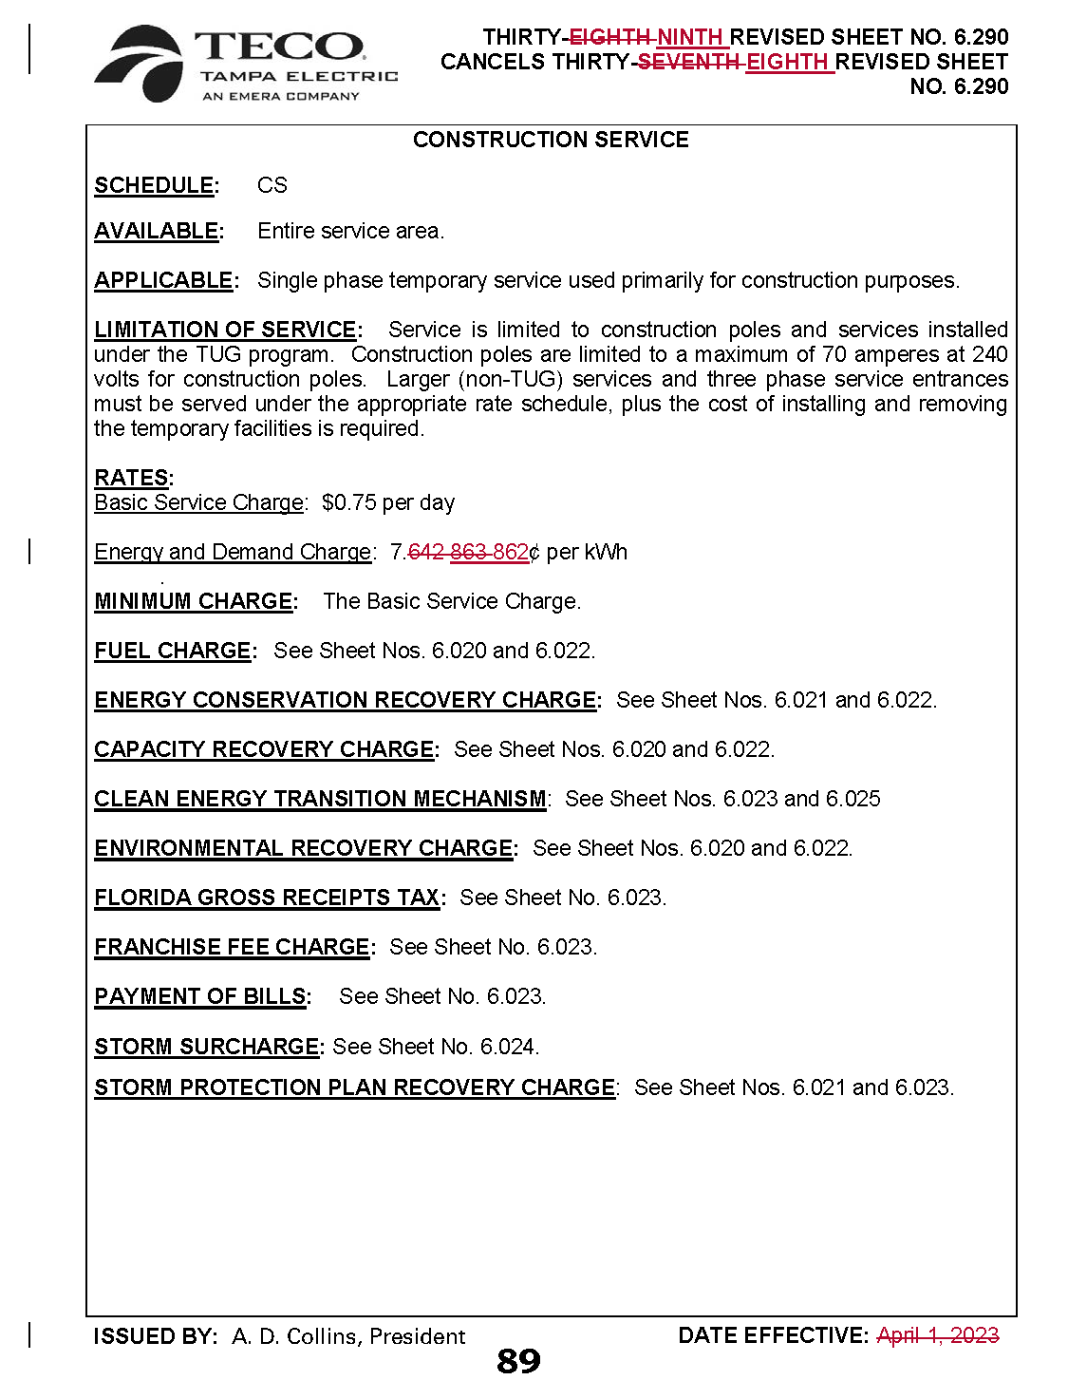
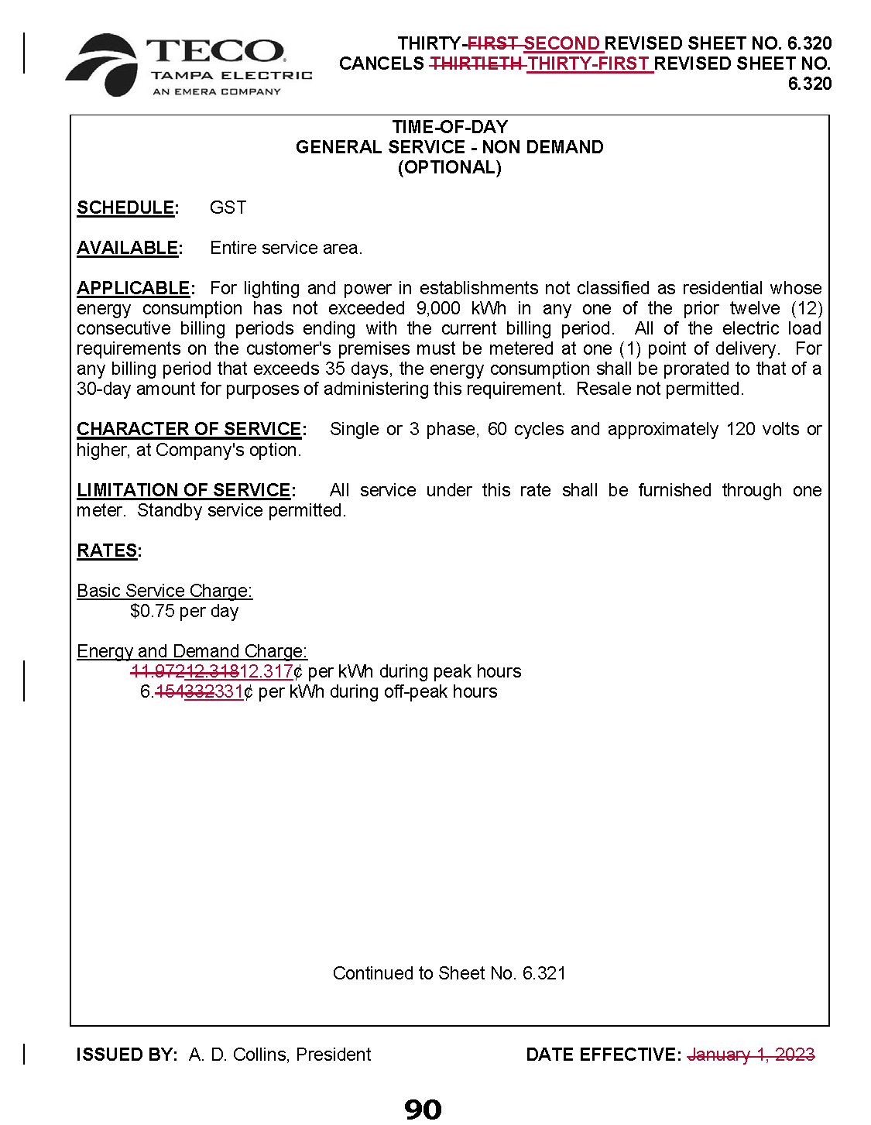
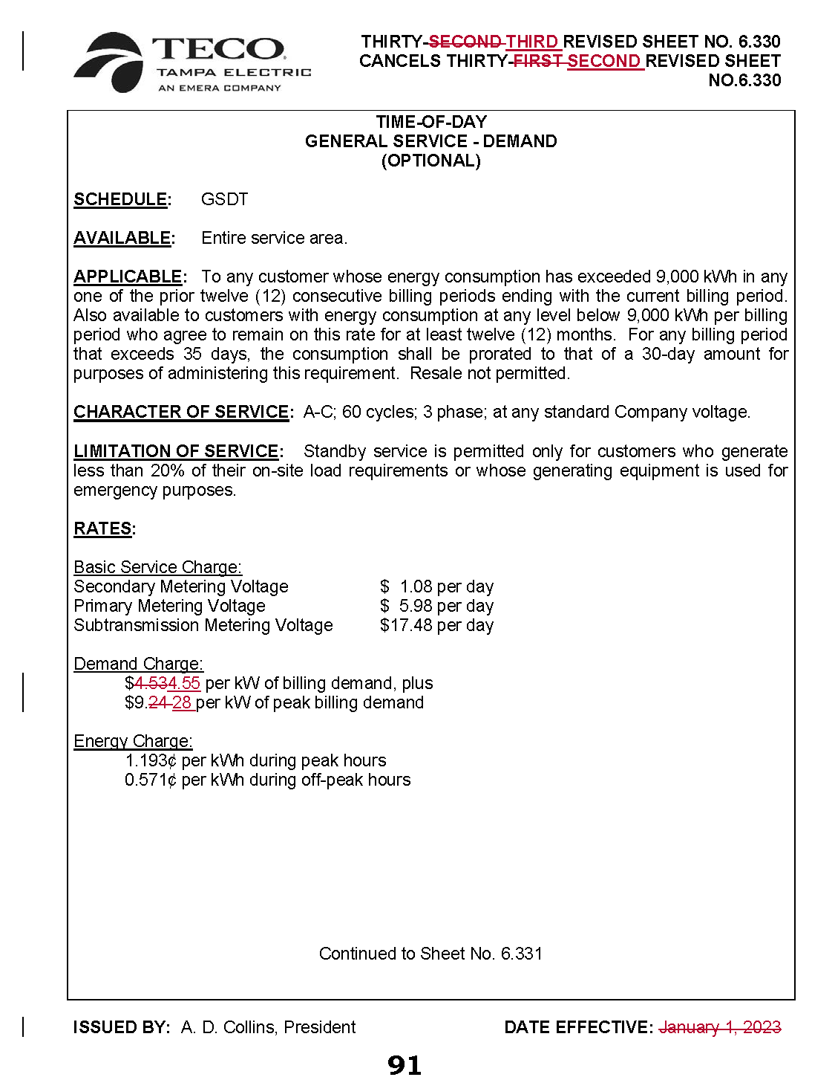
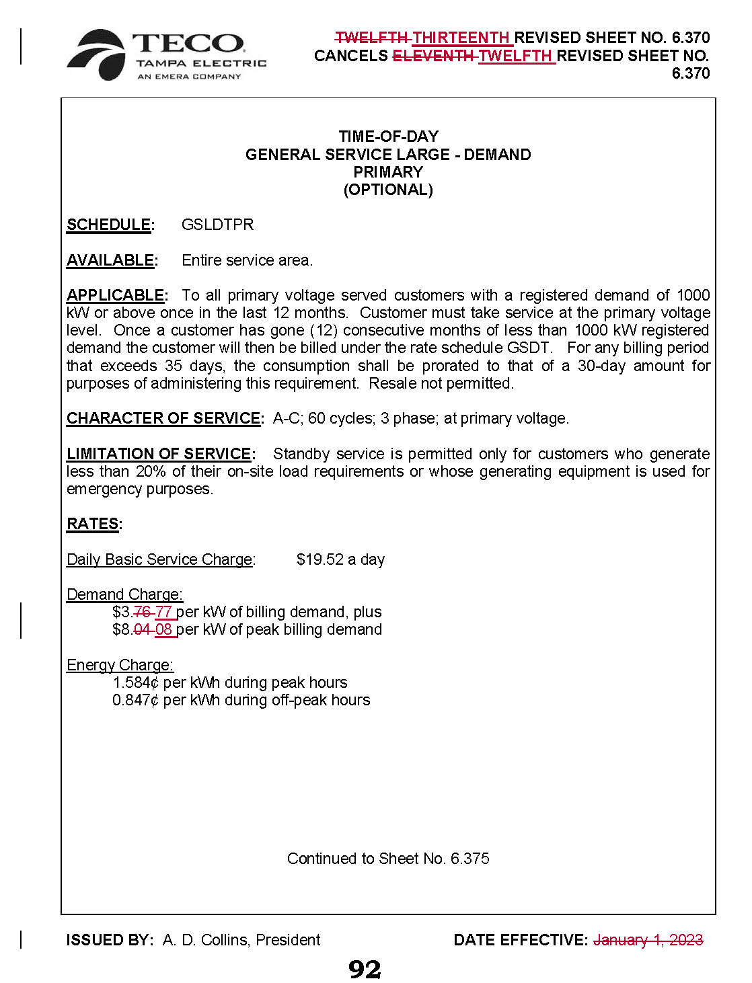
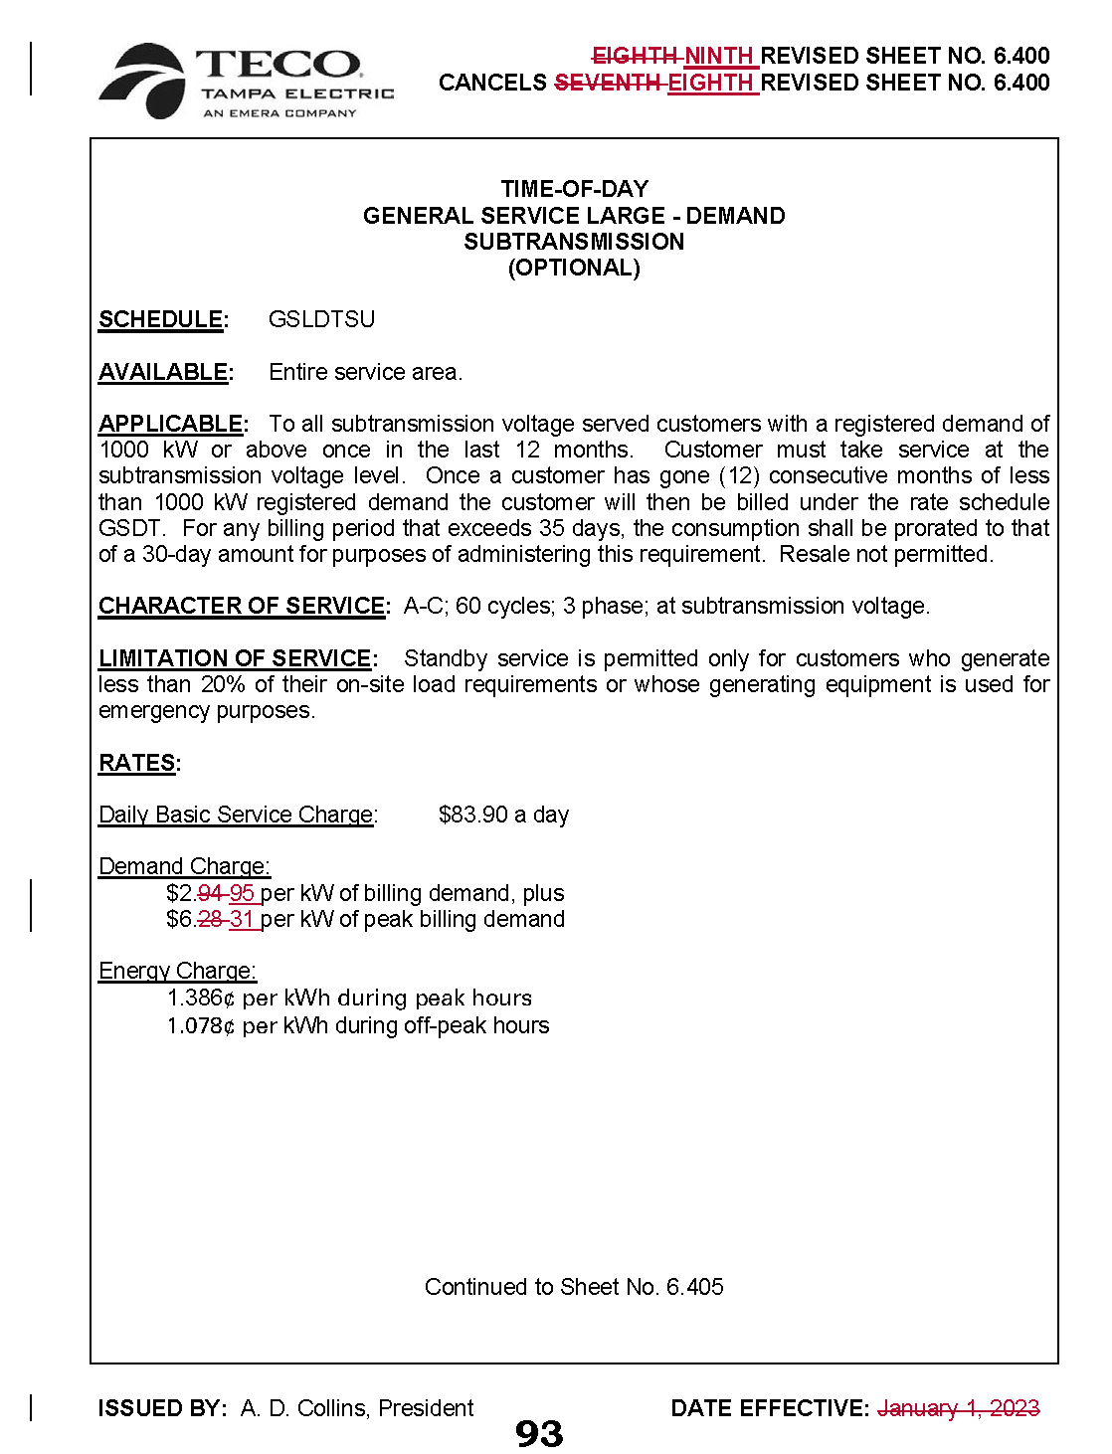
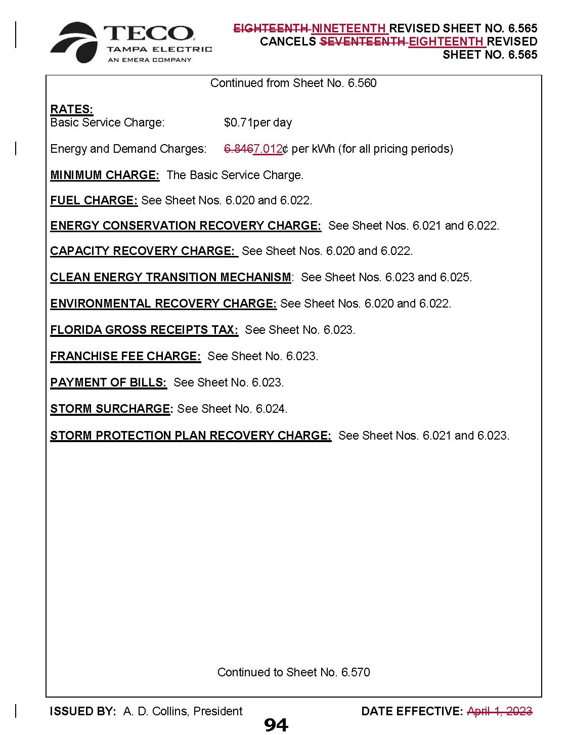
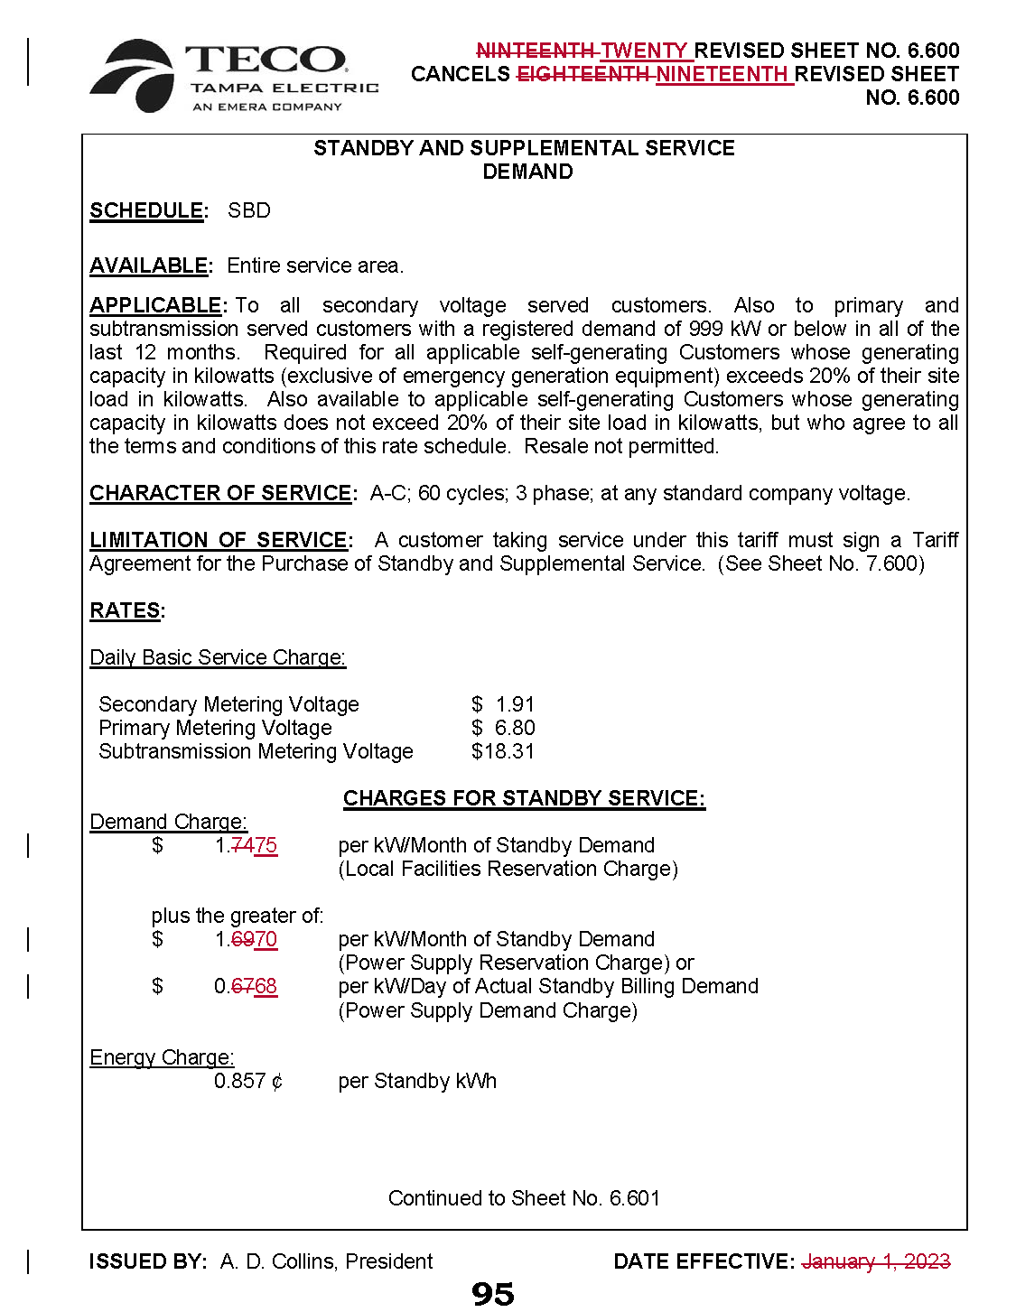
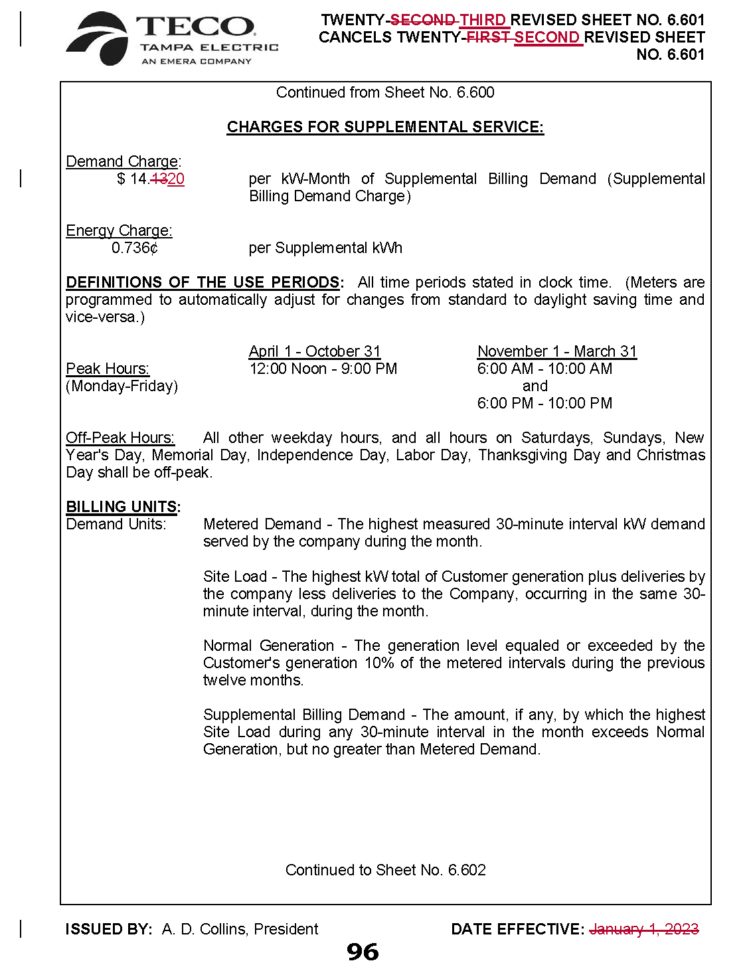
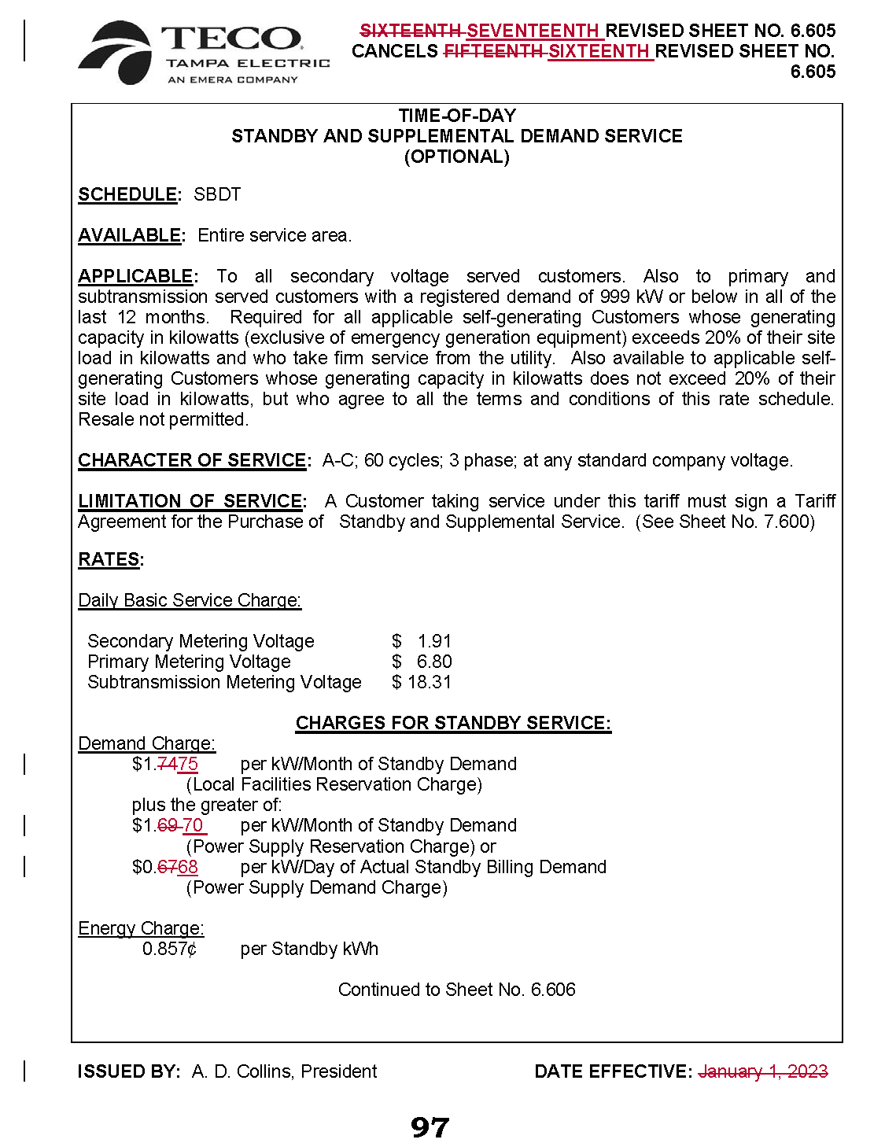
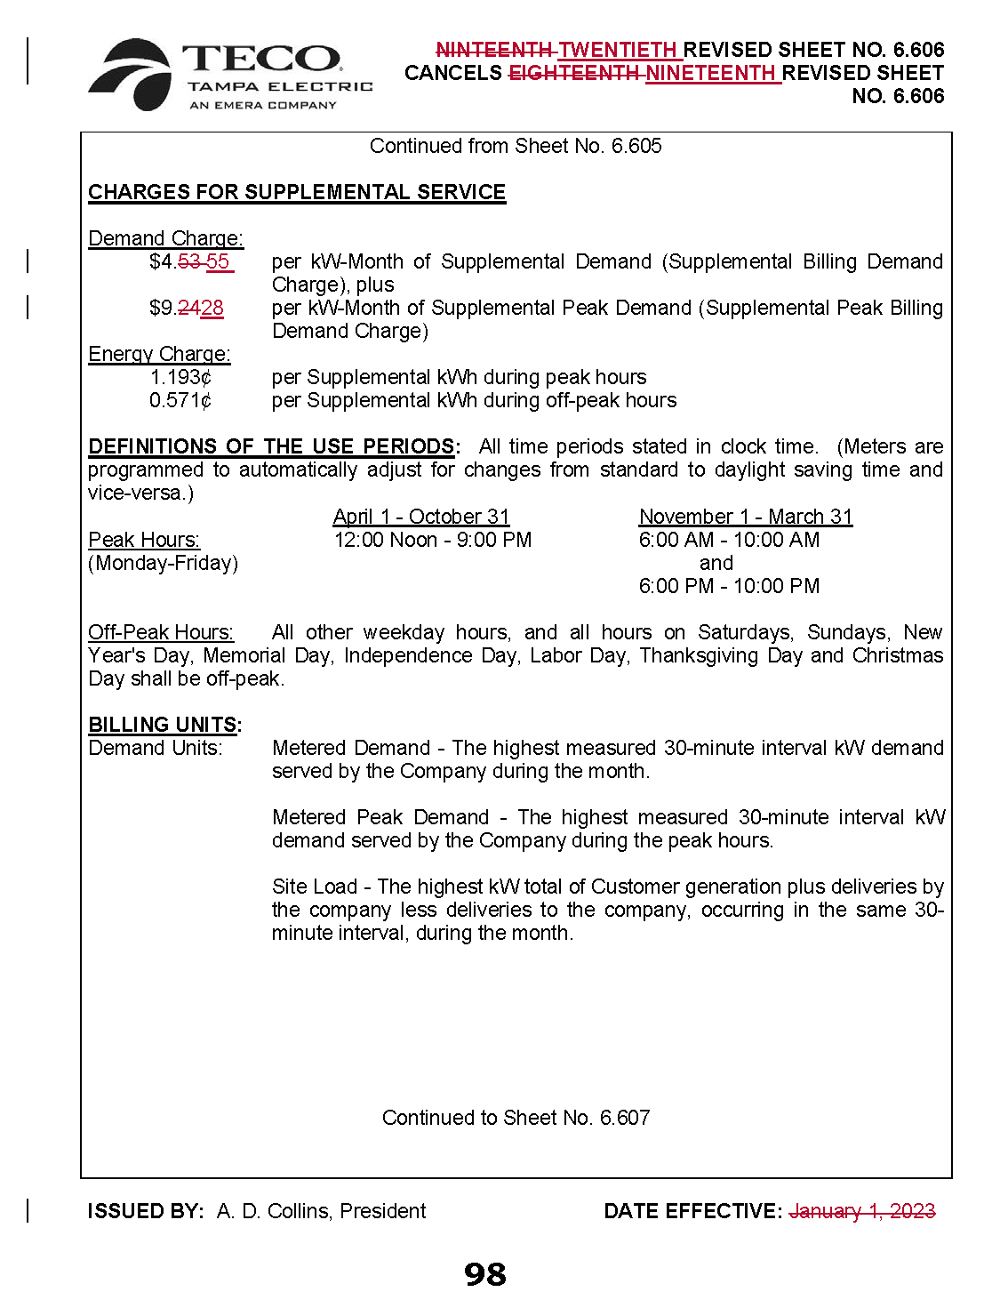
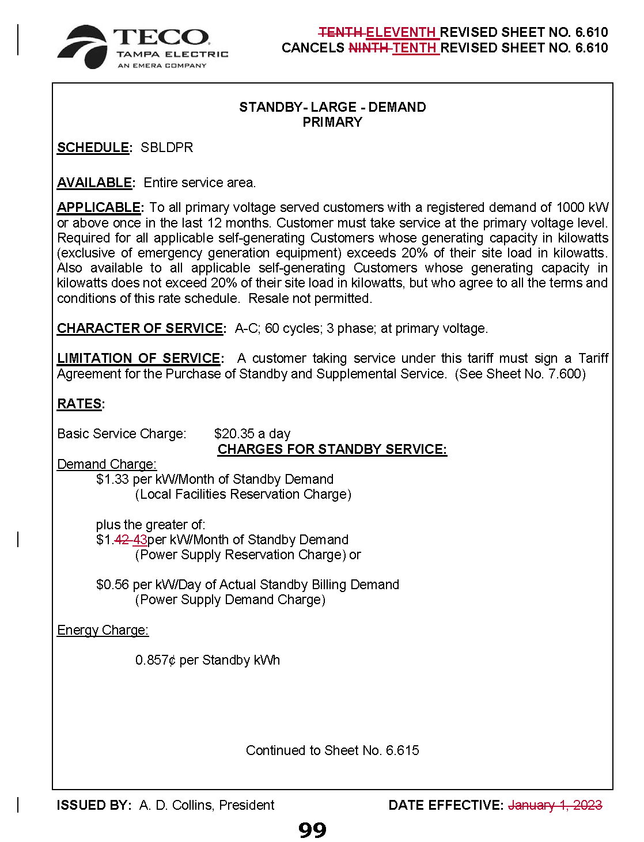
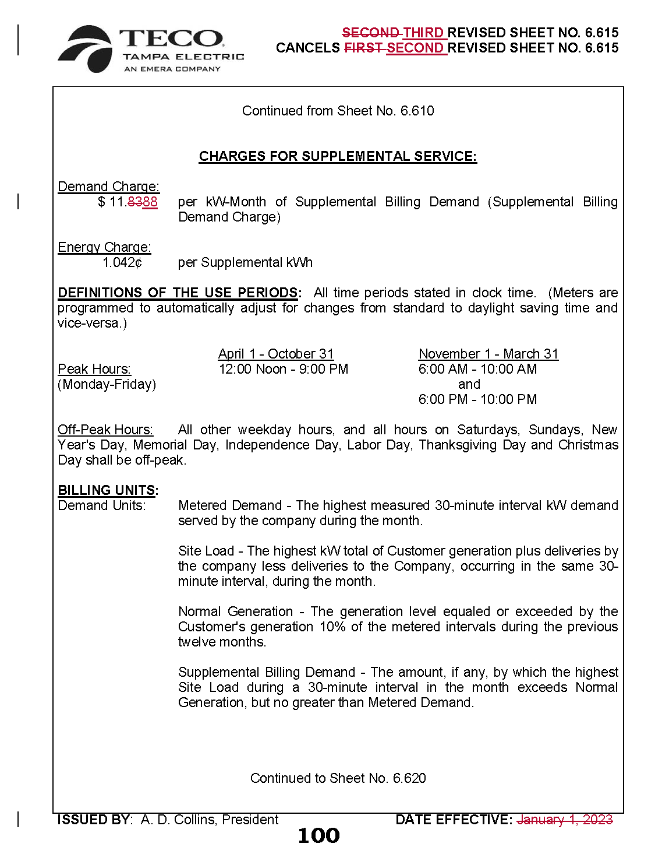
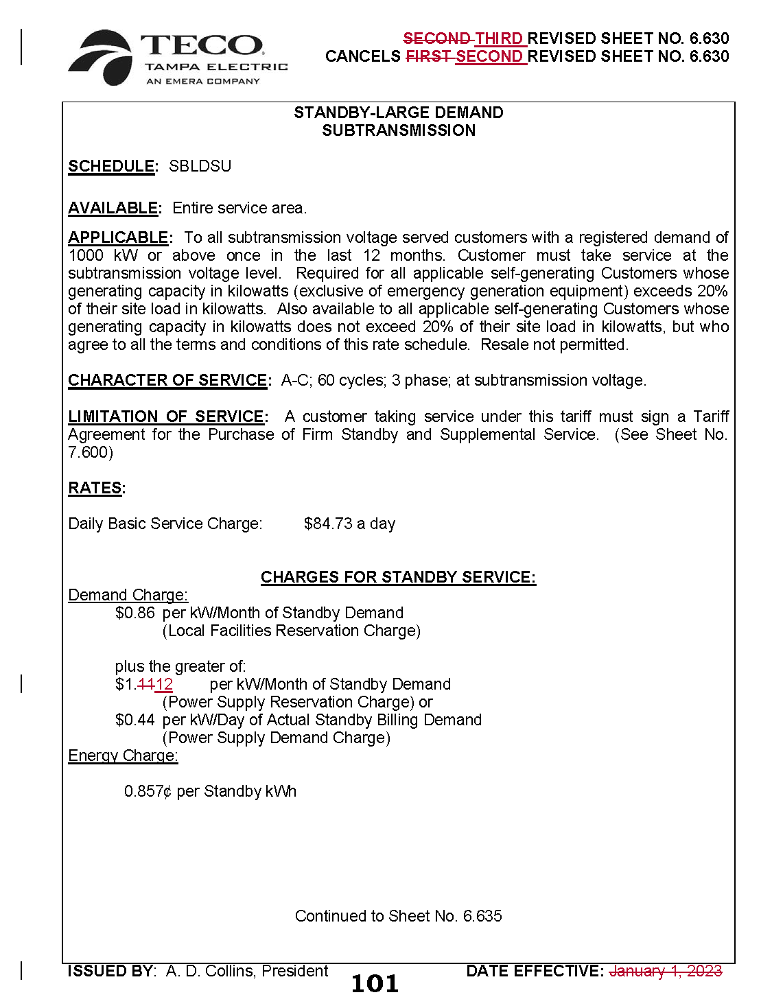
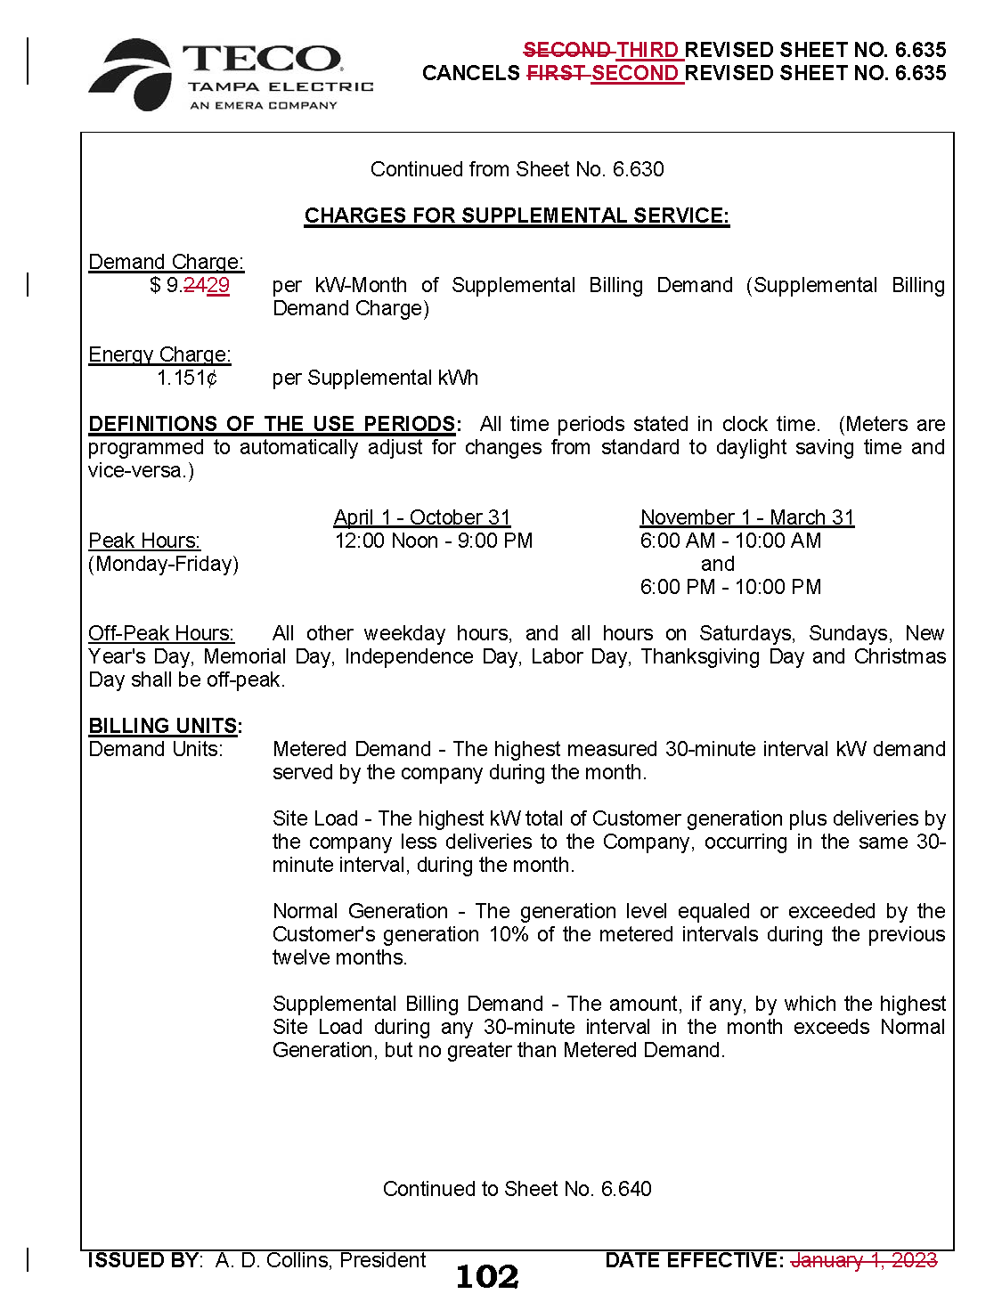
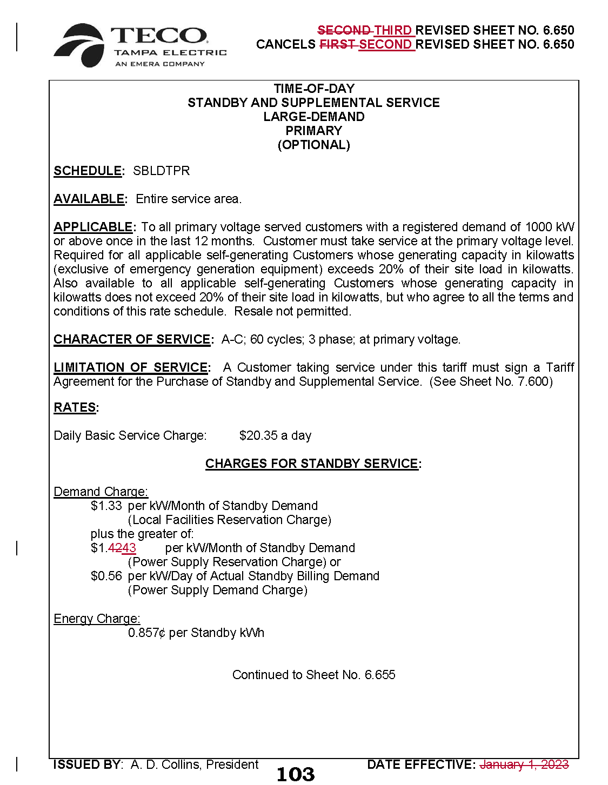
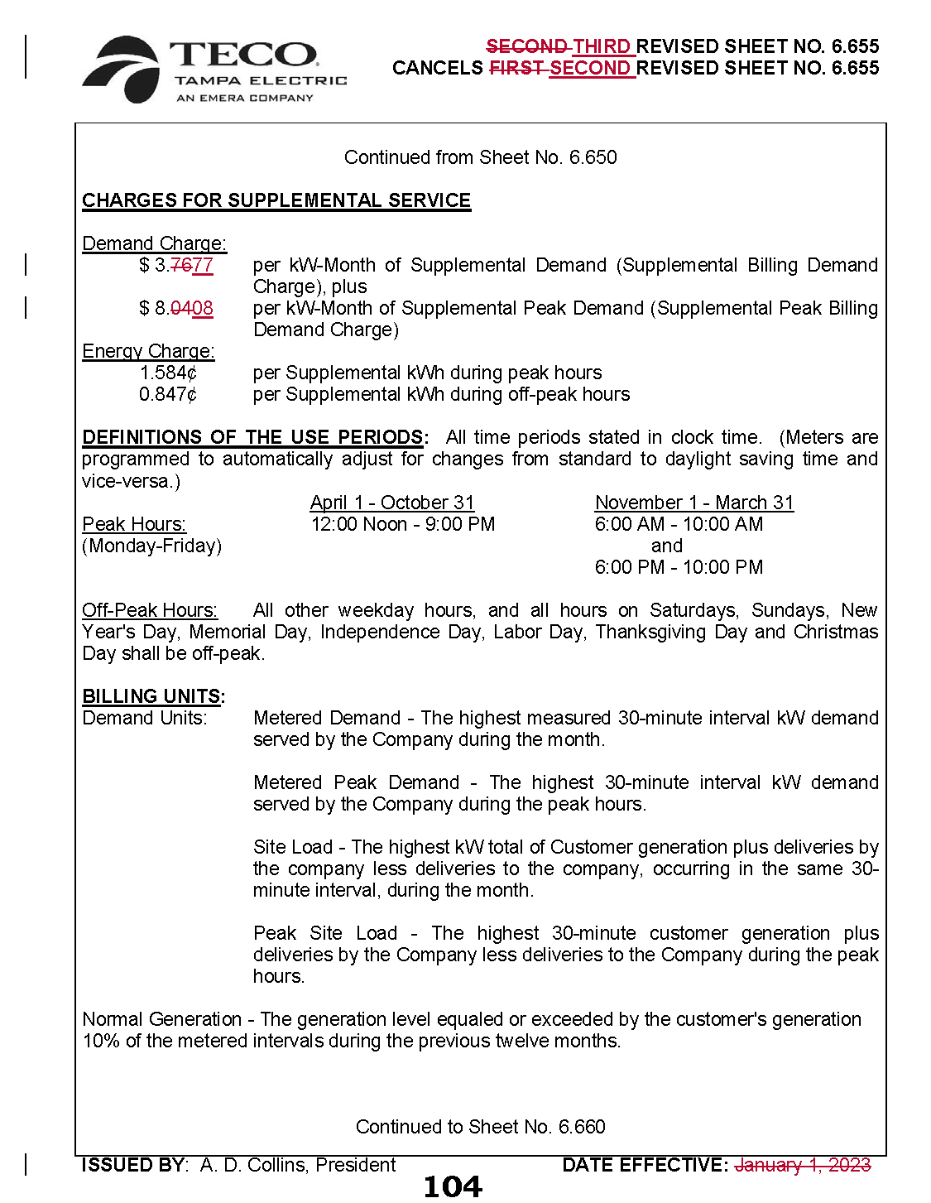
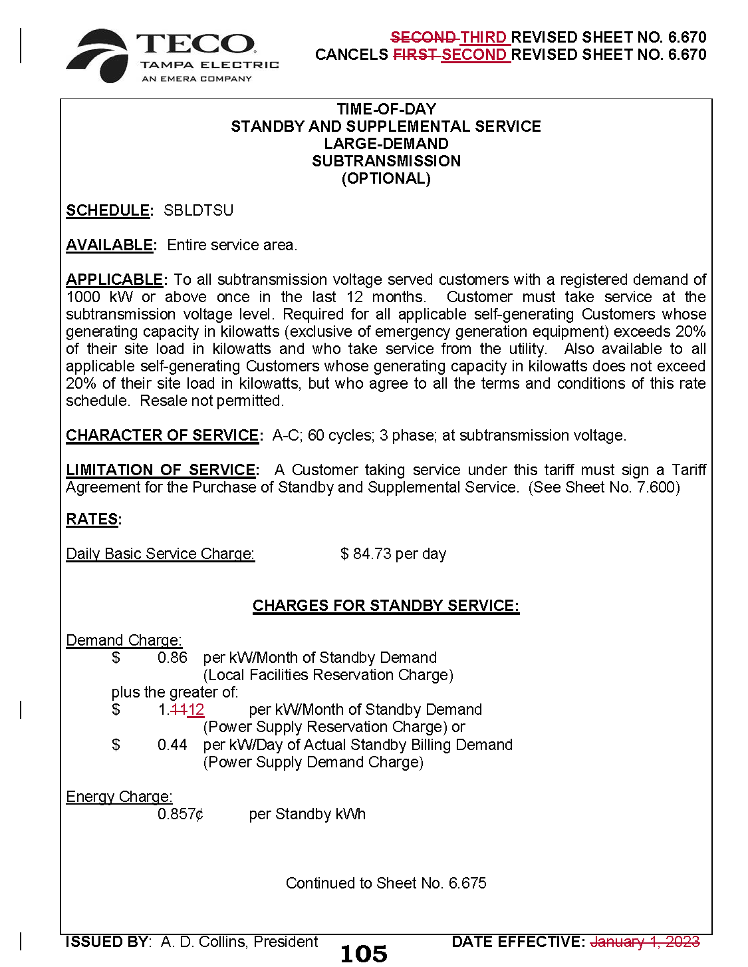
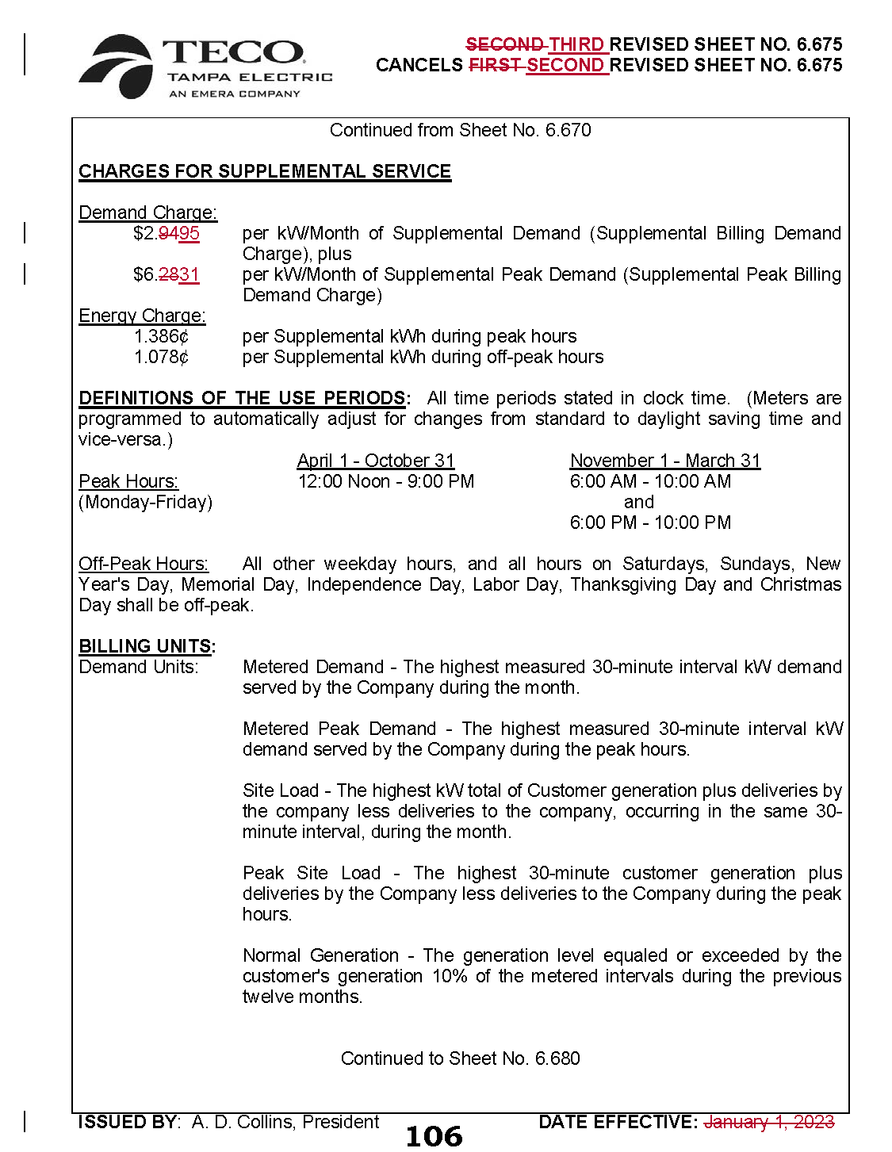
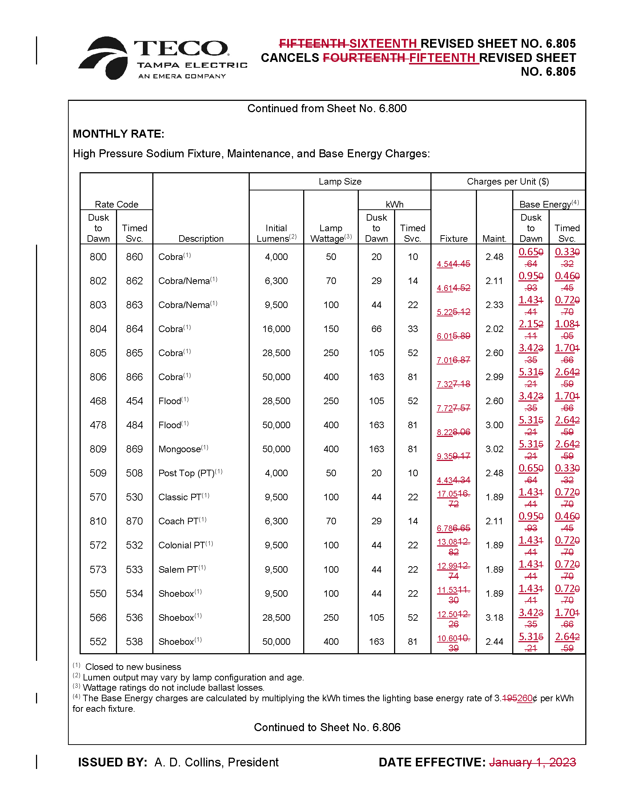
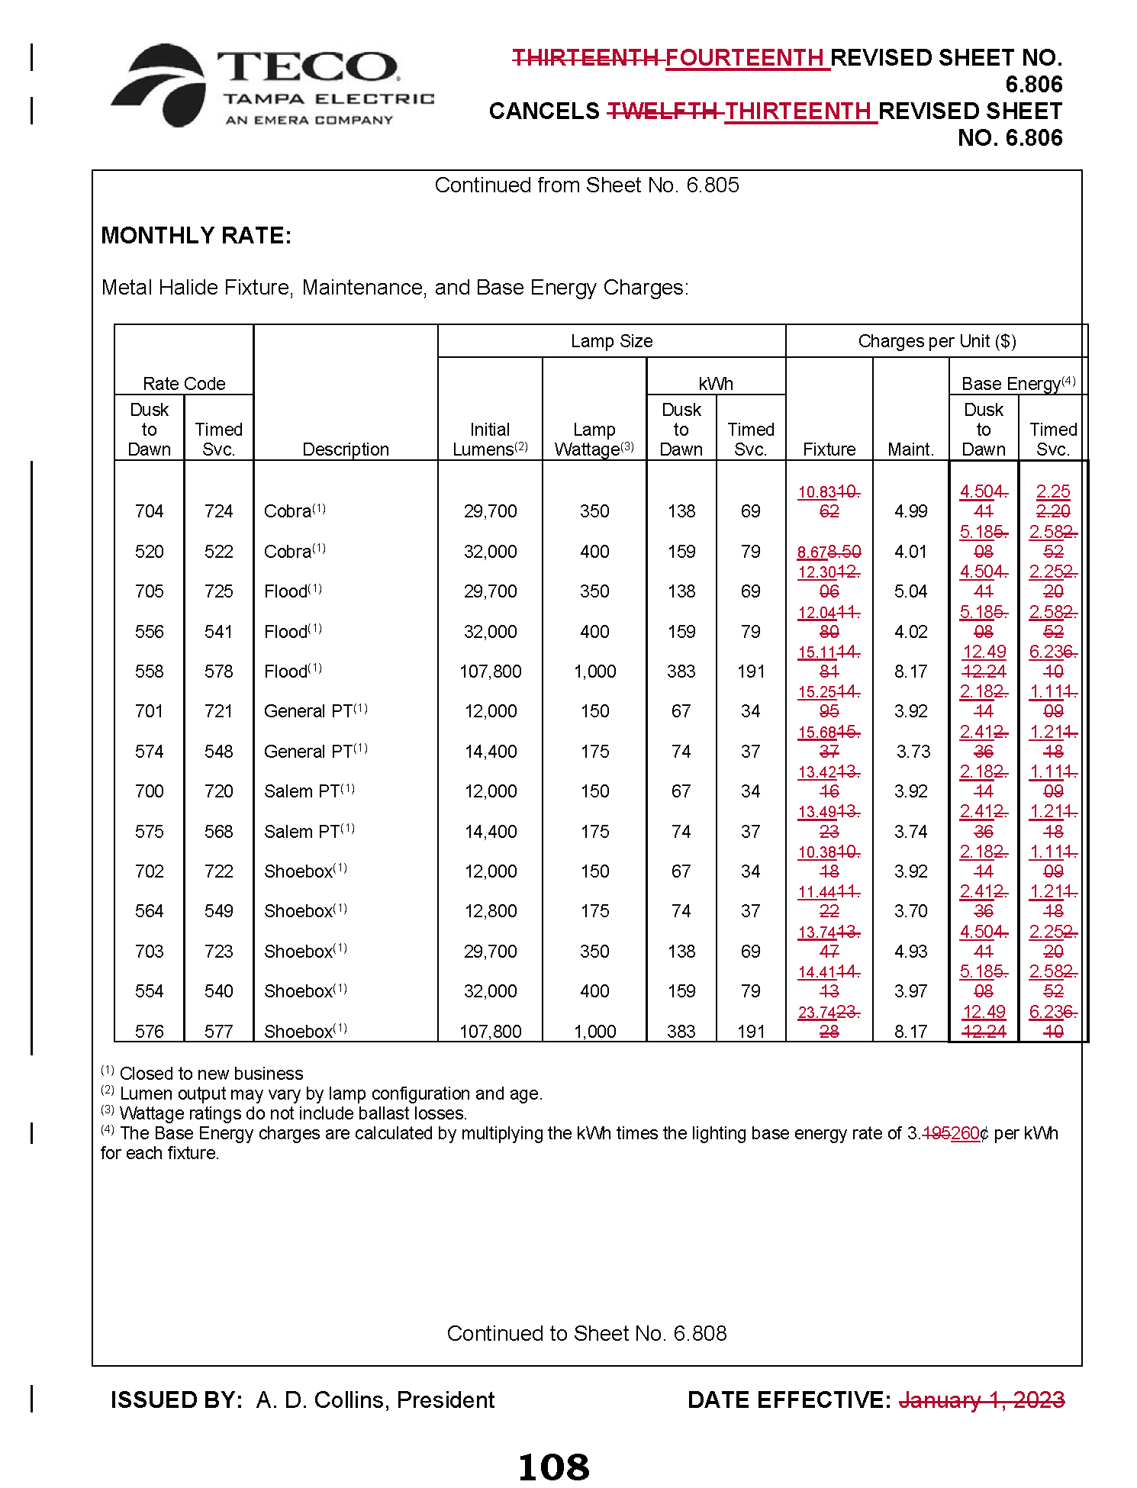
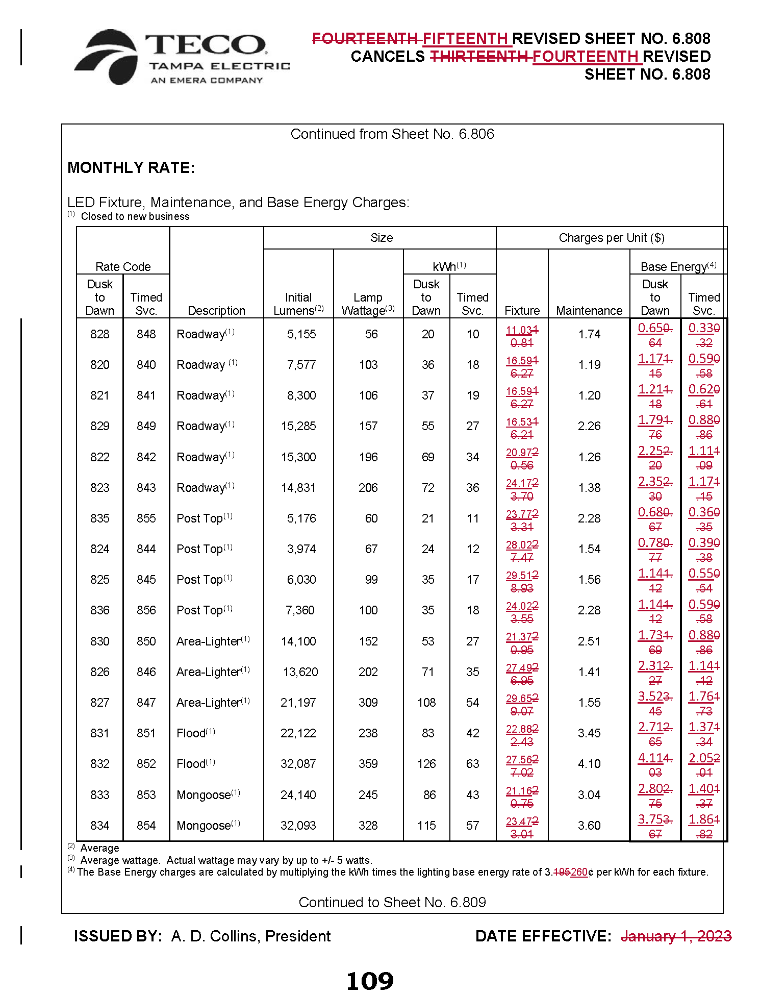
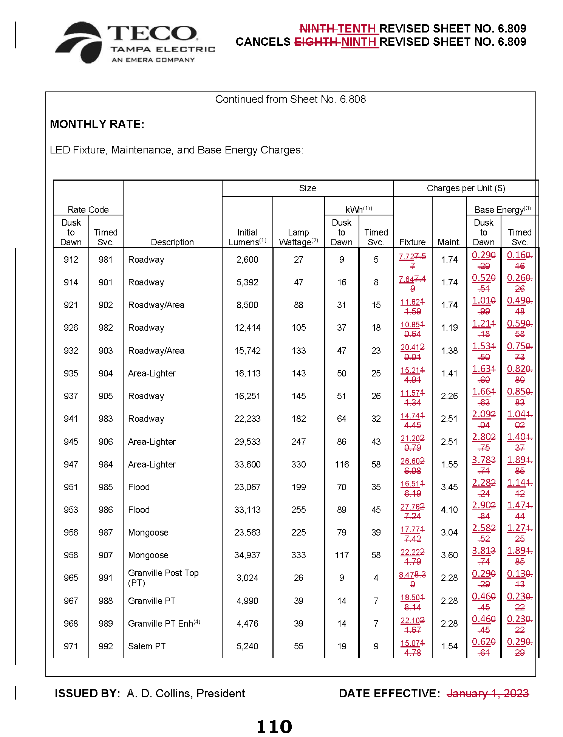
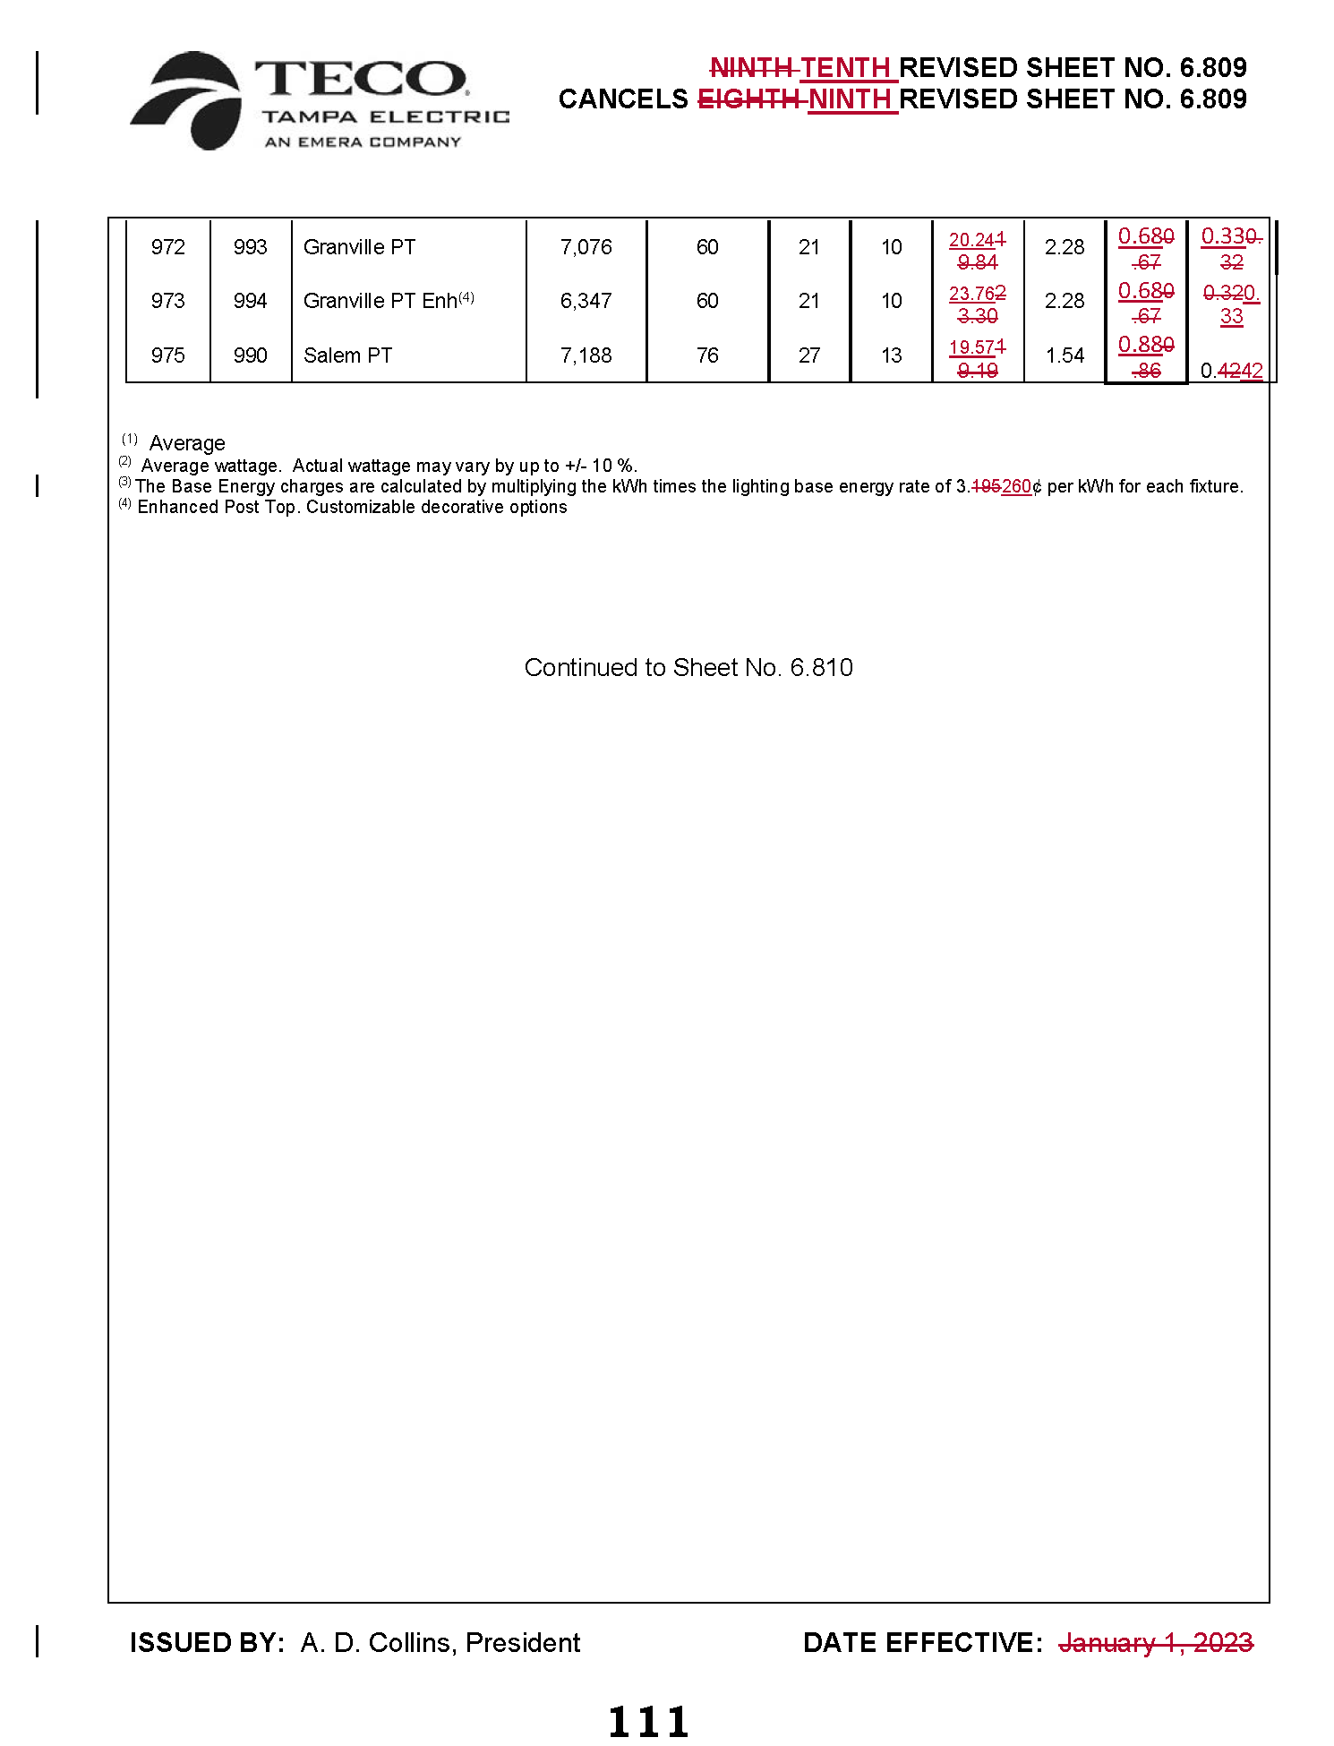
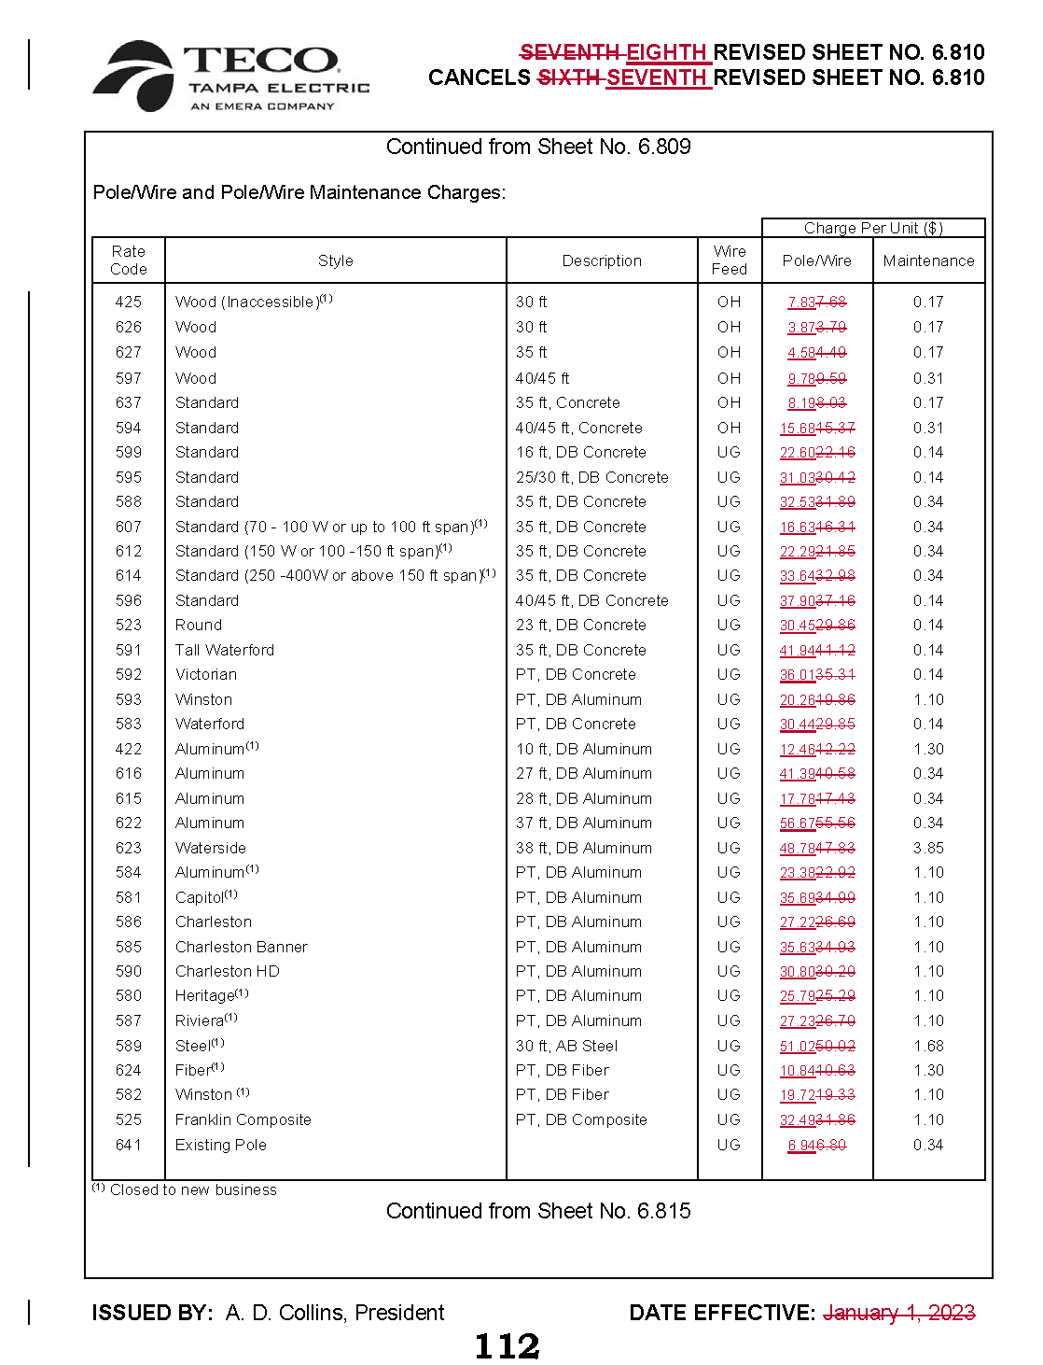
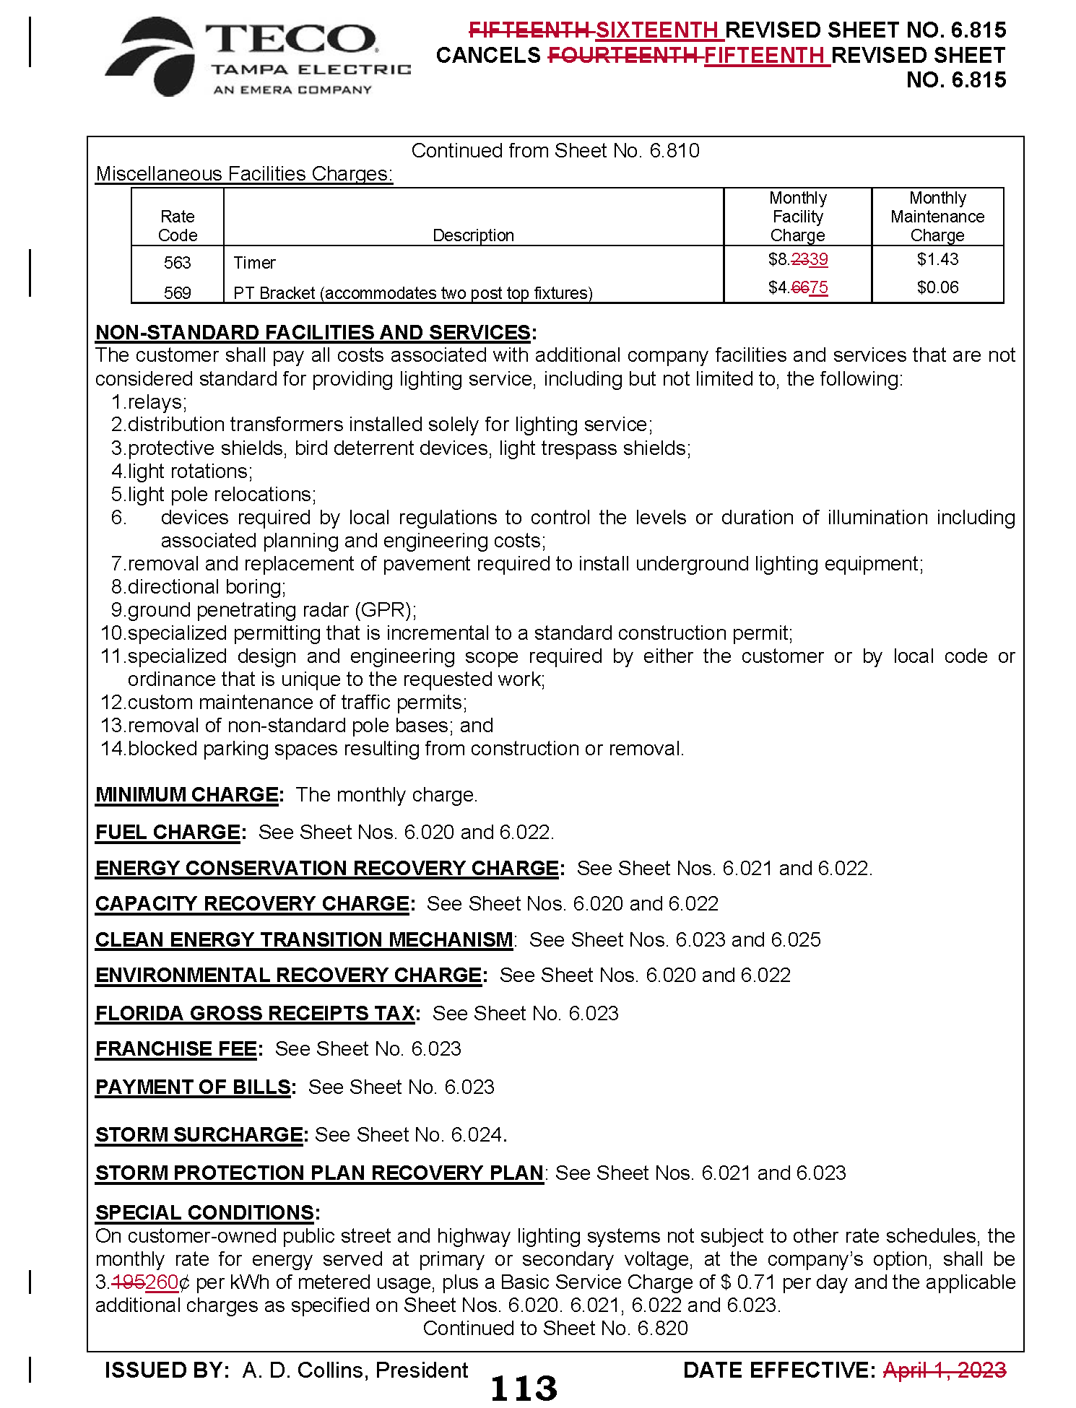
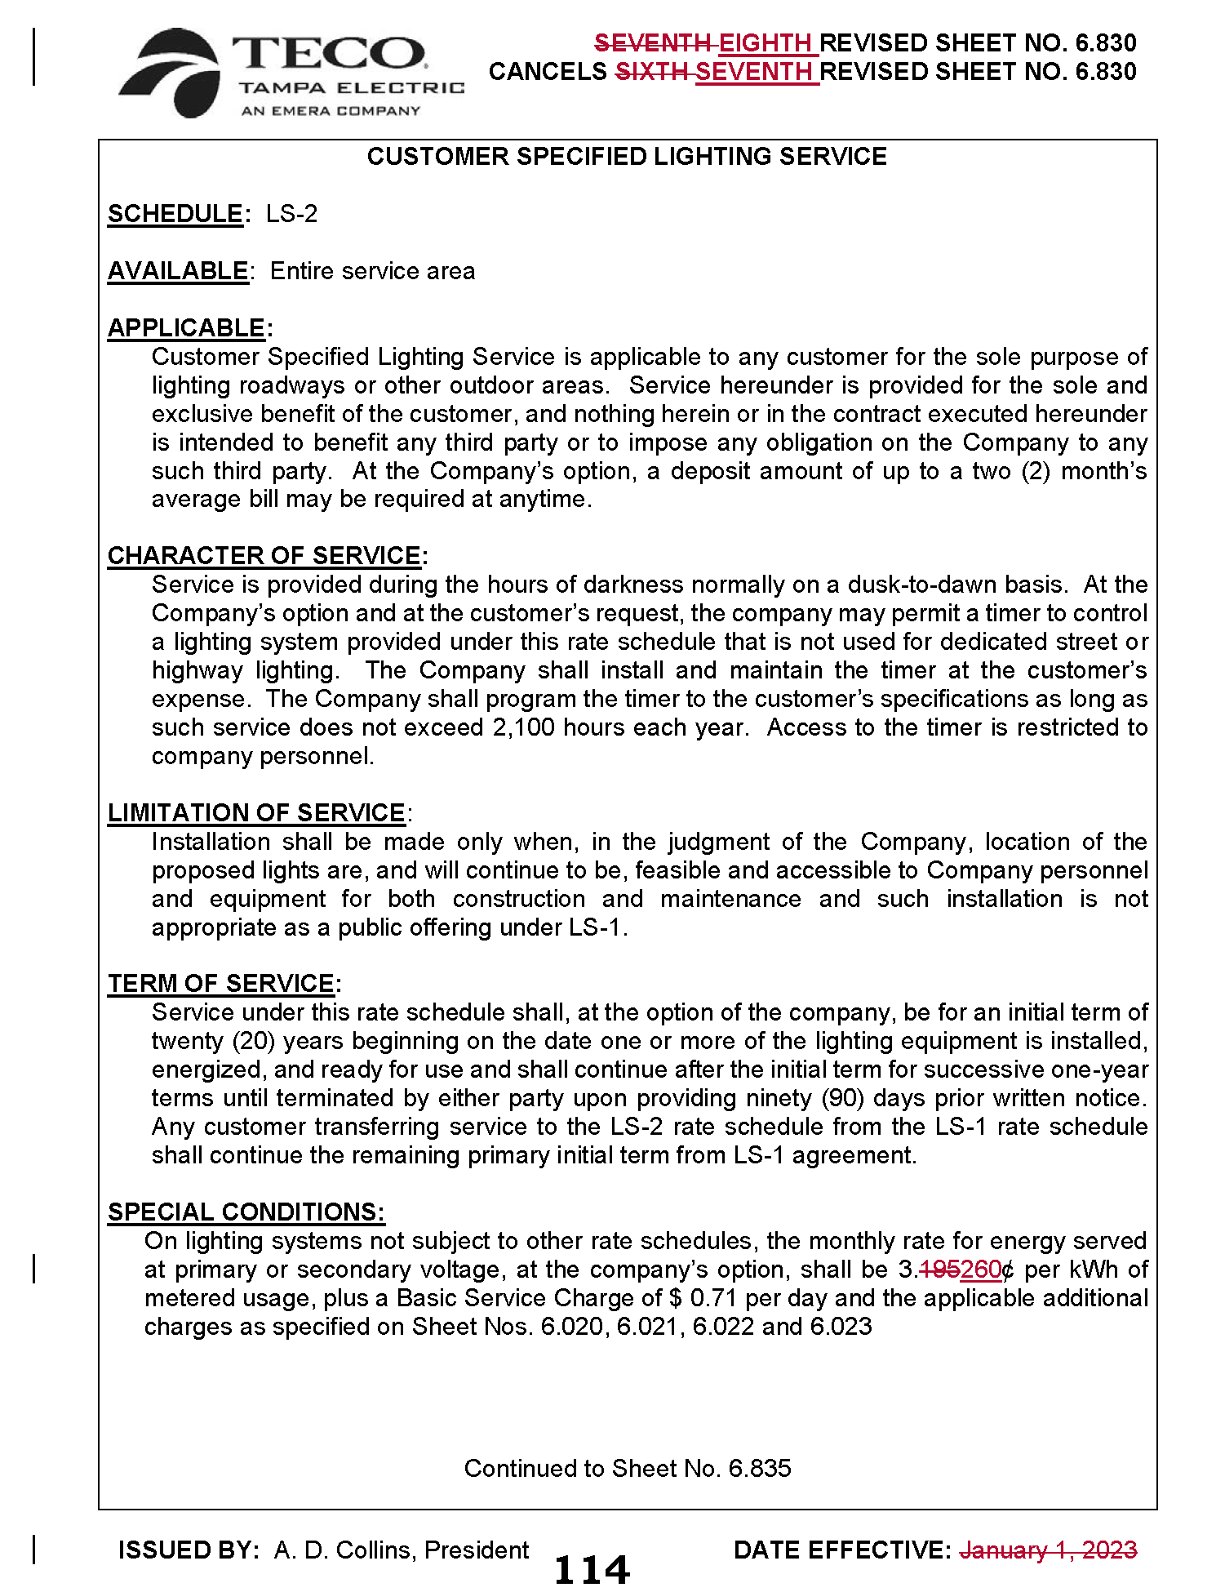
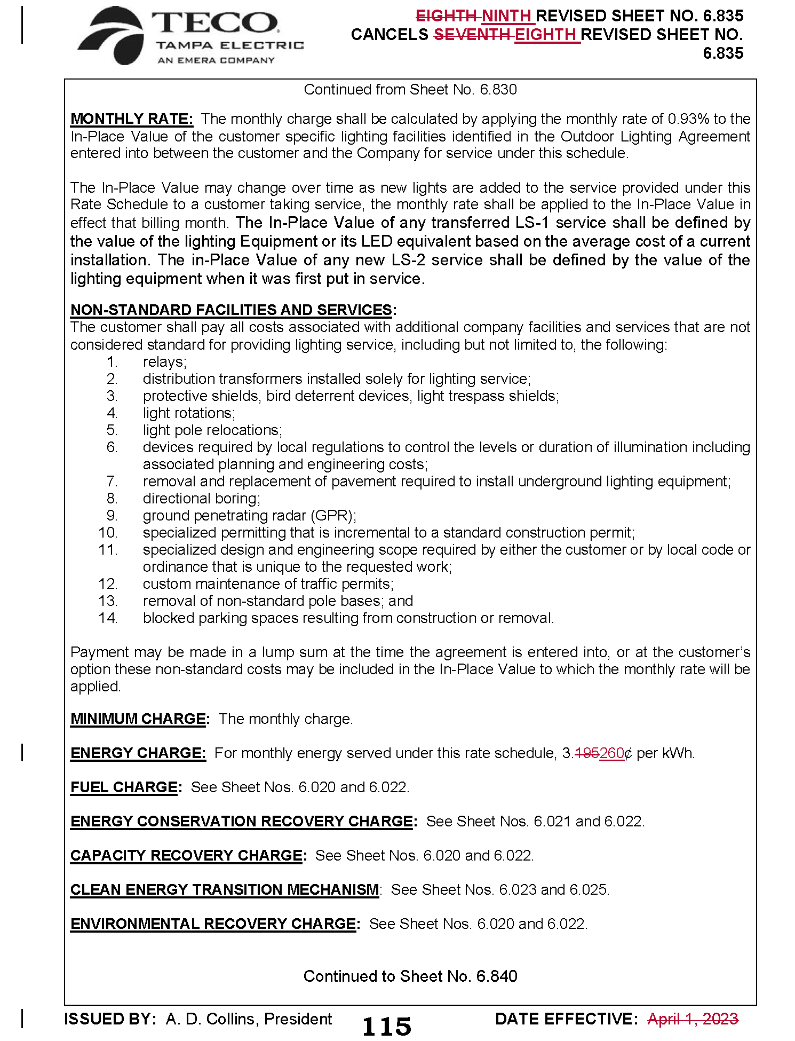

Order No. PSC-2021-0423-S-EI, issued November 10, 2021, in Docket No. 20210034-EI, In re: Petition for rate increase by Tampa Electric Company.
Order No. PSC-2022-0434-TRF-EI, issued December 21, 2022, in Docket No. 20220148-EI, In re: Petition to implement 2023 generation base rate adjustment provisions in 2021 agreement, by Tampa Electric Company.
See page 20 in Order No. PSC-2021-0423-S-EI, issued November 10, 2021, in Docket No. 20210034-EI, In re: Petition for rate increase by Tampa Electric Company.
Order No. PSC-2022-0322-FOF-EI, issued September 12, 2022, in Docket No. 20220122-EI, In re: Petition for limited proceeding rate increase to implement return on equity provisions in 2021 agreement, by Tampa Electric Company.
Document No. 04531-2023, filed August 4, 2023, in Docket No. 20230002-EG, In re: Energy Conservation Cost Recovery Clause.

