State of Florida |  | Public Service Commission  Capital Circle Office Center ● 2540 Shumard Oak Boulevard  Tallahassee, Florida 32399-0850  -M-E-M-O-R-A-N-D-U-M-
DATE: | February 22, 2024
TO: | Office of Commission Clerk (Teitzman)
FROM: | Office of the General Counsel (Sapoznikoff) SMC  Division of Accounting and Finance (Cicchetti) ALM  Division of Economics (Guffey) EJD
RE: | Docket No. 20240019-PU – Proposed amendment of Rule 25-14.004, F.A.C., Effect of Parent Debt on Federal Corporate Income Tax.
AGENDA: | 03/05/24 – Regular Agenda – Rule Proposal – Interested Persons May Participate
COMMISSIONERS ASSIGNED: |  |  | All Commissioners
PREHEARING OFFICER: |  |  | Graham
RULE STATUS: |  |  | May Be Deferred
SPECIAL INSTRUCTIONS: |  |  | None

Case Background
Rule 25-14.004, Florida Administrative Code (F.A.C.), Effect of Parent Debt on Federal Corporate Income Tax, addresses how to assess the income tax expense of a regulated entity that is a subsidiary company and which files a consolidated tax return with a parent company. Under the current rule, which applies to all regulated industries, if the regulated utility is a subsidiary of one or more parent companies, the income tax effect of any parent debt invested in the equity of the subsidiary utility reduces the income tax expense of the regulated utility. There is a rebuttable presumption that a parent company’s investment in any subsidiary or in its own operations shall be considered to have been made in the same ratios as exist in the parent’s overall capital structure.

History of the Rule
Before Rule 25-14.004, F.A.C., was adopted, to determine the tax amount to be used in ratemaking for a regulated subsidiary that filed a consolidated income tax return with one or more parent companies, the Commission typically used only the subsidiary’s income (subsidiary approach), rather than the combined income reflected on the consolidated return (consolidated approach). That policy was challenged by OPC in Citizens of Fla. v. Hawkins, 356 So. 2d 254 (Fla. 1978). OPC argued that use of the subsidiary approach resulted in double-leverage as the regulated entity was able “to receive an allowance for income tax expense greater than the actual income tax liability for which it would be properly responsible under [the] consolidated return.” Id. at 259.
In Hawkins, the Court found that there was insufficient record evidence to support the subsidiary approach and that the evidence in the record supported the consolidated approach as being more accurate. Id. at 259-260 (citations omitted).
Thereafter, in 1983, the Commission adopted the current rule reflecting the consolidated approach. The rule was challenged and upheld as a valid exercise of legal authority in General Tele. Co. of Fla. v. Fla. Pub. Serv. Comm’n, 446 So. 2d 1063 (Fla. 1984). However, as discussed further below, General Telephone was not a substantive endorsement of the consolidated approach over the subsidiary approach. Rather, the Court only evaluated whether the rule was “reasonably related to the purposes of the enabling legislation, and. . . not arbitrary or capricious.” General Tele., 446 So. 2d at 1067 (quoting Agrico Chem. Co. v. State, Dep’t of Env. Reg., 365 So. 2d 759 (Fla. 1st DCA 1978), cert. den’d, 376 So. 2d 74 (Fla. 1979)).
In 1988, the Commission considered whether the rule was necessary or whether the litigation process would resolve the tax matter, and whether the rule should be repealed. The staff recommendation provided argument both in support of the current rule and also in support of its repeal. The Commission did not affirmatively reject repeal of the rule. Rather, the Commission order simply stated, “[w]e do not wish to revisit the rule at this time.”
No further efforts to repeal or amend the rule have been made since that time.

Procedural Matters
Staff initiated this rulemaking to amend Rule 25-14.004, F.A.C., to update the rule to change the method by which the tax expense of a regulated subsidiary utility is determined to a stand-alone basis (which reflects current, nationally recognized best practices), and to clarify and simplify the rule by deleting reference to a repealed rule.
The Notice of Development of Rulemaking appeared in the June 23, 2023, edition of the Florida Administrative Register, Volume 49, Number 122. Following publication of the Notice of Development of Rulemaking, the Office of Public Counsel (OPC) requested a workshop. The rule development workshop occurred on August 15, 2023. Representatives of OPC, Duke Energy Florida (DEF), Florida Power & Light Company (FPL), Florida City Gas (FCG), Florida Public Utilities Company (FPUC), People’s Gas System, Inc. (PGS), and Tampa Electric Company (TECO) attended the workshop. All stakeholders submitted comments.
This recommendation addresses whether the Commission should propose the amendment of Rule 25-14.004, F.A.C. The Commission has jurisdiction pursuant to Sections 120.54 and 350.127(2), Florida Statutes (F.S.).

Discussion of Issues

Issue 1:
Should the Commission propose the amendment of Rule 25-14-004, F.A.C., Effect of Parent Debt on Federal Corporate Income Tax?

Recommendation:
Yes. The Commission should propose the amendment of Rule 25-14.004, F.A.C., as set forth in Attachment A. The Commission should certify the rule as a minor violation rule. (Sapoznikoff, Cicchetti, Guffey)

Staff Analysis:
Currently the rule considers the debt of a parent company invested in a regulated, subsidiary utility. Following adoption of the rule in 1983, regulatory theory and practice, accounting principles, finance theory, economic theory, corporate structure, and legal rulings have evolved. Consequently, use of consolidated parent company data to set utility rates is no longer generally accepted and the method in the recommended amendments has become the prevailing national standard over time. By imputing a parent’s debt the current rule results in an inaccurate revenue requirement which ultimately results in artificially low rates that can adversely affect or increase the frequency of the need for rate increases. Accordingly, the time has come to make a change. Staff recommends that the rule be amended as set forth in Attachment A. Below is a detailed discussion of staff’s recommended amendments to the rule.

Rule 25-14.004, F.A.C., Determination of Total Corporate Income Tax
The initial paragraph of the current rule is unnumbered and requires that when a regulated utility is a subsidiary of one or more parent companies and files a consolidated tax return with a parent company, the subsidiary’s income tax must be adjusted to reflect the income tax expense of the parent debt that may be invested in the equity of the subsidiary.
The recommended amendments to the unnumbered introductory paragraph require that the income tax expense of a regulated utility be determined using only its income, regardless of any parent-subsidiary relationship that may exist. This policy is referred to as the stand-alone approach. The stand-alone basis ensures that the revenue requirement is based upon tax benefits associated with the debt that is both an expense of the regulated utility and borne by that utility’s customers.
Overall, staff recommends changing Commission policy on how to determine the income tax expense of a regulated utility that is a subsidiary of one or more parent companies to align the rule with the current national standard. Under the current rule, the tax benefits associated with the parent company’s interest expense are attributed to the subsidiary utility. This inappropriately lowers utility rates, distorts price signals, and contributes to the inefficient allocation of resources. Under the recommended amendments to Rule 25-14.004, F.A.C., the Commission would use only the interest expense inherent in the capital structure of the regulated utility to compute income tax expense, rather than reducing the tax expense in accordance with the parent’s capital structure.
If the Commission votes to approve the recommended policy change, the recommended amendments to subsections (1) through (4) and the addition of subsection (5) are necessary to reflect the change in the process of making tax determinations from incorporating parent debt to only using the tax expense of the regulated utility. Staff’s recommendations for the amendment of each subsection of the rule is below.

Subsection (1)
Subsection (1) of the current rule addresses how to calculate the income tax effect of the parent’s debt when there is only one parent company.
As parent debt is not a consideration in the recommended amendments, the recommended amendment of subsection (1) deletes the prior language in its entirety. In its place the recommended rule language of subsection (1) sets forth the method of determining state corporate current income tax of the regulated, subsidiary utility. This amount is calculated by multiplying the regulated utility’s state taxable income before state and federal income taxes by Florida’s corporate income tax rate, plus or minus any applicable tax adjustments or credits in accordance with applicable state income tax laws and regulations.

Subsection (2)
Subsection (2) of the current rule addresses how to calculate the income tax effect of the parent’s debt when there is more than one parent company.
As parent debt is not a consideration in the recommended amendments, the recommended amendment of subsection (2) deletes the prior language in its entirety. In its place, the recommended rule language of subsection (2) sets forth the method of determining the federal taxable income of the regulated, subsidiary utility after state corporate income tax. This amount is calculated by deducting the state corporate income tax amount calculated pursuant to the recommended amendment of subsection (1) from the regulated utility’s federal income before taxes.

Subsection (3)
Subsection (3) of the current rule addresses what is included in the capital structure of the parent and notes that it is a rebuttable presumption that “a parent’s investment in any subsidiary or in its own operations shall be considered to have been made in the same ratios as exist in the parent’s overall capital structure.”
As parent debt is not a consideration in the recommended amendments, the recommended amendment of subsection (3) deletes the prior language in its entirety. In its place, the recommended rule language of subsection (3) sets forth the method of determining the federal current corporate income tax of the regulated, subsidiary utility. This amount is calculated by multiplying the federal taxable income after state taxes (which amount was calculated pursuant to the recommended amendment of subsection (2)), by the federal corporate income tax rate, plus or minus any applicable tax adjustments or credits in accordance with applicable federal income tax laws and regulations.

Subsection (4)
Subsection (4) of the current rule addresses how to calculate the parent debt adjustment using debt ratio and debt cost of the parent, the statutory tax rate applicable to the consolidated entity, and the equity dollars of the regulated subsidiary, excluding its retained earnings.
As parent debt is not a consideration in the recommended amendments, the recommended amendment of subsection (4) deletes the prior language in its entirety. In its place, the recommended rule language of subsection (4) clarifies that applicable temporary adjustments to taxable income multiplied by the respective federal and state corporate income tax rates, plus or minus any applicable tax adjustments or credits in accordance with applicable federal and state income tax laws and regulation, shall be used in determining federal and state income tax expenses for the regulated utility.

Subsection (5)
The current version of the rule does not contain a subsection (5). The recommended amendment of the rule adds subsection (5), which states that total income tax expense for the regulated utility will be determined by adding the amounts calculated pursuant to the recommended amendments of subsections (1), (3), and (4) of the rule.

Stakeholder Comments
All stakeholders who commented, except for OPC, support the recommended amendments to Rule 25-14.004, F.A.C. OPC’s objections to the recommended amendment of the rule fall into two main categories. First, OPC opposes the recommended amendment of the rule because it alleges the stand-alone method will inappropriately increase rates and result in double-leverage. Next, OPC alleges that precedent disallows the stand-alone method contained in the recommended amendments to the rule. As discussed below, staff disagrees with OPC’s comments.

The recommended amendments align the rule with current national standards and will not inappropriately increase rates or result in double leverage.
In essence, the parent-debt adjustment (recognizing double leverage) perverts the calculation of return on equity (ROE). In a rate proceeding, the Commission determines the appropriate ROE and capital structure (i.e., the appropriate debt and equity ratios), which reflect the utility’s cost of obtaining funds. The parent-debt adjustment imputes the tax deduction associated with parent company debt to the regulated utility. However, because the regulated utility did not incur the parent’s interest expense, the regulated utility cannot claim that expense on its taxes and reduce its costs.
When the current rule is applied, the utility does not collect the actual cost of providing utility service. Consequently, the utility may seek rate increases more frequently incurring additional rate case expense. Moving away from the parent debt adjustment and adopting the stand-alone approach is also beneficial to rate payers. Setting rates on a stand-alone basis ensures only the costs associated with the provision of utility service are charged to customers.
Under [the] stand-alone methodology, a regulated entity's income tax allowance is based on the income and deductions specifically attributable to the regulated entity's jurisdictional cost of service and the income tax allowance does not incorporate potentially offsetting losses and deductions of the parent owner not reflected in the regulated entity's jurisdictional cost of service.
Trailblazer Pipeline Co., LLC, 166 F.E.R.C. P61141, 61674, 2019 WL 830962, at *10 (FERC Feb. 21, 2019) (citing City of Charlottesville v. Fed. Energy Reg. Comm’n, 774 F.2d 1205, 1215 (1985), cert. den’d, 475 U.S. 1108 (1986)).
While some cases have described the stand-alone approach as relying on a “hypothetical” calculation, using the parent debt adjustment artificially decreases the regulated utility’s tax expense and lowers the regulated subsidiary’s revenue requirement. While the parent debt adjustment approach lowers rates, it results in a revenue requirement based upon tax benefits associated with debt that is neither an expense of the utility nor borne by the utility’s customers. If taxes are allocated in a manner other than on a stand-alone basis, utility customers may pay rates that reflect costs or benefits of other nonregulated members of the consolidated group.
In its written comments, OPC alleges that staff’s concern that application of the rule results in “double leverage” is unfounded. However, contrary to OPC’s allegations, the cases that advance a parent-debt adjustment do so for double-leverage. See, e.g., New England Tele. & Teleg. Co. v. Pub. Utils. Comm’n, 390 A.2d 8, 28-47 (Me. 1978). Double leverage occurs when a subsidiary enjoys its own leverage (use of debt instead of all equity capital) plus the leverage factor of its parent company (which also uses some debt instead of all equity capital). See id. at 41.
Of the utilities providing comments, DEF, FPL, FCG, FPUC, PGS, and TECO agree with staff’s rationale for the recommended amendment of the rule. FPL and its affiliates note the rule’s effect is that the “parent company’s debt is imputed to the benefit of customers even though customers are not obligated to pay rates reflecting the interest expense on the parent’s debt in rates” which may result in the need to file requests for “more frequent and costly base rate increases, which will further increase rates paid by customers.” They assert that “to mitigate this costly and time-consuming potential that rates should reflect the taxes associated with only the items that are included in the cost of service and net operating income directly attributable to them.” TECO’s comments generally adopt those submitted by FPL and its affiliates.
DEF agrees that “the better approach is to compute the regulated utility’s tax expense on a stand-alone basis without making the adjustment currently called for in the Rule.” DEF asserts that the stand-alone approach “provides a match between capital structure interest and the tax effect considered in the regulated utility’s cost of service.” Because capital structure is always determined in a base rate proceeding, DEF contends that the “Commission is assured that the capital structure has been properly set.”

There is no precedent disallowing the stand-alone method.
In its oral and written comments, OPC argues “there is no basis to change a 40-year old consumer protection rule that has survived challenges in the Florida Supreme Court, the United States Treasury Department and the United States Congress.” OPC further argues that the Commission has twice considered and denied repeal of the rule. OPC states the rule is “a fundamental bedrock principle of Florida utility regulation that has been applied to keep Florida customer utility rates low for 45 years.”
Staff believes there is no indication that the rule was designed with consumer protection in mind nor that the recommended amendments to the rule would harm consumers. Just because the rule has survived challenges does not mean it has been endorsed as the only or proper way to assess tax liability. In fact, as discussed in more detail below, the cases to which OPC cites support the stand-alone method contained in the recommended amendments to the rule.

Florida Supreme Court precedent does not preclude the stand-alone method.
OPC asserts the current version of the rule was unequivocally upheld by the Florida Supreme Court in General Tele. Co. of Fla. v. Fla. Pub. Serv. Comm’n, 446 So. 2d 1063 (Fla. 1984). OPC further argues General Telephone supported the Court’s prior decision in Citizens of Fla. v. Hawkins, 356 So. 2d 254 (Fla. 1978), which OPC alleges stands for the proposition that “the regulated utility’s tax deductible debt may cause customers to overpay on the income tax component imbedded in their rates.” As explained below, staff believes OPC has misconstrued the holdings of those cases.
Citizens of Fla. v. Hawkins, 356 So. 2d 254 (Fla. 1978), was the first Florida Supreme Court case to address the Commission’s computation of the income tax for a regulated entity that was a subsidiary and filed a consolidated return with a parent company. At that time, the Commission did not have a rule on that matter, but traditionally used what was referred to as a “subsidiary approach” rather than a “consolidated approach.” The “subsidiary approach” was described as using “an allowance for federal income tax expense equal to the hypothetical tax which would have been paid if [the subsidiary] had filed a separate federal income tax return.” Hawkins, 356 So. 2d at 259. In Hawkins, OPC argued that use of the “subsidiary approach” resulted in double-leverage as the regulated entity was able “to receive an allowance for income tax expense greater than the actual income tax liability for which it would be properly responsible under [the] consolidated return.” Id.
In Hawkins, the Commission noted that OPC did not object to using the “subsidiary approach” to calculate the cost of capital and, accordingly, it would be consistent also to do so in determining tax effect. Id. However, unable “to discern a rationale for a rule of consistency” and finding that the Commission’s order “nowhere identified a record basis for preferring...the subsidiary approach over a calculation on the consolidated approach,” the Court held that “each [tax] determination must be based on specific independent findings supported by competent substantial evidence” and that “what evidence there is in the record supports the consolidated approach as being more accurate.” Id. at 259-260 (citations omitted).
Thus, contrary to OPC’s suggestions, Hawkins did not mandate application of the consolidated approach. Rather, the Court merely held that under the facts of that case, the consolidated approach was supported by the record evidence. See id.
Thereafter, the current rule (mandating the consolidated approach) was adopted in 1983. Although the Florida Supreme Court upheld the validity of the rule in General Tele. Co. of Fla. v. Fla. Pub. Serv. Comm’n, 446 So. 2d 1063 (Fla. 1984), it was not necessarily a substantive endorsement. Rather, the Court only evaluated whether the rule was “reasonably related to the purposes of the enabling legislation, and. . . not arbitrary or capricious.” General Tele., 446 So. 2d at 1067 (quoting Agrico Chem. Co. v. State, Dep’t of Env. Reg., 365 So. 2d 759 (Fla. 1st DCA 1978), cert. den’d, 376 So. 2d 74 (Fla. 1979)).
While the Court acknowledged that it had previously “instructed the PSC to apply this type of adjustment in a ratemaking case,” it qualified that statement by stating:
There is no single correct method of dealing with the income tax expense of a subsidiary-utility joining in the filing of a consolidated return. By choosing this particular method, the PSC is merely acting within the scope of its discretion.
General Tele., 446 So. 2d at 1067. Therefore, the recommended amendments to the rule are within the discretion of this Commission and reflect nationally recognized best practices.
Moreover, while General Telephone noted that the Federal Energy Regulation Commission (FERC) and “at least eighteen jurisdictions” had adopted the consolidated approach, that is no longer the case. FERC now uses the stand-alone approach reflected in the recommended amendments to the rule, and Florida is one of only a handful of states that still use a consolidated approach. States that have adopted the stand-alone approach have done so “due to the increasing structural complexity of regulated utility entities and the expansion of non-utility activities by subsidiaries.” SFPP, L.P. v. Public Utils. Comm’n, 217 Cal. App. 4th 784, 795 (2013). In addition, “without the stand-alone treatment of the regulated entity, the non-utility activities could result in a tax expense or savings unrelated to the costs of providing utility service.” ARCO Prods. Co. v. Santa Fe Pacific Pipeline, L.P., Dec. No. 11–05–045, 2011 WL 2246059 at 8 (Cal. P.U.C. 2011).

United States Treasury and Congressional inaction do not preclude the stand-alone method.
OPC also asserts that inaction by the U.S. Treasury and Congress indicated that the stand-alone method is improper. OPC states that in 1990, the U.S. Treasury proposed a regulation that many interpreted “as an indication that the [parent debt adjustment] could be deemed a consolidated tax savings adjustment and a normalization violation.” According to OPC, it and the Commission joined in filing comments at a 1991 IRS hearing on the matter and were in agreement that the parent debt adjustment was not a consolidated tax savings adjustment or a normalization violation. According to OPC, of the hundreds of parties (which OPC asserts included utilities, consumers, and regulatory agencies), no one supported the regulation. OPC further states that the IRS eventually withdrew the proposed regulation. OPC advises that Congress also was “concerned about whether normalization was costing the United States Treasury tax revenue” and held hearings. According to OPC, it and the Commission testified before Congress “in support of the rule and the Commission’s practice to recognize the tax effect of parent company debt in ratemaking.” OPC states that Congress took no action. OPC does acknowledge that by that time FERC had retreated from a parent debt adjustment.
OPC’s reliance on the failure of the IRS to change its consolidated return rule as validation of the parent debt rule is misplaced. The proposed Treasury regulation may have resulted in the Commission’s parent debt adjustment rule violating a normalization method of accounting. However, the failure of the IRS to change its policy (regarding the flow-through of tax savings arising from the filing of a consolidated return) does not mean the IRS endorsed the parent debt adjustment contained in the rule, or that the rule was the proper or only way for the Commission to determine a subsidiary’s taxes when setting rates.
Moreover, federal tax policy and rate setting by a utility commission are two distinct regulatory mechanisms. See Federal Power Comm’n v. United Gas Pipe Line Co., 386 U.S. 237, 243 (1967). The Court noted that a commission has the power “to limit cost of service to real expense” and that doing so would not frustrate tax laws. Id. at 245-47.

Prior Commission orders do not preclude the stand-alone method.
In its oral comments, OPC asserts that the Commission had twice previously been asked to repeal the parent-debt adjustment and had twice rejected that request. That is not correct. The Commission has never substantively rejected repeal of the parent-debt adjustment.
In 1987, staff submitted a recommendation to repeal the rule asserting that the rule was unnecessary and that the litigation process would resolve the tax matter. The Commission deferred ruling and requested that staff submit a new recommendation.
In 1988 the Commission considered the new recommendation which provided argument both in support of the rule and also in support of its repeal. Again, the Commission did not affirmatively reject repeal of the rule. Rather, the Commission order simply stated, “[w]e do not wish to revisit the rule at this time.”
Moreover, in contrast to the options previously submitted of either repealing or keeping the parent debt adjustment, the current recommended amendment of Rule 25-14.004, F.A.C., sets forth an alternative approach which updates the rule to conform to best practices.

Minor Violation Rule Certification
Pursuant to Section 120.695, F.S., for each rule filed for adoption, the agency head shall certify whether any part of the rule is designated as a rule the violation of which would be a minor violation. Rule 25-14.004, F.A.C., is currently listed as a minor violation rule by the Commission. This rule is a minor violation rule because the violation of this rule would not result in economic or physical harm to a person, cause an adverse effect on the public health, safety, or welfare, or create a significant threat of such harm. Violations of Rule 25-14.004, F.A.C., with the recommended amendments would continue to be minor violations. Therefore, for the purposes of filing the proposed amended rules for adoption with the Department of State, staff recommends that the Commission certify Rule 25-14.004, F.A.C., as a minor violation rule.

Statement of Estimated Regulatory Costs
Section 120.54(3)(b)1., F.S., encourages agencies to prepare a Statement of Estimated Regulatory Costs (SERC) before the adoption, amendment, or repeal of any rule. A SERC was prepared for this rulemaking and is appended as Attachment B. As required by Section 120.541(2)(a)1., F.S., the SERC analysis includes whether the rule amendments are likely to have an adverse impact on economic growth, private sector job creation or employment, or private sector investment in excess of $1 million in the aggregate within five years after implementation. None of the impact/cost criteria will be exceeded as a result of the recommended amendments.
The SERC concludes that the amendments to the rule will likely not directly or indirectly increase regulatory costs in excess of $200,000 in the aggregate in Florida within one year after implementation. Further, the SERC concludes that the recommended rule amendments will not likely increase regulatory costs, including any transactional costs, or have an adverse impact on business competitiveness, productivity, or innovation, in excess of $1 million in the aggregate within five years of implementation. Thus, pursuant to Section 120.541(3), F.S., the recommended amendment of the rule does not require legislative ratification.
In addition, the SERC states that the recommended amendments to the rule would have no impact on small businesses, would have no implementation or enforcement costs on the Commission or any other state or local government entity, and would have no impact on small cities or small counties. The SERC states that there will be no transactional costs likely to be incurred by individuals and entities required to comply with the requirements.

Conclusion
The Commission should propose the amendment of Rule 25-14.004, F.A.C., as set forth in Attachment A. Staff also recommends that the Commission certify the rule as a minor violation rule.

Issue 2:
Should this docket be closed?

Recommendation:
Yes. If no requests for hearing or comments are filed, the rule should be filed for adoption with the Department of State, and the docket should be closed. (Sapoznikoff)

Staff Analysis:
If no requests for hearing or comments are filed, the rule should be filed for adoption with the Department of State, and the docket should be closed.

25-14.004 Determination Effect of Parent Debt on Federal Total Corporate Income Tax.
In Commission proceedings to establish revenue requirements or address over-earnings, other than those entered into under Rule 25-14.003, F.A.C., the income tax expense of a regulated utility company must shall be determined using only the income of the regulated utility regardless of any adjusted to reflect the income tax expense of the parent debt that may be invested in the equity of the subsidiary where a parent-subsidiary relationship that may exists. and the parties to the relationship join in the filing of a consolidated income tax return. The regulated utility’s stand-alone income tax expense will be calculated as follows:
(1) State corporate current income taxes will be determined by multiplying the regulated utility’s state taxable income before state and federal income taxes by Florida’s corporate income tax rate, plus or minus any applicable tax adjustments or credits in accordance with applicable state income tax laws and regulations. Where the regulated utility is a subsidiary of a single parent, the income tax effect of the parent’s debt invested in the equity of the subsidiary utility shall reduce the income tax expense of the utility.
(2) The state current corporate income taxes as calculated in subsection (1) will then be deducted from the regulated utility’s federal income before income taxes to yield the federal taxable income after state income taxes. Where the regulated utility is a subsidiary of tiered parents, the adjusted income tax effect of the debt of all parents invested in the equity of the subsidiary utility shall reduce the income tax expense of the utility.
(3) The federal taxable income after state current income taxes as calculated in subsection (2) will then be multiplied by the federal corporate income tax rate, plus or minus any applicable tax adjustments or credits in accordance with applicable federal income tax laws and regulations, to yield the federal current corporate income tax for the regulated utility. The capital structure of the parent used to make the adjustment shall include at least long term debt, short term debt, common stock, cost free capital and investment tax credits, excluding retained earnings of the subsidiaries. It shall be a rebuttable presumption that a parent’s investment in any subsidiary or in its own operations shall be considered to have been made in the same ratios as exist in the parent’s overall capital structure.
(4) Federal and state deferred income tax expenses for the regulated utility will be determined based on the applicable temporary adjustments to taxable income multiplied by the respective federal and state corporate income tax rates, plus or minus any applicable tax adjustments or credits in accordance with applicable federal and state income tax laws and regulations. The adjustment shall be made by multiplying the debt ratio of the parent by the debt cost of the parent. This product shall be multiplied by the statutory tax rate applicable to the consolidated entity. This result shall be multiplied by the equity dollars of the subsidiary, excluding its retained earnings. The resulting dollar amount shall be used to adjust the income tax expense of the utility.
(5) Total income tax expense for the regulated utility will be determined by adding the amounts calculated in subsections (1), (3), and (4) of this rule.
Rulemaking Authority 350.127(2) FS. Law Implemented 366.05(1), 367.121(1)(a) FS. History–New 1-25-83, Formerly 25-14.04. Amended _____

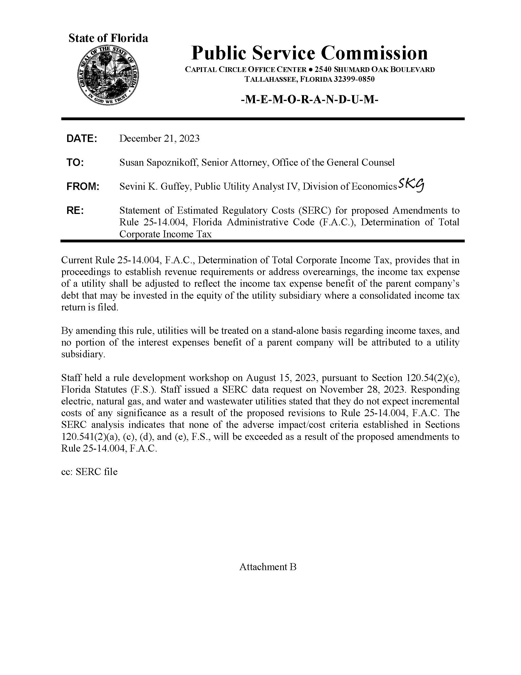

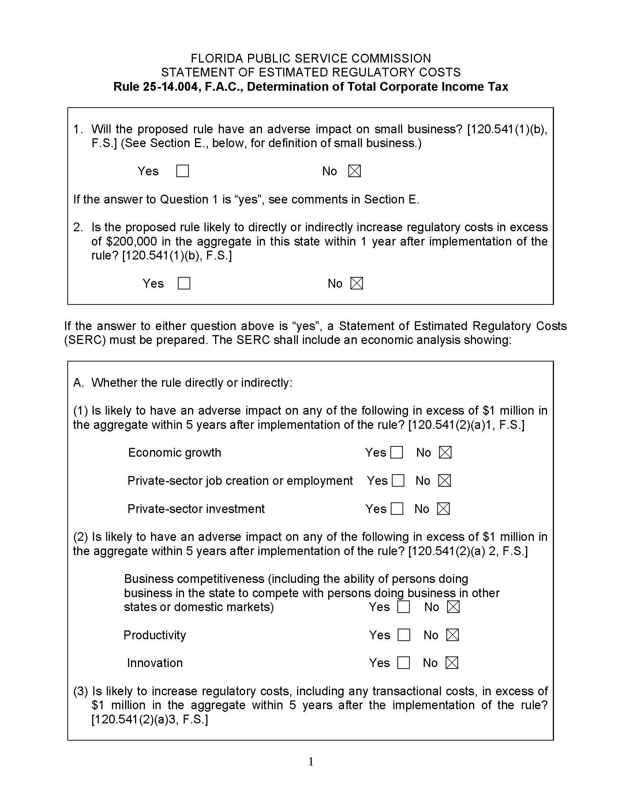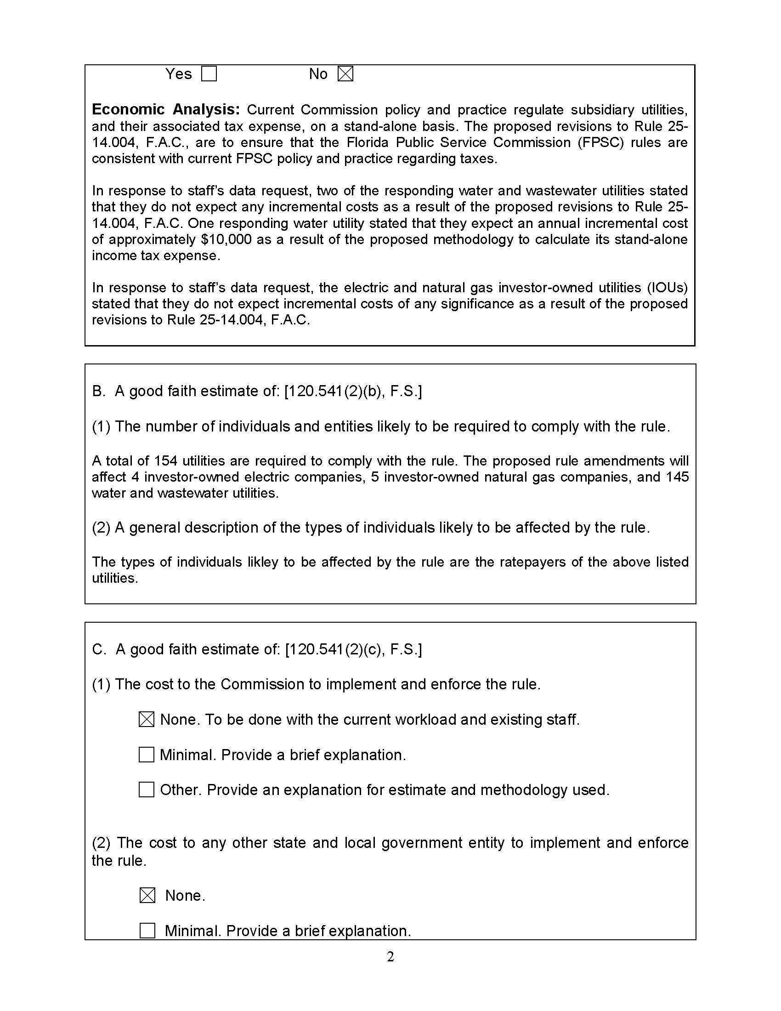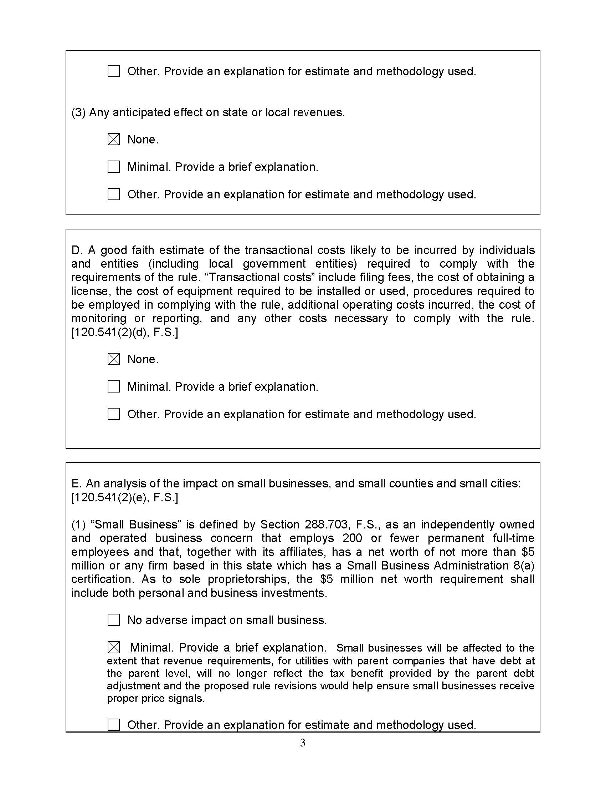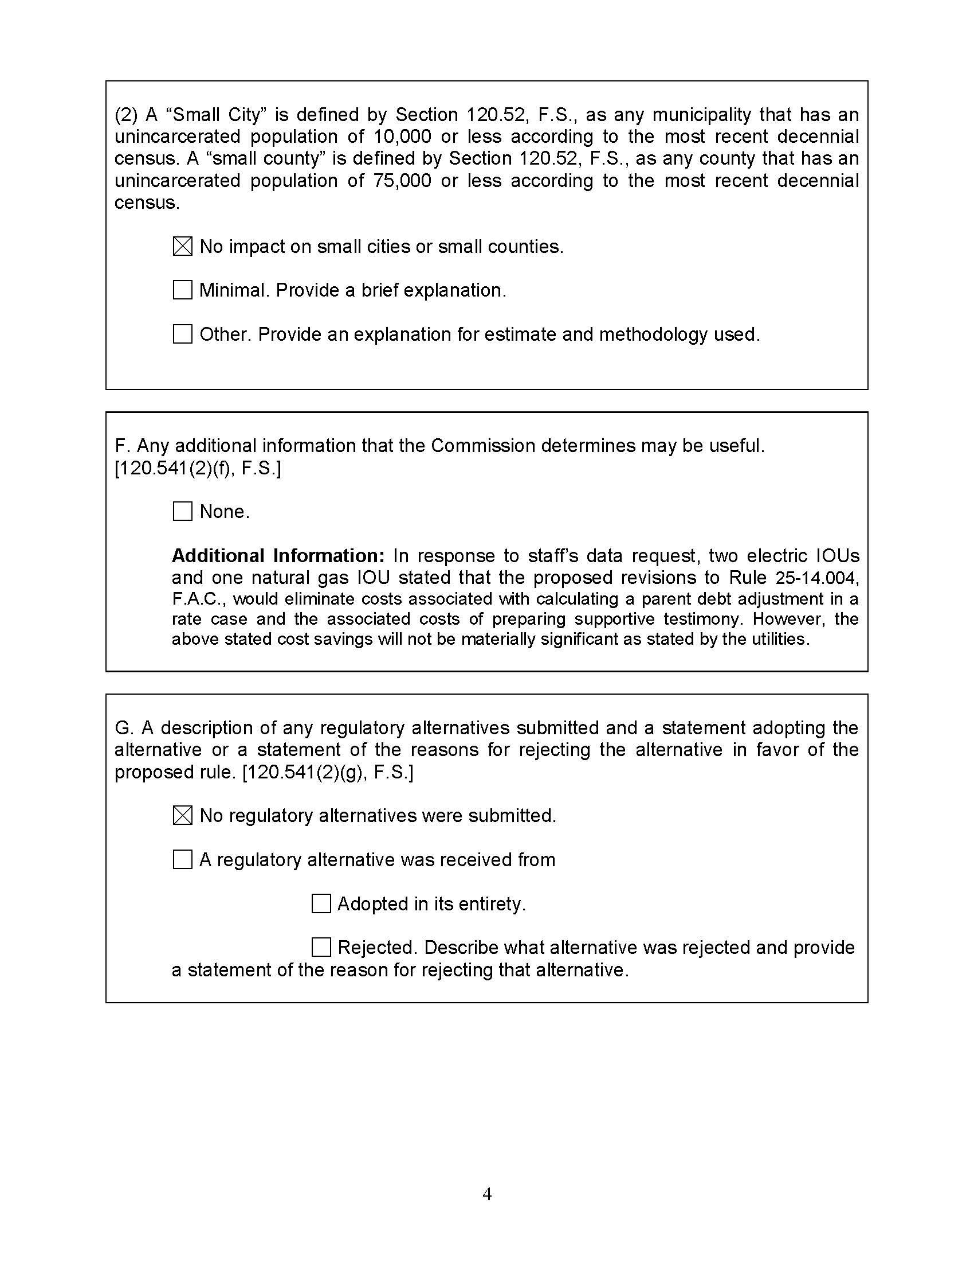

Financial leverage involves using debt to increase earnings. Shareholders benefit from financial leverage to the extent that the return on the borrowed money exceeds the interest cost. Double leverage implies a parent company issued debt to invest in the equity of a subsidiary that also issued its own debt. Hence, the leverage is doubled.
Docket No. 870386-PI, DN09448, Sept. 8, 1988.
Order No. 20206, issued Oct. 24, 1988, in Docket No. 870386-PU, In re: Repeal of Rule 25-14.004, F.A.C., Effect of Parent Debt on Fed. Corp. Income Tax.
The rule is currently named “Effect of Parent Debt on the Federal Corporate Income Tax.” Staff recommends that if the Commission votes to approve the recommended amendments of the rule, that the title of the rule also be amended to accurately reflect the rule’s content. The recommended amendment of the title of the rule is “Determination of Total Corporate Income Tax” because the recommended amendments change the policy for making tax determinations from incorporating parent debt to only using the tax expense of the regulated utility.
See, e.g., Constellation Mystic Power, LLC v. Fed. Energy Reg. Comm’n, 45 F.4th 1028 (D.C. 2022), McCloskey v. Penn. Pub. Util. Comm’n, 255 A.3d 416 (Pa. 2021), Oncor Elect. Del. Co. LLC v. Pub. Util. Comm’n of Texas, 507 S.W.3d 706 (Tex. 2017), SFPP, L.P. v. Pub. Utils. Comm’n, 217 Cal. App. 4th 784 (2013), In re North. States Power Co., 2008 WL 131201 (2008), Stumbo v. Ky. Pub. Serv. Comm’n, 243 S.W.3d 374 (Ky. App. 2007), Litchfield Park Serv. Co. v. Az. Corp. Comm’n, 874 P.2d 988 (1994), Pittman v. Miss. Pub. Serv. Comm’n, 538 So. 2d 387 (Miss. 1989), General Tele. Co. of the Southwest v. Corp. Comm’n, 852 P.2d 1200 (N.M. 1982), General Tele. Co. of SW v. Ark. Pub. Serv. Comm’n, 616 S.W.2d 1 (Ark. 1981), New York Water Serv. Corp. v. Pub. Serv. Comm’n, 72 A.D.2d 841 (N.Y. App. 3d 1979), United Tele. Co. of Iowa v. Iowa State Comm. Comm’n, 257 N.W.2d 466 (Iowa 1977).
Even though OPC opposes a change to the rule policy, it recommended an edit to the wording of subsection (4), which edit was also suggested by the other stakeholders who commented. That edit is incorporated into the recommended amendments.
In City of Charlottesville, supra, at 1213, 1221, then Judge Antonin Scalia, writing for the Federal District Court for Washington, D.C., upheld the stand-alone method.
FPL filed comments on behalf of itself, Florida Public Utilities Company, and Florida City Gas.
TECO file comments on behalf of itself and Peoples Gas.
Id. at 1069.
See Trailblazer Pipeline Co. LLC, 166 F.E.R.C. P 61141, 2019 WL 830962, at *10 (F.E.R.C. Feb. 21, 2019); Constellation Mystic Power, LLC, 165 F.E.R.C. P 61267, 2018 WL 6720402 at *14 (F.E.R.C. Dec. 20, 2018); System Ener. Resources, Inc., 57 F.E.R.C. P 63012, 1991 WL 307023, **11 (F.E.R.C. Nov. 21, 1991); City of Charlottesville v. FERC, 774 F.2d 1205, 1213, 1221 (D.C. Cir. 1985), cert. den’d, 475 U.S. 1108 (1986); In re: Columbia Gulf Trans. Co., 54 P.U.R. 4th 31, 1983 WL 874322 (F.E.R.C. June 22, 1983).
Docket No. 870386-PI, DN08216, Sept. 3, 1987.
Docket No. 870386-PI, DN08570, Sept. 15, 1987.
Docket No. 870386-PI, DN09448, Sept. 8, 1988.
Order No. 20206, issued Oct. 24, 1988, in Docket No. 870386-PU, In re: Repeal of Rule 25-14.004, F.A.C., Effect of Parent Debt on Fed. Corp. Income Tax.

