State of Florida
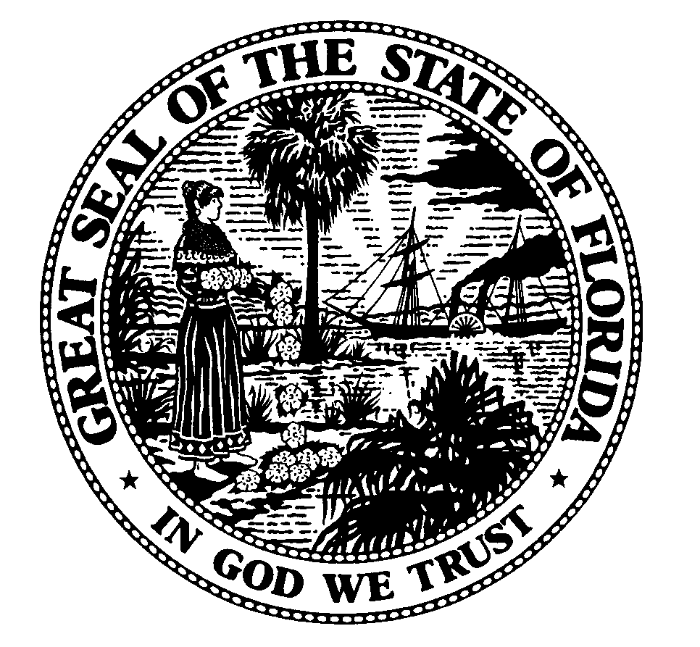

Public Service Commission
-M-E-M-O-R-A-N-D-U-M-

DATE: October 11, 2004
TO: Parties of Record
FROM: Lisa S. Harvey, Chief, Bureau of Regulatory Review
RE: Docket No. 000121A-TP
Comments on Six-Month Review of BellSouth’s Performance Assessment Plan

On August 18, 2004, BellSouth and the CLECs filed proposed changes to BellSouth’s SEEM Plan in conjunction with the six-month review process. Staff created a template that identifies the parties’ proposed changes to the SEEM plan. Staff requests that parties respond with an agreement or disagreement for each itemized change proposed by either BellSouth or the CLECs. For those areas of disagreement, please provide a basis for disagreeing. The template is filed in Docket 000121A-TP and can be downloaded from the Commission’s website at www.psc.state.fl.us or be obtained by contacting Jerry Hallenstein at jhallens@psc.state.fl.us or (850) 413-6818. Please provide to Jerry Hallenstein an electronic version of responses to items 1-42 by October 19, 2004, and items 43-72 by October 26, 2004. Please file responses in Docket No. 00021A shortly after the response due dates.

