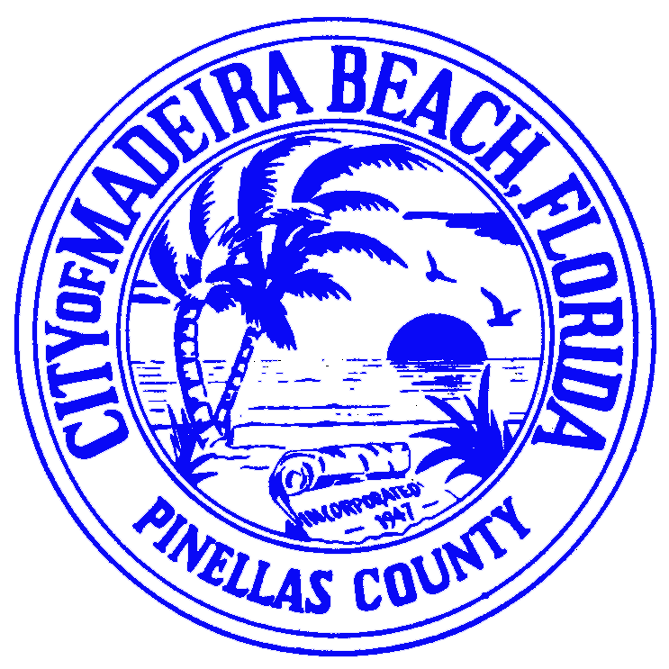
C I T Y O F M A D E I R A B E A C H
CITY MANAGER’S OFFICE
300 MUNICIPAL DRIVE  MADEIRA BEACH, FLORIDA 33708
City Hall: (727) 391-9951 Fax: (727) 395-9361
Web Site: www.ci.madeira-beach.fl.us

VIA ELECTRONIC and US MAIL

August 18, 2005

Ms. Blanca S. Bayo, Director
Division of the Commission Clerk
Florida Public Service Commission
2540 Shumard Oak Boulevard
Tallahassee, Florida 32399-0850

Re: City of Madeira Beach – Proposed Rule Development
Docket No. 050438-EU

Dear Ms. Bayo:

On June 16, 2005, the City of Madeira Beach, Florida, submitted a petition, pursuant to Florida Statutes, Section 120.54 (7), for amendment to Public Service Commission Part IV, General Service Provisions 25-6.044 (4). The City’s petition was made after receiving complaints from our residents that local utility services had failed to provide adequate notice of scheduled service disruptions within our community. In placing sole reliance upon the complaints of our citizens, the City did not engage local utility service providers in a dialogue about their notice procedures for scheduled disruptions. Having since done so, we are writing to withdraw our request for amendment of the above-referenced rule.

Please accept our apology for any inconvenience or work resulting from our original request. We appreciate your understanding in this matter.

Sincerely,

s/Jill Silverboard
City Manager

cc: Marlene Stern, Sr. Attorney, General Counsel Office/ Florida Public Service Commission
Bill McNulty, Florida Public Service Commission
Board of Commissioners

