EXHIBIT C
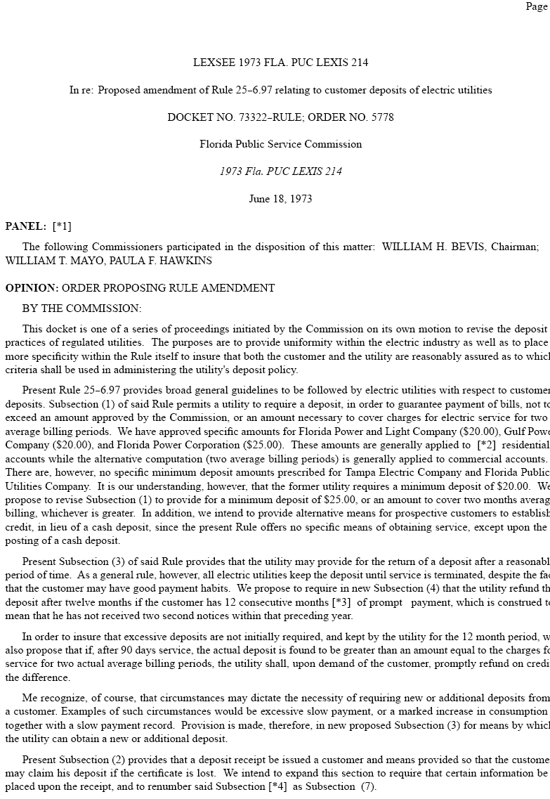
EXHIBIT C
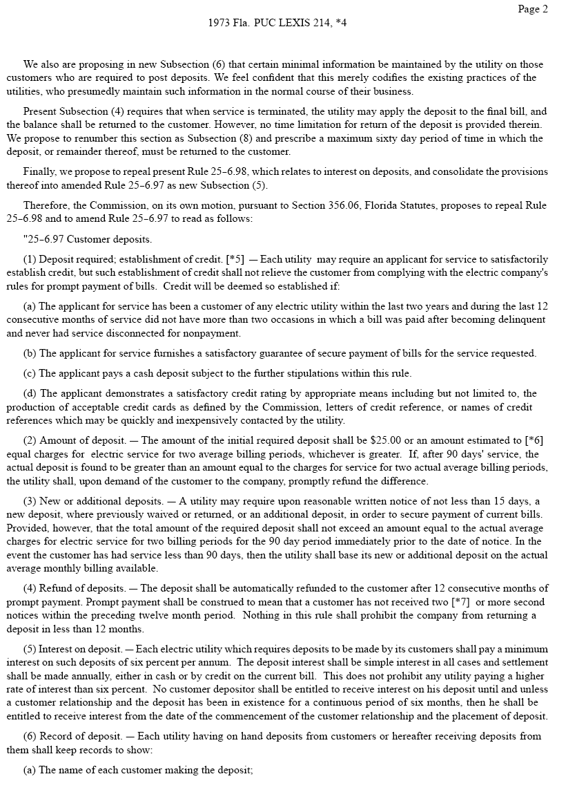

EXHIBIT C

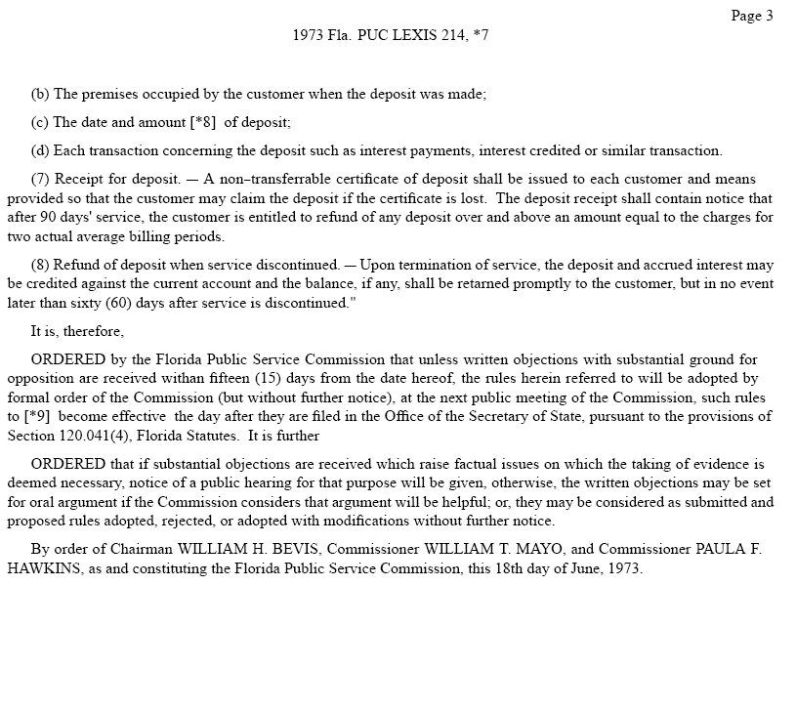

EXHIBIT C-1

………………..


EXHIBIT C-1

………………..

………………..

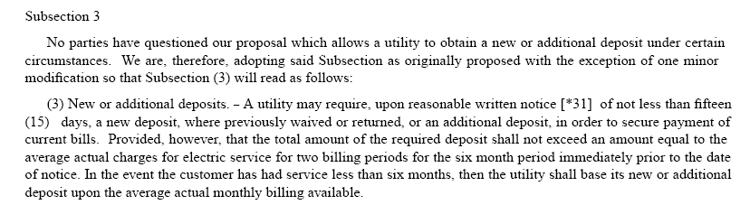

EXHIBIT C-2

input.doc

input.doc

