State of Florida   |  | Public Service Commission  Capital Circle Office Center ● 2540 Shumard Oak Boulevard  Tallahassee, Florida 32399-0850  -M-E-M-O-R-A-N-D-U-M-
DATE: | November 19, 2013
TO: | Office of Commission Clerk (Cole)
FROM: | Office of the General Counsel (Miller)  Division of Economics (Garl)
RE: | Docket No. 130257-EI – Proposed amendment of Rule 25-17.003, F.A.C., Energy Audits.
AGENDA: | 12/03/13 – Regular Agenda – Interested Persons May Participate
COMMISSIONERS ASSIGNED: |  |  | All Commissioners
PREHEARING OFFICER: |  |  | Brown
RULE STATUS: |  |  | Proposal May Be Deferred
SPECIAL INSTRUCTIONS: |  |  | None

Case Background
In 1980, the Legislature enacted the Florida Energy Efficiency and Conservation Act (FEECA). In 1982, the Commission adopted Rule 25-17.003, Florida Administrative Code (F.A.C.), Energy Audits. The rule specifies the minimum requirements for utilities performing energy audits.
In its annual rule review, staff discovered that rules were referred to in Rule 25-17.003, F.A.C., which are no longer in effect. In addition, staff believes that the reporting requirement for certified auditors is unnecessary because the information has not been used or reviewed by the Commission, Commission staff, or outside parties.
The Notice of Rule Development appeared in the August 22, 2013, edition of the Florida Administrative Register. There were no requests for a workshop, and thus no workshop was held.
This recommendation addresses whether Rue 25-17.003, F.A.C. should be amended to eliminate obsolete and unnecessary requirements. The Commission has jurisdiction pursuant to Section 120.54 and Chapter 366, Florida Statutes.
Discussion of Issues
Issue 1:1
Should the Commission propose amendments to Rule 25-17.003, F.A.C., Energy Audits?
Recommendation:
Yes. The Commission should propose amendments to Rule 25-17.003, F.A.C., as set forth in Attachment A. (Miller, Garl)
Staff Analysis:
Rule 25-17.003, F.A.C., sets out minimum requirements for performing energy audits by the utilities defined in Section 366.82(1), F.S. The seven utilities subject to the rule are Florida Power & Light Company, Duke Energy Florida, Tampa Electric Company, Gulf Power Company, Florida Public Utilities Company, Orlando Utilities Commission, and JEA.
“Building Energy Efficiency Rating System (BEHRS) Audit” is defined as an energy analysis of a residence performed in compliance with Section 553.995, F.S., and certain listed rules. However, those rules have now been repealed. Department of Business & Professional Regulation Rule 62-39.004 on Florida Building Energy Rating System was repealed September 9, 2013. Similarly, Rule 61-39.005, F.A.C., on Florida Building Energy Rating System was repealed September 9, 2013. The rules were previously codified as 9B-60.004(3) and 9B-60.005. Thus, staff recommends that Rule 25-17.003, F.A.C., be corrected to remove these references.
In addition, subsection (5)(a) requires the certification that each utility’s residential energy auditors meet certain minimum qualifications be filed with the Commission, along with a list of auditors performing the energy audits. This information has not been used by the Commission or outside entities, and staff believes the information is not necessary. Thus, staff recommends that Rule 25-17.003, F.A.C., be amended to remove this rule requirement
Statement of Estimated Regulatory Costs (SERC)
Pursuant to Section 120.54, F.S., agencies are encouraged to prepare a statement of estimated regulatory costs before the adoption, amendment, or repeal of any rules. The SERC is appended as Attachment B. As a result of the rule amendments, the Commission and the seven affected utilities should achieve a cost savings by not having to file and store unnecessary information. The SERC analyzes whether the rule amendments are likely to have an adverse impact on growth, private sector job creation or employment, or private sector investment in excess of $1 million in the aggregate within 5 years after implementation. The SERC concludes that the amendments will likely not directly or indirectly increase regulatory costs in excess of $200,000 in aggregate in Florida within 1 year after implementation. Further, the SERC concludes that the amendments will not likely have an adverse impact on business competitiveness, productivity, or innovation in excess of $1 million in the aggregate within 5 years of implementation. Thus, the rule amendments do not require legislative ratification, pursuant to Section 120.541(3), Florida Statutes. In addition, the SERC states that the amendments would not have an adverse impact on small businesses, and would have no impact on small cities or small communities. The SERC addresses additional statutory requirements. Staff recommends that the amendments to Rule 25-17.003, F.A.C, should be proposed.
Issue 2:2
Should this docket be closed?
Recommendation:
Yes, if no requests for hearing or comments are filed, the rule amendments as proposed should be filed for adoption with the Secretary of State and the docket should be closed. (Miller)
Staff Analysis:
Unless comments or requests for hearing are filed, the rule amendments as proposed may be filed with the Secretary of State without further Commission action. The docket may then be closed.

25-17.003 Energy Audits.
(1) Purpose. This rule specifies the minimum requirements for performing energy audits by every utility that falls under the definition of “utility” in Section 366.82(1), F.S.
(2) Definitions.
(a) “Building Energy-Efficiency Rating System (BERS) Audit” means an energy analysis of a residence performed in compliance with Section 553.995, F.S. subsections 9B-60.004(3) and (4) and Rule 9B-60.005, F.A.C.
(b) “Computer-Assisted Audit” means an energy analysis of a residence in which a qualified auditor performs a comprehensive on-site evaluation of the residence in accordance with subsection (6) and paragraphs (7)(c) and (7)(d), and, if applicable, provides installation arrangements and inspections pursuant to this rule.
(c) “Commercial Audit” means an energy analysis of a commercial building and its associated energy systems to determine its energy efficiency and to identify for the customer those measures that may improve its energy efficiency.
(d) “Conservation Measures” refers to replacing, upgrading, or installing equipment which reduces energy usage or peak demand contribution, such as the:
1. Installation of clock thermostat;
2. Replacement of furnace or boiler;
3. Replacement of resistance heat with heat pump or natural gas furnace;
4. Replacement of central air conditioning system;
5. Installation of duct or pipe insulation;
6. Sealing leaks in pipes and ducts;
7. Caulking of windows or doors;
8. Weatherstripping of windows or doors;
9. Installation of heat-reflective, heat-gain retardant, and heat-absorbing window or door materials;
10. Insertion of plastic window panels;
11. Installation of storm or thermal windows;
12. Installation of wall insulation;
13. Installation of ceiling insulation;
14. Installation of floor insulation;
15. Plugging leaks in attic, basement, and fireplace;
16. Installation of waste heat recovery water heating system;
17. Installation of heat pump or natural gas water heater;
18. Installation of solar water heating system;
19. Installation of water heater insulation;
20. Installation of water flow restrictors in showers and faucets;
21. Installation of solar swimming pool heating system; and
22. Installation of load management devices, where load management rates are offered.
(e) “Conservation Practices” refers to actions performed by a customer which reduce energy usage or peak demand contribution, such as:
1. Furnace efficiency maintenance and adjustments;
2. Cooling system efficiency maintenance and adjustments;
3. Nighttime temperature setback;
4. Reduction of thermostat setting in winter;
5. Increase of thermostat setting in summer;
6. Reduction of hot water temperature;
7. Reduction of energy use when residence is unoccupied; and
8. Efficient use of shading.
(f) “Eligible Customer” means the owner or occupant of a residence that receives a bill for service from a utility.
(g) “Industrial Audit” means an energy analysis of an industrial facility and its associated energy systems to determine its energy efficiency and to identify for the customer those measures that may improve its energy efficiency.
(h) “Mail-in Audit” means an energy analysis of a residence or building in which the utility supplies to the eligible customer a data collection form which is completed by the customer, and, upon receipt of the completed form, the utility analyzes the data and submits to the customer the results of its evaluation.
(i) “Walk-Through Audit” means an energy analysis of a residence in which a qualified auditor walks through the residence making extensive observations as to the physical structure and components, performs simplified heat gain and heat loss computations, and advises the customer of feasible energy conservation practices and measures.
(3) Scope.
(a) All utilities are required to offer eligible residential customers BERS Audits which comply with subsections (12), (13), and (14) below.
(b) All utilities are required to offer eligible residential customers Computer-Assisted and Walk-Through Audits which comply with subsections (4) through (14) below. Prior to conducting Computer-Assisted and Walk-Through Audits, procedures for conducting these audits must be approved by the Commission.
(c) Any utility may offer Mail-In Audits to eligible customers. Every utility that performs Mail-In Audits shall comply with subsections (13) and (14) below.
(d) Any utility may offer a Commercial or Industrial Audit to commercial and industrial customers. Every utility that performs Commercial or Industrial Audits shall comply with subsections (13) and (14) below.
(4) Energy Audit Charges.
(a) Every public utility shall charge an eligible customer for a BERS Audit. The amount of this charge, which shall reflect actual cost, shall first be filed with the Commission as part of the utility’s tariff.
(b) Every utility may charge an eligible customer for a Computer-Assisted Audit. The amount of this charge, which shall not exceed $15, shall first be filed with the Commission as part of the utility’s tariff.
(c) Every utility may charge an eligible customer for a Walk-Through Audit. The amount of this charge, which shall not exceed $5, shall first be filed with the Commission as part of the utility’s tariff.
(d) Every utility may charge an eligible customer for a Commercial or Industrial Audit. The amount of this charge shall not exceed the actual cost of providing the audit.
(5) Minimum Auditor Qualifications.
(a) Every utility shall certify that each of its residential energy auditors meets the minimum qualifications in paragraph (5)(b). The certification, along with a list of auditors performing energy audits, shall be filed annually with the Director, Division of Economic Regulation, by September 30 of each year.
(b) To be qualified to perform energy audits, a person must:
1. Have been trained in a program meeting the curriculum requirements of paragraph (5)(c); and
2. Have demonstrated a proficiency in the areas listed in paragraph (5)(c) through a written test or practical demonstration.
(c) At a minimum, the curriculum to be followed in training auditors shall include instruction in the following areas:
1. The three types of heat transfer and the effects of temperature and humidity on heat transfer;
2. General mathematics, including powers of ten, decimals and fractions, simple equations, heat loss and heat gain computations utilizing British Thermal Units (BTUs), and pay back calculations;
3. Utility billing procedures, meter reading, and identification of weather sensitive consumption relationships based on a customer’s billing history;
4. Residential construction terminology and components;
5. The operation of heating and cooling systems used in residential buildings; and
6. The application of energy conservation practices and measures including the advantages and disadvantages of each.
(6) Pre-audit performance criteria for Computer-Assisted Audits.
(a) Every utility shall adopt procedures to assure that estimates of energy cost savings and costs for conservation measures are based on:
1. Typical and recent local prices for materials and installation;
2. Typical local climate data for the audited residence; and
3. Typical local price of electricity.
(b) At least twice annually, each utility shall update the data collected pursuant to paragraph (6)(a).
(7) Performance of the audit.
(a) Upon arrival at a residence, the auditor shall provide proper identification and confirm the customer’s understanding of the scope and cost of the audit.
1. The auditor shall discontinue or decline to perform the audit if the customer, at any time, objects to its performance.
2. The auditor may discontinue or decline to perform the audit if the auditor determines that continuation of the audit may be dangerous.
(b) The auditor shall determine and explain to the customer which conservation practices are applicable and recommend that the customer apply them prior to or in conjunction with adopting any conservation measure.
(c) For Computer-Assisted Audits, to determine the appropriate conservation measures, the auditor shall gather and record the following information where applicable:
1. Exterior opaque wall area, including present level of wall insulation;
2. Type and condition of exterior window and door areas;
3. Ceiling area, including present level of attic insulation;
4. Floor area, including present level of floor insulation, if any;
5. Water heater size, age, and type;
6. Air conditioning system type, size, age, fuel type, and duct condition;
7. Heating system type, size, age, and fuel type; and
8. Other items as appropriate.
(d) For Computer-Assisted Audits, using the data gathered pursuant to paragraph (7)(c), the auditor shall provide the customer with a result sheet showing:
1. An estimate of the potential energy and cost savings of each applicable conservation measure;
2. An estimate of the total installation cost for each applicable conservation measure, both by the customer and by a contractor;
3. An estimate of the expected payback time for the customer’s cost of purchasing and installing each applicable conservation measure, calculated using the anticipated percentage change in energy costs;
4. An example calculation which clearly indicates that total energy cost savings from the installation of more than one conservation measure could be different from the sum of energy cost savings of each individually installed conservation measure; and
5. An explanation of the availability of energy conservation and load management programs.
(8) Energy Audit Disclosures and Disclaimers.
(a) Each Computer-Assisted Audit result sheet shall include the following or similar statement: “The procedures used to make these installation cost and energy savings estimates are consistent with Commission rules and good engineering practices. However, the actual installation costs you incur and energy savings you realize from installing these measures may be different from the estimates contained in this audit report. Although the estimates are based on measurements of your house, they are also based on assumptions which may not be entirely correct for your household due to differing energy use patterns.”
(b) The auditor shall provide the eligible customer with a written statement of any interest, direct or indirect, which the auditor or the utility has in the sale or installation of any energy conservation measure.
(c) Upon customer request, the auditor shall disclose the results of any prior audit of the customer’s residence if such records are still available.
(d) The results of the energy audit shall contain the following or a similar disclaimer: “The utility does not warrant or guarantee the audit findings or recommendations, nor is the utility liable as a result of the audit for the acts or omissions of any person who implements or attempts to implement those conservation measures recommended by the auditor.”
(9) Installation Arrangements.
(a) A utility may offer installation arrangement services such as providing a list of suppliers and installers of conservation measures.
(b) If a utility provides these services, the availability of the services shall be noted on the written results of the energy audit.
(c) When arranging installation services pursuant to this rule, a utility shall not:
1. Discriminate among eligible customers, suppliers, or contractors; or
2. Arrange for installation of any measure which is not included in the utility’s most recent Demand Side Management Plan approved by the Commission.
(10) Post-Audit Inspection.
(a) To ensure quality control, the utility performing the audit shall ensure that its recommended installations conform to quality standards.
(b) The utility performing the audit shall be responsible for performing post-audit inspections of 10 percent of each type of energy conservation measure installed as a result of the utility’s recommendation.
(c) The utility shall reinspect a residence if a violation of materials or installation standards is found.
(11) Program announcement.
(a) Each utility shall send a program announcement to all eligible customers at least every six months.
(b) The program announcement shall describe the BERS, Computer-Assisted, and Walk-Through Audits, offer them to all eligible customers, and advise eligible customers of any fee charged for the audits.
(c) A gas utility and an electric utility servicing the same geographical area are encouraged to jointly issue a single Program Announcement.
(12) For every customer requesting either a BERS, Computer-Assisted, or Walk-Through Audit, every utility shall:
(a) Advise the customer as to the scope and cost of the audit;
(b) Schedule the audit within 15 days of an eligible customer’s request, as well as provide the name, title, and phone number of the auditor; and
(c) Perform the audit within 21 days of scheduling it, unless the eligible customer requests a later date.
(13) Program Record Keeping.
(a) For every audit performed, every utility shall keep for 3 years from the audit performance a record that consists of the customer’s energy use for 12 months prior and 12 months after the date of the audit. The record shall list the amount of electricity or natural gas purchased for every month of both 12 month periods.
(b) Every electric utility shall record the amount collected pursuant to subsection 25-17.003(4), F.A.C., in subaccounts within Account 456. Every gas utility shall record the amount collected pursuant to subsection 25-17.003(4), F.A.C., in subaccounts within Account 495.
(14) Contracts for Performing Audits. Any utility may contract with another entity to perform the audits required by this rule.
Specific Authority 366.05(1), 350.127(2) FS. Law Implemented 350.115, 366.04(2)(a), (f), 366.82(5), (7) FS. History–New 12-2-80, Amended 12-30-82, Formerly 25-17.03, Amended 11-24-86, 5-10-93, 7-14-96, _____________.

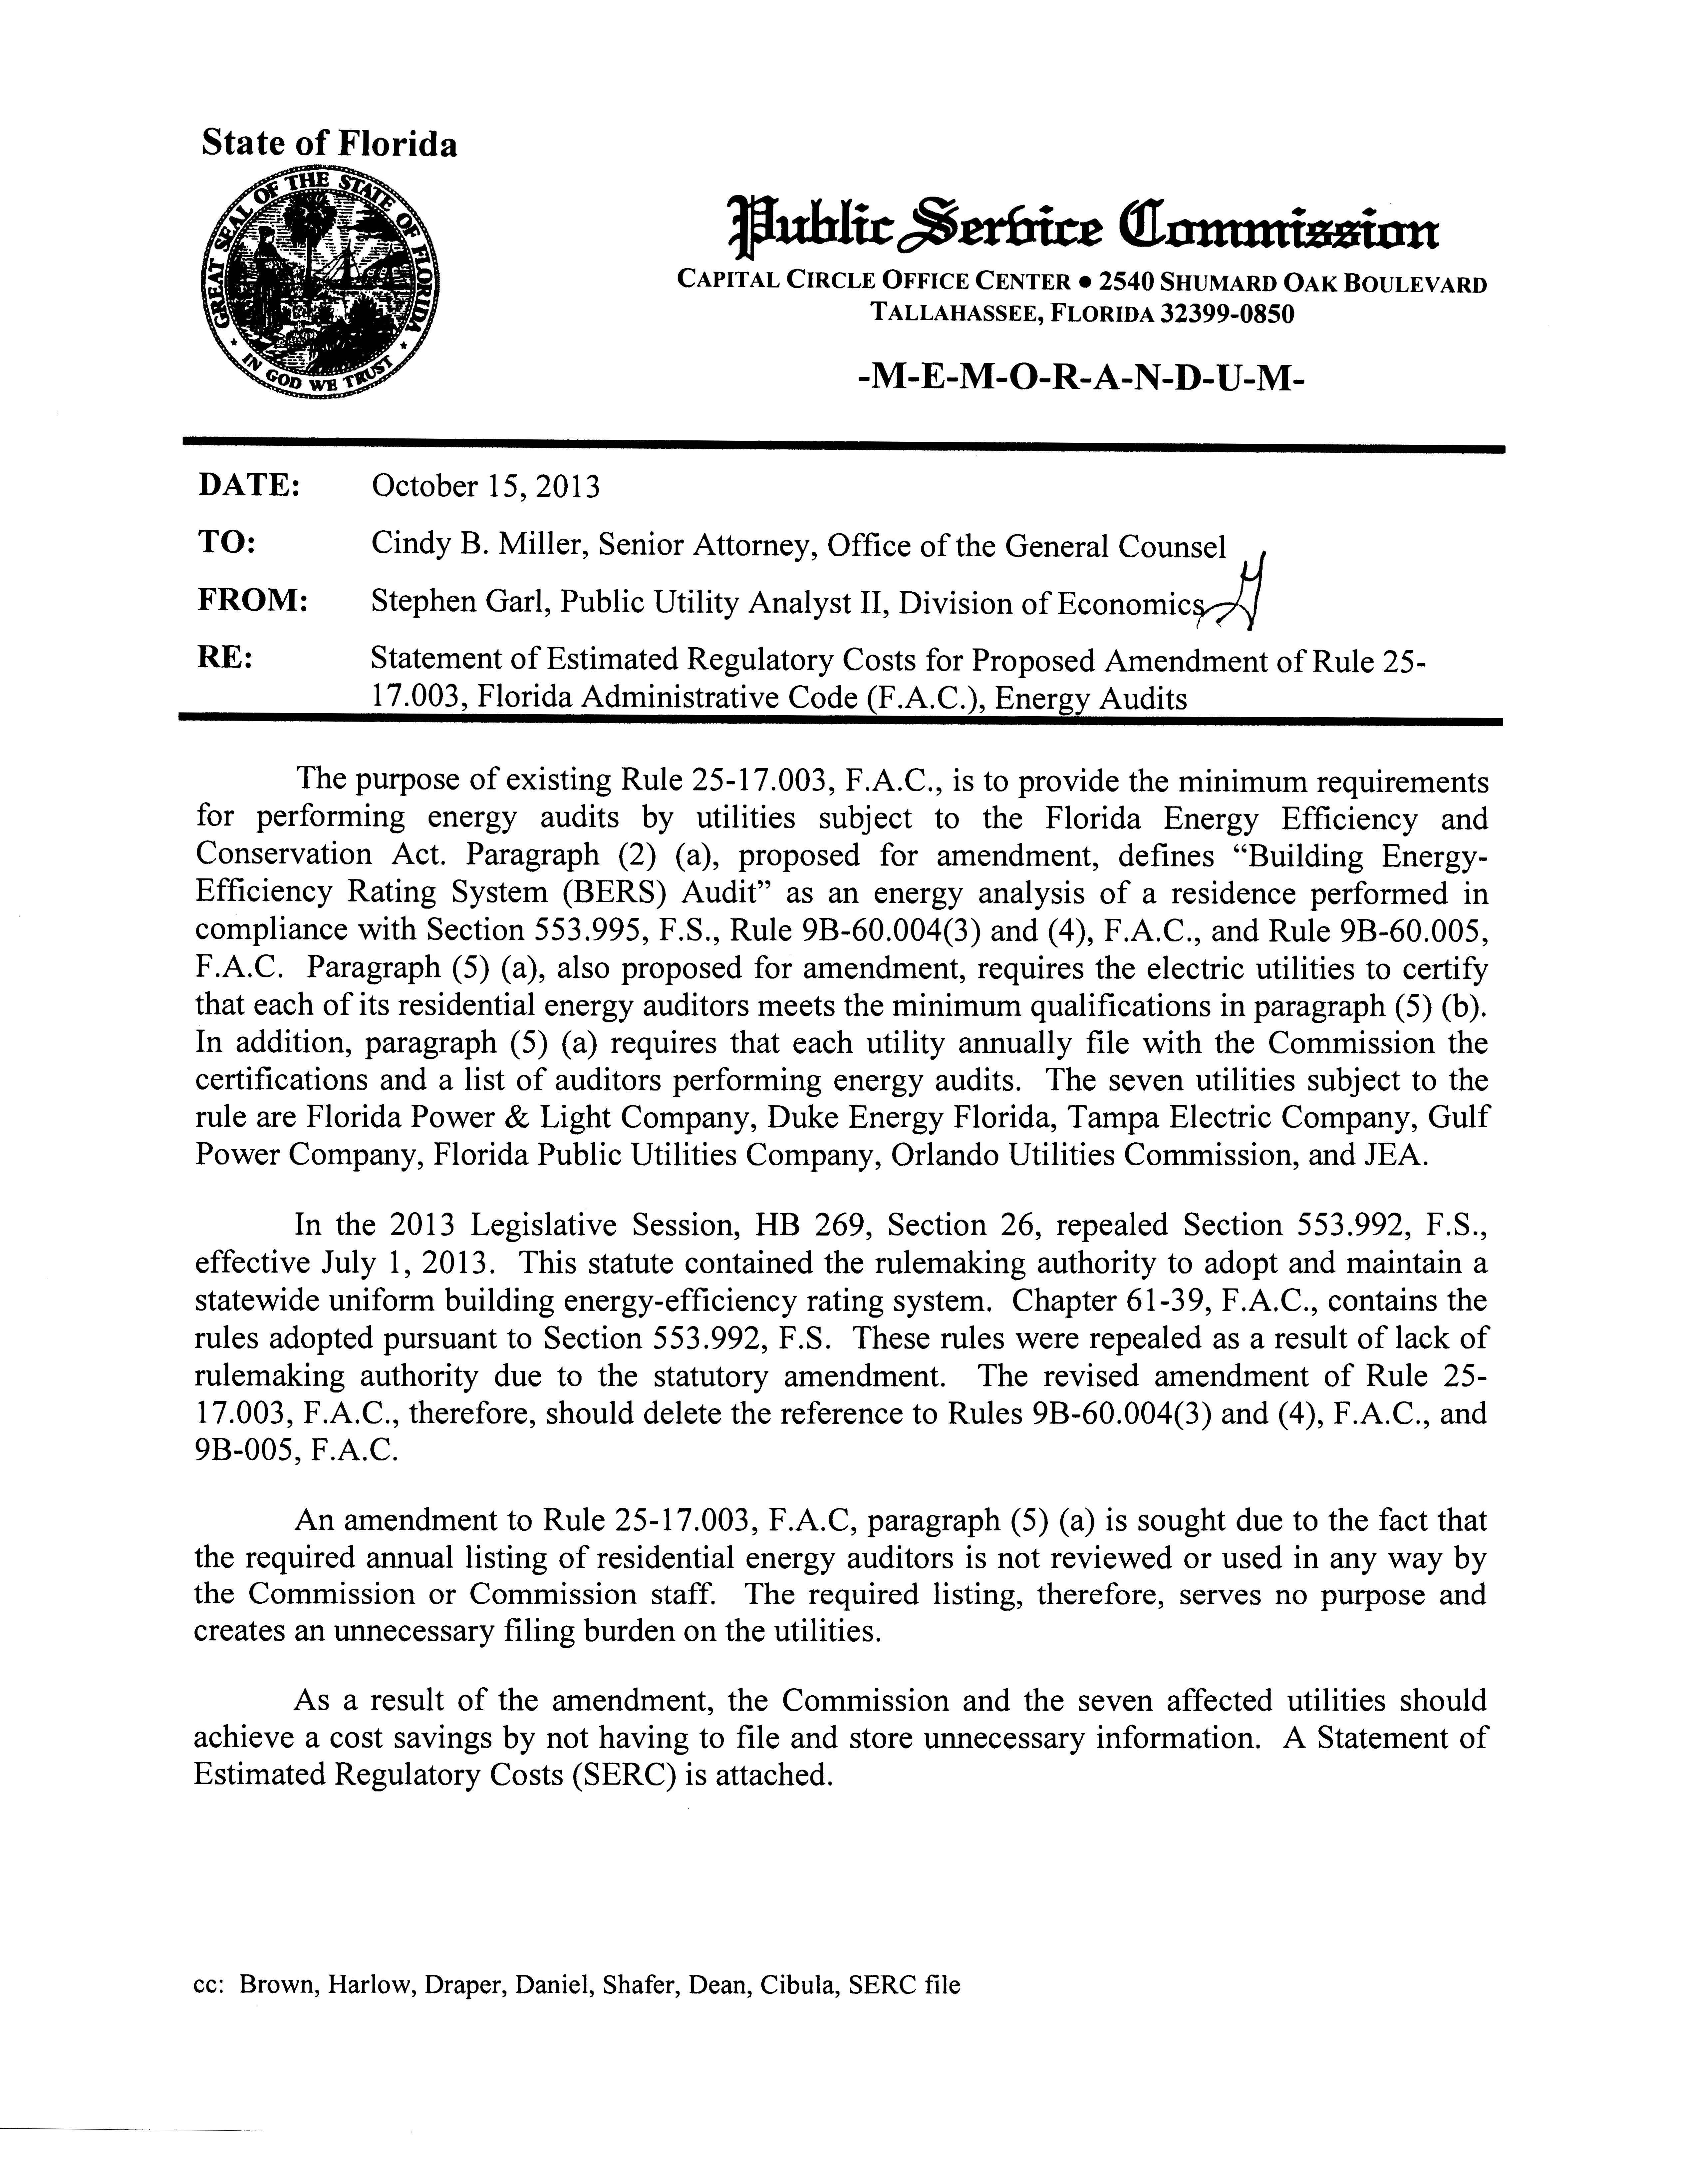
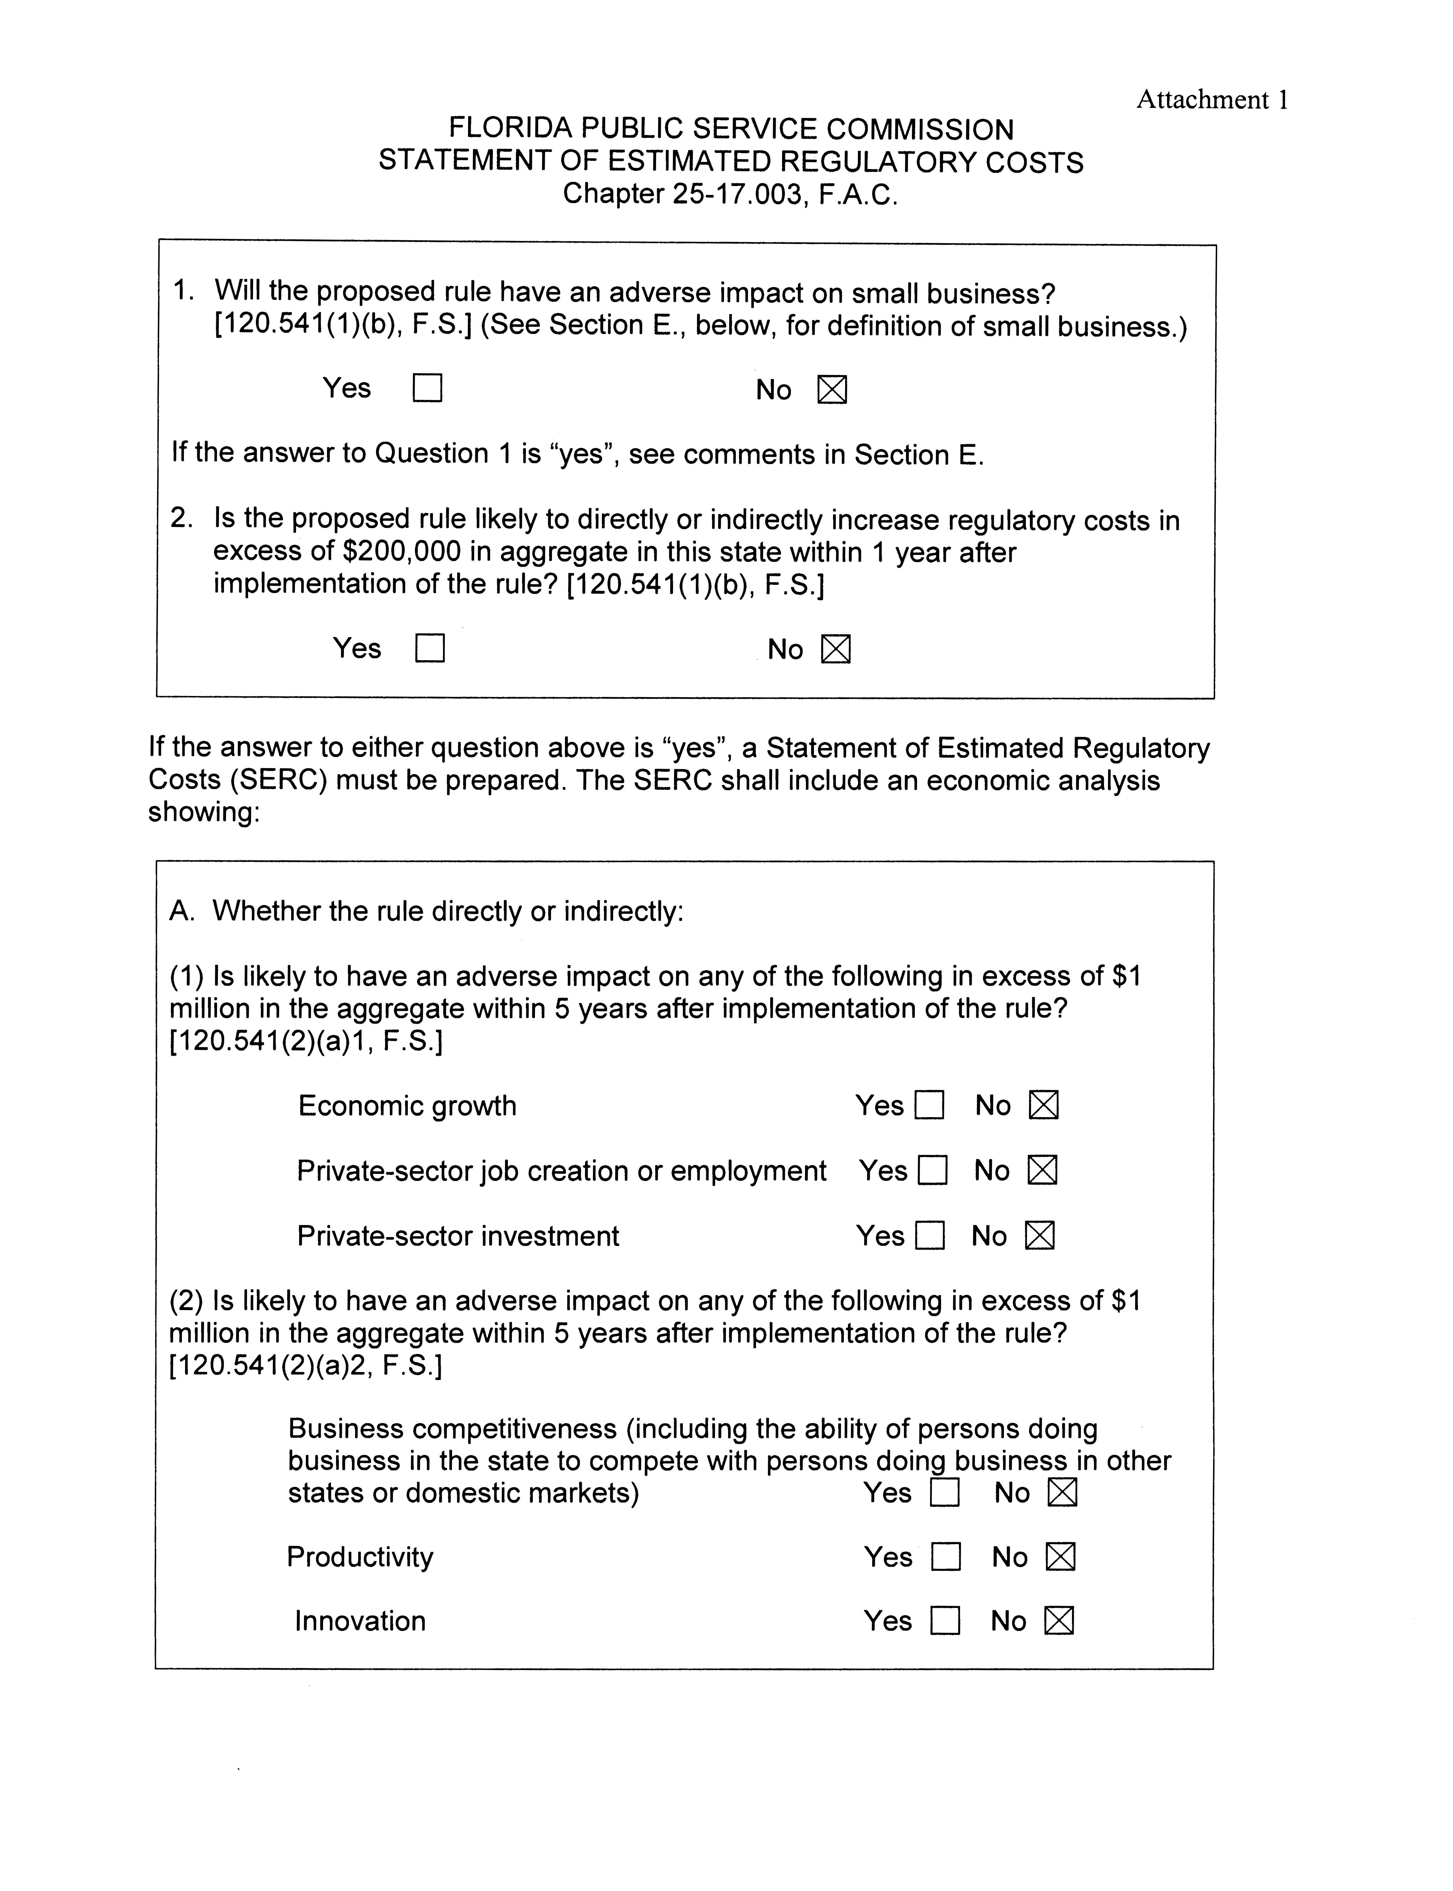
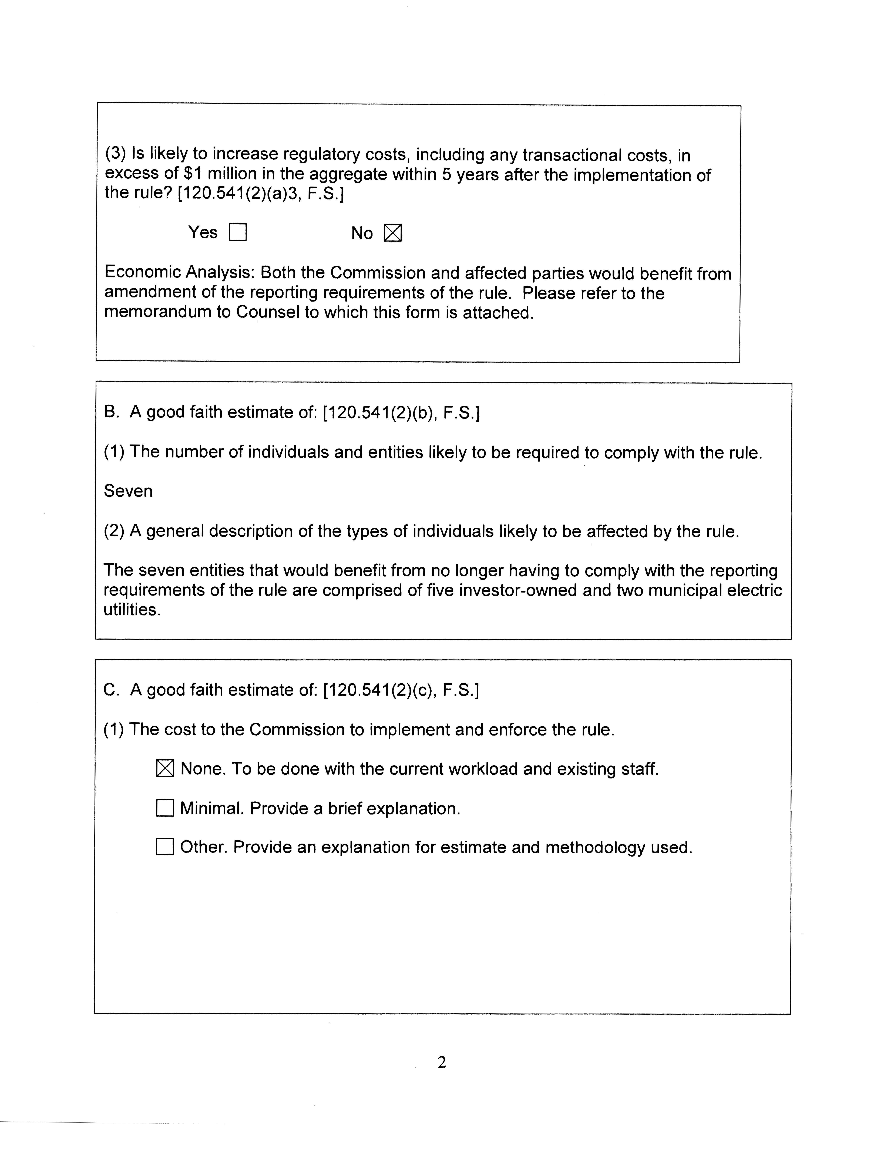
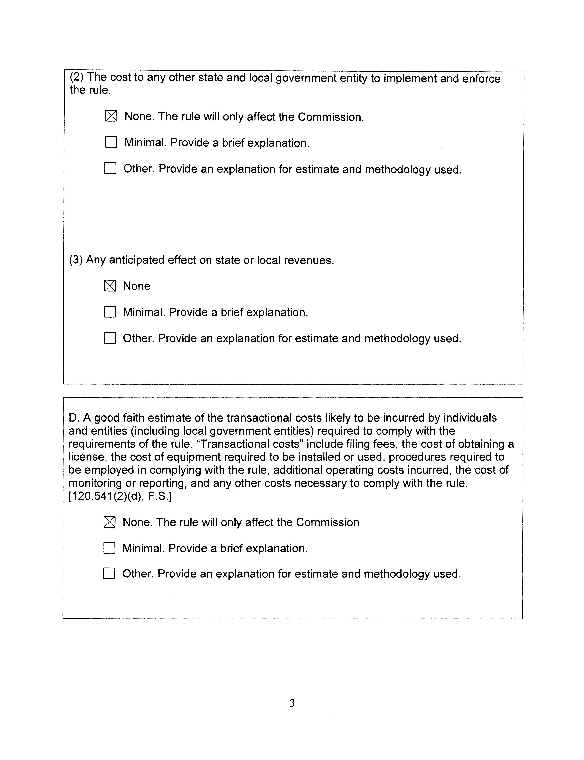
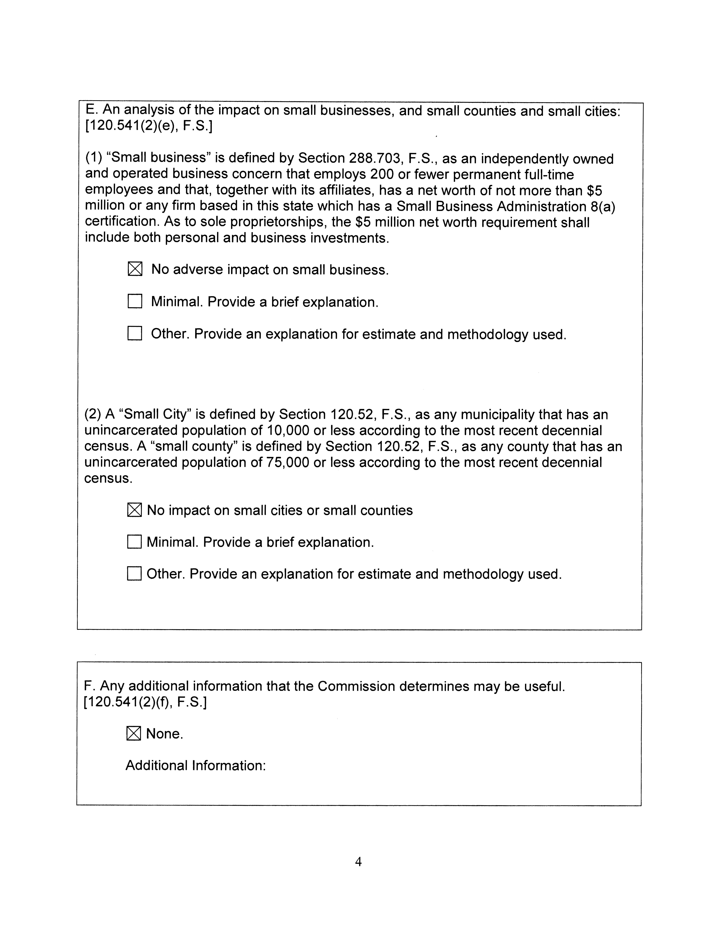
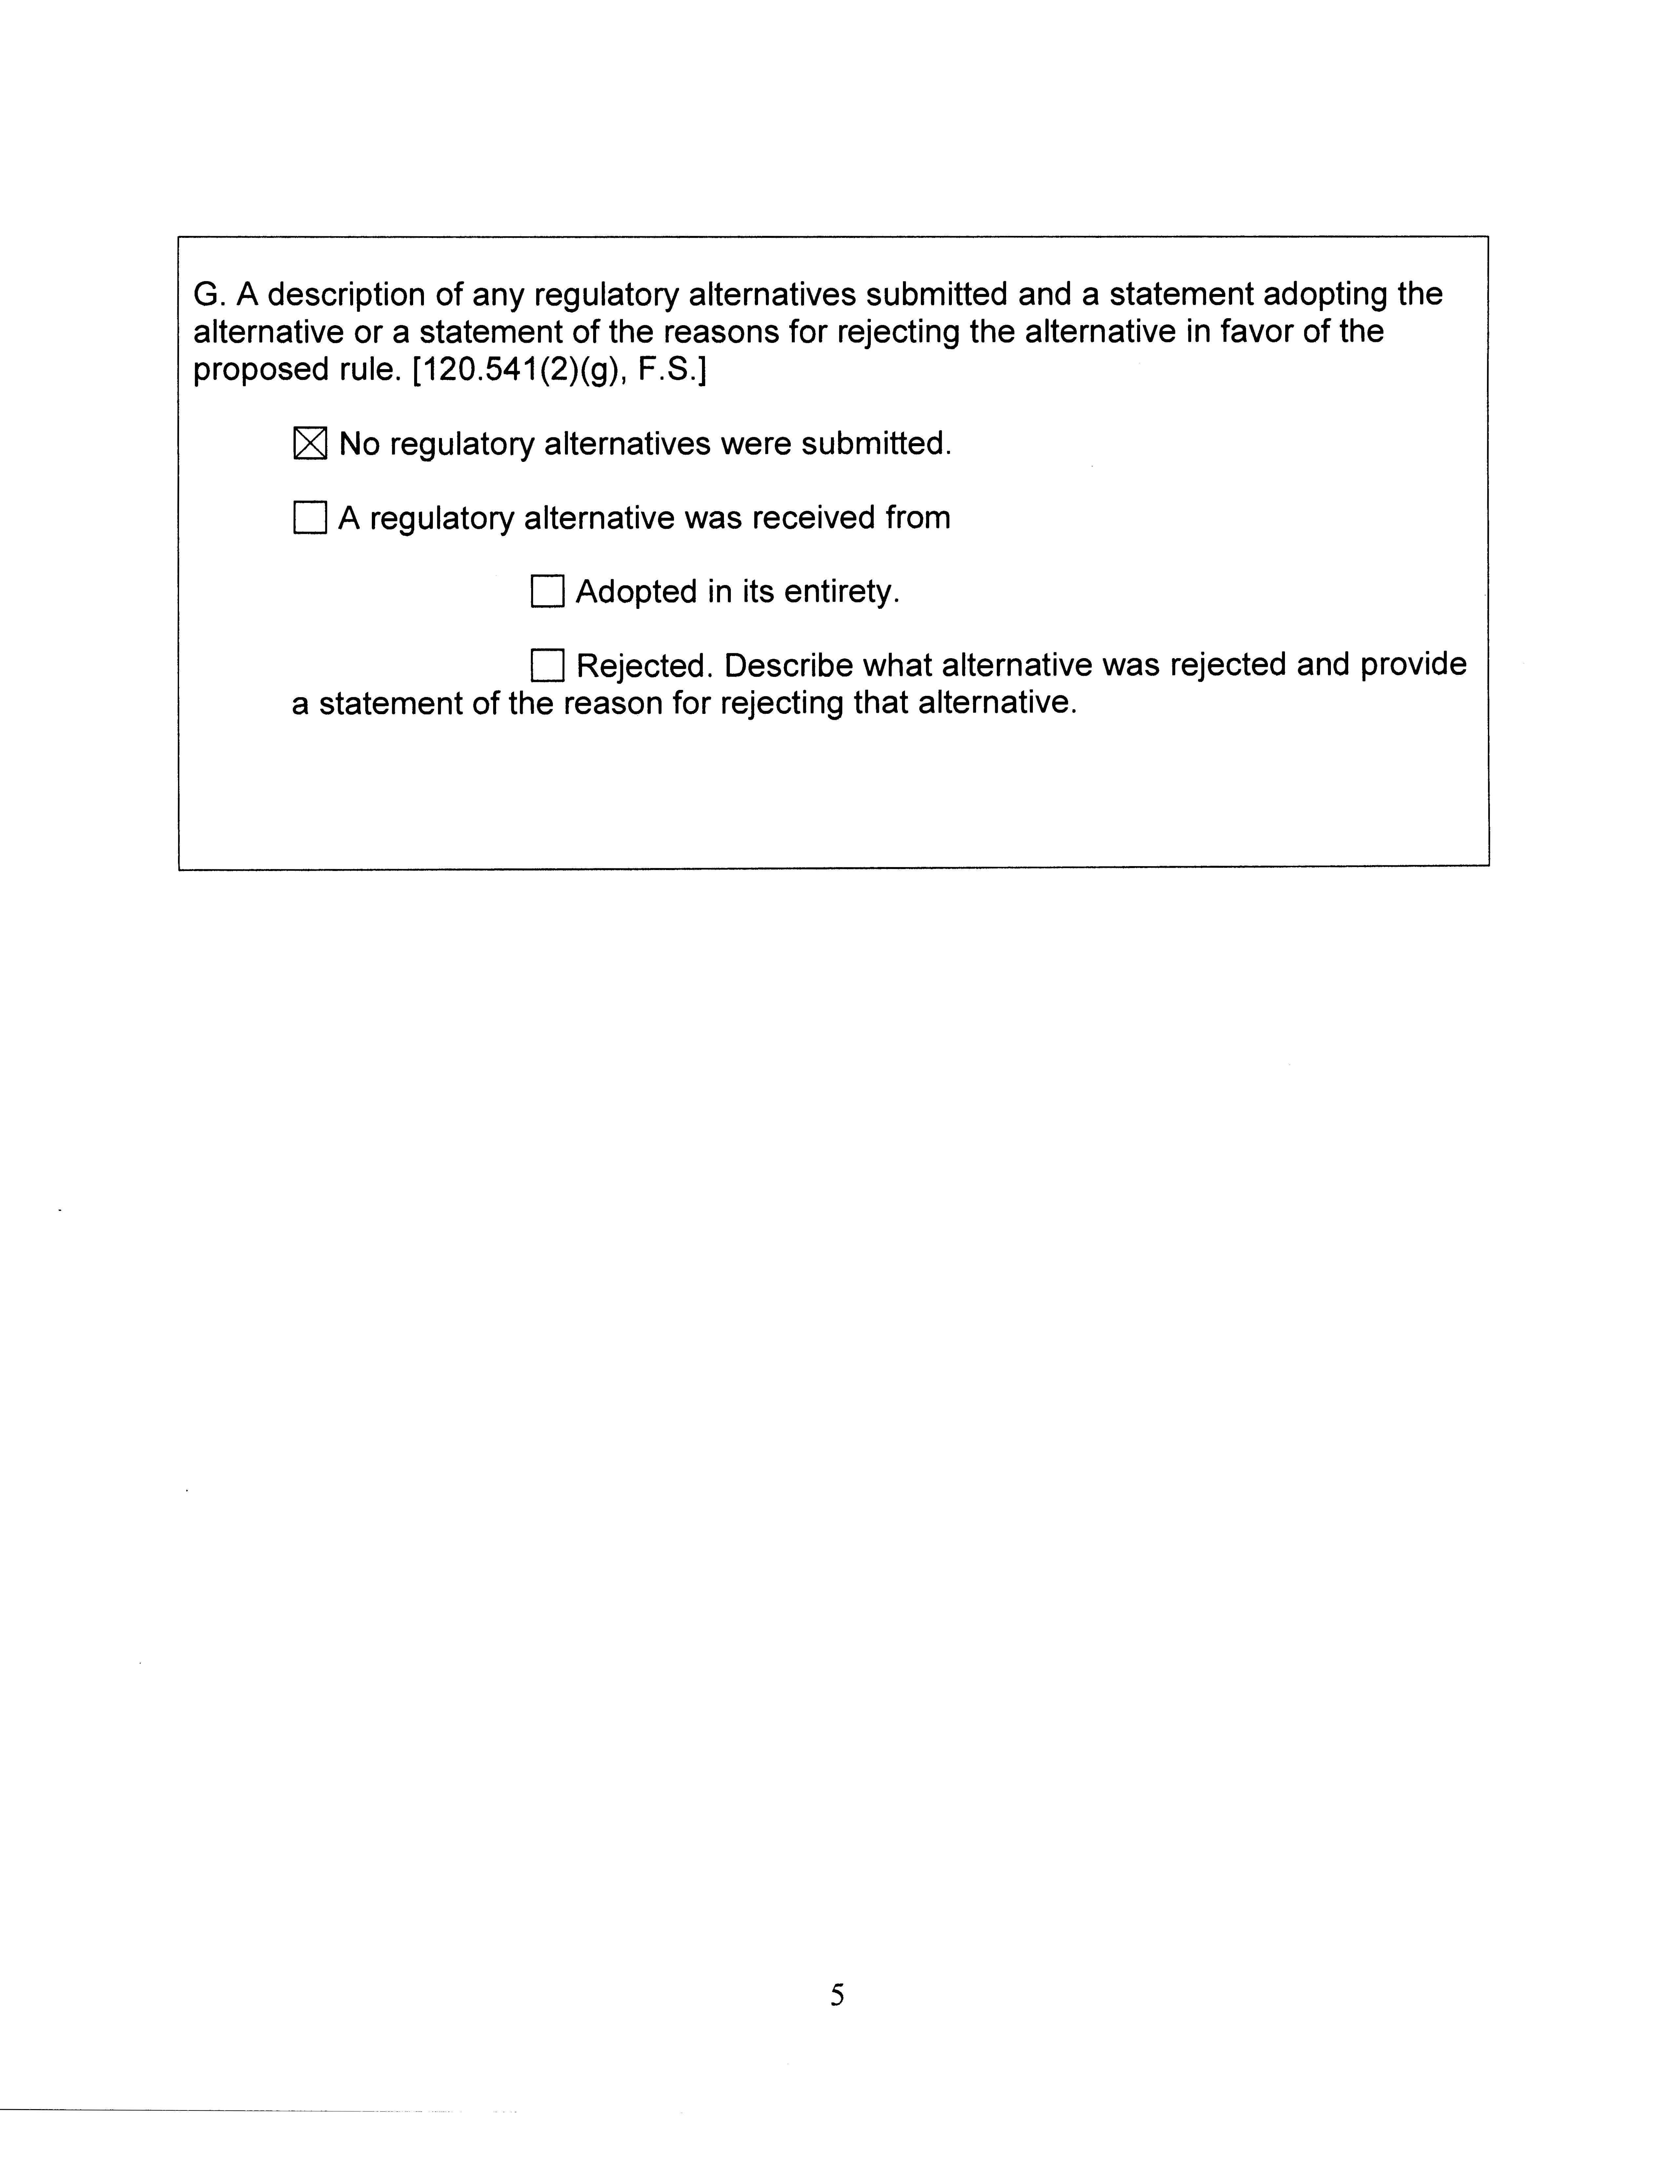

Chapter 80-65, Laws of Florida, addressing Sections 366.80-366.85, Florida Statutes.

