State of Florida   |  | Public Service Commission  Capital Circle Office Center ● 2540 Shumard Oak Boulevard  Tallahassee, Florida 32399-0850  -M-E-M-O-R-A-N-D-U-M-
DATE: | April 24, 2025
TO: | Office of Commission Clerk (Teitzman)
FROM: | Division of Economics (Ward, Hampson)  Office of the General Counsel (Brownless)
RE: | Docket No. 20250037-EI – Petition for termination of my energy bill+ program with income qualified component, by Duke Energy Florida, LLC.
AGENDA: | 05/06/25 – Regular Agenda – Tariff Filing – Interested Persons May Participate
COMMISSIONERS ASSIGNED: |  |  | All Commissioners
PREHEARING OFFICER: |  |  | Administrative
CRITICAL DATES: |  |  | 8-month effective date: 11/03/25 (60-day suspension date waived by the utility)
SPECIAL INSTRUCTIONS: |  |  | None

Case Background
On March 3, 2025, Duke Energy Florida, LLC (Duke or the utility) filed a petition to close to new customers, and ultimately terminate, its optional My Energy Bill+ Program with Income Qualified Component (My Energy Bill+ Program) contained in Tariff Sheet Nos. 6.415 – 6.417. These tariff sheets are contained in Attachment A to this recommendation. The utility states that it wants to terminate the My Energy Bill+ Program due to a lack of customer interest. The My Energy Bill+ Program is a fixed bill program that allows Duke to have limited control of a participating customer’s thermostat during specified demand response events. In exchange for this control, participating customers pay a fixed monthly bill for a year with no true-up costs. The bill calculation includes a usage adder of six percent during the first year of participation, plus a risk adder of four percent, which is lower than Duke’s FixedBill tariff. The My Energy Bill+ Program was approved in Order No. PSC-2022-0246-TRF-EI.
If the petition is approved, Duke states that it would work with enrolled customers to transition them to the FixedBill program, Budget Billing, or return them to their previous standard rate schedule. Once all customers have been transitioned out of the My Energy Bill+ Program, Duke requests that the Commission grant staff administrative authority to approve tariff sheets to terminate the program.
Duke’s current FixedBill tariff is a flat bill program that allows participating customers to receive a fixed monthly bill for 12 months, which is calculated using the prior 12 months of actual usage data, applying weather normalization, plus an additional risk and usage adder. The FixedBill tariff was first approved by Order No. PSC-2017-0451-AS-EU and became effective on March 1, 2018.
During the evaluation of the petition, staff issued a data request for which responses were received on April 7, 2025. The Commission has jurisdiction over this matter pursuant to Sections 366.03, 366.04, 366.05, and 366.06, Florida Statutes (F.S.).

Discussion of Issues

Issue 1:
Should the Commission approve Duke’s request to close the My Energy Bill+ Program to new customers and grant staff administrative authority to approve tariff sheets to terminate the program once all customers have been transitioned to an alternative rate schedule?

Recommendation:
Yes. The Commission should approve Duke’s request to close the My Energy Bill+ Program to new customers as of August 1, 2025 and approve the tariffs contained in Attachment A to the recommendation. Additionally, the Commission should grant staff administrative authority to approve tariff sheets to terminate the program once all customers have been transitioned to an alternative rate schedule. (Ward)

Staff Analysis:

My Energy Bill+ Program Participation
Duke launched its first My Energy Bill+ offers to customers in November 2022. In its petition, the utility stated that additional offers were sent from March to May 2023. Duke stated that after sending 358,164 customers multiple direct marketing offers, including by mail and by email, only 142 customers enrolled in the program. Duke stated that the cost of the marketing offers was $295,695 and the costs were recovered below-the-line. Currently, there are 130 customers enrolled in the program. Due to lack of customer interest in the My Energy Bill+ Program, Duke seeks to close the program to new customers and ultimately terminate the program.
For participating in the program, Duke also offered income qualified customers a free smart thermostat and installation, of which Duke completed 41 installations. The utility asserted that customers who received smart thermostat installations through the program will continue to own them if the My Energy Bill+ Program is terminated.
The utility stated that the annual program costs for the My Energy Bill+ Program are $288,510 for year 1, $379,650 for year 2, and $459,275 for year 3. The utility also stated that program costs are expected to increase annually based on vendor costs to support smart thermostat enrollment. All program costs are recorded below-the-line.

Closure and Termination of My Energy Bill+ Program
In its petition, Duke stated that if the program is closed it would work with enrolled customers to transition them to an alternative rate schedule. Customers would be transferred to the FixedBill program, Budget Billing, or returned to their previous standard rate schedule. Duke stated that it plans to allow customers to complete their current My Energy Bill+ 12-month service agreement. Two months before the end of the agreement period, customers will receive an email from the utility informing them that the program will be terminated and other billing options are available. The utility stated that it expects all customers to be transitioned out of the My Energy Bill+ Program by October 2026.
Additionally, Duke requests that the Commission grant staff administrative authority to approve tariffs to terminate the program after all customers have been transitioned out of the My Energy Bill+ Program. If this recommendation is approved, staff will approve tariffs to terminate the My Energy Bill+ Program once staff has confirmed that all customers have been removed from the rate schedule. The utility stated that it will notify staff once all customers have been removed from the My Energy Bill+ Program, including details about the new billing or payment option selected by each customer.

Conclusion
Based on the petition and the utility’s response to staff’s data request, staff believes that the Commission should approve Duke’s request to close the My Energy Bill+ Program to new customers as of August 1, 2025 and approve the tariffs contained in Attachment A to the recommendation. Additionally, the Commission should grant staff administrative authority to approve tariff sheets to terminate the program once all customers have transitioned to an alternative rate schedule. Due to the lack of customer interest and the availability of alternative fixed bill and budget billing rate schedules, staff believes the proposal is reasonable.

Issue 2:
Should this docket be closed?

Recommendation:
Yes. If no protest is filed by a person whose substantial interests are affected within 21 days of the issuance of the Order, this docket should be closed upon the issuance of a Consummating Order. However, if a timely protest is filed in this docket, this docket shall remain open, and the current tariff remain in effect, until the resolution of the protest. (Brownless)

Staff Analysis:
If no protest is filed by a person whose substantial interests are affected within 21 days of the issuance of the Order, this docket should be closed upon the issuance of a Consummating Order. However, if a timely protest is filed in this docket, this docket shall remain open, and the current tariff remain in effect, until the resolution of the protest.

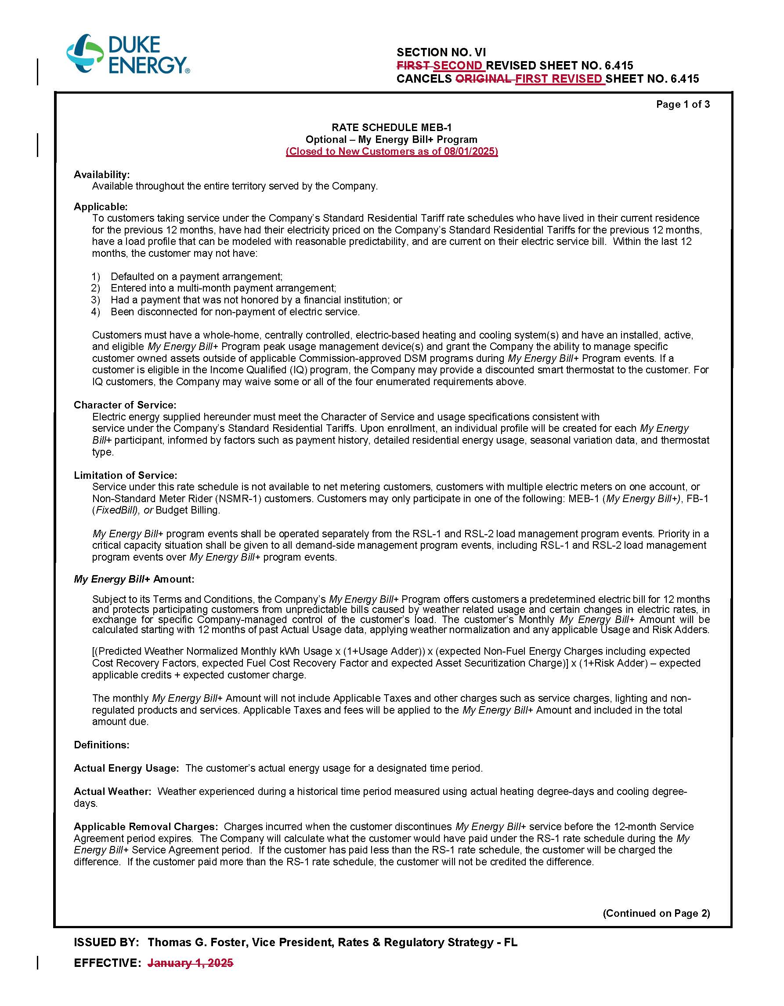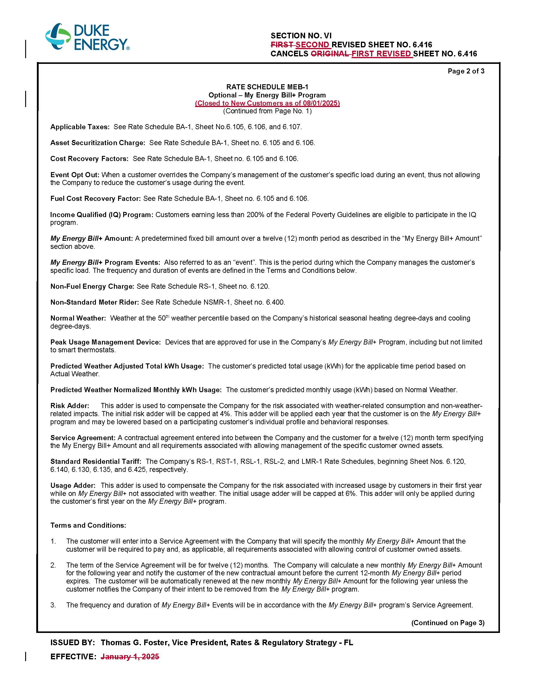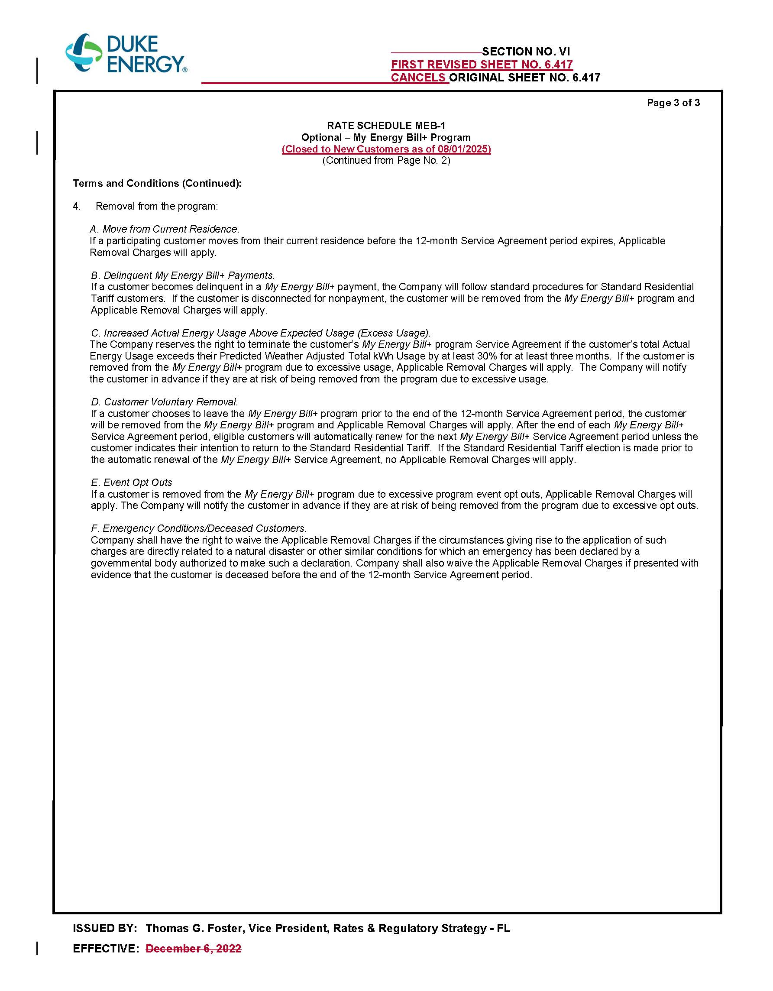

Order No. PSC-2022-0246-TRF-EI, issued December 14, 2022, in Docket No. 20220106-EI, In re: Petition for approval of new my energy bill+ program with income qualified component, by Duke Energy Florida, LLC.
Order No. PSC-2017-0451-AS-EU, issued November 20, 2017, in Docket No. 20170183-EI, In re: Application for limited proceeding to approve 2017 second revised and restated settlement agreement, including certain rate adjustments, by Duke Energy Florida, LLC.
Responses to Staff’s First Data Request, Response No. 7.
Responses to Staff’s First Data Request, Response No. 3.
Responses to Staff’s First Data Request, Response No. 2.
Responses to Staff’s First Data Request, Response No. 4.
Responses to Staff’s First Data Request, Response No. 6.
Responses to Staff’s First Data Request, Response No. 5.

