State of Florida   |  | Public Service Commission  Capital Circle Office Center ● 2540 Shumard Oak Boulevard  Tallahassee, Florida 32399-0850  -M-E-M-O-R-A-N-D-U-M-
DATE: | May 21, 2025
TO: | Office of Commission Clerk (Teitzman)
FROM: | Division of Engineering (Sanchez, Ellis)  Office of the General Counsel (Augspurger, Marquez)
RE: | Docket No. 20250054-EQ – Petition for approval of amended standard offer contract (Schedule COG-2), by Duke Energy Florida, LLC.
AGENDA: | 06/03/25 – Regular Agenda – Proposed Agency Action – Interested Persons May Participate
COMMISSIONERS ASSIGNED: |  |  | All Commissioners
PREHEARING OFFICER: |  |  | Administrative
CRITICAL DATES: |  |  | None
SPECIAL INSTRUCTIONS: |  |  | Staff recommends the Commission simultaneously consider Docket Nos. 20250053-EQ, 20250054-EQ, 20250055-EQ, and 20250056-EQ.

Case Background
Section 366.91(3), Florida Statutes (F.S.), requires each investor-owned utility (IOU) to continuously offer to purchase capacity and energy from renewable generating facilities (RF) and small qualifying facilities (QF). Rules 25-17.200 through 25-17.310, Florida Administrative Code (F.A.C.), implement the statute and require each IOU to file with the Commission, by April 1 of each year, a revised standard offer contract based on the next avoidable fossil-fueled generating unit of each technology type identified in the utility’s current Ten-Year Site Plan (TYSP). On April 1, 2025, Duke Energy Florida, LLC (DEF) filed a petition for approval of its amended standard offer contract based on its 2025 TYSP. The Commission has jurisdiction over this amended standard offer contract, pursuant to Sections 366.04, 366.041, 366.05, 366.055, 366.06, and 366.91, F.S.

Discussion of Issues

Issue 1:
Should the Commission approve the amended standard offer contract and associated rate schedule COG-2 filed by Duke Energy Florida, LLC?

Recommendation:
Yes. The provisions of DEF’s amended standard offer contract and associated rate schedule COG-2 conform to the requirements of Rules 25-17.200 through 25-17.310, F.A.C. The amended standard offer contract offers multiple payment options so that a developer of renewable generation may select the payment stream best suited to its financial needs. (Sanchez)

Staff Analysis:
Section 366.91(3), F.S., and Rule 25-17.250, F.A.C., require that an IOU continuously make available a standard offer contract for the purchase of firm capacity and energy from RFs and QFs with design capacities of 100 kilowatts (kW) or less. Pursuant to Rules 25-17.250(1) and (3), F.A.C., the standard offer contract must provide a term of at least 10 years, the payment terms must be based on the utility’s next avoidable fossil-fueled generating unit identified in its most recent TYSP or, if no avoided unit is identified, its next avoidable planned purchase. In its 2025 Ten-Year Site Plan, DEF has identified a 245 megawatt (MW) natural gas-fueled combustion turbine as the next avoidable planned generating unit. This unit has a projected in-service date of June 1, 2033, with planned construction beginning in January 2029.
Under DEF’s amended standard offer contract, the RF/QF operator commits to certain minimum performance requirements, based on the identified avoided unit, such as being operational and delivering an agreed upon amount of capacity by the in-service date of the avoided unit. In this way, the RF/QF thereby becomes eligible for capacity payments in addition to payments received for energy. The standard offer contract may also serve as a starting point for negotiation of contract terms by providing payment information to an RF/QF operator in a situation where one or both parties desire particular contract terms other than those established in the standard offer.
In order to promote renewable generation, the Commission requires each IOU to offer multiple options for capacity payments, including the options to receive early or levelized payments. If the RF/QF operator elects to receive capacity payments under the normal or levelized contract options, it will receive as-available energy payments only until the in-service date of the avoided unit (in this case June 1, 2033). Thereafter, they begin receiving capacity payments in addition to firm energy payments. If either the early or early levelized option is selected, then the operator will begin receiving capacity payments earlier than the in-service date of the avoided unit. However, payments made under the early capacity payment options tend to be lower in the later years of the contract term, because the net present value (NPV) of the total payments must remain equal for all contract payment options.
Table 1 contains DEF’s estimates of the annual payments for the normal and levelized capacity payment options available under the amended standard offer contract to an operator with a 50 MW facility operating at a capacity factor of 95 percent, which is the minimum capacity factor required under the contract to qualify for full capacity payments. Normal and levelized capacity payments begin with the projected in-service date of the avoided unit (June 1, 2033), and continue for 10 years, while early and early levelized capacity payments begin two (2) years prior to the in-service date, or January 2031 in this case.
Table 1
Estimated Annual Payments to a 50 MW Renewable Facility
(95% Capacity Factor)
Year | Energy Payments | Capacity Payment
 |  | Normal | Levelized | Early | Early Levelized
 | $(000) | $(000) | $(000) | $(000) | $(000)
2026 | 13,585 | - | - | - | -
2027 | 13,799 | - | - | - | -
2028 | 13,538 | - | - | - | -
2029 | 12,569 | - | - | - | -
2030 | 12,141 | - | - | - | -
2031 | 12,905 | - | - | 7,679 | 8,441
2032 | 14,327 | - | - | 7,807 | 8,444
2033 | 15,628 | 5,952 | 6,493 | 7,938 | 8,447
2034 | 16,721 | 10,374 | 11,135 | 8,071 | 8,450
2035 | 18,488 | 10,547 | 11,140 | 8,206 | 8,454
2036 | 19,381 | 10,724 | 11,144 | 8,344 | 8,457
2037 | 20,071 | 10,904 | 11,149 | 8,484 | 8,461
2038 | 19,203 | 11,087 | 11,153 | 8,626 | 8,464
2039 | 19,829 | 11,272 | 11,158 | 8,770 | 8,468
2040 | 21,259 | 11,461 | 11,163 | 8,917 | 8,472
2041 | 21,474 | 11,653 | 11,168 | 9,067 | 8,476
2042 | 20,957 | 11,849 | 11,173 | 9,219 | 8,480
2043 | 21,180 | 12,047 | 11,178 | 9,374 | 8,484
2044 | 20,761 | 12,249 | 11,184 | 9,531 | 8,488
2045 | 21,124 | 12,455 | 11,189 | 9,691 | 8,492
Total | 348,940 | 142,575 | 140,427 | 129,723 | 126,975
Total (NPV) | 172,068 | 54,425 | 54,425 | 54,425 | 54,425
Source: DEF’s Response to Staff’s First Data Request.
DEF’s amended standard offer contract, in type-and-strike format, is included as Attachment A to this recommendation. The changes made to DEF’s tariff sheets are consistent with the updated avoided unit. Revisions include updates to calendar dates and payment information, which reflect the current economic and financial assumptions for the avoided unit.

Conclusion
The provisions of DEF’s amended standard offer contract and associated rate schedule COG-2 conform to the requirements of Rules 25-17.200 through 25-17.310, F.A.C. The amended standard offer contract offers multiple payment options so that a developer of renewable generation may select the payment stream best suited to its financial needs. The Commission should approve the amended standard offer contract.

Issue 2:
Should this docket be closed?

Recommendation:
Yes. This docket should be closed upon issuance of a Consummating Order, unless a person whose substantial interests are affected by the Commission’s decision files a protest within 21 days of the issuance of the Commission’s Proposed Agency Action Order. Potential signatories should be aware that, if a timely protest is filed, DEF’s standard offer contract may subsequently be revised. (Augspurger, Marquez)

Staff Analysis:
This docket should be closed upon issuance of a Consummating Order, unless a person whose substantial interests are affected by the Commission’s decision files a protest within 21 days of the issuance of the Commission’s Proposed Agency Action Order. Potential signatories should be aware that, if a timely protest is filed, DEF’s standard offer contract may subsequently be revised.

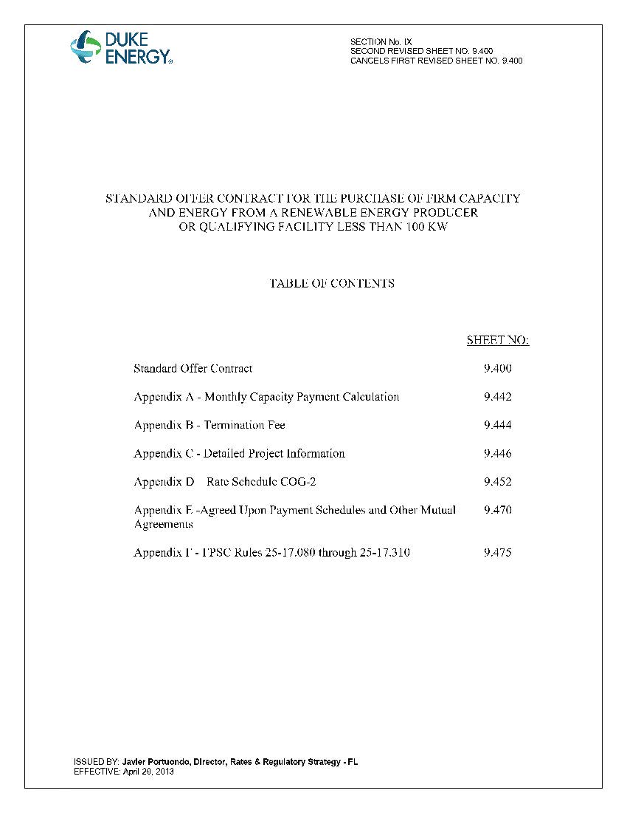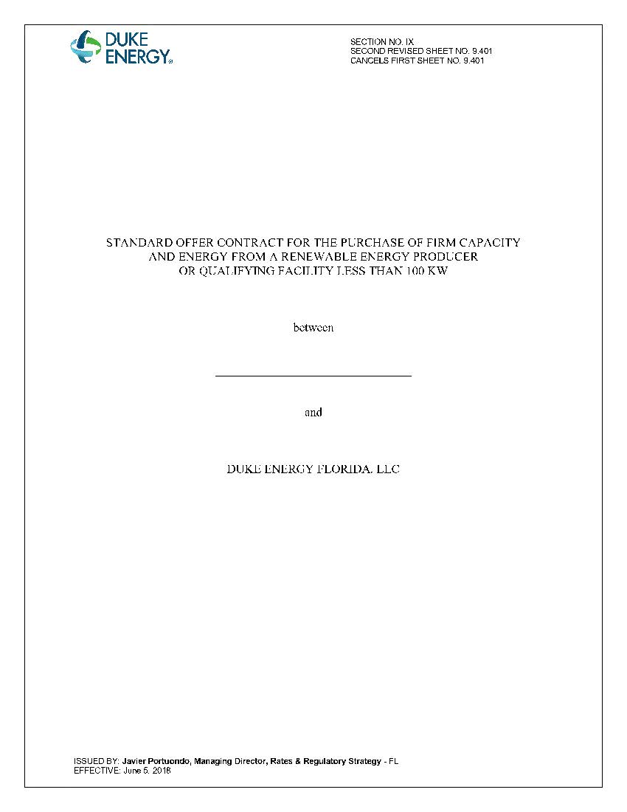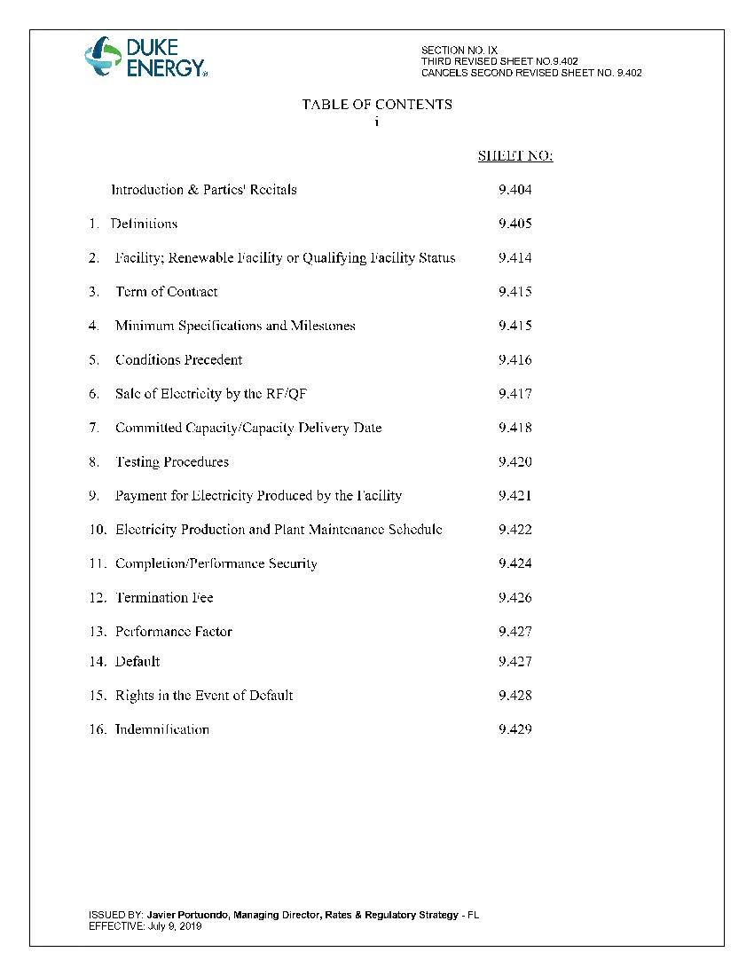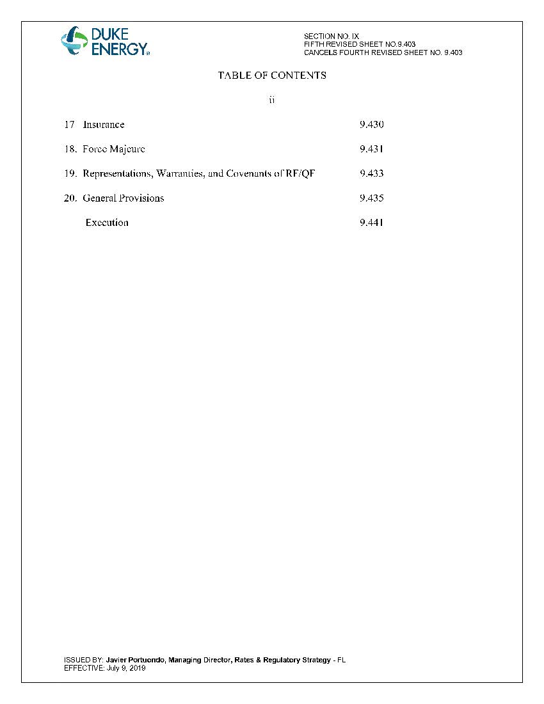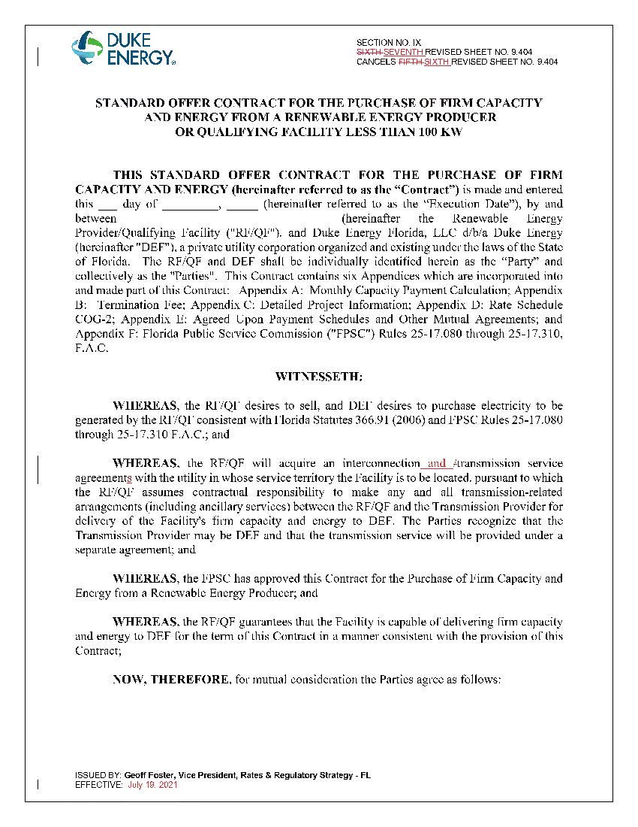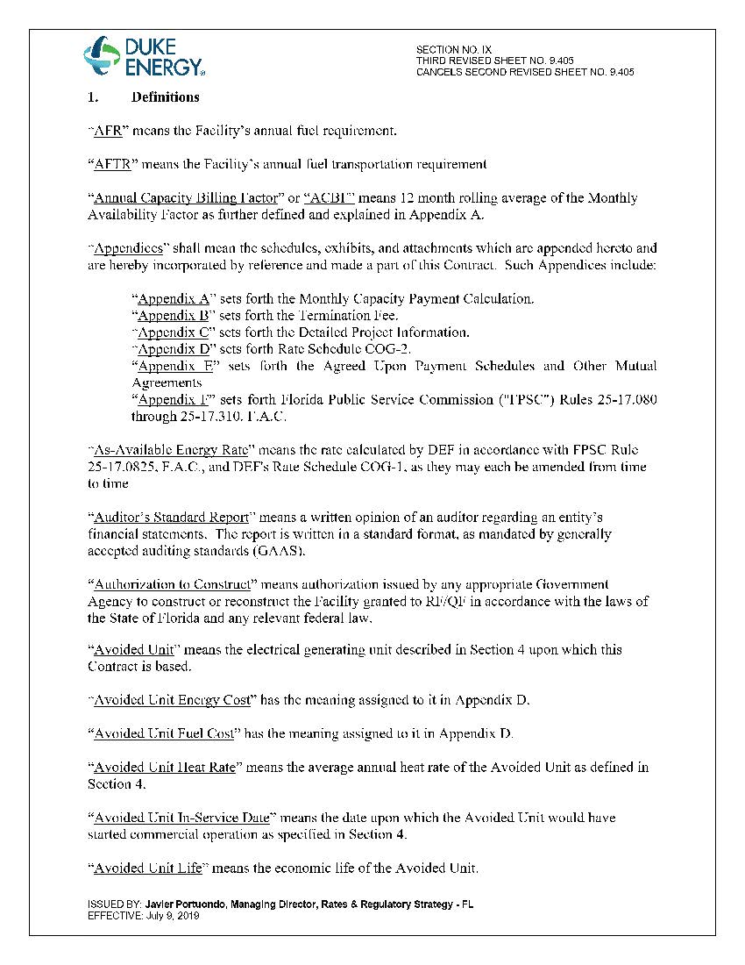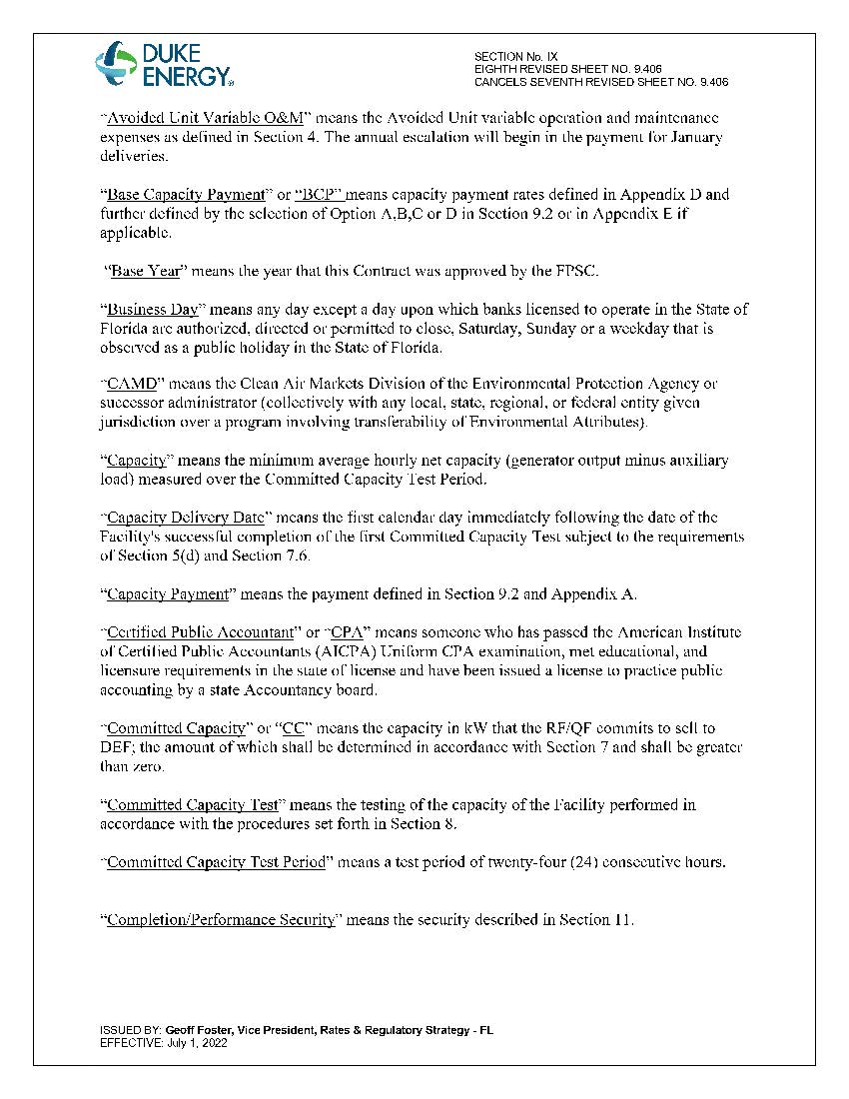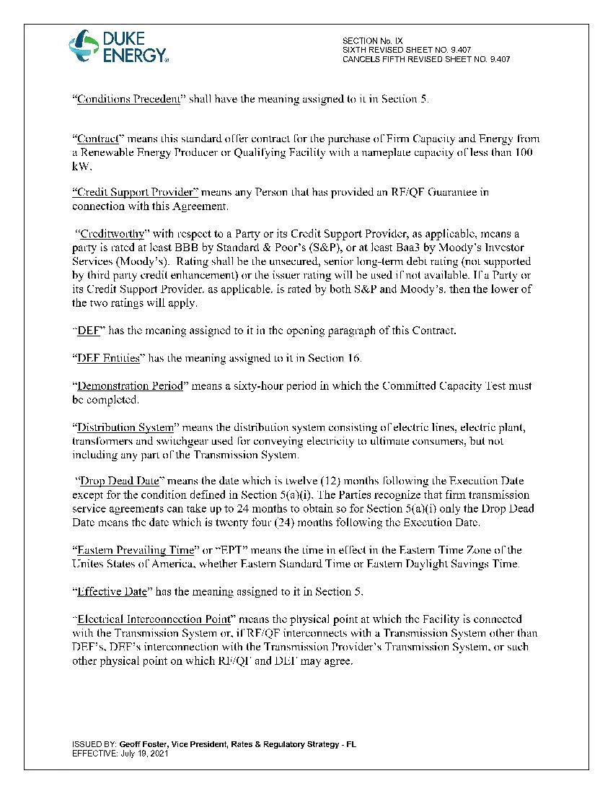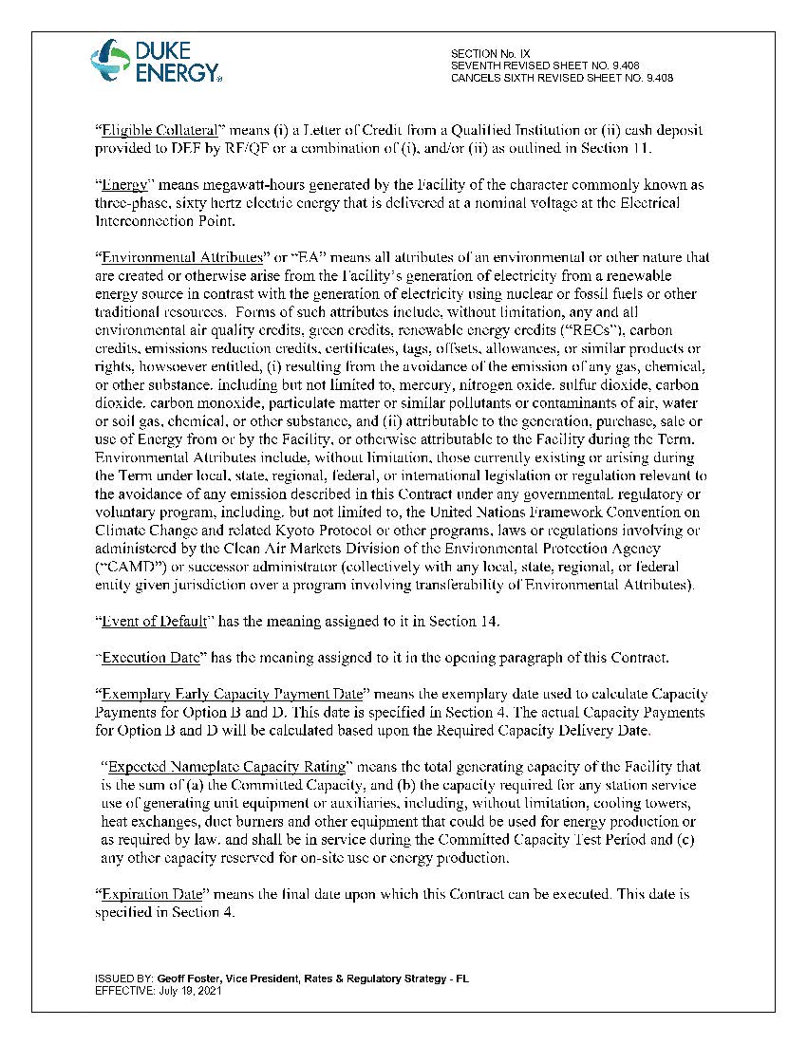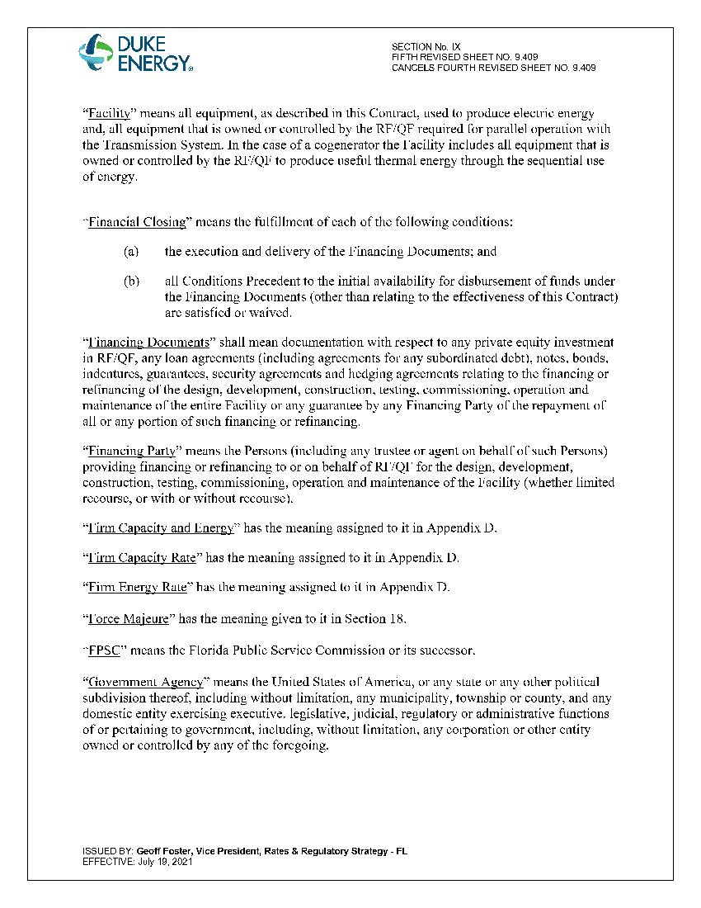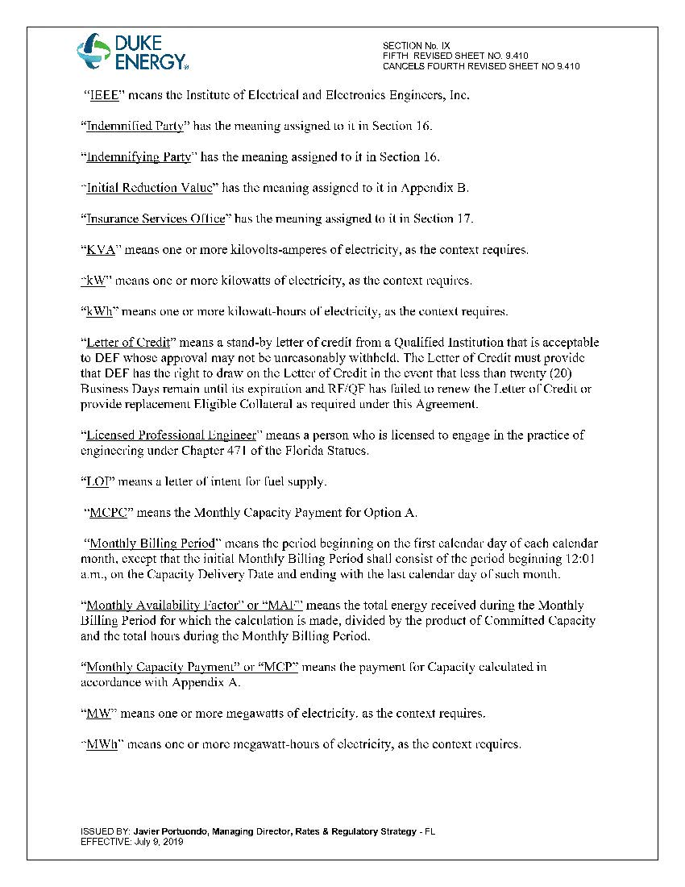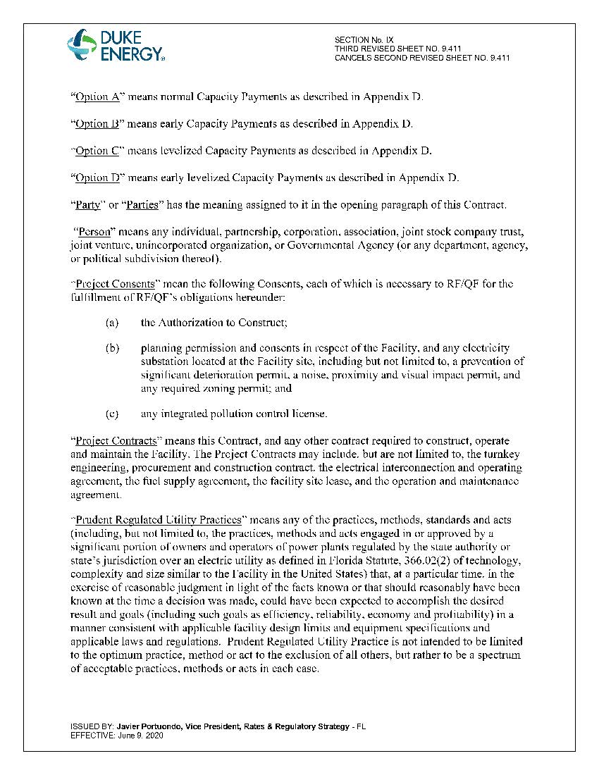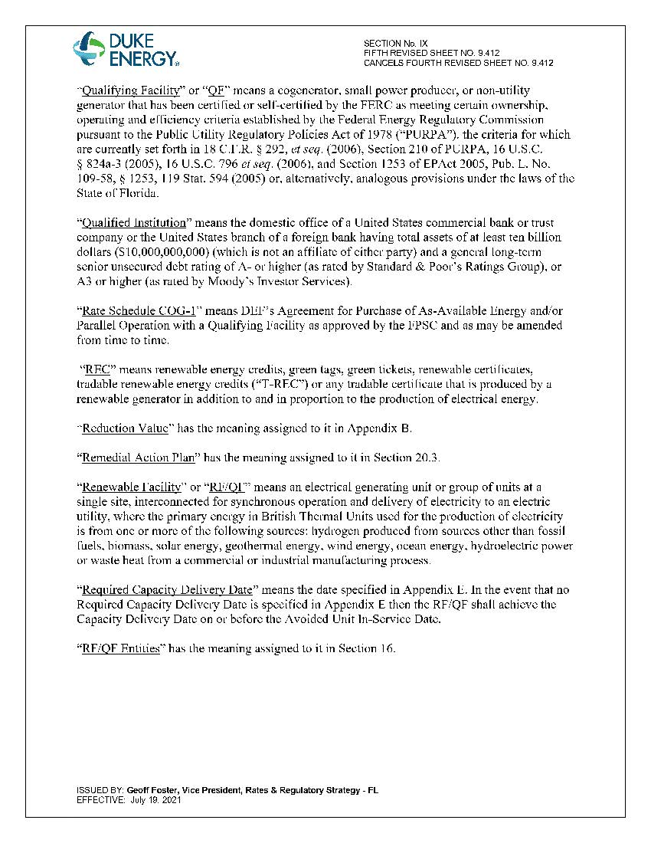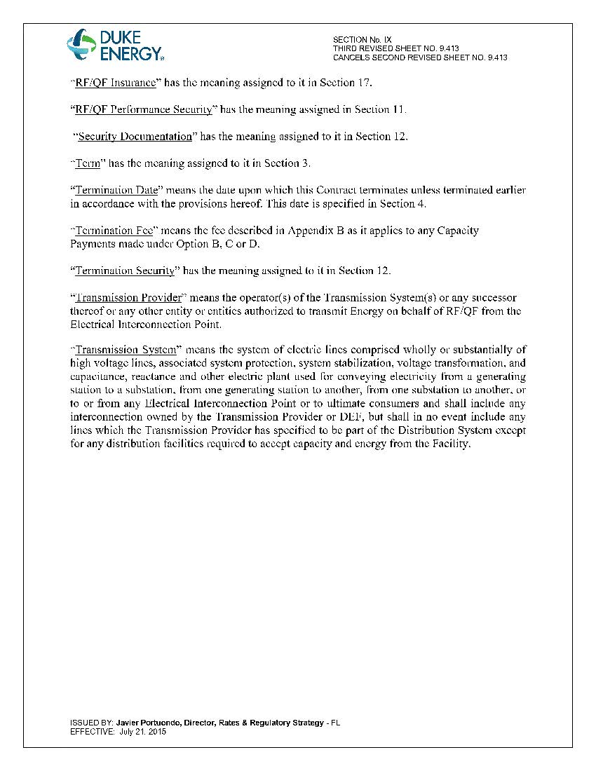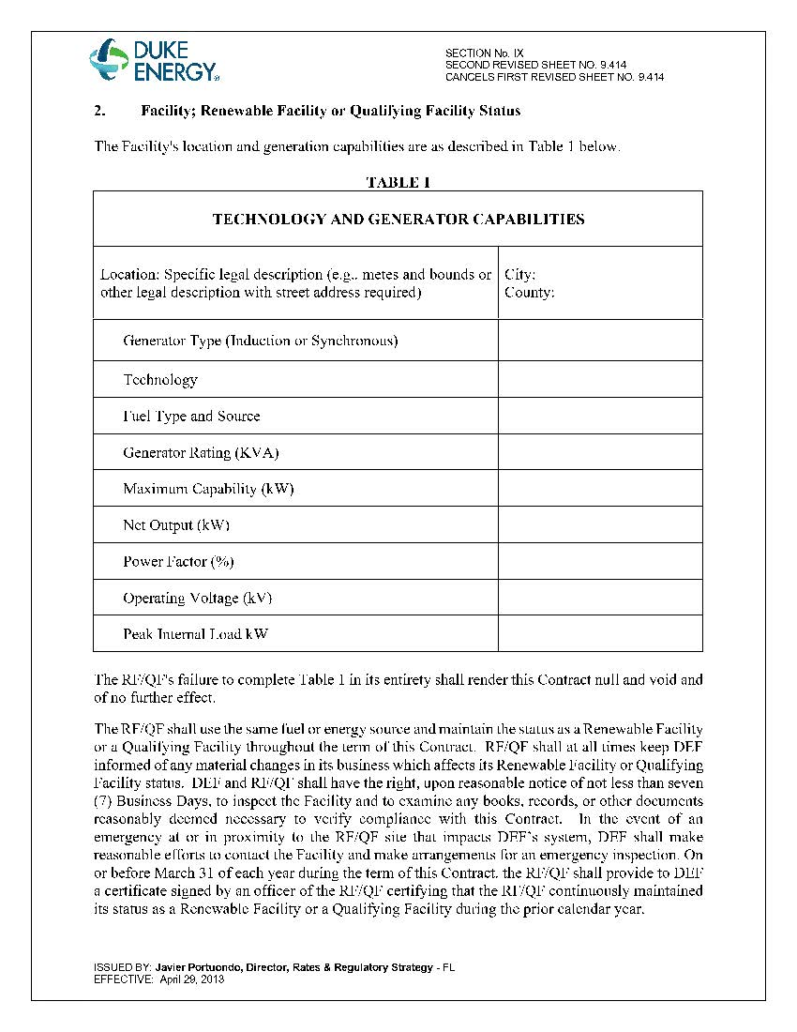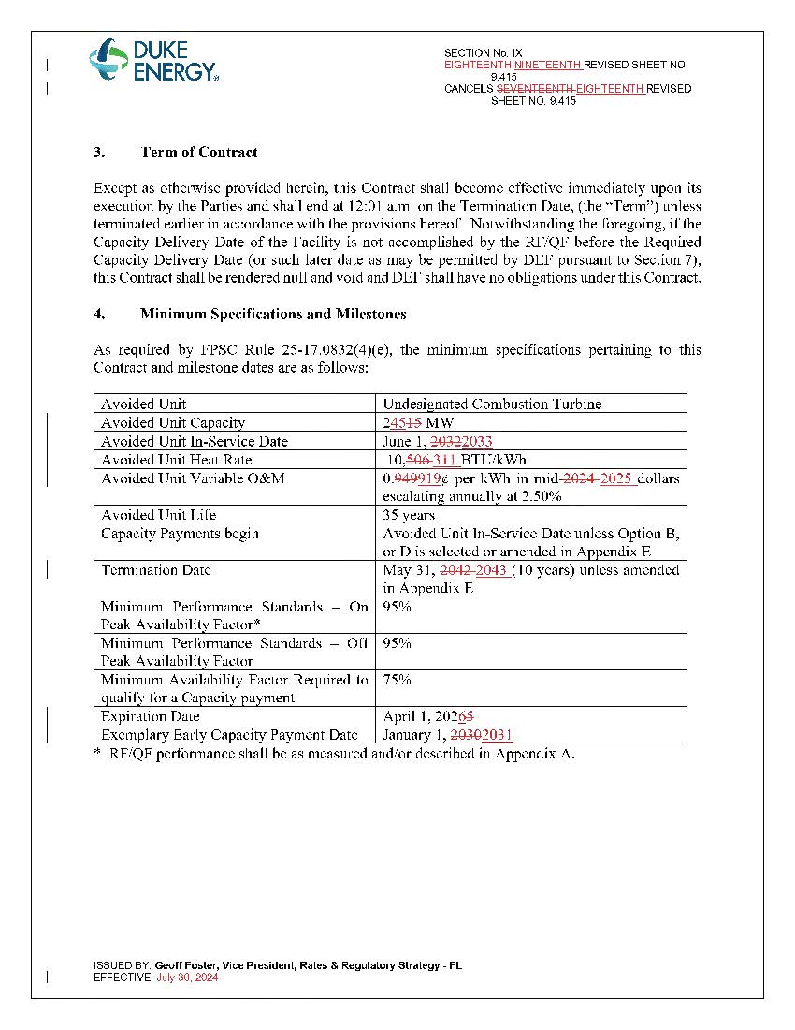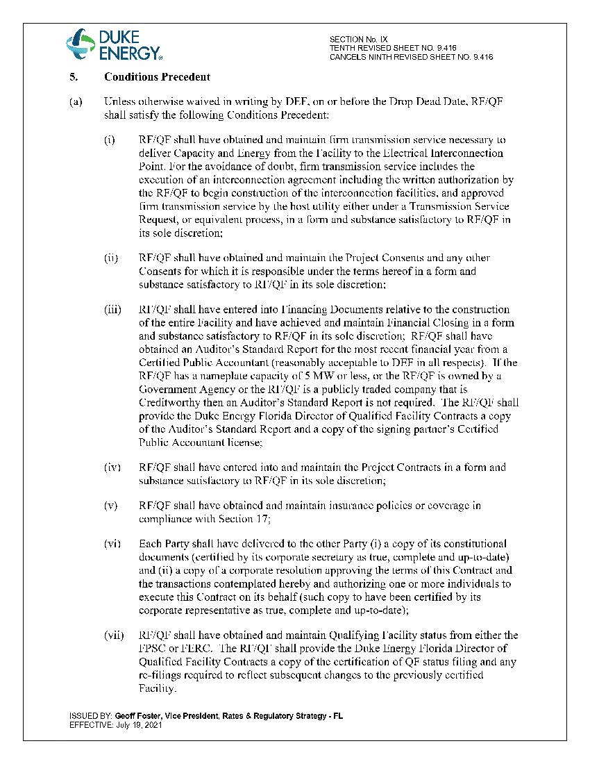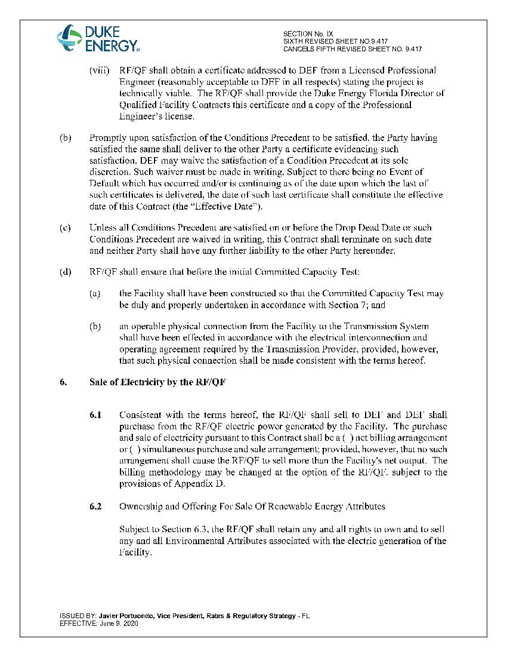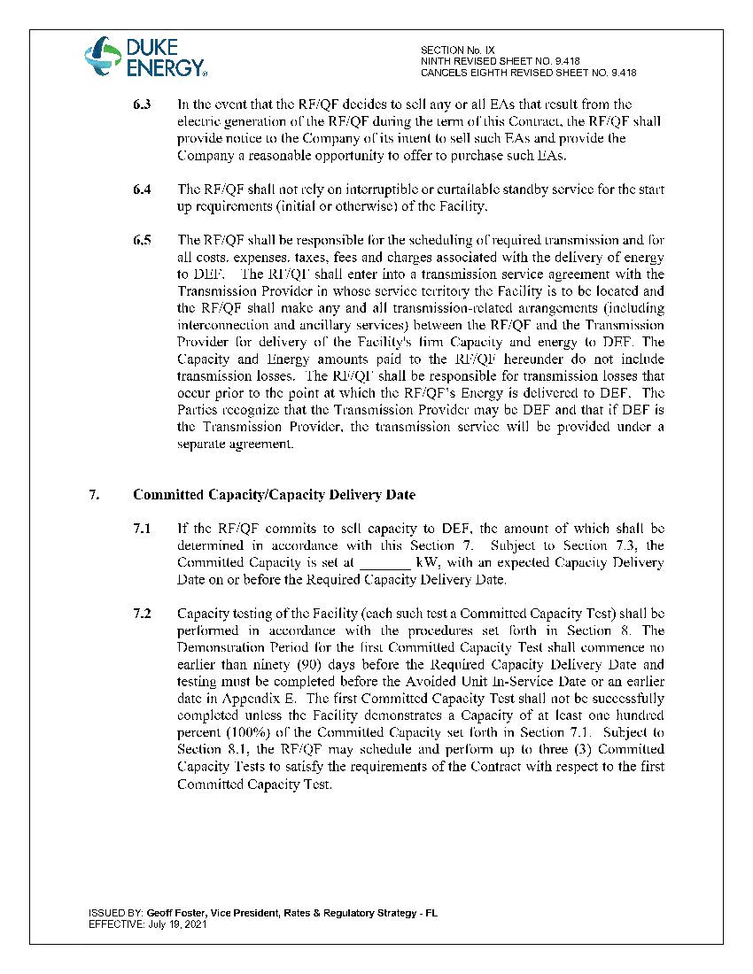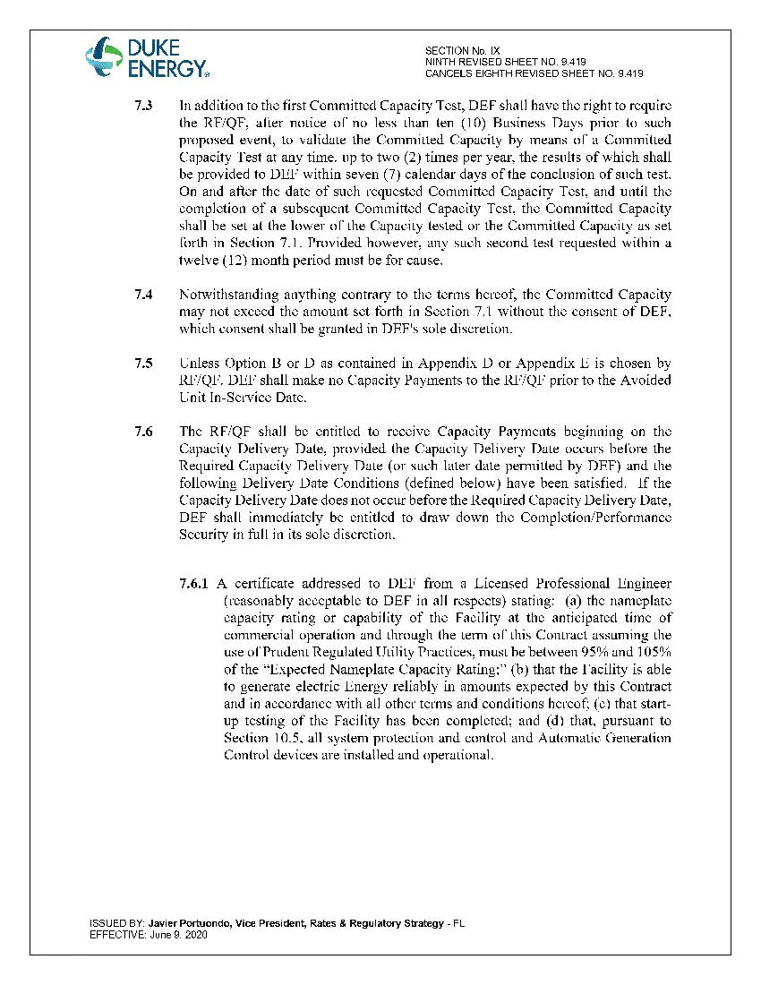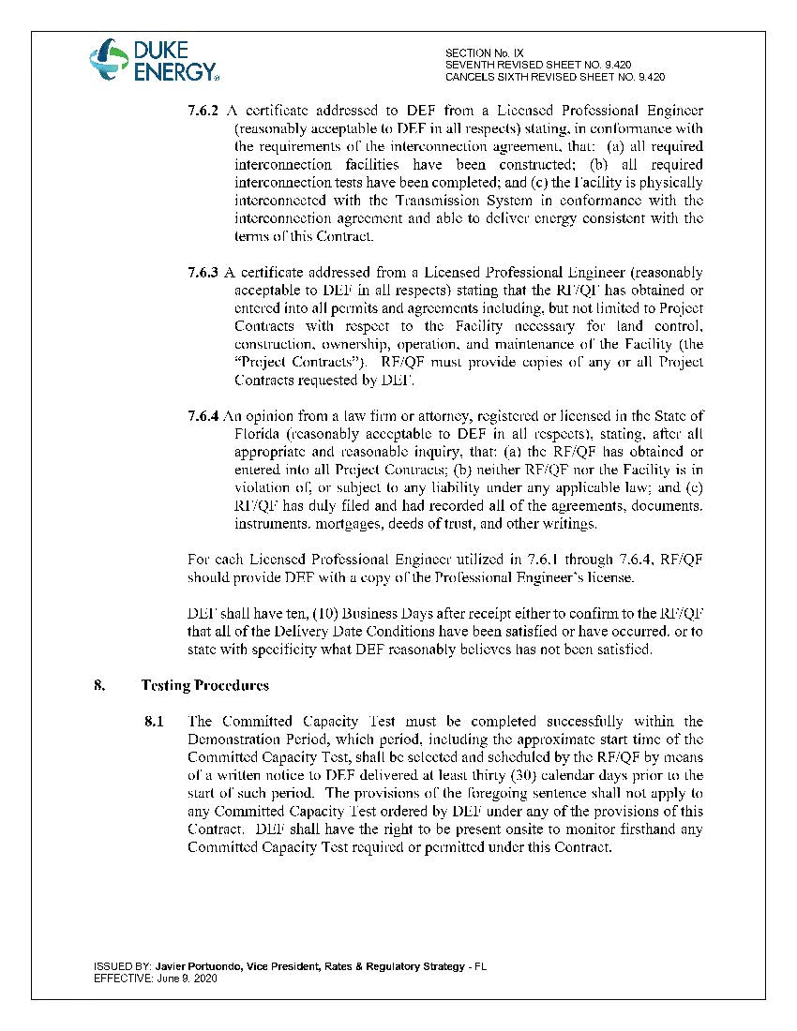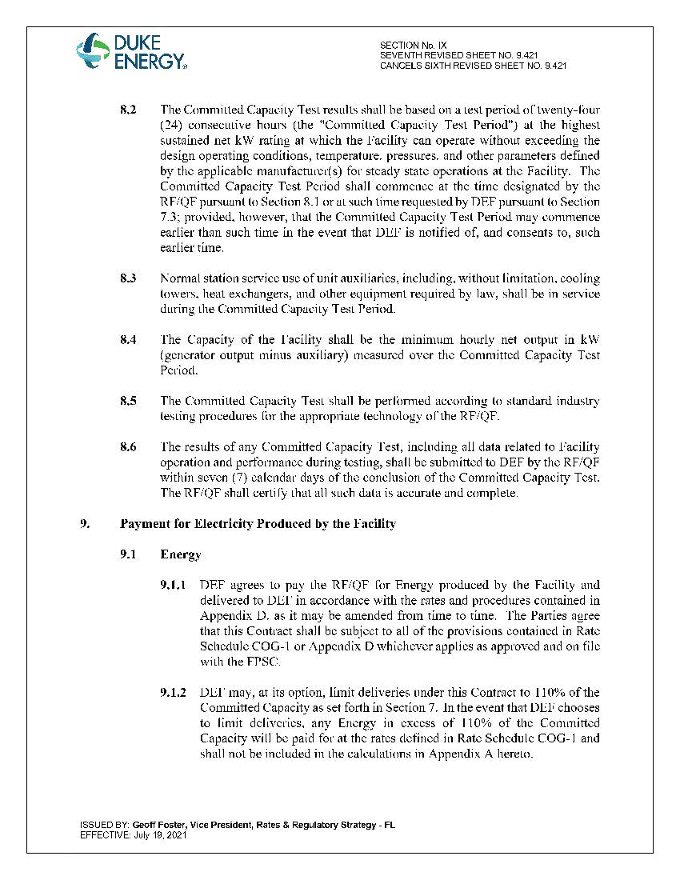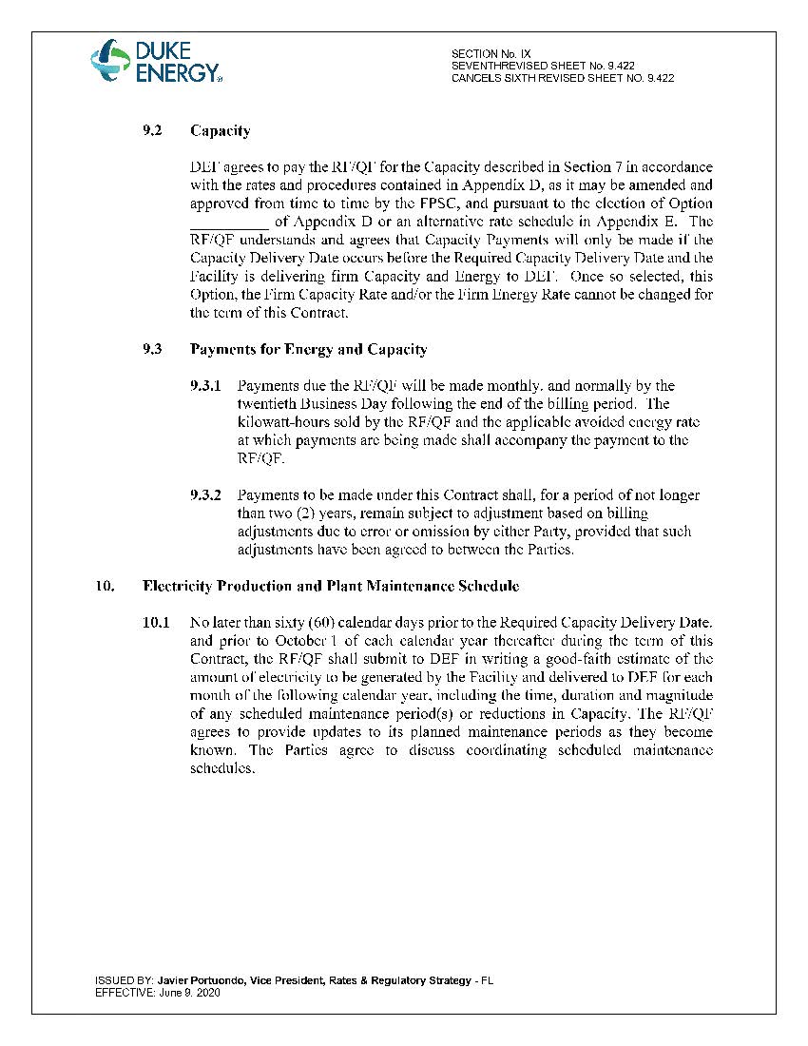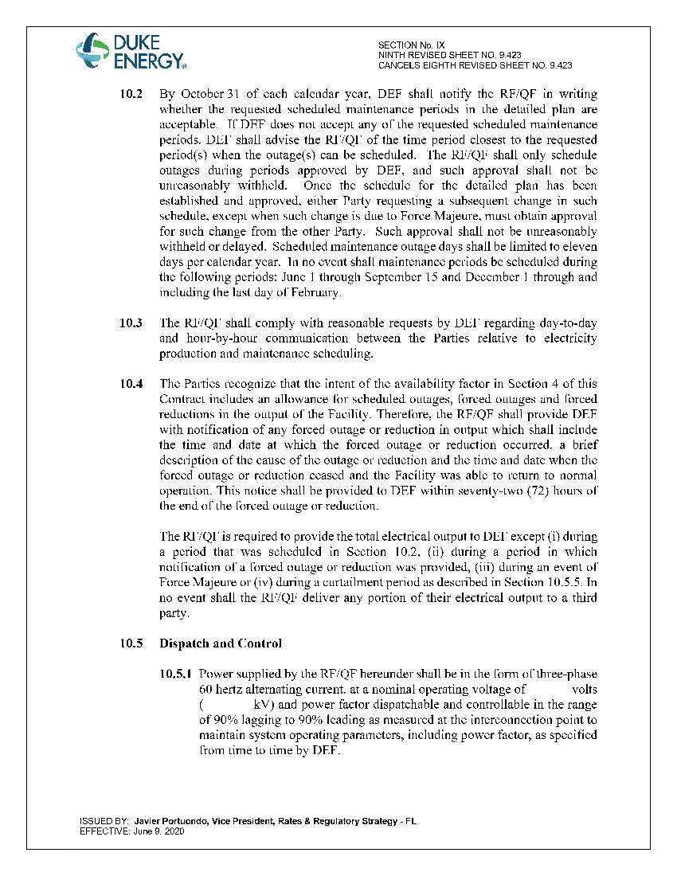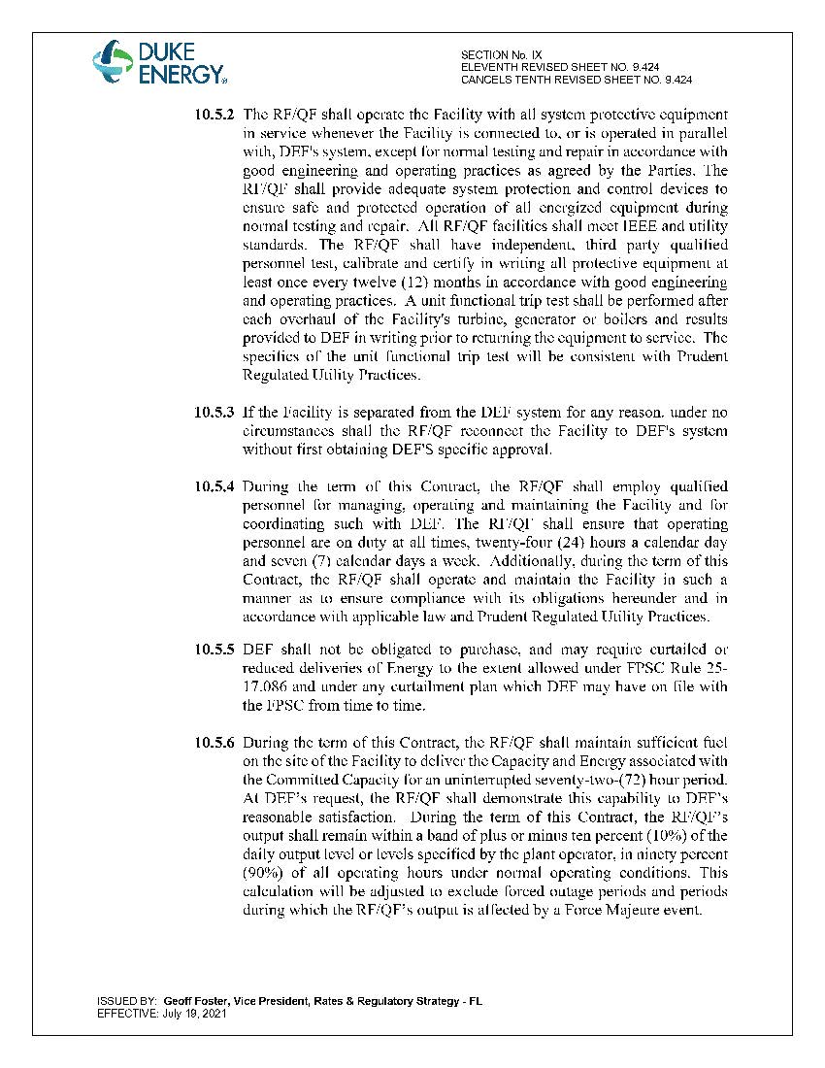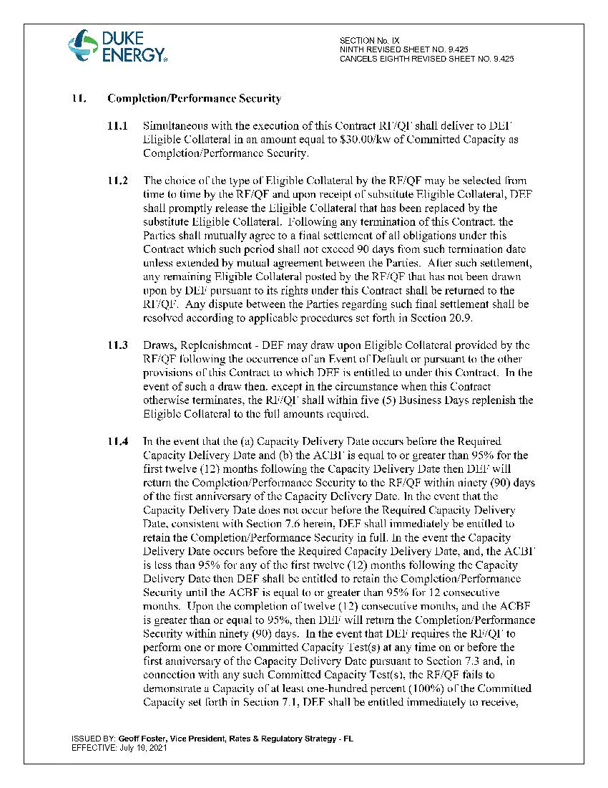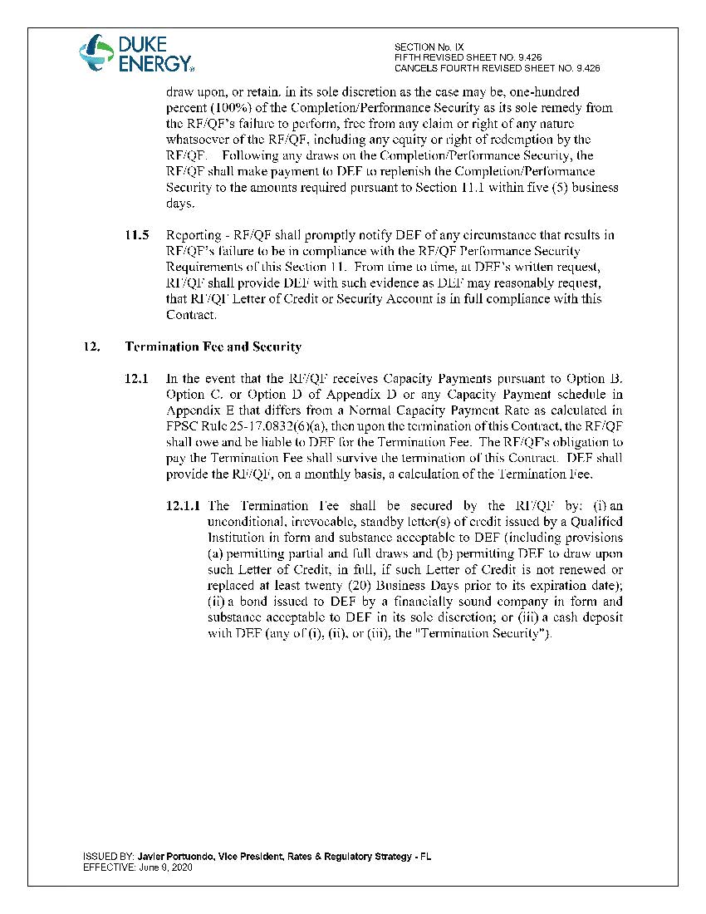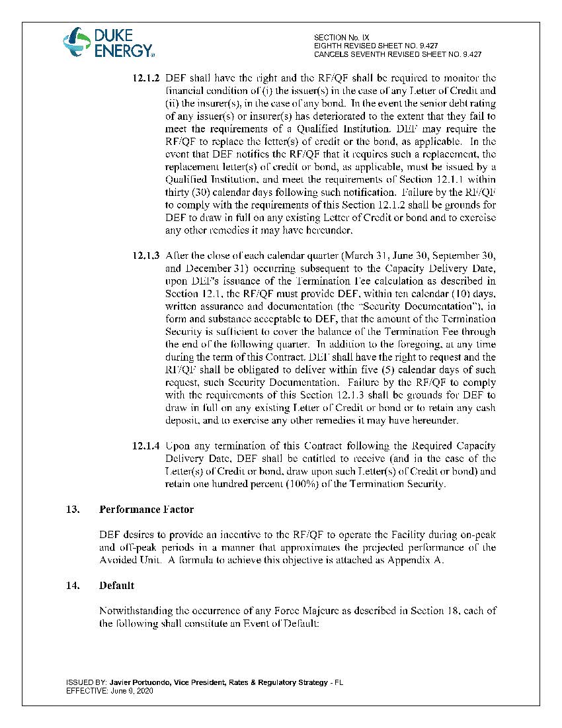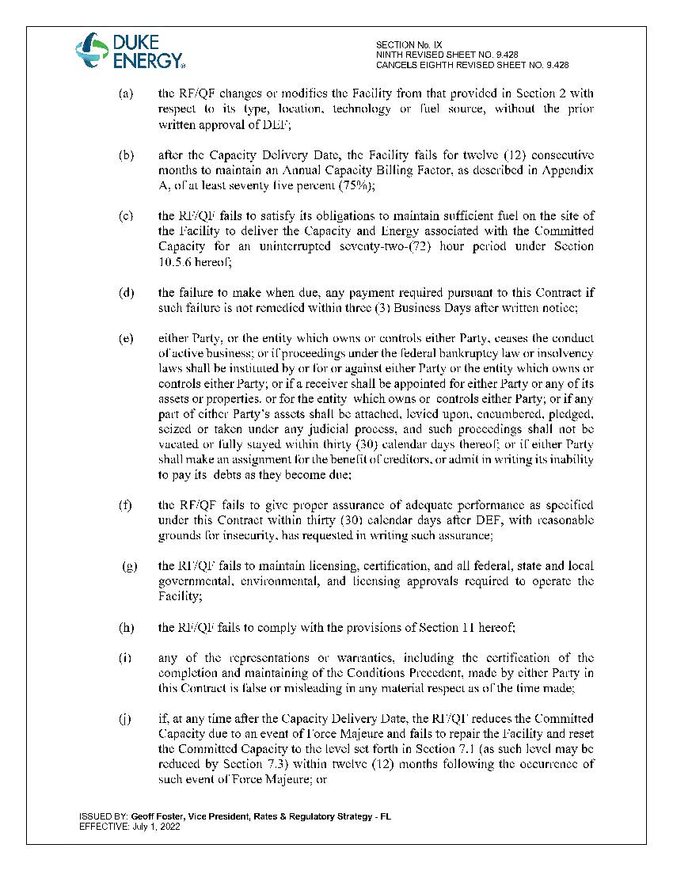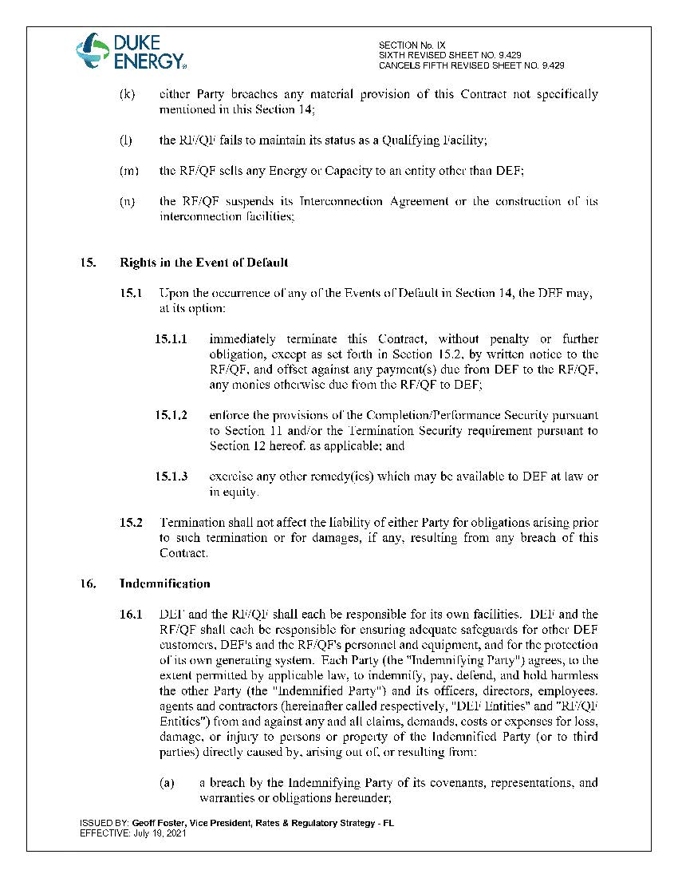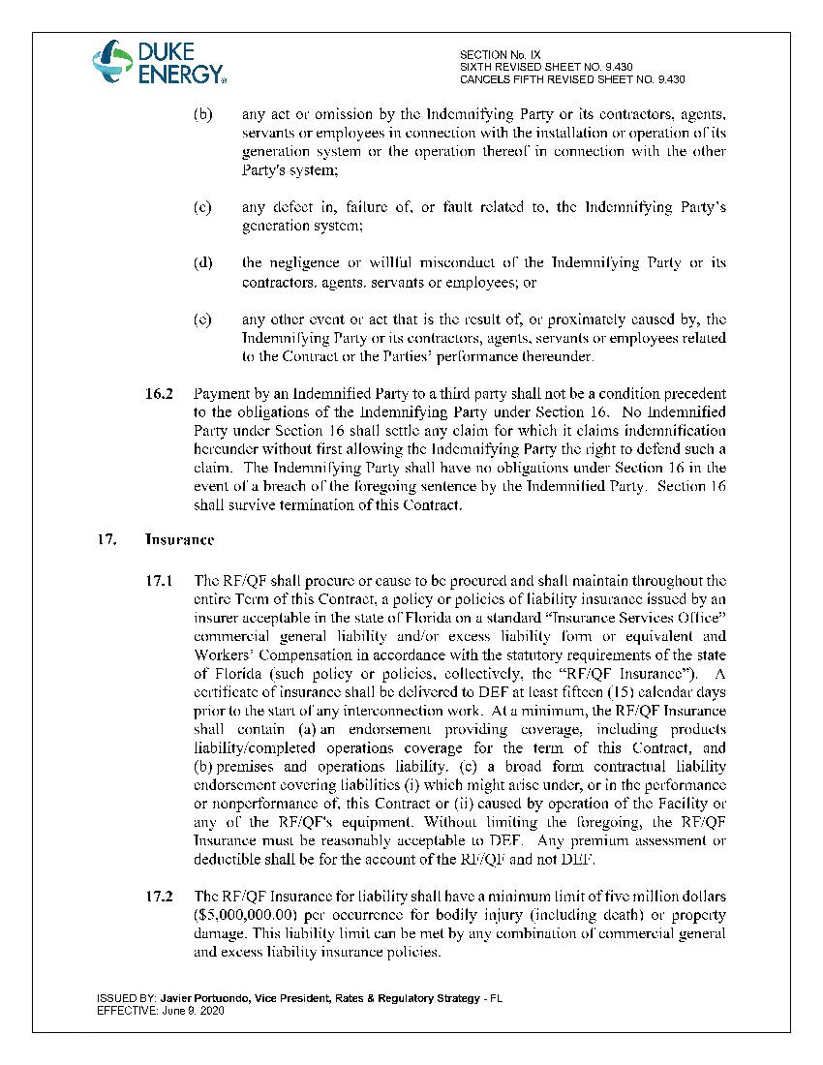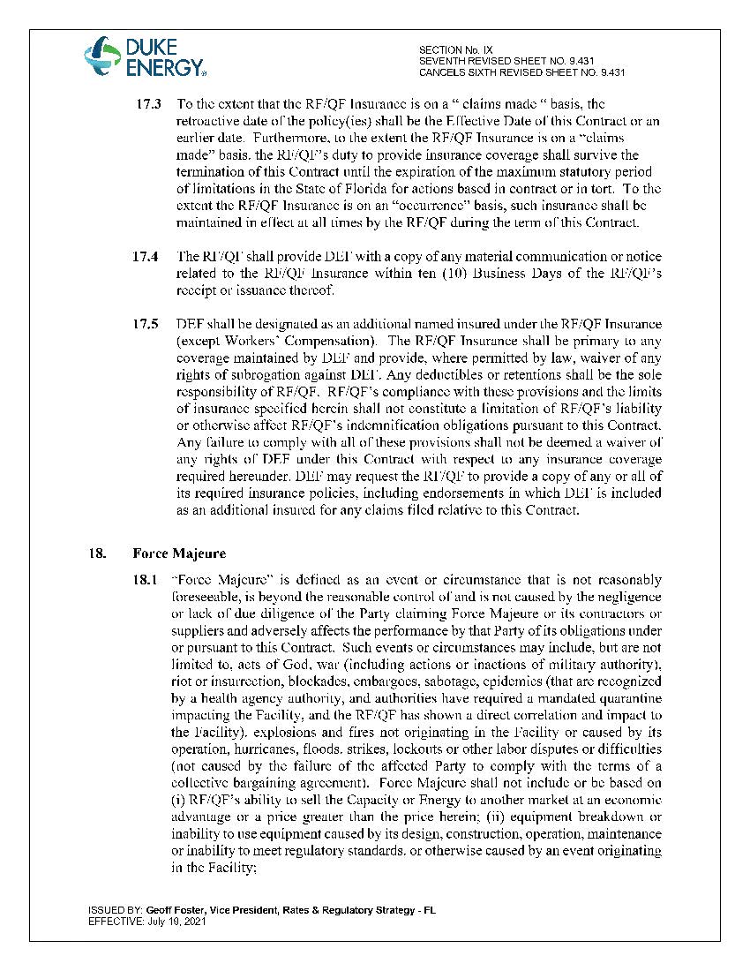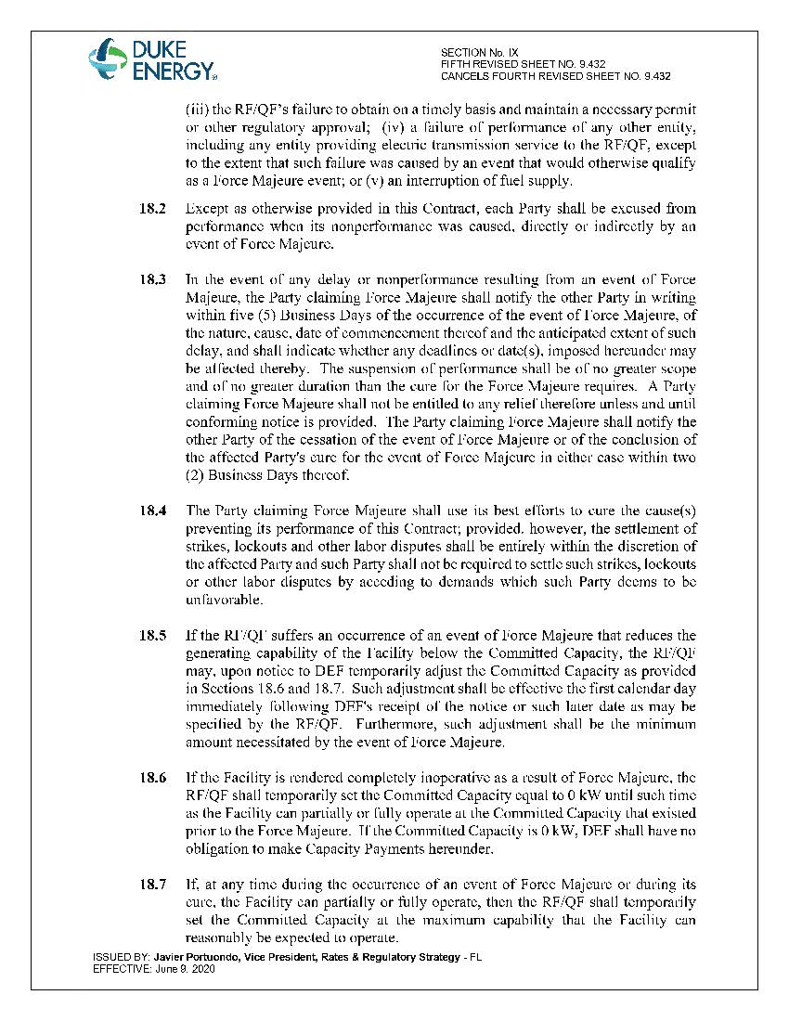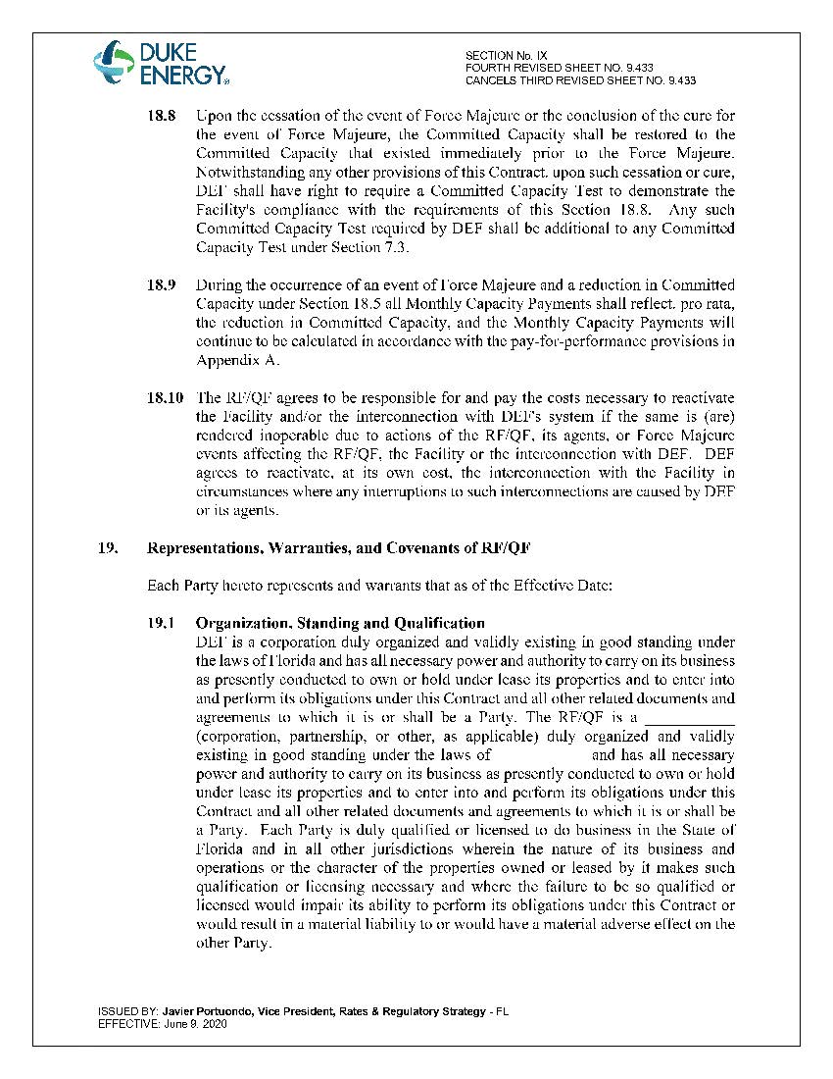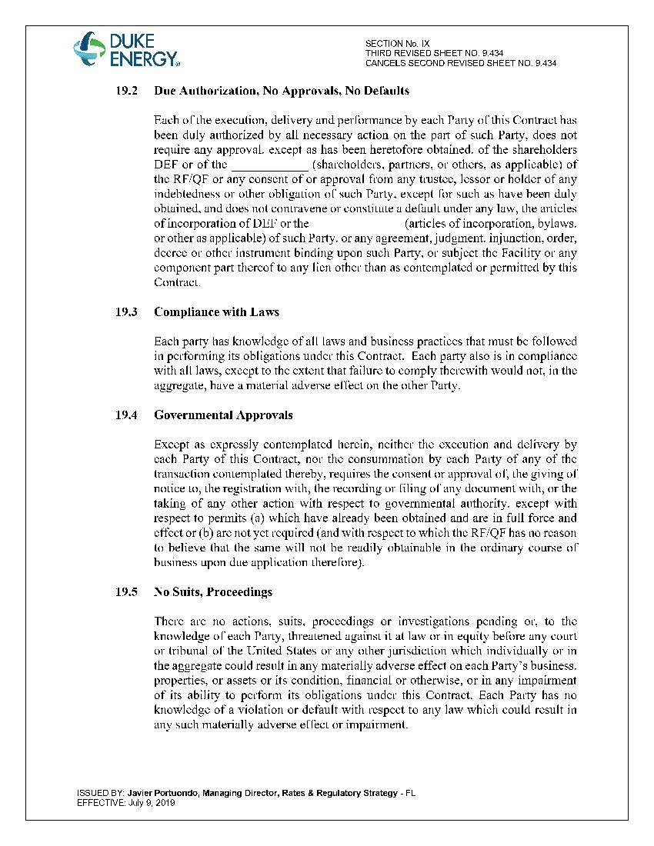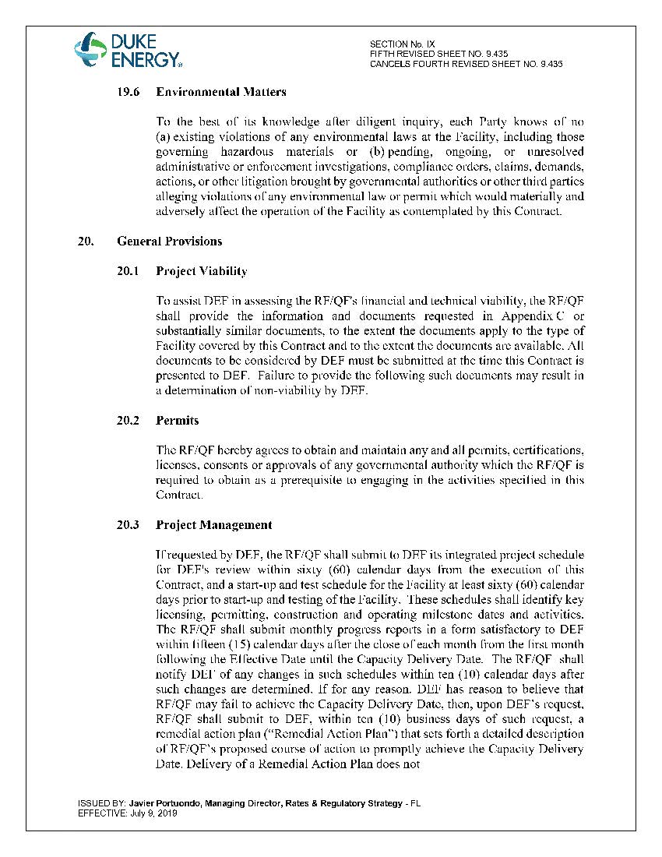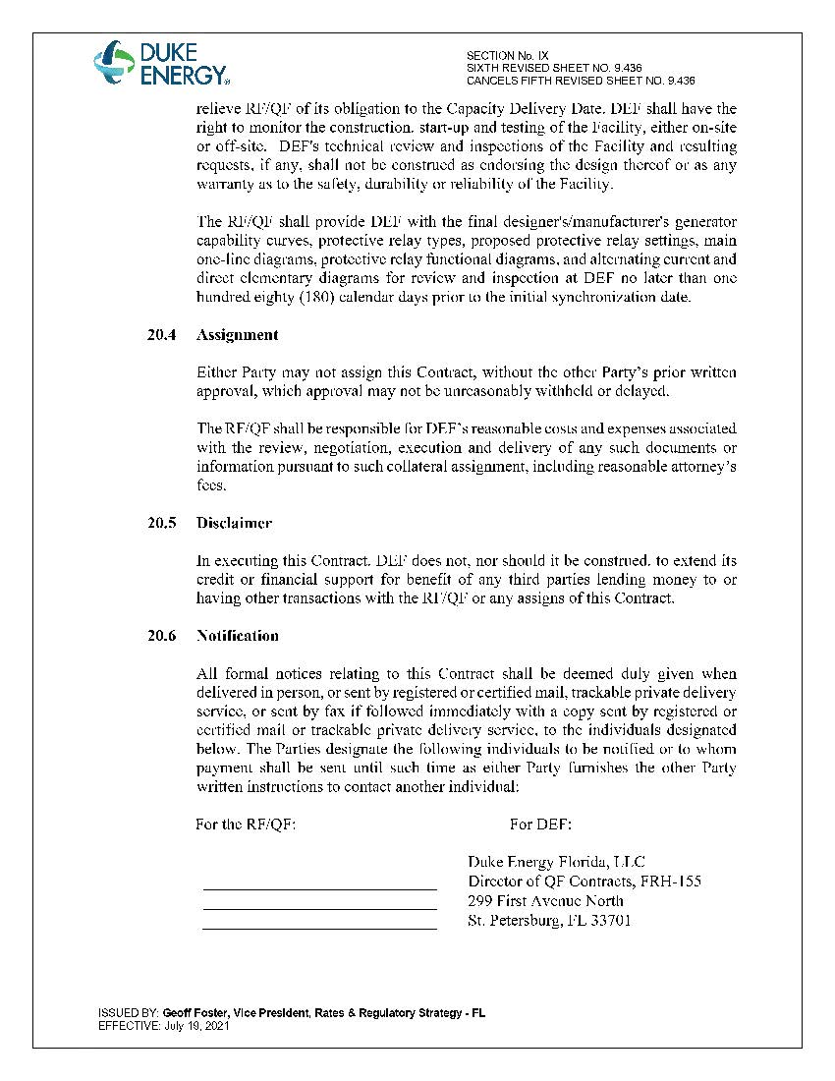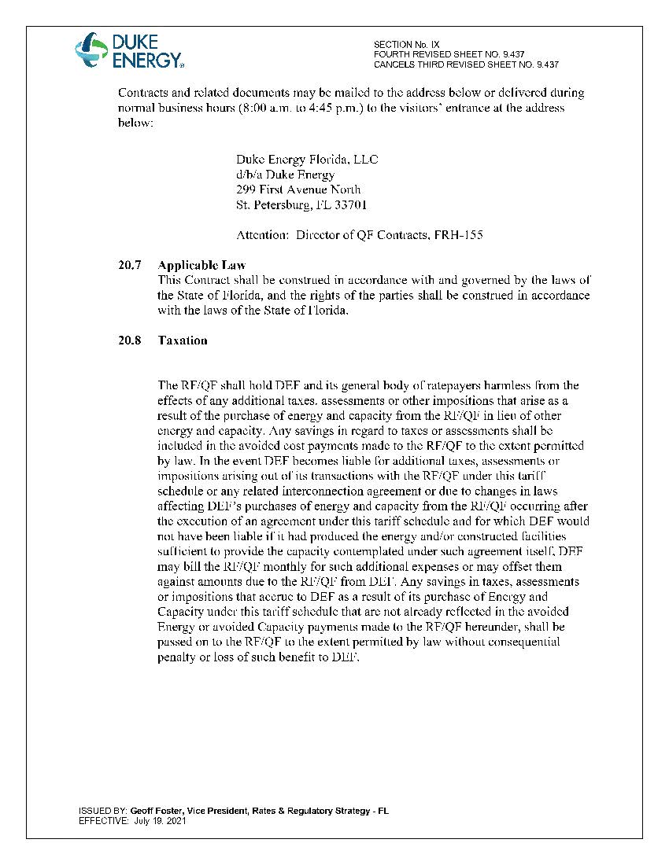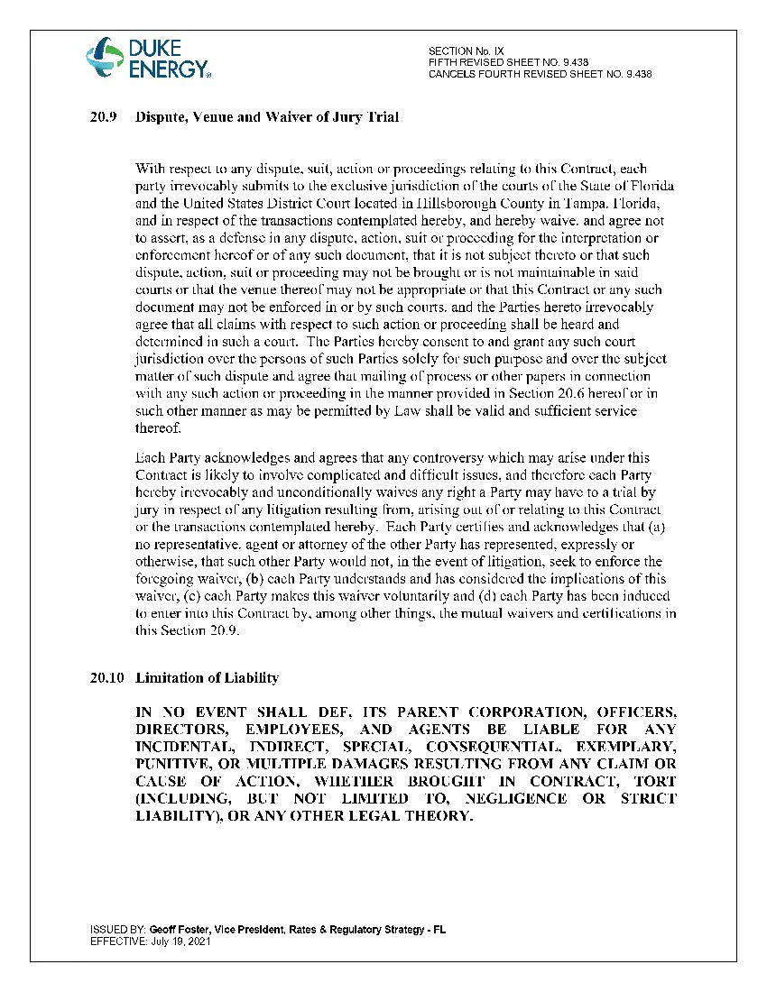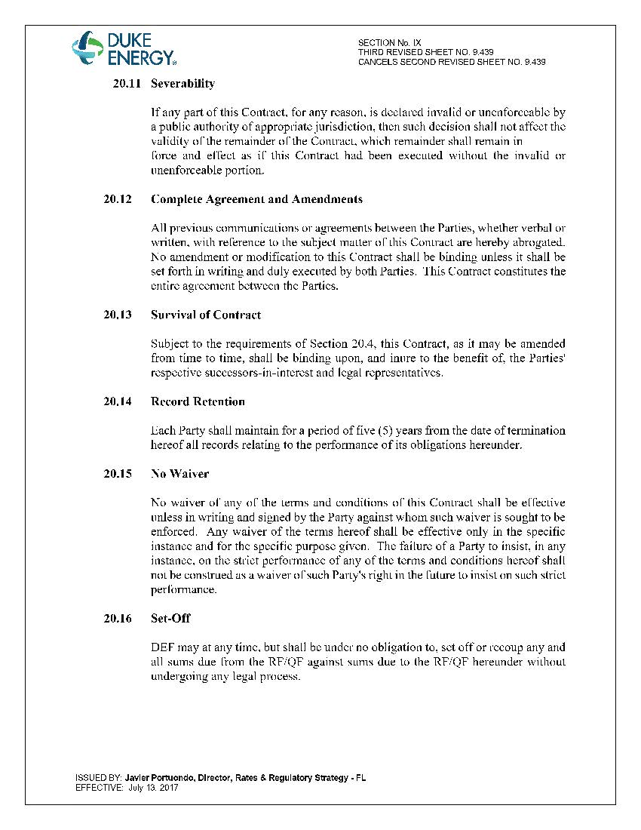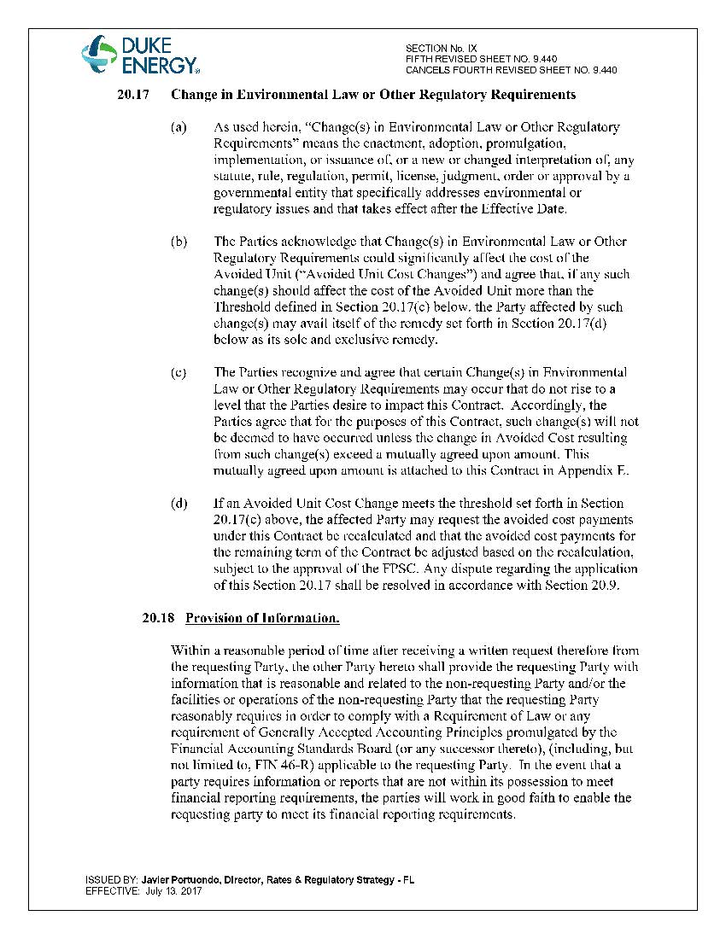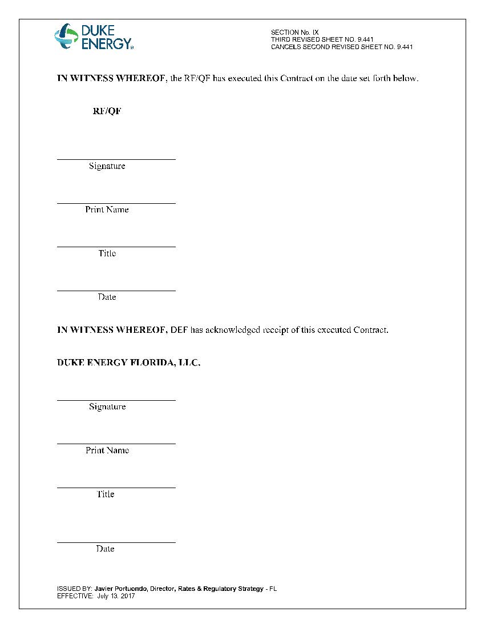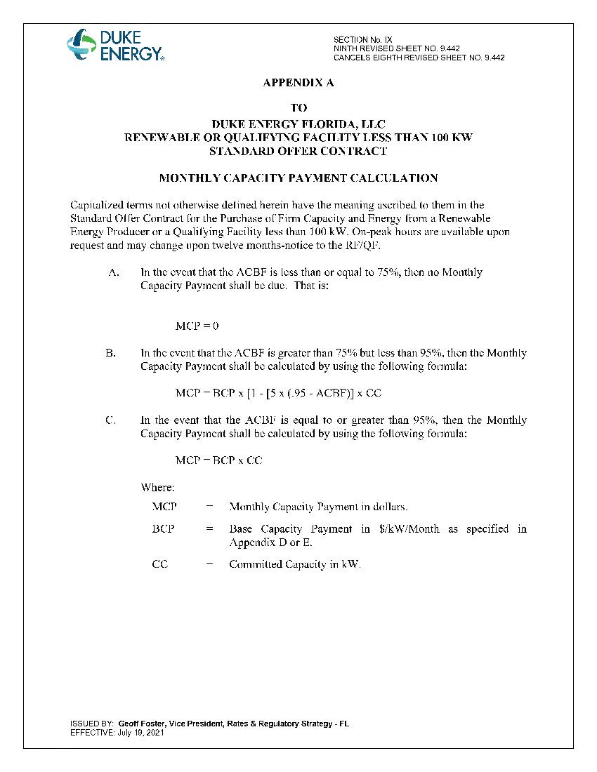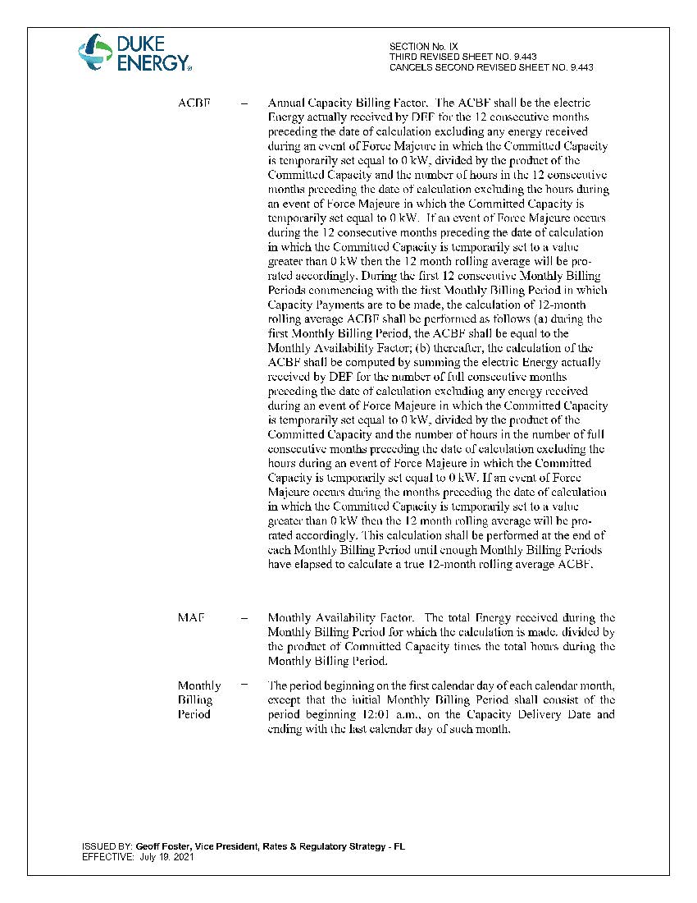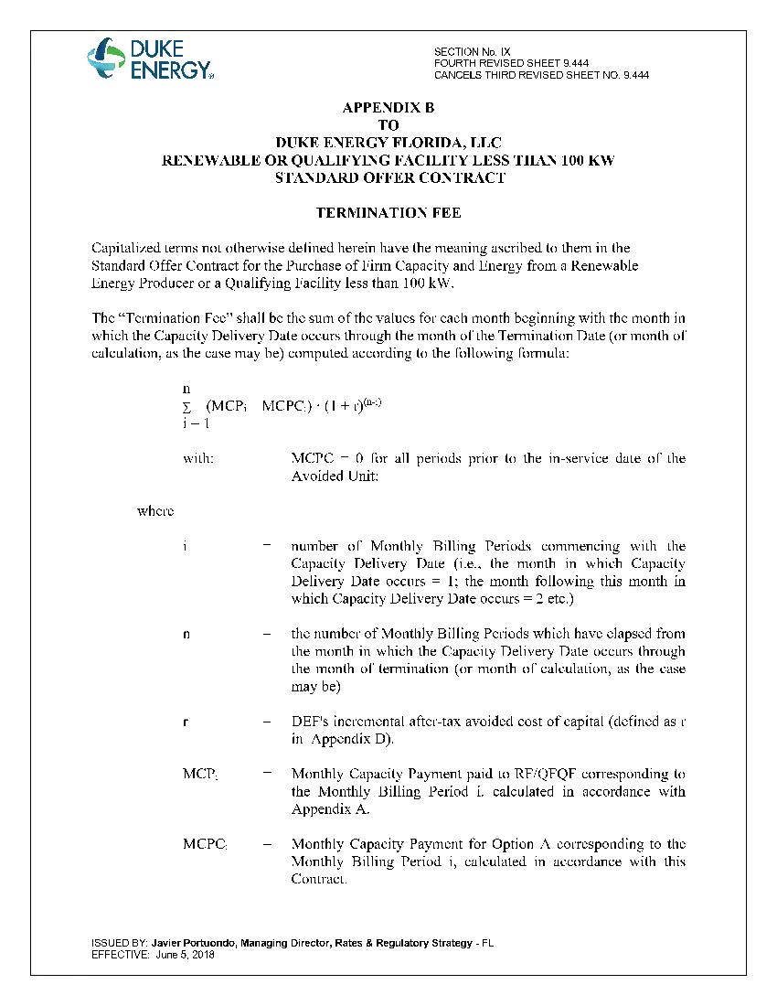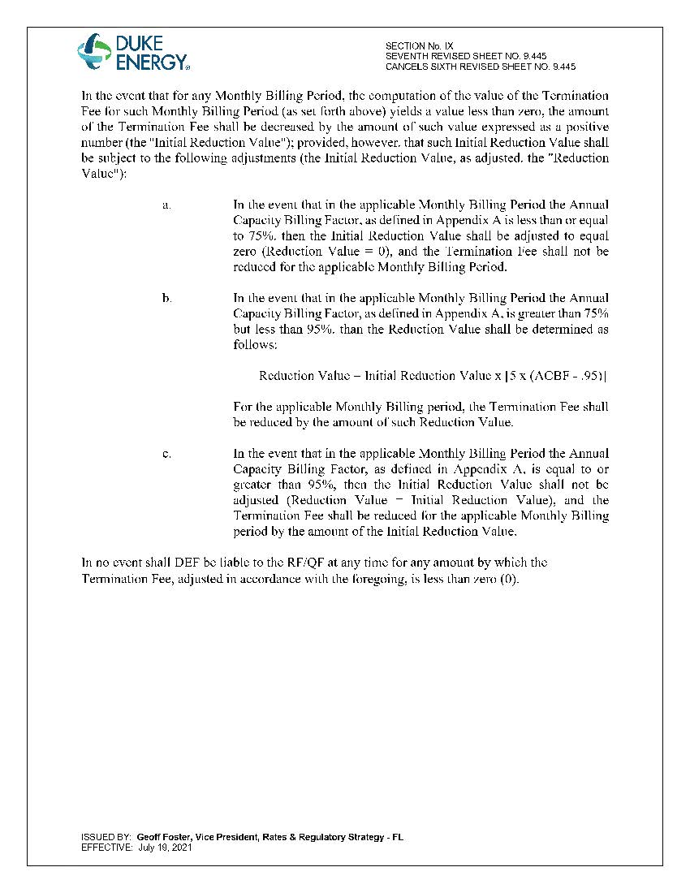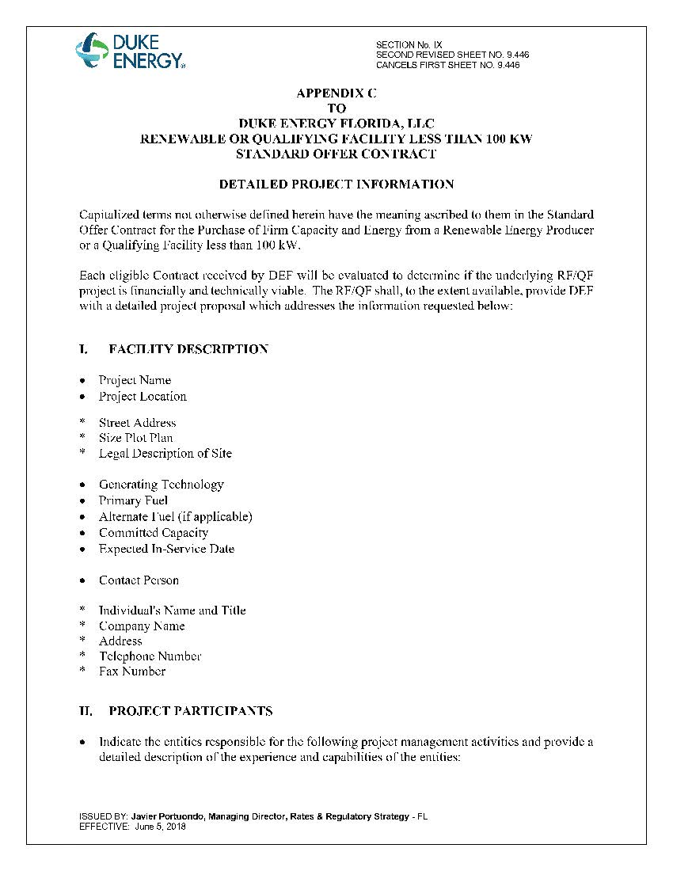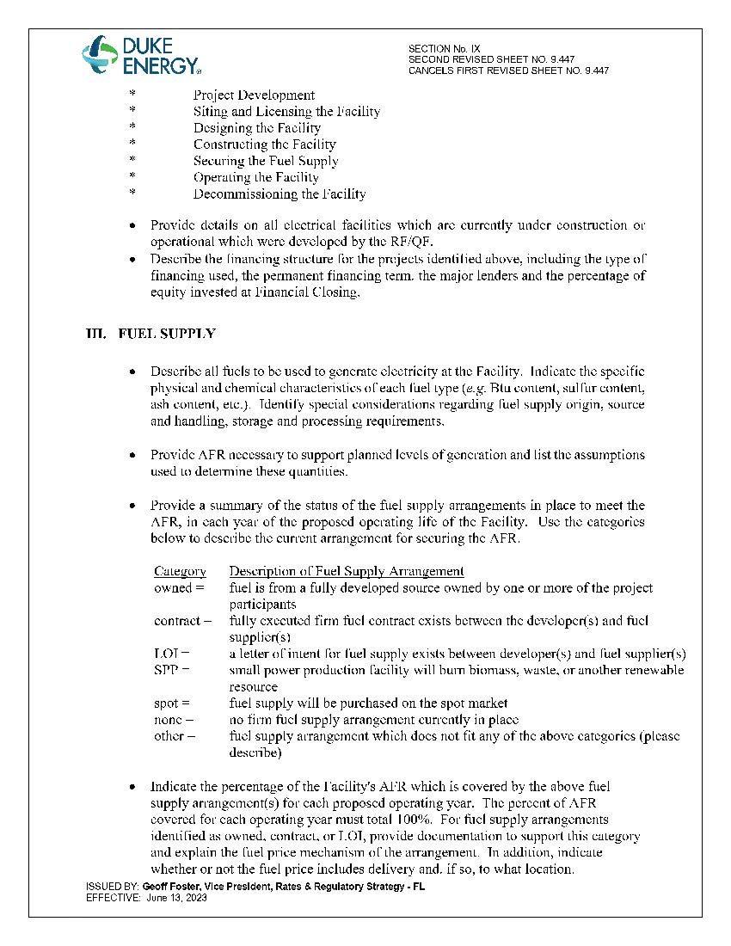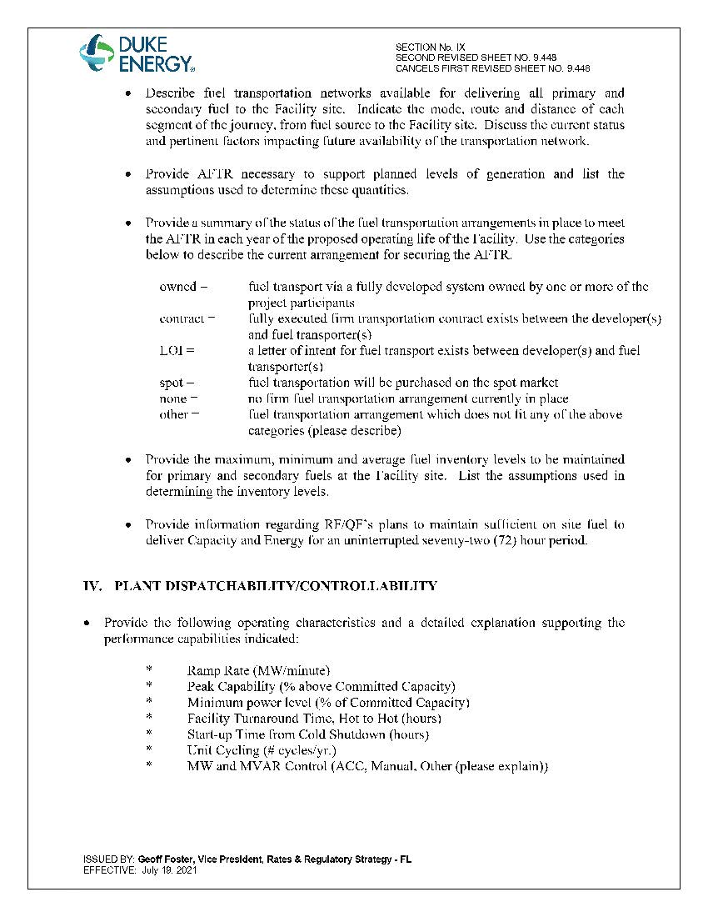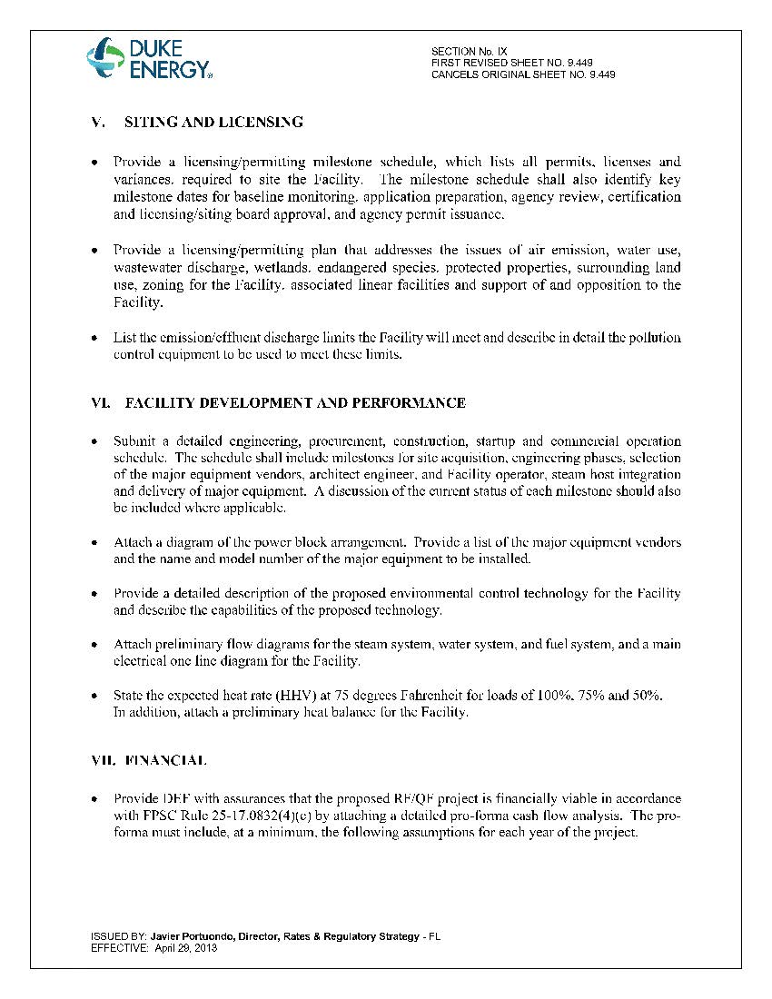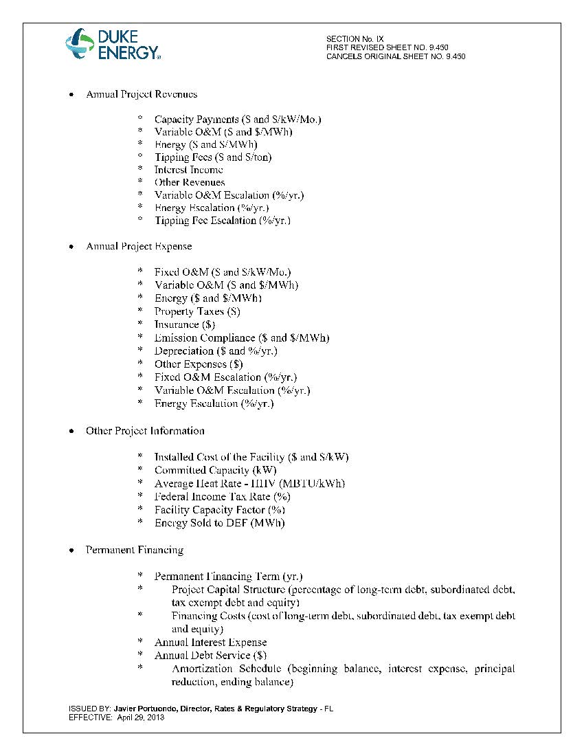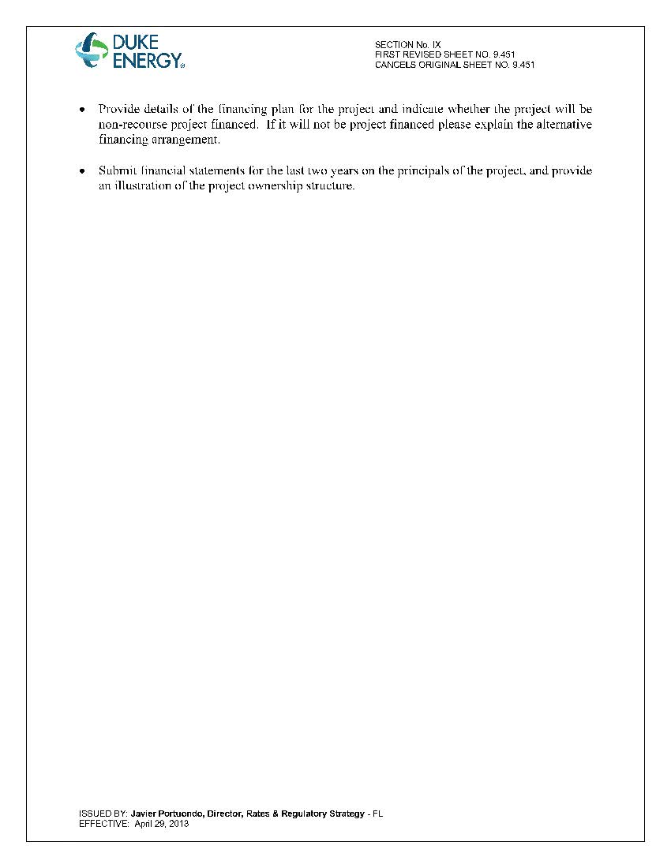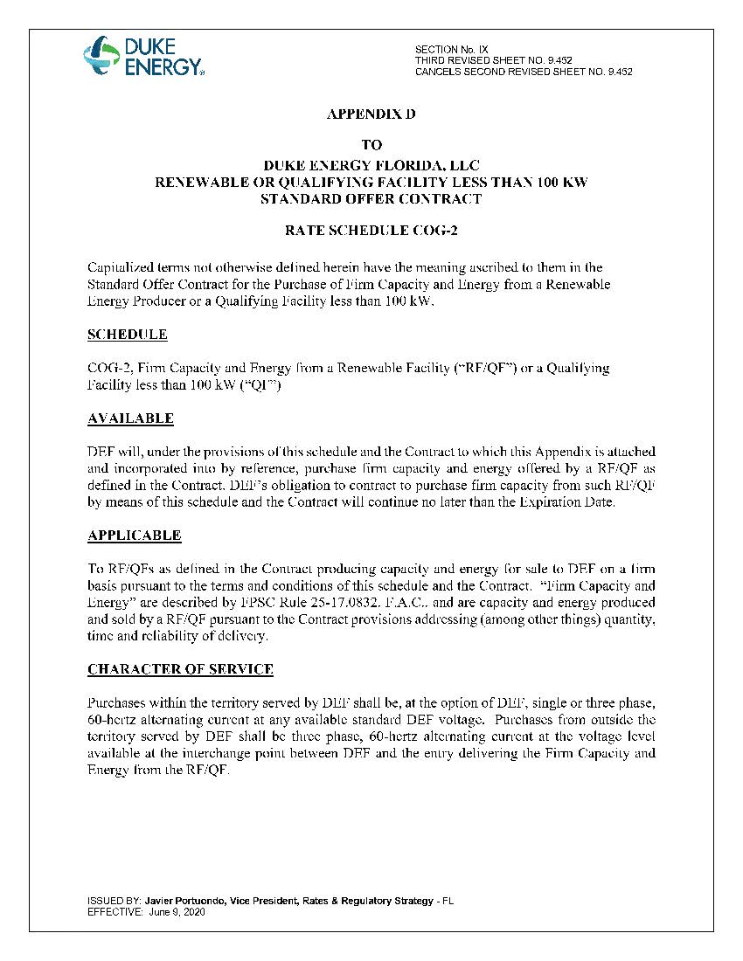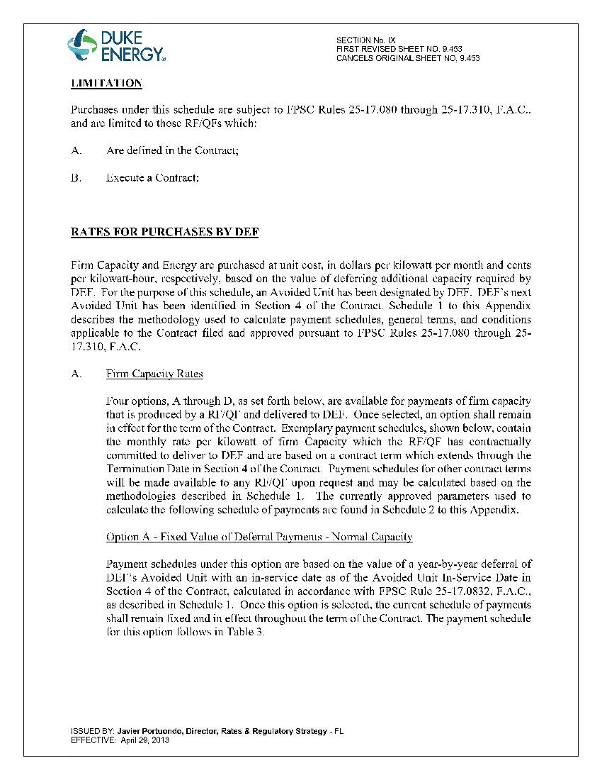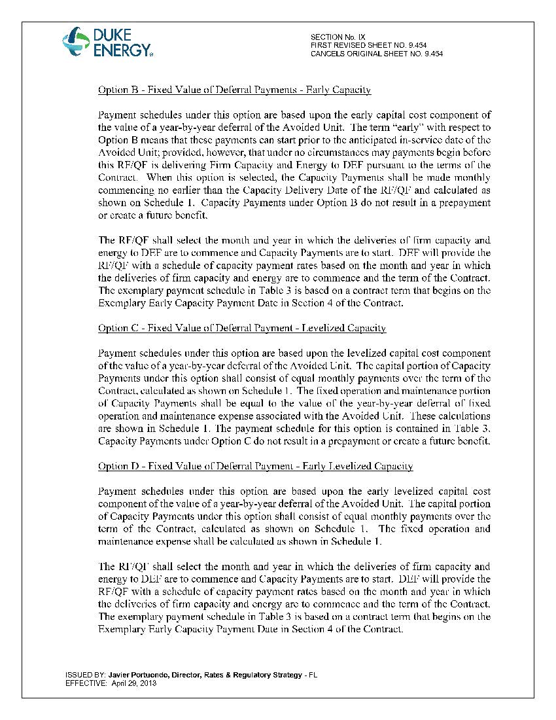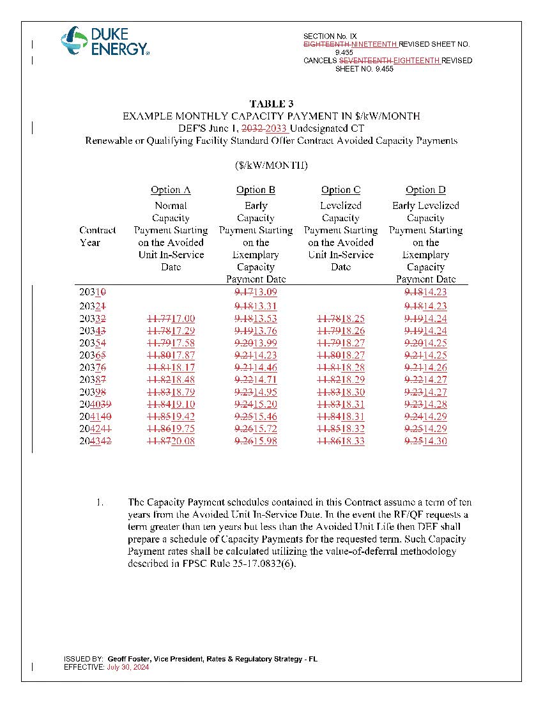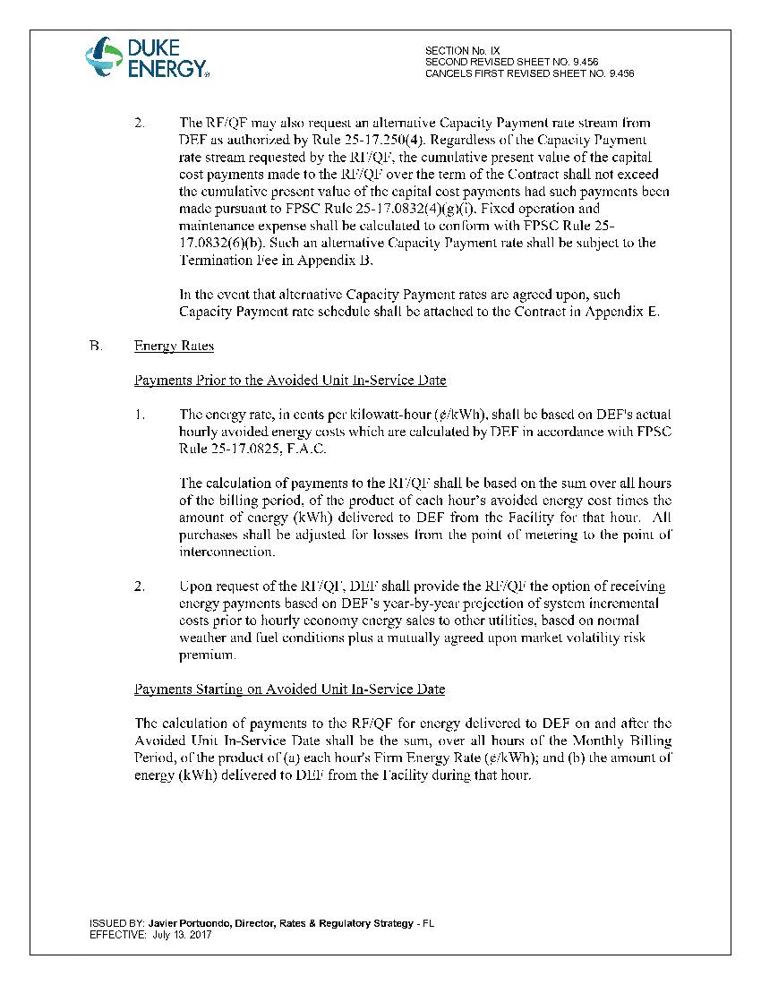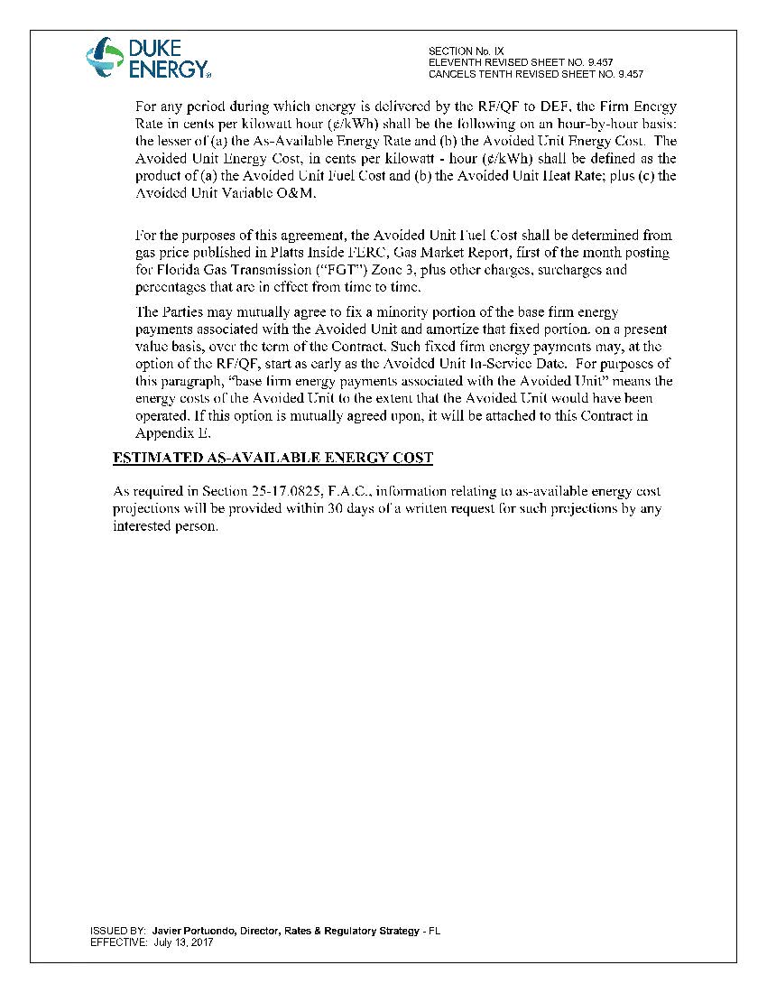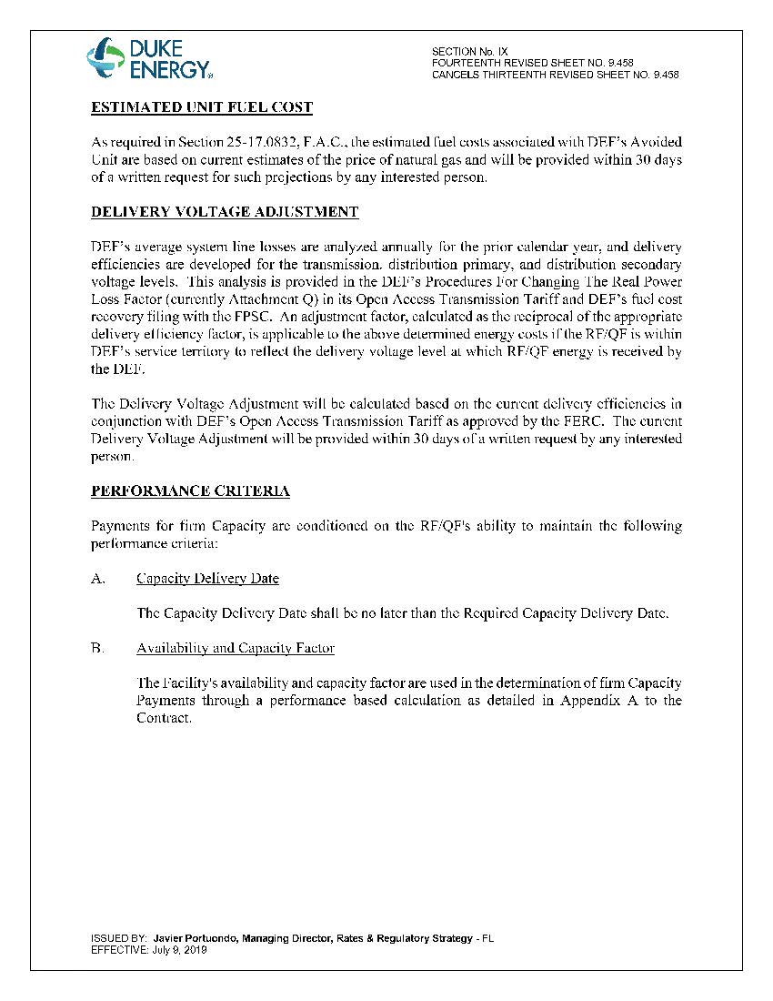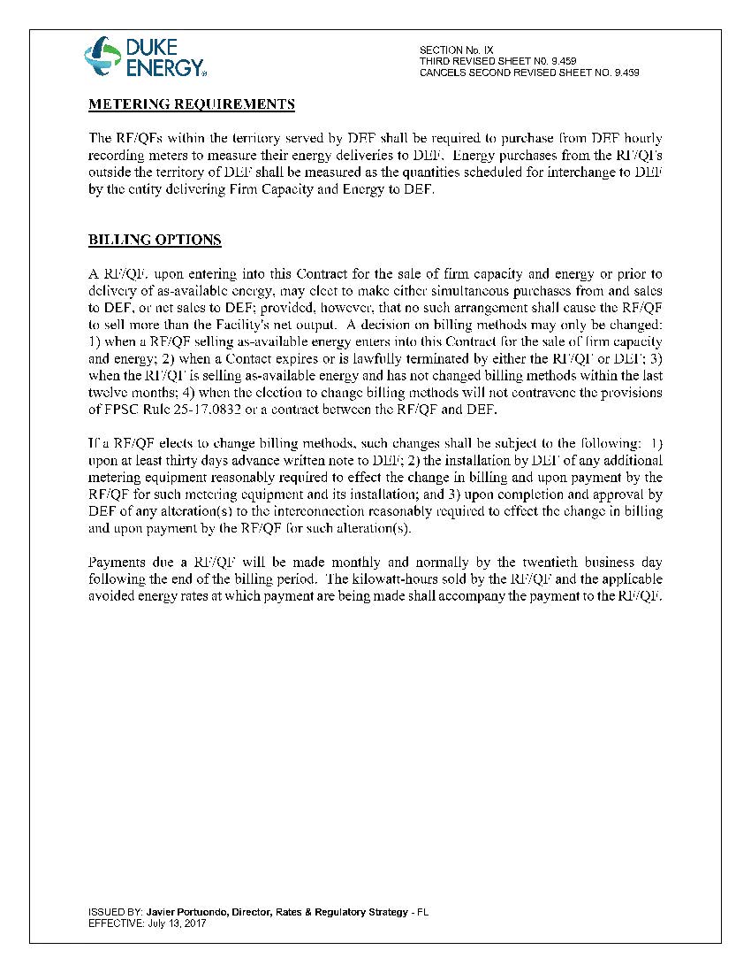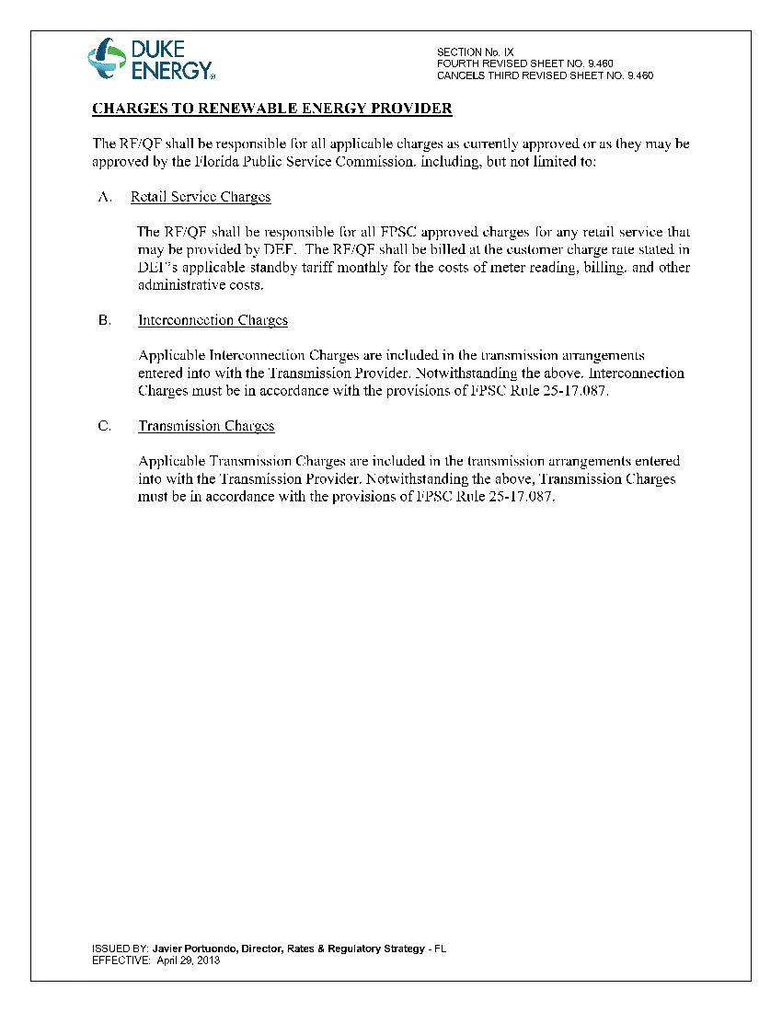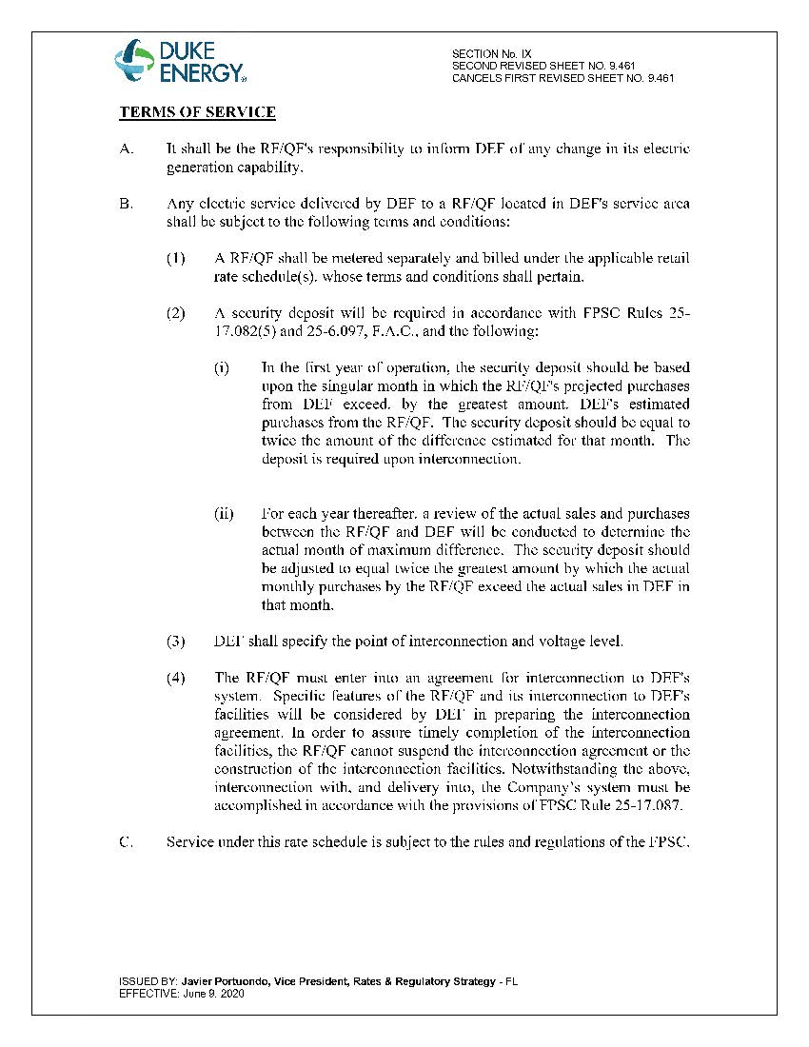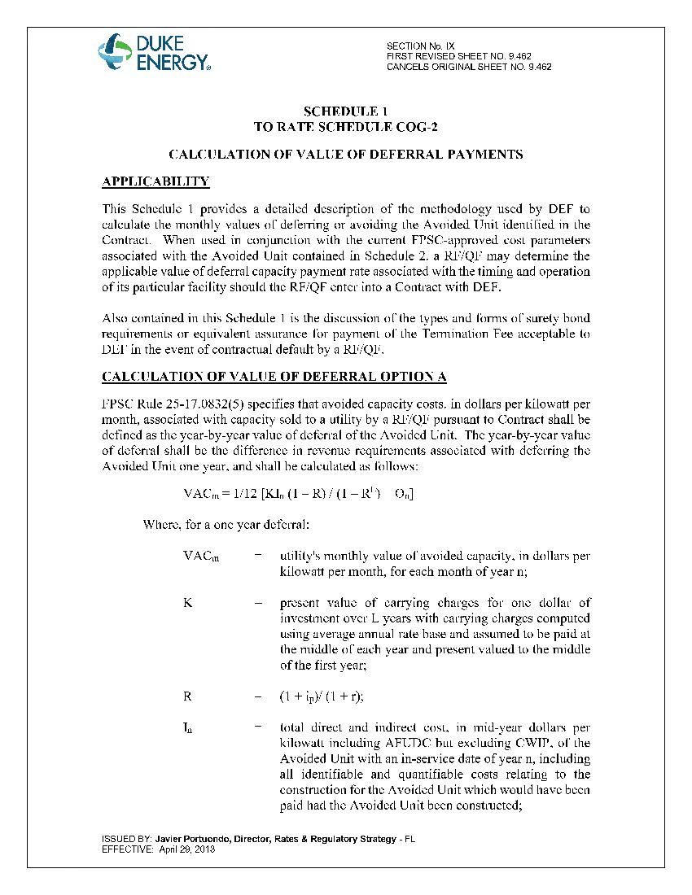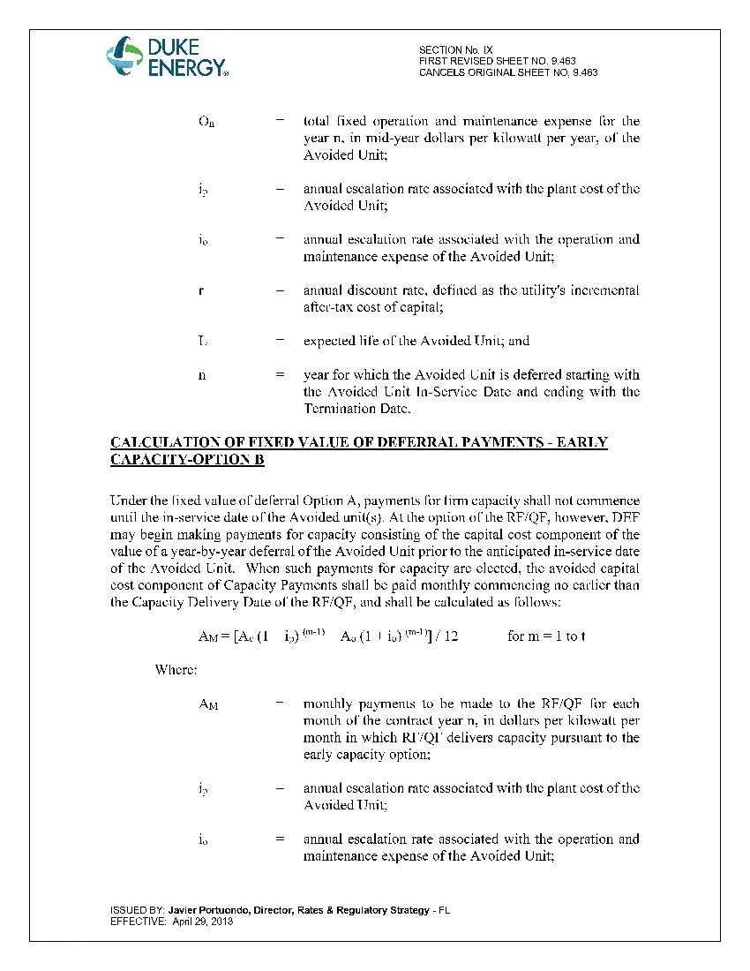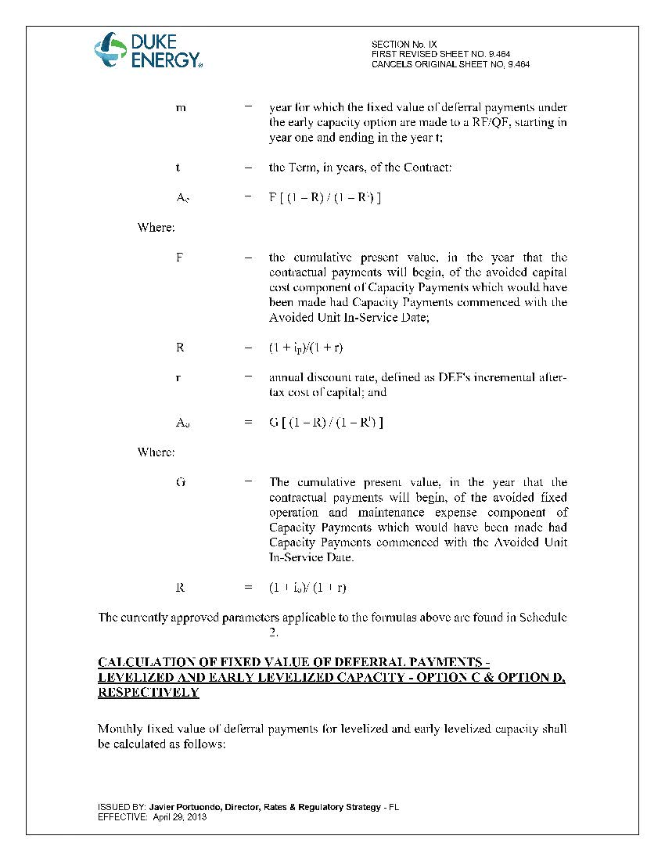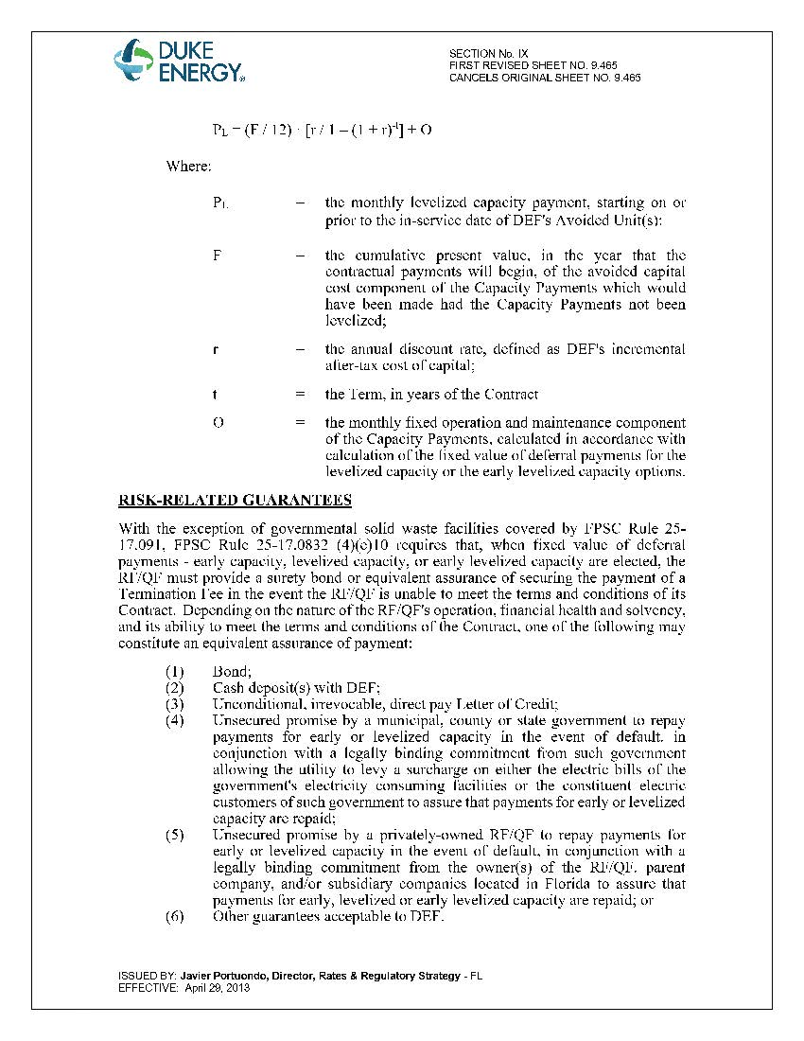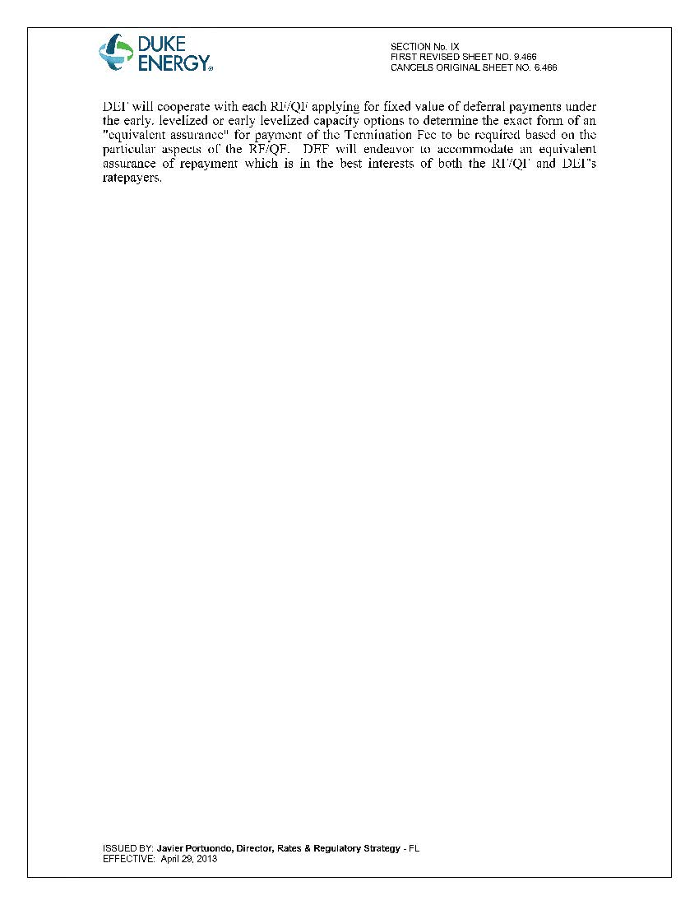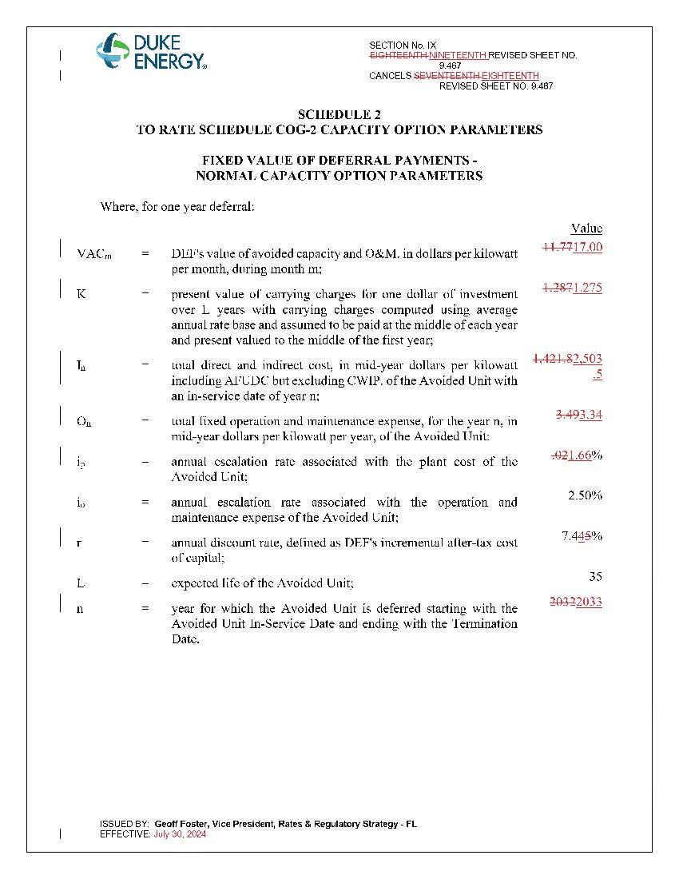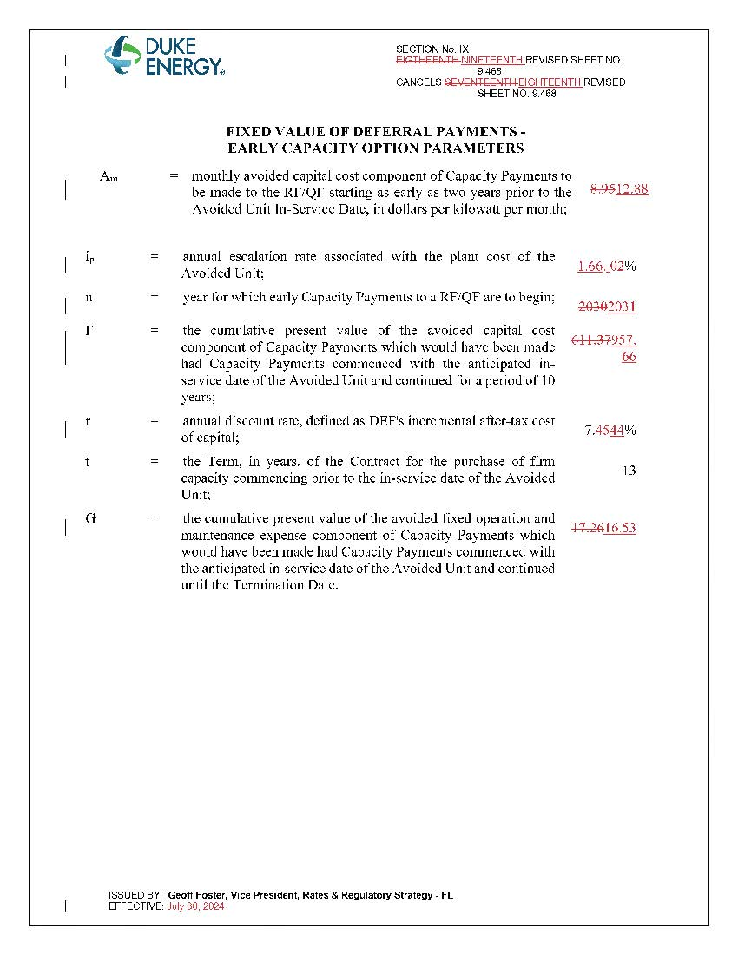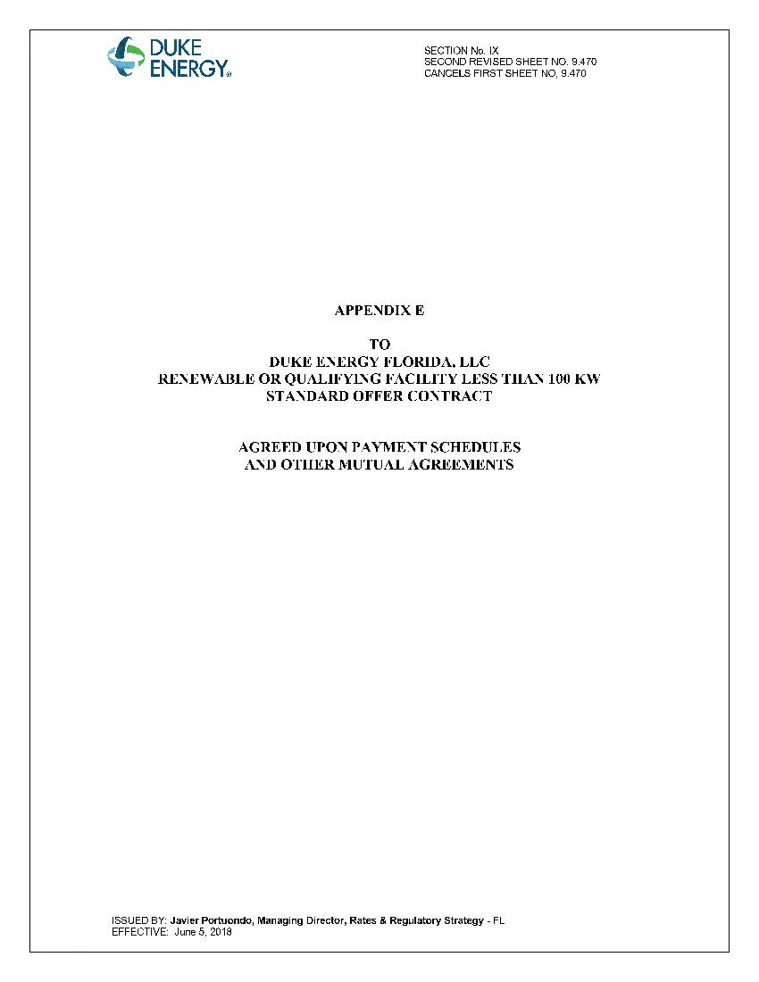

Document No. 02948-2025, filed Apr. 17, 2025, in Docket No. 20250054-EQ, In re: Petition for approval of amended standard offer contract (Schedule COG-2), by Duke Energy Florida, LLC.

