BEFORE THE FLORIDA PUBLIC SERVICE COMMISSION

In re: Petition for approval of amended standard offer contract, by Progress Energy Florida, Inc. | DOCKET NO. 120067-EI  ORDER NO. PSC-12-0335-TRF-EI  ISSUED: June 27, 2012

The following Commissioners participated in the disposition of this matter:

RONALD A. BRISÉ, Chairman
LISA POLAK EDGAR
ART GRAHAM
EDUARDO E. BALBIS
JULIE I. BROWN

ORDER APPROVING AMENDED STANDARD OFFER CONTRACT

BY THE COMMISSION:

Case Background
Section 366.91(3), Florida Statutes (F.S.), requires that each investor owned electric utility (IOU) continuously offer to purchase capacity and energy from renewable energy generators. Pursuant to Rules 25-17.200 through 25-17.310, Florida Administrative Code, (F.A.C.) by April 1 of each year, each IOU must file with the Florida Public Service Commission (Commission) a standard offer contract that is based on the next avoidable generating unit or planned purchase. Progress Energy Florida, Inc. (PEF) filed its petition for approval of amended standard offer contract on March 30, 2012. We have jurisdiction pursuant to Sections 366.04-366.06, and 366.91, F.S.
Decision

PEF is an IOU. As such, PEF is required by Rule 25-17.250, F.A.C., to continuously make available a standard offer contract for the purchase of firm capacity and energy from renewable generating facilities (RF) and small qualifying facilities (QF) with design capacities of 100 kilowatts (kW) or less. The standard offer contract must provide a term of at least ten years and be based on the utility’s next avoidable fossil-fueled generating unit identified in its most recent Ten-Year Site Plan or, if no avoided unit is identified, its next avoidable planned purchase. Id. PEF has identified a 767 megawatt (MW) natural gas-fired combined cycle unit as its next fossil-fueled generating unit. The projected in-service date of this unit is June 1, 2019.
An RF/QF operator may elect to make no commitment regarding the quantity or timing of its deliveries to PEF, and to have a committed capacity of zero (0) MW. In this case, the energy is delivered on an as-available basis and only an energy payment is made. Alternatively, an RF/QF operator may elect to commit to certain minimum performance requirements based on the avoided unit and thereby become eligible for capacity payments in addition to those made for energy. If an RF/QF operator wishes to have contract terms that are different from those offered under the standard offer contract, the parties may enter into a negotiated contract instead.
In order to promote renewable generation, we require IOUs to offer multiple options for capacity payments, including the options to receive early or levelized payments. If an RF/QF operator elects to receive capacity payments under the normal or levelized contract options, it will receive as-available energy payments only until the in-service date of the avoided unit (in this case June 1, 2019), and thereafter begin receiving capacity payments in addition to the energy payments. If either the early or early levelized option is selected, then an operator will begin receiving capacity payments earlier than the in-service date of the avoided unit. However, payments made under the early capacity payments options tend to be lower in the later years of the contract term because the net present value (NPV) of the total payments must remain equal for all contract options. Moreover, if capacity payments are made which are greater than those called for under the normal option, additional performance security will be required from the RF/QF operator.
Table 1 below, reflects an estimate of all annual payment options under the proposed standard offer contract for an RF/QF operator with a 50 MW facility and an in-service date of June 2012, operating at a capacity factor of 86 percent. This amount is less than the 94 percent value used in the 2011 standard offer contract. The minimum capacity factor required to qualify for any capacity payment was also reduced from 74 percent to 66 percent. According to PEF, the minimum performance standards in the 2012 standard offer contract were reduced from those in the previous years’ contracts due to the change in the anticipated availability factor for the avoided unit, which is 86.5 percent. Table 1 also includes the net present values, in 2012 dollars, for each of the contract payment options.

Table 1 – Estimated Annual Payments to a 50 MW Renewable Facility (86% Capacity Factor)
Year | Energy Payment | Capacity Payment (By Type)
Year | Energy Payment | Normal | Levelized | Early | Early Levelized
Year | $(000) | $(000) | $(000) | $(000) | $(000)
2012 | - | - | - | - | -
2013 | 15,611 | - | - | 4,560 | 5,820
2014 | 16,461 | - | - | 4,668 | 5,832
2015 | 16,202 | - | - | 4,779 | 5,835
2016 | 17,549 | - | - | 4,891 | 5,841
2017 | 17,809 | - | - | 5,005 | 5,847
2018 | 18,629 | - | - | 5,122 | 5,853
2019 | 18,612 | 4,497 | 5,531 | 5,241 | 5,859
2020 | 19,217 | 7,882 | 9,491 | 5,363 | 5,866
2021 | 18,103 | 8,059 | 9,500 | 5,488 | 5,873
2022 | 17,533 | 8,240 | 9,510 | 5,615 | 5,879
2023 | 16,740 | 8,426 | 9,520 | 5,746 | 5,886
2024 | 18,173 | 8,615 | 9,530 | 5,879 | 5,894
2025 | 18,826 | 8,809 | 9,540 | 6,015 | 5,901
2026 | 19,705 | 9,007 | 9,551 | 6,155 | 5,908
2027 | 20,688 | 9,210 | 9,562 | 6,297 | 5,916
2028 | 20,926 | 9,417 | 9,573 | 6,443 | 5,924
2029 | 21,948 | 9,629 | 9,584 | 6,592 | 5,932
2030 | 21,540 | 9,846 | 9,596 | 6,744 | 5,940
2031 | 22,221 | 10,067 | 9,608 | 6,900 | 5,948
2032 | 23,150 | 10,294 | 9,620 | 7,059 | 5,957
Total | 379,643 | 121,998 | 129,716 | 114,562 | 117,711
NPV (2012$) | 202,499 | 52,137 | 52,123 | 52,104 | 52,102

PEF submitted a total of eleven revised tariff sheets, including six revised sheets of the standard offer contract and five revised sheets corresponding to Rate Schedule COG-2. The revisions to the tariff sheets are as follows:
- The modified table of example monthly capacity payments on Sheet No. 9.455.
- The modified dates and figures for the estimated incremental avoided energy costs for the next four semi-annual periods on Sheet No. 9.457.
- The revised estimated unit fuel cost and adjustment factors for delivery voltage on Sheet No. 9.458.
- The revised fixed value of deferral parameters for the normal contract option payments on Sheet No. 9.467.
- The revised fixed value of deferral parameters for the early contract option payments on Sheet No. 9.468.
All of the changes made to the tariff sheets, as well as the economic assumptions used in the preparation of the contract, are consistent with the updated avoided unit. In addition to the changes made to the minimum performance standards discussed previously, PEF changed the maximum allowed number of scheduled maintenance days per calendar year from 15 to 28 days. This change was made to correspond to the anticipated planned outage factor for the avoided unit, which is 7.7 percent or 28 days per year. All other revisions pertain to the date of the avoided unit, economic parameters, or document formatting. Beyond these modifications, all other items are retained from the 2011 standard offer contract and related tariffs.
Upon review, we find that the provisions of the 2012 standard offer contract and related tariffs submitted by PEF conform to all requirements of Rules 25-17.200 through 25-17.310, F.A.C. The standard offer contract provides flexibility in the arrangements for payments so that a developer of renewable generation may select the payment stream best suited to its financial needs. Thus, we shall approve the standard offer contract and related tariffs submitted by PEF.
Potential signatories to the standard offer contract should be aware that our approval of PEF’s tariffs and standard offer contract is subject to a request for hearing, and if a hearing is held, PEF’s tariffs and standard offer contracts may subsequently be revised.
Based on the foregoing, it is

ORDERED by the Florida Public Service Commission that0
the revised standard offer contract filed by Progress Energy Florida, Inc. is hereby approved. It is further
ORDERED that if no person whose substantial interests are affected by this decision requests a hearing to address this matter, then Docket No. 120067-EI shall be closed upon issuance of a Consummating Order, and the standard offer contracts and tariffs filed by PEF shall be effective as June 19, 2012. If a protest is filed within 21 days of the issuance of this Order, the tariffs shall remain in effect pending resolution of the protest.

By ORDER of the Florida Public Service Commission this 27th day of June, 2012.

/s/ Ann Cole
ANN COLE
Commission Clerk
Florida Public Service Commission
2540 Shumard Oak Boulevard
Tallahassee, Florida 32399
(850) 413-6770
www.floridapsc.com

Copies furnished: A copy of this document is provided to the parties of record at the time of issuance and, if applicable, interested persons.

CWM

NOTICE OF FURTHER PROCEEDINGS

The Florida Public Service Commission is required by Section 120.569(1), Florida Statutes, to notify parties of any administrative hearing or judicial review of Commission orders that is available under Sections 120.57 or 120.68, Florida Statutes, as well as the procedures and time limits that apply. This notice should not be construed to mean all requests for an administrative hearing or judicial review will be granted or result in the relief sought.

Mediation may be available on a case-by-case basis. If mediation is conducted, it does not affect a substantially interested person's right to a hearing.

The Commission's decision on this tariff is interim in nature and will become final, unless a person whose substantial interests are affected by the proposed action files a petition for a formal proceeding, in the form provided by Rule 28-106.201, Florida Administrative Code. This petition must be received by the Office of Commission Clerk, 2540 Shumard Oak Boulevard, Tallahassee, Florida 32399-0850, by the close of business on July 18, 2012.

In the absence of such a petition, this Order shall become final and effective upon the issuance of a Consummating Order.

Any objection or protest filed in this docket before the issuance date of this order is considered abandoned unless it satisfies the foregoing conditions and is renewed within the specified protest period.

ATTACHMENT “A”

Revised Tariff Sheets
Sheet Nos. 9.455, 9.457, 9.458, 9.467, 9.468
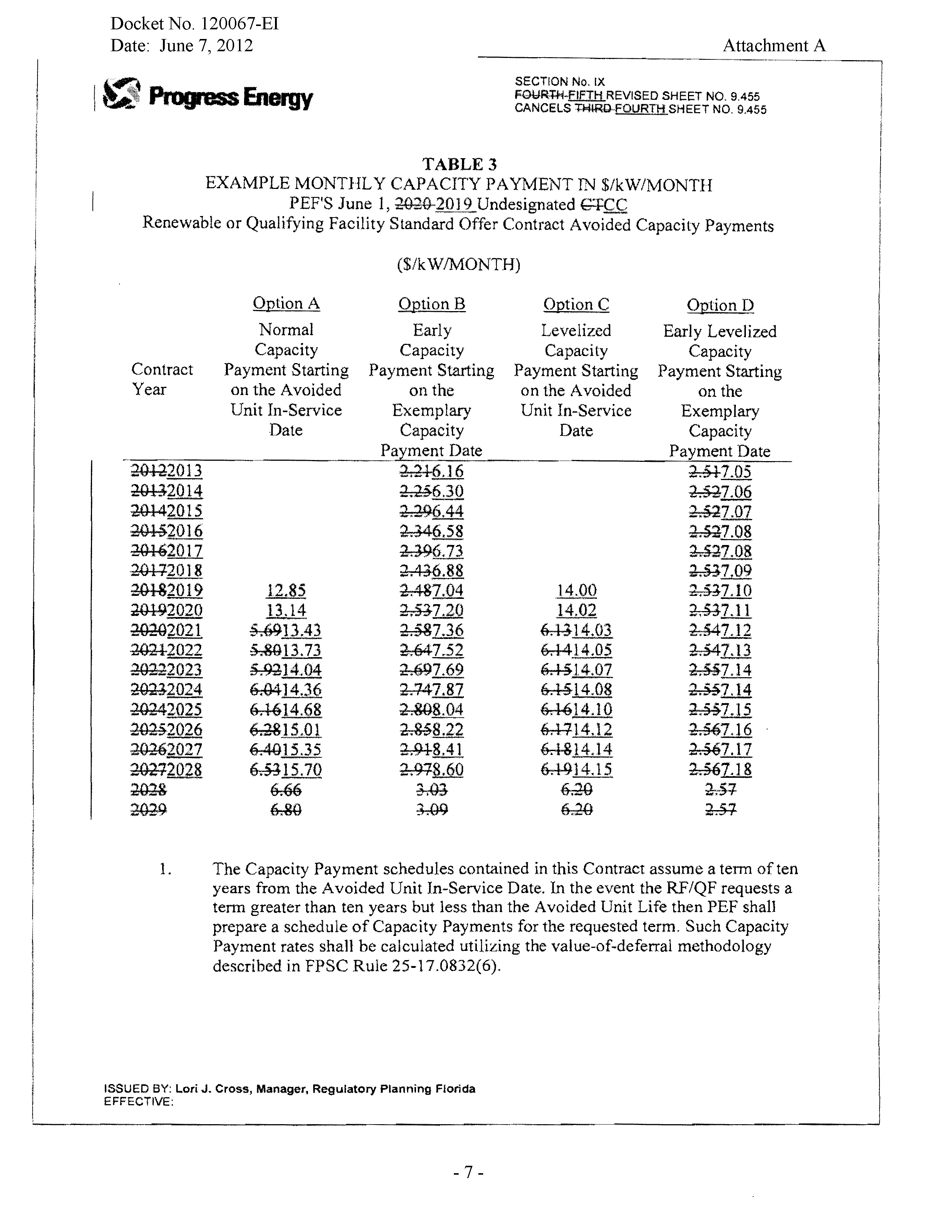
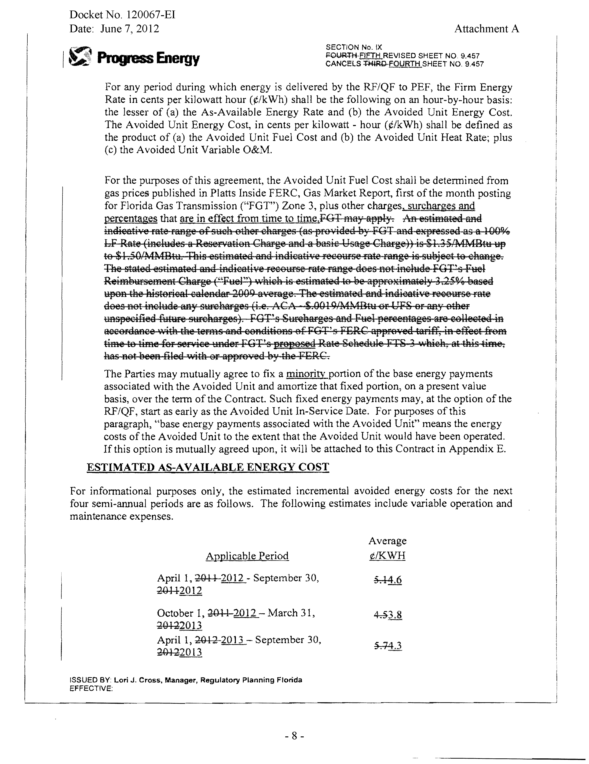
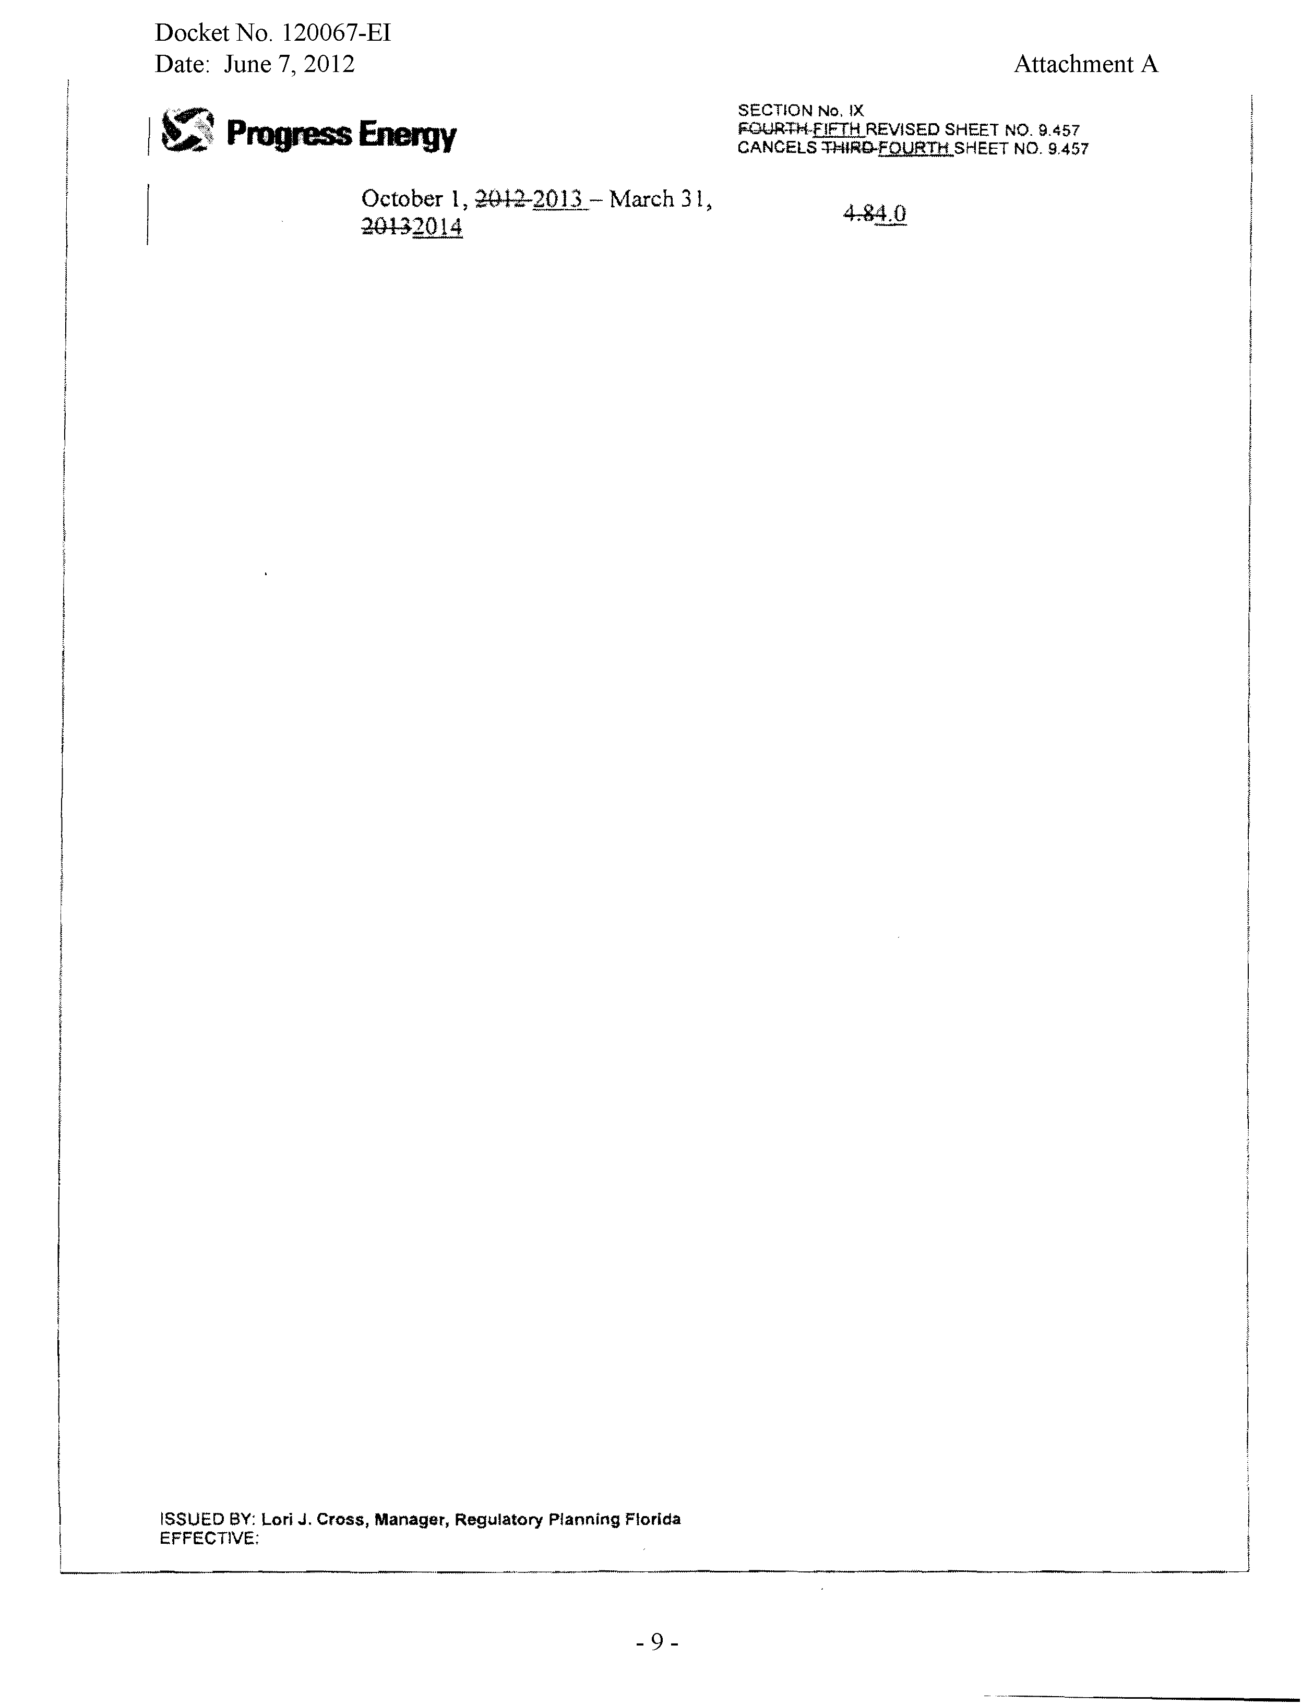
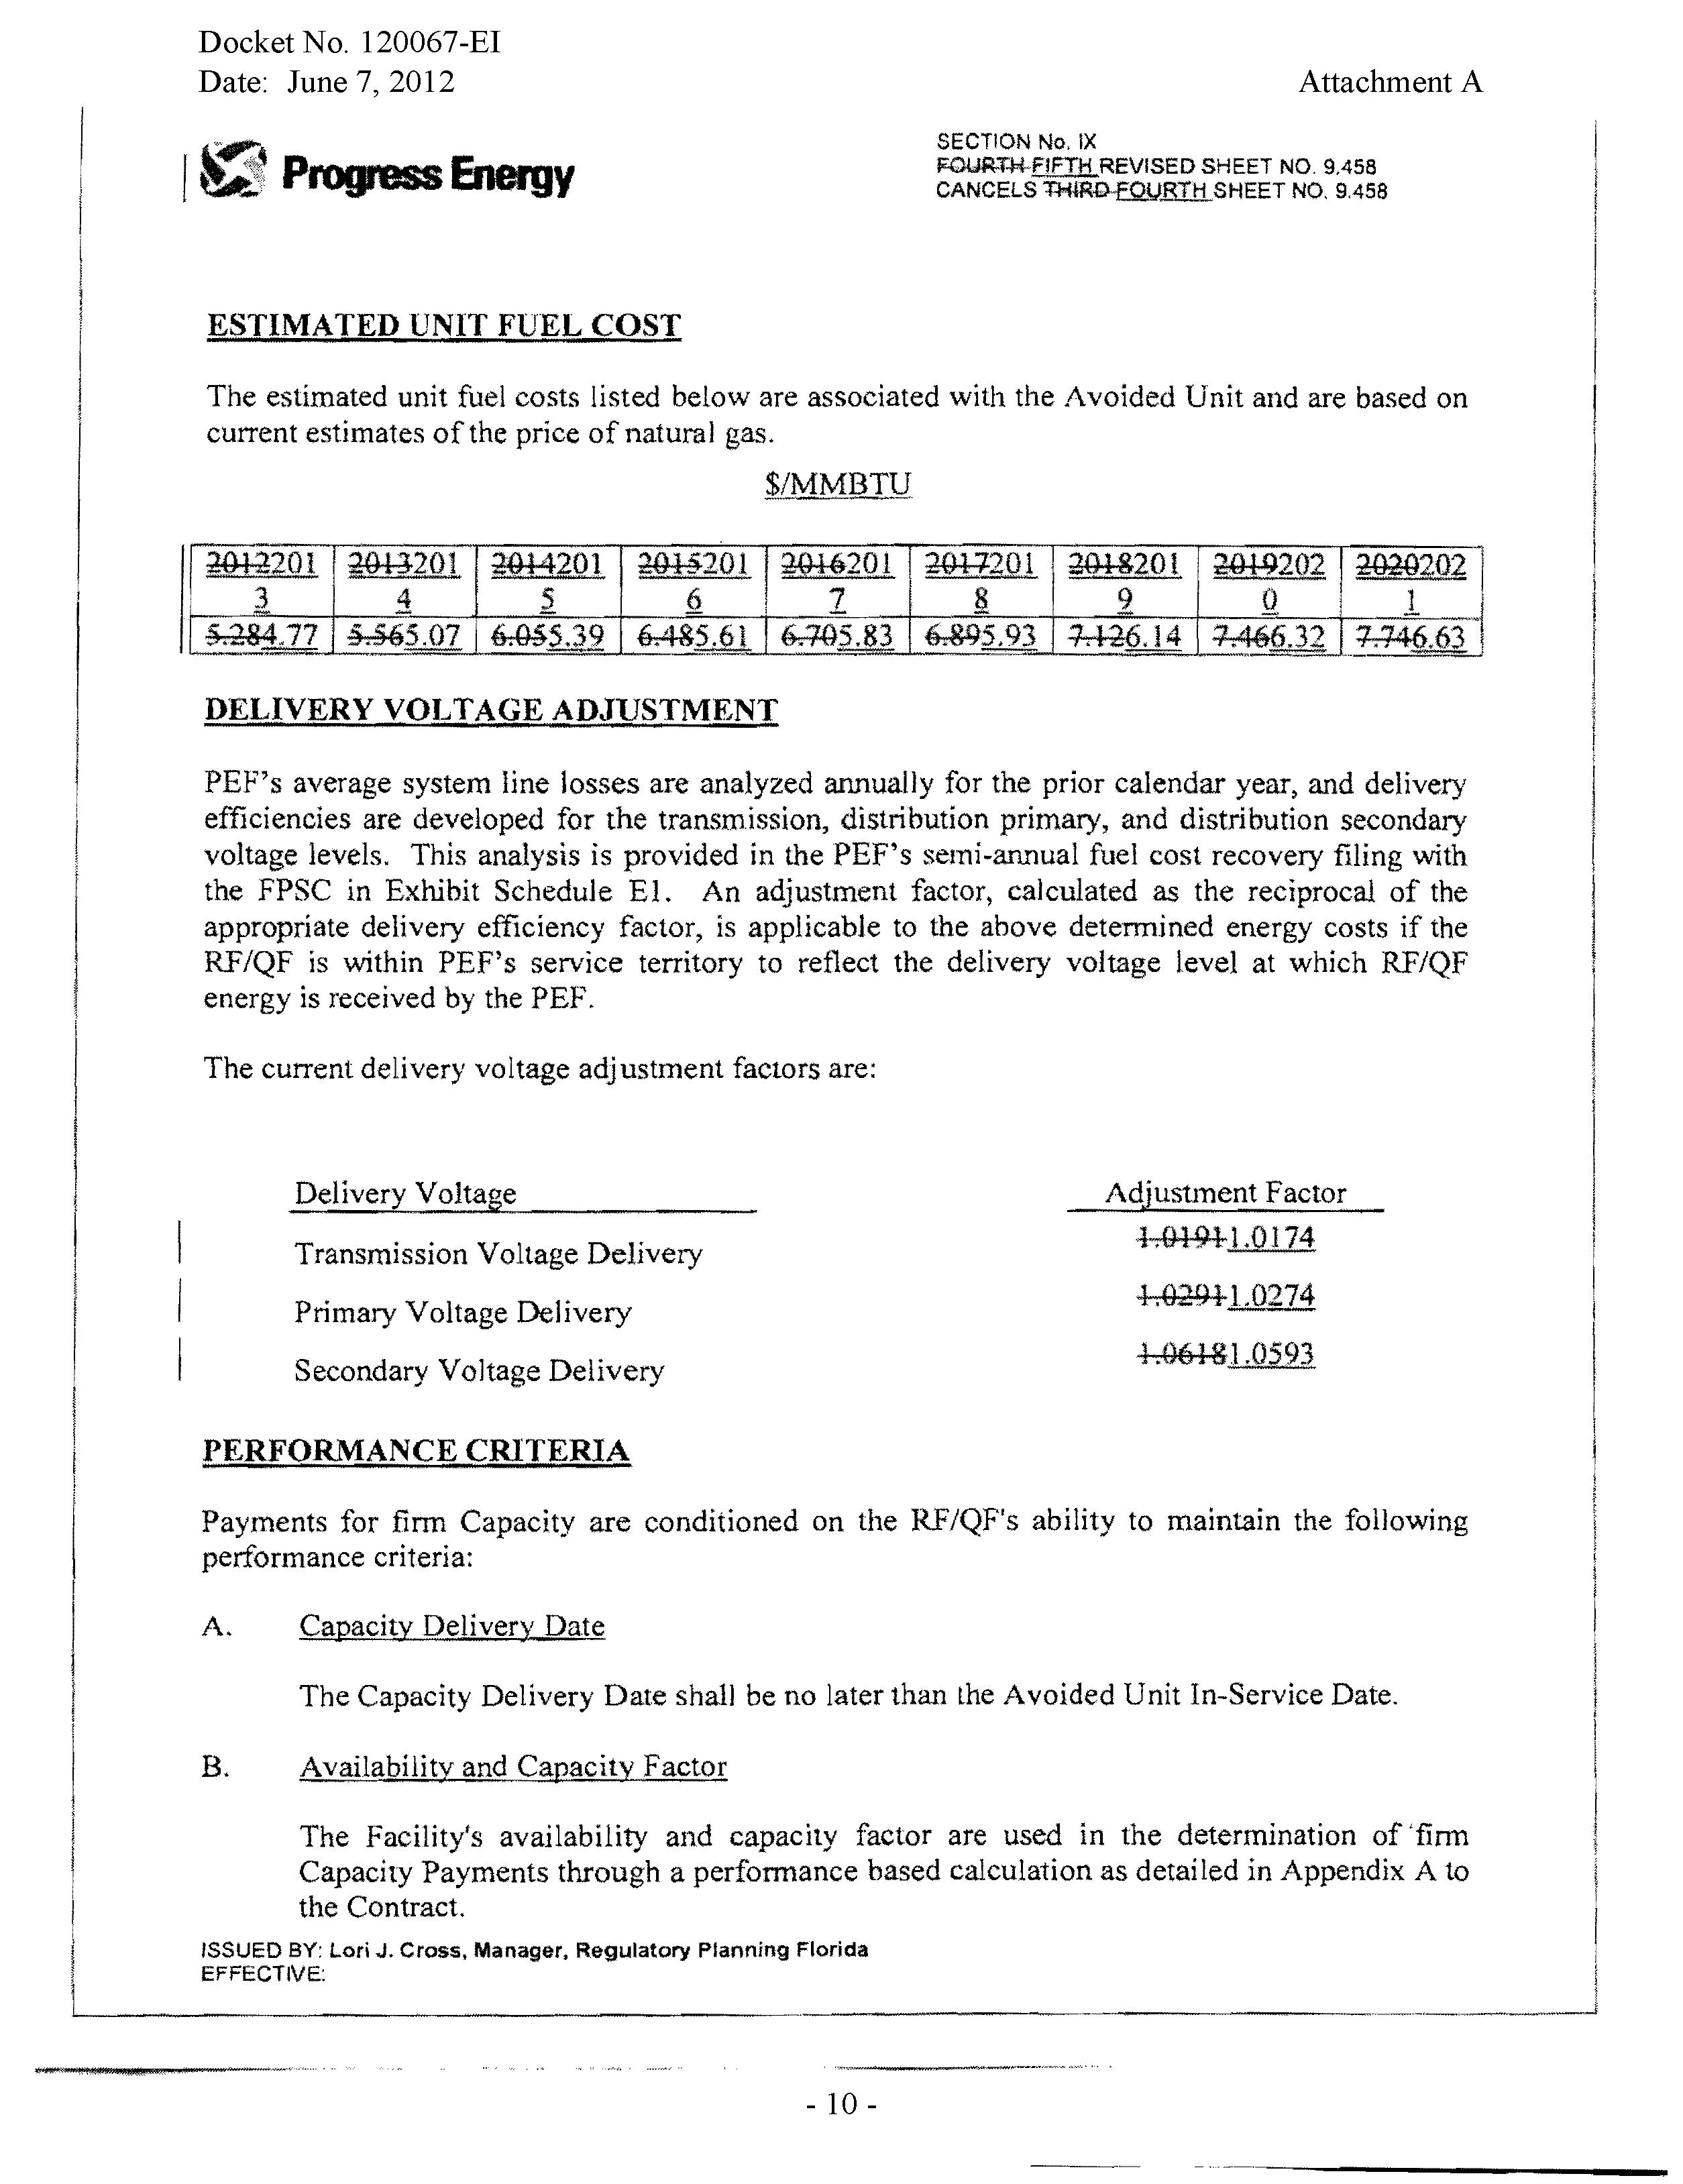
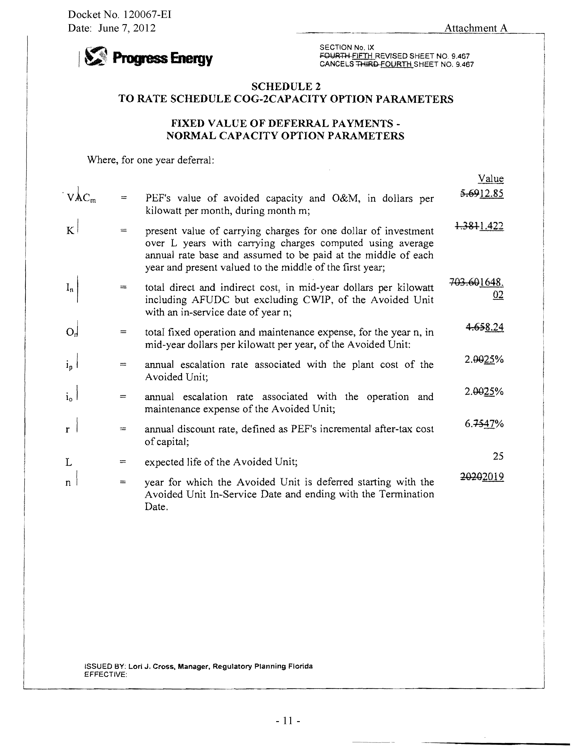
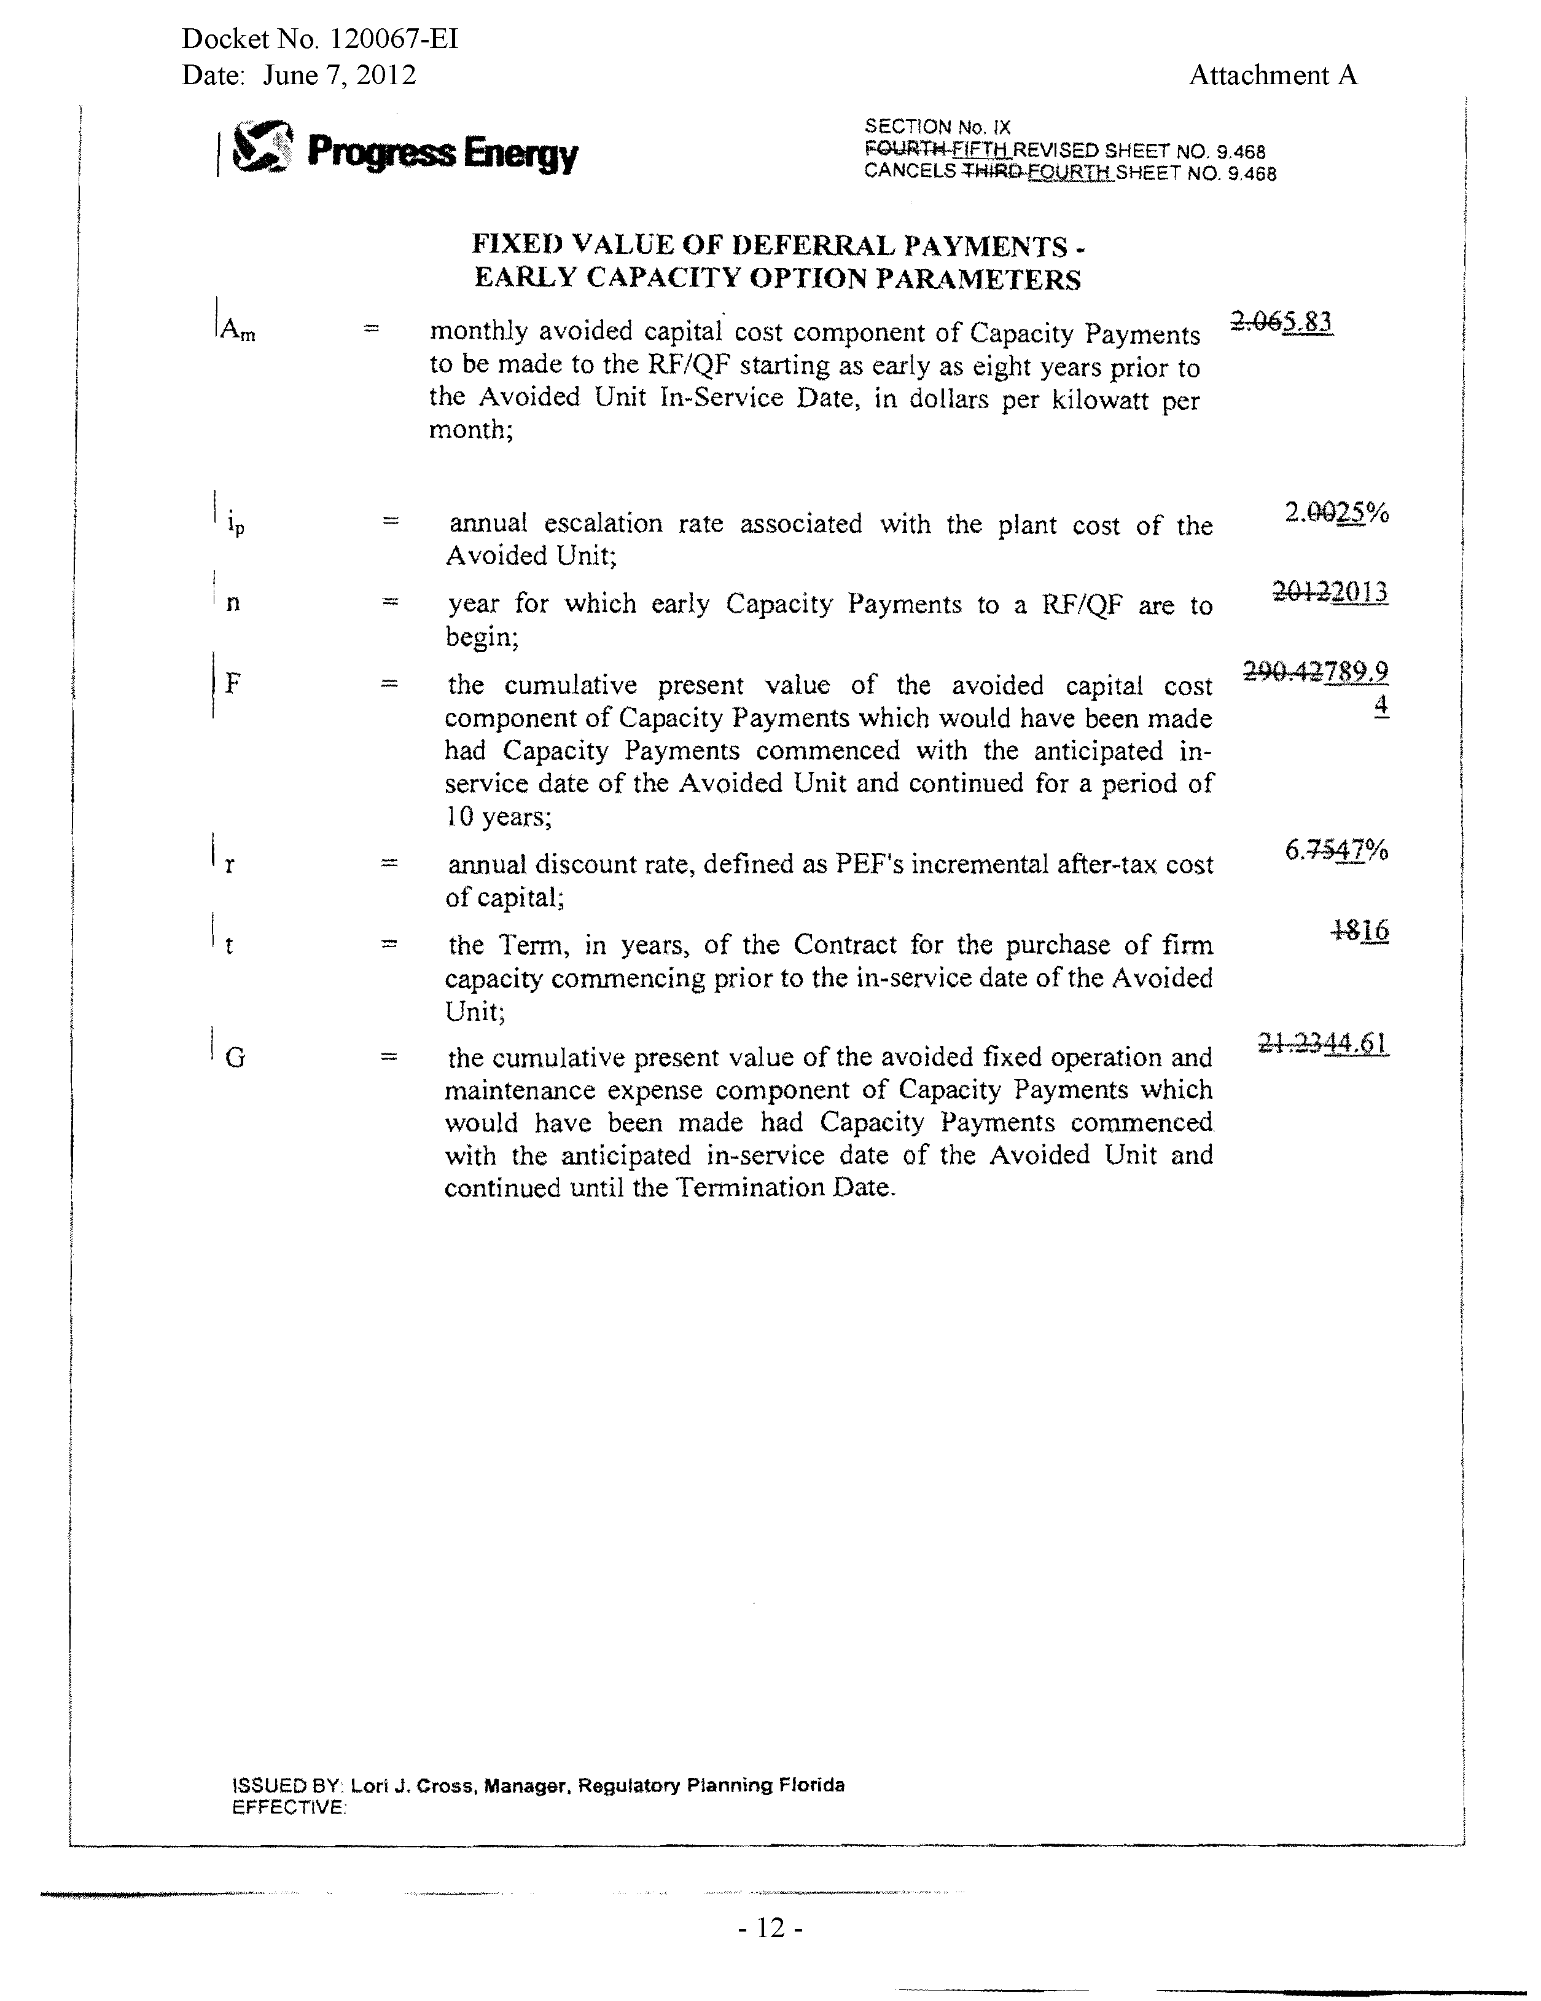

Such as being operational and delivering the agreed upon amount of capacity by the in-service date.
The minimum capacity factor required to qualify for a full capacity payment.
PEF represents that these figures do not match exactly due to rounding error in the mathematical calculation of NPV. The maximum difference is approximately 0.067 percent.

