BEFORE THE FLORIDA PUBLIC SERVICE COMMISSION

In re: Joint petition for approval of amendment to territorial agreement in St. Johns County between Florida Power & Light Company, a Florida corporation, and JEA, a Florida municipal corporation. | DOCKET NO. 120171-EU  ORDER NO. PSC-12-0561-PAA-EU  ISSUED: October 22, 2012

The following Commissioners participated in the disposition of this matter:

RONALD A. BRISÉ, Chairman
LISA POLAK EDGAR
ART GRAHAM
EDUARDO E. BALBIS
JULIE I. BROWN

NOTICE OF PROPOSED AGENCY ACTION
ORDER APPROVING AN AMENDMENT TO A TERRITORIAL AGREEMENT BETWEEN FLORIDA POWER & LIGHT COMPANY AND JACKSONVILLE ELECTRIC AUTHORITY

BY THE COMMISSION:

NOTICE is hereby given by the Florida Public Service Commission that the action discussed herein is preliminary in nature and will become final unless a person whose interests are substantially affected files a petition for a formal proceeding, pursuant to Rule 25-22.029, Florida Administrative Code.

Background
On June 11, 2012, Florida Power & Light Company (FPL) and Jacksonville Electric Authority (JEA) filed a joint petition for approval of an agreement amending an existing territorial agreement (amended agreement) between the two utilities in St. Johns County. FPL and JEA are parties to a currently effective territorial agreement (current territorial agreement) delineating their respective territories in Duval and St. Johns counties, which was approved by this Commission through Order No. PSC-98-1687-FOF-EU.
This Order addresses the parties’ joint petition for approval of the amended agreement. We have jurisdiction over this matter pursuant to Section 366.04, Florida Statutes (F.S.).

Decision
Pursuant to Section 366.04(2)(d), F.S., we have jurisdiction to approve territorial agreements between and among rural electric cooperatives, municipal electric utilities, and other electric utilities. Pursuant to Rule 25-6.0440(2), F.A.C., when approving territorial agreements, we may consider the reasonableness of the purchase price of any facilities being transferred, the likelihood that the agreement will cause a decrease in the reliability of electric service to existing or future ratepayers, and the likelihood that the agreement will eliminate existing or potential uneconomic duplication of facilities. Unless we find that the agreement will cause a detriment to the public interest, the agreement shall be approved.
On June 11, 2012, FPL and JEA filed a joint petition for approval of an amended agreement. According the petition, the amended agreement will alter the territorial boundary between the parties along Palm Valley Road, south of the Nocatee Parkway, in St. Johns County. The area lies just northwest of, and is contiguous with, the current territorial boundary between FPL and JEA. The property, which consists of approximately 17 acres, will contain 28 proposed single-family residential lots. While the area is presently within JEA’s territory, it is part of a larger residential development in FPL’s service territory that began construction in April 2012.
JEA’s infrastructure is located over a half mile from the property, while FPL’s infrastructure is approximately 600 feet away. Due to the close proximity of FPL’s existing infrastructure to this site, the parties agreed to modify the territorial boundary to allow FPL to serve the electric needs of the additional seventeen acres of the overall development. In response to Commission staff’s data request, FPL has stated it plans to extend three-phase primary underground cable and conduit from existing underground facilities to the area. FPL also indicated that facility design is complete and FPL plans to meet a requested end of October 2012 service timeline.
According to the amended agreement, there are currently no existing customers or electric facilities in the amended area, and FPL’s provision of service to the area will avoid unnecessary duplication of services and provide for the most cost effective provision of service to utility customers. The amended agreement also states that all other parts of the current territorial agreement shall remain in effect. The amended agreement, as well as associated maps and territory description delineating the proposed amended area, are attached to this Order as Attachment A.
Based on all of the above, we find that the amended agreement proposed by FPL and JEA eliminates existing or potential uneconomic duplication of facilities and does not cause a decrease in the reliability of electric service to existing or future ratepayers. We find that the joint petition for approval of the amended territorial agreement between FPL and JEA is in the public interest and shall be approved.
Based on the foregoing, it is

ORDERED by the Florida Public Service Commission that the joint petition for approval of the amended territorial agreement between FPL and JEA is granted. The territory subject to the amended territorial agreement is more properly described in Attachment A. It is further
ORDERED that the provisions of this Order, issued as proposed agency action, shall become final and effective upon the issuance of a Consummating Order unless an appropriate petition, in the form provided by Rule 28-106.201, Florida Administrative Code, is received by the Commission Clerk, 2540 Shumard Oak Boulevard, Tallahassee, Florida 32399-0850, by the close of business on the date set forth in the “Notice of Further Proceedings” attached hereto. It is further

ORDERED that in the event this Order becomes final, this docket shall be closed.

By ORDER of the Florida Public Service Commission this 22nd day of October, 2012.

/s/ Hong Wang
HONG WANG
Chief Deputy Commission Clerk
Florida Public Service Commission
2540 Shumard Oak Boulevard
Tallahassee, Florida 32399
(850) 413-6770
www.floridapsc.com

Copies furnished: A copy of this document is provided to the parties of record at the time of issuance and, if applicable, interested persons.

MTL

NOTICE OF FURTHER PROCEEDINGS OR JUDICIAL REVIEW

The Florida Public Service Commission is required by Section 120.569(1), Florida Statutes, to notify parties of any administrative hearing that is available under Section 120.57, Florida Statutes, as well as the procedures and time limits that apply. This notice should not be construed to mean all requests for an administrative hearing will be granted or result in the relief sought.

Mediation may be available on a case-by-case basis. If mediation is conducted, it does not affect a substantially interested person's right to a hearing.

The action proposed herein is preliminary in nature. Any person whose substantial interests are affected by the action proposed by this order may file a petition for a formal proceeding, in the form provided by Rule 28-106.201, Florida Administrative Code. This petition must be received by the Office of Commission Clerk, 2540 Shumard Oak Boulevard, Tallahassee, Florida 32399-0850, by the close of business on November 12, 2012.

In the absence of such a petition, this order shall become final and effective upon the issuance of a Consummating Order.

Any objection or protest filed in this/these docket(s) before the issuance date of this order is considered abandoned unless it satisfies the foregoing conditions and is renewed within the specified protest period.

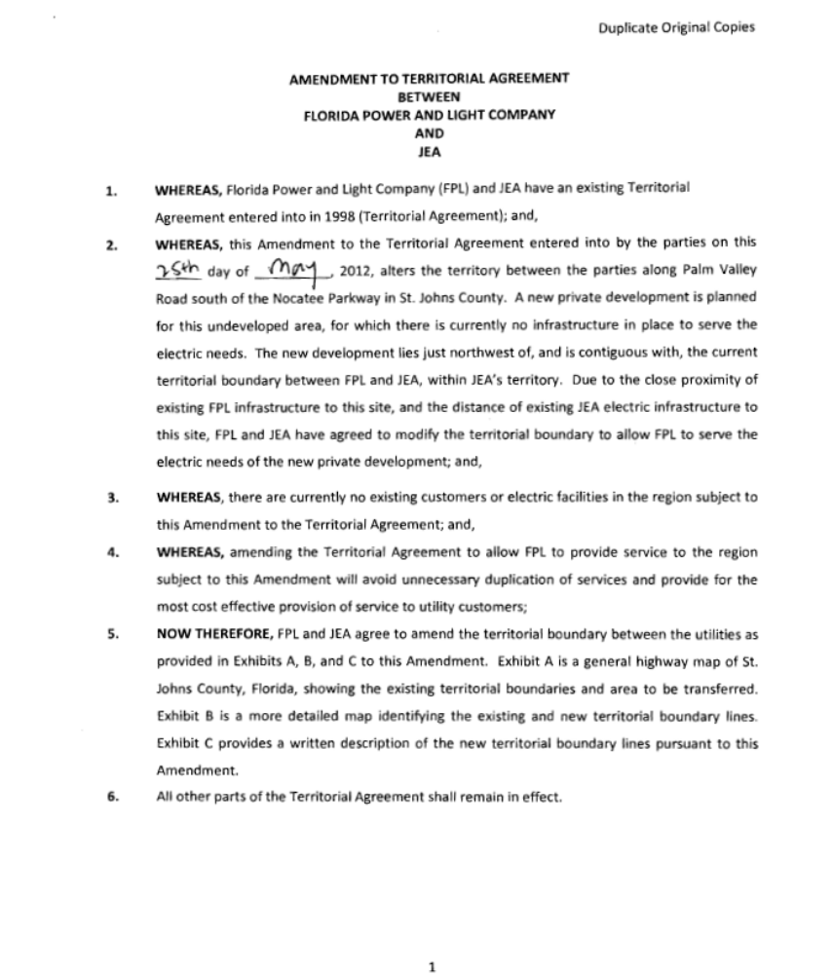
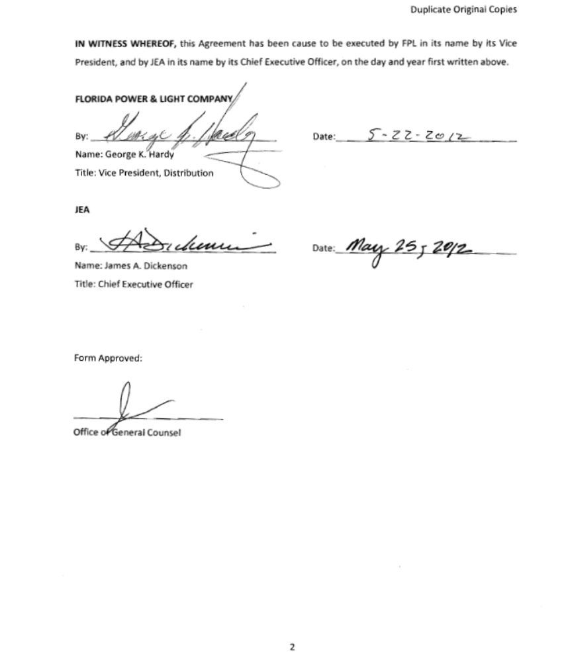
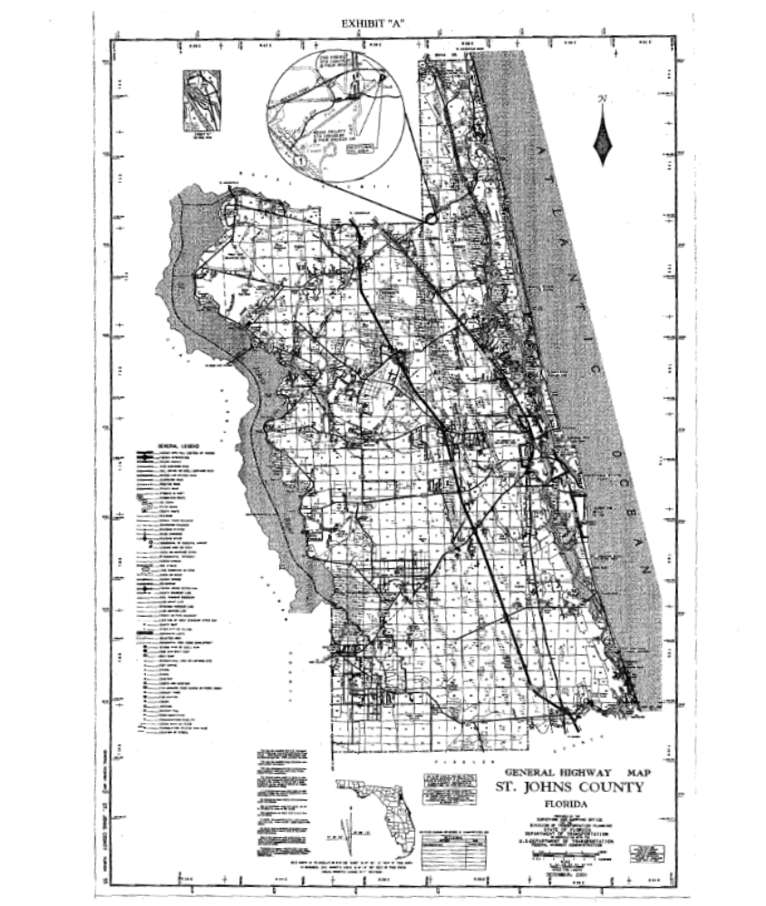
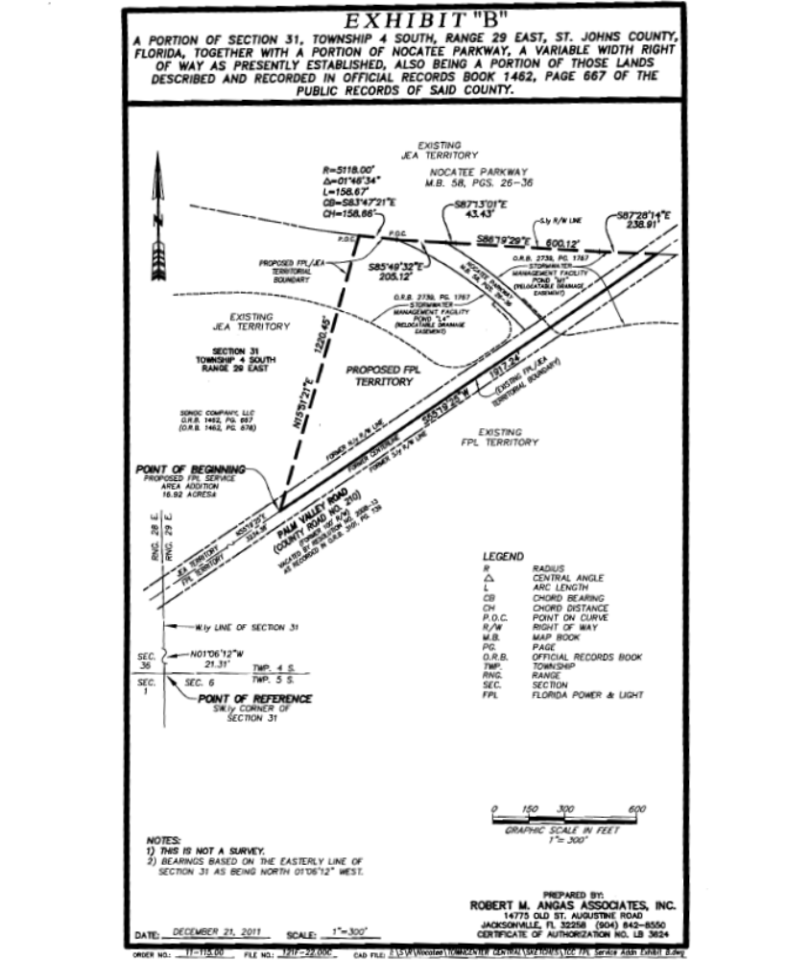
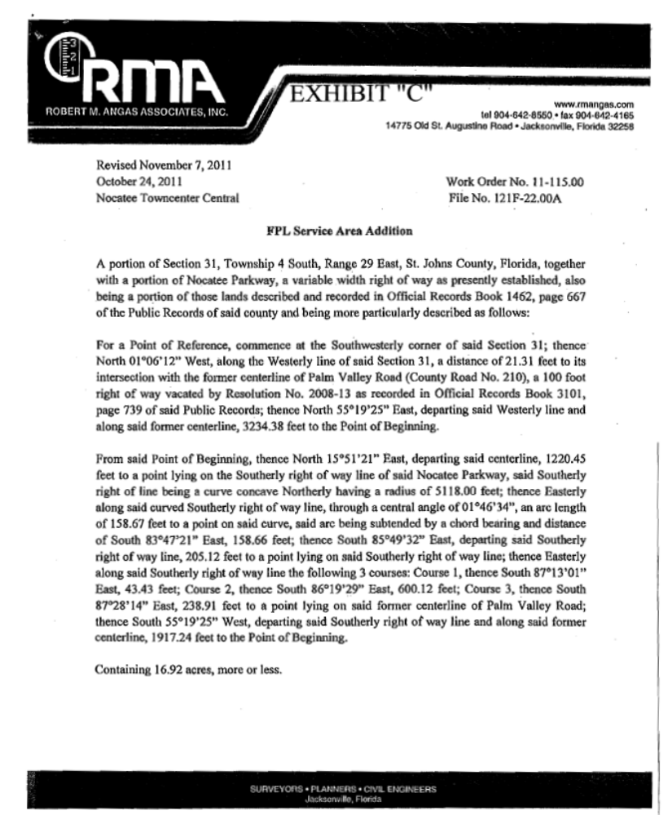

See Order No.PSC-98-1687-FOF-EU, issued December 14, 1998, in Docket No. 980755-EU, In re: Joint Petition of for approval of new territorial agreement between Florida Power & Light Company and Jacksonville Electric.
Utilities Commission of the City of New Smyrna v. Florida Public Service Commission, 469 So. 2d 731 (Fla. 1985).

