BEFORE THE FLORIDA PUBLIC SERVICE COMMISSION

In re: Petition for relinquishment of eligible telecommunications carrier status, by Cox Florida Telcom, L.P. d/b/a Cox Communications d/b/a Cox Business d/b/a Cox. | DOCKET NO. 20190058-TX  ORDER NO. PSC-2019-0209-PAA-TX  ISSUED: June 3, 2019

The following Commissioners participated in the disposition of this matter:

ART GRAHAM, Chairman
JULIE I. BROWN
DONALD J. POLMANN
GARY F. CLARK
ANDREW GILES FAY

NOTICE OF PROPOSED AGENCY ACTION
ORDER APPROVING COX FLORIDA TELCOM, L.P. D/B/A COX COMMUNICATIONS D/B/A COX BUSINESS D/B/A COX’S RELINQUISHMENT OF
ELIGIBLE TELECOMMUNICATIONS CARRIER DESIGNATION

BY THE COMMISSION:

NOTICE is hereby given by the Florida Public Service Commission (Commission) that the action discussed herein is preliminary in nature and will become final unless a person whose interests are substantially affected files a petition for a formal proceeding, pursuant to Rule 25-22.029, Florida Administrative Code.

Background

On March 6, 2019, Cox Florida Telcom, L.P. d/b/a Cox Communications d/b/a Cox Business d/b/a Cox (Cox) filed a petition with this Commission for relinquishment of its Eligible Telecommunications Carrier (ETC) designation in Florida effective August 1, 2019. Cox has been a Competitive Local Exchange Carrier in Florida since 2005. On May 31, 2012, Cox filed an application for designation as an ETC in the state of Florida for purposes of receiving Lifeline support in its non-rural service areas. On June 15, 2012, Cox filed a separate application for designation as an ETC in its rural service areas. On September 28, 2012, and October 17, 2012, this Commission issued orders granting Cox’s applications for ETC designation, respectively.
ETC designation is a requirement for telecommunications carriers to receive federal Universal Service Funds for the Lifeline program. The Lifeline program enables low-income households to obtain and maintain telephone service by providing qualifying households with discounts on their monthly telephone bills. Since the inception of the Lifeline program there have been a variety of changes. However, Cox asserts that the most significant change, which has led to its request for ETC relinquishment, was the Federal Communications Commission’s transition plan that will essentially eliminate the Lifeline discount for standalone voice service after December 1, 2021.

Cox states their number of Lifeline customers in Florida has been declining. At the beginning of 2019, Cox had 498 Lifeline customers, which is only .07 percent of the Lifeline customers in Florida. Cox contends that the declining trend in Lifeline customers and the upcoming decrease in federal Lifeline support for voice service have led to its request for relinquishment.

We are vested with jurisdiction in this matter pursuant to Sections 364.10, Florida Statutes, 47 U.S.C. §214 (e)(4), and 47 C.F.R. §54.205.

Decision
Federal rules allow an ETC to relinquish its ETC designation pursuant to 47 C.F.R. §54.205(a), which provides that:
A state commission shall permit an eligible telecommunications carrier to relinquish its designation as such a carrier in any area served by more than one eligible telecommunications carrier. An eligible telecommunications carrier that seeks to relinquish its eligible telecommunications carrier designation for an area served by more than one eligible telecommunications carrier shall give advance notice to the state commission of such relinquishment.
In approving a relinquishment state commissions must require the remaining ETCs to ensure that existing customers will continue to be served. 47 C.F.R. §54.205(b), provides that:
Prior to permitting a telecommunications carrier designated as an eligible telecommunications carrier to cease providing universal service in an area served by more than one eligible telecommunications carrier, the state commission shall require the remaining eligible telecommunications carrier or carriers to ensure that all customers served by the relinquishing carrier will continue to be served, and shall require sufficient notice to permit the purchase or construction of adequate facilities by any remaining eligible telecommunications carrier. The state commission shall establish a time, not to exceed one year after the state commission approves such relinquishment under this section, within which such purchase or construction shall be completed.

In its petition, Cox identified all of the designated ETCs currently serving in its service territory (Attachment A). A data request was sent to each of the ETCs identified in Cox’s petition asking each provider to verify that it is a designated ETC in Cox service areas. ETCs were also asked to confirm that they currently provide or are capable of providing Lifeline service to customers in those areas. We analyzed and reviewed the responses to verify that the customers in the relinquished areas would continue to be served. Based on our review and analysis, we find that in Cox’s service areas, customers will continue to be served by one or more ETC.

In its petition, Cox has asserted that its Lifeline customers will receive adequate notice to select another ETC to continue receiving the Lifeline discount. The first notice will be sent to customers, via U.S. Mail, at least 60 days prior to the effective date of the relinquishment. A second notice will be sent out via bill messages at least 30 days prior to the effective date of relinquishment. Both notices will explain that Cox will no longer offer a Lifeline discount. If the customer does not choose another Lifeline provider, they have the option of being transitioned to Cox Voice service at a new promotional rate of $9.99 per month for 12 months. Cox’s notice will also provide a list of Lifeline providers that may offer service in the customers’ service area. Cox plans to stop enrolling customers in the Lifeline program 30 days prior to its relinquishment.
After reviewing Cox’s petition and the responses to the ETC data requests, we have verified there will be one or more ETCs remaining in Cox’s service territory. Lifeline service will continue to be available to customers residing within the relinquishment area if Cox’s petition is granted. As such, it appears that Cox has met 47 C.F.R. §54.205 requirements to relinquish its ETC designation in its service territory. Therefore, we hereby approve Cox’s request to relinquish its ETC designation in Florida.

Based on the foregoing, it is

ORDERED by the Florida Public Service Commission that Cox Florida Telcom, L.P. d/b/a Cox Communications d/b/a Cox Business d/b/a Cox’s request to relinquish its Eligible Telecommunications Carrier designation in Florida is hereby approved. It is further

ORDERED that the provisions of this Order, issued as proposed agency action, shall become final and effective upon the issuance of a Consummating Order unless an appropriate petition, in the form provided by Rule 28-106.201, Florida Administrative Code, is received by the Commission Clerk, 2540 Shumard Oak Boulevard, Tallahassee, Florida 32399-0850, by the close of business on the date set forth in the “Notice of Further Proceedings” attached hereto. It is further

ORDERED that if no person whose substantial interests are affected by the proposed agency action files a protest within 21 days of the issuance of the order, this docket shall be closed upon the issuance of a Consummating Order.

By ORDER of the Florida Public Service Commission this 3rd day of June, 2019.

/s/ Adam J. Teitzman
ADAM J. TEITZMAN
Commission Clerk
Florida Public Service Commission
2540 Shumard Oak Boulevard
Tallahassee, Florida 32399
(850) 413-6770
www.floridapsc.com

Copies furnished: A copy of this document is provided to the parties of record at the time of issuance and, if applicable, interested persons.

MAD

NOTICE OF FURTHER PROCEEDINGS OR JUDICIAL REVIEW

The Florida Public Service Commission is required by Section 120.569(1), Florida Statutes, to notify parties of any administrative hearing that is available under Section 120.57, Florida Statutes, as well as the procedures and time limits that apply. This notice should not be construed to mean all requests for an administrative hearing will be granted or result in the relief sought.

Mediation may be available on a case-by-case basis. If mediation is conducted, it does not affect a substantially interested person's right to a hearing.

The action proposed herein is preliminary in nature. Any person whose substantial interests are affected by the action proposed by this order may file a petition for a formal proceeding, in the form provided by Rule 28-106.201, Florida Administrative Code. This petition must be received by the Office of Commission Clerk, 2540 Shumard Oak Boulevard, Tallahassee, Florida 32399-0850, by the close of business on June 24, 2019.

In the absence of such a petition, this order shall become final and effective upon the issuance of a Consummating Order.

Any objection or protest filed in this/these docket(s) before the issuance date of this order is considered abandoned unless it satisfies the foregoing conditions and is renewed within the specified protest period.

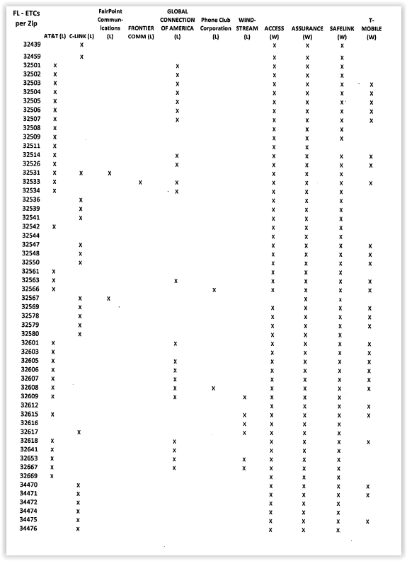
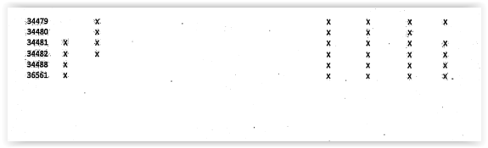

Order Nos. PSC-12-0500-PAA-TP and PSC-12-0552-PAA-TP.
FCC 16-38, WC Docket No.11-42, Lifeline and Link Up Reform Modernization, Third Report and Order, released on April 27, 2016, https://docs.fcc.gov/public/attachments/FCC-16-38A1.pdf.
Specifically, we understand that the following ETCs will continue to offer Lifeline in Cox’s territory in whole or in part: AT&T Florida, CenturyLink, Consolidated Communications of Florida Company, Phone Club, Windstream, Assurance wireless, Access wireless, SafeLink wireless, and T-Mobile wireless.

