BEFORE THE FLORIDA PUBLIC SERVICE COMMISSION

|  |  |
| --- | --- |
| In re: Petition for approval of tariff changes to implement a temporary surcharge to recovery regulatory asset, by St. Joe Natural Gas Company, Inc. | DOCKET NO. 20250080-GU  ORDER NO. PSC-2025-0281-TRF-GU  ISSUED: July 21, 2025 |

The following Commissioners participated in the disposition of this matter:

MIKE LA ROSA, Chairman

ART GRAHAM

GARY F. CLARK

ANDREW GILES FAY

GABRIELLA PASSIDOMO SMITH

ORDER APPROVING TARIFF CHANGES

TO IMPLEMENT A TEMPORARY SURCHARGE BY ST. JOE NATRUAL GAS COMPANY, INC.

BY THE COMMISSION:

Background

On May 20, 2025, St. Joe Natural Gas Company, Inc. (St. Joe or the utility) filed a petition for approval of tariff changes to implement a temporary surcharge that will enable it to collect $77,761 associated with a regulatory asset established in accordance with the settlement (2021 settlement) approved by Order No. PSC-2021-0196-AS-GU.[1] Paragraph one of the 2021 settlement provided that St. Joe should be allowed to recover $330,115 in storm costs through a storm surcharge through December 2024.[2]

Paragraph two of the 2021 settlement provided that, “The Parties agree that it is appropriate for [St. Joe] to record $77,761 associated with the remaining life value of lost capital assets in a regulatory asset and recover said amount over a period of 10 years through an increase to the Company’s base rates (“Base Rates”).”[3] Furthermore, paragraph three of the 2021 settlement stated:

The increase to Base Rates contemplated by Paragraph 2 will be implemented after the Storm Surcharge terminates. As such it is anticipated that the increase to Base Rates will be implemented January 1, 2025. [St. Joe] will file revised tariffs in 2024 to reflect this increase.

In its 2024 rate case proceeding, St. Joe did not include the $77,761 in base rates that went into effect January 7, 2025.[4] In its petition, the utility states that given the minimal increase and the ease of terminating a surcharge, it is asking that it be allowed to implement recovery of the $77,761 through the surcharges reflected in proposed Tariff Sheet No. 83, rather than implement recovery through base rates. Proposed Tariff Sheet No. 83 is attached to this order as Attachment A.

During the evaluation of the petition, our staff issued a data request for which responses were received on June 9, 2025. We have jurisdiction over this matter pursuant to Sections 366.03, 366.04, 366.05, and 366.06, Florida Statutes (F.S.).

Decision

The 2021 settlement provided that St. Joe recover $77,761 associated with a regulatory asset through base rates over a period of ten years. As stated in the case background, the utility did not include the regulatory asset in its 2024 base rate proceeding. In its petition, the utility stated that given the minimal increase and ease of terminating a surcharge at the end of ten years, it is asking to implement recovery of the $77,761 through a surcharge. If the proposed surcharge is approved, an RS-2 customer using 20 therms a month will see a bill increase of $0.30.

In response to our staff’s first data request, the utility stated that there was no interest included in the calculation of the surcharge.[5] St. Joe also provided work papers to demonstrate the methodology used to calculate the surcharge rates.[6] We have reviewed the provided work papers and found that the utility appropriately divided the increase amongst the customer classes as a percent of the classes’ total base rate revenue. Using projected billing determinants for January to December 2025, St. Joe then calculated the surcharge for each customer class by dividing the increase by the class’s therm sales and adjusting for taxes.

We find that St. Joe’s request to implement a surcharge to recover the $77,761 associated with a regulatory asset established by the 2021 settlement instead of recovering the $77,761 through base rates is reasonable. The surcharge as shown on proposed Tariff Sheet No. 83, attached hereto as Attachment A, shall become effective on the date of our vote, July 1, 2025.

Based on the foregoing, it is

ORDERED by the Florida Public Service Commission that St. Joe Natural Gas Company, Inc.’s request to implement a temporary 10-year surcharge to recover $77,761 associated with a regulatory asset established by the 2021 settlement is approved. The surcharge as shown on proposed Tariff Sheet No. 83, attached hereto as Attachment A, shall become effective on the date of our vote, July 1, 2025. It is further

ORDERED that if a protest is filed within 21 days of issuance of the Order, the tariff shall remain in effect with any charges held subject to refund pending resolution of the protest. It is further

ORDERED that if no timely protest is filed, this docket shall be closed upon the issuance of a Consummating Order.

By ORDER of the Florida Public Service Commission this 21st day of July, 2025.

|  |  |
| --- | --- |
|  | /s/ Adam J. Teitzman |
|  | ADAM J. TEITZMAN  Commission Clerk |

Florida Public Service Commission

2540 Shumard Oak Boulevard

Tallahassee, Florida 32399

(850) 413‑6770

www.floridapsc.com

Copies furnished: A copy of this document is provided to the parties of record at the time of issuance and, if applicable, interested persons.

RPS

NOTICE OF FURTHER PROCEEDINGS

The Florida Public Service Commission is required by Section 120.569(1), Florida Statutes, to notify parties of any administrative hearing or judicial review of Commission orders that is available under Sections 120.57 or 120.68, Florida Statutes, as well as the procedures and time limits that apply. This notice should not be construed to mean all requests for an administrative hearing or judicial review will be granted or result in the relief sought.

Mediation may be available on a case-by-case basis. If mediation is conducted, it does not affect a substantially interested person's right to a hearing.

The Commission's decision on this tariff is interim in nature and will become final, unless a person whose substantial interests are affected by the proposed action files a petition for a formal proceeding, in the form provided by Rule 28-106.201, Florida Administrative Code. This petition must be received by the Office of Commission Clerk, 2540 Shumard Oak Boulevard, Tallahassee, Florida 32399-0850, by the close of business on August 11, 2025.

In the absence of such a petition, this Order shall become final and effective upon the issuance of a Consummating Order.

Any objection or protest filed in this docket before the issuance date of this order is considered abandoned unless it satisfies the foregoing conditions and is renewed within the specified protest period.

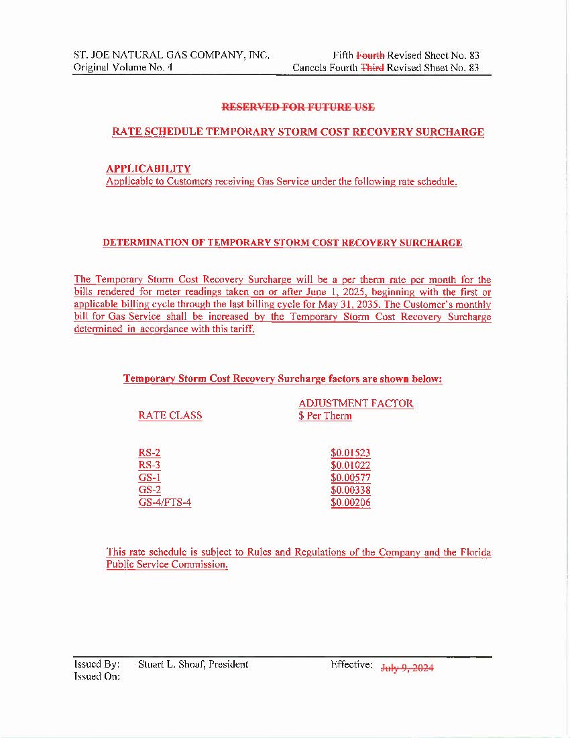

1. Order No. PSC-2021-0196-AS-GU, issued June 3, 2021, in Docket No. 20200039-GU, *In re: Petition for approval to implement a temporary storm cost recovery surcharge, by St. Joe Natural Gas Company.*
2. Order No. PSC-2021-0196-AS-GU, page 12.
3. Order No. PSC-2021-0196-AS-GU, page 12.
4. Order No. PSC-2025-0035-PAA-GU, issued January 30, 2025, in Docket No. 20250046-GU, *In re: Petition for rate increase by St. Joe Natural Gas Company, Inc.*
5. Response to our staff’s First Data Request, Response No. 2.
6. Response to our staff’s First Data Request, Response No. 1.