BEFORE THE FLORIDA PUBLIC SERVICE COMMISSION

|  |  |
| --- | --- |
| In re: Petition for approval to modify swing service charge, individual transportation service rider, and off-system service rate schedule, by Peoples Gas System, Inc. | DOCKET NO. 20250026-GU  ORDER NO. PSC-2025-0282-TRF-GU  ISSUED: July 21, 2025 |

The following Commissioners participated in the disposition of this matter:

MIKE LA ROSA, Chairman

ART GRAHAM

GARY F. CLARK

ANDREW GILES FAY

GABRIELLA PASSIDOMO SMITH

ORDER APPROVING MODIFICATIONS TO SWING SERVICE CHARGE, ITS RIDER, AND OSS SHARING MECHANISM

BY THE COMMISSION:

Background

On January 13, 2025, Peoples Gas System, Inc. (PGS or utility) filed a petition for approval of modifications to the Swing Service Charges applicable to transportation customers, Individual Transportation Service (ITS), and Off-System Service (OSS).

In 2000, we approved PGS’ Natural Choice Program, which enabled customers to more easily receive transportation service from the utility by consolidating and simplifying the existing transportation programs.[1] The Natural Choice Program offered two types of transportation service: a “pooled” service through the Natural Choice Transportation Service (NCTS) and “individual” service through the ITS Rider. NCTS customers are pooled together in groups and are supplied gas by a Pool Manager, which is a third-party natural gas marketer.

The Pool Manager is responsible for supplying and managing natural gas for its customer pool as well as acquiring firm upstream capacity from PGS. While Pool Managers deliver a fixed daily quantity of gas supply and capacity, the amount of gas actually consumed by NCTS customers varies. As a result, PGS varies (or swings) the level of gas and capacity delivered to the utility’s system through operational purchases and sales in order to balance the system. The cost to swing gas adds costs to the Purchased Gas Adjustment (PGA) clause, paid for by PGS’ sales customers.

The Swing Service Charge is designed to recover the cost to swing gas for transportation customers and is credited to the PGA clause. The Swing Service Charge is a cents per therm charge applicable to NCTS customers, who purchase gas from third party marketers, and therefore do not pay the PGA charge. In 2015, we approved updated calculations for the Swing Service Charges to reflect PGS’ then-current cost of providing swing service.[2] In the instant petition, PGS is proposing to update the methodology and calculations of the costs included in estimating system balancing costs, resulting in revised Swing Service Charges.

With respect to the ITS Rider, PGS is proposing to increase the eligibility threshold from 182,500 to 500,000 annual therms and to add a requirement to receive a certain minimum daily pipeline capacity from PGS (versus receiving capacity from a third party). Finally, PGS proposed a change to the sharing mechanism contained in its OSS tariff, which was first approved in 1994.

PGS currently has a rate case proceeding in Docket No. 20250029-GU before us (rate case docket), with the hearing currently scheduled for September 8 – 11, 2025. By Order No. PSC-2025-0090-PCO-GU, we suspended the proposed modifications for further review by our staff.[3] During evaluation of the petition, our staff issued two data requests to the utility for which responses were received April 1 and May 5, 2025. On June 9, 2025, our staff held an informal meeting on this docket with PGS and the Office of the Public Counsel (OPC). Although OPC is not a party to the instant docket, it joined the informal meeting to have unresolved technical questions answered by PGS. Furthermore, the utility provided written responses to technical questions that have included in the docket file.

The proposed tariff revisions, approved herein, are shown in Attachment A to this Order. We have jurisdiction over this matter pursuant to Sections 366.04, 366.041, 366.05, and 366.06, Florida Statutes.

Decision

The utility contends that its proposed changes to the swing service charge, ITS rider, and OSS sharing mechanism are designed to improve the allocation of costs between transportation and PGA customers. Therefore, we find that it is best to analyze the utility’s proposed tariff changes as a whole.

1. **Modifications to the Swing Service Charge**

The swing service charge is assessed to all transportation customers who take service under PGS’ NCTS Rider. Costs to balance the system are calculated based on six primary tools PGS uses to balance its system. The six tools are (1) reserve capacity, (2) swing gas supply, (3) No Notice transportation service, (4) storage contracts, (5) swing sale agreements, and (6) upstream pipeline park and loan services. PGS is proposing to update four of the six tools to estimate system balancing costs. The four modifications are discussed in more detail below.

***Modifications to the Reserve Capacity Calculation***

Reserve capacity is interstate and intrastate pipeline capacity contracted to be available when customer usage increases. Capacity cost represent the reservation charges PGS pays pipeline companies based on how much capacity PGS reserves. PGS provides a monthly release of upstream pipeline capacity to the NCTS pool managers and charges the pool managers for released capacity at the weighted average cost of capacity (WACC). WACC are expressed in dollars per MMBtu and are the weighted average costs per day of firm transportation rights held by PGS pursuant to contracts with delivering pipelines.

PGS proposed to modify the calculation of the WACC. The existing formula divides the total interstate and intrastate capacity cost, less ITS capacity release credits, by the total interstate and intrastate capacity quantity, less ITS capacity release quantity. According to PGS, it historically only used interstate pipelines, such as the Florida Gas Transmission Company (FGT), to transport natural gas into Florida. About 10 years ago, utilities also began using intrastate pipelines to transport natural gas.

The proposed change would eliminate intrastate capacity quantity from the denominator of the formula. PGS explained that the inclusion of both interstate and intrastate capacity was duplicative and distorted the WACC formula. Transporting gas on an interstate pipeline and then transporting that same gas again on an intrastate pipeline would double-count that quantity in the existing WACC formula. Double-counting the quantity would create a larger denominator in the WACC formula, which would in turn result mathematically in a lower WACC. PGS’ justification for the updated formula is to prevent understating the cost of capacity and under-collecting full capacity costs from the NCTS pool managers.

***Modifications to the Swing Gas Supply***

PGS explained in its petition that the utility currently calculates swing gas supply based off a 30-day rolling average of Platts Gas Daily FGT Zone 3 prices. PGS has proposed to modify the calculation to account for recurring purchases of gas from Transco Zone 5. PGS explained the utility also purchases swing gas supply at the Southern Natural Gas Pipeline and Elba Express Pipeline, which is priced at the Transco Zone 5 index. The proposed modifications will more closely reflect actual costs incurred by PGS to purchase swing gas supply.

***Update to No Notice Transportation Service***

No Notice Transportation Service (NNTS) is a firm rate schedule offered by FGT and represents the quantity by which a shipper’s (e.g., PGS) actual delivery quantities vary from scheduled deliveries. PGS states in its petition that the Federal Energy Regulatory Commission (FERC) recently issued an order regarding the most recent FGT rate case, modifying FGT’s rates. PGS’ proposed changes to the swing service calculation reflect the updated FERC-approved NNTS rates. Approval of the proposed rates would enable PGS to pass through all FGT pipeline charges to the customers incurring them.

***Storage Contracts – Modification to Add Gas Commodity Costs***

Storage contracts are held with storage facilities, typically subterranean salt domes, and are used to manage supply and demand constraints as well as price volatility. In the process of storing gas supply, PGS typically incurs injection costs, withdrawal costs, and capacity reservation costs, on top of the cost of gas purchased.

Currently, PGS only recovers capacity reservation fees in the swing service rider, which are the charges for contracted storage quantity (i.e., storage space). PGS is seeking to modify the calculation to also recover injection and withdrawal costs as they contribute to the actual storage contract expenses the utility incurs. In paragraph 37 of the petition, PGS states that it would modify the calculation for storage contracts by adding three components included with “one turn of storage.” “One turn of storage” refers to one complete cycle of injecting and withdrawing natural gas from a storage facility.

PGS explained during its meeting with our staff and OPC that the utility typically signs a storage contract for anywhere between four and twelve turns of storage in one year. PGS proposed to allocate one turn of storage to the swing service rider. PGS explained that the number of turns used varies based on market conditions and system peaks, and the storage contract only charges the utility for as many turns as are actually used. PGS believes that one turn of storage accurately covers the quantities of stored gas demanded by swing service customers.

***Removal of Natural Gas Vehicle Service (NGVS) from Tariff Sheet***

The Swing Service Charge (Tariff Sheet No. 7.101-3) and NCTS Rider (Tariff Sheet No. 7.803) currently include reference to the NGVS class, which was terminated in Docket No. 20200051-GU.[4] PGS has requested to remove mention of the closed NGVS class from the two existing tariff sheets.

1. **Modifications to ITS Rider**

Under PGS’ ITS Rider, commercial and industrial customers take transportation service on an individual basis and choose their own gas supplier. Currently, ITS customers are not required to acquire upstream capacity release from PGS. ITS Rider customers purchase their capacity either directly from the interstate pipeline, through a third-party marketer, or by receiving a capacity release from PGS. ITS customers do not pay a PGA or swing service rider charge as they receive capacity releases and the natural gas commodity from a third party. When PGS releases capacity to the ITS, the interstate pipeline handles the transaction. The capacity is released by PGS through the interstate pipeline’s electronic bulletin board. ITS customers purchase capacity off the electronic bulletin board and are billed by the interstate pipeline according to their FERC approved tariff. PGS is then credited for any revenues by the interstate pipeline. The revenues are in turn credited to the PGA.

PGS has proposed two modifications to the ITS Rider. First, PGS has proposed to raise the threshold to qualify for the ITS Rider from 182,500 therms per year to 500,000 therms per year. All current ITS customers below the threshold will be transferred to the Rider NCTS program. Currently, PGS anticipates transferring 61 out of 174 existing ITS customers to NCTS, leaving 113 customers as ITS Rider customers, as explained during the utility’s meeting with staff. ITS customers are not subject to the swing service charge, while NCTS customers are; this transfer will subject additional customers to the swing service charge, thus increasing the overall amount recovered through the swing service rider. Revenues collected through the swing service rider are credited to the PGA. Therefore, an increase in the revenues collected through the swing service rider would provide benefits to customers subject to the PGA, primarily residential and small commercial customers. PGS explained in its responses to staff that examples of customers that consume more than 500,000 therms annually include paper mills, citrus processors, or large hospitals.

Second, PGS has proposed to modify ITS Rider to require customers to take a minimum percentage of 25 percent of their daily capacity release requirement from PGS. PGS stated that currently only 13 percent of ITS Rider customers take capacity release from PGS. In response to our staff’s second data request No. 9, PGS provided three benefits to an ITS customer to elect to receive the utility’s capacity versus the capacity of a third-party marketer: reliability, price, and flexibility. PGS stated that increasing the amount of capacity released to ITS customers allows for recovery of more of the overall capacity costs from those customers utilizing such capacity and any capacity costs recovered through capacity release will be directly credited to the PGA. PGS estimated a credit of $3 million to the PGA in 2026 as a result of the proposed change.

The proposed ITS tariff revisions also would allow PGS to require a minimum of as much as 40 percent capacity release requirement. PGS explained in its response to our staff’s data request that it would increase the minimum release requirement when the utility forecasts having sufficient excess capacity; excess capacity could not be released through OSS sales; and the release of incremental capacity would be beneficial to the ITS customers (improved reliability or reduced costs). PGS further stated that it has the highest scheduling priority on the interstate pipelines; therefore, the utility’s capacity is the most reliable. In its petition, PGS committed to providing impacted ITS customers a minimum of 12 months written notice prior to the effective date of the tariff change. PGS also committed to continuing to communicate with impacted ITS customers throughout the period leading up to the change.

1. **Proposed Revision to OSS Sharing**

We first approved the OSS rate schedule in Order No. PSC-94-1187-FOF-GU.[5] The original order outlined that the OSS was to allow the utility to make capacity sales to customers not connected to the PGS distribution system, and revenues received from off-system sales would be shared 50/50 between PGS as above the line revenues and as a credit to the PGA. These off-system sales provide additional revenues to the utility and its general body of ratepayers. The OSS rate schedule was devised to allow the utility to make interruptible sales of unused capacity reserved on the interstate pipelines. As the utility paid for capacity whether or not it was ultimately used, the OSS schedule permitted the utility to recover costs during times when customers’ gas requirements are below the capacity reserved by PGS.

In PGS’ 2002 rate case, PGS originally proposed to maintain the 50/50 OSS sharing mechanism, while including no OSS sales in test year revenues. In Order PSC-03-0038-FOF-GU, we approved the proposal to include $500,000 in off-system sales in test year revenues and amend the sharing to a 25/75 split, with 25 percent of the revenues retained by the utility as above the line regulated revenues and 75 percent credited to the PGA.[6] In PGS’ 2008 rate case, we maintained the 25/75 sharing mechanism and increased OSS revenues to $1.5 million for the test year to reflect higher OSS revenues.[7]

In its current 2025 rate case docket, PGS filed MFRs under the current 25/75 sharing and included $2.6 million (25 percent) in OSS net revenues in operation revenues. PGS stated that if we approved the revision to the sharing mechanism in this docket, PGS would increase the OSS margin from 25 to 50 percent and increase OSS net revenues in the rate case to $5.3 million. The amount of projected OSS revenues for the test year is an issue to be determined by us in PGS’ current rate case docket.[8] Any increase in other operating revenues decreases the revenue requirement to be recovered through base rates.

In the instant petition, PGS has now proposed to modify the OSS sharing mechanism from a 25/75 to a 50/50 basis, as originally approved in 1994. Under a 50/50 sharing, 50 percent of net off-system revenues would be credited to the PGA, and 50 percent included as projected OSS revenues for the 2026 test year in the rate case docket. To support this change, PGS stated that the 50/50 sharing would align the utility with the off-system sales sharing mechanism currently used by Florida Public Utilities Company and Florida City Gas and their respective OSS rate schedules.

Furthermore, the utility stated in its responses to our staff’s first data request that under the proposed 50/50 sharing mechanism, the utility would be able to “enhance the projected OSS revenue for 2026, thereby reducing the base revenue requirement in Docket No. 20250029-GU for 2026 and providing long-term savings embedded within base rates for customers.” We note that the proposed revision to the sharing mechanism reduces the percentage of OSS revenues allocated to the PGA (from 50 to 25 percent); however, the changes to the ITS Rider discussed above would increase the credit to the PGA. Therefore, as a whole, PGS’ proposal provides a reasonable approach as to how the utility allocates costs and benefits between transportation and sales customers.

1. **Conclusion**

Based on the above, we approve the proposed modifications to the swing service charge, ITS rider tariffs, and OSS tariff. PGS shall be required to reflect the revised OSS net revenues in its rate current case. The proposed changes, as a whole, are designed to improve the allocation of costs between transportation and PGA customers. The revised swing service charges (Tariff Sheet No. 7.101-3) and OSS tariff (Tariff Sheet No. 7.702-1) shall be effective on the date of our vote, July 1, 2025. The revisions to the ITS rider (Tariff Sheet Nos. 7.805 and 7.805-9) shall take effect 12 months after our vote to allow for customer notification.

Based on the foregoing, it is

ORDERED by the Florida Public Service Commission that Peoples Gas System, Inc.’s proposed modifications to its swing service charge, individual transportation service rider, and off-system service sharing mechanism are approved. It is further

ORDERED that Peoples Gas System, Inc. shall be required to reflect the revised OSS net revenues in its rate case docket (Docket No. 20250029-GU). The revised swing service charges (Tariff Sheet No. 7.101-3) and OSS tariff (Tariff Sheet No. 7.702-1) shall be effective on the date of our vote, July 1, 2025. The revisions to the ITS rider (Tariff Sheet Nos. 7.805 and 7.805-9) shall take effect 12 months after our vote to allow for customer notification. It is further

ORDERED that if a protest is filed within 21 days of issuance of this Order, the tariffs shall remain in effect, with any revenues held subject to refund, pending resolution of the protest. It is further

ORDERED that if no timely protest is filed, this docket shall be closed upon the issuance of a Consummating Order.

By ORDER of the Florida Public Service Commission this 21st day of July, 2025.

|  |  |
| --- | --- |
|  | /s/ Adam J. Teitzman |
|  | ADAM J. TEITZMAN  Commission Clerk |

Florida Public Service Commission

2540 Shumard Oak Boulevard

Tallahassee, Florida 32399

(850) 413‑6770

www.floridapsc.com

Copies furnished: A copy of this document is provided to the parties of record at the time of issuance and, if applicable, interested persons.

RPS

NOTICE OF FURTHER PROCEEDINGS

The Florida Public Service Commission is required by Section 120.569(1), Florida Statutes, to notify parties of any administrative hearing or judicial review of Commission orders that is available under Sections 120.57 or 120.68, Florida Statutes, as well as the procedures and time limits that apply. This notice should not be construed to mean all requests for an administrative hearing or judicial review will be granted or result in the relief sought.

Mediation may be available on a case-by-case basis. If mediation is conducted, it does not affect a substantially interested person's right to a hearing.

The Commission's decision on this tariff is interim in nature and will become final, unless a person whose substantial interests are affected by the proposed action files a petition for a formal proceeding, in the form provided by Rule 28-106.201, Florida Administrative Code. This petition must be received by the Office of Commission Clerk, 2540 Shumard Oak Boulevard, Tallahassee, Florida 32399-0850, by the close of business on August 11, 2025.

In the absence of such a petition, this Order shall become final and effective upon the issuance of a Consummating Order.

Any objection or protest filed in this docket before the issuance date of this order is considered abandoned unless it satisfies the foregoing conditions and is renewed within the specified protest period.

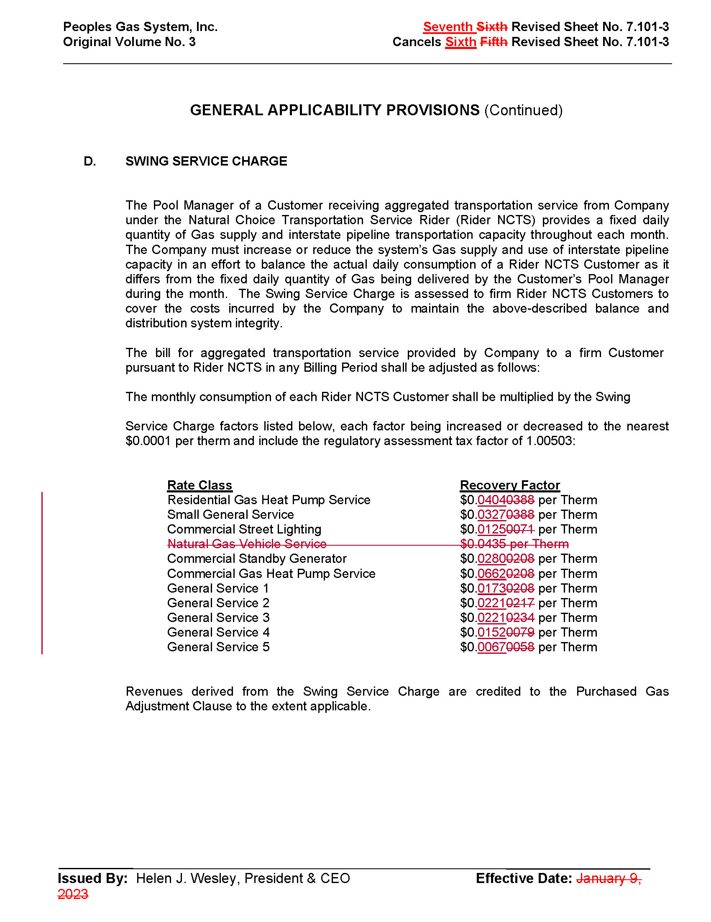

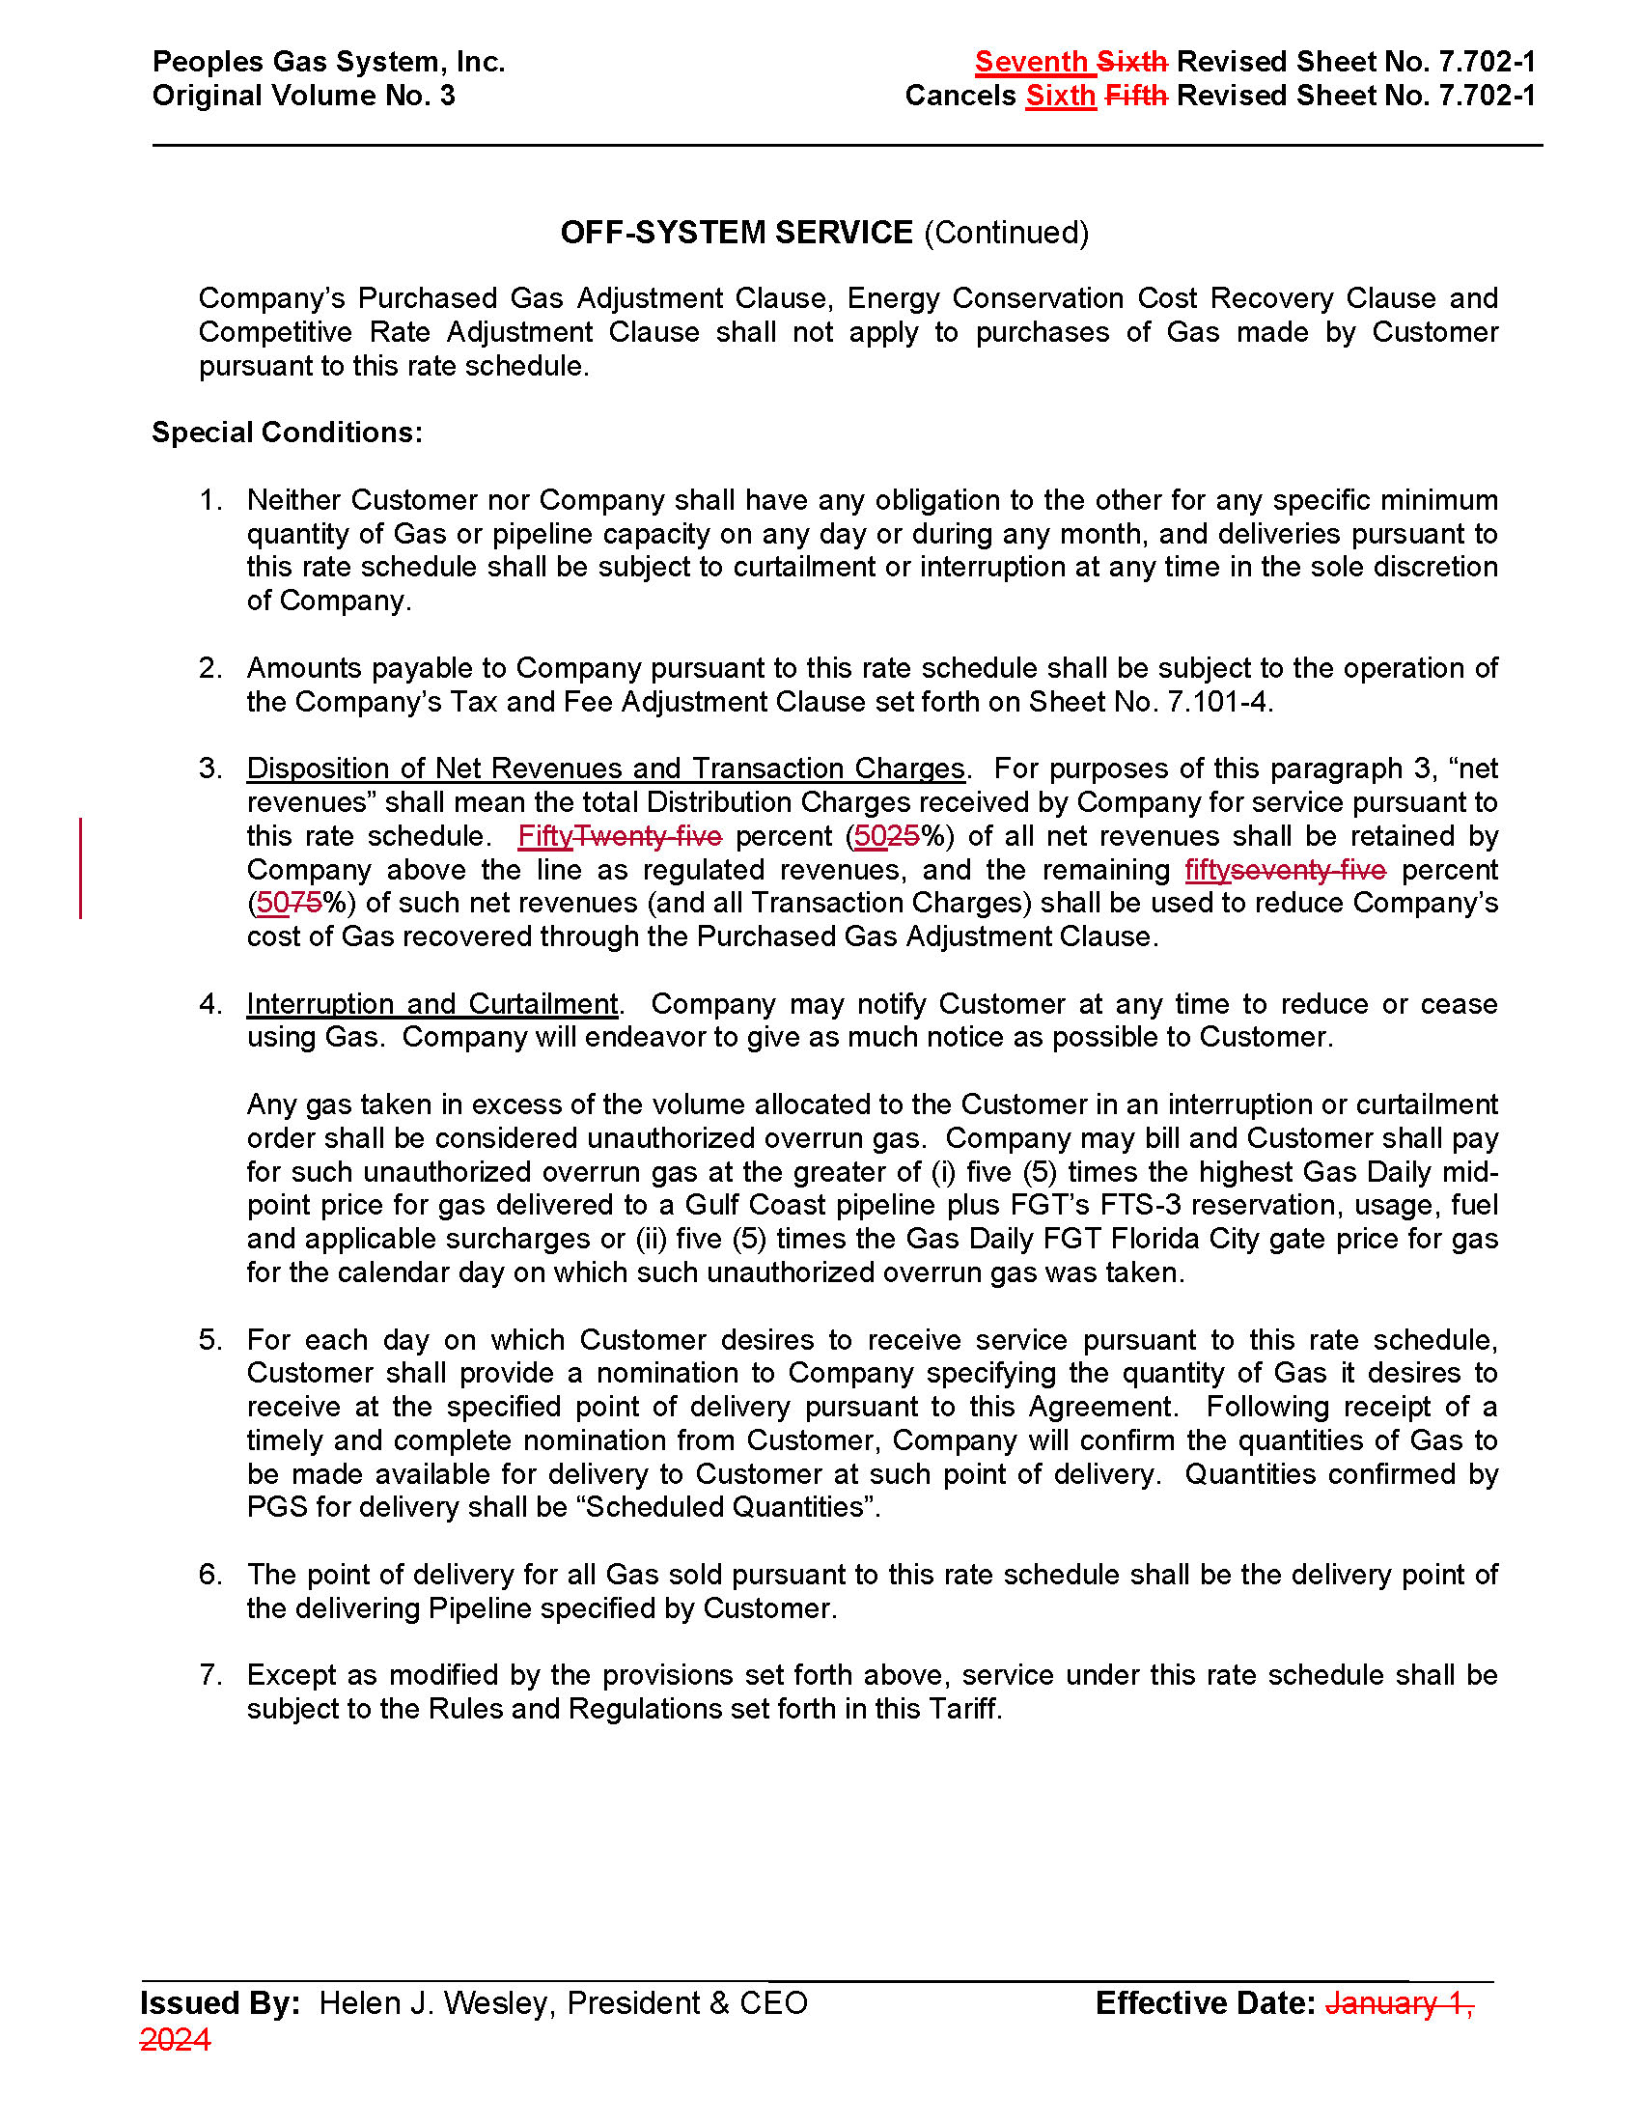

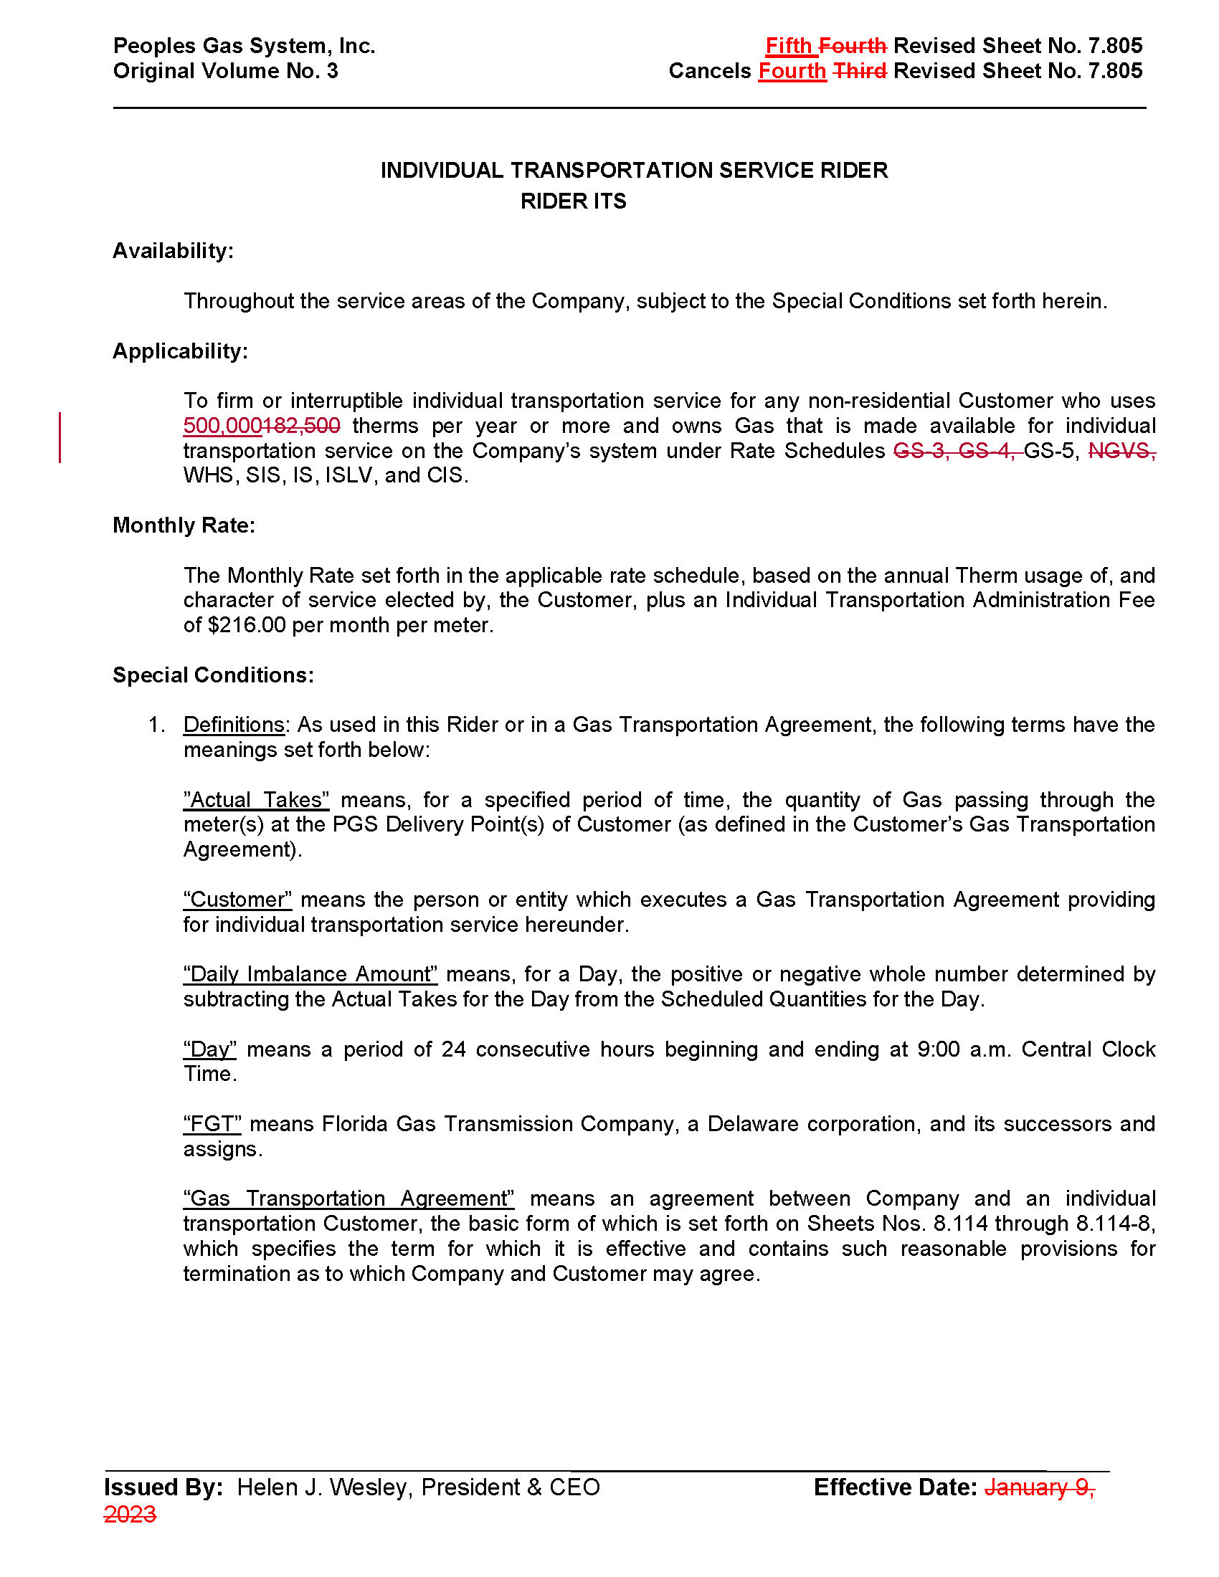

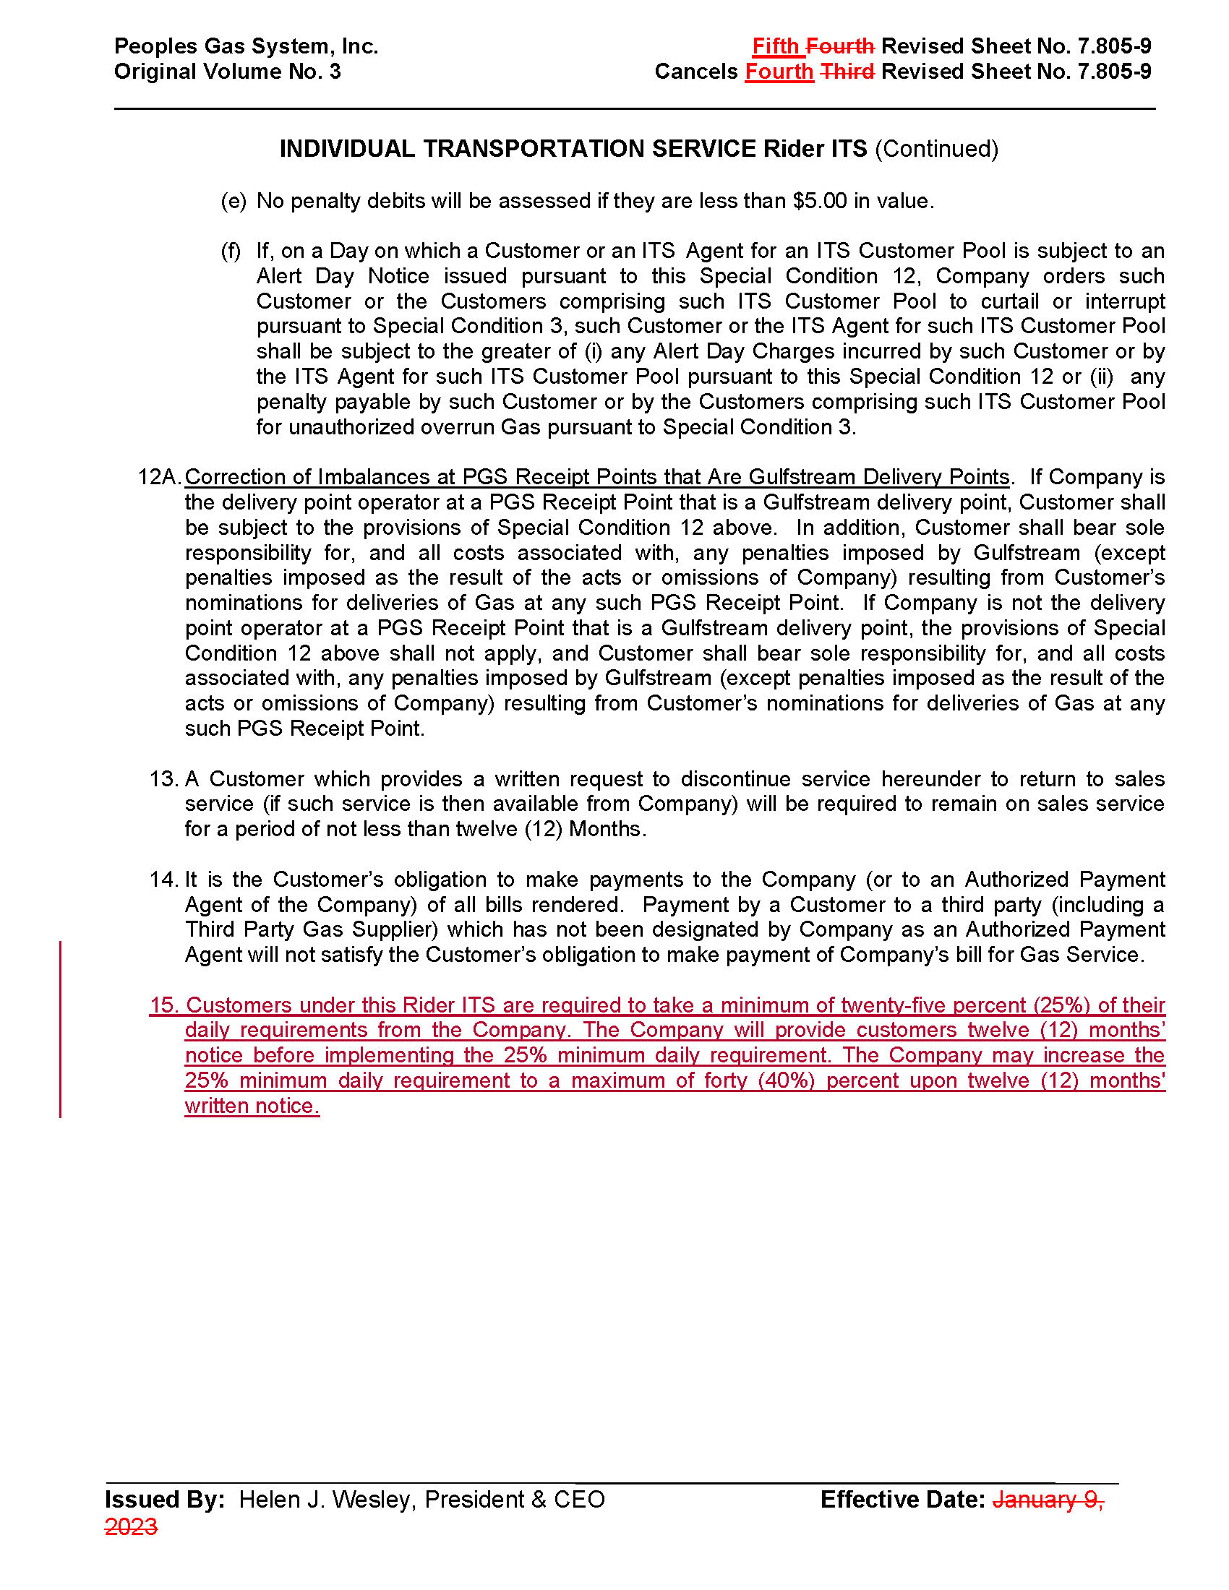

1. Order No. PSC-00-1814-TRF-GU, issued October 4, 2000, in Docket No. 000810-GU, *In re: Petition for approval of modifications to tariff provisions governing transportation of customer-owned gas and tariff provisions to implement Rule 25-7.0335, F.A.C., by Tampa Electric Company d/b/a Peoples Gas System.*
2. Order No. PSC-15-0570-TRF-GU, issued December 17, 2015, in Docket No. 150220-GU, *In re: Petition for approval of tariff modifications related to the swing service charge, by Peoples Gas System.*
3. Order No. PSC-2025-0090-PCO-GU, issued March 24, 2025, in Docket No. 20250026-GU, *In re: Petition for approval to modify swing service charge, individual transportation service rider, and off-system service rate schedule, by Peoples Gas System, Inc.*
4. Order No. PSC-2020-0485-FOF-GU, issued on December 10, 2020, in Docket No. 20200051-GU, *In re: Petition for rate increase by Peoples Gas System.*
5. Order No. PSC-94-1187-FOF-GU, issued September 28, 1994, in Docket No. 940856-GU, *In re: Petition for approval of Off-System Sales (OSS) Rate Schedule by Peoples Gas System, Inc.*
6. Order No. PSC-03-0038-FOF-GU, issued January 6, 2003, in Docket No. 020384-GU, *In re: Petition for rate increase by Peoples Gas System*.
7. Order No. PSC-09-0411-FOF-GU, issued June 9, 2009, in Docket No. 080318-GU, *In re: Petition for rate increase by Peoples Gas System.*
8. Docket No. 20250029-GU, *In re: Petition for rate increase by Peoples Gas System, Inc.*