BEFORE THE FLORIDA PUBLIC SERVICE COMMISSION

In re: Petition for rate increase by Florida Public Utilities Company. | DOCKET NO. 20240099-EI  ORDER NO. PSC-2025-0287-AS-EI  ISSUED: July 24, 2025

The following Commissioners participated in the disposition of this matter:

MIKE LA ROSA, Chairman
ART GRAHAM
GARY F. CLARK
ANDREW GILES FAY
GABRIELLA PASSIDOMO SMITH

FINAL ORDER APPROVING SETTLEMENT AGREEMENT

BY THE COMMISSION:

APPEARANCES:

BETH KEATING, ESQUIRE, Gunster Law Firm, 215 South Monroe Street, Suite 601, Tallahassee, Florida 32301; appearing on behalf of Florida Public Utilities Company (FPUC).

WALT TRIERWEILER, PUBLIC COUNSEL; PATRICIA CHRISTENSEN, ESQUIRE, OFFICE OF PUBLIC COUNSEL, c/o The Florida Legislature, 111 west Madison Street, Room 812, Tallahassee, Florida 32399-1400, appearing on behalf of the Citizens of the State of Florida.

ROBERT SCHEFFEL WRIGHT and JOHN T. LaVIA, III, Gardner Law Firm, 1300 Thomaswood Drive, Tallahassee, Florida, appearing on behalf of the City of Marianna, Jackson County Board of County Commissioners, and the Jackson County School Board.

SUZANNE BROWNLESS, ESQUIRE, FPSC General Counsel’s Office, 2540 Shumard Oak Boulevard, Tallahassee, Florida 32399-0850, appearing on behalf of the Florida Public Service Commission (Staff).

SAMANTHA CIBULA, ESQUIRE, Florida Public Service Commission, 2540 Shumard Oak Boulevard, Tallahassee, Florida 32399-0850, Advisor to the Florida Public Service Commission.

BY THE COMMISSION:
BACKGROUND

Florida Public Utilities Company (FPUC or Company) filed a test year notification letter with the Florida Public Service Commission (Commission) on June 18, 2024, in which the Company indicated its intent to seek a permanent increase in its rates and charges based on a test year ending December 31, 2025, and a request for an interim rate increase. On August 22, 2024, FPUC filed its petition for an increase in base rates, as well as minimum filing requirements schedules (MFRs) and direct testimony of 10 witnesses. At that time FPUC requested that its petition for rate increase be processed using the proposed agency action process in Section 366.06(4), F.S.

Order No. PSC-2024-0441-PCO-EI, issued October 14, 2024, suspended the final rates and approved interim rates. On September 5, 2024, the Office of Public Counsel (OPC) filed its Notice of Intervention which was acknowledged by Order No. PSC-2024-0408-PCO-EI, issued on September 5, 2024. Order No. PSC-2025-0114-PAA-EI, granting in part and denying in part FPUC’s rate increase, was issued on April 7, 2025. A timely request for hearing on Order No. PSC-2025-0114-PAA-EI was filed by the City of Marianna, Jackson County, and the Jackson County School Board (Jackson County) on April 21, 2025. OPC filed its request for hearing on April 24, 2025. On May 7, 2025, FPUC, OPC and Jackson County filed a Joint Motion for Approval of Stipulation and Settlement, a unanimous settlement which resolves all of the issues in this case (2025 Settlement), which is incorporated and attached as Attachment A. On June 5, 2025, Order No. PSC-2025-0189-PCO-EI was issued establishing procedure and setting the key elements of the 2025 Settlement to be addressed by the parties at the final hearing.

A final hearing was held on July 1, 2025, in which the prefiled testimony of Michael Galtman, Noah Russell, Nicholas Crowley, Kim Estrada, Vikrant Gadgil, Devon Rudloff-Daffinson, Wraye Grimard, William Haffecke, Michelle Napier, and John Taylor was admitted into the record as though read. Mike Cassel and Jim Dean testified on behalf of FPUC and the Jackson County intervenors, respectively. Written statements on behalf of both witnesses were also placed in the record as though read without objection. Additionally, 97 exhibits were admitted into the record. The parties waived briefs and a bench vote was taken at the final hearing approving the 2025 Settlement.
DISCUSSION
In evaluating a proposed unanimous 2025 Settlement we must identify the major elements of the proposed settlement, discuss how those elements differ from what was originally proposed in the rate case filing, and discuss the impact the major elements have on the rate case. Once that analysis is done, we must determine whether, when taken as a whole, the settlement is in the public interest.
The major elements of the 2025 Settlement are as follows:
A. Base revenue increase
FPUC originally requested a $12,593,450 base revenue increase. The 2025 Settlement sets the base revenue increase at $8.4 million. The 2025 Settlement divides the base rate increase into 2 parts: a $7.4 million increase starting on March 20, 2025 to March 19, 2026 and the final $8.4 million increase starting March 20, 2026, with a minimum term ending September 20, 2028.
In addition to the base revenue increases, an increase in miscellaneous charges of $164,495 will be charged from March 20, 2025 until the next rate proceeding. Also from March 20, 2026 until March 20, 2028, $333,000 per year (1/3 of the deferred first year’s $1 million) will be added to the base revenues of $8.4 million. Finally, 1/3 of the difference between the PAA rates collected from March 20, 2025 until July 2, 2025, plus interest, will be subtracted from the base revenue requirement starting on March 20, 2026 and ending March 20, 2028.
The structure of the base revenue increase is directly responsive to the testimony given at the service hearings in both Fernandina Beach and Marianna. Both commercial and residential customers testified that they could not absorb the proposed base rate increase of 44% all at one time. Likewise, Jackson County, the Jackson County School Board, and the City of Marianna all testified that if the base revenue increase proposed were to be put in place, the economic impact on Jackson County, one of the poorest counties in the state, would be catastrophic. The School Board testified that it would be unable to fill needed teaching positions and would have to cancel existing school programs. Reducing the base revenue increase by approximately $4.2 million in 2025 reduces the base rate increase to a 26% for residential customers, a more manageable increase.
B. Miscellaneous fees and charges increase
The proposed increase in fees and charges of $164,495 in the 2025 Settlement are those proposed by FPUC and consist of customer disconnect and reconnect fees, collection charges, temporary service charges and miscellaneous charges. Upon review, we find these to be reasonable.
C. Effective date of tariffs
FPUC did not request a specific effective date for implementation of its requested revenue increase. The 2025 Settlement delays collection of the full $8.4 million base revenue increase by 1 year, until March 20, 2026. This allows the customers an opportunity to budget for the increase and make other financial adjustments to accommodate the higher rates.
D. Substations and transmission assets step increase
Step increase tariffs
FPUC originally requested $678,271 for the acquisition and replacement of four substations and a transmission line in its Northwest territory and replacement/rebuild of two FPUC-owned substations in its Northeast territory. The replacement and acquisition of the Northwest assets is expected to total $10.7 million and will result in annual savings of approximately $1.4 million generated by reduced purchased power costs and a reduced fuel factor. In the Northeast, FPUC is replacing two substations originally installed in the 1970s. These projects are expected to cost a total of $8.7 million.
The 2025 Settlement allows FPUC to implement a base revenue increase when these substation and transmission assets are brought on line which shall not exceed $727,778. FPUC also requests that our staff be allowed to approve the step increases associated with these assets administratively upon confirmation that the rates proposed will produce the correct revenues. These upgrades and purchases will provide increased reliability for both the Northeast and Northwest regions and provide significantly lower fuel costs.
E. Midpoint ROE and ROE range
FPUC requested an ROE of 11.30% with a range of 10.30% to 12.30%. The 2025 Settlement has an ROE of 10.20% with a range of 9.20% to 11.20%. FPUC’s calculation of ROE relied heavily on historical financial and market data from 2021 to 2023 that does not accurately reflect expected market conditions or investor required equity returns.
The 2025 Settlement’s ROE of 10.20% is consistent with calculations using more recent market data and current forecasted interest rates. A reduction of 110 basis points results in a base revenue reduction of $848,026.
F. Equity ratio
FPUC proposed an equity ratio of 50.04% for all regulatory purposes which the 2025 Settlement adopted as reasonable for a utility of FPUC’s size and risk profile. This equity ratio is within the range of equity ratios for Florida’s investor-owned electric (55.53%) and natural gas utilities (53.57%) which average 54.3%.
G. General liability reserve accrual increase
FPUC proposed to increase the general liability (self-insurance) reserve accrual by $189,432 annually. The 2025 Settlement adopts this amount and requires that the credit balance be used to offset working capital in rate base for all applicable regulatory purposes.
H. Rate case expense
FPUC requested rate case expense of $1,530,907 amortized over four years. The 2025 Settlement has increased the rate case expense to $1,536,000 amortized over five years. The 2025 Settlement reflects approximately $6,000 in additional costs but adds an additional year for cost recovery which lowers the annual expense for customers.
I. Annual storm reserve accrual
FPUC requested an annual storm reserve accrual of $446,979 amortized over five years until the reserve reaches $2,234,895. The 2025 Settlement reduced the annual accrual to $121,620 until the storm reserve reaches $1.5 million which is what FPUC is currently collecting. Because the 2025 Settlement maintains the current accounting treatment for storm reserve accrual there is no adverse impact imposed by this provision.

J. Minimum term of 2025 Agreement
Next base rate increase
FPUC did not make any representation regarding rate case stay-out provisions or a minimum term in its petition. The 2025 Settlement states that FPUC will not seek a base rate increase until September 20, 2028, unless its earnings fall below 9.2%. This is consistent with the proposed minimum term proposed in the 2025 Settlement of 3½ years, from March 20, 2025 through September 20, 2028.
Stay-out provisions lock in rates for a set period of time, here 3½ years. This allows ratepayers/businesses to more accurately budget and plan for capital and non-capital expenses.

K. Enhanced customer service measures
FPUC has 33 walk-in payment locations in and around Marianna and 26 walk-in payment locations on Amelia Island. In Marianna 7 locations do not require an additional fee to pay FPUC’s bill; on Amelia Island 9 locations do not do so. At both customer hearings there were many requests for FPUC to provide customers with more convenient ways to contact FPUC about billing disputes and to pay bills without incurring additional fees.
The 2025 Settlement has extensive changes to the manner in which customers may pay their bills and get quick responses regarding billing disputes. These consist of enhanced bill and social media messaging, website changes, periodic in-person and remote town hall meetings, public surveys of FPUC’s outreach operations, etc. Increased contact with FPUC’s customers should go a long way to resolve outstanding issues with customer service.
When taken as a whole, the 2025 Settlement is in the public interest. The 2025 Settlement establishes a $8.4 million revenue requirement which is 33.3% less than requested by FPUC. This reduction in revenue requirement results in lowering the residential base rate increase from 44% to 26% for residential customers. When coupled with collecting $7.4 million dollars the first year, the impact of the rate increase is mitigated and allows FPUC’s customers time to better accommodate the implementation of the full $8.4 million rate increase. Establishing a minimum term through September 2028 creates price stability and also allows customers and governmental entities the ability to establish more accurate budgets. Many ratepayers in both Fernandina Beach and Marianna complained about their inability to get timely answers to billing and service complaints from FPUC. The enhanced customer services outlined in the 2025 Settlement are meaningful steps to address this issue.
FPUC’s need to provide adequate service and maintain a solid financial structure is addressed by the 2025 Settlement. The 2025 Settlement allows $727,778 for the construction and purchase of transmission and substation assets in both the Northeast and Northwest divisions necessary to provide cheaper and more reliable service. Likewise, the Company will maintain an equity ratio of 50.04% and return on equity of 10.2%, both within the range of Florida’s other electric and natural gas utilities. The 2025 Settlement disposes of all issues in this case which relieves both FPUC and the intervenors from incurring significant additional rate case expense. Finally, the 2025 Settlement allows the implementation of its terms and conditions at an earlier date than would be possible if the case were tried. All parties benefit from implementing the terms and conditions of the 2025 Settlement as soon as possible.

Given these facts, the 2025 Settlement appropriately balances the need for FPUC to have the revenues necessary to provide safe and reliable electric service with the requirement that reliable and safe electric service be provided at the lowest cost to ratepayers. Therefore, we find that the 2025 Settlement, when taken as a whole, is in the public interest and provides rates that are fair, just and reasonable.
Based on the foregoing, it is
ORDERED that the 2025 Settlement, Attachment A hereto, is hereby approved. It is further
ORDERED that the rates and tariff sheets attached to the 2025 Settlement as Exhibit B are hereby approved effective March 20, 2025.
By ORDER of the Florida Public Service Commission this 24th day of July, 2025.

/s/ Adam J. Teitzman
ADAM J. TEITZMAN
Commission Clerk
Florida Public Service Commission
2540 Shumard Oak Boulevard
Tallahassee, Florida 32399
(850) 413-6770
www.floridapsc.com

Copies furnished: A copy of this document is provided to the parties of record at the time of issuance and, if applicable, interested persons.

SBr

NOTICE OF FURTHER PROCEEDINGS OR JUDICIAL REVIEW

The Florida Public Service Commission is required by Section 120.569(1), Florida Statutes, to notify parties of any administrative hearing or judicial review of Commission orders that is available under Sections 120.57 or 120.68, Florida Statutes, as well as the procedures and time limits that apply. This notice should not be construed to mean all requests for an administrative hearing or judicial review will be granted or result in the relief sought.

Any party adversely affected by the Commission's final action in this matter may request: 1) reconsideration of the decision by filing a motion for reconsideration with the Office of Commission Clerk, 2540 Shumard Oak Boulevard, Tallahassee, Florida 32399-0850, within fifteen (15) days of the issuance of this order in the form prescribed by Rule 25-22.060, Florida Administrative Code; or 2) judicial review by the Florida Supreme Court in the case of an electric, gas or telephone utility or the First District Court of Appeal in the case of a water and/or wastewater utility by filing a notice of appeal with the Office of Commission Clerk, and filing a copy of the notice of appeal and the filing fee with the appropriate court. This filing must be completed within thirty (30) days after the issuance of this order, pursuant to Rule 9.110, Florida Rules of Appellate Procedure. The notice of appeal must be in the form specified in Rule 9.900(a), Florida Rules of Appellate Procedure.

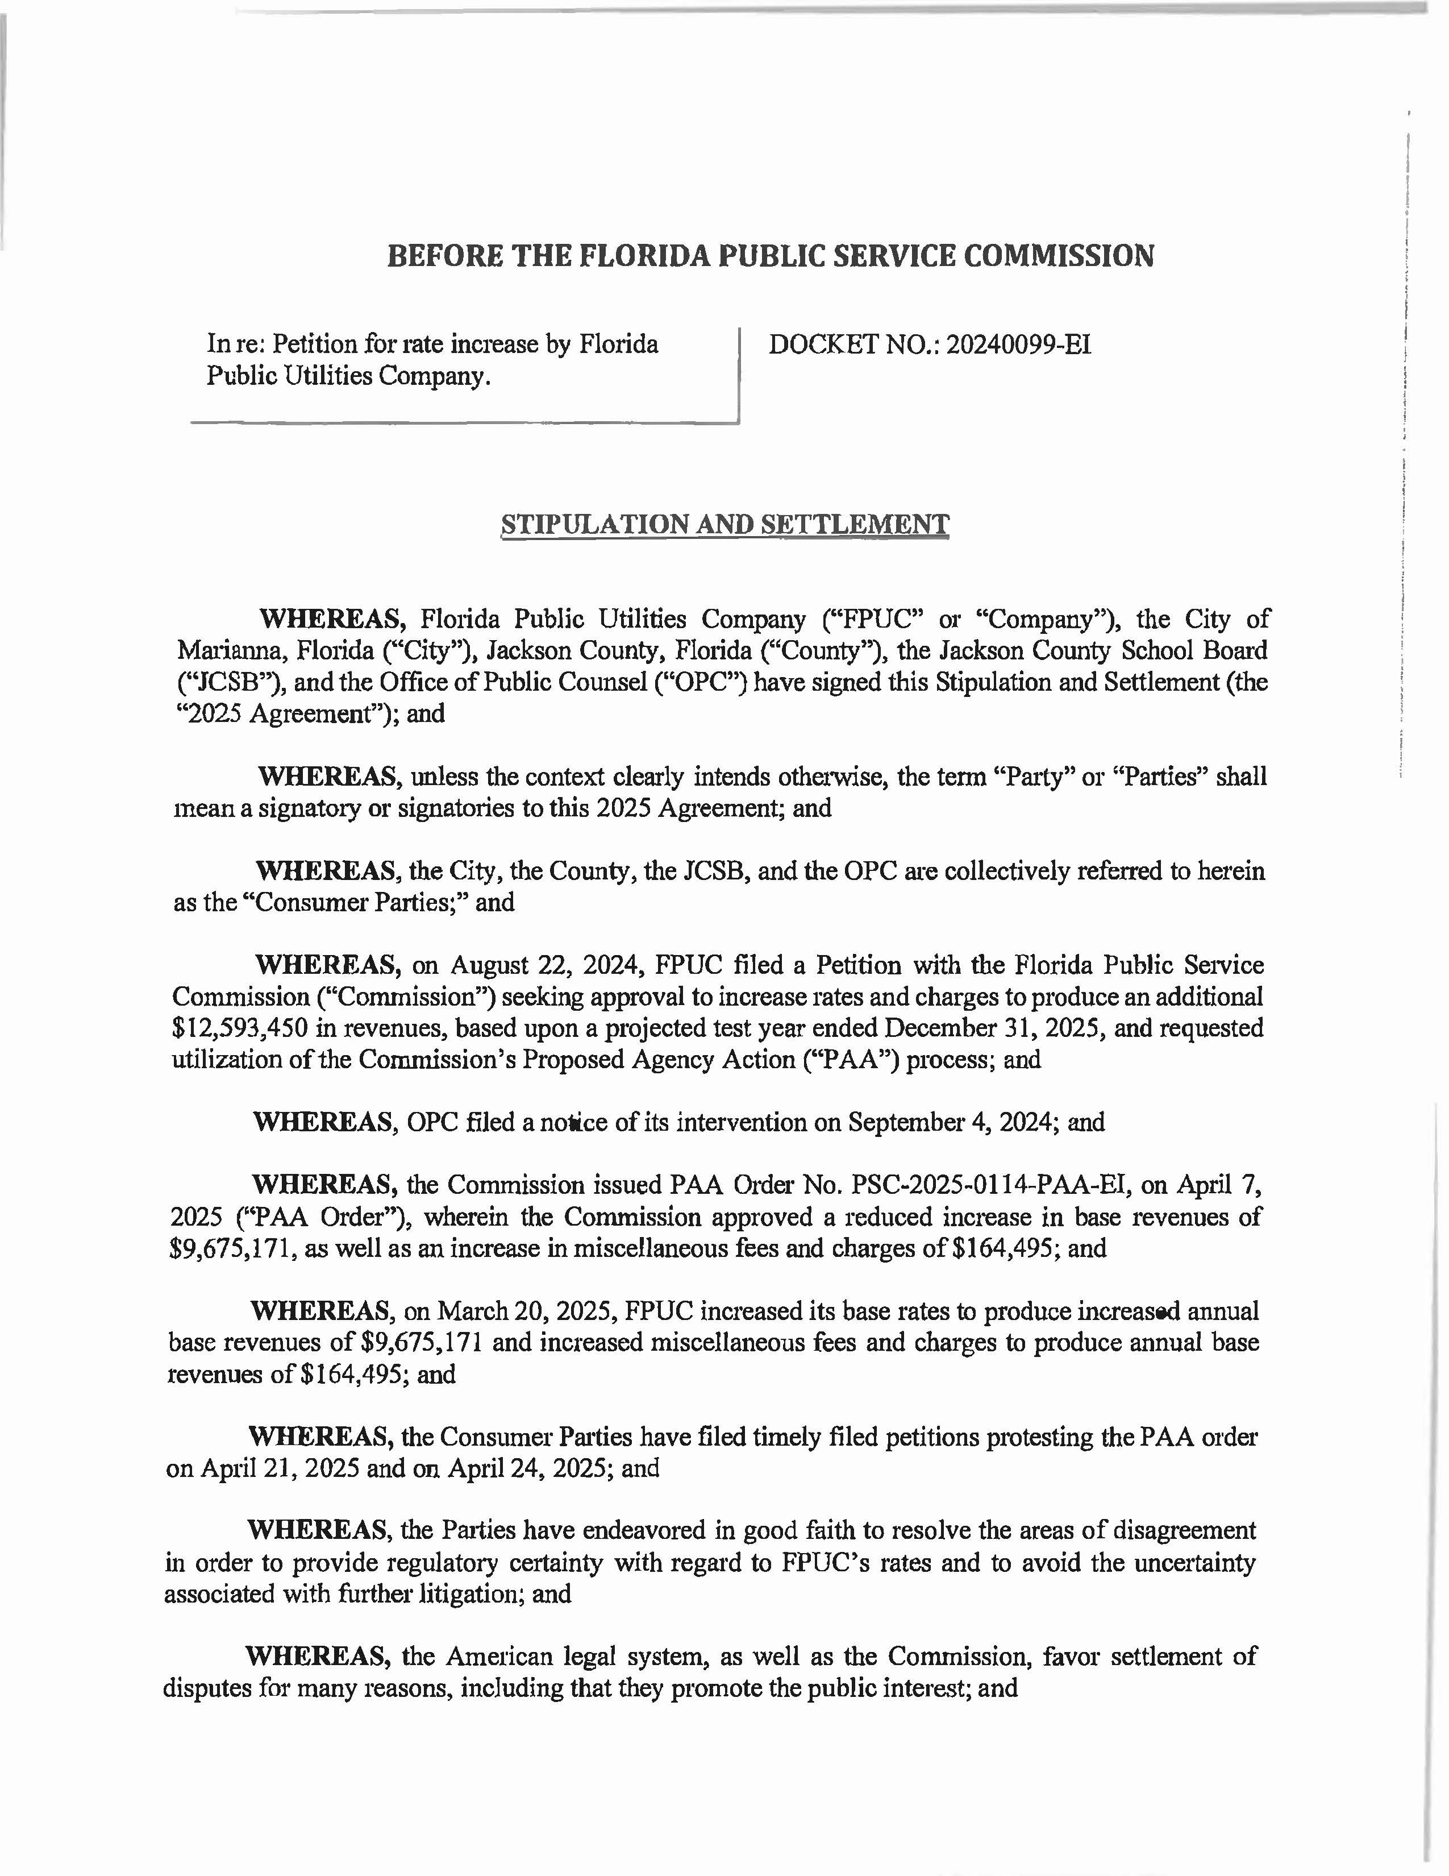
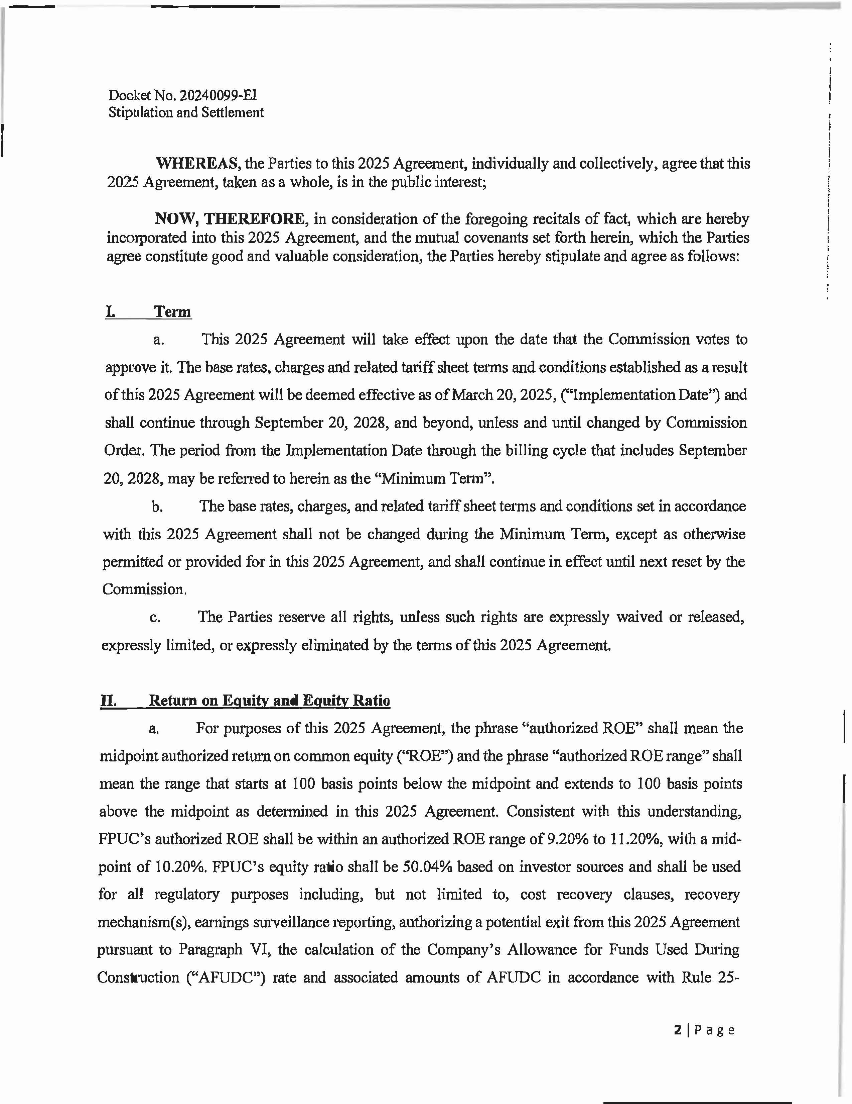
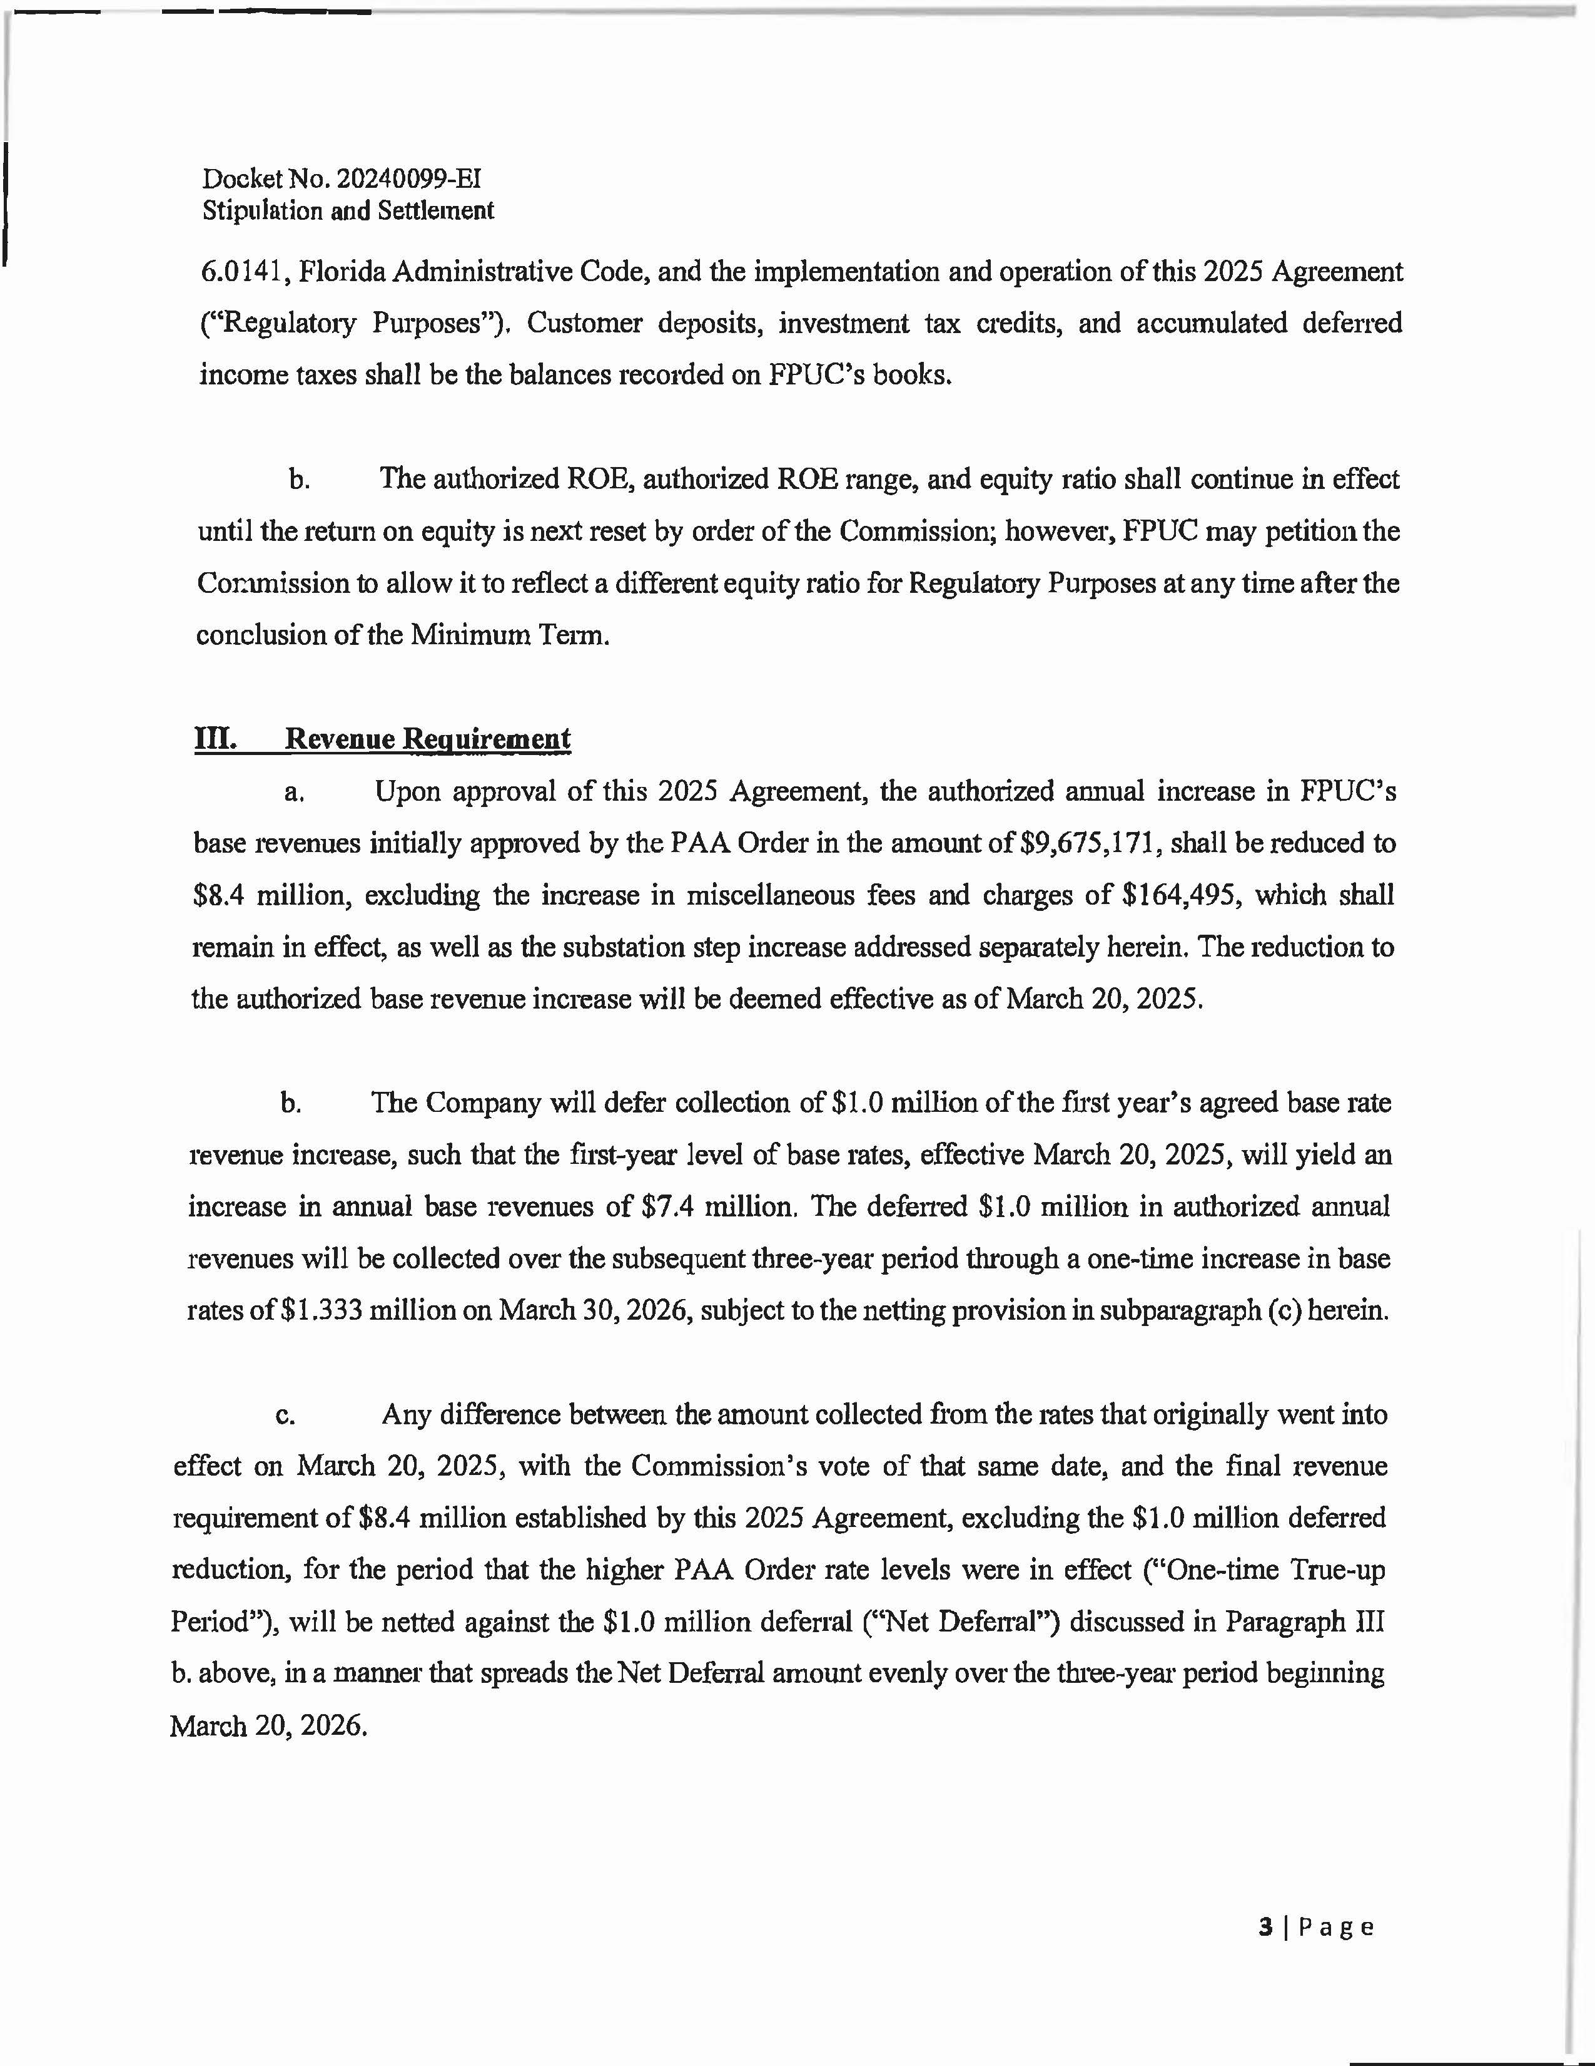
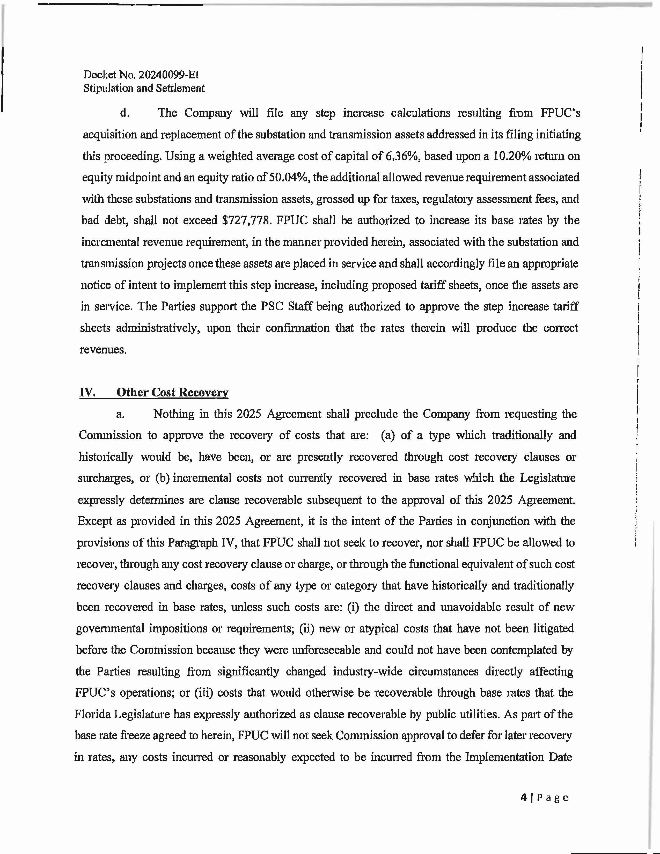
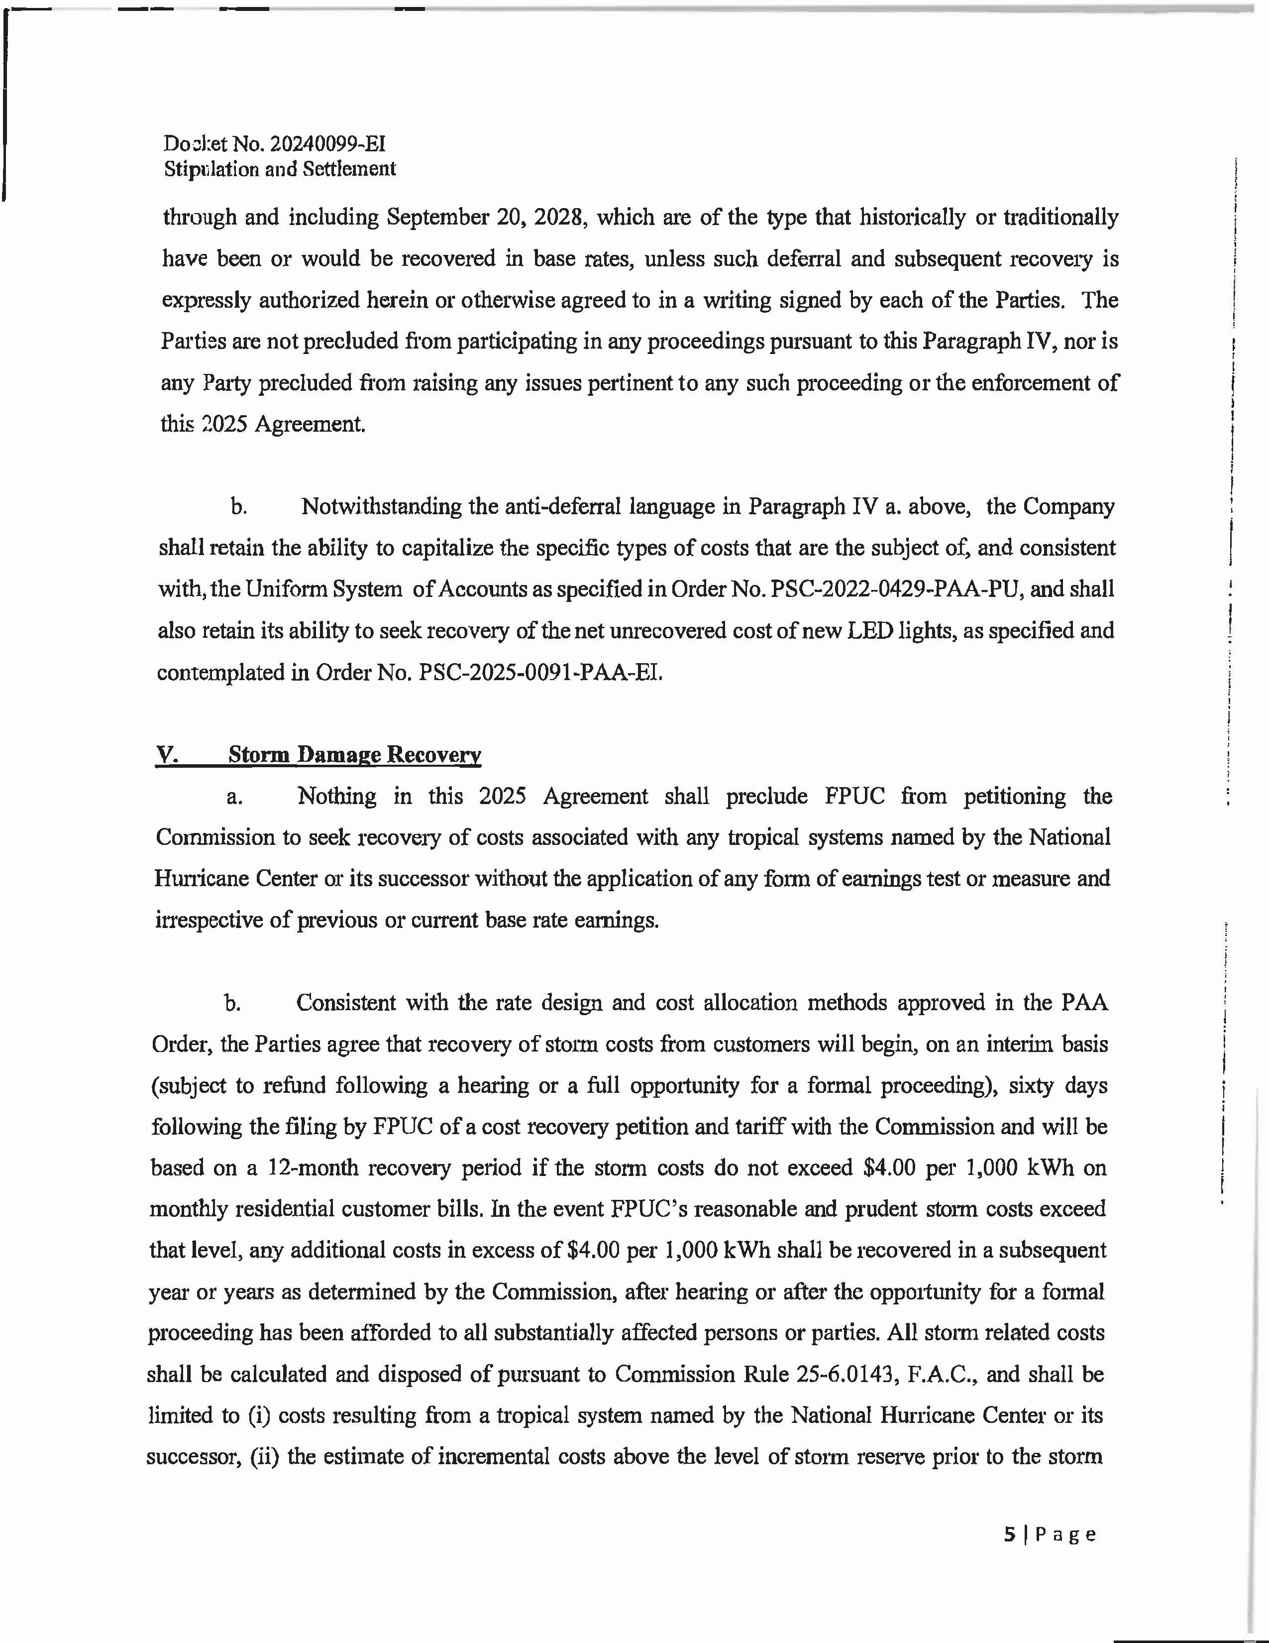
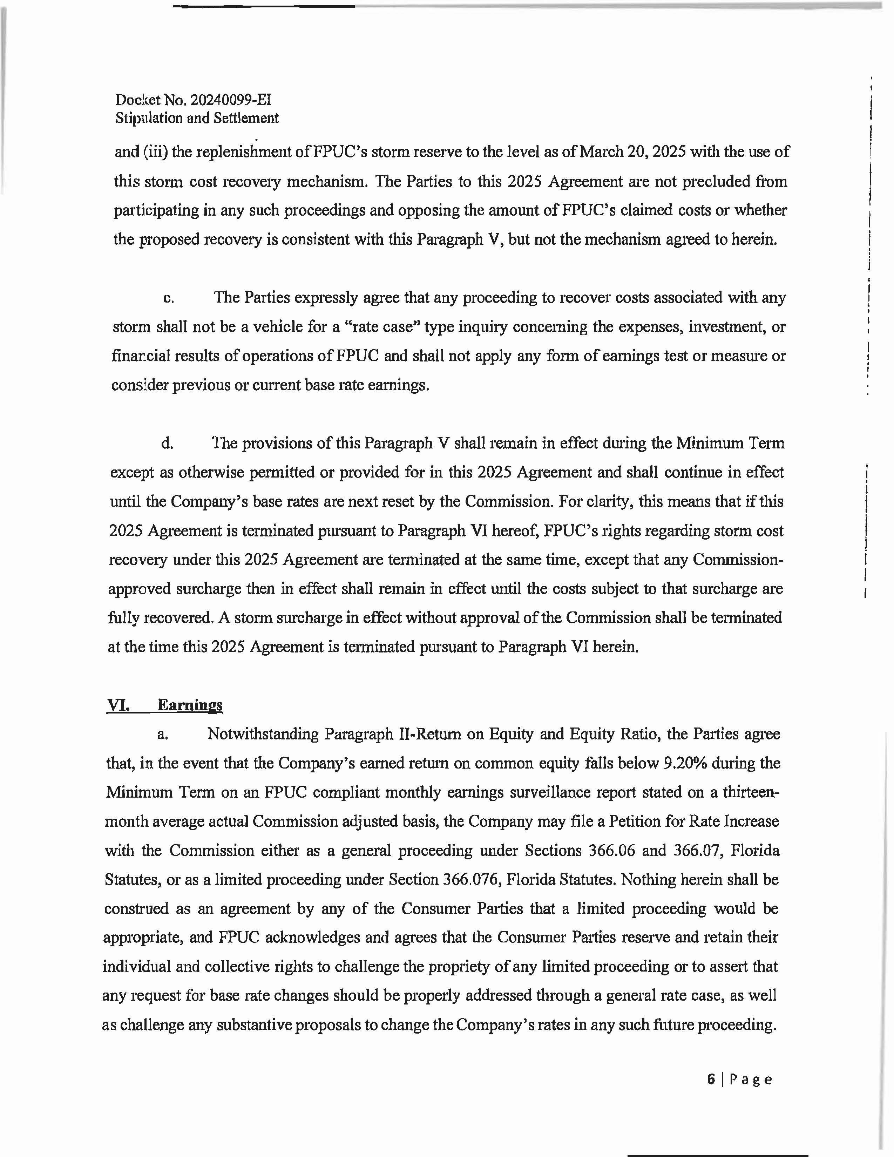
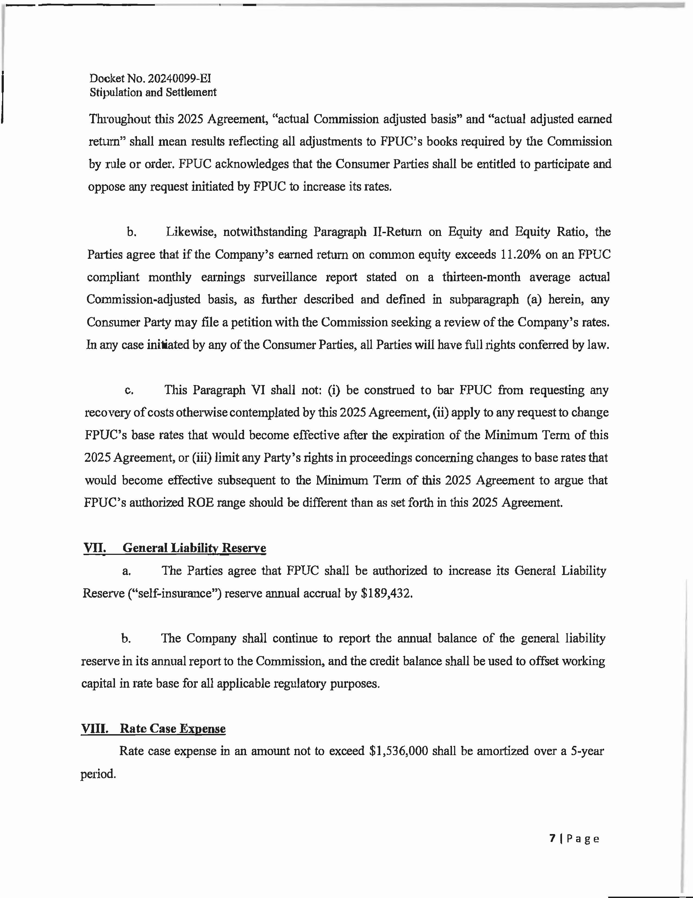
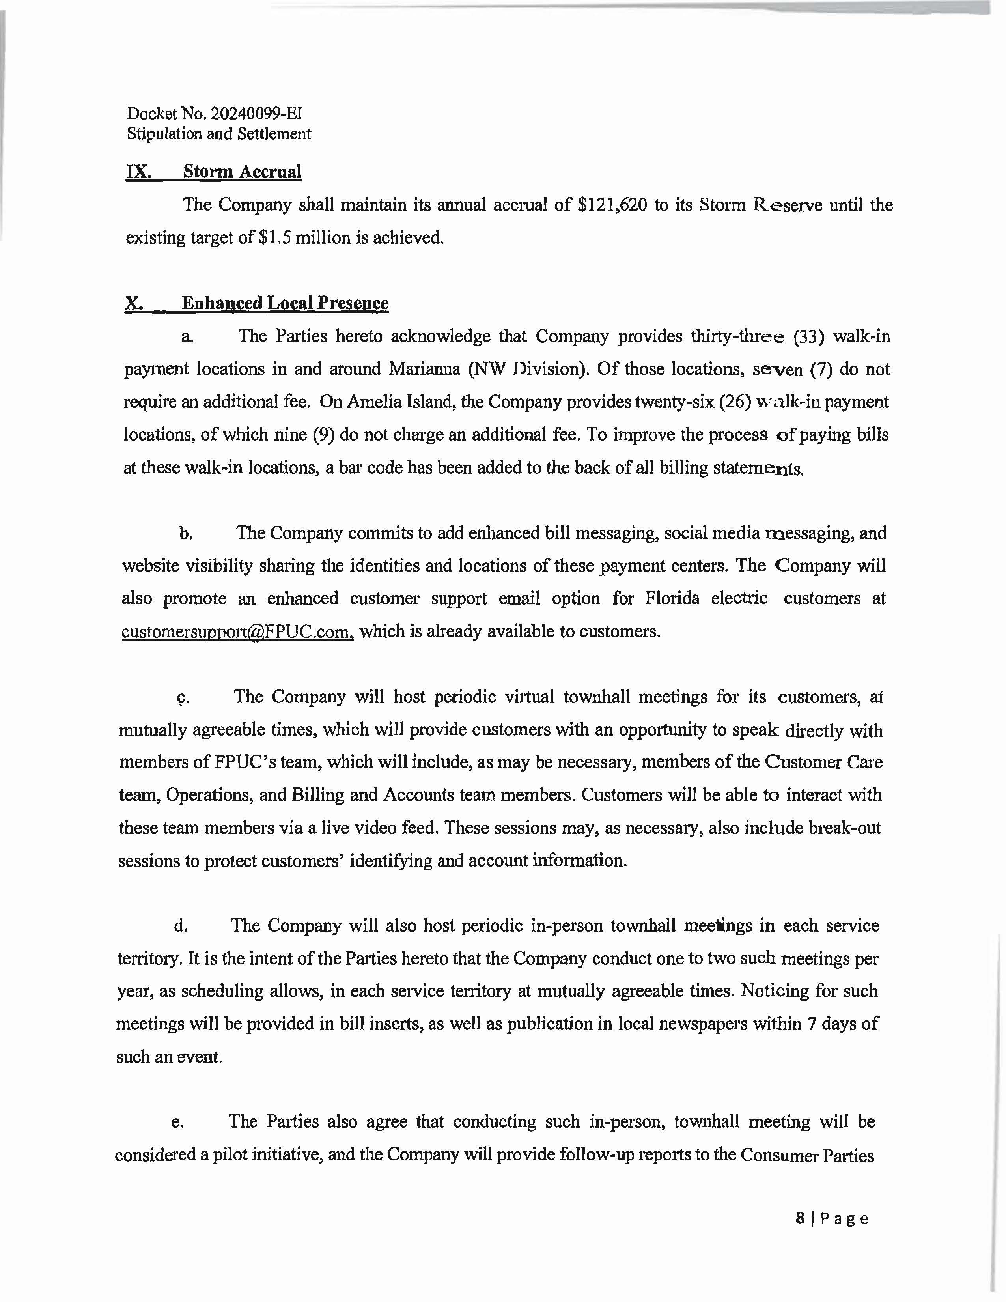
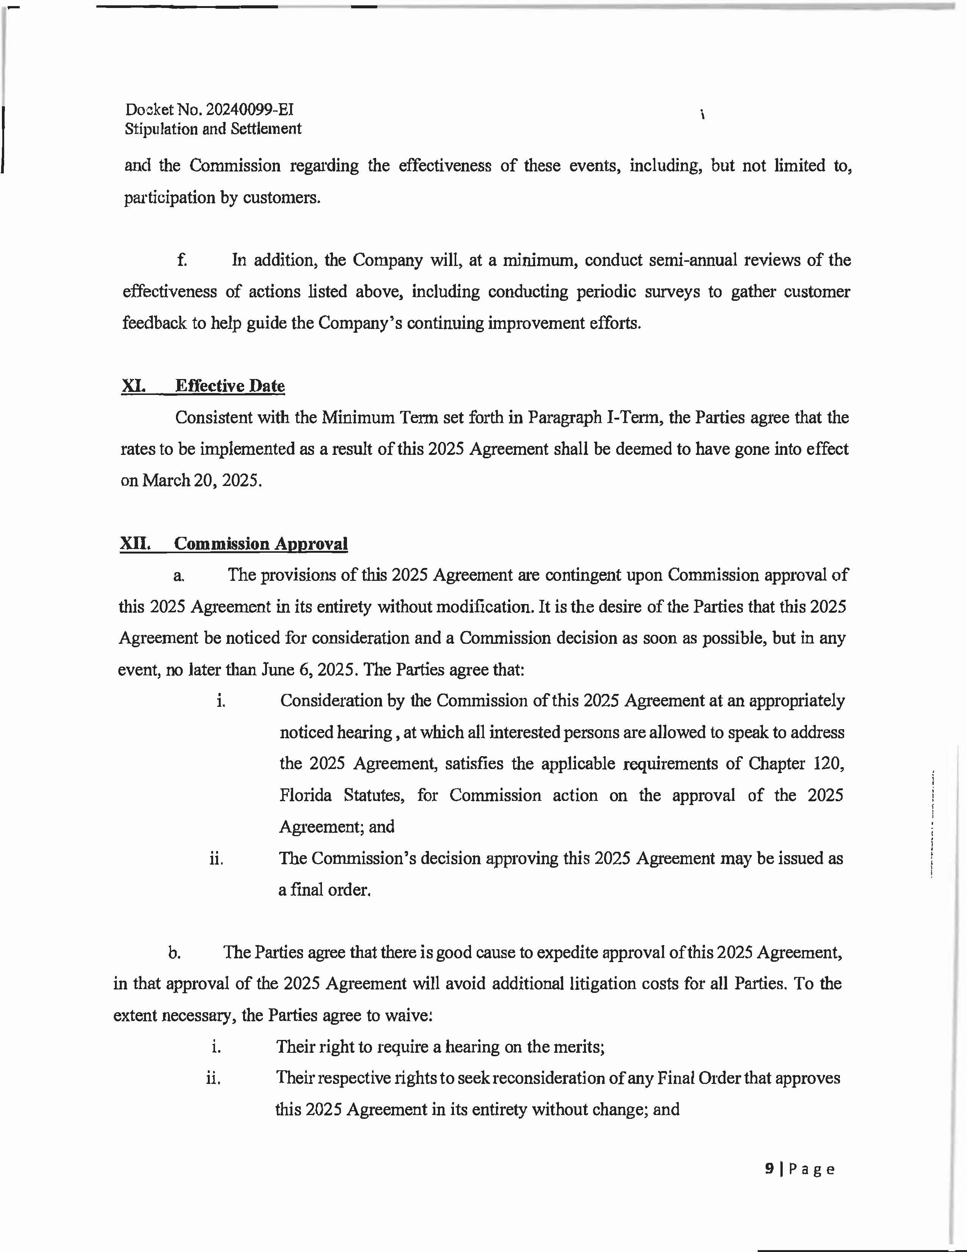
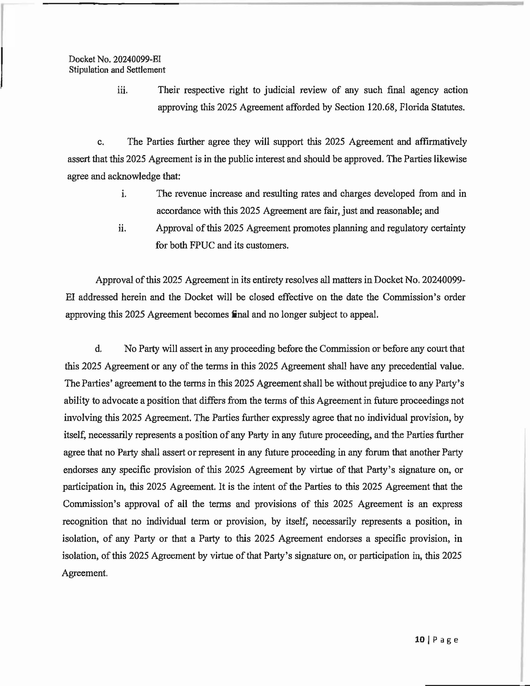
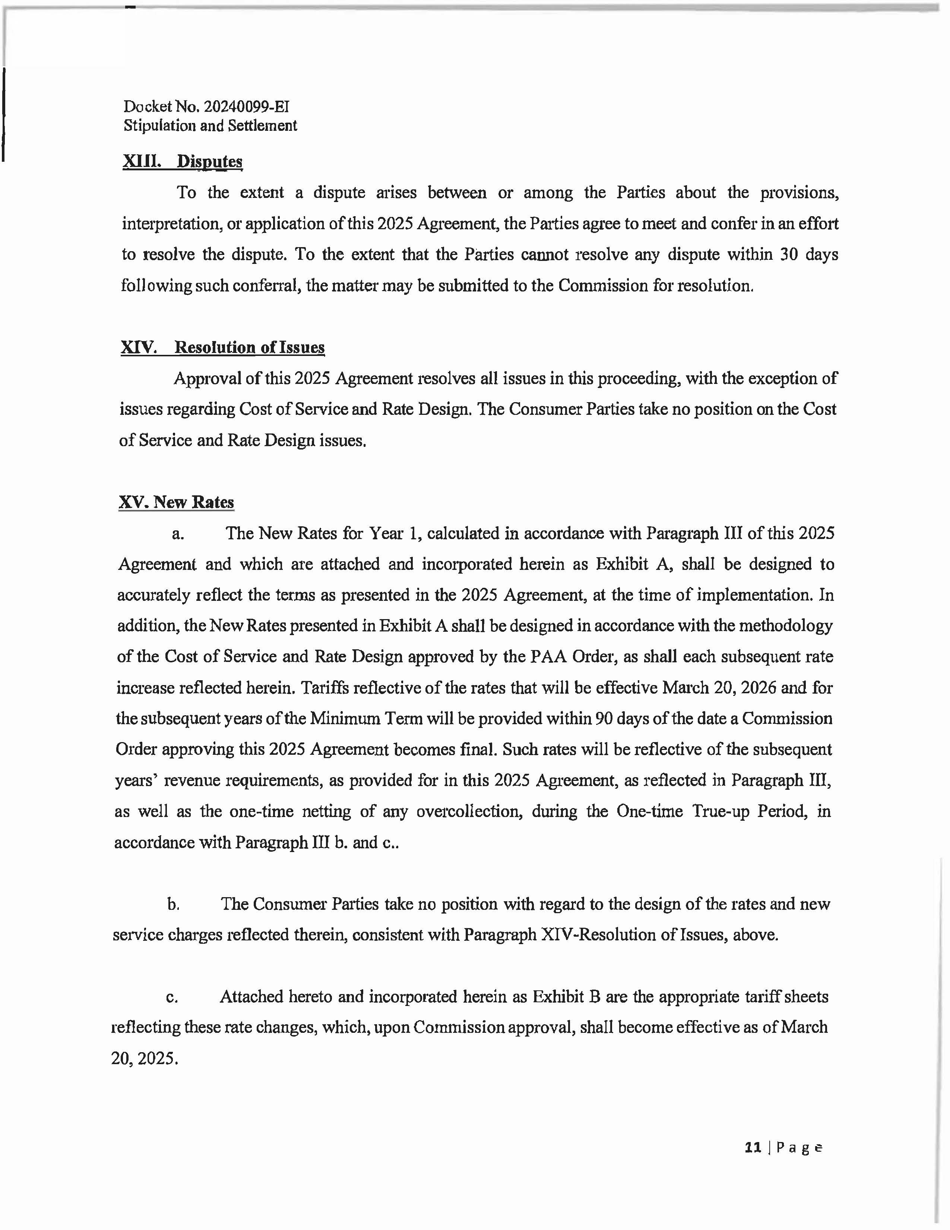
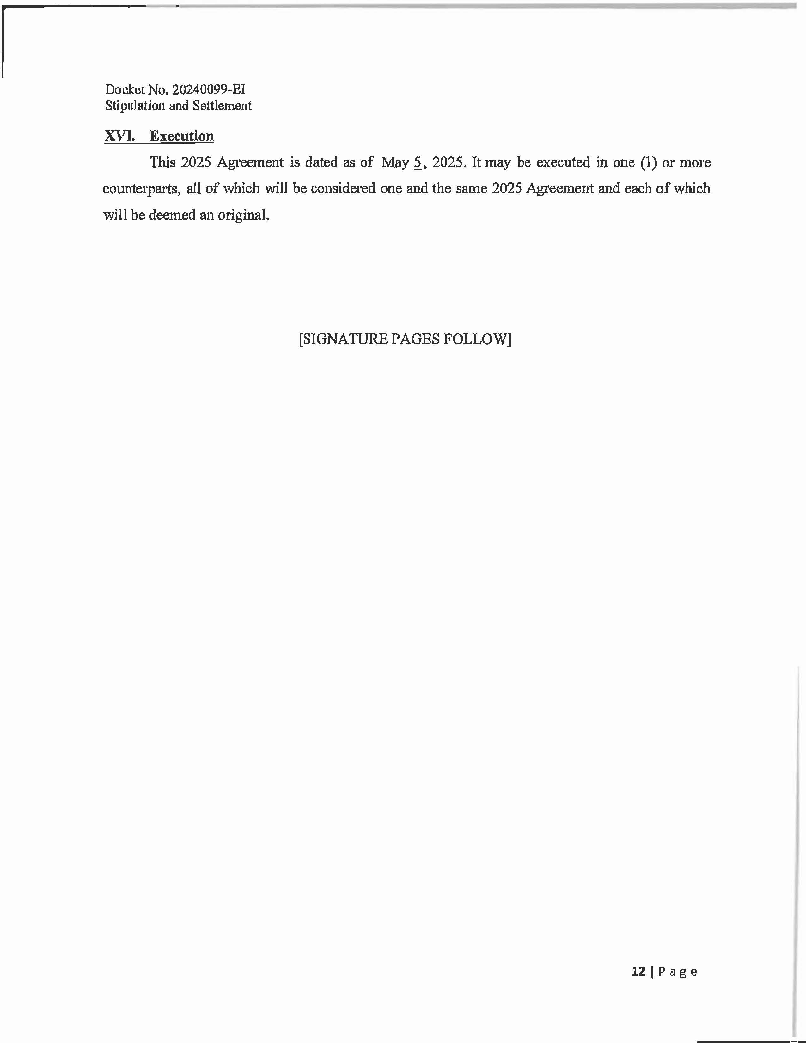
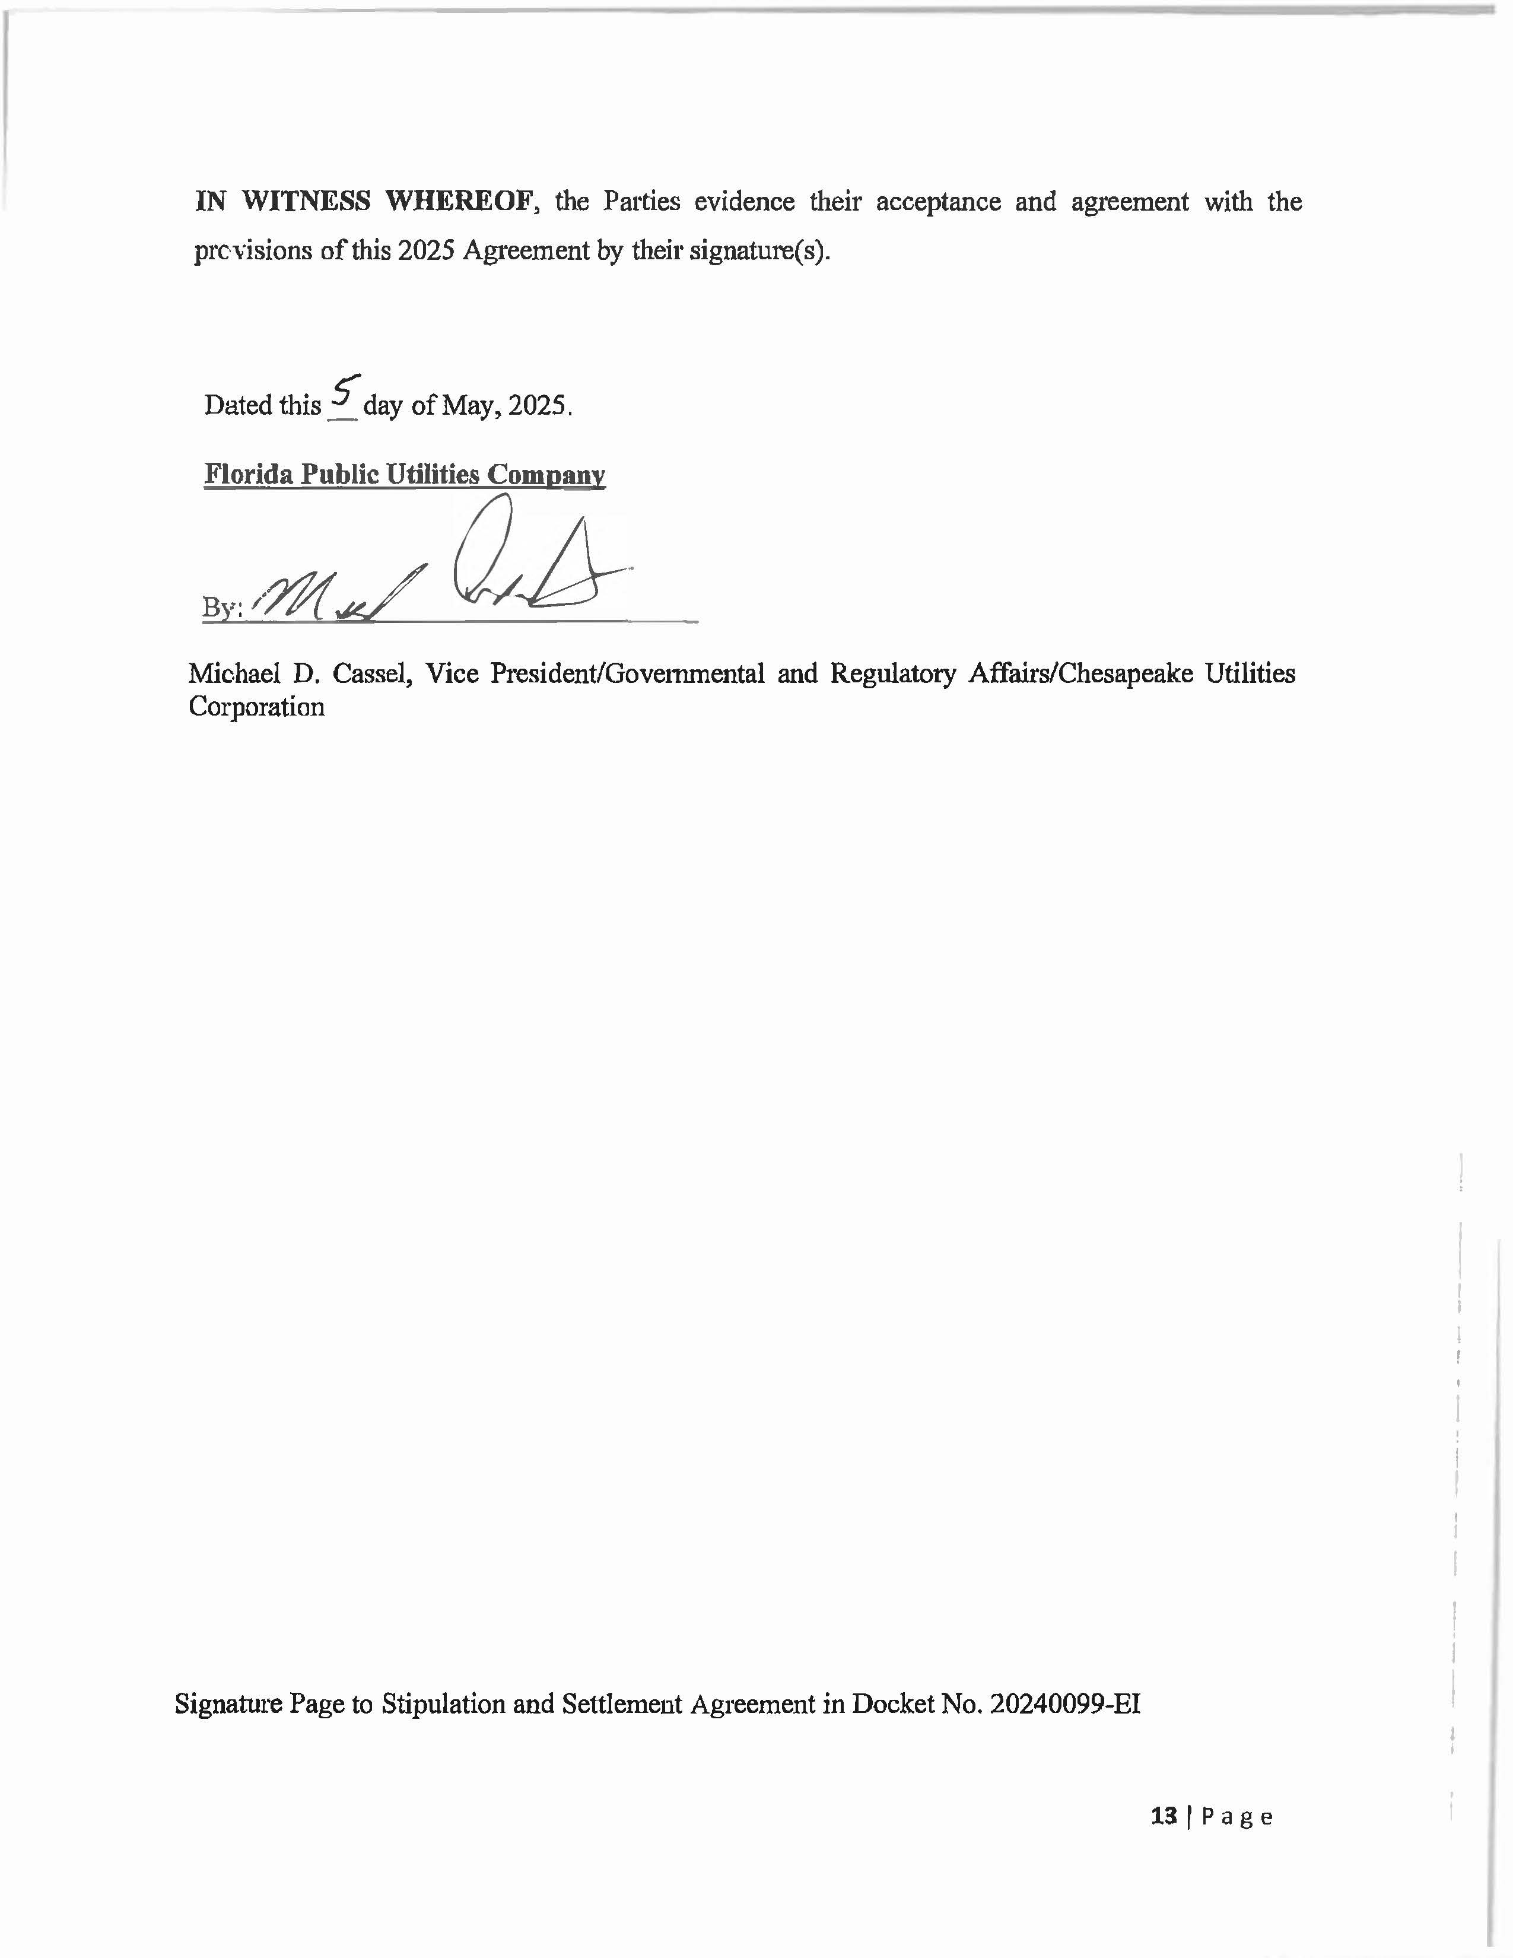
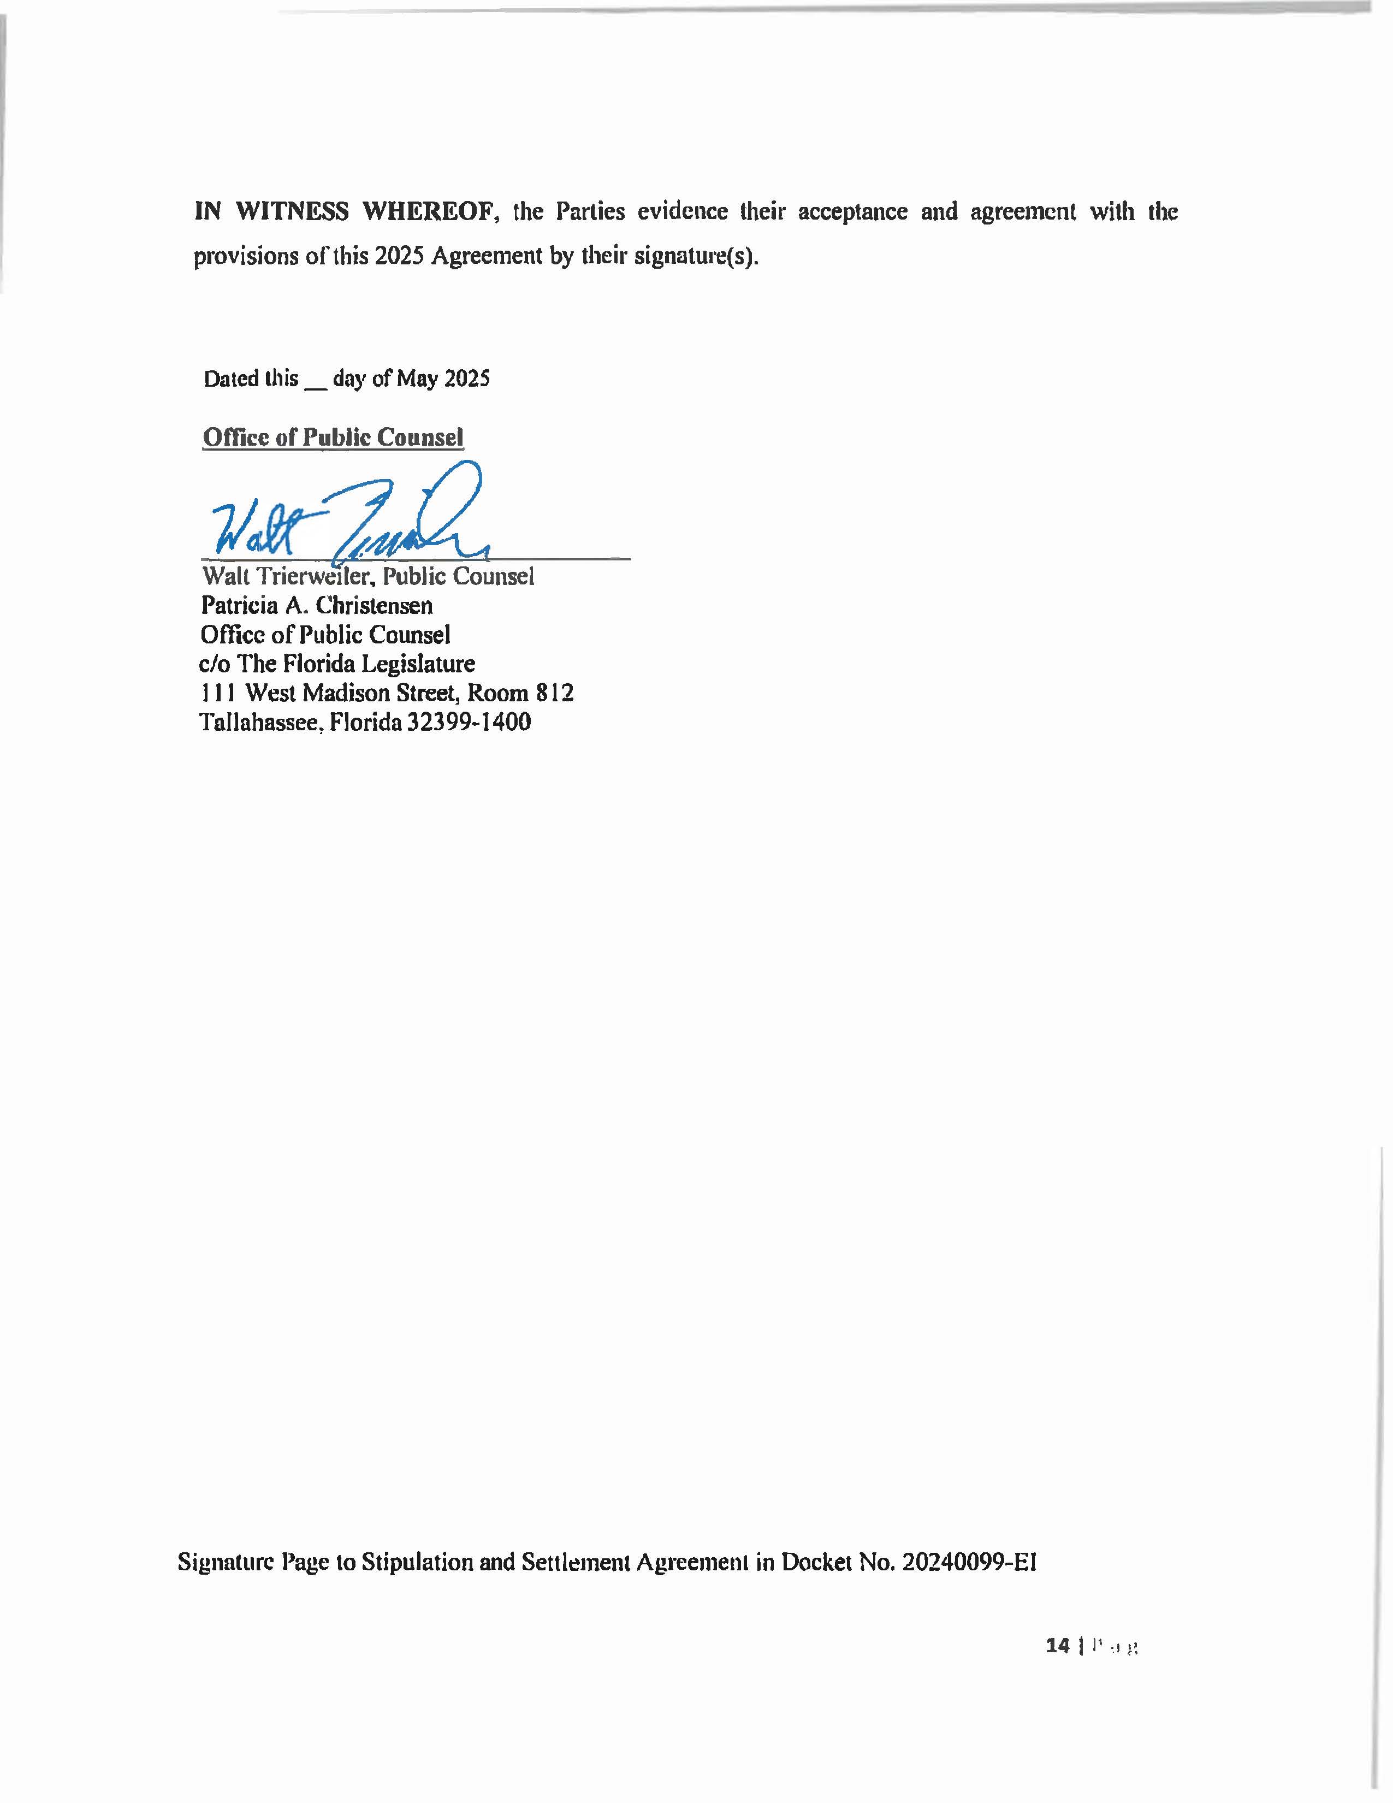
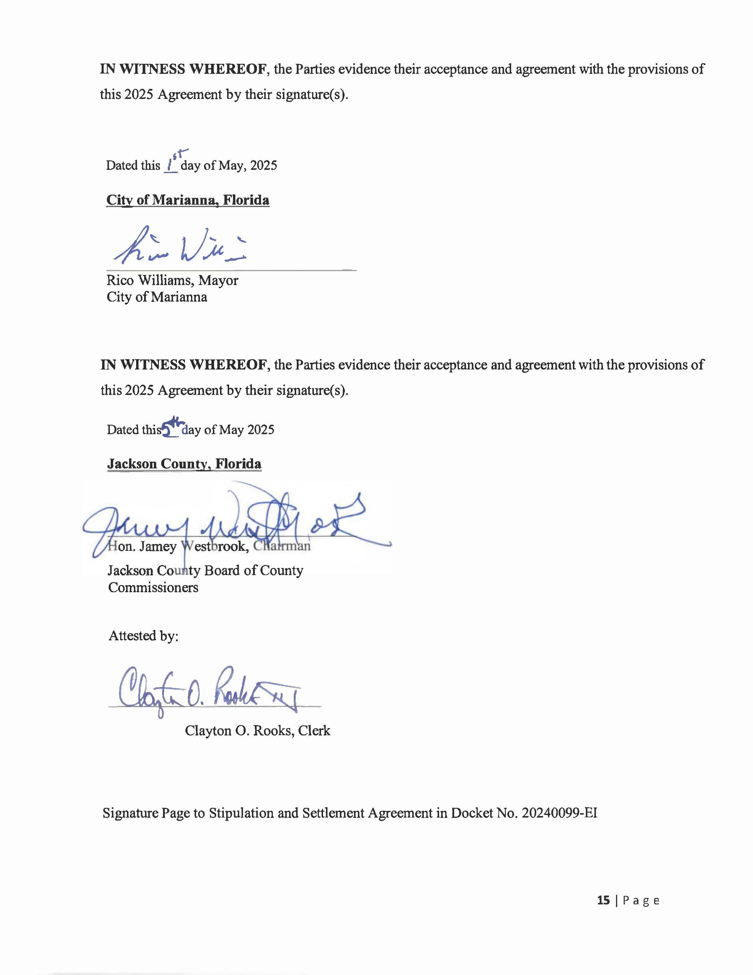
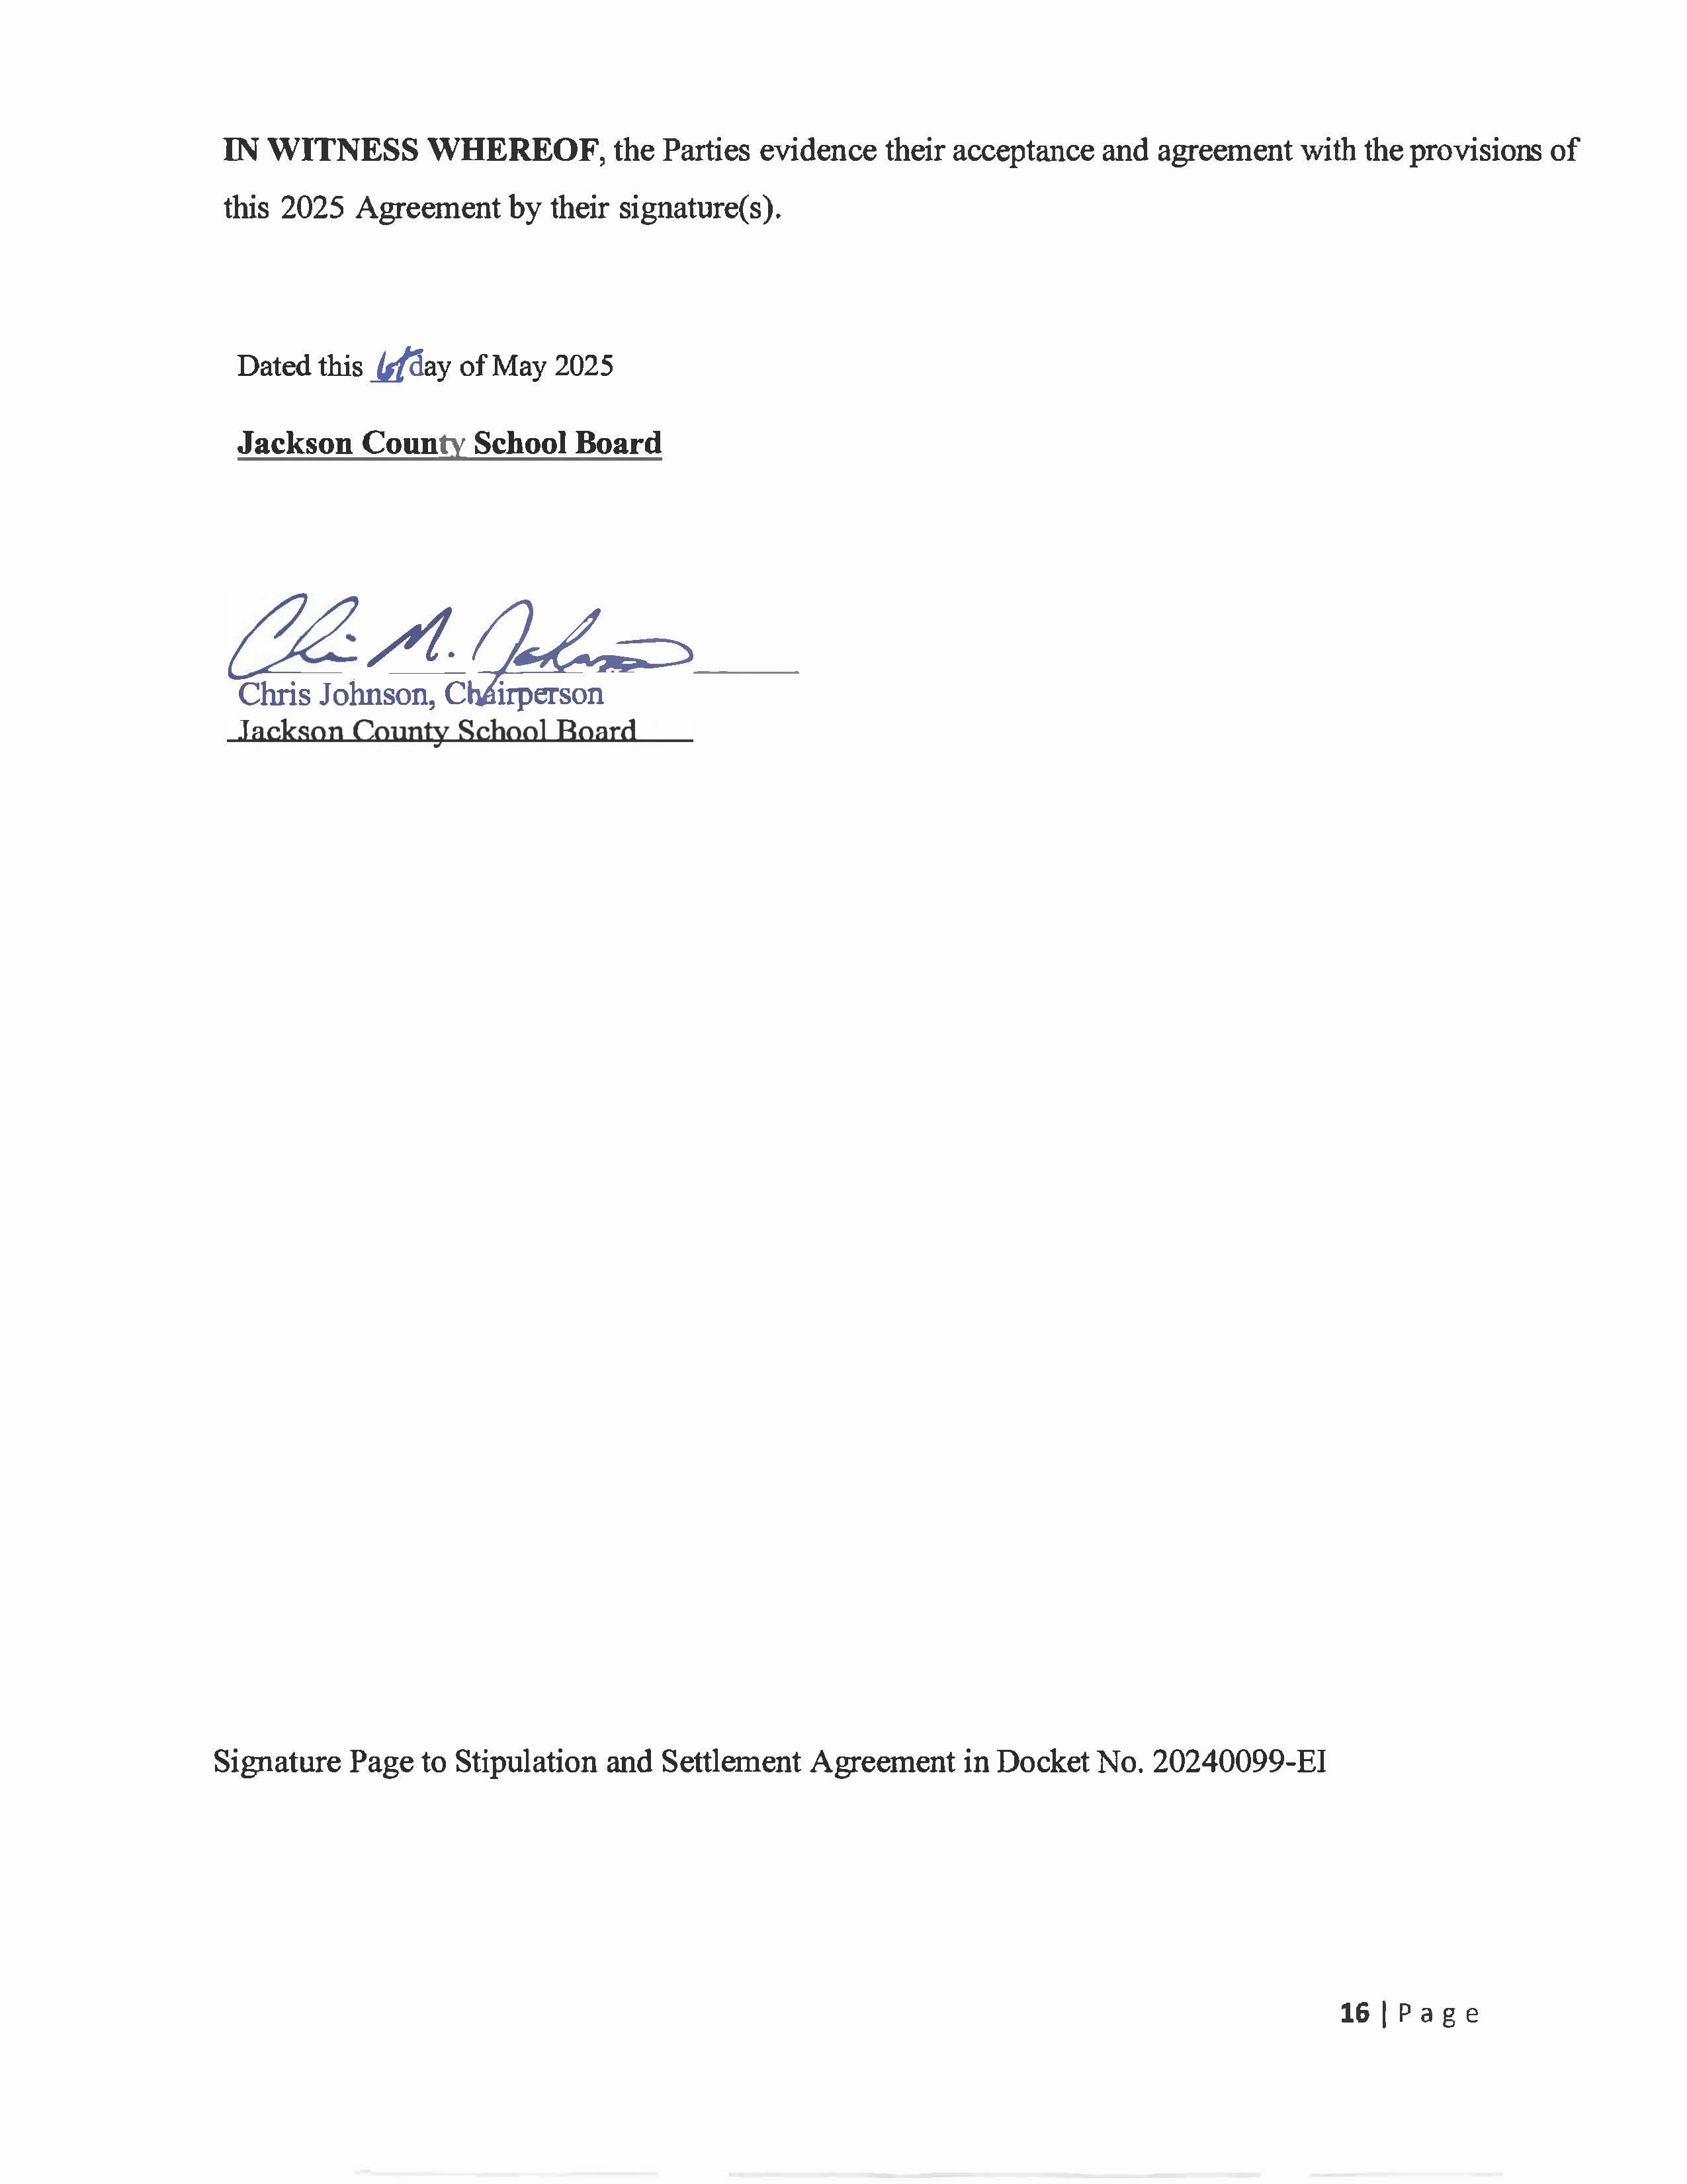
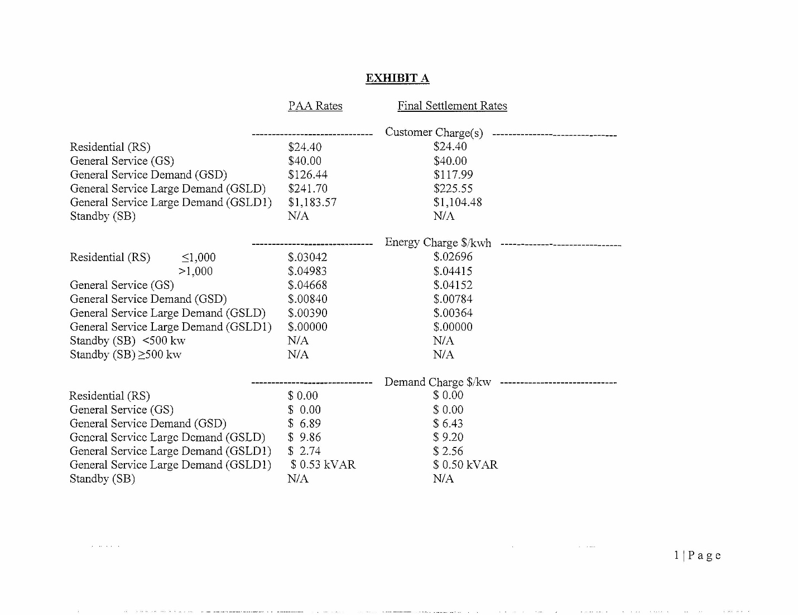
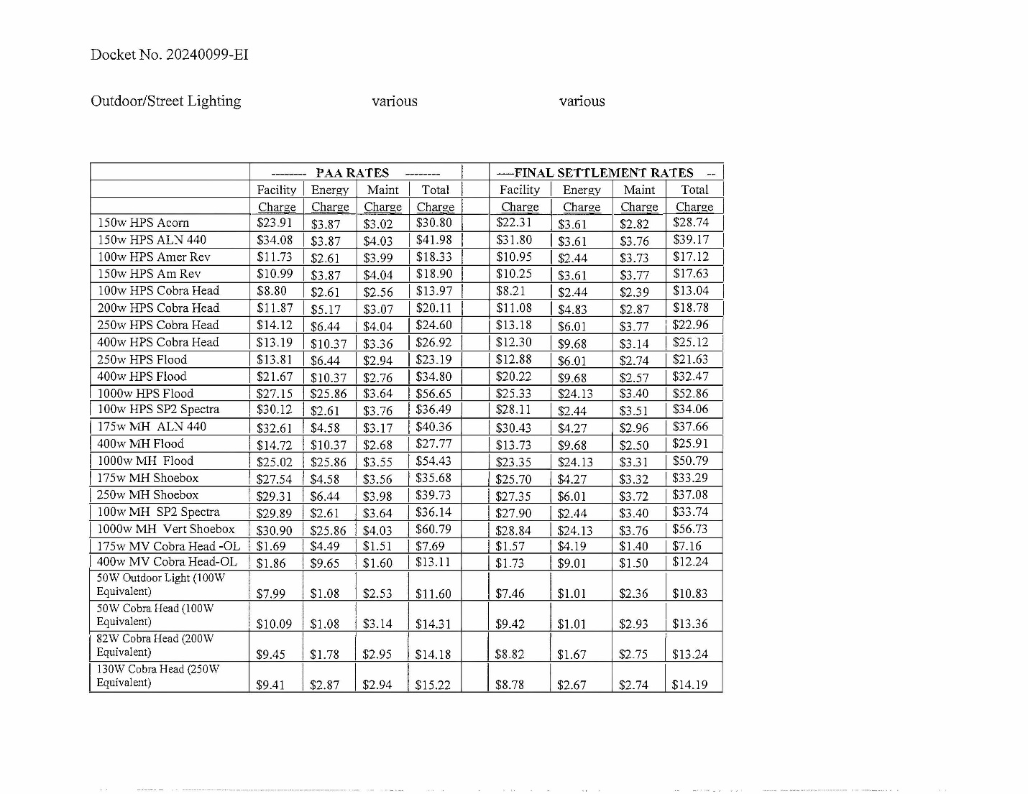
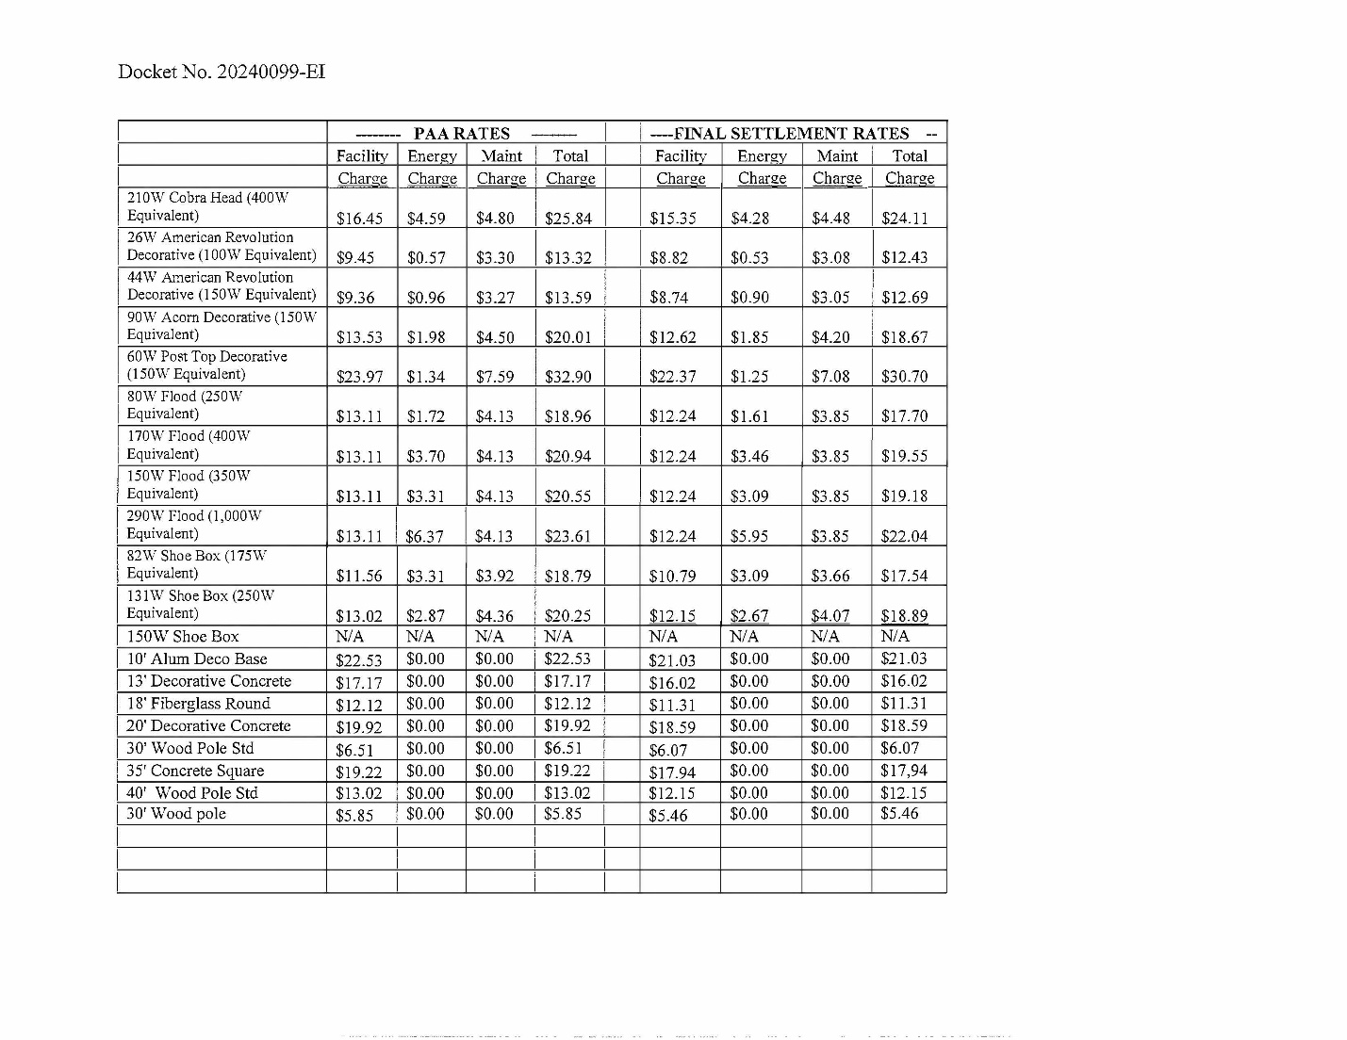
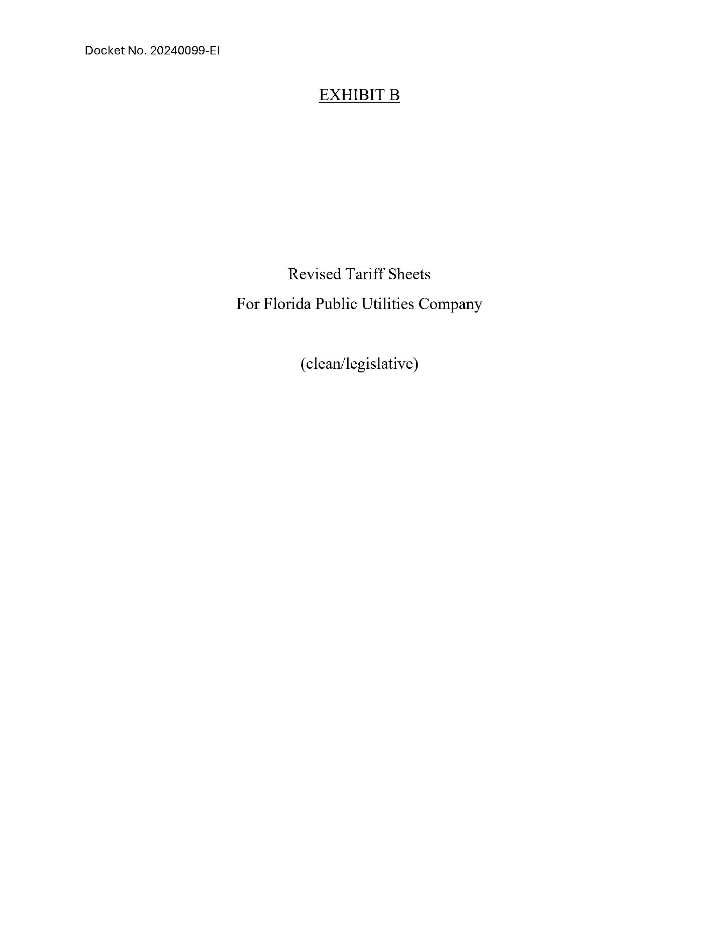
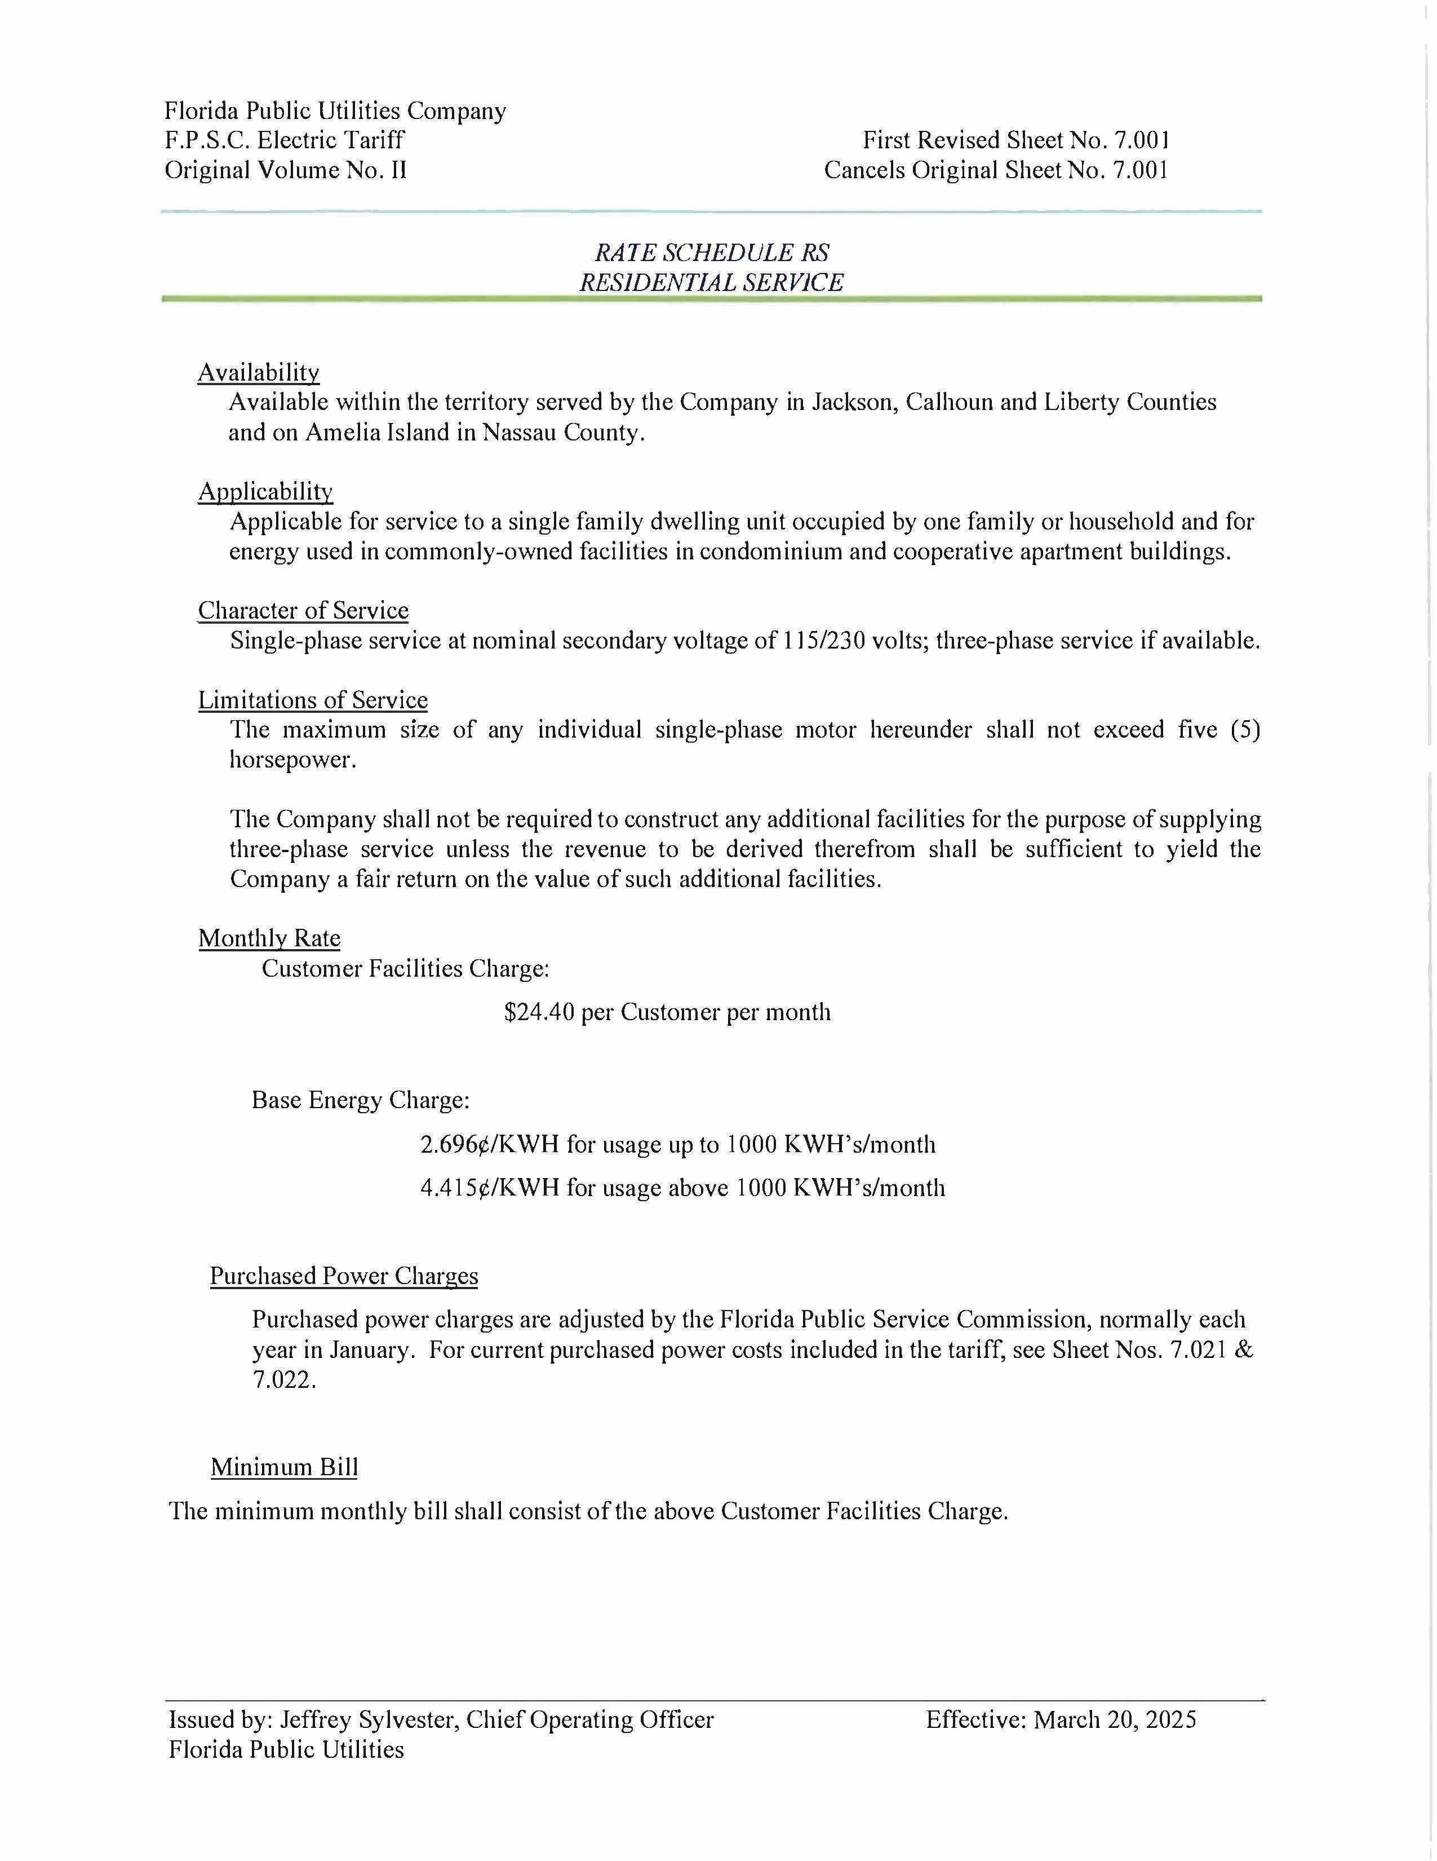
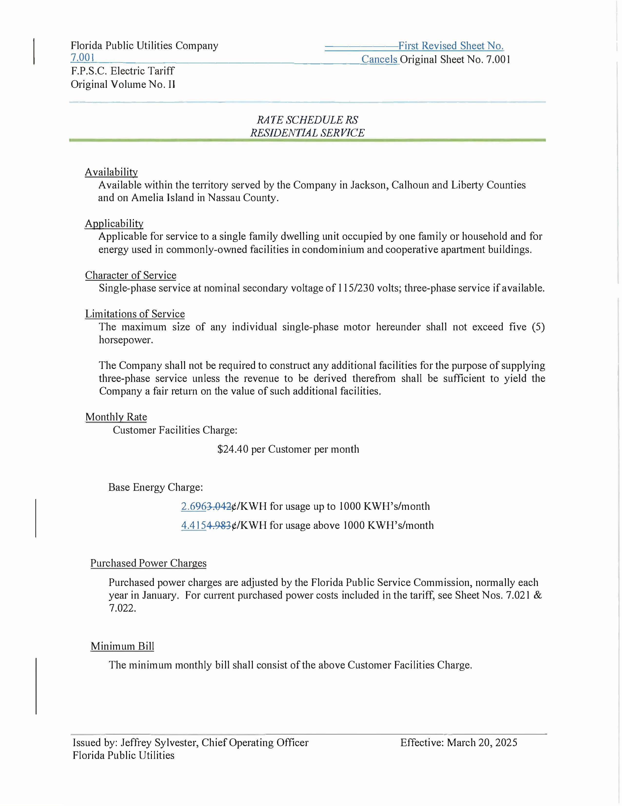
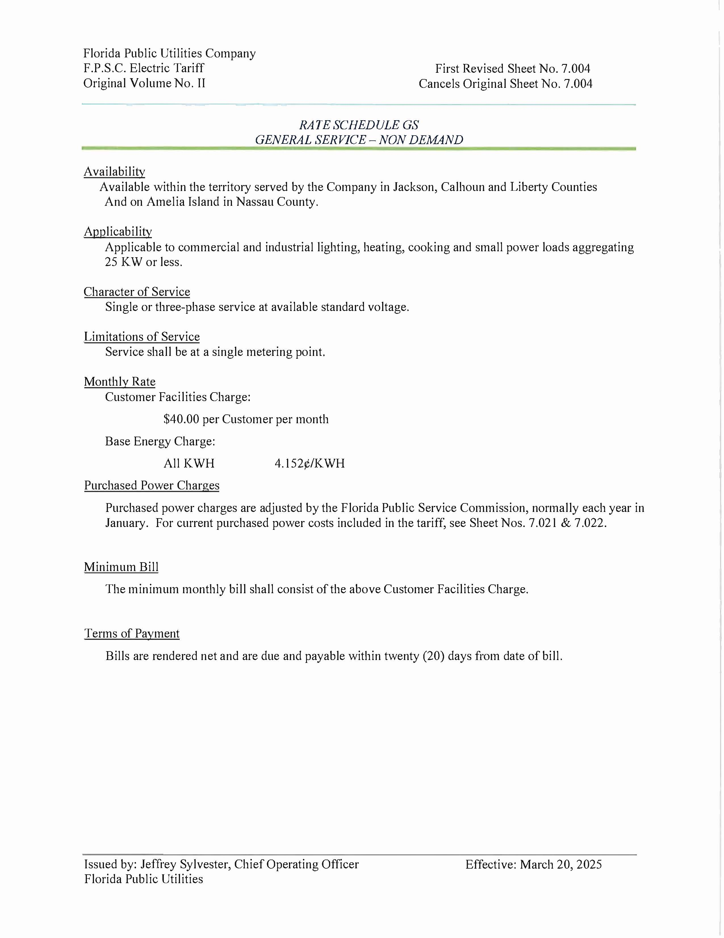
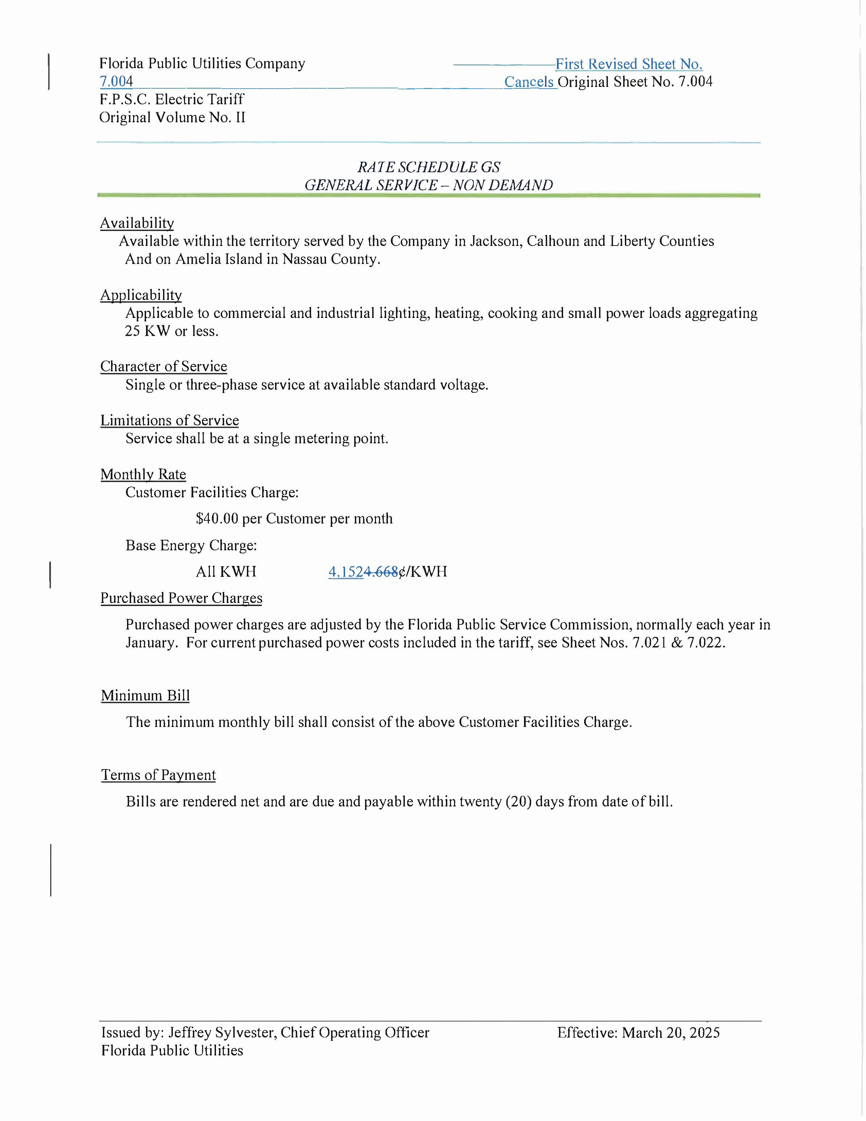
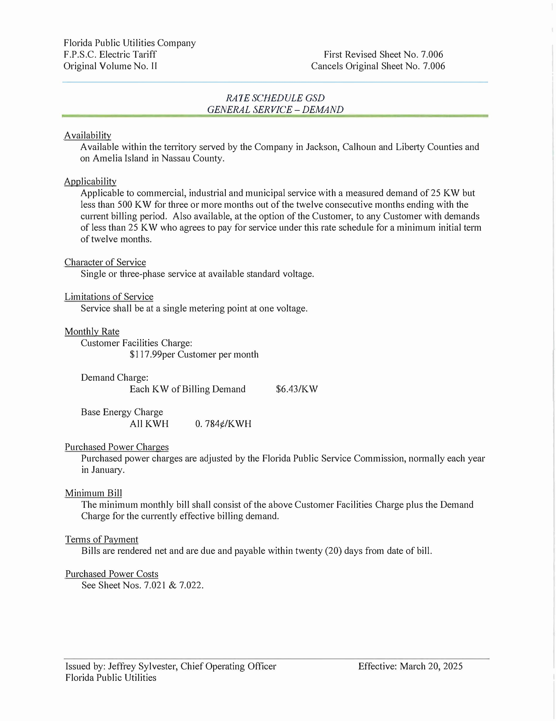
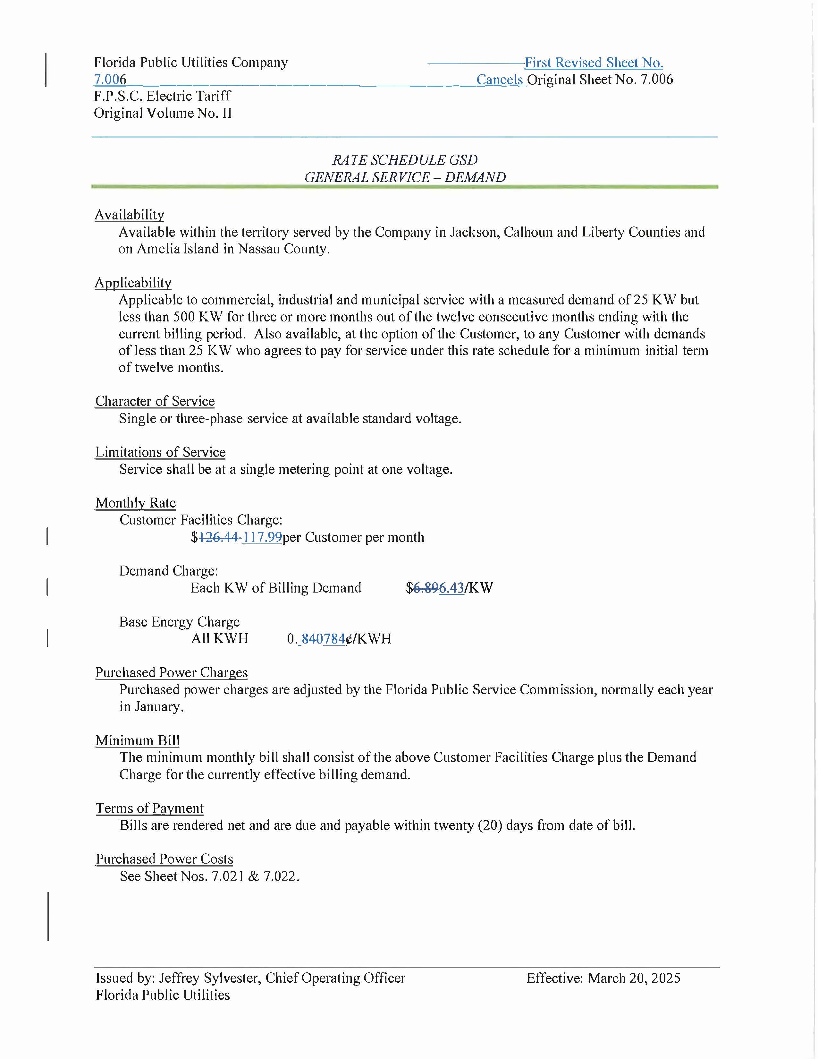
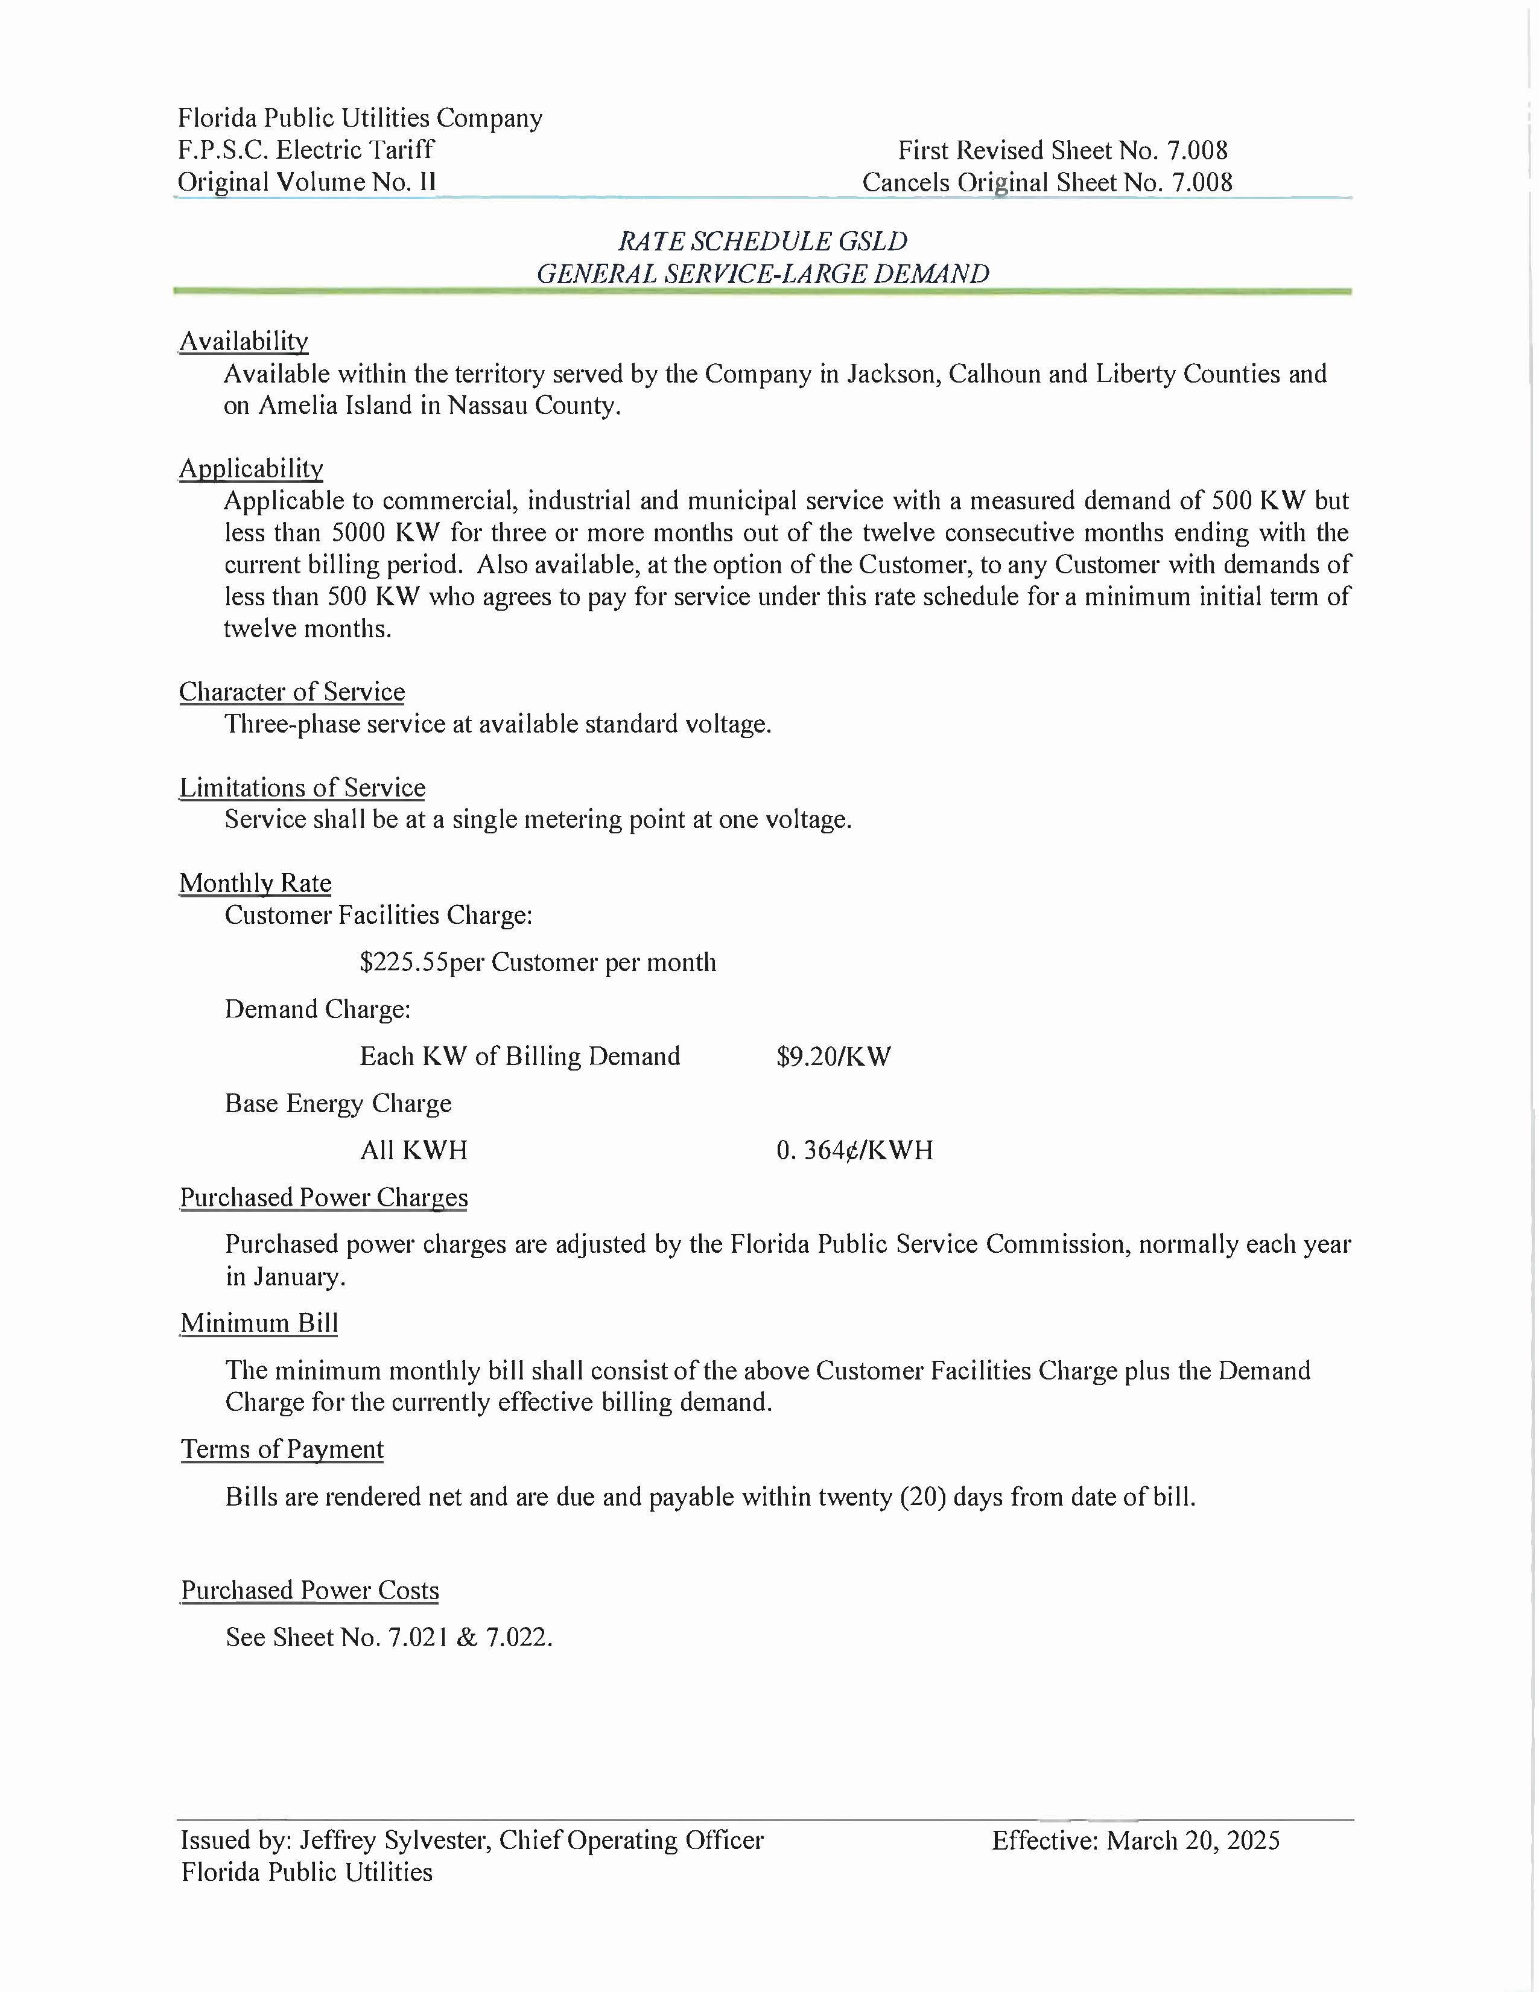
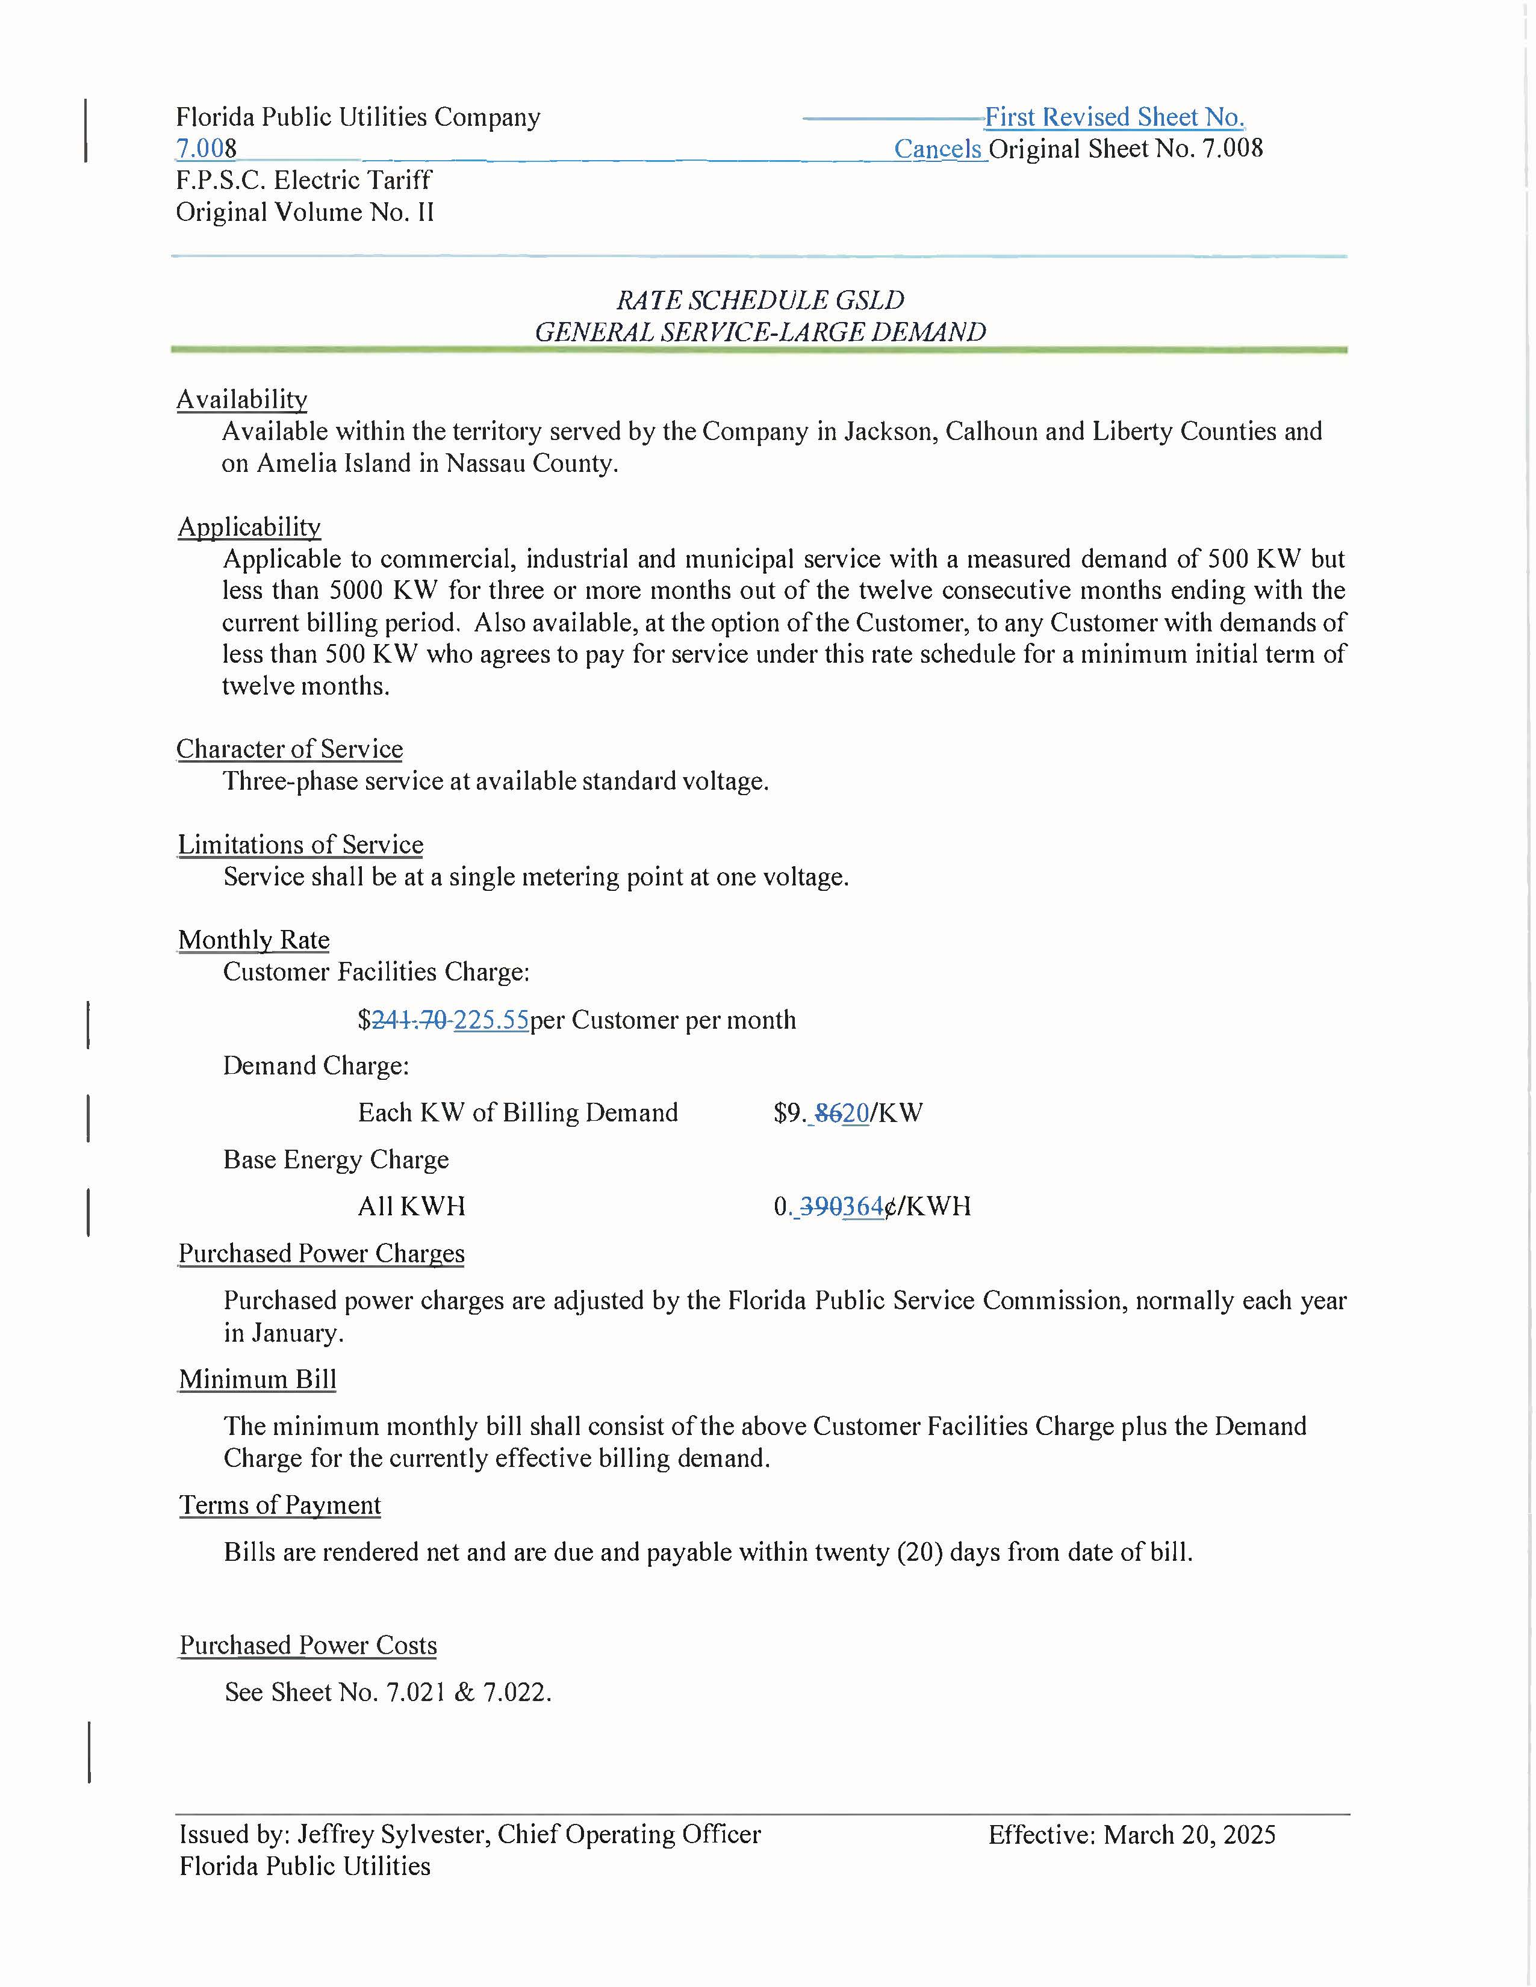
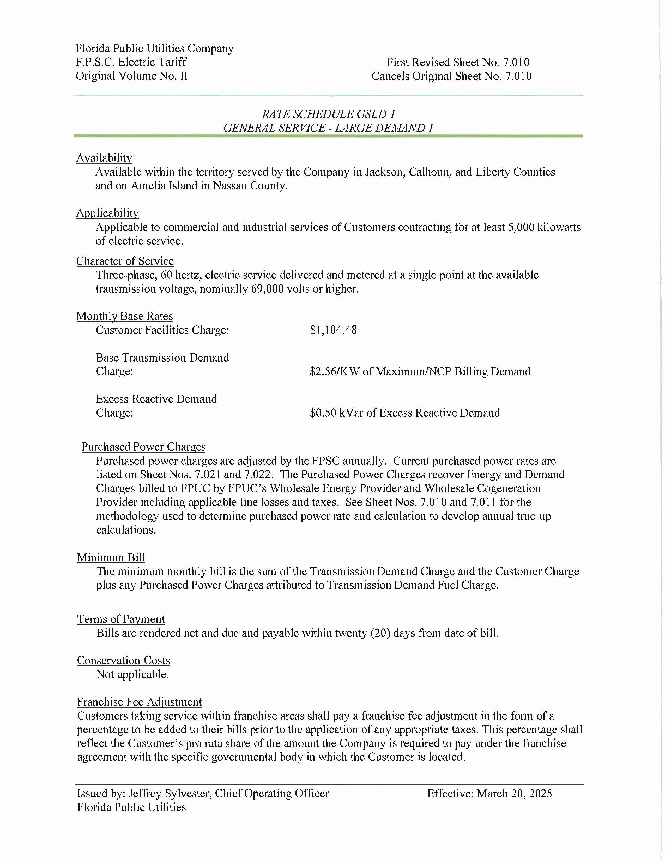
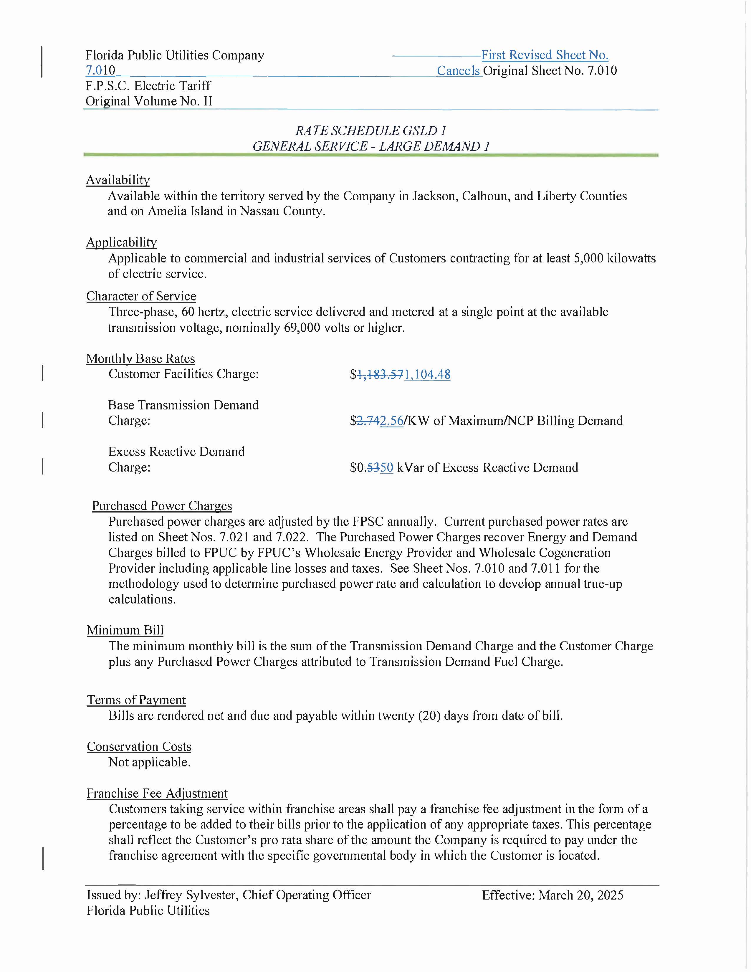
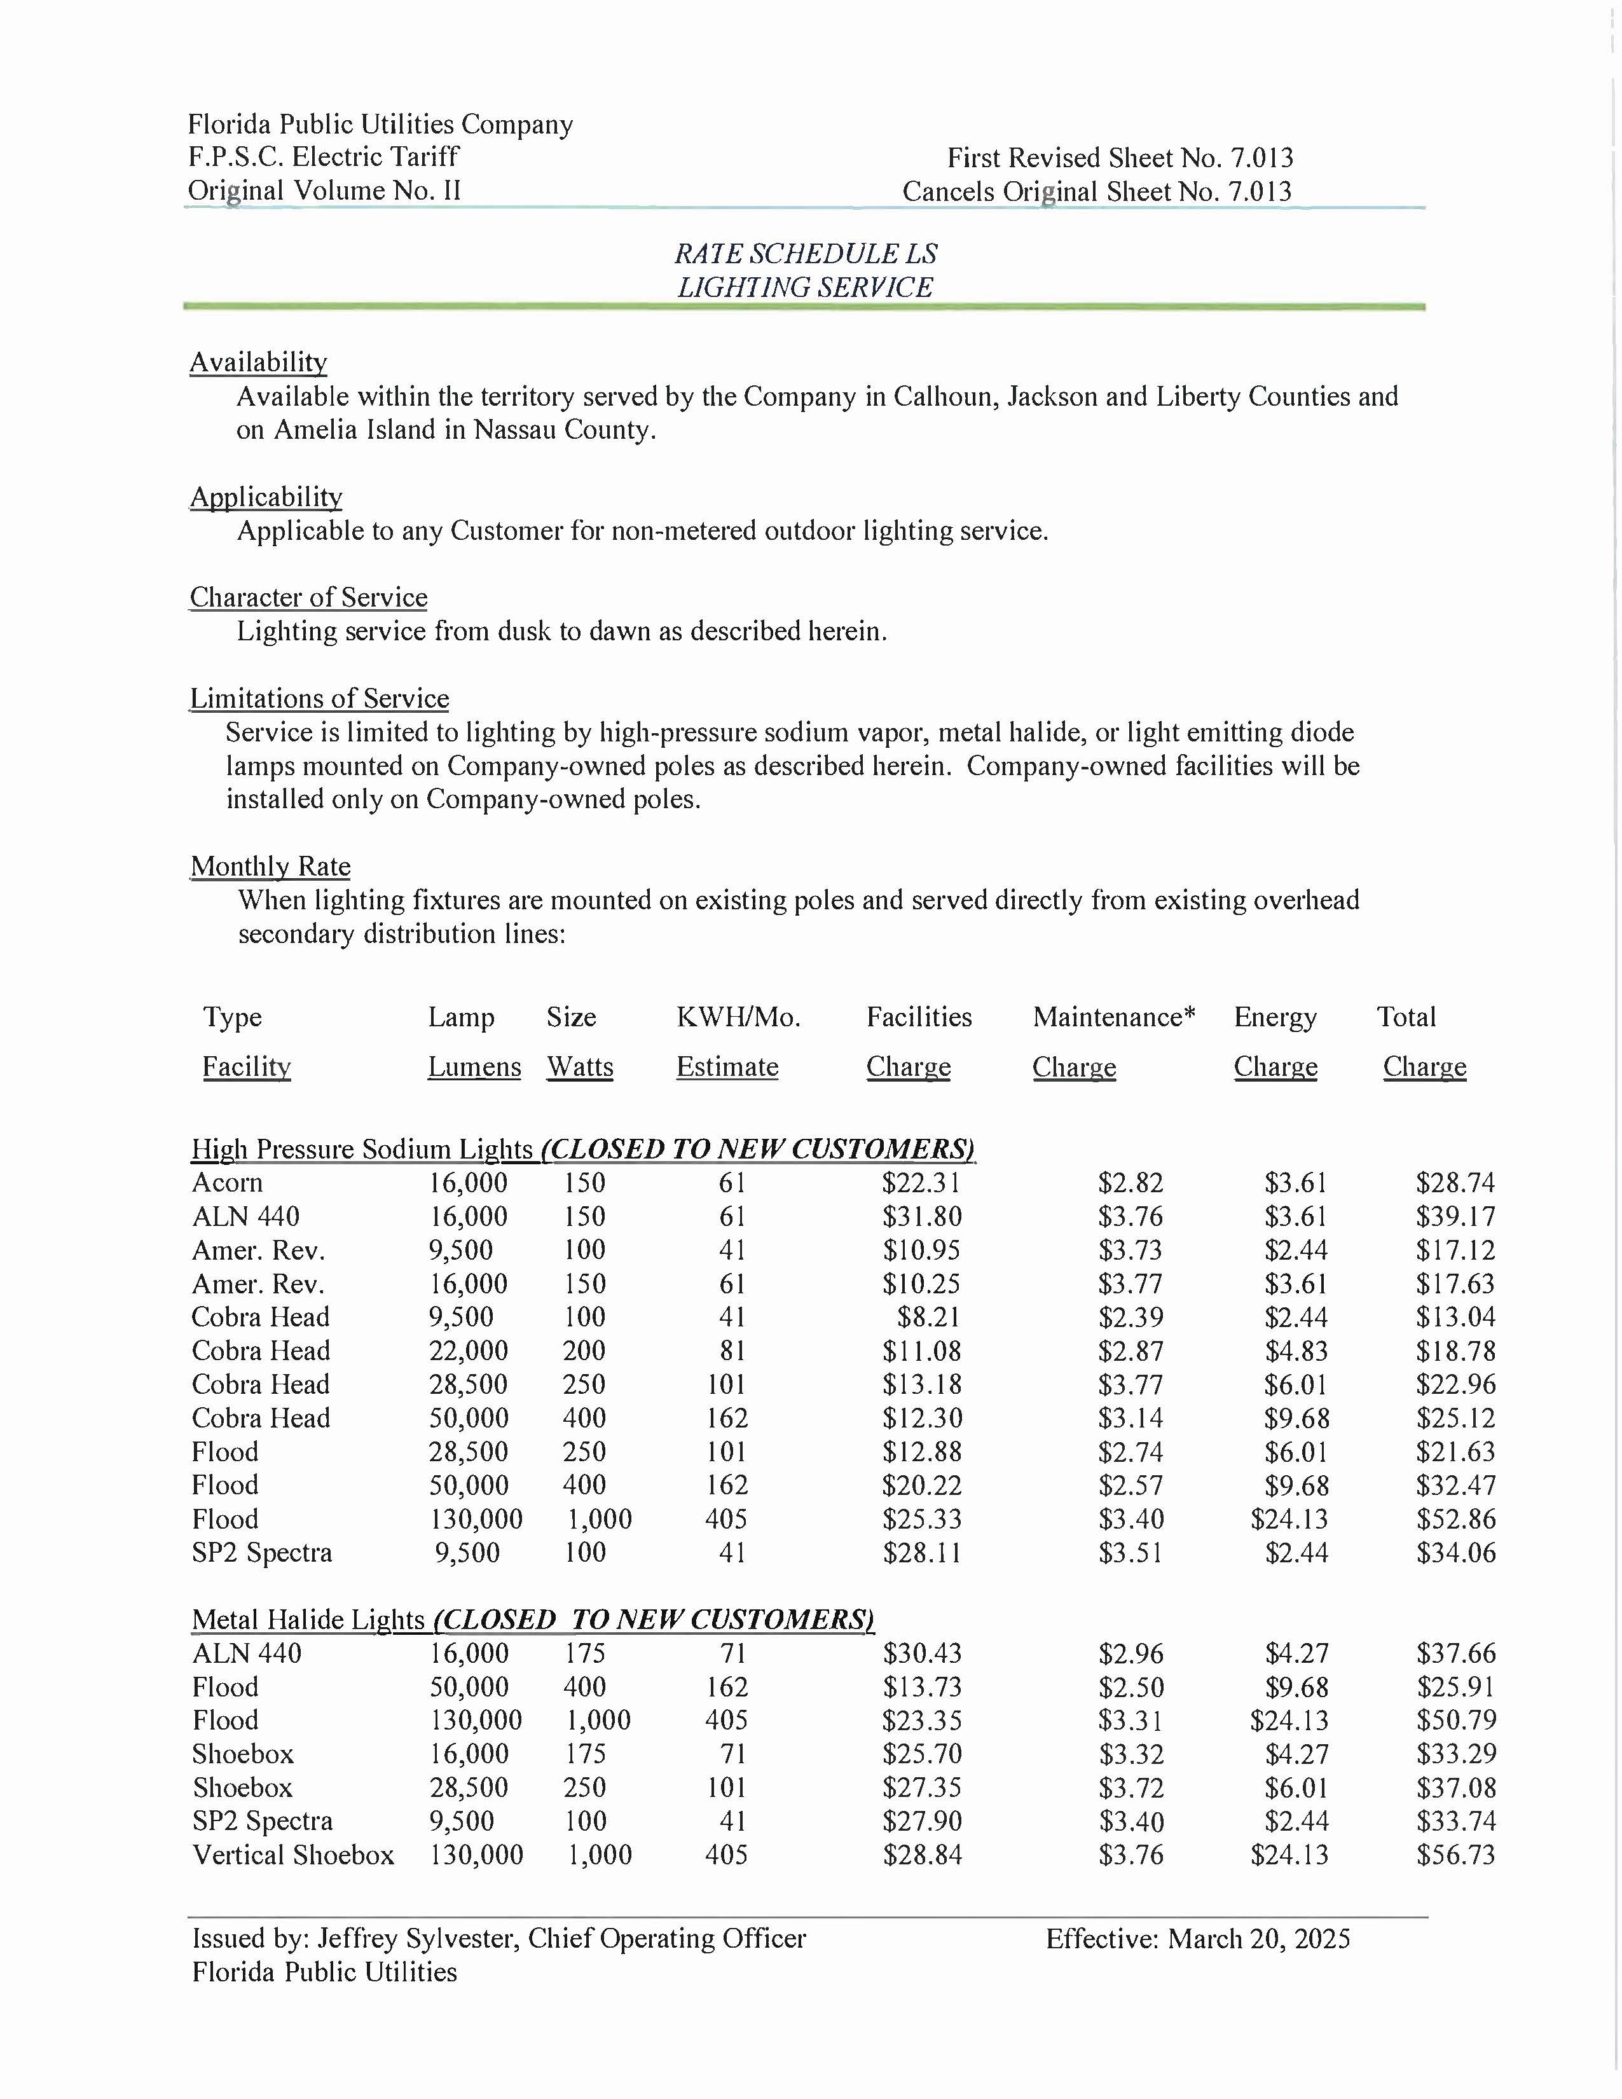
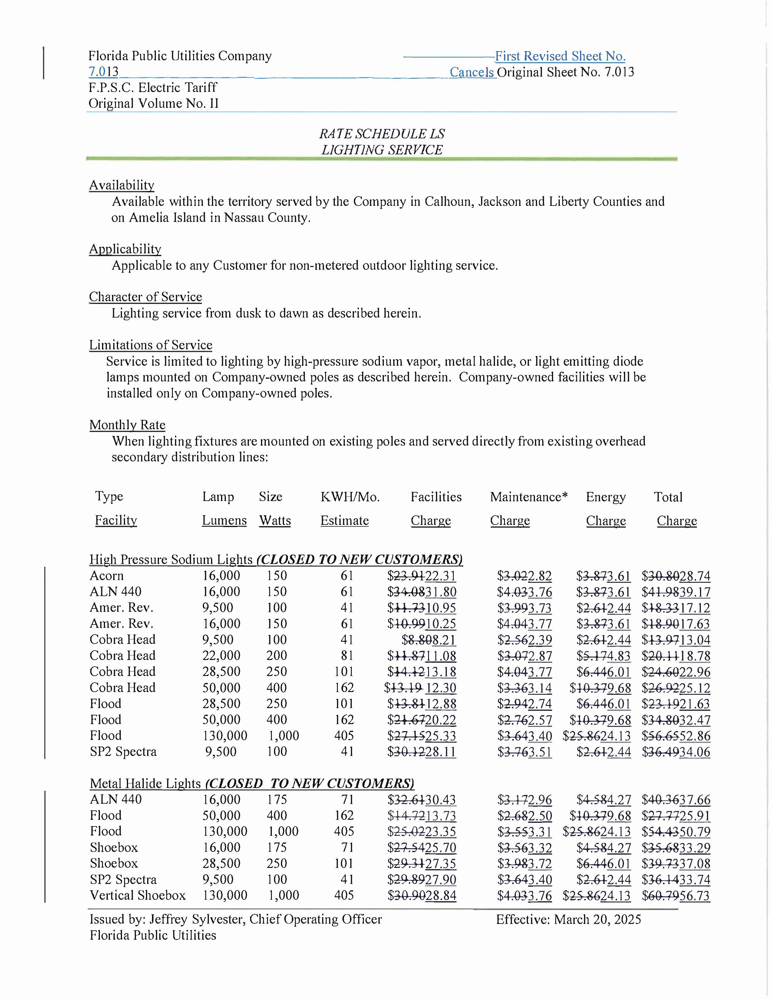
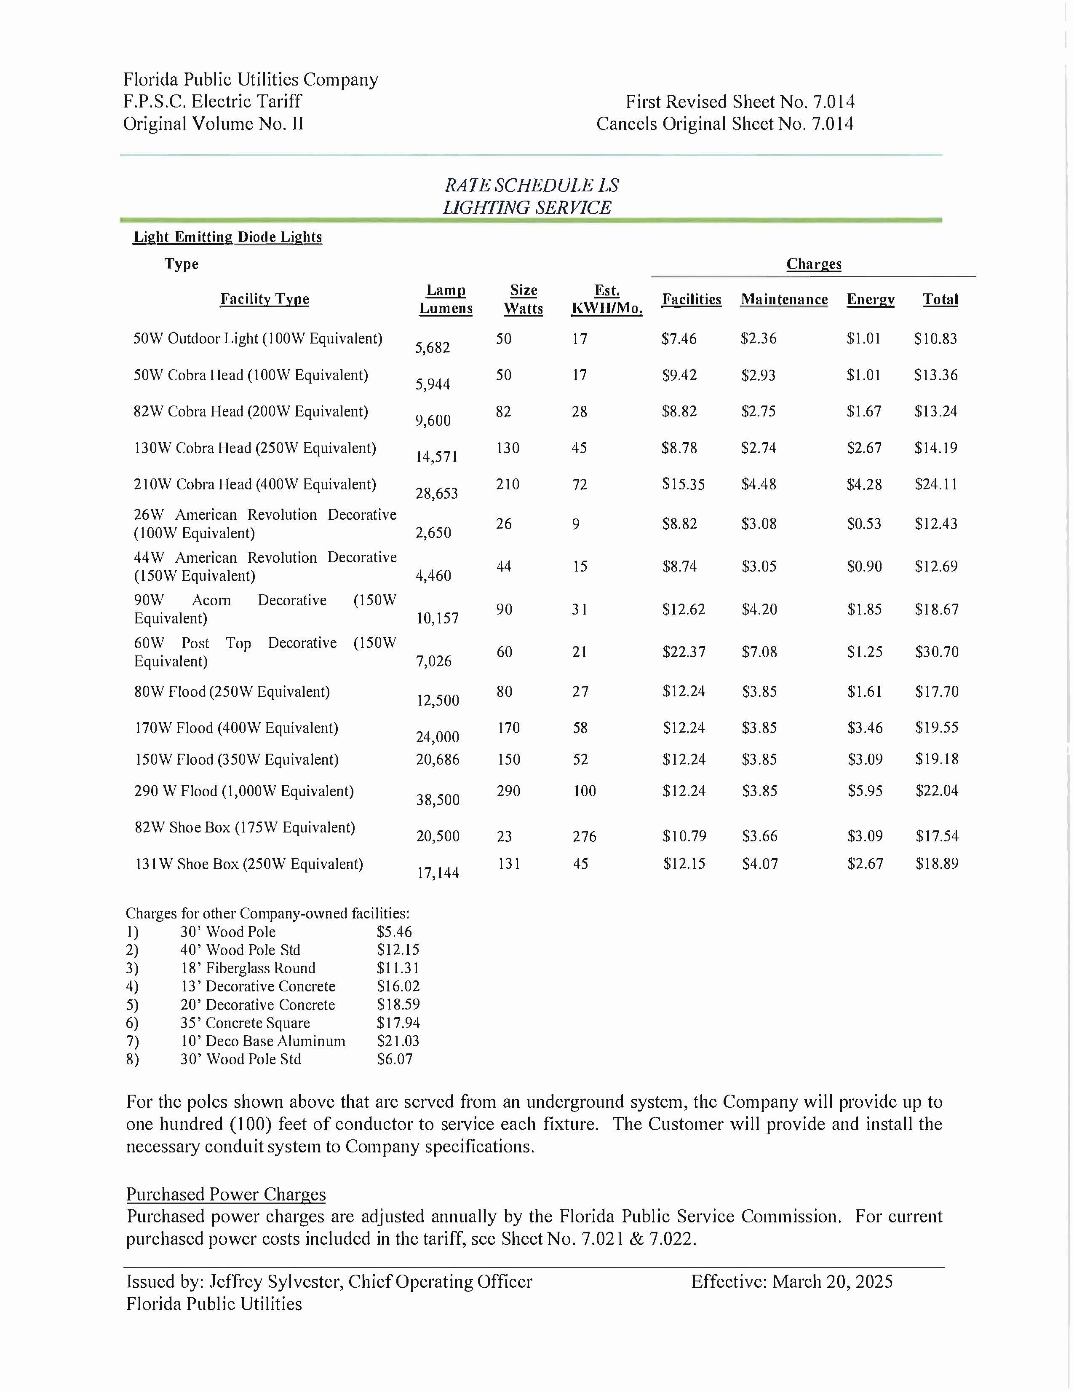
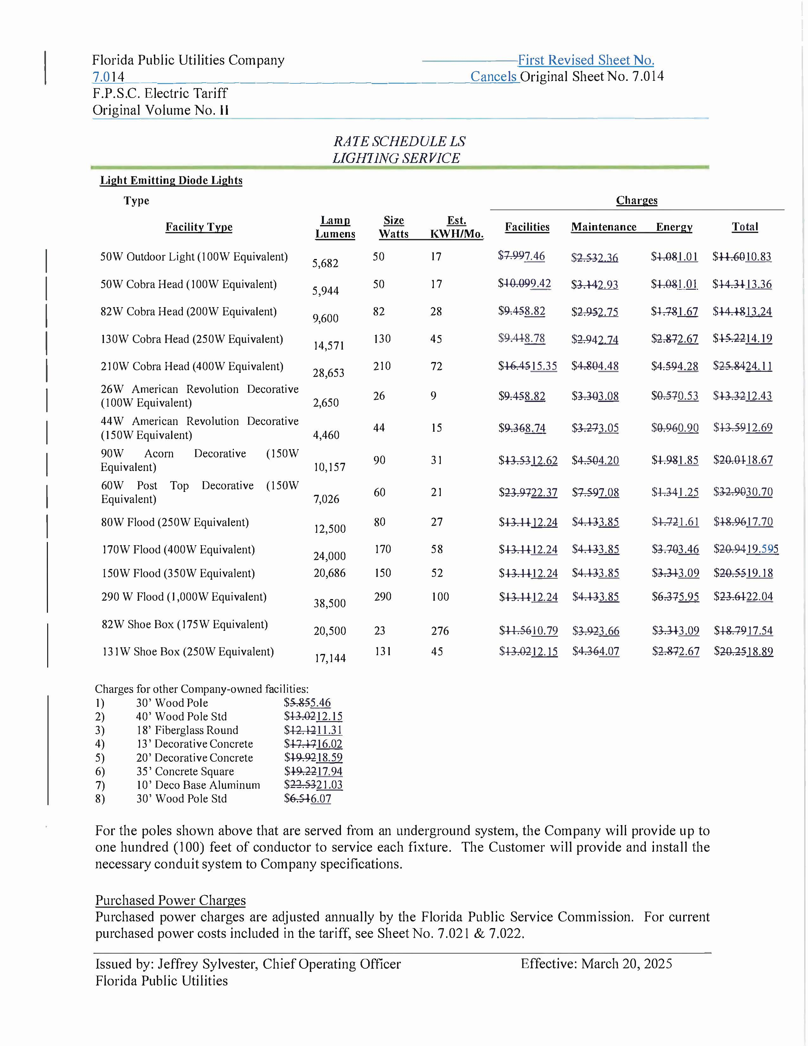
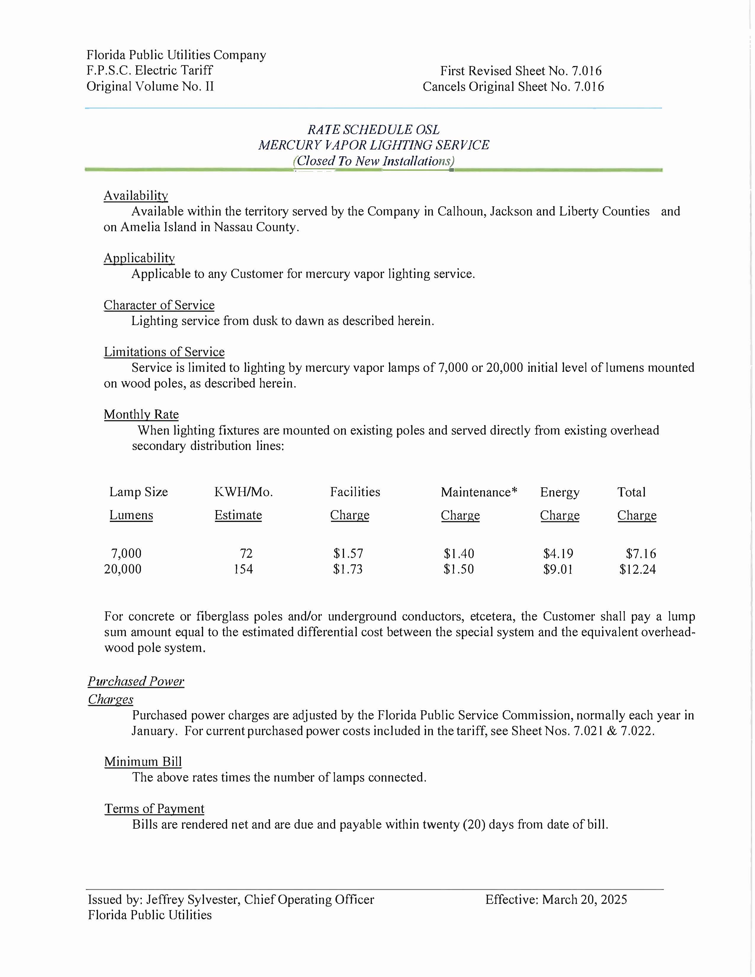
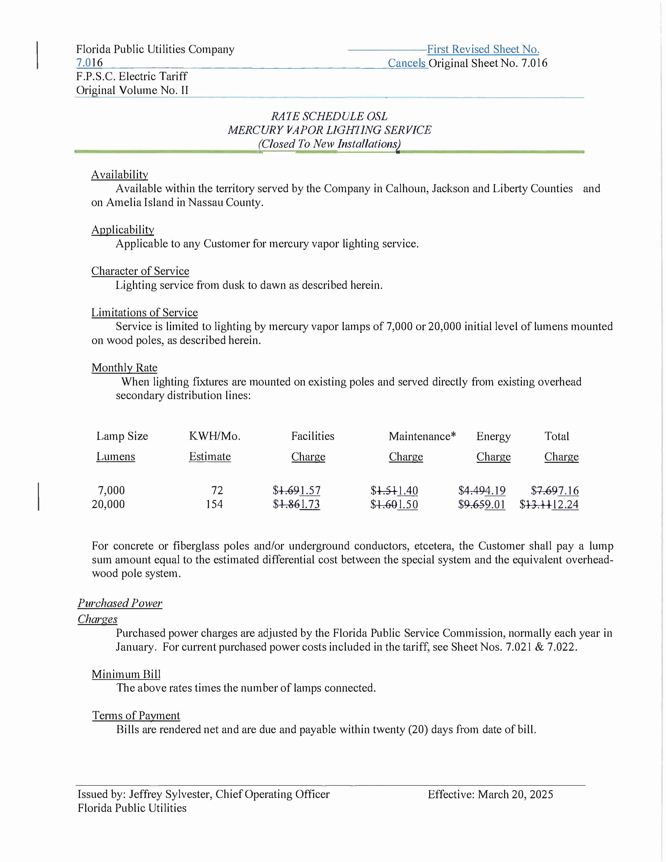

Order No. PSC-2024-0441-PCO-EI, issued October 4, 2024, in Docket No. 20240099-EI, In re: Petition for rate increase by Florida Public Utilities Company.
Order No. PSC-2025-0114-PAA-EI, issued April 7, 2025, in Docket No. 20240099-EI, In re: Petition for rate increase by Florida Public Utilities Company.
Floridians Against Increased Rates v. Clark, 371 So. 3d 905 (Fla. 2023).

