State of Florida   |  | Public Service Commission  Capital Circle Office Center ● 2540 Shumard Oak Boulevard  Tallahassee, Florida 32399-0850  -M-E-M-O-R-A-N-D-U-M-
DATE: | September 27, 2007
TO: | Office of Commission Clerk (Cole)
FROM: | Division of Economic Regulation (Draper, Colson)  Office of the General Counsel (Jaeger)
RE: | Docket No. 070242-EI – Request for revisions to underground residential differential, by Gulf Power Company.
AGENDA: | 10/09/07 – Regular Agenda – Tariff Filing – Interested Persons May Participate
COMMISSIONERS ASSIGNED: |  |  | All Commissioners
PREHEARING OFFICER: |  |  | Administrative
CRITICAL DATES: |  |  | 12/02/07 (8-Month Effective Date)
SPECIAL INSTRUCTIONS: |  |  | Should be taken up with Docket No. 070231-EI
FILE NAME AND LOCATION: |  |  | S:\PSC\ECR\WP\070242A.RCM.DOC

Case Background
Rule, 25-6.078, Florida Administrative Code (F.A.C.), defines electric investor-owned utilities’ (IOU) responsibilities for filing Underground Residential Distribution (URD) tariffs. This rule requires IOUs to file updated URD charges for Commission approval at least every three years, or sooner if a utility’s underground cost differential for the standard low-density subdivision varies from the last approved charge by 10 percent or more. The rule requires IOUs to file on or before October 15 of each year a schedule showing the increase or decrease in the differential for the standard low-density subdivision.
On October 12, 2006, Gulf Power Company (Gulf) notified the Commission, pursuant to Rule 25-6.078, F.A.C., that its underground cost differential for the standard low-density subdivision varies from the last approved differential by 16.71 percent. Gulf’s current URD charges were approved in 2004.
To comply with both the 3-year and the 10 percent filing requirement of the rule, Gulf filed a petition for Commission approval of revisions to its URD tariffs and their associated charges on April 2, 2007. The URD tariffs apply to new residential developments and represent the additional costs Gulf incurs to provide underground distribution service in place of overhead service. By Order No. PSC-07-0490-PCO-EI, issued on June 11, 2007, the Commission suspended Gulf’s proposed tariffs. On June 4 and on August 13, 2007, Gulf filed revised tariff sheets that included a correction in the calculation of the overhead estimate for the high-density subdivision. On June 4 and August 6, 2007, Gulf filed responses to staff’s data requests.
This recommendation addresses Gulf’s revised URD tariffs and the associated charges. The Commission has jurisdiction over this matter pursuant to Sections 366.03, 366.04, 366.05, and 366.06, Florida Statutes.
Discussion of Issues
Issue 1:1
Should the Commission approve Gulf’s revised Underground Residential Distribution (URD) tariffs and their associated charges?
Recommendation:
Yes. The proposed URD differential for the low-density subdivision is $507 per lot and for the high-density subdivision $397 per lot. Gulf does not install underground service to subdivisions where service is provided using grouped meter pedestals. (Draper, Colson)
Staff Analysis:
The URD charges represent the additional costs Gulf incurs to provide underground distribution service in place of overhead service, and are calculated as differentials between the cost of underground and overhead service. Costs for underground service have historically been higher than for standard overhead construction. The URD differential is paid by the customer as a contribution-in-aid-of-construction (CIAC). Typically the URD customer is the developer of the subdivision. The URD tariffs provide standard charges for certain types of underground service, and apply to new residential developments such as subdivisions and townhouses.
Gulf developed URD charges based on two model subdivisions: (1) a 210-lot low-density subdivision with a density of one or more, but less than six, dwelling units per acre; and (2) a 176-lot high-density subdivision with a density of six or more dwelling units per acre. All four of the largest investor-owned electric utilities use the same standardized model subdivisions to develop their URD charges. Gulf does not install underground service to subdivisions where service is provided using grouped meter pedestals (e.g., mobile home parks).
As stated in Rule 25-6.078(1), F.A.C., the URD differential is developed by estimating the cost per lot of both underground service and overhead service. The differential is based on the utility’s standard engineering and design practices. The difference between these numbers is the per-lot charge that customers must pay when requesting underground service in lieu of standard overhead service. The costs of both underground and overhead service include the material and labor costs to provide primary, secondary, and service distribution lines, and transformers. The cost to provide overhead service also includes poles. The cost to provide underground service also includes the cost of trenching and backfilling. The utilities are required to use current cost data.
The following table shows Gulf’s current and proposed URD differentials:
Type of Subdivision | Current URD differential per lot | Proposed URD differential per lot | Percent Change
210-lot low density | $413 | $507 | +23%
176-lot high density | $363 | $397 | +9%

The above per-lot charges apply if Gulf supplies and installs all equipment and materials. Gulf’s URD tariff also provides for reduced URD charges if the customer chooses to supply and/or install the primary and secondary trench and duct system.
Gulf states that the overall increase in the URD differentials are due to increases in material and labor costs. Gulf proposed one design change, which reduces the differential.
Material Costs. Gulf states that material costs for transformers, conductors, and duct for the underground conductors have risen due to an increase in prices of steel, copper, aluminum, and other raw materials used in the manufacturing process. In addition, manufacturers’ transportation costs have increased because of higher fuel costs. Gulf also states that mergers and acquisitions of manufactures and suppliers have limited the available supplier base.
The largest increase in the material costs occurred in the costs of transformers. Transformers are the most costly individual piece of equipment installed and impact the subdivision costs more than any other single piece of equipment. Gulf’s transformer costs have increased by over 60 percent since 2004. Gulf states that Southern Company uses a competitive bid process to ensure Gulf obtains the lowest pricing available. Attachment B summarizes the number of transformers used and the cost associated with each transformer size. Transformer sizes are measured as kilovolt amperes (kva). The number of transformers and customers per transformer vary among the IOU’s.
Labor Costs. Gulf uses company employees for its overhead construction and contractors for its underground construction and tree trimming. Gulf’s labor rates are adjusted annually. Some factors that are taken into consideration are employee pay and benefits, as well as transportation costs. The increase in labor rates was primarily due to the transportation component, especially fuel costs.
Design changes. Attachment C shows Gulf’s overhead and underground design assumptions. Each IOU has its own engineering and design philosophy for constructing the standard URD subdivision, which impacts costs and thus the URD differential. For both low- and high-density subdivisions, Gulf has always designed its subdivisions using front-lot construction. Differences in air conditioning and heat strip assumptions among the IOU’s are a result of temperature differences within geographic areas. For instance, Gulf uses 10 kW heat strips in its overhead and underground design, while Florida Power & Light Company (FPL) uses 5 kW heat strips. The number of transformers used in the subdivision and loading criteria also vary among the IOU’s.
Gulf proposed one change to the overhead design for both the low and high-density subdivision. Gulf’s current standard overhead design provides for one spool rack to connect the neutral service wire to the transformer. However, during the past hurricane seasons, Gulf found that installing three spool racks (one for each conductor) adds strength to the connection between the transformer and service wire. Gulf therefore proposed to include two additional spool racks in its overhead URD design. This design change results in an increase in the overhead cost per lot of $15.40 for the low-density subdivision and of $12.81 for the high-density subdivision. This increase in overhead costs decreases the URD differential. Gulf proposed no changes to the underground designs.
Finally, Gulf’s tariff includes charges that apply when an applicant requests a three-phase lift station for sewage in a new residential subdivision. Gulf proposed to update those charges to reflect current material costs.
Conclusion. Staff has reviewed the proposed charges and accompanying work papers. Based on a review of the information provided, staff believes the proposed charges are reasonable, and should be approved.
Issue 2:2
Should this docket be closed?
Recommendation: Yes.
If Issue 1 is approved, this tariff should become effective on October 9, 2007. If a protest is filed within 21 days of the issuance of the order, this tariff should remain in effect, with any revenues held subject to refund, pending resolution of the protest. If no timely protest is filed, this docket should be closed upon the issuance of a consummating order. (Jaeger)
Staff Analysis:
If Issue 1 is approved, this tariff should become effective on October 9, 2007. If a protest is filed within 21 days of the issuance of the order, this tariff should remain in effect, with any revenues held subject to refund, pending resolution of the protest. If no timely protest is filed, this docket should be closed upon the issuance of a consummating order.

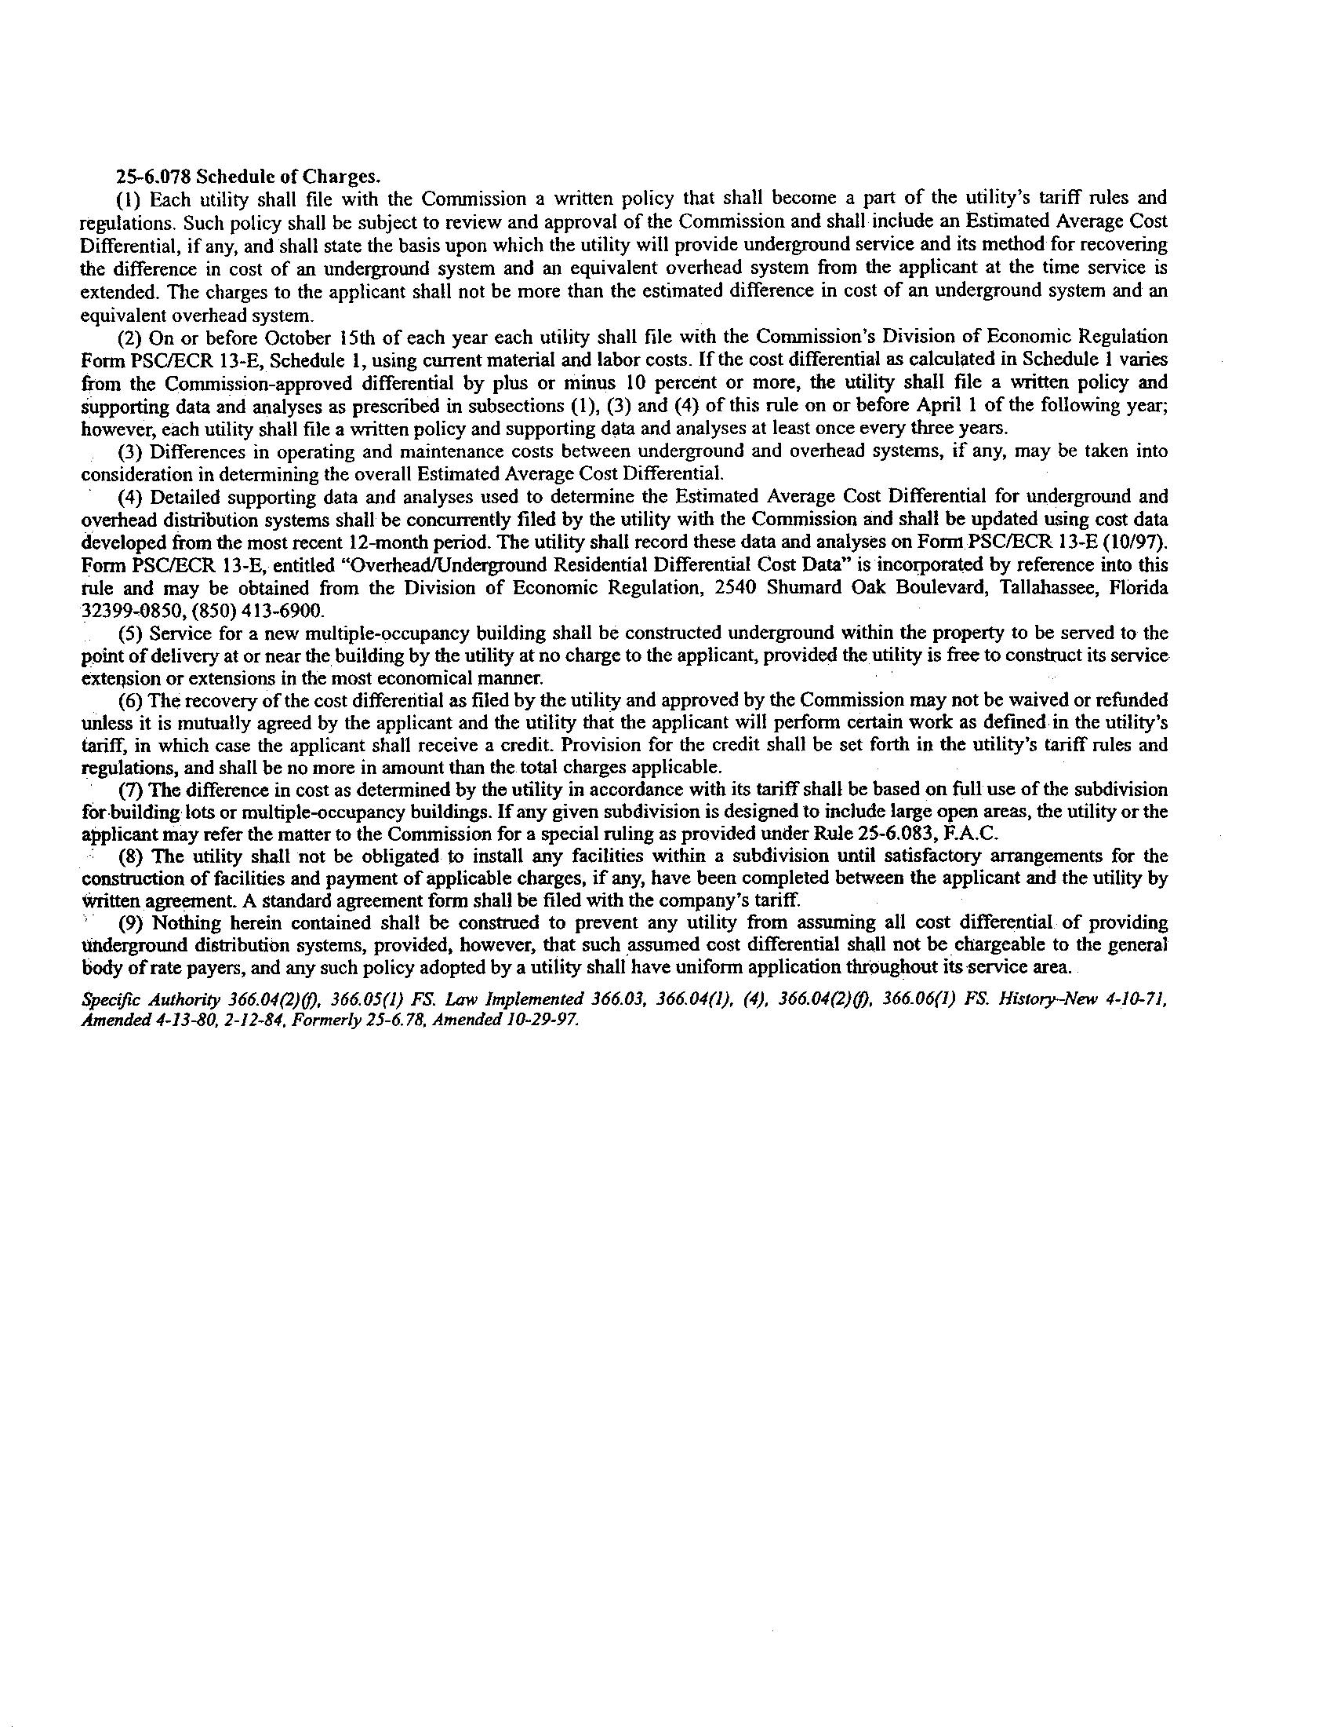
 |  |  | 2004 cost | 2007 cost
 | number of transformers | kva | per transformer | per transformer
OH -210 lot | 30 | 25 | 406.36 | 696.4
 | 36 | 37.5 | 543.59 | 886.13
 | 66
UG -210 lot | 1 | 25 | 818.60 | 1,378.53
 | 31 | 37.5 | 936.29 | 1,564.49
 | 13 | 50 | 1,026.32 | 1,693.53
 | 1 | 75 | 1,314.22 | 2,175.51
 | 46
OH -176 lot | 4 | 15 | n/a | 542.7
 | 2 | 25 | 406.36 | 696.4
 | 39 | 37.5 | 543.59 | 886.16
 | 1 | 50 | n/a | 1,133.57
 | 46
UG -176 lot | 9 | 50 | 1,026.32 | 1,693.53
 | 12 | 75 | 1,314.22 | 2,175.51
 | 2 | 100 | 1,648.50 | 2,578.74
 | 23

Gulf 2004 vs. 2007 transformer costs

Gulf’s Design Assumptions for overhead and underground

OVERHEAD DESIGN | LOW DENSITY (210 Lot) | HIGH DENSITY (176 Lot)
a. A/C or Heat pump (tons) | 3.5 | 2.5
b. Heat strips (kW) | 10 | 10
c. Subdivision total Power usage (kva) | 2,100 | 1,622
d. Total Transformers | 66 | 46
e. Average homes per transformer | 3.0 | 3.8
f. Size of home (sq. ft) | 2,400 - 3,200 | <1,800
g. Total cable feet | 48,005 | 28,514
h. Number of phases | 3 | 3

UNDERGROUND DESIGN | LOW DENSITY (210 Lot) | HIGH DENSITY (176 Lot)
a. A/C or Heat pump (tons) | 3.5 | 2.5
b. Heat strips (kW) | 10 | 10
c. Subdivision total Power usage (kva) | 1,913 | 1,550
d. Total Transformers | 46 | 23
e. Average homes per transformer | 5 | 8
f. Size of home (sq. ft) | 2,400 – 3,200 | <1,800
g. Total cable feet(includes 5% adder) | 38,409 | 24,641
h. Number of phases | 4 | 3
i. Loop design (yes or no?) | Some looped, some radial | Mostly looped, some radial
j. Cable in Conduit (yes or no?) | Yes | Yes

Staff notes that Rule 25-6.078 was recently amended by the Commission as part of its rulemaking proceeding to require electric utilities to strengthen Florida’s electrical infrastructure. The amended rule became effective on February 1, 2007. However, because Gulf initiated this matter by its notification to the Commission on October 12, 2006, the prior rule governs in this instance. A copy of the applicable version of the rule is attached to this recommendation as Attachment A.
See Order No. PSC-04-0669-TRF-EI, issued July 12, 2004, in Docket No. 040313, In re: Request for approval of 2004 underground residential cost report and revised tariff sheets by Gulf Power Company.

