State of Florida   |  | Public Service Commission  Capital Circle Office Center ● 2540 Shumard Oak Boulevard  Tallahassee, Florida 32399-0850  -M-E-M-O-R-A-N-D-U-M-
DATE: | August 2, 2012
TO: | Office of Commission Clerk (Cole)
FROM: | Division of Accounting and Finance (Cicchetti, Maurey, Springer)  Office of the General Counsel (Murphy, Tan, Barrera)
RE: | Docket No. 120001-EI – Fuel and purchased power cost recovery clause with generating performance incentive factor.  Docket No. 120002-EG – Energy conservation cost recovery clause.  Docket No. 120007-EI – Environmental cost recovery clause.
AGENDA: | 08/14/12 – Regular Agenda – Proposed Agency Action – Interested Persons May Participate
COMMISSIONERS ASSIGNED: |  |  | All Commissioners
PREHEARING OFFICER: |  |  | Balbis
CRITICAL DATES: |  |  | None
SPECIAL INSTRUCTIONS: |  |  | None
FILE NAME AND LOCATION: |  |  | S:\PSC\AFD\WP\120001.RCM.DOC

Case Background
The cost recovery dockets, Energy Conservation Cost Recovery (ECCR), Fuel and Purchased Power Cost Recovery Clause (Fuel Clause), and the Environmental Cost Recovery Clause (ECRC) are continuing dockets that handle issues pertaining to Florida’s Investor-Owned electric Utilities (IOU). These IOUs are Florida Power & Light Company, Progress Energy Florida, Inc., Gulf Power Company, Florida Public Utility Company and Tampa Electric Company. Intervenors for all three cost recovery clauses include the Office of Public Counsel, Federal Executive Agencies, Florida Industrial Power Users Group, Florida Retail Federation, and White Springs Agricultural Chemicals, Inc. In addition, the Southern Alliance for Clean Energy (SACE) and Florida Solar Energy Industry Association (FLASEIA) intervened in the ECCR clause.

The Commission, when appropriate, allows recovery of a return on capital investments through the fuel clause, the ECCR and the ECRC. Traditionally, the Commission has relied on the jurisdictional capital structure and cost rates for each component of the capital structure approved in each utility’s most recent base rate case to determine the appropriate weighted average cost of capital.
In certain instances, significant differences developed between investor-owned electric utilities’ weighted average cost of capital authorized in the last base rate case and their current weighted average cost of capital. After a series of noticed meetings, which included parties and intervenors, a methodology addressing the weighted average cost of capital that more closely aligns current costs with current cost recovery was developed. On July 17, 2012, the parties filed a Settlement and Stipulation Agreement (Attachment A) in Docket Nos. 120001-EI, 120002-EG, and 120007-EI. A timeline example of the methodology is provided on the last page of Attachment A. This recommendation addresses the Settlement and Stipulation Agreement.
The Commission has jurisdiction pursuant to Chapter 120 and several provisions of Chapter 366, including Sections 366.04 - 366.06 and 366.80 - 366.85, Florida Statutes (F.S.).

Discussion of Issues
Issue 1:1
Should the Commission approve the attached Stipulation and Settlement Agreement of the parties, addressing the methodology for calculating the allowable return on clause-approved investments, that was filed on July 17, 2012, in Docket Nos. 120001-EI, 120002-EG, and 120007-EI?
Recommendation:
Yes. The Commission should approve the Stipulation and Settlement Agreement of the parties, addressing the methodology for calculating the allowable return on clause-approved investments. (Cicchetti)
Staff Analysis:

The Commission, when appropriate, allows recovery of a return on capital investments through the Fuel and Purchased Power Cost Recovery Clause, the Conservation Cost Recovery Clause, and the Environmental Cost Recovery Clause. Traditionally, the Commission has relied on the jurisdictional capital structure and cost rates for each component of the capital structure approved in each IOU’s most recent base rate case to determine the appropriate weighted average cost of capital. In certain instances, significant differences developed between the IOUs’ weighted average cost of capital authorized in the last base rate case and their current weighted average cost of capital. For example, in a recent cost recovery clause docket, the difference between the current cost of capital as reported in the Earnings Surveillance Report and the cost of capital from the last rate case was over 100 basis points. A methodology that more closely aligns current costs with current cost recovery was developed and is set out in the attached stipulation. The new methodology would be applied to clause cycling expenses beginning January 1, 2013. A timeline example of the methodology is provided with Attachment A.

In addition to the methodology, the Stipulation and Settlement Agreement contained the following elements of note:

- Progress Energy will be allowed to exclude its Clean Air Interstate Rule investments from the application of the new method in 2013 and will be allowed to continue use of the current method on those investments in setting clause rates for 2013.

- No Party will challenge the justness or reasonableness of the new methodology or the appropriateness of the weighted average cost of capital reflected in the May Earnings Surveillance Reports used thereunder in any Clause proceedings. The Settlement Agreement allows that any Party may challenge a mathematical error that it contends has been made in calculating the weighted average cost of capital in an Earnings Surveillance Report.

- The provisions of the Settlement Agreement are contingent on approval of the Settlement Agreement in its entirety by the Commission. The Parties agree to support the Settlement Agreement and will not request or support any order, relief, outcome or result in conflict with the terms of the Settlement Agreement in any administrative or judicial proceeding relating to, reviewing or challenging the establishment, approval, adoption or implementation of the Settlement Agreement.

- If the Commission rejects or modifies this Agreement in whole or in part, the Parties agree the Settlement Agreement is void unless ratified by the Parties, and that each Party may pursue its interests as those interests exist, and no Party will be bound by or make reference to Agreement before the Commission, any court, any other administrative forum or arbitration panel.

- The Parties respectfully request that the Commission take the following actions:

  - Restate and affirm the Commission’s conclusion in Order No. PSC-94-0044-FOF-EI that “potentially controversial and time consuming evidentiary debates regarding the appropriate capital structure and return on equity should be the subject of proceedings [other than the clause proceedings]”.

  - Confirm the appropriateness of the weighted average cost of capital calculation methodology set forth in this Agreement for application to the calculation of projected Clause factors, actual/estimated true-ups of Clause factors and final true-ups of Clause factors in all subsequent dockets unless and until modified by the Commission.

Staff agrees with the Parties that potentially controversial and time consuming evidentiary debates regarding the appropriate capital structure and the return on equity should be the subject of other proceedings other than the clause proceedings. Unless and until modified by the Commission, staff believes that the weighted average cost of capital calculation methodology as established in the Settlement Agreement is appropriate in all subsequent clause dockets. Further, staff believes the Stipulation and Settlement Agreement filed by the parties is in the public interest because the methodology more accurately aligns current costs with cost recovery and sends a more precise price signal. Therefore, staff recommends that the Commission approve the Stipulation and Settlement Agreement of the parties, addressing the methodology for calculating the allowable return on clause-approved investments.

Issue 2:2
Should these dockets be closed?
Recommendation:
No. If no person whose substantial interests are affected by the proposed agency action files a protest within 21 days of the issuance of the order, a consummating order should be issued. These dockets should remain open to address the evidentiary issues presented in each. (Tan)
Staff Analysis:
If no person whose substantial interests are affected by the proposed agency action files a protest within 21 days of the issuance of the order, a consummating order should be issued. These dockets should remain open to address the issues presented in each.
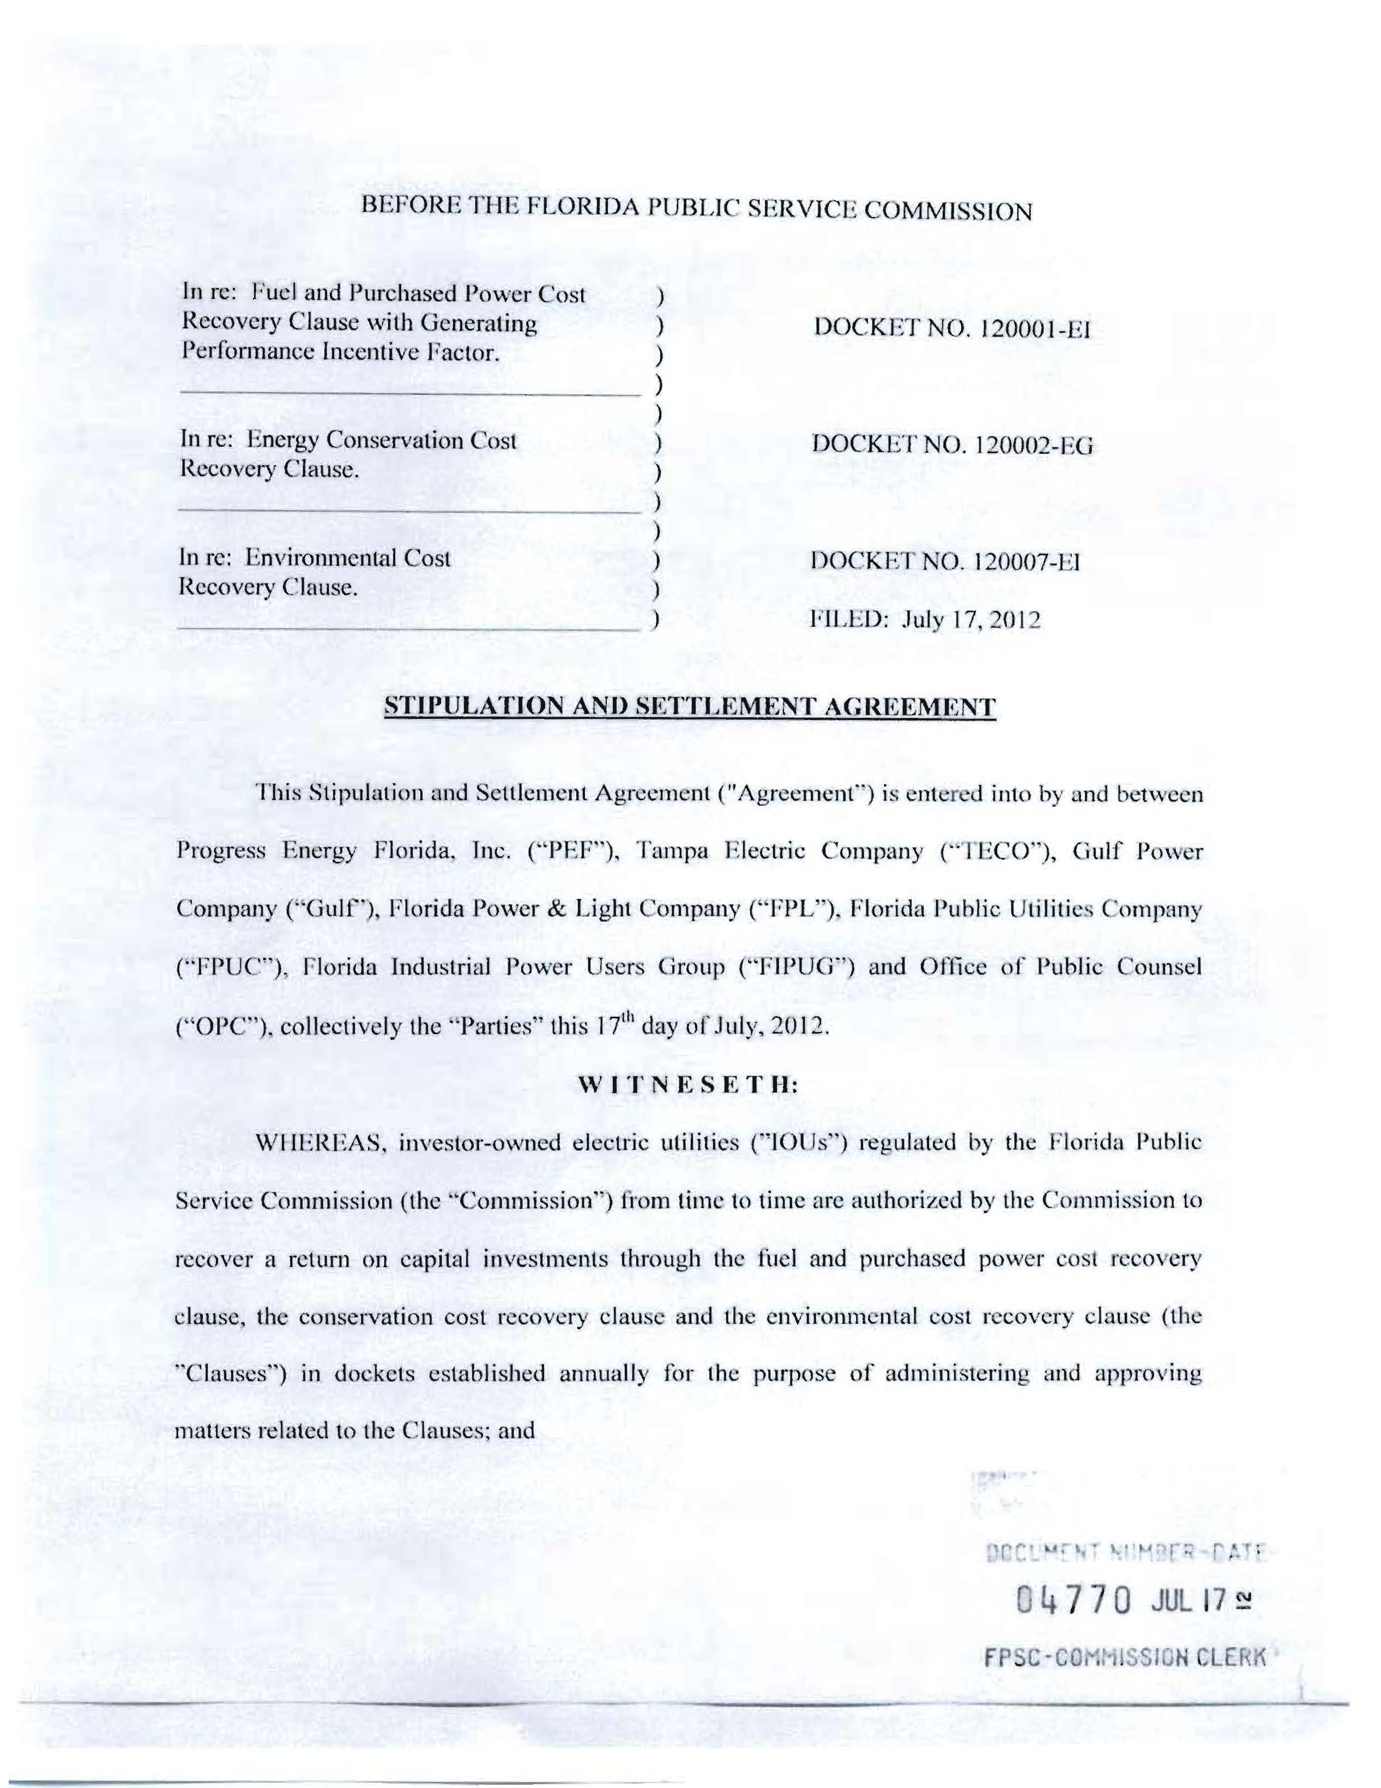
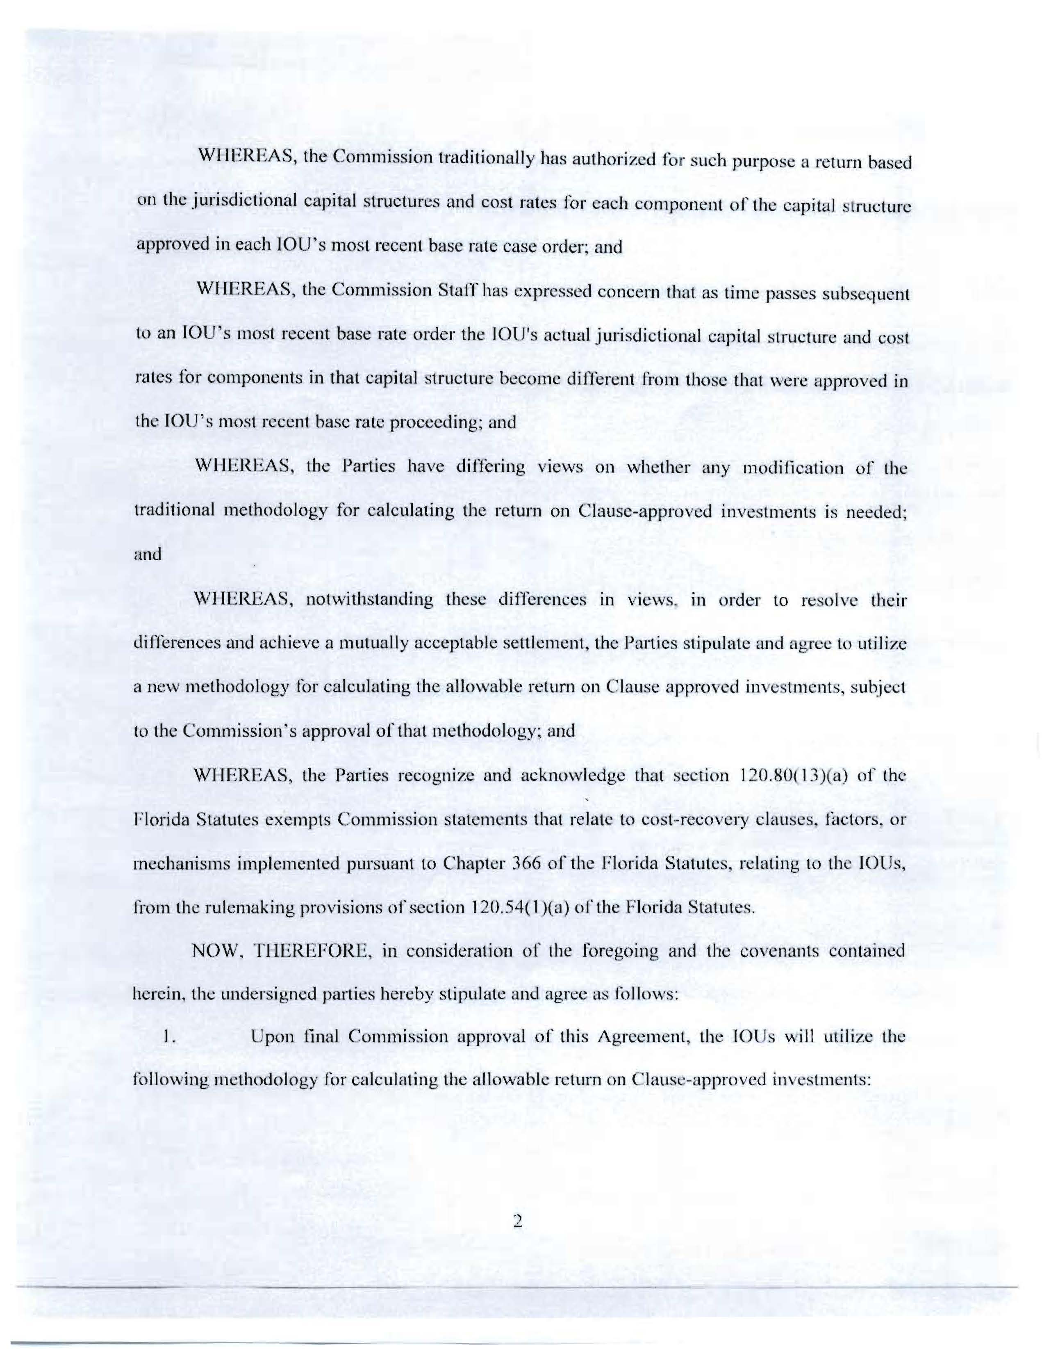
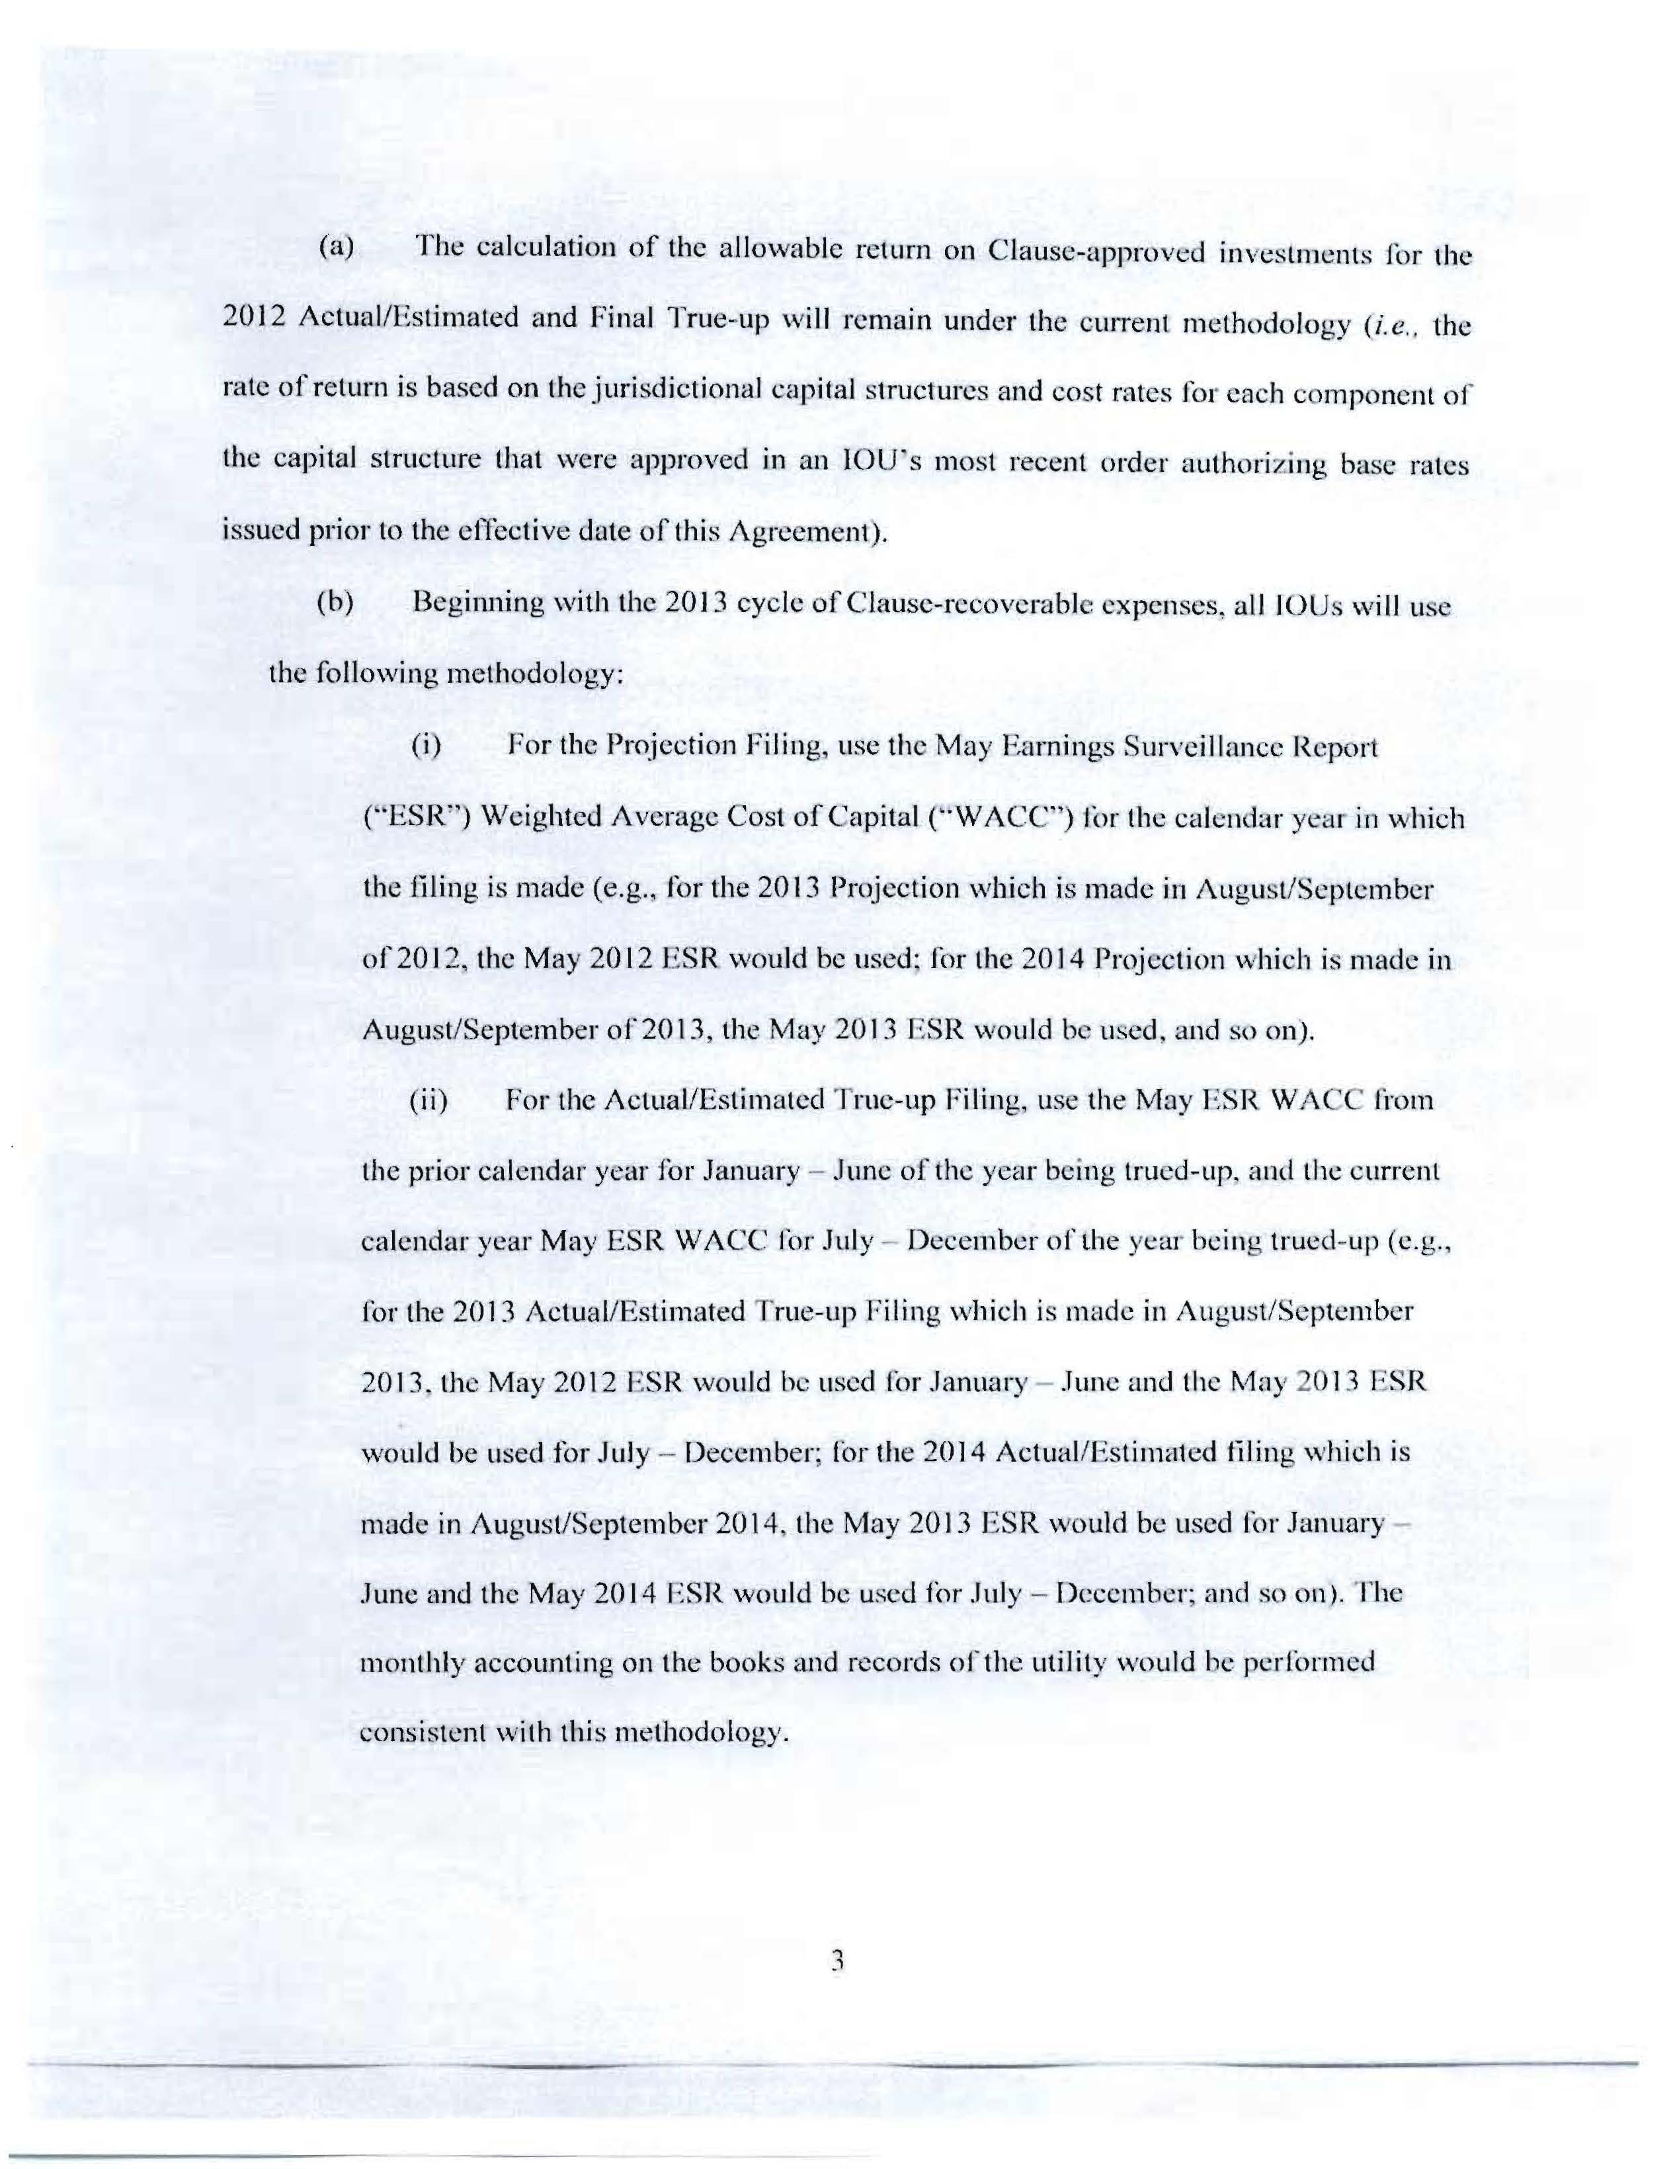
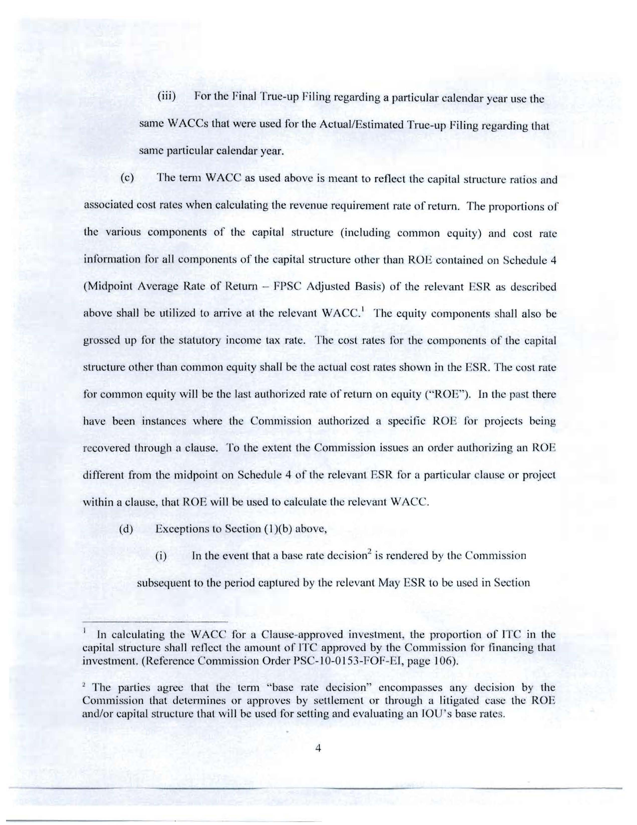
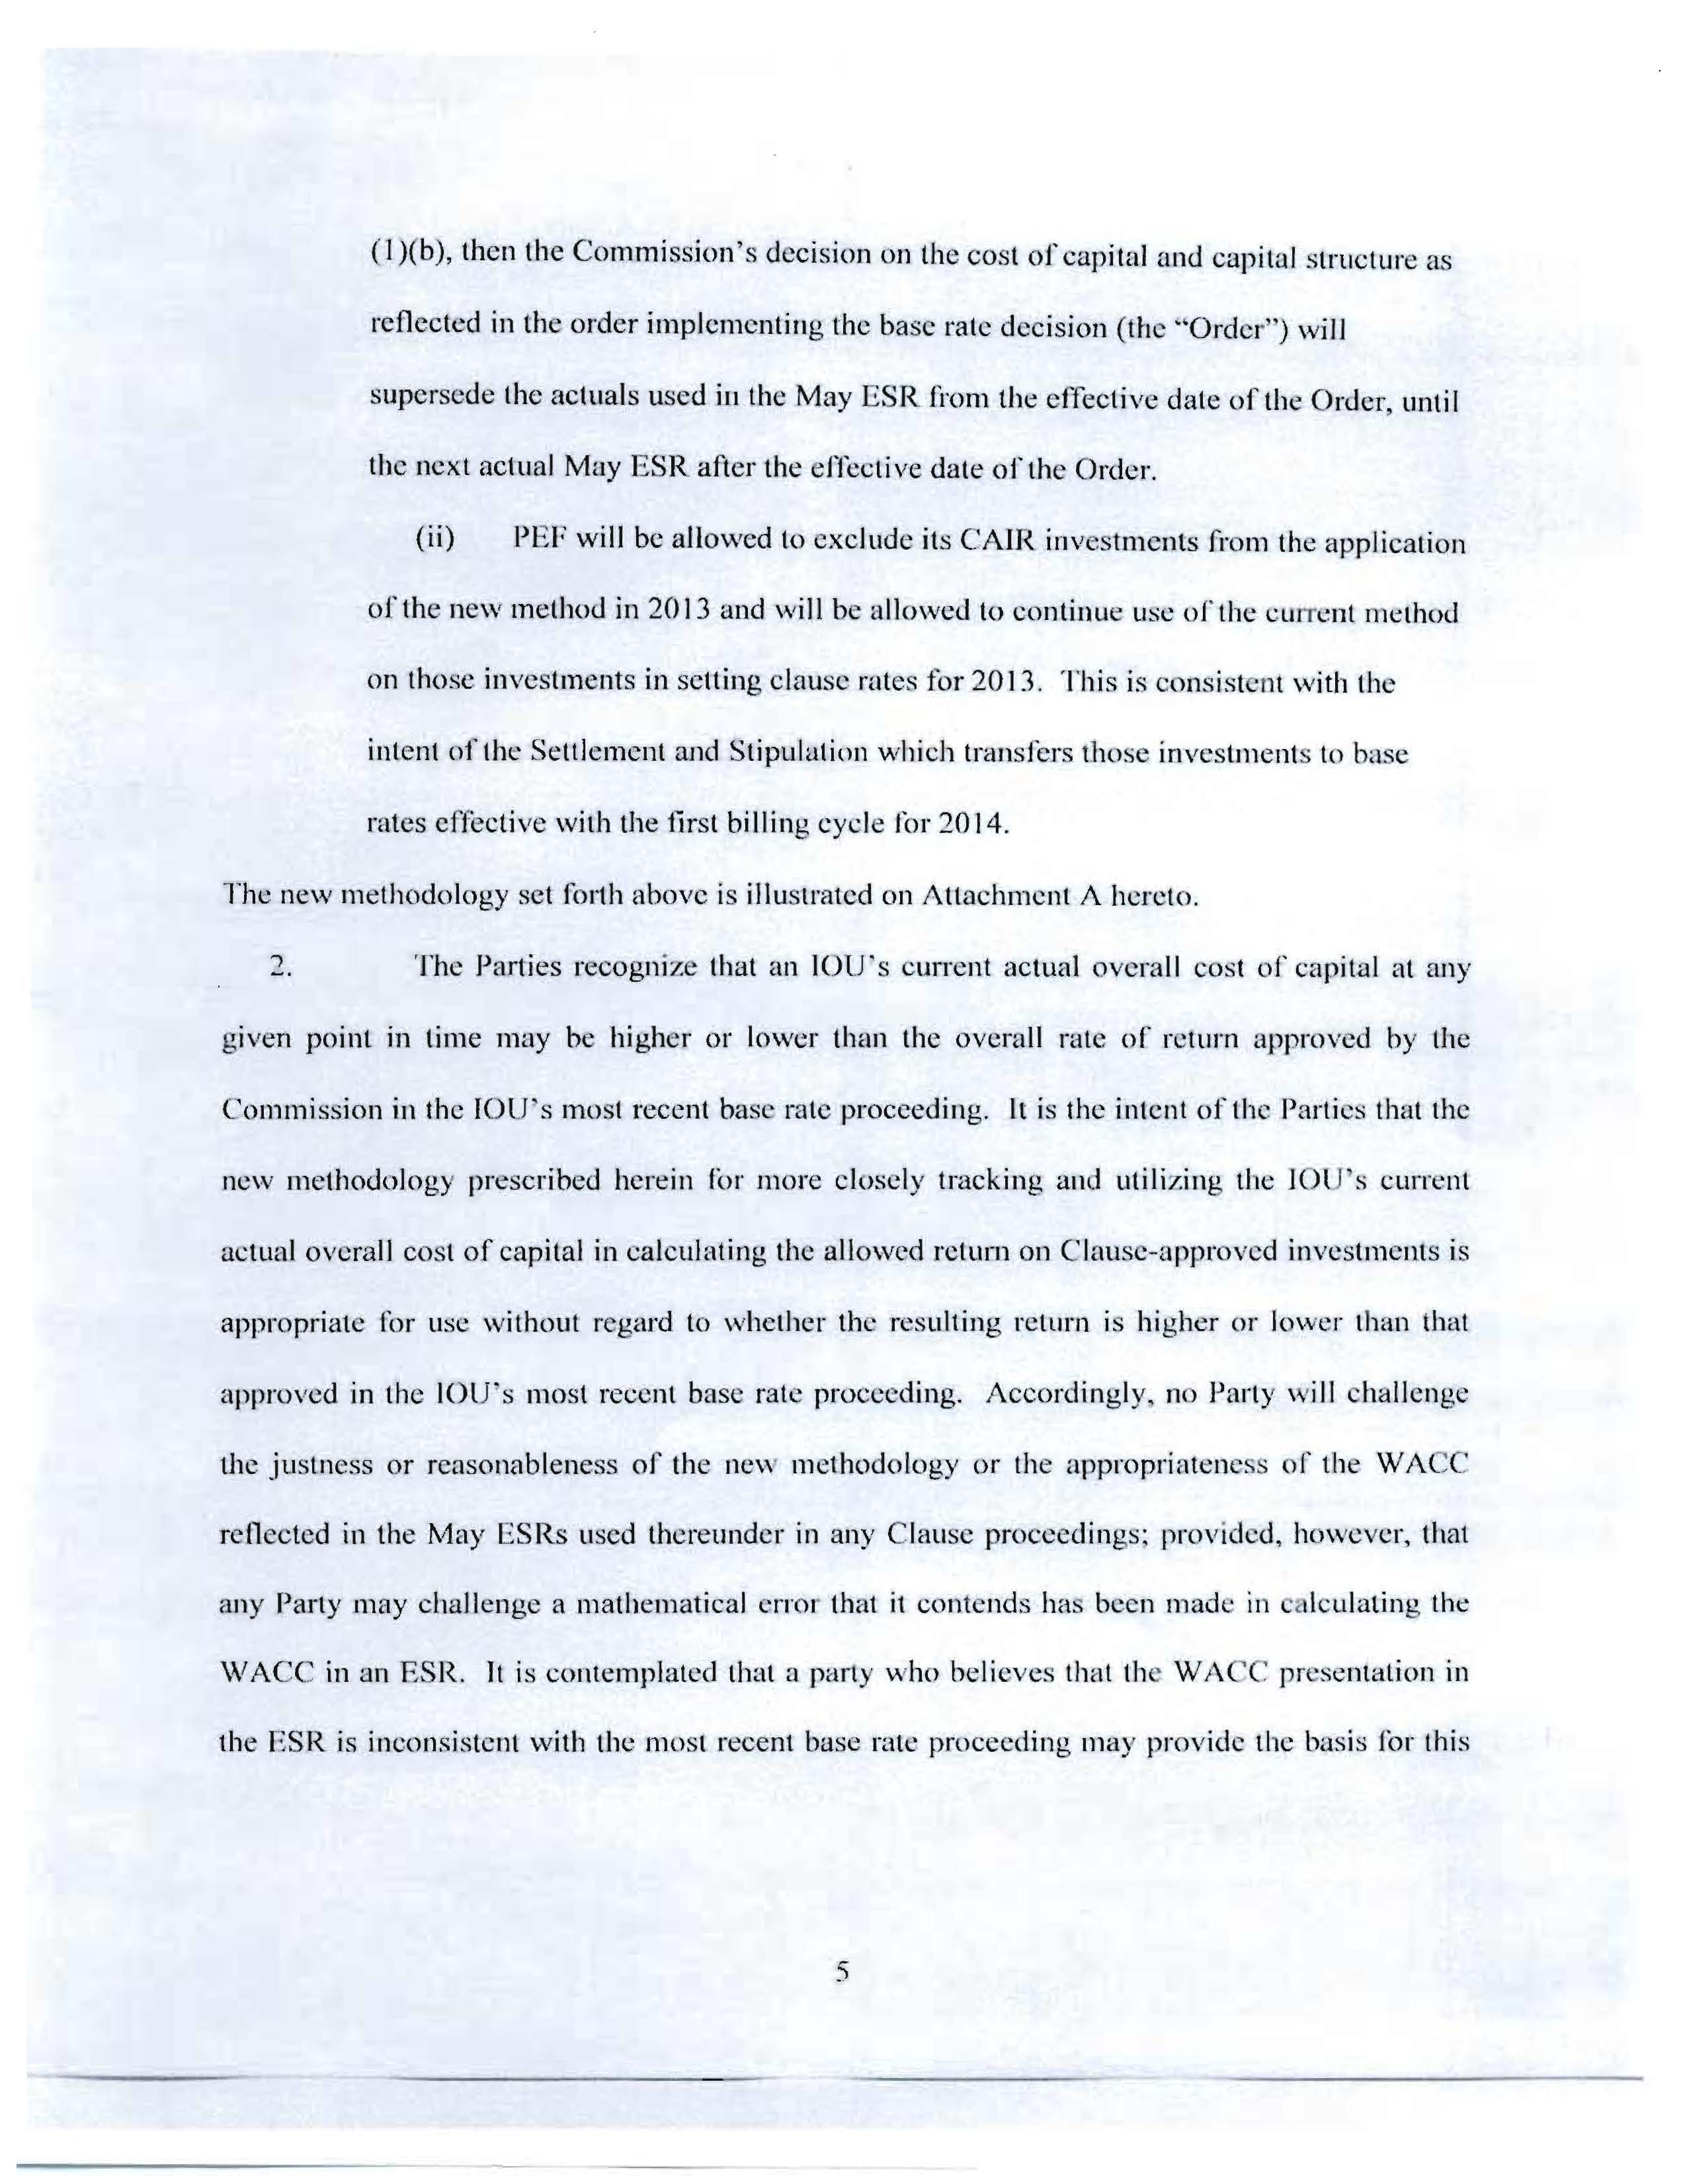
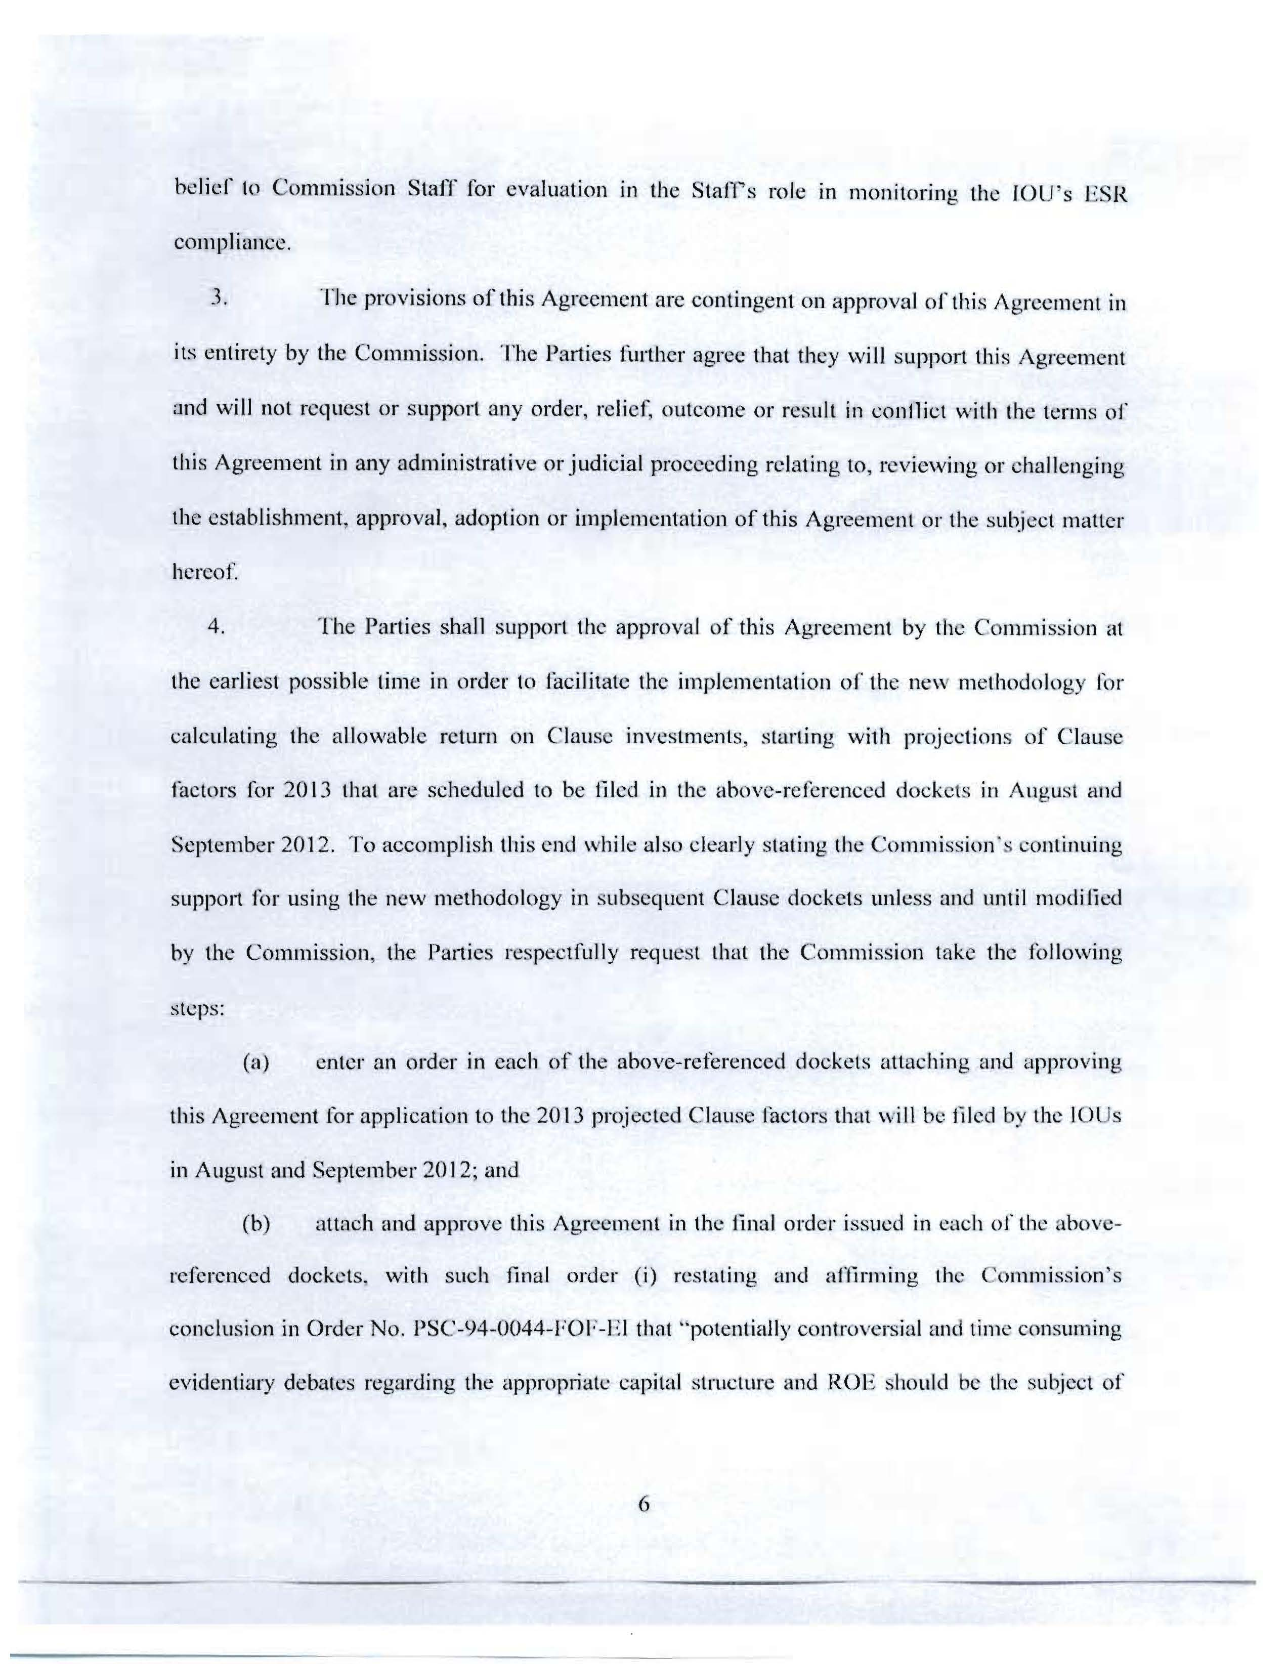
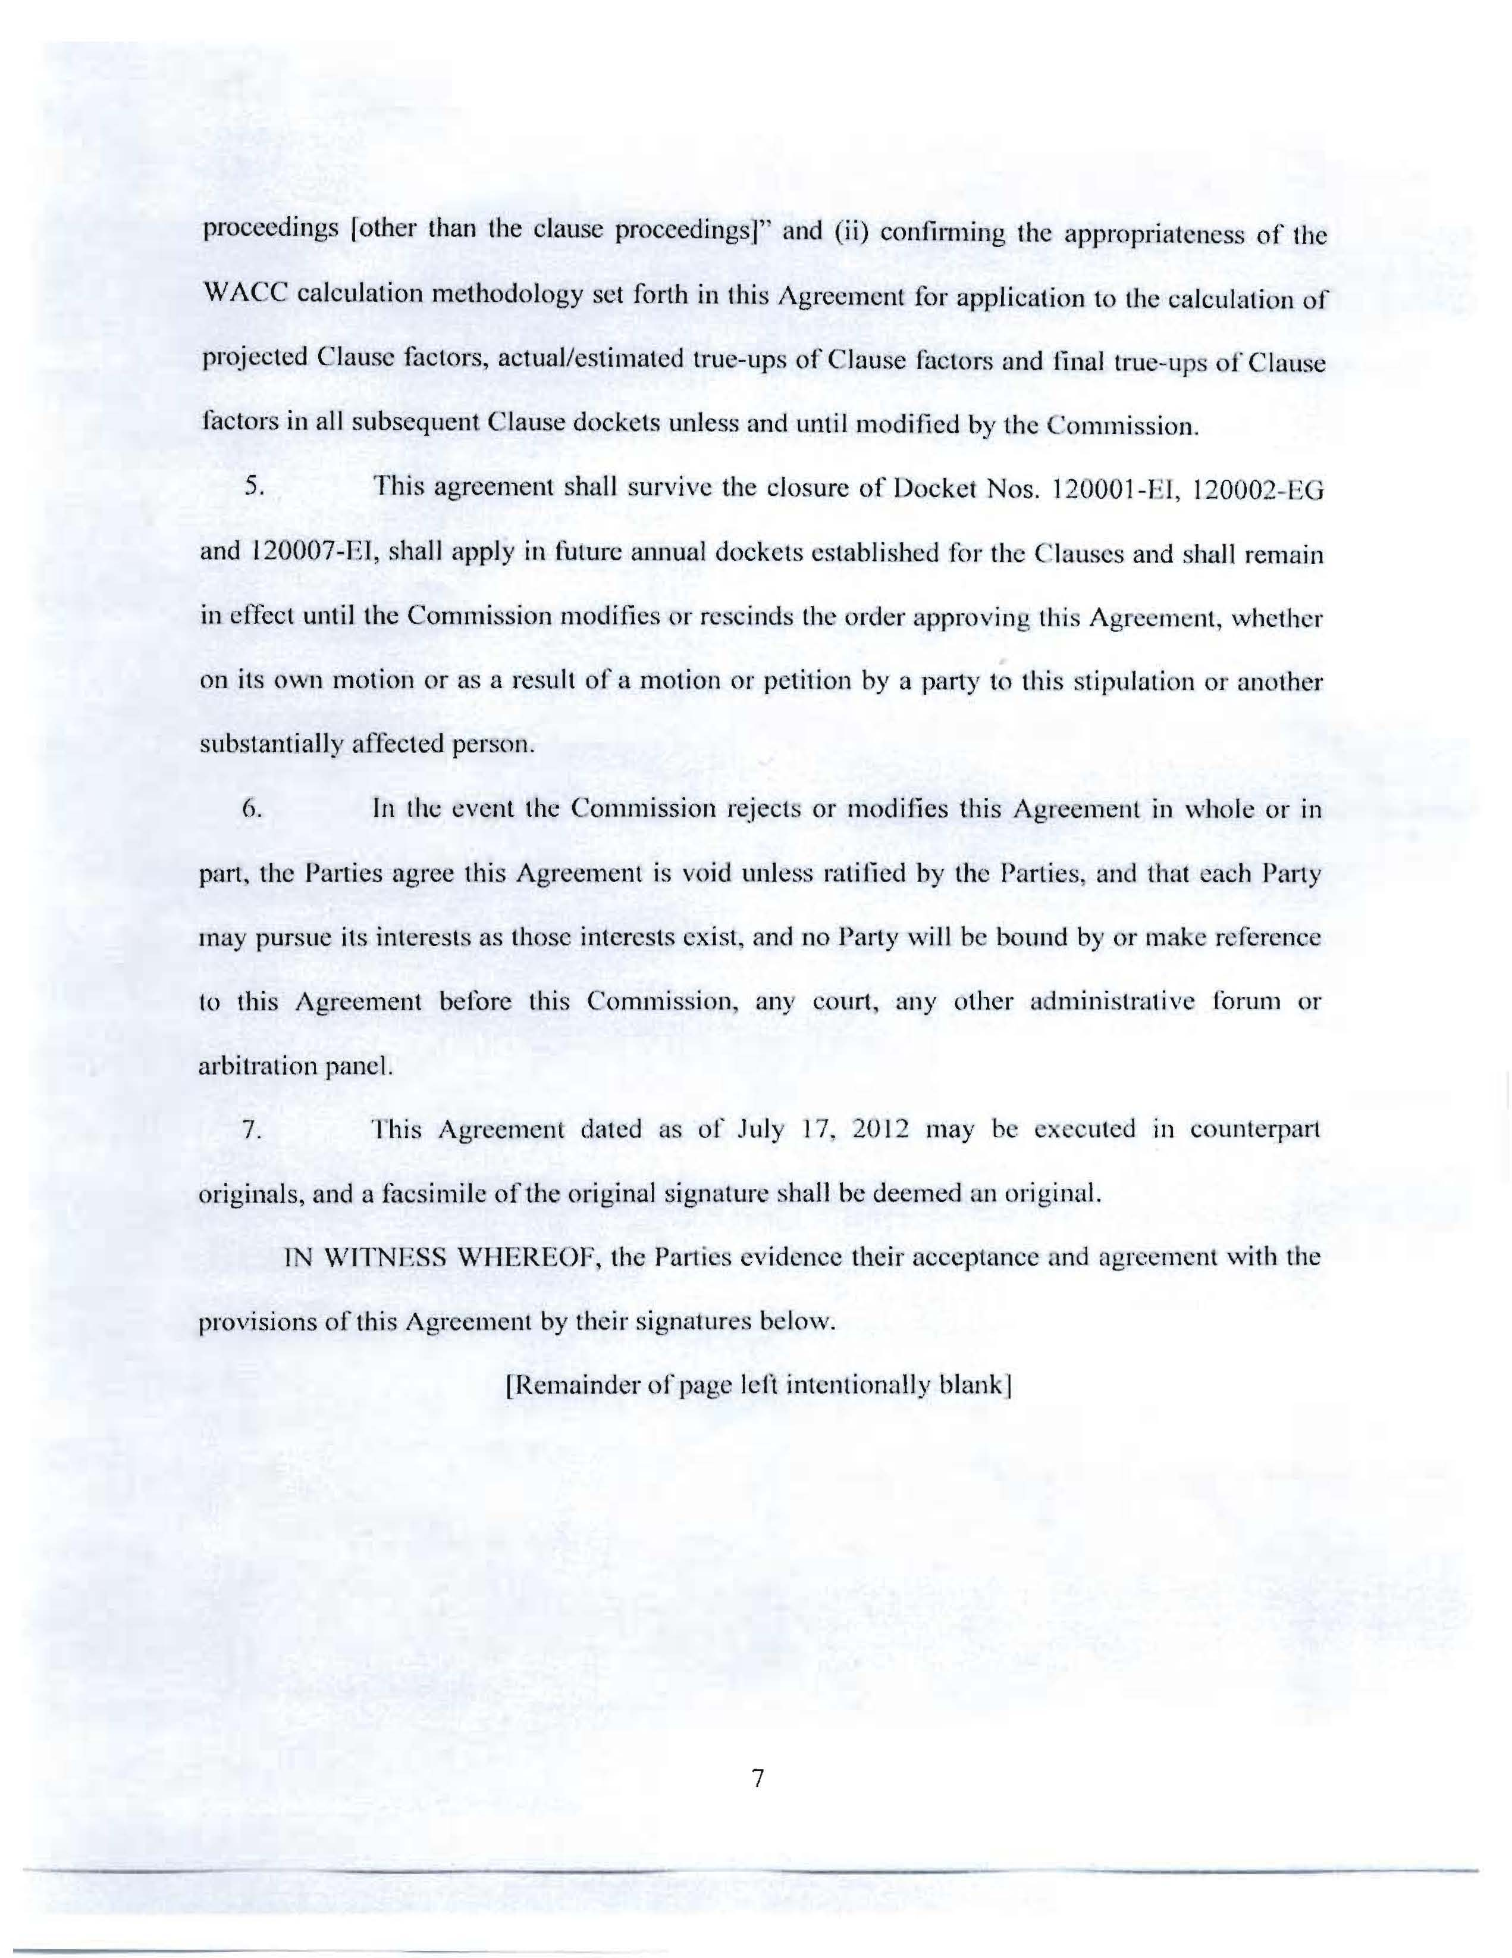
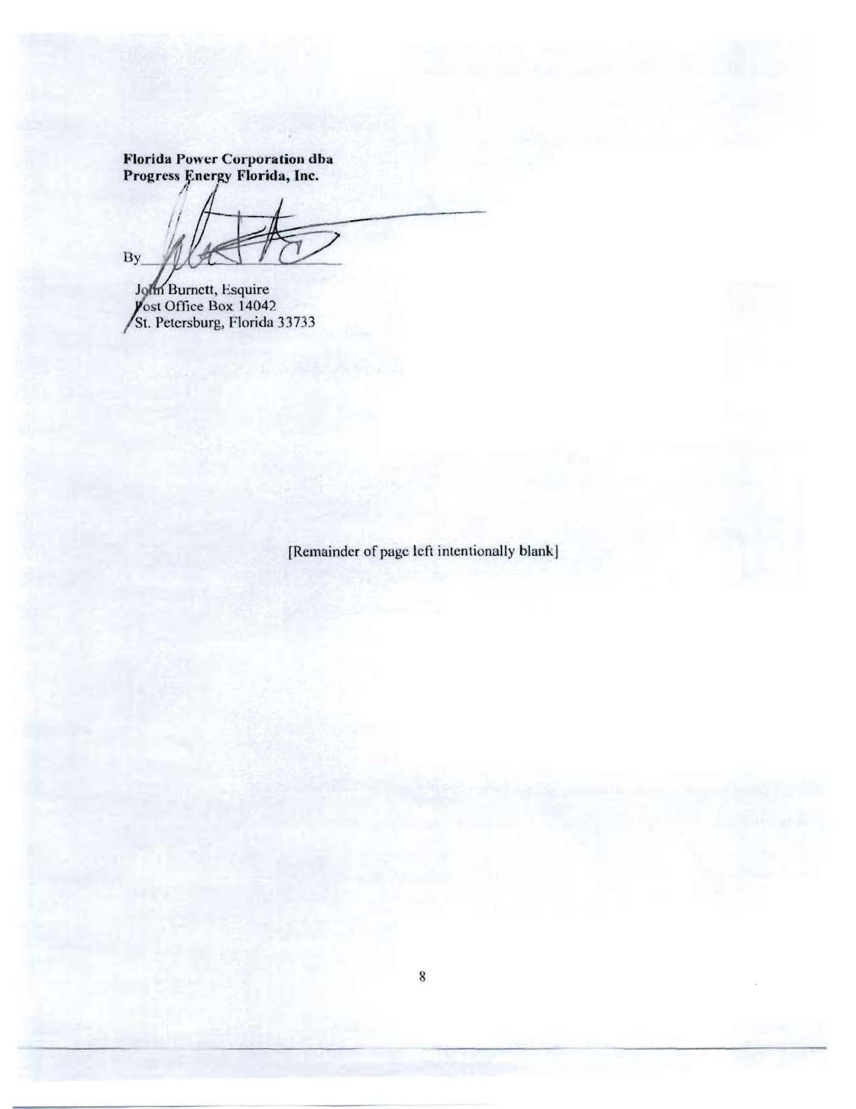
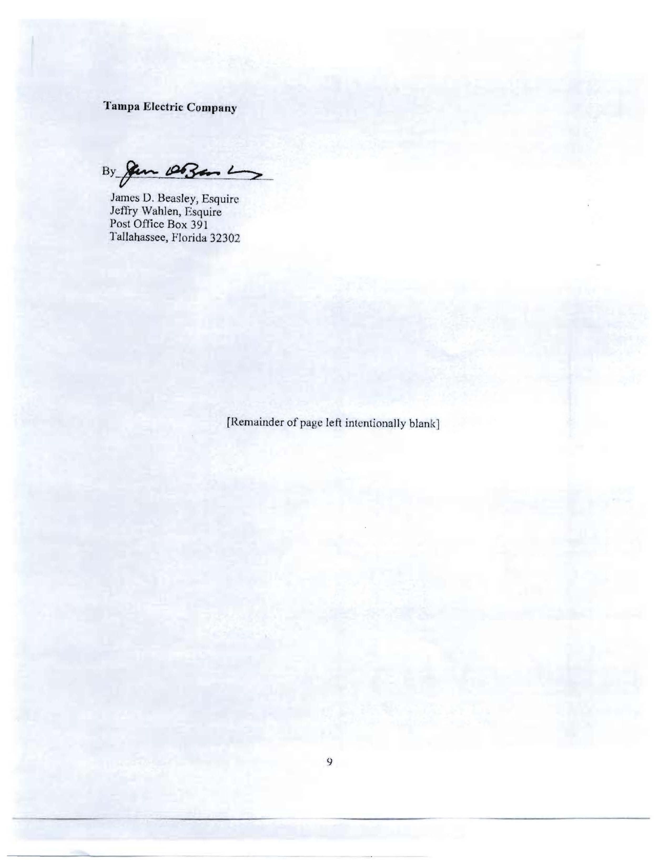
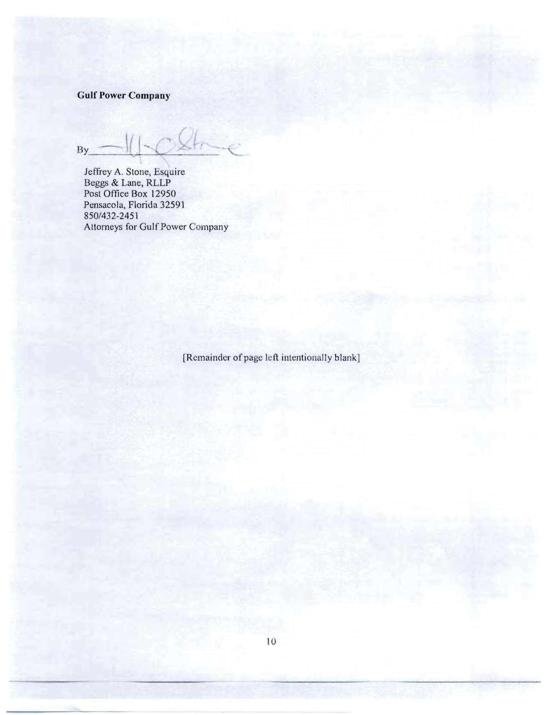
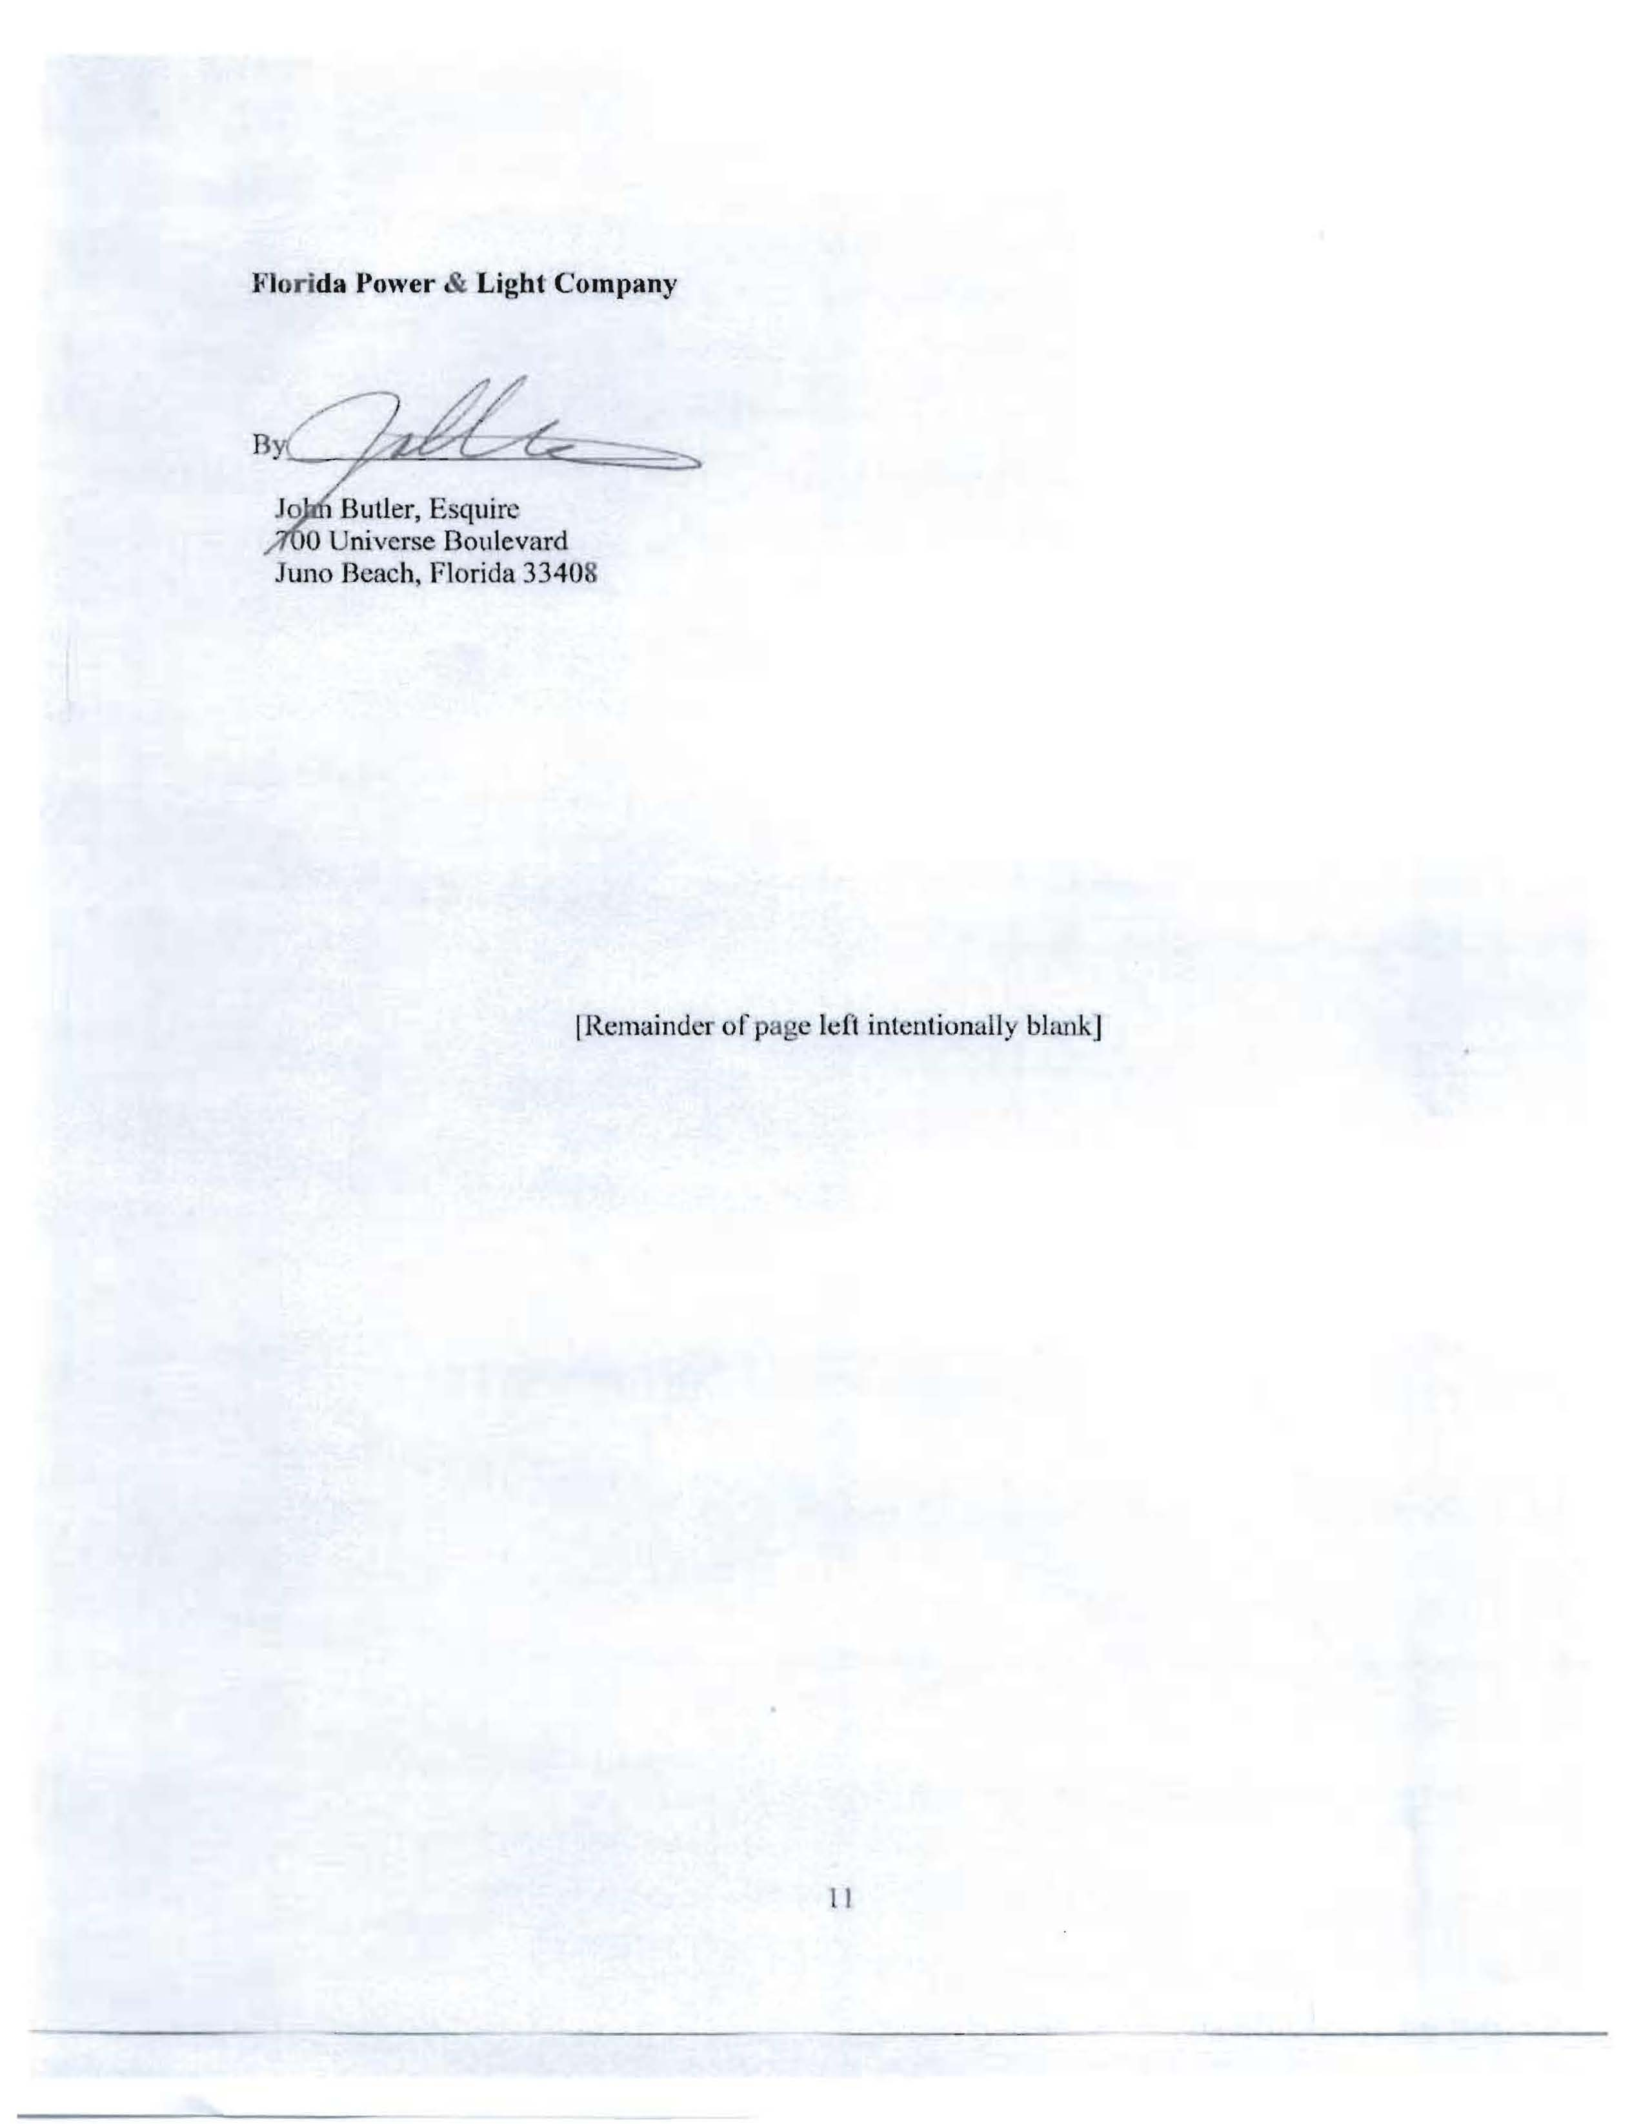
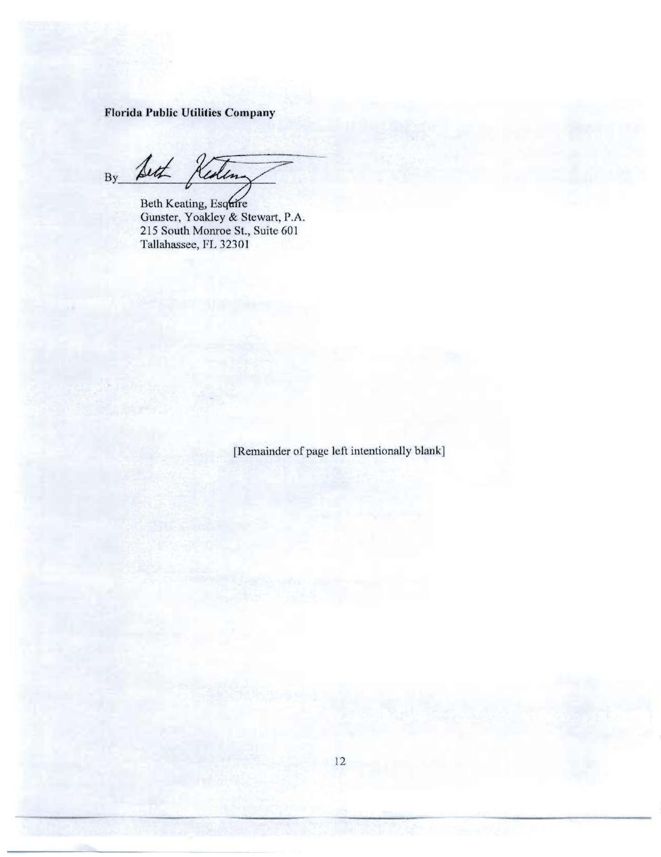
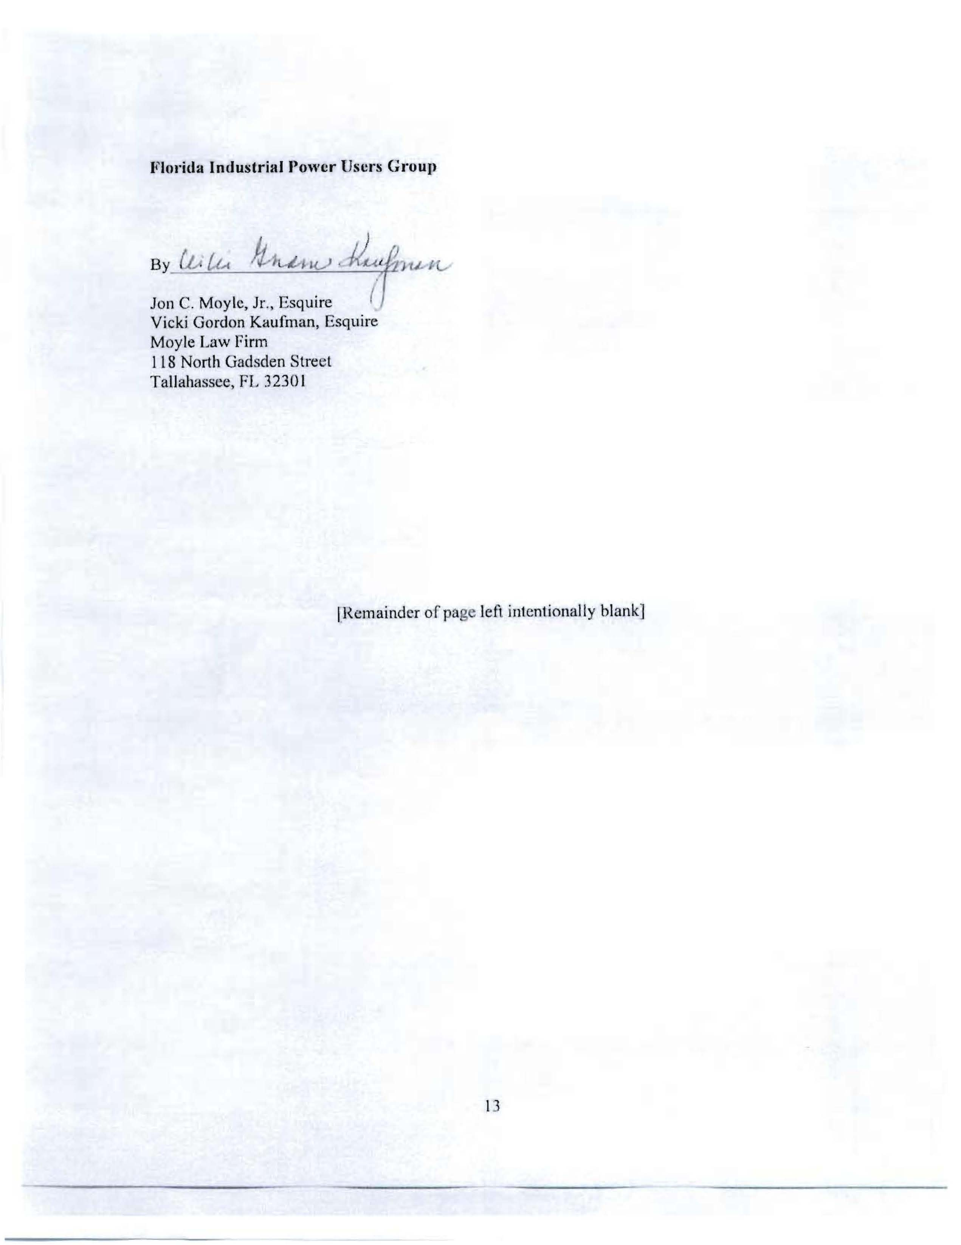
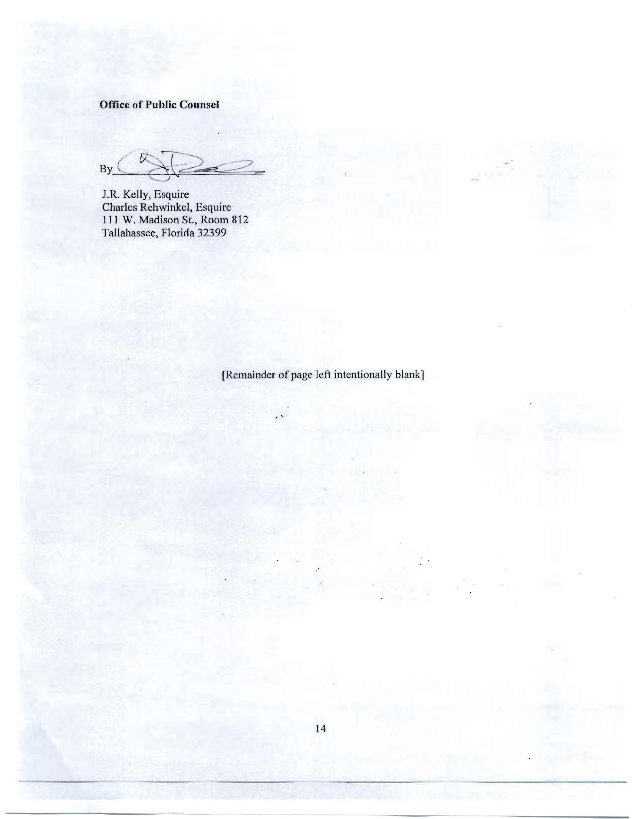
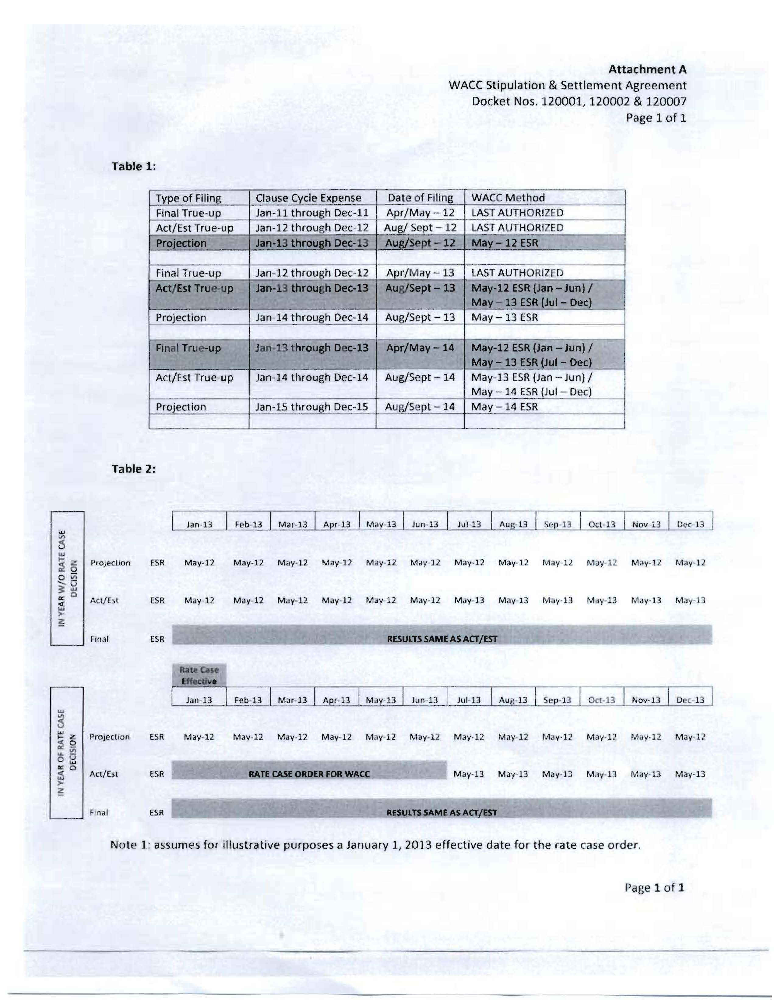

The signatories are the five electric IOUs, the Office of Public Counsel, Federal Executive Agencies, Florida Industrial Power Users Group, and White Springs Agricultural Chemicals, Inc.
Order No. PSC-94-0044-FOF-EI, issued January 12, 1994, Docket No. 930613-EI, In re: Petition to establish an environmental cost recovery clause pursuant to Section 366.0825, Florida Statutes, by Gulf Power Company.

